

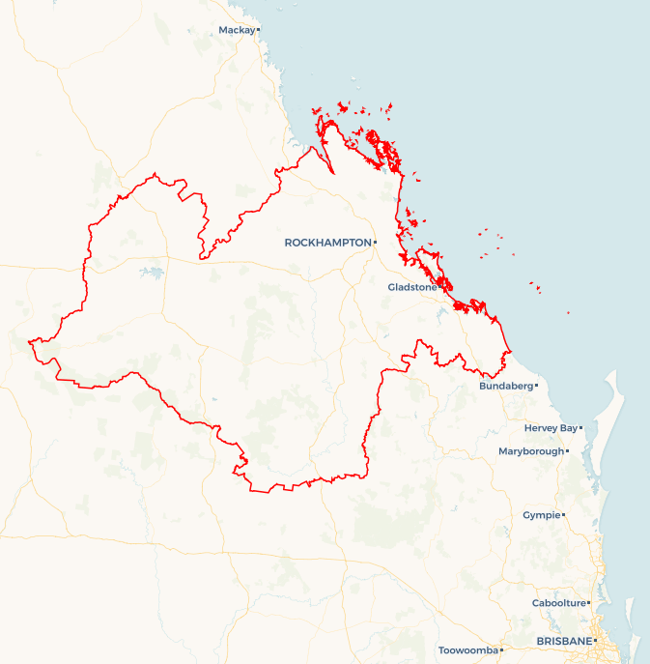Local Jobs Plan

Fitzroy ****Employment Region**** | QLD | ****March 2025****

Workforce Australia Local Jobs (Local Jobs) is a program that supports tailored approaches to accelerate   
reskilling, upskilling and employment pathways in response to current and emerging local workforce needs.

## Local Jobs elements

### Local Jobs Plan

The Local Jobs Plan sets out the skills and employment challenges and priorities of the region, and associated strategies that will drive the design and implementation of activities to be implemented to address these challenges.

### Employment Facilitators

Employment Facilitators and Support Officers support the delivery of the program by bringing together key stakeholders including businesses, employment services providers, higher education and training organisations.

### Local Jobs and Skills Taskforce

Each Employment Region has its own Taskforce. Representatives include local stakeholders who have demonstrated experience in upskilling, reskilling, and an ability to represent, connect and collaborate with others in the region to meet labour market needs.

### Local Recovery and National Priority Funds

The Local Recovery Fund supports projects that meet the priorities identified in the Local Jobs Plan. The National Priority Fund provides funding for innovative local solutions to address structural barriers to employment.

Explore labour market insights for the   
[Fitzroy](https://www.jobsandskills.gov.au/data/employment-region-dashboards-and-profiles/monthly-labour-market-dashboards) Employment Region

## Local labour market challenges in the region

* Youth unemployment: Many young people struggle with low literacy and numeracy, reducing job opportunities and confidence. Additional challenges include transport and licensing issues, homelessness and mental health challenges.
* Challenges for marginalised groups: First Nations people, mature age individuals, people with disabilities and the long-term unemployed face compounded challenges.
* Transport and licensing barriers: Limited public transport, poor connectivity to employment hubs and long wait times for licensing programs restrict workforce participation.
* Education and digital literacy gaps: School and higher education completion rates are below state and national averages and digital literacy remains a significant challenge for some individuals.
* Limited internet access: Outside major centres like Rockhampton and Gladstone, unreliable internet limits access to job opportunities, training and remote work options.
* Childcare places: A lack of childcare services, staff shortages and long waitlists make it difficult for parents to enter or remain in the workforce.
* Skilled worker shortages: Despite a strong pipeline of projects in Central Queensland, attracting and retaining skilled and professional workers remains a challenge.
* Entry-level workforce gaps: Industries struggle to fill entry-level roles due to a lack of job-ready candidates, skill mismatches and low workforce participation among key demographics.

## Local jobs and skills priorities and strategies in the region

**Priority 1 – Establishing career pathways into essential industries focus areas including health care and social assistance, mining, construction, hospitality, manufacturing, agriculture, renewables and the net zero transformation**

**What are our challenges and opportunities?**

The Fitzroy Employment Region presents numerous employment opportunities across these industries, with continued growth anticipated over the next 3–5 years. However, staffing shortages and skill gaps present challenges in finding or upskilling candidates to meet future job demands.

**How we are responding:**

* Pathways to employment: Supporting the implementation of head start (trade taster) courses, allowing Workforce Australia participants to explore industries before committing to formal training.
* Targeted training and industry collaboration: Engaging with businesses, industry associations, Registered Training Organisations (RTOs) and Workforce Australia Employment Services Providers (providers) to identify training gaps and develop innovative training solutions tailored to regional needs.
* Optimising funding opportunities: Leveraging programs such as the Local Recovery Fund, Launch into Work and Back to Work, to provide individuals with transferable skills applicable across multiple industries.
* Employer support and workforce planning: Ensuring employers are aware of available workforce support initiatives and facilitating connections with key stakeholders to enhance long-term workforce development.
* Net zero economy transformation: Collaborating with government entities and stakeholders to drive workforce adaptation and skills development in alignment with a low-carbon economy.

**Priority 2 – Workforce development and placement in high-demand industries focus areas including mining, health care and social assistance, manufacturing, construction, tourism and hospitality**

**What are our challenges and opportunities?**

While employment opportunities continue to expand in the Fitzroy Employment Region, ongoing labour shortages and skills mismatches create challenges to meet industry demands.

**How we are responding:**

* Addressing skills gaps: Partnering with businesses, industry associations and RTOs to align training programs with workforce needs and upcoming regional projects.
* Maximising funding initiatives: Utilising available funding including the Local Recovery Fund, Launch into Work and Back to Work programs to develop skills for individuals across multiple industries through the creation of programs that will upskill and progress participants towards employment.
* Employer engagement and planning: Keeping businesses informed of available workforce development supports and fostering stakeholder collaboration for future workforce sustainability.
* Strengthening industry relationships: In collaboration with providers and educational staff, we are strengthening on-the-ground understanding of industry and facilitating relationships with industry through workshops and other events to support career pathways and industry readiness.
* Advancing the net zero economy: Engaging with government and industry to ensure workforce strategies align with the transition to a sustainable, low-carbon future.

**Priority 3 – Increase the number of individuals aged between 15 and 24 who can fill current and emerging employment opportunities by improving their general employability and suitability for current vacancies and by increasing the uptake of apprenticeships and traineeships**

**What are our challenges and opportunities?**

The Fitzroy Employment Region faces significant challenges due to lower levels of educational attainment, digital literacy and soft/life skills among youth.   
These factors strongly impact employment outcomes, limiting young individuals' ability to secure and maintain meaningful work. However, there are opportunities to address these gaps through targeted interventions and collaboration with stakeholders.

**How we are responding:**

* Enhancing skills development: Partnering with stakeholders to facilitate youth participation in existing programs such as the Foundation Skills for Your Future Program, Employability Skills Training and Skills for Education and Employment. Additionally, we are supporting access to pre-employment programs like Vocational Education and Training and Transition to Work to ensure job readiness.
* Aligning education with Industry needs: Engaging with businesses and industry associations to identify workforce demands and skills shortages and working with training providers and other relevant organisations to offer education, training and pre-employment solutions that align with job market opportunities.
* Supporting employer engagement: Educating businesses about financial incentives, including wage subsidies available to those who employ youth to encourages businesses to invest in young workers.
* Promoting pathways to employment: Increasing participation in apprenticeships, traineeships, work experience and pre-employment programs through active engagement with various stakeholders, including training providers, providers, businesses and young people.
* Connecting youth to support networks: Partnering with local stakeholders to link young individuals to community services, role models and mentors, helping them overcome employment challenges.

**Priority 4 – Leverage new and existing programs through collaboration and communication to increase employment pathway opportunities through training and upskilling for First Nations people, mature age individuals, people with a disability, long-term unemployed, parents, culturally and linguistically diverse communities and ex-offenders.**

**What are our challenges and opportunities?**

There is significant disparity in training and employment outcomes for marginalised cohorts in the Fitzroy Employment Region. High unemployment rates persist among First Nations people, mature age individuals and people with disabilities. Long-term unemployed individuals may also encounter additional non-vocational challenges that hinder workforce participation.

**How we are responding:**

* Creating specialised employment pathways: Partnering with businesses experiencing current or future labour demand to develop tailored employment opportunities for marginalised individuals.
* Promoting workforce diversity: Engaging with local businesses to highlight the benefits of a diverse workforce and encourage the hiring of underrepresented groups.
* Supporting employers: Educating businesses on available wage subsidies, cultural competency training, disability education, workplace modifications and assistive technology to facilitate inclusive employment practices.
* Reskilling and upskilling: Assisting transitioning workers by promoting mature-age apprenticeships, traineeships, and free or low-cost training opportunities, such as fee-free TAFE courses. Additionally, we are facilitating skills recognition and promoting initiatives like Career Transition Assistance to help mature age individuals re-enter the workforce.
* Culturally appropriate support: Connecting and collaborating with local support services, including First Nations organisations, traditional owner groups and mentors, which offer culturally tailored assistance to First Nations people to assist in navigating employment challenges.
* Encouraging self-employment: Connecting individuals interested in entrepreneurship to initiatives such as the Self-Employment Assistance Program, enabling them to explore and develop business opportunities.

## Want to know more?

* Contact: Anthony Clements, Fitzroy Region Employment Facilitator: Anthony.clements@fitzroyef.com.au
* Visit: [Local Jobs](https://www.dewr.gov.au/local-jobs) or [Workforce Australia](https://www.workforceaustralia.gov.au/)