

Izinhlelo Zokuhlola Amakhono

Ingabe uyafisa ukuhlolelwa amakhono OKUMAHHALA NOKUSHESHAYO?
Uma uhlala e-Australia nomndeni, nomuntu othandana naye, umbaleki, noma nge-visa yokuvikelwa, ungathola ukuqashelwa kweziqu zakho zakwamanye amazwe mahhala.
- Bamba iqhaza Emathubeni Okuhlolwa Kwamakhono enzelwe Uhlelo Lwabafuduki
- Yenza iziqu zakho zakwamanye amazwe ziqashelwe
- Thuthukisa amathuba akho okuqasheka
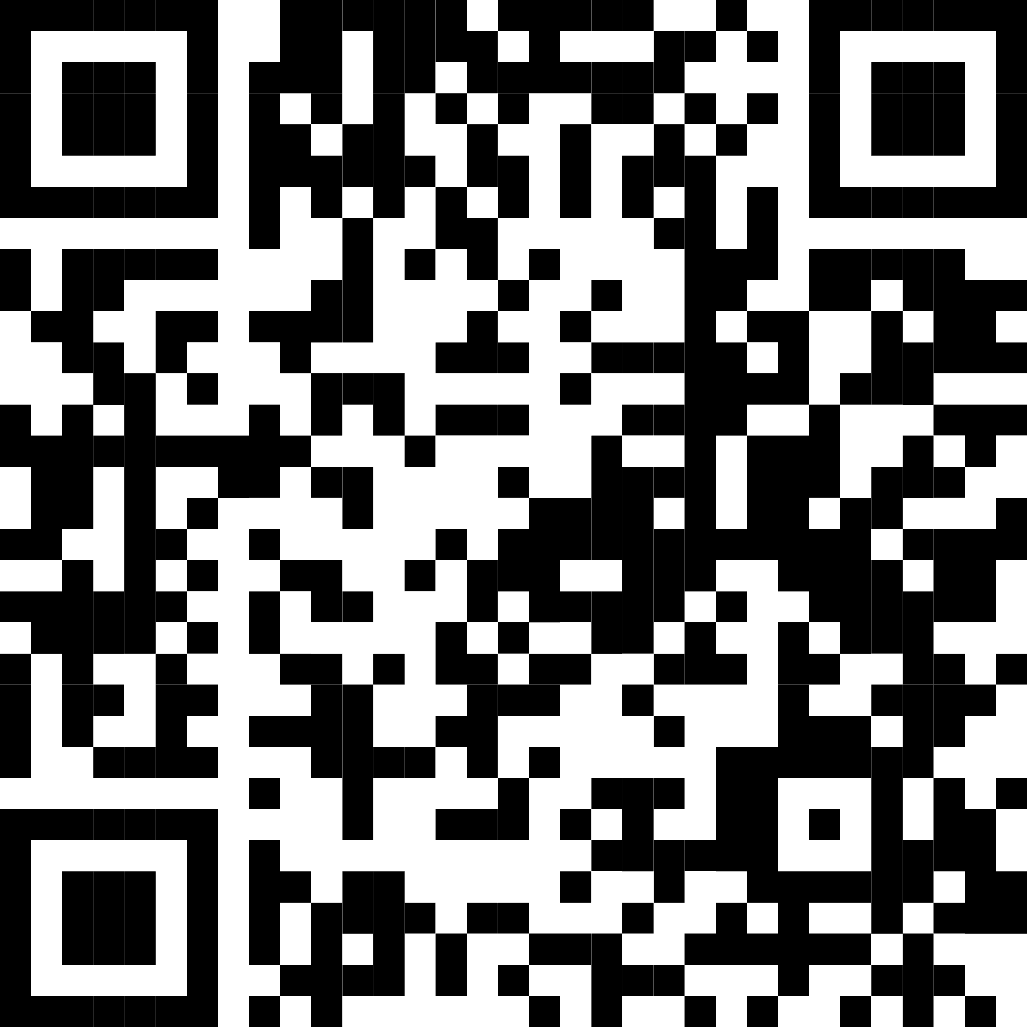 | BHALISA MANJE!  Skena ikhodi ye-QR ukuze uthole imininingwane eyengeziwe

