

Jobs and Skills Councils

Performance monitoring arrangements

## Jobs and Skills Councils work to understand and address skills and workforce challenges and lead industry-driven solutions

Jobs and Skills Councils (JSCs) bring together employers, unions and governments in a tripartite arrangement to deliver workforce solutions through addressing skills gaps, strengthening collaboration, supporting career pathways and enhancing training quality.

Each JSC operates in a unique industry context and is funded through a Grant Agreement with the Australian Government.

## The JSC performance monitoring arrangements provide a structure for demonstrating value and impact

Performance monitoring arrangements were co-designed by JSCs and the Department of Employment and Workplace Relations. The arrangements form part of the JSC Integrity Framework and are comprised of four interdependent elements, collectively providing a picture of JSC performance:

* **exchange of letters**: a structured conversation to support alignment of priorities (through an exchange of letters) between the Commonwealth Skills Minister and JSCs
* **core logics**: core logics that describe how JSCs move from outputs to impact by influencing stakeholder behaviour
* **common metrics**: a handful of key metrics to demonstrate JSCs are on track to deliver impact and are operating as expected
* grant agreement and other **administrative requirements**.

## JSC performance monitoring arrangements support continuous improvement

As a central aspect of measurement, evaluation and learning, these arrangements provide a structure for demonstrating the value and success of JSCs, identifying opportunities for improvement, and understanding overall performance across the program. The arrangements also inform ongoing relationship management, risk management and grant administration by the department.

##### Figure 1. The Jobs and Skills Councils performance monitoring arrangements contribute to an ongoing cycle of measurement, evaluation, and learning

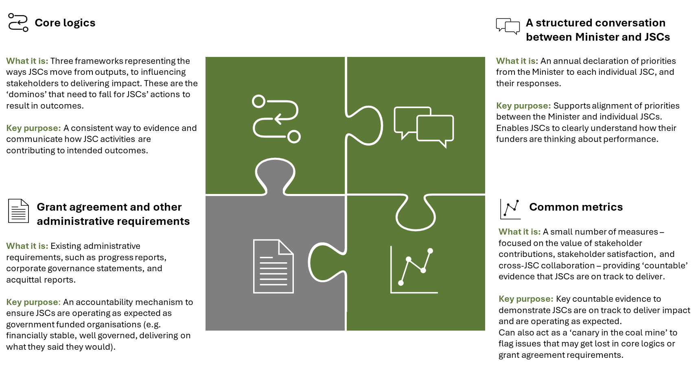

# JSC Performance Framework image description

**Core Logics:**

**What it is:** Three frameworks representing the ways JSCs move from outputs, to influencing stakeholders to delivering impact. These are the ‘dominos’ that need to fall for JSCs’ actions to result in outcomes.

**Key purpose:** A consistent way to evidence and communicate how JSC activities are contributing to intended outcomes.

**A structured conversation between Minister and JSCs**

**What it is**: An annual declaration of priorities from the Minister to each individual JSC, and their responses.

**Key purpose:** Supports alignment of priorities between the Minister and individual JSCs. Enables JSCs to clearly understand how their funders are thinking about performance.

**Common Metrics**

**What it is:** A small number of measures – focused on the value of stakeholder contributions, stakeholder satisfaction, and cross-JSC collaboration – providing ‘countable’ evidence that JSCs are on track to deliver.

**Key purpose:** Key countable evidence to demonstrate JSCs are on track to deliver impact and are operating as expected.   
Can also act as a ‘canary in the coal mine’ to flag issues that may get lost in core logics or grant agreement requirements.

**Grant agreement and other administrative requirements**

**What it is:** Existing administrative requirements, such as progress reports, corporate governance statements, and acquittal reports.

**Key purpose**: An accountability mechanism to ensure JSCs are operating as expected as government funded organisations (e.g. financially stable, well governed, delivering on what they said they would).