


Transition to Work
Supplementary Evaluation
Report
2016-2021
December 2024

Evaluation team
Alison Inglis, Michael Gao, Eh Eh Tin, Alison Reinhard, Caroline Daley, Robyn Henderson, Yingru Wu
Acknowledgements
The Youth and Pre-employment Initiatives Evaluation research team would also like to acknowledge the contributions of the Social Research Centre (SRC), and the TtW Evaluation Working Group.
The Working Group supported the development of the evaluation strategy and provided insights and questions throughout the evaluation process.
Findings from participant and provider research conducted by SRC has been synthesised with departmental administrative data in this report.

ISBN
978-1-76114-181-2 [PDF]
978-1-76114-182-9 [DOCX]

With the exception of the Commonwealth Coat of Arms, the department’s logo, any material protected by a trade mark and where otherwise noted all material presented in this document is provided under a Creative Commons Attribution 4.0 Australia licence.
The details of the relevant licence conditions are available on the Creative Commons website (accessible using the links provided) as is the full legal code for the CC BY 4.0 AU licence.
The document must be attributed as the Transition to Work Supplementary Evaluation Report.

Contents
List of short forms ix
Glossary x
Executive summary xiv
Background to this supplementary evaluation xiv
Evaluation objectives xiv
Evaluation approach xv
Key findings xv
How has participation in TtW impacted human capabilities of participants? xv
What impact has TtW had on participants’ contact with the criminal justice system? xvii
To what extent is TtW achieving the intended longer-term (3 to 4 year) objective of increased employment and labour market engagement and reduced dependence on income support for young people? xvii
What impact did extending the maximum duration of service in TtW from 12 to 18 months have on participant outcomes? xviii
Does TtW offer value for money? xix
Conclusion xix
Departmental response to the Transition to Work Supplementary Evaluation Report (2022) xxi
Transition to Work context xxi
Design principles and continuous improvement xxi
Supplementary evaluation findings xxii
Conclusion xxv
About this report 1
Chapter 1 – Introduction 3
1.1 The TtW service 3
1.1.1 Eligible groups 3
1.1.2 Outline of services 5
1.1.3 The TtW population is significantly more disadvantaged than young people overall in Australia 6
1.2 Macroeconomic environment 6
1.3 Policy and program context 8
1.4 Youth transitioning from education to work: Australian and international research 9
1.4.1 Building the human capabilities of young people as a necessary step to employment and wellbeing 10
1.5 Previous evaluation of the TtW program 13
1.5.1 Findings from the TtW final evaluation 13
1.6 TtW’s role in supporting the development of participants’ human capabilities – the theory of change 13
Chapter 2 – Supplementary evaluation of TtW 15
2.1 Evaluation scope 15
2.2 Key evaluation questions 15
2.3 Data sources 16
2.4 Evaluation approach and methodology 17
2.4.1 Evaluation approach 17
2.4.2 Methodology for EQ1: impact on human capabilities 18
2.4.3 Methodology for EQ2: Long-term impact analysis 21
2.4.4 Methodology for EQ3: Impact of increasing the maximum duration of service from 12 to 18 months 25
2.4.5 Methodology for examining the value for money of TtW 27
Chapter 3 – What impact does TtW have on participants’ human capabilities? 29
3.1 Introduction 29
3.2 Human capabilities: the impact of TtW on participants’ psychological capabilities 29
3.2.1 Confidence 29
3.2.2 Motivation 32
3.2.3 Empowerment 34
3.2.4 Resilience 37
3.2.5 Mental health 40
3.2.6 Physical health 45
3.3 The impact of TtW on participants’ capability influencers 45
3.3.1 Social connectedness 46
3.3.2 Availability of and access to support services 48
3.4 Impact of TtW on participants’ overall subjective wellbeing and life satisfaction 50
3.4.1 Context 50
3.4.2 Life satisfaction 50
3.4.3 Personal wellbeing 52
3.4.4 Psychosocial wellbeing 54
3.5 What elements of the TtW program are associated with increased human capability in participants? 54
3.5.1 Correlations between program elements and human capability indicators 54
3.5.2 Correlations between work/study and human capability indicators 56
3.5.3 The impact of provider characteristics 57
3.6 Conclusion 60
Chapter 4 – What impact does TtW have on participants’ incarceration rates? 62
4.1 Introduction 62
4.2 Prison sentences 62
4.3 Reoffending 63
4.4 Participants who are ex-offenders on referral 64
4.5 Aboriginal and Torres Strait Islander participants 65
4.6 Conclusion 66
Chapter 5 – To what extent is TtW achieving the intended longer-term (3 to 4 year) objective of increased employment and labour market engagement and reduced dependence on income support for young people? 67
5.1 Introduction 67
5.2 The impact of TtW over the longer term 67
5.2.1 Employment 67
5.2.2 Labour market attachment 70
5.2.3 Number of income support episodes 72
5.2.4 Full-time accredited study or apprenticeships 72
5.3 Impact of COVID-19 pandemic 74
5.4 Long-term impact for participants of different equity cohorts 74
5.5 Other longer-term trends 76
5.5.1 Movement between income support payment types 76
5.5.2 Relationship between income support and employment services 77
5.6 Conclusion 78
Chapter 6 – What was the impact of extending the maximum duration of service from 12 to 18 months? 79
6.1 Introduction 79
6.2 Impact of changing maximum program duration on participant outcomes 79
6.2.1 Time in program 79
6.2.2 Employment and education outcomes 81
6.2.3 Provider perspectives 84
6.2.4 Timing of outcomes 85
6.3 Provider views on the impact of increasing program duration on service delivery 86
6.4 Participant perspectives on program duration 88
6.5 Conclusion 89
Chapter 7 – Does TtW offer value for money? 91
7.1 Introduction 91
7.2 Summary: the value for money of TtW 92
7.3 Valuing benefits associated with increased human capabilities and wellbeing 100
7.3.1 The appropriateness of and methodologies for valuing wellbeing 100
7.3.2 Establishing the impact of TtW on wellbeing 102
7.3.3 Calculating the value of changes in wellbeing 102
7.3.4 Estimating the monetary value of changes in wellbeing attributable to TtW 103
7.4 Valuing savings associated with reduced offending 103
7.4.1 Nights of incarceration that were avoided due to TtW participation 104
7.4.2 Cost per person per night of incarceration 105
7.4.3 Total value of savings from ‘avoided’ incarceration 105
7.5 Calculating the cost of servicing one participant in TtW 106
7.6 Calculating the average cost/person associated with additional income support payments 106
7.7 Estimating the cost : benefit ratio 107
7.8 Conclusion 108
Chapter 8 – Conclusion 109
References 110
List of tables 115
List of figures 118
Appendix 1: Macroeconomic conditions affecting program outcomes 121
A1.1. An underlying upward trend in economic growth, 2016–2020 121
A1.2. The shock of COVID-19 and natural disasters 124
Appendix 2: Data sources 126
A2.1. Qualitative research 126
A2.1.1. 2021 participant, provider and stakeholder interviews 126
A2.2. Quantitative research 126
A2.2.1. 2021 TtW provider survey 126
A2.2.2. 2021 TTW participant survey 127
A2.3. Analysis of the department’s administrative data 128
Appendix 3: Long-term impact analysis: study population methodology and demographics, analysis methodology and data limitations 129
A3.1. Introduction 129
A3.2. Construction of the study population 129
A3.3. Population and sample demographics 131
A3.3.1. The study samples are matched and very similar 131
A3.4. Construction of the ‘employment-related’ income support exit indicator 137
A3.5. Impact of COVID-19 138
A3.6. Limitations 139
Appendix 4: Analysis of extension of program duration: study population selection and demographics, analysis methodology and data limitations 141
A4.1. Introduction 141
A4.2. Construction of study populations and samples 141
A4.3. Population and sample demographics 142
A4.4. Regression analysis 145
A4.5. Limitations 146
Appendix 5: Methodology, data and calculations used in the value-for-money analysis of TtW 147
A5.1. Introduction 147
A5.2. Valuing the broader benefits of TtW 148
A5.3. Valuing benefits associated with increased wellbeing 148
A5.3.1. Valuing savings associated with reduced offending 152
A5.3.2. Limitations associated with calculation of benefits 154
A5.4. Calculating the relative costs associated with TtW 155
A5.4.1. Calculating the cost of servicing one participant in TtW 155
A5.4.2. Calculating the average cost/person associated with additional income support payments 155
A5.5. Estimating the cost : benefit ratio 157
A5.6. Assessing risks and testing sensitivities 158
A5.7. Future research needs 159
Appendix 6: Regression analysis 160
A6.1. Long-term impact analysis – regression output 160
A6.2. Participant survey – regression output 170
Appendix 7: Impact of COVID-19 180
A7.1. General COVID-19 impacts 180
A7.2. Impact on TtW support 181
A7.3. Impact on participants’ human capabilities 181
Appendix 8: Data from 2021 provider and participant surveys 184
A8.1. 2021 participant survey results 184
A8.2. 2021 provider survey results 188

List of short forms
Short form | In full
ABS | Australian Bureau of Statistics
ASC | Australian Skills Commission
CALD | Culturally and linguistically diverse
CPI | Consumer Price Index
department | Department of Employment and Workforce Relations
DESE | Department of Education, Skills and Employment
DEWR | Department of Employment and Workforce Relations
ESAt | Employment Services Assessment
ESL | Early school leaver
FTE | Full-time equivalent
HILDA | Household, Income and Labour Dynamics in Australia Survey
IS | Income support
JSCI | Job Seeker Classification Instrument
LMA | Labour market attachment
NCVER | National Centre for Vocational Education Research
NEST | New Employment Services Trial
POS | Period of service
PWI | Personal Wellbeing Index
RED | Research and Evaluation Database
SWB | Subjective wellbeing
TAFE | Tertiary and further education
TtW | Transition to Work
TtW Deed | Transition to Work Deed 2016–2022
YA (O) | Youth Allowance (Other)

Glossary
Term | Description
Annual funded places | Transition to Work (TtW) providers are contracted for an agreed number of funded places, with each funded place expected to allow participation for approximately 2 young people on average per annum.
Caseload | Caseload refers to the number of participants in services and information about this group captured at a point in time.
Contract | In this report, a contract is an agreement between a provider and the Australian Government to deliver TtW services in a particular employment region. Some providers have more than one contract because they deliver TtW in more than one region.
ESAt | An Employment Services Assessment (ESAt) provides a comprehensive work capacity assessment for people with disability and/or other potentially serious barriers to work. An ESAt is required before a participant can be referred to Disability Employment Services.
Exit | In this report, an exit occurs when a participant is removed from the caseload of a TtW or jobactive provider. Most exits are automatic (effective exit) for reasons such as stopping or changing income support payments, changing to another employment service, death or imprisonment. Providers can initiate a manual exit (provider exit) and they must record reasons for exits.
Group 1 | Young people aged under 22 years referred to TtW through the Department of Human Services (now Services Australia) who meet the following eligibility criteria:  - have not been awarded a Year 12 certificate or a Certificate III or higher  - are receiving Youth Allowance (Other) or any other activity-tested income support payment  - are eligible for Stream B in jobactive
Group 2 | Disengaged young people who are directly registered with a TtW provider and meet the following eligibility criteria:  - have not been awarded a Year 12 certificate or a Certificate III or higher  - are not already participating in employment services  - for the last 13 weeks have not been working an average of 8 hours or more per week  - have not attended secondary education for 13 weeks, are not enrolled in secondary education and have an exemption from legal requirements to attend school (if compulsory school age)  - are not receiving income support or are receiving non-activity-tested income support such as Parenting Payment.
Group 3 | Young people referred from a jobactive provider who meet the following eligibility criteria:  - are in Stream C in jobactive  - are identified by their jobactive provider as having capacity to benefit from TtW (e.g. young people with one or more particular types of disadvantage, such as unstable housing).
Human capabilities | Human capabilities theory proposes that for a person to be able to make good choices and act to achieve their goals (for example, finding and maintaining work) they need a well-rounded set of personal capabilities coupled with favourable external conditions (capability influencers).  The human capabilities included in this research comprise pre-employment factors (education, vocational skills, qualifications and experience) personal psychosocial capabilities (such as self-confidence, resilience and ability to cope with setbacks, physical and mental health, motivation and sense of control over one’s life); and capability influencers (including social connections and ability to access social supports and services).
Inflow population | The inflow population is the primary study population used for the analysis of the long-term impact of TtW and the impact of changing the duration of service of TtW in this report.  The inflow populations for the change in service duration comprised 2 comparison groups: participants who were eligible for the longer service duration (the MD18 population), who commenced in the TtW service between 1 July 2019 and 30 June 2020; and participants who were ineligible for the extension in program duration (MD12), which includes all participants who commenced in TtW between 20 January 2018 and 30 June 2019.  The primary inflow population chosen for the long-term impact analysis included participants referred to the TtW service between 1 April 2016 and 31 March 2017 who commenced in the service. It excludes any initial caseload referrals from jobactive. An inflow population of jobactive participants was constructed for the same period as the TtW inflow population (referred between 1 April 2016 and 31 March 2017). This population was restricted to commenced Stream B participants aged under 22 years at referral.
Job plan | A job plan is an agreement that a jobactive or TtW participant must make with their employment services provider and comply with in return for receiving income support payments and services. It covers things they need to do to meet their mutual obligations, such as applying for jobs, attending appointments with the provider and participating in approved activities.
jobactive | jobactive was the Australian Government’s previous employment service model that commenced on 1 July 2015 and was replaced by Workforce Australia Employment Services on 4 July 2022. This evaluation of TtW was undertaken before this change, and hence refers to jobactive as the alternative employment service that young people could, at that time, choose to access.
Labour market attachment (LMA) | A participant achieves labour market attachment when the income support and job placement information on the department’s IT system suggests they have secured some form of employment.
Lock-in effect | Where a program causes a path dependency that results in participants spending less time and effort on job search activities than non-participants and reducing the likelihood of exiting income support.
Matched samples | Samples of TtW and jobactive participants (for examination of the impact of TtW on human capability, incarceration and longer-term employment and LMA), or comparison populations of TtW participants (for examination of the impact of changing maximum service duration). The samples contain an equal number of participants from each population selected so that the participants have similar labour market characteristics (using case-control matching).
Maximum Duration  (MD12 and MD18) | As noted above the inflow populations for the change in service duration comprised 2 comparison groups: participants who were eligible for the longer service duration (the MD18 population), who commenced in the TtW service between 1 July 2019 and 30 June 2020; and participants who were ineligible for the extension in program duration (MD12), which includes all participants who commenced in TtW between 20 January 2018 and 30 June 2019.
Mutual obligation requirements | Mutual obligation requirements are actions that people on activity-tested income support must complete in return for receiving payments. These include requirements for job seekers to attend employment service provider appointments and interviews, undertake activities to improve their job prospects, and look for and accept suitable paid work.
Participant | In this report, a participant is a young person who has commenced with the TtW service (or, in some cases, with jobactive).
Period of assistance | A period of assistance, defined for evaluation purposes, is the time over which a person in employment services has received servicing. A period of assistance for a TtW or jobactive participant begins when the participant is referred to TtW or jobactive. It ends when the participant has exited TtW or jobactive for more than 91 days.
Period of service | A period of service, defined for evaluation purposes, is the time over which a TtW or jobactive participant is receiving service in one period of assistance. A period of service for a TtW or jobactive participant begins when the participant commences in the program. It pauses when the service is suspended or pending and ends when the period of assistance ends.
Provider | In this report, a provider is an organisation that has a contract (or contracts) to deliver TtW (or, where specified, jobactive) services.
Provider Portal | The Provider Portal is a secure website for providers of Australian Government employment services and departmental staff to access policy and program information and advice.
Referrals | In this report, referrals are people who have been referred by Services Australia and TtW providers to the TtW service (or, in some cases, to jobactive).
Service guidelines | Service guidelines provide information on administering employment service programs.
Stream A (jobactive) | Stream A participants are the most job ready. They receive services to help them understand what employers want and how to navigate the local labour market, build résumés and look for jobs.
Stream B (jobactive) | Stream B participants are those who require more assistance from their jobactive provider. They may have barriers such as housing instability or poor language, literacy and numeracy skills that make them less competitive in the job market.
Stream C (jobactive) | Stream C participants are the most disadvantaged group in jobactive. They have a combination of vocational and non-vocational barriers that require attention before they are work ready.
Study period | Participants in the main study populations were observed for at least 48 months following their commencement with TtW or jobactive. Various study periods were used for different types of analyses. These are noted in the report.
TtW Deed | Providers are contracted under this legal agreement to deliver TtW services.
Workforce Australia Employment Services | The mainstream employment services program introduced in July 2022, replacing jobactive. Under Workforce Australia, there are 2 mainstream employment services – online services (Workforce Australia Online) and provider-led services (Workforce Australia Services). Workforce Australia Online focuses on enabling individuals to self-manage and connect with businesses through online and digital platforms. Workforce Australia Services comprises a network of providers who are engaged to deliver personalised support for those with more complex needs. TtW is the youth specialist service in Workforce Australia.
Work readiness | Work readiness in the TtW Deed is defined as possessing the core skills and behaviours required by employers, including teamwork skills, communication skills and a positive attitude and work ethic, including motivation, reliability and a willingness to work. It is sometimes assessed according to 7 key attributes: job skills and experience; aspiration and motivation; job search skills; stability; basic skills; workplace and social skills; and health and wellbeing (Department of Employment, Skills, Small and Family Business, 2020).

Executive summary

Background to this supplementary evaluation
Transition to Work (TtW) is an Australian Government program that aims to provide intensive pre-employment support to improve the work readiness of young people who are at risk of long-term unemployment and help them into work (including apprenticeships and traineeships) or education. The rollout of this program commenced in February 2016.
Findings from a previous TtW evaluation completed by the Department of Employment and Workforce Relations (at that time the Department of Education, Skills and Employment) (DESE 2021) concluded that the tailored and intensive support provided through TtW increased the target groups’ work readiness and contributed to their achievement of study and employment outcomes. The research found that while the human capital investment associated with the program increased the program’s cost and the duration participants spent in it, the flexibility of the service delivery model allowed participants to engage with their consultants in ways that enabled participants to address both vocational and non-vocational barriers.
The evaluation demonstrated that participation in TtW had a positive impact on young people’s self-confidence and motivation to undertake study and/or find and retain employment.
The evaluation also identified early indications that in addition to building the human capital that would enable participants to compete in the jobs market, TtW reduced recidivism and was likely to support the development of participants’ human capabilities, with wider benefits for both the individuals and society.
More research was needed to verify the effect of the TtW program on recidivism and participants’ human capabilities and to investigate the longer-term impacts of the program. These are key elements of this supplementary evaluation. The maximum duration of service in TtW was extended by 6 months, from 12 to 18 months, on 1 July 2020. The impact of the extended service on participant outcomes is another focus of this evaluation.

Evaluation objectives
This supplementary evaluation of TtW addresses 4 questions:
- How has participation in TtW impacted human capabilities of participants?
- What impact has TtW had on participants’ contact with the criminal justice system?
- To what extent is TtW achieving the intended longer-term (3 to 4 year) objective of increased employment and labour market engagement and reduced dependence on income support for young people?
- What impact did increasing the maximum duration of service from 12 to 18 months have on participant outcomes?
An exploratory study of the value for money of the TtW program is also undertaken.

Evaluation approach
To ensure the evaluation questions were answered in a robust manner, a mixed-methods approach was adopted. Research involved collecting and analysing qualitative and quantitative data from a range of data sources. Data sources included administrative data; surveys of TtW providers and matched samples of TtW and jobactive participants; qualitative data collected through interviews and discussions with TtW participants, providers and other stakeholders; and data from the Australian Bureau of Statistics (ABS) (Labour Force, Australian National Accounts and Consumer Price Index (CPI)), the Productivity Commission and academic literature.
Several different study populations were used in the exploration of the evaluation questions. Statistical methods used to analyse quantitative data included descriptive statistics and logistic regression modelling. Where appropriate, analysis compared outcomes achieved by TtW participants with outcomes achieved by matched samples of jobactive participants.

Key findings

How has participation in TtW impacted human capabilities of participants?
Findings from this evaluation confirm that the TtW program has a positive impact on building human capabilities and increasing the wellbeing of most participants.
Results from participant surveys demonstrated that, compared to the comparison group (similar young people in jobactive), more TtW participants felt that their caseworker had a positive impact on their:
self-confidence (caseworker impact very positive/positive – TtW 69% versus 55% for the matched comparison group, or 14 percentage points higher)
an ability to keep trying and not give up (caseworker impact very positive/positive – TtW 76% compared to 66%, or 10 percentage points higher)
understanding of what they wanted to do in the future (caseworker impact very positive/positive – TtW 71% compared to 61%, or 10 percentage points higher)
motivation to work towards their goals (caseworker impact very positive/positive – TtW 80% compared to 66%, or 14 percentage points higher)
mental health (caseworker impact very positive/positive – TtW 63% compared to 49% for matched comparison group, or 14 percentage points higher).
TtW participants demonstrated significantly greater:
self-rated mental health (TtW 26% excellent/very good compared to 19% for the comparison group, and TtW 45% fair/poor compared to 60% for comparison group)
life satisfaction (6.6 compared to 5.9 out of 10)
personal wellbeing (71.1 compared to 65.6 out of 100, Personal Wellbeing Index score)
resilience (TtW 3.3 out of 5 compared to 3.1 for the comparison group – Brief Resilience Scale average score)
access to the support and services they need (various indicators).
The majority of TtW participants who were interviewed easily identified where the program had a positive impact on their human capabilities that related to engaging with work or study. They noted that the program improved their confidence and motivation to search for, apply for and maintain work, and in some instances leave poor work situations. Participants also spoke about feeling clearer about their career pathways, and more resilient in managing job rejections.
The findings demonstrated significant impacts on the broader wellbeing of participants, and interviews provided examples of participants being more empowered in their lives: managing substance abuse, finding stable housing, reducing contact with the criminal justice system, and improving their mental and physical health and (to a lesser extent) developing greater social connectedness and self-confidence.
A few of the participants interviewed during the qualitative research reported negative impacts of the program on their confidence, resilience and mental health, as a result of feeling that their caseworkers were neither interested in nor supportive of their needs. This negatively affected their self-esteem and mental health and was an important reminder of the fragility of some participants’ self-esteem and the significant role TtW caseworkers play.
Providers were very positive about the impact of TtW on the human capabilities of participants, being more optimistic than surveyed participants about the program’s impact. This may be influenced by provider staff more easily recollecting positive outcomes with participants compared to mediocre or negative outcomes and/or may reflect a positive bias due to business and personal interests. However, this difference between provider and participant views also reflects the complexity of participants’ lives where TtW is but one element amongst many influences (both positive and negative).
There was also acknowledgement by providers that where they relied on external services to support the non-vocational barriers experienced by participants – for example, mental health concerns, homelessness, drug and alcohol dependency, or lack of transport – they often had difficulty accessing appropriate services or assistance for participants.

What impact has TtW had on participants’ contact with the criminal justice system?
TtW was shown to reduce reoffending. TtW participants who were ex-offenders at referral were 11.5 percentage points less likely than ex-offenders in the matched comparison group to reoffend in the 4 years from commencement. There was almost no difference in incarceration rates between TtW and comparison group participants who had no history of offending at referral.
TtW was also more effective than the comparison program at supporting Aboriginal and/or Torres Strait Islander participants to avoid contact with the criminal justice system. Aboriginal and/or Torres Strait Islander participants in TtW were 3.8 percentage points less likely to be incarcerated in the 4 years from commencement than participants from the comparison group.

To what extent is TtW achieving the intended longer-term (3 to 4 year) objective of increased employment and labour market engagement and reduced dependence on income support for young people?
In the longer term (3 and 4 years from commencement in the service) participation in TtW resulted in participants achieving the same degree of employment, labour market attachment (LMA) and reduced income support reliance as the matched comparison group. Thirty-six months after commencement, approximately 2 in 5 (39%) of the participants from both TtW and the comparison group were in employment and just over half (56%) had increased their LMA with a corresponding reduced reliance on income support. The COVID-19 pandemic (which began to affect some participants 36 months from commencement) pushed participants from both TtW and the comparison group out of the labour market and back on to income support.
Similarly, over the longer term (24, 36 and 48 months), TtW participants from different equity groups were no more, or no less, likely than similar participants in the comparison group to be employed or have increased LMA.
It appears that while only a small proportion of participants from TtW or the comparison group undertook full-time study or a full-time apprenticeship within 4 years from commencement, a slightly lower proportion of TtW participants took this pathway. For example, at 6 months, 4.5% of the TtW group and 8.4% of the comparison group were receiving a study-related income support payment. This dropped to 3.1% of TtW participants and 5.5% of the comparison group at 36 months.
TtW participants appear to have a slightly higher rate of ‘sticking’ with their study than participants from the comparison group, with the proportion of participants on a study payment remaining relatively steady from 6 to 24 months, while the proportion of comparison group participants shows a steady decline after the highest uptake level by month 6.

What impact did extending the maximum duration of service in TtW from 12 to 18 months have on participant outcomes?
Increasing the maximum duration of service from 12 to 18 months more than doubled the proportion of participants who remained in the program for over 12 months (from 23.4% to 49.7%). A similar proportion of participants remained in the program for longer than the maximum time allowed both before and after the program duration was extended (23.4% and 23.0% respectively).
It is worth noting that the level of labour market disadvantage experienced by a participant was not related to the likelihood that they would continue for over 12 months when the maximum duration of service increased to 18 months – participants were as likely to continue for over 12 months regardless of their level of labour market disadvantage. However, those staying for over the maximum service time were more likely to have higher labour market disadvantage both before and after the change in maximum duration.
Not surprisingly, extending the duration of the program led to an increase in the total number of outcomes being achieved by participants. While there was a small increase in the proportion of participants achieving at least one outcome, the majority (78%) of the increase in outcomes by MD18 participants comprised extra outcomes achieved by participants who had already achieved an outcome. Employment outcomes made up the majority of all outcomes achieved by participants from both cohorts (MD18, 84.7%; MD12, 77.6%). The proportion of employment-related outcomes was 7.1 percentage points higher for MD18 participants compared to MD12 participants, which was largely a result of MD18 participants achieving more 12-week employment outcomes.
Providers believed that there were 2 main groups who benefited from the extension in program duration: participants who had significant non-vocational barriers that needed addressing before they could engage with work, and those who had undertaken lengthier training courses or study and would benefit from further engagement with the program to translate their new skills into employment. While providers felt that extending the program had enabled more employment and education outcomes to be obtained, they also emphasised the broader benefit of the program on participants, including helping participants to work towards longer-term goals, and enhancing their human capabilities (outcomes that could not be quantified in this analysis).

Does TtW offer value for money?
Exploratory research was undertaken to examine the value for money offered by TtW. While there were several limitations associated with this analysis, using values for the costs and benefits that could be monetised it was estimated that every additional dollar spent on TtW (in addition to what would have been spent on a participant if they were in jobactive) has a value of between $1 and $6 over a 12-month period. Due to data limitations the analysis underestimated the value of benefits achieved by TtW related to reduced incarceration of participants. The value placed on changes in human capabilities and wellbeing attributable to TtW was presented as a range, and this proved to be a determining factor regarding whether TtW offers value for money.

Conclusion
Moving from education to work is a key phase in a young person’s life and is undertaken during a period when young people are experiencing rapid physical, biological and psychological changes, as well as changes in their social and economic circumstances as they move into adulthood. A young person’s experience during this time can influence their work choices and options, their mental health and general wellbeing and their ability to contribute more broadly to society.
TtW targets young people who have not completed Year 12, are disengaged from work or education and/or are Aboriginal or Torres Strait islander. By design, the TtW cohort have very low labour market competitiveness, facing both vocational and non-vocational barriers in their transition from school to work. Whether by accident or design, TtW uses a capability approach to build the skills and attitude participants need in their transition to work.
There is strong evidence that, for this highly disadvantaged group, the TtW program has a positive impact on building participants’ human capabilities and adult life skills, and increasing their wellbeing. These human capabilities are fundamental to participants’ engagement with employment services, education and employment and – together with improved wellbeing and reduced recidivism – they represent a significant social value and return on investment. There is also evidence that TtW is as effective as the mainstream employment program (which had a strong compliance regime) at supporting disadvantaged young people to engage in employment and reduce their income support reliance in the medium term (3 to 4 years).
These outcomes demonstrate that the TtW model services young people who are at risk of long-term employment in a more holistic way than the mainstream employment program and offers value for money. The research provides more evidence that it takes time for young people experiencing vocational and non-vocational barriers to employment to build the skills and personal capabilities they need to move into sustainable work. It also acknowledges the interconnectedness of employment services with other support services, and indicates that these highly disadvantaged young people face structural barriers to achieving sustainable employment in the longer term.
The extent to which the development of human capability might lead to a future reduction in lifetime welfare dependency and intergenerational disadvantage needs to be the subject of future longitudinal studies.

Departmental response to the Transition to Work Supplementary Evaluation Report (2022)

Transition to Work context
Transition to Work (TtW) is the youth-focused pre-employment service that operates alongside the Australian Government’s mainstream employment service. It targets early school leavers and young people who are at heightened risk of not making a successful transition from education into work.
Participants in TtW (now Workforce Australia – Transition to Work) receive intensive support from youth-specialist providers to finish their education, connect with further education or training, develop skills to get a job, address obstacles to employment, and connect with community organisations and other government agencies to access support.
TtW providers address participants’ needs through a holistic and personalised approach that assesses and builds their human capability. The service was designed to ensure providers work alongside disengaged and disadvantaged young people, establishing trust with them and enlisting them as an agent of their own change.

Design principles and continuous improvement
The TtW service is designed to empower participants to make successful transitions to employment and contribute to the economic, social and cultural life of Australia. Providers deliver services that build the human capability of young people by assisting them to:
manage vocational and non-vocational obstacles to employment and education
gain and retain sustainable employment – including apprenticeships or traineeships
engage in targeted education/training to improve long-term employment prospects
develop and enhance employability skills and work readiness
identify and explore career options
recognise and address identified mental ill-health concerns
connect with local community support services
make informed decisions about pathways to employment and education.
The core elements which made Transition to Work successful and trusted by the community during the previous contract (2016–2022) and the evaluation period have been maintained in the current contract (Workforce Australia – Transition to Work 2022–2027). These elements include:
flexible service delivery, empowering providers to deliver tailored supports to address participants’ needs
an equal focus on employment and education
a non-competitive service delivery environment, supporting providers to collaborate with each other and build strong community relationships
access for disengaged young people not in receipt of income support.
Program enhancements from July 2022 have seen eligibility for the service expanded to include a greater number of young people who are experiencing complex non-vocational barriers, as well as more robust participant engagement and provider performance frameworks. These changes were informed by program monitoring and evaluations, as well as stakeholder feedback. The impacts of these changes are yet to be evaluated.

Supplementary evaluation findings
This supplentary evaluation builds on the findings of the Transition to Work Final Evaluation Report (2021). The department welcomes the findings of this report and acknowledges that it provides further valuable insights into the impact of the service. The findings of this report will inform continued development and iteration of government employment programs.
The supplementary evaluation asked 4 key questions, the high-level findings on which are set out in Table I.
Table I: Evaluation questions and high-level findings
Evaluation question | Key finding and departmental response
How has participation in Transition to Work impacted human capabilities of participants? | Finding: The Transition to Work program has a positive impact on building human capabilities and increasing wellbeing of most participants.  The department welcomes this finding. As the report states, participation in TtW can have a very meaningful impact on young people’s lives, resulting in their becoming more resilient, motivated to apply for work, and capable of sustaining work and choosing successful employment pathways.  This finding adds to the growing body of evidence that investment in early intervention for young people is key in producing better outcomes for individuals, the community and the economy. Further, this finding emphasises the importance of core program design features that make TtW successful.  The department acknowledges that not all participants experienced the same positive impact as their counterparts. The department will continue to work with providers to support the delivery of a holistic and personalised service for all participants – one which helps build human capabilities and sets participants up to succeed.  Under the new Transition to Work Performance and Quality Framework the department has implemented an active servicing measure to ensure that providers are not only engaging with their participants regularly but also engaging them in activities. This performance measure is intended to increase participant-provider connection and ensure participants are engaged and being actively supported by their provider to progress towards their goals.  The department will continue to look for opportunities to share information with providers to help them improve service delivery and minimise the number of participants who do not receive the support they need.
What impact has Transition to Work had on participants’ contact with the criminal justice system? | Finding: Transition to Work was shown to reduce reoffending. Transition to Work was also more effective than the comparison program at supporting Aboriginal and/or Torres Strait Islander participants to avoid contact with the criminal justice system.  While reducing recidivism was not an explicit aim of TtW, the department welcomes the finding as an incidental positive impact of the service. It is noted that these findings are likely linked to the positive impact the service has on participant human capability development more generally. As participants are supported to work through their non-vocational barriers, they are more likely to overcome or manage issues that would have contributed to contact with the criminal justice system. It is encouraging that TtW is empowering young people to forge (new) pathways that limit their risk of (re)offending.  The finding further confirms that investment in early intervention for young people, as well as the service’s flexible delivery model and focus on holistic, personalised support, results in long-term positive impact for participants and their communities.  The department will continue to look for opportunities to support young people who have encountered the criminal justice system to make positive changes in their lives.
Is Transition to Work achieving the intended longer-term (3 to 4 year) objective of increased employment and labour market engagement and reduced dependence on income support for young people? | Finding: Participation in Transition to Work in the longer term (3 to 4 years from commencement in the service) resulted in participants achieving the same degree of employment, labour market attachment and reduced income support reliance as the matched jobactive comparison group.  This evaluation finding demonstrates that the TtW model, with elements supporting human capability building and less of a ‘work-first’ focus than mainstream services, is valid for disadvantaged young people who choose to engage in this type of service.  It is noted that TtW participants showed slightly less labour market attachment and income support exits than the comparison group in the first 24 months following commencement in service. This is likely due to the service focusing on pre-employment, developing skills and reducing non-vocational barriers of participants to increase their employability.  This finding should be considered alongside other evaluation findings regarding the additional positive impacts and value of the TtW service.
What impact did increasing the maximum duration of service from 12 to 18 months have on participant outcomes? | Finding: Increasing the maximum duration of service led to a doubling of the proportion of participants who remained beyond 12 months and led to an increase in the total number of outcomes being achieved by participants.  The department acknowledges these findings.  The maximum duration of service was extended in 2020 to provide participants continuity of services and allow providers more time to work with participants, helping them to overcome barriers and work towards achieving positive outcomes for participants.  The department notes the finding that the proportion of participants achieving any outcome increased slightly in the MD18 cohort (increase of 1.8%). While this is a small increase, it is likely a reflection of the complexity and vast differences in participant profiles in the TtW caseloads. It further confirms how challenging it can be to progress some disadvantaged young people towards employment, due to non-vocational barriers they may be experiencing.  Early findings from this evaluation and the Transition to Work Final Evaluation Report 2021, along with stakeholder feedback, helped inform the design of program settings in the current Workforce Australia – Transition to Work 2022–2027 service. As noted, the expanded eligibility of the service includes a greater share of young people experiencing complex non-vocational barriers who may require more time to build the skills and capabilities needed to move into work.  To support successful service delivery to all participants, the maximum duration of service can be extended by providers, from 18 months to 24 months, in limited circumstances. This includes circumstances where the 18-month period of service has been used to focus on addressing complex non-vocational barriers which have not allowed the provider to turn their attention to vocational support activities.  The department will continue to monitor and evaluate the impact of service duration on the effectiveness and efficiency of the TtW service.
Value for money – exploratory study | Finding: Every dollar spent on Transition to Work has a value of (at least) between $1 and $6 over a 12-month period.  The department welcomes the finding that TtW delivered value for money, while acknowledging the complexity and debate around appropriate approaches to evaluating wellbeing.  The findings of this exploratory study help measure and communicate the often less immediately visible, positive impacts and value of TtW. This finding confirms that, while the service incurred higher costs per participant than jobactive while achieving similar employment and labour market attachment, there was identifiable value to participants and the broader community from this investment and an approach to youth servicing focused on the development of human capability.

Conclusion
The findings in this report reaffirm the efficiency and effectiveness of the TtW model in supporting young people who are at risk of long-term employment. The report notes that TtW, by design, services young people when they are undertaking a vulnerable transition from education to work – a transition that can be complemented and complicated by a variety of factors.
TtW providers play a valuable positive role in impacting young people’s attitude, behaviour, choices and opportunities during this critical period. The department notes the positive impact TtW was found to have on building participants’ human capabilities and adult life skills, increasing their wellbeing and, as a mainstream employment program, supporting transitions to employment. The department welcomes this evaluation and its analysis that seeks to quantify the value (for money) of such approaches to targeted employment services.
The department remains committed to ensuring the TtW service is fit for purpose and is achieving the best possible outcomes. The findings of departmental evaluations of TtW have helped inform the design of the current Workforce Australia – Transition to Work 2022–2027. The department will continue to use the findings from evaluation activities to inform policy and program design, especially in the context of supporting youth employment.
The Government has a vision for a dynamic and inclusive labour market as outlined in the Working Future: The Australian Government’s White Paper on Jobs and Opportunities (Employment White Paper). The employment services delivered by the Australian Government play a crucial role in achieving this vision. The 2024-25 Budget includes a range of improvements to the employment services system, consistent with the eight principles of employment services reform outlined in the Employment White Paper. These measures are an initial response to the immediate issues identified through the House of Representatives Select Committee on Workforce Australia Employment Services.

About this report
This report is a supplement to the TtW Final Evaluation Report. Research for this supplementary evaluation was conducted approximately 4 years after the implementation of the TtW program and examined the impact of the program. In line with the stated longer-term objectives of the program, the longer-term impact of the program on participants’ employment, labour market attachment and income support receipt was examined. In response to findings from previous TtW evaluation research and academic literature, a broader view of the impact of TtW was also explored, specifically the impact that TtW has on participants’ human capabilities and participants’ contact with the criminal justice system. Findings from this research on impact feeds into an analysis of the value for money of the program. The impact of changing the maximum duration of service from 12 to 18 months was also explored.
Chapter 1 presents the context of the current evaluation, including a brief outline of the TtW service, the macroeconomic environment and the policy and program context. The chapter includes a discussion of the pathways and challenges faced by young people making the transition from school to work and presents evidence from previous evaluation research regarding the role of the TtW program in supporting disadvantaged and disengaged young people in this transition. The human capabilities framework used in this supplementary evaluation is presented.
Chapter 2 provides detail about the current supplementary evaluation, including outlining the evaluation scope, questions, data sources, approach and methodology, and limitations.
Chapter 3 examines the extent to which the TtW program impacts participants’ human capabilities, their overall wellbeing and their satisfaction with life. It also explores the elements of the TtW program that are associated with increasing human capability in participants.
Chapter 4 investigates the impact of TtW on participants’ contact with the criminal justice system over the longer term.
Chapter 5 examines the extent to which TtW achieves its intended outcomes over the longer term, looking at the impact of the program on young people’s employment, labour market attachment and full-time study status and their dependence on income support, including examining impacts for different demographic groups. Other longer-term trends are also described.
Increasing the maximum duration of service from 12 to 18 months, in response to previous research and provider feedback, was a notable modification to the program. The impact of increasing service duration is assessed in Chapter 6. Analysis of this change and its effect on participants’ employment and education outcomes is presented, along with evidence about how the change affected provider behaviour. The impact of this extension on participants’ human capabilities and wellbeing was not examined.
An exploratory examination of the value for money that TtW provides is presented in Chapter 7. This value-for-money analysis is undertaken in acknowledgement that TtW is considerably more expensive than jobactive per outcome and per participant, as it offers more intensive and individualised support to participants. This chapter includes an assessment of the relative benefits and costs of TtW, valuing increased wellbeing and reduced incarceration attributable to the program and balancing this against the additional costs associated with the program relative to jobactive. This analysis is undertaken in the context of contested views on the validity and practicality of placing a monetary value on human capabilities and wellbeing.
Brief concluding comments are presented in Chapter 8.

– Introduction
This report presents findings from the supplementary evaluation of the Transition to Work (TtW) program undertaken by the Employment Evaluation Branch in the Department of Employment and Workplace Relations (the department), covering the period March 2016 to September 2021. This supplementary evaluation explores a number of questions raised in the report of the final evaluation of the TtW program (DESE 2021), examining the broader and longer-term impacts of TtW, particularly focusing on the role TtW plays in developing participants’ human capabilities. The exploration of human capabilities is a relatively new area of analysis for the department and the evaluation seeks to ascertain whether TtW delivers broader value to participants and society above supporting young people to move from school to work.

The TtW service
TtW supports disadvantaged youth between the ages of 15 and 24 who are at high risk of long-term unemployment, with a focus on early school leavers, Aboriginal and/or Torres Strait Islander young people, and young people who are disengaged from education and work. The TtW service is designed to provide intensive pre-employment support to improve the work readiness of participants, focusing on support to complete education or training and gain work experience, including apprenticeships and traineeships. While the longer-term goal of TtW is to increase participants’ employment and labour market engagement and reduce their dependence on income support, this service differs from the jobactive program as it provides more intensive support that is targeted at improving participants’ work readiness rather than employment outcomes, which was the focus of jobactive. The TtW Final Evaluation Report (DESE 2021) provides a more detailed description of the TtW program.

Eligible groups
Three groups are specifically targeted for support within TtW: early school leavers referred from Services Australia, young people who are disengaged from study or work, and jobactive Stream C referrals who their provider has assessed as capable of benefiting from the support offered by TtW. Aboriginal and/or Torres Strait Islander young people are also a TtW target group. The eligibility requirements for TtW at the outset of the program are outlined in Table 2 and Table 3. Changes have been made to the program over time aimed at improving its effectiveness. These are also identified in the table.
Table 2: Initial eligibility requirements for TtW, and changes to eligibility requirements throughout the study period
Overarching eligibility criteria | Program changes¹
Young person to:  - be aged 15–21 years on commencement in the service  - be an Australian citizen or the holder of a permanent visa or  - New Zealand Special Category Visa (protected or non-protected) or  - nominated visa (including Temporary Protection Visa or Safe Haven Visa).  Participants must live in a postcode where the TtW service is delivered. | From 1 January 2020 eligibility age was expanded from 21 years to 24 years.  From 1 July 2020, the maximum length of time that participants could access services was extended from 12 months to 18 months.
Table 3: Initial additional eligibility requirements for TtW, and changes to eligibility requirements throughout the study period
Additional eligibility requirements for the 3 different TtW groups | Program changes
Group 1 – early school leavers referred from Services Australia. These are young people who:  - have not been awarded a Year 12 certificate or a Certificate III  - are receiving Youth Allowance (Other) or any other activity tested income support (IS) payment  - are assessed as eligible for Stream B in jobactive. | From 1 January 2018, under the Closing the Gap Agreement, eligibility requirements were expanded to include Aboriginal or Torres Strait Islander young people, irrespective of whether they have completed Year 12 or a Certificate III or higher.
Group 2 – disengaged young people. These are young people who:  - have not been awarded a Year 12 certificate or a Certificate III  - are not participating in employment services  - are not working an average of 8 hours or more per week for a period of 13 weeks (104 hours)  - have not attended education for a period of 13 weeks, or are not enrolled in education, or have an approved exemption from legal requirements to attend school.  This group includes young people who are not receiving income support or who are receiving non-activity-tested income support such as Parenting Payment. | From 1 January 2018, under the Closing the Gap Agreement, eligibility requirements were expanded to include Aboriginal or Torres Strait Islander young people, irrespective of whether they have completed Year 12 or a Certificate III or higher  From 1 January 2021, young people not on income support, and without Year 12 or equivalent qualification, only need to have been disengaged from work or education for 4 weeks.
Group 3 – referrals from a jobactive or New Employment Services Trial (NEST) provider. These are young people who:  - are Stream C in jobactive or Tier 2 NEST² participants  - are identified by their jobactive/NEST providers as having a capacity to benefit from TtW services. | No changes
Notes:
1: None of the program changes are relevant to the analysis of long-term impact undertaken in this study, as they came into effect after the participant selection period of 1 April 2016 to 31 March 2017.
2: In order to inform the design of Workforce Australia, the employment services model rolled out from 1 July 2022, key elements of the model were trialled through the NEST in 2 employment regions from 1 July 2019 to 30 June 2022. Tier 2 NEST participants were those assessed as facing substantial non-vocational barriers to employment.

Outline of services
The TtW service is voluntary. Those who opt in must participate for 25 hours per week (through a mix of individual, group and self-directed activities) as outlined in their job plan, and can participate for up to 12 months (longer if they are tracking for an outcome at this point). TtW participants meet their mutual obligation requirements through their participation in TtW. If Group 1 or Group 3 TtW participants fail to engage adequately in the program, they should be exited to jobactive by their provider. TtW Providers are expected to assist young people participating in the service with activities such as:
facilitating activities and referrals to address non-vocational barriers
improving the young person’s foundation skills
assisting with vocational skills development, including through work experience, apprenticeships et cetera
career advice
facilitating access to education and training courses
providing ongoing and regular support.
Providers are expected to work with local community, education organisations and employers to build networks and create opportunities for participants. The TtW funding model is designed to enable and encourage tailored upfront investment in young people. The payment structure for TtW includes both an Upfront Payment to provide flexibility for providers to facilitate the individual tailoring or services and support to the specific needs of participants, and Bonus Outcome Payments that are intended to drive high performance. Unlike in jobactive, there is no Employment Fund in TtW, with providers instead using the Upfront Payments to fund participant needs. The department sets performance targets for providers which are linked to outcome payments. A broader performance framework is also in place that includes measures of effectiveness, efficiency and service quality.

The TtW population is significantly more disadvantaged than young people overall in Australia
Not surprisingly, given that the TtW program is targeted at early school leavers, young people who are disengaged from education or work and/or are Aboriginal and/or Torres Strait Islander, the TtW study population is significantly more disadvantaged than young people (15 to 24 years) in Australia overall. TtW participants made up less than 1% of the total Australian youth population. At commencement:
the TtW population had a higher proportion of men (60%) than women (40%). This is in contrast to the general population of young people in Australia which is more evenly distributed (men 51%, women 49%) (ABS 2016)
almost one-fifth of the TtW population (19%) were Aboriginal and/or Torres Strait Islander compared to 4% of the young people in Australia more broadly (ABS 2016)
6% of TtW participants had a reduced work capacity due to disability or a medical condition. While not directly comparable, this is in contrast to less than 2% of the general population of 15 to 22 year old Australians who identify as living with disability (ABS 2016)
only 15% of the TtW population had Year 12 or equivalent, while 9 out of 10 young people (90%) aged 20–24 in Australia have achieved this (ABS 2021b)
9% of TtW participants had unstable housing, compared to less than 1% of young Australians who are homeless
8% were ex-offenders, compared to an imprisonment rate of 0.1% for 18 year olds, 0.2% for 19 year olds and 0.2% for 20–24 year olds in Australia.

Macroeconomic environment
This evaluation covers the period March 2016 to September 2021, encompassing a period of ongoing growth in the Australian economy followed by shocks caused by bushfires, floods and COVID-19 in the later part of this period. In looking at the longer-term impact of TtW on participant labour market attachment, it is useful to have a broad understanding of the labour market during this period.
Before the 2019 bushfires and COVID-19, the Australian economy had experienced almost 3 decades of growth. Between 2016 and late 2019 the national unemployment rate dropped from 5.7% to 5.3% (ABS 2021). While young people benefited from this economic growth, the unemployment rate for 15 to 24 year olds was more than double the rate for all persons, falling from 12.1% to 11.6% (ABS 2021). There was evidence showing young people as more likely to be employed in part-time or casual jobs, and more likely than previous generations to be long-term unemployed, start their work careers in lower quality jobs, and increasingly need to compete for jobs through activities such as unpaid internships (Borland and Coelli 2021).
A number of trends were apparent in the labour market (Australian Skills Commission (ASC) 2019) that could impact young people, particularly:
an increased focus on service-based industries and higher skilled occupations that has made education increasingly important, combined with the Australian population becoming increasingly highly educated
employers increasingly valuing skills such as communication skills, relationship building, teamwork, collaboration and planning capabilities, and complex problem-solving skills
more women and mature-aged people participating in the workforce
an increase in part-time and casual work, and a rise in underemployment.
While benefiting some, in general these labour market trends were likely to adversely impact TtW participants, the majority of whom were young people who were early school leavers with limited education or training, had limited work experience and faced other vocational and non-vocational barriers to work.
A catastrophic bushfire season beginning in December 2019, the COVID-19 pandemic which started in March 2020, and widespread flooding in New South Wales in March 2021 had a dramatic, if patchy, impact on the Australian economy and on individuals and businesses during the period of this analysis (late 2019 to late 2021). Young people were again those most severely affected, with youth employment accounting for around 38% of the total decline in employment over the period (ASC 2021). This was likely due to their over-representation in industries that were most severely affected by COVID-19, as well as being more vulnerable to retrenchment due to often having fewer skills and less experience than older workers (ASC 2021) and many having only casual work. The youth unemployment rate rose to a peak of 16.4% in July 2020, falling to 11.7% in March 2021, just below the youth unemployment rate before the pandemic (ABS 2021). It should also be noted that these shocks had a significant impact on providers, as their caseloads increased significantly and rapidly.
The influence of these macroeconomic trends on participant outcomes, particularly the impact of COVID-19, is very apparent.
Appendix 1 provides more detail regarding the macroeconomic conditions faced by participants during the period of this evaluation.

Policy and program context
Historically young people have experienced higher levels of unemployment than the Australian population as a whole. In response to growing fears that young people would continue to fall behind, the then Australian Government introduced a $331.2 million Youth Employment Strategy in the 2015–16 Budget (APH 2016). The strategy aimed to increase young people’s participation in education, training and employment and to reduce the likelihood of young people becoming long-term unemployed. The TtW service, an integral component of the Youth Employment Strategy, commenced in 2016, with a focus on young people considered most at risk of long-term unemployment because they had left school early or were having difficulties entering the labour market. TtW providers were originally contracted until 2020; however, their contracts were extended to 30 June 2022.
In addition, a Youth Employment Package was introduced in the 2016–17 Budget that included Youth Jobs PaTH (Prepare-Trial-Hire) and measures to encourage young people to start a business and create their own job. TtW participants were eligible for the Trial and Hire components of Youth Jobs PaTH, as well as access to the Youth Bonus Wage Subsidy.
While the TtW program targeted support to all disadvantaged young people who met certain eligibility criteria, under the Closing the Gap Agreement changes were made to the TtW program in the 2016–17 Budget to enable more Aboriginal and Torres Strait Islander young people to participate.
Successive Federal Budgets have made further changes to strengthen TtW, including:
In the 2018–19 Budget, funding for TtW moved from a capped funding model to a more flexible demand-driven funding model, giving the service greater flexibility to respond to demand (effective from 1 January 2018).
As part of the 2019–20 Budget, eligibility for TtW was expanded from young people aged 15–21 to those aged 15–24 (effective from 1 January 2020).
As part of the 2019–20 Mid-Year Economic and Fiscal Outlook, the government invested $12.5 million over 4 years to extend the maximum time a participant could spend in TtW from 12 months to 18 months, from 1 July 2020.
As part of the 2020–21 Budget the government reduced the waiting period for disengaged early school leavers not in receipt of income support, helping them access TtW more quickly. The government also invested in Youth Advisory Sessions which provide young people receiving Online Employment Services access to advisory sessions with a TtW provider.
Following the COVID-19 outbreak in mid-2020, there was strong evidence that youth were again disproportionately represented in the unemployed. The 2021–22 Budget included an increased investment of $481.2 million in TtW over 4 years from 2021–22. This brought the total government investment in TtW to $1.2 billion over the forward estimates. The 2021–22 Budget also included measures to strengthen the TtW service, making it the sole youth specialist service in Workforce Australia, the new employment services model which replaced jobactive on 1 July 2022 (DESE 2021b).

Youth transitioning from education to work: Australian and international research
Moving from education to work is a key phase in young people’s lives and happens when they are experiencing rapid physical, biological and psychological changes, as well as changes in their social and economic circumstances, as they move into adulthood (Lui and Nguyen 2011). A young person’s experience during this time can influence their work choices and opportunities for a productive future working life, and their mental health and general wellbeing (Maneen and Milner 2019, Dietrich et al 2021). While a young person’s skills, knowledge, experience and attitude can influence the success of the transition from school to work, broader family, community, societal and economic factors can also influence the transition to independence strongly.
Research by the National Centre for Vocational Education Research (NCVER) demonstrates that for a young person, the pathway from school to work is an evolving process that can be complex and diverse (Ranasinghe et al 2010). NCVER identified 5 pathways that describe how young people (16–25 years old) in Australia are likely to transition from education to employment:
higher education to work (60%)
early entry to full-time work (23%)
mix of higher education and VET (8%)
mixed and repeatedly disengaged (5%)
mostly working part-time (4%).
There is evidence that lower educational attainment is associated with lower success in the labour market and higher levels of unemployment, and that young people without Year 12 attainment are more likely to experience unemployment and for longer periods than their peers (Social Ventures Australia 2016). The ‘mixed and repeatedly disengaged’ pathway is identified as where young people have the most tenuous labour market attachment. This pathway contains the highest proportion of vulnerable young people (for example, early school leavers, youth from the lowest socioeconomic status, young parents and young people living with disability). Young people following the ‘mostly working part-time’ pathway hold the least qualifications of all the pathways (Ranasinghe et al 2010).
The TtW Final Evaluation Report (DESE 2021) identified that young people who are targeted to participate in TtW are likely to be following one of the 2 most tenuous transition pathways (‘mixed and repeatedly disengaged’ and ‘mostly working part-time’), and that engagement in TtW may enhance participants’ chances of moving into full-time work, or into further education that will support full-time work in the future.

Building the human capabilities of young people as a necessary step to employment and wellbeing
Traditional labour market activation programs have either a work-first approach or focus on building an individuals’ human capital – developing knowledge, skills, experience, attitudes and personal attributes to prepare them for and propel them into work (Carter and Whitworth 2017), with the objective of supporting individuals to be economically productive members of society, to the benefit of themselves and the broader community.
Focusing only on building an individual’s human capital (a person’s work-related knowledge, skills, experience and attitudes) can be insufficient, however, as individuals are situated within a household, community and economy and their ability to engage with study and work depends on more than their individual human capital. Capabilities theory was first developed by Amartya Sen (1999) as a way of understanding people’s ability to make good choices and to act in ways to achieve their goals. Central to the theory is that it is not sufficient to have the freedom to do certain things; one must have the ability or capacity to act for those freedoms to be meaningful (a very simple example being that in order to use a bike for transport it is not enough to be able to ride a bicycle; you also have to have access to a bicycle to ride). Martha Nussbaum (2011) added to this theory, noting that people’s capacity to realise capabilities is affected by their life circumstances and external influences.
The capabilities theory posits that an individual with a well-rounded set of capabilities and favourable external conditions (or capability influencers) results in the conditions in which the individual can thrive and achieve their goals. There is therefore an important distinction between human capital and human capability. Human capability is a concept that subsumes human capital and extends beyond a focus purely on a person’s economic productivity (Perales et al 2018).
Significant academic research and examples of the practical application of human capabilities approaches to at-risk young people exist, and this suggests that a capability building approach is a key element of the success of services, including active labour market programs, for young people. It is commonly understood that relevant human capabilities need to be identified in the context of culture and opportunity.
In the context of work readiness, factors affecting people’s ability to move into work and achieve their employment goals include their job search skills and their level of educational attainment. These skills are not sufficient on their own but require psychosocial ‘capabilities’ to allow those goals to come to fruition. These include, for example, an individual’s emotional resilience, their optimism and their motivation levels. Outside of these psychosocial factors are ‘capability influencers’, which are the external factors that affect an individual’s capacity to meet their goals. These can include an individual’s social networks and access to support services, but also labour market forces such as the availability of jobs in the local economy, and access to childcare and transport that facilitate workforce participation. More generally, the benefits of a human capability building approach are not only seen in increases in economic participation and productivity but also seen in increases in social and civic participation (Perales et al 2018).
A detailed outline of the human capability framework for young people, developed through the review of literature, to underpin this evaluation, is presented in Figure 1.
Figure 1: Human capability framework for young people
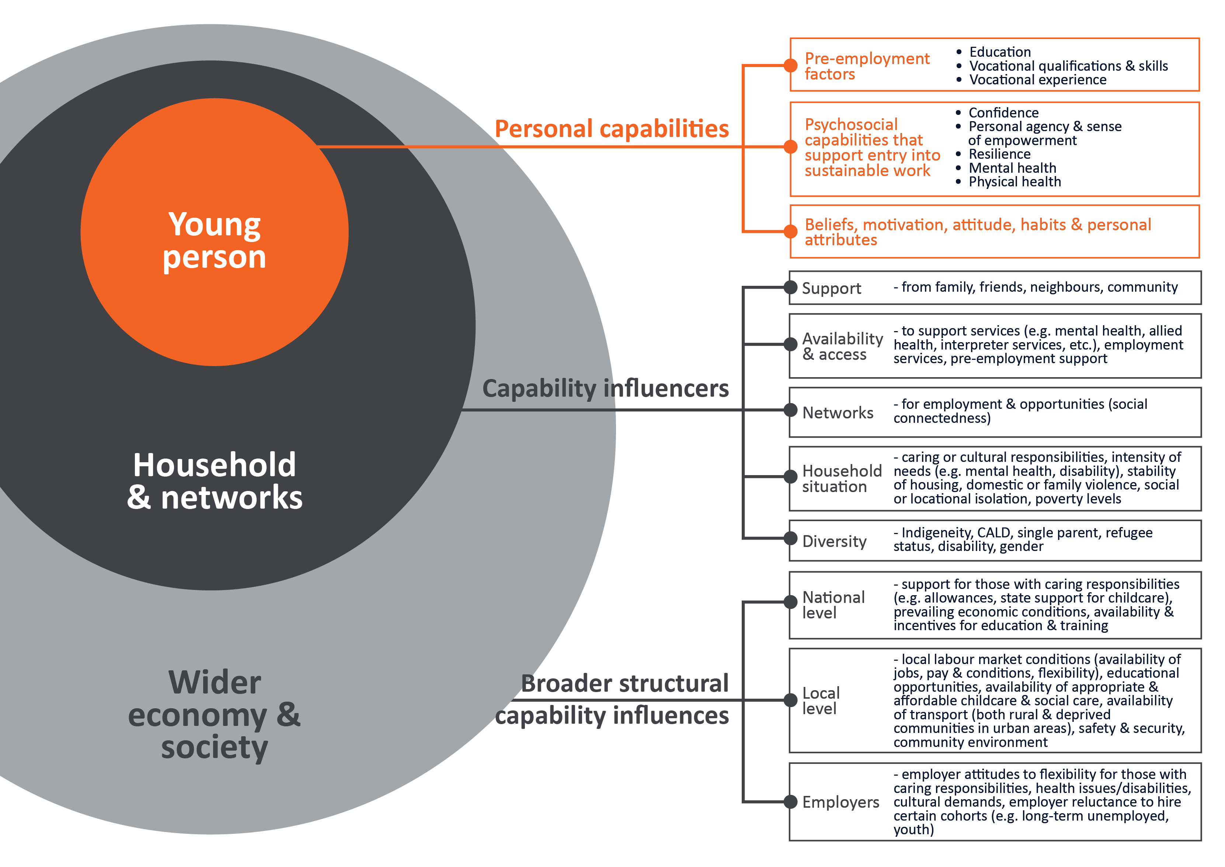

Previous evaluation of the TtW program
Previous TtW evaluation research undertaken by the department was presented in 2 reports. The formative element, presented in the TtW Interim Evaluation Report (DESE 2019) focused on service design, implementation, participant engagement and early results. The summative element, which assessed service appropriateness, effectiveness, efficiency, quality and equity, was presented in the TtW Final Evaluation Report (DESE 2021).

Findings from the TtW final evaluation
Research undertaken for the TtW final evaluation (DESE 2021) found that while TtW participants were less likely to experience labour market attachment (LMA) than participants from the comparison group in their first year after referral, they were much more likely to undertake education and training. TtW participants reported improvements in their work readiness and work skills due to working with their TtW provider, including improvements in confidence and communication skills. There was also an indication that TtW was more effective at helping participants avoid contact with the criminal justice system.
The intensive nature of TtW was found to enable providers to build a trusting and supportive environment that encouraged ongoing engagement with participants and the successful targeting of both vocational and non-vocational barriers. The evaluation research found that in addition to TtW delivering positive work readiness, education and employment outcomes for young people, the service’s investment in the work-related knowledge, skills and experience of participants (their human capital) also had positive impacts on their self-confidence and motivation to find and retain employment. It was postulated in the evaluation report that this upfront investment in the human capital of participants would support them to find more sustainable work in the longer term. The evaluation also identified that in addition to the development of human capital, supporting the development of participants’ broader human capabilities such as confidence, motivation, mental and physical health, personal agency and empowerment and resilience may have wider benefits for both the individuals and society.

TtW’s role in supporting the development of participants’ human capabilities – the theory of change
The TtW final evaluation identified that TtW involves a series of ‘virtuous cycles’ where participation in TtW provides young people with support as they move along a pathway of self-improvement to gain additional training and/or qualifications. This is often not a linear process, with TtW staff working alongside participants: providing genuine engagement, helping participants to set achievable and relevant goals, providing appropriate feedback and encouragement and facilitating tailored vocational and non-vocational assistance. This process was found to facilitate increased participant competence which led to heightened confidence and motivation (DESE 2021).
The TtW service clearly focuses on building human capital with the objective of achieving sustained employment outcomes for young people in the longer term. Evidence from the final evaluation indicated that TtW plays an important role in building the human capabilities of young people. It also indicated that enhancing their human capabilities would enable them to better meet their vocational goals, experience benefits beyond work readiness and have increased capacity to contribute to their broader community. From these findings it is hypothesised that TtW is instrumental not only in meeting the goal of work readiness but also in improving individuals’ broader wellbeing through a holistic people-centred approach.

– Supplementary evaluation of TtW

Evaluation scope
This supplementary evaluation extends and broadens previous TtW evaluation research. It examines how effective TtW has been at achieving the intended longer-term (3 to 4 year) objective of the program that ‘young people have increased employment/labour market engagement and reduced dependence on Income Support’, both overall, and for different equity groups. It examines the impact that increasing the maximum duration of engagement from 12 to 18 months has had on participant outcomes and provider behaviour. As outlined in the theory of change (Section 1.6) it also broadens the research to look at the ‘emergent’ impacts of TtW, examining the effect of TtW on participants’ contact with the criminal justice system, their human capability and their overall wellbeing.
This evaluation does not examine the overall effectiveness, efficiency, appropriateness or equity of the TtW program, as this was the focus of previous evaluations and is reported in the TtW Final Evaluation Report (DESE 2021).

Key evaluation questions
The supplementary evaluation answers 3 key evaluation questions:
Evaluation Question 1 (EQ1): What were the effects of TtW on broader human capabilities, wellbeing and contact with the criminal justice system?
The TtW Final Evaluation Report posited that TtW creates a virtuous cycle, providing young people with the support they need to move along a pathway of self-improvement involving participation in education, training and work experience, skills development, and enhanced confidence, work readiness, motivation and aspiration that leads ultimately to workforce participation. This supplementary evaluation further examines the impact of TtW on participants’ human capabilities and wellbeing and verifies previous evidence that TtW reduced recidivism for participants.
Evaluation Question 2 (EQ2): To what extent is TtW achieving the intended longer-term (3 to 4 year) objectives of increased employment and labour market engagement and reduced dependence on income support for young people?
Given the intensive support and pre-employment focus of TtW – building appropriate skills, experience and attitudes for work, it is assumed that increased and sustainable employment outcomes, and reduced income support dependency, will be achieved over the longer term. Examining participant outcomes up to 4 years after participation is therefore a focus of this evaluation.
Evaluation Question 3 (EQ3): What impact did increasing the maximum duration of service in TtW from 12 to 18 months have on participant outcomes?
TtW is a time-limited service. Originally, TtW participants could only continue receiving services through their TtW provider beyond 12 months if they were progressing towards an employment or education outcome. From 1 July 2020, TtW providers were given greater flexibility to continue delivering intensive servicing beyond 12 months and for up to 18 months to young people who need ongoing assistance, even if they were not tracking for an outcome. TtW participants continue to be able to receive services through their TtW provider beyond 18 months if they are progressing towards an employment or education outcome. This change was expected to achieve better results for more young people by keeping them connected to their TtW service provider, with whom they had an established relationship and who understood their needs.

Data sources
This evaluation used a range of qualitative and quantitative data sources, including surveys, qualitative fieldwork and departmental administrative data. These data sources are summarised in Table 4: Evaluation data sources, and further described in Appendix 2.
Table 4: Evaluation data sources
Data source | Description
Administrative data | DEWR administrative data caseload information (e.g. participant demographics, referrals, commencements, other data collected through the performance framework) and payment transactions (e.g. claims for service and outcome fees and wage subsidies).  DEWR also has access to income support data collected by Services Australia through the administration of income support.  Used for descriptive and regression analysis.
TtW 2021 provider survey | Data from a census of all TtW providers, conducted by the department during June and July 2021.  To understand provider experiences and their views on the impact of the program on participants.
Commissioned qualitative research | A purposive sample of TtW participants, providers and peak bodies, conducted by the Social Research Centre (SRC) during April and May 2021.  Informed by the human capability framework and using tools codesigned with young people, to understand the perspectives and experiences of respondents.
Commissioned participant survey | TtW participants and a comparison group of jobactive participants, conducted by the SRC and carried out in July and August 2021.  Gauging the program’s effect on participants’ attitude towards education and work, and their human capabilities and wellbeing.
Other data sources | Including data from the Australian Bureau of Statistics (Labour Force, Australian National Accounts and CPI), the Productivity Commission and academic literature.

Evaluation approach and methodology

Evaluation approach
The evaluation used a mixed-methods approach to address the 3 key evaluation questions, using information from a range of the data sources (listed in Table 4) to answer each of the evaluation questions. As the evaluation questions are quite distinct, the sample populations for each question were unique. An overview of the sample populations for each evaluation question is presented in Figure 2Figure 2. The components of this approach are described in more detail in the methodology sections below.
Figure 2: Components of the mixed-methods approach used for the evaluation, identifying the study populations used to explore each evaluation question
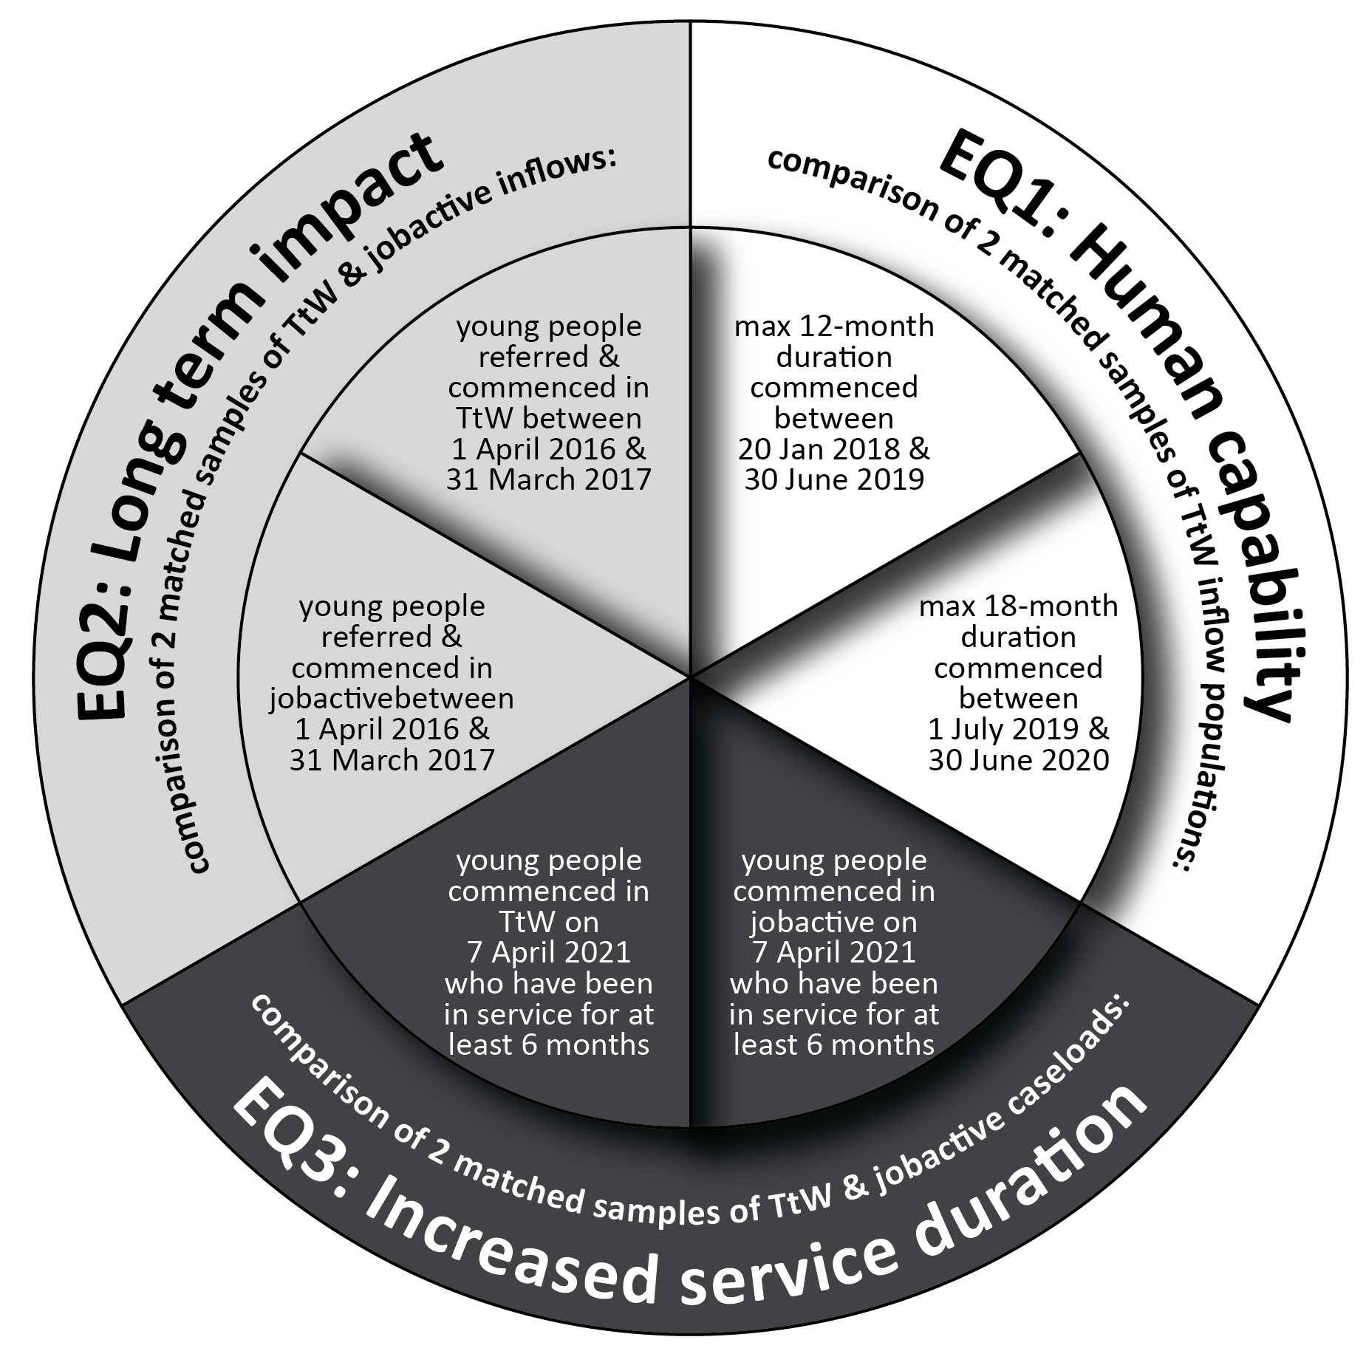
Where necessary and feasible, data was disaggregated for different equity cohorts (including Aboriginal and/or Torres Strait Islander people, women, people from culturally and linguistically diverse (CALD) backgrounds, people living with disability, age, and geography) to enable assessment of how well the program was meeting the needs of particular groups.
The advent of COVID-19 and other natural disasters complicated the analysis for each of the evaluation questions. Details of how these external impacts were managed are presented in Appendices 3 and 4 and findings are discussed in the context of COVID-19.

Methodology for EQ1: impact on human capabilities

Theoretical framework for analysis of human capabilities
A human capabilities framework was developed to underpin this evaluation, informed by a literature review and stakeholder discussions (see Section 1.4). Framework components include:
personal capabilities including psychosocial capabilities and pre-employment factors
capability influencers such as family support and social connectedness, availability of and access to social supports and services, and access to transport and housing
broader structural influencers, particularly relating to the labour market such as the availability of jobs in the local economy, and the accessibility of these jobs.
The TtW program cannot impact all of these factors, particularly the broader structural influencers. The current analysis examined the impact TtW has on young peoples’ psychological capabilities and the capability influencers outlined in Table 5. The impact on participants’ overall wellbeing and life satisfaction was also examined.
Table 5: Components of human capability examined in this evaluation
Factor | Component
Personal capabilities | - Confidence  - Resilience  - Motivation  - Empowerment  - Mental health  - Physical health
Capability influencers | - Social connectedness  - Availability of and access to support services

Approach and methodology
As this part of the evaluation was exploratory, an iterative mixed-methods approach was adopted, initially working with a small group of young people to explore themes and ideas to inform the further collection of qualitative data, and this further informing survey design for the collection of quantitative data.
Qualitative data was collected through interviews and focus group discussions with TtW participants, providers and peak bodies. Quantitative data was collected through the provider survey, participant survey and administrative data. Analysis included descriptive statistics and multivariate regression analysis where necessary, to provide evidence of any changes in participant capabilities that can be attributed to TtW.

Study population for participant surveys
Analysis of the impact on human capability required data to be collected through surveys and consultations from participants who had experience of TtW and the comparison group. Previous experience demonstrated that cold-contacting participants who had left a service led to very poor response rates, so it was decided to target participants who were currently in the program, limiting it to those who had been involved in the program for 6 months or more.
The study population included TtW participants who, on 7 April 2021:
were currently in the program
had been in the program for at least 6 months (cumulative)
had not been in jobactive before joining TtW (except in the case of Group 3 participants, who by necessity move from a jobactive provider to TtW).
The sample design ensured a representative sample of TtW participants was selected by using stratification by TtW group (Group 1 Early School Leavers/Aboriginal and/or Torres Strait Islander), Group 2 (Disengaged), Group 3 (Stream C/Tier 2 referrals) with other balancing factors including age, gender, state, Aboriginal and/or Torres Strait Islander status, current JSCI score, and Statistical Area 4 ABS unemployment rate for 15–24 year olds.
To assess the contribution that TtW has made to participants’ human capabilities and wellbeing, it was necessary to identify a comparison group who did not receive TtW services and support but who had similar characteristics and opportunities. The alternative service available for Group 1 and Group 3 participants (approximately 95% of TtW participants) involved participation in the mainstream jobactive program.
A comparison sample of participants from jobactive, matching the characteristics of the TtW group as closely as possible, was selected for the quantitative work. Participants from the jobactive comparison population needed to have met the same conditions (including not having been commenced in TtW) and TtW eligibility criteria at their first jobactive referral. Further details regarding study populations can be found in Appendix 2: Data sources.
Limitations and considerations
While efforts were made to ensure the jobactive sample was comparable to the TtW sample, there was a risk of selection bias, as sample selection could not take into account participant motivation:
TtW is not a compulsory program, and young people were required to opt in to the program (though this could have simply involved Services Australia referring them to TtW), so young people who were more disengaged may have been more likely to remain in jobactive. Low engagement when joining a program could be associated with ongoing disengagement and lower motivation and willingness to engage in a program into the future, reducing the ability of a program to impact a participant’s human capabilities.
In counterpoint to this, while TtW does support young people to engage in work, jobactive is more strongly focused on moving people into work. Young people who were more strongly motivated to find work may have chosen to be referred to jobactive rather than participate in the activity-intensive services offered in TtW.
Findings from the research should be read in this context.
Additionally, serious life shocks (such as the death of someone close or experiencing domestic violence) could affect a participants’ self-assessed wellbeing. To control for this an additional question was included in the participant survey to provide a measure of any ‘shocks’ they had experienced in the last 12 months. Multivariate regression models were then used to control for any differences.
It should be noted that some provider respondents and TtW interview participants had direct experience of the jobactive program and were able to give insight into how their experiences with the 2 programs compared. Where possible, this insight is provided.
Unless otherwise noted, differences reported from survey data are statistically significant at a 95% confidence level and differences that are not statistically significant at this level are not mentioned. When interpreting results, it is important to remember the cross-sectional nature of this research, whereby all items were measured at the same point in time. While cross-sectional studies can demonstrate associations or correlations between variables, they cannot be used to draw conclusions on causation or the direction of these relationships. For example, a cross-sectional survey can identify if there is an association or correlation between program type and human capability outcomes but cannot comment on if the program caused changes in these human capability outcomes.

Measures of wellbeing
Three validated measures were used in this research to assess wellbeing: overall life satisfaction, the Personal Wellbeing Index (PWI) and the Flourishing Scale.
Wellbeing relates to people’s overall quality of life and general sense of satisfaction or contentment with life. It includes both the subjective evaluation of life, and objective circumstances such as education, health and income. The PWI was developed to measure the subjective dimensions of quality of life (IWB 2013). The PWI covers 7 domains of wellbeing: relationships, achievement, standard of living, health, community connectedness, personal safety and future security. There is also an overarching question relating to subjective life satisfaction.
Its reliability, validity and sensitivity has been tested in many countries and contexts (ACQoL, 2021). Each of the 7 domains can be analysed as a separate variable, or the 7 domain scores can be summed to yield an average score which represents ‘subjective wellbeing’. The index is designed to be used with adults who are at least 18 years of age. While there is an adapted index that is designed to be used with children and adolescents, for consistency it was decided that the adult version was more appropriate as the majority of respondents are 18 years or older, and the children’s version is worded to target children rather than older adolescents.
Flourishing, ‘the experience of feeling good and functioning effectively’ (Huppert 2011), has become an influential construct in the area of wellbeing research (Steer 2016). The Flourishing Scale (Diener et al 2009) is an 8-item questionnaire designed to measure overall psychological functioning from the point of view of respondents. Based on theories of wellbeing, it includes measures of social relationships – having supportive and rewarding relationships, contributing to the happiness of others, and being respected by others. It also includes other items that support wellbeing including having a purposeful and meaningful life, being engaged and interested in one’s activities, feeling competent and capable in the activities that are important to the respondent, self-respect and optimism.
The Flourishing Scale has been shown to provide an effective assessment of overall self-reported psychological wellbeing (Hone et al 2014), although it does not accurately assess the individual components of psychological wellbeing due to the limited number of questions associated with each element (Steer 2016).

Methodology for EQ2: Long-term impact analysis

Impact analysis methodology
The impact analysis compared the outcomes of TtW participants with a matched sample of jobactive participants (the comparison group), taken from the inflow population of TtW and jobactive participants referred to services between 1 April 2016 and 31 March 2017 (see Appendix 4). The populations and samples are discussed below.
This was followed by a regression analysis of the matched TtW and jobactive samples, which isolated the impact of TtW from the effects of participants’ demographic and socioeconomic characteristics for each outcome measure. The impact of TtW was estimated by calculating the probability of the average participant achieving an employment or LMA outcome – that is, the ‘average marginal effect’ of TtW on each outcome.
For detailed descriptions of the regression analysis, as well as a more detailed discussion of the outcome measures, see Appendix 6.1.

Study population
In order to understand and attribute changes achieved over the longer term to TtW it was essential to also identify and measure the impact for a comparison (or control) group. As young people on income support are required to participate in employment services, there is no ‘no-program’ alternative. Rather, there is an opportunity to compare impacts from TtW with those of the then mainstream employment program, jobactive. For this reason, this analysis compared the impact on TtW participants with a matched sample of jobactive participants (the ‘comparison’ sample).
The TtW final evaluation used a population of young people referred to TtW between 1 April 2016 and 31 March 2017, and identified matched samples of TtW and jobactive participants, following them for at least 12 months to assess their study and labour market outcomes. For comparability, this supplementary evaluation used the same TtW population, with slightly different sample selection criteria, identifying matched TtW and jobactive participants and following them for 4 years from commencement to examine longer-term impacts of TtW relative to jobactive.

Study populations and samples
The primary inflow population chosen for the long-term impact analysis is participants referred to the TtW service between 1 April 2016 and 31 March 2017 who had commenced in the service. It excludes any initial caseload referrals from jobactive. An inflow population of jobactive participants was constructed for the same period as the TtW inflow population (referred between 1 April 2016 and 31 March 2017). This population was restricted to commenced Stream B participants aged under 22 years at referral who had not previously participated in TtW. For both populations, participants may have had more than one period of assistance. As the objective of this analysis is to examine whether engagement in TtW for 28 days or more has had a different impact on participants in the longer term than the impact of no experience of TtW, only the first period of assistance of any individual is used.
A matched TtW and jobactive sample was constructed from these 2 inflow populations, with 3 restrictions applied. Participants must:
have commenced in the program within 90 days from their initial referral date
have participated in the program for at least 28 days
have been receiving income support at day 28 from their commencement date.
To ensure that the TtW and comparison participant groups had similar levels of disadvantage, a number of different characteristics were investigated for use as matching variables. While all have shortcomings, the final comparison populations selected for analysis consisted of commenced participants from both programs matched on their education attainment (under Year 12 or Year 12 and above) and level of employment disadvantage (measured by their JSCI score). Although the final matched TtW sample was found to be statistically different to the broader TtW inflow population, having the matched TtW and comparison samples constructed in this way minimised the characteristics that needed to be controlled for through regression analysis. Further details about the sampling methodology and population and sample demographic characteristics can be found in Appendix 4.
Limitations and considerations
As noted in the discussion about the sample selection for EQ1, it is important to note that participants in the EQ2 TtW sample may still have been different in some ways from those in the comparison sample. For instance, while TtW does support young people to engage in work, young people who are strongly motivated to find work may opt to be referred to jobactive rather than participate in the activity-intensive services offered in TtW. Alternatively, as TtW is not a compulsory program and young people were required to opt in to participate, young people who are more disengaged may be more likely to remain in jobactive. Logistic regression analysis was used to mitigate differences between the TtW and comparison participant samples by including a range of control factors (independent variables), though this did not include attitude to work or level of engagement.
The impact analysis examines the trajectory of participants who commenced in either TtW or jobactive during the inflow period, to test the relative impact an initial period of service with TtW may have on participant employment or full-time study in the longer term (up to 4 years). This long-term analysis has 2 limitations.
More broadly it should be acknowledged that employment services are only one factor affecting participant behaviour, and over the longer term the influence of a service will diminish, so it is difficult to attribute any long-term changes to participation in any one program.
Secondly, while participants included in the sample were initially in either TtW or jobactive, TtW participants may have chosen at any time to transfer to jobactive, and those who did not exit income support within the time they were eligible for TtW were transferred to jobactive, so many of the TtW sample will have experience in jobactive at some time after their exposure to TtW. If they met eligibility requirements, there was also opportunity for jobactive participants to transfer to TtW. The sample was chosen to ensure that participants in the TtW sample did not have prior experience with jobactive, and participants from the jobactive sample did not have prior experience with TtW, but they may have experience in the other program sometime during the 4-year assessment period.
The results from this long-term analysis are therefore indicative of the relative impact of TtW on participants over the longer term.

Constructing measures of long-term impact
This analysis examined the impact of TtW on participants’ engagement in employment and full-time education or an apprenticeship over 4 years. Three measures were used in this analysis:
exit from income support as an indicator of employment
reduction in income support reliance as an indicator of increased labour market attachment
movement to a study-related income support payment as an indicator of movement to full-time study or apprenticeship.

Employment
This analysis examined the impact of TtW on supporting participants to move into employment in the longer term. As no direct measure of employment status is available once a person leaves employment services, data on exits from income support were used as an indicator of a participant taking up employment. It is acknowledged that leaving income support can be a result of many factors, some of which are not related to employment (for example, moving overseas or disengaging from income support). To refine the off-income support indicator, participants’ exit from income support was further linked to the associated reason for exiting employment services. Where someone exited income support and their reason for exiting employment services was linked to employment (or study) this was defined as an ‘employment-related IS exit’, which was used in this analysis as an indicator of employment.
Income support status for each participant was tracked across the study period each 4-week (28-day) period. Where an employment-related exit from income support was recorded in any 4-week period their employment indicator was set at 1. If there was no evidence of an employment-related IS exit in any 4-week period, their employment indicator was set at 0.
Appendix 4.5 provides a detailed discussion of the definition and estimation of an ‘employment-related IS exit’.

Labour market attachment
The use of exits from income support does not account for the part-time and casual nature of some employment, or for those with a partial work capacity who find employment but remain on income support. For this reason, a second indicator, LMA, was developed. This indicator utilised the following factors: a recorded reduction in income support rate from the participant’s initial base rate (as a proxy for increased employment); any reported earnings (as evidence of engagement in the labour market); and/or a recorded employment-related IS exit (as outlined above). Each factor for each participant was tracked across the study period each 4-week (28-day) period. If any one of these factors applied during a 4-week period, a participant was identified as engaged in some paid work and their LMA indicator was set at 1.

Uptake of full-time study or apprenticeship
Again, there is no direct measure of participants moving to higher degree/longer-term accredited study or apprenticeships. Data on the income support payment types that participants were accessing (namely Youth Allowance (Student), Youth Allowance (Apprenticeship), ABSTUDY or Austudy) was used as an indicator of a participant taking up longer-term full-time study or a full-time apprenticeship.
This assumes that everyone who was on income support at month 1 who later took up an apprenticeship or full-time study moved on to a study-related income support payment. Some apprentices may earn enough to leave income support. Similarly, some participants may not remain eligible for income support – for example, if they partner with someone who has an income level that makes them ineligible. This analysis assumed the number of participants who are missed by this indicator would be insignificant and similar for both programs.

Long-term impact for different cohorts
The analysis examined if, and how, the long-term impacts of TtW on employment and labour market attachment differed based on a young person’s specific characteristics, including gender, Indigenous status, disability, education level and JSCI score (level of disadvantage).

Contact with the criminal justice system
Analysis was undertaken with this matched sample of TtW and comparison participants to examine the impact of TtW on the likelihood that participants would enter or re-enter the criminal justice system. Income support data was used to identify participants’ episodes of incarceration. Individuals who were incarcerated are exited from income support and their exit reason is recorded as ‘exited to prison’ in the department’s administrative data.
Further details about the sampling methodology, analysis methodology and measures and research limitations for the long-term impact analysis can be found in Appendix 4.

Methodology for EQ3: Impact of increasing the maximum duration of service from 12 to 18 months

Study population
Administrative data was used to examine the impact of increasing service duration on participant outcomes.
Participants potentially affected by increasing the service duration (the ‘maximum 18 months’ population) included participants who commenced in the TtW service between 1 July 2019 and 30 June 2020. The comparison population comprised TtW participants who were ineligible for the extension in program duration (the ‘maximum 12 months’ population) and includes all participants who commenced in TtW between 20 January 2018 and 30 June 2019. The total ‘maximum 12 month’ and ‘maximum 18 month’ inflow populations numbered, respectively, 34,749 and 34,679 participants.
To compare the effectiveness of extending the maximum duration of service, the evaluation isolated the impact of this change from the impact of participants’ personal characteristics by identifying 2 matched samples from the ‘maximum 12 months’ and ‘maximum 18 months’ populations. The analysis followed participants until they exited the program.
Matching was based on 4 participant characteristics: education attainment (under Year 12 or Year 12 and above), level of employment disadvantage (identified through the participant’s JSCI score, work experience (paid work, unpaid work or none) and available form of transport (private, public or no transport).
After matching, both the ‘maximum 12 month’ and ‘maximum 18 month’ samples contained 30,345 participants each. The matching process did not change the overall participant characteristics from the original inflow populations. Most of the characteristics (12 of 14) had less than 1 percentage point change after the matching process. The study participants represented more than 87% of the original inflow population, providing confidence that analyses based on these matched participants could represent characteristics of the original inflow populations.

Constructing the outcome measure
The analysis assessed the impact of extending the maximum time participants can spend in the service by examining the number of outcomes achieved by participants from the 2 comparison groups.
Outcomes that could be achieved through TtW, and were used in this analysis, were a:
12-week employment outcome
12-week hybrid outcome (combining education and employment)
26-week education outcome
26-week sustainability outcome (where a 12-week outcome (employment or hybrid) is followed by an additional consecutive 14 weeks of employment or combined employment and education).
The analysis examined both:
the total number of outcomes achieved by participants in the study sample
the number of participants from each study sample who achieved at least one outcome.
Further details about the sampling methodology, sample demographics and research limitations for the analysis of the impact of the change in service duration on participant outcomes can be found in Appendix 3.

Other research
Additional data was collected through interviews with TtW participants and providers to understand and explore further the impact of the increase in duration on participant outcomes and provider behaviours. This fieldwork was carried out about 18 months after the change in maximum duration came into effect as part of the qualitative research undertaken by the SRC. Further data was collected from providers through the 2021 provider survey.

Methodology for examining the value for money of TtW
Assessment of the value for money of TtW used a social cost-benefit analysis (SCBA) framework to estimate the economic value and social benefit of the TtW service. The research was exploratory in nature, identifying methods to monetise the additional costs and benefits associated with the TtW program, compared to jobactive, over 12 months.
Previous evaluation research, and analysis undertaken to answer evaluation questions EQ2 and EQ3, was used to provide data for this value-for-money assessment.
The following steps, which guide an SCBA, were followed in this analysis:
- Define the ‘no-program’ comparison.
- Identify benefits and costs:
- identify and define relative outcomes that can be attributed to the intervention, and how they will be measured
- identify additional costs associated with the intervention.
- Quantify and value costs and benefits.
- Estimate the cost : benefit ratio.
- Assess risks and test sensitivities.
- Identify qualitative factors and distributional impacts.
- Consider what future research is needed.
Further details about the methodology can be found in Appendix 5.

Key costs and benefits examined
This analysis explored how benefits attributable to TtW (relative to jobactive) could be valued and compared these to the relative cost of TtW compared to jobactive. The following costs and benefits were identified as relevant to the value-for-money assessment:
additional costs associated with servicing participants in TtW
costs associated with additional income support payments received by TtW participants
value of improvements in human capability attributable to TtW
savings associated with reduced offending.
It is acknowledged that many ‘human capability’ benefits are difficult to both measure and value in a robust way. This research uses wellbeing as an overarching and composite indicator of the impact of TtW on the human capabilities of participants, in line with broader academic and practitioner practice. Section 7.3 provides an overview of the debate around the use of wellbeing to value human capability outcomes, and describes the methodology used in this analysis to value wellbeing. Given the contention around placing a value on wellbeing, a range of values for wellbeing, identified through a review of recent literature, are used in this analysis.

– What impact does TtW have on participants’ human capabilities?

Introduction
This section examines the impact of the TtW program on participants’ human capabilities, and their overall wellbeing and satisfaction with life. It examines the following questions:
What is the impact of TtW on the development of participants’ human capabilities?
What is the broader impact of TtW on participants’ wellbeing?
What elements of the TtW model are associated with the development of human capabilities and wellbeing?
The analysis utilises the human capability framework outlined in Section 1.4.1, specifically examining the impact TtW has on young people’s psychosocial capabilities (confidence, resilience, motivation, empowerment, mental health and physical health) and capability influencers (social connectedness and availability of and access to support services).
Data used to examine the impact of TtW on participants’ human capabilities and wellbeing was drawn from a number of sources, to enable triangulation and test responses; these included:
interviews and group discussions with a sample of TtW participants and TtW provider staff
a participant survey with a representative sample of TtW participants and a comparison group of jobactive participants
a census survey of TtW providers
administrative data.
Section 2.4.2 contains an overview of the research methodology.
Appendix 8 presents relevant data from the 2021 provider and participant surveys.

Human capabilities: the impact of TtW on participants’ psychological capabilities

Confidence
During the 2021 participant survey, participants were asked what impact participation in TtW had on them overall. Respondents’ most common first response was that it increased their confidence in relation to both vocational and non-vocational aspects of their lives. TtW respondents were more likely to report that their provider had a positive impact on their confidence than the comparison group, with just over two-thirds of TtW respondents (69%) noting that caseworkers had a positive or very positive impact on their self-confidence, compared to just over half of the comparison group (55%). Conversely, fewer TtW participants (4%) felt that their caseworker had a negative or very negative impact on their self-confidence than the comparison group (9%) (Figure 3). Almost three-quarters (71%) of TtW participants felt that their caseworker had a positive or very positive impact on their ability to ‘put themselves out there’, compared to 61% of the comparison group.
Respondents to the provider survey had a more positive view of the impact of the program on participants’ confidence, with 94% noting that engagement in TtW had a ‘very good’ or ‘good’ impact on participants self-confidence. This may be due to caseworkers being more likely to remember the successful interactions with participants, or to talk up the benefits of the program.
Figure 3: Participant views on caseworker impact on their self-confidence (% of participants)
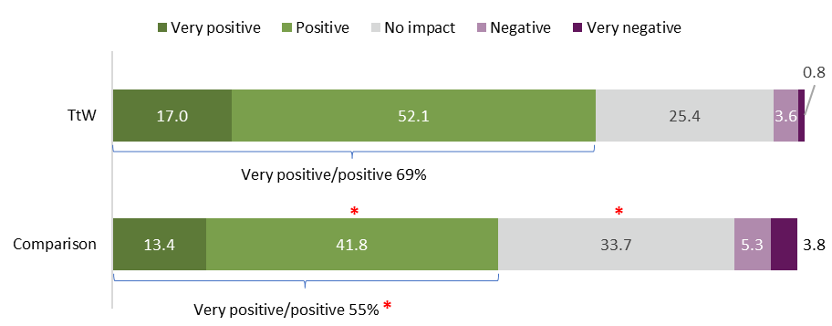
Source: Participant survey 2021
Base: TtW participants who had contact with their provider (n=1,494), jobactive participants who had contact with their provider (n=578)
QTTB4 In your opinion, has your <TtW / jobactive> caseworker(s) had a positive or negative impact on your…
Notes: *Indicates result is significantly different to TtW participants (p<0.05). Percentages shown. Responses of ‘don’t know’ and ‘refused’ not shown.
Interview and focus group discussions with participants and providers allowed for a more nuanced view of the impact of TtW on participants’ human capabilities.

Vocational impacts
Many participants claimed that TtW had improved their confidence in their ability to find work. Some participants mentioned that their caseworker fostered a ‘you can do it’ attitude and encouraged them to ‘put themselves out there’ to apply for jobs. This instilled participants with the confidence necessary to face unfamiliar situations and potential rejection from job applications. A number of participants said that the passion their caseworker had for their job, and their genuine interest in the participants’ success, made them feel more confident about themselves and their abilities.
[It’s] just good to boost your confidence a bit. Give it a go, get out there. Give it a try … [My caseworker was] just telling me I could do it. And I was just like I suppose I can just do it. What’s the worst thing that can happen? … They just kept telling me to give it a shot, just see what happens. Just kept telling me to put my résumés in here and there. Just give it a shot and hope for the best. And eventually I was just like, you know what, that’s what I need to do. So, I did. I ended up getting a job. And I was happy. (Participant 25, male, 22+ years old, regional NSW, Group 1)
One of the main ways in which TtW caseworkers helped to improve the confidence of participants was to highlight their skills and positive attributes and provide practical help. Some participants mentioned that their caseworker helped them to identify what roles they would be most suited for, and in some cases, linked them with education to improve their skills, which also provided a confidence boost. Some participants stated that their caseworker had helped them to improve their résumé, practised mock interviews and arranged direct exposure via attending real interviews, which made them more confident to apply for jobs.
So, getting that certificate – which they helped me get that certificate – has given me even more confidence in applying for a better job … So now that I’ve got a Certificate III in Business, it makes me feel a little bit good because I’ve got at least something to have on my résumé. (Participant 13, male, 19–21 years old, regional Qld, Group 1)
She re-wrote my résumé and she put my skills down in a way that she said … I would stand out, and then, after she did that, I started getting more response from the employers, so, yeah, I had more confidence with my résumé. (Participant 8, female, 19–21 years old, metro NSW, Group 2)
For some participants, this new-found confidence motivated them to approach employers, helped develop their soft skills and improved their ability to socialise in the workplace.

Broader impacts
The improvements in confidence experienced by participants also flowed through to broader areas of their lives. For example, some participants felt that TtW had helped to improve their overall self-esteem. Others reported that TtW had helped them to improve their confidence in other aspects of their life, including overcoming the fear of driving to obtain a licence, feeling more confident and supported while going through court proceedings, and developing greater confidence in their parenting abilities.
It has boosted my confidence a lot actually. I wasn’t a very confident person, I always had doubt in myself, but [caseworker] has helped me a long way with that and everyone there, they’ve all lovely and kind. You can talk to them all if you’ve got any doubts on yourself. (Participant 43, female, 16–18 years old, regional Tas, Group 1)
He has made me more confident in myself, and the things that I can do – it’s not limited. (Participant 24, female, 16–18 years old, metro NSW, Group 1, CALD)
Being able to connect with the right kind of driving instructor … it really helped me in my confidence … I know that I can do it. I’m not scared to try it anymore … I was able to build up confidence to return to something I was so scared of doing … When I got my Ps, [my caseworker] was the first person to congratulate me [caseworker accompanied her to the test] … she waited there and when I called her, the smile on her face was just … they have helped me grow further and more confident. And I’m not as sad because I don’t feel as useless anymore. Because I’m working. (Participant 16, female, 19–21 years old, regional Qld, Group 1, homeless)
A few participants, who felt that their caseworkers were not positively engaged with their needs, reported experiencing a strong negative impact on their confidence which extended to their sense of wellbeing more broadly. This is an important reminder of the fragility of some participants’ self-esteem and the significant role TtW caseworkers can play.
When it came down to it, their lack of wanting to help made me feel like I’m not overly worth helping. It made me feel worthless in the end … [it was like my caseworker] couldn’t really give two s*s whether you get a job or not, they just want to tick their boxes and get their pay cheque, it ruins your confidence. (Participant 11, male, 22+ years old, regional Vic, Group 1)

Motivation
Motivation, or the stimulus or a sense of purpose to act, is strongly related to confidence. Increased motivation to participate in work and/or study was commonly reported by participants in interviews as a benefit of participating in TtW. The impact of the program on participants’ broader sense of motivation (i.e. beyond vocational settings) was less apparent.
Survey participants were asked if their caseworker had a positive or negative impact on their motivation to work towards their goals. Four out of 5 TtW participants (80%) felt that their caseworkers’ influence had been positive or very positive (compared to 66% of the comparison participant group). As with confidence, there was a small proportion of TtW participants who felt that their caseworkers had a negative or very negative influence on their motivation (3%), which was much lower than the comparison group (7%) (Figure 4).
Figure 4: Participant views on caseworker impact on their motivation to work towards their goals (% of participants)
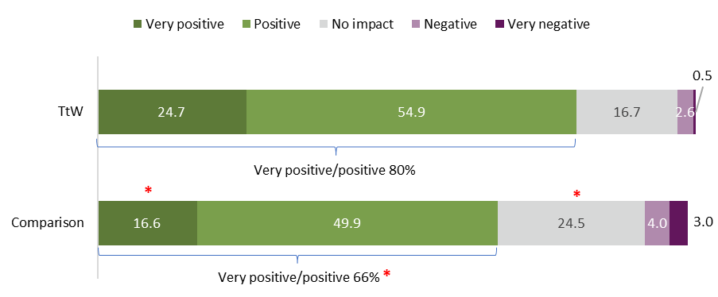
Source: Participant survey 2021
Base: TtW participants who had contact with their provider (n=1,494), jobactive participants who had contact with their provider (n=578)
QTTB4 In your opinion, has your <TtW / jobactive> caseworker(s) had a positive or negative impact on your…
Notes: *Indicates result is significantly different to TtW participants (p<0.05). Percentages shown. Responses of ‘don’t know’ and ‘refused’ not shown.
More TtW participants felt that their caseworkers had a positive or very positive impact on their ability to keep trying and not give up than did those in the comparison group (76% compared to 66%).
Providers responding to the provider survey were again more positive than participants, with the vast majority responding that engagement in TtW had a ‘very good’ or ‘good’ impact on participants’ ability to keep trying and not give up (96%), and their motivation to work towards their goals (97%)..
During interviews for the participant survey, many participants highlighted that the constant support and contact from their TtW caseworker helped them to push through periods of low motivation. Participants spoke of the benefits and the boost to their morale of having someone who believed in them to contact during difficult periods. The support they received made them more confident and motivated to participate in activities they may not have previously felt comfortable undertaking.
After I spoke to her, I felt like I was like, ‘No, I’m getting my life sorted, I need to devote all my energy into this job’ … It only lasted a couple of days, though, and then I would slip back into my old ways, but then I’d go back for my next appointment, and it would do that top-up. (Participant 13, male, 19–21 years old, regional Qld, Group 1)
It has definitely motivated me more, having someone contact me every month to see how I’m going and how I feel about getting back to work. (Participant 14, female, 19–21 years old, metro SA, Group 1)
More motivated, and like energised. The day does get the better of me, sometimes, but yeah … they’re supportive and they help me and they just push me to like motivate myself, and, yeah. It’s the support that I’ve got that makes my motivation come up. I guess it’s the advice, it’s the vibe they give. And that some of that that they give, it’s really personal advice … No matter what, every situation that’s going on, they’ve always got a way to help me, and like push me to just get away from it and like, you know, do better. (Participant 31, female, 19–21 years old, metro SA, Group 3, Indigenous)
Some participants mentioned that identifying long-term goals with their caseworker was helpful, as this gave them something meaningful to work towards. When TtW activities were aligned with these goals, motivation increased and they felt more confident to aim higher.
It got me more motivated in my thinking around what I wanted to do, what skills I already have, and how to put it forward. And what careers I can aim for. (Participant 15, female, 19–21 years old, metro WA, Group 1, Indigenous)
I think it motivated me with pushing through my limits. Not just being content with what is available … it motivated me in searching for jobs with better opportunities. (Focus group 1, 18–22 years old, Australia-wide, Group 1)
Participants noted in interviews that their motivation levels fluctuated day to day. Many participants were facing challenging circumstances, such as mental health difficulties, homelessness, domestic violence and COVID-19, that impacted on their motivation levels. Some participants explained that it was difficult to maintain motivation for work or study when the activity was demanding and/or monotonous.
With my kind of work, it’s hard to stay motivated when you’re doing long shifts … I went through a fair bit … and then I lost the will to do a lot of things. ’Cos I had two friends pass away on me … One was 19, the other was 16 at the time. I lost some friends. And it really impacts you, when you lose someone so close. (Participant 16, female, 19–21 years old, regional Qld, Group 1, homeless)
A few participants stated that TtW had negatively impacted their motivation. Some participants reported negative impacts on motivation due to being involved in study or being placed in jobs that were not aligned with their interests. For example, one participant felt discouraged that his caseworker did not seem to understand that study was not a good fit for him, and that he was better at learning on the job.
She tried to set me up with a TAFE course and I went there for a bit, but it was just – it felt like it was just a place for naughty kids or some s**t … I just didn’t fit in there … I was like, ‘I don’t want to go here’ […] It’s not their fault … it’s me: I’ve never found anything that’s suited to me. (Participant 20, male, 16–18 years old, metro WA, Group 2)
Another respondent felt that her motivation had fallen when her case worker changed (from one she had a strong rapport with to one she did not get along with).
With the change of people, yes, that did affect my motivation quite a lot and it made me disappointed because I had someone who was willing and wanting me to go somewhere to having people who couldn’t really give two s**ts about it. (Participant 11, female, 22+ years old, regional Vic, Group 1)
This highlights the important role of caseworker rapport and consistency in support over the course of participants’ engagement in the program.

Empowerment
Empowerment describes a sense of agency or control over one’s life which enables people to make positive decisions which drive the direction of their life. Some participants mentioned in interviews that TtW helped them to make their own choices and take control of their life. Involvement in the program helped some participants to develop a positive sense of self and to identify objectives and pursue goals that were meaningful to them.
She’s helping me strive towards the goals I want to make, rather than making me set some that I don’t want to hit towards. She’s more for me finding my path and where I want to go. (Participant 16, female, 19–21 years old, regional Qld, Group 1, homeless)
Before I started with this program, I didn’t really know what objectives I wanted to achieve in life, other than not be in debt and I wanted to own a home, but since starting with the program, I’ve had a very different change of outlook on my life, and where I’ve wanted to go … I believe that if I went to Transition to Work a lot earlier in my life I would be a lot better. It’s something that I believe that young people should go to if they don’t have a sense of direction in life. (Participant 38, male, 22+ years old, regional Qld, Group 1, Indigenous)
[Before TtW], I wasn’t really happy … It was like I was left in limbo; I didn’t know where things would go and didn’t have that direction. Whereas TtW provided that direction and how to get there, which was very beneficial … Now that I’ve seen – that I’ve had that … guidance, it’s sort of easier to see potential outcomes of things or potential opportunities, I guess, so … that was very good. (Participant 39, male, 19–21 years old, regional Qld, Group 1, Indigenous)
I’ve come more – what’s the word, assertive and more like wanting to actually think to participate, and be involved, where I never wanted to … It was always something I just sort of felt I’d let it go, but this time around I’ve actually stuck with it … (Participant 31, female, 19–21 years old, metro SA, Group 3, Indigenous)
Empowerment is also closely related to confidence. It was apparent that, upon building a greater sense of confidence, participants felt more empowered to pursue their goals and make their own choices in life.
In interviews, providers offered examples of participants who had changed their lives significantly following engagement with the program. These participants faced particularly complex barriers including drug taking, homelessness, criminal offenses, and mental health issues. The program helped them to reorient their lives and impacted their broader wellbeing.
We’ll have the kids that will ring us up and say, ‘Oh my God, I just saw this job! Do you think I should apply for it?’ ‘Yes! Do you want to come in? I’ll help you!’ And down the track, that same kid will go, ‘No, I can do it myself now. You’ve showed me too many times. I want to do it myself!’ That sort of stuff. We share that. It’s a big buzz, those ones. (Provider 1, regional Qld, large size)
One Aboriginal and/or Torres Strait Islander participant joined TtW not long after fleeing an abusive relationship. She noted that TtW had been integral to helping her regaining control and direction in her life (independence, financial security and emotional wellbeing).
[B]efore I was with them [TtW], I … was as low as you could get … I wasn’t allowed to leave the house I lived in; I wasn’t allowed to talk; I wasn’t allowed to go outside; I wasn’t allowed to do anything. I was in an abusive relationship … [GRAPHIC DETAIL REDACTED] That was at my worst. Transition to Work – they actually helped me start to get a job and stuff. I was actually pretty happy going there and everything because I was doing something and then I got a job and stuff like that and … [inaudible] now I’m … happy. (Participant 34, female, regional Qld, Group 1, Indigenous)
The participant survey results confirmed that TtW had a stronger effect on empowering participants than jobactive. When asked during the participant survey if employment services had empowered them in any way, over two-thirds (69%) of TtW participants agreed it had, compared with half (50%) of the comparison group. Related to this, TtW participants were more likely to agree that that their caseworker had discussed their hopes and plans for the future (85% compared to 67%), supported them to set work and study goals (85% compared to 74%), and supported them to set other personal goals (71% compared to 58%) (Figure 5).
Figure 5: Participant views on support provided by caseworkers (% yes)
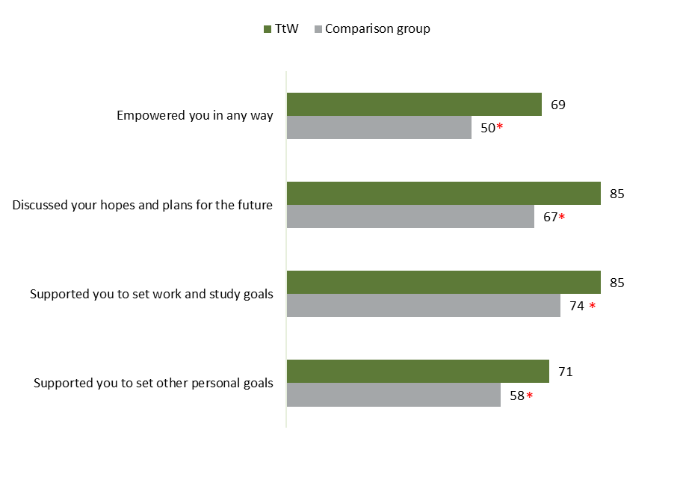
Source: Participant survey 2021
Base: TtW participants who had contact with their provider (n=1,494), jobactive participants who had contact with their provider (n=578)
QTTA7 Since you started seeing your <TtW / jobactive> caseworker(s), have they…
Notes: *Indicates result is significantly different to TtW participants (p<0.05). % yes.
TtW participants were also more likely to agree that their caseworker had a positive or very positive impact on their understanding of what they wanted to do in the future (73% compared to 59%) and their ability to put themselves ‘out there’ (71% compared to 61%) (Figure 6).
Providers had a more positive view of the impact of the program, with 95% responding that engagement in TtW had a ‘very good’ or ‘good’ impact on participants’ understanding of what they wanted to do in the future.
Figure 6: Participant views on caseworker impacts on development of human capabilities (% positive / very positive)
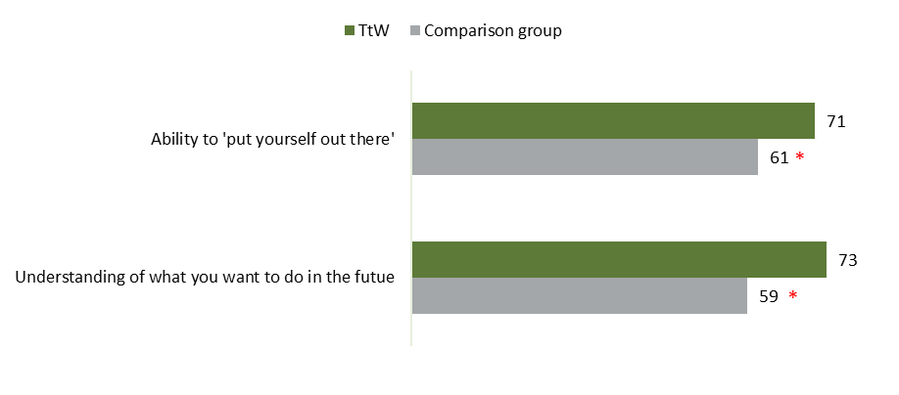
Source: Participant survey 2021
Base: TtW participants who had contact with their provider (n=1,494), jobactive participants who had contact with their provider (n=578)
QTTB4 In your opinion, has your <TtW / jobactive> caseworker(s) had a positive or negative impact on your…
Notes: *Indicates result is significantly different to TtW participants (p<0.05). % Very positive / Positive shown.

Resilience
Resilience is a person’s ability to maintain or regain mental health, despite experiencing adversity (Herman et al 2011). The participant survey included a well-established and validated tool, the Brief Resilience Scale, that assesses a person’s perceived ability to bounce back or recover from stress (Smith et al 2008). Survey participants were asked to agree or disagree with 6 statements, including both positively and negatively worded items, designed to measure traits associated with resilience. Responses to these items were combined together to produce a score for the Brief Resilience Scale. This is a score from 1 to 5 where higher scores indicate higher levels of resilience. TtW participants had an average Brief Resilience Scale score of 3.3.
TtW participants showed a slightly higher resilience score than the comparison group (average 3.3 versus 3.1). This difference is statistically significant, and remained after adjusting for number of stressful life events in the past 12 months and length of time in program.
Figure 7 displays the proportion of participants who agreed or strongly agreed with each of the items. Three in 4 TtW respondents (76%) agreed that they tended to bounce back after hard times, while 1 in 3 (33%) agreed that they tended to take a long time to get over setbacks in their life.
TtW participants were less likely than the comparison group to agree that it was ‘hard to snap back when something bad happens’ (34% versus 41%).
Figure 7: Participant individual Brief Resilience Scale items (% agree / strongly agree)
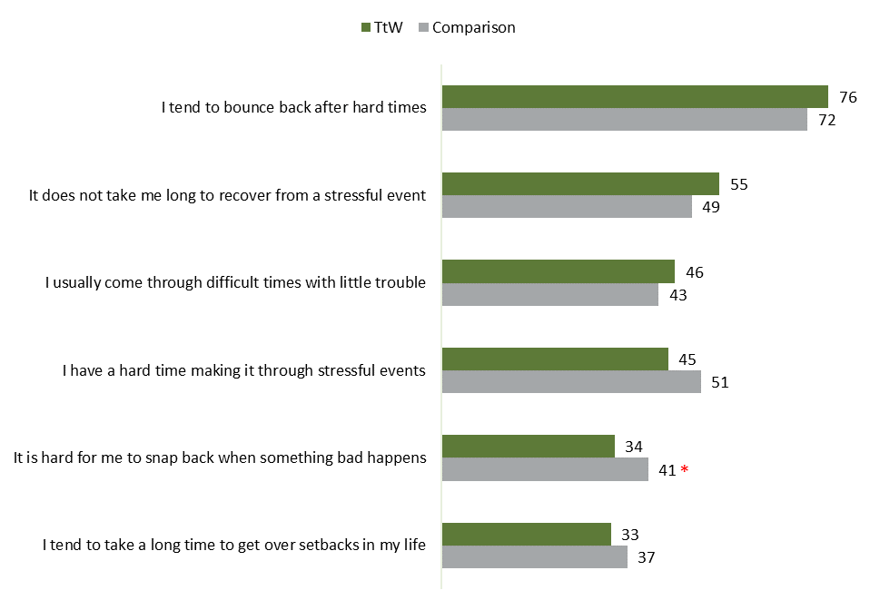
Source: Participant survey 2021
Base: All respondents – TtW participants (n=1,502), jobactive participants (n=580)
QHC4 How strongly do you agree or disagree with the following statements…
Notes: *Indicates result is significantly different to TtW participants (p<0.05). % Strongly agree / Agree shown.
Provider respondents in interviews discussed how participants often do not have positive role models to frame constructive and resilient thinking when it comes to managing setbacks.
A lot of them are going through significant issues: whether it’s personal crisis; family crisis. And sometimes they’re not taught how to deal with that the right way. So, it’s trying to, in a sense – for some of them, not all of them, we’ve got to take on that parenting role and help develop those skills and build that resilience. (Provider 14, regional Qld, small size)

Vocational impacts
The focus of providers in managing setbacks was to step through what had happened, to put the experience in context (such as to point out the other opportunities available) and to identify areas for improvement in a consistent manner.
We also have specific workshops on resilience. And goalsetting and what to do if you get a setback. […] So, we do concentrate a lot on looking at that, and building that up in young people, cause we know they don’t have it. It’s not built in. A lot of people don’t have it. They get one knockback and that’s it. That’s the end of the world. I’m never going to get a job. I’ve applied to twenty jobs, and I haven’t had an interview, blah blah blah. So, we unpack all of that and find out exactly why they’re not getting an interview. What are they doing when they have an interview? What’s holding them back? (Provider 11, metro WA, small size, community of practice)
This perspective was reiterated in the participant interviews, with many participants explaining how their caseworkers framed setbacks constructively, which helped to start building resilience.
She was constantly speaking about resilience and giving me ways on handling stress and how to deal with people saying negative things … I could call my mum and tell her about the problems I’m having, but she’s going to be like, ‘Shut up and stop whinging. Deal with it. Stick up the stick to it,’ whereas [my caseworker] was giving me constructive advice and just keeping me hanging in there and I would have not worked there for as long as what I did without her or the support, I got from Transition to Work … Every time I felt like I was going to make an impulse decision [and quit my job], I’d give her a call and she’d pull me back to my place and tell me what we need to do to strategically quit and not just quit and then go and do nothing; I found that helpful. (Participant 13, male, 19–21 years old, regional Qld, Group 1)
Many participants explained that their caseworkers talked them through job application rejections in ways that bolstered their confidence. The repeated experience of job rejections coupled with that positive debriefing with the caseworker seems to have helped participants frame a more positive mindset in managing those setbacks.
Whenever I get rejected, they would say there’s still lots of opportunities out there. Just keep on searching … it’s made me feel a lot better about myself. It doesn’t really phase me when it happens now. I just brush it over and get ready to apply for the next job, or next interview. […] Rejection was a big thing for me. At first, whenever I feel rejected, I lose my motivation and confidence. So, she helped me and said it’s a normal thing. Not everyone would accept you. But it doesn’t mean that you should stop looking for work. (Focus group 1, 18 to 22 year olds, Australia-wide, Group 1)
I used to let opportunities slide because I couldn’t, I didn’t think I was good enough or I didn’t think I didn’t want to be turned down. […]. So, in a way they’ve just sort of pushed me to, sometimes in life, you don’t get what you’ve wanted, and you just keep going and keep applying for more and eventually something will come up. So, they did help me with that. (Participant 3, female, 22+ years old regional Vic, Group 2)
I didn’t get the job, and so then she just said, ‘It might not be you, your skillset, your personality; it might just be something else,’ like my availability, which has nothing to do with my personality or my skills … so what I’ve learnt is even if a situation seems negative, if you just keep trying, then it can turn positive. (Participant 8, female, 19–21 years old, metro NSW, Group 2)

Broader impacts
Survey participants were asked what impact, if any, their caseworker had on their resilience. Around three-quarters of TtW participants felt that their caseworkers had a positive or very positive influence on their ability to keep trying and not give up (76%) and their understanding of their strengths and weaknesses (73%)
Providers had a more positive view of the impact of TtW on participants, with 96% reporting that TtW had a ‘good’ or ‘very good’ impact on participants’ ability to keep trying and not give up, and 95% reporting that TtW had a ‘good’ or ‘very good’ impact on participants’ understanding of their strengths and weaknesses.
In interviews for the qualitative research, while most participants discussed resilience in terms of managing job application rejections, some participants did feel that the positive framing that they were developing with the support of their caseworkers could have a broader impact.
It’s helped with knowing that there is bigger and better things out there and it can push through it because I’ve got that support and … kind of like a voice that sits there to say, no there is better out there, like that sucks you’re going through that right now, you can push past it and there is better things out there. […] Instead of me just sitting there and dwelling in what I’m going through and not knowing how to progress forward. I feel that’s what they’ve really helped with. (Participant 18, female, 19–21 years old, metro NSW, Group 1)

Mental health

Mental health outcomes
Participants were asked in the 2021 participant survey to provide an overall rating of their mental health and wellbeing. Figure 8 displays the responses participants provided when self-rating their mental health and wellbeing.
Only 1 in 4 (26%) TtW participants reported their mental health as ‘excellent’ or ‘very good’, and almost 1 in 5 (19%) reported that their mental health was ‘poor’. The comparison group had significantly fewer respondents reporting ‘very good’ or ‘good’ mental health (19% versus 26%) and significantly more reporting that their mental health was ‘poor’ (27% versus 19%). These differences remained after adjusting for number of stressful life events in the past 12 months and length of time in program.
Figure 8: Participant self-rated mental health and wellbeing (% of participants)
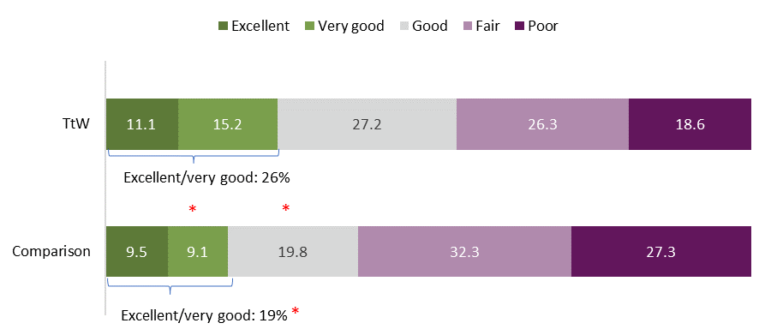
Source: Participant survey 2021
Base: All respondents – TtW participants (n=1,502), jobactive participants (n=580)
QHC3 How would you rate your mental health and wellbeing?
Note: *Indicates result is significantly different to TtW participants (p<0.05)
More than a third (36%) of TtW participant survey respondents reported poor mental health as a current barrier to work and study, compared to almost half (46%) of the comparison group. In interviews, poor mental health was also a very common barrier discussed by participants. This included mental health conditions with high community prevalence, such as depression and anxiety, as well as other difficulties, such as bipolar disorder (mentioned by 2 participants). This finding is supported by providers, with 9 out of 10 respondents to the provider survey (91%) identifying that mental health issues were a barrier to participants at their site moving towards their employment and education goals. When respondents were asked to rank the 3 most important barriers to participants moving towards their employment and education goals, mental health issues was ranked second (after transport issues).

Impact of poor mental health
Mental health had a significant impact on participants and their vocational pursuits. For example, some participants noted that anxiety and low confidence impacted on their ability to approach employers and operate in social settings. Other mental health concerns, such as low mood/depression, impacted on motivation and the ability to maintain employment.
I had bad mental health and haven’t had the… motivation to stay in a real job. So yeah, it was just my daily life, my daily life was just play computer games, stream it, make some money. Go to sleep. (Participant 4, female, 19–21 years old, metro SA, Group 1)
[M]y anxiety and that, I hate being around people … So it is – it’s me also stopping myself from wanting to work. ’Cause I don’t have the guts to do it, ’cause I’m too scared, like too nervous … It’s just my anxiety that stops me the most. (Participant 31, female, 19–21 years old, metro SA, Group 3, Indigenous)
Mental health issues were particularly prevalent among the Aboriginal and/or Torres Strait Islander participants, with many reporting either depression or anxiety, or a combination of both. In one case, this was compounded by trauma from an abusive relationship.

TtW focus on mental health
Just under two-thirds (63%) of TtW participants reported that their caseworker had a positive or very positive impact on their mental health (significantly more than the comparison group (49%). Comparatively few TtW participants (6%) reported their caseworker(s) had a negative or very negative impact on their mental health, compared with 1 in 8 (13%) of the comparison group (Figure 9). Most providers (91%) also felt that engagement with TtW had a ‘good’ or ‘very good’ impact generally on participants’ mental health, with none feeling that it had a poor impact.
Figure 9: Participant views on caseworker impact on mental health (% of participants)
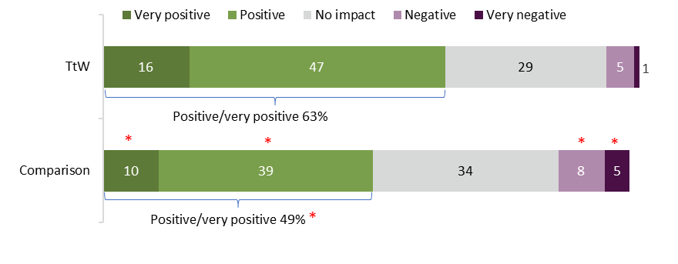
Source: Participant survey 2021
Base: TtW participants who had contact with their provider (n=1,494), jobactive participants who had contact with their provider (n=578)
QTTB4 In your opinion, has your <TtW / jobactive> caseworker(s) had a positive or negative impact on your…
Note: *Indicates result is significantly different to TtW participants (p<0.05)
Receiving assistance from their caseworker to access mental health support was reported by 42% of TtW participant survey respondents (this was similar to the percentage of the comparison group, at 38% – not significantly different). Considering those reporting poor mental health, those with a higher JSCI score were more likely than those with a lower JSCI score to report accessing mental health support (48% versus 39%).
In addition to referrals for specialist mental health support, most interview participants explained that the emotional support that caseworkers provided extended beyond their vocational needs and exerted a positive influence on their mental health and overall wellbeing. Participants noted that being able to talk to their caseworker and feel ‘understood’ was important.
I’ve found that they’re really supportive. I suffer from PTSD and generalised anxiety … they’re really understanding of it. Especially – I get really traumatised pretty quickly by certain bad environments … but they’re really understanding. (Focus group 3, >20 year olds, Melbourne, Groups 1 & 2)
Having her there when I needed her. I don’t really – at the time, I didn’t really have that many people that I could reach out to, so it was just nice to know that I had another support system. (Participant 22, female, 22+ years old, metro SA, Group 1)
In addition to general emotional support, some participants reported that their caseworkers helped to teach them coping skills to manage common issues such as low mood, anxiety, and stress. Some participants emphasised that their caseworker had helped them to shift to a more ‘positive’ mindset which helped to alleviate low mood and negative self-perception.
I got really depressed and had to go on antidepressants. I got in a really bad spot and didn’t want to do anything, never wanted to go anywhere … she’d always say something, and it got me out of that bubble. (Participant 6, female, 19–21 years old, regional Qld, Group 1, Indigenous)
It has definitely given me that sense of knowing that it will be okay. Do you know what I mean? … usually when you’re in a dark place you don’t have a job, it’s really hard to see that there is light at the end of the tunnel and that there is possibility out there. So, I think someone say, no there is, I’ll show you this is there, it’s helped in everyday life as in, that’s okay, it’s okay to feel this way in a certain point, but like better things out there and like to be realistic, that there are things out there, and you just gotta change your mindset towards it. (Participant 18, female, 19–21 years old, metro NSW, Group 1)
There were a few participants who reported that involvement in the TtW program had negatively impacted their confidence and mental health. These few participants had negative experiences with their caseworkers, where they felt their caseworkers were neither interested in nor supportive of their needs. These participants described a sense of ‘worthlessness’, where caseworker disengagement was interpreted as evidence that they were ‘not worth the effort’.
In interviews, provider respondents spoke of mental health being a significant barrier to many participants and talked about how they supported participants’ mental health through listening and building resilience. In addition, they relied heavily on referring participants to appropriate services for mental health support. In the provider survey, 92.4% of providers reported making referrals to mental health services, and this was the service referred to by the highest proportion of providers. While it was clear that providers rely on specialist mental health services to support their clients, almost two-thirds of the providers (65%) reported that mental health services were ‘unavailable for participant referral’. Providers were then asked generally ‘what were the MAIN reasons you were NOT able to refer participants to services or assistance that they needed?’. While not specifically related to mental health, the most common reasons for inability to refer were that there were no appointments/places available (65%) or services were not available in the local area (50%).
A couple of providers who were interviewed noted the limitations of referrals in regional areas where services are often limited to phone contact. These providers indicated that the lack of external services placed greater pressure on them to support participants.
Providers who had been unable to refer participants to mental health services were then asked to describe the actions they take to manage this (Figure 10). Referring participants to doctors and increasing the frequency of contact with the participant were the most common responses (over 90% of providers), while just over 10% referred to counselling and allied health services. Providers also mentioned a range of other actions including ‘Connect them to a phone service, which is not ideal’, ‘Provide emergency contact numbers and complete safety plans’, ‘We may end up calling mental health triage if we assess that the client is a high risk to themselves or others on a given day’, ‘Refer to additional complimentary services in an effort to provide a wraparound service until such time as the needed supporting service becomes available’ and ‘Police intervention’.
Figure 10: Provider actions when unable to refer to mental health services (% of respondents)
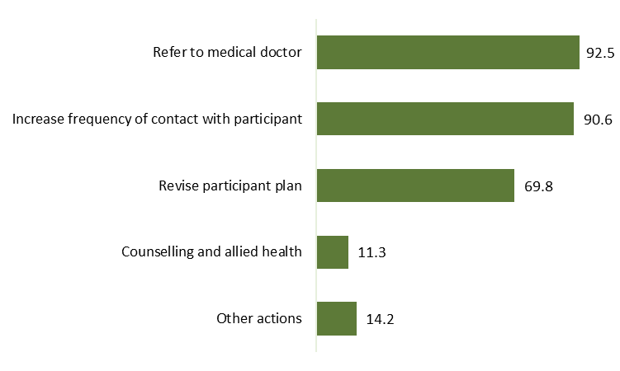
Source: Provider survey 2021
Base: Selected respondents who answered ‘Mental health services’ to Q3.9 (n=106)
Q3.11 When you are unable to refer participants for mental health services, what actions do you take? Select all that apply.
Q3.9 Which services or assistance were you UNABLE to refer participants to? Select all that apply.
While participants overall appreciated the support they received from caseworkers, it was acknowledged in one focus group that it was essential that caseworkers be sensitive to the mental health needs and concerns of participants, and some participants suggested that this be a focus of provider support.

Physical health
Participant feedback on physical health outcomes was scarce in interviews, with most reporting that this was not so relevant to the program; however, provider interviews were more insightful in this respect.
Some providers explained that targeting physical health concerns was sometimes a necessary first step in addressing barriers to labour market participation and overall wellbeing. Examples included supporting participants to achieve a weight appropriate for them by organising a gym membership or buying sports equipment, attending to their general personal hygiene/appearance and helping participants recovering from substance dependence.
He spoke to his consultant privately about his concerns about his weight and a lot of it had come from generational unemployment and eating bad food was a much cheaper option that eating healthy and exercising. Once we identified that that was a real issue for him and that he lacked confidence with, we actually arranged for him to undertake some gym classes. […] When he got to the end of it, he was all dressed in his uniform and his work clothing was a few sizes smaller than what he previously was and he had a massive amount of confidence when it came to going out and presenting himself to employers and the general public. It had a really great impact to his overall confidence and how he felt about himself. (TtW Provider 3, metro NSW, medium size)
He was a very heavy user of drugs that basically smoked dope morning, noon, and night. […] His girlfriend had their first child when she was 15, he was 16 … now he’s just finished his first six months’ work at a windscreen place. Totally off the drugs. Has turned his entire life around. He’s healthy. Him and his family have got this wonderful little family happening now. He comes home from work and him and the kids make dinner together. They ride bikes together. So the whole family dynamics have changed from what he was doing six months ago. (Provider 11, metro WA, small size, community of practice)
You know the person that was living in his car, they were telling me about him I thought, that’s really, really sad. Go out and buy him a personal hygiene pack please. Soap, some flannels, some deodorant. A brush, a comb, a new toothbrush, new toothpaste, that sort of stuff. Give it to him. Having that sort of flexibility in our program is our ‘boom!’ (Provider 1, regional Qld, large size)

The impact of TtW on participants’ capability influencers
Within the human capabilities framework for young people, external factors that can influence an individual’s capability and affect their capacity to meet their goals were identified. Through linking participants to services and supports, as well as to employers, TtW acts as a ‘capability influencer’. This section examines participants’ social connectedness and access to services. It is worth noting that participants may have been impacted by other external factors during their time in the program. These include stressful events that affected them personally, the COVID-19 pandemic and natural disasters such as bushfires and floods that occurred during the preceding 12 to 18 months.

Social connectedness
Peer support, community involvement, having a positive mentor and role model relationships are understood to be key parts of feeling capable and supported as young people transition into adulthood.
Participants were asked to identify their level of agreement with a series of statements about their access to support and social connections in the participant survey (Figure 11).
Close to 4 in 5 TtW participants agreed or strongly agreed they were able to access support and social connection. Few agreed with ‘I don’t know people who can help me at the moment’ (17%). TtW participants reported having better access to supports and social connections than participants from the comparison group. TtW participants were more likely to agree with ‘I am well supported by family and friends’ (83% versus 74%), ‘I know where to go to get the support I need’ (81% versus 67%) and ‘The help and support I need is available to me’ (80% versus 67%), and less likely to agree with ‘I don’t know people who can help me at the moment’ (17% versus 23%).
Figure 11: Participant ratings of supports and social connections (% agree / strongly agree)
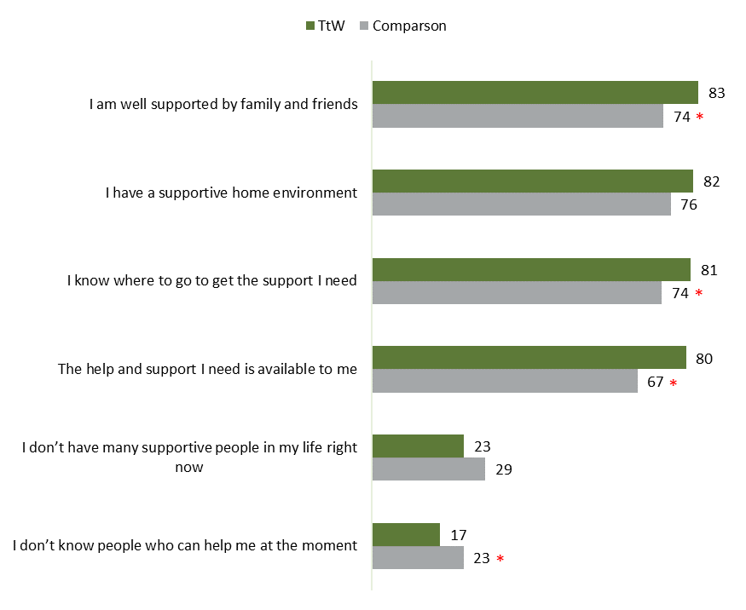
Source: Participant survey 2021
Base: All respondents – TtW participants (n=1,502), jobactive participants (n=580)
QHC10 Now, some statements about the help you get from services, people in your community and family and friends. Do you agree or disagree that…?
Notes: *Indicates result is significantly different to TtW participants (p<0.05). % Strongly Agree / Agree shown.
While these survey results indicate that TtW participants have stronger support and social connections than participants in the comparison group, it is difficult to determine whether this relates to the support offered by TtW, or is associated with the selection of participants. In interviews, TtW participants overall found it difficult to identify how the TtW program had impacted their sense of social connectedness. Most participants’ experiences of TtW were limited to periods when COVID-19 restrictions were in place. This meant that most participants did not participate in group sessions in TtW, and many had limited face-to-face engagement with their caseworkers.
However, some participants had regular discussions with their caseworker that helped to improve their social skills and make them feel less isolated.
They’re getting me back into like social life and – ’cause I didn’t have a social life a few months ago – but like, yeah just having those phone calls and everything, it’s improving my way of speaking and stuff like that. (Participant 4, female, 19–21 years old, metro SA, Group 1)
A few participants who had experienced face-to-face groups organised by their provider, either pre-COVID-19 or as lockdown restrictions were lifted, mentioned gaining benefit from the social opportunities that these groups provided, including that they had made friends through the program, and that it was helpful to see that others were in a similar situation to themselves.
I guess it’s just nice to like, be social, really like going, we had the Christmas party. I did mention there was lots of young people there. It was just, it’s nice that they’re not just sort of like I guess when you’d go to a place like Centrelink, for example, they’d just sit you down in a cubicle, like are blah, blah, blah, blah. But [Provider] it’s more like, Oh, well we’ll just sit over here and like having a chit chat … they provide a very healthy environment for, to just cultivate a very good a social environment. (Participant 28, male, 22+ years old, metro Qld, Group 1, disability)
A deeper insight into the impacts of TtW on participants’ social connectedness was gained from providers interviewed for the qualitative research as they were able to draw on experiences pre-COVID-19. Several providers mentioned that their face-to-face group activities enabled participants to connect with other young people with similar experiences, which reduced their social isolation and built their confidence. Others mentioned that warm referrals to other organisations, as well as providing vocational support and sourcing education and employment opportunities, had positive effects on the social connectedness of participants.
It teaches them that it’s okay to talk to somebody they don’t know. It challenges them to actually open their mouth and engage with somebody they don’t know. (Provider 10, metro NSW, medium size)
We’ve definitely had the experience where young people have met each other in a group setting and they’ve come back to visit us a couple of years later and they’re still friends. That’s cool. Because actually before that … they found it challenging to make friends because of a whole heap of different stuff. And so when a young person can actually also see that this other young person my age is succeeding, that’s a motivating factor. ‘Hey, you got your Ls! I want to get my Ls!’ Or ‘How’d you get your Ps? I want to get my Ps!’ We’ve seen that happen right in front of us. It’s amazing. (Provider 4, metro Vic, medium size)
… when they’ve exited the program and they’ve come back to visit us. And we’ve asked, ‘Hey, how’s it …?’ […] And you can see that they’ve maintained their connection with the supports. It hasn’t just weaned off. (Provider 4, metro Vic, medium size)
In another example, a provider mentioned paying for a pair of Doc Martens shoes when one of their participants got a job in hospitality, to help her fit in with her new colleagues. This example demonstrates the extent to which caseworkers consider the social identity of their participants and the importance of confidence in social situations to maintaining vocational motivation.
This young girl ended up getting some – it was only casual work, in a restaurant in a club. […] Everyone there sort had like doc martens and all of that sort of thing – so we made sure she had the appropriate shoes and clothing and things like that so she fitted in with everyone and you know. You see her now walking to work wearing her doc martens, smiling and things like that was a great achievement of [our caseworker] (Provider 15, regional NSW, small, Indigenous specialist)

Availability of and access to support services
During the participant survey, participants were asked if their caseworker had a positive or negative impact on their ability to access the support services they needed. Almost 4 out of 5 TtW participants (79%) felt that their caseworker’s influence had been positive or very positive (compared to 68% of the comparison group).
Close to half of TtW participants reported they had received support accessing reliable transport or getting a driver’s licence (50%), and financial or material assistance of any kind (49%). Two in 5 reported having received help accessing mental health support (42%). TtW participants were more likely to report receiving support related to accessing reliable transport or getting a driver’s licence (50% versus 42%), financial or material assistance of any kind (49% versus 42%), and accessing childcare (13% versus 8%) than participants from the comparison group (Figure 12).
Figure 12: Participant views on non-vocational support provided by caseworkers (% yes)
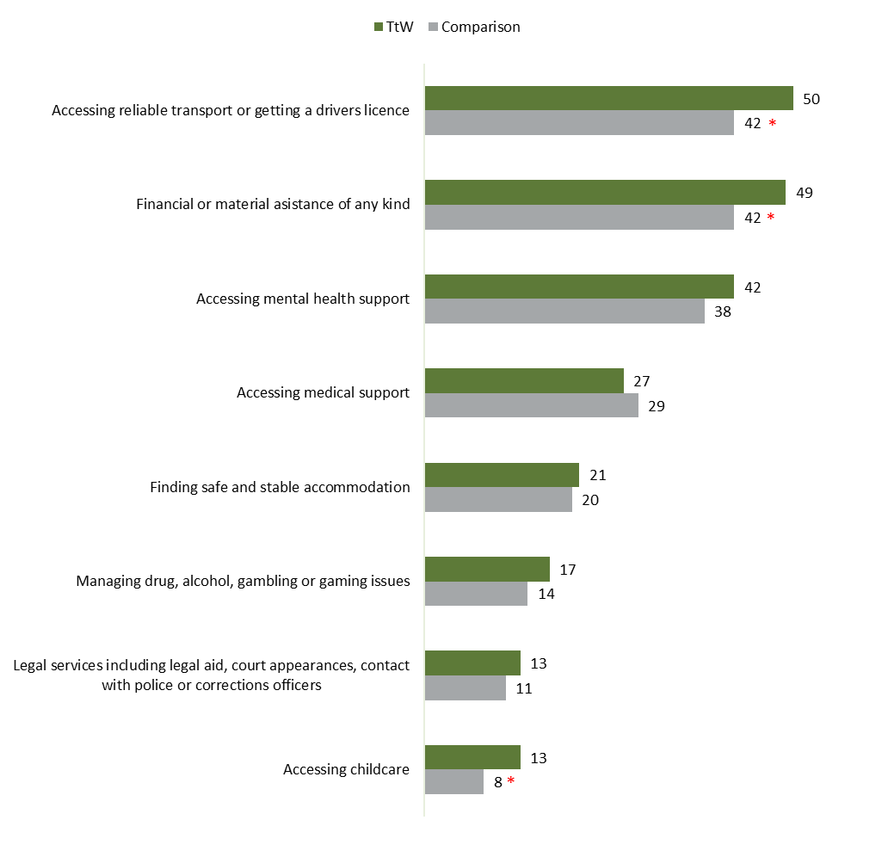
Source: Participant survey 2021
Base: TtW participants who had contact with their provider (n=1,494), jobactive participants who had contact with their provider (n=578)
QTTB3 And since you started seeing your <TtW / jobactive> caseworker(s), did they provide you with any support in the following areas?
Note: *Indicates result is significantly different to TtW participants (p<0.05)
TtW survey participants were also asked if there was any help from their TtW caseworker that they wanted but did not receive. Most (84%) reported nothing extra was needed. The most common response was help finding a job (5%). Two per cent wanted help to obtain a driver’s licence, and 2% wanted help accessing mental health support.

Impact of TtW on participants’ overall subjective wellbeing and life satisfaction

Context
Findings from international and Australian research show that while promoting the wellbeing of young people is a valuable and fundamental end in itself, high levels of wellbeing are also shown to have a positive impact on health, work, relationships and economic activity (Australian Unity 2020). A study of 3,913 young people in South Australia (Venning et al 2013) found that lower levels of mental wellbeing were associated with increased health‐risk behaviour such as smoking, drinking, and negative relationships. Other studies have shown that high levels of wellbeing are associated with effective learning, increased productivity and creativity, good relationships, pro-social behaviour, good health and longer life expectancy. Internationally, governments are increasingly recognising the significance of measuring wellbeing as an indicator of national progress (Witten et al 2019).
While there is no current agreement of a conceptual definition or measurement of wellbeing, there is strong agreement that wellbeing is multidimensional and cannot be reduced to a single measure or concept. Psychological wellbeing is seen to include a combination of both feeling good and functioning well, and for different theorists includes a combination of factors such as autonomy, personal growth, competence, positive relationships, pleasure, engagement, meaning, purpose in life and self-acceptance.

Life satisfaction
General life satisfaction was measured by asking respondents to the participant survey to rate their satisfaction with life as a whole, using a scale from 0 to 10, where 0 indicates ‘completely dissatisfied’ and 10 indicates ‘completely satisfied’. TtW participants rated their life satisfaction as 6.6 out of 10 on average, significantly higher than the comparison group (average 5.9) (Figure 13). Significantly more TtW participants than the comparison group were highly satisfied with their life as a whole, scoring between 8 and 10 (36% compared to 26%) (Figure 14). These differences remained after adjusting for number of stressful life events experienced in the past 12 months and length of time in the program.
In comparison, the 2018 HILDA survey asked young people between 15 and 24 across Australia ‘How satisfied are you with your life as a whole?’. The average satisfaction score was 8.1. Between 2008 and 2018, the score remained stable at between 8.0 and 8.1 (out of 10) (Figure 13).
Figure 13: Average participant satisfaction with life as a whole
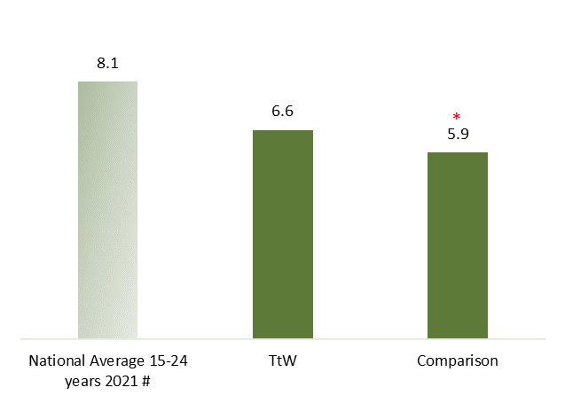
Source: Participant survey 2021
Base: All respondents – TtW participants (n=1,502), jobactive participants (n=580)
QHC1 Using a scale of 0 to 10, where 0 is completely dissatisfied and 10 is completely satisfied, thinking about your own life and your personal circumstances, how satisfied are you with your life as a whole?
Notes: *Indicates result is significantly different to TtW participants (p<0.05). # Source: AIHW 2021: HILDA Survey – score remained stable between 2008 and 2018.
Figure 14: Participant satisfaction with life as a whole (% of participants)
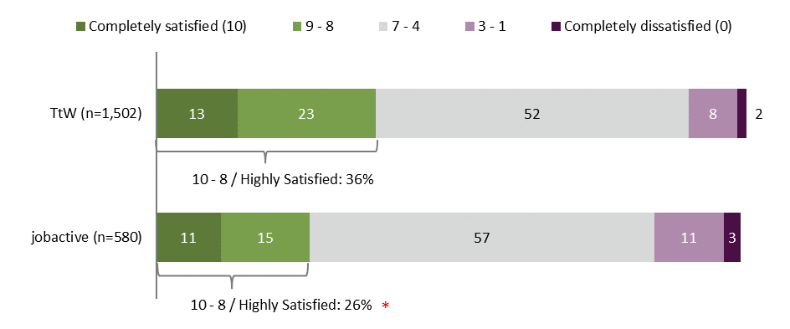Source: Participant survey 2021
Base: All respondents – TtW participants (n=1,502), jobactive participants (n=580)
QHC1 Using a scale of 0 to 10, where 0 is completely dissatisfied and 10 is completely satisfied, thinking about your own life and your personal circumstances, how satisfied are you with your life as a whole?
Note: Not shown: ‘Don’t know’ (<1%), Refused (<3%)

Personal wellbeing
Most providers (94.6%) felt that engagement in TtW had a ‘very good’ or ‘good’ impact on participants’ wellbeing. During interviews, provider respondents offered examples of participants who had significantly changed their lives following engagement with the program. These participants faced particularly complex barriers including drug addiction, homelessness, contact with the criminal justice system, and mental health issues. The impact of the program was significant on their broader wellbeing, helping them to reorient their lives.
She had a lot of non-vocational barriers: she had mental health; she’d been homeless. […] She had a few issues with the police; she’d been caught up in a bad group of people; she’d been on, I think, marijuana, since the age of about eleven – just a list of these barriers. And I don’t know what it was, but she just connected with one of our youth advisers. Just clicked with her … She’d never had that level of support before, she said. […] we referred her out to a lot of specialist areas, from drug and alcohol to mental health. Meanwhile, very slowly, just putting her through those workshops; getting those social skills where they need to be. […] Wrapping them around and making sure they’re fully supported. [She has now been transferred to jobactive as she had been on TtW for 18 months], she’s applying for jobs now; she hasn’t been on marijuana now for, … coming up around four or five months. […] not in trouble with the police. The police have come in a number of times and just thanked us for the support that we’ve given the young person; they can’t believe the turnaround in this young person. (Provider 10, metro NSW, medium size, TtW + jobactive)
To determine the impact that TtW has on participants’ wellbeing, survey participants were asked to respond to a series of questions across a number of areas related to their life and wellbeing, using a scale of 0 (no satisfaction) to 10 (complete satisfaction). Responses to these items were combined into a score to determine participants’ Personal Wellbeing Index (PWI) (IWB, 2013). This is a score out of 100, where higher scores indicate higher levels of personal wellbeing.
Overall, TtW participants had an average personal wellbeing score of 71.1 out of 100, which was significantly higher than the comparison group (65.6). However, their wellbeing remains lower than the national average PWI for 18–25 year olds (75.1) (Figure 15). The national average remained relatively stable over 3 years to 2020 (Table 6). Differences between the TtW and comparison samples remained after adjusting for the number of stressful life events experienced in the past 12 months and length of time in program.
Figure 15: Average participant Personal Wellbeing Index score
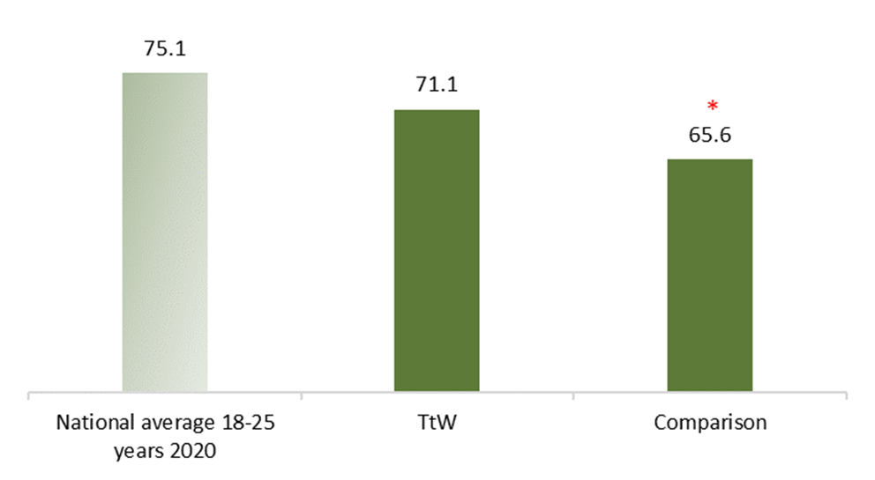
Source: Participant survey 2021; source for national average 18–25 years 2020: Australian Unity Wellbeing Index Summary Reports 2020, Deakin University
Base: All respondents – TtW participants (n=1,502), jobactive participants (n=580)
QHC2 Turning now to various areas of your life. Please answer use a scale from 0 to 10, where 0 is completely dissatisfied and 10 is completely satisfied.
Note: *Indicates result is significantly different to TtW participants (p<0.05)
Table 6: National average Personal Wellbeing Index for young people 2018–2020
Year | National average Personal Wellbeing Index, 18–25 years
2018 | 74.9
2019 | 75.6
2020 (early COVID-19 – latest data available) | 75.1
Source: Australian Unity Wellbeing Index Surveys 35, 36 and 37: Summary Reports (2018, 2019, 2020), Deakin University

Psychosocial wellbeing
The Flourishing Scale is an 8-item summary measure of respondents’ self-perceived success in important areas such as relationships, self-esteem, purpose, and optimism (Diener et al 2009).
When responses are combined, the scale provides a single psychosocial wellbeing, or flourishing, score ranging from 8 (lowest possible) to 56 (highest possible). A higher score represents a person with many psychosocial resources and strengths.
Overall, TtW participants had an average flourishing score of 44.6 out of 56, which is higher than the comparison group (42.8). This difference remained after adjusting for number of negative life events in the past 12 months in a multivariate regression model.
When asked what impact their caseworker had had on their ‘outlook on life’, 68% of TtW participants felt they had had a positive or very positive impact, which is significantly greater than was reported by the comparison group (57%). Most providers (92.1%) felt that engagement in TtW had a ‘very good’ or ‘good’ impact on participants’ outlook on life.

What elements of the TtW program are associated with increased human capability in participants?
The above sections demonstrate that TtW has a positive impact on the human capabilities of participants (including confidence, resilience, motivation, mental and physical health, and availability of and access to support services) and overall wellbeing. This section examines the elements of the TtW program that may play a significant role in the development of participants’ human capabilities.
The qualitative fieldwork with participants and providers identified several elements of TtW that support the development of human capabilities, and these reflect the findings of the TtW final evaluation (DESE 2021). These elements include low caseloads per caseworker, which gives caseworkers the time to provide intensive wraparound support; the flexibility in time and funding to provide innovative ways to engage young participants (games, employer visits, pizza nights); the voluntary nature of the program with no formal compliance framework; and the youth focus, which helps participants feel they are in an enabling and supportive environment.

Correlations between program elements and human capability indicators
Multivariate regression models were used on participant survey data to examine TtW program experiences that were associated with human capability outcomes. While the direction of causality cannot be determined from this analysis, it is useful to see which elements are correlated. Program experiences, identified as relevant through the qualitative and quantitative research, that were explored included frequency of contact with caseworker (at least weekly / less than weekly); satisfaction with caseworker (satisfied / very satisfied / other); attitude when joined (positive / very positive / other); and number of vocational supports and non-vocational supports (continuous). In addition, factors that were associated with satisfaction with caseworkers were also examined through regression. Regression models can be found in Appendix 6.2.
As summarised in Table 7, satisfaction with caseworkers (compared to those who were not satisfied) and having a positive attitude when they joined the program (compared to those who felt that they did not have a positive attitude) were associated with higher life satisfaction, personal wellbeing, resilience and flourishing scores, and ‘excellent’ or ‘very good’ self-rated mental health.
Being satisfied or very satisfied with caseworkers was associated with feeling that a caseworker was ‘someone you can talk to or get support from’, ‘empowered you in any way’, ‘took your needs and goals into account when developing your job plan’, ‘provided useful feedback about your progress’ and ‘discussed your strengths and weaknesses’. This supports evidence from the TtW final evaluation (DESE 2021) that facilitating a strong relationship with caseworkers is an essential element of the program’s success, but also points to the value of using a strengths-based approach that acknowledges the needs and desires of participants. The association between a ‘positive attitude when joined’ and higher human capability development also points to the importance of clarifying expectations about the program in early interactions between caseworkers and participants.
While there was no significant relationship between having at least weekly contact with caseworkers (compared to less than weekly contact) and any of the assessed human capability measures, there was a strong correlation between the frequency of contact being ‘just right’ and high satisfaction with caseworkers. This finding highlights the value of having a flexible program that meets the needs of participants.
Receiving a greater number of vocational supports was associated with higher life satisfaction, personal wellbeing, and flourishing scores. This could indicate that engagement with work increases participants’ human capabilities, or that having greater human capabilities makes it easier to engage in work.
Receiving more non-vocational supports was associated with lower resilience. This is not surprising as it is likely that those with lower levels of resilience have a need for more support to manage their non-vocational barriers.
These findings emphasise that there can be a 2-way relationship between human capabilities and program elements. While the program has an influence on human capabilities, the human capabilities of participants also influence their ability to engage with the program, and the services and supports that they need.
Table 7: Correlations between program elements and human capability indicators
TtW program element/experience | Life satisfaction | Personal wellbeing | Mental health | Psychosocial wellbeing | Resilience
Satisfaction with caseworker  Satisfied/very satisfied (versus other) | yes | yes | yes | yes | yes
Attitude when joined  Positive / very positive (versus other) | yes | yes | yes | yes | yes
Frequency of contact with caseworker  At least weekly (versus less than weekly) | no | no | no | no | no
Frequency of contact with caseworker  Just right (versus too little or too much) | yes | yes | yes | yes | yes
Number of vocational supports (continuous) | yes (+ve) | yes (+ve) | no | yes (+ve) | no
Number of non-vocational supports (continuous) | no | no | no | no | yes (-ve)
Key:
yes = the 2 items are correlated
no = the2 items are not correlated
yes (+ve) = there is a correlation between the 2 items, and it is a positive relationship (continuous variable), eg, More supports, more life satisfaction
yes (-ve) = there is a correlation between the 2 items, and it is negative relationship (continuous variable), eg, More supports, less resilience.

Correlations between work/study and human capability indicators
TtW participants who had done any paid work since starting with their caseworker and those who believed that it was very likely or likely that they would find a job or be employed in the next 12 months also demonstrated a significantly higher outcome in all the assessed human capability measures. While this research cannot determine causality, this finding is consistent with the broader literature which links employment with increased human capabilities and wellbeing, and unemployment with decreased wellbeing, confidence and mental health (Dietrich et al 2021, Carter and Whitworth 2017, Casebourne et al 2010).
Undertaking study or believing that they would undertake study in the next 12 months was not found to be associated with TtW participants demonstrating higher human capability outcomes, with one exception. Belief that they would study in the next 12 months was associated with higher resilience scores (Table 8). This could be explained whereby growing resilience is associated with increased confidence and aspiration to study.
While it may not be intuitive, the lack of evidence from this research of an association between wellbeing/higher human capability and participation in study is consistent with other recent research by Dietrich et al 2021 looking at transitions from school in Australian youth, which found that transitions to study increased subjective wellbeing only among men, while such transitions appear to decrease subjective wellbeing among women.
Table 8: Correlations between work/study and human capability indicators
TtW program experience | Life satisfaction | Personal wellbeing | Mental health excellent or very good | Psychosocial wellbeing | Resilience
Done any paid work since starting with caseworker (versus not done) | yes | yes | yes | yes | yes
Thought it was very likely or likely that they would find a job or be employed in the next 12 months (versus neither, unlikely, very unlikely) | yes | yes | yes | yes | yes
Undertaken study since starting with their caseworker (versus not) | no | no | no | no | no
Thought it was very likely or very likely that they would study in the next 12 months (versus neither, unlikely, very unlikely) | no | no | no | yes | no

The impact of provider characteristics
In the 2021 provider survey respondents were asked to provide an overall view on the extent to which TtW had a positive impact on the human capabilities of participants. All participants responded, with over three-quarters (77%) reporting that TtW has a positive impact to a ‘great extent’, and a quarter (23%) that it has a positive impact to a ‘moderate extent’. No respondents felt that the impact on TtW participants’ human capabilities was ‘slight’, or ‘none’ or that they did not know the impact.
These results were further disaggregated to understand if differences in provider characteristics would influence provider views of the degree to which TtW impacted the human capabilities of participants. Provider characteristics that were examined included remoteness, profit status, site size (total caseload and staffing), specialist staff, including Aboriginal and/or Torres Strait Islander staff, and servicing approaches (degree of post-program contact, scheduled contact and unscheduled contact).

Profit and not-for-profit status
Provider staff working in not-for-profit organisations were more likely to consider that TtW impacted the human capabilities of participants to a great extent (79%) compared with those working in for-profit organisations (53%) (Figure 16). It is not clear why this is the case, but it could indicate a different organisational focus that leads to either different human capability outcomes or differences in staff awareness of or focus on participants’ human capability outcomes.
Figure 16: Provider views on impact of TtW on participants’ human capabilities, by profit status (% to a great extent/moderate extent)
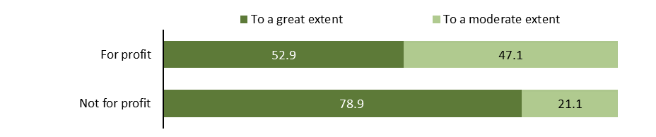Source: Provider survey 2021
Base: All respondents (n=278); For-profit (n=17); not-for-profit (n=261); based on profit status from the department’s administrative data
Q7.3 We can think about the confidence, motivation, resilience, health and connectedness of TtW participants as their ‘human capabilities’. To what extent do you think that TtW has a positive impact on the human capabilities of participants?

Frequency of contact with participants
Not surprisingly, where provider staff reported more frequent contact with participants (weekly scheduled contact, very frequent unscheduled contact, and very frequent/frequent post-program contact) they also reported that the TtW program had a greater positive impact on participants’ human capability (Figure 17, Figure 18 and Figure 19). A very high proportion of respondents who reported very frequent unscheduled contact also reported an impact on human capabilities ‘to a great extent’ (91%). This could be associated with the finding from the participant survey that frequency of contact being ‘just right’ (as opposed to ‘too much’ or ‘too little’) was correlated with high outcomes in all of the human capability factors examined (Table 7 above).
Figure 17: Provider views on impact of TtW on participants’ human capabilities, by scheduled contact (% to a great extent/moderate extent)
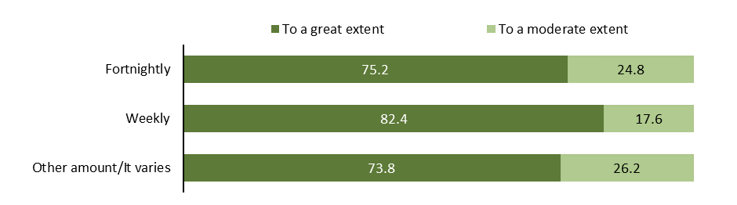Source: Provider survey 2021
Base: All respondents (n=278); Monthly (n=3), Fortnightly (n=149), Weekly (n=85), Other amount/It varies (n=39); based on responses to Q5.3; 2 responses of ‘Don’t know (to a great extent)’ are not shown.
Q5.3 How often, on average, do staff at the [site name] site have scheduled appointments with each participant?
Q7.3 We can think about the confidence, motivation, resilience, health and connectedness of TtW participants as their ‘human capabilities’. To what extent do you think that TtW has a positive impact on the human capabilities of participants?
Figure 18: Provider views on impact of TtW on participants’ human capabilities, by unscheduled contact (% to a great extent/moderate extent)
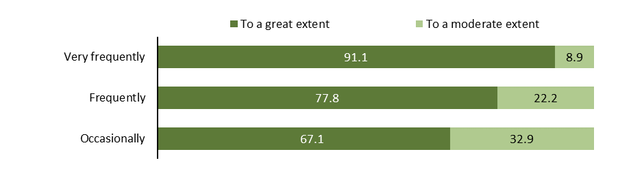Source: Provider survey 2021
Base: All respondents (n=278); Very frequently (n=45) Frequently (n=158) Occasionally (n=73); based on responses to Q7.3; 2 responses of ‘Rarely’ and ‘Don’t know’ to Q5.4 are not shown.
Q5.4 How often, on average, do staff at the [site name] site have contact with participants other than at their scheduled appointments?
Q7.3 We can think about the confidence, motivation, resilience, health and connectedness of TtW participants as their ‘human capabilities’. To what extent do you think that TtW has a positive impact on the human capabilities of participants?
Figure 19: Provider views on impact of TtW on participant’s human capabilities, by post program contact (% to a great extent/moderate extent)
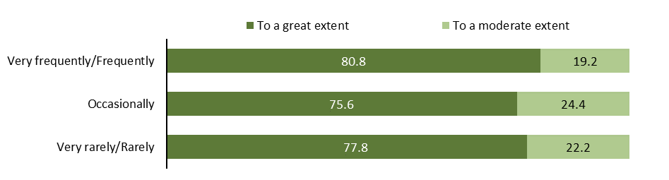Source: Provider survey 2021
Base: All respondents (n=278); Very frequently (n=10) Frequently (n=42) Occasionally (n=160), Rarely (n=36), Very rarely (n=27); based on responses to Q7.3; 3 responses of ‘Never’ and ‘Don’t know’ to Q3.19 are not shown.
Q3.19 How frequently do you have any contact with participants after they have exited the TtW program?
Q7.3 We can think about the confidence, motivation, resilience, health and connectedness of TtW participants as their ‘human capabilities’. To what extent do you think that TtW has a positive impact on the human capabilities of participants?

Site size and use of specialist staff
Respondents from sites with larger caseloads or more staff were more likely to feel the program impacted participants’ human capabilities to a ‘great extent’ than those from smaller sites. More respondents from sites with caseloads larger than 120 (82%) felt the program impacted participants’ human capabilities to a ‘great extent’ compared to around 74% of respondents from smaller sites. Similarly, 86% of respondents from sites with 6 or more staff had this view compared to around 76% of sites with 5 or fewer staff (Figure 20 and Figure 21). Sites with specialist staff were also more likely to believe that TtW had a positive impact to a ‘great extent’ on participants’ human capabilities compared to sites without specialist staff (80% compared to 64%) (Figure 22). It should be noted that sites with specialist staff are more likely to be larger sites. It is unclear why respondents from larger sites would have a more positive view of the impact of TtW on participants’ human capabilities.
Figure 20: Provider views on impact of TtW on participants’ human capabilities, by caseload count at site (% to a great extent/moderate extent)
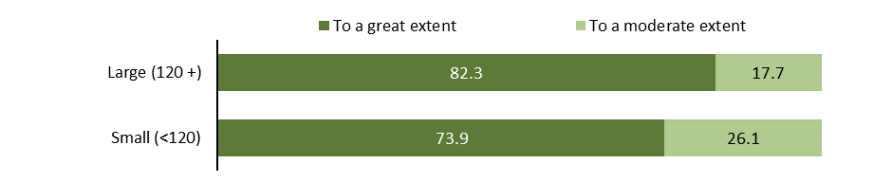Source: Provider survey 2021
Base: All respondents (n=278); Extra-large (n=85); Large (n=28); Medium (n=37); Small (n=74); Very small (n=54); based on caseload count from the department’s administrative data
Q7.3 We can think about the confidence, motivation, resilience, health and connectedness of TtW participants as their ‘human capabilities’. To what extent do you think that TtW has a positive impact on the human capabilities of participants?
Figure 21: Provider views on impact of TtW on participants’ human capabilities, by full-time equivalent (FTE) at site (% to a great extent/moderate extent)
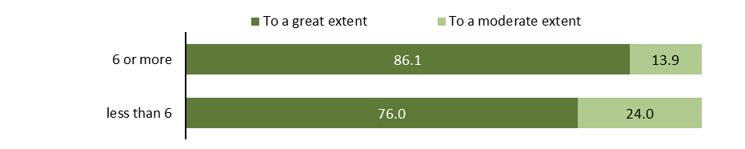Source: Provider survey 2021
Base: All respondents (n=278); FTE fewer than 3 (n=172); FTE 3–5.9 (n=70); FTE 6 or more (n=36); based on Q2.6
Q2.6 At the [site name] site, how many full-time equivalent (FTE) staff, including yourself, are employed to service Transition to Work clients?
Q7.3 We can think about the confidence, motivation, resilience, health and connectedness of TtW participants as their ‘human capabilities’. To what extent do you think that TtW has a positive impact on the human capabilities of participants?
Figure 22: Provider views on impact of TtW on participants’ human capabilities, by specialist staffing levels at site (% to a great extent/moderate extent)
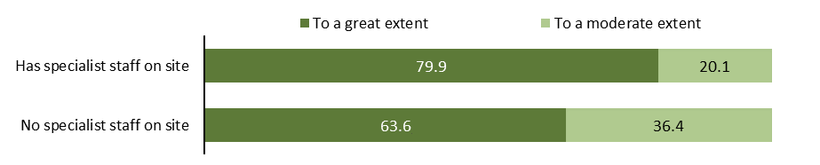Source: Provider survey 2021
Base: All respondents (n=278); Has specialist staff (n=234); No specialist staff (n=44); based on Q2.10
Q2.10 Thinking about staff roles, are there any of the following specialist roles at the [site name] site?
Q7.3 We can think about the confidence, motivation, resilience, health and connectedness of TtW participants as their ‘human capabilities’. To what extent do you think that TtW has a positive impact on the human capabilities of participants?

Conclusion
Participation in TtW had a significant impact on participants’ self-confidence, understanding of what they wanted to do in the future, motivation to work towards their goals, resilience, and access to the support and services they needed.
TtW participants also demonstrated better self-rated mental health, life satisfaction and personal wellbeing than the comparison group. Participants provided examples where participation in TtW had let them take more control of their lives: managing substance abuse, leaving abusive work or personal relationships, finding stable housing, reducing contact with the criminal justice system, and improving their mental and physical health.
A few of the participants interviewed during the qualitative research reported negative impacts of the program on their confidence, resilience and mental health, as a result of feeling that their caseworkers were neither interested in nor supportive of their needs. This highlights the importance of caseworkers needing to have good communication skills and a supportive attitude, as well as being sensitive to mental health and other factors in participants’ lives. The qualitative research showed that participants are unlikely to disclose everything to caseworkers in the first instance, so caseworkers need to build trust and rapport before meaningful progress can take place.
This research confirms that key elements of the TtW model support the building of participants’ human capabilities, including:
Use of a strengths-based and client-centred model that provides constructive and tailored support, within a safe, enabling environment. This is supported by low caseloads per caseworker, giving caseworkers the time to provide intensive wraparound support; a flexible funding model, allowing providers to use innovative methods to engage young participants; and a youth focus which helps participants feel welcome and valued.
Flexible servicing that takes the needs of individuals into account when determining the frequency and duration of servicing.

– What impact does TtW have on participants’ incarceration rates?

Introduction
This chapter explores the impact of TtW on the likelihood that participants will enter or re-enter the criminal justice system, examining the overall impact and the specific impact on participants who were ex-offenders on referral, and on Aboriginal and/or Torres Strait Islander participants. This analysis is limited to the examination of incarceration rates – i.e., where a participant is sent to prison. It does not include criminal activity that did not lead to contact with the criminal justice system, contact with the criminal justice system which did not lead to a conviction, or a conviction led to a sentence that was unsupervised or supervised in the community.

Prison sentences
Analysis of income support data (exits from income support with an exit reason ‘exited to prison’) demonstrates that TtW participants are less likely than participants in the comparison group to go to prison in the 4 years from commencement.
Logistic regression modelling showed that TtW had a significant, if small, positive impact on incarceration rates for participants. TtW participants were 0.83 percentage points less likely to be incarcerated in the 4 years from commencement than comparison group participants (Table 9). While this seems to be a small difference, only around 5% of participants were incarcerated overall, so a 1 percentage point difference in the probability of being incarcerated is notable.
In terms of the number of people this affected, compared to the comparison group, 95 fewer TtW participants were incarcerated in the 4 years from their commencement, with a total of 265 fewer periods of incarceration (from almost 16,722 participants) (Figure 23).
The average number of days spent in prison per incarceration was also calculated by looking at average time spent off income support, and this is the same for both TtW and comparison group participants, at 142 days/prison episode.
Table 9: Predicted probability that a participant will be incarcerated once within 4 years of commencement
Program | Probability (%)
TtW | 4.97
jobactive | 5.79
Difference | -0.83 percentage points
Source: The department’s administrative data
Base: Matched TtW (n=8,361) and jobactive (n=8,361) samples
Note: Statistically significant to p < 0.05
Figure 23: Number of individuals who were incarcerated and episodes of incarceration within 4 years of commencement
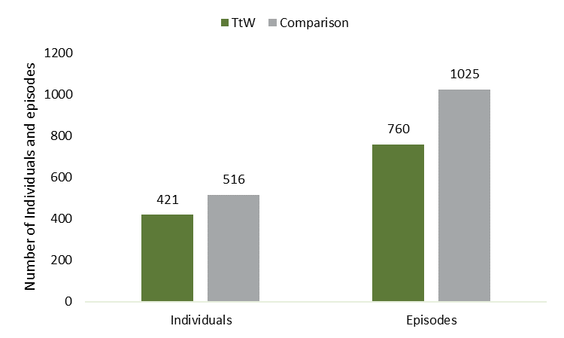
Source: The department’s administrative data
Base: Matched TtW (n=8,361) and jobactive (n=8,361) samples
Note: *People incarcerated as a percentage of total number of people in program sample

Reoffending
Comparison group participants who were incarcerated during the 4-year study period were more likely to return to prison after being released than TtW participants. Of TtW participants who were incarcerated during the study period, 44.7% returned to prison at least once, compared to 51.9% of the comparison group (Table 10).
To put this in context, while not exactly comparable, in 2018–19, 60% of young people aged 10 to 17 who were in juvenile detention returned to juvenile detention within 12 months (AIHW 2021), and 45.2% of adult prisoners who were released were returned to prison within 2 years (Productivity Commission 2022). These outcomes vary slightly depending on state of residence, Indigeneity and gender. A slightly higher proportion of Aboriginal and Torres Strait Islander men (both young people and adults) returned to detention than non-Indigenous men.
Table 10: Number of times in prison per person within 4 years from commencement
Frequency | TtW |  | Comparison
 | # | % | # | %
1 | 233 | 55.3 | 248 | 48.1
2 | 106 | 25.2 | 133 | 25.8
3 | 46 | 10.9 | 70 | 13.6
4 | 21 | 5.0 | 41 | 7.9
5 or more | 15 | 3.5 | 24 | 4.7
Total | 421 | 100 | 516 | 100
Source: The department’s administrative data
Base: Matched TtW (n=8,361) and jobactive (n=8,361) samples
It should be noted that the above results (presented in Table 9 and Figure 23) were mainly driven by participants who had a previous history of offending at referral (see below).

Participants who are ex-offenders on referral
TtW was more effective at supporting participants who were ex-offenders at referral to avoid being sent to prison than jobactive. Of the TtW participants who were ex-offenders at referral, 24.2% were sent to prison in the 4 years from commencement, compared to 35.7% of jobactive participants who were ex-offenders at referral (11.5 percentage points difference). There is almost no difference between TtW and jobactive for participants who had no history of offending at referral (Figure 24).
Figure 24: Proportion of participants who were ex-offenders (and non-ex-offenders) at the time of referral who were incarcerated at least once within 4 years from commencement, by program (%)
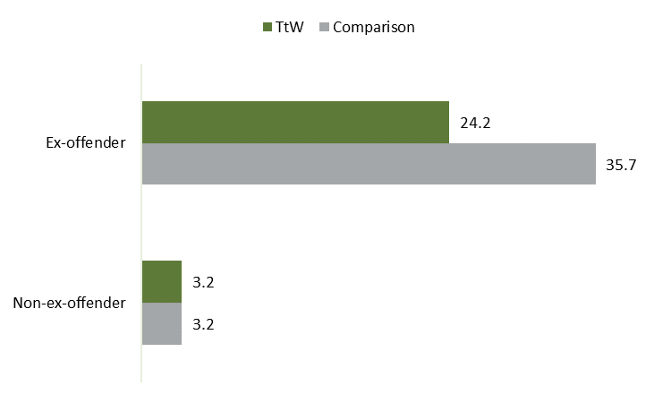
Source: The department’s administrative data
Base: Matched TtW (n=8,361) and jobactive (n=8,361) samples
Note: Number of ex-offenders at referral in the samples: TtW – 753, of whom 186 reoffended, jobactive – 761 of whom 272 reoffended

Aboriginal and Torres Strait Islander participants
TtW was also more effective at supporting Aboriginal and/or Torres Strait Islander participants to avoid contact with the criminal justice system than jobactive. Fewer Aboriginal and/or Torres Strait Islander participants in TtW (10%) were incarcerated in the 4 years from commencement, compared to 13.6% of jobactive Aboriginal and/or Torres Strait Islander participants (Figure 25).
Figure 25: Proportion of Aboriginal and/or Torres Strait Islander participants (and non-Aboriginal and Torres Strait Islander participants) who were incarcerated at least once within 4 years from commencement, by program (%)
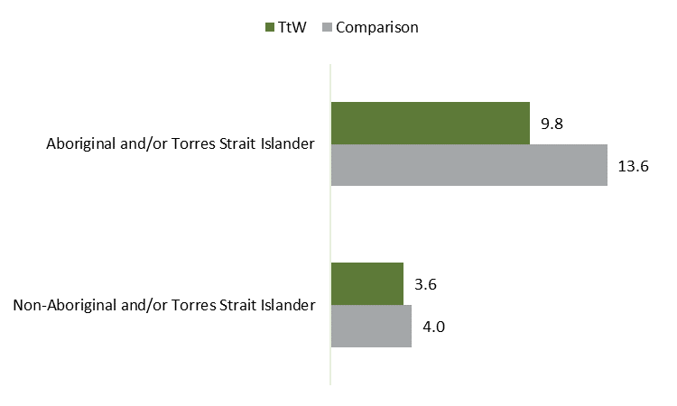
Source: The department’s administrative data
Base: Matched TtW (n=8,361) and jobactive (n=8,361) samples
Note: Number of Aboriginal and Torres Strait Islander participants in each sample: TtW – 1922 of whom 189 reoffended, jobactive – 1,925 of whom 261 reoffended. Number of non-Aboriginal and Torres Strait Islander participants in each sample: TtW – 6,439 of whom 232 reoffended, jobactive – 6,436 of whom 255 reoffended.
It is likely that the higher levels of support and engagement offered by TtW and the provision of more tailored and personalised support influenced this outcome. While a number of providers noted the importance of a young person’s attitude, it is clear that the TtW model enables caseworkers to identify moments when they can influence and work intensively with young people in a tailored way when they are receptive.
We’ve got one young lad who has always done crime. […] His partner had a little baby girl three months ago and he came and he said ‘I need to get a job, I’ve got to stop being in trouble with the police, I need to be a dad and I’ve got to stand on my own two feet’. We were proud of him for saying that and we were thinking what we were going to do. We helped him to get his learners, his forklift licence, a job interview, he started and he’s still there now and he’s loving it and it’s absolutely changed his life. He’s a better dad, he’s a better partner, a better son to his mum. It’s just changed him altogether and his family are so much happier and grateful that he’s working and the hours that he’s working. He’s working forty hours a week and so he’s earning really good money and they’re starting to save for a house. (Provider, Vic, medium, regional)
… we’ve certainly had our fair share of ex-offenders come through, and we treat them as we would anybody else. But you know, we work with them like any client. We meet them, we tailor the service that we’re going to give them, and you know, that’s different for everybody and ex-offenders again, it’s different. I mean, we’ve got one young lad who came in, who’d been in jail, and he goes ‘I just want a job, I just want to work.’ Great. He’s now, we’re tracking for a 26-week outcome for him. So he came out with a really good attitude, we’ve had some come out with not so great attitudes, but. (Provider, SA, large, regional)
Providers may also play a proactive role with employers. One of the provider peak bodies mentioned that providers work with employers to try to change any negative attitudes about working with certain groups of young people, including ex-offenders.
The strong connections that caseworkers form with participants may also be important in the success of the program, with one provider noting they ran a program in prison to build connections before young people are released.
We run a couple of programs in prison in [location]. They approach us … we’re running a program so when those that are incarcerated are released, they’ve got a connection to us, they can be referred to us. We really feel very strongly about that. It’s probably something that’s lacking … as you know people who are released and it’s really good if you already got a connection with us. (Provider, Qld, medium, metro)

Conclusion
TtW is shown to have a positive impact on reducing reoffending, when compared with jobactive. TtW participants who were ex-offenders at referral were 11.5 percentage points less likely than ex-offenders in the comparison group to reoffend in the 4 years from commencement. There is almost no difference in incarceration rates between TtW and the comparison group for participants who had no history of offending at referral.
TtW was also more effective at supporting Aboriginal and/or Torres Strait Islander participants to avoid contact with the criminal justice system. Aboriginal and/or Torres Strait Islander participants in TtW were 3.8 percentage points less likely to be incarcerated in the 4 years from commencement than those in the comparison group.

– To what extent is TtW achieving the intended longer-term (3 to 4 year) objective of increased employment and labour market engagement and reduced dependence on income support for young people?

Introduction
This chapter examines the longer-term (3 to 4 years) impact of TtW on young people’s employment and labour market engagement and their dependence on income support by comparing the impact of the program on a cohort of TtW participants with that on a matched cohort of jobactive participants (the comparison group). The relative program impact over the longer term is analysed using a number of measures described in Section 2.4.3, namely:
employment, which occurs when the department’s income support data indicates that a participant exits from income support for an employment-related reason
labour market attachment (LMA), which occurs when income support data indicates that a participant has a reduction in their income support rate from their initial base rate, any reported earnings and/or an income support exit for an employment-related reason
full-time study or apprenticeship, which occurs when a participant moves to a study-related income support payment.
This chapter also discusses the impact of COVID-19 on participants’ employment, as well as the impact of TtW on employment over the longer term for participants of different equity cohorts, including young people who are female, are Aboriginal and/or Torres Strait Islander, identify that they have a disability, have not completed Year 12, and/or have poor or mixed English language competency.

The impact of TtW over the longer term

Employment
The proportion of participants from TtW and the comparison group who were off income support for an employment-related reason at any point in time, as an indicator of the influence of TtW on participants entering employment, is presented in Figure 26.
While the TtW participants appeared to be slightly less likely to be employed during the first 2 years than the comparison group, this equalises at around 2 years. The proportion of participants who are in employment at any given point in time continues to rise slowly, with 2 out of 5 (39%) participants from both TtW and the comparison group in employment 36 months after commencement in the program.
It is also evident that COVID-19 had a marked impact on participants’ movement back on to income support. It appears that the impact of the COVID-19 pandemic was similar on both TtW participants and participants from the comparison group.
Figure 26: Proportion of participants off income support in any month (1 to 48 months from commencement)
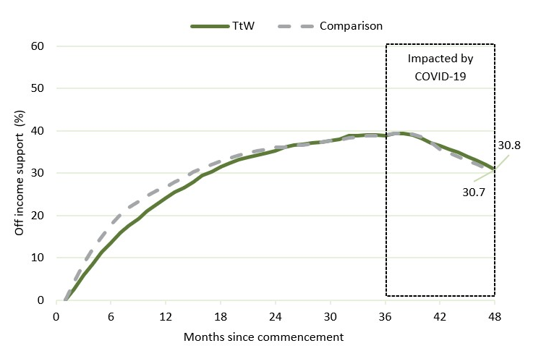
Source: The department’s administrative data
Base: Matched TtW (n=8,361) and jobactive (n=8,361) samples
Note: Off-income support status was based on exits from income support for ‘employment-related’ reasons
Regression analysis was undertaken to adjust for participant characteristics. TtW participants were 3.7 percentage points less likely to be employed 12 months from commencement in the program than participants in the comparison group, and 1.7 percentage points less likely to be employed at 24 months. However, 36 and 48 months from commencement there is no significant difference between the groups (Table 11).
Table 11: Average change¹ in probability of exiting income support in TtW compared to jobactive, by period after commencement
Period after commencement (months) | Average change in probability of exiting income support in TtW compared to jobactive² (percentage points)
6 | -5.2
12 | -3.7
24 | -1.7
36 | Not significant
48 | Not significant
Base: Matched samples, excluding those with one or more regression model variable with a value of ‘Unknown’ (TtW: n=8,148; jobactive: n=8,130)
1. The ‘average change’ is the difference in probability of the average participant exiting income support in TtW compared to jobactive, adjusted for participant characteristics – that is, the ‘average marginal effect’ of TtW compared to jobactive.
2. Exits from income support only included those which were for ‘employment-related’ reasons.
While there is no data available on the types of work TtW participants exit into, analysis of administrative data showed that approximately 70% of jobactive participants (of any age) who gain employment are employed in casual positions (with approximately 20% gaining full-time positions and 10% gaining part-time positions). This goes some way to explaining why only 40% of participants from either TtW or the comparison group are off income support at month 36, as they are mainly employed in casual positions which may be unstable, with inadequate pay or hours to enable them to earn enough to completely exit income support.
The initial difference in employment reflects the different focus and services provided by TtW and jobactive. TtW has an intensive focus on supporting participation in activities that build employment readiness and address barriers to employment, in contrast to the strong ‘work first’ focus of jobactive. This is likely to encourage both TtW providers and TtW participants to focus on a range of activities, along with employment-related activities. This could also reduce the time participants have available for searching for and undertaking employment activities.
A comment from a Group 1 participant in interviews reflects this focus:
I’d tell them, like if you need the help, go for it, … there’s a service [TtW] there for you that can, …, they can help you write resumes, they can do like sort of trial things and give me scenarios and things like that in a job interview. If you’re struggling with that, of course go and speak to them. But if you’re looking to try and get a job, … probably not the best place to go. (Participant, NSW metro Aboriginal and/or Torres Strait Islander, Group 1)
The TtW Final Evaluation Report (DESE 2021) proposed that this focus on pre-employment and training was likely to enhance the employability of participants in the longer term. This is not yet evident 3 and 4 years after commencement. While we do not yet see any marked difference in the proportion of participants who are employed at 36 or 48 months, it is possible that individuals are undertaking work that requires more skills or participants are engaging in work that they are more suited to or happier with (with better long-term health and wellbeing outcomes). There is also evidence that the barriers faced by many young people who participate in TtW are significant, require a tailored approach and take time to manage. All providers in interviews spoke about the long-term process involved in supporting a participant with a number of non-vocational barriers to move into work – one such example is provided below.
So, he was living in his car, using a Kmart stovetop for cooking. We helped him with getting food and support from the local communities in the local area, because again, you’d understand the homeless crisis is quite bad everywhere at the moment. […]. So, linking him in with all the support services in that local area. After many weeks, he was able to get accommodation, which we helped with. [… we paid for the car and registration …] We’re helping to support him, we’re not talking [yet] about anything employment or education. We … gave him an aim to get off the streets and be fully supported by Christmas. Does that make sense? That all happened, so great, he was stable. So, he was excited to keep coming in and telling us all this stuff. And staff were able to talk to him then about, great, let’s talk about getting you a job. Imagine what you could do. So [we] talked to local [employers about him], an employer gave him a go and boom. Got a job. So that’s the kind of stuff that we do. (Provider, regional Qld, large size)
Participant program status was also examined. At the 12-month mark, only 32% of the TtW participants remained in TtW, and at the 24-month mark only 5% remained (Figure 27). Those who had not exited income support would have moved to an alternative employment program, usually jobactive. This could have the effect of refocusing participants on job search. While it is not yet apparent that TtW leads to greater employment in the longer term, it appears that the ‘lock-in’ effect of TtW does not have a detrimental effect on participants’ longer-term employment. The proportion of participants ‘not in program’ tracked a similar trajectory as the ‘off-income support’ figures, albeit at a slightly higher proportion
Figure 27: Program types since commencement (TtW cohort)
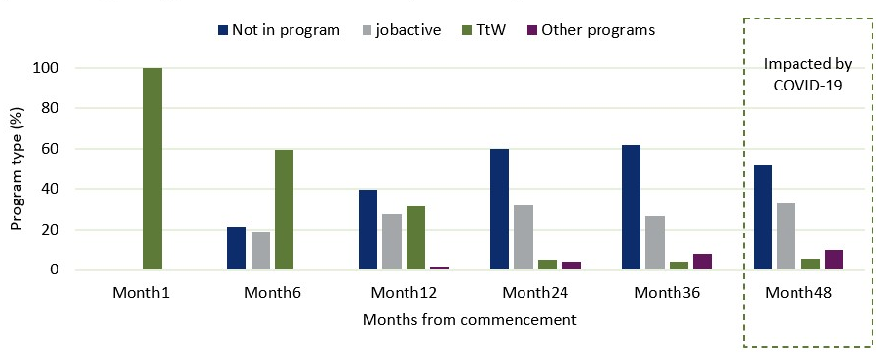
Source: The department’s administrative data
Base: Matched TtW cohort (n=8,361)
Note: Other programs include DESA, DESB and ParentsNext

Labour market attachment
For the matched samples, TtW participants were less likely to increase their LMA over their initial level than the comparison group in any month for the first 2 years, though this difference decreases over time, and appears to equalise at this point. Just over half (56%) of both TtW and comparison group participants demonstrate increased LMA at month 36 (Figure 28).
Figure 28: Proportion of participants achieving LMA (1 to 48 months from commencement)
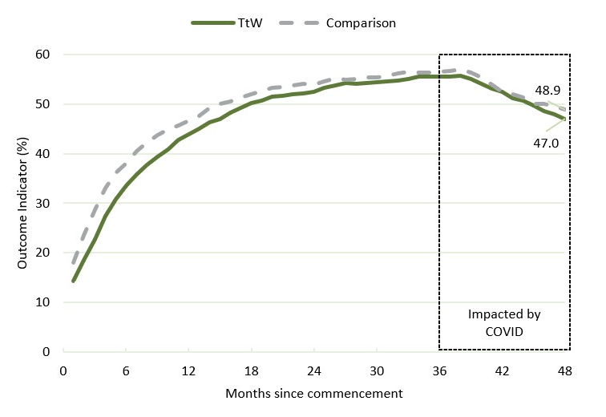
Source: The department’s administrative data
Base: Matched TtW (n=8,361) and jobactive (n=8,361) samples with full income support rate
Note: Includes ‘employment-related’ income support exits, reductions in income support, and earnings. A reduction in income support occurred when a participant recorded a rate lower than the initial rate on the first day of the month. Initial base rate is the highest base rate of income support received by a participant in the first 2 months following their commencement.
Regression analysis was undertaken to adjust for participant characteristics. TtW participants were 3.1 percentage points less likely to demonstrate increased LMA 12 months from commencement in the program than participants in the comparison group, and 2.1 percentage points less likely to demonstrate increased LMA at 24 months. However, at 36 months from commencement there is no significant difference between the groups. At 48 months (after COVID-19 had impacted all participants) TtW participants were 2.0 percentage points less likely to demonstrate an increased LMA on their original level of LMA than participants in the comparison group (Table 12).
Table 12: Average change¹ in probability of reducing income support reliance (increased labour market attachment) in TtW compared to jobactive, by period after commencement
Period after commencement (months) | Average change in probability of reducing reliance on income support in TtW compared to jobactive² (percentage points)
12 | -3.1
24 | -2.1
36 | Not significant
48 | -2.0
Base: Matched samples, excluding those with one or more regression model variable with a value of ‘Unknown’ (TtW: n=8,148; jobactive: n=8,130)
1. The ‘average change’ is the difference in probability of the average participant reducing reliance on IS in TtW compared to jobactive, adjusted for participant characteristics – that is, the ‘average marginal effect’ of TtW compared to jobactive.
2. Reduced reliance on income support is flagged when a participant demonstrates one or more of the following: reductions in a participants’ income support rate, reduction in reported earnings and/or exits from income support for an ‘employment-related reason’.

Number of income support episodes
As can be seen in Figure 29, there is very little difference between TtW participants and the comparison group regarding the number of episodes of income support participants experience. Just over half of the TtW participants have one income support episode (53.6%) and just under a third (32.7%) experience 2 episodes.
Figure 29: Income support episodes per participant, as at 48 months post commencement
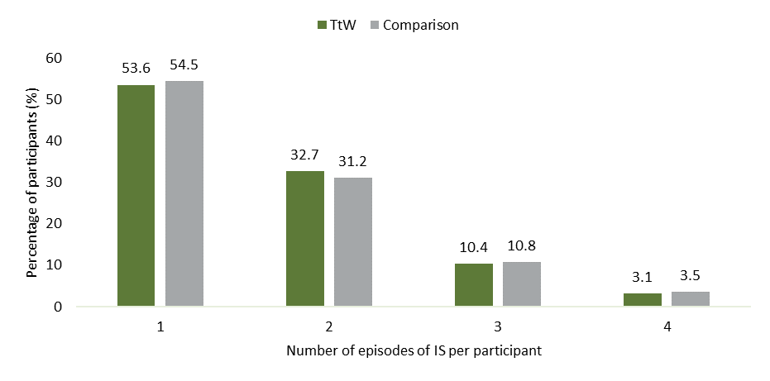
Source: The department’s administrative data
Base: Matched TtW (n=8,361) and jobactive (n=8,361) cohorts

Full-time accredited study or apprenticeships
While the proportion of participants in either TtW or the comparison group receiving student payments at any time is small, fewer of the TtW participants are on a student payment one month from commencement. There is a much stronger increase in student payments for the comparison group participants in the first 6 months from commencement (at 6 months TtW 4.5%, comparison 8.4%). The proportion of the TtW participants receiving student payments continues to rise slowly to 12 months, where it then remains fairly steady for the next 12 months, while the proportion of comparison group participants falls gradually from 6 months onwards. By month 36, fewer TtW participants (by 2.5 percentage points) are receiving a student payment than the comparison group (TtW 3.1%, comparison 5.5%) (Figure 30).
Figure 30: Proportion of participants on student payments (%) (includes Youth Allowance (Student), Youth Allowance (Apprenticeship), ABSTUDY, Austudy) (1 to 48 months from commencement)
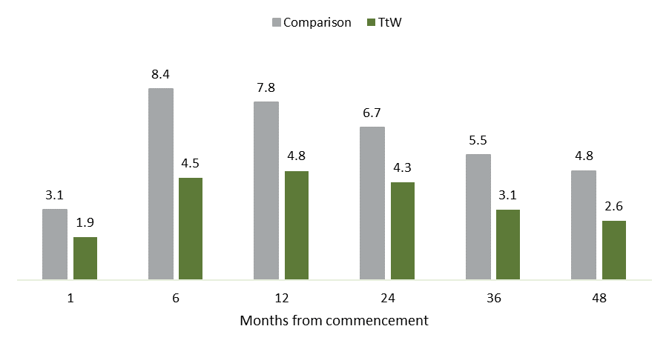
Source: The department’s administrative data
Base: Matched TtW (n=8,361) and jobactive (n=8,361) samples
Note: Participants are not required to participate in employment services when they move on to Youth Allowance (Student), Youth Allowance (Apprenticeship), ABSTUDY or Austudy
The TtW Final Evaluation Report (DESE 2021) reported that TtW achieved almost double the number of study outcomes for its participants than did jobactive over the first 12 months from commencement and was more effective than jobactive at encouraging female participants to undertake training or education. It appears that this may not translate into full-time accredited study that would make participants eligible to receive study-related income support payments.
This pattern is not surprising given the focus of TtW on promoting completion of Year 12 education and training that targets specific skill sets required for work. In addition, compliance mechanisms in jobactive may cause a stronger ‘deterrence effect’ for jobactive participants, which may motivate jobactive participants to choose to study or enter an apprenticeship with greater urgency. It is interesting that the TtW participants appear to have a slightly higher rate of ‘sticking’ with their study than jobactive participants, with the proportion of participants on a study payment remaining relatively steady from 6 to 24 months, while the proportion of jobactive participants shows a steady decline after a large increase by month 6.

Impact of COVID-19 pandemic
The COVID-19 pandemic pushed participants from both TtW and jobactive out of the labour market and back on to income support. In both the TtW and jobactive samples, there was a 20% drop in the number of participants who were in employment between month 36 and month 48 (from Figure 26). There was a slightly smaller impact on LMA, with a 16% drop in the number of participants who had increased LMA between 36 months and 48 months. This compared to a 12.5% drop in the number of participants who had increased LMA between 36 months and 48 months for the comparison group (from Figure 27). This could indicate that while a proportion of people lost all employment, others were able to maintain work but with reduced hours or wages. It also implies that the jobactive comparison group may have had a slightly higher degree of employment resilience.

Long-term impact for participants of different equity cohorts
The relative long-term impact of TtW on employment for individuals from different equity cohorts – young people who are female, Aboriginal and/or Torres Strait Islander, have a disability, have not completed Year 12 and/or have poor or mixed English language competency – was also explored. The analysis examined the proportion of TtW and comparison group participants from each equity cohort who were off income support for an employment-related reason 6, 12, 24, 36 and 48 months from commencement. Regression analysis was used to examine the relative impact of TtW on participants from these cohorts, holding other characteristics constant.
Over the longer term (24, 36 and 48 months) there was no significant difference in employment between TtW and jobactive participants from any of these cohorts (Table 13). In line with results for the population as a whole, jobactive was more effective than TtW at moving young people with any of these specific characteristics into employment at 6 months (and for women, jobactive was also more effective at moving them into employment at 12 months).
Table 13: Average change¹ in probability of TtW participants exiting income support² compared to jobactive, by participant characteristic (percentage points).
Months from commencement | Female | Aboriginal and/or Torres Strait Islander | Disability³ | Early school leaver⁴
6 | -4.9 | -2.1 | -3.18 | -6.19
12 | -4.7 | NS | NS | NS
24 | NS | NS | NS | NS
36 | NS | NS | NS | NS
48 | NS | NS | NS | NS
Base: Matched samples, excluding those with one or more regression model variable with a value of ‘Unknown’ (TtW: n=1,864; jobactive: n=1,856)
NS = no significant difference
1. The ‘average change’ is the difference in probability of the average participant exiting income support in TtW compared to jobactive, adjusted for participant characteristics – that is, the ‘average marginal effect’ of TtW compared to jobactive.
2. Exits from income support only included those which were for ‘employment-related’ reasons.
3. Identifying participants who have a disability is challenging, not least because the Job Seeker Classification Instrument (JSCI) which is used to identify ‘disability’ relies on voluntary disclosure. The question asked in the JSCI relates to a participant having a disability and/or medical condition at that time which affects their work capacity. That is, the data does not indicate if they do have a disability, but rather, if they believe that their ability to work is affected due to a disability and/or current medical condition.
4. Participants who had not completed Year 12 at commencement.
While not surprising, it should be noted that for all of these characteristics, in both the TtW cohort and the comparison group, the respective less disadvantaged cohorts (non-Indigenous, male, good English, no disability, Year 12 or more) had higher exits from income support than the more disadvantaged (Indigenous, female, poor English, disability, less than Year 12) from 1 to 48 months. As an example, the proportion of participants off income support at 36 months, just before COVID-19 and at the point of highest participant off income support rates, is presented in Table 14.
Table 14: Proportion of participants off income support at 36 months, by participant characteristic and program (%)
Characteristic | TtW | Comparison
 | % | %
Female | 31.4 | 33.3
Male | 45.5 | 44.9
Aboriginal and/or Torres Strait Islander | 28.7 | 27.2
Non-Aboriginal and/or Torres Strait Islander | 42.4 | 42.9
Poor/mixed English | 23.3 | 30.1
Good English | 40.5 | 40.5
Disability | 27.6 | 30.3
No disability | 40.3 | 40.2
Education level at commencement: under Year 12 | 35.7 | 33.3
Education level at commencement: Year 12 and above | 46.9 | 51.2
Source: The department’s administrative data
Base: TtW n=8,361, jobactive n=8,361
Sample sizes for each characteristic were respectively:
TtW Male (n=4,671) and jobactive Male (n=4,333), TtW Female (n=3,690) and jobactive Female (n=4,028)
TtW Indigenous (n=1,922) and jobactive Indigenous (n=1,925), TtW Non-Indigenous (n=6,439) and jobactive Non-Indigenous (n=6,436)
TtW Under Year 12 (n=5,528) and jobactive under Year 12 (n=5,528), TtW Year 12 and over (n=2,764) and jobactive Year 12 and over (n=2,764)
TtW disability (n=675) and jobactive disability (n=740), TtW no disability (n=7,686) and jobactive no disability (n=7,621)
TtW poor/mixed English (n=576) and jobactive poor/mixed English (n=979), TtW good English (n=7,785) and jobactive good English (n=7,382)
Note: Employment status was based on exits from income support for ‘employment-related’ reasons

Other longer-term trends

Movement between income support payment types
Participants in TtW could be receiving one of several different income support payment types. As shown in Figure 31, one month after commencement, 96% of the TtW participants were receiving Youth Allowance (Other), 2% were on a student payment, 1% were receiving JobSeeker Payment, and a very small proportion were receiving Parenting Payment or other payments such as the Disability Support Pension. Over the study period there was a steady movement of participants off Youth Allowance (Other) (YA(O)), with only one-quarter (24%) of TtW participants on YA(O) at 36 months. Almost half (46%) of the TtW participants were off income support by month 36. There was also a steady increase in the number of TtW participants who become parents, with almost 1 in 10 (9%) on Parenting Payment by month 36.
Interestingly, further analysis of the data demonstrated that about one-fifth of participants left income support within the first 12 months and had not re-entered income support by month 36. Another 15% did not exit income support at all between commencement and 36 months. The remainder moved between different payment types or on and off income support.
Figure 31: Proportion of TtW participants on each income support payment type (months from commencement)
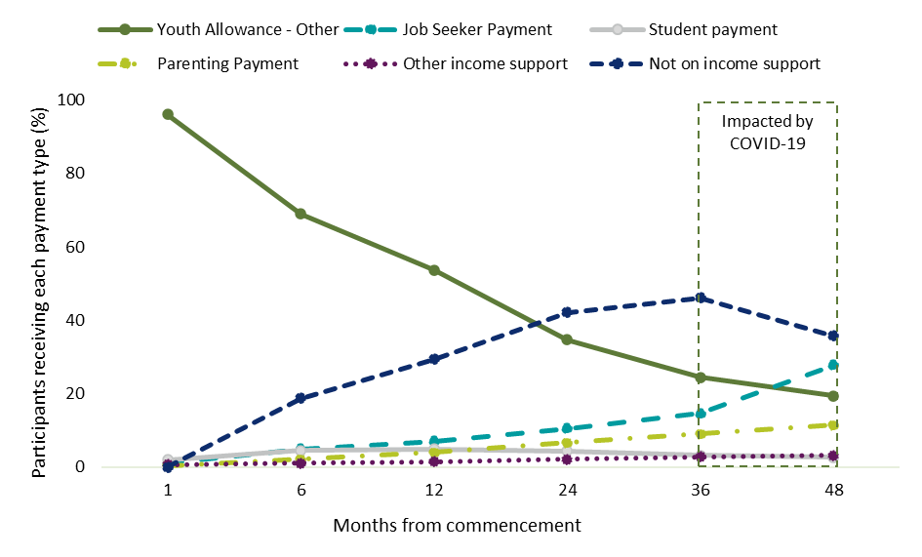Source: The department’s administrative data
Base: TtW (n=8,361)
Note: Student payment includes Youth Allowance (Student), Youth Allowance (Apprenticeship), ABSTUDY, Austudy
These patterns are very similar for jobactive participants, while there are slight differences in the size of movements. By month 36:
42% of the TtW participants are on Youth Allowance (Other), JobSeeker or ‘Other’ income support payments, compared to 38.2% of the jobactive participants
a similar proportion are off income support (TtW 46.1%, jobactive 46.9%)
a similar proportion are on Parenting Payment (TtW 9.0%, jobactive 9.4%)
more jobactive participants are receiving a student payment (TtW 3.1%, jobactive 5.5%).

Relationship between income support and employment services
It is interesting to examine the relationship between participants receiving income support and participating in employment services (Figure 32). At month 0, all participants in both programs are on income support and in employment services. Within the first 12 months there is a solid decrease in the number of people from both programs on income support and in employment services, but approximately 10% of participants leave employment services but remain on income support (moving to an income support payment that does not require them to participate in employment services, including student payments, Parenting Payment (excluding those eligible for ParentsNext), or Disability Support Pension). By 36 months this gap has widened slightly to 15.6 percentage points for TtW and 12.7 percentage points for jobactive.
Figure 32: Proportion of participants on income support and in employment services (months from commencement)
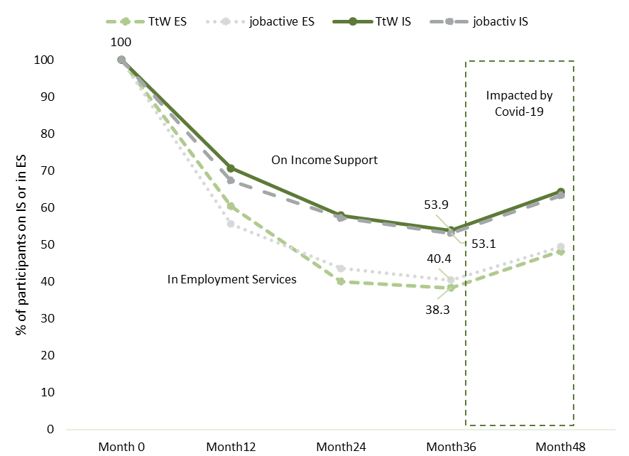Source: The department’s administrative data
Base: Matched TtW (n=8,361) and jobactive (n=8,361) samples
Note: Employment services include jobactive, TtW, ParentsNext, DESA and DESB. There may be other smaller employment services not captured in this analysis.

Conclusion
Participation in TtW resulted in TtW participants achieving the same degree of employment, labour market attachment and reduced income support reliance over the longer term (3 to 4 years) as was achieved by the matched comparison group. Thirty-six months after commencement, approximately 2 in 5 (39%) of the participants from both TtW and the comparison group were in employment and just over half (56%) had increased LMA. The COVID-19 pandemic (which began to affect some participants 36 months from commencement) pushed participants from both TtW and the comparison group out of the labour market and back on to income support.
Similarly, TtW participants from different equity groups were no more, or less, likely than similar participants from the comparison group to be employed over the longer term (24, 36 and 48 months). In line with results for the population as a whole, young people with any of these specific characteristics from the comparison sample were more likely to be employed 6 months from commencement (and women from the comparison group were more likely to be employed at 12 months).
It appears that while only a small proportion of participants from TtW or the comparison group entered full-time study or a full-time apprenticeship within 4 years from commencement, slightly fewer TtW participants took this pathway (at 36 months, 3.1% of TtW participants and 5.5% of the comparison group were receiving a study-related income support payment.) However, TtW participants who did take up full-time study or an apprenticeship appear to have remained in study for a longer period.

– What was the impact of extending the maximum duration of service from 12 to 18 months?

Introduction
This chapter examines the impact of the policy change that came into effect on 1 July 2020 which enabled TtW providers to continue delivering intensive servicing beyond 12 months and for up to 18 months to young people who needed ongoing assistance, even if they were not tracking to an outcome. It was expected that this change would help more young people to achieve better results, by keeping them connected to their TtW service provider with whom they have an established relationship and who understands their needs.
Administrative data was used to examine the effect that increasing maximum service duration had on the time participants spent in the program, and the number and type of employment and education outcomes they achieved. To do this, outcomes from 2 matched samples of TtW participants (participants who were eligible for a maximum of 18 months of servicing (MD18) were compared to participants eligible for a maximum of 12 months (MD12). These participants were followed for a minimum of 27 months. Data was also collected from providers and participants through interviews and surveys undertaken approximately 18 months after the change came into effect. It was not possible to quantify the impact of this change on participants’ work readiness, human capability or wellbeing.

Impact of changing maximum program duration on participant outcomes

Time in program
It was expected that increasing the maximum duration of service would increase the proportion of participants who stayed in the program for over 12 months. Figure 33 shows the total time that participants were in the program (defined as the period of service, or POS).
With the increase in maximum duration of service from 12 to 18 months, the proportion of participants remaining in the program for over 12 months more than doubled (from 23.3% to 49.7%).
It is interesting to note that a similar proportion of participants stayed in the program beyond their maximum allowed service period (23.4% with POS over 12 months in the MD12 sample and 23% with POS over 18 months in the MD18 sample). Participants who were progressing towards an outcome when the maximum service time was reached were allowed to remain in the program to complete the outcome, which likely explains this ‘overstay’.
Figure 33: Proportion of participants with a period of service that is <12 months, 12–18 months, and >18 months, matched samples: maximum duration 12 months (MD12) and maximum duration 18 months (MD18) (% of participants)
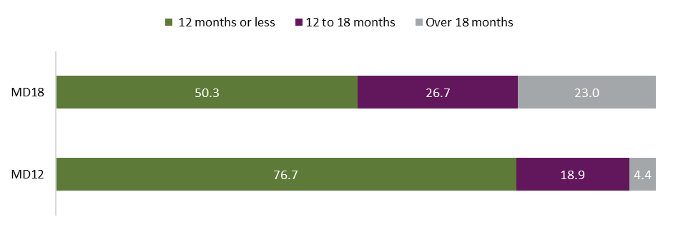Source: The department’s administrative data
Base: Matched before duration change (n=30,045) and after duration change (n=30,045) participants
Note: MD12 – 23,046 participants had POS <12 months, 5,692 had POS 12–18 months, and 1,307 had POS >18 months, MD18 – 15,118 participants had POS <12 months, 8,019 had POS 12-18 months, and 6,908 had POS >18 months
It appears that the increase in the proportion of participants taking advantage of the longer maximum duration was not related to participants’ labour market disadvantage (determined by participant JSCI score).
Figure 34 presents the proportion of participants with high versus moderate labour market disadvantage remaining in the program for less than 12 months, 12–18 months or more than 18 months for both the MD12 and MD18 cohorts.
Both participants with high levels of labour market disadvantage and those with moderate labour market disadvantage took advantage of the extension, with participants from both categories remaining in the program for longer after the maximum duration increased. About half (52% of participants with high disadvantage, and 49% of those with moderate disadvantage) remained in the program for 12 months or more. A slightly higher proportion of participants with higher labour market disadvantage remained in the program beyond the maximum allowed service period (28% compared to 22%), presumably again due to still progressing towards an outcome.
Figure 34: Proportion of participants with high or moderate/low labour market disadvantage remaining in the program for less than 12 months, 12–18 months or more than 18 months, matched samples: maximum duration 12 months (MD12) and maximum duration 18 months (MD18) (% of participants)

Source: The department’s administrative data
Base: Matched samples: maximum duration 12 months MD12 (n=30,045) and maximum duration 18 months MD18 (n=30,045) participants
Note: Both MD12 and MD18, total participants with a low/moderate JSCI n = 23,332, total participants with high JSCI n = 6,700

Employment and education outcomes
Figure 35 shows the number of outcomes achieved and the number of participants achieving at least one outcome, for the MD12 and MD18 cohorts.
Not surprisingly, more outcomes were achieved by participants who were able to remain in the program for longer, with the MD18 cohort achieving 2,490 more outcomes than the MD12 cohort overall. While there was an increase in the number of participants achieving at least one outcome (542 more MD18 participants achieved any outcome than MD12 participants), about four-fifths (78%) of the increase in outcomes by MD18 participants were extra outcomes achieved by participants who had already achieved an outcome.
The proportion of participants who achieved any outcome rose from 35.5% (MD12) to 37.3% (MD18) (i.e. extending the maximum duration of service by 6 months was associated with 1.8 percentage points more participants achieving at least one outcome).
Figure 35: Numbers of participants who achieved any outcomes, and total outcomes achieved, MD12 and MD18 matched samples
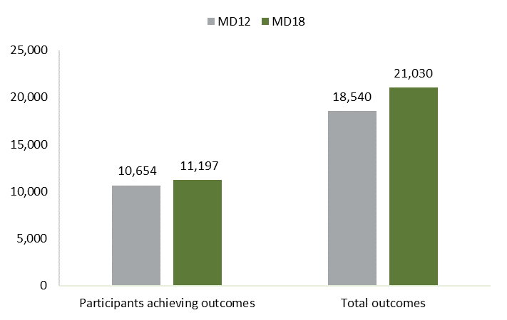
Table 15: Numbers and percentages of participants who achieved any outcomes, and total number of outcomes achieved, MD12 and MD18 matched samples
Sample | Number of participants achieving outcomes | % of participants achieving outcomes | Total number of outcomes
MD12 | 10,654 | 35.5 | 18,540
MD18 | 11,197 | 37.3 | 21,030
Difference | 543 | 1.8 | 2,490
Source: The department’s administrative data
Note: Matched samples MD12 n = 30,045; MD18 n = 30,045
The proportion of participants with ‘high’ or ‘moderate’ labour market disadvantage who achieved at least one outcome is presented in Figure 36. The change in maximum duration of service led to very little difference in the proportion of participants with high labour market disadvantage who achieved an employment or education outcome (MD12 = 27.5%, MD18 = 27.1%).
Figure 36: Proportion of participants with high or moderate labour market disadvantage achieving an outcome, MD12 and MD18 matched samples
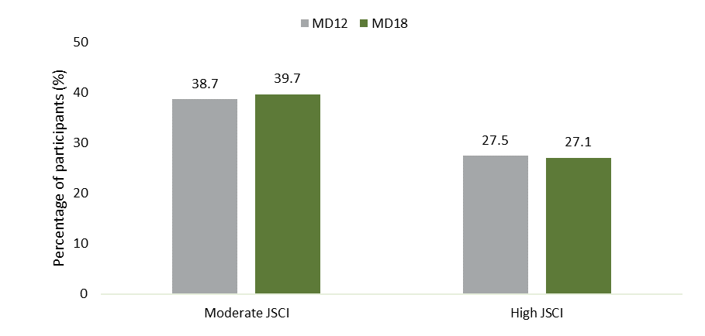
Source: The department’s administrative data
Base: Matched MD12 (n=30,045) and MD18 (n=30,045) participants
Note: Both MD12 and MD18, total participants with a moderate JSCI n = 23,332, total participants with high JSCI n = 6,700
Employment outcomes were the majority (over three-quarters) of all outcomes claimed both before and after the maximum duration of service was increased (MD18, 84.7%; MD12, 77.6%), as shown in Figure 37. The proportion of employment-related outcomes was 7.1 percentage points higher for MD18 participants compared to MD12 participants. This is largely a result of these participants achieving more 12-week employment outcomes. Correspondingly, proportionately fewer MD18 participants achieved education outcomes than MD12 participants.
Figure 37: All outcomes – types claimed by MD12 and MD18 participants (%)
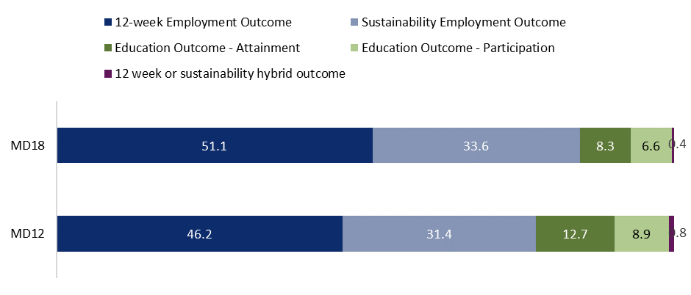Source: The department’s administrative data
Base: Matched MD12 (n=30,045) and MD18 (n=30,045) participants
Note: MD12 total outcomes achieved = 18,540, employment-related outcomes = 14,387, education-related outcomes = 3,999, hybrid outcomes = 154. MD18 total outcomes achieved = 21,030, employment-related outcomes = 17,812, education-related outcomes = 3,132, hybrid outcomes = 86.
Looking at the first outcomes achieved by participants, while employment-related outcomes account for a slightly lower proportion of first outcomes than all outcomes, they also make up the majority of first outcomes for both MD12 (65.2%) and MD18 (74.9%) populations. Proportionately more MD18 participants achieved employment-related first outcomes (9.9 percentage points greater) than MD12 participants, and fewer education-related first outcomes (Figure 38).
Figure 38: First outcomes – types claimed by MD12 and MD18 participants (%)
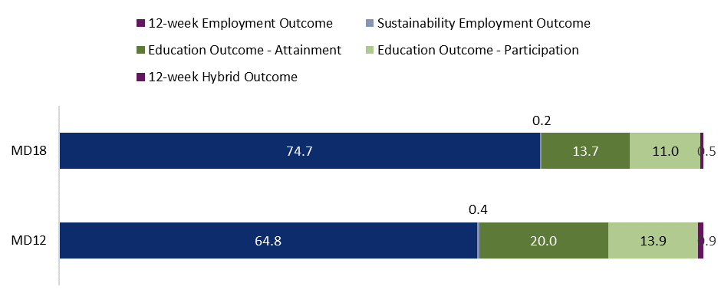Source: The department’s administrative data
Base: Matched MD12 (n=30,045) and MD18 (n=30,045) participants
Notes: MD12 number of first outcomes achieved = 10,654, employment-related outcomes = 6,902, education-related outcomes = 3,616, hybrid outcomes = 136. MD18 number of first outcomes achieved = 11,197, employment-related outcomes = 8,359, education-related outcomes = 2,761, hybrid outcomes = 77. Sustainability outcomes, by definition, come after a 12-week outcome, so should not be identified as a first outcome. The small number of sustainability employment outcomes are due to administrative error.

Provider perspectives
Providers tended to be more optimistic about the positive impact of extending program duration than the above findings describe.
Overall providers who were interviewed felt that the TtW program allowed the time, flexibility and freedom to meaningfully address participants’ barriers and support them in finding appropriate job placements. Providers were pleased to have the additional 6 months to be able to work with participants who needed a longer period of support and felt the longer service duration appeared most important in enabling them to continue to work with participants who either had significant non-vocational barriers that needed addressing before participants could engage with work, or to link those who had undertaken lengthier training courses or study to opportunities to engage with employment. In addition, providers emphasised the broader benefit of the program on participants.
In the provider survey staff were invited to describe the main impacts of the extension on participant outcomes. Most staff (85%) responded, describing a variety of impacts on participant outcomes. While providers felt that extending the program had enabled more employment and education outcomes to be obtained, they also emphasised the broader benefit of the program on participants, including helping participants to work towards longer-term goals, and enhanced human capabilities.
Responses included:
Some education and employment outcomes were likely to be obtained as a result of the extension, especially those who may have had more significant barriers at initial referral
More sustainable outcomes [because of] the ability to work with participants longer
Focus on long-term career paths vs short term solutions
Improved overall wellbeing and motivation as barriers were addressed
Provider responses were categorised and the majority reported that enabling participants to remain in the program for longer would make participants more job ready (69%). They also noted that the extension would enable participants to complete more education or training (45%), find more sustainable longer-term employment (14%) or develop their human capabilities (6%) (Figure 39).
Figure 39: Provider views on the impact of extending maximum service duration on participant outcomes (% of providers)
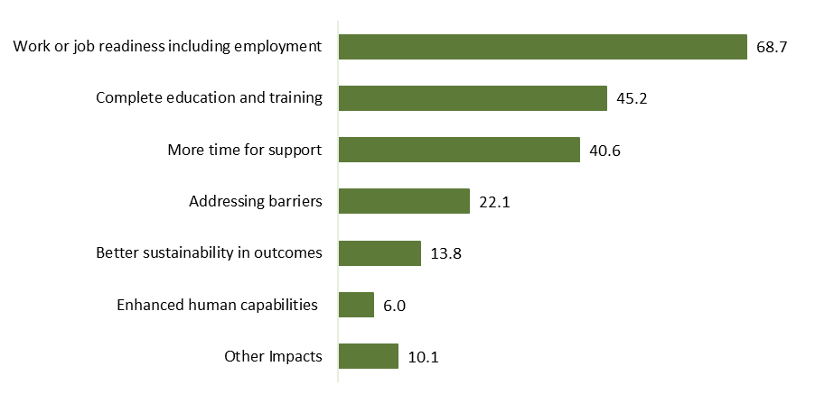Source: Provider survey 2021
Base: Selected respondents who reported an impact in Q8.3 (n=217)
Q8.3 – What were the MAIN impacts of this extension on participant outcomes, including education, employment and other non-vocational outcomes?

Timing of outcomes
As well as examining the impact of the change in maximum service duration on overall outcomes, it is interesting to examine how this change affected the time it took for participants to begin progressing towards their first outcomes.
As shown in Figure 40, while most participants who achieved an outcome began progressing towards this outcome within 12 months of commencing, the change in program duration was associated with a small increase in the number of participants who started progressing towards their first outcome after 12 months (3.4 percentage point increase). It is also associated with a slight reduction in the number of participants who started progressing towards their first outcome within 12 months (1.6 percentage point drop). This might indicate a small change in provider servicing to participants, enabling them to have a longer-term plan with participants.
Figure 40: Start date for first outcome in the program, by proportion of participants, MD12 and MD18 matched samples (%)
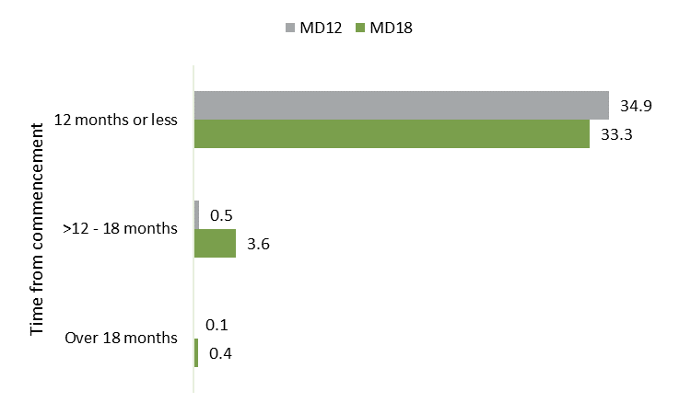
Source: The department’s administrative data
Base: Matched MD12 (n=30,045) and MD18 (n=30,045) participants

Provider views on the impact of increasing program duration on service delivery
In interviews, provider staff mentioned that while they did not feel that the extended time had changed how they managed most of their participants, as noted above, they felt that the longer service duration enabled them to continue to work with participants who either had significant non-vocational barriers or had undertaken lengthier training courses or study.
Providers felt that the extra time meant that those participants were not transitioned to jobactive at the crucial time when they were almost work ready and when caseworkers were poised to set up an appropriate placement. The longer lead time was spent addressing significant non-vocational barriers or undertaking lengthier training courses.
Definitely we like the change because it gives … participants who are most vulnerable in our caseload the opportunity to remain in our service. […] Those most vulnerable can take longer. [Also] those that are studying can complete their study, and then we can work with them to gain employment in the field that they’ve studied. [Before, those who did long-term study] it meant that they used up their whole service with us and then they’d have to go to jobactive. (Provider 6, metro Qld, medium size)
TtW extended the period of service from twelve months to eighteen months. That was really, really critical because twelve months was too short. […] [Before the change was introduced] we’d get to twelve months, and, as you know, back then we had to exit them. Particularly if they weren’t tracking to an outcome. But we had a number of young people, particularly in our Indigenous cohort … that just needed that additional six months. (Provider 10, metro NSW, medium size, TtW + jobactive)
We don’t say that every young person is going to have the 18 months. That’s not feasible. It’s about what is appropriate for that young person, what actually do they need, and where they’re at in that journey. Particularly if they’ve studied something, we find that that extra six months is really important. Because it helps us link their studies and their skills into the labour market. What we have had happen [in the past] is when young people have moved onto jobactive at the 12-month mark and they’ve studied something, they’ve just gone on to study something else, rather than having the time to actually explore and think about, ‘I’ve studied this, what kind of jobs can I have?’ (Provider 4, metro Vic, medium size)
Provider survey respondents were asked an open-ended question regarding the main impacts of this extension on providers’ support to participants at their site. These were categorised, and support findings from provider interviews, including that the extended time allowed providers to continue to provide general ongoing support, including mentoring (61%), more time to address barriers before moving into employment or training (37%), and longer to work on participants’ work readiness and target appropriate employment opportunities (36%) (Figure 41).
Responses included:
More time to address barriers like mental health which can take 6-12 months while still affording time to then move into education or employment
More time to upskill and then support the transition to paid employment
Important for participants to navigate severe non-vocational barriers, and still allow sufficient time to then move beyond the non-vocational to the vocational
Additional time to make sure these young people are work ready and find employment or training that meets their own individual needs
There was some indication from the survey that the change in duration may have changed how providers plan their engagement with participants; for example, one provider noted that they were:
… able to create a plan that allowed participants to follow at a comfortable pace – ensuring the participants stayed engaged and were not discouraged by unattainable goal setting within the 12 months
Figure 41: Provider views on the impact of extending maximum service duration on their support to participants (% of providers)
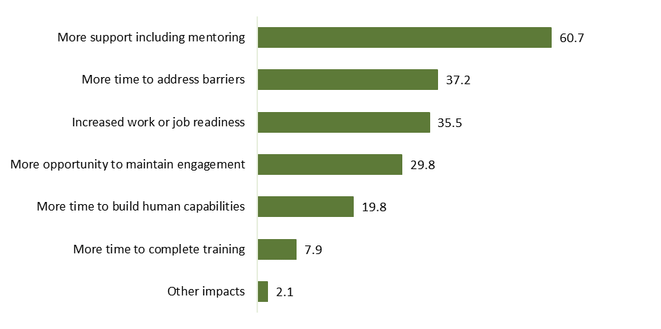
Source: Provider survey 2021
Base: Selected respondents who reported an impact in Q8.2 (n=242)
Q8.2 What were the MAIN impacts of this extension on your support to participants at your site?

Participant perspectives on program duration
Interviews and focus group discussions with participants were undertaken approximately 18 months after the duration change took effect. Most participants were not aware that maximum duration had changed and many participants were unaware of how much time they had left in the program.
When asked about how long the program should be, many participants felt that the program should be available for as long as people needed it or as long as they were engaging and finding it useful, and that a longer program would allow them and other young people to receive more support from their caseworkers, which they valued. Several participants also suggested that there should be no time limit in the program and wanted to be able to continue accessing support into the foreseeable future.
I mean, as long as you can show you’re legitimately trying to get a job and actually putting your best foot forward, then I don’t see why there should be a real limit I guess. […] Like if you’re really just trying your best and yeah, it’d be kind of weird to just cut you off after 12 months, even 18 months. (Participant 1, male, 22+ years old, metro Qld, Group 2)
I’d say as much support as I could get, because I don’t have a lot of people that I know personally – I just know my mum and her friends, I don’t have anyone close that I can reach out and say ‘oh, could you help me get this?’ (Participant 20, male, 16–18 years old, metro WA, Group 2)
I think 18 months is long enough. Most people won’t actually need to be in it for that long. But some people just need reassurance that you’re not going to be kicked out or something like that. I just think that’s a good standard. But I don’t actually really think people would be in it for that long. (Focus group 1, 18–22 years old, Australia-wide, Group 1)
Many participants reported they wanted to be able to stay in the program until they had found stable employment and gained financial independence. Some felt that even if they were employed, they would benefit from having the reassurance and ongoing support from their caseworkers.
I’d like to be on [the TtW program] until I find the stability and financial support and what I need out of it, I guess. Not really a time frame I can say, but for me, I guess yeah, until I reach that point of ‘I don’t need help anymore’. (Participant 18, female, 19–21 years old, metro NSW, Group 1)
Those who had been in the program for longer than 12 months appreciated being able to remain in TtW (though this is not surprising, as if they did not feel remaining was beneficial it is likely that they would have chosen to leave earlier).
Yeah, well I was originally only for 12 months, but then they changed it to 18 months, which is really helps like, the 12 months were ending and I’ve no idea what I was going to do and things like that, but they extended it and I had extra time with my case worker and I’m starting to figure out what I want to do which is really nice. (Participant 29, female, 16–18 years old, regional Qld, Group 2, Indigenous)

Conclusion
Extending the maximum duration of service by 6 months more than doubled the number of people who remained in the program (from 23% to 50%). This was associated with an increase in the total number of outcomes being achieved by participants, most of which were second or third outcomes, and employment-related outcomes. The proportion of participants achieving at least one outcome increased by 1.8% (37.3% of the MD18 participants achieved at least one outcome, compared to 35.5% of the MD12 participants).
While there was an increase in the number of participants achieving at least one outcome, the majority (about four-fifths, or 78%) of the increase in outcomes by MD18 participants comprised extra outcomes achieved by participants who had already achieved an outcome.
Employment outcomes made up the majority (over three-quarters) of all outcomes claimed both before and after the maximum duration of service was increased (MD18, 84.7%; MD12, 77.6%). The proportion of employment-related outcomes was 7.1 percentage points higher for MD18 participants compared to MD12 participants. This is largely a result of these participants achieving more 12-week employment outcomes.
This is consistent with the finding that the increase in the proportion of participants taking advantage of the increase in maximum duration was not related to participants’ labour market disadvantage (determined by participant JSCI score).
These outcomes are in line with provider observations that identified 2 main groups who benefited from the extension in program duration: participants who had significant non-vocational barriers that needed addressing before participants could engage with work, and those who had undertaken lengthier training courses or study and would benefit from further engagement with the program to translate their new skills into employment. While providers felt that extending the program facilitated more employment and education outcomes, they also emphasised the broader benefit of the program on participants, including helping participants to work towards longer-term goals, and enhanced human capabilities. It should be noted that this evaluation was not able to quantify the impact of the change in maximum duration on these broader factors: work readiness, human capability and wellbeing. The high rate of participants who remained in the program for over 12 months after the maximum duration was increased is an indicator that participants are satisfied with and benefiting from the program.

– Does TtW offer value for money?

Introduction
Evidence from the evaluation indicates that TtW participants and providers in general are highly satisfied with the TtW program; however, TtW is considerably more expensive than jobactive because it offers much more intensive and individualised support to participants (DESE 2021). It is important therefore to assess the value for money that TtW provides. To do this, the evaluation team examined benefits and costs related to participation in TtW, in addition to those associated with jobactive. While analysis of the longer-term impact of TtW has been carried out, and informs the discussion regarding the benefits of TtW, a 12-month period was chosen for this value-for-money analysis due to data constraints.
Analyses in the preceding chapters indicate that TtW may be no more effective than jobactive over the longer term at supporting young people to engage with the labour market. It is clear, however, that engagement in TtW leads to a number of other benefits that are highly valued by participants and are likely to have broader personal and social value, namely increased human capabilities, increased wellbeing and reduced incarceration.
While it is acknowledged that many of the non-labour-market benefits associated with TtW are difficult to both measure and value in a robust way, this chapter presents an exploratory attempt at, where possible, expressing benefits and costs in monetary terms so they can be compared.
Section 7.2 outlines the expected impacts of TtW as well as additional benefits and costs in comparison with jobactive, and summarises findings from the value-for-money analysis.
Sections 7.3 to 7.6 present the methodology and findings for valuing increased wellbeing (as a measure of increased human capability) and reduced incarceration attributable to the program, and calculating the additional costs associated with the program relative to jobactive.
While it is relatively straightforward to estimate additional cost of TtW relative to jobactive based on program expenditure, estimating the additional benefits associated with increased wellbeing and reduced incarceration is much more involved, especially with regard to valuing wellbeing. This analysis therefore does not attempt to put a single value on wellbeing; rather it explores several published methods to generate a range of estimated value.
Sections 7.7 and 7.8 present the estimated cost : benefit ratio and conclusions. Appendix 5 contains additional details regarding the methodology used for all elements of this analysis.

Summary: the value for money of TtW
The below tables summarise the expected benefits, additional benefits and additional costs associated with TtW, compared to jobactive. They include indicative monetised costs and benefits of the program where this was possible to estimate, and a summary of other non-monetised costs and benefits discussed in Chapters 4 and 5 of this report. The benefits and costs associated with the TtW program activities were identified through evaluation research.
TtW is a pre-employment program, aiming to assist eligible young people to gain and retain employment (including apprenticeships or traineeships), move into education and/or improve their work readiness. Table 17 outlines the benefits that could be expected from TtW over the longer term. There is no evidence that TtW is more or less effective than jobactive at helping disadvantaged young people move into employment or off income support 3 or 4 years from commencement. While TtW is more effective at supporting participants to undertake training in the shorter term, there is also no evidence that TtW is more effective than jobactive at supporting participants to undertake full-time study. These elements are therefore not included in the value-for-money analysis, as there is no additional benefit accruing to individuals or society from TtW in relation to increased employment or full-time education.
There is evidence, however, that TtW leads to a number of other benefits that are highly valued by participants and are likely to have broader social value, above those achieved by jobactive, as described in Table 18. These include increased human capabilities (including mental health), increased wellbeing and reduced incarceration. Additional costs associated with TtW include a higher cost per participant for service provision, and higher income support payments associated with the lock-in effect of TtW, as outlined in Table 19.
Summarising findings for the value of additional costs and benefits that could be monetised, it is estimated that every dollar spent on TtW (in addition to what would have been spent on a participant if they were in jobactive) has a social value of between $1 and $6. This analysis demonstrated that the value placed on changes in human capabilities and wellbeing attributable to TtW is a determining factor in the analysis of whether TtW offers value for money.
Table 16: Legend for assessment of the conceptual fit of indicators and the quality of data used in Tables 16–18
Target diagram | Type of indicator | Description – assessment of conceptual fit
 | Direct measure | An indicator that measures all of the concept reflected by the theme or element, i.e. a good conceptual fit
 | Partial measure | An indicator that measures part of the concept reflected by the theme or element, where that part is considered significant enough to stand as an indicator for the theme or element as a whole, i.e. a partial conceptual fit
 | Indirect measure | An indicator that measures the concept reflected by the theme or element, while being somewhat conceptually separate from the central idea of the theme or element, i.e. a proxy for the idea, rather than a good conceptual fit (e.g. life expectancy for the health theme – social domain)
Scale diagram | Quality of data source | Description – assessment of quality
 | High quality | The data source rates highly in terms of reliability, currency and methodology
 | Acceptable quality | The data source is acceptable in terms of reliability, currency and methodology
 | Limited quality | The data source is of limited quality in terms of reliability, currency and methodology
Source: 1370.0.00.003 – Information Paper: Measures of Australia’s Progress Proposed Statistical Indicators, 2013 (abs.gov.au)

Table 17: Summary of expected benefits attributable to TtW, calculations and data sources
Expected benefits | Actual benefit | Calculation of the value of the change attributed to TtW (difference between benefits for TtW and comparison group) | Type of indicator | Quality of data source | Source
Improved employment, with resultant increased earnings and reduced unemployment | No statistical difference in employment outcomes between TtW and jobactive participants at 36 or 48 months  It is not clear if TtW has any impact on the type or sustainability of employment | Difference in number of participants exiting income support for an employment-related reason or reducing their reliance on income support  Comparison between TtW and jobactive participants |  |  | Departmental administrative data – long-term impact analysis undertaken for this evaluation
Improved education and skills attainment, with a resultant impact on undertaking more skilled work, likely with resultant higher earnings, in the longer term | TtW participants are slightly less likely to take up full-time study or apprenticeship, but it appears that those who do are slightly more likely to stick with it  Typical participant is 10.6 percentage points more likely to achieve a ‘study outcome’ up to a year after referral if they were in TtW rather than in jobactive | Movement to a study-related income support payment as an indicator of movement to full-time study or apprenticeship over the longer term  Difference in percentage of participants achieving a ‘study outcome’ in the 12 months from commencement |  |  | Departmental administrative data – long-term impact analysis undertaken for this evaluation  TtW Final Evaluation Report (DESE 2021)
Table 18: Summary of additional benefits attributable to TtW, calculations and data sources
Additional benefits | Benefit/financial proxy per participant | Calculation of the value of the change attributed to TtW (difference between benefits for TtW and comparison group) | Type of indicator | Quality of data source | Source
Reduced contact with the criminal justice system | Average savings over 12 months associated with reduced incarceration: $287 per participant  In addition, reducing costs associated with policing, court, legal aid, harm to victims and criminal damage – these have not been included in this analysis and would contribute to an underestimate of overall benefits  Impact on participants associated with not having contact with the criminal justice system is assumed to be included in overall wellbeing outcomes  TtW had a notable impact on reducing recidivism for Aboriginal and Torres Strait Islander and ex-offender participants | Direct savings associated with reduced incarceration  From the sample population of 8,361 participants, reduction in number of incarcerations attributable to TtW = 265 over 4 years  Cost per day to incarcerate individual – $254.84  Average time spent in prison – 142 days  Total savings from reduced incarceration 265 x $254.84 x 142 = $9,589,629  Value saved per person (total savings/number of people in sample) ($9,250,960/8,361) = $1,147 over 4 years  Savings per person over 12 months = $1,147/4 = $287 |  |  | Departmental administrative data – long-term impact analysis undertaken for this evaluation  Productivity Commission (various years) Report on Government Services
Increased human capability, with a likely resultant impact on longer-term employment and earnings, as well as increased personal efficacy, and improved parenting, relationships and engagement in community | Average participant had increased confidence, motivation, resilience and access to the support and services they needed  Impact on participants of increases in these human capabilities is likely to influence overall wellbeing outcomes, so is not valued here to avoid double counting  There is likely to be additional value in increasing an individual’s human capabilities through enhancing their contribution to family, friends and community | Confidence: Caseworker had a positive/very positive impact on confidence – TtW 14 percentage points more likely to agree than comparison group  Motivation: Caseworker had a positive/very positive impact on motivation to work towards your goals – TtW 14 percentage points more likely to agree  Access to required services and supports: Caseworker had a positive/very positive impact on access to the support and services you need – TtW 11 percentage points more likely to agree than comparison group  Resilience: Brief Resilience Score for TtW participants (out of 5) TtW 3.3, comparison group 3.1 |  |  | Survey of representative sample of participants and comparison group undertaken as part of the research for this evaluation
Improved mental health, affecting personal wellbeing and possibly having a positive impact on family and friends  Higher levels of self-reported mental health may also translate into reduced use of mental health services. Given reported insufficient mental health services to meet demand, this may also free up mental health services for others | Typical participant 7 percentage points more likely to report their mental health was ‘excellent’ or ‘very good’  Impact of improved mental health is likely to influence overall wellbeing outcomes, so is not valued here to avoid double counting  - In addition, there are likely to be cost savings associated with reduced demand on mental health services, and possible benefits to family and friends | Improvements in self-rated mental health |  |  | Survey of representative sample of participants and comparison group undertaken as part of the research for this evaluation
Increased personal wellbeing | Average value of increased wellbeing: $3,170 – $20,777 per participant | Participation in TtW increases Personal Wellbeing Index score by 5.5 percentage points over comparison group  Value of increasing PWI by 1 percentage point is $576 – $3,777 per participant assuming wellbeing benefit is maintained for 6 months  Value of increased wellbeing = 5.5 x ($576 to $3,777) = $3,170 to $20,774 per participant |  |  | Survey of representative sample of participants and comparison group undertaken as part of the research for this evaluation  Various academic papers
Estimated monetary value of benefits per participant, 48 months | $3,457 to $21,064 | Sum of benefits per participant | NA | NA | As above
Table 19: Summary of costs attributable to TtW, calculations and data sources
Estimated additional costs | Total cost per participant | Calculation of the cost associated with providing TtW service to one participant over 4 years | Type of indicator | Quality of data source | Source
Expenditure by DESE, additional unit cost for a TtW participant | Average additional cost associated with TtW servicing over 12 months: $3,242 per participant | Average cost per participant  - The final evaluation calculated the average program cost per participant over a 12-month period. This took into account the average time participants spent in either TtW or jobactive or outside employment services  - Unit cost for a jobactive participant: $1,801. Unit cost for a TtW participant: $5,043. Average additional cost per participant over a 12-month period: $5,043 – $1,801 = $3,242 |  |  | TtW Final Evaluation Report, Table 7.4 (DESE 2021)  Departmental administrative data – long-term impact analysis undertaken for this evaluation
Increased income support payments associated with the small lock-in effect of TtW | Average per person cost associated with small lock-in effect of TtW 12 months from commencement: $281 per participant | Average cost/person associated with increased income support payments due to the small lock-in effect of TtW  - Calculated the percentage difference between TtW and jobactive participants in the number of people off income support in any month  - Average per person cost associated with lock-in effect of TtW = [sum of all months in period of (difference between percentage of participants exiting income support in any month from TtW compared to jobactive x the IS rate per month)]/total number of participants in sample. Average monthly difference was determined in the long-term impact analysis. Average monthly income support payment = $1,118  - Average per person cost associated with lock-in effect of TtW, at 48 months from commencement: $1,123  Additional cost per person over 12 months = 1,123/4 = $281 |  |  | Departmental administrative data – long-term impact analysis undertaken for this evaluation
Other monetary and non-monetary costs | Assumed similar for TtW and jobactive | Participant costs, including transport and phone costs, and time  Employer time | NA | NA | Not estimated
Estimated cost per participant, 12 months | $3,523 | Sum of costs per participant | NA | NA | As above

Valuing benefits associated with increased human capabilities and wellbeing
As discussed in Chapter 3, TtW led to an average increase in participants’ human capabilities relative to the comparison sample from jobactive, including their confidence, motivation, resilience, mental health and sense of empowerment. TtW participants were also more likely to have higher self-assessed life satisfaction and wellbeing than jobactive participants.
Research (presented in Section 1.4) has demonstrated that human capability factors are linked to and influence wellbeing. For this reason, rather than attempting to value each of these different elements, which are interrelated and correlated, change in wellbeing is used as an overarching and composite indicator of the impact of TtW on the human capabilities of participants. This decision is in line with other research that attempts to value non-monetary benefits that impact wellbeing; this is discussed below (Section 7.3.1).
This section provides an overview of the debate around using wellbeing and describes the methodology used in this analysis to place a monetary value on wellbeing. This includes:
discussing the appropriateness of and methodologies for valuing wellbeing
establishing the impact of TtW on wellbeing
calculating the value of changes in wellbeing
estimating the monetary value of changes in wellbeing resulting from participation in TtW per participant.

The appropriateness of and methodologies for valuing wellbeing

International measures of wellbeing
How to value wellbeing has been a focus of discussion by academics and policymakers for over 20 years. While a number of governments (including the New Zealand and New South Wales governments) acknowledge the importance of valuing wellbeing, there is limited agreement on the ideal methodology either in the public sector or in academic research. Methods such as revealed preferences and stated preferences have been used to value changes in certain wellbeing outcomes, but the reliability of these methodologies to value changes in overall wellbeing has been questioned as they often lead to inflated values (see Fujiwara 2013). The UK Treasury has produced a wellbeing discussion paper (HM Treasury 2021a) and supplementary guidance (HM Treasury 2021b) outlining its rationale and agreed methodology for evaluating wellbeing, which also includes a comprehensive review of approaches. Key approaches outlined in the discussion paper (HM Treasury 2021a) present opposing views:
approaches that argue against the monetisation of wellbeing, preferring to rely on the description of outcomes, or describing and using measures of specific outcomes where this is appropriate (for example, improvements in mental health)
approaches that translate a change in wellbeing or life satisfaction to a robust monetary value that can be used as part of a social cost-benefit analysis.
The first set of approaches argue that wellbeing impacts cannot credibly be combined into a single measure that can be monetised, and instead should be described, quantified where possible, and communicated alongside the costs of policies to inform decision-making. The research undertaken for this evaluation demonstrates the multidimensional nature of wellbeing, and the interrelationships between factors influencing wellbeing.
The second set of approaches all (HM Treasury 2021a):
… assume that measures of life satisfaction and other subjective wellbeing measures are good proxies for an individual’s underlying utility. [noting] If policy change X leads to Y change in wellbeing, and Y change in wellbeing can be valued as $Z (through using an appropriate, evidence-based conversion value) then policy change X leads to a Y change in wellbeing valued at $Z.
Under the assumption that subjective wellbeing is a good proxy for underlying utility, estimation of the value of changes to wellbeing attributable to a policy change or program requires 3 steps (HM Treasury 2021a, Australian Social Value Bank n.d.):
evidence of robust causal wellbeing impacts – establishing the change in subjective wellbeing attributable to the program (number of units change) (a)
calculating the monetary amount that an average (relevant) person would require to increase their subjective wellbeing by one unit (b)
calculating the value of this change in wellbeing (a x b).
The UK Treasury (2021a) discussion paper notes that while there are several ways to estimate wellbeing impacts, including through cross-sectional regression and econometrics techniques, it recommends the use of ratified tools that directly quantify changes in ‘life satisfaction’ or wellbeing where possible.

Measuring the wellbeing of TtW participants
This evaluation acknowledges the validity of the first set of approaches, and this has been adopted as a default approach by this evaluation. Analysis in this section, however, attempts to explore further the feasibility of expressing benefits and costs in monetary terms so they can be compared. Research in this section therefore follows the lead of the UK Treasury and uses an approach fitting into the second set of approaches. The arguments emphasising difficulties with using a single measure clarify the need to additionally assess the different factors and describe how different groups may be affected differently, how context matters, and why wellbeing is high or low. Chapter 3, provides this more nuanced and detailed analysis, while general outcomes are summarised in this section.
The UK guidelines for valuing wellbeing (HM Treasury 2021b) note that some factors are likely to directly increase wellbeing (for example, there is evidence that being employed is strongly associated with higher levels of wellbeing, and someone who is employed and likes their job is likely to be happier still) while other factors can be interrelated in different ways. Some factors can be positively or negatively reinforcing. For example, stronger networks can help someone find a job and being in work can support social connections and build confidence contributing to greater wellbeing; alternatively, poor mental health can decrease employability, which in turn increases isolation et cetera, further reducing wellbeing. Positive and negative wellbeing factors can also neutralise each other – for example, lack of success in finding work can negatively impact on confidence, while having someone to talk to and feeling listened to around this situation can build resilience. This supports the use of an overarching subjective wellbeing indicator to value changes that affect a range of factors (rather than attempting to value factors individually). To value the human capability benefits associated with TtW overall, this research therefore uses wellbeing as an overarching and composite indicator of the impact of TtW.

Establishing the impact of TtW on wellbeing
Changes in wellbeing that can be attributed to TtW were established through the 2021 TtW participant survey using a recognised tool (the Personal Wellbeing Index (PWI) (International Wellbeing Group 2013)) discussed in detail in Section 2.4.2.
Overall, TtW participants in the participant survey had an average PWI of 71.1 out of 100. The comparison group scored an average of 65.6. An improvement in subjective wellbeing of 5.5 points can be attributed to participation in TtW. This data was collected at a point in time, but it is assumed that the increase in wellbeing attributable to TtW remains relevant for 6 months. As noted previously, this finding also assumes there was no selection bias between these 2 groups, as discussed in Section 2.4.

Calculating the value of changes in wellbeing
As noted above, different measurement techniques and contexts result in different values being calculated for the monetary value of changes in wellbeing. The benefit of an additional unit of wellbeing to an individual has also been shown to depend on their original level of wellbeing, and the direction in which the wellbeing is moving (a loss in wellbeing has been shown to have a higher ‘cost’ than the value of the same size increase in wellbeing). To estimate the value of the change in wellbeing, this research undertook a literature review to identify recent studies that attempt to value changes in wellbeing (summarised in Appendix A5.2), and these values were used to determine a range in the value of wellbeing changes. Table 20 presents a summary of values identified from these sources.
Table 20: Values ascribed to a one-point change in wellbeing (10-point scale)
Author | Value associated with a one-point change in wellbeing (10-point scale, 2020 dollars)ª
UK Treasury (2021a) | $5,764/person/6 months
Stanley et al (2021) | $28,623/person/6 months
Cummins et al (2021) | $36,590/person^{b}
Biddle et al (2020) | $37,765/person/6 months
Notes:
a All amounts were converted to 2020 dollars. To convert to 2020 dollars: $ amount x end period CPI/initial period CPI. Data sourced from Consumer Price Index (CPI) rates | Australian Taxation Office (ato.gov.au). Annual CPI calculated as average over the 4 periods.
b Transposing the percentage point change into a 10-point scale for equivalence.
This research presents the value of wellbeing as a range, taking into account the highest and lowest values for changes in wellbeing identified in the literature.

Estimating the monetary value of changes in wellbeing attributable to TtW
Using the PWI results from the 2021 TtW participant survey and the methodology presented above, the value of improved wellbeing that may be attributable to TtW was estimated to be between $3,170 and $20,774 per TtW participant, as outlined in Table 21.
Table 21: Estimated value of improved wellbeing attributed to TtW, per person
Attribute | Value
TtW PWI | 71.1 points
Comparison group PWI (jobactive participants) | 65.6 points
The impact of TtW on participants’ subjective wellbeing (SWB)  (TtW PWI – comparison group PWI) = per person wellbeing impact | 5.5 points
Value of increasing SWB by 1 percentage point (100-point scale) – range | $576 – $3,777
Value of increased wellbeing attributable to TtW per participant  5.5 x ($576 or $3,777) = $3,170 to $20,774 | $3,170 – $20,774
Source: Participant survey 2021; UK Treasury (2021a), Biddle et al (2020)

Valuing savings associated with reduced offending
The TtW program has been shown to have led to fewer young people being incarcerated, and lower reoffending rates of participants (see Chapter 4) compared to the comparison group. This will lead to direct savings in the criminal justice system through fewer people spending time in prison, and reduced costs associated with policing, court and legal aid, as well as reduced harm to victims and criminal damage. There are also likely to be strong benefits to the individuals who were supported to stay out of contact with the criminal justice system. To more reliably estimate the value of the benefit over 12 months, the benefit has been valued over 4 years, then divided by 4.
The analysis was limited to the direct cost savings associated with reduced incarceration rates. It is not possible to reliably apportion the reduced cost of policing expended on youth from the criminal justice system (Bratanova et al 2014), and similarly difficult to estimate the reduced cost of court and legal aid services, or the value of reduced harm to victims and reduced criminal damage associated with youth justice in any reliable manner. These benefits have not been included in this analysis but should be noted as additional benefits. The value attached to reducing contact with the criminal justice system is therefore an underestimate.
It is also likely that reduced contact with the criminal justice system will have a positive impact on the wellbeing and human capabilities of participants. This is a complex relationship, as improved confidence, resilience, employability and connection are likely involved in reducing contact with the criminal justice system, and reduced contact with the criminal justice system is likely to further enhance these human capabilities and overall wellbeing. It is therefore assumed that the positive impact of reduced contact with the criminal justice system will influence overall wellbeing, and any change in wellbeing will be captured in the wellbeing analysis.
To estimate the savings associated with reduced offending attributable to TtW we:
determined the number of nights of incarceration that were avoided due to TtW participation
estimated the cost per person per night for incarceration
estimated the total amount saved from reduced incarceration
calculated the savings per TtW participant.

Nights of incarceration that were avoided due to TtW participation
In order to calculate the number of nights of incarceration that were avoided through participation in TtW, the matched samples of participants from TtW and the comparison group who were referred between 1 April 2016 and 31 March 2017 were utilised (see Section 2.4.3 for details about this population), followed from commencement for 48 months. The department’s administrative data was used to establish the number of episodes of incarceration and the average length of time (days) spent in prison. This assumes that the impact of incarceration rates is a result of the program and not of unmeasured differences between the TtW and comparison groups.

The number of episodes of incarceration
TtW participants were less likely to experience incarceration than participants from the comparison group (421 versus 516) (Table 22). There were also fewer total episodes of incarceration in the TtW sample (760) compared to the comparison group (1,025). These results are used to estimate the number of incarcerations that were avoided due to TtW program activities. It is estimated that in the absence of TtW program interventions, from the sample of 8,361 participants, a total of 1,025 incarcerations would have occurred, compared to the 760 incarcerations that did occur. It is therefore assumed that, for the 8,361 participants, 265 incarcerations were avoided due to the TtW program over a 4-year period.
Table 22: Incarceration (number of individuals and episodes), by program
Program | Number of participants  # | Number of participants  % | Episodes of incarceration  #
Comparison group | 516 | 6.2 | 1,025
TtW | 421 | 5 | 760
Difference | 95 | 1.2 | 265
Source: The department’s administrative data
Base: Matched sample: TtW (n=8,361) and jobactive (n=8,361)
Note: Incarceration within 48 months from participant’s commencement date

Average length of time (days) spent in prison
The department’s administrative income support data was again used to estimate the average duration of each prison stay. The average number of prison days for both TtW and comparison group participants was almost identical: TtW 142.2 days versus comparison group 142.0 days.
An average duration of 142 incarceration days was used in our calculations of cost savings from reduced incarceration.

Cost per person per night of incarceration
The Productivity Commission’s Report on Government Services (Productivity Commission 2017 to 2022) provides data on the cost of corrective services for both adults and youth. Daily rates are significantly higher in youth detention (average daily rate between 2016 and 2021 was $1,835/person/day). Departmental administrative data demonstrated that the majority of participants incarcerated from both TtW and jobactive were over 18 years at the time of commencement. To simplify this analysis, and ensure overclaiming was avoided, the average adult net real operating expenditure for adult prisoners of $254.84/person/day (average 2016–17 to 2020–21) is used. Real net operating expenditure does not include capital costs – i.e., the additional cost associated with housing and servicing a prisoner for one day.

Total value of savings from ‘avoided’ incarceration
The estimated saving from reduced incarceration attributable to TtW is $1,147 per TtW participant, as outlined in Table 23.
Table 23: Estimated cost savings due to reduced incarceration attributed to TtW, per person
Attribute | Value
TtW participants in matched sample | 8,361 participants
Reduction in number of incarceration episodes attributable to TtW for TtW participants in matched sample  = (TtW number of incarceration episodes minus comparison group number of incarceration episodes) | 265 fewer episodes
Average number of days in prison per incarceration | 142 days
Cost of imprisonment | $254.84/day
Total cost savings from reduced imprisonment (# incarceration episodes x # days per episode x $/day)  = (265 x 142 x 254.84) | $9,589,629
Cost savings associated with reduced incarceration, per TtW participant in matched sample  = (# incarcerations x days in prison x daily cost of imprisonment)/total population  = $9,589,629/8,361 | $1,147 per participant over 4 years, or $287 per participant over 12 months
Source: The department’s administrative data; Productivity Commission (various dates) Report on Government Services

Calculating the cost of servicing one participant in TtW
The final evaluation calculated the average program cost per participant over a 12-month period in 2021 dollars. This took into account the average time participants spent in either TtW or jobactive or outside employment services. The unit cost for a jobactive participant was calculated as $1,801/participant, and for TtW was $5,043/participant. The additional cost per participant is therefore $3,242 for a 12-month period (2021 dollars).

Calculating the average cost/person associated with additional income support payments
The long-term impact analysis found that for the first 24 months from commencement, slightly fewer TtW participants exited income support than the comparison group in each month, leading to higher government expenditure on income support payments. This equalised at 25 months, with slightly more TtW participants exiting income support in any month after this time.
Participants could be receiving one of a number of income support types, which could change over time, with different fortnightly payments (depending on age, partner, children, living at home). Income support recipients can also be receiving other supplementary payments including the Energy Supplement, Rent Assistance, and Pharmaceutical Allowance. Participants may also be receiving income support at less than 100%, and this rate may change over time.
For simplicity, and to ensure that the cost of the lock-in effect was not undervalued, it was assumed that everyone was on a rate of 100% income support. In 2022 approximately 75% of TtW participants were on Youth Allowance and 25% were on JobSeeker (departmental administrative data), so this distribution of allowance types is used in this analysis.
The average total income support payment (direct and supplementary) received by participants was $549 per fortnight (calculated using data from Australian Government 2022 and ACOSS 2021).
Actual employment-related exits from income support were used to calculate the average per participant cost associated with the lock-in effect of TtW over 4 years, then this was divided by 4 to provide a more realistic estimate of the cost for 12 months. Average additional income support payments per participant associated with lock-in effect of TtW over 48 months was calculated as $1,123, or $281 per person over 12 months.

Estimating the cost : benefit ratio
Summarising the above findings for the value of costs and benefits that could be monetised, it is estimated that every dollar spent on TtW has a social value of between $1 and $6 over a 12-month period, as presented in Table 24. This does not include the value of non-monetised benefits, so the overall cost : benefit ratio is an underestimate, and should only be used in the context of the broader report.
Table 24: Cost : benefit ratio for the TtW program
Benefit or cost item | Measure | Value of cost | Value of benefit
Reduced contact with the criminal justice system | Average direct savings over 12 months associated with reduced incarceration (this is an underestimate as it does not include costs associated with policing, court and legal aid, or the value of reduced harm to victims and criminal damage) |  | $287 per participant
Increased personal wellbeing | Average value of increased wellbeing (assuming improved wellbeing effect lasts 6 months) |  | $3,170 to $20,777 per participant
Total monetary value of benefits per participant |  |  | $3,457 to $21,924 per participant
Expenditure by DESE: additional unit cost for a TtW participant | Average additional cost associated with TtW servicing over 12 months | $3,242 per participant
Increased income support payments associated with the small lock-in effect of TtW | Average per person cost associated with small lock-in effect of TtW over 12 months | $281 per participant
Total cost per participant |  | $3,523
Cost : benefit ratio |  | 1 | 1 to 6
Source: Summary of above analysis

Conclusion
While not providing a definitive answer to the question of whether the TtW program offers value for money, undertaking a structured analysis of the TtW program that collates the additional social and economic benefits and costs associated with the program (relative to jobactive) and attempts to value both the monetary and non-monetary elements provides useful information for policymakers and researchers.
This analysis identified possible methods for valuing costs and benefits associated with pre-employment programs which could inform future evaluations. The findings also provide some clarity regarding the relative magnitude of costs and benefits associated with the program. Most importantly, the analysis demonstrated that the value placed on changes in wellbeing is a determining factor in the analysis of whether TtW offers value for money. Further research is therefore warranted into how changes in human capabilities and wellbeing attributable to a program, particularly over the longer term, can be measured and valued.

– Conclusion
Moving from education to work is a key phase in young people’s lives and is undertaken during a period when young people are experiencing rapid physical, biological and psychological changes, as well as changes in their social and economic circumstances as they move into adulthood. A young person’s experience during this time can influence their work choices and opportunities for a productive future working life, and their mental health and general wellbeing.
The TtW cohort are a particularly vulnerable group of young people who face both vocational and non-vocational barriers to this transition from school to work. TtW uses a capability approach to support young people at risk of long-term unemployment to build the skills and attitude they need to transition from school to work. This is in line with broader evidence that a capability-building approach is a key element of the success of services for disadvantaged young people.
While this evaluation found no evidence that participation in TtW leads to greater engagement in employment for disadvantaged young people in the medium term (3 to 4 years) than participation in mainstream employment services, this does not mean that the program is not effective; rather it provides more evidence that it takes time for young people experiencing barriers to employment to build the skills and personal capabilities they need to move into sustainable work.
There is strong evidence that the TtW program has a positive impact for participants, building human capabilities and increasing the wellbeing of most participants, and that these human capabilities are fundamental to participants’ engagement with employment services, education and employment. It appears that while TtW plays a small role in the lives of some participants, for many it offers support and mentoring from adults that they have not found elsewhere, and this was an important element in building confidence and a sense of empowerment.
TtW had a significant impact on participants’ self-confidence and understanding of what they wanted to do in the future, their motivation to work towards their goals, and their resilience and ability to keep trying and not give up. It appears to have been more effective at supporting access to the support and services participants needed, and led to higher levels of mental health, overall life satisfaction and personal wellbeing than the mainstream service for this cohort of young people. TtW also has a greater impact on reducing reoffending for young people and was more effective at supporting Aboriginal and/or Torres Strait Islander participants to avoid contact with the criminal justice system than the mainstream service.
These outcomes demonstrate that the TtW model effectively services young people who are at risk of long-term employment, securing strong engagement from participants and leading to improved work readiness, human capability and wellbeing for most participants.

References
Albaek K, Asplund R, Erling B, Lindahl L, von Simson K and Vanhala P (2015). Youth unemployment and inactivity: a comparison of school‐to‐work transitions and labour market outcomes in four Nordic countries, Nordic Council of Ministers.
Anand P, Hunter G, Carter I, Dowding K, Guala F and van Hees M (2019). The development of capability indicators. Journal of Human Development and Capabilities 10(1):125–152.
Anlezark A (2011). At risk youth: a transitory state? Longitudinal Surveys of Australian Youth: Briefing Paper 24, National Centre for Vocational Education Research, Adelaide.
Australian Bureau of Statistics (2016). 2016 Census, ABS website.
Australian Bureau of Statistics (2021a). ABS Labour Force, Australia, Detailed, Cat 6291.0.55.001, ABS website.
Australian Bureau of Statistics (2021b). Education and Work, ABS website.
Australian Bureau of Statistics (2021c). Prisoners in Australia, 2021, ABS website, accessed 17 January 2022.
Australian Centre on Quality of Life (ACQL) (n.d.). Australian Unity Wellbeing Index – results, Deakin University, accessed 11 November 2021.
Australian Institute of Health and Welfare (2021a). Australia’s youth: subjective wellbeing, AIHW, accessed 24 November 2021.
Australian Institute of Health and Welfare (2021b). Young people returning to sentenced youth justice supervision 2019–20, accessed 5 August 2022.
Australian Parliament House (2016). Budget Review 2015–16 (aph.gov.au).
Australian Social Value Bank (n.d.). What is the ASVB and how can it help measure your social impact?, ASVB, accessed 18 January 2022.
Australian Skills Commission (2019). Changes in the Australian labour market: a 30-year perspective, Australian Government, accessed 7 December 2021.
Australian Skills Commission (2021). Australian Jobs 2021, Department of Education, Skills and Employment, accessed 12 December 2021.
Biemer P (2010). Total survey error: design, implementation, and evaluation, Public Opinion Quarterly 74(5):817–848.
Bond S and Keys D (2020). Finding that spark: What works to achieve effective employment services for young people? Brotherhood of St Lawrence, Fitzroy, Vic.
Borland J (2014). Dealing with unemployment: What should be the role of labour market programs? Evidence Base 4:1–26.
Borland J and Coelli M (2021). Is it ‘dog days’ for the young in the Australian labour market? Melbourne Institute Working Paper No 5/21, University of Melbourne.
Bowles M (2020). Human capability reference framework: complete 7 levels, The Institute for Working Futures.
Bratanova A and Robinson J (2014). Cost effectiveness analysis of a ‘justice reinvestment’ approach to Queensland’s youth justice services, School of Economics, University of Queensland, on behalf of the Pro Bono Centre and the TC Beirne School of Law, University of Queensland.
Bussi M (2011). Rephrasing employability: the contribution of the capabilities approach to the transitional labour markets approach, International Conference HDCA.
Carter E and Whitworth A (2017). Work activation regimes and well-being of unemployed people: rhetoric, risk and reality of quasi-marketization in the UK Work Programme, Social Policy and Administration 51(5): 796–816.
Churchill B (2020). COVID‐19 and the immediate impact on young people and employment in Australia: a gendered analysis, Gender, Work and Organization 28(2):783–794.
Cobb-Clark D (2019). Intergenerational transmission of disadvantage in Australia, Australia’s welfare 2019: data insights, Australia’s Welfare series no 14, Cat no AUS 226, AIHW, Canberra.
Contini D, Filandri M and Pacelli L (2019). Persistency in the NEET state: a longitudinal analysis, Journal of Youth Studies 22(7):959–980, DOI: 10.1080/13676261.2018.1562161.
Cummins RA, Mead R and the Australian Unity-Deakin University Wellbeing Research Partnership (2021). The Australian Unity Wellbeing Index 20th Anniversary Commemorative Edition, Australian Unity and Deakin University, Melbourne.
dandolopartners (2012). Interim evaluation of the National Partnership on Youth Attainment and Transitions: a report for the Department of Education, Employment and Workplace Relations, dandolopartners, Melbourne.
Department of Education, Skills and Employment (2021). Transition to Work Final Evaluation Report, Australian Government, accessed 8 September 2021.
Department of Education, Skills and Employment (2021a). Transition to Work Consultation Paper, accessed 24 January 2022.
Department of Employment, Skills, Small and Family Business (2016). Transition to Work Deed 2016–22, incorporating GVD no 1–12, Australian Government.
Department of Parliamentary Services (2015). Budget Review 2015–16, accessed 17 December 2021.
Diener et al (2009). New well-being measures: short scales to assess flourishing and positive and negative feelings, Social Indicators Research 97(2):143–156.
Dietrich H, Patzina A, Chesters J and Reissner V (2021). School to work transitions and subjective wellbeing in Australia, British Journal of Sociology, September 2021.
Egdell V and Graham H (2017). A capability approach to unemployed young people’s voice and agency in the development and implementation of employment activation policies, Social Policy and Administration 51(7):1191–1209.
Egdell V and McQuaid R (2016). Supporting young people into work: insights from the capability approach, Social Policy and Administration 50(1):1–18.
Fujiwara D (2013). A general method for valuing non-market goods using wellbeing data: three-stage wellbeing valuation, CEP Discussion Paper 1233, Center for Economics Performance.
Gee G, Dudgeon P, Schultz C, Hart A and Kerrie K (2014). Aboriginal and Torres Strait Islander social and emotional wellbeing. In P Dudgeon, H Milroy and R Walker (eds), Working together: Aboriginal and Torres Strait Islander mental health and wellbeing principles and practice (2nd edn), Commonwealth of Australia, Canberra pp. 55–68.
Groves R, Fowler F Jr, Couper M, Lepkowski J, Singer E and Tourangeau R (2009). Survey methodology. John Wiley & Sons.
Headspace (2021). Take a step towards a stronger you, accessed 11 November 2021.
Herrman H, Stewart DE, Diaz-Granados N, Berger EL, Jackson B and Yuen T (2011). What is resilience? Canadian Journal of Psychiatry 56(5):258–265. DOI: 10.1177/070674371105600504. PMID: 21586191
HM Treasury (2021a). Wellbeing discussion paper: monetisation of life satisfaction effect sizes, a review of approaches and proposed approach, UK Government, London.
HM Treasury (2021b). Wellbeing guidance for appraisal: supplementary green book guidance, UK Government, London.
Hone LC, Jarden A, Schofield GM and Duncan S (2014). Measuring flourishing: the impact of operational definitions on the prevalence of high levels of wellbeing, International Journal of Wellbeing 4(1):62–90.
Huppert F and So T (2011). Flourishing Across Europe: Application of a New Conceptual Framework for Defining Well-Being, Soc Indic Res (2013) 110:837–861
International Wellbeing Group (2013). Personal Wellbeing Index: 5th Edition. Australian Centre on Quality of Life, Deakin University, Melbourne.
Kimberly H, Gruhn R and Huggins, S (2012). Valuing capabilities in later life: the capability approach and the Brotherhood of St Laurence aged services, Brotherhood of St Laurence.
Lamb S and Hua S (2017). Counting the cost of lost opportunity in Australian education, Mitchell Institute Report no 02/2017.
Liu S-H and Nguyen N (2011). Successful youth transitions. Longitudinal Surveys of Australian Youth: Briefing Paper 25. National Centre for Vocational Education Research, Adelaide.
Maneen H and Milner A (2019). Young people, transition into work and mental wellbeing, Centre for Health Equality, University of Melbourne.
Mission Australia (2016–2021). Youth Survey reports (various), accessed 24 January 2022.
Mourshed M, Farrell D and Barton D (2013). Education to employment: designing a system that works, McKinsey and Company, Chicago.
Nous Group (2016). Investing in the future. The impact of youth programs in remote central Australia: a social return on investment (SROI) analysis.
Nussbaum M (2011). Creating capabilities: the human development approach, Oxford University Press, London.
Organisation for Economic Co-operation and Development (OECD) (2016a). Society at a Glance 2016: OECD Social Indicators, OECD Publishing, Paris.
OECD (2016b). Investing in Youth: Australia, OECD Publishing, Paris.
OECD (2017). Connecting people with jobs: key issues for raising labour market participation in Australia, OECD Publishing, Paris
OECD and International Labour Office (2014). Promoting better labour market outcomes for youth, Background paper for the G20 Labour and Employment Ministerial Meeting, Melbourne, 10–11 September 2014.
Parker PD, Jerrim J and Anders J (2016). What effect did the global financial crisis have upon youth wellbeing? Evidence from four Australian cohorts, Development Psychology 52(4):640–651.
Perales F, Higginson A, Baxter J, Western M, Zubric SR and Mitrou F (2018). Intergenerational welfare dependency in Australia: a review of the literature, Life Course Centre Working Paper Series.
Positive Psychology (2021). The Connor Davidson and Brief Resilience Scales, PositivePsychology, accessed 10 November 2021.
Productivity Commission (2017, 2018, 2019, 2020, 2021, 2022). Report on Government Services.
Ranasinghe R, Chew E, Knight G and Siekmann G (2019). School-to-work pathways. Research report. National Centre for Vocational Education Research, Adelaide.
Sage D (2014). Do active labour market policies promote the well-being, health and social capital of the unemployed? Evidence from the UK, Social Indicators Research 124(2):319–37.
Sen A (1999). Development as Freedom, Oxford University Press, London.
Smith BW, Dalen J, Wiggins K, Tooley E, Christopher P and Bernard J (2008). The brief resilience scale: assessing the ability to bounce back, International Journal of Behavioural Medicine 15(3):194–200.
Social Ventures Australia (2016). Fundamental principles for youth employment, accessed 17 January 2022.
Steer EJ (2016). What constitutes positive mental health in young people? Examining four multi-dimensional models of flourishing in 16 to 24 year olds, Charles Sturt University.
Venning A, Wilson A, Kettler L and Eliott J (2013). Mental health among youth in South Australia: a survey of flourishing, languishing, struggling, and floundering, Australian Psychologist 48(4):299–310, DOI: 10.1111/j.1742-9544.2012.00068.x.
Volkert J and Schneider F (2011). The application of the capability approach to high-income OECD countries: a preliminary survey, CESIFO Working Paper No 3364.
Washington State Institute of Public Policy (2015). Workforce development programs: a review of the evidence and benefit-cost analysis, Washington State Institute of Public Policy.
Witten H, Savahl S and Adams S (2019). Adolescent flourishing: a systematic review, Cogent Psychology 6:1640341.

List of tables
Table 1: Initial eligibility requirements for TtW, and changes to eligibility requirements throughout the study period 4
Table 2: Initial additional eligibility requirements for TtW, and changes to eligibility requirements throughout the study period 4
Table 3: Evaluation data sources 16
Table 4: Components of human capability examined in this evaluation 18
Table 5: National average Personal Wellbeing Index for young people 2018–2020 53
Table 6: Correlations between program elements and human capability indicators 56
Table 7: Correlations between work/study and human capability indicators 57
Table 8: Predicted probability that a participant will be incarcerated once within 4 years of commencement 63
Table 9: Number of times in prison per person within 4 years from commencement 64
Table 10: Average change¹ in probability of exiting income support in TtW compared to jobactive, by period after commencement 69
Table 11: Average change¹ in probability of reducing income support reliance (increased labour market attachment) in TtW compared to jobactive, by period after commencement 72
Table 12: Average change¹ in probability of TtW participants exiting income support² compared to jobactive, by participant characteristic (percentage points). 75
Table 13: Proportion of participants off income support at 36 months, by participant characteristic and program (%) 75
Table 14: Numbers and percentages of participants who achieved any outcomes, and total number of outcomes achieved, MD12 and MD18 matched samples 82
Table 15: Legend for assessment of the conceptual fit of indicators and the quality of data used in Tables 16–18 93
Table 16: Summary of expected benefits attributable to TtW, calculations and data sources 94
Table 17: Summary of additional benefits attributable to TtW, calculations and data sources 95
Table 18: Summary of costs attributable to TtW, calculations and data sources 98
Table 19: Values ascribed to a one-point change in wellbeing (10-point scale) 103
Table 20: Estimated value of improved wellbeing attributed to TtW, per person 103
Table 21: Incarceration (number of individuals and episodes), by program 105
Table 22: Estimated cost savings due to reduced incarceration attributed to TtW, per person 105
Table 23: Cost : benefit ratio for the TtW program 107
Table 24: Demographic characteristics of TtW inflow population and matched TtW and jobactive samples at commencement (1 April 2016 to 31 March 2017) 132
Table 25: Income support episodes per participant, as at 48 months post-commencement 136
Table 26: Timing of impact of COVID-19 on participants included in the long-term-impact analysis 139
Table 27: Demographic characteristics of before and after policy change inflow populations and matched samples 143
Table 28: Values ascribed to a one-point change in wellbeing (10-point scale) 151
Table 29: Estimated value of improved wellbeing attributed to TtW, per person 151
Table 30: Incarceration (number of individuals and episodes) 152
Table 31: Community-based supervision and incarceration: cost per person per day/night 153
Table 32: Estimated cost savings due to reduced incarceration attributed to TtW, per person 154
Table 33: Average additional income support payments per participant associated with lock-in effect of TtW 157
Table 34: Benefit : cost ratio for the TtW program 158
Table 35: Sensitivity analysis of the cost : benefit ratio for TtW 159
Table 36: Explanatory variables used in impact analyses 160
Table 37: Logistic regression model – impact of TtW on probability of exiting income support at 6 months after commencement 162
Table 38: Logistic regression model – impact of TtW on probability of exiting income support one to 12 months after commencement 162
Table 39: Logistic regression model – impact of TtW on probability of exiting income support at 24 months after commencement 163
Table 40: Logistic regression model – impact of TtW on probability of exiting income support at 36 months after commencement 164
Table 41: Logistic regression model – impact of TtW on probability of exiting income support at 48 months after commencement 164
Table 42: Logistic regression model – impact of TtW on probability of reducing reliance on income support (labour market attachment) at 6 months after commencement 165
Table 43: Logistic regression model – impact of TtW on probability of reducing reliance on income support (labour market attachment) at 12 months after commencement 166
Table 44: Logistic regression model – impact of TtW on probability of reducing reliance on income support (labour market attachment) at 24 months after commencement 166
Table 45: Logistic regression model – impact of TtW on probability of reducing reliance on income support (labour market attachment) at 36 months after commencement 167
Table 46: Logistic regression model – impact of TtW on probability of reducing reliance on income support (labour market attachment) at 48 months after commencement 168
Table 47: Odds ratio estimates on probability of TtW and jobactive participants being in prison within 4 years of commencement 168
Table 48: Odds ratio estimates on probability of TtW and jobactive participants who were ex-offenders at commencement being in prison within 4 years of commencement 169
Table 49: Regression results for factors associated with being satisfied with service provided by TtW caseworker (satisfied / very satisfied) 170
Table 50: Regression results for program type and life satisfaction score 171
Table 51: Regression results for TtW characteristics and life satisfaction score 172
Table 52: Regression results for TtW program elements and life satisafction score 172
Table 53: Regression results for program type and Personal Wellbeing Index score 173
Table 54: Regression results for TtW characteristics and Personal Wellbeing Index score 173
Table 55: Regression results for TtW program elements and Personal Wellbeing Index score 174
Table 56: Regression results for program types and self-rated mental health (excellent / very good) 175
Table 57: Regression results for TtW characteristics and self-rated mental health (excellent / very good) 175
Table 58: Regression results for TtW program elements and self-rated mental health (excellent / very good) 176
Table 59: Regression results for program type and flourishing scale (psychological wellbeing) 176
Table 60: Regression results for TtW characteristics and flourishing scale (psychological wellbeing) 177
Table 61: Regression results for TtW program elements and flourishing scale (psychological wellbeing) 177
Table 62: Regression results for program type and resilience (brief resilience scale) 178
Table 63: Regression results for TtW characteristic and resilience (brief resilience scale) 178
Table 64: Regression results for TtW program elements and resilience (brief resilience scale) 179

List of figures
Figure 1: Human capability framework for young people 12
Figure 2: Components of the mixed-methods approach used for the evaluation, identifying the study populations used to explore each evaluation question 17
Figure 3: Participant views on caseworker impact on their self-confidence (% of participants) 30
Figure 4: Participant views on caseworker impact on their motivation to work towards their goals (% of participants) 32
Figure 5: Participant views on support provided by caseworkers (% yes) 36
Figure 6: Participant views on caseworker impacts on development of human capabilities (% positive / very positive) 37
Figure 7: Participant individual Brief Resilience Scale items (% agree / strongly agree) 38
Figure 8: Participant self-rated mental health and wellbeing (% of participants) 41
Figure 9: Participant views on caseworker impact on mental health (% of participants) 42
Figure 10: Provider actions when unable to refer to mental health services (% of respondents) 44
Figure 11: Participant ratings of supports and social connections (% agree / strongly agree) 46
Figure 12: Participant views on non-vocational support provided by caseworkers (% yes) 49
Figure 13: Average participant satisfaction with life as a whole 51
Figure 14: Participant satisfaction with life as a whole (% of participants) 52
Figure 15: Average participant Personal Wellbeing Index score 53
Figure 16: Provider views on impact of TtW on participants’ human capabilities, by profit status (% to a great extent/moderate extent) 58
Figure 17: Provider views on impact of TtW on participants’ human capabilities, by scheduled contact (% to a great extent/moderate extent) 58
Figure 18: Provider views on impact of TtW on participants’ human capabilities, by unscheduled contact (% to a great extent/moderate extent) 59
Figure 19: Provider views on impact of TtW on participant’s human capabilities, by post program contact (% to a great extent/moderate extent) 59
Figure 20: Provider views on impact of TtW on participants’ human capabilities, by caseload count at site (% to a great extent/moderate extent) 60
Figure 21: Provider views on impact of TtW on participants’ human capabilities, by full-time equivalent (FTE) at site (% to a great extent/moderate extent) 60
Figure 22: Provider views on impact of TtW on participants’ human capabilities, by specialist staffing levels at site (% to a great extent/moderate extent) 60
Figure 23: Number of individuals who were incarcerated and episodes of incarceration within 4 years of commencement 63
Figure 24: Proportion of participants who were ex-offenders (and non-ex-offenders) at the time of referral who were incarcerated at least once within 4 years from commencement, by program (%) 64
Figure 25: Proportion of Aboriginal and/or Torres Strait Islander participants (and non-Aboriginal and Torres Strait Islander participants) who were incarcerated at least once within 4 years from commencement, by program (%) 65
Figure 26: Proportion of participants off income support in any month (1 to 48 months from commencement) 68
Figure 27: Program types since commencement (TtW cohort) 70
Figure 28: Proportion of participants achieving LMA (1 to 48 months from commencement). 71
Figure 29: Income support episodes per participant, as at 48 months post commencement 72
Figure 30: Proportion of participants on student payments (%) (includes Youth Allowance (Student), Youth Allowance (Apprenticeship), ABSTUDY, Austudy) (1 to 48 months from commencement) 73
Figure 31: Proportion of TtW participants on each income support payment type (months from commencement) 76
Figure 32: Proportion of participants on income support and in employment services (months from commencement) 77
Figure 33: Proportion of participants with a period of service that is <12 months, 12–18 months, and >18 months, matched samples: maximum duration 12 months (MD12) and maximum duration 18 months (MD18) (% of participants) 80
Figure 34: Proportion of participants with high or moderate/low labour market disadvantage remaining in the program for less than 12 months, 12–18 months or more than 18 months, matched samples: maximum duration 12 months (MD12) and maximum duration 18 months (MD18) (% of participants) 81
Figure 35: Numbers of participants who achieved any outcomes, and total outcomes achieved, MD12 and MD18 matched samples 82
Figure 36: Proportion of participants with high or moderate labour market disadvantage achieving an outcome, MD12 and MD18 matched samples 83
Figure 37: All outcomes – types claimed by MD12 and MD18 participants (%) 83
Figure 38: First outcomes – types claimed by MD12 and MD18 participants (%) 84
Figure 39: Provider views on the impact of extending maximum service duration on participant outcomes (% of providers) 85
Figure 40: Start date for first outcome in the program, by proportion of participants, MD12 and MD18 matched samples (%) 86
Figure 41: Provider views on the impact of extending maximum service duration on their support to participants (% of providers) 88
Figure 42: Employed persons, seasonally adjusted, 2016–2020 122
Figure 43: Participation rate, seasonally adjusted, 2016–2020 122
Figure 44: Unemployment rate, seasonally adjusted, 2016–2020 123
Figure 45: Underemployment rate, seasonally adjusted, 2016–2020 123
Figure 46: Unemployment rate, seasonally adjusted, post COVID-19 125
Figure 47: Participation rate, seasonally adjusted, post COVID-19 125
Figure 48: Study population construction flowchart 131
Figure 49: Program types since commencement (TtW sample) (% of participants in each program) 137
Figure 50: Program types since commencement (jobactive sample) (% of participants in each program) 137
Figure 51: Internet Vacancy Index at Skill Level 5 between January 2018 and December 2021, by state 146
Figure 52: Average Personal Wellbeing Index score 149
Figure 53: Participant views on impacts of COVID-19 (% negative / very negative) 182
Figure 54: Caseworker impacts on development of human capabilities (% of participants rating caseworker impact as positive / very positive) 184
Figure 55: Current barriers to work and study (% of participants identifying barrier) 185
Figure 56: Vocational support provided by caseworker (% of participants identifying support) 186
Figure 57: Non-vocational support provided by caseworker (% of participants identifying support) 187
Figure 58: Effect of TtW program on participant attributes (% of provider respondents identifying that TtW had a very good, good or moderate effect on participant attributes) 188
Figure 59: Most common vocational barriers for participants at provider sites (% of provider respondents identifying each barrier) 189
Figure 60: Most common non-vocational barriers for participants at provider sites (% of provider respondents identifying each barrier) 190
Figure 61: Types of referred services – non-vocational (% of provider respondents identifying services that participants are referred to at their site) 191
Figure 62: Types of services or assistance not available for referrals – non-vocational (% of provider respondents identifying services they had been unable to refer participants at their site) 192
Figure 63: Reasons why unable to refer participants to services or assistance (% of provider respondents identifying reasons they were unable to refer participants at their site) 193

- Macroeconomic conditions affecting program outcomes
- An underlying upward trend in economic growth, 2016–2020
Prior to the bushfires and COVID-19, the Australian economy had experienced almost 3 decades of growth, with employment growth recorded across a diverse range of jobs and at all skill levels. Accompanying this growth was structural change to the labour market, with a shift away from manufacturing, agriculture and related industries towards labour-intensive service industries, as well as higher skilled occupations (Australian Skills Commission 2019).
The Skills Commission (2019) identified a number of other trends:
The shift towards service-based industries and higher skilled occupations has meant that education has become increasingly important, and the population has become increasingly highly educated.
Skills such as communication skills, relationship building, teamwork and collaboration and planning have also become increasingly valued by employers.
Shortages of skilled workers have become more prevalent.
More women and mature-aged people are participating in the workforce.
Part-time and casual work has increased, as has underemployment.
While many have benefited from this growth, the impact has not been uniform, with some areas and groups – such as youth (particularly early school leavers), the long-term unemployed and unskilled workers – being adversely impacted.
During the 4 years from April 2016 to March 2020 labour market conditions in Australia strengthened considerably, with an increase in the level of employment overall (from 11.9 million to 13 million people), a slight increase in the participation rate (from 64.9% to 65.9%) and a decrease in the unemployment rate (Figures 42 to 44).
Figure 42: Employed persons, seasonally adjusted, 2016–2020
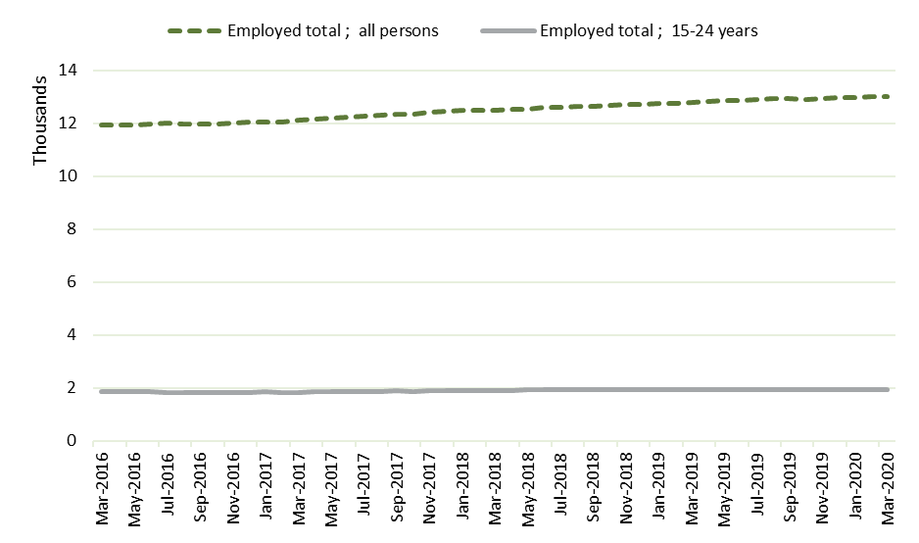
Source: ABS, 6291.0.55.001 Labour Force, Australia, Detailed
Note: A person is considered to be employed if they are in a paid job for one hour or more in a week
Figure 43: Participation rate, seasonally adjusted, 2016–2020
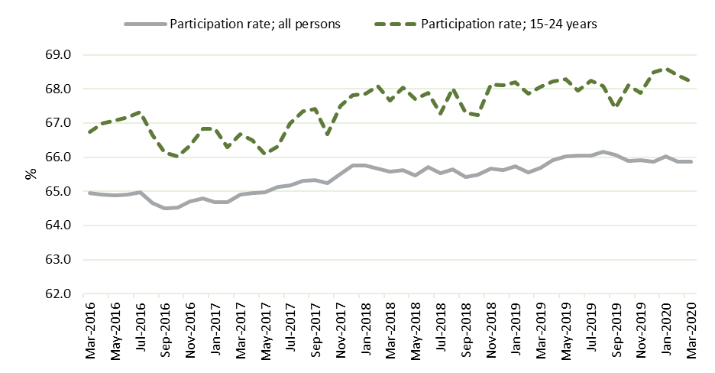
Source: ABS, 6291.0.55.001 Labour Force, Australia, Detailed
Note: The participation rate is the percentage of people in the working age population who are in the labour force
Nationally, the unemployment rate for all persons dropped from 5.7% to 5.3%. The unemployment rate for 15–24 year olds fell proportionately slightly further, but was more than double the rate for all persons and was more volatile, falling from 12.1% to 11.6% (Figure 44). The underemployment rate (the proportion of the labour force who are underemployed) rose slightly (from 8.4% to 8.8%), but for young people, the underemployment rate is more than double that of the employed population overall (rising from 17.3% to 19.2%) (Figure 45).
Figure 44: Unemployment rate, seasonally adjusted, 2016–2020
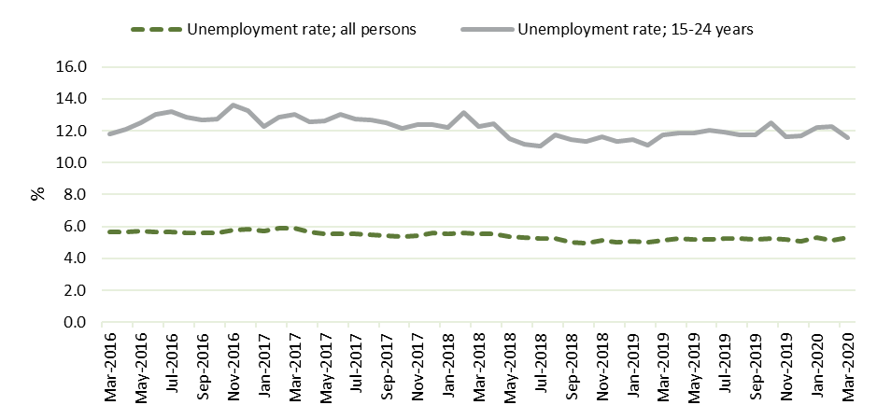
Source: ABS, 6291.0.55.001 Labour Force, Australia, Detailed
Note: The unemployment rate is percentage of people in the labour force who are unemployed. Unemployed people are defined as all those of working age who were not in employment (not in any paid employment of self-employment), carried out activities to seek employment and were available to take up employment given a job opportunity during the reference period.
Figure 45: Underemployment rate, seasonally adjusted, 2016–2020
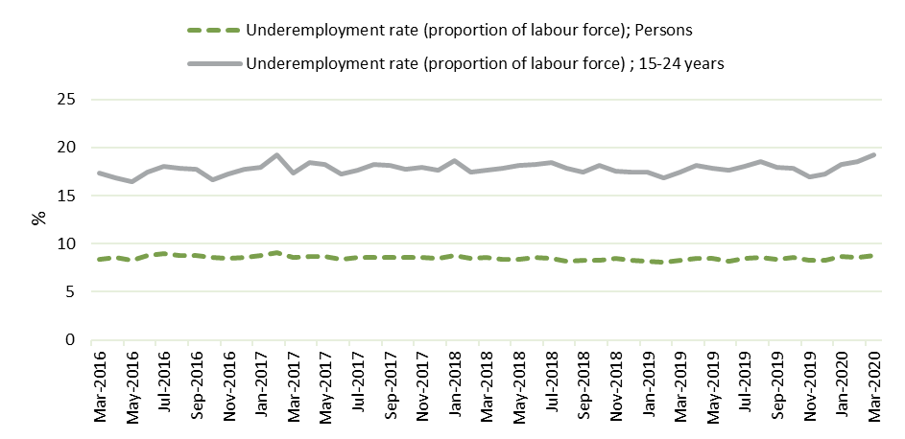
Source: ABS, 6291.0.55.001 Labour Force, Australia, Detailed
Notes: The underemployment rate is the percentage of people in the labour force who are underemployed. Underemployed workers are employed people who would prefer, and are available for, more hours of work than they currently have during the reference period.
While young people benefited from economic growth during this period, there is evidence to show that young people are more likely to be employed in part-time or casual jobs, more likely to be long-term unemployed, start their work careers in lower quality jobs, and need increasingly to compete for jobs through activities such as unpaid internships (Borland and Coelli 2021).
A catastrophic bushfire season beginning in December 2019, the COVID-19 pandemic which started in March 2020, and widespread flooding in New South Wales in March 2021 had a dramatic, if patchy impact on the Australian economy and on individuals and businesses.
- The shock of COVID-19 and natural disasters
The COVID-19 pandemic, on top of natural disasters, had an unprecedented impact on the labour market, with youth again disproportionately affected. In the initial months of the pandemic the unemployment rate rose from 5.3% to a peak of 7.4% in July 2020, with the JobKeeper scheme likely playing a significant role in moderating the increase in unemployment. Unemployment appeared to rebound as lockdowns stopped, with the unemployment rate falling to 5.1% in May 2021, below pre-pandemic levels (Figure 46). COVID-19 also impacted the labour participation rate, which dropped in the initial stages of the pandemic, but also restabilised in the final quarter of 2020 (Figure 47).
Young people were again more severely affected, with youth employment contracting by 17% between March and May 2020, and accounting for around 38% of the total decline in employment over the period. This is likely due to their over-representation in industries that were most severely affected by COVID, as well as being more vulnerable to retrenchment due to often having fewer skills and less experience than older workers (National Skills Commission 2021) and many having only casual work. The youth unemployment rate rose to a peak of 16.4% in July 2020, falling to 11.7% in March 2021, just below the youth unemployment rate before the pandemic. Despite this fall, the youth unemployment rate remained almost double the rate recorded for all persons.
Figure 46: Unemployment rate, seasonally adjusted, post COVID-19
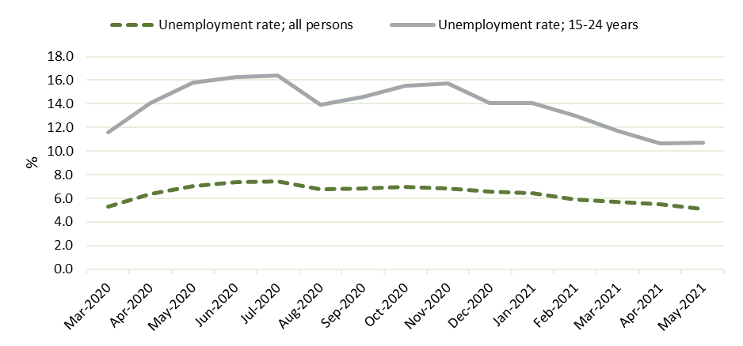
Source: ABS, 6291.0.55.001 Labour Force, Australia, Detailed
Figure 47: Participation rate, seasonally adjusted, post COVID-19
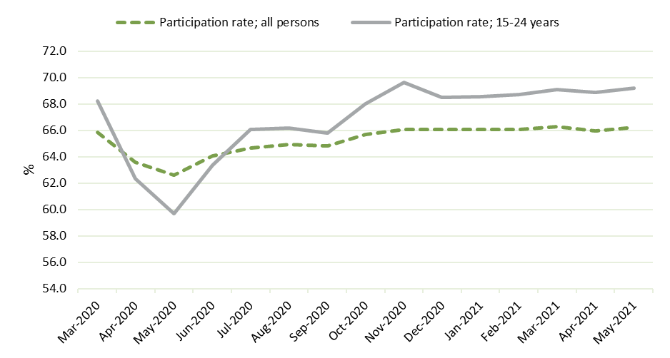
Source: ABS, 6291.0.55.001 Labour Force, Australia, Detailed

- Data sources
- Qualitative research
- 2021 participant, provider and stakeholder interviews
The Social Research Centre and Murawin, a majority Aboriginal and/or Torres Strait Islander owned organisation that specialises in working with Aboriginal and Torres Strait Islander communities, were commissioned to undertake qualitative research to inform this evaluation. Given the high proportion of Aboriginal and/or Torres Strait Islander participants in the TtW population (32%), Murawin was engaged to ensure culturally safe and sensitive research methodology and practice.
The qualitative component involved an investigation phase with young people to identify key topics and areas for exploration, and insights from this phase were used to inform the development of the discussion guides and participant survey. This was followed by in-depth interviews and focus groups (conducted both via videoconferencing and telephone and face to face) with TtW participants (64), as well as in-depth interviews with TtW providers (14) and peak body representatives (2).
The study population was drawn on 7 April 2021 from the TtW caseload and included only participants who had commenced, were currently in the program and had been in the TtW program for at least 6 months (cumulative) to ensure that participants had sufficient experience of the TtW service to reflect on its impact on them. Qualitative fieldwork was conducted during April and May 2021.
The purpose of the qualitative research was to enable deeper examination of human capability development through TtW, and how this contributes to the success of the TtW program and the overall wellbeing of participants. It also examined the impact of extending the duration of service to 18 months. Measures were taken to ensure a wide range of participants were consulted; however, the views expressed by participants may not be representative of the wider population of TtW participants.
- Quantitative research
- 2021 TtW provider survey
The 2021 TtW provider survey was conducted by the department’s Evaluation, Research and Evidence Branch between July and August 2021. The survey focused on understanding the impact of services on participant’s human capabilities, and which service elements were associated with any changes in human capability.
The survey is a census of providers operating full-time and part-time sites; those operating outreach sites were excluded. Of the 292 sites invited to participate, 279 responses were received, giving an overall response rate of 96%.
- 2021 TTW participant survey
The Social Research Centre was commissioned to undertake the 2021 participant survey, carried out in July and August 2021 using an online survey and Computer Assisted Telephone Interviewing.
This quantitative research involved surveying a representative sample of TtW participants, and a comparison sample of participants from jobactive selected to match the broad characteristics of the TtW group as closely as possible. The study population was drawn on 7 April 2021 from the TtW and jobactive caseloads. The population included TtW participants who were commenced and had been in the program for at least 6 months (cumulative). Participants from the jobactive comparison population must have met the TtW eligibility criteria at their first jobactive referral. A total of 2,082 surveys were completed (1,502 for TtW and 580 for jobactive). A larger number of TtW respondents were included to enable analysis of the different cohorts within TtW (including TtW group, gender, education level, Indigenous identification).
The sample design ensured a representative sample was selected by using stratification by TtW group (Group 1 (early school leavers / Aboriginal and/or Torres Strait Islander), Group 2 (disengaged), Group 3 (Stream C/Tier 2 referrals) with other participant characteristics such as age, gender, state, Aboriginal and/or Torres Strait Islander status, current JSCI score, and ABS youth unemployment rate. The jobactive comparison group sample was selected to match the TtW group as closely as possible.
The questionnaire was developed in collaboration with the department and the Social Research Centre and was informed by results from the qualitative research. The survey instrument underwent cognitive testing with TtW participants and was tested to determine comprehension (understanding of the question), judgment (consideration of what response to give), retrieval (recall of the appropriate information needed to provide a response) and response (ability to provide an honest response).
Several points should be kept in mind when considering the findings from the participant survey:
all data was weighted to match relevant population parameters
all charts and tables, unless otherwise specified, show weighted survey estimates
all bases (n) shown in the participant survey tables and graphs are unweighted
statistical tests were conducted to establish whether differences between TtW and jobactive participants were genuine rather than simply due to random variation. Where differences are reported, unless otherwise noted, they are statistically significant at a 95% confidence level.
The participant survey used a range of recognised scales to assess life satisfaction, personal wellbeing, psychological wellbeing and resilience.
- Analysis of the department’s administrative data
Impact analysis using the department’s administrative data and Research and Evaluation Database (RED) income support data was used to examine the long-term impact of the program on participants’ labour market attachment. This analysis extends the work undertaken during the final evaluation, using the same study populations from TtW and jobactive to enable attribution of impact to the TtW program.
Impact analysis using administrative and RED income support data was also used to examine the impact that changing the duration of engagement from 12 to 18 months had on participant outcomes.
Appendices 3 and 4 contain further details regarding the impact analyses.

- Long-term impact analysis: study population methodology and demographics, analysis methodology and data limitations
- Introduction
This appendix details how the study population for the analysis of long-term impact was constructed, and how the matched samples were selected. It then provides detail on the demographics of the study population, and the 2 matched samples for comparison, outlining any notable differences that need to be considered when interpreting results. This appendix then discusses the construction of the ‘positive’ income support (IS) indicator and outlines how the impact of COVID-19 has affected the analysis. Limitations of this analysis are then presented.
- Construction of the study population
In order to allow comparability with the final evaluation, and to maximise the length of time available for analysis, this supplementary evaluation uses the same TtW study population used in the Stage 2 (final) evaluation. This population was drawn from departmental administrative data and was the inflow population between 1 April 2016 and 31 March 2017. It included 26,994 participants (collectively with 27,241 periods of assistance). An inflow population of jobactive participants was constructed for the same period as the TtW inflow population (between 1 April 2016 and 31 March 2017).
The TtW inflow population consisted of new applicants for Youth Allowance (Other) (Group 1); disengaged young people recruited by providers, and other eligible young people receiving non-activity-tested income support payments (Group 2); and suitable Stream C participants referred from jobactive (Group 3). The jobactive population was restricted to Stream B participants aged under 22 years at referral to ensure comparability.
To ensure that data was robust and outcomes could be reasonably attributed to TtW, the sample was limited to population members who had commenced in the TtW or jobactive programs within 90 days from their initial referral dates, and participated in TtW or jobactive programs for at least 28 days. Participants also needed to have been on an income support payment at day 28 from their commencement dates. In addition, for jobactive participants, they must not have had experience in TtW between 1 April 2016 and 31 March 2017. Further to these restrictions, if a participant had multiple periods of service (POS) in TtW or jobactive, only the first POS was kept in the analysis. POS is the length of time measured from participant’s commencement date to exit from the program date. The evaluation followed participants for up to 4 years from their commencement date.
- TtW population characteristics (treatment group)
Inflow population referred to the program between 1 April 2016 and 31 March 2017
Excludes initial caseload referrals from jobactive
Commenced in service within 90 days from initial referral date
From groups 1, 2 and 3
Participated in the program for at least 28 days of service from commencement date
On income support at day 28 from commencement
- jobactive population characteristics (comparison group)
Inflow population referred to the program between 1 April 2016 and 31 March 2017
Stream B participants aged under 22 years at referral
Commenced in the program within 90 days from initial referral date
Participated in the program for at least 28 days of service from commencement date
On income support at day 28 from commencement
Had not previously participated in the TtW program
- Matched TtW and jobactive samples construction
Matched samples of TtW and jobactive participants were constructed for the purpose of the impact analysis. This enables comparison of the effects of the TtW service model on labour market and educational outcomes for TtW participants, compared to the ‘no TtW’ situation, which for these participants would have been the jobactive program. The base populations used for the matching process were the TtW and jobactive inflow populations outlined above. Figure 48 provides a flowchart for study population and sample selection.
The TtW and jobactive sample populations were matched on their education attainment (under Year 12 or Year 12 and above) and JSCI score group (JSCI scores were distributed into 4 groups). This minimises the characteristics that need to be controlled for when undertaking regression analyses between these 2 groups. It is important to note that participants in one service may still have been different in some ways from those in the other. For instance, young people who are less motivated or face greater barriers to workforce participation, such as poor language skills, mental illness or homelessness, may opt to go or be referred to jobactive rather than participate in the 12 months of activity-intensive services offered in TtW. The logistic regression analysis aims to mitigate differences between the TtW and jobactive participant samples by including a range of control factors (independent variables).
The matched samples were followed for 4 years from commencement for the purpose of long-term impact analysis. The 4-year follow-up period included the COVID-19 pandemic period.
Figure 48: Study population construction flowchart
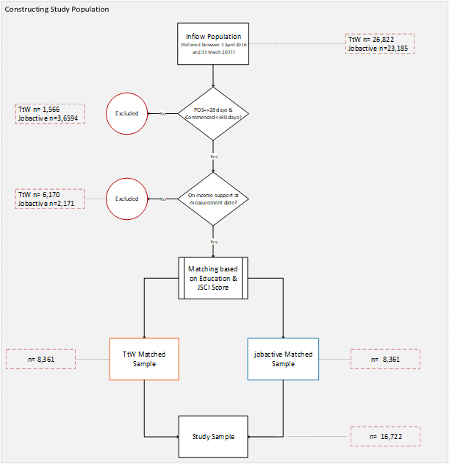
Note: Commence_dt is the earliest commencement date of the JSA/JACT placements in the POS
- Population and sample demographics
- The study samples are matched and very similar
The TtW and jobactive participants were matched on their education attainment and JSCI score and display very similar characteristics across the majority of other factors including Aboriginal and/or Torres Strait Islander status, disability, access to transport, ex-offender status and housing stability. There were a number of small discrepancies. In the TtW sample there were slightly fewer women (TtW 44%, jobactive 48%) and TtW participants had slightly higher English capability (poor English capability: TtW 7%, jobactive 12%). The TtW sample was also slightly younger (age at commencement 15–18: TtW 44%, jobactive 38%). These differences were controlled for through regression analysis.
- TtW participants are largely representative of the TtW study population
While largely representative of the TtW study population, the TtW sample is slightly more disadvantaged (high JSCI: TtW sample 35%, population 22%) and has a slightly higher proportion of women (sample 44%, population 40%) and non-Aboriginal and/or Torres Strait Islander participants (sample 23%, population 19%).
There are 2 larger differences between the TtW sample and the TtW population.
The TtW sample had a higher level of education overall. Four-fifths (82%) of the TtW study population have not completed Year 12 or an equivalent level of study, compared to two-thirds (66%) of the TtW sample. TtW targets young people who have not completed Year 12 or an equivalent level of study, so significantly more of the TtW population have lower levels of education than the jobactive population. In order to maximise sample size, this was not used as a determining characteristic during the matching process. Regression analysis was used to control for this difference.
The indicators used for the long-term analysis were related to income support. It was therefore necessary for the analysis that sample participants were on income support 28 days from commencement. This is in contrast to almost one-quarter (24%) of the TtW study population not being on income support 28 days from commencement. Group 2 participants are by definition not on income support at commencement, so findings from the long-term outcome analysis should not be taken to represent outcomes for Group 2 participants.
Table 25 allows comparison of the demographic characteristics of the TtW inflow population, the TtW sample and the jobactive matched sample. Statistics for Australian young people for a number of characteristics are also provided for context.
Table 25: Demographic characteristics of TtW inflow population and matched TtW and jobactive samples at commencement (1 April 2016 to 31 March 2017)
Factor/level | TtW inflow population n=26,822 |  | TtW matched sample n=8,361 |  | jobactive matched sample n=8,361 |  | Australian population, 15–24 years old
 | (no) | (%) | (no) | (%) | (no) | (%)
Gender
Male | 16,025 | 59.7 | 4,671 | 55.9 | 4,333 | 51.8 | 51% ^{b}
Female | 10,797 | 40.3 | 3,690 | 44.1 | 4,028 | 48.2 | 49% ^{b}
Unknown | 1 | 0
JSCI score group
Medium | 20,025 | 74.7 | 5,406 | 64.7 | 5,406 | 64.7
High | 6,012 | 22.4 | 2,886 | 34.5 | 2,886 | 34.5
Unknown | 785 | 2.9 | 69 | 0.8 | 69 | 0.8
Education level |  |  |  |  |  |  | 20–24 y/o
<Y12 | 21,984 | 82.0 | 5,528 | 66.1 | 5,528 | 66.1 | 10.5% ª
*=>Y12 | 4,052 | 15.1 | 2,764 | 33.1 | 2,764 | 33.1 | 89.5% ª
Unknown | 786 | 2.9 | 69 | 0.8 | 69 | 0.8
Identifies as Aboriginal and/or Torres Strait Islander
Yes | 5,046 | 18.8 | 1,922 | 23.0 | 1,925 | 23.0 | 4% ^{b}
No | 21,776 | 81.2 | 6,439 | 77.0 | 6,436 | 77.0
Reduced work capacity due to disability or medical condition |  |  |  |  |  | Disability 15–22 y/o
Yes | 1,422 | 5.3 | 613 | 7.3 | 617 | 7.4 | 2% ^{b}
No | 24,445 | 91.1 | 7,617 | 91.1 | 7,552 | 90.3
Decline to answer | 170 | 0.6 | 62 | 0.7 | 123 | 1.5
Unknown | 785 | 2.9 | 69 | 0.8 | 69 | 0.8
Work history
Paid work | 7,351 | 27.4 | 1,886 | 22.6 | 1,494 | 17.9
Unpaid work | 171 | 0.6 | 65 | 0.8 | 74 | 0.9
None | 18,515 | 69.0 | 6,341 | 75.8 | 6,724 | 80.4
Unknown | 785 | 2.9 | 69 | 0.8 | 69 | 0.8
Transport
Private | 9,915 | 37 | 2,891 | 34.6 | 3,199 | 38.3
Public | 14,636 | 54.6 | 4,838 | 57.9 | 4,436 | 53.1
None | 1,486 | 5.5 | 563 | 6.7 | 657 | 7.9
Unknown | 785 | 2.9 | 69 | 0.8 | 69 | 0.8
Ex-offender status
Yes | 2,171 | 8.1 | 753 | 9.0 | 761 | 9.1 | 2.3% ^{c}
No | 23,389 | 87.2 | 7,368 | 88.1 | 7,272 | 87
Decline to answer | 477 | 1.8 | 171 | 2.0 | 259 | 3.1
Unknown | 785 | 2.9 | 69 | 0.8 | 69 | 0.8
English level (speak, read, write)
Good | 24,745 | 92.3 | 7,785 | 93.1 | 7,382 | 88.3
Poor | 1,292 | 4.8 | 507 | 6.1 | 910 | 10.9
Unknown | 785 | 2.9 | 69 | 0.8 | 69 | 0.8
Residence
Stable | 23,494 | 87.6 | 7,265 | 86.9 | 7,094 | 84.8
Unstable | 2,543 | 9.5 | 1,027 | 12.3 | 1,198 | 14.3 | <1% ^{d}
Unknown | 785 | 2.9 | 69 | 0.8 | 69 | 0.8
Personal reason impact
No impact | 23,905 | 89.1 | 7,245 | 86.7 | 7,616 | 91.1
Some impact | 2,132 | 7.9 | 1,047 | 12.5 | 672 | 8
Unknown | 785 | 2.9 | 69 | 0.8 | 69 | 0.8
Income support history
More than once | 4,714 | 17.6 | 1,859 | 22.2 | 1,737 | 20.8
Others | 21,323 | 79.5 | 6,433 | 76.9 | 6,555 | 78.4
Unknown | 785 | 2.9 | 69 | 0.8 | 69 | 0.8
TtW group
Group 1 | 23,644 | 88.1 | 7,758 | 92.8 | 0 | 0
Group 2 | 2,433 | 9.1 | 198 | 2.4 | 0 | 0
Group 3 | 745 | 2.8 | 404 | 4.8 | 0 | 0
Locality type
Major City/Inner Regional | 22,622 | 84.3 | 6,951 | 83.1 | 6,908 | 82.6
Outer Regional/ Remote/Very Remote | 4,128 | 15.4 | 1,389 | 16.6 | 1,433 | 17.1
Unknown | 72 | 0.3 | 21 | 0.3 | 20 | 0.2
Income support rate at commencement
Full | 17,544 | 65.4 | 7,045 | 84.3 | 7,201 | 86.1
Part | 2,923 | 10.9 | 1,135 | 13.6 | 1,000 | 12
Nil | 6,355 | 23.7 | 181 | 2.2 | 160 | 1.9
Period of service in program
28 days – 6 months |  |  | 3,678 | 44.0 | 3,800 | 45.4
7–12 months |  |  | 3,532 | 42.2 | 1,605 | 19.2
13–18 months |  |  | 1,040 | 12.4 | 1,019 | 12.2
19–24 months |  |  | 92 | 1.1 | 609 | 7.3
Over 24 months |  |  | 19 | 0.2 | 1,328 | 15.9
Age at commencement
15–17 | 8,852 | 33.0 | 1,279 | 15 | 907 | 11
18–20 | 14,893 | 55.5 | 2,099 | 25 | 2,000 | 24
21 | 3,077 | 11.5 | 1,120 | 13 | 1,241 | 15
Source: The department’s administrative data
TtW inflow population n=26,822 (all referred within 01/04/2016 – 31/03/2017)
TtW matched sample n=8,361 (commenced within 90 days, in program for at least 28 days, all on income support at measurement date of Month 0 which is commencement date + 28)
Note: Characteristics were extracted from the JSCI assessments which was closest to commencement date and within one year of commencement date. If there are no assessments in the 2-year period centred on commencement date then the characteristics variables are missing.
a Source: ABS, May 2021, Education and Work, Australia, https://www.abs.gov.au/statistics/people/education/education-and-work-australia/latest-release, sourced 29 March 2022
b Source: ABS 2016 Census
c TtW ‘ex offender’ includes participants who self-disclosed in their initial JSCI assessment that they have any criminal conviction that is either non-custodial sentence or any length of custodial sentence. There is no equivalent data for the broader population, but as an indication, imprisonment rate for 18 year olds was 0.7%, 19 year olds was 1.5% and 20–24 year olds was 2.3% in 2020 – source: Prisoners in Australia, 2020 | Australian Bureau of Statistics (abs.gov.au)
d Homelessness rate for people 19–24 years old was 0.95%, Homelessness rate for 12–18 year olds was 0.5%. ‘Homeless’ includes improvised dwellings, tents, sleeping out, supported accommodation, temporary arrangements with other households, boarding houses, other temp lodgings, severely crowded dwellings. Source: ABS 2016 Census
- Number of income support episodes
As can be seen in Table 26, there is very little difference between TtW participants and participants from the jobactive sample regarding the number of episodes of income support participants experience. Just over half of the TtW participants had one income support episode (53.6%) and just under a third (32.7%) experienced 2 episodes.
Table 26: Income support episodes per participant, as at 48 months post commencement
Number of episodes | TtW (n=8,361)  (%) | jobactive (n=8,361)  (%)
1 | 53.6 | 54.5
2 | 32.7 | 31.2
3 | 10.4 | 10.8
4 or more | 3.5 | 3.1
Total | 100.0 | 100.0
Source: The department’s administrative data
Base: Matched TtW (n=8,361) and jobactive (n=8,361) samples
- Movement between employment programs
Participants were either in TtW (the TtW sample) or jobactive (the jobactive sample) at referral. Over the study period, there was significant movement between and out of employment programs (Figure 49 and Figure 50)
By month 24 both TtW and jobactive participants are displaying a similar distribution across jobactive, other programs, TtW or not in program, which is even more pronounced by month 36. By month 36, the majority of participants from both programs have either moved out of employment services (62% of TtW participants, and 60% of jobactive participants) or are in jobactive (27% of TtW participants, and 29% of jobactive participants).
There was a more rapid and absolute decline in the proportion of the TtW participants remaining in TtW than jobactive participants remaining in jobactive. By month 24 only 5% of TtW participants remained in TtW, while 36% of jobactive participants remained in jobactive. This is not surprising. TtW is a time-limited service. Participants were only able to remain in TtW for longer than 12 months if they were tracking for an outcome. Additionally, TtW has a focus on pre-employment support, so participants may have chosen to transfer to jobactive for a more employment-focused service. Eligibility criteria limit the number of people who can move from jobactive to TtW, though jobactive providers can refer Stream C participants who they think will benefit from participation in TtW.
Figure 49: Program types since commencement (TtW sample) (% of participants in each program)
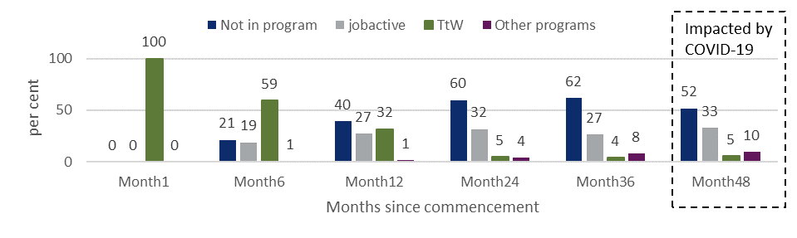
Source: The department’s administrative data
Base: Matched TtW sample (n=8,361)
Note: Other programs include DESA, DESB and ParentsNext
Figure 50: Program types since commencement (jobactive sample) (% of participants in each program)
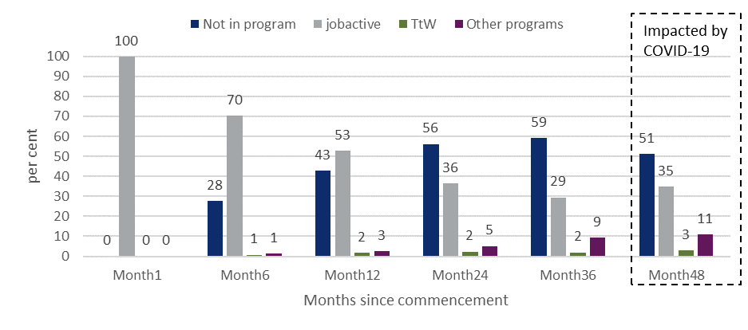
Source: The department’s administrative data
Base: Matched jobactive sample (n=8,361)
Note: Other programs include DESA, DESB and ParentsNext
- Construction of the ‘employment-related’ income support exit indicator
The off-income-support measure has been used previously to evaluate employment program success. Each individual in the study sample was flagged as off income support at 28-day intervals from the commencement date.
It is acknowledged that leaving income support can be a result of many factors. In order to refine the off-income-support indicator, participants’ exit from income support was further linked to the associated reason for exiting employment services.
Employment services exit reasons are recorded in the department’s IT system when a participant leaves employment services. Work was undertaken in 2018 by the department to examine the possible reasons for exiting recorded in the department’s IT system. There were over 1,000 reasons listed, and these were collated into 13 overarching subcategories and the validity of these subcategories was tested using data collected through post-program monitoring surveys. The Data Analytics team continues to update categories into these subcategories. These proxy subcategories include:
moved to employment
moved to study
not eligible for servicing
administrative failure before participation (these can be due to, for example, a job seeker’s claim for income support being rejected, or a job seeker failing to provide required information)
administrative failure post participation (these were found to be generally due to an administrative failure, or when a job seeker fails to engage with services and is subsequently exited – for example, if a job seeker fails to participate in an activity, which may be due to their gaining employment)
voluntary exit – not for employment
moved overseas.
Findings demonstrated that 86.5% of participants who left employment services with an exit code categorised as ‘moved to employment’ reported being employed 3 months later, 74.6% categorised as ‘administrative failure (post service)’ reported being employed 3 months later, and 96.5% with an exit code ‘moved to study’ reported studying 3 months later.
For our analysis, exits that were categorised as ‘moved to employment’, ‘administrative failure post participation’ and ‘moved to study’ have been recorded as ‘employment-related’ income support exits. Creating this ‘employment-related’ exit had a similar impact on both the TtW and comparison jobactive participants.
- Impact of COVID-19
As noted above, the long-term impact analysis uses an inflow population who commenced between April 2016 and June 2017, and follows individuals for 48 months. COVID-19 was first identified in Australia on 25 January 2020, but a nationwide lockdown began to significantly impact the economy in March. Therefore, while participants who commenced in April 2016 only felt the impacts of the lockdowns in the final (48th) month, those who commenced in June 2017 felt this impact in their 34th month. For example 3% of the study population were affected by month 36, 50% were affected by month 42, and 100% were affected by month 48. Table 27 summarises the progressive proportion of the study participants impacted by COVID-19. Month 36 is the point at which COVID-19 begins to have an impact on results, and from this point results are progressively more influenced as more people become impacted.
Table 27: Timing of impact of COVID-19 on participants included in the long-term-impact analysis
Participant commencement date | Months to COVID start (March 2020) | Number of participants  Frequency |  | Number of participants  % |  | Number of participants  Cumulative frequency |  | Number of participants  Cumulative %
Jun-17 | Month 34 | 18 | 0.11 |  | 18 |  | 0.11
May-17 | Month 35 | 99 | 0.59 |  | 117 |  | 0.7
Apr-17 | Month 36 | 395 | 2.36 |  | 512 |  | 3.06
Mar-17 | Month 37 | 1,483 | 8.87 |  | 1,995 |  | 11.93
Feb-17 | Month 38 | 1,376 | 8.23 |  | 3,371 |  | 20.16
Jan-17 | Month 39 | 1,540 | 9.21 |  | 4,911 |  | 29.37
Dec-16 | Month 40 | 1,438 | 8.6 |  | 6,349 |  | 37.97
Nov-16 | Month 41 | 1,438 | 8.6 |  | 7,787 |  | 46.57
Oct-16 | Month 42 | 1,232 | 7.37 |  | 9,019 |  | 53.94
Sep-16 | Month 43 | 1,324 | 7.92 |  | 10,343 |  | 61.86
Aug-16 | Month 44 | 1,455 | 8.7 |  | 11,798 |  | 70.56
Jul-16 | Month 45 | 1,364 | 8.16 |  | 13,162 |  | 78.72
Jun-16 | Month 46 | 1,350 | 8.07 |  | 14,512 |  | 86.79
May-16 | Month 47 | 1,330 | 7.95 |  | 15,842 |  | 94.74
Apr-16 | Month 48 | 880 | 5.26 |  | 16,722 |  | 100
Total |  | 16,722 | 100 |  | 16,722 |  | 100
Source: The department’s administrative data
- Limitations
There are a number of limitations associated with the long-term impact analysis.
Comparative approach – the lack of a credible counterfactual where no TtW or other services and programs are present renders a net impact study infeasible at a whole-service level. The comparative approach used for this evaluation enables conclusions as to how effective TtW is in comparison to a matched sample from jobactive, but not relative to a no-service situation.
Data availability issue – relying on income support data as proxies in tracking participants’ longer-term labour market outcomes may not give a full picture of outcomes. This is necessary due to a lack of direct data on participants’ labour market status after they exit the program.
Data quality issues – missing or poorly recorded data (for example, missing exit reasons and poorly recorded hours and earnings data) may affect some parts of the analysis.
Comparison groups – there are difficulties with creating comparison groups even under the comparative approach, especially for Group 2 participants (disengaged young people), as there is no jobactive equivalent.
Consistency in service delivery – the highly flexible nature of the training and services offered by TtW providers, under service delivery plans, may lead to difficulties in isolating ‘program-specific’ effects from ‘provider-specific’ effects.
Over the longer term, other exogenous factors are likely to become increasingly influential in determining outcomes, making it difficult to conclusively attribute outcomes to TtW service interventions. Using a matched comparison group of jobactive participants will partially counteract this. Notably, COVID-19 and the 2020 bushfires affected participants in different regions across Australia differently. These events not only led to changes in participant requirements but also affected individuals in diverse and challenging ways.

- Analysis of extension of program duration: study population selection and demographics, analysis methodology and data limitations
- Introduction
This appendix details how the study population for the analysis of changed maximum service duration was constructed, and how the matched samples were selected. It then provides detail on the demographics of the study population, and the 2 matched samples for comparison, outlining any notable differences that need to be considered when interpreting results. A discussion of why regression analysis was not undertaken on the samples and a discussion of limitations of the overall analysis are then presented.
- Construction of study populations and samples
The policy change to extend TtW service from 12 months to 18 months became effective on 1 July 2020. Therefore, anyone who commenced in the TtW program after 1 July 2019 is potentially eligible to stay in the program for 18 months, compared to those who started earlier, who may only be able to stay up to 12 months except when they are tracking towards outcomes at the end of their 12-month period. To understand the effect of this policy change, 2 study populations were constructed.
The inflow population potentially affected by the policy change (the ‘maximum 18 months’ population) included participants who commenced in the TtW service between 1 July 2019 and 30 June 2020, identified through the department’s administrative data.
The comparison population comprises the TtW inflow population who were ineligible for the extension in program duration (the ‘maximum 12 months’ population) and includes all participants who commenced in TtW between 20 January 2018 and 30 June 2019. This date was chosen to ensure that the ‘maximum 12 months’ population (counted as 34,749) is the same size as the ‘maximum 18 months’ population (counted as 34,679).
Population members consist of new applicants for Youth Allowance (Other) (Group 1); disengaged young people recruited by providers, and other eligible young people receiving non-activity-tested income support payments (Group 2); and suitable Stream C participants referred from jobactive (Group 3). Data on the participant study populations included information on the periods of assistance a participant received, beginning on the date of the participant’s referral to TtW and ending when they exited TtW for more than 91 days.
The evaluation followed participants for the time periods after they commenced in the TtW program, with all participants observed for at least 27 calendar months following commencement in TtW except where they exited earlier. Participants may have had more than one period of assistance; however, since a significant amount of time elapsed between participants ending a period of assistance and starting a new one, a participant’s labour market situation and personal characteristics may have differed significantly from one period of assistance to the next. The evaluation therefore treated each of a participant’s periods of assistance as separate cases, rather than combining them and treating each participant as a single case. For ease of reporting, reference is made to ‘participants’ when referring to these ‘periods of assistance’ throughout the report.
- Construction of matched samples
Matched samples of before and after policy change participants were constructed for the purpose of the impact analysis of the effects of the service extension on labour market and educational outcomes for participants, compared to the ‘no service extension’ situation. The base populations used for the matching process were the before and after policy change inflow populations.
To ensure that the participant groups had similar levels of disadvantage, 4 sets of characteristics were used as matching variables. The final comparison samples selected for analysis consisted of commenced participants from both inflow populations matched on their education attainment (under Year 12 or Year 12 and above), JSCI score group (JSCI scores were distributed into 4 groups), work experience (paid work, unpaid work or none) and transport (private, public or no transport). This minimises the characteristics that need to be controlled for in analyses between these 2 samples.
It was important to note that participants in one sample may still have been different in some ways from those in the other. For instance, they may be different in language skills, mental illness or homelessness. The logistic regression analysis aims to mitigate differences between the 2 samples by including a range of control factors (independent variables).
- Population and sample demographics
The total ‘maximum 12 month’ and ‘maximum 18 month’ inflow populations comprised, respectively, 34,749 and 34,679 participants. Matching of these populations was undertaken based on participants’ education attainment (under Year 12 or Year 12 and above), JSCI score group (JSCI scores were distributed into 4 groups), work experience (paid work, unpaid work or none) and available form of transport (private, public or no transport).
After matching, both the before and after samples contained 30,345 participants each. The matching process did not significantly change overall participant characteristics from the original inflow populations, with most of the factors (12 of 14) having less than 1 percentage point change after the matching procedure. The study participants represent more than 87% of the original inflow population, providing confidence that analyses based on these matched participants can represent characteristics of the original inflow populations.
Table 28 allows comparison of the demographic characteristics of the original and matched TtW inflow populations before and after during extension.
Table 28: Demographic characteristics of before and after policy change inflow populations and matched samples
Factor/level | Before policy change inflow n=34,749 | Before policy change matched n=30,345 | After policy change inflow n=34,679 | After policy change matched n=30,345
 | % | % | % | %
Gender
Male | 56.8 | 56.8 | 57.1 | 57.1
Female | 43.1 | 43.2 | 42.9 | 42.9
JSCI score group
Low | 74.7 | 76.1 | 78.1 | 76.1
High | 23.1 | 22.3 | 20.6 | 22.3
Unknown | 2.2 | 1.3 | 1.6 | 1.5
Education level
Above Year12 | 26.0 | 26.7 | 28.0 | 26.7
Under Year 12 | 71.9 | 71.7 | 70.6 | 71.7
Unknown | 2.2 | 1.6 | 1.4 | 1.6
Identifies as Aboriginal and/or Torres Strait Islander
No | 70.2 | 70.2 | 68.0 | 68.5
Yes | 29.8 | 29.8 | 32.0 | 31.5
Reduced work capacity due to disability or medical condition
Yes | 5.4 | 5.7 | 7.2 | 7.3
No | 92.1 | 92.4 | 91 | 90.7
Decline to answer | 0.3 | 0.3 | 0.5 | 0.5
Unknown | 2.2 | 1.6 | 1.4 | 1.6
Work history
Yes | 5.4 | 5.7 | 7.2 | 7.3
No | 92.1 | 92.4 | 91 | 90.7
Decline to answer | 0.3 | 0.3 | 0.5 | 0.5
Unknown | 2.2 | 1.6 | 1.4 | 1.6
Transport |  |  |  | 0%
Private | 38.5 | 42.6 | 46.9 | 42.6
Public | 54.0 | 50.8 | 46.7 | 50.8
None | 5.4 | 5.1 | 5.0 | 5.1
Unknown | 2.2 | 1.6 | 1.4 | 1.6
Ex-offender
Yes | 7.2 | 7.1 | 7.6 | 7.8
None | 89 | 89.8 | 89.1 | 88.7
Decline to answer | 1.6 | 1.6 | 1.9 | 1.9
Unknown | 2.2 | 1.6 | 1.4 | 1.6
English level
Good | 93.4 | 94.1 | 93.1 | 92.6
Poor | 4.5 | 4.4 | 5.5 | 5.9
Unknown | 2.2 | 1.6 | 1.4 | 1.6
Residence
Stable | 88.3 | 88.9 | 87.6 | 87.1
Unstable | 9.6 | 9.5 | 11 | 11.3
Unknown | 2.2 | 1.6 | 1.4 | 1.6
Personal factors
No impact | 92.9 | 93.2 | 92.1 | 91.8
Some impact | 5 | 5.3 | 6.6 | 6.6
Unknown | 2.2 | 1.6 | 1.4 | 1.6
Income support history
More than once | 15.9 | 16.4 | 21.5 | 20.6
Others | 82 | 82.1 | 77.1 | 77.9
Unknown | 2.2 | 1.6 | 1.4 | 1.6
TtW group
Group 1 | 80.2 | 80.9 | 85.7 | 84.6
Group 2 | 18.6 | 17.8 | 13 | 14
Group 3 | 1.2 | 1.2 | 1.3 | 1.3
Locality type
Major City/Inner Regional | 82.7 | 82.3 | 83.6 | 83.7
Outer Regional/ Remote/Very Remote | 17.1 | 17.5 | 16.2 | 16.1
Unknown | 0.2 | 0.2 | 0.2 | 0.2
Income support rate at commencement
Full | 59.2 | 59.2 | 62.7 | 62.9
Part | 13.3 | 13.6 | 15.2 | 14.7
Nil | 27.5 | 27.2 | 22.1 | 22.4
Age at commencement
15–17 | 35.4 | 33.9 | 25.1 | 27.7
18–20 | 55.0 | 55.8 | 53.4 | 52.9
21–25 | 9.7 | 10.3 | 21.5 | 19.4
Source: The department’s administrative data
Base: Study populations (before-policy-change inflow population: n=34,749, matched sample: n=30,345; after-policy-change inflow population: n=34,749, matched sample: n=30,345)
Note: Demographics are as at a participant’s JSCI assessment date, using the JSCI assessment that was closest to their TtW commencement date. Numbers and percentages within categories may not add to total population/100% as datum points with ‘no information’ have not been included.
- Regression analysis
The analysis used logistic regression models to try to control for any remaining differences between the 2 matched samples and for differences in economic conditions. However, the COVID-19 pandemic, which started in March 2020, and restrictions and employment-related policies introduced by federal and state governments in response to the pandemic, led to highly fluctuating employment conditions, most notably just after the policy change as shown in Figure 51, which shows time series of Internet Vacancy Index at Skill Level 5. This made regression modelling unreliable.
Figure 51: Internet Vacancy Index at Skill Level 5 between January 2018 and December 2021, by state
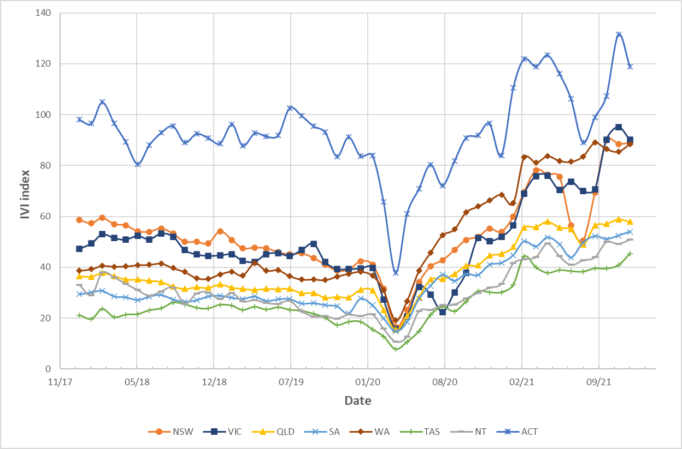
Source: Internet Vacancy Index | Labour Market Insights
After policy change inflow population
Policy change: 30 June 2020
Before policy change inflow population
- Limitations
In the before policy change inflow sample, all participants have exited the program and their outcomes have been claimed. However, in the after policy change inflow sample, though the cut-off commencement date of 30 June 2020 was chosen so that all participants could have been in the program for at least 18 months when we constructed the dataset, some participants may still progress towards their outcomes when no claim has been made. Therefore, the outcome count for after policy change sample might be under-counted.
The other potential effect is that all participants in the after policy change sample (commencement date between 1 July 2019 and 30 June 2020) commenced their program before the policy change effective date (1 July 2020) and some participants exited the program before they were aware of the policy change. We assumed here that these participants would exit the program with the similar POS even if they knew of the policy change.
- Methodology, data and calculations used in the value-for-money analysis of TtW
- Introduction
This appendix outlines the methodology, data and calculations used in the value-for-money analysis of TtW and should be read in the context of findings presented in Chapters 3 to 5.
In order to ensure that the analysis does not overestimate benefits or underestimate costs, a number of factors were considered.
Deadweight acknowledges that in some instances outcomes will be achieved regardless of the program intervention (for example, young people may become more (or less) satisfied with their lives regardless of the intervention of an employment program). This is particularly problematic if a before and after intervention comparison is made. This analysis avoids deadweight by establishing the difference in outcomes between 2 comparable populations over the same time period.
Attribution and causality recognises that the investment and core program activity may not be wholly responsible for all of the value created. In order to ensure that only changes that are attributable to TtW are included, analysis involved identifying evidence linking support provided through the program to the outcomes achieved, and applying a methodology to control for other factors that may have contributed to this change (through using comparable samples and regression analysis).
Duration and drop-off: ‘Duration’ recognises that outcomes may continue for many years. ‘Drop-off’ recognises that the value of outcomes declines over time. For this analysis, actual costs and benefits accruing over time have been used where possible (assuming no additional duration and full drop-off). While the analysis assesses costs and benefits over 12 months, it is assumed that any benefit accrued through increased human capabilities drops off after 6 months.
The valuation of wellbeing is slightly problematic, as data on the impact of the program on participants’ human capabilities is only available for one point in time, while the analysis is looking at the impact over 12 months. As noted above, the value of the change in wellbeing is assumed to be a one-off benefit that lasts for 6 months.
Discounting: This analysis uses current dollars and does not apply discounting or deflation for comparisons over the period of the analysis, due to the complexity that this would add to the analysis, and the fact that the analysis is undertaken during a period of relative inflationary stability (inflation averaged 1.8 per year between June 2016 and June 2021). It is acknowledged that the period following this analysis is experiencing more rapid inflation, and there is also an argument to use the long-term cost of capital. A more exacting cost-benefit analysis would require discounting to be undertaken.
- Valuing the broader benefits of TtW
This analysis explores how the broader benefits of TtW could be valued and compares these to the relative cost of TtW compared to jobactive. It includes:
valuing changes in wellbeing attributable to TtW
valuing savings associated with reduced offending
calculating the average cost of servicing participants in TtW
calculating the average cost associated with additional income support payments received by TtW participants.
- Valuing benefits associated with increased wellbeing
It is acknowledged up front that valuing wellbeing, and the factors that affect it, can be problematic. Section 7.3.1 provides a discussion of the appropriateness of and methodologies for measuring and valuing wellbeing. While this research acknowledges the limitations associated with placing a value on wellbeing, it is an attempt to explore the feasibility of this to aid the assessment of the value for money that TtW provides.

Establishing the impact of TtW on wellbeing
Changes in wellbeing that can be attributed to TtW were established through the 2021 TtW participant survey. Participants were asked to respond to 7 questions regarding their satisfaction across a number of areas of their own life. Responses were combined into a score to determine participants’ Personal Wellbeing Index (PWI) – a score out of 100, where higher scores indicate higher levels of personal wellbeing. The survey was undertaken in July 2021, with participants from across Australia. While it is acknowledged that COVID-19 and a number of other natural disasters are likely to have affected participants’ wellbeing, participants from TtW and the comparison group were surveyed at the same time, and efforts were made to ensure the comparability of these participants. It is assumed that these events would have had a similar influence on the average PWIs of these 2 groups.
Overall, participants in the 2021 TtW participant survey had an average PWI of 71.1 out of 100. The comparison group scored an average of 65.6. This difference was statistically significant as assessed by regression which adjusted for the number of negative life events experienced in the past 12 months, and length of time in the respective program (Figure 52).
Figure 52: Average Personal Wellbeing Index score
Source: National average, AIHW (2021) HILDA Survey; TtW and jobactive, participant survey 2021
QHC2. Turning now to various areas of your life. Please answer use a scale from 0 to 10, where 0 is completely dissatisfied and 10 is completely satisfied.
Base: All respondents – TtW participants (n=1,502), jobactive participants (n=580)
*Result is significantly different to TtW participants (p<0.05)

Calculation of the impact of TtW on participants’ wellbeing
(TtW PWI – comparison group PWI) = per person wellbeing impact
(71.1 – 65.6) = 5.5 points (100-point scale)
An improvement in subjective wellbeing of 5.5 points can be attributed to participation in TtW. We assume that the wellbeing impact attributable to TtW remains relevant for at least 6 months.

Calculating the value of changes in wellbeing
As noted above, different measurement techniques and contexts result in different values being calculated for the monetary value of changes in wellbeing. The benefit of an additional unit of wellbeing to an individual has also been shown to depend on their original level of wellbeing, and the direction in which the wellbeing is moving (a loss in wellbeing has been shown to have a higher ‘cost’ than the value of the same size increase in wellbeing). In order to estimate the value of the change in wellbeing, this research undertook a literature review to identified recent studies that attempt to value changes in wellbeing, and these values were used to determine a range in the value of wellbeing changes. Table 26 presents a summary of values identified from these sources.
Cummins et al (2021) used survey data collected between 2016 and 2020 for individuals across Australia that included PWI and income data. They found a strong association between wellbeing and income, with data demonstrating that for Australians as a whole, higher wellbeing is associated with higher household income until it reaches the $100,000–$150,000 per annum range, when the relationship between income and wellbeing becomes weaker. People living on a gross household income of $60,000 per annum or less struggled to reach the average level of wellbeing (the average range of PWI since 2001 has been 74–78, with no particular pattern). This is consistent with the law of diminishing marginal utility of income, which demonstrates that increases in income improve reported quality of life more for those on lower incomes than for those on higher incomes (Layard et al 2008). The research found that ‘for those on a household income of less than $15,000, a single wellbeing percentage point costs $3,659’ (i.e. using a 100-point scale).
Stanley et al (2021) used standard and generalised ordered logit models to examine data from the 2006 ABS Census of Population and Housing General Community Profile and results from in-depth research undertaken in Victoria in 2008 focusing on social exclusion (aged 18–39). Using the PWI (using an averaged 10-point scale), Stanley et al found that ‘increasing a person’s subjective wellbeing by one unit was equivalent to giving them an extra AUD$124/day (2008 prices), about half the sample average household income (AUD$240/day)’. Over 6 months, this is equivalent to $22,620 (2008 prices).
Biddle et al (2020) examined the impact of COVID-19 on people’s life satisfaction, through surveys undertaken in October 2019, January 2020 and April 2020. Using quadratic regression, they estimated that the reduction they observed in life satisfaction (using a 10-point scale) from 6.90 to 6.40 was equivalent to a reduction in income of $581 per person per week. A one-point decrease would be equivalent to $1,452.50/person/week, or $37,765/person over 6 months).
UK Treasury (2021a) used a linear conversion with a range of values, based on quality of life and willingness to pay evidence, and concluded that a change in life satisfaction of one unit (on a 10-point scale) per year was valued at $11,528.
Table 29: Values ascribed to a one-point change in wellbeing (10-point scale)
Author | Value associated with a one-point change in wellbeing (10-point scale, 2020 dollars)ª
HM Treasury (2021a) | $5,764/person/6 months
Stanley et al (2021) | $28,623/person/6 months
Cummins et al (2021) | $36,590/person^{b}
Biddle et al (2020) | $37,765/person/6 months
Notes:
a All amounts were converted to 2020 dollars. To convert to 2021 dollars: $ amount x end period CPI/initial period CPI. CPI data sourced from Consumer price index (CPI) rates | Australian Taxation Office (ato.gov.au). Annual CPI calculated as average over the 4 periods.
b Transposing the percentage point change into a 10-point scale for equivalence.
This research presents the value of wellbeing as a range, taking into account the highest and lowest values for wellbeing identified in the literature.

Estimating the monetary value of changes in wellbeing per participant
It is assumed that the impact of the program on a participant lasts on average for 6 months. Using the PWI results from the 2022 TtW participant survey and the methodology presented above, the value of improved wellbeing attributable to TtW was estimated to be between $3,170 and $20,774 per TtW participant, as outlined in Table 30.
Table 30: Estimated value of improved wellbeing attributed to TtW, per person
TtW PWI | 71.1
Comparison group PWI (jobactive participants) | 65.6
Impact of TtW on participants’ subjective wellbeing (SWB)  (TtW PWI – comparison group PWI) = per person wellbeing impact | 5.5 points
Value of increasing SWB by 1 percentage point (100-point scale) – range | $576 – $3,777
Value of increased wellbeing attributable to TtW per participant  5.5 x ($576 or $3,777) = $3,170 to $20,774 | $3,170 – $20,774
Source: Participant survey 2021; UK Treasury (2021a); Biddle et al (2020)
- Valuing savings associated with reduced offending
In order to estimate the savings associated with reduced offending attributable to TtW it was necessary to:
determine the number of nights of incarceration that were avoided due to TtW participation
estimate the cost per person per night for incarceration
estimate the total amount saved from reduced incarceration
calculate the savings per TtW participant.

Nights of incarceration that were avoided due to TtW participation
In order to calculate the number of nights of incarceration that were avoided through participation in TtW, the research utilised the matched sample of TtW and jobactive participants who were referred between 1 April 2016 and 31 March 2017, followed from commencement for 48 months. The department’s administrative data was used to establish the number of episodes of incarceration and the average length of time (days) spent in prison.

The number of episodes of incarceration
All participants in the matched sample were on income support 28 days from commencement.
During a period of imprisonment people are exited from income support, with the department’s administrative system identifying that their exit was due to imprisonment. Administrative data was used in this analysis to calculate the number of episodes of incarceration recorded for the matched sample. TtW participants had proportionately fewer incarcerations than jobactive participants (Table 31). The difference was used to estimate the number of incarcerations that would have occurred in the absence of TtW.
Table 31: Incarceration (number of individuals and episodes)
Program | Number of participants |  | Episodes of incarceration
 | # | % | # | %
jobactive | 516 | 6.2 | 1,025 | 12.3
TtW | 421 | 5 | 760 | 9.1
Difference | 95 | 1.2 | 265 | 3.2
Source: National average, AIHW (2021) HILDA Survey; TtW and jobactive, participant survey 2021
Base: Matched sample: TtW (n=8,361) and jobactive (n=8,361)
Note: Incarceration within 48 months from participant’s commencement date
It should be noted that while a matched sample was used for this analysis, which controlled for participant JSCI score and education level, this difference (95 individuals and 265 episodes of incarceration) is the ‘uncontrolled’ outcome. Using logistic regression (controlling for age, gender, Indigeneity, work experience, time on income support, disability, English proficiency, ex-offender status, stability of housing, availability of transport, location, state, vocational qualification, other personal factors influencing employability, and labour market conditions), statistical analysis confirmed that the difference in incarceration rate was driven by a program effect – that is, TtW participants were 0.83 percentage points less likely to be incarcerated in the 4 years from commencement than jobactive participants (TtW : jobactive odds ratio of 0.823). While this seems to be a small difference, only around 5% of participants were incarcerated overall, so a 1 percentage point difference in the probability of being incarcerated is notable.

Average length of time (days) spent in prison
The department’s administrative income support data was again used to estimate the average duration of each prison stay. The average number of prison days for both TtW and jobactive participants was almost identical: TtW 142.2 days, jobactive 142.0 days.
An average duration of 142 incarceration days was used in our calculations of cost savings from reduced incarceration.

Estimating the cost per person per night for incarceration
The Productivity Commission’s Report on Government Services (Productivity Commission 2017 to 2022) provides data on the cost of corrective services for both adults and youth, as shown in Table 32.
Table 32: Community-based supervision and incarceration: cost per person per day/night
Year | Youth community-based supervision  ($, real expenditure) | Youth detention-based supervision  ($, real expenditure) | Adult prisoners  ($, net real operating expenditure) | Adult prisoners  ($, recurrent expenditure / prisoner / day (operating plus capital)
2020–21 | 246.80 | 2,517.52 | 272.41 | 375.09
2019–20 | 235.64 | 1,882.92 | 250.94
2018–19 | 200.30 | 1,698.71 | 238.79
2017–18 | 181.46 | 1,515.50 | 236.5
2016–17 | 159.53 | 1,558.57 | 230.85
Source: Productivity Commission (various dates), Report on Government Services
Note: Net real operating expenditure does not include capital costs – i.e., is the cost associated with housing and servicing a prisoner for one day
Daily rates are significantly higher in youth detention. Departmental administrative data demonstrated that the majority of participants who were incarcerated from both TtW and jobactive were over 18 at the time of commencement. To simplify this analysis, and ensure not overclaiming, the average adult prisoners (net real operating expenditure) value is used. Net real operating expenditure does not include capital costs – i.e., this is the cost associated with housing and servicing a prisoner for one day.
- Estimating the total amount saved from avoided incarceration
The estimated saving from reduced incarceration attributable to TtW is $1,147 per TtW participant, as outlined in Table 33. It should be noted that this is likely an underestimate of the benefit of reduced incarceration as it includes only costs directly associated with imprisoning individuals, and does not include costs associated with policing or the court system more generally, or the value of the avoided harm to victims and property.
Table 33: Estimated cost savings due to reduced incarceration attributed to TtW, per person
TtW participants in matched sample | 8,361
Reduction in number of incarceration episodes attributable to TtW for TtW participants in matched sample over 4 years  = (TtW number of incarceration episodes minus jobactive number of incarceration episodes) | 265
Average number of days in prison per incarceration | 142
Cost of imprisonment ($/day) | 254.84
Total cost savings from reduced imprisonment (# incarceration episodes x # days per episode x $/day)  = (265 x 142 x 254.84) | $9,589,629
Cost savings associated with reduced incarceration, per TtW participant in matched sample  = (# incarcerations x days in prison x daily cost of imprisonment)/total population  =$9,589,629/8,361 | $1,147 over 4 years, or $287 over 12 months
Source: The department’s administrative data; Productivity Commission (various dates), Report on Government Services
- Limitations associated with calculation of benefits

Value of savings from reduced incarceration
Average length of time in prison was calculated using administrative data on participants’ income support status. It was assumed that for each period of incarceration an individual’s time in prison commenced when they exited income support due to entering prison as their exit reason, and ended when they recommenced income support. This may overestimate the average length of time in prison if individuals did not recommence income support directly on their departure from prison. To minimise this overestimation, individuals who did not re-enter income support are excluded from the analysis. For those who remained in prison at the date 4 years from their commencement (the end of the study period), the date they reached the 4-year cut-off minus in-prison commencement date was used to calculate their length of time in prison.

Valuation of wellbeing
As different measurement techniques and contexts result in different values being calculated for the monetary value of changes in wellbeing, this research uses the range of values for changes in wellbeing that have been identified in recent literature.
- Calculating the relative costs associated with TtW
- Calculating the cost of servicing one participant in TtW
Average additional program costs associated with servicing one TtW participant over 4 years is $3,809.35.
The final evaluation calculated the average program cost per participant over a 12-month period in 2021 dollars. This took into account the average time participants spent in either TtW or jobactive or outside employment services.
Unit cost for a jobactive participant (a): $1,801.
Unit cost for a TtW participant (b): $5,043.
Therefore, the additional cost per participant (b – a) = $3,242 for a 12-month period (2021 dollars).
- Calculating the average cost/person associated with additional income support payments
The average cost per participant associated with the lock-in effect of TtW is $281 over 12 months (see calculations below). The below analysis calculates the additional cost/person associated with additional income support payments over 4 years, then divides this by 4 to calculate the cost/person over a 12-month period; this was done to provide a more realistic ‘average’ 12-month benefit.
It should be noted that the long-term impact analysis found that for the first 24 months from commencement, slightly fewer TtW participants exited income support than the comparison group in each month, leading to higher government expenditure on income support payments. This equalised at 25 months, with slightly more TtW participants exiting income support in any month after this time.
This led to an increased cost associated with income support payments continuing for people who may otherwise have left income support. The cost of this lock-in effect is equal to sum of the percentage difference in the number of participants exiting income support in any fortnight multiplied by the income support payment per fortnight.
- What is the income support payment received by participants per fortnight?

Direct income support payments
Participants could be receiving one of a number of income support types, which could change over time, with different fortnightly payments (depending on age, partner, children, living at home). Income support recipients can also be receiving other supplementary payments including the Energy Supplement, Rent Assistance, and Pharmaceutical Allowance. Participants may also be receiving income support at less than 100%, and this rate may change over time.
For simplicity, and to ensure that the cost of the lock-in effect was not undervalued, it is assumed that everyone is on a rate of 100%. In 2022 approximately 75% of TtW participants were on Youth Allowance and 25% were on JobSeeker (departmental administrative data), so this distribution of allowance types is used in this analysis.
Maximum unemployment benefits have gradually increased between 2016 and 2022, with Youth Allowance (Other) for a single person (to the age of 21) living away from home without children increasing from $433.20 per fortnight in January 2016 to $530 per fortnight in January 2022, and JobSeeker allowance for a single person (22 years or over) without children increasing from $527.60 per fortnight in March 2016 to $642.70 in March 2022 (Australian Government 2022).
For this analysis, the average of actual payments between 2016 and 2022 has been used:
Youth Allowance (Other), living away from home: $467.45 per fortnight
JobSeeker – over 22: $566.9 per fortnight.
Average fortnightly income support payment = (% participants on youth allowance x average Youth Allowance rate) + (% participants on JobSeeker x average Jobseeker rate)
= (0.75 x $467.45) + (0.25 x $566.9) = $492pf

Supplementary payments
The below data is for JobSeeker payments (ACOSS, 2021) but it is assumed that equivalent payments are available for participants on Youth Allowance (Other), and similar proportions of participants receive these payments.
Everyone receiving JobSeeker receives the Energy Supplement of $4.40 a week for a single person.
The next most common supplementary payment is Rent Assistance, received by 40% of people on JobSeeker. The maximum rate for a single person is $70 a week, provided they pay more than twice this in rent.
The third most common supplementary payment is the Pharmaceutical Allowance, received by 38% of people on JobSeeker. It is $3.10 a week.
Summary of average per person supplementary payments:
Energy Supplement: $8.80 per fortnight
Rent assistance: 0.4 x $140 = $56 per fortnight
Pharmaceutical Allowance: 0.38 x $6.20 = $2.36 per fortnight
Total average per person supplementary payments = $67 per fortnight
Average total income support payments received by participant = $492 + $67 = $559 per fortnight = $1,118 per month

Average per participant cost associated with lock-in effect of TtW
Average per participant cost associated with lock-in effect of TtW was calculated for different time periods, from commencement to 12, 24, 36 and 48 months (Table 34). This cost increased to 24 months as a greater number of jobactive participants left income support than TtW participants, but began to decrease after this time as a slightly greater number of TtW participants exited income support in most fortnights from this time forward.
Table 34: Average additional income support payments per participant associated with lock-in effect of TtW
Period | Total average cost for period per participant
Commencement to 12 months | $855
Commencement to 24 months | $1,260
Commencement to 36 months | $1,223
Commencement to 48 months | $1,123
Source: National average, AIHW (2021) HILDA Survey; TtW and jobactive, participant survey 2021
Note: Average additional income support payment per participant in any time period = sum of all months in period of [(exits from comparison group – exits from TtW group in each month) x average income support payment for one person for a month ($1,118)] / sample size (8,361).
Average additional income support payments per participant associated with lock-in effect of TtW over 48 months was $1,123. Average additional income support payments per participant associated with lock-in effect of TtW over 12 months was $281.
- Estimating the cost : benefit ratio
Summarising the above findings for the value of costs and benefits that could be monetised, it is estimated that over 12 months, every dollar spent on TtW has a social value of between $1 and $6 as presented in Table 35. This does not include the value of non-monetised benefits, so the overall benefit: cost ratio is an underestimate, and should only be considered in the context of the broader report.
Table 35: Benefit : cost ratio for the TtW program
Benefit or cost item | Measure | Value of cost | Value of benefit
Reduced contact with the criminal justice system over 4 years | Average savings over 4 years associated with reduced incarceration |  | $287 per participant
Increased personal wellbeing | Average value of increased wellbeing (improved wellbeing effect lasts 6 months) |  | $3,170 – $20,777 per participant
Total monetary value of benefits per participant |  |  | $3,457 – $21,064 per participant
Expenditure by DESE – additional unit cost for a TtW participant | Average additional cost associated with TtW servicing over 4 years | $3,242 per participant
Increased income support payments associated with the small lock-in effect of TtW | Average per person cost associated with small lock-in effect of TtW 4 years from commencement | $281 per participant
Total cost per participant |  | $3,523 per participant
Cost : benefit ratio |  | 1 | 1 to 6
Source: Summary of above analysis
- Assessing risks and testing sensitivities
The above analysis relies on a range of assumptions. The most contentious is possibly the valuation of changes in wellbeing. It is appropriate, where there is less confidence around the valuation of elements of an SCBA, to include a sensitivity analysis testing a range of values. A sensitivity analysis has been undertaken to examine the impact of changes in wellbeing and incarceration indicators, summarised in Table 36.
Table 36: Sensitivity analysis of the cost : benefit ratio for TtW
Indicator | Baseline assumption | New assumption | Cost : benefit ratio
 |  |  | Highest | Lowest
Base |  |  | 1 : 6.0 | 1 : 1.0
Wellbeing | 5.5 percentage point change in SWB | Halve impact of TtW on SWB | 1 : 3.0 | 1 : 0.5
Wellbeing | Improved wellbeing effect lasts 6 months | Improved wellbeing effect lasts 12 months | 1 : 11.9 | 1 : 1.9
Incarceration | 3.2% difference in incarceration rate | Halve difference in incarceration rates | 1 : 5.9 | 1 : 0.9
Incarceration | 3.2% difference in incarceration rate | Double difference in incarceration rate | 1 : 6.1 | 1 : 1.1
Source: Data from above analysis
- Future research needs
This analysis has raised a number of issues regarding estimating the social benefits and economic value of the TtW program. Specifically, it would be useful to undertake longitudinal research regarding longer-term changes in wellbeing, and develop mechanisms to collect data that facilitates examination of the longer-term impact of TtW on participants’ study outcomes and on the quality and quantity of employment.
The results from this analysis also demonstrate that the value that is placed on changes in wellbeing play a significant role in determining the overall social benefit of the TtW program. More detailed work looking at how to value changes in wellbeing associated with the TtW program is necessary to refine this analysis.
- Regression analysis
- Long-term impact analysis – regression output
- Methodology
To compare the effectiveness of TtW with jobactive for the selected population, the evaluation isolated the impact of TtW from the impact of participants’ personal characteristics. The evaluation achieved this using 2 methods. First, to compare the performance of TtW with jobactive, the evaluation used a matched case-control sampling design to take matched samples of TtW and jobactive participants from the inflow population. This means that the analysis included 2 groups of TtW and jobactive participants with similar characteristics.
Second, the analysis used logistic regression models that controlled for any remaining differences between the TtW and jobactive matched samples. This means that, rather than just comparing the outcomes of the matched TtW and jobactive participants, the analysis adjusted for the personal characteristics of participants when making the comparisons. Table 37 describes the explanatory variables used in these analyses, including the controls.
Table 37: Explanatory variables used in impact analyses
Variable | Description
TtW | Participant is in TtW rather than jobactive
Age | Age at referral in years
Female | Participant is female rather than male
Non-Indigenous | Participant does not identify as Aboriginal or as Torres Strait Islander
Year 12 completer | Participant has completed Year 12
Transport | Whether participant has no transport, private transport or public transport for travel to and from work
Stable residence | Participant has a stable residence
Work history | Whether participant spent most of the previous 2 years in paid work, unpaid work or not working
Income support duration | Whether participant spent less than 12 months on income support, spent more than 12 months on income support, or was not on income support before commencing services
Good English skills | Participant reports having good English reading and writing skills
Personal factors | Participant reports personal barriers to finding work not otherwise recorded in JSCI
Disability | Participant reports having a disability or medical condition that affects their ability to work
Income support payment | Whether participant has been on income support more than once
Ex-offender | Participant reports having been convicted of a criminal offence
Geographic location | Whether participant lives in Statistical Area Level 2 (SA2) with Accessibility/Remoteness Index of Australia code ‘Major Cities of Australia’, ‘Inner Regional Australia’, ‘Outer Regional Australia’ or ‘Remote or Very Remote Australia’
Strength of local economy | Internet Vacancy Index (IVI) score for Skill Level 5 (i.e. low-skill) jobs in the participant’s SA2
Source: Department of Employment, Skills, Small and Family Business regression analysis
To ensure that variables with the strongest impact were included in each model, a stepwise selection was conducted to screen out those that had no statistically significant relationship to outcome variables. The stepwise selection procedure evaluates the significance of the entire categorical variable using a chi-square test. It does not separately evaluate the significance of each individual category within the categorical variable.
To illustrate how the stepwise selection procedure treats categorical variables, consider the geographic location variable. Residential location is often included in the final model. However, the individual residential location categories were usually statistically insignificant. This means that, while residential location appears to have some relationship with the outcome variables, it cannot be said with confidence that participants living in major cities, for example, have better outcomes than do other participants.
- Interpreting the logistic regression tables
The logistic regression tables use odds ratios to represent the relationship between the explanatory or independent variables and the outcome or dependent variable. If a variable has an odds ratio greater than 1, then the variable has a positive relationship with the outcome of interest. Likewise, variables with odds ratios that are lower than 1 have a negative relationship with the outcome. Statistically significant effects are identified with an asterisk (*).
The odds ratios for variables with more than 2 categories also need to be interpreted cautiously. An example is the variable ‘Transport’, which contains 3 categories: ‘No transport’, ‘Public transport’ and ‘Private transport’. The odds ratio for a variable category does not compare the outcomes of participants in that category with those of participants in all other categories. It instead compares the outcomes of participants in that category with participants in a single ‘reference category’. For example, the odds ratio for the variable ‘Transport’ does not compare participants who had public transport with participants who had private transport. Rather, it compares these participants with young people who had no transport (the ‘reference group’). In each table, the reference category for each variable is indicated to the right of the forward slash (/).
- Regression tables
Table 38: Logistic regression model – impact of TtW on probability of exiting income support at 6 months after commencement
Variable | Odds ratio¹ | Lower 95% confidence limit | Upper 95% confidence limit
TtW / jobactive | 0.660* | 0.603 | 0.722
Female / Male | 0.604* | 0.551 | 0.662
Age (increased by 1 year) | 1.133* | 1.097 | 1.170
Non-Indigenous / Indigenous | 1.166* | 1.041 | 1.307
Year 12 completer / Non-Year 12 completer | 1.386* | 1.263 | 1.521
No transport / Public transport | 0.819* | 0.663 | 1.012
Private transport / Public transport | 1.482* | 1.351 | 1.625
Stable residence / Unstable residence | 1.361* | 1.162 | 1.594
History of paid or unpaid work / Was not working | 1.695* | 1.529 | 1.879
More than 12 months on income support / Less than 12 months on income support | 0.758* | 0.649 | 0.886
Disability / No disability | 0.634* | 0.511 | 0.786
Good English skills / Poor or combination of good and poor | 1.252* | 1.039 | 1.510
Personal factors – No impact on employability / Some impact | 1.239* | 1.023 | 1.500
Strength of local economy (increased IVI score by 1) | 1.006* | 1.002 | 1.010
Base: n (excluding missing) = 16,278
1. *Variable has statistically significant coefficient: p < 0.05
Source: The department’s administrative data
Table 39: Logistic regression model – impact of TtW on probability of exiting income support one to 12 months after commencement
Variable | Odds ratio^{1*} | Lower 95% confidence limit | Upper 95% confidence limit
TtW / jobactive | 0.811* | 0.752 | 0.875
Female / Male | 0.564* | 0.522 | 0.609
Age (increased by 1 year) | 1.134* | 1.103 | 1.165
Non-Indigenous / Indigenous | 1.419* | 1.287 | 1.565
Year 12 completer / Non-Year 12 completer | 1.441* | 1.332 | 1.560
No transport / Public transport | 0.849* | 0.715 | 1.007
Private transport / Public transport | 1.410* | 1.304 | 1.526
Stable residence / Unstable residence | 1.327* | 1.167 | 1.510
History of paid or unpaid work / Was not working | 1.668* | 1.524 | 1.825
More than 12 months on income support / Less than 12 months on income support | 0.795* | 0.701 | 0.900
Ex-offender / None | 0.777* | 0.673 | 0.897
Disability / No disability | 0.733* | 0.620 | 0.868
Good English skills / Poor or combination of good and poor | 1.508* | 1.286 | 1.768
Personal factors – No impact on employability / Some impact | 1.338* | 1.146 | 1.563
Strength of local economy (increased IVI score by 1) | 1.008* | 1.005 | 1.012
Base: n (excluding missing) = 16,278
1. *Variable has statistically significant coefficient: p < 0.05
Source: The department’s administrative data
Table 40: Logistic regression model – impact of TtW on probability of exiting income support at 24 months after commencement
Variable | Odds ratio^{1*} | Lower 95% confidence limit | Upper 95% confidence limit
TtW / jobactive | 0.924* | 0.863 | 0.991
Female / Male | 0.580* | 0.541 | 0.622
Age (increased by 1 year) | 1.108* | 1.081 | 1.136
Non-Indigenous / Indigenous | 1.611* | 1.476 | 1.758
Year 12 completer / Non-Year 12 completer | 1.480* | 1.376 | 1.592
No transport / Public transport | 0.908 | 0.784 | 1.051
Private transport / Public transport | 1.343* | 1.249 | 1.444
Stable residence / Unstable residence | 1.324* | 1.183 | 1.482
History of paid or unpaid work / Was not working | 1.529* | 1.404 | 1.666
More than 12 months on income support / Less than 12 months on income support | 0.886* | 0.793 | 0.991
Ex-offender / None | 0.726* | 0.637 | 0.826
Disability / No disability | 0.589* | 0.506 | 0.686
Good English skills / Poor or combination of good and poor | 1.495* | 1.302 | 1.717
Personal factors – No impact on employability / Some impact | 1.237* | 1.082 | 1.415
Strength of local economy (increased IVI score by 1) | 1.007* | 1.004 | 1.010
Base: n (excluding missing) = 16,278
1. *Variable has statistically significant coefficient: p < 0.05
Source: The department’s administrative data
Table 41: Logistic regression model – impact of TtW on probability of exiting income support at 36 months after commencement
Variable | Odds ratio^{1*} | Lower 95% confidence limit | Upper 95% confidence limit
Female / Male | 0.591* | 0.552 | 0.632
Age (increased by 1 year) | 1.081* | 1.055 | 1.108
Non-Indigenous / Indigenous | 1.657* | 1.523 | 1.804
Year 12 completer / Non-Year 12 completer | 1.412* | 1.314 | 1.518
No transport / Public transport | 0.824* | 0.714 | 0.950
Private transport / Public transport | 1.356* | 1.262 | 1.456
Stable residence / Unstable residence | 1.263* | 1.134 | 1.407
History of paid or unpaid work / Was not working | 1.506* | 1.383 | 1.640
More than 12 months on income support / Less than 12 months on income support | 0.899* | 0.807 | 1.002
Ex-offender yes / None | 0.742* | 0.655 | 0.841
Disability / No disability | 0.675* | 0.584 | 0.779
Good English skills / Poor or combination of good and poor | 1.414* | 1.239 | 1.613
Personal factors – No impact on employability / Some impact | 1.286* | 1.131 | 1.462
Strength of local economy (increased IVI score by 1) | 1.008* | 1.005 | 1.011
Base: n (excluding missing) = 16,278
1. *Variable has statistically significant coefficient: p < 0.05
Source: The department’s administrative data
Table 42: Logistic regression model – impact of TtW on probability of exiting income support at 48 months after commencement
Variable | Odds ratio^{1*} | Lower 95% confidence limit | Upper 95% confidence limit
Female / Male | 0.617* | 0.574 | 0.662
Age (increased by 1 year) | 1.093* | 1.064 | 1.123
Non-Indigenous / Indigenous | 1.575* | 1.429 | 1.736
Year 12 completer / Non-Year 12 completer | 1.360* | 1.263 | 1.466
No transport / Public transport | 0.841* | 0.719 | 0.982
Private transport / Public transport | 1.341* | 1.245 | 1.444
Stable residence / Unstable residence | 1.287* | 1.145 | 1.446
History of paid or unpaid work / Was not working | 1.358* | 1.244 | 1.482
More than 12 months on income support / Less than 12 months on income support | 0.846* | 0.754 | 0.950
Ex-offender / None | 0.631* | 0.549 | 0.725
Disability / No disability | 0.709* | 0.608 | 0.827
Good English skills / Poor or combination of good and poor | 1.350* | 1.171 | 1.555
More than once on income support / Other² | 0.841* | 0.763 | 0.928
Personal factors – No impact on employability / Some impact | 1.230* | 1.072 | 1.412
Strength of local economy (increased IVI score by 1) | 1.004* | 1.001 | 1.007
Base: n (excluding missing) = 16,278
1. *Variable has statistically significant coefficient: p < 0.05
2. ‘Other’ includes the following categories: ‘Received Crisis Payment’, ‘Received Crisis Payment + Multiple spells on income support’, ‘All others’
Source: The department’s administrative data
Table 43: Logistic regression model – impact of TtW on probability of reducing reliance on income support (labour market attachment) at 6 months after commencement
Variable | Odds ratio | Lower 95% confidence limit | Upper 95% confidence limits
TtW / jobactive | 0.803* | 0.750 | 0.860
Female / Male | 0.882* | 0.825 | 0.944
Age (increased by 1 year) | 1.050* | 1.025 | 1.075
Non-Indigenous / Indigenous | 1.421* | 1.305 | 1.547
Year 12 completer / Non-Year 12 completer | 1.598* | 1.487 | 1.718
No transport / Public transport | 0.824* | 0.711 | 0.956
Private transport / Public transport | 1.490* | 1.387 | 1.600
Stable residence / Unstable residence | 1.410* | 1.260 | 1.578
History of paid or unpaid work / Was not working | 1.775* | 1.633 | 1.928
Disability / No disability | 0.788* | 0.681 | 0.912
Good English skills / Poor or combination of good and poor | 1.615* | 1.403 | 1.861
Personal factors – No impact on employability / Some impact | 1.423* | 1.245 | 1.627
Strength of local economy (increased IVI score by 1) | 1.007* | 1.004 | 1.010
Base: n (excluding missing) = 16,278
1. *Variable has statistically significant coefficient: p < 0.05
Source: The department’s administrative data
Table 44: Logistic regression model – impact of TtW on probability of reducing reliance on income support (labour market attachment) at 12 months after commencement
Variable | Odds ratio | Lower 95% confidence limit | Upper 95% confidence limit
TtW / jobactive | 0.870* | 0.815 | 0.930
Female / Male | 0.735* | 0.688 | 0.786
Age (increased by 1 year) | 1.061* | 1.036 | 1.085
Non-Indigenous / Indigenous | 1.540* | 1.420 | 1.671
Year 12 completer / Non-Year 12 completer | 1.613* | 1.501 | 1.732
No transport / Public transport | 0.825* | 0.720 | 0.945
Private transport / Public transport | 1.393* | 1.298 | 1.494
Stable residence / Unstable residence | 1.363* | 1.228 | 1.513
History of paid or unpaid work / Was not working | 1.705* | 1.569 | 1.853
Ex-offender / None | 0.801* | 0.710 | 0.905
Disability / No disability | 0.761* | 0.664 | 0.872
Good English skills / Poor or combination of good and poor | 1.720* | 1.510 | 1.958
Personal factors – No impact on employability / Some impact | 1.305* | 1.154 | 1.475
Strength of local economy (increased IVI score by 1) | 1.008* | 1.005 | 1.011
Base: n (excluding missing) = 16,278
1. *Variable has statistically significant coefficient: p < 0.05
Source: The department’s administrative data
Table 45: Logistic regression model – impact of TtW on probability of reducing reliance on income support (labour market attachment) at 24 months after commencement
Variable | Odds ratio | Lower 95% confidence limit | Upper 95% confidence limit
TtW / jobactive | 0.911* | 0.852 | 0.974
Female / Male | 0.678* | 0.634 | 0.725
Age (increased by 1 year) | 1.061* | 1.036 | 1.087
Non-Indigenous / Indigenous | 1.680* | 1.549 | 1.822
Year 12 completer / Non-Year 12 completer | 1.659* | 1.542 | 1.785
No transport / Public transport | 0.849* | 0.743 | 0.970
Private transport / Public transport | 1.392* | 1.295 | 1.497
Stable residence / Unstable residence | 1.301* | 1.176 | 1.439
History of paid or unpaid work / Was not working | 1.612* | 1.476 | 1.761
More than 12 months on income support / Less than 12 months on income support | 0.958* | 0.863 | 1.064
Ex-offender / None | 0.836* | 0.742 | 0.941
Disability / No disability | 0.612* | 0.535 | 0.699
Good English skills / Poor or combination of good and poor | 1.494* | 1.321 | 1.688
Major City or Inner Regional / Outer Regional or Remote or Very Remote | 1.129* | 1.029 | 1.238
Personal factors – No impact on employability / Some impact | 1.208* | 1.072 | 1.362
Strength of local economy (increased IVI score by 1) | 1.008* | 1.005 | 1.010
Base: n (excluding missing) = 16,278
1. *Variable has statistically significant coefficient: p < 0.05
Source: The department’s administrative data
Table 46: Logistic regression model – impact of TtW on probability of reducing reliance on income support (labour market attachment) at 36 months after commencement
Variable | Odds ratio | Lower 95% confidence limit | Upper 95% confidence limit
Female / Male | 0.670* | 0.627 | 0.716
Age (increased by 1 year) | 1.079* | 1.052 | 1.106
Non-Indigenous / Indigenous | 1.629* | 1.495 | 1.775
Year 12 completer / Non-Year 12 completer | 1.533* | 1.424 | 1.651
No transport / Public transport | 0.838* | 0.735 | 0.956
Private transport / Public transport | 1.344* | 1.250 | 1.445
Stable residence / Unstable residence | 1.299* | 1.176 | 1.436
History of paid or unpaid work / Was not working | 1.550* | 1.418 | 1.695
More than 12 months on income support / Less than 12 months on income support | 0.852* | 0.767 | 0.946
Ex-offender / None | 0.821* | 0.729 | 0.923
Disability / No disability | 0.729* | 0.639 | 0.831
Good English skills / Poor or combination of good and poor | 1.428* | 1.265 | 1.611
More than once on income support / Other² | 0.822* | 0.751 | 0.900
Major City or Inner Regional / Outer Regional or Remote or Very Remote | 1.133* | 1.033 | 1.243
Personal factors – No impact on employability / Some impact | 1.308* | 1.163 | 1.471
Strength of local economy (increased IVI score by 1) | 1.007* | 1.004 | 1.010
Base: n (excluding missing) = 16,278
1. *Variable has statistically significant coefficient: p < 0.05
2. ‘Other’ includes the following categories: ‘Received Crisis Payment’, ‘Received Crisis Payment + Multiple spells on income support’, ‘All others’
Source: The department’s administrative data
Table 47: Logistic regression model – impact of TtW on probability of reducing reliance on income support (labour market attachment) at 48 months after commencement
Variable | Odds ratio | Lower 95% confidence limit | Upper 95% confidence limit
TtW / jobactive | 0.919* | 0.861 | 0.982
Female / Male | 0.796* | 0.746 | 0.851
Age (increased by 1 year) | 1.078* | 1.051 | 1.105
Non-Indigenous / Indigenous | 1.605* | 1.472 | 1.751
Year 12 completer / Non-Year 12 completer | 1.470* | 1.369 | 1.578
No transport / Public transport | 0.888 | 0.776 | 1.016
Private transport / Public transport | 1.359* | 1.266 | 1.458
Stable residence / Unstable residence | 1.365* | 1.233 | 1.511
History of paid or unpaid work / Was not working | 1.337* | 1.228 | 1.455
More than 12 months on income support / Less than 12 months on income support | 0.828* | 0.746 | 0.920
Ex-offender / None | 0.794* | 0.705 | 0.894
Disability / No disability | 0.739* | 0.647 | 0.844
Good English skills / Poor or combination of good and poor | 1.341* | 1.186 | 1.517
More than once on income support / Other² | 0.775* | 0.709 | 0.848
Major City or Inner Regional / Outer Regional or Remote or Very Remote | 1.110* | 1.013 | 1.216
Personal factors – No impact on employability / Some impact | 1.153* | 1.023 | 1.299
Base: n (excluding missing) = 16,278
1. *Variable has statistically significant coefficient: p < 0.05
2. ‘Other’ includes the following categories: ‘Received Crisis Payment’, ‘Received Crisis Payment + Multiple spells on income support’, ‘All others’
Source: The department’s administrative data
Table 48: Odds ratio estimates on probability of TtW and jobactive participants being in prison within 4 years of commencement
Effect | Odds ratio | Lower 95% confidence limit | Upper 95% confidence limit
Program – TtW / jobactive | 0.823 | 0.706 | 0.959
Gender – female / male | 0.327 | 0.272 | 0.393
Indigenous – no / yes | 0.416 | 0.357 | 0.486
Education – Year 12 and above / under Year 12 | 0.527 | 0.431 | 0.644
Transport – no transport / public | 1.004 | 0.795 | 1.268
Transport – private / public | 0.724 | 0.605 | 0.866
Residence – stable / unstable | 0.653 | 0.544 | 0.785
IS duration – less than 12 months / no IS | 1.186 | 0.987 | 1.424
IS duration – more than 12 months / no IS | 1.4 | 1.146 | 1.709
Ex-offender – yes / none or no answer | 8.096 | 6.912 | 9.481
Personal factors impacting employability – no impact / some impact | 0.689 | 0.562 | 0.844
Source: National average, AIHW (2021) HILDA Survey; TtW and jobactive, participant survey 2021
Base: Matched TtW (n=8,361) and jobactive (n=8,361) participants
Notes: All odds ratio results have a statistically significant coefficient: p < 0.05. Other factors examined but not significant include work experience, disability, English capability, income support history, location and Internet Vacancy Index.
Table 49: Odds ratio estimates on probability of TtW and jobactive participants who were ex-offenders at commencement being in prison within 4 years of commencement
Effect | Odds ratio | Upper 95% confidence limit | Lower 95% confidence limit
Program – TtW / jobactive | 0.628 | 0.491 | 0.803
Gender – female / male | 0.487 | 0.354 | 0.670
Indigenous – no / yes | 0.465 | 0.366 | 0.590
Education – Year 12 and above / under Year 12 | 0.710 | 0.508 | 0.993
Transport – no transport / public | 0.975 | 0.698 | 1.362
Transport – private / public | 0.684 | 0.505 | 0.926
Residence – stable / unstable | 0.753 | 0.574 | 0.987
Personal factors impacting employability – no impact / some impact | 0.701 | 0.529 | 0.929
Source: National average, AIHW (2021) HILDA Survey; TtW and jobactive, participant survey 2021
Base: Matched TtW (n=8,361) and jobactive (n=8,361) participants
Notes: All odds ratio results have a statistically significant coefficient: p < 0.05. Other factors examined but not significant include work experience, disability, English capability, income support history, location and Internet Vacancy Index.

- Participant survey – regression output
Table 50: Regression results for factors associated with being satisfied with service provided by TtW caseworker (satisfied / very satisfied)
Variable | Odds ratio¹ | Lower 95% confidence limit | Upper 95% confidence limit
(Intercept) | 0.005* | 0.001 | 0.016
Attitude when joined TJA9 (Other)
Positive / very positive | 1.820* | 1.127 | 2.938
Frequency of contact with caseworker TJA3 (Less than weekly)
At least weekly | 0.776 | 0.471 | 1.280
Caseworker support – listened to your needs TTA6_a (Other)
Agree / strongly agree | 1.620 | 0.819 | 3.204
Took your needs and goals unto account when developing your job plan TTA6_b (Other)
Agree / strongly agree | 2.695* | 1.330 | 5.461
Is on your side TTA6_c (Other)
Agree / strongly agree | 1.047 | 0.457 | 2.399
Can be trusted TTA6_d (Other)
Agree / strongly agree | 1.648 | 0.735 | 3.696
Is someone you can talk to or get support from TTA6_e (Other)
Agree / strongly agree | 3.111* | 1.644 | 5.890
Discussed your hopes and plans for the future TTA7_a (Other)
Yes | 1.235 | 0.701 | 2.175
Discussed your strengths and weaknesses TTA7_b (Other)
Yes | 1.950* | 1.174 | 3.240
Supported you to participate in activities that would get you ready for work TTA7_c (Other)
Yes | 1.748 | 1.048 | 2.916
Supported you to set work and study goals TTA7_d (Other)
Yes | 0.754 | 0.389 | 1.460
Supported you to set other personal goals TTA7_e (Other)
Yes | 1.527 | 0.887 | 2.630
Referred you to support services TTA7_g (Other)
Yes | 1.263 | 0.761 | 2.095
Provided useful feedback about your progress TTA7_h (Other)
Yes | 2.072* | 1.262 | 3.402
Empowered you in any way TTA7_i (Other)
Yes | 2.829* | 1.813 | 4.414
Frequency of contact with caseworker – (Too little) TJA4
Too much | 1.915 | 0.641 | 5.723
Just right | 4.849* | 2.618 | 8.981
Number of service months (continuous) | 0.986 | 0.607 | 1.602
Number of vocational supports (continuous) | 1.218* | 1.055 | 1.406
Number of non-vocational supports (continuous) | 0.9888 | 0.852 | 1.146
1. *Variable has statistically significant coefficient: p < 0.05
Table 51: Regression results for program type and life satisfaction score
Co-variate | Coef¹ | Lower 95% confidence limit | Upper 95% confidence limit
(Intercept) | 6.778* | 6.372 | 7.184
Program (jobactive)
TtW | 0.565* | 0.289 | 0.842
Number of life events (continuous) | -0.416* | -0.483 | -0.348
Number of service months (continuous) | 0.002 | -0.015 | 0.019
1. *Variable has statistically significant coefficient: p < 0.05
Table 52: Regression results for TtW characteristics and life satisfaction score
Co-variate | Coef¹ |  | Lower 95% confidence limit |  | Upper 95% confidence limit
(Intercept) | 5.983* |  | 5.509 |  | 6.457
Age as of May 2021 (16 to 21 years)
22–25 years | -0.224 |  | -0.666 |  | 0.217
Gender (Female)
Male | 0.104 |  | -0.174 |  | 0.382
Aboriginal and/or Torres Strait Islander person (No)
Yes | 0.687* |  | 0.358 |  | 1.015
TtW group (Group 1)
Group 2 | 0.286 |  | -0.055 |  | 0.628
Group 3 | -0.071 |  | -1.129 |  | 0.987
Education (Year 11 or less)
Year 12 or higher | 0.103 |  | -0.223 |  | 0.429
Current JSCI score (26+)
0–25 | 0.425* |  | 0.098 |  | 0.752
Remoteness area (Major City or Inner Regional)
Regional or Remote | -0.147 |  | -0.549 |  | 0.256
Number of service months (continuous) | 0.065 |  | -0.199 |  | 0.328
1. *Variable has statistically significant coefficient: p < 0.05
Table 53: Regression results for TtW program elements and life satisafction score
Co-variate | Coef¹ | Lower 95% confidence limit | Upper 95% confidence limit
(Intercept) | 4.874* | 4.493 | 5.254
Satisfaction with caseworker (other)
Satisfied / very satisfied | 0.767* | 0.365 | 1.169
Attitude when joined (other)
Positive / very positive | 0.812* | 0.543 | 1.082
Frequency of contact with caseworker (Less than weekly)
At least weekly | -0.157 | -0.407 | 0.094
Number of vocational supports (continuous) | 0.170* | 0.078 | 0.263
Number of non-vocational supports (continuous) | -0.029 | -0.084 | 0.026
1. *Variable has statistically significant coefficient: p < 0.05
Table 54: Regression results for program type and Personal Wellbeing Index score
Co-variate | Coef¹ | Lower 95% confidence limit | Upper 95% confidence limit
(Intercept) | 74.350 | 70.893* | 77.806
Program (jobactive)
TtW | 4.241 | 1.889* | 6.593
Number of life events (continuous) | -4.025 | -4.595* | -3.454
Number of service months (continuous) | -0.017 | -0.165 | 0.132
1. *Variable has statistically significant coefficient: p < 0.05
Table 55: Regression results for TtW characteristics and Personal Wellbeing Index score
Co-variate | Coef¹ | Lower 95% confidence limit |  | Upper 95% confidence limit
(Intercept) | 65.672* | 61.523 |  | 69.82
Age as of May 2021 (16 to 21 years)
22–25 years | -4.315* | -7.991 |  | -0.639
Gender (Female)
Male | 0.548 | -1.801 |  | 2.896
Aboriginal and/or Torres Strait Islander person (No)
Yes | 6.586* | 3.912 |  | 9.26
TtW group (Group 1)
Group 2 | 2.329 | -0.328 |  | 4.985
Group 3 | -1.497 | -10.918 |  | 7.924
Education (Year 11 or less)
Year 12 or higher | 1.555 | -0.999 |  | 4.109
Current JSCI score (26+)
0–25 | 3.651* | 0.862 |  | 6.440
Remoteness area (Major City or Inner Regional)
Regional or Remote | 0.794 | -2.424 |  | 4.012
Number of service months (continuous) | 0.468 | -1.718 |  | 2.653
1. *Variable has statistically significant coefficient: p < 0.05
Table 56: Regression results for TtW program elements and Personal Wellbeing Index score
Co-variate | Coef¹ | Lower 95% confidence limit | Upper 95% confidence limit
(Intercept) | 52.405* | 49.014 | 55.797
Satisfaction with caseworker (other)
Satisfied / very satisfied | 8.782* | 5.177 | 12.388
Attitude when joined (other)
Positive / very positive | 8.243* | 5.959 | 10.527
Frequency of contact with caseworker (Less than weekly)
At least weekly | -1.778 | -3.839 | 0.282
Number of vocational supports (continuous) | 1.678* | 0.91 | 2.446
Number of non-vocational supports (continuous) | -0.195 | -0.622 | 0.232
1. *Variable has statistically significant coefficient: p < 0.05
Table 57: Regression results for program types and self-rated mental health (excellent / very good)
Co-variate | Odds ratio¹ | Lower 95% confidence limit | Upper 95% confidence limit
(Intercept) | 0.442* | 0.296 | 0.659
Program (jobactive)
TtW | 1.456* | 1.096 | 1.934
Number of life events (continuous) | 0.654* | 0.601 | 0.712
Number of service months (continuous) | 1.005 | 0.989 | 1.021
1. *Variable has statistically significant coefficient: p < 0.05
Table 58: Regression results for TtW characteristics and self-rated mental health (excellent / very good)
Co-variate | Odds ratio¹ | Lower 95% confidence limit | Upper 95% confidence limit
(Intercept) | 0.141* | 0.088 | 0.225
Age as of May 2021 (16 to 21 years)
22–25 years | 1.010 | 0.671 | 1.519
Gender (Female)
Male | 1.622* | 1.228 | 2.143
Aboriginal and/or Torres Strait Islander person (No)
Yes | 1.355* | 1.000 | 1.835
TtW group (Group 1)
Group 2 | 1.203 | 0.875 | 1.653
Group 3 | 0.530 | 0.203 | 1.382
Education (Year 11 or less)
Year 12 or higher | 1.059 | 0.777 | 1.444
Current JSCI score (26+)
0–25 | 1.385* | 1.013 | 1.893
Remoteness area (Major City or Inner Regional)
Regional or Remote | 1.220 | 0.854 | 1.744
Number of service months (continuous) | 1.220 | 0.943 | 1.578
1. *Variable has statistically significant coefficient: p < 0.05
Table 59: Regression results for TtW program elements and self-rated mental health (excellent / very good)
Co-variate | Odds ratio¹ | Lower 95% confidence limit | Upper 95% confidence limit
(Intercept) | 0.095* | 0.061 | 0.15
Satisfaction with caseworker (other)
Satisfied / very satisfied | 2.270* | 1.396 | 3.690
Attitude when joined (other)
Positive / very positive | 1.800* | 1.337 | 2.425
Frequency of contact with caseworker (Less than weekly)
At least weekly | 0.916 | 0.706 | 1.188
Number of vocational supports (continuous) | 1.088 | 0.992 | 1.194
Number of non-vocational supports (continuous) | 0.955 | 0.904 | 1.009
1. *Variable has statistically significant coefficient: p < 0.05
Table 60: Regression results for program type and Flourishing Scale (psychological wellbeing)
Co-variate | Coef¹ | Lower 95% confidence limit | Upper 95% confidence limit
(Intercept) | 44.414* | 43.035 | 45.793
Program (jobactive)
TtW | 1.624* | 0.651 | 2.597
Number of life events (continuous) | -0.900* | -1.130 | -0.669
Number of service months (continuous) | 0.017 | -0.040 | 0.074
1. *Variable has statistically significant coefficient: p < 0.05
Table 61: Regression results for TtW characteristics and Flourishing Scale (psychological wellbeing)
Co-variate | Coef¹ | Lower 95% confidence limit |  | Upper 95% confidence limit
(Intercept) | 41.957* | 40.345 |  | 43.569
Age as of May 2021 (16 to 21 years)
22–25 years | -1.287 | -2.938 |  | 0.363
Gender (Female)
Male | 0.479 | -0.417 |  | 1.375
Aboriginal and/or Torres Strait Islander person (No)
Yes | 1.904* | 0.925 |  | 2.883
TtW group (Group 1)
Group 2 | 0.626 | -0.371 |  | 1.623
Group 3 | -0.225 | -4.294 |  | 3.845
Education (Year 11 or less)
Year 12 or higher | 0.687 | -0.275 |  | 1.649
Current JSCI score (26+)
0–25 | 1.622* | 0.538 |  | 2.706
Remoteness area (Major City or Inner Regional)
Regional or Remote | 0.397 | -0.679 |  | 1.472
Number of service months (continuous) | 0.456 | -0.392 |  | 1.305
1. *Variable has statistically significant coefficient: p < 0.05
Table 62: Regression results for TtW program elements and Flourishing Scale (psychological wellbeing)
Co-variate | Coef¹ | Lower 95% confidence limit | Upper 95% confidence limit
(Intercept) | 38.572* | 37.186 | 39.958
Satisfaction with caseworker (other)
Satisfied / very satisfied | 2.525* | 1.081 | 3.969
Attitude when joined (other)
Positive / very positive | 2.684* | 1.721 | 3.648
Frequency of contact with caseworker (Less than weekly)
At least weekly | -0.535* | -1.368 | 0.299
Number of vocational supports (continuous) | 0.643* | 0.341 | 0.944
Number of non-vocational supports (continuous) | -0.114 | -0.288 | 0.06
1. *Variable has statistically significant coefficient: p < 0.05
Table 63: Regression results for program type and resilience (brief resilience scale)
Co-variate | Coef¹ | Lower 95% confidence limit | Upper 95% confidence limit
(Intercept) | 3.289* | 3.171 | 3.408
Program (jobactive)
TtW | 0.117* | 0.035 | 0.199
Number of life events (continuous) | -0.077* | -0.098 | -0.056
Number of service months (continuous) | 0.001* | -0.004 | 0.006
1. *Variable has statistically significant coefficient: p < 0.05
Table 64: Regression results for TtW characteristic and resilience (brief resilience scale)
Co-variate | Coef¹ | Lower 95% confidence limit | Upper 95% confidence limit
(Intercept) | 2.977* | 2.838 | 3.115
Age as of May 2021 (16 to 21 years)
22–25 years | 0.016 | -0.128 | 0.16
Gender (Female)
Male | 0.244* | 0.159 | 0.330
Aboriginal and/or Torres Strait Islander person (No)
Yes | 0.152* | 0.054 | 0.251
TtW group (Group 1)
Group 2 | -0.035 | -0.131 | 0.062
Group 3 | 0.026 | -0.227 | 0.278
Education (Year 11 or less)
Year 12 or higher | 0.052 | -0.046 | 0.15
Current JSCI score (26+)
0–25 | 0.160* | 0.063 | 0.256
Remoteness area (Major City or Inner Regional)
Regional or Remote | -0.035 | -0.146 | 0.076
Number of service months (continuous) | 0.003 | -0.076 | 0.083
1. *Variable has statistically significant coefficient: p < 0.05
Table 65: Regression results for TtW program elements and resilience (brief resilience scale)
Co-variate | Coef¹ | Lower 95% confidence limit | Upper 95% confidence limit
(Intercept) | 2.964* | 2.843 | 3.086
Satisfaction with caseworker (other)
Satisfied / very satisfied | 0.162* | 0.036 | 0.288
Attitude when joined (other)
Positive / very positive | 0.203* | 0.114 | 0.293
Frequency of contact with caseworker (Less than weekly)
At least weekly | 0.012* | -0.066 | 0.089
Number of vocational supports (continuous) | 0.023* | -0.007 | 0.052
Number of non-vocational supports (continuous) | -0.020* | -0.037 | -0.003
1. *Variable has statistically significant coefficient: p < 0.05

- Impact of COVID-19
This appendix outlines the general impacts of COVID-19 on participants and the impacts that COVID-19 had on the delivery of the TtW program as reported during this research. Data for this analysis was collected through interviews with TtW participants, TtW providers and peak bodies undertaken in 2021, the 2021 provider survey and the 2021 participant survey.
- General COVID-19 impacts
Overall, COVID-19 had a significant impact on employment opportunities for young people. In interviews, representatives from peak bodies identified young people as most vulnerable in terms of job loss during the COVID-19 pandemic.
I guess with COVID, when there are shocks to the economy, they are proven to be the most vulnerable in terms of being the first people laid off. It’s very difficult to get a foothold in life when you don’t have certainty. (Peak body 1)
Participants noted in interviews that while they were seeking greater independence through employment, a lack of opportunities meant that they were often having to depend on their families or Centrelink for support. A few participants reported that they lost their jobs or did not get many shifts at work. Many participants, who were unemployed at the time, reported there being few jobs available in the labour market.
Another impact of COVID-19 on participants was on their education and training. Many participants reported that they did not get the most out of their courses due to distance learning. A few participants said they had to defer or drop out of their courses during this time.
Decreased mental health due to changes in the COVID-19 period also had significant impacts on study and work motivation for several participants.
A few participants noted in interviews that due to COVID-19 restrictions they were unable to gain the required hours of driving to get their driver’s licence, which had a negative impact on their ability to find employment and gain independence.
COVID-19 also had significant non-vocational impacts. A few participants reported having to move back in with their family, or delay leaving home. They also reported feeling a strain on their relationships with their family, especially when they were feeling the pressure from family for not being able to find a job during the COVID-19 pandemic. The strain in their relationships was also amplified after being stuck in lockdown for too long.
A few participants reported feeling socially isolated, especially those who were unable to visit their families due to COVID-19 restrictions and border closures. Some participants were suffering from mental health issues or having mental health issues exacerbated due to the social isolation of being in lockdown.
- Impact on TtW support
Participants noted in interviews that during the COVID-19 restrictions, participants’ appointments shifted from face-to-face engagement to telephone contact. The lack of face-to-face contact with caseworkers meant that there was less rapport with their caseworkers for some participants. However, there was a general acceptance of, or even preference for, telephone contact, particularly where transport was a barrier to accessing the service face to face.
Some participants reported that with the lack of face-to-face appointments, the frequency of contact with their caseworkers decreased during COVID-19. Being limited to phone contact restricted the types of activities that providers could offer participants. There were no longer opportunities for group activities, mock interviews, and résumé workshops to help build participant engagement and morale. Some participants reported not receiving the full range of support that they had hoped for.
A few participants reported that they did not receive any help or support from their caseworkers during the COVID-19 pandemic. This suggests that some providers struggled to manage the transition to COVID-19 restrictions, with little communication or support to participants. Some of these participants explained that there was not much more that their provider could have done for them during COVID-19. However, others reported feeling let down by lack of support, and in a few cases this exacerbated an already strained relationship with their caseworker.
It is worth noting in the context of this supplementary evaluation that COVID-19 also impacted the delivery of TtW. Providers in the qualitative interviews reported a substantial increase in their caseload from mid-2020, as more young people were referred to the program. There were also operational changes as TtW providers shifted consultations to phone/video calls, and most providers interviewed said that they stopped conducting group sessions due to lockdown restrictions.
- Impact on participants’ human capabilities
The participant survey took place during July and August 2021. COVID-19 restrictions were common during large portions of 2020 and were reintroduced in parts of Australia while the survey was being conducted. Participants were asked about the impact COVID-19 had had on various human capabilities.
The proportion who said the impact had been negative or very negative in each area is displayed in Figure 53. The areas with the greatest negative impact were mental health (TtW 46%, jobactive 57%), followed by finances/income (TtW 46%, jobactive 54%) and feeling connected with others (TtW 43%, jobactive 51%). One in 3 (30%) TtW participants said COVID-19 had a negative impact on their ability to access TtW services.
On average, TtW participants reported that fewer areas of their life had been negatively impacted by COVID-19 compared with jobactive participants (average 3.6 areas for TtW participants versus average 4.5 areas for jobactive participants). TtW subgroups more likely to be negatively impacted by COVID-19 were:
women – more likely than men to report a negative impact on mental health (53% versus 40%), physical health (41% versus 34%) and ‘motivation to work towards your goals’ (42% versus 33%)
those with a higher JSCI score – more likely than those with a lower JSCI score to report a negative impact on ‘ability to deal with difficulties in life’ (39% versus 29%), ‘ability to access TtW services’ (35% versus 27%) and ‘outlook on life’ (39% versus 29%).
Despite the negative impact on a variety of human capabilities, COVID-19 was not seen by participants as a barrier to work or study, with only 1% of TtW participants reporting that COVID-19 made it difficult for them to work or study.
Figure 53: Participant views on impacts of COVID-19 (% negative / very negative)
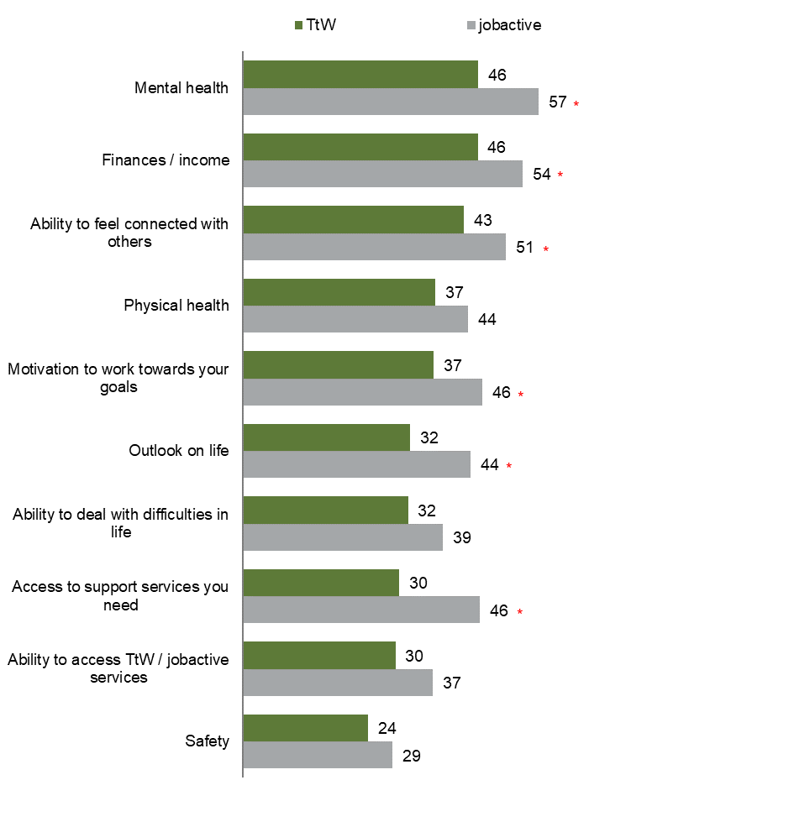
Source: Participant survey 2021
QCV2. In your opinion, what impact has COVID-19 had on your…?
Base: All respondents – TtW participants (n=1,502), jobactive participants (n=580)
*Indicates result is significantly different for TtW participants (p<0.05)
% Very negative / negative shown

- Data from 2021 provider and participant surveys
- 2021 participant survey results
Figure 54: Caseworker impacts on development of human capabilities (% of participants rating caseworker impact as positive / very positive)
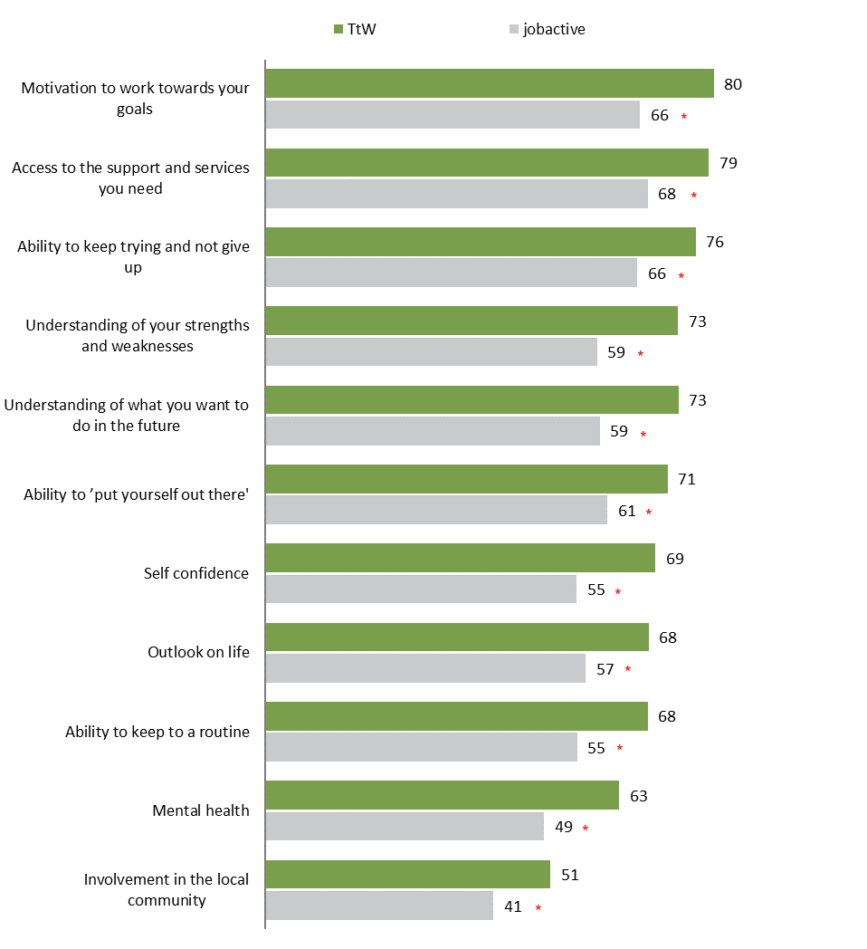
QTTB4 In your opinion, has your <TtW / jobactive> caseworker(s) had a positive or negative impact on your…
Base: TtW participants who had contact with their provider (n=1,494), jobactive participants who had contact with their provider (n=578)
*Indicates result is significantly different to TtW participants (p<0.05)
% Very positive / Positive shown
Figure 55: Current barriers to work and study (% of participants identifying barrier)
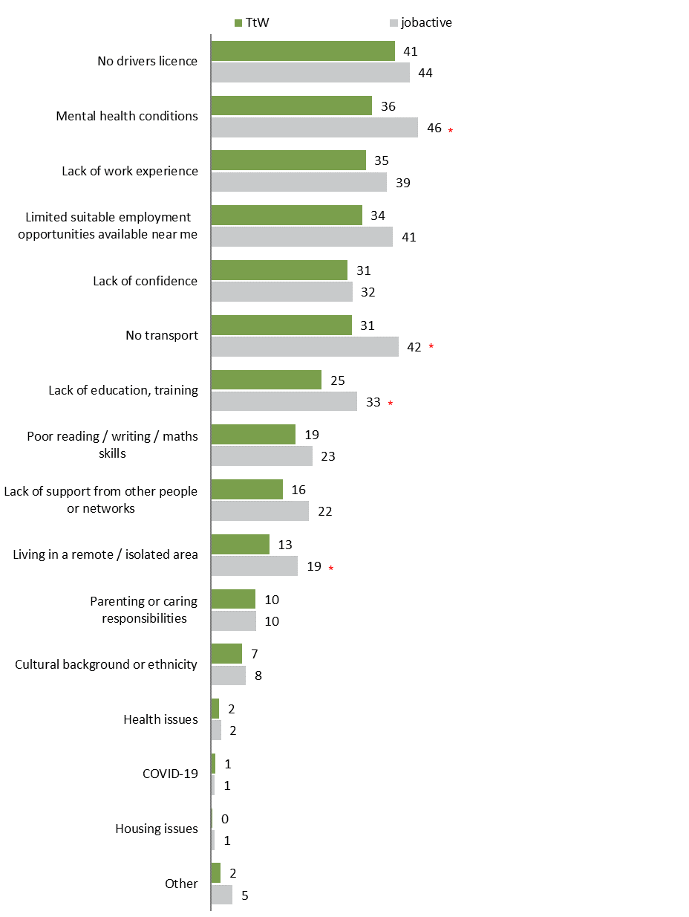
QTTE8 Thinking about your current circumstances, do any of the following make it difficult for you to work or study?
Base: All respondents – TtW participants (n=1,502), jobactive participants (n=580)
*Indicates result is significantly different to TtW participants (p<0.05)
Figure 56: Vocational support provided by caseworker (% of participants identifying support)
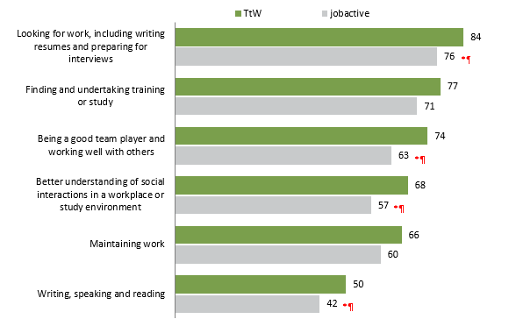
QTTB3. And since you started seeing your <TtW / jobactive> caseworker(s), did they provide you with any support in the following areas…?
Base: TtW participants who had contact with their provider (n=1,494), jobactive participants who had contact with their provider (n=578)
*Indicates result is significantly different to TtW participants (p<0.05)
Figure 57: Non-vocational support provided by caseworker (% of participants identifying support)
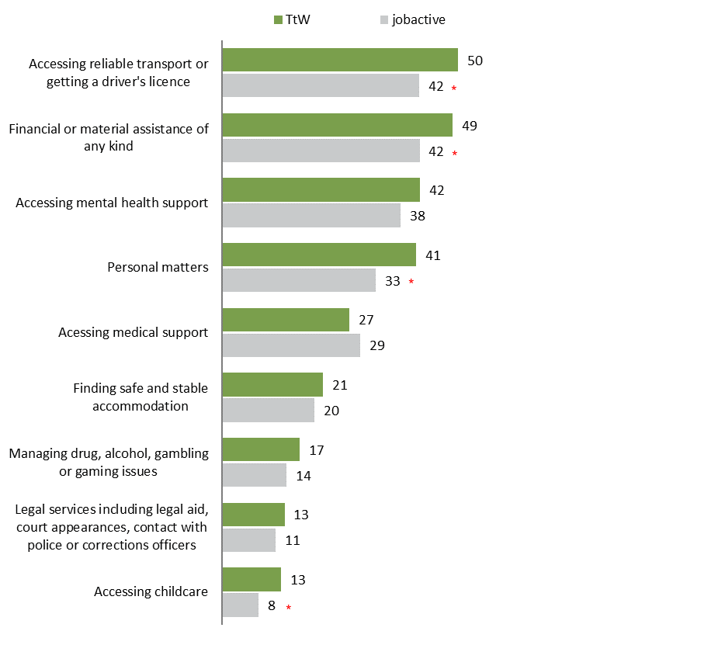
QTTB3. And since you started seeing your <TtW / jobactive> caseworker(s), did they provide you with any support in the following areas…?
Base: TtW participants who had contact with their provider (n=1,494), jobactive participants who had contact with their provider (n=578)
*Indicates result is significantly different to TtW participants (p<0.05)
- 2021 provider survey results
Figure 58: Effect of TtW program on participant attributes (% of provider respondents identifying that TtW had a very good, good or moderate effect on participant attributes)
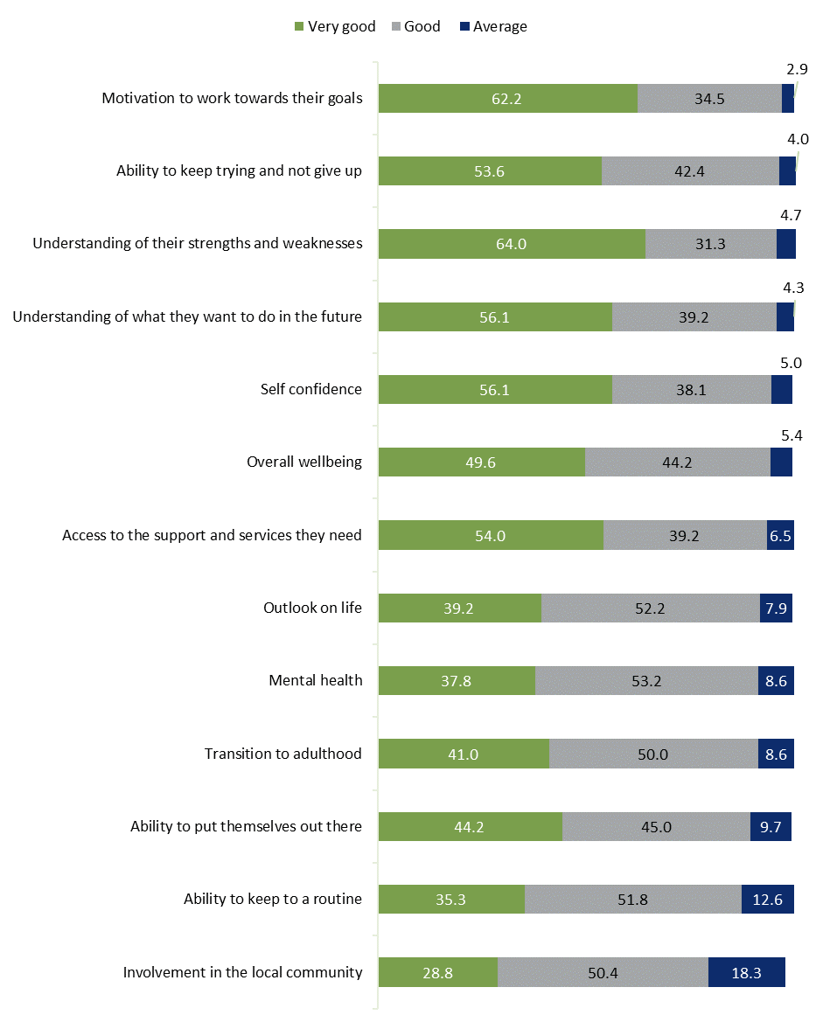
Base: All respondents (n=278)
Q7.2 Thinking about the [site name] site’s involvement with Transition to Work … Overall, what effect has engagement in the TtW program had on participant’s …?
Figure 59: Most common vocational barriers for participants at provider sites (% of provider respondents identifying each barrier)
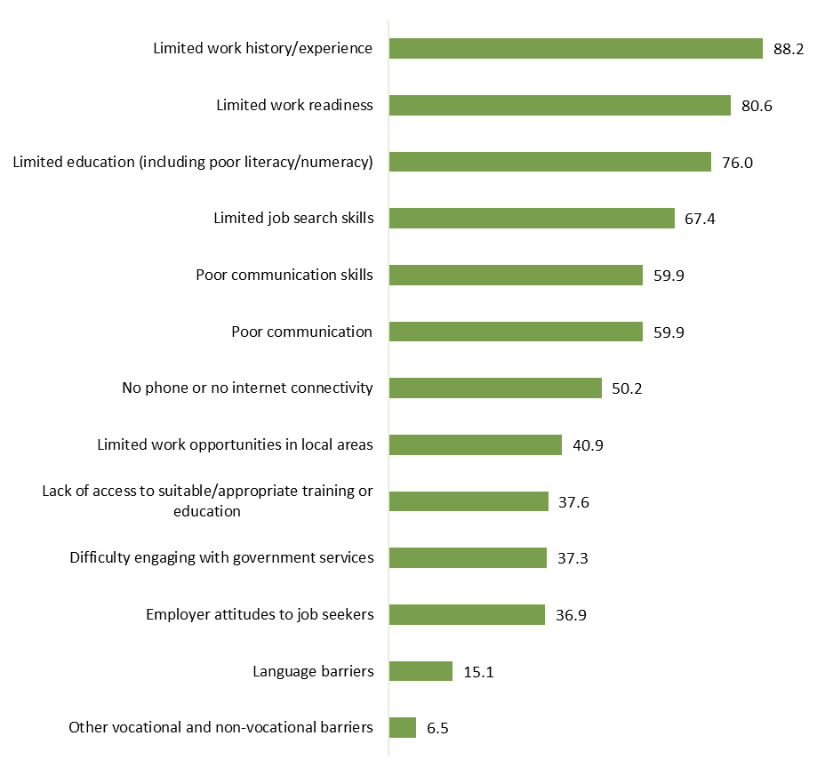
Base: All respondents (n=279)
Q3.2 What are the most common BARRIERS that participants at the [site name] site face in moving toward their employment and education goals? Select all that apply.
Figure 60: Most common non-vocational barriers for participants at provider sites (% of provider respondents identifying each barrier)
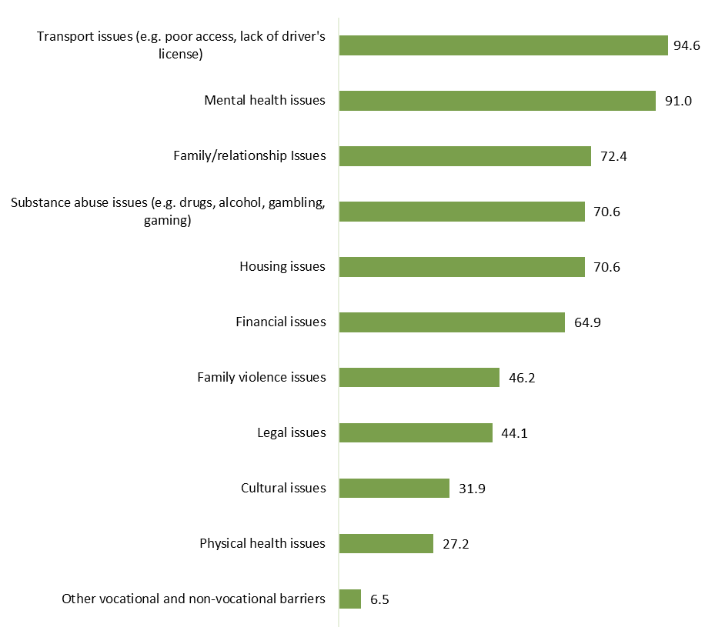
Base: All respondents (n=279)
Q3.2 What are the most common BARRIERS that participants at the [site name] site face in moving toward their employment and education goals? Select all that apply.
Figure 61: Types of referred services – non-vocational (% of provider respondents identifying services that participants are referred to at their site)
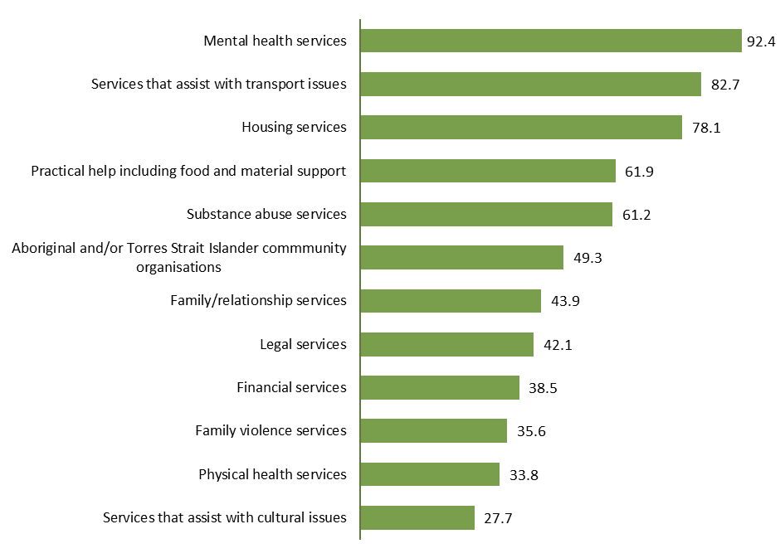
Base: All respondents (n=278)
Q3.7 What are the most common SERVICES that staff at the site refer participants to? Select all that apply.
Figure 62: Types of services or assistance not available for referrals – non-vocational (% of provider respondents identifying services they had been unable to refer participants at their site)
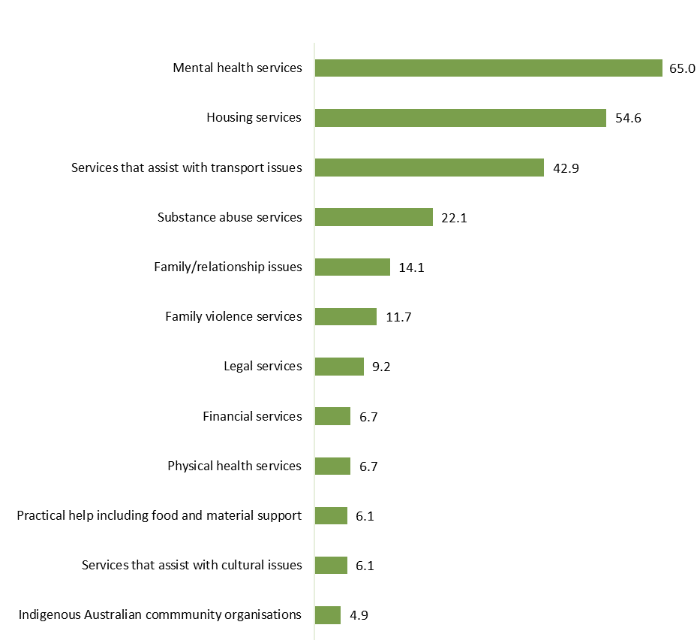
Base: Selected respondents (n=163)
Respondents who answered ‘Yes’ to Q3.8 (In the last 12 months, have staff at the site tried and been unable to refer participants to services or assistance that they needed?) and provided a response to Q3.9.
Q3.9 Which services or assistance were you UNABLE to refer participants to? Select all that apply.
Figure 63: Reasons why unable to refer participants to services or assistance (% of provider respondents identifying reasons they were unable to refer participants at their site)
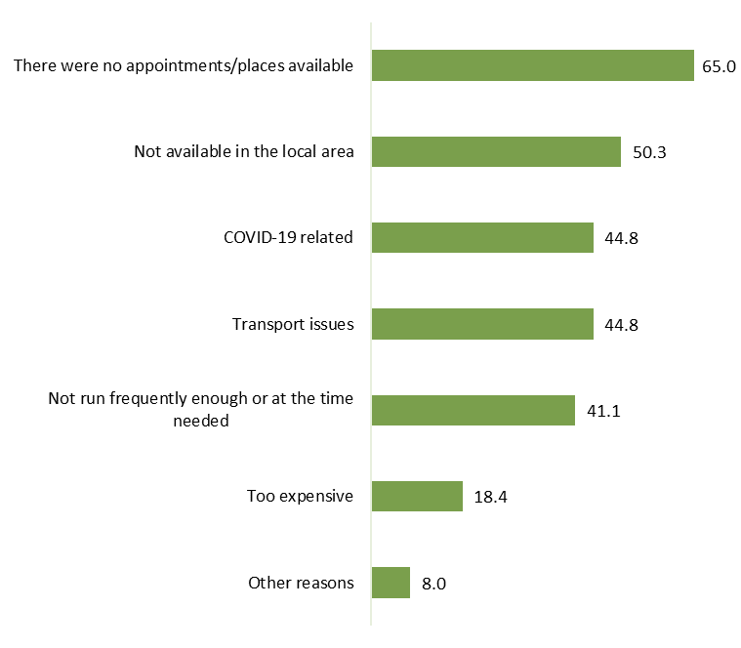
Base: Selected respondents (n=163)
Respondents who answered ‘Yes’ to Q3.8: In the last 12 months, have staff at the [site name] site tried and been unable to refer participants to services or assistance that they needed?
Q3.10 What were the MAIN reasons you were NOT able to refer participants to services or assistance that they needed? Select all that apply.

From 1 January 2020 eligibility age was expanded from 15–21 years to 15–24 years
From 1 January 2018, under the Closing the Gap Agreement, eligibility requirements were expanded to include Aboriginal or Torres Strait Islander young people, irrespective of whether they have completed Year 12 or a Certificate III or higher, for both Group 1 and Group 2.
From 1 January 2021, young people not on income support, and without Year 12 or equivalent qualification, only need to have been disengaged from work or education for 4 weeks.
Human capabilities examined in this research include personal psychosocial capabilities such as participants’ self-confidence, resilience and ability to cope with setbacks, physical and mental health, motivation and sense of control over their lives; and capability influencers including social connections and ability to access social supports and services.
Administrative data includes caseload information from the department’s Employment Services System (ESS Web) and income support data collected by Services Australia.
The term ‘caseworker’ is used as an overarching term for the provider staff who engage with and support participants. It should be noted that the TtW model does not specifically use a ‘case-management’ approach.
For example, almost two-thirds of the providers (65%) reported that mental health services were ‘unavailable for participant referral’.
As no direct measure of employment status is available once a participant exits employment services, data on exits from income support were used as an indicator of a participant taking up employment, where this exit was identified as a likely exit to employment (see Appendix 4.5 for a detailed description of this indicator). Labour market attachment includes where a participant recorded a reduction in income support rate from their initial base rate (as a proxy for increased employment), any reported earnings (as evidence of engagement in the labour market) and/or an employment-related income support exit as outlined above.
The TtW study population included participants referred to TtW between 1 April 2016 and 31 March 2017 who commenced in the program within 90 days from their initial referral date; had participated in the program for at least 28 days; and were receiving income support at day 28 from their commencement date. A comparison group was constructed from jobactive Stream B participants who met the same criteria. Matched samples from these 2 populations were selected for the analysis, based on education attainment (under Year 12 or Year 12 and above) and level of employment disadvantage, identified through participant’s Job Seeker Classification Instrument (JSCI) score. Further regression analysis was undertaken to control for other differences between these populations. It should be noted that, given the differences in program objectives, the comparison group participants may have been more motivated to work than the TtW group.
Equity groups examined included Aboriginal and/or Torres Strait Islander young people, women, early school leavers, people living with disability, and people with poor or mixed English.
There is no direct measure of participants moving to higher degree/longer-term accredited study or apprenticeships. Data on the income support payment types that participants were accessing (namely Youth Allowance (Student), Youth Allowance (Apprenticeship), ABSTUDY or Austudy) was used as an indicator of a participant taking up longer-term full-time study or a full-time apprenticeship.
Participants can remain in the TtW program for longer than their maximum duration of service if they are tracking for an outcome.
Labour market disadvantage was determined by a participant’s JSCI score at commencement.
There were 30,045 participants in each of the matched MD12 and MD18 cohorts. Increasing the duration of service was associated with an extra 7,928 people continuing for 12 or more months, 543 more people achieving at least one outcome, and 2,490 more outcomes being achieved overall.
The proportion of participants who achieved any outcome rose from 35.5% (MD12) to 37.3% (MD18) (i.e. extending the maximum duration of service by 6 months was associated with 1.8 percentage points more participants achieving at least one outcome).
jobactive was the Australian Government’s employment services model that replaced Job Services Australia on 1 July 2015 and was replaced by Workforce Australia Employment Services on 4 July 2022. This evaluation of TtW was undertaken before this change, and hence refers to jobactive as the alternative employment service that young people could choose to access at that time. Under Workforce Australia, there are 2 mainstream employment services – online services (Workforce Australia Online) and provider-led services (Workforce Australia Services). Workforce Australia Online allows individuals to self-manage and connect with businesses through the online platform. Workforce Australia Services comprise a network of providers who are engaged to deliver personalised support for those with more complex needs. TtW is the youth specialist service in Workforce Australia.
From 1 July 2020, the length of time that young job seekers can access TtW services was extended to 18 months (from 12 months). If participants are tracking for an outcome they are permitted to remain in TtW until the completion of that outcome (maximum 3 months).
This data relates to the young people referred to TtW (the inflow population) between April 2016 and March 2017, as this is the population used in the long-term impact analysis. This data is, however, largely representative of TtW across the whole study period.
Homelessness rate for people 19 to 24 years old was 0.95%; homelessness rate for people 12 to 18 years old was 0.5%. ‘Homeless’ includes improvised dwellings, tents, sleeping out, supported accommodation, temporary arrangements with other households, boarding houses, other temporary lodgings, and severely crowded dwellings. Source: ABS 2016.
TtW ‘ex offender’ includes participants who self-disclosed in their initial JSCI assessment that they had any criminal conviction that was either a non-custodial sentence or any length of custodial sentence. There is no equivalent data for the broader population but, as an indication, imprisonment rate for 18 year olds was 0.07%, 19 year olds 0.15% and 20–24 year olds 0.23% in 2020. Source: ABS 2021c.
The 2019–20 bushfires primarily affected the east coast of Australia (Queensland, New South Wales and Victoria), southern parts of Victoria and South Australia, and central east Tasmania, and flooding had the most significant impact in northern New South Wales. While COVID-19 had an impact Australia wide, with a shutdown of all non-essential services and additional restrictions nationwide between March and May 2020, restrictions remained in place or resumed in different states at different times depending on the severity of the outbreak throughout 2020 and 2021.
TtW has been continued as the youth specialist service in Workforce Australia, with new contracts signed for 2022 to 2027.
Youth Jobs PATH was an Australian Government service that aimed to help young people gain the skills and work experience needed to get a job. It included employability skills training for a participant that could be tailored to a specific employer, supported businesses to trial young people in the workplace and provided a financial incentive to businesses to hire young people into ongoing work.
Closing the Gap Agreement, Outcome 7: Aboriginal and Torres Strait Islander young people are engaged in employment or education. Target 7: By 2031, increase the proportion of Aboriginal and Torres Strait Islander youth (15 to 24 years) who are in employment, education or training to 67%. From 1 January 2018, under the Closing the Gap Agreement, eligibility requirements were expanded to include Aboriginal or Torres Strait Islander young people, irrespective of whether they have completed Year 12 or a Certificate III or higher.
Examples include Perales et al (2018), Bond et al (2020), Egdell and Graham (2016), Busi (2011), Carlisle et al (2019) and Mission Australia (various years).
In order to be able to attribute participant outcomes to engagement with TtW, a group of matched participants from jobactive was identified to use as a comparison group (that is, the ‘without TtW service’ comparison).
A participant was identified as experiencing LMA if they demonstrated any of the following factors in any fortnight of the study period: reported earnings to the Department of Human Services, received no income support payment, received an income support payment below their initial base rate, or recorded part-time or casual employment as an activity or had a confirmed job placement recorded in the department’s IT system.
Unemployment has been found to be detrimental to wellbeing, linked to psychological distress, shame, depression and life dissatisfaction. This has been another driver in the focus on programs that ‘activate’ welfare to work, in the belief that ‘work builds self‐esteem, self‐confidence and self‐worth’ (Carter and Whitworth 2017). Further to this, there is evidence that where activation programs focus on enabling people to feel in control of their life and able to design and move towards a desired future life and support people to take part in activities that are self-directed, meaningful and relevant, they are more successful at enhancing participant wellbeing (Carter and Whitworth 2017).
As outlined in the program logic that was developed to underpin the TtW Supplementary Evaluation.
Human capabilities include personal psychosocial capabilities such as self-confidence, resilience and ability to cope with setbacks, physical and mental health, motivation and sense of control over their lives; and capability influencers including social connections and ability to access social supports and services.
Acknowledging that there are many independent factors that influence longer-term outcomes. Specifically, COVID-19 had a significant impact on the lives of many participants in the later 18 months of this period (from March 2020), requiring this ‘COVID period’ to be delineated and specifically discussed.
Qualitative research adds context and explores the how and why of impacts. It both provides a check and deepens our understanding of the meaning of findings that are arrived at through more qualitative data collection methods. Participants in qualitative research were not selected to be representative of all participants. Therefore, qualitative findings cannot be extrapolated to all participants.
This was the date on which fieldwork began.
To be included in the study population, participants also needed to have a contact phone number or email, not be excluded from research, and be 16 years or over at the time of the research.
In the past 12 months have you personally experienced any of the following? … a) Family / domestic violence, b) Moving house, c) You were robbed or your home burgled, d) The death of someone close to you, e) A marriage/relationship breakdown, f) A serious injury, g) Serious illness, h) Financial hardship [yes, no, unsure, refused].
jobactive was the Australian Government’s previous employment services model that commenced on 1 July 2015 and was replaced by Workforce Australia Employment Services on 4 July 2022. This evaluation of TtW was undertaken before this change, and hence refers to jobactive as the alternative employment service that young people could, at that time, choose to access.
This filter was necessary as the analysis used exits from income support as an indicator of a participant gaining employment; however, it should be noted that this filtered out almost all TtW Group 2 participants from the study population (Group 2 participants made up less than 5% of the overall TtW population). This analysis should not therefor be used to draw explicit conclusions about the impact of TtW on volunteers in the longer term.
A very small proportion of participants moved off income support for a study-related reason. This has been included here as this is seen to be a positive reason for exiting IS. For simplicity this measure is named ‘employment’.
Exits from IS are only recorded when a participant has been off IS for 13 weeks when they have been on IS for a continuous period of at least 12 months, or 6 weeks when they have been on IS for a continuous period of less than 12 months.
These apprentices should be included in the above ‘employment’ indicator.
The policy change affected the eligibility of participants who commenced in TtW from 1 July 2019, as they were now able to remain in the program for over 12 months even if they were not tracking for an outcome.
In order to enable the analysis to examine outcomes for 18 months post policy change, the end date for the ‘maximum 18 month’ population was set at 30 June 2020.
This start date was chosen to ensure the size of the ‘maximum 12 month’ inflow population (counted as 34,749) matched the size of the ‘maximum 18 month’ inflow population (counted as 34,679) as closely as possible.
Data on outcomes achieved by participants from both cohorts was collected for a minimum of 27 months from participant commencement to allow time for providers to record participant outcomes.
JSCI scores were distributed into 4 groups: very high, high, low and very low. A higher score identifies a higher level of risk of becoming long-term unemployed.
This analysis did not look at other possible impacts of the program such as changes in human capabilities and wellbeing, as this data was not available and could not be collected for the sample cohorts.
Participants may have had more than one period of assistance; however, since a significant amount of time elapsed between participants ending a period of assistance and starting a new one, a participant’s labour market situation and personal characteristics may have differed significantly from one period of assistance to the next. The evaluation therefore treated each of a participant’s periods of assistance as separate cases, rather than combining them and treating each participant as a single case. For ease of reporting, reference is made to ‘participants’ when referring to these ‘periods of assistance’ throughout the report.
Costs and benefits were identified using information from literature review, previous evaluation research undertaken for TtW, and the analysis of long-term impact and impact on participants’ human capabilities undertaken as part of this supplementary evaluation. The costs and benefits associated with TtW are discussed in Section 7.2.
Participants were asked if their caseworker(s) had a positive or negative impact on a series of human capability measures. It is important to note these questions referred to the caseworker(s) rather than the TtW program. The qualitative component of the evaluation and cognitive testing of the questionnaire found participants tended to associate the services they had received with their caseworker or provider, rather than the TtW program. Participants therefore found it easier to reflect on the impact of their caseworker on the human capability measures.
2021 participant survey QTTB4. In your opinion, has your <TtW / jobactive> caseworker(s) had a positive or negative impact on your …? See Appendix 8, Figure 54.
2021 provider survey Q7.2. Thinking about the [site name] site’s involvement with Transition to Work … Overall, what effect has engagement in the TtW program had on participant’s …? See Appendix 8, Figure 58.
2021 participant survey QTTB4. In your opinion, has your <TtW / jobactive> caseworker(s) had a positive or negative impact on your…? See Appendix 8, Figure 54.
2021 provider survey Q7.2. Thinking about the [site name] site's involvement with Transition to Work …Overall, what effect has engagement in the TtW program had on participant’s …? See Appendix 8, Figure 58.
It should be noted that during interviews many participants did not understand or identify with the term ‘empowerment’, instead understanding it to mean ‘motivation’.
2021 provider survey Q7.2. Thinking about the [site name] site’s involvement with Transition to Work … Overall, what effect has engagement in the TtW program had on participant’s …? See Appendix 8, Figure 58.
Responses are allocated scores from 1 to 5, with 3 items reverse scored. Responses are added together to produce a score ranging from 6 to 30. This score is then divided by the number of questions answered.
Stressful life events included financial hardship, moving house, a death of someone close, a relationship breakdown, a serious injury or illness, family violence, or experiencing a robbery or burglary.
2021 participant survey, QTTB4 In your opinion, has your <TtW / jobactive> caseworker(s) had a positive or negative impact on your…? See Appendix 8, Figure 54
2021 provider survey Q7.2. Thinking about the [site name] site’s involvement with Transition to Work … Overall, what effect has engagement in the TtW program had on participant’s …? See Appendix 8, Figure 58.
This result should be read in the context of possible selection bias in the comparison sample discussed in Section 2.5.8.
Mental health was the most prevalent barrier reported by the comparison group, and the second most prevalent barrier reported by TtW participants after ‘no drivers licence’ which was reported by 41% of TtW participants (see Appendix 8).
2021 provider survey Q3.2. What are the most common BARRIERS that participants at the [site name] site face in moving towards their employment and education goals. See Appendix 8, Figures 59 and 60.
2021 provider survey Q7.2. Thinking about the [site name] site’s involvement in Transition to Work … Overall, what effect has engagement in the TtW program had on participants…? See Appendix 8, Figure 59.
2021 participant survey QTTB3. And since you started seeing your <TtW / jobactive> caseworker(s), did they provide you with any support in the following areas? See Appendix 8, Figures 57 and 58.
2021 provider survey Q3.7. What are the most common SERVICES that staff at the site refer participants to? Select all that apply. See Appendix 8, Figure 61.
2021 provider survey Q3.9. Which services or assistance were you UNABLE to refer participants to? Select all that apply. See Appendix 8, Figure 62.
2021 provider survey Q3.10. What were the MAIN reasons you were NOT able to refer participants to services or assistance that they needed? Select all that apply. See Appendix 8, Figure 63.
Huppert and So (2011) and Steer (2016) reference numerous cross-sectional, longitudinal and experimental studies across a range of countries that demonstrate this.
See Steer (2016), Witten et al (2019) or Diener et al (2010) for discussion of the various and multiple impacts.
If there is selection bias in the samples that has not been accounted for through regression, the finding that TtW participants had higher life satisfaction could be associated with their initial state as well as the program influence.
Australian Institute of Health and Welfare 2021, Australia’s youth: Subjective wellbeing – Australian Institute of Health and Welfare (aihw.gov.au), accessed 24/11/21 AIHW, reported data from HILDA (2018), the Mission Australia Youth Survey (2020) and Longitudinal Survey of Australian Youth (LSAY) (2018). Additional data reported: - In 2020 (mid COVID-19), almost 3 in 5 (59%) young people aged 15–19 reported feeling happy or very happy with their life as a whole, similar to 2019 (61%) but declining steadily since 2012 (71%) (Mission Australia Youth Survey data collected between April and August 2020, compared to data collected annually since 2012). - 2018 LSAY (Y15 and Y09 cohorts – aged 18 and 24, respectively) asked how satisfied young people are with their lives as a whole. Very or fairly satisfied with their life as a whole (24 year olds, 90%; 18 year olds, 84%).
2021 provider survey Q7.2. Thinking about the [site name] site’s involvement with Transition to Work … Overall, what effect has engagement in the TtW program had on participant’s …? See Appendix 8, Figure 58.
If there is selection bias in the samples that has not been accounted for through regression, the finding that TtW participants had higher wellbeing could be associated with their initial state as well as the program influence.
2021 participant survey QTTB4. In your opinion, has your <TtW / jobactive> caseworker(s) had a positive or negative impact on your … See Appendix 8, Figure 54.
2021 provider survey Q7.2. Thinking about the [site name] site’s involvement in Transition to Work … Overall, what effect has engagement in the TtW program had on participants … See Appendix 8, Figure 58.
2021 participant survey QTJA4. And overall, would you say that the frequency of contact with your caseworker(s) is … (just right, too little, too much).
Q7.3 We can think about the confidence, motivation, resilience, health and connectedness of TtW participants as their ‘human capabilities’. To what extent do you think that TtW has a positive impact on the human capabilities of participants?
It should be noted that only 6% of TtW sites are for-profit (17 sites out of 278 sites).
The medial caseload of sites with specialist staff is 95, compared to 77 for sites with no specialist staff.
Regression analysis included the following variables: ex-offender status, gender, Indigenous status, education level, housing stability, access to transport, existence of other personal factors affecting employability, whether a participant had previous work experience, disability, English competency, income support history, location (metro/regional/remote) and the availability of jobs in the employment area. Regression analysis also showed that regardless of what program they are in, participants with any of the following characteristics were also more likely to go to prison in the 4 years from commencement: ex-offender, male, Indigenous, early school leaver, unstable residence, lack of private transport, other personal factors.
‘Ex-offender’ refers to participants who self-disclose in their initial JSCI assessment that they have any criminal conviction that is either a non-custodial sentence or any length of custodial sentence.
Ex-offenders made up 9.0% of the TtW cohort, and 9.1% of the comparison cohort.
It is worth noting that while Aboriginal and/or Torres Strait Islander participants make up only 27% of the study population, overall, they were almost as likely to be incarcerated as non-Aboriginal and/or Torres Strait Islander participants.
The proportion of participants overall who were incarcerated over the 4-year study period is 5.03% of TtW participants, compared to 6.17% of participants in the comparison group (see Section 6.2).
Many participants from both TtW and the comparison sample move in and out of income support (and employment) over time.
see Section 2.4.3 and Appendix 4.3 for details of how this indicator is defined.
This is in line with findings from the TtW final evaluation (DESE 2021).
COVID-19 began to impact some of the research participants at around 36 months, so any results after this point are impacted by COVID-19.
COVID-19 began to impact some of the research participants at around 36 months, so any results after this point are impacted by COVID-19.
It should be noted that those who have only one income support episode may have exited income support and not returned, or may never have exited income support; similarly those who have 2 episodes of income support may still be on income support (for the second time) or have exited and not returned after 2 episodes of income support.
A ‘study outcome’ was defined as the placement (recorded in the department’s IT system) of a TtW or jobactive participant in an education or training activity that could qualify for an education outcome payment.
A 20% decrease in the number off income support.
Equity groups examined included Aboriginal and/or Torres Strait Islander young people, women, early school leavers, people living with disability, and those with poor or mixed English.
Allowing time for providers to complete their claims for outcome payments for participants.
Based on whether they had a ‘high’ or a ‘moderate’ JSCI score, a higher score indicating higher labour market disadvantage
A similar analysis was undertaken examining outcomes for participants who had achieved Year 12 or more, compared to those who had not achieved Year 12, and very similar patterns were observed.
Data on outcomes achieved by participants from both cohorts was collected for a minimum of 27 months from participant commencement to allow time for providers to record participant outcomes.
Five per cent of providers responded that the change in duration had resulted in no impacts to report, and 10% did not know if changing duration had had an impact.
This includes any outcome – employment or education.
It is worth noting that this shift may not solely be due to the change in maximum service duration but may have been influenced by other factors such as the COVID-19 pandemic and other natural disasters.
There were 30,045 participants in each of the matched MD12 and MD18 cohorts. Increasing the duration of service was associated with an extra 7,928 people continuing for 12 or more months, 2,490 more outcomes being achieved overall, and 543 more people achieving at least one outcome.
A participant achieves a ‘study outcome’ when they have participated in an education or study activity that qualifies for an outcome payment. Study outcomes achieved within a month of referral were excluded as it is unlikely these are the result of TtW or jobactive servicing.
Additional benefits have been valued over 4 years, then divided by 4, to obtain a more reliable figure for a representative 12-month period.
It is significantly more expensive to incarcerate people under 18 ($2,518/night), but only about 2% of total incarcerations were for participants under 18, so the cost for incarcerating an adult has been used.
Acknowledging the assumption that there was no selection bias when choosing the comparison group.
Additional costs have been valued over 4 years, then divided by 4, to obtain a more reliable figure for a representative 12-month period.
Treasury NZ, 2015, Guide to Social Cost Benefit Analysis, NZ Government, https://www.treasury.govt.nz/publications/guide/guide-social-cost-benefit-analysis
Treasury NSW, 2017, TPP17-03 NSW Government Guide to Cost Benefit Analysis, https://arp.nsw.gov.au/tpp17-03-nsw-government-guide-cost-benefit-analysis/
Revealed preferences use observations of actual behaviour or transactions to infer a value for a non-market good – for example, estimating the value people place on the environment by analysing how much people are willing to pay for houses close to bushland or with specific environmental attributes through regression modelling.
In the simplest form, stated preferences determine the value of something by asking people what something is worth to them.
Average additional income support payment per participant = sum of all months in period from commencement to 48 months [(exits from comparison group – exits from TtW group in each month) x average income support payment for one person for a month ($1,118)] / sample size (8,361).
TtW had a significantly greater impact on the TtW sample than jobactive had on a matched sample of jobactive participants.
The 2019–20 bushfires primarily affected the east coast of Australia (Queensland, New South Wales and Victoria), southern parts of Victoria and South Australia, and central east Tasmania, and flooding had the most significant impact in northern New South Wales. While COVID-19 had an impact Australia wide, with a shutdown of all non-essential services and additional restrictions nationwide between March and May 2020, restrictions remained in place or resumed in different states at different times depending on the severity of the outbreak throughout 2020 and 2021.
The nature of the sample selections means the jobactive sample does not necessarily represent the experiences of the broader jobactive population.
jobactive group weighted to TtW group benchmarks.
It should be noted that those who have only one income support episode may have exited income support and not returned, or may never have exited income support; similarly those who have 2 episodes of income support may still be on income support (for the second time) or have exited and not returned after 2 episodes of income support.
The 36-month point is relevant as after this time COVID-19 begins to impact an increasing proportion of participants.
It should be noted that moving out of employment services does not equate to moving off income support. A large proportion of individuals on income support are not required to participate in employment programs (due to, for example, caring responsibilities or disability). In September 2021, only 38% of individuals who were receiving income support were engaged in an employment program. Of those on Youth Allowance (Other), 81% were involved in an employment program, with 23% of these in TtW and 77% in jobactive (departmental administrative data).
In addition a small number of reasons had not been categorised, so an assessment was made by the evaluation team regarding their categorisation.
The policy change affected the eligibility of participants who commenced in TtW from 1 July 2019, as they were now able to remain in the program for over 12 months even if they were not tracking to an outcome.
In order to enable the analysis to examine outcomes for 18 months post policy change, the end date for the ‘after policy change’ population was set at 30 June 2020.
This start date was chosen to ensure the size of the before policy change inflow population (counted as 34,749) matched the size of the after policy change inflow population (counted as 34,679) as closely as possible.
The phrase ‘91-day rule’ is used to denote the period in which a TtW or jobactive participant who exits servicing may return to services without entering a new period of service.
Skill Level 5 jobs are low-skill jobs which require Certificate I or secondary education.
Survey respondents included a representative sample of TtW participants who had been receiving services from the TtW program for at least 6 months (n=1,502) and a comparison group of participants who had not previously received support from TtW and had been receiving services from the jobactive program for at least 6 months (n=580). Level of subjective wellbeing was assessed using the PWI tool. A larger TtW sample was used to allow further stratification of the TtW sample. Response rates were very similar – TtW 20.6, jobactive 20.4.
RA Cummins, R Mead and the Australian Unity-Deakin University Wellbeing Research Partnership (2021). The Australian Unity Wellbeing Index 20th Anniversary Commemorative Edition, Australian Unity and Deakin University, Melbourne.
R Layard, S Nicell and G Mayraz (2008). The marginal utility of income, Journal of Public Economics 92:1846–1857, doi:10.1016/j.jpubeco.2008.01.007 (lse.ac.uk).
In 2021–22, maximum JobSeeker and Youth Allowance (Other) payments for a single person living away from home were approximately $13,800. Participants who were earning some income, were partnered or had children would likely have had a higher household income. The proportion of participants claiming Parenting Payment is insignificant, and it is unknown what proportion of participants are partnered or living in multi-person households. For simplicity and to avoid overclaiming, in our analysis we have assumed that on average participants are earning less than $15,000 per annum.
John K Stanley, David A Hensher, Janet R Stanley and Dianne Vella-Brodrick (2021). Valuing changes in wellbeing and its relevance for transport policy, Transport Policy 110:16–27.
N Biddle, B Edwards, M Gray and K Sollis (2020). Hardship, distress, and resilience: the initial impacts of COVID-19 in Australia, ANU Centre for Social Research & Methods, Canberra.
This is the Australian dollar equivalent of the mid-point value ascribed by the UK Treasury. Using the mid-point value of £13,000 and the average exchange rate for the calendar year 2019 of AU$1.7522 per pound (Calendar year ending 31 December 2019 | Australian Taxation Office (ato.gov.au)) then converted to 2020 dollars.
An odds ratio of less than 1 means something is less likely to occur, while an odds ratio of greater than 1 means something is more likely to occur.
Australian Government (2022) Guides to Social Policy Law, Social Security Guide, Historical Payment Rates, Chapter 5.2.1, Unemployment, sickness benefit and youth related payments – historical rates 5.2 Historical rates | Social Security Guide (dss.gov.au)
ACOSS (2021). Who receives Jobseeker, Youth Allowance and other income support? Fact Sheet, accessed 29/4/22, Facts-on-JobSeeker-FINAL.pdf (raisetherate.org.au).
Research was undertaken in mid-2021, so this appendix is examining the impact of COVID-19 until that point in time.

