Slide 1 Introductory slide
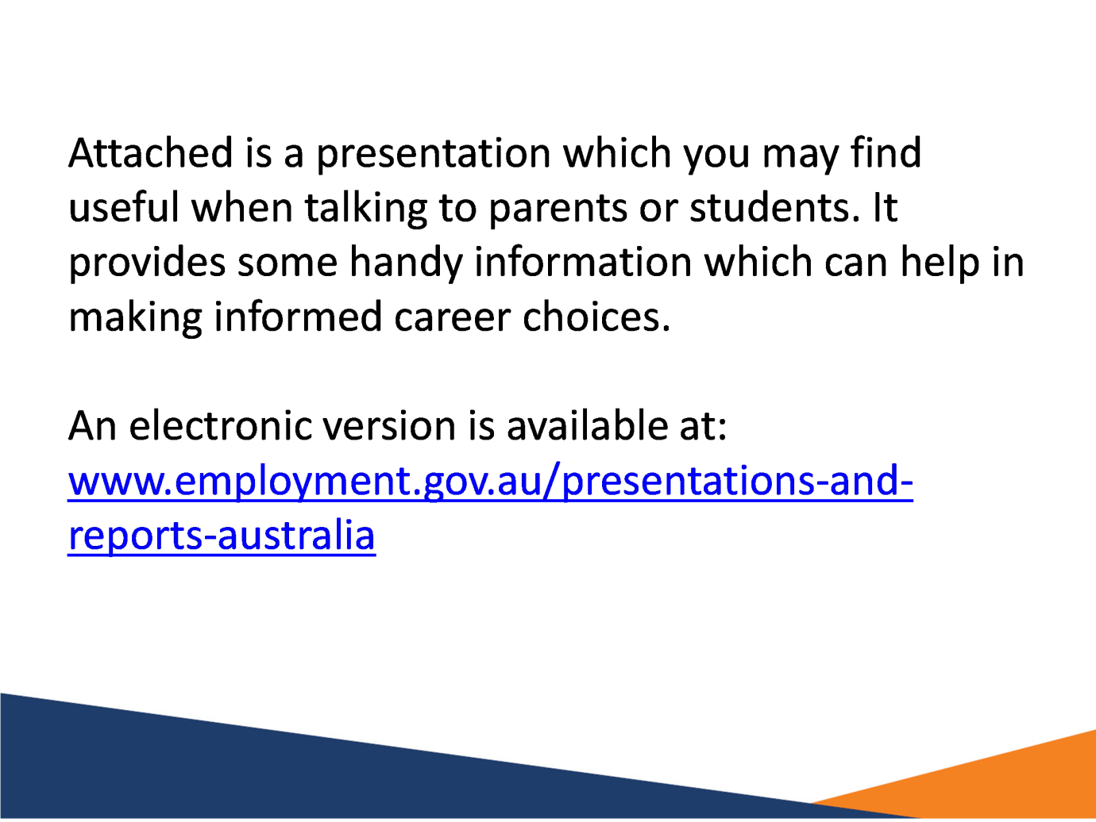

Slide 2 Making informed career choices


Slide 3 Employment by industry
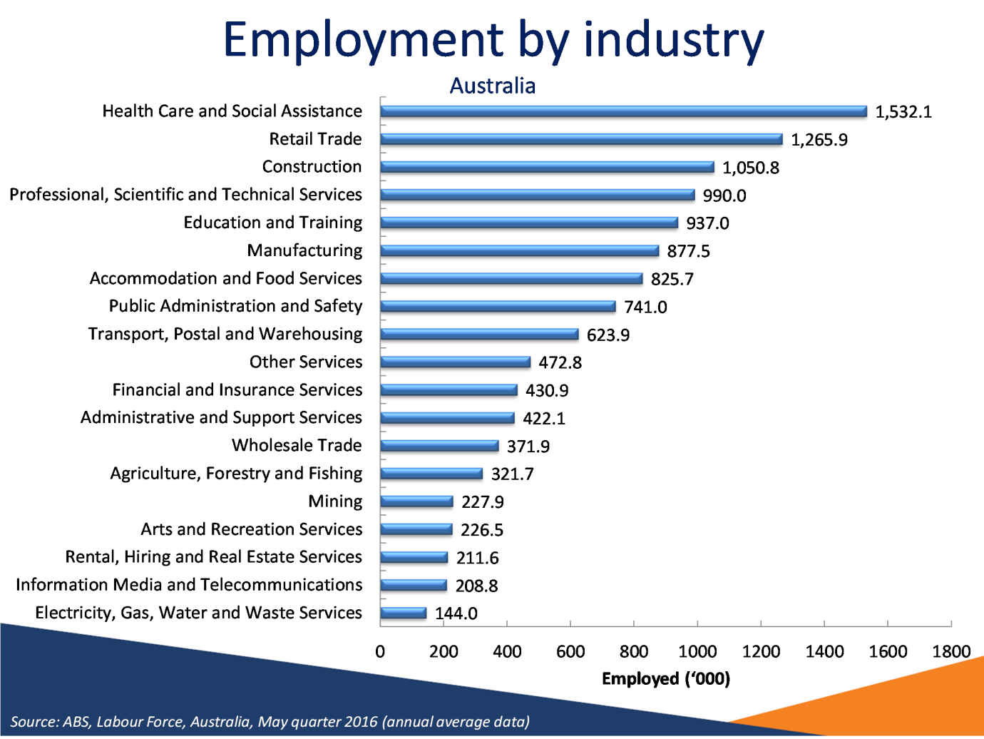

Notes
Source: ABS, Labour Force, Australia, May quarter 2016 (annual average data)

Slide 4 Projected employment change
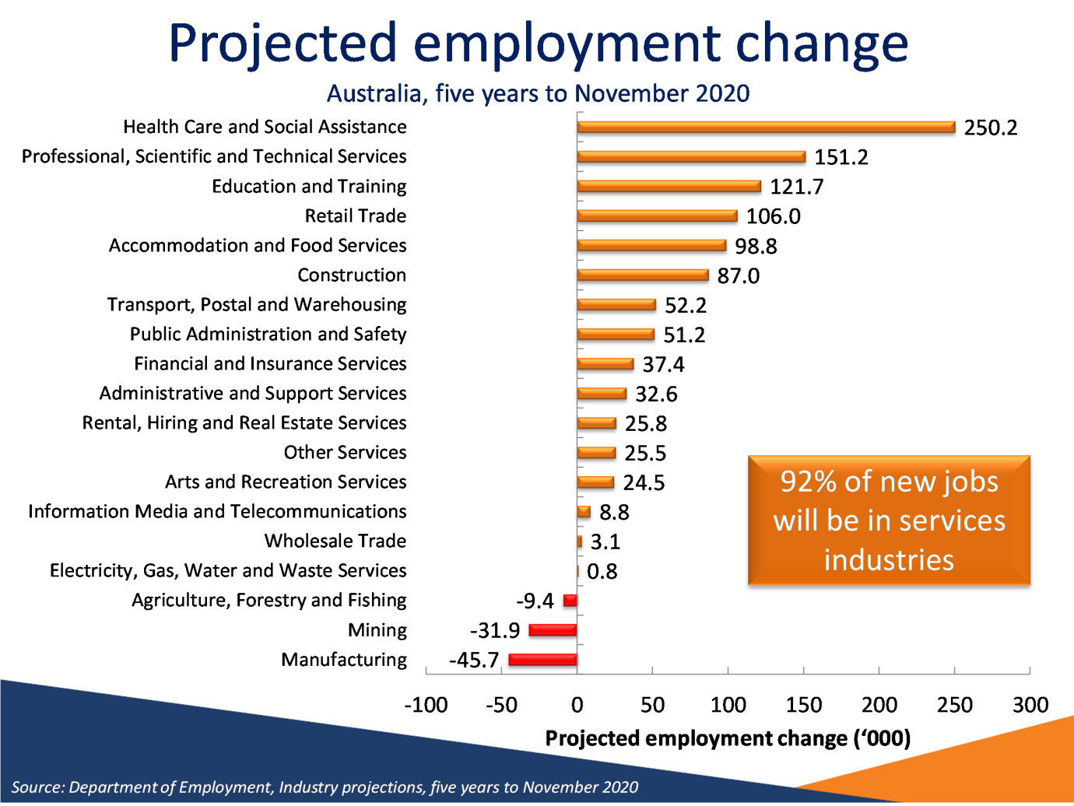

Notes
Source: Department of Employment, Industry projections, five years to November 2020

Slide 5 Growth will be in higher skilled occupations
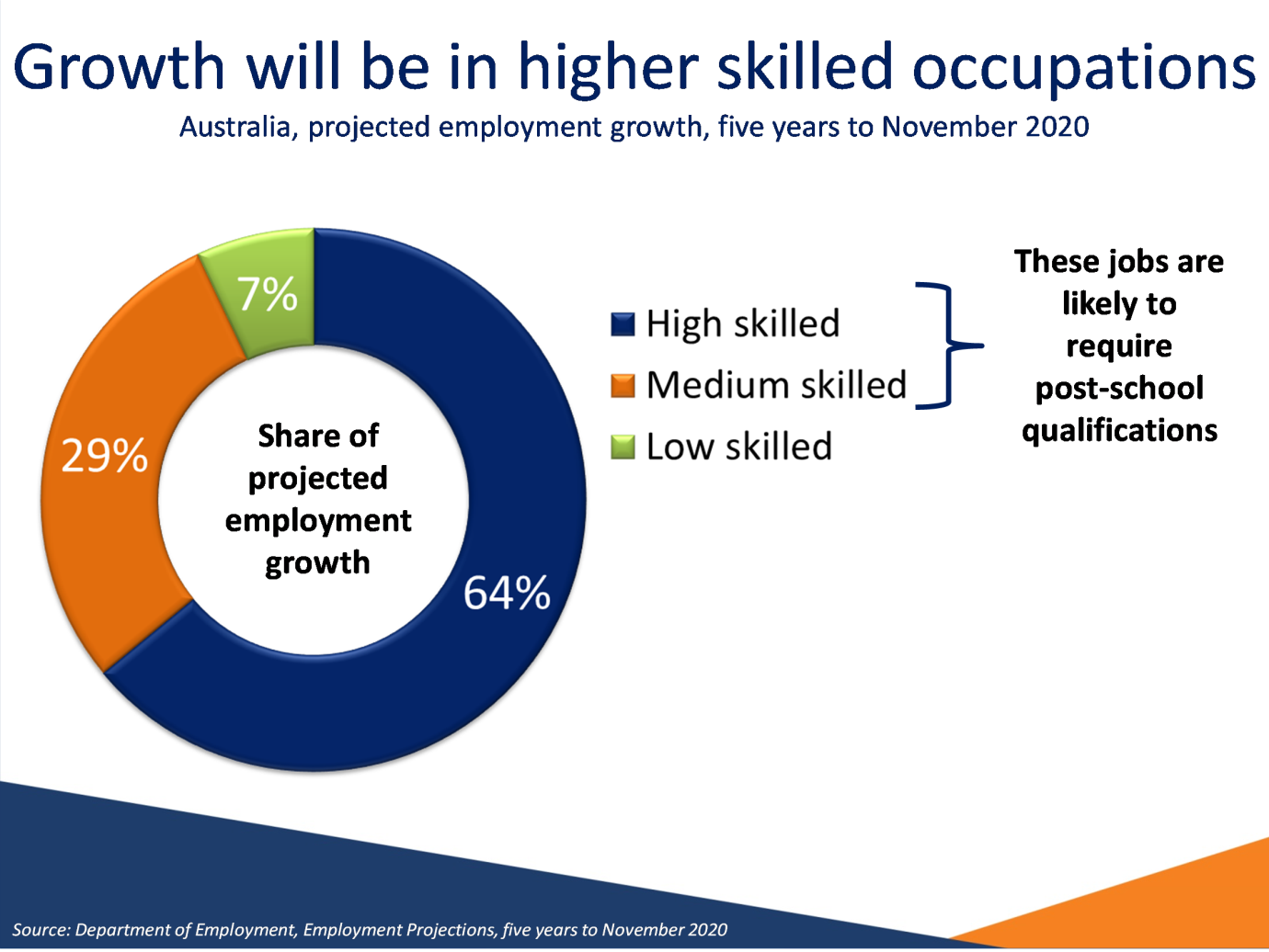

Notes
Source: Department of Employment, Employment Projections, five years to November 2020

Slide 6 The jobs market can be competitive
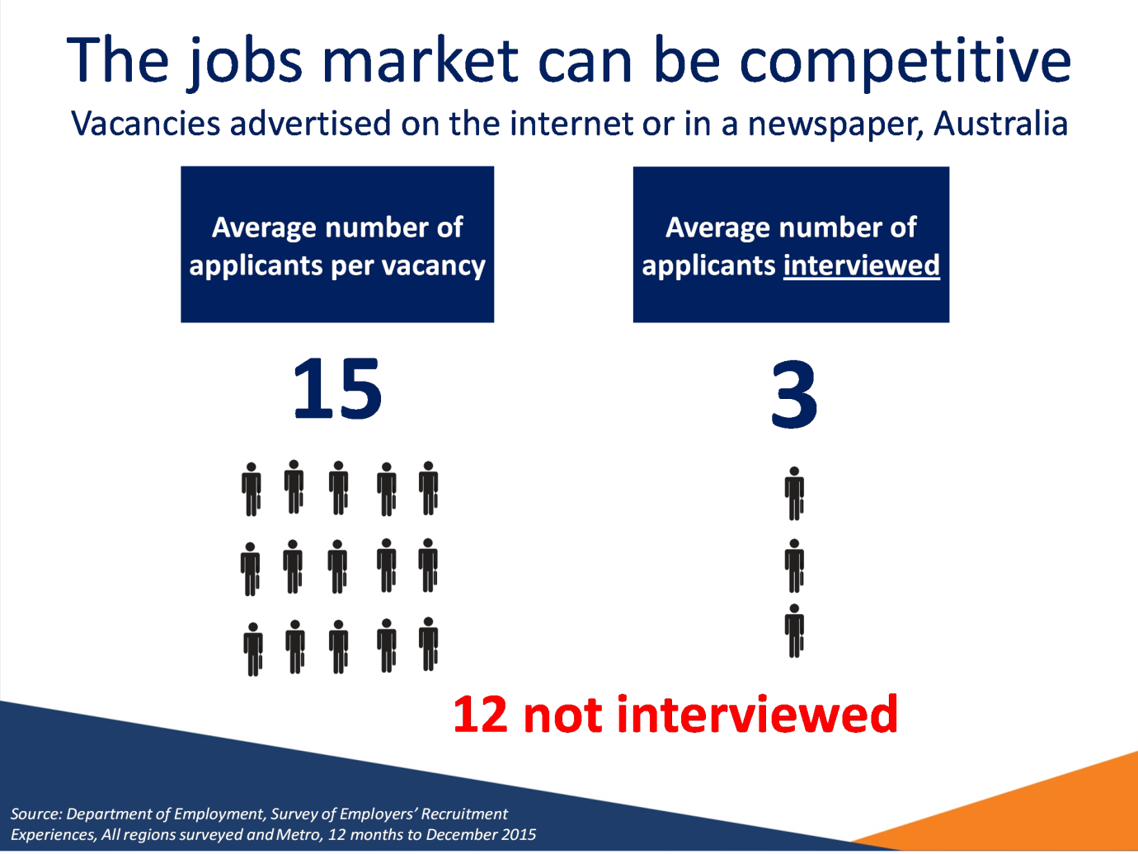

Notes
Source: Department of Employment, Survey of Employers’ Recruitment Experiences, All regions surveyed and Metro, 12 months to December 2015

Slide 7 Educational attainment and labour market outcomes
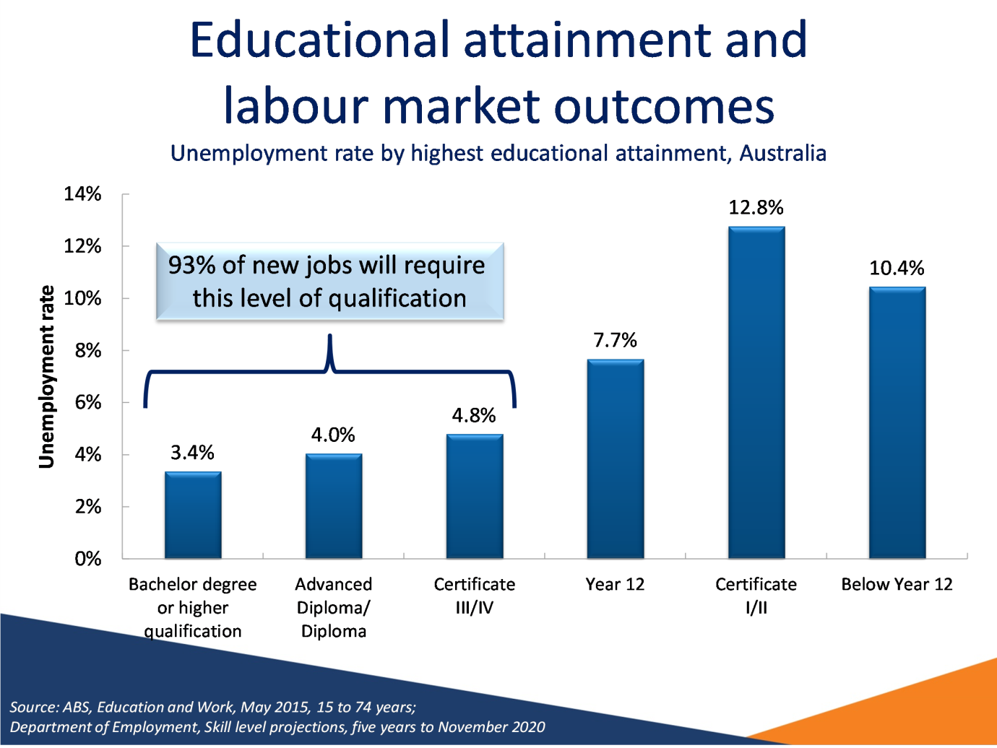

Notes
Source: ABS, Education and Work, May 2015, 15 to 74 years; Department of Employment, Skill level projections, five years to November 2020

Slide 8 Benefits of an apprenticeship or traineeship
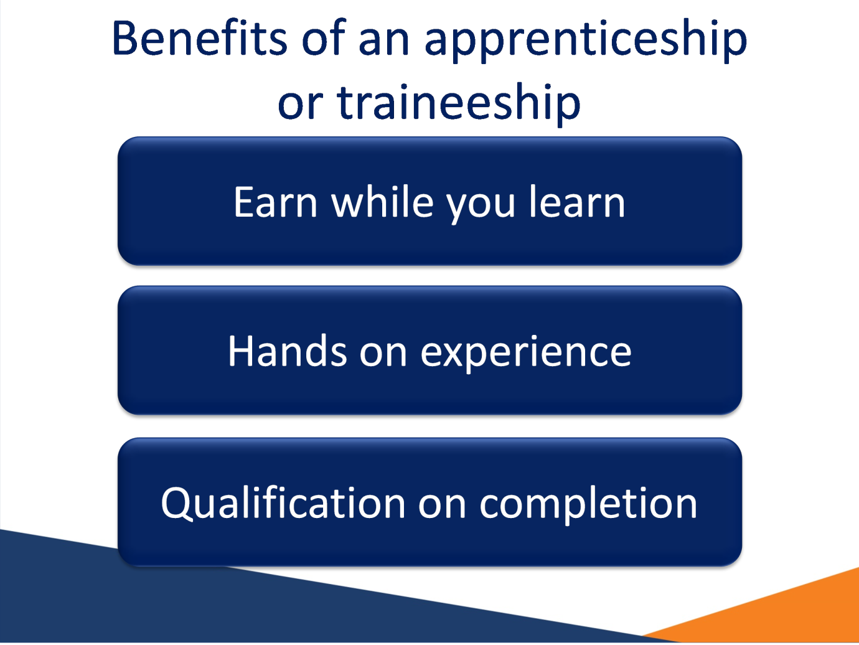

Slide 9 You need to finish your studies
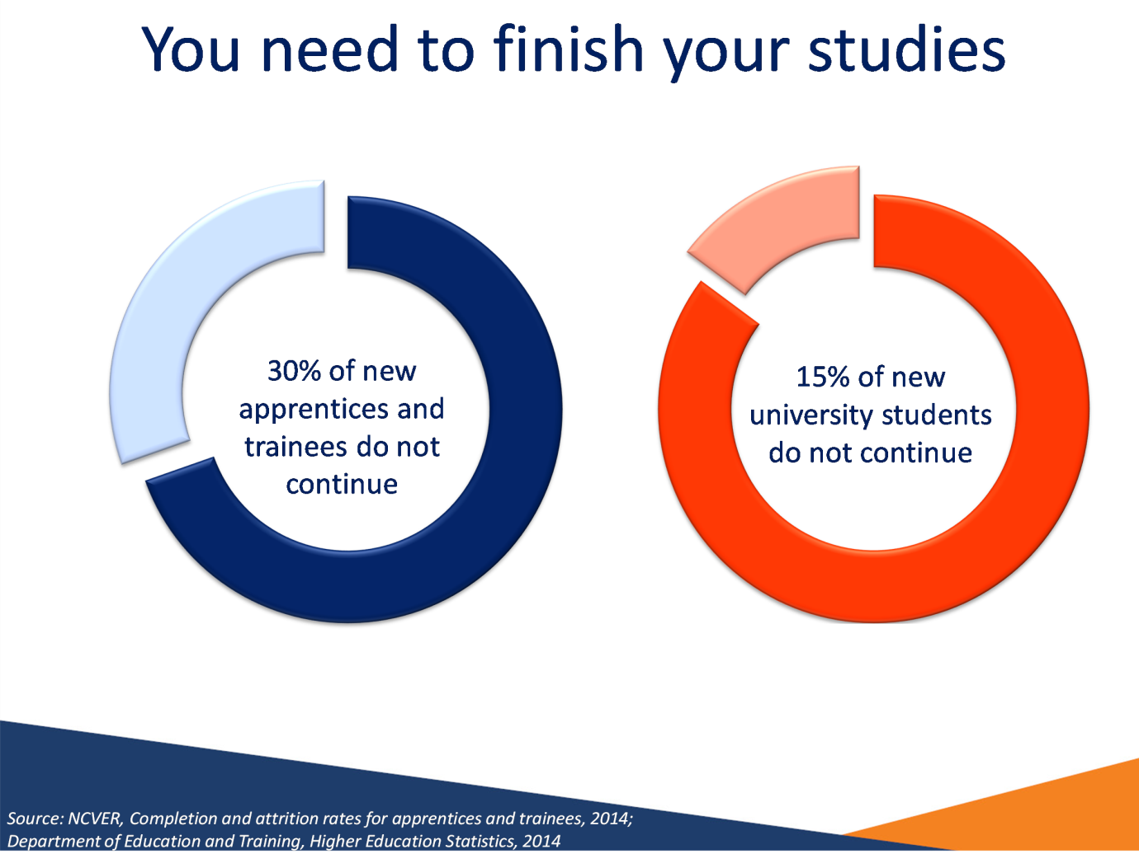

Notes
Source: NCVER, Completion and attrition rates for apprentices and trainees, 2014; Department of Education and Training, Higher Education Statistics, 2014

Slide 10 Experience is vital
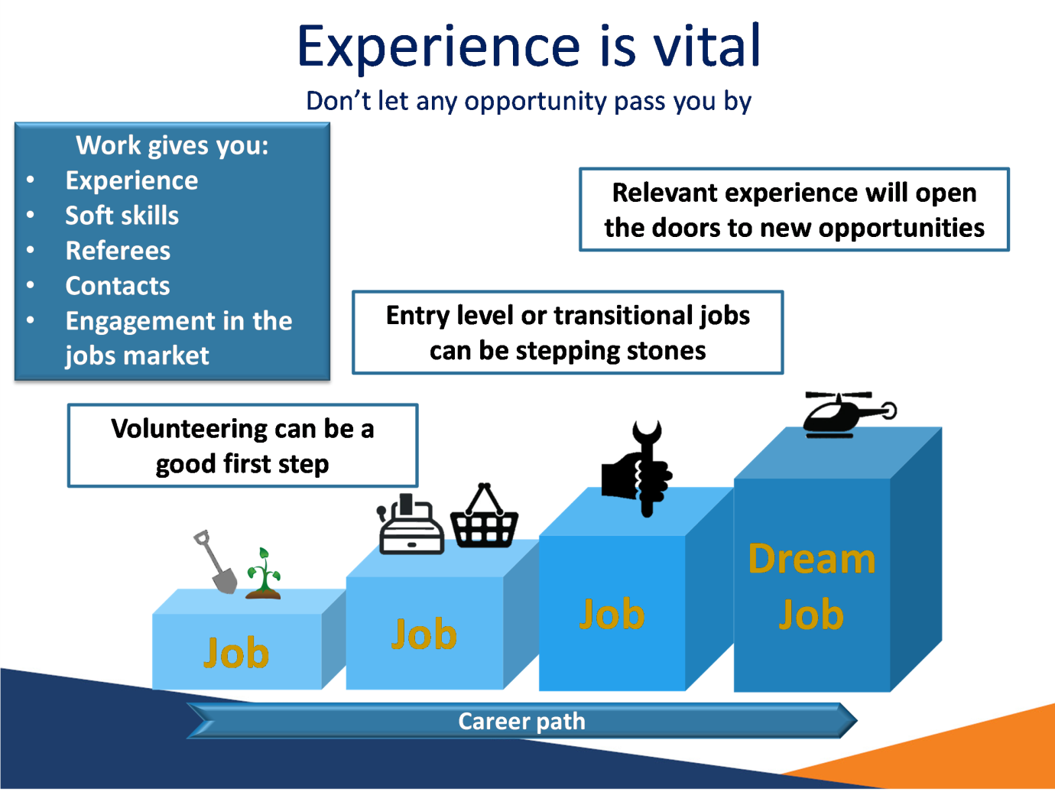

Slide 11 Employers consider these skills to be essential
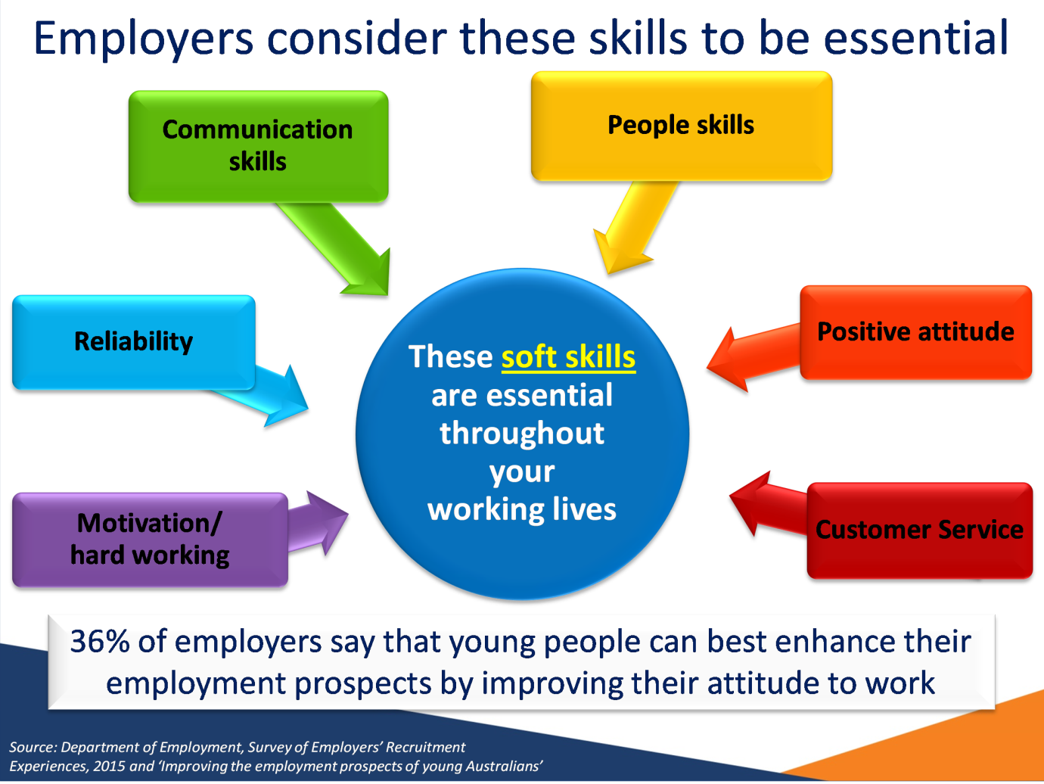

Notes
Source: Department of Employment, Survey of Employers’ Recruitment Experiences, 2015 and ‘Improving the employment prospects of young Australians’

Slide 12 Employers are also increasingly seeking these transferable skills
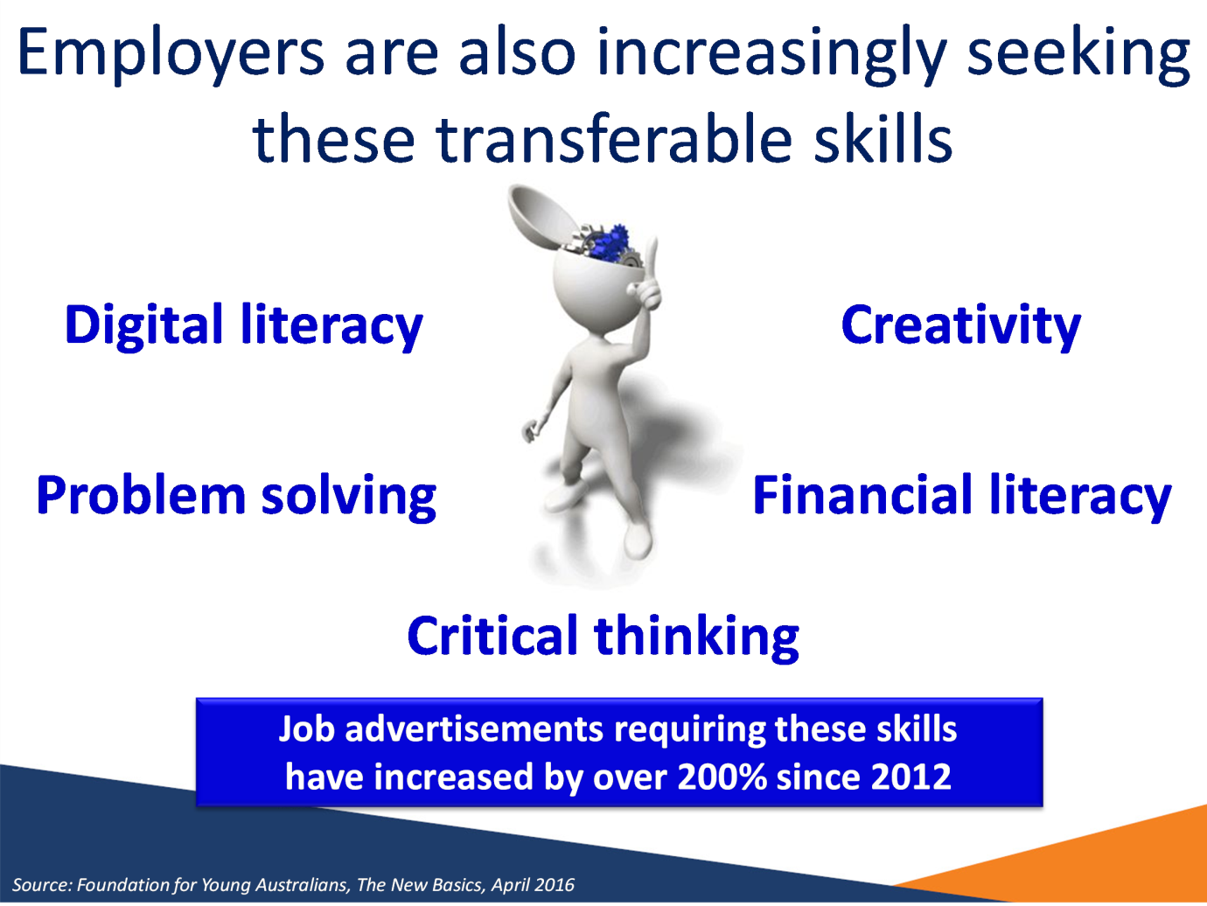

Notes
Source: Foundation for Young Australians, The New Basics, April 2016

Slide 13 Soft skills are equally as important to employers as technical skills and experience
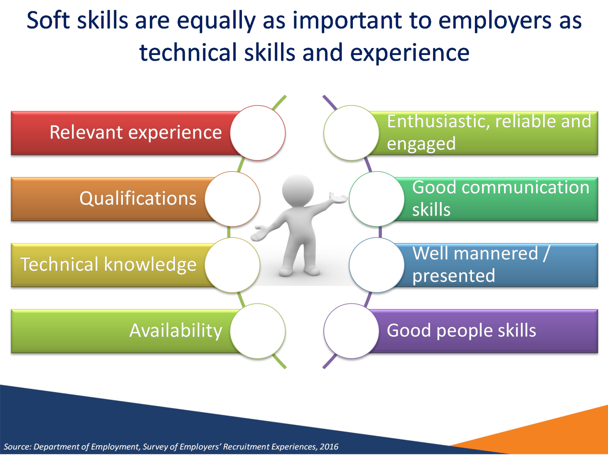

Notes
Source: Department of Employment, Survey of Employers’ Recruitment Experiences, 2016

Slide 14 Research jobs you are interested in
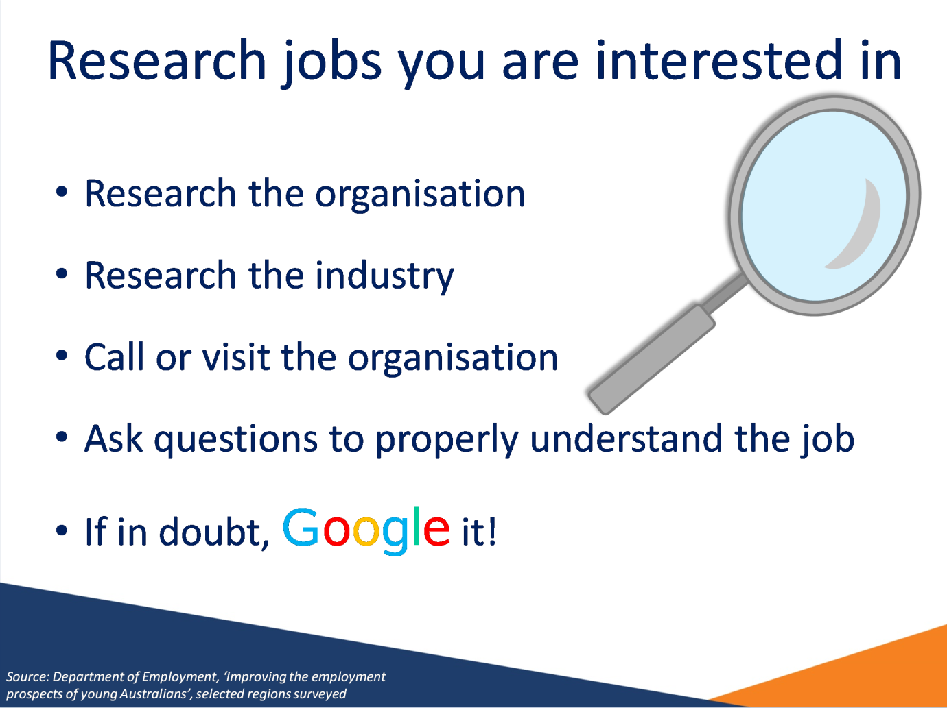

Notes
Source: Department of Employment, ‘Improving the employment prospects of young Australians’, selected regions surveyed

Slide 15 When writing your application and resume
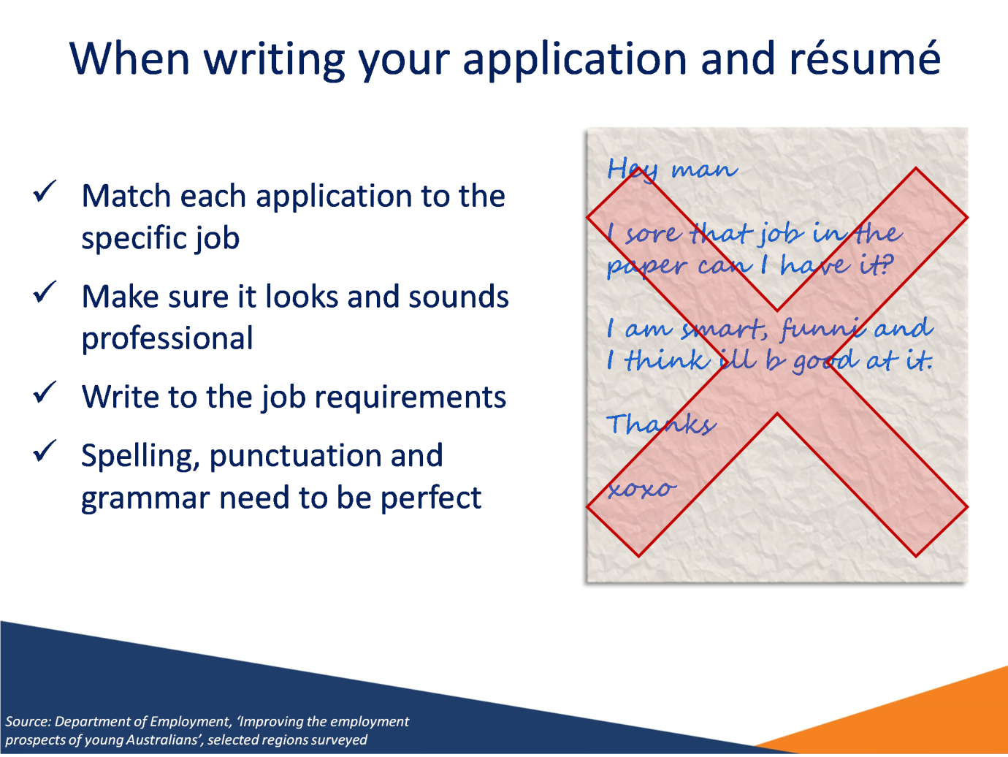

Notes
Source: Department of Employment, ‘Improving the employment prospects of young Australians’, selected regions surveyed

Slide 16 Every application is a learning experience
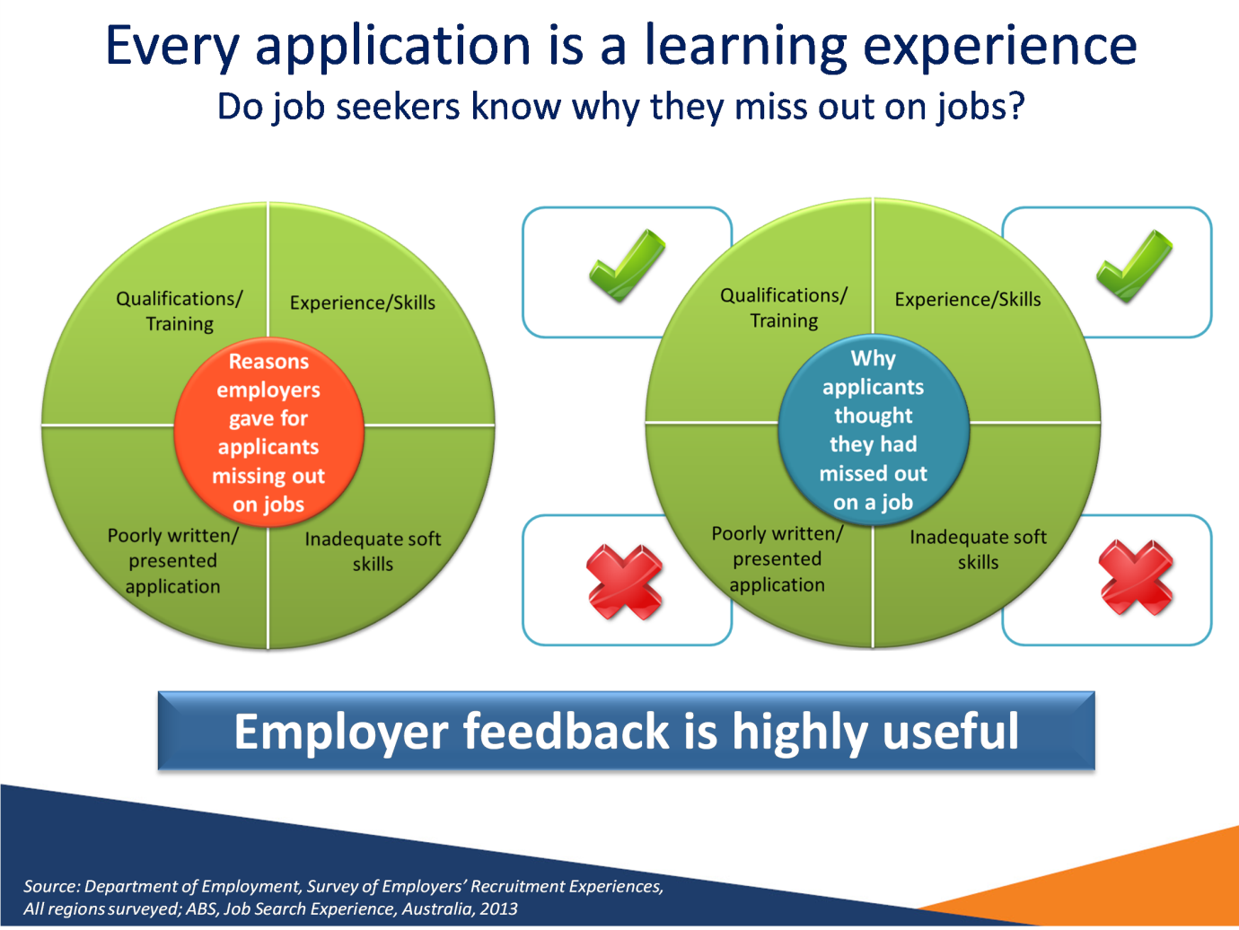

Notes
Source: Department of Employment, Survey of Employers’ Recruitment Experiences, All regions surveyed; ABS, Job Search Experience, Australia, 2013

Slide 17: Approach employers directly where possible
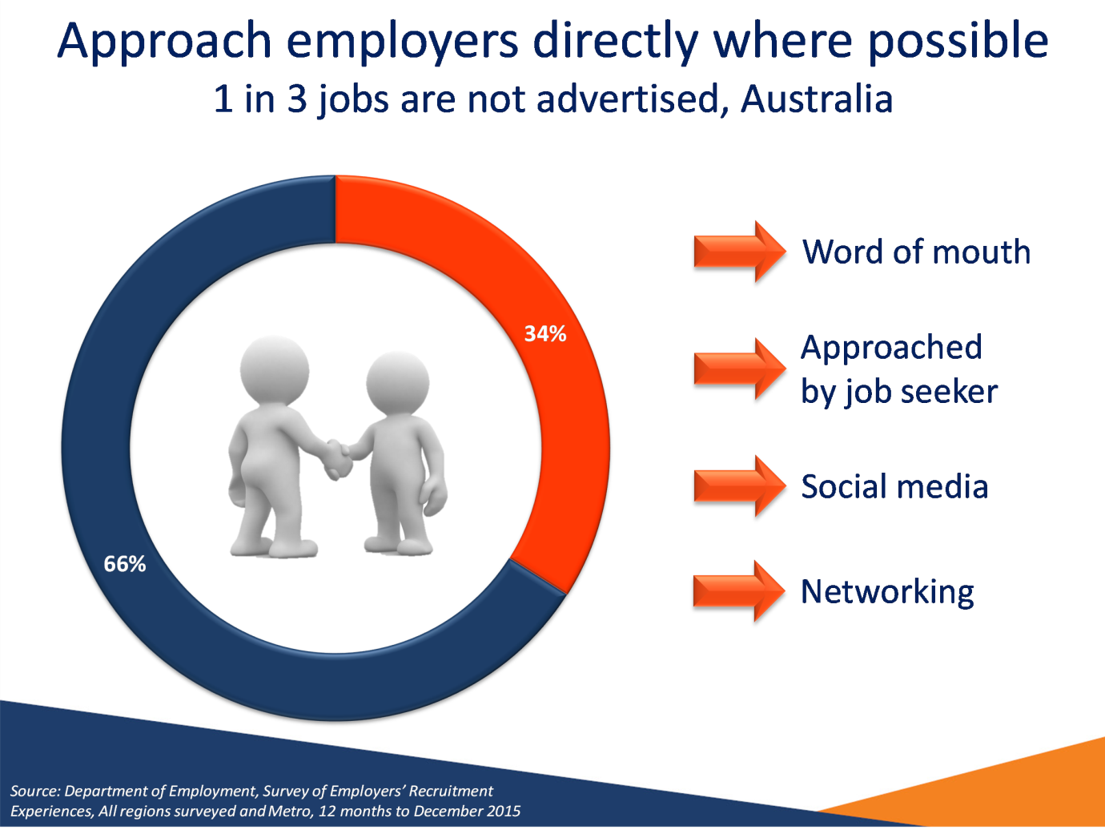

Notes
Source: Department of Employment, Survey of Employers’ Recruitment Experiences, All regions surveyed and Metro, 12 months to December 2015

Slide: 18 Tips for improving your odds
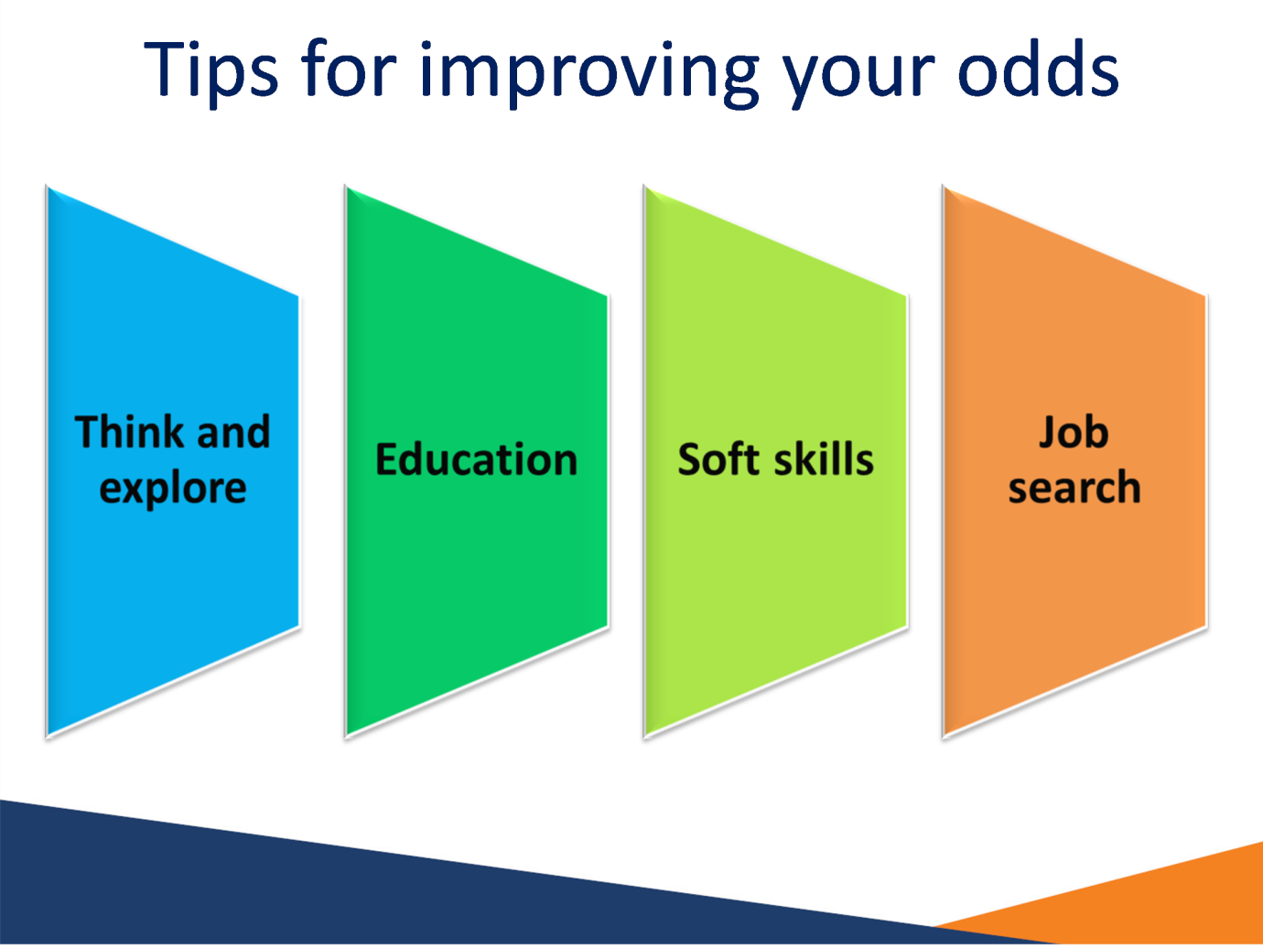

Slide: 19 Tools to assist with job search
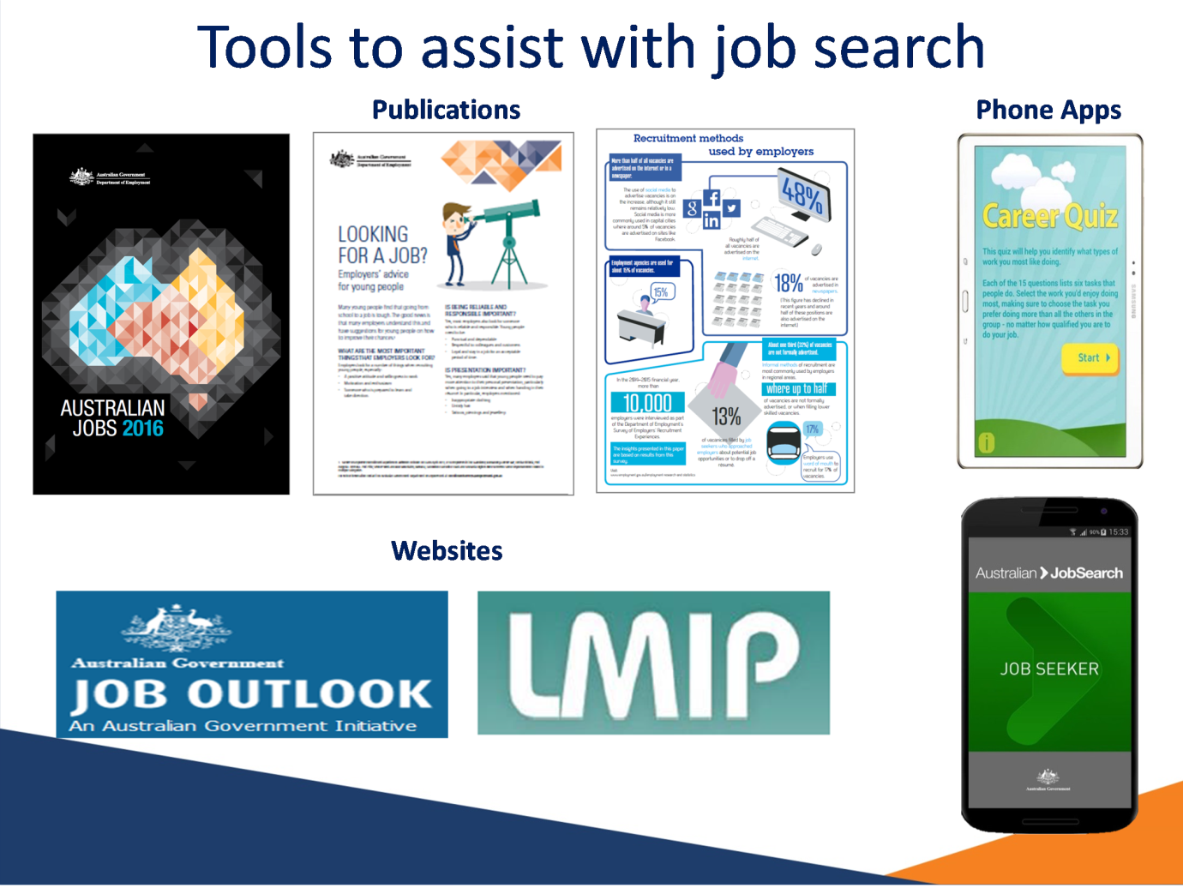

Slide: 20 Australian Government Department of Employment
