

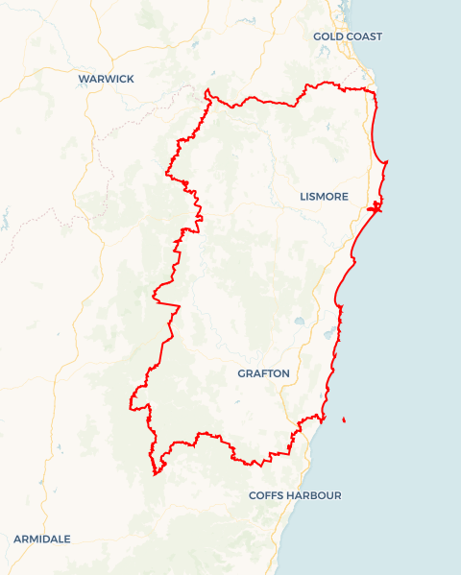Local Jobs Plan

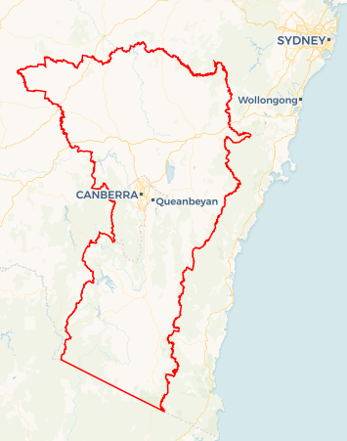

**SAMPLE MAP ONLY**

A map of your Employment Region and hyperlink will be added before publishing.

North Coast ****Employment Region**** | NSW | ****July 2025****

Workforce Australia Local Jobs (Local Jobs) is a program that supports tailored approaches to accelerate   
reskilling, upskilling and employment pathways in response to current and emerging local workforce needs.

## Local Jobs elements

### Local Jobs Plan

The Local Jobs Plan sets out the skills and employment challenges and priorities of the region, and associated strategies that will drive the design and implementation of activities to be implemented to address these challenges.

### Job Coordinators

Job Coordinators and Support Officers support the delivery of the program by bringing together key stakeholders including businesses, employment services providers, higher education, and training organisations.

### Local Jobs and Skills Taskforce

Each Employment Region has its own Taskforce. Representatives include local stakeholders who have demonstrated experience in upskilling, reskilling, and an ability to represent, connect and collaborate with others in the region to meet labour market needs.

### Program Funds

The Local Initiatives Fund enables targeted local investments that support local labour market functioning. Further, from 2025/26, a central grants-based fund will respond to local needs and help progress broader employment service reform objectives.

Explore labour market insights for

[North Coast](https://www.jobsandskills.gov.au/data/employment-region-dashboards-and-profiles/monthly-labour-market-dashboards) Employment Region

## Local labour market challenges in the region

* There is a low unemployment rate which means the available labour market pool is limited.
* Mature aged people and First Nations people experience additional challenges securing employment and make up a considerable proportion of the Workforce Australia caseload.
* In the more remote areas of the region there are fewer employment opportunities and limited public transport services.
* There are intergenerational unemployment challenges and pockets of disengagement for some young people on the North Coast. Also, some sectors of the local business community are sceptical about the willingness of young people to work and the skills they bring.
* There are a variety of complexities involved in securing adequately skilled workers in growth and demand industries. Entry level work is available, but the roles, responsibilities and reward are not considered attractive by individuals. Growth and demand sectors include construction, aged care, disability support, logistics, hospitality, retail, seasonal agricultural work, and meat processing.
* Labour shortages in the aged care sector have been a key priority over the past 4 years for the Local Jobs and Skills Taskforce. Competition across other industries for salary and wages creates difficulties in attracting new recruits in this industry. As the labour shortage for the aged care industry is national, it is no longer listed as a specific regional priority. Nonetheless, the Local Jobs and Skills Taskforce will continue to provide proactive support to the industry with recruitment events, training programs and connections to providers of traineeship and apprenticeship services.
* The North Coast has an ageing workforce with the median age of employees being higher than the rest of NSW. This is especially the case for sectors including health care, social assistance and logistics. These sectors will have an increased outflow of retiring workers in coming years and enticing a new generation of workers is proving difficult.
* Affordable accommodation continues to be a key challenge for many low to middle income workers. This makes it difficult to attract and retain workers.
* The rebuild of the Northern Rivers continues into its fourth year following the February 2022 floods. This requires ongoing effort to leverage opportunities, coordinate responses, and find enough workers to fill vacancies. More than $8 billion has been provisioned to the rebuilding of the Northern Rivers including urgent major infrastructure projects. The $100 million Resilient Lands Program and the $790 million Resilient Homes program, together with business-as-usual construction for the ever-expanding population in Northern NSW, will continue until at least 2028.
* North Coast State Forest hardwood harvesting and processing industries were provided an extension to the Wood Supply Agreements until 2028 by a Federal Court decision in January 2024. While immediate disruptions have been mitigated, transitional plans may need to be initiated in 2026/2027 to reskill workers into alternative employment opportunities.

Explore labour market insights for   
[[Employment Region Name](https://labourmarketinsights.gov.au/regions/employment-regions/)] Employment Region

## Local jobs and skills priorities and strategies in the region

**Priority 1 – First Nations and young people**

**What are our challenges and opportunities?**

First nations people experience particularly high labour market disadvantage. Support needs to be culturally appropriate and enticing, including using creative arts. Young people within the region have limited labour market experience and often underdeveloped soft skills.

**How are we responding?**

* We are developing targeted learning and employment pathways for cohorts that have a high incidence of unemployment and/or underemployment, including First Nations and young people.
* We are identifying opportunities to create skills development pathways aligned with growth sectors like hospitality and retail.
* We are collaborating with stakeholders to develop flexible traineeships and apprenticeships that move away from treating training and work as separate activities to a more integrated simultaneous progression. These pathways equip people with the skills and qualifications they need for employment.
* We are engaging with Workforce Australia Employment Services Providers (including the specialist provider for First Nations people) and the Self-Employment Assistance program to help young people into self-employment in sectors including wellbeing, fitness, digital solutions, and creative arts.
* We are developing and delivering tailored ongoing Indigenous Employment Connection events across the region with participation from major employers and industries.

**Priority 2 – Drivers licence support**

**What are our challenges and opportunities?**

There is limited public transport on the North Coast, combined with inconsistent and expensive learner driver services. This is reducing employment opportunities for a significant number of people on income support, particularly young people, migrants, First Nations people and the long-term unemployed. Innovative thinking and initiatives are required to help people get their drivers licence.

**How are we responding?**

* We are investigating a virtual learning platform to help people progress to on-road driving lessons.
* We are seeking assistance from Services NSW to host information sessions about obtaining a drivers licence.
* We are leveraging the Driver Licensing Access Program (funded by the NSW Government) to help people obtain a drivers license.

### Priority 3 – Construction Projects

**What are our challenges and opportunities?**

The rebuild of the Northern Rivers continues into its fourth year following the flood event of February 2022. More than $8 billion has been allocated to infrastructure projects. This requires ongoing effort to leverage opportunities, coordinate responses, and find enough workers to fill vacancies. Also, opportunities will arise as the Richmond Valley Regional Job Creation Precinct is developed.

**How are we responding?**

* We are collaborating with employers to build stronger pathways to employment in the manufacturing and construction industries. This includes developing pre-employment programs that focus on employability and industry-specific skills for entry-level opportunities.
* We are linking businesses to traineeship and apprenticeship providers to establish training pathways within the industry.
* We are engaging with stakeholders to develop and deliver recruitment solutions. This includes direct recruitment and short course upskilling to support skills transferability into the construction industry.

### Priority 4 – Supporting women into secure employment

**What are our challenges and opportunities?**

Women comprise a small proportion of workers in male-dominated sectors such as manufacturing and construction which have low rates of casualisation. Greater representation of women would ease skill shortages and provide women with greater access to secure employment. Skill shortages in sectors where women are highly represented, such as aged care, may present opportunities to work with employers to reduce casualisation.

**How are we responding?**

* We are working with employers to develop tailored training programs (including programs designed by women) to help women into male-dominated sectors.
* We are building a networking group for women re-entering the workforce.
* We are collaborating with local governments to develop programs and employment events that increase female participation in the workforce.
* We are working with employers to reduce casualisation in sectors with a high representation of women and difficulty filling vacancies.

## Want to know more?

* Contact: Terri Grendon, North Coast Job Coordinator, coordinator@northcoastljp.work
* Visit: [Local Jobs](https://www.dewr.gov.au/local-jobs) or [Workforce Australia](https://www.workforceaustralia.gov.au/)