NCIF Forward Workplan

Timeframes in this workplan are indicative only, they will be refined through further scoping and reviewed at each NCIF Blueprint pulse check.

NCIF Meetings will be held every 6 months, in line with the Fair Work Act 2009, with a Blueprint Pulse Check as a standing agenda item. A full review and update of the Blueprint is expected at the 2-year mark in October 2027.

Ongoing recommendations - the department will continue working with members to explore opportunities to progress other recommendations, including by leveraging and connecting with existing initiatives and reforms.

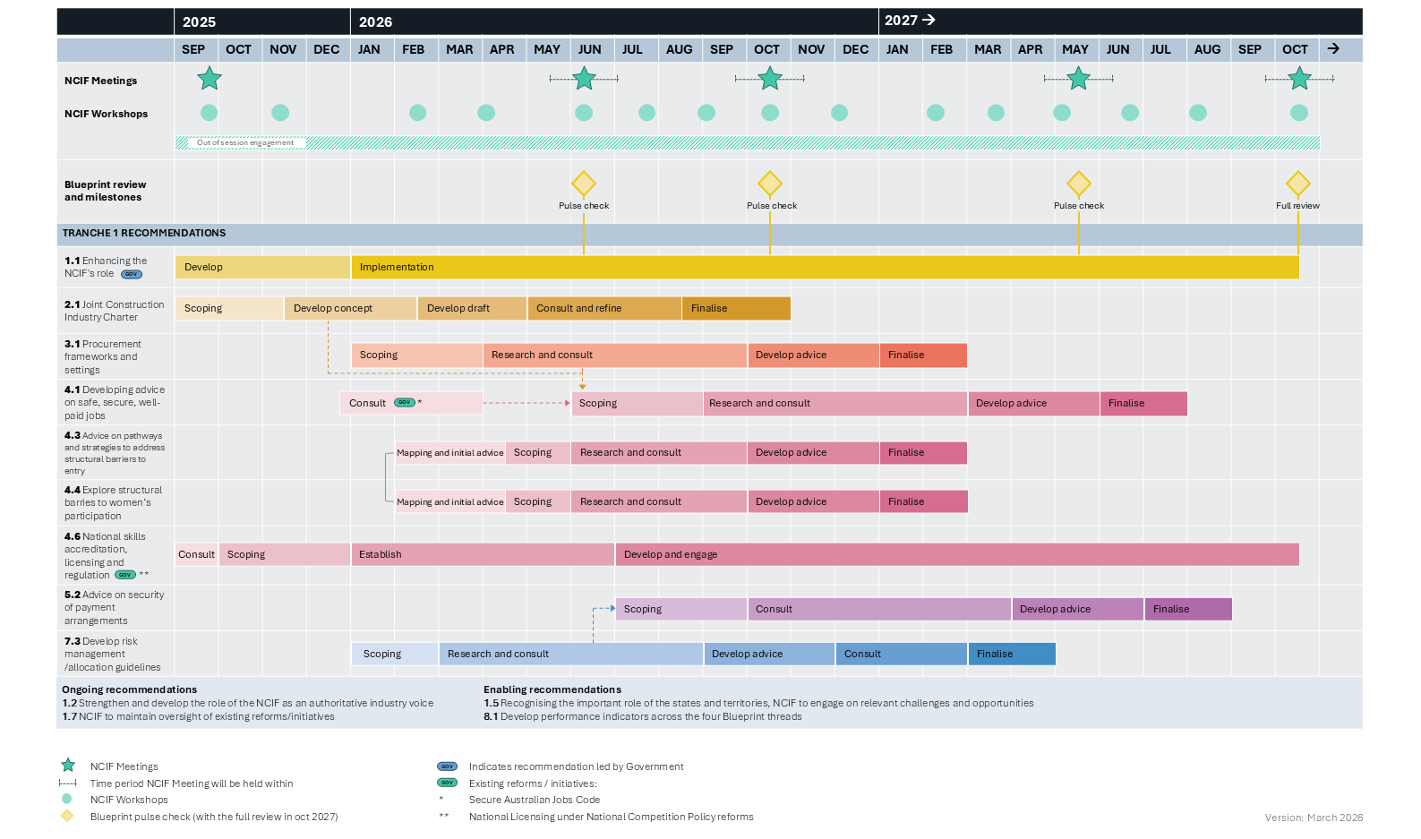
NCIF governance activities
NCIF meetings will be held every 6 months. Indicative dates for the NCIF meetings are September 2025; between May and July 2026; between September and November 2026; between April to June 2027; and between September to November 2027.
NCIF workshops occur more frequently with workshops scheduled in September and November 2025, February, March, June, July September, October, December 2026; and Feb, March, May, Jun, August and October 2027.
NCIF out of session engagement occurring across the full duration of the workplan.
Blueprint review and milestones – Pulse checks align with the NCIF meetings every 6 months with a full review expected at the 2 year mark in October 2027.

Tranche 1 Recommendations

1.1 Enhancing the NCIF's role
Recommendation led by Government
Phase | Indicative timeframe
Develop | September 2025 – December 2025
Implementation | January 2026 – October 2027  With pulse checks aligned with the NCIF Meetings and a full review in October 2027

2.1 Joint Construction Industry Charter
Phase | Indicative timeframe
Scoping | September 2025– November 2025
Develop concept | November 2025 – February 2026
Develop draft | February 2026 – April 2026
Consult and refine | May 2026 – August 2026
Finalise | August 2026 – October 2026

3.1 Procurement frameworks and settings
Phase | Indicative timeframe
Scoping | January 2026 – March 2026
Research and consult | April 2026 – September 2026
Develop advice | October 2026 – December 2026
Finalise | January 2027 – February 2027

4.1 Developing advice on safe, secure and well-paid jobs
Phase | Indicative timeframe
Consult | December 2025 – March 2026 through existing reforms/initiative Secure Australia Jobs Code
Scoping | June 2026 – August 2026  Informed by 2.1 Joint Construction Industry Charter 'develop concept' phase and 3.1 Procurement frameworks and settings 'research and consult' phase.
Research and consult | September 2026 – February 2027
Develop advice | March 2027 – May 2027
Finalise | June 2027 – July 2027

4.3 Advice on pathways and strategies to address structural barriers to entry
Recommendation linked with 4.4 Explore structural barrier to women's participation.
Phase | Indicative timeframe
Mapping and initial advice | February 2026 – April 2026
Scoping | April 2026 – May 2026
Research and consult | June 2026 – September 2026
Develop advice | October 2026 – December 2026
Finalise | January 2027 – February 2027

4.4 Explore structural barriers to women’s participation
Recommendation linked with 4.3 Advice on pathways and strategies to address structural barrier to entry
Phase | Indicative timeframe
Mapping and initial advice | February 2026 – April 2026
Scoping | April 2026 – May 2026
Research and consult | June 2026 – September 2026
Develop advice | October 2026 – December 2026
Finalise | January 2027 – February 2027

4.6 National skills accreditation, licensing and regulation
Existing reforms/initiative National Licensing under National Competition Policy reforms
Phase | Indicative timeframe
Consult | September 2025
Scoping | October 2025 – December 2025
Establish | January 2026 – June 2026
Develop and engage | July 2026 – October 2027

5.2 Advice on security of payment arrangements
Phase | Indicative timeframe
Scoping | July 2026 – September 2026  Informed by 7.3 Develop risk management/allocation guidelines 'research and consult' phase
Consult | October 2026 – March 2027
Develop advice | April 2027 – June 2027
Finalise | July 2027 – August 2027

7.3 Develop risk management/allocation guidelines
Phase | Indicative timeframe
Scoping | January 2026 – February 2026
Research and consult | March 2026 – August 2026
Develop advice | September 2026 – November 2026
Consult | December 2026 – February 2027
Finalise | March 2027 – April 2027

Ongoing recommendations

1.2 Strengthen and develop the role of the NCIF as an authoritative industry voice

1.7 NCIF to maintain oversight of existing reforms/initiatives

Enabling recommendations

1.5 Recognising the important role of the states and territories, NCIF to engage on relevant challenges and opportunities

8.1 Develop performance indicators across the four Blueprint threads

Version: March 2026

