


Transitioning Workforce Fund
  - Guidance information

Document details
Document name | Transitioning Workforce Fund Guidance Information
Document status | Approved | Last updated | May 2026
Point of contact | Prepared by the Workforce Transition Support Delivery Team, Industry Transition and Net Zero Branch in the Labour Market and Industry Policy Division.
Note: This is a controlled document in its electronic form only. Paper copies of this document are not controlled and should be checked against the electronic version prior to use.
Contents
1. Introduction 4
2. Program overview 4
Aim 4
Initial focus 4
Community consultation 5
Worker Transition Advisory Groups 5
Consultation channels 5
3. Project development pathway 5
Development of project ideas 7
Prioritising and selecting priorities and projects 7
Procurement and assessment of applications to deliver projects 7
4. Funding available 8
5. Project priorities 8
Priority groups 9
6. Project examples 10

Introduction
  - Australia’s transition to net zero is reshaping industries, jobs, communities and local economies. Australia’s net zero future brings opportunities to build a resilient, inclusive and competitive economy, and a skilled workforce is central to a successful transition.
  - The Transitioning Workforce Fund is one element of the Australian Government’s Supporting Worker Transition Through Energy System Changes program. The fund will provide project funding in priority regions to support local workforces impacted by the closure of coal and gas-fired power stations and supplying coal mines. Related initiatives include the Energy Industry Jobs Plan, Regional Workforce Transition Plans and Regional Workforce Transition Officers (RWTOs). You can find more information about these initiatives on the department’s website.
  - Workforce transition support will assist the workers in the regions that are most affected, their families and others in affected communities to prepare for new jobs and careers. This may include helping people to:
    - identify skills they can use in different jobs
    - learn new skills for new roles
    - find new work opportunities in their community
    - support people not currently employed to enter the workforce.
  - The department will work closely with other Commonwealth and state government agencies including the Net Zero Economy Authority, to ensure initiatives that support the net zero transition are complementary and that individual ideas and projects under the Transitioning Workforce Fund have broad alignment and support.

Program overview

Aim
  - The Transitioning Workforce Fund will fund projects that support workers and communities to adapt as regions undergo change. These projects will aim to improve access to jobs and training opportunities, increase workforce participation, ensure businesses can access a workforce with the skills they need, and strengthen the social and economic wellbeing of communities.

Initial focus
  - Projects will initially focus on the regions where the labour market is already significantly impacted by Australia’s energy transition. Priority regions are:
    - the Hunter, New South Wales
    - Gippsland, Victoria
    - Central Queensland
    - South-West Western Australia.
  - Departmental RWTOs in each priority region engage and work directly with community to identify and bring together workforce transition priorities.

Community consultation
  - Community consultation is vital in understanding workforce transition priorities, and in ensuring that no one is left behind in the transition to net zero. The department will work in collaboration with communities to enable issues, needs, challenges and opportunities to be identified and brought forward for development as potential projects.

Worker Transition Advisory Groups
  - To enable close and ongoing community consultation, a Worker Transition Advisory Group (WTAG) will be convened in each priority region, reporting to the Minister for Employment and Workplace Relations, to assist in coordinating community input and provide structured, high-level information to the Minister and inform departmental consideration of workforce transition priorities and potential procurement activities. The groups will include representation from local business, unions, community organisations, First Nations peoples, and Commonwealth, state and local governments.
  - WTAGs play a central role in identifying workforce transition needs, challenges and priorities, and in shaping regional priorities for potential action. WTAGs do not approve funding, identify preferred suppliers or participate in procurement decisions.
  - Project ideas considered by WTAGs may inform a range of outcomes, including further exploration, alignment with other government initiatives such as the development of Regional Workforce Transition Plans, or consideration for future procurement.

Consultation channels
  - Community members, organisations and stakeholders can help identify ideas and opportunities to support workforce transition either via the relevant WTAG or direct community engagement through RWTOs.
  - While incorporating community perspectives and priorities, the department makes project selection and procurement decisions, ensuring all activities comply with the Public Governance, Performance and Accountability Act 2013 (PGPA), legislative authority under the Social Security Act 1991 (SSA) and the Commonwealth Procurement Rules (CPRs).

Project development pathway
  - WTAG advice can include both:
    - priority workforce transition needs and potential responses raised by or through WTAG members – where community can articulate an identified need and potential service that could address it.
    - broad priorities for action that are identified and defined collaboratively – where the community can articulate an identified need but not the direct action required to address it.
  - Interested organisations or individuals in priority regions can contact their relevant RWTO to discuss ideas and alignment with WTAG priorities.
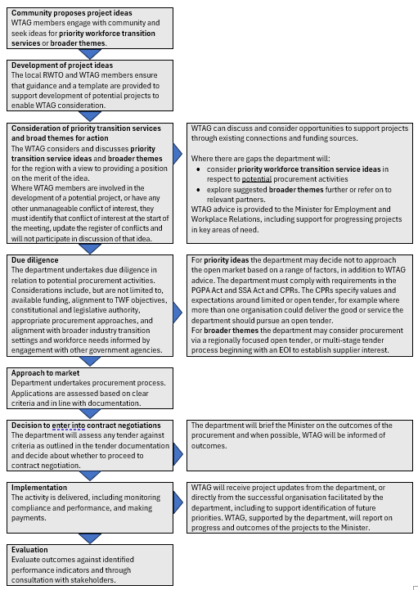
  - An overview of the process for development and implementation of projects follows.

Development of project ideas
  - Ideas for workforce transition supports will be identified through the consultation channels outlined above. Assisted by the RWTO and the department, the WTAG will work with the community to develop clear descriptions of ideas and opportunities that outline:
    - the specific workforce transition need or challenge, including causes and impacts
    - affected cohorts including priority groups (see below)
    - potential impact and scale
    - whether any current or developing services respond to the problem or opportunity.

Prioritising and selecting priorities and projects
  - Workforce transition needs, priorities and potential areas for action identified through community engagement will be discussed by WTAG and inform the department’s consideration of workforce transition priorities and themes, and potential procurement activities in responses to these priorities and themes. In doing so the WTAG may consider:
    - community impact and urgency
    - alignment with regional transition needs
    - alignment with the aim and themes of the Transitioning Workforce Fund
    - feasibility and resource requirements
    - synergy with existing services
    - their impact on priority groups (see below).
  - WTAG members can actively discuss ways to support ideas from existing services or programs while being mindful of any conflicts of interest. This can include identification of gaps that could potentially be supported through the TWF.
  - Outcomes of WTAG discussions will be provided to government in the form of minutes, including reflecting majority views and any significant dissenting views.
  - The department makes project selection and procurement decisions with respect to any potential procurement processes arising from WTAG discussions in accordance with the Public Governance, Performance and Accountability Act 2013, the Social Security Act 1991 and Commonwealth Procurement Rules.

Procurement and assessment of applications to deliver projects
  - The Transitioning Workforce Fund will follow the Commonwealth Procurement Rules.
  - Achieving value for money is the core rule of the Commonwealth Procurement Rules. To achieve value for money, procurements should encourage competition, be non-discriminatory, make efficient, effective and ethical use of public resources, facilitate accountable and transparent decision making and be commensurate with the size of the business requirement.
  - In addition, the financial and non-financial costs and benefits of applications must be considered. This includes consideration of the quality of the services offered, fitness-for-purpose of the proposal, and the potential supplier’s or suppliers’ experience and performance history.
  - In line with the Commonwealth Procurement Rules, limited tenders may be considered in circumstances that meet the Commonwealth Procurement Rules and achieve value for money.
  - WTAGs have highlighted that supporting local First Nations businesses, small to medium enterprises and local supply chains are priorities.
  - The department will look to run procurement processes that ensure the Transitioning Workforce Fund is responsive to local needs and priorities.

Funding available
  - Funding under the Transitioning Workforce Fund, across the four net zero priority regions, will increase over time as the initiative becomes fully established.
 | 2025-26 | 2026-27 | 2027-28 | 2028-29 | 2029-30 | 2030-32
Available funding (GST exclusive) | $0.75 m | $6 m | $8.5 m | $9.25 m | $11.5 m | $12.0 m per annum (ongoing)
  - Individual projects will vary in size and timeframes depending on the identified need in a community. Their cost will determine appropriate procurement approaches.
  - The maximum project value under the TWF is $500,000 (GST exclusive).

Project priorities
  - Transitioning Workforce Fund projects are expected to address the following themes. While projects are intended to be flexible and innovative, these four interconnected themes are presented to assist in framing discussions on workforce transition services.
- Employment outcomes
  - helping displaced workers, their families and community members learn new skills to take up new jobs
  - job placement and matching services connecting workers with new opportunities, especially workers facing retrenchment or industry downsizing
  - targeted support for community groups at risk of long-term unemployment to access education and training and employment opportunities
  - projects addressing local labour market shortages and imbalances
  - career transition counselling, planning and direct supports, including financial and mental health services

- Skills, training and education pathways
  - development of new education and training opportunities that meet local employers’ needs and prepare workers for roles in emerging net zero industries
  - initiatives to ensure education and training is locally available, affordable and accessible
  - individual vocational planning or counselling, including skills assessments and recognition of prior learning for transitioning workers
  - building capacity in local education and training systems, such as increasing the availability of teachers, trainers and assessors
- Industry leadership
  - supporting industry workforce planning, information-sharing and advisory services, including by local businesses and unions, and/or to supercharge existing industries and strengths
  - developing skills among small to medium enterprise employees, including self-employed, so that they are able to build capacity, retain employment and access new opportunities.
- Community needs
  - cultural initiatives to support inclusive workplaces (and enhance sustainable employment outcomes)
  - access to broader services that support education and training and workforce participation, for example projects that link with local and state government and private organisations to ensure transport, childcare, community facilities and other services are available so people/workers can attend education and training
  - capacity building that strengthens community knowledge and self-determination in relation to net zero transition and its opportunities for the community, especially for cohorts including First Nations people
  - These transition themes are interconnected and should be considered together. Activities or approaches that address multiple themes or that demonstrate clear linkages between themes are likely to be particularly valuable.

Priority groups
  - Across all transition themes above, and throughout the identification and consideration of workforce transition needs and priorities, particular attention will be given to supporting community members facing additional challenges to entering or maintaining work (priority groups).
  - Priority groups include:
    - retrenched workers and their families
    - First Nations people
    - women
    - mature aged workers (45 and over)
    - young people (under 25)
    - culturally and linguistically diverse people
    - people with disability.
  - Examples of supports to priority groups may include direct assistance to workers at risk of losing their jobs, culturally appropriate support to facilitate employment outcomes for First Nations people, opportunities for women to participate in emerging industries and occupations, or initiatives that support people from supply chain companies impacted by energy system changes.

Project examples
  - Workforce transition supports are expected to address specific workforce transition needs in each region and complement existing services. Examples of supports that may be considered are:
    - mentoring or coaching strategies that assist displaced workers during transition
    - cultural change initiatives to support inclusive and accessible workplaces
    - testing new education and training delivery methods
    - delivering education and training options to address local business needs
    - using company facilities and instructors to expand education and training options locally
    - assistance that strengthens Indigenous liaison roles to support First Nations recruitment and culturally safe, sustainable employment
    - supporting workers to start apprenticeships or participate in education and training while working
    - partnering with large businesses to extend training to supply chain workers.

