

School Entry Point Financial Acquittal
User Guide

Table of Contents
Introduction 1
1.1 – Overview 1
1.2 – What is SEP? 1
1.3 – How Do I Gain Access to SEP? 2
Qualified Accountant – approved authority level 2
Finance Contact – approved authority level 2
Finance Contact – diocese authority level 2
1.4 – Contact Us 2
Acquittal Certificate 3
2.1 – Accessing the Acquittal Certificate 3
2.2 – Entering Accountant Details 5
2.3 – Submitting the Acquittal Certificate 6
2.3.1 - Who can submit 6
2.3.2 - Confirming grants 6
2.3.3 – Declaration and Qualified Person’s Opinion 8
2.3.4 - Finalising the Acquittal Certificate 9
2.3.5 – Accessing the Submitted Certificate 10
Block Allocation 11
3.1 – Accessing the Block Allocation 11
3.2 – Completing Block Allocation details: Approved Authority Collectives 13
3.2.1 – Reviewing, declaring and submitting Block Allocation details 13
3.3 – Completing Block Allocation Details: Approved System Authorities 14
3.3.1 - Entering system-level funding details 14
3.3.2 - Entering school-level funding details: Finance Contact 15
3.3.3 - Entering school-level funding details: Diocese Allocator 17
3.3.4 - Finalising the Block Allocation: Finance Contact 18

Introduction
This User Guide has been created to assist accountants, auditors and relevant finance officers with completing the Financial Acquittal process within the School Entry Point (SEP) system. The Acquittal Certificate and Block Allocation processes have been broken down into separate chapters to make accessing information quick and easy.
This User Guide should be read in conjunction with the SEP Registration User Guide, which can be found on the SEP Home Page.

1.1 – Overview
Recurrent grant funding for participating schools is payable by the Australian Government each year under section 25 of the Australian Education Act 2013 (the Act). The Act legislates Government funding to schools in Australia and sets out the rights and responsibilities of organisations in order for them to receive Government funding for the purpose of school education.
The Financial Acquittal process involves certification that the financial assistance paid by the Government under the Act has been spent, or committed to be spent, in accordance with relevant provisions of the Act. This financial assistance may include recurrent grant funding, Special Circumstances funding and funding in Prescribed Circumstances. Payments made by the Australian Government for capital funding are not part of the Financial Acquittal process.
All Approved Authorities are required to complete the Financial Acquittal process in order to satisfy their financial accountability obligations under the Australian Education Regulation 2013 (the Regulation).

1.2 – What is SEP?
School Entry Point (SEP) is the Department of Education and Training’s (the department) project and financial management system for clients to manage applications and reporting obligations for funding under Australian Government programs that are administered by the department.

1.3 – How Do I Gain Access to SEP?
To gain access to SEP, all users must register online. To register in SEP, navigate to the homepage and select the “Register here” button from the right-hand menu to create a new account. You will be required to provide your personal and contact information and create logon details (user ID and password). After submitting your form, you will receive an email to your nominated email address containing instructions on how to activate your account. Please note that you must activate your account within 30 days or your account will be automatically removed. Further information on registering for SEP can be found in the Registration User Guide accessible through the SEP homepage.
Once your account is activated, you must request access to the program, organisation and role that you require. For Financial Acquittal purposes, the following roles are applicable:

Qualified Accountant – approved authority level
Allows you to complete the Acquittal Certificate and acquit payments on behalf of school authorities

Finance Contact – approved authority level
Allows you to receive payment related documentation via SEP and submit system-level Block Allocation details for an Approved Authority for more than one school or a System Authority

Finance Contact – diocese authority level
Allows a representative from a Catholic Diocese Office to submit diocese-level Block Allocation details (where the Approved Authority’s approved needs-based funding model goes down to the diocese level).
For all roles, you should select “Funding under the Australian Education Act 2013” as the relevant program from the drop-down menu. To select the relevant organisation, click on the “Find” button and enter its AGEID number.
All requests for access are authorised by departmental staff to verify the legitimacy of registered users. For Financial Acquittal roles, this check will normally involve the department contacting the relevant Approved Authority Representative to verify that the person requesting access has permission to view that Approved Authority’s details. This check is required to ensure the security of Client data.
Note: You must request access to an Approved Authority, not an individual school. If you are unsure of the approved authority number, please contact us as per below.

1.4 – Contact Us
For technical assistance with SEP (including assistance with logons and passwords), please call the Schools IT Support Centre on 1800 677 027 (option 1) (toll free) Monday to Friday
9am-5pm AEST or email to schools@education.gov.au.
For business or policy questions about the Financial Acquittal process, please call the
Financial Assurance Team on 1800 677 027 (option 2) (toll free) Monday to Friday
9am-5pm AEST or email to schoolsassurance@education.gov.au.

Acquittal Certificate
For financial assurance purposes, all Approved Authorities are required to report on the total amount of financial assistance paid by the Australian Government for the year. This process is referred to as the Acquittal Certificate and is completed by a qualified person (see sections 2.2 and 2.3.1 below).
The qualified person is required to complete an online Acquittal Certificate, where they will confirm the total amount of recurrent funding that was received by the Approved Authority from the Australian Government and certify that the funding was spent for the purposes of school education.
Note: This section of the User Guide is designed for users with the Accountant Role. It is assumed that you have already registered in SEP and have requested the Accountant Role and access to the relevant Approved Authority (for gaining access to SEP, see section 1.3).

2.1 – Accessing the Acquittal Certificate
Once you have logged into SEP, navigate to the Acquittal tab using the menu ribbon at the top of the page. SEP will direct you to the Acquittal Summary page and auto-generate a table showing all the Approved Authorities that you are authorised to submit an acquittal certificate for.
Figure 2.1.1 - Navigating to the Acquittal page
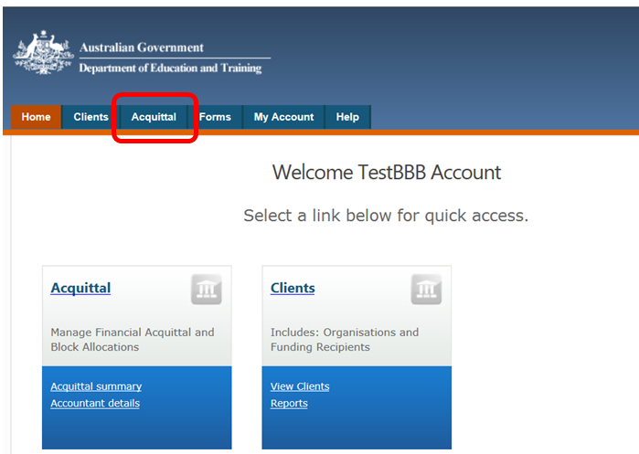
The following information is included in the table for each Approved Authority:
- Action (allows you to start or edit an acquittal that has not been finalised, or view a submitted acquittal)
- Name of the Approved Authority
- Type of acquittal by calendar year (Independent, Independent Collective or System)
- Status of the acquittal: not started, draft (acquittal started but not submitted), confirmed (acquittal has been submitted) and finalised (acquittal has been accepted by the department)
- Total payment amounts calculated by the Australian Government for the Approved Authority (GST exclusive, GST and GST inclusive)
- Hyperlink to view all payments made to the Approved Authority from 1 January to 31 December for the year being acquitted.
To start an acquittal, find the Approved Authority that you wish to acquit in the summary table and click on the “start” or “edit” action button in the far left column next to the Approved Authority’s name. This will direct you to the online Acquittal Certificate.
Figure 2.1.2 - Accessing the Acquittal Certificate
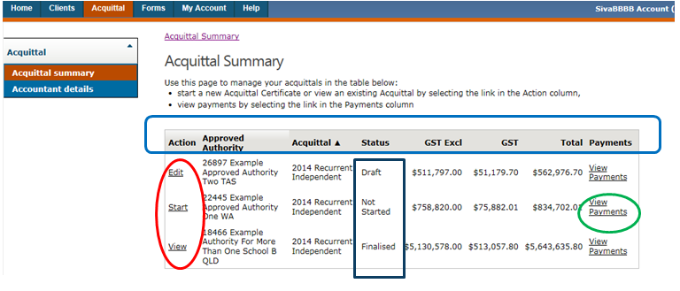

2.2 – Entering Accountant Details
In order to start an acquittal, the qualified person will be directed to enter their professional details. These details are required before any acquittal can be completed.
To enter your details, navigate to the acquittal homepage and select the Accountant Details link on the main page. In the top table, you are required to enter professional details including the name and address details of your organisation and contact details. In the bottom table, you are required to list your professional qualification(s). More than one type of qualification can be added. For each qualification entered, you must provide your membership number and level. These are free-text fields.
Note: Where more than one qualification is entered, the system will use the details of the first qualification when pre-filling details in the Acquittal Certificate.
Figure 2.2 – Accountant Details
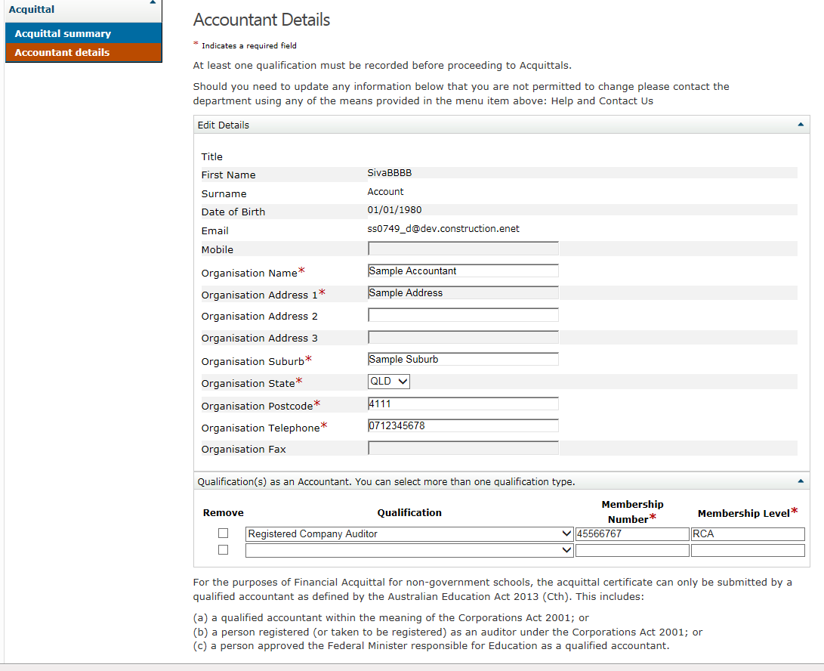Once the mandatory details have been correctly entered click on the Save button. The information on the accountant details page will be used to pre-populate various segments on the acquittal certificate.

2.3 – Submitting the Acquittal Certificate

2.3.1 - Who can submit
The Acquittal Certificate must be submitted on behalf of the approved authority by a qualified person. For non-government schools, a qualified person is a qualified accountant, which is defined under s34 of the Regulation to include:
- A qualified accountant within the meaning of the Corporations Act 2001; or
- A person registered (or taken to be registered) as an auditor under the Corporations Act 2001; or
- A person approved by the Minister as a qualified accountant.

2.3.2 - Confirming grants
The Acquittal Certificate shows the payments made to the Approved Authority’s nominated bank account under three payment types. The payment types are:
- recurrent grant funding (s25 of the Act)
- Special Circumstances funding (s69 of the Act)
- Prescribed Circumstances funding (s69A of the Act)
You must confirm the total amount of funding received by the Approved Authority for the program year (1 January to 31 December for the year being acquitted) for each payment type (where a payment was made) and the grand total of all payments made.
The totals that you are required to confirm are indicated on the Acquittal Certificate table by a red asterisk. The grand total is the total funding provided including GST.
Default totals are pre-filled for each payment type based on the Department’s calculations. These fields may be overwritten, however the new amount entered can only be less than the pre-filled total. If you overwrite a pre-filled total, you must provide an explanation for the new figure in the comments field underneath the table.
For further information regarding confirming a lower amount, please contact the Financial Assurance Team as per Section 1.4 of this guide.
Only the total amount of recurrent funding needs to be confirmed, not the separate amounts displayed on the certificate for the base and loadings. For Approved Authorities for more than one school, the total amount will be the sum of the funding made in respect to all schools.
Funding for Special Circumstances and Prescribed Circumstances will only appear on the Acquittal Certificate if a payment was made by the Australian Government under that payment type. Similarly, refunds will only appear on the Acquittal Certificate where a refund has been made.
To confirm the total grant amounts, you must submit the Acquittal Certificate. Before you submit the Acquittal Certificate you must read through the Declaration and Qualified Person’s Opinion.
Figure 2.3.2 - Confirming grants
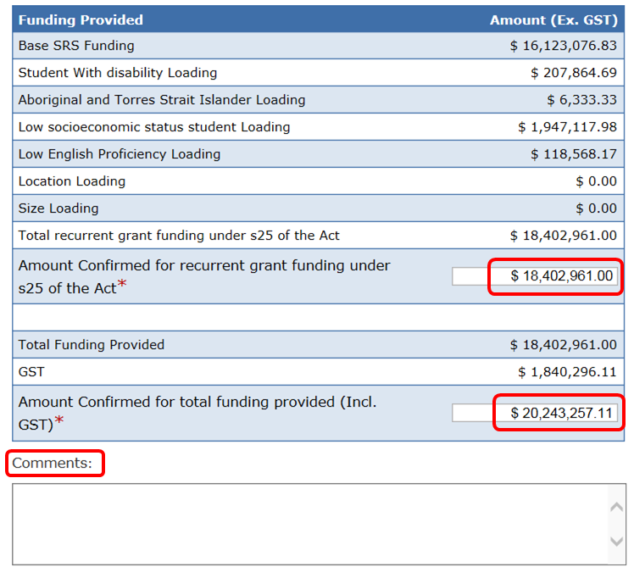

2.3.3 – Declaration and Qualified Person’s Opinion
The Declaration outlines your roles and responsibilities when completing the Acquittal Certificate – such as complying with Australian Accounting Standards and/or Australian Audit Standards. The Declaration reflects what financial accountability obligations under the Act and Regulation are satisfied by submitting the Acquittal Certificate.
Your professional details (such as name, organisation and professional qualifications) are pre-filled in the Acquittal Certificate by the system using the details that you entered into the Accountant Details page. In cases where more than one professional qualification is entered, the system will use the details of the first qualification listed on the Accountant Details page when pre-filling the Acquittal Certificate. If any of your personal or professional details are incorrect, you should update your details in the Accountant Details tab before submitting the Acquittal Certificate to ensure your details are accurate at the time of the submission.
The Qualified Person’s Opinion is found at the end of the Acquittal Certificate. This section requires you to certify that funding received by the Approved Authority from the Australian Government under the Act has been spent, or committed to be spent, in accordance with relevant provisions of the Act and Regulation.
The statements are pre-filled by the system based on the payment types being acquitted. This means that different text will appear in the Qualified Person’s Opinion for each Approved Authority, depending on which payment types funding was paid under. For example, if the Approved Authority did not receive funding for Prescribed Circumstances then you will not be asked to certify anything in relation to that section of the Act. In all certificates, however, you will be required to certify that recurrent grant funding has been spent in accordance with the Act and that any GST has been dealt with in accordance with relevant Australian Taxation Office regulations.
Note: By submitting the Acquittal Certificate you are agreeing to all statements contained in the Declaration and Qualified Person’s Opinion.
Figure 2.3.3 - Qualified Person’s Opinion
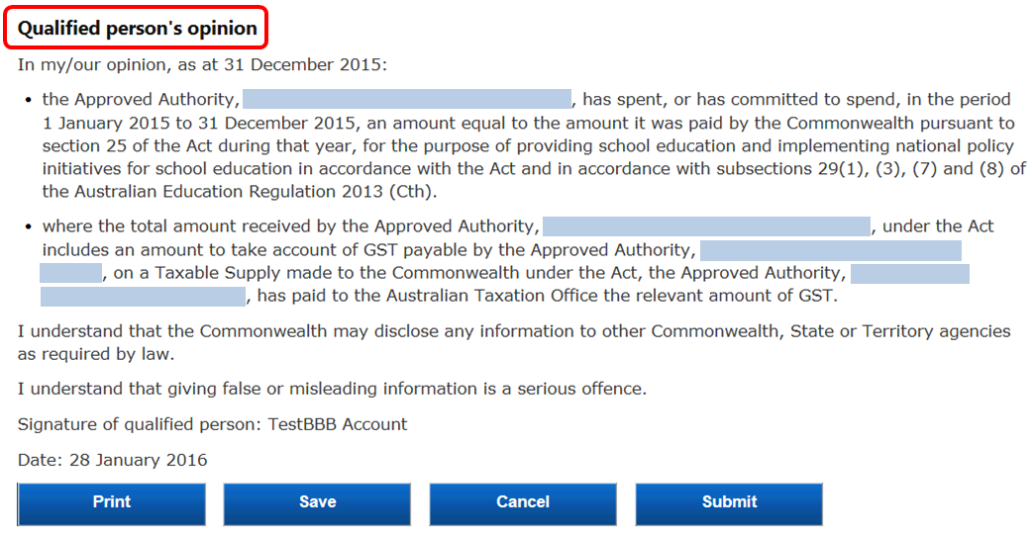

2.3.4 - Finalising the Acquittal Certificate
Once you are ready to finalise the Acquittal Certificate you must click on the “Submit” button at the bottom of the page. The system will pre-fill the date and your name (from the Accountant Details page) to create an electronic signature for the Acquittal Certificate.
If you are not ready to finalise the Acquittal Certificate you can select the “Save” button to save any edits or comments made to date. If you have made a mistake or want to re-open the Acquittal Certificate fresh at a later date (for example, after updating the Accountant Details page), you can select the “Cancel” button. Please note that if you press “Cancel” the Acquittal Certificate will not be saved and any changes will be lost.
Note: You must select “Submit” in order to finalise the Acquittal Certificate. You can re-enter the Acquittal Certificate at any point after saving or cancelling it from the Acquittal Summary page to submit.
Figure 2.3.4 - Finalising the Acquittal Certificate
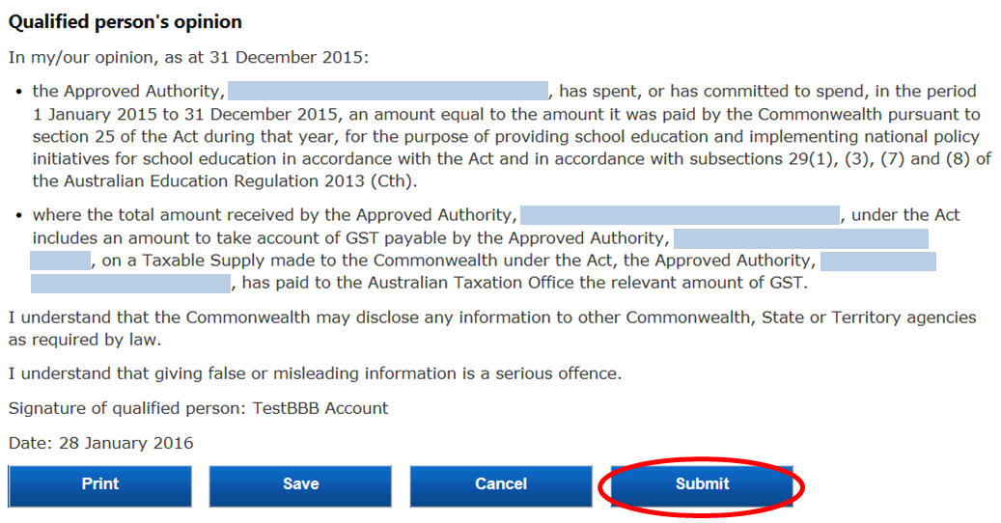

2.3.5 – Accessing the Submitted Certificate
After the certificate has been submitted a copy can be accessed by clicking on the “View” button to the left of the acquittal record. This will open a page which displays the certificate from there a copy in PDF format can be printed via the “Print” button on the bottom of the page.
Figure 2.3.5a – Viewing the Acquittal Certificate
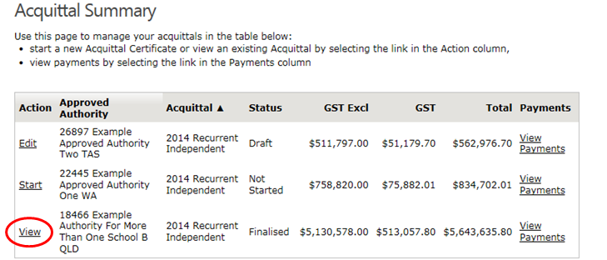
Figure 2.3.5b – Printing the Acquittal Certificate
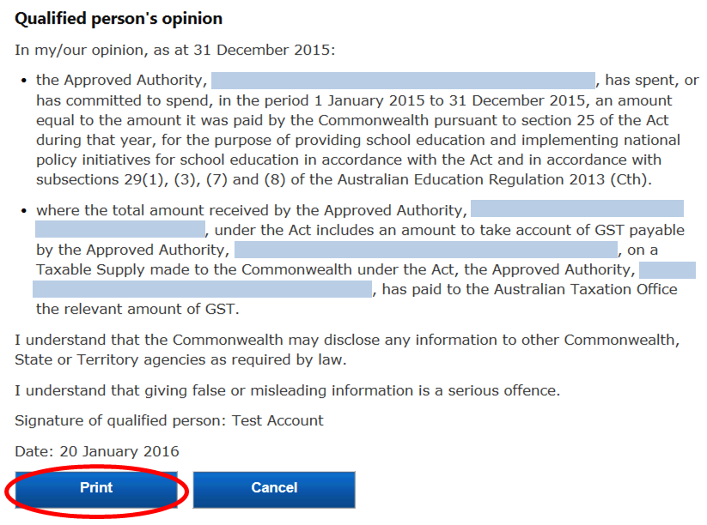

Block Allocation
The Block Allocation is a facility to allow approved authorities that operate more than one school to meet its requirements under the Regulation to report on how funding was distributed to each school. To complete the Block Allocation you are required to have the Finance Contact role or Diocese Allocator role if you represent a Catholic diocesan office in NSW or QLD. There are two types of approved authorities that must complete this component, Approved Authority Collectives and Approved System Authorities.
An Approved Authority Collective is a body that operates more than one school that is not approved as a System Authority. This type of body must distribute funding to schools as directed by the Department and cannot retain any funding for administrative purposes.
An Approved System Authority is a body that operates more than one school that has been approved by the Department as a System Authority. This type of body must distribute funding to schools as per the agreed needs based funding model made between the Authority and the Department. This type of body may retain funding for administrative purposes.
Note: This component of the financial accountability obligations is not required for Approved Authorities that operate only one school.

3.1 – Accessing the Block Allocation
Once you have logged into SEP, navigate to the Acquittal tab using the menu ribbon at the top of the page. SEP will direct you to the Acquittal Summary page and auto-generate a table showing all the Approved Authorities that you have access to.
Navigate to the Block Allocation Summary page using the left-hand menu. SEP will auto-generate a table showing all the Approved Authorities that you are able to complete a Block Allocation for.
The following information is included in the table for each Approved Authority:
- Action (allows you to start or edit an acquittal that has not been finalised, or view a submitted acquittal)
- Name of the Approved Authority
- Type of acquittal (Independent collective or System)
- Status of the acquittal: not started, draft (acquittal started but not submitted) and finalised (acquittal has been submitted)
- Total allocated (amount of funding already allocated at the system or school-level)
- Amount to Block Allocate (total amount of funding required to be allocated).
Where a Block Allocation has been started but not finalised, the “Total Allocated” column gives a running total of how much funding has already been allocated. This amount can be compared to the total in the “Amount to Block Allocate” column on the far right-hand side of the table to indicate how much funding is left to allocate.
To start a Block Allocation, find the Approved Authority that you wish to provide details for in the summary table and click on the “start” or “edit” action button in the far left column next to the Approved Authority’s name. This will automatically direct you to the online Block Allocation page.
Note: Block Allocation tasks will only appear in the Block Allocation Summary after the Acquittal Certificate has been started.
Figure 3.1 - Accessing Block Allocation
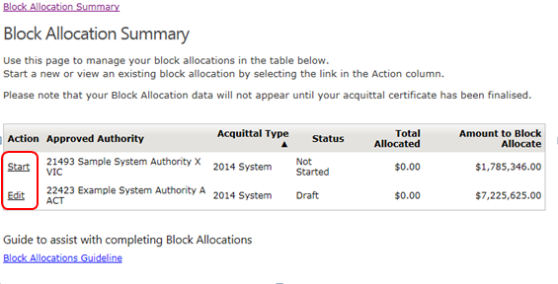

3.2 – Completing Block Allocation details: Approved Authority Collectives

3.2.1 – Reviewing, declaring and submitting Block Allocation details
Approved Authority Collectives are required under the Act and Regulation to distribute funding to the schools they manage in the same way as the funding for each school was calculated by the Australian Government.
As the Approved Authority has no discretion in how to allocate funds between its schools, the school-level details in the Block Allocation table (base and loadings) are pre-filled by the system. None of these values can be edited by the Finance Contact.
You are required to review the pre-filled Block Allocation table, tick the box under Declaration to indicate you are making the declaration below, and then click on the “Submit” button to finalise the Block Allocation.
Note: By selecting submit, you are making a declaration verifying that funding paid under the Act was passed on to schools in the manner outlined in the table.
Figure 3.2.1 – Reviewing, declaring and submitting Block Allocation details: Approved Authorities with More Than One School
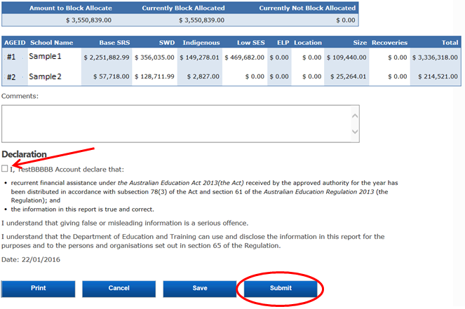

3.3 – Completing Block Allocation Details: Approved System Authorities
The Block Allocation for Approved System Authorities is a facility to allows Systems to comply with the Regulation to report on how funding has been distributed to each school as per the needs based funding arrangements agreed between the Department and the System. Funding that was retained for administration and centralised expenditure is also reported via the Block Allocation.

3.3.1 - Entering system-level funding details
In the top table, you may record any funding allocated at the system level for administrative costs and/or centralised expenditure. These default to $0.00 but are editable fields.
- “Administrative costs” refers to any grant funding that is retained by the System to cover expenditure incurred specifically in relation to the administration of the grant on behalf of the schools in the system.
- “Centralised Expenditure” refers to any grant funding that is either retained by the System Authority or levied back from schools to cover expenditure that is centrally handled by the System Authority on behalf of its schools – this could include costs such as superannuation, relief teachers, long service leave etc.
Once you have completed this section, you should press “Save”, which can be found at the bottom of the page. Saving will automatically update the figure in the far right-hand column of the top table under “Currently Not Block Allocated”. Once all administrative costs and centralised expenditure have been recorded and saved, this figure will indicate how much funding needs to be allocated in the bottom table at the school-level.
Note: If the System Authority did not allocate funding for either administrative costs or centralised expenditure then these fields should be left as $0.
Figure 3.3.1 - Entering system-level funding details
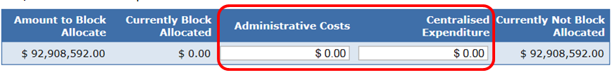

3.3.2 - Entering school-level funding details: Finance Contact
The bottom table requires you to show how the remaining recurrent grant funding has been divided at the school-level. The amount of funding that needs to be allocated at the school-level is the total amount of recurrent grant funding minus administrative costs and centralised expenditure. This figure is down in the “Currently Not Block Allocated” column on the far right-hand side of the top table.
To complete the bottom table, you must record for each school how much funding was allocated for the base and each of the six loadings. If your approved needs-based funding arrangement uses loadings additional to the six outlined in the Act, you should enter funding amounts per school for each of these loadings using the columns labelled “Other”. If you use the “Other” columns, you should enter a comment in the comments field below the table indicating what the loading is (for example, “Other 1 = air conditioning loading).
You must enter an amount for the base and each loading for every school. If no funding was provided to a school under a particular loading, the figure for that column should be left as $0.
There are two ways to complete the school-level table. The first option is to enter the figures for each school online though this page. If you use this option, you must save regularly, as for security reasons your log-on will expire after a certain amount of time and the session will be ended. If this happens, you will lose any figures that you had entered but had not yet saved.
The second way to complete the table is by using the download/upload functionality. Clicking the “Download” button at the bottom of the page will download the school-level table to a CSV file that can be edited using Microsoft Excel. The CSV file will be pre-populated with the AGEID number and school name of every school in the system and will have the same column headers (base and loadings) as on the online page. This functionality allows the Finance Contact to work on the school-level Block Allocation details offline with no risk of losing data when the online session expires.
Once the table has been completed in Excel, you must save the file to your computer as a CSV file. Clicking the “Choose file” button below the school-level table will open a file explorer window – select your completed CSV file. Once you have selected your CSV file, click the “Upload” button to the right. Uploading will overwrite any figures that have previously been entered into the school-level table online.
Figure 3.3.2a - Entering school-level details: Finance Contact
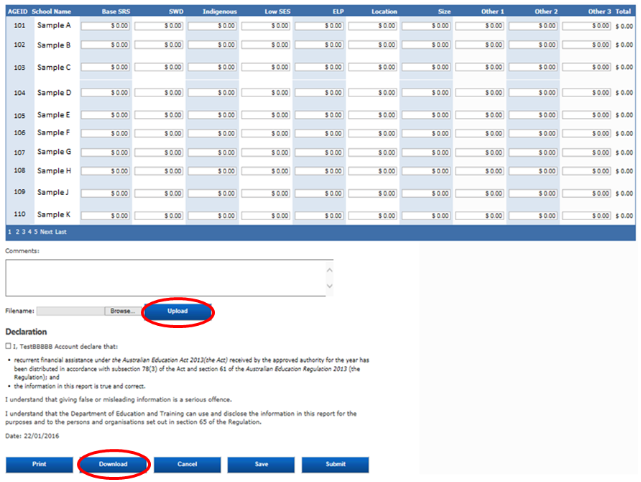
Figure 3.3.2b – Optional CSV file
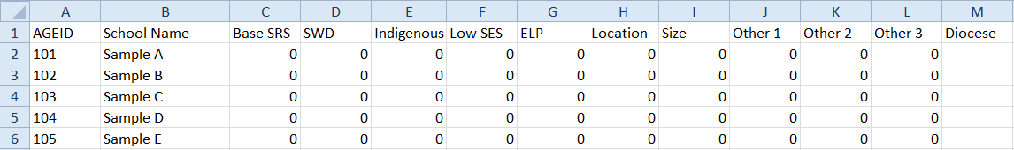
Note: Only CSV files can be uploaded to SEP.
Note: Only figures in online editable fields are uploaded. Therefore, you must not change the order of the columns and rows when working in the CSV file.
Note: for Catholic systems with a funding model going to the diocese level, you can sort by diocese by using the Diocese column in the table.

3.3.3 - Entering school-level funding details: Diocese Allocator
For Catholic systems where the approved needs-based funding arrangement goes down to the diocese level, the Diocese Allocator Role can be requested by a user at each diocese office. Like the Finance Contact, the Diocese Allocator can enter school-level Block Allocation details for schools in their diocese. The Diocese Allocator cannot see system-level details or school-level details for schools that are outside of their diocese and cannot submit the Block Allocation on behalf of the System Authority.
There is no requirement for a Diocese Allocator role to be created – the System Authority must determine through its own processes whether diocese offices will assist to complete the school-level Block Allocation details.
In the same way as a Finance Contact, the Diocese Allocator should enter the funding allocated for base and loadings for each school in the diocese. If loadings additional to those outlined in the Act are used in the system’s approved needs-based funding arrangement, funding allocated for these loadings should be recorded using the “Other” columns. The use of the “Other” columns should be consistent across all dioceses in the system.
You must enter an amount for the base and each loading for every school. If no funding was provided to a school under a particular loading, the figure for that column should be left as $0.
Funding for each school can be entered either online or by using the download/upload functionality. See section 3.3.2 above for detail on how to use enter funding using both of these options.
Once you have completed the funding details for every school in your diocese, you must press “Submit”.
Note: Submitting your Block Allocation updates the school-level details in the Finance Contact’s Block Allocation page, it does not finalise the system’s Block Allocation data.
Figure 3.3.3 - Entering school-level details: Diocese Allocator
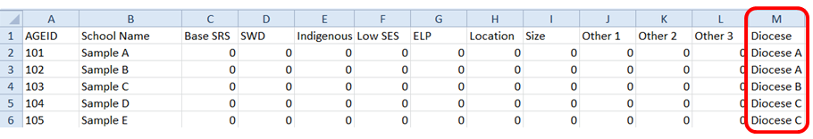

3.3.4 - Finalising the Block Allocation: Finance Contact
Once you have entered funding details for every school in the system, please press “Save”. Saving updates the “Currently Not Block Allocated” figure in the far right-hand column of the top table.
Note: Block Allocation details cannot be submitted until the figure in the “Currently Not Block Allocated” column is $0.
To finalise the Block Allocation data, tick the declaration box and select the “Submit” button at the bottom of the page. Once the Block Allocation has been submitted, the status will change to Finalised on the Block Allocation Summary Page.
If you are not ready to finalise your Block Allocation details you can select the “Save” button at any time to save any edits or comments made to date. If you have made a mistake or want to re-open the Block Allocation fresh at a later date, you can select the “Cancel” button.
Note: If you press “Cancel” all changes to the top and bottom table – including those made by Diocese Allocators - will be lost.
Note: You can only submit the block allocation when the acquittal certificate is finalised.
Figure 3.3.4a Submitting the Block Allocation – Finance Contact
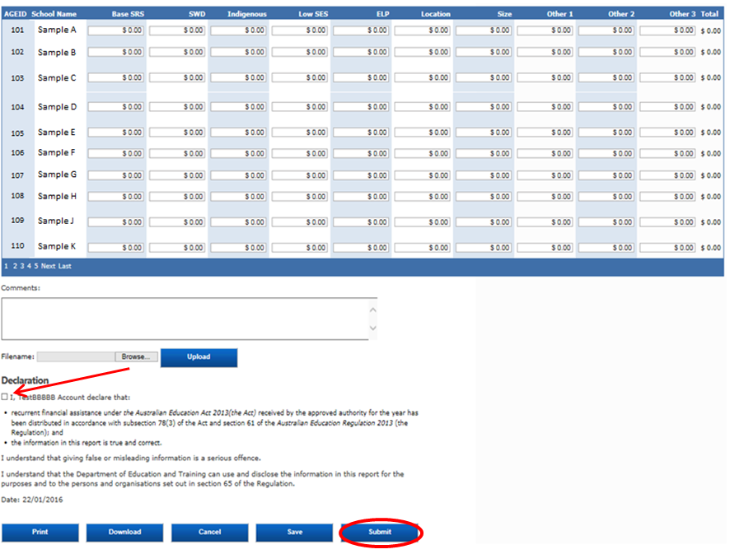
You can view the block allocation data that was submitted via the “Print” button on the bottom left.
Figure 3.3.4b- Printing the Block Allocation: Finance Contact
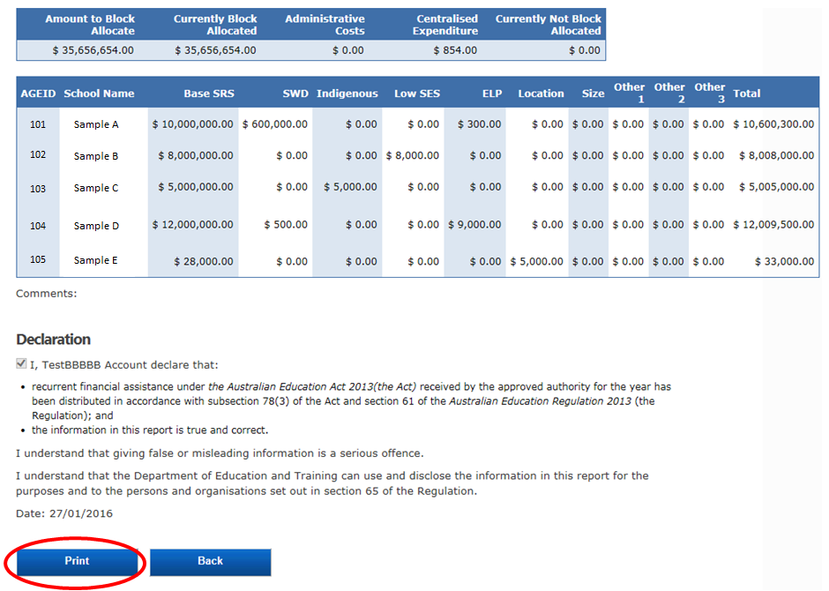
This will open a PDF copy of the details.
Figure 3.3.4c- PDF copy of the Block Allocation
