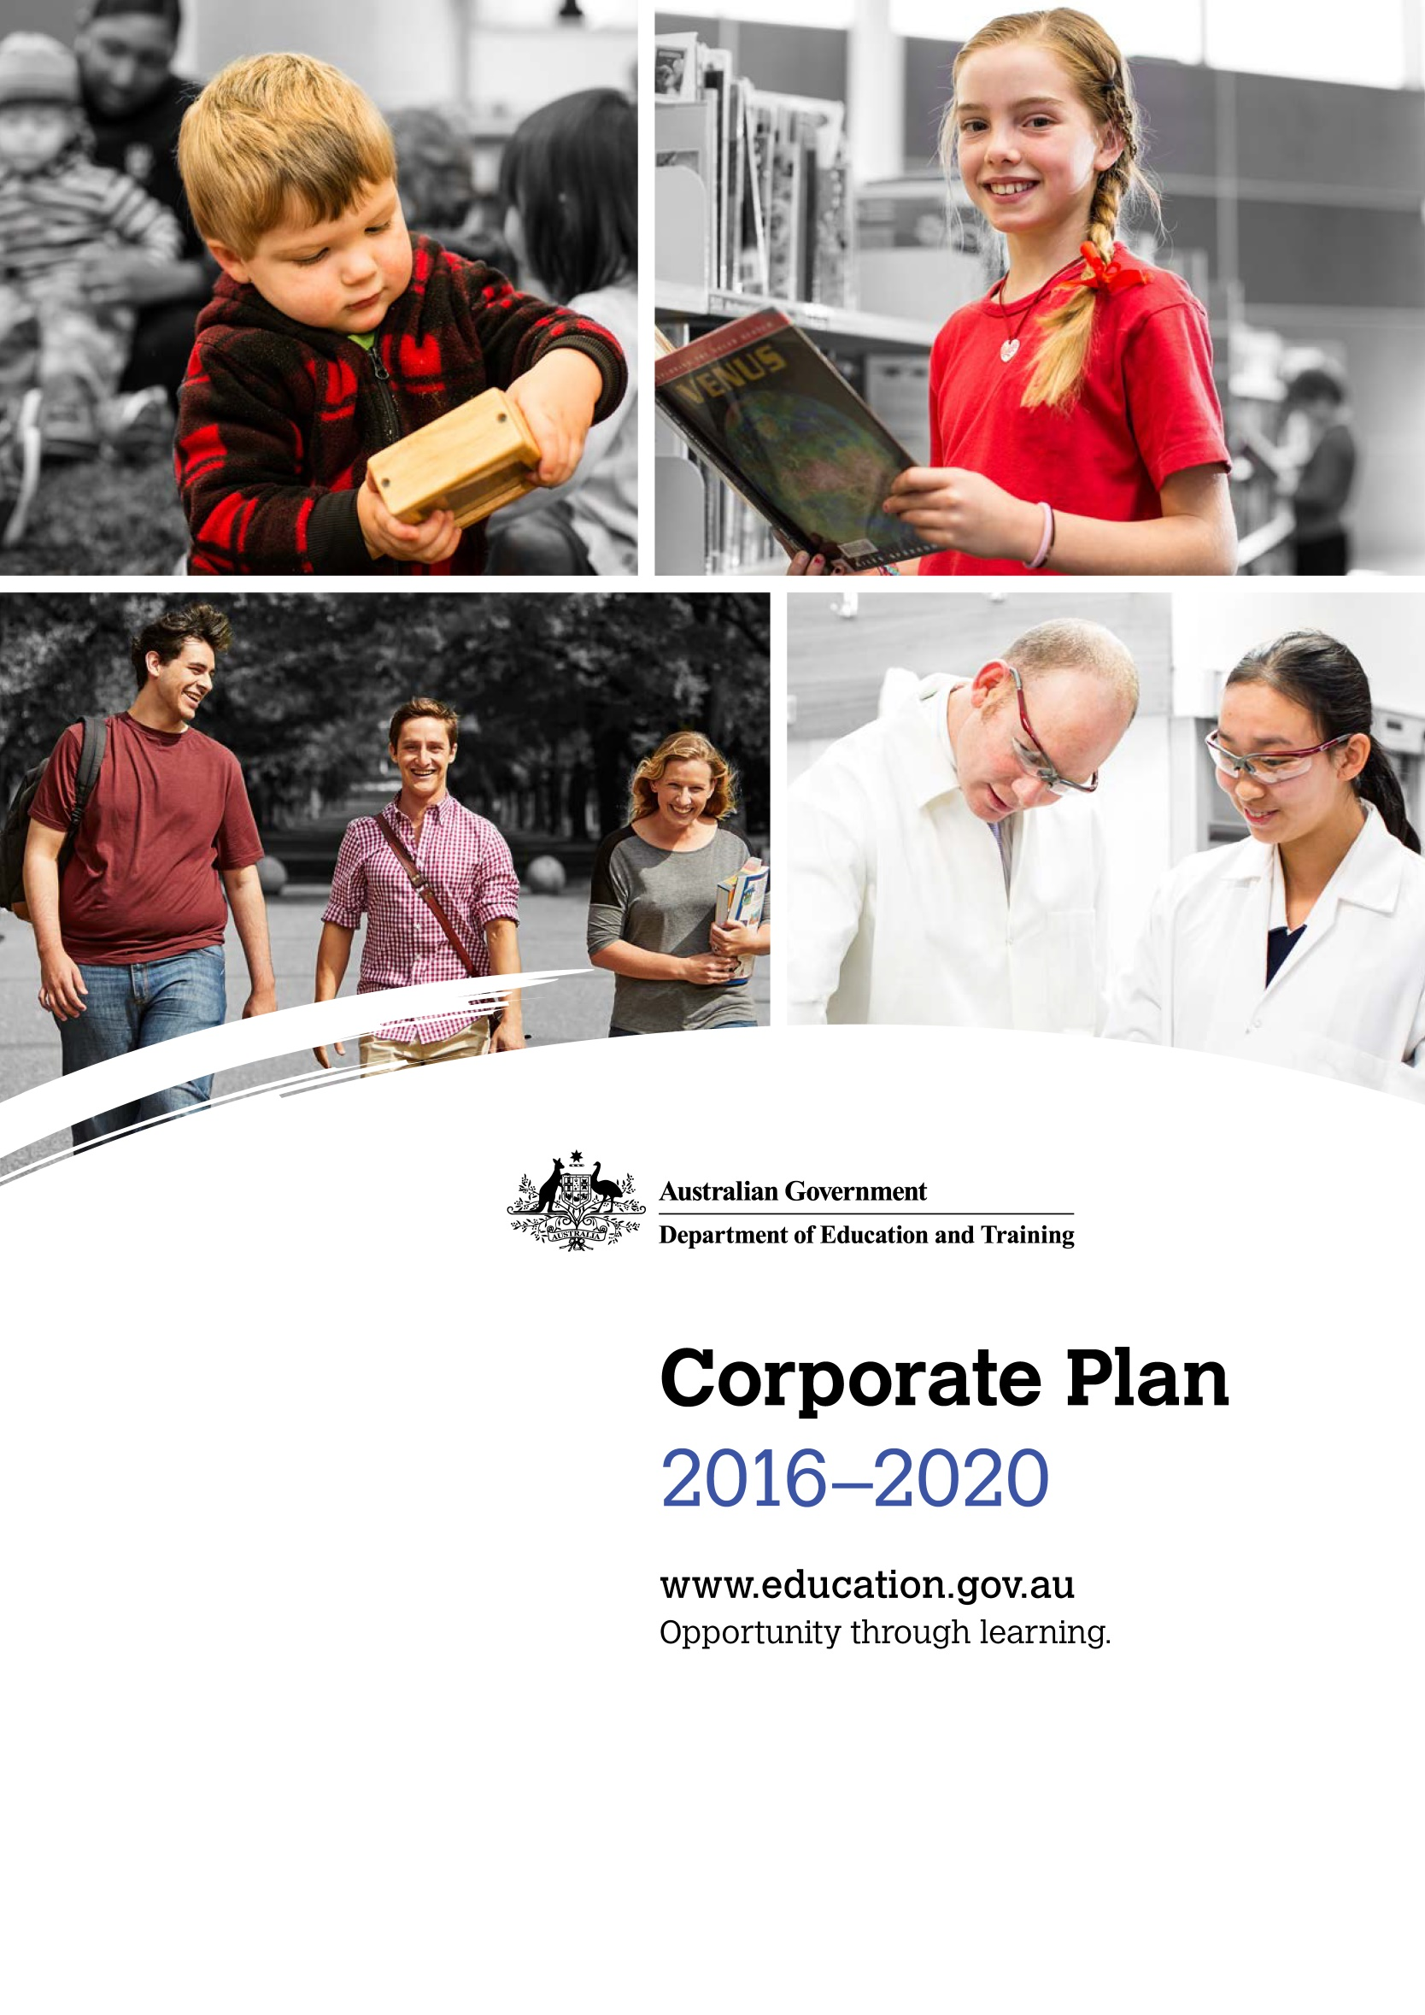

Department of Education and Training

Corporate Plan 2016 - 2020

With the exception of the Commonwealth Coat of Arms, the Department’s logo, any material protected by a trade mark and where otherwise noted all material presented in this document is provided under a Creative Commons Attribution 3.0 Australia (http://creativecommons.org/licenses/by/3.0/au/) licence.
The details of the relevant licence conditions are available on the Creative Commons website (accessible using the links provided) as is the full legal code for the CC BY 3.0 AU licence (http://creativecommons.org/licenses/by/3.0/au/legalcode).
The document must be attributed as the ‘Department of Education and Training Corporate Plan 2016–2020’.

Contents
Secretary’s foreword 4
About our Corporate Plan 5
Purpose 6
Our vision 6
Our mission 6
Our outcomes 6
Our goals 6
Our values and culture 7
Indigenous business is everyone’s business 7
Environment 9
Performance 12
Outcome 1 12
Outcome 2 16
Capability 21
People strategy 21
Enhancing our policy and analytical capabilities 21
ICT capability 22
Our corporate services 22
Risk oversight and management 23
Appendix A – Administered programs 24
Outcome 1 24
Outcome 2 25
Appendix B – Program performance measures 27



Secretary’s foreword
I, as the accountable authority, am pleased to present the Department of Education and Training Corporate Plan 2016–2020, for the four year period 2016–17 to 2019–20, as required under paragraph 35(1)(b) of the Public Governance, Performance and Accountability Act 2013.
The department’s refreshed Corporate Plan reaffirms our commitment to opportunity through learning. We work to support lifelong learning for everyone—from early childhood, through schooling, vocational education and university. Our Corporate Plan also expresses our deep commitment to improving educational opportunities and outcomes for Aboriginal and Torres Strait Islander peoples. For us, Indigenous business is everyone’s business.
Education is a crucial component of maintaining a vibrant, responsive and innovative nation. Our department helps build stronger communities and a stronger economy by improving access to quality child care, enriching teaching and learning in schools, and by building a world-class higher education and research system, as well as a skilled and capable workforce.
The department provides national leadership through evidence based and well informed advice to support our ministers and our stakeholders. This means working in partnership with other government and non-government agencies, state and territory governments, the broader education sector, key stakeholder groups and the community. Only together can we deliver positive social and economic outcomes and strong educational outcomes for the benefit of all Australians.
We have a critically important policy agenda to deliver across the educational lifecycle on behalf of Government, and on behalf of our nation, over the next twelve months and beyond. To ensure the department is well placed to deliver on our responsibilities, we will be strengthening our capability in the areas of strategic policy, data analytics, research, evidence and evaluation. This is a great opportunity to build on the passion, professionalism and commitment of our employees to forge a strong, agile and innovative department.
The Department of Education and Training Corporate Plan 2016–2020 is our key planning document, outlining our purposes, priorities and performance measures. I would like to thank everyone who continues to contribute to achieving our vision expressed in the Corporate Plan.
Dr Michele Bruniges AM
31 August 2016

About our Corporate Plan
The Corporate Plan is the department’s key planning document and is part of a suite of strategic documents that provide the architecture of our funding, operations and performance.
The department takes a tiered and staged approach to planning and reporting, starting with the articulation of the Corporate Plan as indicated below.

Figure 1: The department’s planning and reporting cycle
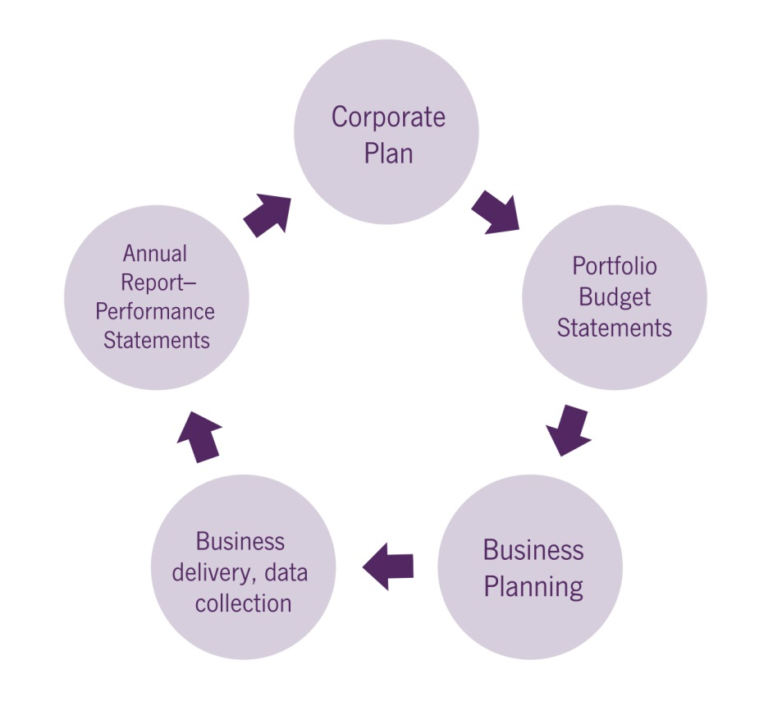
Publication | Role in the planning and reporting cycle
Corporate Plan | The Plan (this document) outlines our purposes, activities, and resulting outcomes, along with how we will assess our effectiveness. It also allows us to provide context on our operating environment. This informs more detailed internal business planning and individual performance agreements.
Portfolio Budget Statements | The Portfolio Budget Statements (PBS) provide further detail about our funded activities including performance measures, criteria and targets.
Business Planning (business delivery, data collection) | Throughout the year, we monitor and evaluate the performance of our activities against the Corporate Plan and PBS performance measures.
Annual Report –Annual Performance Statements | Our progress in meeting our purposes is documented in the Annual Performance Statements, published in our Annual Report. Lessons learned inform our future work and business planning.

Purpose

Our vision
Opportunity through learning

Our mission
Education and training maximises the life chances and choices of every Australian. Creating opportunities to access high quality education from the early years, through schooling and tertiary settings, is central to our mission. We want to be acknowledged for the global reach of our research and internationally recognised for the quality of our educational provision.
Our work reflects the educational priorities of the Australian Government and we will work collaboratively with our stakeholders to achieve the best possible outcomes for children and young people.

Our outcomes
As outlined in the Education and Training 2016–17 Portfolio Budget Statements, the department is responsible for delivering two Government outcomes:
Outcome 1: Improved early learning, schooling, student educational outcomes and transitions to and from school through access to quality child care, support, parent engagement, quality teaching and learning environments.
Outcome 2: Promote growth in economic productivity and social wellbeing through access to quality higher education, international education, and international quality research, skills and training.

Our goals
Our goals describe the key areas of work we will focus on to achieve our vision and deliver on our two outcomes.
- Access to quality child care: Build a sustainable national child care system that supports parents to enter and remain in the workforce while providing quality care and early learning.
- Quality schooling: Support a high quality school education system, including preschool, with improved outcomes for Australia’s students by building on our schooling successes and focusing on quality teaching, school autonomy, parent engagement and the Australian curriculum.
- World-class tertiary education and research: Enable the delivery of quality higher education, international education and research that contributes to both the Australian and the global economy and society.
- Skilled workforce: Ensure that Australia’s workforce has the capability to respond to the needs of current and emerging industries thus contributing to their global competitiveness.

Figure 2: The Department of Education and Training strategic overview
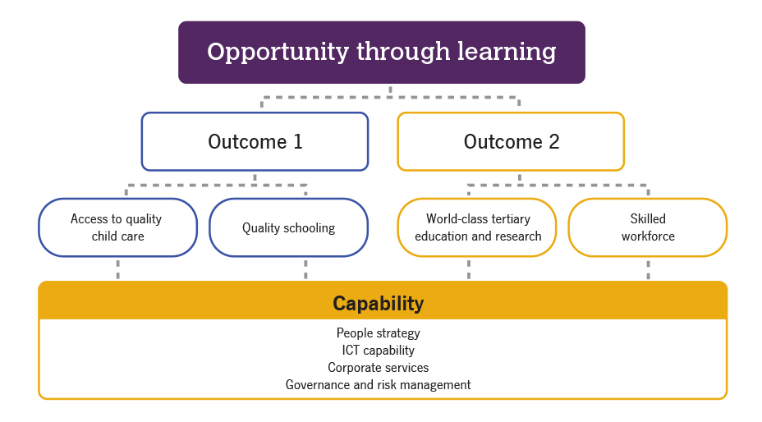

Our values and culture
We proudly uphold the Australian Public Service Values. We are impartial, committed to service, accountable, respectful and ethical. We support these values by creating a culture where we:
- are consultative and responsive
- value learning, research, discovery and opportunity
- innovate to achieve our business outcomes more efficiently and effectively
- collaborate internally and externally to reach our goals
- lead by example at all levels and pride ourselves on being professional, high performing and innovative
- care for and support each other and value the skills, difference and diversity of our people.

Indigenous business is everyone’s business
The department supports the Government’s priority to work with Aboriginal and Torres Strait Islander peoples, communities and business to build a better future and improve opportunities. The department develops and delivers education policies and programs by working with Aboriginal and Torres Strait Islander peoples, respecting their cultures and building our own cultural capability.
We also proudly support the Government’s Indigenous Procurement Policy so we can foster Aboriginal and Torres Strait Islander business, create jobs and employ more Indigenous Australians.
Our employees are encouraged to embrace and value the important contribution Aboriginal and Torres Strait Islander peoples make to our department and wider Australian society. The department’s Reconciliation Action Plan is a formal commitment and call to action for all our employees to ensure Indigenous business is part of their day-to-day business.

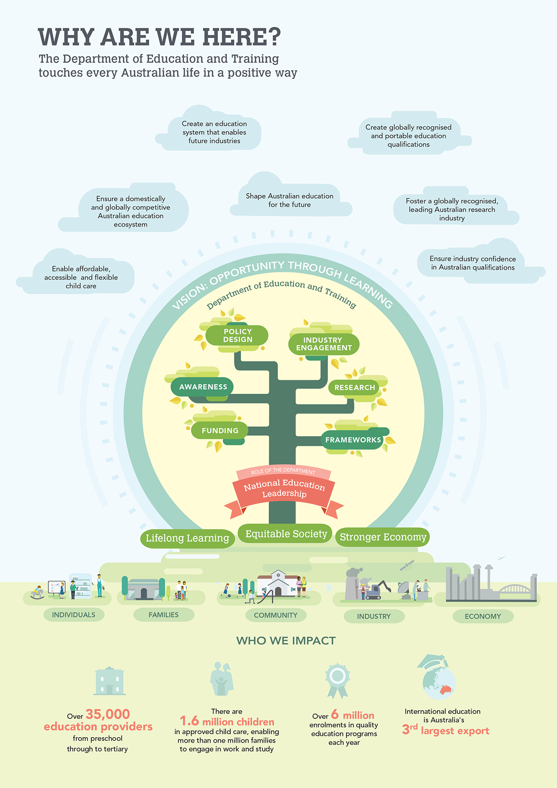

Environment
Education is of fundamental importance to all Australians. It is central to individual opportunity, economic growth, productivity and innovation. It is a key way the Government can support Australia’s global competitiveness while acting as a significant lever for delivering greater inclusion and engagement with the labour market, which is vital to addressing disadvantage.
The Government is committed to strengthening economic growth and social wellbeing through better access to quality child care and early learning, schooling, vocational education and training, higher education, international education and research. The department is strongly committed to providing opportunity through learning. Our overarching purpose is to build stronger communities and a stronger economy by enriching early learning, supporting quality education and research, as well as building skills and capability.
The broader environment in which the department pursues our purpose is changing. Australia is transitioning to a knowledge-based economy, which is increasingly dependent on having a highly educated and skilled workforce.
The education and training sector is multifaceted and education is delivered through a complex mix of government, not-for-profit, religious, private and corporate entities. Our policies, programs and stakeholder engagement strategies need to respond to and reflect this complex environment.
A person’s engagement with learning can also be complex. People’s educational experiences can vary greatly. In particular, people from disadvantaged backgrounds face many barriers to continuing their education. Some may re-engage with formal education at different stages of their lives.
Role of state and territory governments and other Commonwealth agencies
As part of federation arrangements, government schools are owned and operated by state and territory governments. The Australian Government provides significant funding to the states and territories to deliver quality education and training across early childhood, schools and training. A number of portfolio agencies support the Department of Education and Training to deliver the Government’s education priorities (see Figure 3).
An evolving education system
The Government is committed to developing a quality, diverse and innovative education system. To realise this objective, the department will continue to progress the Government’s reform agenda, across all education sectors and to work cooperatively with industry, students and education providers.
Innovation and research are essential to productivity growth. They underpin the process of knowledge creation and drive economic growth by providing business and non-business sectors with the ideas and means to produce products and services more efficiently. The department supports the Government’s commitment to improving science, technology, engineering and mathematics (STEM) learning, and to growing innovation and productivity through National Innovation and Science Agenda measures.
International education is Australia's largest services export and third largest export overall behind iron ore and coal. Last year alone the sector injected over $19 billion into the national economy and accounted for 130,000 jobs. This growing industry experienced a 10 per cent increase in enrolments in 2015. A key challenge will be continuing to drive the quality and outcomes from our education sector to sustain Australia’s international competitiveness and attractiveness to international students. The Government’s National Strategy for International Education 2025 acknowledges the importance of this industry for Australia’s ongoing economic prosperity. The strategy will encourage Australia’s international education sector to be more adaptive, innovative and globally engaged. It will further strengthen our internationally recognised education system, increase global partnerships and drive collaboration with local communities and global partners.
Changes in technology require us to rethink how we do our business and also the role and delivery of education in the future. Interactive social technologies present opportunities to better deliver policy, improve services and increase citizen engagement and participation in education.
Future demand for learning
The 2015 Intergenerational Report, published by The Treasury, makes clear that Australia’s population is expected to grow, and increase in median age over the next 40 years. For example, the proportion of the population aged between 15 and 64 is declining relative to the proportion aged 65 and over. In 1975, for every one person aged 64 years and over, there were 7.3 people aged 15 to 64 years. In 2015, the ratio is only 4.5 people. By 2055, this is projected to nearly halve again to 2.7 people.
This demographic shift will have profound implications for the economy. Without any change to productivity, the projected decline in the proportion of the population participating in the labour force (from 64.6 per cent now to 62.4 per cent by 2054–55) will mean lower economic growth. These demographic changes require policies directed at building lifelong learning opportunities that support workforce participation through all stages of life.

Figure 3 The department's internal and external operating environment
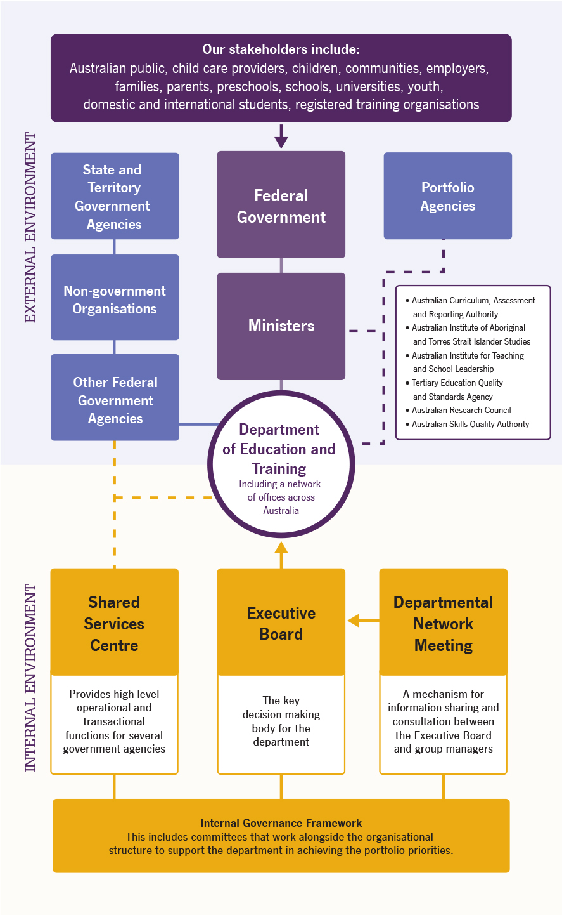

Performance

Outcome 1
Improved early learning, schooling, student educational outcomes and transitions to and from school through access to quality child care, support, parent engagement, quality teaching and learning environments

Goal 1: Access to quality child care
Build a sustainable national child care system that supports parents to enter and remain in the workforce while providing quality care and early learning
The Australian Government developed the Jobs for Families Child Care Package in response to the 2015 Productivity Commission Inquiry Report into Childcare and Early Childhood Learning. The package seeks to create a more sustainable system that encourages greater workforce participation, while addressing children’s learning and development needs. It will make child care more affordable, accessible and flexible for more than one million families by:
- targeting and providing more assistance to low and middle income families
- replacing the multiple payment system with a single payment, paid directly to providers
- reducing barriers to flexible service delivery and trialling programs to provide care for children of families who cannot easily access mainstream services
- providing a safety net for vulnerable and disadvantaged families, and support for services to include children with additional needs.
The package represents a Government investment of around $40 billion on child care support over the next four years, including an increase of more than $3 billion.

Challenges
The implementation of the Jobs for Families Child Care Package depends on passage of the Family Assistance Legislation Amendment (Jobs for Families Child Care Package) Bill 2015. In the 2016–17 Budget, the Government announced full implementation of the package would be deferred to July 2018. The legislation will be re-introduced early in the sitting schedule of the 45th Parliament.
Key challenges through 2016–17 will be preparing child care services and families to plan for transition to the new system while continuing to support the existing child care system. This will include an ongoing focus on quality and compliance.

Activities
- Engaging with internal and external stakeholders to inform the ongoing design and delivery of the new programs, including support for parents and the sector to transition to the new child care system.
- Engaging with the Departments of Human Services and Social Services to inform the design and delivery of the new programs, including developing a new Information Technology (IT) system.
- Establishing baseline data to assist in monitoring program effectiveness and the impact of the child care package on families and child care services.
- Addressing non-compliance in the child care sector, with appropriate measures to ensure payment integrity and longer term Budget sustainability.
Refer to Appendix A for programs administered by the department.

Priorities
- Support workforce engagement while addressing children’s learning and development needs – providing access to affordable, flexible and high quality child care that supports parents and families to engage with work, study, training or other recognised activities.
- Support vulnerable or disadvantaged children – supporting families and services with the provision of quality child care, including better integration of children who have additional needs or are from vulnerable or disadvantaged families.
- Protect taxpayer funding by continuing to focus on addressing child care payment non-compliance – continuing compliance action to significantly reduce the risk to Australian Government outlays and to ensure funds are used for quality care and education.
- Monitor implementation and effectiveness – improving data collection and analysis to assess policy and program implementation and effectiveness.

Performance measures
Key performance measures and the years in which they are reported against are outlined below.
 | 2016–17 | 2017–18 | 2018–19 | 2019–20
Number of families using approved child care
Percentage of families using child care services that receive a child care payment
Successful implementation of strategies and initiatives to transition eligible families and services to the Child Care Subsidy (CCS)
Percentage of all children attending child care from priority groups, including:
- Indigenous children
- children from culturally and linguistically diverse backgrounds
- children with disability.
Refer to Appendix B for performance measures relating to each program, as published in the Education and Training 2016–17 Portfolio Budget Statements.

Goal 2: Quality schooling
Support a high quality school education system, including preschool, with improved outcomes for Australia’s students by building on our schooling successes and focusing on quality teaching, school autonomy, parent engagement and the Australian curriculum
The Australian Government is committed to delivering stable and sustainable needs-based funding into the future for all Australian schools. The Government will provide a record $73.6 billion in total funding for government and non-government schools over the period 2016–17 to 2019–20.
The Government also committed an additional $118.2 million for students with disability, to be directed to where it is needed most by using data from the Nationally Consistent Collection of Data on School Students with Disability (NCCD).
The Government supports quality early childhood education to prepare children for full-time school. In the 2015–16 Budget, the Government responded to the Productivity Commission Inquiry into Childcare and Early Childhood Learning by committing an additional $840 million to states and territories for the 2016 and 2017 calendar years, to support universal access to preschool programs.
Longer term arrangements for schools will be considered in the context of the Quality Schools, Quality Outcomes policy paper which sets out five areas for future focus:
- boosting literacy, numeracy and STEM performance
- teaching and school leadership
- preparing our students for a globalised world
- focusing on what matters most and those who need it most
- accountability through transparency.
By drawing on national and international evidence to improve the educational outcomes of students and the performance of schools, the Australian Government has identified that future efforts should ensure students are able to access the support they need to succeed. The schooling system should also be centred on ensuring young people leave school with the skills they need to succeed in the workplace, in further education and as active and involved citizens. The Government will work with state and territory governments and the non-government sector to implement key reforms in these areas.
Better sharing of information and making improvements to the quality of data available will be central to achieving better educational outcomes for students.

Challenges
The delivery of school education is the constitutional responsibility of the states and territories. The Commonwealth works in partnership with state and territory governments and non-government education authorities to provide funding, develop and implement national policy priorities, assess performance and support other education initiatives.
Despite real increases in the Government’s funding to schools over a considerable period, the performance of Australian students in international testing has declined in both absolute and relative terms in the key learning areas of reading, maths and science. This decline is a result of fewer Australian students classified as ‘high performers’ and an increase in the number of low performers. There is also a substantial gap in student achievement between Indigenous and non-Indigenous students.
This performance record demonstrates that, while school resourcing is important, it is crucial that funding be spent effectively and in ways that lift performance and student outcomes.

Activities
- Sustainable needs-based school funding to support improved student outcomes.
- Supporting early learning preschool programs to facilitate children’s transition to full-time school.
- Partnering with state and territory governments and non-government schooling authorities to achieve national policy priorities.
- Measuring educational outcomes through national assessments and international benchmarking.
- Building national evidence to inform decision making.
Refer to Appendix A for programs administered by the department.

Priorities
- Lift school education outcomes – addressing the decline of Australia’s performance in international assessments
- Improve access to, and participation in, quality preschool programs – supporting 600 hours of preschool education for all children in the year before full-time school.
- Improve access to quality compulsory school education – directing national effort towards the strategies which ensure improved learning outcomes can be achieved for all Australian students regardless of their school or background through the Students First and Quality Schools, Quality Outcomes reform packages.
- Improve the fairness and effectiveness of Government schools funding – funding is needs-based and contributes to the operating costs of government and non-government schools.
- Improve the national evidence base – improving data collection and the information available to policy-makers, education authorities, teachers and parents.

Performance measures
Key performance measures and the years in which they are reported against are outlined below.
 | 2016–17 | 2017–18 | 2018–19 | 2019–20
High-level targets and measures outlined in the Australian Education Act 2013 and the Education Council’s Measurement Framework for Schooling in Australia
Assessing Australia’s performance against international benchmarks
Refer to Appendix B for performance measures relating to each program, as published in the Education and Training 2016–17 Portfolio Budget Statements.

Outcome 2
Promote growth in economic productivity and social wellbeing through access to quality higher education, international education, and international quality research, skills and training

Goal 3: World-class tertiary education and research
Enable the delivery of quality higher education, international education and research that contributes to both the Australian and the global economy and society
The Australian Government is working to reform Australia’s higher education sector to ensure it is fair, sustainable and provides a quality education for all students, improving Australia’s economic performance through better translation of publicly funded research into commercial outcomes, and building Australia’s status as a world leader in international education.
In May 2016, the Government released a paper, Driving Innovation, Fairness and Excellence in Australian Higher Education, which lists reform options to achieve the Government’s vision of a stronger, more sustainable system of higher education. The paper articulates the broad vision and reinforces the need for a fairer and more internationally competitive higher education system, which is more financially sustainable into the future.
At the same time, the Government accepted the recommendations of the Review of Research Policy and Funding Arrangements – Report November 2015 (the Watt Review). The review recommended actions to strengthen Australia’s research system, improve collaboration between universities and business, and translate research outcomes into economic and social benefits. These actions build on measures in the National Innovation and Science Agenda (NISA), released in December 2015.
Under NISA, the Government has commissioned the 2016 National Research Infrastructure Roadmap to support future investment decisions in national research infrastructure. This will ensure Australian researchers can continue to access cutting edge and world-class research infrastructure.
The Government released the National Strategy for International Education 2025 in April 2016, which outlines strategies to strengthen and grow Australia’s international education sector over the coming decade.

Challenges
The department has a critically important policy agenda to deliver on behalf of Government. By actively engaging with stakeholders, delivering evidence based policy advice, and ensuring that policies support the best use of available resources, the department will enable the Government to meet its objectives for higher education, research and international education.

Activities
- Continuing to support the Government to work closely with stakeholders to deliver a revised higher education reform package.
- Sharpening incentives to drive greater collaboration between research and industry, including streamlining research block grants and progressing Australia’s first national assessment of engagement and impact in university research.
- Ongoing support for the National Collaborative Research Infrastructure Strategy and developing a new National Research Infrastructure Roadmap to guide future Government investment in national research infrastructure.
- Working with higher education institutions, Indigenous leaders and organisations to improve participation and success in higher education and research of under-represented groups, including Indigenous Australians.
- Working closely with education and training providers, partner agencies and other stakeholders to progress initiatives to sustain and strengthen our international education sector.
Refer to Appendix A for programs administered by the department.

Priorities
- Strengthen the higher education system – ensuring that Australian higher education providers stay internationally competitive, and attractive to Australian and international students; producing adaptable and well educated professionals for the changing economy of the 21st century; and providing competitive research across all disciplines to underpin social and economic progress.
- Ensure equity of opportunity – for previously under-represented groups, including Indigenous Australians, in higher education and research – including students and staff.
- Improve the sustainability and effectiveness of Government funding to higher education – including striking the right balance between public and private contributions, while minimising upfront barriers to participation.
- Align Australia’s research effort with the national innovation system – improving collaboration between universities and industry and increasing research commercialisation and economic and social benefits.
- Identify Australia’s priority national research infrastructure needs – ensuring that our local and international researchers have access to cutting edge and world-class national facilities and lifting our competitiveness and international reputation.
- Preserve and extend Australia’s share of global education markets – supporting growth and diversity in international education to ensure Australia remains a partner of choice for high quality education, training and research engagement.

Performance measures
Key performance measures and the years in which they are reported against are outlined below.
 | 2016–17 | 2017–18 | 2018–19 | 2019–20
Increased student participation in higher education, including by previously under-represented groups
Evaluation of the Higher Education Participation and Partnerships Program
Quality Indicators in Learning and Teaching drives improved quality, supports transparency and informs student choice
Higher Education Loan Program (HELP) enables access to tertiary education and HELP debts are affordable for both students and the community
Successfully transition to new research block grant funding arrangements
Increased research collaboration between universities, industry and other end-users
Increased access to major national research infrastructure to support collaborative research activities
Maintain and strengthen international students’ satisfaction with studying and living in Australia (biennial survey)
Refer to Appendix B for performance measures relating to each program, as published in the Education and Training 2016–17 Portfolio Budget Statements.

Goal 4: Skilled workforce
Ensure Australia’s workforce has the capability to respond to the needs of current and emerging industries, thus contributing to their global competitiveness
The Australian Government works to position a highly skilled workforce, by providing all students with opportunities for access, participation and success, and striving for an effective and efficient national training system that is industry-led and delivers the skills Australian employers need.
Australia’s vocational education and training (VET) and apprenticeships sector delivers workplace-specific skills and knowledge through diverse career pathways in a wide range of occupations and industries. Vocational education and skills development is crucial to Australia’s social and economic prosperity because it helps develop our national workforce by providing pathways to employment and addressing barriers to workforce participation.

Challenges
The sector is undergoing significant transition with reforms in regulation, funding and information to ensure skills meet the needs of students and employers now and in the future. The challenge for the department is to continue to lift the quality of training providers and their courses, encourage employers to provide Australian Apprenticeship opportunities and to increase the job prospects of students so that workforce trend demands are met.
By engaging openly and meaningfully with stakeholders, the department can maintain its inclusive approach to policy and program development and position itself to achieve the best outcomes for students, employers and industry.

Activities
- Developing policies that will improve the VET sector through three principles:
    - Jobs – stronger linkages between training and real jobs, to deliver better employment outcomes and more effective regulation
    - Quality – high standards for training providers, and stronger consumer protection
    - Status – increasing the VET sector’s reputation nationally and internationally and ensuring its recognition as a vocationally focussed career pathway.
Refer to Appendix A for programs administered by the department.

Priorities
- Create an effective and efficient national training system that meets the needs of Australia’s current and emerging industries – including:
    - improving access to high quality training that leads to real jobs
    - facilitating training that enhances Australian businesses’ competitiveness in global markets
    - increasing apprenticeship commencements, completions and developing the skills of the Australian workforce.
- Better consumer information and regulatory reforms – improving the information available to enable students to make informed choices about training, and improving the quality and reputation of the VET sector, both domestically and overseas.
- Reform the VET FEE-HELP system – redesigning VET FEE-HELP to ensure a high quality system for students and employers, which is sustainable and affordable to the taxpayer and protects the reputation of our education and training sector.
- Trial a range of approaches aimed to increase apprenticeship participation and improve outcomes – including pre-apprenticeship models and alternative delivery pilots.
- Better linking training to real jobs – including demonstrating improved employment outcomes for VET graduates.

Performance measures
Key performance measures and the years in which they are reported against are outlined below.
 | 2016–17 | 2017–18 | 2018–19 | 2019–20
Growth in the number and proportion of Australians with VET skills
VET student satisfaction, salaries and jobs (annual survey)
Employers’ use and views of the VET system (biennial survey)
Growth in the apprenticeship commencement and completion rates
Change in indicators of quality of training, including regulatory actions and revisions to training packages
Progress towards National Partnership on Skills Reform outcomes
Evaluation of the Trade Support Loan program
Refer to Appendix B for performance measures relating to each program, as published in the Education and Training 2016–17 Portfolio Budget Statements.

Capability
Our operating environment is changing. To continue to achieve outcomes for Government, we will give priority to building our capacity to formulate rigorous policy and to share and analyse data. This will further strengthen the department’s national leadership role in education.
Our capability to deliver against our purpose is supported by a range of enabling strategies. These include:
- finalising and implementing our new People Strategy
- strengthening our evidence base through improved data and analytical capabilities
- enabling technology and systems, including user-centre design and strategic ICT investments
- corporate services and the Shared Services Centre (SSC) working together
- strengthening our governance and risk management practices
- improving business planning and performance monitoring processes.

People strategy
Our skilled and professional employees demonstrate each day their commitment to our vision of providing opportunity through learning for all Australians. The department’s people strategy will provide a framework for us to make informed, evidence based decisions about our organisation and our future workforce needs.
We are developing a new people strategy, which will help ensure we have the right:
- Capability: Our people are highly capable, inclusive leaders and equipped to provide robust evidence based policy advice to Government and to deliver our business.
- Culture and performance: Our culture is based on APS core values and provides a workplace environment that motivates our people.
- Shape: The size and shape of our workforce meets the department’s need to deliver business outcomes on behalf of the Government.

Enhancing our policy and analytical capabilities
The development and delivery of good policy can only be achieved through a strong evidence base. As our role in delivering social and economic outcomes for all Australians through national leadership in education policy grows, so too must our capabilities.
In 2016–17, we will actively assess our future capabilities needs, our readiness to take on the challenges ahead, and what we need to do to get there. We will determine how to best share and build our capability into the future.
An immediate priority is to enhance our policy and analytical capabilities. We will work to get our basics right. This includes:
- ensuring the range of data sets we currently hold in the department are more coordinated and accessible, both within the department and externally
- professional development to build staff capability around data analytics
- working with other departments to explore data linkages across social policy areas.

ICT capability
To meet current and future challenges, the department’s approach to information and communications technologies (ICT) capability focuses on the use of tools and technology to inform strategic policy and achieve business outcomes.
Our key ICT capability focus areas include:
- data analytics and evidence driven policy
- a focus on user-centred design and benefits driven investment to deliver strategic priorities
- strong design governance
- encouraging and enabling innovation
- maturing our portfolio, program and project capabilities
- fully utilising our current investments to maximise organisational outcomes, and rationalising our application portfolio
- leveraging our knowledge and technology to reform business processes.

Our corporate services
Our internal corporate services and SSC work collaboratively to support business areas to achieve their goals and maintain productivity and excellence within a constrained fiscal environment.
Our corporate areas:
- offer strategic services and expertise to the department’s business areas
- deliver services seamlessly without compromising accountability, compliance or quality
- ensure reliable technologies and systems are accessible
- support our ministers, the department and stakeholders to strive for better ways of working.

Shared Services Centre
The SSC is a joint operation with the Department of Employment. The SSC provides shared corporate functions to the departments, including corporate IT, human resources, finance operations, property, design, website development, library and mailroom services. This shared services model helps reduce costs and increase efficiency by consolidating and standardising processes. The SSC is accountable to the two departments and overseen by a governance board.

Risk oversight and management
The department is committed to good corporate governance and sound management practices, including a structured approach to the management of risk.
Our risk management framework and policy is based on the Australian and New Zealand Standard for Risk Management (AS/NZS ISO 31000:2009) and draws on the Australian Government’s Better Practice Guide for Risk Management. Our policy and framework promotes risk management as an integral component of core business delivery, at all levels of the organisation, and encourages all employees to manage risk as part of their everyday responsibilities.
Our department uses Senior Executive Service officers, governance committees, and working groups to inform decision making. We aim to ensure decision making is delegated to the most appropriate level to empower our employees and promote a sense of agency. Our Audit Committee, for example, provides independent strategic assurance on the appropriateness of the department’s performance reporting, risk controls and compliance framework.

Appendix A – Administered programs

Outcome 1
Goal 1: Quality schooling
- Program 1.1: Government Schools National Support
  - Government Schools – Recurrent
- Program 1.2: Non-Government Schools National Support
  - Non- Government Schools – Recurrent
  - Non-Government Schools – Capital
  - Short Term Emergency Assistance
  - Non-Government Representative Bodies
- Program 1.3: Early Learning and Schools Support
  - Grants and Awards
  - Helping Children with Autism
  - Teach for Australia
  - Quality Outcomes
  - Maths and Science Participation
  - Flexible Literacy Learning for Remote Primary Schools
  - Improving the Teaching of Foreign Languages
  - National Assessment Reform
  - Science, Technology, Engineering, and Mathematics (STEM)
  - Inspiring all Australians in Digital Literacy and STEM
  - Australian Early Development Census
  - Educating Against Domestic Violence
  - Universal Access to Preschool – Research Component
  - Early Learning Languages Australia (ELLA)
  - Australian Government Response to TEMAG
- Program 1.4: Trade Training Centres in Schools (ceased 30 June 2016)
- Program 1.5: Youth Support
  - Youth Week
Goal 2: Access to quality child care
- Program 1.6: Support for the Child Care System
  - Interim Home Based Carer Subsidy
  - Inclusion Support Programme
  - Community Child Care Fund
  - Additional Child Care Subsidy
  - Community Support
  - Quality Support
  - Program Support
  - Child Care Early Learning Projects
- Program 1.7: Child Care Benefit
- Program 1.8: Child Care Rebate
- Program 1.9: Child Care Subsidy

Outcome 2
Goal 3: World-class tertiary education and research
- Program 2.1: Commonwealth Grant Scheme
  - Cluster Funding
  - Enabling Loading
  - Regional Loading
- Program 2.2 Higher Education Superannuation
- Program 2.3: Higher Education Support
  - National Disability Coordination Officer
  - Quality Indicators for Teaching and Learning
  - Australian Mathematical Sciences Institute
  - Improving the Quality of Maths and Science Teachers
  - Disability Support Program
  - Diversity and Structural Reform
  - Higher Education Participation Program
  - National Institutes
  - Promotion of Excellence in Learning and Teaching in Higher Education
  - Education Investment Fund
- Program 2.4: Higher Education Loan Program
  - HECS-HELP
  - FEE-HELP
  - OS-HELP
  - SA-HELP
  - VET FEE-HELP
- Program 2.5: Investment in Higher Education Research
  - Research Infrastructure Block Grants
  - Joint Research Engagement
  - Sustainable Research Excellence
  - Research Training Scheme
  - Australian Postgraduate Awards
  - International Postgraduate Research Scholarships
  - Research Investment Adjustment Scheme
  - Research Support Program
  - Research Training Program
- Program 2.6: Research Capacity
  - Commonwealth – ANU Strategic Relationships
  - National Collaborative Research Infrastructure Strategy
  - Academic Centres of Cyber Security Excellence
  - Australian Institute of Aboriginal and Torres Strait Islander Studies
  - Higher Education Research Promotion
- Program 2.7: International Education Support
  - Overseas Students Tuition Fund
  - International Education Support

Goal 4: Skilled workforce
- Program 2.8: Building Skills and Capability
2.8.1: Industry Competitiveness
  - Industry Skills Fund
  - National Workforce Development Fund
  - Australian Industry and Skills Committees
2.8.2: Skills Development
  - Australian Apprenticeships Support Network
  - Australian Apprenticeships Incentives Program
  - Job Ready Program – Trades Recognition Australia
2.8.3: Access to Training
  - Adult Migrant English Program
  - National Foundation Skills Strategy
  - Skills for Education and Employment Program
2.8.4: Support for the National Training System

Appendix B – Program performance measures
The following table outlines our performance measures by program and the years in which these measures are reported against, as detailed in the Education and Training 2016–17 Portfolio Budget Statements.
Performance Measures | Type | 2016–17 | 2017–18 | 2018–19 | 2019–20
Program 1.1 – Government Schools National Support
Funded full-time equivalent student enrolment projections | Target
All full-time enrolments in Australian schools:  - Primary students  - Secondary students  - Indigenous students | Targets
Fund 100% of eligible students attending government schools | Target
Continue to work with state and territory governments to deliver quality student outcomes | Performance criteria
Program 1.2 – Non-Government Schools National Support
Funded full-time equivalent student enrolment projections | Target
Number of schools assisted with capital support | Target
All full-time enrolments in Australian schools:  - Primary students  - Secondary students  - Indigenous students | Targets
Fund 100% of eligible students attending non-government schools | Target
Continue to work with non-government education authorities to deliver quality student outcomes | Performance criteria
1.3 – Early Learning and Schools Support
National Partnership Agreement Universal Access to Early Childhood Education  - Percentage of all children enrolled, in the year before full-time school, in quality early childhood education  - Percentage of Indigenous children enrolled, in the year before full-time school, in quality early childhood education  - Percentage of enrolled children, enrolled in the year before full-time school, in quality early childhood education program(s) for 600 hours per year  - Percentage of enrolled Indigenous children, enrolled in the year before full-time school, in quality early childhood education program(s) for 600 hours per year | Targets
Facilitate children’s early learning and development and transition to school, by maintaining universal access to, and improving participation in, affordable, quality early childhood education programs for all children | Performance criteria
The department improved the quality of school education by working collaboratively with states and territories | Performance criteria
National School Chaplaincy Programme  - Number of schools receiving support for chaplaincy services | Target
Number of Associates commencing in schools in the Teach for Australia Program | Target
Helping Children with Autism package  - Number of teachers and other school staff attending professional development courses  - Number of parents and carers attending workshops and information sessions | Targets
Inspiring all Australians in Digital Literacy and STEM  - Students participating in ICT Summer Schools  - Digital Literacy School Grants to be provided | Targets
Program 1.5 – Youth Support
Research informs national and state policies and programs to improve education outcomes of young people | Performance criteria
Program 1.6 – Support for the Child Care System
Percentage of children in priority groups using child care services:  - Indigenous children  - Children from culturally and linguistically diverse backgrounds  - Children with disability | Targets
Number of children in child care assisted through Jobs Education and Training Child Care Fee Assistance (JETCCFA) | Target
Number of families assisted through JETCCFA | Target
Number of child care services receiving assistance to improve access and quality of child care:  - Number receiving sustainability assistance  - Number receiving establishment assistance  - Number receiving subsidy assistance to include children with additional needs  - Number Budget Based Funded (BBF) Services | Targets
Number of families assisted through the Interim Home Based Care Subsidy (Nanny Pilot Programme) | Target
Continue to maintain, develop and implement activities that improve access to child care and provide targeted assistance to services and vulnerable or disadvantaged families by:  - ensuring child care services and families are well informed of changes ahead of a transition to new programs  - implementing the Inclusion Support Programme from 1 July 2016 and  - supporting the integration of child care, maternal and child health and family support services in a number of disadvantaged communities | Performance criteria
Undertake the developmental work necessary for implementation of the Community Child Care Fund grants program from July 2018 to assist services to reduce barriers to accessing child care particularly in disadvantaged, regional and remote communities | Performance criteria
Program 1.7 – Child Care Benefit
Number of families receiving Child Care Benefit (CCB):  - CCB only  - CCB and Child Care Rebate (CCR) | Targets
Percentage of families using child care services that receive a child care payment (CCB or CCR) | Target
Ensure accurate, efficient and effective management of child care fee assistance (including progressing compliance activities that improve the integrity of child care payments) | Performance criteria
Commence the transition to the Jobs for Families Child Care Package by developing strategies and initiatives to shift the eligible families and services from CCB to Child Care Subsidy (CCS) | Performance criteria
Program 1.8 – Child Care Rebate
Number of families receiving CCR:  - CCR only  - CCB and CCR | Targets
Percentage of families using child care services that receive a child care payment (CCB or CCR) | Target
Ensure accurate, efficient and effective management of child care fee assistance including progressing compliance activities that improve the integrity of child care payments | Performance criteria
Commence the transition to the Jobs for Families Child Care Package by developing strategies and initiatives to shift the eligible families and services from CCR to CCS | Performance criteria
Program 1.9 – Child Care Subsidy
Child Care Subsidy (CCS) is implemented from July 2018 and supports families to undertake work, training, study or other recognised activities | Performance criteria

Performance Measures | Type | 2016–17 | 2017–18 | 2018–19 | 2019–20
Program 2.1 – Commonwealth Grant Scheme
Number of Commonwealth supported domestic undergraduate places:  - Number of Commonwealth supported domestic postgraduate coursework places  - Number of enabling places  - Number of Commonwealth Grant Scheme (CGS) medical places | Targets
Number of regional campuses under the CGS for which regional loading is applied | Target
Number of domestic enrolments and completions  - Number of domestic enrolments (full-time equivalent)  - Number of domestic postgraduate enrolments (full-time equivalent)  - Number of undergraduate completions  - Number of postgraduate coursework completions | Targets
All domestic students accepted into a bachelor level course at a public university are provided with a Commonwealth Supported Place | Performance criteria
Program 2.2 – Higher Education Superannuation
All instalments are paid on time to the 27 eligible Table A universities | Target
The department works with eligible universities to ensure accurate projections of future eligible superannuation expenses | Performance criteria
Program 2.3 – Higher Education Support
Number of learning and teaching citations and awards provided to higher education providers by the Promotion of Excellence in Learning and Teaching in Higher Education Program | Target
Number of students participating in Australian Mathematical Sciences Institute activities | Target
Higher education graduates in full-time employment within four months of completion of degree as a proportion of those available for work | Target
Graduate starting salaries as a proportion of male average weekly earnings | Target
Increased participation by previously under-represented groups:  - Number of domestic undergraduate low SES enrolments  - Statistical Area Level 1 measure of the number of domestic undergraduates in low SES  - Proportion of higher education undergraduate students from a low SES background  - Number of Indigenous students enrolled at funded institutions  - Number of Indigenous completions at funded institutions  - Number of Indigenous student enrolments by selected higher education course level categories | Targets
Expand the IT architecture to collect and store future earnings data for the Quality Indicators for Learning and Teaching project on a protected server. This includes qualitative coding and analysis of data | Performance criteria
The Higher Education Participation Program will be evaluated | Performance criteria
The Government will implement its response to the evaluation of the Higher Education Disability Support Program | Performance criteria
The Student Experience Survey, the Graduate Outcomes Survey and the Employer Satisfaction Survey are conducted | Performance criteria
Program 2.4 – Higher Education Loan Program
Number of Commonwealth supported places for which HECS-HELP loans paid | Target
Number of places for which FEE-HELP loans paid | Target
Number of OS-HELP loans to assist students to undertake some of their course overseas | Target
Number of SA-HELP loans to assist students to pay their services and amenities fees | Target
Number of places for which VET FEE-HELP loans paid | Target
Average amount of HELP debt ($) | Target
Average number of years to repay HELP debt | Target
Proportion of new debt not expected to be repaid | Target
Growth in access to higher education and eligible VET courses for students who may have been otherwise deterred by upfront costs – as evidenced by growth in HELP loans to this cohort | Performance criteria
HELP debts are affordable for both students and the community | Performance criteria
Program 2.5 – Investment in Higher Education Research
Number of commencing Australian Postgraduate Awards allocated | Target
Number of commencing International Postgraduate Research Scholarships allocated | Target
The Equivalent Full-time Student Load supported by Research Training funding | Target
Number of higher degree by research student completions | Target
Number of research only and teaching-and-research staff supported | Target
Percentage of research rated as world standard or above in Excellence for Research in Australia process | Target
Number of PhD/Research Masters graduates available for full-time employment are in full-time employment | Target
New program guidelines for block grants to strengthen incentives for university-industry engagement will be developed in consultation with universities and other stakeholders. The new arrangements will be implemented by 1 January 2017 | Performance criteria
Develop quantitative and qualitative measures of engagement and impact for piloting in 2017 in consultation with universities, industry and other end-users | Performance criteria
The performance of the block grants in supporting the university research system will be measured in terms of capacity, quality and student employability | Performance criteria
The level of collaboration between universities, industry and other end-users of research will be measured through a pilot engagement and impact assessment in 2017, and the first full national assessment in 2018 | Performance criteria
Program 2.6 – Research Capacity
Number of attendees participating in activities promoting research awareness | Target
Number of research infrastructure projects established under the National Collaborative Research Infrastructure Strategy (NCRIS) to offer services to the research sector | Target
Number of participants in National Security College courses | Target
Finalisation of the National Research Infrastructure Roadmap in 2016 to guide future national research infrastructure investment, including NCRIS investments | Performance criteria
NCRIS project agreements executed for funding commencing 1 July 2017 | Performance criteria
Australia’s learned academies provide the Government and the Australian community with access to quality, independent advice informed by the latest research and scientific evidence on national and international matters | Performance criteria
Program 2.7 – International Education Support
Number of international scholarships and fellowships supported (Endeavour Scholarships and Fellowships) | Target
Number of exchange opportunities supported (Endeavour Mobility Grants) | Target
Proportion of international student survey respondents who are satisfied or very satisfied with studying in Australia | Target
Complete a national satisfaction survey of international students to determine if international students continue to be satisfied with their study and living experience in Australia | Performance criteria
Proportion of international student survey respondents who are satisfied or very satisfied with living in Australia | Target
National Strategy for International Education will provide targeted foci for a range of activities to enhance international education’s contribution to Australia’s economic prosperity and social well-being | Performance criteria
Number of projects and/or activities delivered to support the National Strategy for International Education | Target
Continue building the strategic connections which benefit both international and Australian students and lead to enduring relationships with other nations to support world-class education and research | Performance criteria
Program 2.8 – Building Skills and Capability
2.8.1 Industry Competitiveness
Number of participants supported to undertake training and/or support services through the Industry Skills Fund (ISF) | Target
Training grants are prioritised to micro and small businesses (through the ISF) | Performance criteria
2.8.2 Skills development
Number of organisations contracted to provide services as Australian Apprenticeship Support Network providers | Target
Total number of employers who have received a payment under the Australian Apprenticeships Incentives Program (AAIP) | Target
Total number of Australian apprentices receiving a personal benefit through the AAIP | Target
Total number of Australian apprentices assisted through Trade Support Loan payments | Target
Increase completion rates of Australian Apprentices | Performance criteria
2.8.3 Access to training
Number of eligible job seekers assisted through the Skills for Education and Employment (SEE) program | Target
Number of eligible migrants and humanitarian entrants assisted through the Adult Migrant English Program (AMEP) | Target
Eligible job seekers are assisted to improve their Language, Literacy and Numeracy (LLN) skills in order to participate effectively in further training or in the labour force | Performance criteria
Improvement in LLN skills through SEE training enabling more effective participation in further training or the labour force | Performance criteria
Eligible migrants and humanitarian entrants are assisted in acquisition of English language enabling better workforce participation and settlement in the broader Australian community | Performance criteria
Improved English language skills through participation in AMEP training | Performance criteria
2.8.4 Support for the national training system
The National Partnership Agreement on Skills Reform set a target of an increase in qualification completions of 375,000 nationally over the life of the agreement (2012–13 to 2016–17) | Target
Report on the range of system reforms implemented in 2015–16 to improve the responsiveness of the system to industry and enhance program outcomes | Performance criteria
Ongoing operation of programs and systems, including data collections, will continue to support the national training system. Further reforms will be implemented as needed | Performance criteria

Contact us
If you have any questions about this document, please contact:
Planning and Performance
External Budget and Performance
Department of Education and Training
GPO Box 9880
CANBERRA ACT 2601
Email: planperform@education.gov.au

Find us
twitter.com/EduSpokesperson
youtube.com/user/EducationGovAU

Child care payments will transition from the current Child Care Benefit (CCB) and the Child Care Rebate (CCR), to the new Child Care Subsidy (CCS) from July 2018, subject to the passage of the relevant legislation.
Subject to passage of the relevant legislation.
This data is drawn from the National Early Childhood Education and Care Workforce Census, currently held every three years. The most recent census was in May 2016.
Using the results of the OECD’s 2018 Programme for International Student Assessment (PISA)
Measured through a pilot engagement and impact assessment in 2017 and full national assessment in 2018

