


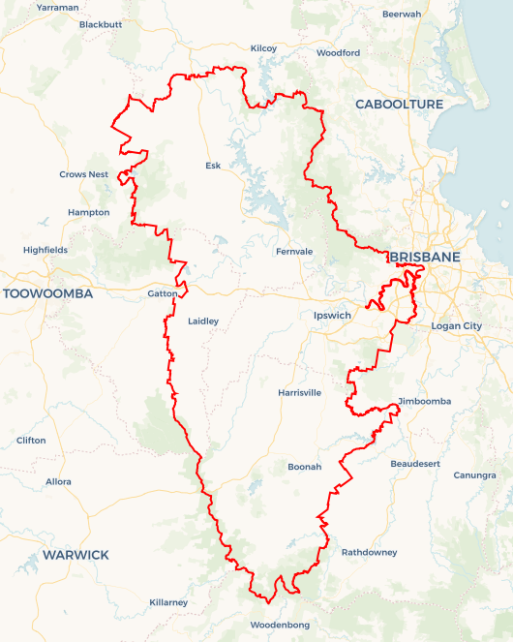
Local Jobs Plan
  - Wivenhoe Employment Region | Queensland | June 2026
Workforce Australia Local Jobs (Local Jobs) is a program that creates partnerships between business
and communities to meet local workforce needs, thereby improving employment outcomes.
Local Jobs operates in all 51 Employment Regions in Australia.

Local Jobs Overview

Local Jobs Plan
Each Employment Region has a Local Jobs Plan which outlines the labour market challenges in the region and the strategies to address these challenges.

Job Coordinators
Each Employment Region has a dedicated Job Coordinator who leverages existing resources, supports local labour markets through structural adjustments and retrenchments, and creates opportunities for collaboration between business and communities.

Local Jobs and Skills Taskforce
Each Employment Region has its own taskforce that meets regularly with the Job Coordinator to develop an understanding of challenges in the region and implement solutions. The taskforce is comprised of representatives from the region.

Local Jobs, Local People Grant
The Local Jobs, Local People grant funds activities that help people into ongoing employment or training. Activities must support local labour market needs.
Explore labour market insights for
Wivenhoe Employment Region

Local labour market challenges

- The Wivenhoe Employment Region has entry level job vacancies across all industries. The major challenge in filling these roles is the level of work readiness of people in Workforce Australia Provider caseloads. People also require support to develop the confidence, motivation, resilience and job endurance required to return to employment.
- There have been significant increases in youth and First Nations unemployed caseloads across all Workforce Australia Providers in the Wivenhoe Region. These cohorts face considerable challenges in securing employment and require targeted solutions and programs to enhance their ability to capitalise on training and job opportunities.
- Culturally and linguistically diverse people and refugees represent significant cohorts within the Wivenhoe Region caseload. A challenge for this cohort, and the labour market, is underutilisation and under employment when matched against their skills, experience and ability acquired overseas.
- A current challenge in the Wivenhoe labour market is the lack of enough readily available candidates who have the skills required by employers. This mismatch applies in most industries within the Employment Region.
- The historic thinking behind the development of labour market intervention programs has been based on jobseeker need. The challenge in the current labour market is to move program development considerations towards industry collaborative and co-designed responses.
- There is an ongoing shortage of labour in the health and community care sectors which is the largest employing sector in the Wivenhoe Region. This sector is open to pre-employment programs and alternative recruitment pathways.
- The construction sector has a trade shortage which will be heightened over the foreseeable future through the development of facilities for the 2032 Olympic and Paralympic Games and other major infrastructure projects including the hospitals upgrade program.
- Transport within and across the Employment Region remains a challenge. In agricultural areas, such as the Scenic Rim and the Lockyer Valley, the local unemployed workforce is insufficient to meet demand, and transport barriers limit the ability of potential workforce from the major population centre of Ipswich to access these jobs.
- The agriculture sector is also becoming more digitised and looking toward ‘smart’ supply chains to minimise future disruptions due to major events. This will likely see future changes in the skills needed for this sector.
- There is a shortage of skilled labour and tradespeople for the manufacturing and supply chain industries in the Employment Region. This challenge is also impacted by an ageing workforce across the sectors.
- A challenge in the current labour market is job retention in the early stages of employment. The support necessary appears to be beyond what is required through post placement support. A challenge to meet this need is to have responsive industry co-designed pre-employment activities that go beyond job requirements and into the development of personal capability building and soft skills.

Local priorities

Priority 1 – To address the level of work readiness in the unemployed caseload to meet entry level job requirements of industries

What are our challenges?
The low level of work readiness presents a significant challenge for people on the caseload to meet local industry job requirements without specific industry focused pre-employment activities. The opportunity exists to co-design these targeted programs with industry that include industry/job specific skills, motivation resilience and job endurance to obtain sustainable employment outcomes.

How are we responding?
- Negotiating and co-designing pre-employment programs with industry and other stakeholders to improve the required job related and individual soft skills including job endurance of unemployed people.
- Encouraging the employment services provider network to provide individualised support to customers to access and participate in pre-employment activities and early stages of employment.
- Working with employment services providers and other stakeholders to ensure equity in participation and outcome achievement across all cohorts on the unemployed caseload.

Priority 2 – To maximise opportunities for unemployed people in the Wivenhoe Employment Region to participate in employment arising from skill shortages in the construction, manufacturing, health and care sectors.

What are our challenges?
A key challenge is the shortage of people within the caseload who have industry required skills and qualifications to meet the current job vacancy demand. This need is further intensified by upcoming construction projects and associated supply chain activity in manufacturing. Workforce shortages in the care sector have persisted for several years and are expected to continue. Together, these conditions present opportunities for unemployed people in the Wivenhoe Employment Region to access employment across these industries. The Brisbane 2032 Olympic and Paralympic Games, Queensland Hospital Expansion Programs, major infrastructure projects and ongoing residential construction are increasing demand for workers in industries already experiencing significant shortages across South East Queensland. These skills shortage extends to manufacturing and supply chain industries that support construction. In addition, there are skill and labour shortages in the local health and care sector that need to be addressed, creating opportunities for unemployed people in the region

How are we responding?
- Negotiating with major construction companies and games infrastructure partners to gain agreement to appropriate recruitment and development opportunities for unemployed people in South East Queensland.
- Negotiating content of codesigned industry focused responses to maximise opportunity for unemployed people across local industries.
- Negotiating with appropriate levels of government to secure funding for the delivery of recruitment pre-employment programs and apprenticeship strategies.
- Developing a coordinated cross-regional management and advisory structure for South East Queensland Employment Regions and participating government bodies.

Priority 3 – Promote the engagement and retention of apprenticeships and traineeships

What are our challenges?
There is a shortage of skilled labour and tradespeople across most industries in the Wivenhoe Employment Region. Improving apprenticeship retention remains a key challenge, which can be addressed through targeted training and support initiatives focused on enhancing the capability of apprentice supervisors. There are significant opportunities to expand apprenticeship and traineeship opportunities across all industries including construction, manufacturing, and the health sector. The Brisbane 2032 Olympic and Paralympic Games present a unique opportunity to increase both apprenticeship commencements and retention.

How are we responding?
- Promoting the engagement and retention of Australian apprenticeships and traineeships to align with projected skills shortages, including areas of future demand in the region.
- Connecting appropriate candidates from Workforce Australia Employment Services Providers and local high schools to engage with the Australian Apprenticeship Support Network and Group Training Companies to leverage existing approaches and programs to increase apprenticeship and traineeship opportunities.
- Negotiating the development of a coordinated approach in South East Queensland that will result in increased apprenticeship commencements and retention.
- Negotiating funding through State and Federal Government agencies to support these initiatives.

Want to know more?
- Contact: John Perry, Wivenhoe Job Coordinator: john.perry@localjobsprogram.org.au or 0418 719 795
- Visit: Local Jobs or Workforce Australia

