


Stakeholder Kit
  - Key Apprenticeship Program

Last Updated: 24 July 2025
Introduction
The Key Apprenticeship Program offers up to $10,000 in financial support to new apprentices starting their careers in the clean energy or housing construction sectors. The program is designed to build a pipeline of skilled workers in priority industries by supporting apprentices to develop the expertise needed for jobs of the future. This initiative will grow Australia’s clean energy and housing construction workforce supporting national infrastructure goals now and into the future.

Spread the word!
You have received this stakeholder kit to help you promote the Key Apprenticeship Program to apprentices and employers who could benefit from this support. Inside this kit, you’ll find a range of promotional materials including social media assets, poster, postcards, banner and website/newsletter article – all designed to help raise awareness of the program.

Promoting on social media
Social media is a great way to raise awareness and connect with a wider audience. Sharing posts from this kit helps extend the reach of the Key Apprenticeship Program, making sure more apprentices and employers hear about the support available.

We encourage you to use the social media content provided and share it through your own networks. Don’t forget to tag us in your social media posts using the handles below:
@DepartmentofEmploymentandWorkplaceRelations

@YourCareer

@DepartmentofEmploymentandWorkplaceRelations

@YourCareer

Key messages
- The Key Apprenticeship Program (KAP) is available to Australian Apprentices working in the clean energy sector and/or the housing construction sector.
- KAP allows eligible apprentices in priority occupations to receive up to $10,000 in incentive payments throughout their apprenticeship.
- There are over 65 occupations listed as clean energy and/or housing construction on the Australian Apprenticeships Priority List.
- The Clean Energy Sector​ includes but is not limited to designing, developing, constructing, and operating the infrastructure for generating, storing, transmitting, and distributing energy from renewable, zero or low emissions energy sources and reducing or managing energy use​.
- The Housing Construction Sector involves building, repairing and remodelling structures that are intended to operate as a fixed dwelling including but not limited to houses, apartments and nursing homes.
- Employers who take on apprentices in these critical industries may also be eligible to receive the Priority Hiring Incentive.
- Learn more about the support available via the Australian Apprenticeships website.
Promotional Products
The following promotional products are available to promote online or through social media channels. Simply copy and paste the text content to the relevant platform, noting you can tailor the text according to your audience.

*The graphics below are visual examples of each promotional product. Please use the high-resolution files saved in the zipped folders attached to this kit for application.

Digital poster
Digital posters can be printed internally or distributed digitally; two versions have been supplied for each purpose.


Social media
Targeting apprentices
Content promotion | Image asset
Apprentice promotional tile 1:  Thinking about commencing or recommencing an apprenticeship in housing construction or clean energy?  You could be eligible for up to $10,000 in financial support through the Key Apprenticeship Program – available for housing construction and new energy occupations listed on the Australian Apprenticeships Priority List.  Whether you’re into carpentry, bricklaying, plastering or other hands-on trades, this support could help you build your future.  To find out more, speak to your local Australian Apprenticeship Support Network or visit https://www.apprenticeships.gov.au/key-apprenticeship-program  First comment:  Want to find out if your Apprenticeship is eligible? Check out the Australian Apprenticeship Priority list ➡️ https://www.dewr.gov.au/australian-apprenticeships/apprenticeship-support#toc-australian-apprenticeship-priority-list | 
Apprentice promotional tile 2:  Get up to $10,000 through the Key Apprenticeship Program on top of your apprentice wage to help you balance study, work and life.  This support is available to apprentices working in the clean energy and housing construction sectors.  With over 65 different occupations on the Australian Apprenticeships Priority List, there’s a good chance your trade is included!  Find out more at 👉 https://www.apprenticeships.gov.au/key-apprenticeship-program  First comment: Unsure if your apprenticeship is on the priority list? Check out the list now: https://www.dewr.gov.au/australian-apprenticeships/apprenticeship-support#toc-australian-apprenticeship-priority-list | 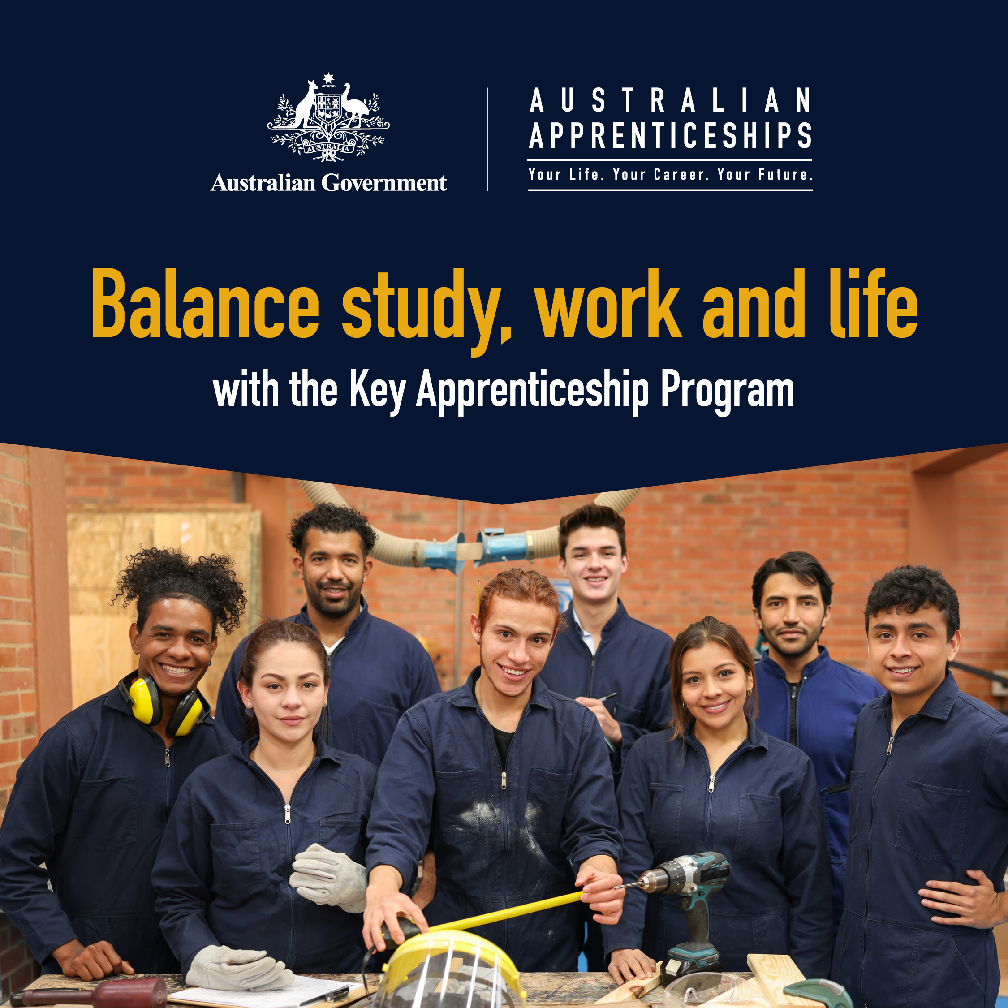
Apprentice promotional tile 3:  Want to get paid while learning a trade? The Key Apprenticeship Program provides eligible apprentices working in clean energy or housing construction apprentices access to up to $10,000.  It’s part of the Australian Government’s plan to help support the next generation by building the workforce Australia needs for the future!  Contact your local Apprentice Connect Australia Provider today to find out if you’re eligible  https://www.apprenticeships.gov.au/who-to-contact/search-for-an-australian-apprenticeship-support-network-provider | 

Targeting employers
Content promotion | Image asset
Employer promotional tile 1:  Thinking on about taking on an apprentice?  Your business could be eligible to receive the Priority Hiring Incentive if your apprentice is working in an occupation listed on the Priority List.  Speak to your local Apprentice Connect Australia Provider to get started.  https://www.apprenticeships.gov.au/who-to-contact/search-for-an-australian-apprenticeship-support-network-provider | 
Employer promotional tile 2:  Looking to grow your workforce in the clean energy or housing construction?🪴  Support is available to help your business train the next generation of skilled workers needed to deliver Australia’s future infrastructure.  By hiring an eligible Australian Apprentice, your business may be eligible for the Priority Hiring Incentive, offering financial support to make onboarding an apprentice easier.  Find out what support your business could receive.  https://www.apprenticeships.gov.au/support-and-resources/financial-support-employers | 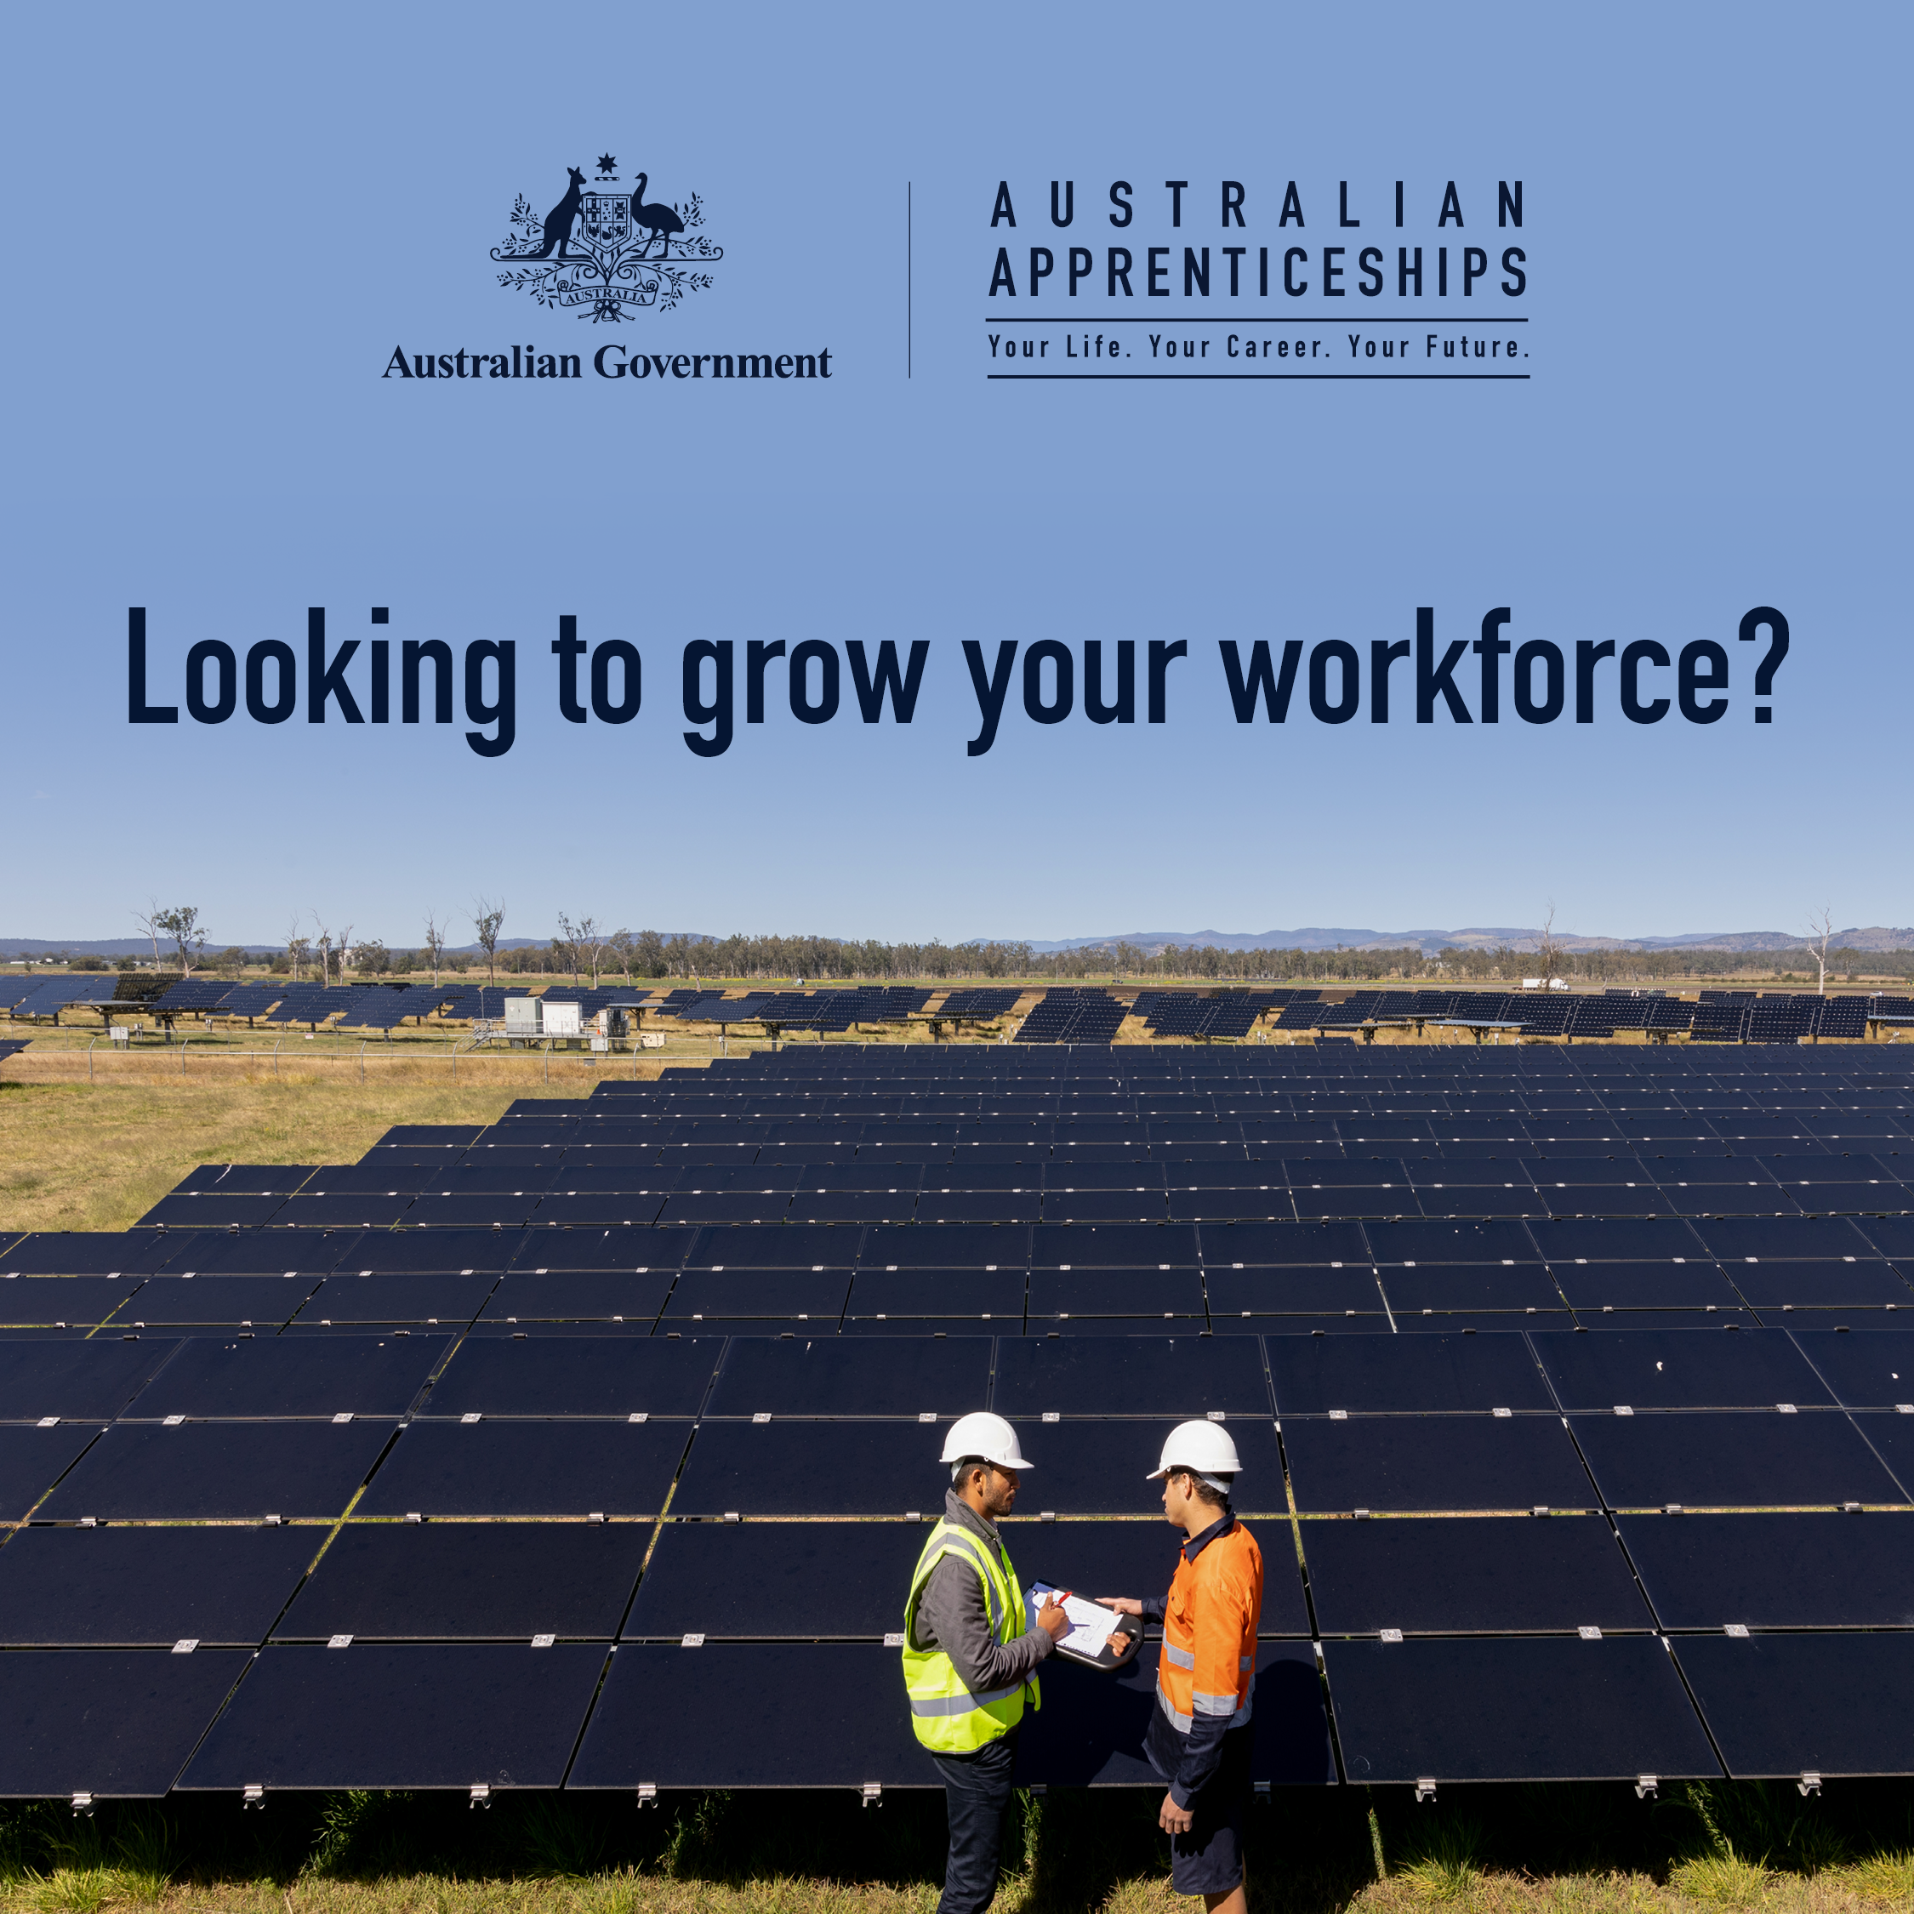

Website articles/Newsletter content

Heading: Build your future in clean energy or housing construction with up to $10,000 in support.
- Long description: Are you ready to kick-start a career in clean energy or housing construction? The Australian Government’s Key Apprenticeship Program (KAP) is here to help you get started with up to $10,000 in direct financial support.
- Short description: Find out more about the Key Apprenticeship Program (KAP).
The Key Apprenticeship Program (KAP) is part of the Australian Government’s Future Made in Australia plan to build a strong and skilled workforce for tomorrow. KAP supports eligible apprentices working in some of Australia’s most in-demand jobs, helping you train, earn and grow in a sustainable and future focused career.
What’s in it for apprentices?
From 1 July 2025, if you start or restart an apprenticeship in an eligible clean energy or housing construction occupation, you may be eligible to receive up to $10,000 in direct financial support on top of your wage.

There are over 65 occupations listed as clean energy and/or housing construction on the Australian Apprenticeships Priority List to choose from.

Support for employers
Employers of KAP apprentices may also benefit from the Priority Hiring Incentive, receiving up to $5,000 in financial support from the Australian Government.
- Full-time apprentices: $2,000 at 6 months and $3,000 at 12 months (full- time)
- Part-time apprentices: $1,000 at 6 months and $1,500 at 12 months (part-time)

Ready to get started?
Whether you’re an aspiring apprentice or an employer ready to grow your team, the Key Apprenticeship Program is designed to support you at every step.

To learn more, contact your local Apprentice Connect Australia Provider or visit apprenticeships.gov.au

Frequently Asked Questions

Is the Key Apprenticeship Program a national program?
Yes, the program is available across Australia.

Can I modify the suggested posts and example articles contained in the toolkit?
Yes. The content of these materials can be amended to suit the tone and style of your channels.

Contact
For more information, or additional content you might like to use on your communication channels, please email apprenticeshipsprogops@dewr.gov.au.

