Incorrect payment cancellation decisions

Compensation process

 |  | This document is from the Australian Government Department of Employment and Workplace Relations.  We say DEWR for short.  When we say we it means DEWR.
 |  | This is an Easy Read summary of information on our website.  This means it has the most important ideas.  Pictures are used to explain some ideas.
 |  | You can go to the website  www.dewr.gov.au/assuring-integrity-targeted-compliance-framework/targeted-compliance-framework-compensation-process  It is not in Easy Read.
 |  | Some words are in bold.  This means the letters are thicker and darker.  These are important words.
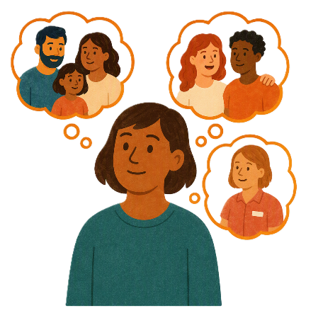 |  | You can ask for help to read this document.  You can ask  - A friend  - Family members  - A support person.

Contents

Who is affected | 5
When the wrong decisions were made | 10
Compensation | 13
What you need to do | 14
If you do not get an email from DEWR | 18

Who is affected

 |  | We have laws for people who get money from Centrelink when they  - Do not have a job  - Only work sometimes.  Laws are rules for how we live.
 |  | There are also laws that say what people must do to get their money from Centrelink.  We call these requirements.
 |  | The Targeted Compliance Framework  - Has rules you must follow to get your Centrelink money.  We call it TCF for short.
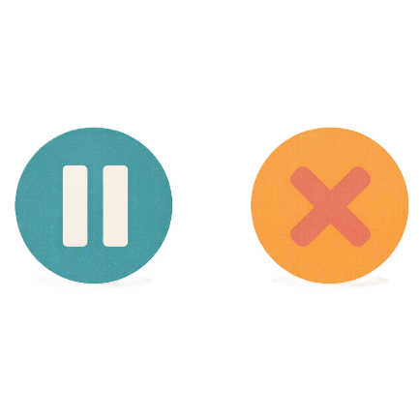 |  | If you do not do your requirements your payment can be  - Paused  - Reduced  - Stopped.  Paused is when your payment is on hold for a while.  Reduced means you get less money.
 |  | When your payment is stopped it is called payment cancellation.  This means your Centrelink money is stopped for not following your requirements.
 |  | We found some TCF decisions to stop payments were wrong.  Some people had the wrong payment cancellation decision made.
 |  | People affected by these decisions can apply for compensation.  Compensation is money you can apply for when the wrong decision was made.  You can only get compensation if you had direct financial loss.  This means you lost money because of the wrong decision.
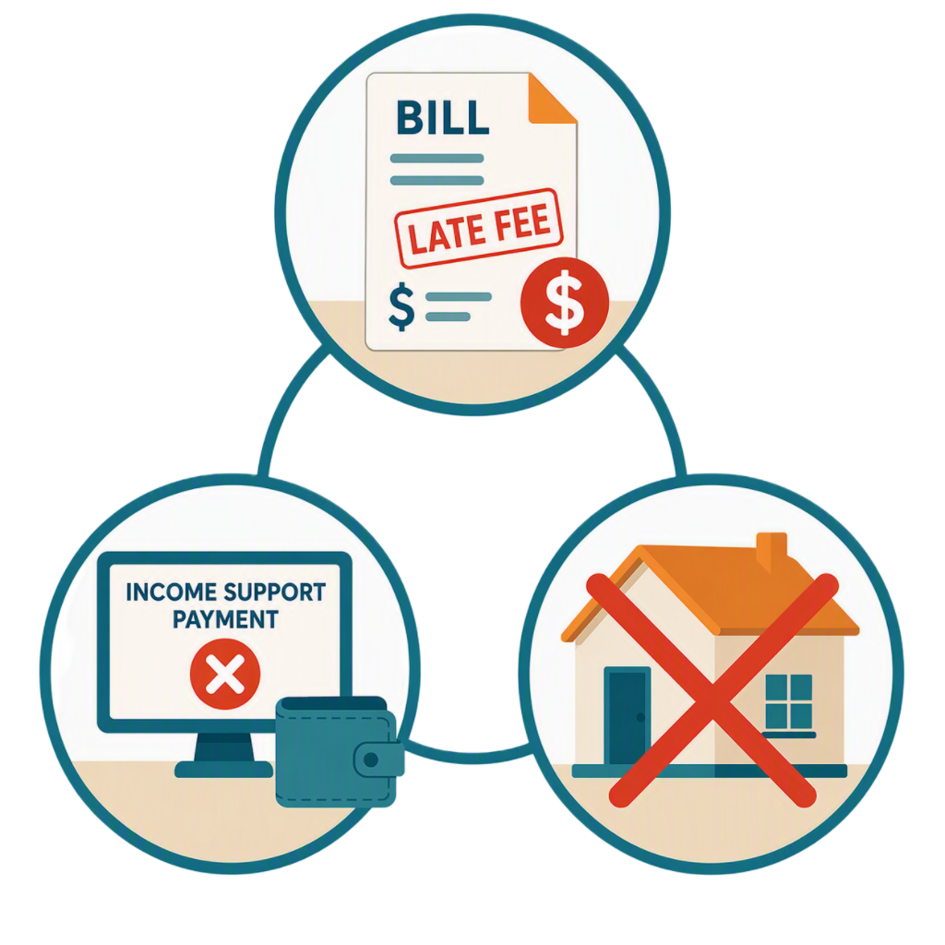 |  | You might have  - Paid late fees on bills  - Not got your income support payments  - Lost your home because you could not pay rent.
 |  | You can also get compensation if you did not have a direct financial loss.
 |  | This means if the wrong decision caused  - You an injury  - People to think badly about you  You can get compensation.
 |  | You do not need to do anything right now.
   |  | If you are affected  - DEWR will send you an email.
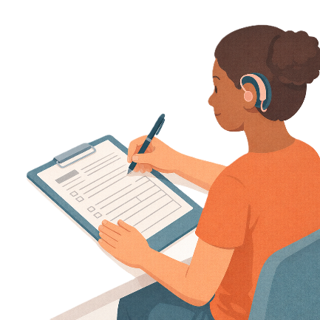 |  | You can then apply for compensation.
 |  | Apply means that you send us information about  - Who you are  - How the cancellation affected you  - How much compensation you want.
 |  | This does not mean you will get paid compensation.  We will check each application to see if you should get compensation.

When the wrong decisions were made

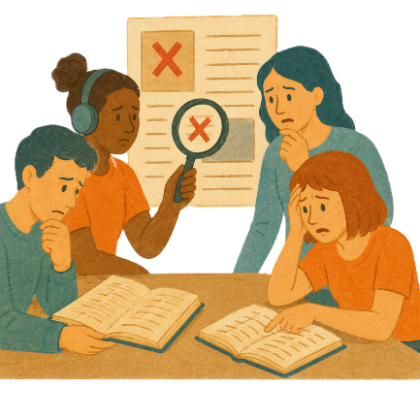 |  |  | DEWR checked the TCF and found that it was not working like it should.  We found that some of the systems made the wrong decisions.
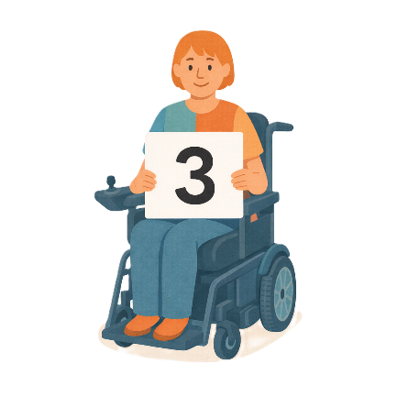 |  |  | People can apply to get compensation for  3 types of wrong decisions.
 |  |  | - Work refusal failure  This is when you  - Do not agree to start a job.
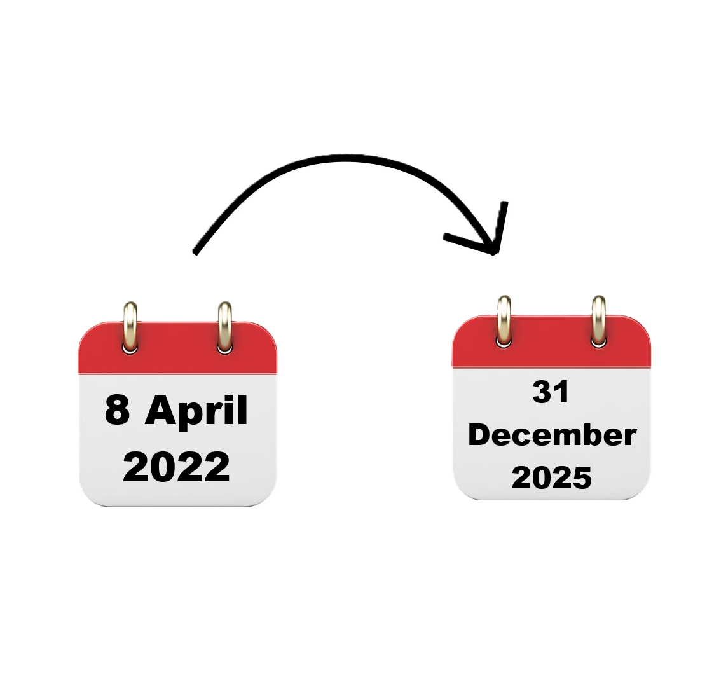 |  |  | Your payment is then stopped.  The decisions were made from  - 8 April 2022 to 31 December 2025.
 |  |  | - Unemployment failure  This is when you no longer have a job because  - You chose to leave your job  - Your actions made you lose your job.
Your payment is then stopped.

The decisions were made from

- 8 April 2022 to 31 December 2025.
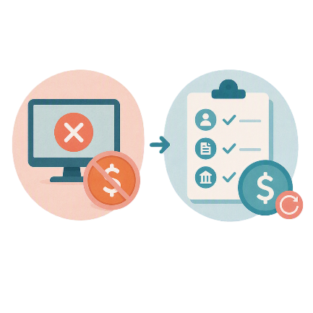 |  |  | - 4 week reconnection requirements  This is when you had your Centrelink payments stopped because you did not  - Meet your requirements
 |  |  | - Have a good reason not to meet your requirements
 |  |  | - Contact us when you needed to.
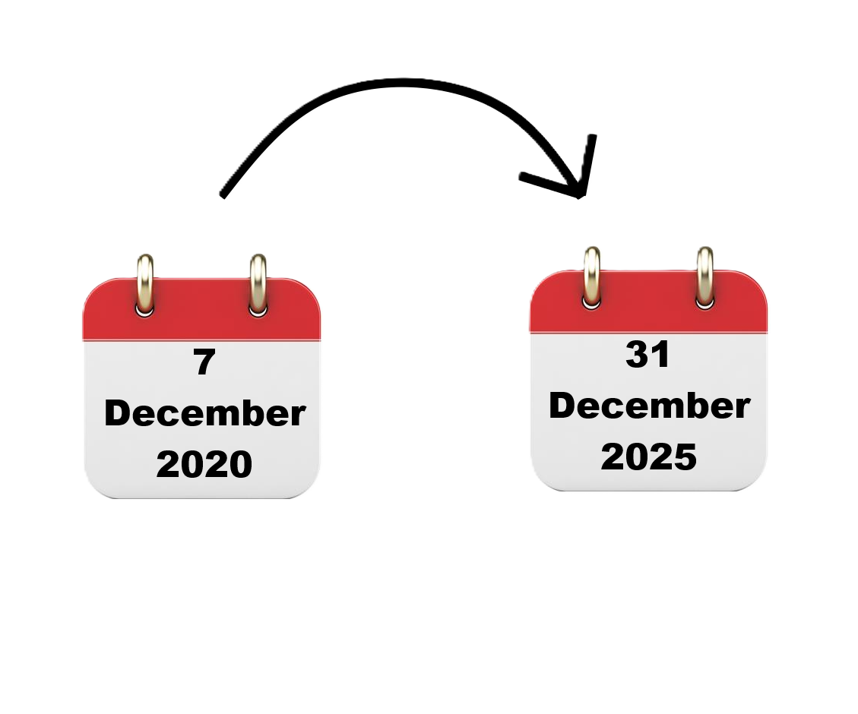 |  |  |  | The decisions were made from  - 7 December 2020 to  31 December 2025.

Compensation

 |  | The people we think might be able to get compensation will get an email.  If you get an email you can apply for compensation.
 |  | We will start sending emails in October 2026 for the next few months.

What you need to do

 |  | You do not have to do anything right now.
We will send an email to people we think might be able to get compensation.

We will ask you to apply for compensation.
You can get support to read the email.

You can ask

- Family
- Friend
- Someone you trust
- A community legal centre
- A disability advocate.
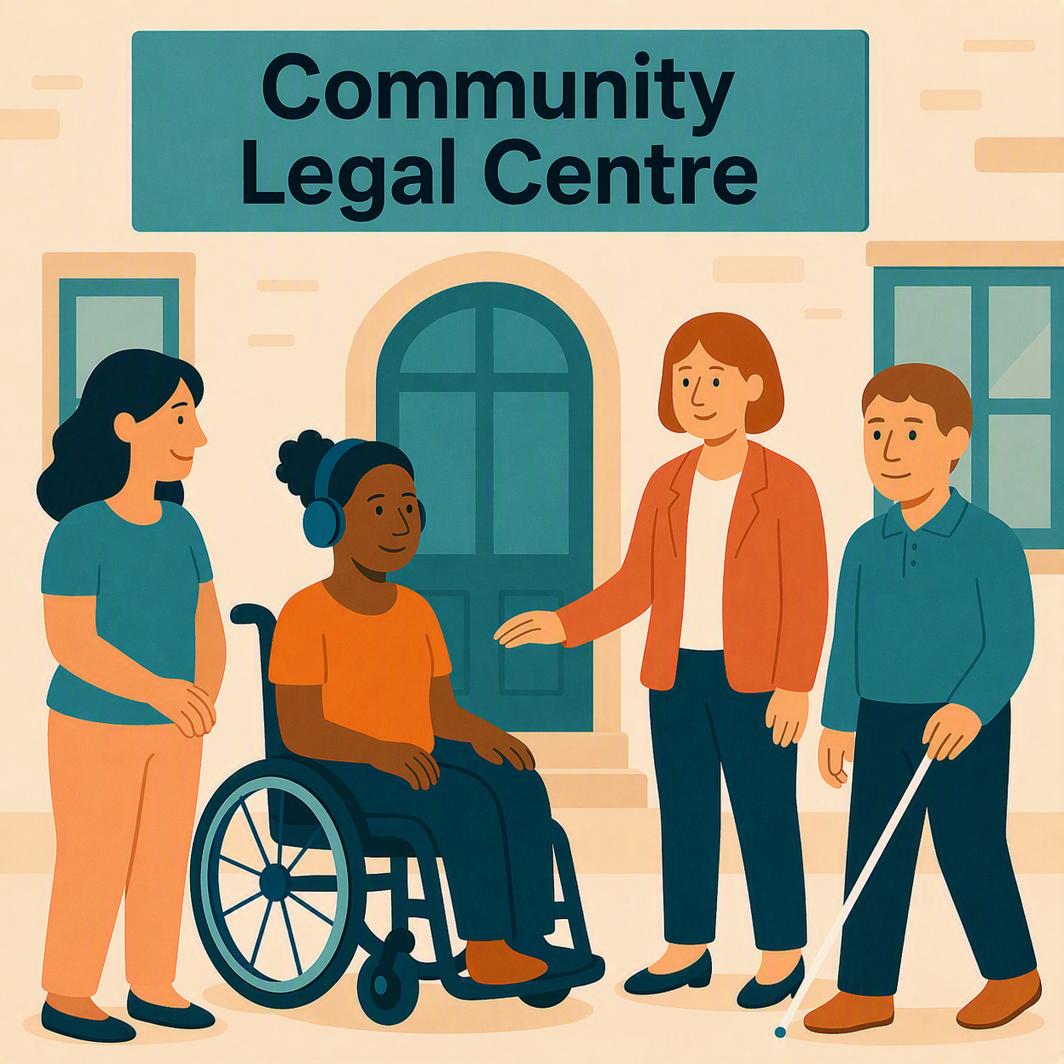 |  | A community legal centre is a place where people can get free legal help.  Legal means something about the law.
 |  | An advocate is someone who supports you to speak up for your rights.  It can also be called advocacy.
In our email we will tell you

- How to apply for compensation
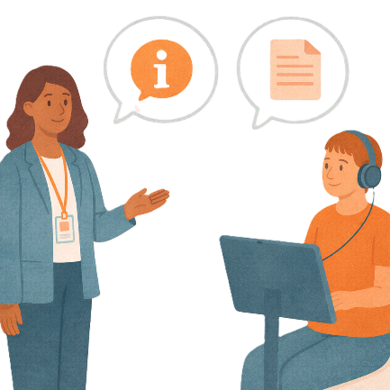 |  | - What information you need to give us.  This is called evidence.  Evidence is proof that something is true.
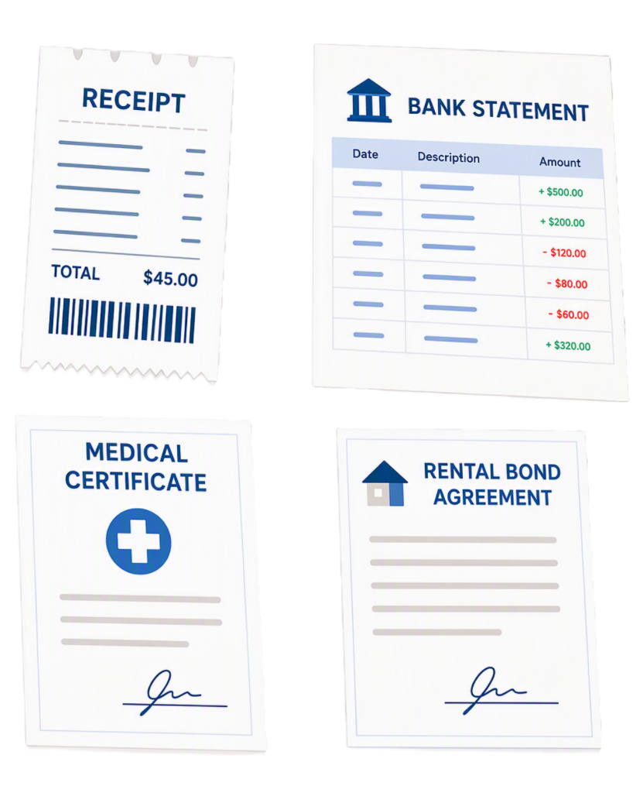 |  | We might need to see  - Receipts  - Bank statements  - Medical certificates  - Rental agreements.
 |  | We will look at your information.  We will try to make our decision within 90 days of getting your information.
We will send you an email of our decision.

- We will tell you if we agree to give you compensation

OR

- We will tell you if you will not get compensation.
 |  | If we decide you should get compensation we will send you  - An email telling you how much you will be paid.
 |  | We asked Services Australia to help us pay the compensation.  They will send you a letter telling you when they have paid the money into your bank account.

If you do not get an email from DEWR

 |  | The DEWR website will say when it has finished sending emails.
 |  | After this time you can still apply for compensation if you think you should have.
 |  | You can visit our website to apply for compensation by using this link:  www.dewr.gov.au/TCFcompensationapplication  It is a good idea to have a support person visit this website with you.  It is not in Easy Read.
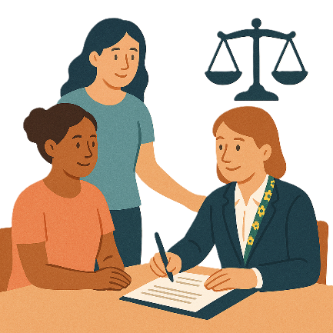 |  | You might  - Want to get legal help  - Be able to get legal help for free  - Like to talk to a disability advocate.
 |  | To find out how to get legal help you can go to the website  www.ejaustralia.org.au/legal-help/  It is a good idea to have a support person visit this website with you.  It is not in Easy Read.

The Department of Health, Disability and Ageing wrote this Easy Read.
Some images were made using AI.
You must not share or copy any of the images without permission.
September 2026.

