

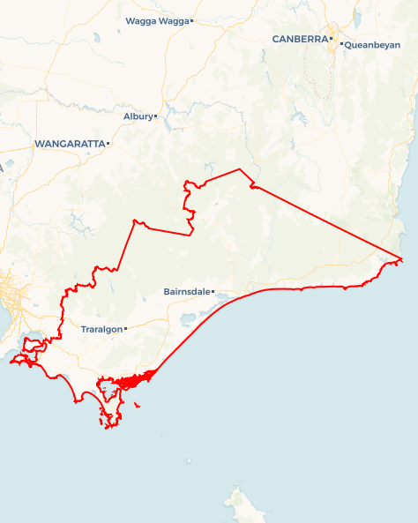Local Jobs Plan

Gippsland ****Employment Region**** | VIC | ****October 2023****

Workforce Australia Local Jobs (Local Jobs) is a program that supports tailored approaches to accelerate   
reskilling, upskilling and employment pathways in response to current and emerging local workforce needs.

## Local Jobs elements

### Local Jobs Plan

The Local Jobs Plan sets out the skills and employment challenges and priorities of the region, and associated strategies that will drive the design and implementation of activities to be implemented to address these challenges.

### Employment Facilitators

Employment Facilitators and Support Officers support the delivery of the program by bringing together key stakeholders including businesses, employment services providers, higher education and training organisations.

### Local Jobs and Skills Taskforce

Each Employment Region has its own Taskforce. Representatives include local stakeholders who have demonstrated experience in upskilling, reskilling, and an ability to represent, connect and collaborate with others in the region to meet labour market needs.

### Local Recovery and National Priority Funds

The Local Recovery Fund supports projects that meet the priorities identified in the Local Jobs Plan. The National Priority Fund provides funding for innovative local solutions to address structural barriers to employment.

Explore labour market insights for the   
[Gippsland Employment Region](https://www.jobsandskills.gov.au/data/employment-region-dashboards-and-profiles/monthly-labour-market-dashboards)

## Local labour market challenges in the region

* Labour force participation rates in Gippsland are among the lowest in Victoria. This may be due to a combination of economic and social factors, including a comparatively low socio-economic profile, with around a quarter of the working age population on income support.
* There are significant pockets of disadvantage within Gippsland in localities such as Moe and Morwell in the Latrobe City Local Government Area (LGA), Yarram in the Wellington LGA and Orbost and Lakes Entrance in the East Gippsland LGA.
* Gippsland has higher early school leaver rates and lower levels of higher education attainment than those recorded for Victoria and Australia.
* The youth unemployment and participation rates in Gippsland are higher than average state and national rates. First Nations people in the region have higher rates of unemployment and lower levels of higher education attainment than non-First Nations people in the region.
* An ageing population in the region is affecting demand in the health care and social assistance industry, particularly in disability, aged care and community services. Over one third of the total population in Gippsland are aged 65 years and over.
* Industries in Gippsland are currently in the midst of a substantial transition. This transition sees a shift away from traditional sectors such as timber and fossil fuel based industries and a growing emphasis on initiatives such as renewable energy projects, which is likely to have repercussions on the existing workforce.
* The geographical dispersal of city and town centres and limited access to public transport in Gippsland hampers individuals’ access to education, training, and employment opportunities

## Local jobs and skills priorities and strategies in the region

### Priority 1 – Maximising the benefits of existing programs to create pathways into local industries

#### What are our challenges and opportunities?

Building awareness for individuals to access and engage with a variety of government and private programs, training and pre-employment opportunities.

Appropriate promotion of programs to ensure maximum benefit is achieved. Local industries that benefit from these programs can include health care, social assistance, construction and food and fibre.

#### How are we responding?

* Collaborating with local stakeholders and industry to develop, co-design, build on and promote citizen-centric pre-employment and training programs that meet participants where that are at in their employment journey.
* Collaborating with employment service providers to ensure that the connection of individuals to suitable programs is targeted to better prepare them for   
  pre-employment activities such as pre-accredited and accredited training. This includes Employability Skills Training, Skilling for Education and Employment, and Vocational Education and Training (VET) pathways.

**Priority 2 – Maximising the extent to which local individuals are skilled to meet the needs of major and local projects, such as energy and resources projects**

#### What are our challenges and opportunities?

A number of major and local projects are planned for the region and will create large scale workforce demands, requiring workforce planning in collaboration with the sector as well as coordinated strategies to support the skilling, training and upskilling of local individuals.

#### How are we responding?

* Engaging with industry to understand their workforce requirements and engage with training and educational providers to understand and build skills and training opportunities.
* Working with education, training, and employment service providers to understand and connect individuals to pre-employment and VET pathways.

**Priority 3 –** **Generating opportunities for skill development aligned to local business and industry needs**

#### What are our challenges and opportunities?

All industries within Gippsland continue to experience significant workforce and skill shortages. Opportunity to identify and create multiple pathways in training, programs and employment.

#### How are we responding?

* Working with Workforce Australia Employment Services Providers and training and education providers to link individuals to existing courses, volunteering and work experience opportunities for skills development.
* Working with businesses to provide opportunities to attract individuals, including local jobs expos, networking opportunities, information sessions and links to other local stakeholders.

**Priority 4 – Brokering opportunities for youth skill development and employment**

#### What are our challenges and opportunities?

The region has high early school leaver rates and lower levels of higher education attainment than those recorded for Victoria and Australia.

#### How are we responding?

* Creating and fostering strong relationships with apprenticeship and traineeship providers and linking them with businesses and employment service providers.
* Collaborating with training and education providers to identify and promote entry level vocational pathways.

**Priority 5 – Boosting employment and training among First Nations people in collaboration with local organisations and programs**

#### What are our challenges and opportunities?

First Nations people have higher unemployment and lower economic participation rates than non-First Nations individuals. Specific programs and services available to this cohort are limited.

#### How are we responding?

* Supporting local First Nations organisations to develop local networks and utilise existing employment and training programs or develop new tailored programs.
* Building on existing partnerships and exploring new partnerships with local First Nations organisations to develop strategies that increase engagement of individuals in these training and employment opportunities.
* Engaging local industries to highlight the importance of cross-cultural training and creating culturally safe environments to increase participation rates of  
  First Nations people.

**Priority 6 – Supporting individuals and transitioning workers, particularly in recovering communities**

#### What are our challenges and opportunities?

Gippsland has experienced a number of local emergencies such as bushfires and flooding that have caused a significant reduction in trade in the tourism and hospitality sectors, especially in East and South Gippsland. Gippsland is transitioning a number of recovering sectors across the region such as, the forestry industry and the energy and renewable industry to NetZero.

#### How are we responding?

* Continuing to contribute to the local transition working group to connect transitioning workers to services and pathway opportunities.
* Coordinating and supporting local events and activities in bushfire affected areas to promote and connect local opportunities and services.

**Priority 7 – Provide** **support and upskilling opportunities to priority cohorts to create pathways into secure employment**

#### What are our challenges and opportunities?

Gippsland consists of several priority cohorts such as, First Nations people, people living with disability, mature aged individuals, long term unemployed, youth, women, culturally and linguistically diverse, and the LGBTQ+ community. Priority cohorts are affected by major industry changes and are especially impacted by the lack of employment opportunities within the region. There is an opportunity to promote programs and services to priority cohorts to increase overall engagement.

#### How are we responding?

* Promoting career counselling services and programs.
* Working with businesses to educate and promote the benefits of recruiting a diverse workforce and providing tools to attract this cohort.

## Want to know more?

* Contact: Darren Beggs, Gippsland Employment Facilitator: Darren.beggs@gippslandfacilitator.org.au
* Visit: [Local Jobs](https://www.dewr.gov.au/local-jobs), [Workforce Australia](https://www.workforceaustralia.gov.au/).
* The Australian Government Employment Facilitator is working collaboratively with the Employment Facilitator in your region to support the positive and orderly transition to a net zero economy. For further information please refer to the [Australian Government Employment Facilitator’s Supporting Workforce Transition to a Net Zero Economy.](https://www.dewr.gov.au/local-jobs/resources/gippsland-supporting-workforce-transition-net-zero-economy)