


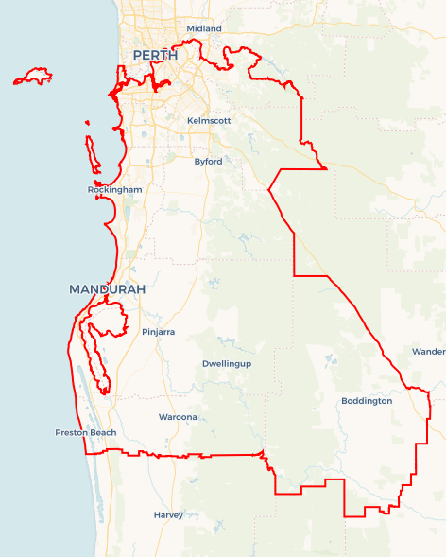
Local Jobs Plan
  - Perth South Employment Region | WA | March 2026
Workforce Australia Local Jobs (Local Jobs) is a program that creates partnerships between business
and communities to meet local workforce needs, thereby improving employment outcomes.
Local Jobs Operated in all 51 Employment Regions in Australia

Local Jobs elements

Local Jobs Plan
Each Employment Region has a Local Jobs Plan which outlines the labour market challenges in the region and the strategies to address these challenges.

Job Coordinators
Each Employment Region has a dedicated Job Coordinator who leverages existing resources, supports local labour markets through structural adjustments and retrenchments, and creates opportunities for collaboration between business and communities.

Local Jobs and Skills Taskforce
Each Employment Region has its own taskforce that meets regularly with the Job Coordinator to develop an understanding of challenges in the region and implement solutions. The taskforce is comprised of representatives from the region.

Local Jobs, Local People Grant
The Local Jobs, Local People grant funds activities that help people into ongoing employment or training. Activities must support local labour market needs.
Explore labour market insights for the
Perth South Employment Region

Local labour market challenges in the region

- There are skills and people shortages across main employing industries in the Perth South Employment Region such as healthcare and social assistance including the care sector, construction, education and training, mining, manufacturing including defence industry, accommodation and food services, transport and logistics.
- Lack of affordable housing, accommodation and high cost of living is impacting current and future labour supply.
- Low unemployment and the prevalence of fly-in fly-out roles creates a challenge to connect people to jobs in the region.
- Where some people live is not where suitable jobs, training opportunities and industries are. There is also limited public transport in some suburbs including Waroona, Boddington and Forrestdale.
- There is below average workforce participation in some areas and/or a growing rate of disengagement for several cohorts in the region including First Nations, female, culturally and linguistically diverse (CALD), mature age, people with disability, males aged 25-34 years and youth.

Local jobs and skills priorities and strategies in the region

Priority 1 – Engage with stakeholders across the top employing industries to identify the needs of employers and individuals, informing the development of strategies which maximise sustainable and meaningful local job placements

What are our challenges and opportunities?
Perth South Employment Region is experiencing skills and people shortages across main employing industries such as healthcare and social assistance including the care sector, construction, education and training, mining, manufacturing including Defence industries, accommodation and food services, transport and logistics.

How are we responding?
- We are running targeted recruitment roundtables for business, contractors and sub-contractors to showcase employment opportunities to local individuals seeking employment.
- We are building collaboration between education providers and Workforce Australia employment services providers
- We are showcasing the employment programs that have increased the opportunities for employers and local jobseekers through innovative approaches to recruitment.
- We are advocating and informing policy makers of the cost benefit analysis of the innovative programs to mainstream national / state employment strategies.
- We are identifying skills shortages and gaps in the health care and social assistance, construction, mining, education and training and retail trade and mapping current skills of participants to meet training requirements and upskilling opportunities.
- We are identifying opportunities to transition retrenched workers in the Perth South Employment Region and ensuring skill shortage areas are met from this labour source.
- We are collaborating with the Department of Education (WA Government), Department of Training and Workforce Development (WA Government), TAFEs, Jobs and Skills Centres and Registered Training Organisations (RTOs) to implement training to meet operational requirements and needs.
- We are engaging with local RTOs and Group Training Organisations to connect with industry and stakeholders.
- We are identifying the factors that inhibit access to employment for individuals, assisting employers to consider reviewing internal policies and practices to enhance engagement.
- We are identifying key construction projects, meeting business and/or organisations and identifying vacancies and opportunities.
- We are educating employers about Workforce Australia client needs for successful employment and how to engage with provider services.

Priority 2 – Creating opportunities for local people to be adequately skilled, prepared and supported for current and growth industries, including apprenticeship and traineeship pathways

What are our challenges and opportunities?
The Perth South Employment Region has a growing rate of disengagement across several cohorts in the region including youth, First Nations, people with disability and CALD. There is an opportunity to engage these cohorts in current opportunities in the top 5 employing industries; and upcoming training and employment initiatives, with a focus on the defence and net zero economy industries.

How are we responding?
- We are identifying opportunities to develop initiatives in key industries to support people into employment in current and future industry skill needs.
- We are working with business and Skills for Education and Employment (SEE) Providers to assist with upskilling new and existing workers with language, literacy, numeracy and digital levels.
- We are providing feedback to Industry Skills Councils to assist in industry led training development and reform.
- We are creating industry exposure events for people to learn about the types of jobs and industries that are available to them.
- We are building, strengthening and sustaining ongoing relationships with Apprentice Connect Providers and assisting businesses and individuals to better understand the benefits and how to navigate apprenticeship and traineeship pathways.

Priority 3 – Leverage existing Australian and Western Australian government programs to create pathways into local growth industries and broker employment and education opportunities for priority groups not participating in the labour market

What are our challenges and opportunities?
The Perth South Employment Region has an over-representation of underutilised individuals across several cohorts in the region including First Nations, female, CALD, mature age and people with disability, as well as a growing rate of disengagement within the youth cohort and males between the ages 25-34.

How are we responding?
- We are collaborating with appropriate community, social organisations and businesses to codesign cohort specific pathways.
- We are promoting the use of existing federal and state government funding to support transition of individuals seeking employment into occupations that are in local demand.
- We are hosting targeted industry specific forums that educate and move beyond information sharing to employer commitment and recruitment outcomes for individuals.
- We are hosting monthly information sessions to inform and educate Workforce Australia Employment Services Providers and offer business the opportunity to showcase current vacancies in industry-specific forums.
- We have created a platform for Australian Government program representatives to showcase new and existing initiatives to Perth South stakeholders and providers.
- We will work with high demand industries such as the Construction Training Futures Centre to create cohort-specific industry exposure and engagement activities, supporting informed career decision making.
- We are supporting individuals and businesses to build entrepreneurial capability and innovate in response to new and emerging economic opportunities in the region.

Priority 4 – Understand the needs of individuals with the capacity to work by providing an individualised and holistic approach to assist in building capacity

What are our challenges and opportunities?
Training pathways and upskilling, as well as support into employment can be lacking on a localised level.

How are we responding?
- We are facilitating connections and linkages between local stakeholders, enabling collaboration on employment opportunities and training pathways.
- We are identifying local training organisations that deliver funded skill sets and training and connecting to business and providers.
- We are identifying gaps and opportunities to connect stakeholders across community and supports in the region.
- We are working with our Perth South Taskforce to connect with providers.
- We are collaborating with SEE Providers to provide support to individuals in accredited training.
- We are collaborating with the Department of Training and Workforce Development (WA Government), TAFE and Jobs and Skill Centres to encourage flexible training options and locations.
- We have created a platform for Australian Government program representatives to showcase new and existing initiatives to Perth South stakeholders and providers to assist with training and upskilling.
- We are collaborating with organisations that support licensing opportunities to assist mobility amongst individuals who need licencing support.

Want to know more?
- Contact: Rosie Hegarty, Perth South Job Coordinator: localjobs@pslocaljobs.com.au
- Visit: Local Jobs or Workforce Australia

