


Online Employment Services Trial Evaluation Report

ISBN
978-1-76114-083-9 [PDF]
978-1-76114-084-6 [DOCX]
With the exception of the Commonwealth Coat of Arms, the Department’s logo, any material protected by a trade mark and where otherwise noted all material presented in this document is provided under a Creative Commons Attribution 4.0 Australia licence.
The details of the relevant licence conditions are available on the Creative Commons website (accessible using the links provided) as is the full legal code for the CC BY 4.0 AU licence.
The document must be attributed as the (Online Employment Services Trial Evaluation Report).

Acknowledgements
The evaluation was conducted by the RED Support and Strategic Research team in the Evaluation, Research and Evidence Branch, Quality, Integrity and Evidence Division.
Contributors to this report were Lixin Cai, Michael Bathgate, Emanuela Diaz, Minh-Ha Nguyen, Yusuf Muharram, Patricia Barber and Robyn Henderson.
The department would also like to acknowledge the contribution to this report from commissioned research undertaken by ORIMA Research.

Contents
Acknowledgements 3
List of abbreviations and acronyms 9
List of tables 10
List of figures 11
Glossary 13
Executive summary 16
About the Online Employment Services Trial 16
Key findings 16
Efficiency 16
Effectiveness 17
OEST participant experience 18
Summary 19
Departmental response to the evaluation findings 20
Safeguards and enhancements in OES 20
Chapter 1. Introduction 23
1.1 Digital trends in government services 23
1.2 The OEST 24
1.2.1 Eligibility criteria of the OEST 24
1.2.2 OEST services 25
1.3 Recent developments 25
1.3.1 New Employment Service 26
1.3.2 Online Employment Services 26
Chapter 2. The evaluation of the OEST 27
2.1 Aims of the OEST evaluation 27
2.2 Key evaluation questions 28
Efficiency 28
Effectiveness 28
2.3 Methodology 29
2.3.1 Qualitative research 29
2.3.2 Quantitative survey 30
2.3.3 Quantitative analysis of departmental administrative data 31
2.4 The study populations 31
2.4.1 Study population characteristics 33
Chapter 3. The efficiency of the OEST 35
3.1 Time to commencement 35
3.2 Opt-outs 37
3.2.1 Characteristics of participants who opted out 37
3.2.2 Opt-out reasons 38
3.2.3 Awareness of opt-out arrangements 39
3.3 The jobactive website 41
3.3.1 Website usage 41
3.3.2 Usability 42
3.3.3 Participant satisfaction 43
3.4 Monitoring of OEST participant compliance 44
3.4.1 Awareness of requirements 44
3.4.2 Accumulation of demerit points 45
3.5 Awareness of service elements 48
Chapter 4. The effectiveness of the OEST 49
4.1 Exiting income support and employment services 50
4.1.1 Exit rates after transferring to provider servicing 51
4.1.2 Impact of job seeker characteristics on exits from income support and employment services 52
4.1.3 Sustainability of exits from income support 54
4.2 Employment and study rates 54
4.2.1 Employment rates 54
4.2.2 Undertaking study and training 56
4.3 Cost-effectiveness 57
4.4 Participants’ confidence 58
4.4.1 Confidence in job search skills 58
4.4.2 Confidence in finding and retaining a job 59
4.4.3 Confidence in job search resources and support 60
Chapter 5. OEST participant experience 61
5.1 Participants’ experiences with the OEST 61
5.1.1 Satisfaction with online servicing 61
5.1.2 Advantages and disadvantages of online servicing 63
5.1.3 Preference for online or provider servicing 64
5.1.4 Duration of online servicing 65
5.2 Transferring out of the OEST after completing six months 66
5.2.1 Awareness of transferring arrangements 68
5.3 OEST eligibility 68
5.3.1 Digital literacy and access 69
5.3.2 Identifying job seekers with significant barriers to work 69
5.4 Understanding participant views of digital servicing 70
Segment 1: ‘I can find employment myself, and I’d prefer to do it online’ 70
Segment 2: ‘I might need some extra help, but online is more convenient’ 70
Segment 3: ‘I need extra help, but don’t want the inconvenience of meeting a provider in person’ 71
Segment 4: ‘I need all the help I can get’ 71
Segment 5: ‘I could do it myself, but having extra advice and support from an employment service provider could be valuable’ 71
5.5 Participants’ and stakeholders’ suggested improvements to online employment services 73
Chapter 6. Conclusion 75
6.1 What did we learn? 75
6.1.1 What worked? 75
6.1.2 Who did not participate? 76
6.1.3 Limits of the learnings 76
6.2 Future directions 77
Bibliography 78
Appendices 82
Appendix A International practice 82
The OECD 82
Canada 82
India 83
South Korea 83
United Kingdom 84
Denmark 85
Appendix B Impact of policy and systems changes 1 July 2019 to 9 December 2019 86
Appendix C Demographic profile of focus groups 88
Appendix D The quantitative fieldwork 89
Appendix E Impact of participant characteristics on exits from income support and employment services – comparison group versus trial participants 90
Age 90
Location 92
Gender 93
Education 94
CALD 95
Previous experience of income support 96
Previous experience of jobactive services 97

List of abbreviations and acronyms
the department/DESE Department of Education, Skills and Employment (and its predecessors)
CALD Culturally and Linguistically Diverse
CATI Computer Assisted Telephone Interviews
DHS Department of Human Services, now Services Australia
ESS Employment Services System
ICT information and communications technology
JSCI Job Seeker Classification Instrument
MORs Mutual Obligation Requirements
NCSL National Customer Service Line
NESM New Employment Services Model
NEST New Employment Services Trial
NSA Newstart Allowance, now JobSeeker Payment
OECD Organisation for Economic Co-operation and Development
OES Online Employment Services
OEST/the trial Online Employment Services Trial
RED Research and Evaluation Database

List of tables
Table 2.1 Demographic characteristics of the study groups 33
Table 3.1 Characteristics of OEST job seekers who opted out of the trial before or after commencement 38
Table 3.2 Reasons for opting out of the OEST before and after commencement 39
Table 3.3 Accumulation of demerit points for insufficient job search for job seekers who commenced from July 2018 to June 2019 46
Table 4.1 Exits from income support and employment services for OEST participants compared with job seekers in provider-based services who have completed six months 52
Table 4.2 Sustainability of income support exits over the period of 6 months from exit date (*) 54
Table C1 Demographic profile of focus groups 88
Table E1 Exits by age group 90
Table E2 Exits by remoteness 92
Table E3 Exits by gender 93
Table E4 Exits by education 94
Table E5 Exit by CALD status 95
Table E6 Exits by previous experience of income support 96
Table E7 Exits by previous experience of jobactive services 97

List of figures
Figure 2.1 Overview of the OEST participant pathways 32
Figure 3.1 Time from referral to commencement of online services compared with provider-based services 36
Figure 3.2 OEST commenced participants – opt-out reasons by month (cumulative) 40
Figure 3.3 Ease of using the jobactive website 42
Figure 3.4 Satisfaction with the jobactive website – OEST participants and comparison group 43
Figure 3.5 Awareness of Mutual Obligation Requirements 45
Figure 3.6 Percentage of job seekers without job search demerits by commencement month (matched samples) 47
Figure 4.1 Comparison of exits from employment services and income support 50
Figure 4.2 Comparison of exits from income support and employment services by individual characteristics 53
Figure 4.3 Employment rates by duration in employment services 55
Figure 4.4 Study or training rates by duration on assistance 57
Figure 4.5 Job seekers’ confidence in job search skills 58
Figure 4.6 Change in confidence in job search skills for longitudinal respondents 59
Figure 4.7 Confidence in finding and retaining a job 60
Figure 4.8 Job search resources and support 60
Figure 5.1 Satisfaction with online servicing 62
Figure 5.2 Top five advantages of online employment services 63
Figure 5.3 OEST participants’ and job seekers’ preference for using online or provider-based employment services to look for a job 65
Figure 5.4 Experience after transferring out of the OEST after six months 67
Figure 5.5 Segmentation of job seekers who were eligible for the OEST 72

Glossary
Term | Description
Caseload | Caseload refers to the number of participants in services and information about this group captured at a point in time.
Commencement | For job seekers participating in the trial, commencement is the date the job seeker agrees to a Job Plan on the jobactive website, which is done by following prompts. For job seekers who are receiving provider-based jobactive servicing, commencement is the date the job seeker participates in an initial interview.
Comparison group | Includes job seekers who, at the time of referral, are eligible for the OEST but not selected to be in the trial. Instead, these job seekers receive assistance in government employment services with a jobactive provider. This group has a provider-based service experience without any online trial experience.
Employment Fund | The Employment Fund General Account (Employment Fund) is a flexible pool of funds available to jobactive providers. Each provider receives credits which they can use to claim reimbursements for goods and services that support and assist job seekers to gain the tools, skills and experience they need to get and keep a job. OEST participants do not have access to the Employment Fund.
Job Plan | A Job Plan is an agreement by a participant in employment services in return for income support payments and services. It details actions they need to take to meet their Mutual Obligation Requirements, for example applying for jobs, attending appointments with the provider and participating in approved activities.
jobactive | jobactive is the Australian Government’s mainstream employment services system. It connects job seekers with employers and is delivered by a network of jobactive providers in over 1,700 locations across Australia. jobactive commenced on 1 July 2015.
Mutual Obligation Requirements | Mutual Obligation Requirements are actions that people on activity-tested income support must complete for a certain number of hours per week in return for receiving payments. These may include requirements for job seekers to attend appointments and interviews with employment service providers or Services Australia, undertake activities to improve their job prospects, and look for and accept suitable paid work.
OEST participants | OEST participants are job seekers who commenced in the OEST, including those who were still in the trial at the time of analysis, those who had exited employment services from the trial (e.g. because they found a job or commenced study/training) and those who had completed the full six months of the trial and were automatically transferred into provider-based employment services.
Opt-outs | Opt-outs are job seekers selected for the OEST who opted out of the trial before or after commencing and receive provider-based jobactive employment services.
RapidConnect | RapidConnect was a Social Security policy that connected Newstart Allowance (now JobSeeker Payment) or Youth Allowance (Other) recipients with an employment service provider in a timely manner. Operating during the time of the evaluation period, RapidConnect typically required attendance at an initial appointment with an employment service provider within two working days of initial contact with Services Australia.
Referrals | A referral is when a participant is referred to the OEST or jobactive prior to commencing in employment services.
Stream A (jobactive) | Stream A participants are the most job-ready. They receive services to help them understand what employers want and how to navigate the local labour market, build résumés and look for jobs.
Study population | The study population is the primary population used in this report. It contains participants who commenced in the trial between 1 July 2018 and end September 2019.

Executive summary

About the Online Employment Services Trial
The Online Employment Services Trial (OEST) sought to test whether job seekers with Mutual Obligation Requirements (MORs) receiving employment services assistance through jobactive could effectively self-manage using an online platform. This included undertaking job search and meeting their MORs.
The OEST was offered for a maximum of six months to job seekers who were considered the most job-ready and who did not require any specialised assistance. Participants agreed to an online Job Plan designed to help them meet their MORs and accessed the jobactive website to search for jobs and report their job search efforts online.
Unlike those in provider-based servicing, OEST participants were not matched with an employment service provider; nor were they required to attend appointments. However, participants could opt out of OEST and transfer to jobactive provider-based services at any time by contacting the National Customer Service Line (NCSL) of the Department of Education, Skills and Employment (the department). Participants who had not left the service within six months were transferred from the OEST to provider-based services.

Key findings

Efficiency
- OEST participants commenced services more quickly than the comparison group. Sixty-two per cent of OEST participants commenced employment services on the day they were referred, compared to 10% of the comparison group.
- Fewer than one in 10 OEST participants (9.3%) opted out of the OEST, either before or after commencement in the trial, with 3.8% opting out before commencement and 5.5% opting out after commencement. The main reasons job seekers expressed for opting out of the trial after commencement were a preference for face-to-face servicing (49%) and a lack of confidence in, or difficulty with, using computers or the internet (12%).
- Opt-out rates were notably higher for participants aged 50 years or older, both prior to commencement (12%) and after commencement (9.8%). Participants without Year 12 and those living in outer regional areas also had higher opt-out rates.
- The majority of OEST participants were satisfied with the jobactive website (80%) and found the website functionality easy to use (83%).
- OEST participants were as likely to incur no job search related demerit points as those in provider servicing.

Effectiveness
- OEST participants in the quantitative research indicated higher levels of confidence than did those in the comparison group that the assistance they received would help them secure employment.
- Over two-thirds of OEST participants in a longitudinal survey agreed that their skills in using the internet for job searches and applications had increased (70%) together with their job-seeking skills (68%).
- OEST participants were more likely to report that their employment services were improving their chances of getting a job than the comparison group (63% versus 46%).
- OEST participants were as likely to exit income support and employment services within six months of commencement as those receiving provider-based services (50% versus 52% and 47% versus 47% respectively). This suggested that job-ready job seekers in online servicing can achieve similar employment outcomes to comparable job seekers in provider servicing. Given online servicing was provided at a lower cost than provider-based services, it was a more cost-effective way of providing employment services to job-ready job seekers.
- When exits within one month (four weeks) and three months (12 weeks) of service commencement were considered, OEST participants performed better than the comparison group.
- However, OEST participants had poorer results than comparison job seekers after they transferred to provider servicing. After a nine-month period (including three months in provider servicing and a full six months in the OEST) trial participants were less likely to exit from income support and employment services (5.3% and 2.7% less respectively) than the comparison group. Potential explanations include participants finding the adjustment of transferring from OEST to provider servicing challenging, and a lack of financial incentives for jobactive providers to service Stream A entrants to their caseloads during the first 90 days (including former OEST participants). It is also possible that provider servicing from the outset was more suitable for this cohort, perhaps due to undisclosed disadvantage or a lack of ability to self-manage their job search requirements.
- Online servicing was as successful as provider servicing at maintaining exits from income support. Ninety-one per cent of the OEST group did not return to income support within six months following their exit date, compared with 89% of job seekers in the comparison group.

OEST participant experience
- Seventy-one per cent of the OEST group were satisfied or very satisfied with online employment services and 8% were dissatisfied. The level of satisfaction with provider services for the comparison group was similar (67% and 14% respectively).
- OEST participants identified various advantages of online employment servicing such as the convenience of being able to access services from home or other places (68%) and at their own time or after business hours (58%). Participants also agreed that not having to attend appointments with a jobactive provider was a significant advantage that gave them more time to look for work (50%).
- Some cohorts of OEST participants reported difficulties with aspects of online servicing. These participants tended to be older, had limited IT skills and/or did not have a computer at home. This conforms with existing literature findings that identify age and low internet usage and/or access as factors impacting on digital exclusion.
- jobactive providers interviewed for the evaluation expressed concern that online servicing was not suitable for certain Stream A job seekers. Providers also indicated that their experiences had shown that participants’ barriers were not always disclosed. Providers noted that digital literacy screening did not form part of the trial (this has since been developed and implemented as part of digital servicing).
- Feedback suggests that appropriate targeting of the eligibility criteria is a vital component of an effective online employment services model.

Summary
The evaluation found that online servicing is an efficient way to deliver employment services to the most job-ready participants, with only a small percentage of job seekers indicating difficulty in accessing or trusting the necessary website functionality.
The OEST was as effective as provider-based servicing in delivering employment services to the most job-ready job seekers. OEST participants were as likely as job seekers in the comparison group to exit employment services and income support within six months of commencement.
The majority of OEST participants were satisfied with OEST and the jobactive website, reflecting the quality of the online platform. Most respondents surveyed (from both the OEST and comparison groups) agreed that online services should be the default or ‘first option’ for providing employment services to job seekers who have just started looking for a job.
Given the efficiency, effectiveness and quality of online servicing, this evaluation provides evidence that supports the Government’s broad move towards digital services for the most job-ready job seekers. In particular, it provides firm evidence for rolling out the Online Employment Service in the 2020–21 Budget.
As online servicing is expanded over the coming years, it is important to ensure it is targeted at the most job-ready job seekers. Overall, the low opt-out rates and employment outcomes suggest eligibility was generally well targeted. However, the evaluation confirmed international and Australian research that job seekers most likely to experience difficulties with online employment servicing are those with low levels of digital literacy and lack of job search skills.

Departmental response to the evaluation findings
Technology is driving change in how employment services are being delivered in Australia.
Demand is shifting away from face-to-face service delivery, as increasingly more job seekers can, and do, look for and find work using government and private sector digital services every day.
The Government recognises digital service delivery may not be appropriate for some job seekers, such as disadvantaged job seekers who require more intensive support. Job seekers who require greater assistance will continue to access support offered by employment service providers.
To test whether job-ready job seekers can effectively self-manage using an online platform, the Government commenced an Online Employment Services Trial (OEST) from 2 July 2018. The trial was conducted for a group of randomly selected job-ready job seekers.
As detailed in the OEST evaluation report, evidence generally supports that most job-ready job seekers can self-manage using the online platform. Furthermore, the COVID-19 pandemic necessitated the extension of online servicing from a trial with selected job-ready job seekers to all eligible job-ready job seekers and the OEST platform has been transformed into Online Employment Services (OES).

Safeguards and enhancements in OES
As with the OEST, job seekers can opt out of OES at any time and be referred to an employment service provider. Job seekers can also update their assessment profile if their circumstances change, which will ensure they are referred to the most appropriate service.
Informed by the OEST evidence, there are additional safeguards and enhancements built into OES.
The Digital Services Contact Centre has been expanded. The Digital Services Contact Centre assists job seekers to deal with issues and provides individualised advice to support their job preparation and training needs. It also helps to manage any issues job seekers face in relation to complying with their MORs to ensure they do not face any unnecessary financial burden.
Additional assessment points have been introduced to make sure job seekers are and remain suitable for online servicing. A Digital Assessment will help identify job seekers who may not have the ability to participate online and prompt them to consider opting into face-to-face servicing.
A new Digital Service Review will be conducted every four months to help ensure that job seekers are successfully managing their online job search requirements. Those job seekers identified as potentially at risk will be prompted to consider opting into face-to-face servicing.
Participation in the OES is time limited. Job seekers who have been unsuccessful in finding employment will be referred to a provider at a maximum of 12 months in online servicing. Those who undertake study or training can remain in the online platform for up to six months after the completion of their course, even if this takes them beyond 12 months. Job seekers with earnings from employment can also remain in the OES.
There will also be enhanced services for young job seekers. From March 2021 young people (aged 15–24) in the OES and the Digital Employment Services in the New Employment Services Trial will have access to up to three one-hour advisory sessions with a Transition to Work (TtW) provider. Young people who think they might benefit will be able to call the Digital Services Contact Centre to connect with a TtW provider that has expressed its interest and capacity to deliver advisory sessions.
These sessions will be tailored to meet the needs of the young person and may include provider support such as interview preparation assistance, career advice, or help to connect with education, training or non-vocational support services. Participation is voluntary and can be accessed any time during the young person’s time in OES.
Further enhancements are being made to OES to support the needs of online job seekers. These include the following:
- Functionality to allow employers to better describe the requirements they are looking for when advertising roles, to better target/match suitable job seekers.
- Support to upskill or reskill through links to subsidised training offered through JobTrainer and higher education short course offerings.
- Skills matching tools – including Job Switch, which is powered by a newly developed skills-based labour market analysis tool that integrates skill supply and demand information, known as the Jobs and Education Data Infrastructure (JEDI), managed by the National Careers Institute.
- Support to connect job seekers to complementary programs such as New Enterprise Incentive Scheme, Employability Skills Training, Career Transition Assistance and training opportunities.
- Greater capacity for support through expansion of the Digital Service Contact Centre. This support will:
- supplement the human interaction job seekers would otherwise get from a provider to help them deal with issues
- provide individualised advice to support their job preparation and training needs
- manage any issues they face in relation to complying with MORs to ensure they do not face any unnecessary financial burden.
Job seekers in OES will have more flexibility to undertake study or training as part of their MORs. Job seekers will also be able to participate in other activities, including complementary programs and training.
The Department is also looking at ways to best address the concerns raised by job seekers and providers about the transition from online to provider servicing. This could include system changes to ensure that providers are aware that a job seeker has transferred from online services and receive additional advice through existing communication channels. The department is also monitoring the transition processes in the New Employment Services Trial (NEST) to ensure that job seekers are not disadvantaged through this process.
It should be noted that the new employment services referral arrangements require new referrals to jobactive and NEST to first be referred to Online Employment Services and NEST Digital Services. Job seekers will complete their JSCI and Digital Assessment while in the online ‘gateway’ before being referred to providers if required.

Chapter 1. Introduction

1.1 Digital trends in government services
Digital technology is changing service delivery around the world. International practice (see Appendix A) provides useful insights into the philosophy behind, and rationale for, online servicing. Despite differences across settings, there are common benefits from the successful delivery of online services. These include potential benefits for both governments and end users such as:
- improved efficiency and convenience for end users
- time and cost benefits for users and cost savings to government
- enhanced coverage of government services, for example to rural and remote areas
- more efficient record keeping (including reducing the burden of record keeping from citizens) and administrative work
- data driven policy development
- greater transparency
- the development of improved digital literacy among individuals.
With digital technology transforming the global and Australian economy, workplaces and jobs, the Australian Government has adopted an e-government agenda and digital transformation strategy. In 2015, the Digital Transformation Agency was formed to focus on enhancing service delivery and as a central repository for open government data, including myGov, which is a simple and secure way to access government services online with one login and one password.
The move towards e-government-more responsive, comprehensive and integrated government operations and service delivery-requires a transformation of business processes to adopt and respond to new technologies. In this environment, the business case for a whole-of-government approach to ICT investment and governance is strengthened.
(Australian Public Service Commission, 2018)
In January 2018, an Employment Services Expert Advisory Panel was established to provide options for a future mainstream employment services model to commence when the current employment service provider contracts expire in mid-2022. In the evolving digital environment, the design of future employment services considered these technological changes.
To inform the future of the new employment services model, the department commenced two trials in July 2018 to test the online delivery of some elements of employment services: The Online Employment Services Trial (OEST) and the Online Job Seeker Classification Instrument (JSCI) Trial. An evaluation of the Online JSCI Trial will be presented in a separate report.

1.2 The OEST
The OEST commenced on 1 July 2018 and was expected to run until the implementation of the new employment services model. The purpose of the OEST was to assess the feasibility of delivering some aspects of employment services online. The trial focused on testing whether more job-ready job seekers could effectively self-manage using digital tools and meet their Mutual Obligation Requirements (MORs) in an efficient and effective manner using an online platform.
As at 30 September 2019, 17,800 job-ready job seekers had agreed to a Job Plan that commenced them in the OEST.
The OEST was suspended as a trial in mid-April 2020 because with the advent of the COVID-19 pandemic demand for employment services changed rapidly and dramatically. Online Employment Services (OES) commenced in April 2020 as the mainstream online employment servicing platform on the jobactive website for job ready job seekers (see Section 1.3).

1.2.1 Eligibility criteria of the OEST
The OEST participants were randomly selected from eligible job seekers who were:
- newly registered with the former Department of Human Services (DHS, now Services Australia) on or after 1 July 2018
- in Stream A of jobactive with a low JSCI score
- receiving Newstart Allowance (NSA, which became the JobSeeker Payment from 20 March 2020), or Youth Allowance (other) (YA(o))
- RapidConnect eligible (RapidConnect was a Social Security policy that connected NSA and YA(o) recipients with an employment service provider in a timely manner)
- subject to full-time MORs
- registered in the Employment Services System (ESS) with an email address or a mobile phone number.
To commence in the trial, job seekers were required to accept a system generated Job Plan. Job seekers could opt out before commencing the trial, or at any time during the trial.
Participants could remain in OEST for up to six months, after which they were transferred to a jobactive provider. The online system tracked demerit points accrued by trial participants who did not meet their MORs during the trial. Those who incurred three demerits were automatically transferred out of the trial to a jobactive provider.

1.2.2 OEST services
OEST participants were assisted through the jobactive website. Website features included the ability to agree to a Job Plan, access resources and instructional videos on topics including training and compliance, search for jobs, create a career profile, set up job alerts, and report job search efforts in order to meet MORs. The service guarantee to job seekers in digital employment services is found on the Online Employment Services Guarantee page of the Department of Education, Skills and Employment website.
OEST participants were unable to access the Employment Fund (a flexible pool of funds available to jobactive providers to offer tailored support to job seekers) or relocation assistance during online servicing.
Over the life of the OEST, a number of policy and systems changes, events and improvements to the jobactive website were made (refer to Appendix B for details).

1.3 Recent developments
Since the two trials (the OEST and the Online JSCI Trial) were announced, the digital employment services environment has changed fundamentally.

1.3.1 New Employment Service
Informed by the OEST and the Online JSCI Trial, and earlier work, the department commenced a trial of key elements of the New Employment Services Model (NESM) in two regions, Adelaide South (South Australia) and Mid North Coast (New South Wales), from 1 July 2019.
Under the NESM, job seekers who are job-ready and digitally literate (much like those in the OEST) are placed into Digital First to self-service online. Job seekers who need some extra support can access Digital Plus, where digital servicing is supplemented by additional support – including training to help with using the digital service, work skills training, and funding to pay for things like tools and licences – in addition to face-to-face support from an employment services or training provider as needed. The most disadvantaged job seekers receive enhanced services delivered through employment service providers.

1.3.2 Online Employment Services
The impact of the COVID-19 pandemic fast-tracked digital provision of online employment services (OES). Created in April 2020 because of a demand for Centrelink payments and employment services, OES became the Australian Government’s mainstream online employment servicing platform on the jobactive website for the most job-ready job seekers. As at 30 September 2020, 1.25 million job seekers had been referred to OES. Based on JSCI assessments, job seekers were referred to provider servicing as required. Similar to the OEST, OES allows job seekers to opt out of online servicing at any time.
Much like the OEST, OES enables job seekers to self-manage their job search and reporting requirements online. Participation in OES is time limited. Job seekers will normally be referred to a provider after a maximum of 12 months in OES (compared to six months in OEST). However, there are exceptions – for example, job seekers who are earning or learning will remain in OES.
A major change from the OEST is that once job seekers are referred to OES they will complete a Job Seeker Snapshot, which is the online version of the JSCI, and a Digital Assessment. The Snapshot and Digital Assessment will identify job seekers who require provider support.

Chapter 2. The evaluation of the OEST
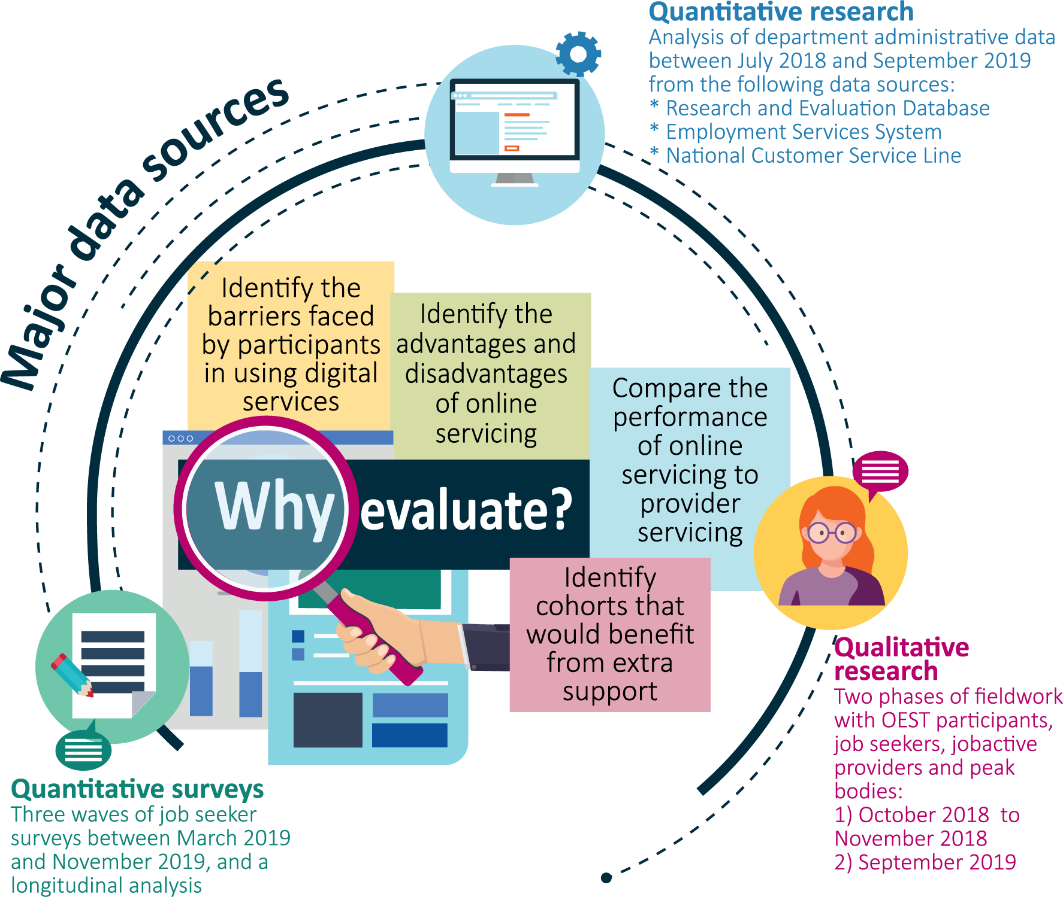
This chapter details the evaluation approach, including the use of mixed-methods analysis and data sources used in the evaluation. A profile of the characteristics of the study populations is featured in this chapter, including details of the population’s size and profile and how it differed from the main study population.

2.1 Aims of the OEST evaluation
The objectives of the evaluation were to assess the appropriateness, efficiency and effectiveness of the trial. To this end, the OEST evaluation:
- compared the performance of digital servicing to provider servicing
- identified the advantages and disadvantages of online servicing for job seekers
- identified the barriers faced by job seekers in using digital services
- identified cohorts that would benefit from extra support or tailoring of digital services.

2.2 Key evaluation questions
The evaluation sought to address the following questions and examine whether the results varied by different cohorts of job seekers.

Efficiency
- What were the opt-out rates from the trial? What were the reasons for opting out from the OEST into provider services?
- What were the patterns of use of online services by OEST participants?
- How efficient was the monitoring of job seeker compliance requirements in a digital environment?
- Was job search compliance similar between OEST participants and provider-serviced job seekers?

Effectiveness
- Did digital services affect the probability of job seekers finding employment?
- How did exits from employment services and income support compare between OEST participants and provider-serviced job seekers?
- How did employment rates for job seekers in OEST compare with provider-serviced job seekers over time?
- How did the online delivery of services affect job seekers’ job search skills and experience?
- Is digital servicing more cost efficient for government compared to provider services?
The evaluation also explored participants’ experience and satisfaction with the OEST:
- What were job seekers’ expectations and experiences – were they satisfied?
- What were providers’ and peak bodies’ views about online services provision?
- What were the barriers faced by job seekers in using the online service?
- What were the advantages and disadvantages of online servicing for different cohorts of job seekers?

2.3 Methodology
The evaluation of the OEST used a mixed methods approach. It included:
- qualitative research that involved analysis of the perceptions and experiences of the OEST from focus group discussions and in-depth interviews with participants and stakeholders
- three waves of a quantitative survey that provided further information about the experiences of the OEST participants
- administrative data analysis using data from the Employment Services System (ESS) and the Research and Evaluation Database (RED), including exit rates, trial opt-out rates and the compliance results of OEST participants compared to job seekers in the comparison group.

2.3.1 Qualitative research
The department commissioned Orima Research to conduct the qualitative fieldwork and quantitative surveys to inform the evaluation. Orima researched the perceptions, attitudes and experiences of job seekers who participated in or were eligible for OEST, as well as the perceptions and attitudes of jobactive providers and peak bodies.
The qualitative fieldwork involved two stages of research:
- An initial stage was conducted four months after the commencement of OEST, when most participants had been using the online service for two months or less. This first stage was conducted between 15 October 2018 and 8 November 2018 and consisted of 10 focus group discussions and 21 in-depth interviews with 98 participants.
- Drawing on the results of the initial stage, a smaller follow-up stage was conducted around one year later. This stage aimed to understand the impacts on participants who had been in the trial for a longer period (i.e. four to six months) and participants’ experiences of transitioning to provider-based servicing. The follow-up stage was conducted between 9 and 12 September 2019 and consisted of two focus group discussions with 19 participants.
Qualitative research participants comprised:
- OEST participants
- job seekers who opted out of OEST
- jobactive providers
- peak bodies including Jobs Australia and National Employment Services Australia.

2.3.2 Quantitative survey
A quantitative survey was conducted over three waves between March 2019 and November 2019. The survey was informed by the findings of the qualitative research in terms of the topics it covered and the specific questions that were asked.
Data was collected using both online and Computer Assisted Telephone Interviews (CATI) collection modes. The combined data collection approach maximised the response rate and minimised the risk of biasing the survey results towards participants who preferred either online or telephone survey completion modes.
- Wave 1 involved stratified random samples of job seekers who were selected for the trial, job seekers who were in the comparison group and job seekers who were not eligible for the trial
- Waves 2 and 3 included a smaller new sample of job seekers within the groups who took part in Wave 1, as well as a longitudinal sample – that is, participants selected for the trial who had completed a survey in at least one of the previous waves.
A total of 4,083 job seekers completed the surveys across all three waves. This included 2,222 survey respondents in Wave 1 with 880 additional respondents in Wave 2, and another 981 additional respondents in Wave 3. Further information on the surveys can be found in Appendix D.

Longitudinal analysis
A longitudinal analysis was conducted on responses from 863 job seekers who had participated in at least two of the main survey waves. The longitudinal analysis provided a measure of changes in job seekers’ views and experiences over time. It drew on:
- 490 responses from job seekers who participated in both Wave 1 and Wave 2
- 373 responses from job seekers who participated in Wave 3 in addition to Wave 1, Wave 2 or both Wave 1 and Wave 2.
Further details on longitudinal sample selection are in Appendix D.

2.3.3 Quantitative analysis of departmental administrative data
The department conducted quantitative analysis of administrative data for the OEST evaluation, comparing OEST participants with job seekers in the comparison group.
Two administrative datasets managed by the department were used: RED and ESS. RED is a longitudinal dataset on recipients of Australian Government income support payments. ESS contains jobactive administrative data, providing insights about people’s interactions with employment services through transactions recorded by employment service provider staff.
The quantitative analysis used the two administrative datasets to examine income support and employment services exit rates (as a proxy for employment), compliance with job search requirements and opt-out rates.
The analysis covered a 15-month period from 1 July 2018 (start date for the OEST) to 30 September 2019. Analysis of compliance data covered a longer period to 31 December 2019 in order to take into account policy changes which occurred mid-way through 2019 and their resulting impact on demerit rates for trial participants.

2.4 The study populations
Over the evaluation period, 21,493 job seekers were selected to participate in the OEST. However, not all job seekers who were selected for the OEST commenced in or completed the trial. Figure 2.1 shows the possible pathways of an OEST participant.
Of those selected, 17,810 (82.9%) job seekers commenced in the trial (by agreeing to a Job Plan) while 3,683 job seekers (17.1%) did not commence for various reasons. Of those who commenced, a further 3,480 either opted out or were transferred out due to eligibility changes.
The remaining 14,330 OEST participants who commenced in the program between 1 July 2018 and end September 2019 made up the main study population for this evaluation. This consists of those who:
- were still in the OEST at the time of analysis
- had exited the OEST and employment services (e.g. because they found a job or commenced training)
- had completed the full six months of the OEST and were automatically transferred to a jobactive provider.
The comparison group consisted of job seekers who were eligible for OEST but were not selected and were instead referred to a jobactive provider.
The evaluation also analysed job seekers who commenced OEST but chose to opt-out of the OEST into provider-based services (Chapter 3).
Figure 2.1 Overview of the OEST participant pathways
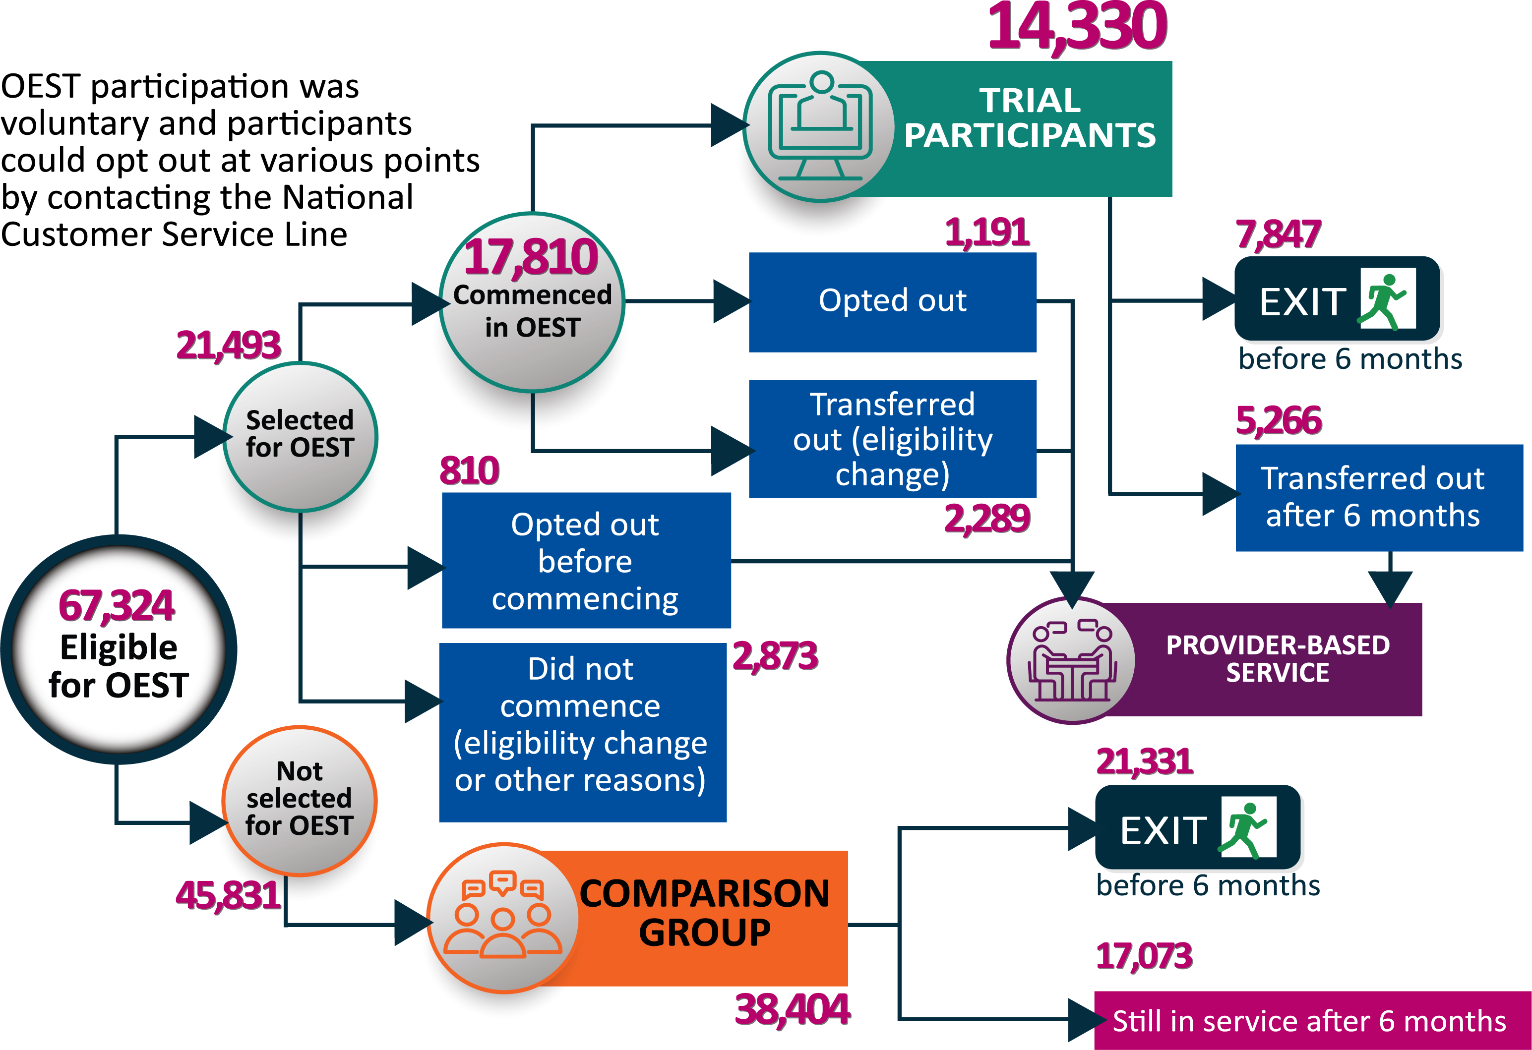
Source: DESE administrative data
Table 2.1 Demographic characteristics of the study groups
Characteristics | OEST group |  | Comparison group
— | Number | (%) | Number | (%)
Gender | — | — | — | —
Female | 5,993 | 41.8 | 16,139 | 42.0
Male | 8,337 | 58.2 | 22,265 | 58.0
Education | — | — | — | —
Under Year 12 | 1,449 | 10.1 | 3,352 | 8.7
Year 12 and above | 12,881 | 89.9 | 35,052 | 91.3
Age group
Less than 25 years | 7,901 | 55.1 | 18,634 | 48.5
25 to 29 years | 1,755 | 12.2 | 4,439 | 11.6
30 to 49 years | 3,149 | 22.0 | 9,468 | 24.7
50 years and above | 1,525 | 10.6 | 5,863 | 15.3
Indigeneity | — | — | — | —
Indigenous | 291 | 2.0 | 600 | 1.6
Non-Indigenous | 14,039 | 98.0 | 37,804 | 98.4
Remoteness
Major cities | 10,737 | 74.9 | 28,404 | 74.0
Inner regional | 2,644 | 18.5 | 7,103 | 18.5
Outer regional | 949 | 6.6 | 2,897 | 7.5
CALD | — | — | — | —
Yes | 2,298 | 16.0 | 6,637 | 17.3
No | 12,032 | 84.0 | 31,767 | 82.7
Previous income support | — | — | — | —
Yes | 666 | 4.6 | 2,092 | 5.4
No | 13,664 | 95.4 | 36,312 | 94.6
Previous jobactive experience | — | — | — | —
Yes | 544 | 3.8 | 1,727 | 4.5
No | 13,786 | 96.2 | 36,677 | 95.5
Total | 14,330 | 100.0 | 38,404 | 100.0
Source: DESE administrative data
Note: OEST population data was represented in this table. Matched sample data was used for impact analysis.

2.4.1 Study population characteristics
The demographic profiles of the OEST participant group and the comparison group were similar across a range of key characteristics, including gender, remote location, state, educational attainment and Culturally and Linguistically Diverse (CALD) background, although there were some differences in other characteristics such as age and education (Table 2.1). To address these differences, matched samples were used for comparisons where appropriate.

Chapter 3. The efficiency of the OEST
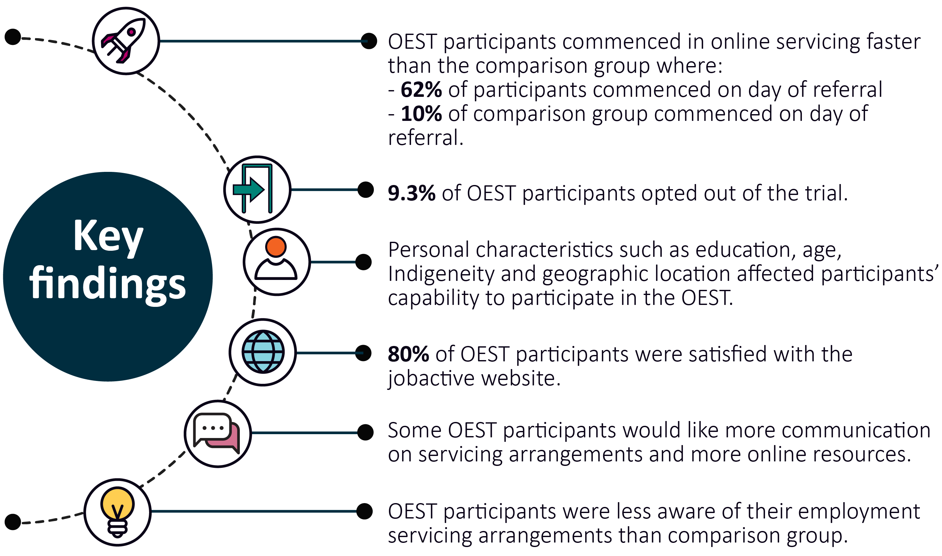
One of the expected key benefits of online government servicing is that it improves efficiency. This chapter examines the extent to which OEST delivered operational efficiencies, in particular:
- the number of participants who opted out of the trial, whether opt-out rates varied by participant characteristics and reasons for opting out
- whether digital servicing affected the time taken for participants to commence in employment services
- participants’ compliance in a digital environment
- service elements most critical for easy access to the participant
- OEST participants’ awareness of online employment servicing arrangements.

3.1 Time to commencement
The time taken to commence in a service is an important efficiency indicator because it determines how quickly those who need assistance start to receive it. Analysis of administrative data showed most OEST participants (62%) commenced on the same day they were referred to the trial, compared to only 10% of the comparison group.
By day 14, however, commencement rates for both groups were comparable, with 94% of the OEST group and 93% of the comparison group having commenced in online services and provider services respectively (Figure 3.1).
Figure 3.1 Time from referral to commencement of online services compared with provider-based services
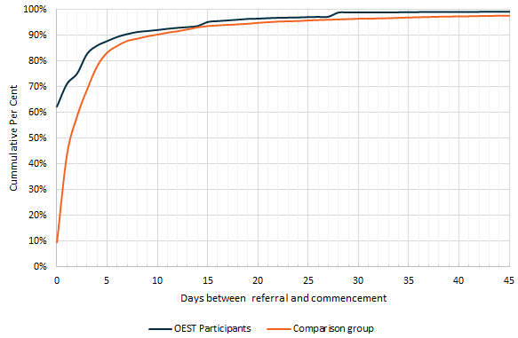
Source: DESE administrative data
The higher commencement rate for OEST participants (usually on the day of referral) was most likely due to the nature of the online process itself. Commencement for OEST participants was completed by clicking a button on the jobactive website. On the other hand, job seekers commencing in provider-based servicing were required to meet with their nominated provider before they could commence, which could take a few days to occur.
It should be noted that all trial participants and job seekers in the comparison group were referred by Services Australia through ‘RapidConnect’, which required connection with employment services in a timely manner, usually within two business days.

3.2 Opt-outs
As discussed in Chapter 2, participants could opt out of the OEST either before or after commencement in favour of employment servicing with a jobactive provider by contacting the National Customer Service Line (NCSL).
A total of 2,001 or 9.3% of selected job seekers opted out of the OEST. Of these, 810 or 3.8% opted out before commencing and 1,191 or 5.5% opted out during the trial.

3.2.1 Characteristics of participants who opted out
Table 3.1 shows that participants with certain characteristics had higher opt-out rates. Consistent with the literature, key factors influencing participants’ capability to participate in online servicing were personal characteristics, such as their level of education, age, Indigeneity and geographic location.
- OEST participants who had commenced in the trial with an educational attainment of less than Year 12 had an opt-out rate of 8.1% compared with 5.2% for those who had an educational level of Year 12 and above
- OEST participants who had commenced in the trial aged 50 years and over had an opt-out rate of 9.8% compared with 4.8% for those aged less than 25 years
- OEST participants who had commenced in the trial living in outer regional areas had an opt-out rate of 8.6% compared with 4.7% for those living in major cities
- Indigenous OEST participants who had commenced in the trial had an opt-out rate of 7.8% compared with 5.5% for non-Indigenous participants.
Except for participants aged 50 years and over, more participants opted out during the trial than before commencement. Those aged 50 years and over had a slightly higher opt-out rate prior to commencement (12%) than after commencement (9.8%).
Table 3.1 Characteristics of OEST job seekers who opted out of the trial before or after commencement
Characteristics | Number of job seekers referred to OEST | Number of opt-outs before commencement | Opt-out rate (%) | Number of opt-outs after commencement | Opt-out rate (%)
Gender | — | — | — | — | —
Female | 8,955 | 308 | 3.4 | 453 | 5.1
Male | 12,538 | 502 | 4.0 | 738 | 5.9
Education
Under Year 12 | 2,621 | 200 | 7.6 | 212 | 8.1
Year 12 and above | 18,872 | 610 | 3.2 | 979 | 5.2
Age group
Less than 25 years | 11,112 | 188 | 1.7 | 533 | 4.8
25 to 29 years | 2,342 | 47 | 2.0 | 82 | 3.5
30 to 49 years | 5,030 | 213 | 4.2 | 280 | 5.6
50 years and over | 3,009 | 362 | 12.0 | 296 | 9.8
Indigeneity | — | — | — | — | —
Indigenous | 514 | 16 | 3.1 | 40 | 7.8
Non-Indigenous | 20,979 | 794 | 3.8 | 1,151 | 5.5
Remoteness | — | — | — | — | —
Major cities | 15,708 | 528 | 3.4 | 736 | 4.7
Inner regional | 4,175 | 182 | 4.4 | 317 | 7.6
Outer regional | 1,610 | 100 | 6.2 | 138 | 8.6
CALD | — | — | — | — | —
Yes | 3,510 | 187 | 5.3 | 190 | 5.4
No | 17,983 | 623 | 3.5 | 1,001 | 5.6
Previous income support | — | — | — | — | —
Yes | 1,421 | 86 | 6.1 | 93 | 6.5
No | 20,072 | 724 | 3.6 | 1,098 | 5.5
Previous jobactive experience | — | — | — | — | —
Yes | 908 | 52 | 5.7 | 79 | 8.7
No | 20,585 | 758 | 3.7 | 1,112 | 5.4
Total | 21,493 | 810 | 3.8 | 1,191 | 5.5
Source: DESE administrative data

3.2.2 Opt-out reasons
The main reason given by participants for opting out of the OEST, either before or after commencement, was a preference for face-to-face servicing (Table 3.2). Online servicing not meeting participants’ needs was the second most common reason for opting out after commencement but was not a major reason for opting out before commencement. Other common reasons for both cohorts were online servicing being too difficult to use and a lack of confidence in using computers or the internet.
Table 3.2 Reasons for opting out of the OEST before and after commencement
Opt-out reason | Number of opt-outs before commencement | (%) | Number of opt-outs after commencement | (%)
Prefer face-to-face service | 477 | 52.7 | 618 | 49
Not confident in using computers/internet | 159 | 17.6 | 146 | 11.5
Online service is too difficult to use | 100 | 11 | 158 | 12.5
Online service is not meeting my needs | 41 | 4.5 | 178 | 14.1
Concerned about providing personal details online | 2 | 0.2 | 0 | 0.0
Online service is confusing | 56 | 6.2 | 110 | 8.7
Unable to access internet from elsewhere | 5 | 0.6 | 2 | 0.2
Unable to access internet from home | 65 | 7.2 | 50 | 4
Total | 905 | 100.0 | 1,262 | 100.0
Source: DESE administrative data
While participants continued to cite a preference for face-to-face servicing as the main opt-out reason, proportionally fewer participants cited this over time, declining from close to 70% in July 2018 to around 52% of reasons in September 2019 (Figure 3.2). Other reasons rose proportionally over time, including online servicing being difficult to use (from 6% to 11%) and online servicing being confusing (from 2% to 8%).

3.2.3 Awareness of opt-out arrangements
Trial participants emphasised the extent to which their decision to opt out was influenced by their awareness of the provider servicing option and their understanding of the process by which they could opt out. Many, but not all, participants were aware that they could choose to leave the trial at any time and transfer to a jobactive provider (72%). OEST participants in general had limited knowledge about provider-based services.
OEST participants who were unaware that online employment servicing was being provided on a trial basis assumed that online servicing was the norm and had limited awareness of the opt-out/transfer process to provider services.
… because it was my first time [using government-funded employment services], I thought I had to do it online, I thought everyone had to. (OEST participant, 35 years or below)
A few participants reported that they would have opted out if they had known they could or felt more supported had they known this option was available to them if they experienced any difficulties.
Figure 3.2 OEST commenced participants – opt-out reasons by month (cumulative)
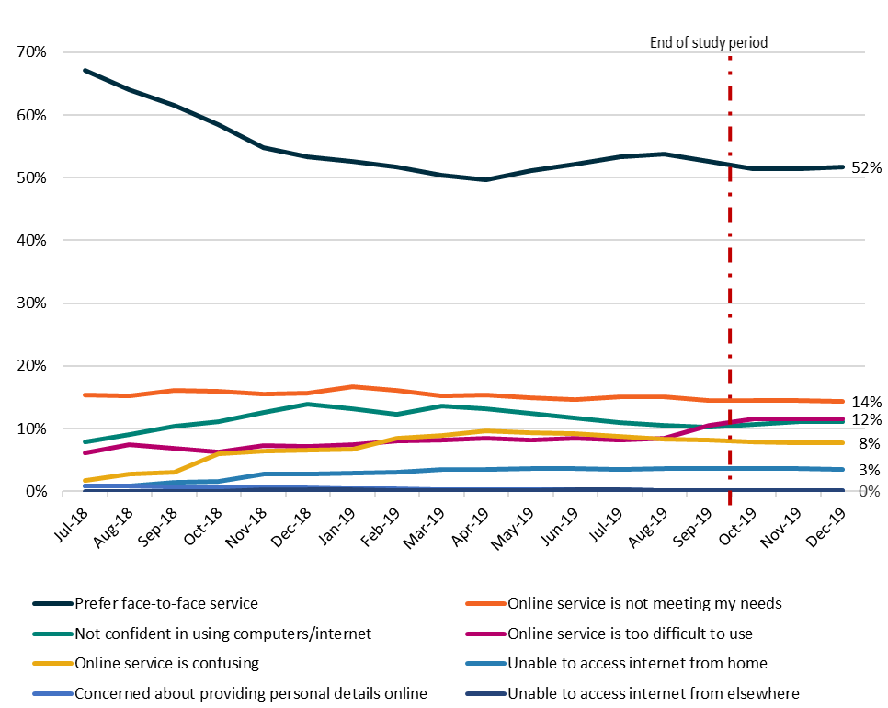
Source: DESE administrative data
Note: OEST commenced participants who opted out by 31 December 2019 (n=1,488)

3.3 The jobactive website
International and Australian research on the use of digital services has stressed the importance of accommodating a range of technological knowledge and attitudes among users, and of keeping the design and flow simple to encourage participation from new or novice internet users. Central to the success of online government services is reliable and consistent technology that helps avoid user dissatisfaction and disappointment through technical issues, such as webpage errors and host connectivity issues.
In the case of OEST, success was dependent on the jobactive website’s reliability and ease of use. The website was the key source of information for participants, and was where participants registered their job searches, set up their job seeker profiles, accessed resources to assist with their job searches and self-managed MORs compliance.

3.3.1 Website usage
Survey results showed that 83% of OEST participants recalled having accessed the jobactive website since commencing the trial, compared with 69% in the comparison group.
Website usage was 89% among OEST participants still in the trial and 88% for those who transferred to provider services after six months in the trial. About 3% to 5% of OEST participants were not sure if they had visited and used the jobactive website since commencement. This could explain why some survey respondents indicated that they had not yet visited the website.
Survey results also showed that the majority of OEST participants who accessed the jobactive website had used the following functions:
- job search function (87%)
- ‘my job search effort’ function to record the jobs they applied for (87%)
- updating their profile or résumé (69%).
Other functions, including guides, FAQs and the calendar were used less frequently. Some participants reported that they did not use the job search feature regularly as they thought there were higher quality alternatives (such as Seek).

3.3.2 Usability
From quantitative survey responses, over three-quarters of OEST participants (83%) found the website functions easy to use (Figure 3.3). About 79% thought the website was easy to navigate and 78% agreed that the website had the functionality and features they needed.
Figure 3.3 Ease of using the jobactive website
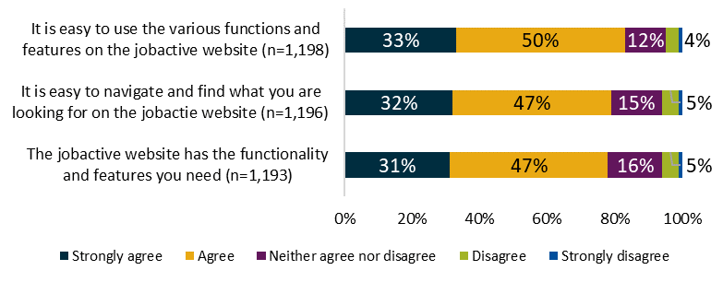
Source: 2019 quantitative survey
Note: OEST participants
Some trial participants identified problems with site navigation, the job search reporting function and a lack of clarity about what was considered ‘evidence’ when reporting job search efforts.
I thought I could log the jobs on the due date, but it turns out I couldn’t. (OEST participant, 18 years+)
I have gone to the portal and logged a lot of jobs but it still says I have 16 to go. It’s slow, it’s buggy, and it never refreshes the counter. (OEST participant, 36 years+)
Just under one-quarter of OEST participants reported experiencing issues with the jobactive website (23%). Just over one-third of these indicated that their issues had been fully (18%) or partially (17%) resolved, with a similar proportion of participants indicating that these issues had not been resolved at all (38%).

3.3.3 Participant satisfaction
Participant views about the jobactive website provide insights into the design and support features and can inform future iterations of the service model.
Results from the Job Seeker Survey showed that over three-quarters of OEST participants (80%) were satisfied with the jobactive website and only 4% were dissatisfied. This compared favourably to the comparison group’s satisfaction with the jobactive website (76% satisfied and 5% dissatisfied, see Figure 3.4). All job seekers in the comparison group had access to the jobactive website.
Figure 3.4 Satisfaction with the jobactive website – OEST participants and comparison group
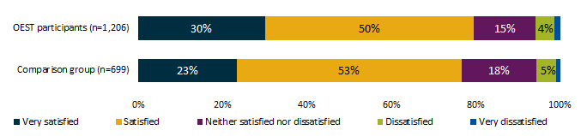
Source: 2019 quantitative research survey
Those who opted out of the trial were less satisfied with website functionality than those who completed the OEST, although almost two-thirds of them rated aspects of it positively (64%).
Qualitative research findings also confirmed that most participants were satisfied with the jobactive website.
I just went online and worked it out for myself. They told me exactly how it was going to work, there was no confusion or anything. It was quite effective. I felt like it was explained really well.
(OEST participant, 18 years+)
The dashboard part is the only part I use to report jobs, and I find it useful and efficient… it’s accessible and very straightforward to see that you’re meeting your requirements.
(OEST participant, 36 years+)
Having a better understanding of the online process beforehand was helpful. Participants who recalled receiving detailed information from Centrelink before they commenced in the trial (such as on the availability of the NCSL and on the processes for opting out, linking their myGov account and accepting their Job Plans) felt that it contributed to a positive experience of online employment servicing.
Satisfaction with the jobactive website varied with participant characteristics. Younger participants (aged 24 or below) were more likely to be satisfied with the jobactive website (84%) than older participants, whose satisfaction ranged from 72% for those aged 55 or over to 77% for those aged 25 to 44. OEST participants who had had previous experience with jobactive employment services were also more likely to be satisfied with the jobactive website (86%) than those who had not (78%).

3.4 Monitoring of OEST participant compliance
OEST participants were required to comply with MORs in order to receive their income support payments. The MORs for OEST participants were that they searched for work and reported their job search efforts on a monthly basis. For job seekers in provider servicing, MORs also included requirements to attend appointments and activities, alongside job search requirements.
Failure to meet MORs incurred a demerit point. The accrual of demerit points could lead to the reduction or cancellation of income support payments. Job seekers who incurred three demerits were automatically transferred out of the trial to an employment service provider for the Compliance Interview.

3.4.1 Awareness of requirements
The quantitative survey revealed that OEST participants and the comparison group reported a high level of awareness of their MORs (Figure 3.5). Almost all OEST participants were aware that they could provide evidence of job search online through the jobactive website (95%).
Figure 3.5 Awareness of Mutual Obligation Requirements
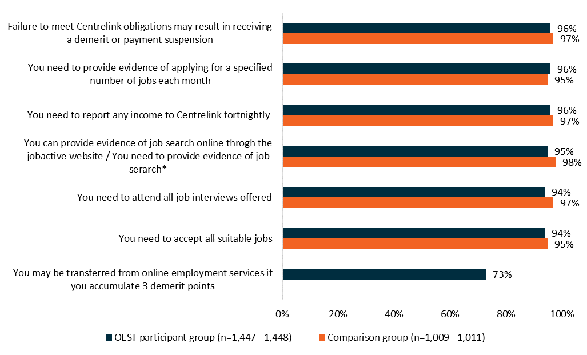
Source: 2019 quantitative research survey

3.4.2 Accumulation of demerit points
A key area of interest for this evaluation was to compare whether OEST participants were as likely to meet their MORs as job seekers in the comparison group. This was measured through job search related demerits as this was the only type of demerit OEST participants could receive.
Departmental administrative data was studied to examine job search demerit points accumulated over time by OEST participants compared with the comparison group in provider-based services. Results showed similar performance between participants and comparison job seekers (71% versus 69%). However, this result varied over time:
- two-thirds of OEST participants and job seekers in provider servicing who commenced between 1 July 2018 and 31 March 2019 incurred no job search related demerits within six months from service commencement (66% of OEST participants compared to 68% of the comparison group, Table 3.3)
- results changed in favour of OEST participants who commenced between 1 April 2019 and 30 June 2019, of whom 80% incurred no job search demerit points within six months of service commencement (compared to 72% of those who commenced in provider servicing, Table 3.3).
Table 3.3 Accumulation of demerit points for insufficient job search for job seekers who commenced from July 2018 to June 2019
Number of demerits | OEST | (%) | Comparison | (%) | Per cent difference
Commenced from July 2018 to June 2019 | — | — | — | — | —
0 | 6,715 | 71.0 | 6,547 | 69.2 | 1.8*
1 | 2,202 | 23.3 | 2,267 | 24.0 | -0.7
2 | 542 | 5.7 | 645 | 6.8 | -1.1
Commenced from July 2018 to June 2019 | — | — | — | — | —
0 | 4,067 | 66.2 | 4,169 | 67.8 | -1.6
1 | 1,651 | 26.9 | 1,552 | 25.3 | 1.6
2 | 429 | 7.0 | 426 | 6.9 | 0.1
Commenced from April 2019 to June 2019 | — | — | — | — | —
0 | 2,648 | 80.0 | 2378 | 71.8 | 8.2*
1 | 551 | 16.6 | 715 | 21.6 | -5.0
2 | 113 | 3.4 | 219 | 6.6 | -3.2

Source: DESE administrative data
Note: *indicates significant at p = 0.05
As the only type of demerit OEST participants could receive was job search related demerits, the analysis only involved job search related demerits. If the analysis was extended to include all other types of demerits such as failing to attend appointments and activities, then the results would have shown the comparison group accruing more demerits.
Figure 3.6 presents a visual timeline of the percentage of OEST participants and job seekers in the comparison group who commenced in the trial or provider services between 1 July 2018 and 30 June 2019 and did not accrue any job search demerit points within six months of their service commencement date, up to and including 31 December 2019.
Figure 3.6 Percentage of job seekers without job search demerits by commencement month (matched samples)
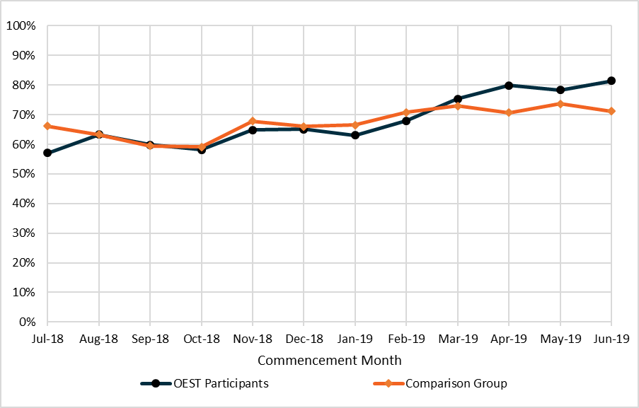
Source: DESE administrative data
Note: Samples included both OEST participants in receipt and not in receipt of income support who commenced in OEST or provider services between 1 July 2018 and 30 June 2019, and demerit points observed from July 2018 to December 2019.
The gap between the percentages of OEST participants and comparison group job seekers who did not accrue job search demerit points closed and crossed over at the beginning of March 2019 and widened approaching the end of the timeline. The chart indicates better performance for OEST participants compared to the comparison group as the trial progressed. The improved performance of OEST participants over time could be attributed to a number of factors.
Qualitative research conducted at the early stage of the trial found that fewer OEST participants than those in the comparison group (85% compared with 91%) agreed they understood how to provide evidence of the jobs they had applied for on the jobactive website. However, as OEST became more established, communications improved and this could have increased participants’ understanding of MORs. Changes in the wording and timing of job search related reminders are likely to have contributed to improved participant performance. Reminders prompting trial participants to report their job search efforts were sent out from 29 June 2019 onwards.
Another factor that could explain why trial participants accrued fewer job search demerit points over time was the introduction of an online ‘paid work declaration’ mid-way through 2019, which in some cases reduced job search requirements. This feature allowed job seekers using online employment services to manage their mutual obligation (Job Search) online and declare if they were working by clicking a button on the screen. Job search was then halved or reduced to zero depending on personal circumstances. Separate to this feature, NCSL operators were also given the ability to vary a job seeker’s job search requirements at the same time, which could also translate to fewer demerit points being applied to job seekers.

3.5 Awareness of service elements
Survey results showed that OEST participants were less aware of their servicing arrangements than were their counterparts in provider-based servicing.
Approximately three-quarters of trial participants were aware that they did not need to attend an appointment with a jobactive provider (77%) and that they were not connected to a jobactive provider for assistance (75%). This compared to 96% of the comparison group job seekers, who were aware of their connections to a provider and the need to attend appointments (98%).
Some OEST participants were unaware of the NCSL, with many assuming that they needed to either call or visit Centrelink for assistance while on the trial or that there was no assistance available. When informed that the helpline was available, most reported that they would have felt reassured if they had known it was available and that they might have used it.
The qualitative research reflected some OEST participants’ preference for more effective communication on servicing arrangements and additional online resources. Participants who were best informed about the OEST tended to recall detailed information during initial application interviews with Services Australia or, for a few participants, via a text or email.
I had a phone interview with [Services Australia] and they told me they were putting me on this trial.
(OEST participant, 18 years+)

Chapter 4. The effectiveness of the OEST
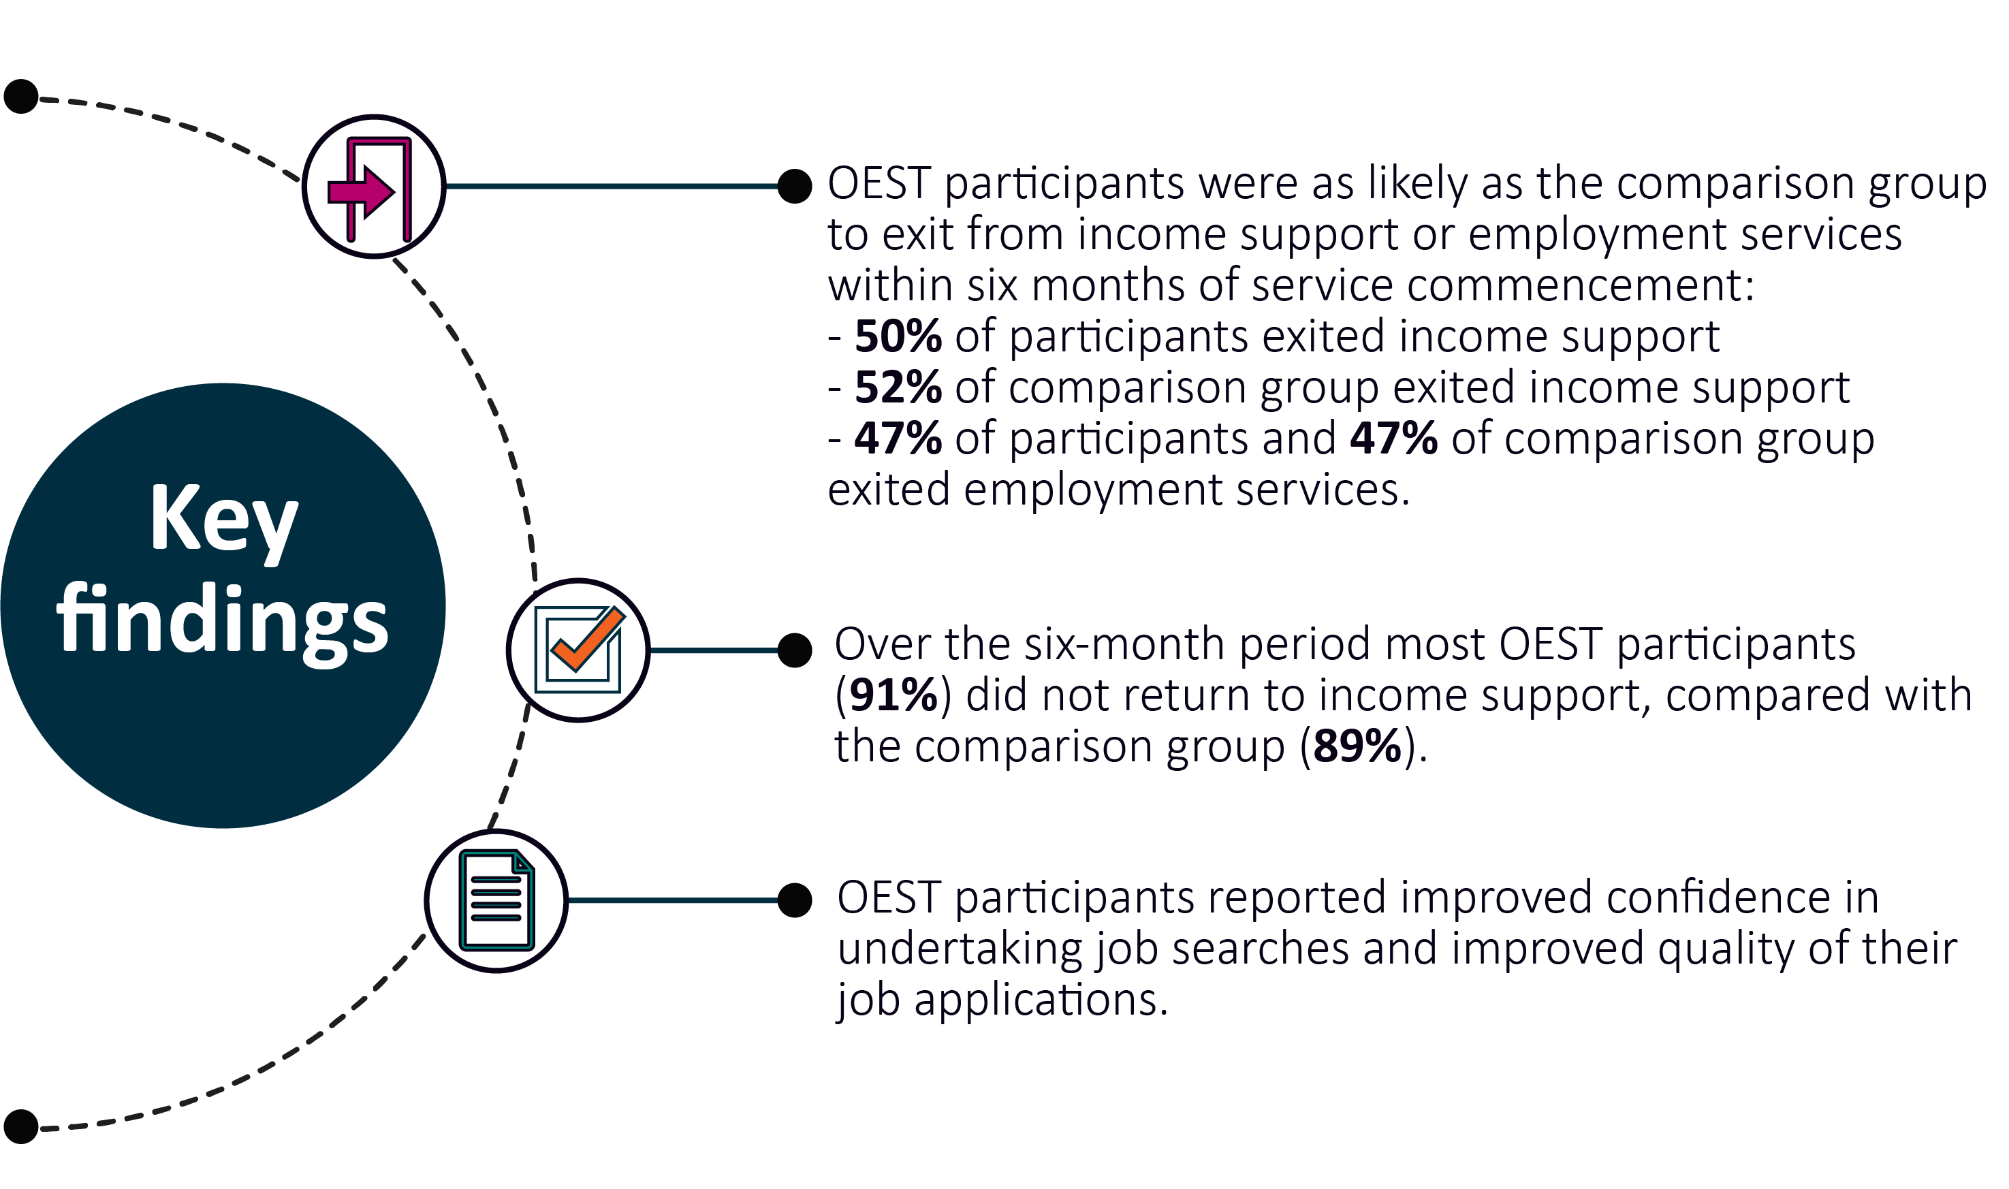
The key objective of employment services is to help job seekers find and maintain employment. If online servicing achieved similar or better labour market outcomes for job seekers compared to provider servicing, this would be a successful outcome. Therefore, the key question considered in evaluating the effectiveness of the OEST was ‘Do digital services affect the probability of job seekers finding employment?’
To answer this question, two measures of employment are considered:
- exit rates from income support and employment services
- employment rates based on survey data.
This chapter also considers other measures of job readiness including job search skills, confidence and resources.

4.1 Exiting income support and employment services
Income support and employment services exits are strong proxies for employment. Analysis of administrative data (Figure 4.1) showed that OEST participants were as likely as job seekers in the comparison group to exit from income support or employment services within six months of service commencement.
Figure 4.1 Comparison of exits from employment services and income support
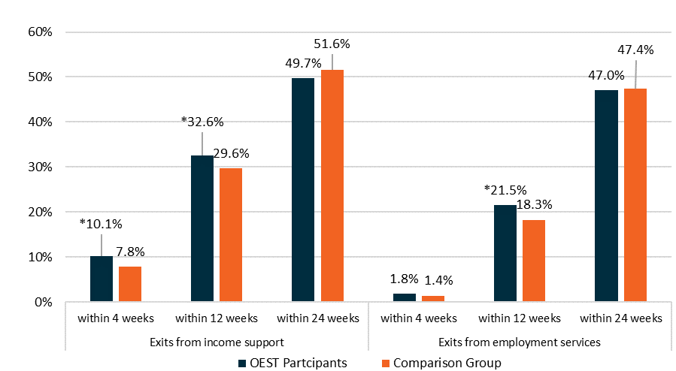
Source: DESE administrative data
Note: *indicates a statistically significant difference between groups at p < 0.05
Within six months (24 weeks) of commencement in the OEST, 49.7% of participants exited from income support compared with 51.6% of the comparison group, and approximately 47% of both the OEST and comparison groups exited from employment services within six months. Although OEST exits from income support are lower, the difference is not statistically significant.
Proportionally more OEST participants than job seekers in the comparison group exited income support and employment services within one month (four weeks) and three months (12 weeks) of commencement in the OEST and provider-based services respectively.

4.1.1 Exit rates after transferring to provider servicing
The above analysis relates to exit rates for OEST participants during six months of OEST servicing. However, OEST participation could affect exit rates after the participant had completed their six months in OEST and transferred to a jobactive provider.
Further analysis (Table 4.1) of departmental administrative data after a nine-month period (six months in OEST and three months in provider servicing) showed that OEST participants were less likely to exit from income support and employment services (35.7% and 31.5% respectively) than the comparison group (41.0% and 34.2% respectively) between six and nine months of service. The difference for exits from income support was small but statistically significant.
The lower exit rates after transferring to a provider could be for several reasons:
- jobactive providers might focus less on recently transferred OEST participants. When a participant transferred from the OEST to a jobactive provider, they were treated as a new participant for the purpose of provider outcome payments. This meant that providers had less financial incentive to place the participant in a job relative to a job seeker who had been with the provider for more than six months.
- The transition from OEST to a jobactive provider disrupted a participant’s servicing, with qualitative feedback indicating that the transition could have been smoother (see Section 5.2).
- There may be disadvantages to extended periods in online servicing, including job seekers losing motivation (see Section 5.1.4).
This analysis should be treated with caution as it is based on a small sample and pertains to participants who had been through the first six months of the trial while the service delivery was still being refined. However, it is reinforced by the employment rates analysis (see Section 4.2.1).
Table 4.1 Exits from income support and employment services for OEST participants compared with job seekers in provider-based services who have completed six months
Exits | Number of OEST participants⁽¹⁾ |  | (%) | Number of comparison group⁽²⁾ | (%) | Per cent difference
Exits from income support since commencement |  | — | — | — | — | —
– within 39 weeks |  | 196 | 35.7 | 225 | 41.0 | -5.3*
Exits from employment services since commencement |  | — | — | — | — | —
– within 39 weeks |  | 173 | 31.5 | 188 | 34.2 | -2.7
Source: DESE administrative data
Notes: Job seekers who commenced between 1 July 2018 and 15 November 2018.
* indicates statistically significant difference between groups at p < 0.1.
(1) OEST participants who have completed a full-term OEST and have been in employment services for at least 182 days. As such, the exit rates cannot be compared to those in Figure 4.1.
(2) job seekers who have been in provider-based employment services for at least 182 days.

4.1.2 Impact of job seeker characteristics on exits from income support and employment services
Variations in OEST participant exit rates by age, location, gender, education, CALD and previous history of income support and the sustainability of income support exits within six months (24 weeks) of commencement were examined to determine whether online servicing affected labour market outcomes differently for these subgroups of job seekers (Figure 4.2).
Exit rates were very similar between OEST participants and the comparison group when comparing across most individual characteristics measured. The exception was among males, where OEST participants had slightly (albeit statistically significantly) lower exit rates from income support within 24 weeks of commencement compared to males in the comparison group.
OEST participants with a previous history of income support also had notably lower exit rates from both income support and employment services than comparison job seekers (although the differences were not statistically significant, noting a small sample size).

Figure 4.2 Comparison of exits from income support and employment services by individual characteristics
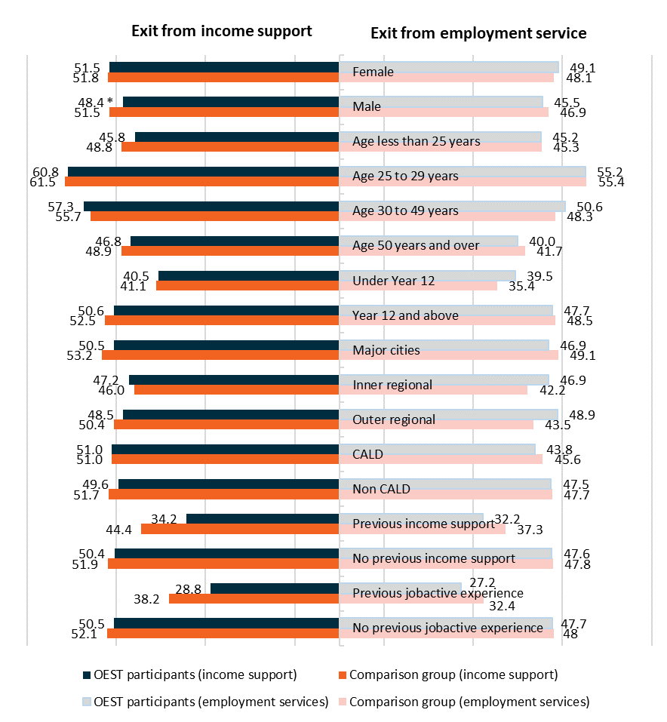
Source: DESE administrative data
Note: *indicates a statistically significant difference between groups at p < 0.05
Appendix E contains more detailed exit rate tables for each characteristic with exact exit rate percentages, measured for within four, 12 and 24 weeks of commencement in services.

4.1.3 Sustainability of exits from income support
The effect of the OEST compared to provider servicing can be further studied by examining the sustainability of exits from income support over time (Table 4.2). Job seekers were observed for an additional six months following their exit from either the OEST or provider-based services. Overall, there is evidence that online servicing was slightly more effective at maintaining exits from income support. Over the six-month period, most OEST participants (91%) did not return to income support, compared with the comparison group (89%).
Table 4.2 Sustainability of income support exits over the period of 6 months from exit date (*)
Return to income support | OEST participants | (%) | Comparison group | (%) | Total
Did not return to income support | 2,347 | 90.6 | 10,316 | 89.4 | 12,633
Returned between 6 and less than 12 weeks | 89 | 3.4 | 447 | 3.9 | 536
Returned between 12 and less than 18 weeks | 60 | 2.3 | 323 | 2.8 | 383
Returned between 18 and less than 24 weeks | 64 | 2.5 | 301 | 2.6 | 365
Returned after 24 weeks or more | 30 | 1.2 | 149 | 1.3 | 179
Total | 2,590 | 100.0 | 11,536 | 100.0 | 14,126
Source: DESE administrative data
Note: (*) for job seekers who exited income support before 1 July 2019, data was observed for an extra 6 months from the date of exit from income support to 31 December 2019.
This analysis is limited by the short timeframe (1 July 2018 to 31 December 2019), which is insufficient to determine whether remaining off income support can be sustained over the longer term.

4.2 Employment and study rates

4.2.1 Employment rates
As administrative data does not capture employment status for OEST participants, exits from income support and employment services were used as a proxy for employment (Section 4.1).
Figure 4.3 Employment rates by duration in employment services
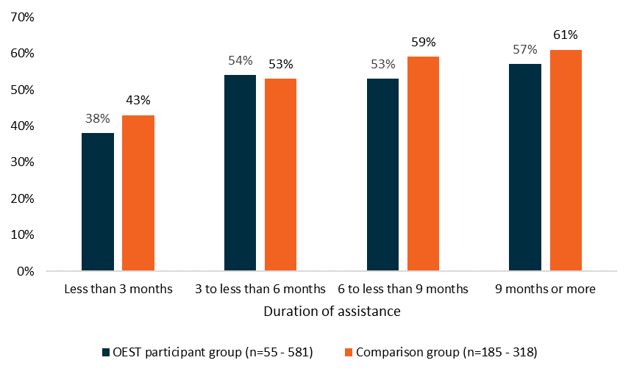
Source: ORIMA quantitative survey
Note: All respondents; DESE administrative data was used to calculate duration.
Survey data on employment rates was used to augment administrative data analysis (Figure 4.3), which shows:
- employment rates for both OEST participants and the comparison groups were similar at three to six months (54% compared with 53%)
- employment rates for OEST participants were slightly lower at six to nine months (53% compared with 59%) and beyond nine months (57% versus 61%)
- employment rates of OEST participants were slightly lower than those of the comparison group at less than three months (38% versus 43%).
The employment rates were consistent with the exit rate analysis, which showed comparable performance between online and provider servicing during the six months of OEST servicing, but with OEST participants having poorer results after their six months in the trial.

4.2.2 Undertaking study and training
The proportion of OEST participants and job seekers in the comparison group undertaking study and training increased significantly during the first six months in employment services (Figure 4.4) and then returned to the lower study rates observed soon after job seekers commenced in employment services.
Study rates for OEST participants compared with the comparison group were:
- slightly higher for those who had received assistance for less than three months (16% compared with 12%)
- similar for those who had received assistance for three to six months (24% compared with 24%)
- slightly lower for those who had received assistance for six to nine months (22% compared with 26%)
- similar for those who had received assistance for nine months or more (18% compared with 16%).
Survey results also showed that OEST participants were less likely than those in the comparison group to be studying on a full-time basis, though this is not statistically significant.
One factor that could have affected study participation was that OEST participants, unlike the comparison group in jobactive, did not have access to the Employment Fund to assist with study costs.
Figure 4.4 Study or training rates by duration on assistance
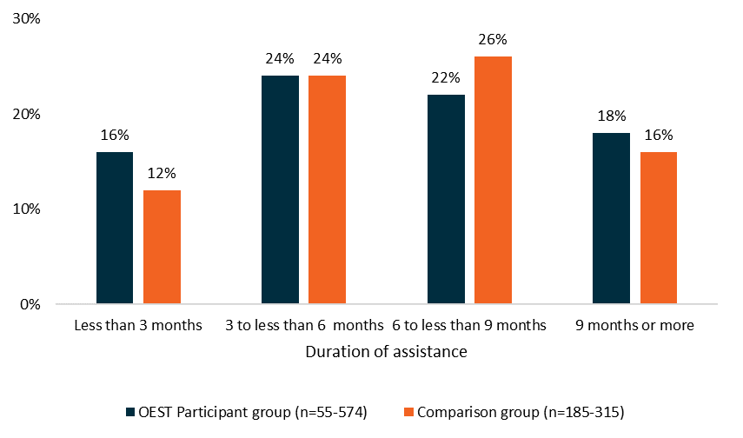
Source: ORIMA quantitative survey
Note: All respondents; DESE administrative data was used to calculate duration.

4.3 Cost-effectiveness
A key consideration in the provision of employment services is its cost-effectiveness.
The OEST offered a comparatively low-cost structure to deliver. Relative to provider servicing, OEST involved no provider payments, which created significant financial efficiencies (although there were some offsetting costs in the design and delivery of the OEST in an online platform). These efficiencies were reflected in the budgetary measures establishing and expanding the OEST.
Given that OEST provided similar employment outcomes, in terms of both exits and employment rates, to provider servicing and did so at a lower cost, this means digital servicing can be cost-effective for the most job-ready job seekers.

4.4 Participants’ confidence
The evaluation used confidence across job search skills, ability to find a job, and resources as an indicator of participants’ employability. The analysis compared survey results between trial participants and the comparison group after six months or more of assistance.

4.4.1 Confidence in job search skills
Analysis shows that OEST participants’ confidence in their job search skills was similar to the comparison group’s across five different measures (Figure 4.5).
Figure 4.5 Job seekers’ confidence in job search skills
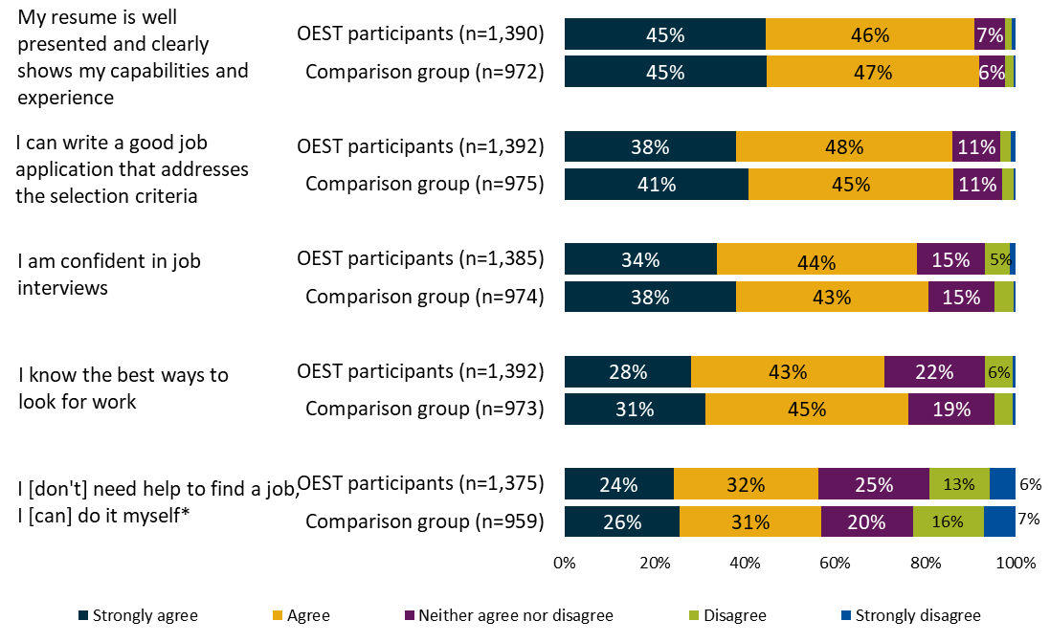
Source: 2019 quantitative research survey
Note: * Results in the first two bars (navy and yellow) show % Disagree/Strongly Disagree and those in the last two bars (green and blue) show % Agree/Strongly Agree to the statement, as it was framed as a negative statement in the questionnaire (“I need help to find a job, I can’t do it myself”). Results have been presented in reverse to allow comparison with the other positive statements in this section.
Knowing the best way to find work, however, differed between OEST participants (71%) and the comparison group (76%), reflecting that the latter group had access to additional help from a jobactive provider.

Longitudinal analysis
Most OEST participants in the longitudinal analysis thought that their job search skills had increased over time. Figure 4.6 shows that over two-thirds of respondents agreed that their skills in using the internet for job searches and applications had improved (70%) and that their job search skills had also improved (68%).
Figure 4.6 Change in confidence in job search skills for longitudinal respondents
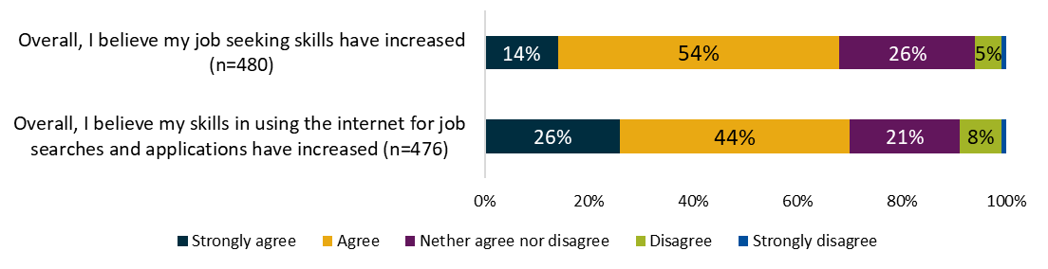
Source: 2019 quantitative research survey
Note: Longitudinal survey respondents

4.4.2 Confidence in finding and retaining a job
OEST participants and comparison job seekers had similar levels of confidence that they could find and retain a job. Figure 4.7 shows that:
- 91% of OEST participants agreed that they would be able to keep a new or current job, while 92% of the comparison group agreed to this statement
- 72% of OEST participants and the comparison group agreed with the survey statement that they were confident that they would find a job soon.
Figure 4.7 Confidence in finding and retaining a job
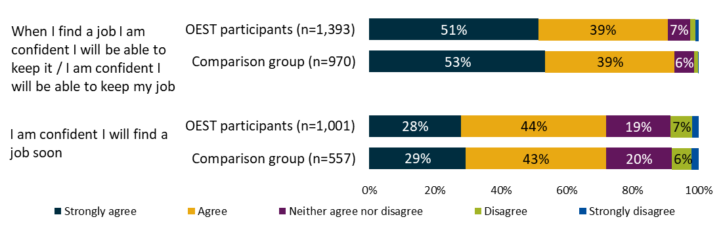
Source: 2019 quantitative research survey
Note: OEST participants and comparison group.

4.4.3 Confidence in job search resources and support
OEST participants displayed higher levels of confidence that the assistance they were receiving would help get them a job than those in the comparison group (63% versus 46%). They were also less likely to consider that they would benefit from the assistance of an employment service provider than those who were receiving provider assistance (Figure 4.8).
Figure 4.8 Job search resources and support
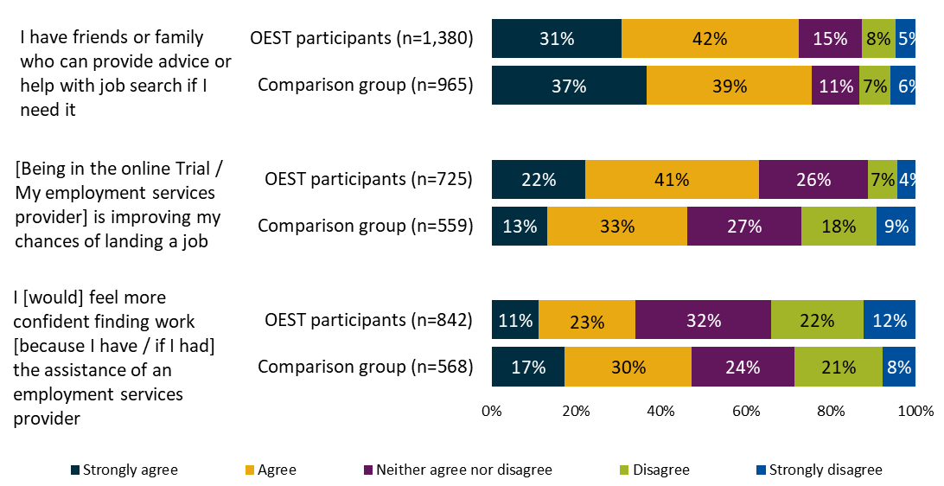
Source: 2019 quantitative survey
Note: All respondents

Chapter 5. OEST participant experience
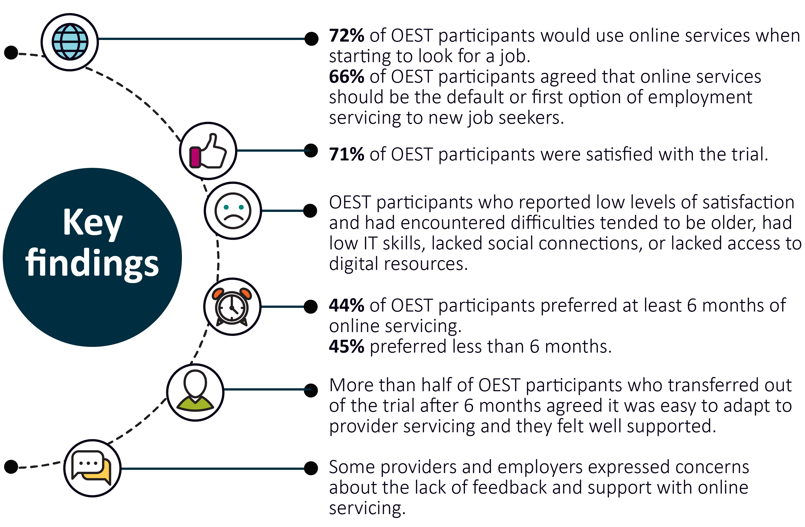
This chapter examines OEST participants’ experiences with, and opinions, of online servicing. It discusses the transfer process from online to provider servicing, and how easy it was for participants to adapt to provider-based services after exiting online services. The suitability of the Job Seeker Classification Instrument (JSCI) as an assessment tool for selecting OEST participants is also considered in this chapter.

5.1 Participants’ experiences with the OEST
OEST participants’ satisfaction with online servicing and their feedback on the advantages and disadvantages of online servicing were reviewed.

5.1.1 Satisfaction with online servicing
Overall, OEST participants were more satisfied with online servicing than job seekers with provider servicing. Results from quantitative surveys showed 71% of OEST participants were satisfied or very satisfied with online employment services and 8% were dissatisfied or very dissatisfied. Twenty-one per cent were neither satisfied nor dissatisfied. The comparison group’s satisfaction with provider-based services was similar (67%), although the proportion of dissatisfied job seekers was slightly higher than the OEST group (14%, 19% were neither satisfied nor dissatisfied, Figure 5.1).
Figure 5.1 Satisfaction with online servicing
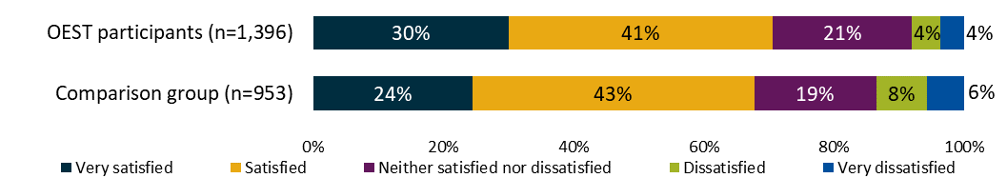
Source: ORIMA quantitative survey
Qualitative research findings support these results, as most OEST participants gave positive feedback on online employment servicing. They reported that they understood the requirements to fulfil their job search and MORs; that the process was simple and user-friendly; and that they had enough information and support to complete their requirements and had been able to do so successfully.
It’s simple enough … great for keeping your own records … very user-friendly. (OEST participant, 36 years+)
OEST participants who reported low levels of satisfaction and significant difficulties with online employment services were participants who were older, had limited IT skills, experienced a lack of social connection/lack of contact/feelings of isolation or had no access to a computer at home. These participants also tended to have limited digital literacy or English language skills and found the process ‘confusing’ or ‘overwhelming’. These job seekers required:
- assistance or feedback on job search
- assistance or feedback on job applications, résumé or cover letters
- career guidance or advice.
I sort of felt like I was dumped onto the program … the information is all over the place. It’s all a bit confusing and not very convenient because you’re not getting the answers you want. It can be quite confusing and upsetting. (OEST participant, 36 years+)

5.1.2 Advantages and disadvantages of online servicing
Given that OEST participants were generally more satisfied with online servicing, it is unsurprising that they were also more likely to identify advantages of online employment services compared to provider-based services.
Figure 5.2 Top five advantages of online employment services
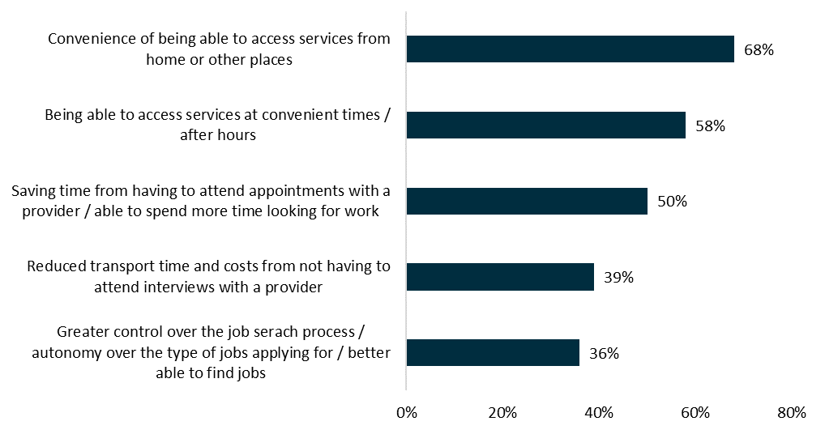
Source: 2019 quantitative research survey
Note: OEST participants (n=1,449)
Sixty-eight per cent of OEST survey respondents identified the convenience of accessing services from home as a significant advantage (Figure 5.2). These sentiments were confirmed in the qualitative research.
I find it more convenient to do online because I have other family commitments. (OEST participant, 35 years and under)
OEST participants also cited reduced transport time and costs from not having to attend face-to-face interviews with a provider (39%) as an advantage of online servicing. This was reiterated in the qualitative research.
It’s more cost effective … you’re [not] paying for petrol or public transport or parking.
(OEST participant, 35 years and under)
Greater control and autonomy over the job search process, the types of jobs being applied for and finding suitable jobs were identified as additional advantages by 36% of the OEST group.
[It’s] autonomous … you’ve still got obligations but I like that you’re running your own show.
(OEST participant, 18 years +)
Notably, those who opted out of the OEST into provider servicing before completing six months in the trial were not as comfortable operating in the digital environment and were more appreciative of the support from a jobactive provider.
OEST participants reported several other benefits from undertaking online job searches. These included becoming more efficient and flexible and more practised at job applications, improving the quality of their résumés and cover letters, finding job applications easier and becoming more comfortable with the process of submitting job applications.
It’s given me access to a bigger job market in an easier way. (OEST participant, survey response)
It allows me to see what companies are looking for, and what they are expecting from potential employees. It allows me to edit my résumé or cover letter to their liking before sending in my application form.
(OEST participant, survey response)

5.1.3 Preference for online or provider servicing
When asked whether they preferred to use online or provider-based employment services to look for a job, almost three-quarters (72%) of OEST participants reported they definitely, or probably, would use online services when starting to look for a job while only 58% of the comparison group preferred online services (Figure 5.3).
Figure 5.3 OEST participants’ and job seekers’ preference for using online or provider-based employment services to look for a job
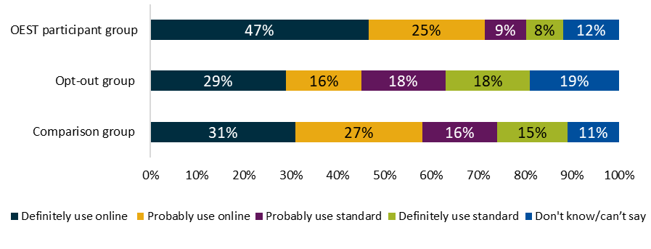
Source: ORIMA quantitative survey
Note: All respondents – OEST participants (n=1,442); comparison group (n=1,006); opt-out group (n=461)
Question: If you had just started looking for a job and had the choice between receiving online employment services and employment services with a provider, would you choose to use online employment services or provider-based services?
The majority of OEST participants (66%) agreed that online services should be the default or ‘first option’ for providing employment services to job seekers who have just started looking for a job if they were assessed as being ‘job-ready’. Notably, more than half of those in the comparison group (62%) also agreed. This indicates broad support for online service delivery as implemented within the trial – where the default approach is online service delivery with job seekers being able to opt out.
Survey results also showed a strong preference for online employment servicing among:
- participants aged 24 years or below
- participants with high levels of educational attainment
- participants in metropolitan locations
- participants with high levels of internet usage
- participants who had not previously used jobactive services.

5.1.4 Duration of online servicing
Participants had mixed views about the appropriate duration of online employment services, with OEST participants favouring longer durations on average. Some trial participants preferred online employment services for at least six months (44%), while a similar proportion considered it should be for less than six months (45%). Over half of the comparison group (65%) considered the duration should be less than six months.
Results from qualitative research indicated that job seekers’ perceived self-sufficiency in finding work was likely to decline after several months of unsuccessfully seeking employment in a purely online environment.
If it was months and months and I hadn’t got a job, I’d think, ‘well I can’t do this’, so I’d want help then.
(OEST participant, 18 years +)
In other cases, participants formed more positive attitudes to online employment services after adjusting to the service mode.
I was a bit annoyed, I probably would have opted-out at the start if I’d known I could have … but I’ll wait until six months. I find it easy to use, no issues at all.
(OEST participant, 18 years +)
Over time, some participants became less positive about online employment services and lost confidence in their ability to find employment and began to feel unsupported.
My confidence decreased … I didn’t think anything would come of [my job search] … I wasn’t really getting any feedback.
(OEST participant)
Similarly, qualitative research feedback from several jobactive providers indicated that they considered that six months in digital servicing was too long for job seekers without additional support because many would have lost motivation and/or confidence by then.

5.2 Transferring out of the OEST after completing six months
Evaluating the effectiveness of the OEST should not be restricted to whether it assisted participants in finding work during the trial but should also consider whether the trial maximised participants’ chances of finding work over time. This includes a smooth transition with sufficient support from their jobactive provider. More than half of the participants who transferred out of the trial after six months and were surveyed in the quantitative research said they were supported (55%) and agreed it was easy to adapt to provider servicing (58%, Figure 5.4).
Figure 5.4 Experience after transferring out of the OEST after six months
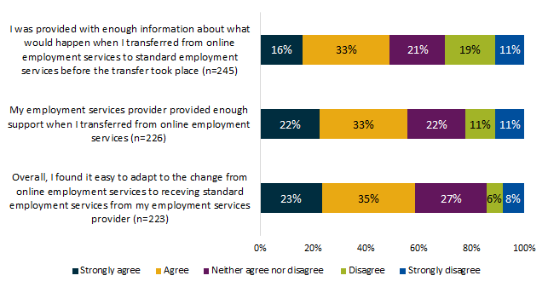
Source: 2019 quantitative research survey
Note: OEST participants who transferred out of the trial after six months
Survey respondents who disagreed that it was easy to adapt to the change from online to provider-based services (14%) were asked to describe the main reasons why it was difficult. Three key themes emerged from their responses:
- challenges in attending appointments
- dissatisfaction with the jobactive provider
- feelings of stress or lack of control associated with being in provider-based services.
The appointments for the employment agency can sometimes be inconvenient for plans, whereas online you can do it in your own time. (OEST participant, survey response)
Little communication. Treated like a number rather than a person. Waste of money and time to do the same things I was doing online. (OEST participant, survey response)
Constant pressure of attending appointments, wait times at employment provider and hard to deal with many times. Plus, extra expenses of travel and phone bill brings stress and anxiety trying to get used to employment providers, which most of are just time wasters.
(OEST participant, survey response)

5.2.1 Awareness of transferring arrangements
Survey results showed that while a majority of participants were aware that they would be transferred to a jobactive provider after six months in OEST if they had not found a job (63%), only 49% felt they were provided enough information (Figure 5.4).
However, a significant minority were not aware of the transfer arrangements. Qualitative research revealed OEST participants felt confused and/or surprised when they only became aware of this right before the end of the trial, through either a text message or an inbox notification.
Some OEST participants and providers felt that the transition was poorly communicated, negatively impacting the transition experience and participants’ willingness to engage in provider servicing.

5.3 OEST eligibility
An efficient and effective process of selecting participants for online servicing is important for targeted and high-quality service delivery. The JSCI formed a core part of assessing whether job seekers were eligible for employment servicing, by measuring job seeker disadvantage based on a series of questions. With online servicing, only the most job-ready job seekers were referred to the trial.
Qualitative research revealed providers believed that online servicing is not for everyone and suggested that it would be difficult for some job seekers to rely solely on online services without external support or additional services, notably those with low digital literacy and those with significant barriers to work.
However, the low level of opt-outs from the OEST (Chapter 3) and its effectiveness in terms of employment outcomes (Chapter 4), suggested that eligibility was generally well targeted. This was despite the JSCI in its current form being an assessment tool that is designed to predominantly measure labour market disadvantage and does not include criteria for assessing digital literacy. Nonetheless, there is room to further refine eligibility screening.

5.3.1 Digital literacy and access
Opt-out rates were higher among cohorts with lower digital literacy, such as older age groups and those with less education (Chapter 3). This finding was reinforced by providers reporting that internet access and digital literacy were not universal among Stream A job seekers.
[Job seekers] may have access to the internet because they have a smart phone, but they may not have internet at home.
(jobactive provider)
A considerable amount of job seekers don’t know how to use the internet … job seekers who have done factory or construction work need more help. (jobactive provider)
I think about 50% of my As can use the internet.
(jobactive provider)
As there were no provisions in the JSCI for assessing job seekers’ digital literacy over the length of the trial, it is likely that some job seekers selected for the OEST faced difficulty in managing the online platform appropriately.

5.3.2 Identifying job seekers with significant barriers to work
Providers identified a range of job seeker groups that they considered unlikely to be suitable for online employment servicing because of their significant barriers to finding work and/or interacting online. With regard to identifying job seekers with significant barriers, providers suggested that JSCI scores were often inaccurate due to:
- job seekers not understanding the questions, particularly those with limited English skills
- cultural reasons (e.g. acquiescence, which was identified as common in some cultures)
- job seekers not wanting to disclose personal circumstances they felt might compromise employer perceptions.
The classification is made over the phone so it’s difficult to get real data … it’s a five-minute process.
(jobactive provider or peak body representative in the qualitative research)
A lot of job seekers answer [the JSCI] in a way that they think will help them get a job … they’re the ones who could be lost.
(jobactive provider or peak body representative in the qualitative research)
Providers suggested that the JSCI assessment needed improving to more accurately reflect the level of support required by job seekers. However, early results from the separate evaluation of the Online JSCI Trial show high levels of consistency in JSCI results when they were re-tested in a follow-up survey. This confirms the results of regular departmental assurance of the JSCI.

5.4 Understanding participant views of digital servicing
In addition to providers’ and stakeholders’ views on who was suitable or not suitable for online servicing, qualitative research identified job seekers most suitable for online servicing, namely individuals with:
- a preference for online servicing
- perceived self-sufficiency in finding employment – the extent to which job seekers felt that they could find employment without assistance.
Segmentation analysis was conducted among survey respondents to analyse the relationship between the above factors and other related survey measures to identify and quantify groups of job seekers with similar suitability for online servicing. This analysis grouped job seekers who were eligible for OEST into five segments (Figure 5.5):

Segment 1: ‘I can find employment myself, and I’d prefer to do it online’
This segment accounted for 23% of eligible job seekers who were looking for work and is characterised by a strong preference for online employment services and by high perceived self-sufficiency in terms of finding employment. Compared with other segments, job seekers in Segment 1 were more likely to be:
- 24 years old or younger (60%)
- highly educated (tertiary educated or above (68%)
- heavy internet users (80%).

Segment 2: ‘I might need some extra help, but online is more convenient’
This segment comprised 29% of eligible job seekers who were looking for work and is characterised by a strong preference for online employment services and by lower perceived self-sufficiency. Job seekers in Segment 2 were more likely to be:
- living in metropolitan areas (80%)
- university educated (33%)
- currently participating in the OEST (24%)
- in employment services for less than three months (26%).

Segment 3: ‘I need extra help, but don’t want the inconvenience of meeting a provider in person’
This segment comprised 8% of eligible job seekers who were looking for work and is characterised by low perceived self-sufficiency and by a preference for online employment services. Compared to other segments, eligible job seekers in Segment 3 generally had:
- lower educational attainment (Year 12/13 educated or below, 45%)
- moderate to light internet usage (40%)
- lower likelihood of finding the jobactive website easy to use (68%).

Segment 4: ‘I need all the help I can get’
This segment comprised 25% of eligible job seekers who were looking for work and is characterised by low perceived self-sufficiency and by a preference for provider-based employment services. This segment consisted of job seekers who:
- had lower educational attainment (Year 12 educated or below, 44%)
- had been involved with employment services for six to nine months (33%)
- had received provider-based employment services previously (58%).

Segment 5: ‘I could do it myself, but having extra advice and support from an employment service provider could be valuable’
This segment accounted for 15% of eligible job seekers who were looking for work and is characterised by higher perceived self-sufficiency and by a preference for provider-based employment services. These job seekers were more likely to:
- be aged 50 or older (27%)
- live in regional or remote locations (32%)
- have received a vocational education qualification (45%)
- have received jobactive employment services (57%).
Figure 5.5 Segmentation of job seekers who were eligible for the OEST
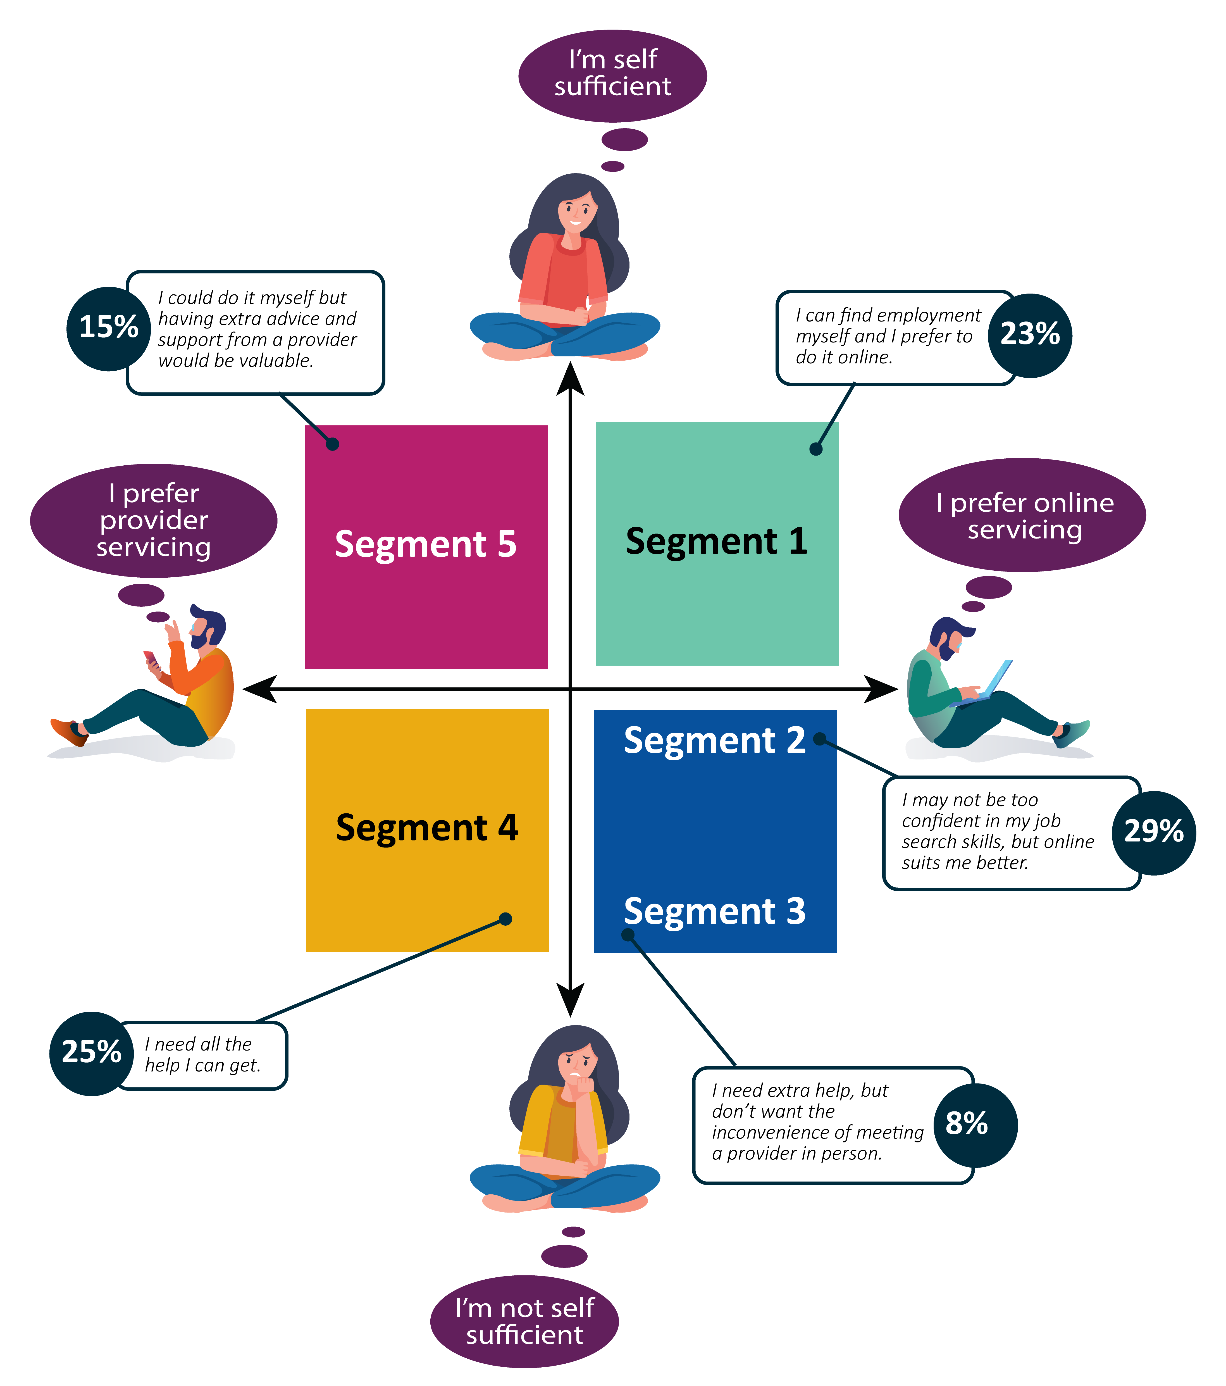
Source: ORIMA quantitative survey
Note: Survey respondents who were eligible for OEST and looking for work, n=2,005.

5.5 Participants’ and stakeholders’ suggested improvements to online employment services
When surveyed, almost half of OEST participants (49%) offered suggestions for improvement. Stakeholders and jobactive providers also made some suggestions. The most common suggestions from participants were to:
- receive assistance from a ‘real person’ where needed (16%)
- improve aspects of the jobactive website (8%)
- feature additional jobs on the website (8%)
- improve the quality/suitability of jobs and/or the job search tool (5%)
- introduce or improve linkages to other (private) job search sites (3%)
- provide more and clearer information about the OEST (5%).
Suggestions received from participants, jobactive providers and/or other stakeholders during the qualitative research included:
- having a compulsory guide to or overview of the website when job seekers commence online employment services. This would ensure they were aware of the resources available to them, even if they did not wish to access them immediately
- conducting the initial assessment of job seeker suitability for online employment servicing face to face to improve screening and better identify barriers that might impact on eligibility for online servicing
- checking the wellbeing of job seekers at three months
- providing tailored advice or tips to help improve employment outcomes
- providing more detailed briefings to job seekers about how online employment servicing works at the initial application/assessment interview
- reducing the maximum length of time on online servicing to three to four months
- including a mechanism (e.g. identifying patterns in administrative data/information recorded on the jobactive website) to identify job seekers who are either not actively looking for jobs (e.g. submitting bulk applications on the last day) or providing poor-quality cover letters, applications or CVs
- featuring tips for expanding job seekers’ job search approaches and ensuring job seekers are aware of these resources.

Chapter 6. Conclusion
This chapter summarises findings from the OEST evaluation and considers any additional servicing required to meet the needs of job seekers who are disadvantaged in receiving employment services on an online platform. This report concludes by discussing the relevance of the OEST evaluation to recent changes to the employment services model.

6.1 What did we learn?
Overall, the evaluation showed online employment servicing has the capacity to deliver efficient and effective services to the most job-ready cohort. Most OEST participants demonstrated that they could self-manage their job search and meet their MORs in an online platform.
The majority of OEST participants indicated that they were comfortable operating in an online self-managed environment. A small proportion of job seekers referred to the trial preferred face-to-face contact and opted for provider-based services.
Both OEST participants and job seekers in provider servicing were aware of their MORs. Over the study period, the compliance of the OEST participants was broadly similar to that of job seekers in provider servicing.
Importantly, OEST participants (who were the most job-ready job seekers) were as likely to exit income support and employment services as Stream A job seekers in the comparison group in provider-based servicing.
The OEST was well received by participants. They considered that digital servicing should be the default option, or ‘first option’, for the provision of employment services to job seekers who have just started looking for a job.
While the majority of job seekers were satisfied with the jobactive website, qualitative research identified areas for improvement including enhanced guidance and support, and user friendliness. There is scope for improvement in the transition of participants from online employment services into provider-based employment services, including communication and the transition process itself.

6.1.1 What worked?
As noted in the literature, one key enabler of a successful e-government service is that the system and the necessary infrastructure are reliable and easy to use (Colesca, 2009). The evaluation shows that a majority of OEST participants had a positive experience with online servicing. More than three-quarters (80%) of both OEST participants and provider-serviced job seekers reported they were satisfied with the jobactive website, and only 4% were dissatisfied.
OEST participants’ job search skills increased over time. Participants demonstrated high levels of confidence in their belief that the assistance they received through the jobactive website would help them secure employment. Importantly, participants were as likely as those in provider servicing to exit employment services and income support.

6.1.2 Who did not participate?
During the qualitative research jobactive providers expressed a concern that disadvantaged job seekers were referred to the OEST when they required provider support and assistance. Despite providers’ concerns, only 9% of job seekers referred to OEST opted out of the trial. The cohorts that opted out tended to be:
- those with lower digital literacy or access
- those with lower educational attainment
- mature aged job seekers
- those in more regional areas
- Indigenous job seekers.
A solution is being developed for job seekers with low digital literacy that is not identified through the JSCI assessment. The Digital Assessment identifies job seekers who may not be able to self-manage their job search and training requirements adequately and encourages them to connect with a provider as appropriate.

6.1.3 Limits of the learnings
There are three major caveats to the above lessons.
- The trial occurred during a relatively strong labour market. Further analysis is required to determine if the results would be repeated under softer labour market conditions.
- OEST servicing was limited to six months and the evaluation focused on the analysis within the six-month trial period. The department will undertake further analysis on the impact beyond six months.
- The trial only tells us about the effectiveness of digital services for job-ready job seekers. It may be the case that digital servicing is less effective for job seekers with substantial barriers.

6.2 Future directions
As discussed in Chapter 1, the use of digital servicing has significantly expanded since the trial was announced. In particular, the department has been conducting the New Employment Services Trial (NEST) and has rolled out Online Employment Services (OES) in response to the unprecedented demand for employment services created by the COVID-19 pandemic. The evaluation of the OEST is timely as it provides insights that will be useful in the continuing rollout of OES and the ongoing development of NESM.
Importantly, this evaluation provides evidence to support the approach of providing digital services to the most job-ready job seekers, which is used in both the NEST and OES. For the most job-ready job seekers online servicing was as successful as provider servicing in assisting job seekers to find employment.
The evaluation findings are in line with international and local research. They reinforce the view that sensitive assessment remains an important part of connecting job seekers with the right assistance and will be an important part of building online servicing into the broader employment services framework.
The department is also evaluating NEST to gauge how digital servicing for the most job-ready, combined with enhanced services for the most disadvantaged, can lead to better targeting of assistance and improved employment outcomes. The department will also conduct an evaluation of OES.

Bibliography
Alawadhi, Suha and Morris, Anne (2009). Factors influencing the adoption of e-government services. Journal of Software 4. doi: 10.4304/jsw.4.6.584-590. https://www.researchgate.net/profile/Suha_Alawadhi/publication/42804639_Factors_Influencing_the_Adoption_of_E-government_Services/links/54f2cf100cf2b36214b2d56c/Factors-Influencing-the-Adoption-of-E-government-Services.pdf
Anzai, Y and Simon, HA (1979). The theory of learning by doing. Psychological Review 86(2): 124–140. https://psycnet.apa.org/record/1979-27801-001
Australian Government (2019). Be Connected [website]. https://beconnected.esafety.gov.au/ [accessed 8 November 2019]
Australian Public Service Commission (2018). Australian Government use of information and communication technology. Canberra. https://www.apsc.gov.au/australian-government-use-information-and-communication-technology
Australian Institute of Health and Welfare (2019). Older Australia at a glance: Australia’s changing age and gender profile [online]. https://www.aihw.gov.au/reports/older-people/older-australia-at-a-glance/contents/demographics-of-older-australians/australia-s-changing-age-and-gender-profile [accessed 19 December 2019]
Australian Taxation Office (2019). The four pillars of compliance [online]. https://www.ato.gov.au/General/Tax-and-individuals---not-in-business/In-detail/The-four-pillars-of-compliance/ [accessed 8 July 2020]
Barth, M and Veit, D (2011). Electronic service delivery in the public sector: Understanding the variance of citizens’ resistance. In Hawaii International Conference on System Sciences. Kauai, USA. https://www.researchgate.net/publication/224221252_Electronic_Service_Delivery_in_the_Public_Sector_Understanding_the_Variance_of_Citizens'_Resistance [accessed 7 July 2020]
Bekkers, V and Homburg, V (2007). The myths of e-government: Looking beyond the assumptions of a new and better government. The Information Society 23(5): 373–382. doi: 10.1080/01972240701572913. https://www.researchgate.net/publication/220175531_The_Myths_of_E-Government_Looking_Beyond_the_Assumptions_of_a_New_and_Better_Government [accessed 7 July 2020]
Carter, L and Bélanger, F (2005). The utilization of e-government services: Citizen trust, innovation and acceptance factors. Information Systems Journal 15(1): 5–25. doi: 10.1111/j.1365-2575.2005.00183.x. http://csel.eng.ohio-state.edu/productions/intel/research/trust/utilization%20of%20e-government%20services.pdf
Chen, J (2017). Breaking down barriers to digital government: How can we enable vulnerable consumers to have equal participation in digital government? Australian Communications Consumer Action Network (ACCAN). https://accan.org.au/Breaking%20Down%20Barriers%20to%20Digital%20Government.pdf
Colesca, Sofia (2009). Understanding trust in e-government. Engineering Economics 3: 7–15. https://www.researchgate.net/publication/228867440_Understanding_Trust_in_e-Government, [accessed 7 July 2020]
Department of Education and Training (2012). National Foundation Skills Strategy for Adults. Canberra: Australian Government. https://www.employment.gov.au/national-foundation-skills-strategy-adults
Department of Education, Skills and Employment (2019). Career transition assistance [online]. https://www.employment.gov.au/career-transition-assistance [accessed 8 November 2019]
Department of Infrastructure, Transport, Regional Development and Communications (2019). Universal Service Guarantee for Telecommunications [online]. https://www.communications.gov.au/what-we-do/phone/phone-services/universal-service-guarantee-telecommunications [accessed 4 November 2019]
Digital Transformation Agency (2019). Digital Transformation Agency [website]. https://www.dta.gov.au/ [accessed 20 February 2020]
Ebrahim, Z and Irani, Z (2005). E‐government adoption: Architecture and barriers. Business Process Management Journal 11(5): 589–611. doi: 10.1108/14637150510619902. https://www.researchgate.net/publication/235254120_E-government_adoption_Architecture_and_barriers [accessed 7 July 2020]
Gauld, R, Gray, A and McComb, S (2009). How responsive is e-government? Evidence from Australia and New Zealand. Government Information Quarterly 26: 69–74. doi: 10.1016/j.giq.2008.02.002. https://www.researchgate.net/publication/236214457_How_responsive_is_E-Government_Evidence_from_Australia_and_New_Zealand
Glance, D (2016). #CensusFail: The ABS hasn’t convinced the public their privacy is protected [blog]. The Conversation, 9 August 2016. https://theconversation.com/censusfail-the-abs-hasnt-convinced-the-public-their-privacy-is-protected-63702
Hill, S (2019). 5 reasons why governments are ignoring UX thinking. Esri Australia [website]. https://esriaustralia.com.au/blog/5-reasons-why-governments-are-ignoring-ux-thinking [accessed 8 November 2019]
Idler, S (2012). Towards user centered design in 5 steps [blog]. CX Insights, 31 January 2012. https://usabilla.com/blog/towards-user-centred-design-in-5-steps/ [accessed 19 December 2019]
Joseph, S (2019). Advantages and disadvantages of e-government implementation. International Journal Of Marketing And Technology 5(9): 18–34. https://www.researchgate.net/publication/281409802_Advantages_and_disadvantages_of_E-_government_implementation_literature_review
Kamau, G, Njihia, M and Wausi, A (2016). E-government websites user experience from public value perspective: Case study of iTax website in Kenya. In 2016 IST-Africa Week Conference. https://www.researchgate.net/publication/305997845_E-government_websites_user_experience_from_public_value_perspective_Case_study_of_iTax_website_in_Kenya
Lapowsky, I (2019). The challenge of America’s first online census. Wired, 2 July 2019. https://www.wired.com/story/us-census-2020-goes-digital/
Liu, Y, Zhu, L and Gorton I (2007). Performance assessment for e-government services: An experience report. In HW Schmidt, I Crnkovic, GT Heineman and JA Stafford (eds), Component-based software engineering. CBSE 2007. Lecture Notes in Computer Science 4608. Berlin/Heidelberg: Springer https://link.springer.com/chapter/10.1007/978-3-540-73551-9_6
Macquarie Group (2019). Demystifying the magic behind eTax and tax pre-fill. Macquarie [website]. https://www.macquarie.com/au/personal/financial-advice/expertise/eTax-and-tax-pre-fill/ [accessed 7 November 2019]
Merhi, M and Koong, K (2016). E-government effectiveness: A rocket model of contributing user-related factors. International Journal of Services and Standards 11(1): 1. doi: 10.1504/ijss.2016.076968. https://www.researchgate.net/publication/303909258_E-government_effectiveness_A_rocket_model_of_contributing_user-related_factors [accessed 7 July 2020]
OECD (2017). Building skills for all in Australia: Policy insights from the survey of adult skills. OECD Skills Studies. Paris: OECD Publishing. https://doi.org/10.1787/9789264281110-en
OECD (2018). Digital Government Toolkit. https://www.oecd.org/governance/digital-government/toolkit/home/ [accessed 1 November 2019]
Quinn, B (2018). The ‘nudge unit’: The experts that became a prime UK export. The Guardian, 11 November 2018. https://www.theguardian.com/politics/2018/nov/10/nudge-unit-pushed-way-private-sector-behavioural-insights-team
Solinthone, P and Rumyantseva, T (2016). E-government implementation. MATEC Web Conference. doi: 10.1051/matecconf/20167901066. https://doi.org/10.1051/matecconf/20167901066
Stragier, J, Verdegem, P and Verleye, G (2010). How is e-government progressing? A data driven approach to e-government monitoring. Journal of Universal Computer Science 16: 1075–1088. doi: 10.3217/jucs-016-08-1075. https://www.researchgate.net/publication/220348920_How_is_e-Government_Progressing_A_Data_Driven_Approach_to_E-government_Monitoring [accessed 7 July 2020]
Teicher, J and Dow, N (2002). E-government in Australia: Promise and progress. Information Polity 7(4): 231–246. https://www.deepdyve.com/lp/ios-press/e-government-in-australia-promise-and-progress-qh1KqBIRZU
Thomas, J, Barraket, J, MacDonald, T, Mundell, M, Tucker, J and Ewing, S (2018). Measuring Australia’s digital divide: The Australian Digital Inclusion Index 2018. Melbourne: Telstra. https://digitalinclusionindex.org.au/wp-content/uploads/2018/08/Australian-digital-inclusion-index-2018.pdf [accessed 7 July 2020]
United Nations (2018). United Nations E-Government Survey 2018: Gearing e-government to support transformation towards sustainable and resilient societies. New York: United Nations. doi: 10.18356/d54b9179-en. https://www.un-ilibrary.org/democracy-and-governance/united-nations-e-government-survey-2018_d54b9179-en [accessed 8 July 2020]
Van Dijk, J, Peters, O and Ebbers, W (2008). Explaining the acceptance and use of government internet services: A multivariate analysis of 2006 survey data in the Netherlands. Government Information Quarterly 25(3): 379–399. doi: 10.1016/j.giq.2007.09.006. https://www.researchgate.net/publication/248544637_Explaining_the_acceptance_and_use_of_government_Internet_services_A_multivariate_analysis_of_2006_survey_data_in_the_Netherlands [accessed 8 July 2020]

Appendices

Appendix A International practice

The OECD
In 2014, the Organisation for Economic Co-operation and Development (OECD) Council adopted the Recommendation on Digital Government Strategies. The recommendation provided a set of 12 principles structured around three pillars (OECD, 2018). These represent the ideals of e-government that governments around the world ought to espouse. The OECD offered governments self-assessment guidelines for each of the principles.
The recommendation recognised that digitisation will play a key role in leveraging transformation of the public sector at large, given its potential to increase productivity and inclusiveness of service production and delivery in public welfare areas. It acknowledged the political imperatives of member governments for improving the efficiency, effectiveness and governance of public services design and delivery through digitisation.

Canada
Bekkers and Homburg (2007) noted:
The mission of the Canadian e-government policies, as formulated in the ‘Government Online’ programs (Treasury Board, 1999, 2000, 2006), is to advance the federal government’s citizen centred service delivery vision collaboratively across departments and other levels of government.
An evaluation of the Canadian Government e-services in the early 2000s sought to establish a mechanism for continued evaluation of the services offered, in order put effective measures in place to increase usership and general satisfaction (D’Auray, 2003).
Almost 10 years later, Reddick and Turner (2012) examined the gap between online and offline populations in regard to the use of e-government services in Canada. They identified the decision process for the choice of service delivery (phone or online) of users as largely driven by the cause of the individual’s engagement with the government service – that is, whether it was to seek information (online), or to solve a problem (phone). As with the previous authors, they concluded that, ‘creating a positive experience for citizens when they received a service translates into a more satisfied experience with e-government’ (Reddick and Turner, 2012).

India
Rana and Dwivedi (2015) studied e-government services in India, and examined how social cognitive theory (SCT) influenced participation in government online services. They determined that factors such as outcome expectation, affect, anxiety, self-efficacy, social influence and behavioural intention were all influential in the adoption of societal-based information systems, including e-government systems. The government system examined in this study was a non-compulsory government service (meaning that users opted in). Therefore, applying the influence of SCT assumed a level of choice by the participant to take part, or not. Where the government system in question is a compulsory tool, such as part of receiving income support, the motivations for participation may not rest as strongly on social influence and self-efficacy and more on outcome expectation and anxiety, with participants looking to social exchange theory (SET) (Blau, 1964) to determine cost, risk and benefit of using the service.
Osman et al. (2014) used SET as the basis for an evaluation model of user satisfaction with e-government services, identifying core factors such as cost, opportunities, benefits and risk analysis (COBRA) and the multidirectional relationship of these factors in creating user satisfaction. Most notably, economic theory (cost-benefit) was said to explain user satisfaction.
The importance of user satisfaction is central to the success of e-government services. Osman et al. (2014) concisely illustrated that where ‘the benefit and opportunity values are greater than the cost and risk values, then an e-service user would be more satisfied and more likely to continue using such e-service; otherwise the user will not re-use’ (Osman et al., 2014). This was echoed by Lin (2010), who examined online use through the lens of the theory of planned behaviour (TPB). The TPB relies on three core assumptions/belief structures: the attitudinal belief structure, the normative belief structure and the behavioural control belief structure (ease of use).
Lin (2010) emphasises the importance of creating an inclusive online environment in line with TPB belief structures, creating a positive user experience to achieve high engagement. ‘IT adoption is more than just technology deployment; it requires careful consideration of social-cognitive factors (e.g., attitudes, subjective norms, and perceived behavioural control) for increasing user intention toward a new system and persuading them to use it’ (Lin, 2010).

South Korea
By its nature, e-government tends to enable more efficient record keeping. Solinthone and Rumyantseva (2016) cite the example of South Korea to demonstrate the potential and flow-on benefits of e-government for record keeping. In South Korea, the use of electronic documents has become standard, and most administration is handled electronically.
All central administrative organisations have adopted a standardised business process system. This system records all administrative decision making, which increases not only the efficiency of administration but also transparency. South Korean citizens can request and check online a wide range of administrative information and national records at any time and from any location. This system employed in South Korea is a major reason why the 2018 United Nations E-government Development index ranks South Korea third globally, just behind Australia.

United Kingdom
As noted by Bekkers and Homburg (2007):
In the UK documents ‘Modernising Government’ (Minister for the Cabinet Office, 1999), ‘E-Government: A Strategic Framework for Public Services in the Information Age’ (Minister for the Cabinet Office, 2000) and ‘Transformational Government’ (Minister for the Cabinet Office, 2005), e-government is seen as having only one purpose: to make life better for citizens and businesses. The focus upon the improvement of electronic service delivery assumes that it will deliver what people really want, fully exploiting government’s information resources:
‘… new technology offers the possibility of making access to information about government easier (...) The digital age also offers the possibility of a better informed and more participative democracy through electronic consultation and better responses to feedback’ (Minister for the Cabinet Office, 2000: 8).
In ‘Transformational Government’, the promise of a new and better government is stretched further:
‘The specific opportunities lie in improving transactional services (...) in helping front line public servants to be more effective (...) in supporting effective policy outcomes (...) in reforming the corporate services and infrastructure which government uses behind the scenes’ (Minister for the Cabinet Office, 2005: 3; emphasis in original)
In the UK vision, emphasis is on the notion of intra-governmental cooperation: ‘To improve the way we provide services, we need all parts of the government to work together’ (Minister for the Cabinet Office, 1999: 4)’.
As governments increasingly use digital channels to deliver a wide range of information, interaction and transaction services, and at a growing level of sophistication, the amount of data collected also grows. This occurs both by design and as a by-product of this transition to e-government. This data can be analysed and used to inform government policy in order to make it more effective. Data analysis can also be used to make the e-government systems themselves more user-centric (Stragier, Verdegem and Verleye, 2010) and leverage behavioural insights. For example, in the United Kingdom there was a 38% reduction in patient referrals to overbooked hospitals. This resulted from making use of data collected via e-government platforms, and then installing a pop-up prompt in the GP referral system.

Denmark
Bekkers and Homburg (2007) observe:
In the Danish vision on e-government, From Vision to Action: The Information Society 2000 (Ministry of Research and Information Technology, 1995), e-government is described, conceptualized and discussed in the context of the network society: a worldwide short circuit of time, space, people and processes. As such, the Danish case (at least until 2004) is an exceptional case in the sense that ICTs are seen as contributing to free access of information, grass roots democracy, personal development of individuals in workplace and private life, and transparency of the administrative apparatus:
‘The new technologies must give all citizens free access to information and exchange of information, and the possibilities for increasing the citizens’ self-determination are to be exploited. It must be ensured that the technologies are not used for monitoring citizens or invading their privacy’ (Ministeriet for Videnskab Tecknologi og Udvikling, 2000: 9)
In order to accomplish the goals described earlier, policymakers put emphasis on life-long learning, the stimulation of e-commerce, more effective and cheaper public service delivery, the stimulation of grassroots digital democratic initiatives, and the establishment of information intensive organizations in specific regions (so-called IT lighthouses). The above vision of e-government contrasts with that of the 2004 policy document ‘The Danish eGovernment Strategy 2004-06’ (Digital Taskforce, 2004). In this document the vision is articulated in one sentence: ‘digitalization must contribute to the creation of an efficient and coherent public service with a high quality of service, with citizens and businesses in the centre’ (Digital Taskforce, 2004: 4).

Appendix B Impact of policy and systems changes 1 July 2019 to 9 December 2019
Date | Action | Policy or system impact | End date
1 July 2018 | Launch of the OEST | 5,000 participants a year | 30 June 2020
1 Jan 2019 | Expansion of OEST (MYEFO 2018–19) | Additional 25,000 Stream A jobactive participants | 30 June 2020
Budget 2019–20 | Expansion of OEST and new end date | Extended to June 2022. An additional 35,000 participants | June 2022
MYEFO 2019–20 | Expansion of OEST | Additional 33,750 participants between 1 April 2020 and 30 June 2022 | 30 June 2022
Feb 2019 | Yarrabah area excluded from OEST | Prevention of Yarrabah Trial and OEST intersection | 30 June 2022
29 June 2019 | 1. TtW participants excluded from OEST  2. Paid work declaration feature on jobactive website included  3. Adjustment to job search by NCSL feature  4. Messaging feature | TtW eligible participants are no longer referred to OEST  Job search halved or reduced to zero depending on personal circumstances  Job search function on jobactive website made easier. NCSL operators able to vary a job seeker’s job search MOR requirements  Introduction of additional message on jobactive website at the 15-day mark to remind job seekers in the trial of their job search requirements and deadline  Job search function on jobactive website made easier | 30 June 2022
1 July 2019 | OEST intake numbers anticipated to be affected by the commencement of NEST | Commencement of NEST in Adelaide South and Mid North Coast NSW Employment Regions (ERs) | 30 June 2022
10–18 Sept 2019 | Bushfire contingency plans apply in four jobactive sites* | Proxy servicing area impacted, affecting 510 job seekers (by Job Seeker ID type) | 30 June 2022
25 Sept 2019 | Job Seeker Snapshot introduced | Job Seeker Snapshot – JSCI landing page on OEST updated with wording saying ‘This form is called the Job Seeker Snapshot. Your answers help us understand how to support you to find and keep a job. Your Job Seeker Snapshot must be accurate and up to date.’ Participants’ answers enable tailored support to find and keep a job | 30 June 2022
1 Oct 2019 | Digital Plus service commenced in NEST areas | Digital Service Contact Centre established | 30 June 2022
9 Oct 2019 | Text messages sent to participants | 1. Compliance notifications sent on first and second demerit  2. Reminder 5 days before the end of the job search period to undertake job search  3. Compliance notification – sent on third demerit | 30 June 2022
30 Oct 2019 | Bushfire contingency plans apply in north coast NSW | Advice sent to DHS to lift payment suspension for non-compliant events in relevant areas | 30 June 2022
4 Nov 2019 | OEST participants transition to NEST in the two trial regions | OEST to NEST transition for Adelaide South and Mid North Coast NSW ERs  Anticipated to affect intake numbers for the OEST as new flow in these regions will go to NEST instead of OEST
9 Dec 2019 | Introduction of Volunteer Online Employment Services Trial (VOEST) | Eligible volunteers (Stream A volunteers) in all jobactive, ParentsNext and NEST ERs to self-manage their job search through an online platform for a period of 12 months | 30 June 2022

Appendix C Demographic profile of focus groups
Table C1 Demographic profile of focus groups
Gender | Male  56% | Female  44% | — | — | — | —
Age | 18–24 yrs  35% | 25–30 yrs  11% | 31–40 yrs  17% | 41–50 yrs  18% | 51–60 yrs  14% | 61–70 yrs  4%
Marital status | Single  60% | Married  19% | Divorced / Separated  14% | De facto / Partnered 7% | — | —
Dependent children | No  83% | Yes  17% | — | — | — | —
Employment status | Unemployed / job seeking  70% | Working casually  12% | Studying  7% | Working part time  6% | Self-employed  1% | Other*  3%
Cultural background | NESB  28% | — | — | — | — | —
Indigeneity | Aboriginal and/or Torres Strait Islander 3% | — | — | — | — | —
Frequency of internet access | Once a day  96% | Weekly  4% | — | — | — | —
Device most used | Mobile phone  68% | Personal laptop  56% | Home desk computer  28% | Tablet/iPad  10% | Computer at ESP  4% | Public e.g. library  3%
Source: Qualitative research data
Note: *Home / caring duties receiving a Centrelink payment; retired / semi-retired / self-funded retiree; other

Appendix D The quantitative fieldwork
Each wave of quantitative fieldwork was conducted in two parts, with a new sample drawn from the department’s administrative data system for use in both the first and second parts of the fieldwork. This minimised the delay between when contact details were extracted from the system and when participants were invited to take part in the survey and was done to account for the potential for job seekers to change OEST participation status. The survey also included a screening section to account for any subsequent changes to job seekers’ participation status.
The fieldwork consisted of both online surveys and Computer Assisted Telephone Interviews (CATI). Both parts of the survey wave involved an initial two-week period where online surveys were conducted, followed by a two-week period where CATI surveys were conducted. This sequencing allowed job seekers who did not complete the online survey to be approached to take part in the survey by CATI, together with those job seekers who were not invited to complete the online survey because they did not have an email address recorded in the sample. The online survey involved email invitations and up to two rounds of reminders sent by email and SMS. SMS invitations to the online survey were also sent to job seekers who did not take part in the CATI survey and who did not have an email address.
A total of 11,961 job seekers were invited to take part in the survey across the three waves, including 7,511 job seekers invited to complete the survey online and 8,637 approached to take part via a CATI. A total of 4,083 job seekers completed the surveys across all three waves, representing a 34% response rate (28% online and 23% via CATI). This included 2,222 job seekers in Wave 1, 880 additional job seekers in Wave 2 and 981 additional job seekers in Wave 3.
The longitudinal analysis provided a measure of changes in job seekers’ views and experiences over time. In Wave 2 there were 490 longitudinal job seeker responses who participated in both Waves 1 and 2, and in Wave 3 there were 373 longitudinal job seeker responses who participated in Wave 3 in addition to Wave 1, Wave 2 or both Waves 1 and 2. The longitudinal response rate was 40% (32% online and 33% CATI) – in total, 863 job seekers took the survey out of the 2,134 job seekers who were contacted to take part in the survey after responding to the survey in previous waves.

Appendix E Impact of participant characteristics on exits from income support and employment services – comparison group versus trial participants

Age
Table E1 Exits by age group
Exits | Number of OEST participants | (%) | Number of comparison group |  | (%) | Per cent difference
Exits from income support | — | — | — | — |  | —
Age less than 25 years | — | — | — | — |  | —
- within 4 weeks | 372 | 9.3 | 263 | 6.5 |  | 2.8*
- within 12 weeks | 990 | 29.8 | 905 | 27.2 |  | 2.6*
- within 24 weeks | 1,088 | 45.8 | 1,152 | 48.8 |  | -3.0*
Age 25 to 29 years | — | — | — | — |  | —
- within 4 weeks | 103 | 11.7 | 98 | 11.1 |  | 0.6
- within 12 weeks | 293 | 41.6 | 171 | 38.9 |  | 2.7
- within 24 weeks | 304 | 60.8 | 306 | 61.5 |  | -0.7
Age 30 to 49 years | — | — | — | — |  | —
- within 4 weeks | 138 | 11.3 | 115 | 9.4 |  | 1.9
- within 12 weeks | 340 | 36.1 | 319 | 33.8 |  | 2.3
- within 24 weeks | 340 | 57.3 | 331 | 55.7 |  | 1.6
Age 50 years and over | — | — | — | — |  | —
- within 4 weeks | 64 | 11.4 | 44 | 8.0 |  | 3.4
- within 12 weeks | 134 | 31.7 | 102 | 24.1 |  | 7.6*
- within 24 weeks | 124 | 46.8 | 129 | 48.9 |  | -2.1
Exits from employment services | — | — | — | — |  | —
Age less than 25 years | — | — | — | — |  | —
- within 4 weeks | 66 | 1.6 | 60 | 1.5 |  | 0.2
- within 12 weeks | 676 | 20.3 | 576 | 17.3 |  | 3.0*
- within 24 weeks | 1,073 | 45.2 | 1,069 | 45.3 |  | -0.1
Age 25 to 29 years | — | — | — | — |  | —
- within 4 weeks | ## | 1.8 | ## | 1.7 |  | 0.1
- within 12 weeks | 184 | 26.1 | 168 | 24.0 |  | 2.1
- within 24 weeks | 276 | 55.2 | 296 | 55.4 |  | -0.2
Age 30 to 49 years
- within 4 weeks | 21 | 1.7 | ## | 1.3 |  | 0.4
- within 12 weeks | 215 | 22.8 | 179 | 19.0 |  | 3.8*
- within 24 weeks | 300 | 50.6 | 287 | 48.3 |  | 2.3
Age 50 years and over | —— | — | — | — |  | —
- within 4 weeks | ## | 2.7 | ## | 0.7 |  | 2.0*
- within 12 weeks | 85 | 20.1 | 62 | 14.6 |  | 5.5*
- within 24 weeks | 106 | 40.0 | 110 | 41.7 |  | -1.7
Source: DESE administrative data
Note:
* indicates statistically significant difference between groups at p < 0.05
## indicates values lower than 20

Location
Table E2 Exits by remoteness
Exits | Number of OEST participants | (%) | Number of comparison group | (%) | Per cent difference
Exits from income support | — | — | — | — | —
Major cities | — | — | — | — | —
- within 4 weeks | 491 | 9.9 | 383 | 7.7 | 2.2*
- within 12 weeks | 1,304 | 32.7 | 1,216 | 30.4 | 2.3*
- within 24 weeks | 1,400 | 50.5 | 1,471 | 53.2 | -2.7
Inner regional | — | — | — | — | —
- within 4 weeks | 137 | 10.5 | 103 | 7.9 | 2.6*
- within 12 weeks | 338 | 31.4 | 286 | 27.0 | 4.4*
- within 24 weeks | 343 | 47.2 | 331 | 46.0 | 1.2
Outer regional | — | — | — | — | —
- within 4 weeks | 49 | 12.0 | 34 | 8.3 | 3.6
- within 12 weeks | 115 | 35.0 | 96 | 29.3 | 5.7
- within 24 weeks | 113 | 48.5 | 116 | 50.4 | -1.9
Exits from employment services | — | — | — | — | —
Major cities | — | — | — | — | —
- within 4 weeks | 86 | 1.7 | 77 | 1.6 | 0.2
- within 12 weeks | 842 | 21.1 | 756 | 18.9 | 2.2*
- within 24 weeks | 1,300 | 46.9 | 1,358 | 49.1 | -2.2
Inner regional | — | — | — | — | —
- within 4 weeks | 26 | 2.0 | ## | 1.0 | 1.0*
- within 12 weeks | 237 | 22.0 | 175 | 16.5 | 5.5*
- within 24 weeks | 341 | 46.9 | 304 | 42.2 | 4.7
Outer regional | — | — | — | — | —
- within 4 weeks | ## | 1.5 | ## | 1.2 | 0.2
- within 12 weeks | 81 | 24.6 | 54 | 16.5 | 8.2*
- within 24 weeks | 114 | 48.9 | 100 | 43.5 | 5.5
Source: DESE administrative data
Note:
* indicates statistically significant difference between groups at p < 0.05
## indicates values lower than 20

Gender
Table E3 Exits by gender
Exits | Number of OEST participants | (%) | Number of comparison group | (%) | Per cent difference
Exits from income support | — | — | — | — | —
Female | — | — | — | — | —
- within 4 weeks | 290 | 10.1 | 218 | 7.6 | 2.5*
- within 12 weeks | 788 | 34.0 | 677 | 29.2 | 4.8*
- within 24 weeks | 826 | 51.5 | 822 | 51.8 | -0.3
Male | — | — | — | — | —
- within 4 weeks | 387 | 10.1 | 302 | 7.9 | 2.2*
- within 12 weeks | 969 | 31.5 | 921 | 30.0 | 1.5
- within 24 weeks | 1,030 | 48.4 | 1,096 | 51.5 | -3.1*
Exits from employment services | — | — | — | — | —
Female | — | — | — | — | —
- within 4 weeks | 62 | 2.2 | 38 | 1.3 | 0.8*
- within 12 weeks | 518 | 22.4 | 423 | 18.2 | 4.1*
- within 24 weeks | 787 | 49.1 | 764 | 48.1 | 0.9
Male | — | — | — | — | —
- within 4 weeks | 56 | 1.5 | 57 | 1.5 | 0.0
- within 12 weeks | 642 | 20.9 | 562 | 18.3 | 2.6*
- within 24 weeks | 968 | 45.5 | 998 | 46.9 | -1.4
Source: DESE administrative data
Note:
* indicates statistically significant difference between groups at p < 0.05
## indicates values lower than 20

Education
Table E4 Exits by education
Exits | Number of OEST participants | (%) | Number of comparison group | (%) | Per cent difference
Exits from income support | — | — | — | — | —
Under Year 12 | — | — | — | — | —
- within 4 weeks | 63 | 11.2 | 41 | 7.3 | 3.9*
- within 12 weeks | 124 | 27.5 | 101 | 22.8 | 4.7
- within 24 weeks | 123 | 40.5 | 122 | 41.1 | -0.6
Year 12 and above | — | — | — | — | —
- within 4 weeks | 614 | 10.0 | 479 | 7.8 | 2.2*
- within 12 weeks | 1,633 | 33.0 | 1,497 | 30.3 | 2.8*
- within 24 weeks | 1,733 | 50.6 | 1,796 | 52.5 | -2.0
Exits from employment services | — | — | — | — | —
Under Year 12 | — | — | — | — | —
- within 4 weeks | ## | 2.5 | ## | 1.8 | 0.7
- within 12 weeks | 89 | 19.7 | 58 | 13.1 | 6.7*
- within 24 weeks | 120 | 39.5 | 105 | 35.4 | 4.1
Year 12 and above | — | — | — | — | —
- within 4 weeks | 104 | 1.7 | 85 | 1.4 | 0.3
- within 12 weeks | 1,071 | 21.7 | 927 | 18.7 | 2.9*
- within 24 weeks | 1,635 | 47.7 | 1,657 | 48.5 | -0.8
Source: DESE administrative data
Note:
* indicates statistically significant difference between groups at p < 0.05
## indicates values lower than 20

CALD
Table E5 Exit by CALD status
Exits | Number of OEST participants |  | (%) | Number of comparison group | (%) | Per cent difference
Exits from income support | — | — |  | — | — | —
CALD | — | — |  | — | — | —
- within 4 weeks | 68 | 8.5 |  | 54 | 6.7 | 1.7
- within 12 weeks | 200 | 31.3 |  | 175 | 27.3 | 4.0
- within 24 weeks | 225 | 51.0 |  | 226 | 51.0 | 0.0
Non CALD | — | — |  | — | — | —
- within 4 weeks | 609 | 10.4 |  | 466 | 7.9 | 2.5*
- within 12 weeks | 1,557 | 32.7 |  | 1,423 | 30.0 | 2.8*
- within 24 weeks | 1,631 | 49.6 |  | 1,692 | 51.7 | -2.1
Exits from employment services | — | — |  | — | — | —
CALD | — | — |  | — | — | —
- within 4 weeks | ## | 1.9 |  | ## | 1.9 | 0.0
- within 12 weeks | 129 | 20.2 |  | 105 | 16.4 | 3.8
- within 24 weeks | 193 | 43.8 |  | 202 | 45.6 | -1.8
Non CALD | — | — |  | — | — | —
- within 4 weeks | 103 | 1.8 |  | 80 | 1.4 | 0.4
- within 12 weeks | 1,031 | 21.7 |  | 880 | 18.5 | 3.1*
- within 24 weeks | 1,562 | 47.5 |  | 1,560 | 47.7 | -0.2
Source: DESE administrative data
Note:
* indicates statistically significant difference between groups at p < 0.05
## indicates values lower than 20

Previous experience of income support
Table E6 Exits by previous experience of income support
Exits | Number of OEST participants |  | (%) | Number of comparison group | (%) | Per cent difference
Exits from income support | — | — |  | — | — | —
With previous income support within 2 years prior | — | — |  | — | — | —
- within 4 weeks | ## | 4.4 |  | ## | 5.1 | -0.7
- within 12 weeks | 52 | 23.5 |  | 55 | 24.6 | -1.0
- within 24 weeks | 51 | 34.2 |  | 68 | 44.4 | -10.2
Without previous income support within 2 years prior | — | — |  | — | — | —
- within 4 weeks | 665 | 10.4 |  | 506 | 7.9 | 2.5*
- within 12 weeks | 1,705 | 32.9 |  | 1,543 | 29.9 | 3.1*
- within 24 weeks | 1,805 | 50.4 |  | 1,850 | 51.9 | -1.5
Exits from employment services | — | — |  | — | — | —
With previous income support within 2 years prior | — | — |  | — | — | —
- within 4 weeks | ## | 1.1 |  | ## | 1.8 | -0.7
- within 12 weeks | 29 | 13.1 |  | 25 | 11.2 | 2.0
- within 24 weeks | 48 | 32.2 |  | 57 | 37.3 | -5.0
Without previous income support within 2 years prior | — | — |  | — | — | —
- within 4 weeks | 115 | 1.8 |  | 90 | 1.4 | 0.4
- within 12 weeks | 1,131 | 21.9 |  | 960 | 18.6 | 3.3*
- within 24 weeks | 1,707 | 47.6 |  | 1,705 | 47.8 | -0.2
Source: DESE administrative data
Note:
* indicates statistically significant difference between groups at p < 0.05
## indicates values lower than 20

Previous experience of jobactive services
Table E7 Exits by previous experience of jobactive services
Exits | Number of OEST participants |  | Per cent | Number of comparison group | Per cent | Per cent difference
Exits from income support | — | — |  | — | — | —
With previous jobactive experience within 2 years prior | — | — |  | — | — | —
- within 4 weeks | ## | 2.5 |  | ## | 4.5 | -2
- within 12 weeks | 40 | 20.6 |  | 39 | 19.8 | 0.8
- within 24 weeks | 36 | 28.8 |  | 52 | 38.2 | -9.4
Without previous jobactive experience within 2 years prior | — | — |  | — | — | —
- within 4 weeks | 671 | 10.4 |  | 509 | 7.9 | 2.5*
- within 12 weeks | 1,717 | 33.0 |  | 1,559 | 30.0 | 3*
- within 24 weeks | 1,820 | 50.5 |  | 1,866 | 52.1 | -1.6
Exits from employment services | — | — |  | — | — | —
With previous jobactive experience within 2 years prior | — | — |  | — | — | —
- within 4 weeks | ## | 1.2 |  | ## | 2.0 | -0.8
- within 12 weeks | 23 | 11.9 |  | ## | 8.6 | 3.3
- within 24 weeks | 34 | 27.2 |  | 44 | 32.4 | -5.2
Without previous jobactive experience within 2 years prior | — | — |  | — | — | —
- within 4 weeks | 115 | 1.8 |  | 90 | 1.4 | 0.4
- within 12 weeks | 1,137 | 21.9 |  | 968 | 18.6 | 3.3*
- within 24 weeks | 1,721 | 47.7 |  | 1,718 | 48.0 | -0.3
Source: DESE administrative data
Note:
* indicates statistically significant difference between groups at p < 0.05
## indicates values lower than 20

RapidConnect ceased to operate in April 2020 due to new arrangements required with the advent of COVID-19.
jobactive providers were not eligible for an employment outcome payment if OEST participants who transferred from the trial were placed into employment within their first 90 days of the transfer. This is consistent with outcome payment arrangements for Stream A job seekers in jobactive.
The NEST is a parallel trial testing elements of the proposed new employment services model due to commence in July 2022.
RapidConnect ceased to operate in April 2020 due to new arrangements required with the advent of COVID-19.
www.dese.gov.au/online-employment-service-guarantee
www.jobactive.gov.au
Longitudinal job seekers were included in the ‘fresh sample’ response rate calculations only once, based on the first time they completed the survey.
‘Commencement’ is defined as the date on which a job seeker agrees to a Job Plan.
All job seekers have access to the jobactive website.
The department’s analysis of compliance rates demerits included both the population of job seekers who were not in receipt of income support and those who were in receipt of income support within 28 days from the commencement date. The commencement date of OEST participants was the date the Job Plan was signed. The commencement date for the comparison group was the date the job seeker first met with a provider.
The department’s analysis of compliance rates demerits included a matched sample of both job seekers who were in receipt and those who were not in receipt of income support within 28 days from the commencement date.
This would have been a direct function of the different requirements of job seekers in the OEST and provider servicing.
This approach was taken for two reasons: to permit a like-for-like comparison of trial participants and job seekers in provider servicing, and because there was no administrative data available on a job seeker’s employment status (whether participating in OEST or in provider servicing) when they exited employment services. This is because there was no requirement to record a job placement, unless connected to a provider outcome payment.
For the purpose of this analysis, exiting from income support was defined as the last date a job seeker received a non-zero rate of income support payment. Exiting from employment services was defined as the date the job seeker’s period of assistance ended. Exit rate analyses were calculated only for job seekers who received income support within four weeks of their commencement date.
Unless they opted out of the OEST.
This analysis limits the sample to participants who completed the full six months in the OEST. The earlier analysis does not include this restriction. OEST participants were compared to the comparison group who had spent the whole nine months in provider servicing.
jobactive providers receive employment outcome payments when job seekers they are servicing achieve employment outcomes that move them off income support or reduce their income support. However, job seekers who moved into work during their first 91 days of provider servicing do not attract provider outcome payments.
As only 2% of the OEST participants and comparison job seekers were Indigenous, the numbers were too small for a valid analysis of this cohort.
As shown in Figure 4.1, the analysis of departmental administrative data suggests that the exit rates from both income support and employment services were higher among OEST participants than the comparison group.
The reasons for these patterns of study and training participation require further investigation.
Similarly, costs were incurred to establish and maintain the jobactive IT system.
For example, see Portfolio Additional Estimates Statements 2017–18 and Mid-Year Economic and Fiscal Outlook 2018–19.
The survey asked those who were looking for work about their confidence in keeping a job when they found one and asked those with a job about their confidence in keeping their current job.
The Digital Assessment is an assessment instrument aimed at identifying job seekers who are potentially unsuitable to self-manage using Online Employment Services (OES) and subsequently encourages them to opt out to a provider.
See OECD Digital Government Toolkit, OECD website https://www.oecd.org/governance/digital-government/toolkit/home/
Percentages were based on the total number of valid responses to the questions being reported on. Percentages may not sum to 100% due to rounding.
Longitudinal job seekers were included in the ‘fresh sample’ response rate calculations only once, based on the first time they completed the survey.

