

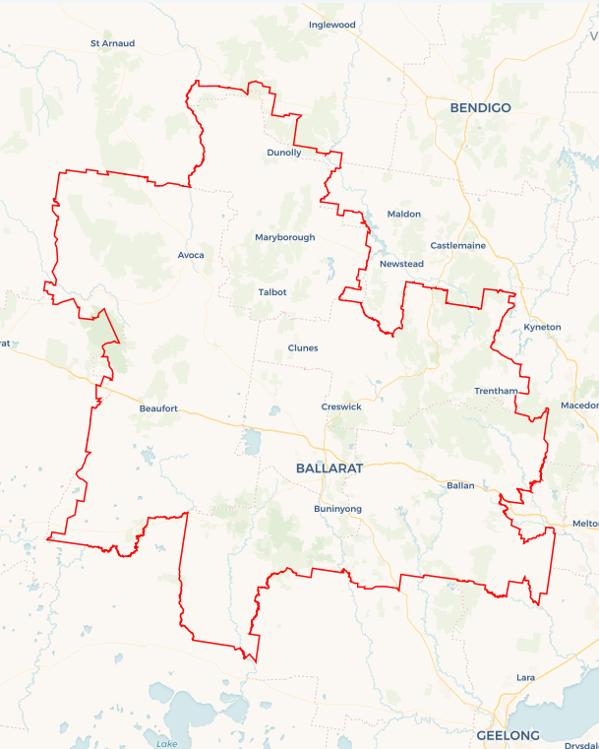Local Jobs Plan

Ballarat Employment Region | VIC | March 2025

Workforce Australia Local Jobs (Local Jobs) is a program that supports tailored approaches to accelerate   
reskilling, upskilling, and employment pathways in response to current and emerging local workforce needs.

## Local Jobs elements

### Local Jobs Plan

The Local Jobs Plan sets out the skills and employment challenges and priorities of the region, and associated strategies that will drive the design and implementation of activities to be implemented to address these challenges.

### Job Coordinators

Job Coordinators and Support Officers support the delivery of the program by bringing together key stakeholders including businesses, employment services providers, higher education, and training organisations.

### Local Jobs and Skills Taskforce

Each Employment Region has its own Taskforce. Representatives include local stakeholders who have demonstrated experience in upskilling, reskilling, and an ability to represent, connect and collaborate with others in the region to meet labour market needs.

### Program Funds

The Employment Region’s Local Initiatives Fund enables targeted local investments that support local labour market functioning. Further, from 2025/26, a central grants-based fund will respond to local needs and help progress broader employment service reform objectives.

Explore labour market insights for the  
[Ballarat](https://www.jobsandskills.gov.au/data/employment-region-dashboards-and-profiles/monthly-labour-market-dashboards) Employment Region

## Local labour market challenges in the region

* Mature age individuals comprise a significant portion of our labour market. Mature age individuals may face specific challenges to gaining employment, including a changed labour market, digital literacy confidence or capability, identifying or accessing training opportunities, arranging or accessing flexible work opportunities and/or identifying or promoting transferrable skills.
* Young people represent a significant percentage of the region’s Employment Services Provider caseload. Young people in the region who do not transition into work or training after leaving school are likely to become or remain disengaged.
* The cost of private transportation (fuel, insurance and vehicle maintenance) places additional financial burdens on workers. There is a need for better public transport options within and across the region to meet some industry locations and shift work hours.

* Women in the region represent a significant percentage of our labour market. Women may face specific or additional challenges to gaining or sustaining employment, including family violence, cost or availability of childcare, caring responsibilities, pay inequality, lower wages in female-dominated industries, work-life balance and/or arranging or accessing flexible working arrangements.
* Working-age people with disability in the region may be unemployed longer and/or experience several unique challenges to gaining employment, including discriminatory recruitment practices, a lack of understanding of the supports available and/or difficulties negotiating reasonable adjustments in the workplace.

## Local jobs and skills priorities and strategies in the region

### Priority 1 – Advocate for female employment within the region

### What are our challenges and opportunities?

Women in the region may face specific or additional challenges to gaining or sustaining employment. Community and employer advocacy and education can assist female individuals to address these potential challenges.   
**How are we responding?**

* Engaging with Women’s Networking groups, government and stakeholders to connect women to services that can assist to address challenges.
* Engaging with local industry and business groups to create flexible pathways for women into local jobs, particularly within male-dominated industries.
* Collaborating with Workforce Australia Employment Services Providers (providers), Registered Training Organisations (RTO) and business groups to identify emerging job opportunities and prepare women for these.

### Priority 2 – Broker opportunities for youth skill development and employment, including apprenticeships and traineeships

### What are our challenges and opportunities?

Young people in the region who do not transition into work or training after leaving school are likely to become or remain disengaged. Engaging with young people earlier about their career choices will empower them to make more informed decisions based on local labour market needs. Young people in regional communities must have access to secure and sustainable employment opportunities.

### How are we responding?

* Identifying training opportunities for youth that align with current local employment needs.
* Collaborating with stakeholders including secondary schools, Highlands Local Learning Employment Network, providers, businesses, Transition to Work Providers, the Australian Apprenticeships Service Network and RTOs to identify apprenticeship, traineeship and job placement opportunities for young people.
* Engaging with local industry and business groups (with a focus on large-scale infrastructure and development projects) to create flexible pathways for youth.

**Priority 3 –** **Address transport barriers**

**What are our challenges and opportunities?**

Public transport options with the Employment Region do not meet industry locations and shift work hours. For example, Maryborough to Ballarat and connection to industrial hubs in the Pyrenees Shire Council. There is an opportunity to leverage the region’s established road and rail infrastructure to alleviate transport barriers.

**How are we responding?**

* Working with local councils to identify current transport infrastructure and explore gaps in service delivery.
* Encouraging and facilitating usage of funding opportunities to support transport initiatives.
* Working with businesses and stakeholders to explore alternative participant transport support opportunities.
* Engaging with the transport and driver training industry to develop solutions to transport issues.

### Priority 4 – Broker employment opportunities for mature age individuals

### What are our challenges and opportunities?

Mature age individuals may experience challenges to gaining employment due to age discrimination, digital literacy confidence or capability (particularly noting online recruitment processes), identifying or accessing training opportunities, arranging or accessing flexible work opportunities, identifying or promoting transferrable skills, qualifications and skill sets and location of the vacant positions. Promoting education and upskilling opportunities to mature age individuals and advocating to business will assist in creating employment opportunities matched to local labour market and industry’s needs.

### How are we responding?

* Working with industry to review their recruitment practices and encourage job flexibility.
* Promoting existing programs to enhance local employment and training opportunities.
* Engaging with organisations to identify and link individuals to suitable local vacancies.
* Collaborating with providers and RTOs to ensure individuals are better equipped to identify and promote transferrable skills.

### Priority 5 – Support the employment of people with disability

### What are our challenges and opportunities:

Working-age people with disability may face unique or additional challenges to gaining employment. These may discriminatory recruitment practices, a lack of understanding of the supports available and/or difficulties negotiating reasonable adjustments in the workplace. Advocating the opportunities available to individuals and educating businesses of the value of inclusive workplace environments, will assist in creating employment opportunities matched to local labour market and industry’s needs.

### How are we responding?

* Collaborating with businesses to create a greater understanding of the supports and reasonable adjustments available in the workplace.
* Providing links between Disability Employment Services and industry to enhance collaboration and promotion of employment opportunities.
* Working with employers and business groups to enhance organisations’ knowledge and tools necessary to meet social procurement policies, create inclusive workplaces and develop individualised pathways to employment for individuals.
* Working to enlighten employers and stakeholders on impactful ways to support people with disability and encourage recruitment.

## Want to know more?

* Contact: Margi Cousins, Ballarat Job Coordinator: Margi.cousins@ballaratlocaljobs.com.au
* Visit: [Local Jobs](https://www.dewr.gov.au/local-jobs) or [Workforce Australia](https://www.workforceaustralia.gov.au/)