
oakes


Online Employment Services
  - Evaluation Strategy
16 December 2021

ISBN
978-1-76114-010-5 [PDF]
978-1-76114-009-9 [DOCX]
With the exception of the Commonwealth Coat of Arms, the Department’s logo, any material protected by a trade mark and where otherwise noted all material presented in this document is provided under a Creative Commons Attribution 4.0 Australia licence.
The details of the relevant licence conditions are available on the Creative Commons website (accessible using the links provided) as is the full legal code for the CC BY 4.0 AU licence.
The document must be attributed as the Online Employment Services Evaluation Strategy, dated 16 December 2021.

Disclaimer
This is a working document and the information provided is a guide to research and evaluation currently in progress. The government’s digital services and the operational environment are dynamic and evolving, therefore, this evaluation strategy is subject to adjustments to adapt to a changing policy and economic conditions, including the impacts of COVID-19. Before relying on the material, readers are advised to carefully make their own assessment as to its currency and relevance and should obtain any appropriate advice.

Contents
1. Introduction 5
1.1 About the evaluation strategy 5
2. Background on online employment services 7
2.1 Context 7
2.2 Evaluation of digital employment services 7
2.3 Online Employment Services 8
2.3.1 Core functionality of Online Employment Services 8
2.3.2 Enhancements 8
2.3.3 Safeguards 10
2.3.4 Digital Services Contact Centre 10
3. Purpose, scope and key evaluation questions 11
3.1 Purpose of the evaluation 11
3.2 Program logic 11
3.3 Focus and scope 11
3.4 Key assumptions underlying the program logic 11
3.5 Key evaluation questions 12
3.5.1 Appropriateness 12
3.5.2 Effectiveness 12
3.6.3 Efficiency 13
4. Methodology 14
4.1 Data sources 14
4.1.1 RED 14
4.1.2 ESS data 14
4.1.3 ESFS data 14
4.1.4 PPM Survey data 15
4.2 Data collection and analysis 15
4.3 Data limitations 16
5. Evaluation management 18
5.1 Governance 18
5.2 Stakeholders 18
5.3 Risks 18
6. Key deliverables 20

1. Introduction
The Commonwealth performance framework under the Public Governance, Performance and Accountability Act 2013 (PGPA Act) focuses on demonstrating the value created when public resources (including taxpayer contributions) are used. The performance framework emphasises the importance of using evaluation tools such as program logic to identify meaningful performance information and combining quantitative and qualitative information to tell rich performance stories.
The performance framework applies to all Commonwealth entities and companies captured under the PGPA Act, which includes the Department of Education, Skills and Employment (the department) and supports not only reporting on performance, but also continuous improvement to maximise the efficiency and effectiveness of the department’s activities within the constraints of the context in which the department operates. The framework requires performance planning and reporting to clearly link between activities and results achieved and provides meaningful performance information with a clear line of sight between planned and actual performance. It is expected that service and program evaluations should assess the extent to which intended results were achieved and identify the factors that affected performance.

1.1 About the evaluation strategy
In accordance to Section 16EA of the Public Governance, Performance and Accountability Rule 2014 made under the PGPA Act, performance measures should:
- relate directly to one or more of the service/program’s purposes or key activities
- use sources of information and methodologies that are reliable and verifiable
- provide an unbiased basis for the measurement and assessment of performance
- where reasonably practicable, comprise a mix of qualitative and quantitative measures
- include measures of outputs, efficiency and effectiveness
- provide a basis for an assessment of performance over time.
The Online Employment Services (OES) evaluation strategy has been developed according to the above guidelines, using the following terms of reference:
Appropriateness | To decide if the services were fit for purpose and meet the needs of the targeted cohort of job seekers  - Assessing the relevance of the services in light of current circumstances, including government policy changes and variations of job seeker needs.
Effectiveness | To test whether the service outcomes have achieved stated objectives.  - Measuring the extent to which outcomes are achieved and the factors that affect achievement of the outcomes.
Efficiency | To ascertain whether the services are cost effective.

Section 2 describes the context and background of the OES and its service elements.
Section 3 details the purpose, scope and key evaluation questions.
Section 4 presents the evaluation approach and methodology including data collection and analysis strategies.
Section 5 explains how the evaluation is managed.
Appendix 1 presents the program logic for this evaluation.
Appendix 2 presents a data framework that maps success indicators to key evaluation questions and identifies data sources and data collection activities for reviewing the indicators.

2. Background on online employment services
This section outlines the context and the department’s evaluations of digital employment services trials, and an overview and the objectives of the OES.

2.1 Context
Digitalisation, globalisation and technological advancements are changing the way we work, the nature of employment, the types of roles and industries, and, as a result, the delivery of public employment services. Given these labour market changes and a greater focus on digital government services, it was foreseeable that government funded services and programs, including employment services, would transition to an online format to a great extent. Furthermore, the job search process and recruitment are increasingly conducted by both job seekers and employers using online services, such as SEEK and Indeed.
The Australian Government is investing $295.9 million over four years to develop and deliver a new digital employment services platform. The New Employment Services Model (NESM) will replace the jobactive program from July 2022. Since 1 July 2019, key elements of NESM are being trialled through the New Employment Services Trial (NEST) in two regions: namely, Adelaide South and the Mid North Coast of New South Wales. Prior to NEST, the department introduced the Online Employment Services Trial (OEST) on 1 July 2018 to test whether the most job-ready job seekers with Mutual Obligation Requirements (MORs) receiving employment services assistance through jobactive could effectively self-manage using an online platform. This included undertaking job search and meeting their MORs. Another trial was implemented at the same time to investigate whether job seekers could effectively and efficiently complete the Job Seeker Classification Instrument (JSCI) online. The JSCI classifies job seekers for employment services that best meet their needs, based on a measure of their relative labour market disadvantage that is determined by their responses to a series of questions.
With the advent of the COVID-19 pandemic, demand for employment services increased rapidly and dramatically, and in response, the Australian Government fast-tracked the rollout of OES in April 2020. As a result, both the OEST and the Online JSCI Trial were terminated. The Job Seeker Snapshot (JSS), which is the online version of the JSCI, was rolled out broadly as part of the OES.

2.2 Evaluation of digital employment services
The department has completed separate evaluations of the OEST and the Online JSCI Trial. Both evaluations found that online servicing was efficient, and most trial participants reported time-savings and ease of use. OEST participants were as likely as job seekers in provider-based servicing to exit employment services and income support. Likewise, those who completed the online JSCI had consistent JSCI scores and streaming outcomes. Full evaluation reports are available from the following links in the department’s website:
- The Online Employment Services Trial Evaluation Report
- The Online Job Seeker Classification Instrument Trial Evaluation Report
The department is currently evaluating NEST and the Volunteer Online Employment Services Trial (VOEST). Implemented in December 2019, the VOEST is targeted at job seekers who are not fully eligible to participate in jobactive or NEST but would like to access an online platform to support and self-manage their job search.

2.3 Online Employment Services
The OEST evaluation provides firm evidence for the rollout of the OES in the 2020-21 Budget in supporting the government’s broad move towards digital employment servicing for the most job-ready job seekers. For example, the core functionality of OES was developed as part of the OEST; and building on the foundations and lessons from the OEST, further enhancements were made to the OES to support the needs of online participants. Similar to the OEST, there are safeguards in the OES to ensure participants are in the right service and can continue to self-manage.
Figure 2.1 illustrates how new job seekers are referred to the OES and complete a JSS by logging in to the jobsearch/jobactive website through MyGov. The JSS, followed by the Digital Assessment (DA) will identify if they are suitable for OES. A job seeker commences as an OES participant after reviewing and accepting a Job Plan.

2.3.1 Core functionality of Online Employment Services
The core functions established in the OEST were retained for the OES. These functions allow participants to:
- review and accept a Job Plan
- create a Career Profile and resume
- search and apply for jobs
- upload job search details (manage mutual obligations)
- access support tools and resources
- access support from the DSCC
- receive notifications via inbox, SMS or emails.

2.3.2 Enhancements
Building on lessons from the OEST evaluation and early findings from the NEST evaluation, the following enhancements were introduced in OES:
- expansion of DSCC’s role to help participants to remain engaged in the OES and meet their MORs
- functionality for employers to better describe their requirements when advertising job vacancies, to better target/match suitable job seekers
- support for participants to upskill or reskill through links to subsidised training offered through JobTrainer and higher education short course offerings
- skills matching tools including Job Switch to encourage participants to explore jobs they might not have considered
- search functionality for participants to access activities and employment programs that will help improve their skills such as Career Transition Assistance (CTA), Employability Skills Training (EST) and New Enterprise Incentive Scheme (NEIS) via the jobsearch/jobactive website.
Further enhancements and refinements will be made in response to ongoing user feedback based on emerging needs.
Figure 2.1
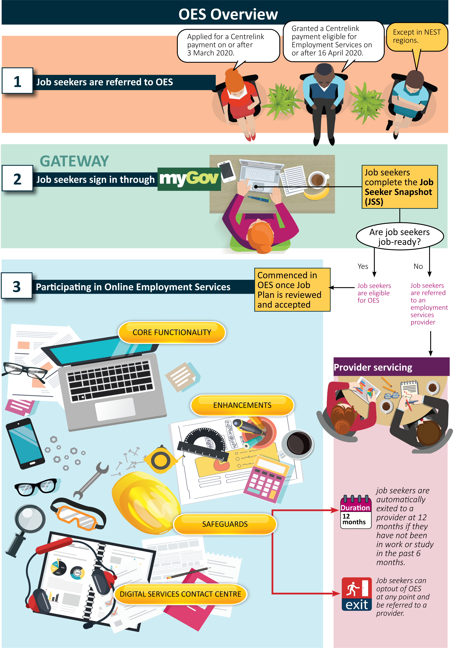

2.3.3 Safeguards
Also resulting from the OEST evaluation and early findings of the NEST evaluation, the following safeguards are in place to ensure that OES participants are in the right service and can continue to self-manage online:
- participation in the OES is voluntary and participants can optout at any point and be referred to a provider
- participants can update their JSS if their circumstances change and contact the DSCC for support
- participants will be asked to complete a Digital Assessment (DA) immediately after the JSS to assess their level of online access and ability to self-manage in an online platform
- participants are prompted to complete a Digital Service Review (DSR) at the fourth and eighth month interval to ensure that online servicing is still suitable for them. Those in employment, study or training will not be subject to these reviews
- participants whose responses to the DA and/or DSR suggest they may be unsuitable for OES are encouraged to optout to a provider
- participants are automatically exited to a provider at 12 months if they have not been in work or undertaking study in the past six months
- young people (15-24) participating in OES can access up to three one-hour Youth Advisory Sessions (YAS) with a Transition to Work (TtW) provider by contacting the DSCC.

2.3.4 Digital Services Contact Centre
The DSCC provides individualised support to participants to help them deal with issues and barriers they may face in relation to complying with their MORs.

3. Purpose, scope and key evaluation questions
As described in Section 2.3, significant changes have been made to OES compared to the OEST in the form of enhancements and additional safeguards. With these changes, an evaluation of the OES is warranted to gather new evidence to support the development of the NESM.

3.1 Purpose of the evaluation
The evaluation aims to:
- assess the appropriateness, effectiveness and efficiency of OES
- contribute to the evidence base for the development and improvement of digital employment servicing.

3.2 Program logic
The OES program logic is a visual representation of how core functionalities, enhancements, safeguards and the DSCC lead to desired outcomes for participants. The program logic at Appendix 1 identifies immediate and intermediate outcomes and their contribution to long-term impact when certain assumptions are met. The program logic is used to structure data collection and analysis activities to assess whether the hypothesised relationships between activities and expected outcomes are achieved and identify unexpected factors or other emerging outcomes.

3.3 Focus and scope
This evaluation will focus on the immediate and intermediate outcomes outlined in the program logic. The long-term outcomes are out of scope due to the relatively short duration of the evaluation which is just over two financial years from 2020-21 to 2021-22.

3.4 Key assumptions underlying the program logic
The OES program logic is underpinned by the three key assumptions as detailed in Table 3.1
Table 3.1 How are assumptions addressed in the evaluation?
Assumption | Within the scope of this evaluation?
1) Only job seekers most suitable for online servicing are referred to the OES to ensure that participants are job-ready, digitally literate and have digital access and ability to self-manage. | The previous OEST evaluation identified cohorts of job seekers most likely to benefit from online servicing based on their perceived self-sufficiency and preference for online or provider servicing. This evaluation will build on the OEST findings to build a profile of job seekers most suitable for online servicing and identify assistance and support required to help job seekers who could benefit from online servicing (e.g. help to navigate the jobsearch website/app).
2) Technology is consistently available and reliable for participants to access OES. | This is not within the scope of the evaluation. While some technological issues can be identified from participants’ experiences through qualitative and quantitative fieldwork, it is not the aim of this evaluation to review digital infrastructure and technology.
3) Data between the department and Services Australia is integrated to streamline the referral process. | Data integration with Services Australia is also out of scope as negotiations with Services Australia is ongoing. The Employment Gateway is also out of scope as its development is currently ongoing; however, any feedback received from research participants that are relevant to the onboarding and referral processes will be reported as part of the evaluation.

3.5 Key evaluation questions
Key evaluation questions are grouped according to the terms of reference discussed earlier and research questions are outlined for each evaluation question as in the following tables.

3.5.1 Appropriateness
 | Key evaluation question |  | Research question
1 | Is the OES fit for purpose? | 1.1 | How well did the OES meet the needs of the targeted cohort of job seekers?
1 | Is the OES fit for purpose? | 1.2 | How well is the OES aligned to meet the strategic priorities of the Australian Government's Digital Transformation Strategy?

3.5.2 Effectiveness
 | Key evaluation question |  | Research question
2 | How effective are the OES Core Functionality and Enhancements in enabling participants to self-manage their job search and MORs and improve their employability to find relevant and sustainable employment? | 2.1 | How effective is the OES Core Functionality in enabling participants to self-manage their job search and MORs?
2 |  | 2.2 | How effective are the OES Core Functionality and Enhancements in improving participants' job-readiness and employment opportunities?
2 |  | 2.3 | How well are the job and skills matching features working in OES?  (the extent of Job Switch enhancements to the Career Profile and its effectiveness in improving job and skill matching)
2 |  | 2.4 | Are there any outcomes that indicate or could lead to achievement of employment outcomes?
3 | Are the OES safeguards sufficient in ensuring that participants are in the right service and can effectively self-manage? | 3.1 | Do optout features work as intended?
3 |  | 3.2 | How effective are the DSRs in ensuring that participants are suitable and remain to be suitable for online servicing?
3 |  | 3.3 | Are participants updating their Job Seeker Snapshots (JSS) or contacting the DSCC for support if their circumstances change?
3 |  | 3.4 | How is the 12-month timeframe an effective safeguard?
4 | How effective is the DSCC in assisting participants to overcome barriers and remain engaged in the OES? | 4.1 | To what extent do participants access the DSCC?
4 |  | 4.2 | How effective Is the DSCC in supporting OES participants to meet their MORs and improve their employability?
4 |  | 4.3 | What aspects of the DSCC worked well in supporting OES participants?  What can be improved?
5 | What worked well and not so well in enhancing participant experience in and engagement with the OES? | 5.1 | The quality of the OES online platform - To what extent is the OES functional and user-friendly?
5 |  | 5.2 | How suitable is the OES compared across various cohorts of participants (e.g. mature age individuals, people from culturally and linguistically diverse (CALD) backgrounds, young people, people with disability, etc.)?

3.6.3 Efficiency
 | Key evaluation question |  | Research question
6 | Do the referral and OES onboarding processes ensure that job seekers get the most appropriate support to find employment? | 6.1 | Do the Job Seeker Snapshot (JSS) and the Digital Assessment (DA) efficiently identify and refer job seekers to the most appropriate service?
7 | Has the OES achieved value-for-money? | 7.1 | Is the OES cost effective?

4. Methodology
This section describes the evaluation approach and methodology. The methodology drives data collection and analysis methods and is mapped in detail in a data matrix excel worksheet, which identifies for each evaluation question:
- the indicators to be examined
- data sources – existing and new
- data gaps
- methods of data collection and analysis
- research participants and stakeholders

A summary of the data matrix is presented in a data framework diagram in Appendix 2.

4.1 Data sources
The program logic in Appendix 1 and described in Section 3.2 informs the design of this evaluation. A mixed-method approach is adopted incorporating both qualitative and quantitative data, from existing and new sources, and integrating these to answer the evaluation questions.
Administrative data for the OES evaluation will be extracted from the department’s existing data systems with a focus on the OES. Where data gaps are identified, research data described in Table 4.1 are expected to fill these gaps and complement the department’s administrative data. The following is a summary of existing departmental data.

4.1.1 RED
The Research and Evaluation Database (RED) contains information related to income support payments and recipients based on Services Australia administrative data. Data examples include job seekers’ demographic characteristics, family circumstance, hours worked and earnings, educational activities and receipt of income support payments. The data will mainly be used to examine changes in job seekers’ reliance on income support, including exits from income support as a proxy for employment.

4.1.2 ESS data
OES participant and job seeker administrative data is held on the Employment Services System (ESS). Each individual has a unique job seeker identification number on ESS, which links to, among other things, job seekers’ JSCI/JSS and Employment Service Assessment (ESAt) results, Job Plans, job search activity, and compliance outcomes. The data will be used to examine how quickly job seekers commence services after a referral, how long they stay in services, whether and when they exit from OES or transfer to a different service module (e.g. from Digital Services to Enhanced Services), job seekers’ accumulation of demerit points resulting from non-compliance, and so on.

4.1.3 ESFS data
In addition to the ESS, the National Customer Service Line (NCSL) and the DSCC record details of calls they receive in the Employment Services Feedback System (ESFS). The data captured on ESFS is predominantly qualitative and will be useful for gauging levels of participant satisfaction with OES, the types of assistance and support participants request from the DSCC, reasons for opting out of OES, barriers and issues faced by participants, etc.

4.1.4 PPM Survey data
Post Program Monitoring (PPM) surveys are used to measure employment and education outcomes of job seekers who received employment services assistance. Each month a pool of employment services participants currently on the caseload and a pool of participants who have exited employment services in the past three months are selected for surveying. Over the following three months, these participants are contacted for follow-up surveys.
OES participants have represented a significant portion of the jobactive caseload from 30 March 2020. As such, collecting a representative and distinct sample of OES participants to complete a PPM Survey became viable from 1 April 2020. PPM surveys of OES participants began in June 2020 (3 months after 1 April 2020).

4.2 Data collection and analysis
The data matrix also maps findings and recommendations from the OEST and Online JSCI Trial evaluations to be explored further in this evaluation. A range of data collection methods were identified in the matrix including:
- literature review comparing international government digital servicing and analysing alignment of OES objectives with the government’s Digital Transformation Strategy
- continuous review of OES and NESM documentation including updates and changes
- analysis of departmental administrative data
- review of evaluation findings from other digital services (e.g. OEST, Online JSCI Trial, NEST and VOEST)
- qualitative data collection through in-depth interviews and focus group discussions to be conducted by external research consultants
- quantitative data collection through CATI and online surveys to be conducted by commissioning an external research consultant
- semi-structured longitudinal interviews with selected OES participants to be conducted by commissioning an external research consultant.
While analysis of departmental administrative data will be undertaken by the OES Evaluation Team, further data collection activities were identified to fill data gaps and provide supporting evidence for the evaluation (see Table 4.1).
Table 4.1: Data to be collected from fieldwork research
Stakeholder | Sampling | Approach
OES participants | - locations – metro vs regional  - demographics – age group, Indigeneity, CALD, disability, and other influencing factors | - Two waves of in-depth interviews  - Two waves of focus group discussions  - Semi-structure longitudinal interviews  - Two waves of CATI and online surveys  - ESFS records*
Job seekers referred to OES but did not commence in OES | - locations – metro vs regional  - demographics – age group, Indigeneity, CALD, disability, and other influencing factors | - Two waves of in-depth interviews  - Two waves of focus group discussions  - Two waves of CATI and online surveys  - ESFS records*
jobactive providers | - mix of jobactive providers with and without OES participant caseloads | - In-depth interviews
Services Australia | - relevant Services Australia staff | - In-depth interviews
DESE | - Evaluation Working Group | - Roundtable discussions
DSCC | - frontline staff | - Focus group discussions
Peak bodies | - NESA  - Jobs Australia | - In-depth interviews
Employers | - locations – metro vs regional  - mix of small, medium and large size organisations  - mix of industry types | - CATI and online surveys  - In-depth telephone interviews
*Source - departmental administrative data
In line with a mixed-methods approach, the analysis of data will require a mix of qualitative and quantitative analysis. Where necessary and feasible, comparisons will be made and data will be disaggregated for demographic groups, including Indigenous, young and mature age individuals, people from culturally and linguistically (CALD) diverse background and people with disability
Information such as preferred type of servicing, perceived self-sufficiency and support network are not available from administrative data and will be collected by the external research consultant through surveys and qualitative fieldwork (where relevant).
Feedback from stakeholders and departmental data will be used to assess the cost effectiveness of OES.

4.3 Data limitations
- Difficulty in identifying comparison groups for OES participants – only eligible job seekers nationwide are referred to OES, hence, it is not feasible to identify a valid comparison group for OES participants. This makes it very challenging to estimate the impact of OES.
- Data availability issues – while the PPM Survey and fieldwork research discussed above provide information on job seekers’ employment and/or education outcomes, these only cover a sample of job seekers and may not provide a full picture of job seeker outcomes. In particular, for job seekers not participating in the survey and the fieldwork research, income support data is used as proxies in tracking participants’ short-term labour market and education outcomes as there is no direct data on participants’ labour market status after they exit OES.
- Data quality issues – missing or poorly recorded data (e.g. missing optout reasons and poorly recorded data), particularly over the COVID-19 period in 2020, may affect some parts of the analysis.

5. Evaluation management

5.1 Governance
This evaluation will largely be undertaken by the OES Evaluation Team from the RED Support and Digital Services Evaluation Section within the Employment Research and Evaluation Branch (EREB) of the department, in consultation with the OES Evaluation Work Group (EWG) representing key areas in the department including those involved in designing, developing and implementing digital services and micro policies of NESM.
The OES Evaluation Team will be responsible for managing the evaluation, engaging with the EWG and other stakeholders, and preparing draft and final reports.

5.2 Stakeholders
Major stakeholders for the OES evaluation include:
- department staff in the EWG and other staff involved in designing and implementing NESM
- DSCC frontline staff
The OES Evaluation Team will endeavour to provide early insights and feedback to the EWG and NESM design teams.

5.3 Risks
EREB identifies and manages risks related to evaluations using RiskNet, the department’s risk management system. Table 5.1 identifies some risks most relevant to the OES evaluation and mitigation strategies.
Table 5.1 OES Risk and mitigation strategies
Risk | Potential impact | Mitigation
Availability and quality of data. | Poor quality or insufficient data collected will result in key evaluation questions not being addressed adequately. | - Effective contract management of external consultants engaged to undertake data collection activities; such as regular communication.  - Regular quality assurance checks using the Data Matrix to ensure key evaluation questions are addressed.
OES undergoes regular changes and micro policies are still being developed, which is part of the NESM development process. | Frequent changes impact the ability of the evaluation to effectively define and measure anticipated change over the life of the project and derive meaningful insights. | - Evaluation questions and associated measures focus on high-level impacts expected from OES participation.  - Ongoing collaboration between the OES Evaluation Team, the EWG and other stakeholders ensures changes to the operation of the OES are understood and their impacts accounted for in data collection, analysis and reporting.  - Regular reviews of the Data Matrix to ensure key evaluation and research questions are still valid and appropriate.
Resource management – ensuring staff in the OES Evaluation Team have the right skillset, such as evaluation and project management skills, data analytics skills and familiarity with the ESS data. | Poor quality data collection, limited/incomplete findings and poor engagement with stakeholders. | - Adequate project planning and resource allocation undertaken in the early phases and good teamwork in the OES Evaluation Team.  - Regular communication and check-ins with team members to foster engagement in the evaluation project.
Evaluation findings not supported by stakeholders. | The EWG and other stakeholders may not implement recommended changes which could improve future program performance. | - Ongoing collaboration with the EWG and stakeholders to ensure the evaluation accounts for program and policy needs.  - Clear communication to stakeholders around key decision points, methodology and project limitations.  - Development and implementation of a stakeholder communication strategy.
This strategy assumes that data collected through the ESS and other processes managed by the department as well as timely access to income support data from Services Australia, will provide sufficient data to enable a robust review. If the scope and nature of data is insufficient, this may limit the robustness, scope and timeliness of the evaluation.

6. Key deliverables
Deliverables | Date
Research report on Waves 1 and 2 research activities | 24 June 2022
Draft OES Evaluation report | 28 October 2022
Final OES Evaluation report | 20 December 2022

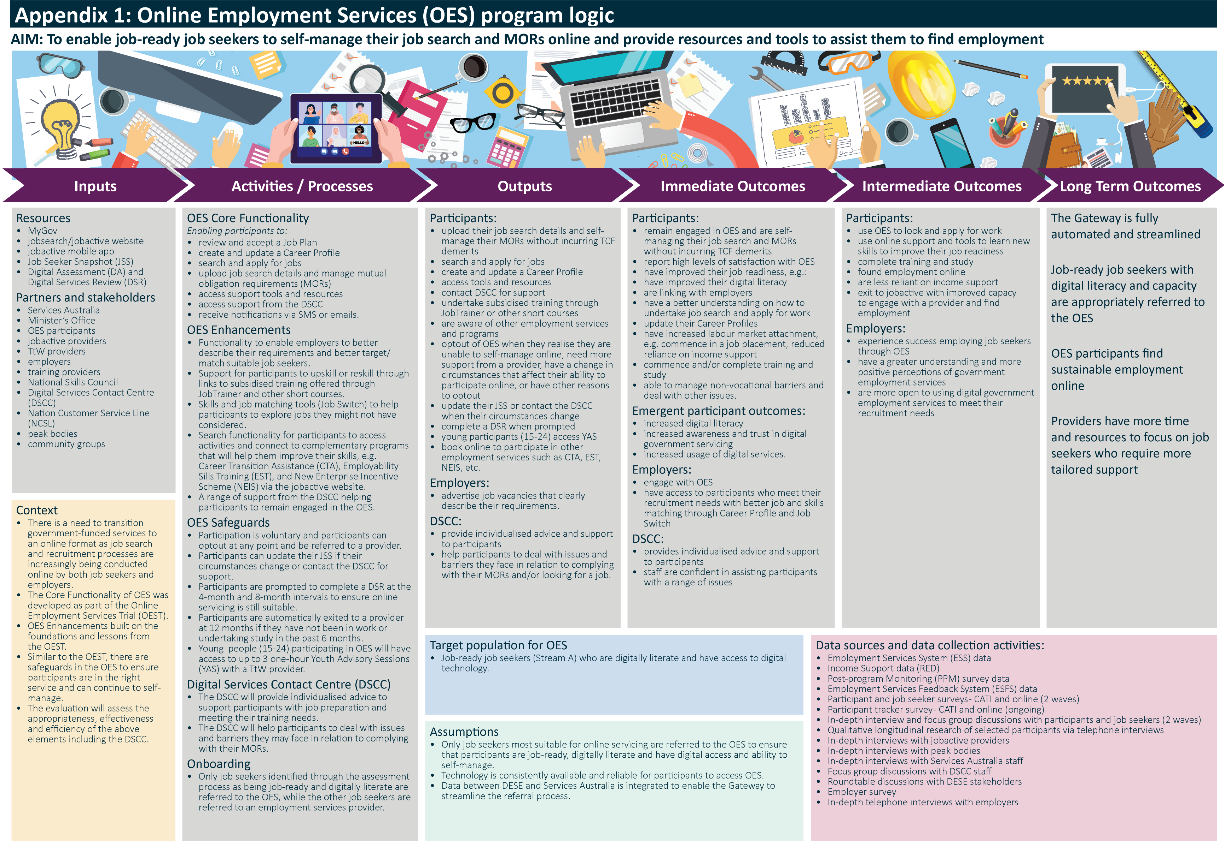
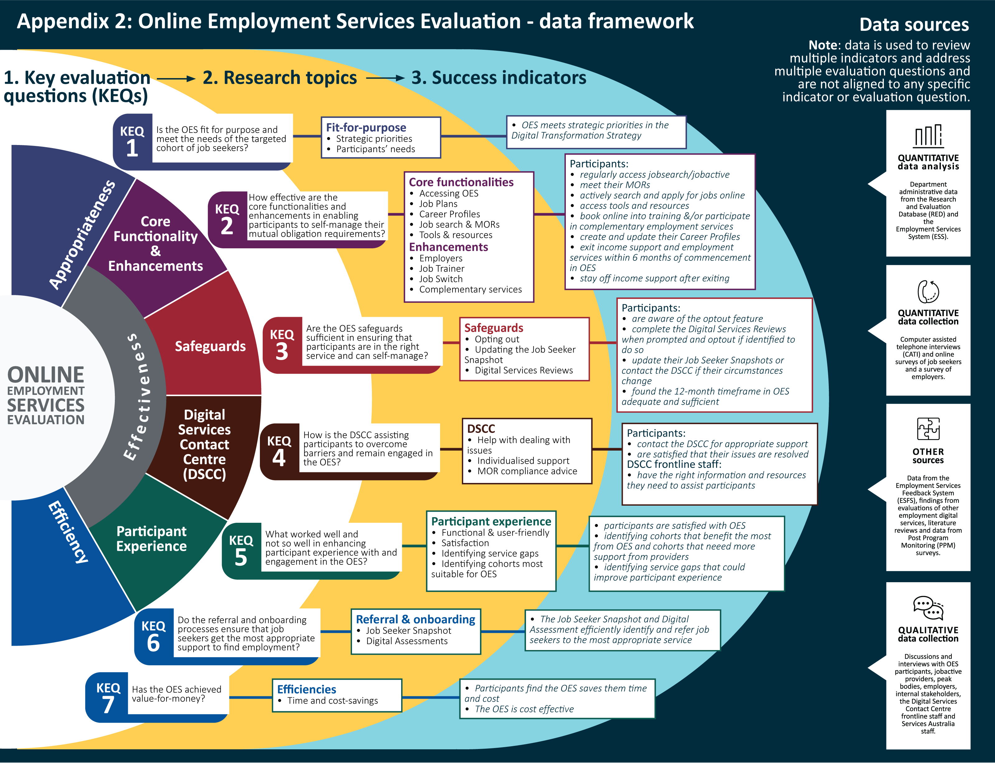

Except the two NEST regions in Adelaide South, SA and the Mid-North Coast, NSW.

