


ParentsNext 2018-2021 Evaluation Report

Published November 2022

ISBN
978-1-76114-149-2[PDF]
978-1-76114-131-7[DOCX]
With the exception of the Commonwealth Coat of Arms, the department’s logo, any material protected by a trade mark and where otherwise noted all material presented in this document is provided under a Creative Commons Attribution 3.0 Australia licence.
The details of the relevant licence conditions are available on the Creative Commons website (accessible using the links provided) as is the full legal code for the CC BY 3.0 AU licence.
The document must be attributed as the ParentsNext National Expansion 2018–2021: Evaluation Report.
Acknowledgements
This report was prepared by Robyn Henderson, Alison Reinhard, Caroline Daley, Julia Radcliffe and Yingru Wu.
The Department would also like to acknowledge the contribution to this report from commissioned research undertaken by the Social Research Centre.

Contents
List of tables ix
List of figures xiii
Executive summary 1
Key findings 2
Effectiveness 2
Appropriateness 4
Efficiency and service quality 5
Conclusion 7
Department response to ParentsNext 2018-2021 Evaluation Report 9
Program Design 9
Performance of ParentsNext 11
Future Improvements 12
About this report 13
Chapter 1 Evaluation of ParentsNext 15
1.1 The evaluation approach 15
1.2 Key evaluation questions 15
1.3 Methods 15
1.3.1 Data sources 16
1.3.2 Qualitative research 16
1.3.3 Quantitative research 17
1.4 Summary 20
Chapter 2 The ParentsNext program 21
2.1 Policy and program context 21
2.2 The macroeconomic environment 21
2.2.1 2019–20 bushfires and COVID-19 shocks 21
2.3 Australian and international research 21
2.4 ParentsNext 22
2.5 Theory of change 24
2.6 ParentsNext eligibility criteria 24
2.6.1 Intensive and targeted streams 24
2.6.2 Compulsory participants 25
2.6.3 Intensive stream volunteers 26
2.7 Job Seeker Classification Instrument 26
2.8 Implementing the ParentsNext service 27
2.8.1 The participant referral pathway 27
2.8.2 MORs – compulsory appointments, Participation Plans and payment eligibility criteria 27
2.9 Exemptions 28
2.9.1 Participants volunteering during an exemption 29
2.10 The Participation Fund 30
2.11 Exits 30
2.12 ParentsNext policy and systems changes 31
2.13 Provider duties 31
2.13.1 Service Delivery Plans 31
2.13.2 Work readiness assessments 31
2.14 Interactions between ParentsNext and employment programs 31
2.15 Departmental monitoring 32
Chapter 3 How well does ParentsNext engage, assist and service participants? 33
3.1 Study populations and their characteristics 33
3.1.1 Referral inflow population 33
3.2 Barriers to participation 33
3.2.1 Vocational barriers 34
3.2.2 Non-vocational barriers 35
3.3 Awareness of ParentsNext 39
3.4 Caseloads 40
3.5 Referrals and commencements 41
3.6 Time to commence 42
3.7 Exemptions 43
3.7.1 Providers’ attitudes to exemptions 46
3.8 Appointments 47
3.9 Participation in activities and interventions 49
3.10 Parenting payment suspensions/compliance 55
3.10.1 Monitoring participant compliance 56
3.11 Exits 62
3.12 Job placements 63
3.13 National Customer Service Line contacts 65
3.14 Unit expenditure per participant 65
3.15 Conclusion 66
Chapter 4 Are the program design and operational processes appropriate to enable the ParentsNext program to achieve its objectives? 68
4.1 Eligibility criteria 68
4.1.1 Age of the youngest child 68
4.1.2 Removing the 2 streams 68
4.1.3 Participants in full-time study, on an employment break or approaching retirement 69
4.2 Appropriateness and effectiveness 69
4.2.1 Participation Plans 69
4.2.2 Use of the Participation Fund 71
4.2.3 Outcome payments 72
4.3 Concurrent activities and other assistance 73
4.3.1 Wage subsidies 73
4.3.2 Relocation funding 74
4.3.3 VOEST 74
4.4 Provider service strategy and good practice 74
4.4.1 Provider assistance to support participants 75
4.4.2 Implementing participants’ ideas 76
4.4.3 Good practice 77
4.5 Servicing different demographic cohorts 82
4.5.1 Aboriginal and/or Torres Strait Islander specific activities 83
4.5.2 Recognition of cultural and linguistic diversity 84
4.5.3 Parents with disability or a child with disability 84
4.5.4 Services for fathers 86
4.5.5 Parents in regional locations 86
4.6 Provider satisfaction 86
4.6.1 Support for the program 86
4.6.2 Flexibility 87
4.6.3 Departmental support 87
4.7 Participant satisfaction 90
4.8 Conclusion 92
Chapter 5 Does participation in ParentsNext improve work readiness and employability of participants? 94
5.1 Work readiness 94
5.1.1 Work StarTM 94
5.1.2 ParentsNext post-program monitoring 97
5.2 Impact analysis 100
5.2.1 Participation in education and training 100
5.2.2 Employment 102
5.2.4 Impact on different equity groups 104
5.3 Wellbeing 108
5.4 Do ParentsNext participants remain on income support? 109
5.5 Conclusion 111
Chapter 6 The impact of the COVID-19 pandemic and the 2019–20 bushfires 113
6.1 The COVID-19 environment 113
6.2 Impact of social isolation on single parents 113
6.3 Social isolation during COVID-19 114
6.4 Impact of COVID-19 and bushfires on referrals and exits 116
6.5 Attending appointments during COVID-19 116
6.6 Impact on child care 117
6.7 Activities during COVID-19 118
6.8 New approaches to servicing 119
6.9 Conclusion 122
Chapter 7 Did ParentsNext achieve its objectives? 123
7.1 How well did ParentsNext engage and service/assist participants? 123
7.1.1 Awareness and engagement 123
7.2 Were the program design and operational processes appropriate to enable the ParentsNext program to achieve its objectives? 123
7.2.1 Satisfaction 123
7.2.2 Connecting parents to local services that can help them prepare for future education or employment 124
7.2.3 Equity 124
7.2.4 Wellbeing 124
7.3 Did participation in ParentsNext improve work readiness and employability of participants? 124
7.3.1 Targeting early intervention assistance to parents with young children 124
7.3.2 Helping parents identify and reach their education and employment goals through participation in activities 124
7.4 Impact of COVID-19 125
7.5 What could be done better 125
7.6 Did the theory of change hold true? 125
7.7 Lessons from Australian and international research 125
7.8 Options for future research 126
7.9 Conclusion 127
References 128
Appendices 133
Appendix 1 Australian and international research 133
Background 133
Conditionality 133
Intergenerational welfare dependency 135
Wellbeing 136
Financial competence, mental health and disability 137
Appendix 2 Program and policy changes over time 139
Appendix 3 Program logic 142
Appendix 4 Impact analysis population construction 143
A4.1 Additional selection criteria 143
A4.2 Population demographics 144
Appendix 5 Impact analysis logistic regression models 149
A5.1 Model variables 149
A5.2 Child care use outcome 150
A5.3 Odds ratios 151
A5.4 Stage 1: Education outcome 152
A5.5 Stage 1: Employment outcome 159
A5.6 Stage 1: Child care use outcome 166
A5.7 Stage 2: Education outcome 168
A5.8 Stage 2: Employment outcome 173
A5.9 Stage 2: Child care use outcome 180
Appendix 6 Impact analysis of subgroups 182
A6.1 Gender 182
A6.2 Aboriginal and/or Torres Strait Islander status 183
A6.3 CALD status 184
A6.4 Residential location 186
Appendix 7 Child Care Subsidy 188
Appendix 8 Activities and interventions 190
Appendix 9 Participation Fund expenditure 192
Appendix 10 Long-term tracking of ParentsNext participants 195
List of short forms 197
Glossary 198

List of tables
Table 1.1: Key evaluation questions 15
Table 1.2: Evaluation data sources 16
Table 1.3: Assignment criteria for each eligibility group 19
Table 1.4: Outcome measures 20
Table 2.1: Stream eligibility criteria 25
Table 2.2: Sections and factors covered in the JSCI questionnaire 27
Table 2.3: ParentsNext exemptions 29
Table 3.1: Participant transfers from ParentsNext 2016–2018, by stream, in the national expansion to 31 December 2020 41
Table 3.2: Time taken to commence in ParentsNext (cumulative per cent) 43
Table 3.3: Exemptions granted, by type and granting entity 43
Table 3.4: Exemptions by eligibility group, July 2018 to December 2020 45
Table 3.5: Referrals and exemptions, by equity group 45
Table 3.6: Exemption types, by equity group 46
Table 3.7: Appointments by type, December 2020 49
Table 3.8: Appointments by result, December 2020 49
Table 3.9: Activity referral result, December 2020 50
Table 3.10: ParentsNext activity referrals, December 2020 50
Table 3.11: ParentsNext activity referrals, by equity group 52
Table 3.12: ParentsNext specific activity referrals 53
Table 3.13: Accredited education and training (vocational) activity referrals 55
Table 3.14: Parenting Payment suspensions and cancellations, by cohort (2 July 2018 to 31 December 2020) 57
Table 3.15: Exit reasons recorded for periods of assistance, July 2018 to December 2020 62
Table 3.16: ParentsNext job placements, by participant group 64
Table 3.17: Average funding per participant, by stream (2 July 2018 to 31 December 2020) 65
Table 4.1: Wage subsidy agreements by type 73
Table 5.1: Work StarTM assessments over time 94
Table 5.2: Percentage improvement overall on the 7 points of Work StarTM 95
Table 5.3: Education outcome achievement rates 101
Table 5.4: Average change in probability of achieving an education outcome, treatment parents compared to comparison parents 102
Table 5.5: Employment outcome rates 103
Table 5.6: Average difference in probability of achieving an employment outcome, treatment parents compared to comparison parents 103
Table 5.7: Estimated impact of ParentsNext (percentage points) – gender 105
Table 5.18: Estimated impact of ParentsNext (percentage points) – Aboriginal and/or Torres Strait Islander status 106
Table 5.9: Estimated impact of ParentsNext (percentage points) – CALD status 107
Table 5.10: Estimated impact of ParentsNext (percentage points) – residential location 108
Table 5.11: Personal Wellbeing Index (PWI) scores 109
Table 6.1: Impacts of COVID on child care needs – comparison by subgroup 118
Table 6.2: Impacts of COVID-19 on ParentsNext interactions – comparison by subgroup 118
Table A2.1: Program and policy changes 1 July 2018 to 31 December2020 139
Table A4.1: Impact analysis population, stage 1 – demographics 144
Table A4.2: Impact analysis population, stage 2 – demographics 145
Table A4.3: Referrals to ParentsNext (commenced) – demographics 147
Table A5.1: Model variables 149
Table A5.2: Child care outcome rates 150
Table A5.3: Average change in probability of achieving a child care use outcome, treatment parents compared to comparison parents 151
Table A5.4: Logistic regression model – impact of ParentsNext on probability of achieving an education outcome – intensive stream 152
Table A5.5: Logistic regression model – impact of ParentsNext on probability of achieving an education outcome – targeted stream 153
Table A5.6: Logistic regression model – impact of ParentsNext on probability of achieving an education outcome – ESL intensive stream 155
Table A5.7: Logistic regression model – impact of ParentsNext on probability of achieving an education outcome – ESL targeted stream 155
Table A5.8: Logistic regression model – impact of ParentsNext on probability of achieving an education outcome – YC5 intensive stream 156
Table A5.9: Logistic regression model – impact of ParentsNext on probability of achieving an education outcome – YC5 targeted stream 156
Table A5.10: Logistic regression model – impact of ParentsNext on probability of achieving an education outcome – high-JSCI intensive stream 157
Table A5.11: Logistic regression model – impact of ParentsNext on probability of achieving an education outcome – high-JSCI targeted stream 158
Table A5.12: Logistic regression model – impact of ParentsNext on probability of achieving an employment outcome – intensive stream 159
Table A5.13: Logistic regression model – impact of ParentsNext on probability of achieving an employment outcome – targeted stream 160
Table A5.14: Logistic regression model – impact of ParentsNext on probability of achieving an employment outcome – ESL intensive stream 162
Table A5.15: Logistic regression model – impact of ParentsNext on probability of achieving an employment outcome – ESL targeted stream 162
Table A5.16: Logistic regression model – impact of ParentsNext on probability of achieving an employment outcome – YC5 intensive stream 163
Table A5.17: Logistic regression model – impact of ParentsNext on probability of achieving an employment outcome – YC5 targeted stream 163
Table A5.18: Logistic regression model – impact of ParentsNext on probability of achieving an employment outcome – high-JSCI intensive stream 164
Table A5.19: Logistic regression model – impact of ParentsNext on probability of achieving an employment outcome – high-JSCI targeted stream 166
Table A5.20: Logistic regression model – impact of ParentsNext on probability of achieving a child care use outcome – intensive stream 166
TableA5.21: Logistic regression model – impact of ParentsNext on probability of achieving a child care use outcome – targeted stream 167
Table A5.22: Logistic regression model – impact of ParentsNext on probability of achieving an education outcome – intensive stream 168
Table A5.23: Logistic regression model – impact of ParentsNext on probability of achieving an education outcome – targeted stream 169
Table A5.24: Logistic regression model – impact of ParentsNext on probability of achieving an education outcome – ESL intensive stream 170
Table A5.25: Logistic regression model – impact of ParentsNext on probability of achieving an education outcome – ESL targeted stream 170
Table A5.26: Logistic regression model – impact of ParentsNext on probability of achieving an education outcome – YC5 intensive stream 171
Table A5.27: Logistic regression model – impact of ParentsNext on probability of achieving an education outcome – YC5 targeted stream 171
Table A5.28: Logistic regression model – impact of ParentsNext on probability of achieving an education outcome – high-JSCI intensive stream 172
Table A5.29: Logistic regression model – impact of ParentsNext on probability of achieving an education outcome – high-JSCI targeted stream 172
Table A5.30: Logistic regression model – impact of ParentsNext on probability of achieving an employment outcome – intensive stream 173
Table A5.31: Logistic regression model – impact of ParentsNext on probability of achieving an employment outcome – targeted stream 175
Table A5.32: Logistic regression model – impact of ParentsNext on probability of achieving an employment outcome – ESL intensive stream 176
Table A5.33: Logistic regression model – impact of ParentsNext on probability of achieving an employment outcome – ESL targeted stream 177
Table A5.34: Logistic regression model – impact of ParentsNext on probability of achieving an employment outcome – YC5 intensive stream 177
Table A5.35: Logistic regression model – impact of ParentsNext on probability of achieving an employment outcome – YC5 targeted stream 177
Table A5.36: Logistic regression model – impact of ParentsNext on probability of achieving an employment outcome – high-JSCI intensive stream 178
Table A5.37: Logistic regression model – impact of ParentsNext on probability of achieving an employment outcome – high-JSCI targeted stream 179
Table A5.38: Logistic regression model – impact of ParentsNext on probability of achieving a child care use outcome – intensive stream 180
Table A5.39: Logistic regression model – impact of ParentsNext on probability of achieving a child care use outcome – targeted stream 181
Table A6.1: Analysis group sizes by gender 182
Table A6.2: Outcome rates by gender 182
Table A6.3: Odds ratios – male/female 182
Table A6.4: Estimated impact of ParentsNext (percentage points) – gender 183
Table A6.5: Analysis group sizes by Aboriginal and/or Torres Strait Islander status 183
Table A6.6: Odds ratios – Aboriginal and/or Torres Strait Islander / non Aboriginal and/or Torres Strait Islander 184
Table A6.7: Estimated impact of ParentsNext (percentage points) – Aboriginal and/or Torres Strait Islander status 184
Table A6.8: Analysis group sizes by CALD status 184
Table A6.9: Analysis group sizes by spoken language 185
Table A6.10: Odds ratios – CALD/non-CALD 185
Table A6.11: Odds ratios – non-English/English spoken language 185
Table A6.12: Estimated impact of ParentsNext (percentage points) – CALD status 185
Table A6.13: Analysis group sizes by residential location 186
Table A6.14: Odds ratios – residential location 186
Table A6.15: Estimated impact of ParentsNext (percentage points) – residential location 187
Table A7.1: Effect of taxable income on CCS (as at 31 December) 188
Table A9.1: Participation Fund expenditure by category 192
Table A9.2: Participation Fund expended transactions by demographic cohort 193
Table A9.3: Participation Fund expended transactions by eligibility reason 193
Table A10.1: Participant characteristics at first referral 195
Table A10.2: Periods of assistance in ParentsNext as at 24 months post first referral 195
Table A10.3: Income support episodes in ParentsNext as at 24 months post first referral 195
Table A10.4: Participant income support exit status 196

List of figures
Figure 1.1: ParentsNext expansion mixed-methods research approach 16
Figure 2.1: ParentsNext participant referral pathway 27
Figure 3.1: Vocational and non-vocational barriers to work 34
Figure 3.2: Vocational barriers – employment, 2019 and 2020 34
Figure 3.3: Vocational barriers – education, 2019 and 2020 35
Figure 3.4: Non-vocational barriers – parental, 2019 and 2020 36
Figure 3.5: Non-vocational barriers – health, 2019 and 2020 38
Figure 3.6: Non-vocational barriers – family relationships, 2019 and 2020 39
Figure 3.7: Whether participants were well informed about ParentsNext, 2019–2020 40
Figure 3.8: Caseload, July 2018 to December 2020 41
Figure 3.9: Referrals to ParentsNext by month, July 2018 to October 2020 42
Figure 3.10: Time taken to commence in ParentsNext (cumulative per cent) 42
Figure 3.11: Exemptions and caseloads, July 2018 to December 2020 44
Figure 3.12: Average proportion of exempted participants on the caseload, July 2018 to December 2020 44
Figure 3.13: Attitudes towards exemptions, 2020 47
Figure 3.14: Participant appointments scheduled by provider, July 2018 to December 2020 48
Figure 3.15: Appointments by communication mode, July 2018 to December 2020 48
Figure 3.16: Activity referrals by stream, July 2018 to December 2020 53
Figure 3.17: Activity referrals – non-vocational, July 2018 to December 2020 54
Figure 3.19: Payment suspensions, July 2018 to December 2020 56
Figure 3.20: TCF zones by service type, 31 December 2019 58
Figure 3.21: ParentsNext payment suspensions, by equity group, July 2018 to December 2020 58
Figure 3.22: Difference between the proportion of all participants with payment suspensions and the proportion of all participants on the caseload (percentage points), by subgroup, July 2018 to December 2020 59
Figure 3.23: TCF encourages participant engagement, 2019 and 2020 61
Figure 3.24: Time taken to exit ParentsNext (cumulative per cent) 63
Figure 3.25: Job placements, July 2018 to December 2020 64
Figure 3.26: NCSL contacts, July 2018 to December 2020 65
Figure 4.1: Attitudes towards Participation Plans, 2020 70
Figure 4.2: Suggested improvements to Participation Plans, 2019 and 2020 71
Figure 4.3: Participation Fund expenditure, July 2018 to December 2020 72
Figure 4.4: Attitudes towards outcome payments, 2020 73
Figure 4.5: Appropriateness of the ParentsNext program 75
Figure 4.6: Assistance from ParentsNext providers 76
Figure 4.7: Implementing participant ideas, 2019 and 2020 77
Figure 4.8: Types of participant ideas implemented at site, 2019 and 2020 77
Figure 4.9: Employment of specialist staff, 2019 and 2020 80
Figure 4.10: Types of training available to staff, 2019 and 2020 81
Figure 4.11: Meeting the objectives of ParentsNext, 2019 and 2020 87
Figure 4.12: Attitudes towards the ParentsNext program – provider flexibility, 2019 and 2020 87
Figure 4.13: Attitudes towards the guidelines, 2019 and 2020 88
Figure 4.14: Satisfaction with the quality of services, 2019 and 2020 88
Figure 4.15: Attitudes about behaviour of department staff, 2020 89
Figure 4.16: Level of administration, by site stream 90
Figure 4.17: Reasons for participant satisfaction 90
Figure 4.18: Agreement with statements regarding aspects of provider service 91
Figure 4.19: Reasons for dissatisfaction 92
Figure 5.1: Satisfaction with Work StarTM assessment tool, 2019 and 2020 97
Figure 5.2: Attitudes towards Work StarTM assessment tool, 2020 97
Figure 5.3: Participant-reported improvements in work-readiness skills 98
Figure 5.4: Improvement in work-readiness skills (a little and a lot) by participant cohort in 2020 99
Figure 5.5: Improvement in work-readiness skills (a little and a lot) by year of survey, 2019–2021 100
Figure 5.6 Program status since first ParentsNext referral 110
Figure 5.7: Income support status since first ParentsNext referral 111
Figure 6.1: Experience of isolation due to COVID-19 restrictions 115
Figure 6.2: Referrals and exits by month 116
Figure 6.3: Attending ParentsNext appointments during COVID-19 restrictions 117
Figure 6.4: Helpfulness of ParentsNext provider during COVID-19 restrictions 120
Figure 6.5: Supporting participants through bushfires and pandemic, 2020 121
Figure A2.1: LGAs eligible for Disaster Recovery Allowance and/or Disaster Recovery Payment 141
Figure A9.1 Participation Fund expended transactions, July 2018 to December 2020 192
Figure A9.2 Participation Fund expenditure, July 2018 to December 2020 192

Executive summary
ParentsNext is a pre-employment program designed to provide early intervention assistance to parents with young children.
ParentsNext 2018–2021 was delivered via 2 streams. The intensive stream operated in 30 locations across Australia, including the 10 locations where ParentsNext 2016–2018 had been delivered and an additional 20 locations where there was a high proportion of Aboriginal and/or Torres Strait Islander Parenting Payment recipients. The targeted stream assisted disadvantaged parents across the 51 employment regions who were at risk of long-term welfare dependency but were not part of the intensive stream.
While ParentsNext 2018–2021 was compulsory for people who met the eligibility criteria, other Parenting Payment recipients with a child under 6 who lived in intensive stream locations, could volunteer to participate in the program.
ParentsNext providers assist parents to identify their education and employment goals and refer them to local services that will help them to increase their work readiness and reduce their social isolation by the time their children start school.
Parents participate in activities related to their needs and family circumstances. For many parents, particularly women, caring for young children means lengthy breaks from the paid workforce. This affects the economic security of women and their children, making it likely that over their life course, women will earn less, be less likely to advance their careers, and accumulate less superannuation and savings than men, and will be more likely to live in poverty in old age (WGEA 2021). The immediate objectives of ParentsNext are to:
- target early intervention assistance to parents with young children
- help parents identify and reach their education and employment goals through participation in activities
- connect parents to local services that can help them prepare for future education or employment.
The theory of change underpinning the program is that pre-employment support for Parenting Payment dependent families with young children will result in greater parental wellbeing and the achievement of education and employment goals. Ultimately the theory holds that intergenerational welfare dependency reduces as the longer-term health, wellbeing and economic security of participating families improves. This is in line with the Australian Government’s broader objectives to:
- reduce joblessness, welfare reliance and intergenerational welfare dependency
- increase female labour force participation
- help Close the Gap in Aboriginal and/or Torres Strait Islander employment.
This report provides a statistical description of 2018–2021 ParentsNext participants, their commencement and engagement with the program, and their progress towards achieving their pre-employment, education and employment goals. Analysis of qualitative and quantitative research undertaken by the Social Research Centre (SRC), administrative data and a substantial literature review inform the evaluation. The service quality of providers overall is examined.
The evaluation assesses the adequacy of the ParentsNext program in meeting its objectives. In reporting the findings, the general performance framework established by the Department of Finance and the Australian Productivity Commission is used. Performance measures are grouped under effectiveness, appropriateness, efficiency, and equity. The impact of the program on the parents, on their wellbeing, and on that of their children where possible, is examined.
During the study period, severe economic shocks impacted the delivery of the ParentsNext program and the lives of this cohort of Australian parents and their children, as a result of the 2019–20 bushfires and the COVID-19 pandemic. The research methodology included consideration of the effects of these events.

Key findings
This evaluation found that the short-term objectives of the 2018–2021 ParentsNext expansion – to address pre-employment needs of parents with young children, and progress towards their education and employment goals – were met for the majority of participants. It established that, with appropriate support, most parents with young children could grow their human capability and work readiness, increase their wellbeing and limit their social isolation by engagement in activities and the development of supportive relationships with their caseworkers.

Effectiveness

Work readiness
From the start of the program in July 2018 to 31 December 2020, 37,941 parents undertook at least one Work StarTM assessment. At least one subsequent assessment was recorded for 20,048 parents. Of these parents, 14,649 (73.1%) showed an improvement in their work readiness compared with their initial assessment.
Respondents to the participant survey agreed that they could work well with others (94%), wanted to work (87%), knew how to get a job (85%), and had adequate reading and writing skills for the job they wanted (83%).
Overall, ParentsNext had a positive impact on participants’ work readiness and wellbeing between 2019 and 2020. In post-program monitoring (PPM) surveys undertaken by the department, around 75% of participants reported an increase in their motivation to achieve their work and study goals, and a majority reported that their skills in searching for work had improved. Early school leaver (ESL) participants reported a higher rate of improvement in work-readiness skills than the other 2 eligibility groups: participants with high Job Seeker Classification Instrument scores (high JSCIs) and participants with a youngest child aged 5 years (YC5s).

Wellbeing
Overall, respondents to the 2020 participant survey had a personal wellbeing score of 74 out of 100, which was slightly higher than the 2017 participant survey score of 71.2. ESL participants had a significantly higher wellbeing score (78.2) than the 2020 national average personal wellbeing score of 76.5. YC5s scored 73.7 and participants with a high JSCI scored 73.1.
Three in 4 participants (77%) rated their satisfaction with the wellbeing of their children as 9 or 10 out of 10. Less than 1 in 10 provided ratings of 0 to 6 out of 10; these were more likely to be provided by respondents who had a child with disability or had self-reported disability.
Those in the intensive stream were more likely to rate their satisfaction with the wellbeing of their children as 9 or 10 out of 10 (80%), than were those in the targeted stream (75%). Aboriginal and/or Torres Strait Islander persons participating in the program were also more likely to provide the highest ratings of 9 or 10 out of 10 (87%). Whether this was a consequence of the program effect was unclear.
In PPM surveys a majority of participants also reported an improvement in their health and wellbeing in 2019 and again in 2020 – especially ESL participants, of whom 65% reported an improvement in 2020.
In the 2020 ParentsNext PPM survey, participants reported some improvement across all categories of work readiness and wellbeing, with the highest in the human capability indicators (motivation, health and wellbeing).

Achieving education and employment outcomes
The impact analysis showed that the ParentsNext program generally had a positive effect on the probability of participants achieving education outcomes. The largest program impact from ParentsNext on education outcomes was for ESL participants, where the average probability of obtaining one was higher than for comparison participants by 11.6 (intensive) and 5.8 (targeted) percentage points in stage 1, and 8.4 (intensive) and 7.9 (targeted) percentage points in stage 2. This may have been expected given that achieving a Year 12 or Certificate III (or higher) qualification was a program priority for these participants.
For all types of outcomes, the achievement rates were higher in stage 1 of the analysis (pre the pandemic) generally than in stage 2 (during the 2019–20 bushfire season and the start of the COVID-19 pandemic). Interestingly, in stage 2 the impact of ParentsNext appears to reduce for education outcomes and strengthen for employment outcomes.
The impact on employment outcomes was mixed. The strongest employment outcome impact of ParentsNext was for YC5 participants. In stage 2, the average YC5 participant had an increased probability of achieving an employment outcome of 14.5 (intensive) and 17.7 (targeted) percentage points compared to the comparison group parents. In almost all cases the stage 1 employment outcome rates were higher than the stage 2 rates. However, in stage 2 all the treatment (participants) groups achieved higher outcome rates than the comparison groups.
The impact analysis indicated that the program effect resulted in some significant education outcomes for culturally and linguistically diverse (CALD) and Aboriginal and/or Torres Strait Islander participants, although not as high as for non-equity-group participants. As expected for a pre-employment program, and similarly to the experience of all participants, employment outcomes were more limited.

Appropriateness

Service adequacy and program design
Most surveyed providers (97%) agreed that ParentsNext was meeting its objectives effectively. They appreciated the flexibility of the program design and the support they received from the department. They were critical of the lack of access to the Participation Fund for targeted participants and made suggestions about how Participation Plans might be improved. Providers were innovative in leveraging concurrent programs and local services to support participants. The employment of specialist staff and the utilisation of staff training (such as courses on mental health awareness and on supporting people in family conflict, including domestic violence), enabled improved connection with equity groups, such as Aboriginal and/or Torres Strait Islander participants, CALD participants, and participants with disability and/or a child with disability.
Overall, the majority of respondents interviewed for the participant survey were satisfied with the quality and appropriateness of the ParentsNext program. Around two-thirds thought the program had improved their chances of meeting their education or employment goals and had increased their level of confidence to achieve them. More than 70% of participants considered the support they received was suited to their circumstances and their family’s circumstances. A few participants who found the program unhelpful thought it was wrong for them and an added burden to their already busy lives.
ParentsNext participants experienced a range of barriers, including access to child care, which impacted their ability to attend appointments and participate in activities. Non-vocational issues including poor mental health, low confidence and self-esteem, disability, general ill health, housing issues, inadequate finances, domestic violence and the health status of their children were not uncommon.
Providers worked with participants to address these issues, sometimes by granting exemptions or by helping participants to access support through relevant local services, either at the start of their period of assistance or through the course of their participation.
Following the national rollout implementation period, many cited examples of ineligible parents being referred, including those who could have been granted an exemption. Examples provided included those who were in stable employment or heavily pregnant.

Eligibility criteria
Debate over the eligibility criteria for participation in ParentsNext has been vigorous since its inception. ParentsNext providers contacted for the evaluation shared their views about how the criteria might be simplified. The most common feedback was to change the program to a single stream. The majority of providers thought that 12 months was the most appropriate age for the youngest child to be before a parent was required to commence in the program. There were suggestions about the appropriateness of the inclusion of full-time students, older carers, and parents on a break from work.

Awareness
More than three-quarters of ParentsNext providers surveyed for the evaluation thought that some new participants were inadequately informed about the program at their initial interview with Services Australia.

Appropriateness for equity groups
Overall, when interviewed for the quantitative research the majority of participants from all equity groups thought the program was appropriate for them. However, while fathers reported they were supported by the program, a few did not feel the program suited their needs.
During the qualitative research, participants with disability or a child with disability were uniformly the least likely to report that they could work well with others, had a manageable life or knew what kind of job that they wanted.
Many ParentsNext providers reported that to support participants who had disability or a child with disability, they employed disability specialists and mental and allied health specialists, provided training to staff to support people with disability, and made referrals to appropriate services to support these families.

Efficiency and service quality

Referrals and commencements
Around 80% of ParentsNext participants commenced within 30 days of referral, with the YC5 cohort commencing the fastest. Commencement was slowest for voluntary participants. Targeted stream participants commenced faster than intensive stream participants. Of the commenced population, 94% were women, 79% single parents, 18% Aboriginal and/or Torres Strait Islander, 21% CALD and 14% with disability.

Appointments
Appointments rose rapidly over time, although their mode of delivery changed from face to face to telephone during the COVID-19 lockdown period, and the number of telephone appointments remained high to the end of December 2020.

Activities
As at 31 December 2020, there had been 320,939 referrals to activities. Many parents were referred to a variety of different activities, both vocational and non-vocational. Only 1.6% of activity referrals did not result in a participant starting the activity. Accredited education and training (vocational) – including Certificate III or IV (51%), accredited skill sets/units (12%), diploma or advanced diploma (11%) and bachelor degree (10%) – represented 19.0% of intensive stream activities and 18.8% of targeted stream activities. Non-accredited education and training represented 16% of intensive stream activities and 15.5% of targeted stream activities. ParentsNext specific activities formed 25.6% of intensive stream activities and 26.5% of targeted activities. These included playgroups; preparation activities; parent support groups; Aboriginal and/or Torres Strait Islander specific activities; and participation in jobactive (including Volunteer Online Employment Services Trial (VOEST), New Enterprise Incentive Scheme (NEIS) and Transition to Work (TtW)).

Exemptions
At 31 December 2020, a total of 72,252 exemptions had been granted for the 47,330 participants. Some parents had more than one. A large family exemption was the most used category for YC5s (26%) and high JSCIs (35%). For ESLs temporary confinement (pregnancy) (54%) was the most used. Of the participants who had received at least one exemption at 31 December 2020, around 21% were CALD and 21% Aboriginal and/or Torres Strait Islander people.

Compliance
The vast majority (88%) of ParentsNext providers surveyed in 2020 considered that the Targeted Compliance Framework (TCF) encouraged compulsory participants to engage with ParentsNext, and only 16% of providers commented on potential changes to compliance arrangements. This was reflected in findings that participants were well aware of their mutual obligation requirements (MORs). They were highly compliant and more likely to be in the TCF Green Zone (94.3%) than those in other employment programs such as jobactive (52%). Very few complaints were recorded about the program by the National Customer Service Line (NCSL).

Payment suspensions
At the end of December 2020, 50,171 parents had had a payment suspension applied, lasting on average 3.5 days, and a further 1,044 participants had had their payments cancelled due to failing to re-engage after 28 days. Aboriginal and/or Torres Strait Islander participants incurred 33%, CALD participants 14% and ESLs 17% of all payment suspension events. Between July 2018 and December 2020, the rate of Aboriginal and/or Torres Strait Islander participant suspensions was much higher than their proportion in the ParentsNext caseload. Conversely, the suspension rates for CALD participants and participants with disability were lower than their respective proportions in the ParentsNext caseload.

Exits
Participants had a variety of reasons for leaving the ParentsNext program. The most common exit reason was that the participant’s eligibility ceased when their youngest child turned 6 years. High-JSCI parents made up the largest proportion of exits (in line with their share of total participants generally). YC5 participants made up the largest proportion of parents with a youngest child over 6 who exited. Some participants exited because they ceased receiving Parenting Payment as their eligibility had changed. While providers supported participants into employment and some participants undertook paid work, during the study period only 5% were recorded as exiting because they had obtained stable employment, as defined by the ParentsNext Deed. Given the pre-employment nature of the program, this was not surprising.

Costs
The return on investment for programs such as ParentsNext may take time to be realised. The average expenditure per ParentsNext participant from 2 July 2018 to 31 December 2020 was $1,444 for participants in the targeted stream and $1,680 in the intensive stream. The difference reflected the fact that the Participation Fund was available to the intensive stream only.

Quality
Respondents contacted during the 2020 participant survey were mostly positive about provider service. Almost all agreed that their provider had treated them with dignity and respect (94%) and had tried to understand their needs (86%). A majority felt that their providers had improved their chances of meeting their education or employment goals (64%) and improved their chances of getting a job in the future (55%). Around half of participants interviewed said they were consulted about ways to improve the delivery of the program.
A clear emerging theme in the longitudinal qualitative research was the importance of the availability, consistency, continuity and skills of the ParentsNext consultants, and their ability to listen actively to, and support, their clients. When these relationships were strong, it appeared the experience for participants was good and could lead to change. When relationships appeared less consistent, or participants viewed their consultant as inflexible or less proactive, progress and satisfaction with ParentsNext appeared more limited.

Conclusion
Evaluations generally need to adopt a flexible approach, recognising that as the evaluation progresses new questions may emerge and some of the questions identified as important at the outset may become less important over time. The evaluation of ParentsNext was no exception. As the evaluation progressed, it was necessary for the focus and scope to be adapted. The impact of the 2019 bushfires and the COVID-19 pandemic lockdown led to a number of significant iterative program changes and some resultant alterations in the evaluation methodology.
The introduction of programs such as ParentsNext has proved controversial internationally and in Australia. The Australian Senate and the Human Rights Committee of the Australian Parliament heard many of these arguments during the course of their inquiries into the program. This evaluation found, however, that for the majority of participants and providers, ParentsNext was appropriate.
An inherent component of the ParentsNext program design was its flexibility, with a broad range of possible exemptions and the provision of support based on individual parents’ requirements. This enabled providers to assist parents to progress successfully towards the achievement of their individual education and employment goals and to address their barriers to future work. This flexible program design ensured that the department and ParentsNext providers were quick to respond to the needs of participants during the COVID-19 lockdown period and the 2019-20 bushfires. Providers were required to contact participants by phone or online on a monthly basis (instead of 3-monthly appointments) to ensure they had the support for their needs.
Despite the multiple mitigation strategies and safety nets designed to prevent participants slipping through unintended gaps, some ParentsNext participants who received Parenting Payment suspensions may on occasions have had limited capacity to pay for their basic needs and those of their children.
The evaluation was unable to establish whether ParentsNext had a long-term impact on joblessness, welfare reliance or intergenerational welfare dependency, because of the difficulty in detecting these types of changes over the short term. International research indicates that the return on investment for ParentsNext type programs may not be apparent for many years and further longitudinal research would be required to test this. While the program had a positive impact on the educational achievement of female participants and Aboriginal and/or Torres Strait Islander participants, it was not possible at this early stage to measure the impact on their labour force participation. Providers and participants reported that a lack of access to flexible and affordable child care remains a persistent problem for parents who wish to attend activities or engage with study or work.



Department response to ParentsNext 2018-2021 Evaluation Report

Program Design
ParentsNext is a pre-employment program that aims to assist parents to plan and prepare for employment before their youngest child starts school. Parents receive assistance from ParentsNext providers to help them identify their education and employment goals, improve their work readiness and link them to activities and services in the local community to help them achieve their goals.
ParentsNext was designed based on evidence that early intervention support for disadvantaged families improves a parent’s chance of completing education or commencing employment. This includes evidence from two trials, the Helping Young Parents Trial and the Supporting Jobless Families Trial, which operated in 10 disadvantaged locations from 2012 to 2016. ParentsNext design elements include:
- preparing parents for future work through flexible support which recognises that participants are caring for young children
- sufficient time in the program for participants to build relationships with their provider and address multiple disadvantages
- connection to appropriate local services such as allied health, financial advice, domestic and family violence, supported playgroups and culturally appropriate workshops
- identifying and achieving education or employment goals through activities such as:
  - completing year 12 – for early school leavers
  - vocational education and training
  - improving language, literacy, numeracy or digital skills
  - driving lessons and help obtaining a driver’s licence
  - résumé writing, interview coaching, or support to find suitable employment – for parents who are ready and want to look for work.
ParentsNext operated in 10 locations from 2016 until it was rolled out nationally in July 2018. Since its national rollout, continuous improvements have been made based on stakeholder feedback, recommendations from parliamentary committee inquiries and program evaluations as well as internal assessment of program performance. Changes implemented include:
- November 2018 – changes to ensure that Services Australia did not book a participant’s first appointment with their provider close to their reporting/payment date. This change was introduced to reduce the number of payment delays for parents who had only recently been referred to the program and were not yet familiar with the TCF. This meant that providers had more time to re-engage the participant before their next payment date.
- October 2019 – reducing participants’ activity reporting requirements so that they were only required to report attendance at activities once per fortnight rather than reporting attendance each time they attended an activity. Changes were also made so that parents engaged in full-time study were not required to report at all.
- October 2019 – in response to the Senate Committee’s recommendation that the department review communication strategies with participants, messages were introduced to remind participants to attend and report their attendance at activities. This change was introduced to reduce the number of payment suspensions by reminding parents of their scheduled activities.
- September 2020 – changes were made to enable Services Australia (in addition to ParentsNext providers) to apply all exemption types. This meant that participants could be granted an exemption before they were referred to a provider, rather than having to attend their first appointment with a provider in order to have an exemption granted. This was introduced in response to feedback from providers and stakeholders that it should be easier for parents who are unable to participate to be granted an exemption.
- September 2020 – changes were introduced so that parents who had a valid reason for not attending an appointment or activity did not have to re-engage with their provider in order to lift a payment suspension. This change was introduced to lift payment suspensions quickly for those parents who were genuinely unable to meet a requirement.
- December 2020 – a two-business day grace period (known as resolution time) was introduced for parents to provide a valid reason or re-engage with their appointment or activity before their payment is affected. This change was introduced in response to stakeholder concerns that immediate suspensions were an unnecessary area of anxiety for parents. Some 37 per cent of potential payment suspensions were avoided as a result of the change in the first six months after introduction.
- July 2021 – the following program changes in response to feedback from stakeholders, including providers:
  - combining the previous two eligibility streams (intensive and targeted) into a single service with consistent eligibility criteria
  - age of youngest child for eligibility purposes was increased from 6 months (intensive stream) to 9 months
  - age of youngest child for eligibility purposes was reduced from 12 months (targeted stream) to 9 months
  - expanding access to the Participation Fund which can be used to assist participants with a range of costs including for training courses, childcare and the cost of medical services
  - allowing any Parenting Payment recipient with a child under six years to volunteer to participate
  - making wage subsidies and relocation assistance available for all eligible participants
  - allowing all providers to claim education and employment outcomes payments, and
  - exempting parents from referral to the program if they are already studying or are on leave with a job, to which they can return.

Performance of ParentsNext
From the program’s national rollout on 1 July 2018 to 30 June 2022, 216,677 parents had participated in the program.
Between 1 July 2018 and 30 June 2022:
- 105,024 participants commenced education
- 63,985 participants had started work
- 74,816 participants undertook non-vocational assistance, such as personal development, courses, career counselling and cultural services.
Over this period, more than $31 million was spent from the Participation Fund to provide financial assistance to help parents cover the cost of training and preparing for work.
The evaluation finds that overall, ParentsNext is meeting the program objectives of targeting early intervention to at-risk parents. The evaluation also finds that ParentsNext is effectively supporting participants to work towards their education and employment goals and connecting parents to local services to address non-vocational and vocational barriers to employment. The findings show particularly positive impacts for early school leaver participants. Most equity group participants felt that ParentsNext was appropriate for them.
The evaluation’s impact analysis finds that ParentsNext had a positive impact on participants achieving education outcomes across all treatment groups. The largest impact was for early school leaver participants where the average probability of obtaining an education outcome was higher than for similar non-participants by up to 11.6 percentage points, but lower (2.3 percentage points) for participants with a youngest child aged 5. The program effect also resulted in significant education outcomes for culturally and linguistically diverse and Aboriginal and Torres Strait Islander participants. With ParentsNext being a pre-employment program, the results for employment outcomes were mixed. The strongest impact was for participants with a youngest child aged five years who had an increased probability of achieving an employment outcome by up to 17.7 percentage points. Some participant groups, such as those assessed as relatively more disadvantaged (as measured by the Job Seeker Classification Instrument), were less likely than the comparison group to achieve an employment outcome.
The evaluation found that most participants were satisfied with the program and the majority thought support from providers was beneficial, including flexible support provided during the 2019-20 bushfires and COVID-19 lockdowns. Participants generally reported high rates of wellbeing, but participants living with a disability or who had a child with a disability were more likely to report lower rates of satisfaction with the health and wellbeing of their children than participants without a disability or who did not have a child with a disability.
Parenting Payment recipients identified as the most disadvantaged have a compulsory requirement to participate in ParentsNext. They are required to:
- attend one provider appointment every three months
- agree to a Participation Plan with at least one activity that is suitable for their personal circumstances, recognising that participants are caring for young children.
Participants who do not meet their requirements and do not have a valid reason may be subject to a temporary payment suspension. After five instances of non-compliance without valid reason within a six month period, and after two separate assessments to ensure their requirements are appropriate, further non-compliance without a valid reason may result in lasting penalties.
The evaluation finds participants had high awareness of, and compliance with, mutual obligation requirements. ParentsNext participants are more likely to be meeting their mutual obligation requirements than participants in employment services. However, Aboriginal and Torres Strait Islander participants were more likely to experience a payment suspension and the evaluation notes this may have had serious impacts for some participants. One Aboriginal and Torres Strait Islander parent interviewed in the qualitative research stated that she was unable to send her children to school with food or feed them properly over the weekend due to her payment being suspended. Financial penalties among ParentsNext participants are relatively rare, with 17 parents (0.01 per cent of ParentsNext participants) receiving a financial penalty over the four years from 1 July 2018. The department notes that financial penalties are likely to impact a participant’s ability to meet the basic needs of their family, particularly as a majority of participants are single parents.
Other evaluation findings include:
- access to flexible and affordable child care remains a persistent problem for parents who wish to attend activities or engage with study or work
- some new participants were not well informed about ParentsNext at their initial appointment with Services Australia and this caused some trepidation for participants ahead of their first ParentsNext appointment
- a few fathers, particularly those who wanted to look for work, did not think the program suited their needs.

Future Improvements
At the Australian Government’s request, the Select Committee on Workforce Australia Employment Services has agreed to include ParentsNext within its scope and will provide an interim report by February 2023. The findings of this report will contribute towards future policy development on the type and nature of support offered to parents of young children.

About this report
Chapter 1 outlines the various stages of the evaluation of the ParentsNext national expansion between 2 July 2018 and 31 December 2020. The evaluation approach is elaborated on, including the use of mixed-methods analyses. The data sources that contribute to the evaluation are identified and an overview of each provided.
Chapter 2 describes the policy and program context surrounding the support provided to parents by the ParentsNext program to prepare them for work. International research and practice that underpins programs supporting parents with young children to develop their education and employment goals is reviewed.
The development of the 2018–2021 nationally expanded ParentsNext program, the theory of change on which it is based, its eligibility criteria and the macroeconomic environment at the time of its commencement are traced. Program changes designed to address these barriers or identified as part of continuous program improvement and rolled out as the program developed are examined.
Chapter 3 presents detailed profiles of the characteristics of the study populations. Barriers identified in prior research that prevent this cohort of parents from active participation in programs such as ParentsNext are discussed. Thereafter, an examination is undertaken of the evaluation question How well does ParentsNext engage and service/assist participants? Participants’ awareness of the program on referral, their speed of commencement, their attendance at appointments, their level of engagement with and participation in activities, and their compliance are reviewed. Participants’ barriers to engagement and the level and types of exemptions applied under the program are discussed. Participation in activities and participants’ compliance with their mutual obligations are reviewed, and the complaints registered through the NCSL are noted.
Chapter 4 reviews the evaluation question Are the program design and operational processes appropriate to enable the ParentsNext program to achieve its objectives? Satisfaction with the eligibility criteria for participation is discussed and suggestions for change noted. The use of Participation Plans, the Participation Fund, concurrent servicing and outcome payments is reviewed. The program design and provider servicing and, as part of an examination of best practice, the role of specialist staff and staff training are considered. Where possible, this chapter examines whether the program design has had a differential impact on particular equity groups: Aboriginal and/or Torres Strait Islander participants, CALD participants, parents with disability, fathers, and those who live in regional or metropolitan areas. The satisfaction levels of participants and providers, important elements in ensuring the program effect is maximised, are discussed.
Chapter 5 reviews the final evaluation question: Does participation in ParentsNext lead to increased participation in education and progress toward education and employment related goals? Changes in attitude, behaviour, skills, work readiness and the wellbeing of participants over time are noted. The proportion of individual cohorts of participants who achieve education and employment outcomes is examined.
Chapter 6 looks at the impact of the 2019–20 bushfires and the COVID-19 pandemic on ParentsNext participants and providers. The potential for, and actual experience of, social isolation of ParentsNext participants during this period is examined. The level of attendance at appointments and activities is noted. This chapter assesses whether program changes during this period had any impact on servicing by providers, and discusses the demand for and availability of child care.
The concluding chapter, Chapter 7, examines the extent to which ParentsNext is meeting its objectives. The policy drivers for the program are reviewed and the theory of change tested. This chapter discusses what has been learnt from the evaluation and what could be done better. It delves further into international and domestic research to establish whether experience in other jurisdictions could provide further understanding of some of the unintended consequence of similar program designs. Finally, some options for future research that may enhance future iterations of the program and inform further evaluations are suggested.

Chapter 1 Evaluation of ParentsNext

1.1 The evaluation approach
The department has conducted a systematic and objective assessment of the performance of the ParentsNext expansion program, building on an earlier evaluation of the ParentsNext 2016–2018 program, published in September 2018. This evaluation is both formative and summative in nature, assessing the appropriateness of the program design and operational processes as well as the program’s efficiency and effectiveness, as outlined in the evaluation questions.
A program logic model including the program inputs, activities and outputs and expected short-term, medium-term and long-term outcomes was constructed to assist with the design of the evaluation (Appendix 3). The core operations and impact of ParentsNext was the primary focus of the evaluation.
Equity measures assessing how well the program was meeting the needs of particular groups of parents formed part of the analysis. Groups canvassed were Aboriginal and/or Torres Strait Islander participants, culturally and linguistically diverse (CALD) participants, refugees, people living in rural and isolated areas, people with disability, female participants, and male participants. Equity measures are discussed in detail in Chapter 5.

1.2 Key evaluation questions
Three evaluation questions were developed to assess the key principal indicators of success for ParentsNext. (Table 1.1)
Table 1.1: Key evaluation questions
Key evaluation questions
How well does ParentsNext engage and service/assist participants?
Are the program design and operational processes appropriate to enable the ParentsNext program to achieve its objectives?
Does participation in ParentsNext lead to increased participation in education and progress towards education and employment related goals?

1.3 Methods
An overview of the research methodology is set out in Figure 1.1. The evaluation adopted a mixed-methods approach to address the key evaluation questions. The research and analysis used to inform the evaluation included qualitative and quantitative research, stakeholder surveys and analysis of administrative data.
Figure 1.1: ParentsNext expansion mixed-methods research approach
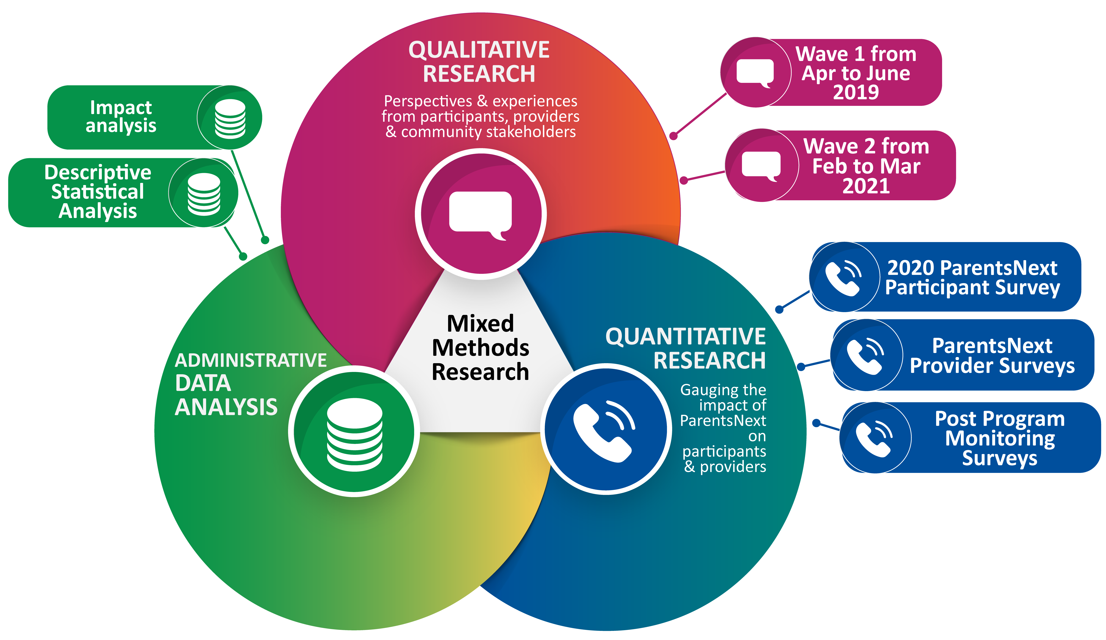

1.3.1 Data sources
Data sources used in the evaluation are presented in Table 1.2.
Table 1.2: Evaluation data sources
Key data sources
ParentsNext departmental administrative data from the Employment Services System (ESS)
Department of Education, Skills and Employment’s Research and Evaluation Database
2019 and 2020 ParentsNext Provider Surveys
2020 ParentsNext Participant Survey
Qualitative research with ParentsNext participants and providers
Longitudinal case studies of ParentsNext participants
Work Star™ work-readiness assessments conducted by ParentsNext providers
ParentsNext Post Program Monitoring Survey – survey data collected 2019, 2020 and 2021 by the department
Additional Child Care Subsidy (Transition to Work) data captured by the department
National Customer Service Line (NCSL) data captured by the department
Australian Bureau of Statistics data (Labour Force and Australian National Accounts)

1.3.2 Qualitative research
SRC was contracted to undertake qualitative research in 2 waves. The first wave, between 5 April 2019 and 14 June 2019, included interviews with 47 participants, 44 provider staff and 20 community stakeholders.
The second wave, conducted between 15 February 2021 and 5 March 2021, consisted of interviews with 24 participants who had participated in the 2020 ParentsNext Participant Survey.
Longitudinal case studies were conducted with 6 participants, in 3 waves over a 12 to 15 month period (April to May 2019, February 2020, and September to October 2020).

1.3.3 Quantitative research

1.3.3.1 ParentsNext Provider Survey 2019
The 2019 ParentsNext Provider Survey was conducted by the department’s Employment Evaluation Branch (formerly the Employment Research and Evaluation Branch) between 6 May 2019 and 17 June 2019. The purpose of the survey was to gather the views of ParentsNext providers about the design and operation of the nationally expanded program and about the quality of services provided by the department. Providers operating full-time and part-time sites were included in the survey; those operating outreach sites were excluded. The overall response rate to the survey was 88%. The analytical dataset consisted of 384 sites; 82% of these sites operated on a not-for-profit basis.

1.3.3.2 ParentsNext Provider Survey 2020
The 2020 ParentsNext Provider Survey was conducted by the department’s Employment Evaluation Branch (formerly the Employment Research and Evaluation Branch) between 6 November 2020 and 3 December 2020. The 2020 survey methodology followed that of the 2019 ParentsNext Provider Survey closely. It was a census of ParentsNext providers conducted at the site level; all providers operating full-time and part-time sites were invited to participate. Of these sites, 77% operated on a not-for-profit basis. The overall response rate was 89%.
The survey was designed to gather the views of ParentsNext providers about the design and operation of the nationally expanded program and about the quality of services provided by the department. It covered the impact of the 2019–20 bushfires and the COVID-19 pandemic.

1.3.3.3 ParentsNext Participant Survey 2020
The data collection for the ParentsNext Participant Survey 2020 was carried out in November 2020 via mixed-mode interviewing: online surveys and Computer Assisted Telephone Interviewing (CATI). The department provided a sample to the SRC on 23 September 2020. The sample consisted of participants from 3 groups of respondents, based on their ParentsNext eligibility reason: ESL, YC5, or high JSCI score. In total, 2,260 surveys were completed.

1.3.3.4 ParentsNext Post Program Monitoring Survey
The department undertakes regular post-program monitoring surveys with participants, and ad hoc surveys of cohorts of participants utilising employment services. Survey results are useful for program comparisons over time because of their relatively consistent methodology. PPM surveys are used by the department to collect feedback and insights from current and former participants on their outcomes and experiences in employment services. Three ParentsNext PPM surveys were conducted during the study period and the survey results were used in this evaluation.
The first PPM survey targeted participants who had been in the ParentsNext program for 3 months at 31 December 2018 or exited between 1 December 2018 and 31 December 2018. In total, 31,531 participants were invited to participate, with a response rate of 28.5%.
The second PPM survey targeted participants who were on the caseload for at least 3 months and either were on the caseload at 29 February 2020 or had exited ParentsNext between 1 February 2020 and 29 February 2020. Of the 65,799 participants invited to participate, 15,323 responded (23.3%).
The third PPM survey targeted participants who had been on the caseload for at least 3 months at 28 February 2021, and those who exited ParentsNext between 1 February 2021 and 28 February 2021. In total 68,823 participants were invited to participate. The response rate was 18.3%.

1.3.3.5 Descriptive statistical analysis
The flow of ParentsNext participants in and out of the program, including to other programs, was tracked over the study period. ParentsNext participants’ engagement in appointments and activities was examined, as was providers’ use of the Participation Fund.

1.3.3.6 Impact analysis
Impact analysis is used to determine the causal effect of an intervention on participant outcomes. For this evaluation, an impact analysis was conducted to address the evaluation question Does participation in ParentsNext lead to increased participation in education and progress towards education and employment related goals?. This is addressed in Chapter 5.
The impact of ParentsNext on participant outcomes was quantified by comparing outcomes of ParentsNext participants (the treatment parents) with those of similar parents who did not participate in the program (the comparison parents). Two populations were selected to examine this under the different socio-economic and operational settings that applied at different stages since the national expansion began. The first population (stage 1) consisted of parents who were eligible for a treatment or comparison group on 2 October 2018, shortly after the rollout of the national expansion. The second population (stage 2) comprised parents who were eligible on 2 October 2019, after which significant economic and social disruption occurred in Australia due to the 2019–20 bushfire season and the onset of the COVID-19 pandemic.
The demographic characteristics of the 2 populations used for the impact analysis can be found in Appendix 4. All parents included in the populations met the base eligibility criteria for ParentsNext and some additional criteria defined for the purpose of the impact analysis (Appendix 4). Treatment group parents were selected from the ParentsNext caseload – that is, their placement status was ‘commenced’, ‘suspended’ or ‘pending’ on 2 October 2018 and 2 October 2019. The comparison groups were selected from parents living in ParentsNext locations who met most but not all of the ParentsNext eligibility criteria on these dates, making them ineligible for participation in the program. Assignment to a treatment or comparison group was based on the criteria shown in Table 1.3.

Table 1.3: Assignment criteria for each eligibility group
Eligibility group | Treatment criterion | Comparison criterion
ESL | Aged up to 21 years and 4 months | Aged between 22 and 24 years (inclusive)
YC5 | Youngest child aged between 5 years and 5 years and 4 months (inclusive) | Youngest child aged between 4 years and 4 years and 4 months (inclusive)
High JSCI | JSCI score at or above high JSCI score threshold | JSCI score below high JSCI score threshold
Notes: The assignment criterion for each eligibility group was the criterion that determined whether parents were placed in a treatment or a comparison group, given that they met the other criteria for that eligibility group. The other criteria included the base eligibility criteria for participation in ParentsNext, regardless of group, and the additional selection criteria that are specific to each eligibility group apart from those listed here (see Appendix 4).
These assignment criteria were chosen to minimise differences in demographic characteristics between the treatment and comparison groups while ensuring the samples were sufficiently large. The construction of the treatment and comparison groups prioritised comparability to increase the robustness of program impact estimates. However, there was a trade-off with the generalisability of the findings, as this limited the representativeness of the treatment groups for the wider ParentsNext participant population.

1.3.3.6.1 Impact analysis outcome measures
It was important to recognise that ParentsNext is a pre-employment program. It does not require participants to look for work but supports those who choose to look for work. A parent’s progress towards their education and employment goals cannot be measured directly, so proxy measures were adopted instead. Composite outcomes, described in Table 1.4, were constructed to capture multiple indicators that a parent had engaged in education or employment activities. Program-defined outcome measures were not used, as they were not available for all the groups being compared. The impact analysis tracked parents’ outcomes in the 8 months following their eligibility for a treatment or comparison group. Caution should be used when comparing the achievement of education outcomes with the achievement of employment outcomes, as data availability differed between these measures. An individual analysis of the Additional Child Care Subsidy (Transition to Work) indicator is included in Appendix 5.

Table 1.4: Outcome measures
Outcome | Indicators for outcome achievement
Education/training composite outcome | - Education course participation, including short courses  - Receipt of an education-related supplement or subsidy, including the Pensioner Education Supplement  - Receipt of the Additional Child Care Subsidy (Transition to Work) for an education activity
Employment composite outcome | - Exiting income support  - Reported employment or business-related earnings  - Receipt of the Additional Child Care Subsidy (Transition to Work) for an employment activity

Logistic regression models were used to estimate program impact while adjusting for differences in personal and socio-economic characteristics between the treatment and comparison groups (Table A4.2, Appendix 4). The impact of ParentsNext was estimated by calculating the probability of the average participant achieving an education or employment outcome – that is, the ‘average marginal effect’ of ParentsNext on each outcome. Odds ratios were also output from the logistic regression models (Appendix 5).

1.4 Summary
The evaluation adopted a mixed-methods approach to answer the key evaluation questions, utilising qualitative and quantitative research and analysis of administrative data. A comprehensive impact analysis (discussed in chapters 3 and 5) was conducted to determine whether participation in ParentsNext led to increased participation in education and progress towards education and employment goals. The characteristics of participants and their barriers to education and employment were considered in examining program effectiveness and efficiency.

Chapter 2 The ParentsNext program

2.1 Policy and program context
The Australian Government is committed to ensuring that parents receive the assistance they need to prepare them for employment by the time their children reach school age. Parenting can provide an avenue for the development of new skills and social networks. However, time out of the workforce can result in loss of work-specific skills, loss of previously gained qualifications, and diminished confidence to enter or re-enter paid employment. For parents already receiving government income support, the risk of long-term welfare dependency can increase the longer they remain on income support.
The policy drivers that underpin ParentsNext are the Australian Government’s objectives to:
- reduce joblessness, welfare reliance and intergenerational welfare dependency
- increase female labour force participation
- help Close the Gap in Aboriginal and/or Torres Strait Islander peoples’ employment.

2.2 The macroeconomic environment
The commencement of the national ParentsNext expansion on 1 July 2018 occurred in a period when labour market conditions in Australia strengthened, with the level of employment increasing at around 2.6% from July 2017 to July 2018 (ABS July 2021). Consequently, the unemployment rate decreased significantly from 6.3% in July 2015 to 5.0% in December 2019, the lowest rate recorded since June 2011 (ABS July 2021). Despite this, in 2018 the Organisation for Economic Co-operation and Development (OECD) noted that Australia’s labour force participation of women with children was relatively low and below the OECD average (OECD 2018 b). In December 2020 the participation rate was 66% overall. For men it was 71% and for women it was 61% (ABS July 2021).

2.2.1 2019–20 bushfires and COVID-19 shocks
The COVID-19 pandemic had severe economic and social impacts on Australia in 2020. In the June quarter there were record reductions in Australian gross domestic product (7%) (ABS June 2021) and the annual change in hours worked (5.8%) (ABS July 2021). The early economic effects disproportionately impacted young people and parents. From mid-March to mid-June 2020, payroll jobs for women decreased by 6.5%, compared to 5.8% for men (WGEA 2020). In May 2020, 76% of adults with children in their household had kept them home from school or child care due to COVID-19; women were 3 times as likely to be looking after these children full-time on their own than men (ABS May 2020).

2.3 Australian and international research
When welfare-to-work activities for parents were first introduced in Australia in 2003, ‘the primary claim was that these measures would increase individual wellbeing’ (Grahame and Marston 2012). The broad objective of these changes, as described in the Explanatory Memorandum to the 2005 Welfare to Work Bill, was that people should look for, and undertake, work in line with their capacity, particularly taking into account caring responsibilities (such as caring for young children or for a frail adult or disabled child) that constrain their availability to work.
For parents with capacity to work, the theory was that increased workforce participation would lead to reduced welfare dependency. Since then, considerable research has been undertaken in Australia and overseas that aims to test the success or otherwise of achieving this claim (Appendix 1). This theory has been supported by Australian and international research indicating that unemployment benefits reduced incentives to search for a job. A meta-analysis of 207 studies of 857 programs found that active labour market policies and conditionality were more effective for disadvantaged and long-term unemployed participants, and also were more effective for women (Card et al. 2018). However, while empirical studies ‘consistently showed that job search monitoring and benefit sanctions reduce unemployment duration and increase job entry in the short term’, research has also found ‘some evidence that longer-term effects of benefit sanctions may be negative’ (McVicar 2020).
Around the world, the stated principles and ideals behind the conditionality reforms have been welcomed broadly, but the scale, pace and targeting of these reforms have been challenged in a number of jurisdictions. Countries have different compliance regimes and sanctions, however; some, including the UK, are much stricter than those in Australia. As a result, the findings from one jurisdiction are not necessarily applicable to another.
Nonetheless, there is research suggesting that the reforms may have some unintended consequences for the most vulnerable in society: people on low incomes, people with disability, and single women with children (Social Security Advisory Committee 2014; Berry et al. 2012). For example, a review of the emergent international evidence on mental health and welfare conditionality suggests that welfare conditionality is largely ineffective in moving people with mental health impairments into, or closer to, paid work. Indeed, in many cases it triggers negative health outcomes that make future employment less likely (Dwyer 2020).
In Australia, the House of Representatives Select Committee on Intergenerational Welfare Dependence found that, while there was a correlation between parents receiving welfare payments for significant periods of time and their children also receiving payments, there was no single explanation, factor or mechanism that linked the outcomes of one generation to those of the next. The committee identified the following factors that increase the risk of entrenched disadvantage: geographic location (accessibility/remoteness); educational attainment; Indigenous and single parent status; suitability of available employment; health and family welfare; and availability of appropriate support systems (House of Representatives Select Committee on Intergenerational Welfare Dependence 2019).

2.4 ParentsNext
ParentsNext is a pre-employment program that, while taking account of their caring responsibilities, places obligations on compulsory participants to plan and prepare for future employment. From April 2016 to June 2018, ParentsNext operated in 10 locations across Australia. The evaluation of ParentsNext 2016–2018 found that the impact of the program was positive, albeit with a small number of caveats.
To build upon the achievements of the 2016–2018 program, the Australian Government expanded ParentsNext nationally to non-remote locations from 1 July 2018. This was expected to enable around 68,000 parents to participate each year. Approximately 96% of ParentsNext participants were women, and around 10,000 Aboriginal and/or Torres Strait Islander women were expected to participate. The program complemented a range of other Australian Government initiatives designed to increase female and Aboriginal and/or Torres Strait Islander participation in the workforce and support meeting Closing the Gap targets. As at 31 December 2020, 79% of ParentsNext participants were single parents.
ParentsNext supports parents and carers who receive Parenting Payment to plan and prepare for work by the time their youngest child starts school. Support includes help with developing skills, training or work experience; help arranging financial support for job preparation skills, training and other work-related expenses; and connection to local support services such as counselling. The ParentsNext program aims to provide a range of assistance to participants, including:
- tailored support to help participants identify their education and employment goals, while taking into account current and anticipated employment opportunities in their community
- assistance to plan for and participate in relevant activities to help participants progress towards their goals, while considering their caring responsibilities and family circumstances
- regular contact, at least once every 3 months, with a ParentsNext provider, who is expected to work to build a rapport with participants to determine their individual education and employment goals and family responsibilities. This includes developing an understanding of the barriers to employment (vocational or non-vocational) participation. For example, lack of confidence, experiencing domestic violence, family breakdown, mental and physical health issues, access to affordable housing, and lack of career counselling can be barriers to employment
- a welcoming environment that caters to the needs of participants and their children by providing child-friendly space at appointments and support for participants
- connection to appropriate activities through referrals to local services, and provision of services by ParentsNext providers where service gaps are identified
- information about existing resources in participants’ local communities, including local Aboriginal and/or Torres Strait Islander services and vocational educational training centres
- assistance to connect with child care providers, including, where eligible, accessing financial assistance for child care, as well as identifying alternative child-minding options
- a ‘warm handover’ when participants transition from ParentsNext to another employment service
- an opportunity for participants to become involved in the delivery of their local ParentsNext service.

2.5 Theory of change
The ParentsNext program is underpinned by a theory of change that suggests that the risk of long-term welfare dependency decreases if participants receive personalised assistance to help them identify their education and employment goals, improve their work readiness and link them to activities and services in the local community.
The theory is associated with a conviction that most parents in need of the support provided are less likely to participate if it is not compulsory to attend appointments. Hence, the application of the Targeted Compliance Framework (TCF) and the associated mutual obligation requirements (MORs) encourages participants to develop work-like behaviours to support them to transition to work when they are ready or to other employment services programs.

2.6 ParentsNext eligibility criteria
The expanded ParentsNext program was delivered in 2 streams – a targeted stream and an intensive stream. The eligibility criteria for ParentsNext are designed to target assistance to parents at greater risk of welfare dependency and support those parents who may soon have participation requirements in employment services to prepare for work. ParentsNext providers are expected to deliver flexible, culturally appropriate and tailored assistance, including a high level of Aboriginal and Torres Strait Islander community engagement. ParentsNext is not delivered in remote regions of Australia.
The immediate objectives of ParentsNext are to:
- target early intervention assistance to parents with young children
- help parents identify and reach their education and employment goals through participation in activities
- connect parents to local services that can help them prepare for future education or employment.

2.6.1 Intensive and targeted streams
- The intensive stream operated in 30 locations across Australia – the 10 locations where ParentsNext 2016–2018 was delivered and an additional 20 locations with a high proportion of Aboriginal and/or Torres Strait Islander Parenting Payment recipients.
- The targeted stream operated in all areas of the 51 employment regions to assist disadvantaged parents who were at risk of long-term welfare dependency but were not part of the intensive stream.
The intensive stream delivered the same services as the targeted stream; however, it made greater financial assistance available to support eligible parents to prepare for or gain employment. The extra financial support included the Participation Fund, access to wage subsidies, Relocation Assistance to Take up a Job (RATTUA), and outcome payments when an intensive stream participant gained sustainable employment or completed a suitable education course. The intensive stream was developed in recognition that more needed to be done to assist Aboriginal and Torres Strait Islander parents to participate in the labour force, and to support the Closing the Gap employment target.
The targeted stream delivered tailored pre-employment assistance to eligible parents in jobactive employment regions throughout Australia, except where the intensive stream operated.
Targeted stream providers could choose to use their service fees to fund some additional activities and referrals.

2.6.2 Compulsory participants
The ParentsNext program is premised on the idea that parents receiving income support have an obligation to prepare themselves for future employment. Parents are required to participate in ParentsNext as a compulsory participant if they:
- meet all of the following base eligibility criteria:
  - have a child aged under 6 years
  - have been continuously receiving Parenting Payment for at least 6 months
  - have no reported earnings from employment in this 6-month period
- meet one of the additional stream eligibility criteria shown in Table 2.1.
Table 2.1: Stream eligibility criteria
Intensive stream | Targeted stream
For those residing in an intensive stream location:  - are an ESL with a youngest child at least 6 months of age  - are assessed as being highly disadvantaged and have a youngest child at least 6 months of age, or  - have a youngest child at least 5 years of age | For those residing in a targeted stream location:  - are an ESL with a youngest child at least 1 year of age  - are assessed as being highly disadvantaged and have a youngest child at least 3 years of age, or  - have a youngest child at least 5 years of age and are part of a jobless family.
Compulsory participants are subject to the TCF. Under the framework, providers are responsible for managing participant non-compliance by using payment suspensions and the accrual of demerits. This is aimed at encouraging participants to remain engaged with their provider, take personal responsibility for meeting their MORs and change any non-compliant behaviour prior to the application of any financial penalties. The framework is designed to target participants who are persistently and wilfully non-compliant with financial penalties, while providing safeguards for the most vulnerable.
In March 2020, as the Australian Government implemented social distancing restrictions as a consequence of COVID-19, ParentsNext MORs were lifted. Participants were not required to participate in activities or appointments; however, providers were expected to maintain monthly contact with participants by phone or online mechanisms to ensure participants had access to the supports that they and their family may have needed. This continued until 28 September 2020, when participants outside Victoria were once again subject to compliance action if they failed to meet MORs. For participants in Victoria, MORs returned from 23 November 2020.
Despite the uneven nature of the impact of both the bushfires and the COVID-19 pandemic lockdowns, each impacted significantly on the capacity of ParentsNext providers to offer participants activities or refer them to local services. With contingency arrangements in place and MORs suspended, face-to-face servicing was severely restricted. Participants were advised directly, and the department’s website was updated with information on the changes.
Despite this, some ParentsNext providers developed innovative practices to service their participants (see Chapter 6).

2.6.3 Intensive stream volunteers
Parents who did not meet the eligibility criteria for compulsory participation had the option to voluntarily enter ParentsNext, provided they remained in receipt of a Parenting Payment, had a child under 6 years and were in an intensive stream location. Providers were required to provide the same level of services to volunteers as to compulsory participants. Voluntary participants were not subject to the TCF.

2.7 Job Seeker Classification Instrument
All participants in ParentsNext were required to have a JSCI assessment, which was expected to be updated following any significant changes to a participant’s circumstances. While Services Australia conducted the JSCI for some participants before they commenced in ParentsNext, providers had to complete a JSCI within 20 days of the participant’s commencement for participants who did not have a current one.
The JSCI is used to identify whether a participant has multiple or complex barriers to employment. It is based on a questionnaire comprising 18-49 questions and 18 factors broadly grouped into 8 sections:age and gender; work experience; education and qualifications; work capacity; descent and origins; language; living circumstances including caring responsibilities; transport; and personal factors, including domestic violence, disability and medical conditions, risk of homelessness and family grief/trauma (Table 2.2).

Table 2.2: Sections and factors covered in the JSCI questionnaire
Section | Factor
Work experience | Recent work experience, and work history
Education and qualifications | Educational attainment, vocational qualifications
Work capacity | Disability/medical conditions
Descent and origins | Country of birth, Aboriginal and/or Torres Strait Islander status, Aboriginal and/or Torres Strait Islander location
Language | English proficiency
Living circumstances | Stability of residence, other living circumstances
Transport | Access to transport
Personal factors | Age, gender, geographic location, proximity to a labour market, phone contactability, criminal convictions, other personal factors

2.8 Implementing the ParentsNext service

2.8.1 The participant referral pathway
The ParentsNext pathway commences with Centrelink (now Services Australia), where a participant may be exempted or streamed. A JSCI is completed and the participant is referred to a provider and commenced or exempted. The participant is then required to attend an appointment and commence in activities (Figure 2.1).
Figure 2.1: ParentsNext participant referral pathway
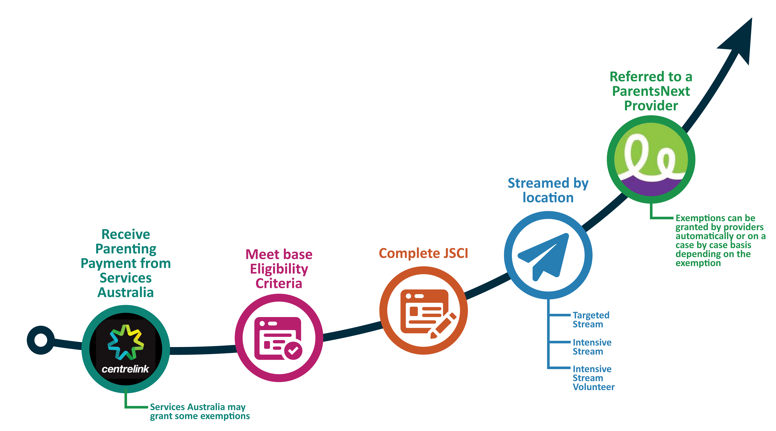

2.8.2 MORs – compulsory appointments, Participation Plans and payment eligibility criteria
As noted earlier, ParentsNext participants are required to comply with MORs. These include:
- attending an initial ParentsNext appointment (generally in person) and then every 3 months (attendance at these subsequent appointments can be in person, by phone or online)
- negotiating, agreeing and signing a Participation Plan that takes account of the participant’s goals, personal circumstances and capacity to undertake the activities. Participation Plans must include a compulsory activity. Participants are not required to undertake unsuitable or unreasonable requirements or participate in a job search activity, although they can choose to participate in a job search if they want to and are job ready
- participating in, and reporting on, agreed activities.
In addition, participants are required to report to Services Australia each fortnight about any additional income.
Under the TCF, participants’ payments can be suspended if they have not met these requirements and do not contact their provider and re-engage. Participants must inform their provider as soon as possible of any changed circumstances, to ensure their payment is not impacted. If they have a valid reason, such as a child being sick, or if they contact their provider soon after missing the appointment or activity, the activity will be rescheduled. A new element was introduced in early December 2020: if participants miss a MOR, they receive a text message, an email or an inbox message to advise them that they must contact their provider within 2 business days to ensure that their payment is not put on hold.

2.9 Exemptions
A unique feature of ParentsNext is that providers have the authority, delegated to them by the Secretary of the department, to exempt compulsory participants from their participation requirements temporarily for a variety of reasons (see Table 2.3). Participants may receive a number of exemptions. Providers are required to comply with Social Security Law when determining whether to grant exemptions. The department monitors the number of exemptions to ensure that providers grant exemptions appropriately and in accordance with guidelines.
Participants with an exemption are not subject to MORs during the period of the exemption. The evidence for granting an exemption and the average length of an exemption varies depending on the type of exemption granted.

Table 2.3: ParentsNext exemptions
Exemption type | Maximum duration (can be re-granted if circumstance continues)
Temporary incapacity
Due to medical incapacity | 13 weeks
Due to serious illness | 52 weeks
Caring responsibilities
Providing home school | 52 weeks
Providing distance education | 52 weeks
Foster carer | 52 weeks
Large family with 4 or more children | 52 weeks
Caring responsibilities | 16 weeks
Caring for a child not eligible for Carer Payment | 52 weeks
Caring non-parent state/territory care plan | 52 weeks
Carer non-parental relative | 52 weeks
Temporary confinement | 32 weeks (6 weeks before due date, 26 weeks after)
Other special family circumstances | 16 weeks
Personal circumstances
Bereavement period | 16 weeks
Bereavement period (partner) | 14 weeks
Bereavement period (pregnant partner) | From day of partner’s death until partner’s due date
Community service order | 13 weeks
Domestic violence or relationship breakdown | Must be granted for initial 16 weeks with further periods on case-by-case basis
Declared natural disaster | 13 weeks but generally 4 weeks is appropriate
Jury duty | 13 weeks but limited to time the participant needs to attend jury duty
Major personal crisis | 13 weeks but should be limited to the time required to address the participant’s circumstances
Major personal disruption | 13 weeks although it is generally appropriate to grant these exemptions for 2 weeks
Other special circumstances | 13 weeks
Other special circumstances – undertaking Indigenous cultural business – maximum | 13 weeks
Other special circumstances – state or national emergency | 13 weeks
Services Australia exemption for approved overseas absence | On a case-by-case basis
Exemptions are generally granted by providers. Services Australia can grant exemptions, but in practice this was limited to only some types until late 2020. Exemptions are either automatic or granted on a case-by-case basis, depending on the type of exemption. Automatic exemptions are granted where a participant’s evidence supports one. For case-by-case exemptions, the provider or Services Australia must consider whether a participant’s circumstances make it unreasonable for them to meet their requirements, and grant an exemption where appropriate. Participants can seek a review by the department if an exemption is not granted.

2.9.1 Participants volunteering during an exemption
Compulsory participants granted a temporary exemption from ParentsNext have their compulsory requirements suspended for the period of the exemption; however, they can voluntarily participate in ParentsNext during the period of the exemption and receive the same level of servicing from their provider.

2.10 The Participation Fund
The Participation Fund is a flexible pool of funds providers may use to help intensive stream participants prepare for employment. Providers must consider how the fund can be used to assist a participant with their education and employment goals and advance their work readiness. Intensive stream participants (both compulsory participants and intensive stream volunteers) attract a one-off credit of $1,200 to their provider’s Participation Fund notional bank balance when they first commence in the intensive stream. Credits are applied at provider site level. Providers claim reimbursements for eligible purchases.

2.11 Exits
The department’s IT systems automatically exit participants from ParentsNext when they are no longer eligible (effective exits), and providers can manually exit participants in certain circumstances (provider exits).
An effective exit is triggered for a compulsory participant when Services Australia advises the department that the participant:
- no longer resides in a ParentsNext location
- no longer has a youngest child under 6 years of age for Parenting Payment purposes
- no longer receives Parenting Payment
- otherwise no longer meets the eligibility criteria.
An effective exit is triggered for an intensive stream volunteer who:
- no longer resides in a ParentsNext intensive stream location
- has not attended 2 consecutive appointments
- has commenced in an employment service administered by the department or Disability Employment Services
- is no longer receiving Parenting Payment or no longer has a child under 6 years of age
- is no longer eligible, on advice from Services Australia.
Providers can manually exit (provider exit) any:
- compulsory participant who has achieved stable employment
- intensive stream volunteer who is not participating in line with their Participation Plan or has advised that they no longer wish to participate in ParentsNext.

2.12 ParentsNext policy and systems changes
Participant and provider feedback over the life of the program, and the bushfire emergency and the COVID-19 pandemic, resulted in several policy and systems changes over the study period (see Appendix 2).
In the main, these changes related to the lifting of MORs as a result of ‘other special circumstances’ exemptions, simplified and flexible scheduling of some activities, and modifications to minimise payment suspensions. Others related to suggestions from providers and participants, findings from the evaluation of ParentsNext 2016–2018, and recommendations from the Senate Standing Committee on Community Affairs inquiry into the program in early 2019.

2.13 Provider duties
Providers are required to connect participants to local activities and support services such as counselling, financial advice, domestic and family violence support, parenting courses, child care, transport, further education, secure housing, training and volunteering. Providers must provide services in accordance with the ParentsNext Deed and Guideline.

2.13.1 Service Delivery Plans
Providers are required to develop a Service Delivery Plan for each employment region in which they are contracted to deliver ParentsNext services. The plans must complement the ParentsNext Services Guarantee, be appropriate to the participants being served and be in an appropriate language. Service Delivery Plans indicate the nature of the service provided, how barriers will be addressed and how specific groups will be accommodated.

2.13.2 Work readiness assessments
Providers must complete a minimum number of work-readiness assessments, utilising the Work StarTM assessment tool, with randomly selected participants – the lesser of either 100 participants or 50% of their caseload – at least every 6 months. The primary aim of these assessments is to measure a participant’s initial state of work readiness and to discuss how to address any barriers participants might have that would impact on their ability to achieve their employment or education goals (see Section 5.2).

2.14 Interactions between ParentsNext and employment programs
During the study period, eligible compulsory participants who were work ready could volunteer for referral to government-funded employment services such as jobactive, Volunteer Online Employment Services Trial (VOEST), Transition to Work (TtW) or New Business Assistance with NEIS (New Enterprise Incentive Scheme), while continuing in ParentsNext. Aboriginal and/or Torres Strait Islander participants could also be referred to vocational training and employment centres (VTECs) that provide job placement services for Aboriginal and Torres Strait Islander people.
The participant’s period of assistance depended on the employment service to which they were referred. For example, participants were eligible for one 6-month period of assistance as a volunteer in jobactive, whereas participants referred to TtW, VOEST or NEIS were eligible for up to 52 weeks of assistance. As ParentsNext is a pre-employment program, features of TtW in particular, especially the attention to human capability building, are complementary to ParentsNext.

2.15 Departmental monitoring
The department monitors ParentsNext through performance measures. During 2019–20, key performance indicators (KPIs), alongside program assurance activities, formed the department’s performance framework. KPIs operated at the provider level, as part of ensuring provider performance. Additional key performance measures (KPMs), were assessed at the program level to determine the effectiveness of the program as a whole.
If ParentsNext participants experience a problem with their ParentsNext service, they can discuss the matter with their provider in the first instance if possible. If the participant is dissatisfied with the results of the provider’s customer feedback process, the provider must refer the participant to the department for further investigation. Participants can also contact the department directly, by calling the department’s NCSL. Contacts are not limited to complaints, but monitoring complaints to the NCSL provides a useful window into the appropriateness of ParentsNext.

Chapter 3 How well does ParentsNext engage, assist and service participants?
This chapter examines participant awareness and engagement. Referrals, commencements and compliance of participants are reviewed.

3.1 Study populations and their characteristics
The evaluation studied several populations of parents to conduct qualitative and quantitative research. The main populations used for quantitative analysis were the inflow population of participants referred to ParentsNext, and 2 caseload populations used for the impact analysis.

3.1.1 Referral inflow population
The referral inflow population (Table A4.3) consisted of periods of assistance for participants who were referred to ParentsNext and commenced by 31 December 2020. This population was used to describe the cohort of parents participating in ParentsNext during the study period and to examine the efficiency of referrals and commencements (sections 3.5 and 3.6). Each period of assistance represented the time in which a participant was receiving ParentsNext servicing, beginning on their referral date and ending when they had exited for more than 91 days. Periods of assistance which were yet to end by 31 December 2020 were still included. During the study period, it was possible for participants to have multiple periods of assistance. In total, there were 154,845 periods of assistance for 150,077 unique participants. For ease of reporting, reference is made to ‘periods of assistance’ as ‘participants’ in this section. Of the 154,845 periods of assistance, 39% were for intensive stream participants and 61% were for targeted stream participants.
The majority (69%) of participants were eligible due to their high JSCI scores, followed by YC5s (19%) and ESLs (10%). Parents were most commonly aged 30 to 39 years (43%) and more than half (62%) had a youngest child aged 3 years or younger. The targeted stream had an older distribution of both parents and youngest children than the intensive stream, in line with the stream eligibility criteria (Section 2.6).
Most participants were female (94%) and single parents (79% received Parenting Payment single). A quarter of participants (26%) in the intensive stream were Aboriginal and/or Torres Strait Islander people, and around 1 in 5 (21%) participants in the whole population had a CALD background. Three-quarters of participants (75%) resided in New South Wales, Victoria or Queensland (see Appendix 5, Table A5.37).

3.2 Barriers to participation
Vocational and non-vocational barriers to parents’ participation in education and training and work, identified in the qualitative research and stakeholder surveys, were largely consistent with those in the literature (see Figure 3.1). For some parents, these issues also inhibited their active participation in the ParentsNext program itself; for example, a lack of child care may have precluded parents’ participation in available activities. Participants in the Wave 1 qualitative research reported child care responsibilities, employment inflexibility, study costs, transport availability and job market competitiveness as typical problems.
Accessing employment opportunities that fitted around caring responsibilities was a key concern for parents. This prompted some parents in the qualitative research to leave unfavourable sectors where they may have worked before having children (such as those involving shift work), to pursue other employment opportunities.
Figure 3.1: Vocational and non-vocational barriers to work
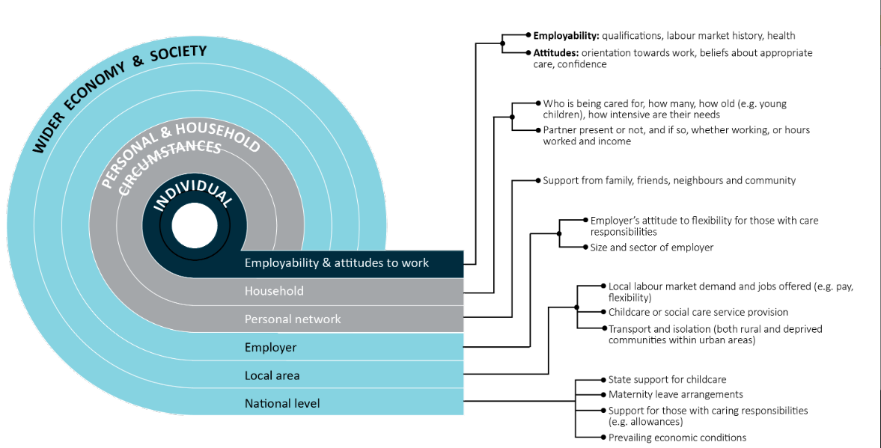
Source: Adapted from McQuaid et al. 2013

3.2.1 Vocational barriers
The vocational barriers most reported by providers in the 2019 ParentsNext Provider Survey were the limited work history or experience (85%), limited education (71%) and limited job search skills (65%) of participants. In the 2020 ParentsNext Provider Survey, again most providers (90%) reported that participants’ limited work history/experience was a barrier to achieving their employment and education related goals (Figure 3.2).
Figure 3.2: Vocational barriers – employment, 2019 and 2020
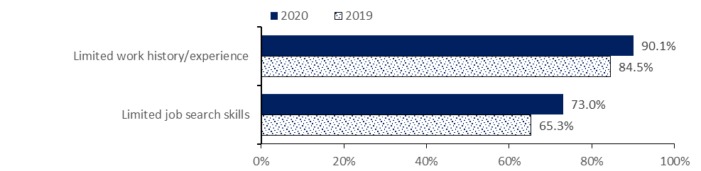
Source: 2019 and 2020 provider surveys
Base: All respondents (2020: n=382; 2019: n=380)
2020: Q6.1; 2019: Q6.1 What are the most common BARRIERS that participants at the site face in moving toward their employment and education goals? Select all that apply.
In 2019, access to affordable training or education was reported as a barrier (51%), as was language (36%). Many respondents (72%) reported that participants’ limited education was a barrier to achieving their education and employment goals. In the 2020 ParentsNext Provider Survey, a higher proportion of providers identified limited education, access to suitable and affordable training and educational opportunities and language as common barriers than in 2019 (Figure 3.3).
Figure 3.3: Vocational barriers – education, 2019 and 2020
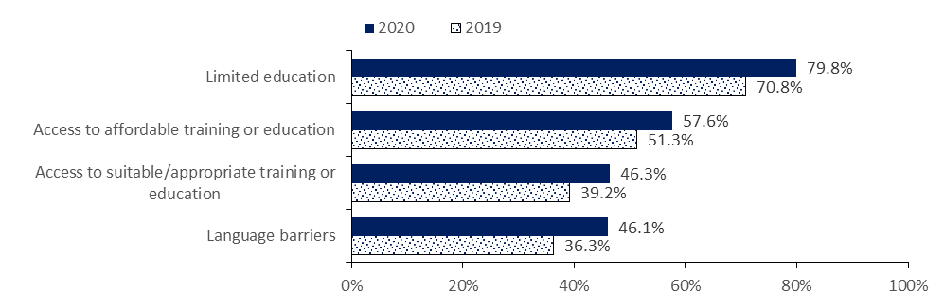
Source: 2019 and 2020 provider surveys
Base: All respondents (2020: n=382; 2019: n=380)
2020: Q6.1; 2019: Q6.1 What are the most common BARRIERS that participants at the site face in moving toward their employment and education goals? Select all that apply.

3.2.2 Non-vocational barriers
Almost all providers who participated in the Wave 1 qualitative research observed notable non-vocational barriers including lack of access to child care, poor mental health, low confidence and self-esteem, disability and health needs among children, housing issues and high rates of domestic violence within their cohort. Some participants described busy lives where they felt they were constantly juggling child care responsibilities and had little time to address their work goals.

3.2.2.1 Child care
Accessing adequate and affordable child care was identified as both a vocational and non-vocational issue in the literature. For example, in 2014, one-quarter of all United Kingdom (UK) parents reported that more affordable child care was the single thing that would make a positive difference to family life (McKendrick 2016).
This view was confirmed in the ParentsNext qualitative and quantitative research. As one participant in the longitudinal case studies put it:
It’s hard because I had my son when I was older and so obviously I can’t ask my mum because I am a carer for my mum and my parents aren’t in a position to look after him and I don’t have any sisters or brothers and I live in [Location] now and so it’s actually quite far away from friends … So, I’m really on my own here now. (Interview, single female, mid-40s)
While the cost and convenience impacted participants’ choice of child care, some participants in the Wave 1 qualitative research highlighted difficulties with understanding the child care subsidy (Appendix 7) and the level/rates of assistance/entitlements that were available. This meant that even if they wanted to use child care, the challenges of understanding the subsidy and the amount of out-of-pocket costs they would incur in order to make an informed decision about using child care, made it too difficult to pursue.
More than 4 in 5 providers (81%) surveyed during the 2019 ParentsNext Provider Survey, reported that the affordability of child care was a barrier to participants achieving their education and employment related goals. Over half of respondents (52%) reported that access to child care was a barrier to achieving participants’ education and employment goals.
In the 2020 provider survey (Figure 3.4), almost two-thirds of respondents (65%) reported that both child care affordability and caring for children with disability/health issues were barriers to participants achieving their education and employment related goals. Reporting of the affordability of child care as a barrier fell by 16 percentage points between 2019 and 2020, while reporting of caring for children with disability/health issues as a barrier rose by 11 percentage points over this time. Lockdown restrictions and the availability of some free child care during the pandemic in 2020 are expected to have impacted these results.
Figure 3.4: Non-vocational barriers – parental, 2019 and 2020
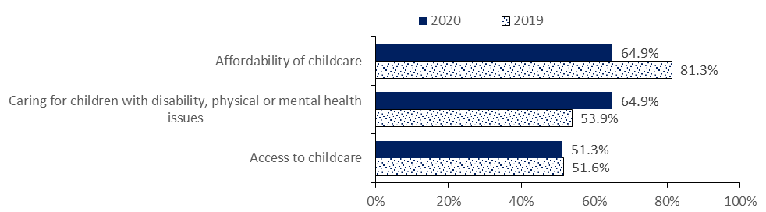
Source: 2019 and 2020 provider surveys
Base: All respondents (2020: n=382; 2019: n=380)
2020: Q6.1; 2019: Q6.1 What are the most common BARRIERS that participants at the site face in moving toward their employment and education goals? Select all that apply.
The Wave 2 qualitative research explored attitudes towards child care services. Many participants indicated that they perceived child care to be beneficial, both in allowing them time to pursue work/education opportunities and in furthering the social development of their children. Aside from availability and access, reasons for not using child care included the child’s age, personal preferences regarding being a stay-at-home parent (believing that it is important for children to spend their formative years at home), concerns about the safety of child care, and financial limitations.
Participants who thought that child care provided a more stimulating environment for their child indicated that they noticed an increase in their child’s development and independence.
I always felt like he needed that step away from me to get more independence. And he’s a very social, happy kid; he makes friends really easy. I also thought that would help him with socialising skills, so we did do one day a week with family child care. (Interview 20. Female, SA, 2 children, single parent, 35–45 years old)
Some participants had received practical help from their caseworkers – for example, to place their child in child care.

3.2.2.2 Physical and mental health
International research points to single parents with a limiting longstanding illness, disability or infirmity, especially those with mental health problems, as the least likely of all parents to move into work (Coleman and Riley 2012). More recently, the National Health Service in Scotland (Teuton 2018) found that single parents were most likely to have suffered from mental health issues and experienced the same social determinants that caused loneliness. Children and adults who were socio-economically disadvantaged and those who had poor physical and mental health were at particular risk.
During the Wave 1 qualitative research, providers noted that many of their participants and some of their participants’ children had health issues, often related to mental health. While a few providers had access to in-house psychologists, there was invariably a charge for this, so providers spoke of advising participants to see their general practitioner to organise a mental health care plan.
Almost all providers noted high levels of disadvantage among their cohort. Intensive stream providers were able to support parents with costs related to mental health care and counselling services using the Participation Fund. Some targeted stream providers also supported participants to access a mental health care plan and counselling, as well as child care services, using funding sources from their own organisation for psychology services. These providers reported that lack of access to the Participation Fund for targeted stream participants limited their capacity to assist these participants.
Both the Wave 1 qualitative research and the 2019 ParentsNext Provider Survey found that health-related disabilities complicated participants’ ability to seek work and/or engage with the community. Provider respondents reported that common barriers faced by participants were poor mental health, low confidence, low self-esteem, and domestic violence. While these were invariably complex barriers, many participants were engaged in support services and treatment, often facilitated through their ParentsNext provider.
So we need to really address diagnoses of children first, child care, we need to address the transport issues, we need to address homelessness issues, mental health issues, so we’re not setting clients up for failure. (Provider 6)
This was reinforced in the Wave 2 qualitative research in April 2021, where mental health concerns, such as anxiety and depression, were reported by some participants. One participant in the longitudinal case studies noted:
… she’s [my new ParentsNext consultant is] awesome and I really like her. I’ve seen her two times…Yes, she just wants me to get my mental [health concerns addressed] … so she just wants me to go to my GP and she just wants to make sure to get this on track and then she said we will do everything to help you … what we can to suit your goals and help you make a CV. I really like her. (Male, 1 child, mid-40s, non-English-speaking background)
Mental health issues were identified as a non-vocational barrier for participants by almost three-quarters (75%) of provider respondents (Figure 3.5) in the 2019 ParentsNext Provider Survey. Although the percentage was much lower, almost 2 in 5 respondents identified substance abuse as a barrier to some participants achieving their employment and education goals.
In the 2020 ParentsNext Provider Survey, which covered the COVID-19 pandemic period, the figure for mental health had risen by 10 percentage points, with 84% of respondents reporting referrals to mental health services and almost half (48%) identifying substance abuse as a barrier to participants achieving their employment and education goals. Given that respondent providers would have supported a larger number of participants by 2020, however, the increase may not necessarily reflect a greater proportion of participants experiencing these barriers in 2020 than in 2019.
Figure 3.5: Non-vocational barriers – health, 2019 and 2020
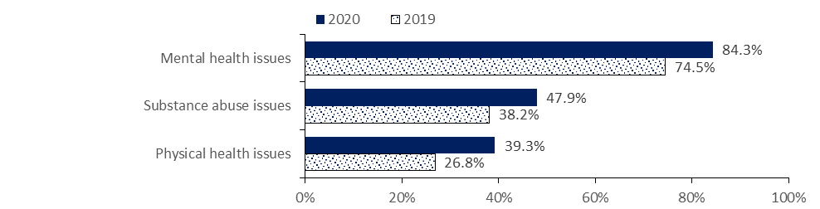
Source: 2019 and 2020 provider surveys
Base: All respondents (2020: n=382; 2019: n=380)
2020: Q6.1; 2019: Q6.1 What are the most common BARRIERS that participants at the site face in moving toward their employment and education goals? Select all that apply.
The impact of COVID-19 may also have influenced the increases of around 10 percentage points for each of the barriers between 2019 and 2020. Many respondent providers (39%) reported being unable to refer some participants to some services and activities. The most common reasons were related to COVID-19 (59%), that no places were available (59%) and that services or assistance were not available in their local area (47%). It is worth noting, however, that while these results may not have reflected the lived experience of all participants, they do represent the opinion of providers who had contact with participants.

3.2.2.3 Transport and commuting
International research shows that transport is a significant factor in enabling parents to take up and retain employment (Griffiths 2011). Most single parents are reliant on public transport, which represents a significant in‐work cost, restricts the hours in which it is possible to travel to and from work, and limits suitable job opportunities (McQuaid and Graham 2014). In addition, the type of child care used also influences commuting, with those using formal care being less willing to commute longer distances, due perhaps to the lack of flexibility and more limited hours of such care and the pressure to be back from work at a precise time (McQuaid 2009).
In the evaluation of ParentsNext 2016–2018, it was noted that parents who wanted to work and were living in areas where few jobs were available locally may have been required to travel substantial distances to accept a position. This could involve higher travel and possibly child care costs and reduce the financial benefits of working – factors particularly problematic for parents with low-level labour market skills or only able to find lower-paid employment.
Access to transport was raised as a particularly significant issue for participants in regional areas during the Wave 1 qualitative research and was highlighted by all providers as a barrier they made efforts to address. Those providers with access to the Participation Fund spoke of being able to use the funds to provide driving lessons and learner test fees. Others highlighted using local services that provided free supervised driver training.
More than three-quarters of respondents (77%) to the 2019 ParentsNext Provider Survey reported transport barriers for participants. This was confirmed in 2020, with 75% of respondents reporting both poor access to transport and a lack of a driver’s licence as significant barriers.
The literature confirms that ownership of private transport is a significant factor in improving the employment status of welfare recipients (Ong and Blumenberg 1998). Access to private transport enables unemployed workers to search for employment outside of the public transport corridors and makes travel more comfortable, thus widening their job search radius and increasing the potential travel-to-work time.

3.2.2.4 Family and domestic violence
In the 2019 ParentsNext Provider Survey, 2 in 3 provider respondents reported that both family/relationship (66%) and domestic violence (64%) issues were barriers to participants achieving their employment and education related goals (Figure 3.6). In 2020, however, there was an increase (12 percentage points) in the proportion of provider respondents reporting domestic violence issues as a common barrier for participants. Again, it may be that the impact of the bushfires and COVID-19 contributed to the result.
Figure 3.6: Non-vocational barriers – family relationships, 2019 and 2020
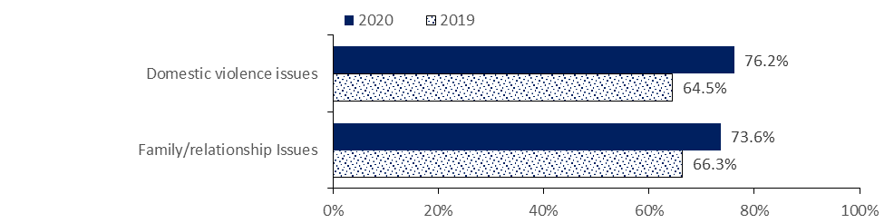
Source: 2019 and 2020 provider surveys
Base: All respondents (2020: n=382; 2019: n=380)
2020: Q6.1; 2019: Q6.1 What are the most common BARRIERS that participants at the site face in moving toward their employment and education goals? Select all that apply.
While both Services Australia and providers can grant exemptions to participants who are experiencing family and domestic violence, some participants did not disclose their experiences at commencement. During the Wave 1 qualitative research, almost all providers who participated observed high rates of domestic violence within their cohort; this was far more prevalent than any provider had anticipated. This reflects the national research finding that family and domestic violence affects 1 in 6 women and 1 in 16 men in Australia. Domestic and family violence occurs across all ages and all socio-economic and demographic groups but predominantly affects women and children. New research also finds that the frequency and severity of domestic and family violence increased over the COVID-19 pandemic period.

3.3 Awareness of ParentsNext
The evaluation of ParentsNext 2016–2018 found that some participants were either unaware of the program when referred or did not have sufficient information about what was required of them. This caused them to approach their first provider appointment with some trepidation. This continued to be the case during the rollout of the expansion of ParentsNext. During the Wave 1 qualitative research, providers reported common scenarios of participants attending their first appointment anxious or angry because they perceived that they were required to seek employment and that their payments could be cut if they did not. For providers, this was a frustrating experience.
And even if someone came with that bare minimum understanding, you’ve already knocked out probably 15 minutes of a conversation telling them that you’re not like jobactive, you don’t have to do job search, you can bring your children, we’re not gonna force you to work. We’re here to help you do whatever you feel like you wanna do, before you have to look for work. (Provider 13)
More than three-quarters of respondents (78%) to the 2019 ParentsNext Provider Survey reported that new participants were not well informed about the program by the Department of Human Services/Centrelink (now Services Australia) at their initial interview; 91% of these respondents reported that this happened often or always. In the 2020 provider survey, over half of the respondents reported that new participants were not well informed, an improvement since 2019 (Figure 3.7).
Figure 3.7: Whether participants were well informed about ParentsNext, 2019–2020
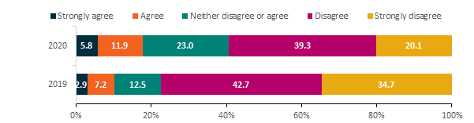
Source: 2019 and 2020 provider surveys
Base: All respondents (2020: n=379; 2019: n=375)
2020: Q11.3; 2019: Q12.6 Thinking about initial appointments with new participants, to what extent do you agree or disagree that new participants are well informed about the ParentsNext program by Services Australia?
In the participant survey in November 2020, parents were asked whether ParentsNext providers had explained the nature of the ParentsNext program and participants’ responsibilities. Almost all respondents reported that their providers talked about what would happen if participants did not meet their participation requirements (96%), what ParentsNext was (95%), how they would help (92%), and participants’ employment and education goals (95%). Intensive stream participants were more likely to report that their ParentsNext provider did ‘explain how they would help you’ (94%) than those in the targeted stream (90%). The results show consistently high and slightly improved levels since 2017 participant survey.

3.4 Caseloads
ParentsNext caseloads rose rapidly in the first 3 months of the rollout of the expansion, then stabilised over the next 2 years at around 45,000 participants in the targeted stream and 34,000 in the intensive stream. Caseload figures dropped between March 2020 and July 2020 as referrals reduced during the COVID-19 lockdown period. As at 31 December 2020, there were 81,329 participants on the caseload (Figure 3.8).
Figure 3.8: Caseload, July 2018 to December 2020
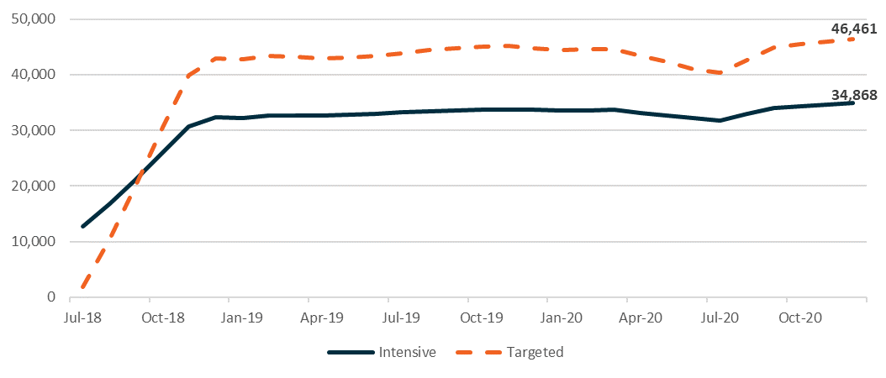
Source: The department’s administrative data
Base: Participants on the caseload (pending, commenced or suspended) at the end of each month, from 31 July 2018 to 31 December 2020 (n=156,558 unique participants)

3.5 Referrals and commencements
Initially participant referrals to the intensive stream were high, as a large number were transferred from the earlier iteration of the program, ParentsNext 2016–2018; 13,180 participants who transferred from ParentsNext at the end of June 2018 to the nationally expanded program had a referral date for the national expansion by 31 December 2020 (Table 3.1). Given that the previous ParentsNext program operated only in locations categorised as intensive stream under the national expansion, the majority of participants were transferred to the intensive stream.
Table 3.1: Participant transfers from ParentsNext 2016–2018, by stream, in the national expansion to 31 December 2020
Stream (national expansion) | Number | Per cent
Intensive compulsory | 12,995 | 98.6
Intensive voluntary | 106 | 0.9
Targeted compulsory | 79 | 0.6
Total | 13,180 | 100.0
Source: The department’s administrative data
Base: Participants who transitioned from the ParentsNext 2016–2018 to the ParentsNext national expansion (n=13,180)
Progressively, targeted referrals overtook intensive referrals until around 1 January 2019, when both streams tracked on similar paths, with the targeted stream slightly higher as it was delivered in more locations (Figure 3.9). As noted in Chapter 6, referrals were suspended during the initial period of COVID-19, resulting in the dip between March 2020 and July 2020.
Figure 3.9: Referrals to ParentsNext by month, July 2018 to October 2020
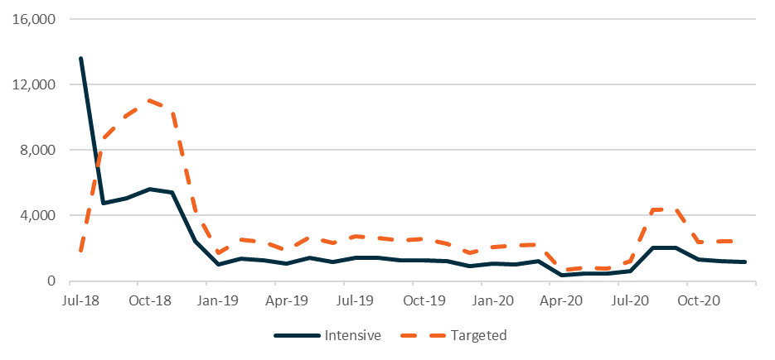
Source: The department’s administrative data
Base: Periods of assistance where the participant was referred to ParentsNext by 31 December 2020 (n=165,037). This population has 158,535 unique participants, as some participants had multiple periods of assistance
At 31 December 2020, approximately 95% of the parents referred to ParentsNext had commenced. High-JSCI participants were the largest group – around 70% of the commenced population – followed by the YC5 (19%) and ESL (10%) groups. Volunteers made up the smallest proportion of referrals/commencements (0.3%). The reasons for this varied, although reported earnings was a common reason why parents who wished to volunteer were ineligible to do so. Women made up 94% of the commenced population, and single parents 79%. Aboriginal and/or Torres Strait Islander and CALD participants were each around 20% of commencements (see Appendix 5, Table A5.37).

3.6 Time to commence
Around 80% of ParentsNext participants commenced within 30 days of referral (Figure 3.10).
Figure 3.10: Time taken to commence in ParentsNext (cumulative per cent)
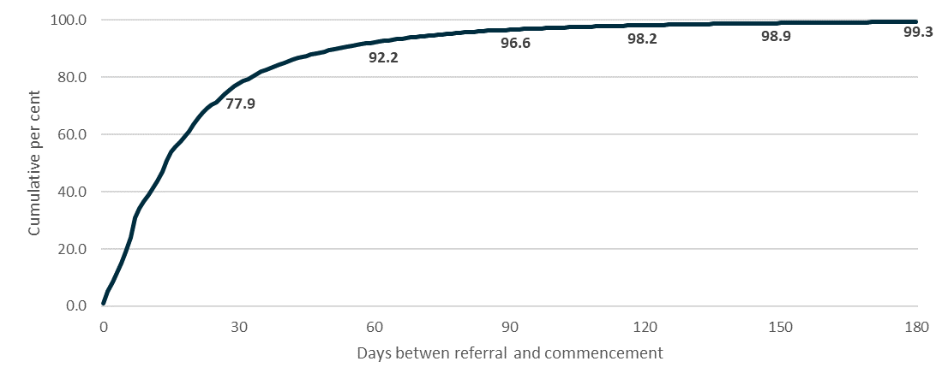
Base: Periods of assistance where the participant was referred to, and commenced, in ParentsNext by 31 December 2020 and within 180 days of referral (n=153,770)
The targeted stream participants commenced faster than the intensive stream, and the YC5 cohort were the most likely to commence within 30 days (Table 3.2).
Table 3.2: Time taken to commence in ParentsNext (cumulative per cent)
Time | Intensive | Targeted | ESL | YC5 | High JSCI
Within 30 days | 75.7 | 79.3 | 75.6 | 81.9 | 77.3
Within 60 days | 91.6 | 92.6 | 89.7 | 94.1 | 92.1
Within 90 days | 96.9 | 96.4 | 94.8 | 97.5 | 96.6
Within 180 days | 99.4 | 99.3 | 98.6 | 99.7 | 99.3
Source: The department’s administrative data
Base: Periods of assistance where the participant was referred to, and commenced, in ParentsNext by 31 December 2020 (n=154,845). This population has n=150,077 unique participants, as some participants had multiple periods of assistance.
Notes: Time taken to commence excludes time where the participant was suspended or exited from service

3.7 Exemptions
As noted in Section 2.9, Services Australia initially had responsibility for granting a limited number of exemptions, and ParentsNext providers were able to grant the full range of exemptions. From late 2020, Services Australia was also able to grant the full range of exemptions. Exemptions were applied prior to referral and continuously over the participation period. Some participants received multiple exemptions, mostly granted by providers (Table 3.3). As at 31 December 2020, 72,252 exemptions had been granted for 47,330 unique participants.
Table 3.3: Exemptions granted, by type and granting entity
Exemption type | Granted by provider  Per cent | Granted by Services Australia  Per cent
Large family (4 or more children) (n=22,288), 31% | 93.4 | 6.6
Temporary confinement (n=14,330), 20% | 94.2 | 5.8
Temporary medical incapacity (n=12,717), 18% | 95.4 | 4.6
Other caring responsibilities (n=9,161), 13% | 95.9 | 4.2
Major personal crisis/disruption (n=4,883), 7% | 55.3 | 44.7
Domestic violence/relationship breakdown (n=4,600), 6% | 79.5 | 20.5
Other personal circumstances (n=4,273), 5% | 81.1 | 18.9
Total (n=72,252), 100% | 90.0 | 10.0
Source: The department’s administrative data
Base: Exemptions starting between 1 July 2018 and 31 December 2020 (n=72,252). These exemptions were granted for n=47,330 unique participants.
The pattern of the application of exemptions over the study period was relatively stable except during the COVID lockdown period, when referrals to, and exemptions granted by, ParentsNext providers dropped as a result of voluntary MORs (Figure 3.11).
Figure 3.11: Exemptions and caseloads, July 2018 to December 2020
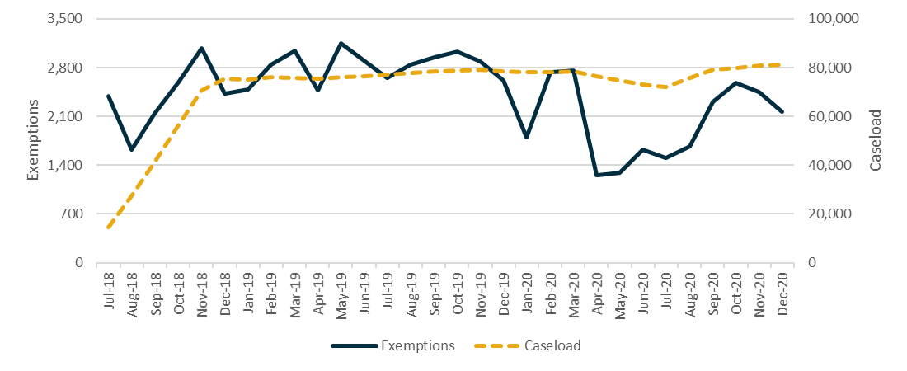
Source: The department’s administrative data
Base: Exemptions starting between 1 July 2018 and 31 December 2020 (n=72,252). These exemptions were granted for n=47.330 unique participants.
The average proportion of participants on the caseload who were exempted from 1 July 2018 to 31 December 2020 was 14.8%. The minimum was 11.1% and the maximum was 17.2% (Figure 3.12).
Figure 3.12: Average proportion of exempted participants on the caseload, July 2018 to December 2020
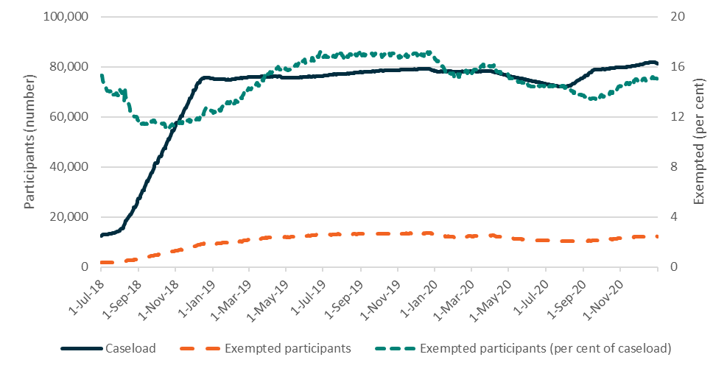
Source: The department’s administrative data
Base: Exemptions starting between 1 July 2018 and 31 December 2020 (n=72,252). These exemptions were granted for n=47,330 unique participants.
Exemptions varied by eligibility group and stream (Table 3.4).
Table 3.4: Exemptions by eligibility group, July 2018 to December 2020
Exemption type | Intensive  (n=32,570)  Per cent | Targeted  (n=39,682)  Per cent | ESL  (n=6,637)  Per cent | YC5  (n=7,381)  Per cent | High JSCI  (n=57,424)  Per cent
Large family (4 or more children) (n=22,288) | 34.5 | 27.9 | 1.5 | 25.8 | 34.9
Temporary confinement (n=14,330) | 23.5 | 16.9 | 53.7 | 12.6 | 16.6
Temporary medical incapacity (n=12,717) | 14.2 | 20.4 | 14.0 | 22.3 | 17.5
Other caring responsibilities (n=9,161) | 10.8 | 14.2 | 6.7 | 18.0 | 12.8
Major personal crisis/disruption (n=4,883) | 6.5 | 6.9 | 9.2 | 7.2 | 6.5
Domestic violence/relationship breakdown (n=4,600) | 5.6 | 7.0 | 9.0 | 5.3 | 6.2
Other personal circumstances (n=4,273) | 4.9 | 6.7 | 6.1 | 8.8 | 5.5
Total | 100.0 | 100.0 | 100.0 | 100.0 | 100.0
Source: The department’s administrative data
Base: Exemptions starting between 1 July 2018 and 31 December 2020 (n=72,252)
The large family exemption was the most used exemption type for all groups except ESLs, for whom temporary confinement exemptions were highest. Intensive stream exemptions were higher than targeted stream exemptions in these 2 categories. This may have reflected the fact that the intensive stream was offered in areas with greater locational disadvantage. Temporary medical incapacity was much higher in the targeted stream and the YC5 group.
Of all referred participants, women, Aboriginal and/or Torres Strait Islander peoples, people with disability and refugees were the diversity groups most likely to have an exemption (Table 3.5). In the case of Aboriginal and Torres Strait Islander peoples, refugees, and parents with disability, the percentage with at least one exemption was much higher than the group’s proportion of total referrals.
Table 3.5: Referrals and exemptions, by equity group
Cohort | Referred participants  (n=158,535)  Per cent | Participants with at least one exemption  (n=47,330)  Per cent
Female | 93.7 | 95.8
Male | 6.3 | 4.2
Aboriginal and/or Torres Strait Islander | 17.8 | 20.6
CALD | 20.7 | 21.3
Person with disability | 14.3 | 18.2
Refugee | 5.9 | 7.8
Source: The department’s administrative data
Base: ‘Referred participants’ = Participants referred to ParentsNext by 31 December 2020 (158,535). Cohort characteristics were as at each participant’s first referral date. ‘Participants with at least one exemption’ = Participants referred to ParentsNext with at least one exemption which started by 31 December 2020 (n=47,330). Cohort characteristics were as at each participant’s first exemption start date.
The nature of exemptions granted to equity groups varied. Large family exemptions were generally the most common type of exemption granted to each group, except for men and for people with disability, for whom temporary medical incapacity was more common. For CALD and refugee participants, exemptions for large families accounted for over 40% of all exemptions applied in each of these cohorts (Table 3.6).
Table 3.6: Exemption types, by equity group
Exemption type | Female (n=69,162)  Per cent | Male (n=3,090)  Per cent | Aboriginal and/or Torres Strait Islander (n=14,625)  Per cent | CALD (n=16,068)  Per cent | Person with disability (n=14,832)  Per cent | Refugee  (n=5,968)  Per cent
Large family (4 or more children) (n=22,288) | 31.1 | 25.5 | 29.1 | 41.9 | 22.0 | 48.7
Temporary confinement (n=14,330) | 20.7 | 1.4 | 23.2 | 17.2 | 11.8 | 20.5
Temporary medical incapacity (n=12,717) | 16.8 | 35.0 | 12.2 | 19.5 | 34.5 | 16.9
Other caring responsibilities (n=9,161) | 12.5 | 16.9 | 11.5 | 8.4 | 13.0 | 5.9
Major personal crisis/disruption (n=4,883) | 6.6 | 9.4 | 10.0 | 3.3 | 7.6 | 3.3
Domestic violence/relationship breakdown (n=4,600) | 6.6 | 1.9 | 8.1 | 2.1 | 6.2 | 1.0
Other personal circumstances (n=4,273) | 5.7 | 9.9 | 5.9 | 7.7 | 4.9 | 3.8
Total (n=72,252) | 100.0 | 100.0 | 100.0 | 100.0 | 100.0 | 100.0
Source: The department’s administrative data
Base: Exemptions starting between 1 July 2018 and 31 December 2020 (n=72,252). These exemptions were granted for n=47,330 unique participants. Participants could belong to more than one cohort.

3.7.1 Providers’ attitudes to exemptions
Providers interviewed during the Wave 1 qualitative research reported being fairly confident about using the guidelines to support the application of exemptions, and their ability to make discretionary decisions about whether to exempt a participant.
Yeah, I’ve used my discretion a couple of times for domestic violence and just used the evidence that they’d given me, like they’ve disclosed to me as evidence. So no written evidence, which could do (Provider 2)
All providers cited examples of people being referred to the program who were ineligible and who could be granted an exemption immediately. Many respondents (79%) to the 2019 ParentsNext provider survey agreed that some new participants should have been granted an exemption by Centrelink (Services Australia) at their initial eligibility interview but were not. In the 2020 provider survey, almost half of respondents (46%) reported that they sometimes had referrals of participants ‘who should have been granted an exemption by Services Australia’. However, 20% of provider staff reported that some of their new participants should have been granted exemptions ‘always’ or ‘often’.
Almost all provider respondents in 2020 agreed or strongly agreed that staff always knew when they could apply exemptions to participants (97%) (Figure 3.13). The results were similar to those in 2019, although in 2019 only 52% strongly agreed and 46% agreed.
Figure 3.13: Attitudes towards exemptions, 2020
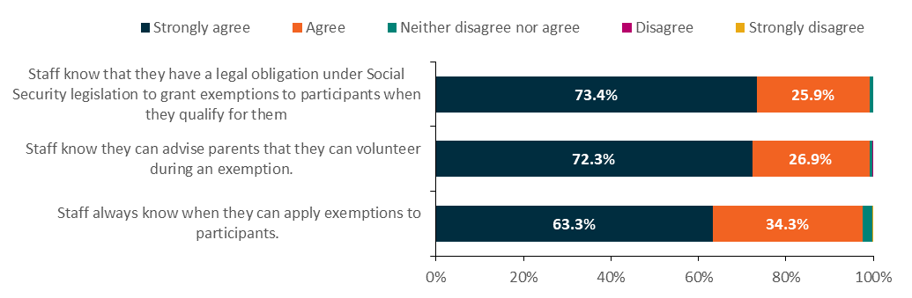
Source: 2020 provider survey
Base: All respondents (n=379)
Q13.2–Q13.4 Thinking about how staff at the [Site Name] site apply exemptions, how strongly do you agree or disagree with the following statements?

3.8 Appointments
Attending an initial ParentsNext appointment (generally in person) and subsequent appointments every 3 months, either in person or by phone/online, was a compulsory activity in ParentsNext except during the COVID-19 lockdown period. During this period (March to September 2020), providers were expected to maintain monthly contact to support participants, but participants were not required to attend appointments. Figure 3.14 shows the volume of scheduled appointments over time, regardless of attendance (see Table 3.8 for the distribution of appointment results). The increase in scheduled appointments in mid-2020 likely reflects the change to monthly appointment frequency during this time.
Figure 3.14: Participant appointments scheduled by provider, July 2018 to December 2020

Source: The department’s administrative data
Base: Appointments where the appointment date was scheduled before/on 31 December 2020 (n=2,061,491). These appointments were made for n=157,268 unique participants.
As noted in Chapter 6, the impact of COVID-19 on how ParentsNext services were delivered was substantial. Under COVID restrictions, providers were not allowed to conduct face-to-face appointments in many Australian states, notably the eastern states. From March 2020, the number of face-to face appointments dropped quickly as the number of telephone appointments increased even more quickly, far exceeding face-to-face appointments in June 2020 (Figure 3.15).
Figure 3.15: Appointments by communication mode, July 2018 to December 2020
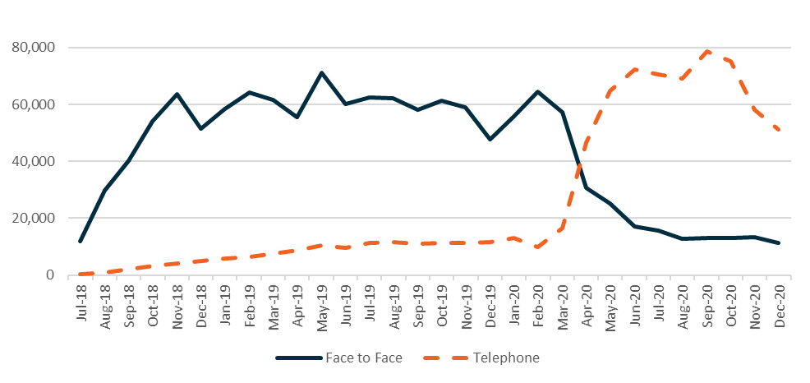
Source: The department’s administrative data
Base: Face to face and telephone appointments where the appointment date was scheduled before/on 31 December 2020 (n=2,059,533). Video conference appointments were excluded from this figure (n=1,958).
Of all appointments, around 17% were initial appointments and most appointments were for contact purposes (82%), as shown in Table 3.7.
Table 3.7: Appointments by type, December 2020
Appointment type | Number | Per cent
Initial | 341,429 | 16.5
Contact | 1,689,829 | 82.0
Re-engagement | 28,847 | 1.4
Capability interview | 1,386 | 0.1
Total | 2,061,491 | 100.0
Source: The department’s administrative data
Base: Appointments where the appointment date was scheduled before/on 31 December 2020 (n=2,061,491). These appointments were made for n=157,268 unique participants.
Around a quarter of appointments were rescheduled and over 52% were attended. In around 2% of instances the participant did not attend but had a valid reason (Table 3.8).
Table 3.8: Appointments by result, December 2020
Appointment result | Number | Per cent
Attended | 1,071,417 | 52.0
Rescheduled | 473,656 | 23.0
Cancelled | 119,741 | 5.8
No longer required | 98,201 | 4.8
Did not attend | 150,301 | 7.3
Did not attend (valid reason) | 46,524 | 2.3
Did not attend (invalid reason) | 99,037 | 4.8
Compliance – failed validity test | 2,535 | 0.1
Misconduct | 79 | 0.0
Total | 2,061,491 | 100.0
Source: The department’s administrative data
Base: Appointments where the appointment date was scheduled before/on 31 December 2020 (n=2,061,491). These appointments were made for n=157,268 unique participants.

3.9 Participation in activities and interventions
Each Participation Plan was an individually tailored agreement between a provider and a participant that set out activities that would help parents reach their education and employment goals. Activities undertaken by ParentsNext participants were designed to help them overcome barriers, build skills and work readiness and develop self-confidence, and to provide valuable networking opportunities.
Providers could not impose an activity on a participant. An individual’s personal circumstances – such as family situation, financial capacity, culture, gender, language, access to transport, and experience of domestic and family violence – were required to be considered if disclosed to their provider.
As at 31 December 2020, there had been 320,939 referrals to activities and 93.3% of those had commenced. Only 1.6% of activity referrals resulted in the participant not starting the activity (Table 3.9).
Table 3.9: Activity referral result, December 2020
Result | Activity referrals  n | Activity referrals  %
Placement confirmed | 299,301 | 93.3
Expected to start | 16,360 | 5.1
Did not start | 5,278 | 1.6
Total | 320,939 | 100.0
Source: The department’s administrative data
Base: Activity referrals made by 31 December 2020 (n=320,939)
Parents were referred to a variety of different activities, both vocational and non-vocational (Table 3.10).
Table 3.10: ParentsNext activity referrals, December 2020
Activity type | Intensive  n=140,002  % | Targeted  n=180,937  % | ESL  n=42,537  % | YC5  n=35,606  % | High JSCI  n=240,678  % | Total  n=320,939  %
ParentsNext specific activity | 25.6 | 26.5 | 27.2 | 18.6 | 27.0 | 26.1
Accredited education and training (vocational) | 19.0 | 18.8 | 20.6 | 20.9 | 18.2 | 18.9
Non-accredited education and training (vocational) | 16.0 | 15.5 | 16.5 | 16.9 | 15.4 | 15.7
Non-vocational assistance | 18.5 | 14.8 | 16.9 | 16.0 | 16.4 | 16.4
Part-time/casual paid employment | 7.8 | 9.3 | 6.4 | 13.4 | 8.4 | 8.7
Interventions | 8.0 | 8.6 | 7.3 | 7.1 | 8.7 | 8.3
Other activity^{(a)} | 5.2 | 6.6 | 5.1 | 7.2 | 6.0 | 6.0
Total | 100.0 | 100.0 | 100.0 | 100.0 | 100.0 | 100.0
Source: The department’s administrative data
Base: Activity referrals made by 31 December 2020 (n=320,939)
Note: (a) ‘Other’ includes ‘Informal activity’, ‘Other government programs’, ‘Voluntary work in community/non-profit sector’, ‘Defence reserves’, ‘Launch into Work’, ‘Other approved programs’.
While the most common activity for ESL and high-JSCI participants was the ParentsNext specific activity, accredited education and training was the most common activity type for the YC5 group. The YC5 group also had a much higher proportion of participants undertaking paid employment than the other 2 groups. This divergence in activity types among the 3 groups likely reflects their differences in work readiness. It also indicates that activities were tailored to different participants.
More than 25% of all activity referrals for all groups were to a ParentsNext specific activity. For women, 19.4% of referrals were to accredited training and 15.5% to non-accredited training (Table 3.11). The percentage of referrals to all activity types was similar for all cohorts except for men, who were more likely than women to be referred to non-accredited education and training (vocational) than accredited training. Referrals to part-time and casual employment were less likely for refugees, people with disability, and Aboriginal and/or Torres Strait Islander peoples. Intervention rates were higher for people with disability.

Table 3.11: ParentsNext activity referrals, by equity group
Activity type | Female  n=304,156  % | Male  n=16,783  % | Person with disability  n=45,315  % | Person without disability  n=275,624  % | Aboriginal and/or Torres Strait Islander  n=61,284  % | Non Aboriginal and/or Torres Strait Islander  n=259,655  % | CALD  n=62,347  % | Non-CALD  n=258,592  % | Refugee  n=18,781  % | Non-refugee  n=302,158  %
ParentsNext specific activity | 25.9 | 28.9 | 25.7 | 26.1 | 27.9 | 25.7 | 28.0 | 25.6 | 27.3 | 26.0
Accredited education and training (vocational) | 19.4 | 9.3 | 15.5 | 19.4 | 16.1 | 19.5 | 19.5 | 18.7 | 18.0 | 18.9
Non-accredited education and training (vocational) | 15.5 | 20.0 | 14.9 | 15.8 | 17.7 | 15.2 | 13.9 | 16.1 | 14.8 | 15.8
Non-vocational assistance | 16.4 | 17.4 | 16.7 | 16.4 | 18.5 | 15.9 | 15.0 | 16.8 | 15.3 | 16.5
Part-time/casual paid employment | 8.7 | 9.0 | 6.0 | 9.1 | 6.4 | 9.2 | 7.1 | 9.1 | 5.3 | 8.9
Interventions | 8.3 | 9.4 | 15.1 | 7.2 | 8.4 | 8.3 | 6.2 | 8.8 | 5.8 | 8.5
Other | 6.0 | 6.1 | 14.4 | 6.0 | 5.1 | 6.2 | 10.4 | 4.9 | 13.6 | 6.0
Total | 100.0 | 100.0 | 100.0 | 100.0 | 100.0 | 100.0 | 100.0 | 100.0 | 100.0 | 100.0
Source: The department’s administrative data
Base: Activity referrals made by 31 December 2020 (n=320,939)
Note: (a) ‘Other’ includes ‘Informal activity’, ‘Other government programs’, ‘Voluntary work in community/non-profit sector’, ‘Defence reserves’, ‘Launch into Work’, ‘Other approved programs’.

ParentsNext specific activities included playgroups, preparation activities, parent support groups, Aboriginal and/or Torres Strait Islander specific activities, and participation in jobactive (including Volunteer Online Employment Services Trial (VOEST), New Enterprise Incentive Scheme (NEIS) and Transition to Work (TtW)) (Table 3.12). A full list of activities and interventions can be found in Appendix 8.
Table 3.12: ParentsNext specific activity referrals
Activity subtype | Activity referrals  n | Activity referrals  %
Child playgroup | 34,257 | 40.9
Research/preparation activity | 27,863 | 33.3
Child-related services | 7,526 | 9.0
Parental support group | 5,397 | 6.5
Aboriginal and/or Torres Strait Islander activity | 2,916 | 3.5
Aboriginal and/or Torres Strait Islander cultural activity | 42 | 0.1
Transition to Work (TtW) | 2,994 | 3.6
jobactive/VOEST | 2,297 | 2.7
New Enterprise Incentive Scheme (NEIS) | 392 | 0.5
Total | 83,684 | 100.0
Source: The department’s administrative data
Base: ParentsNext Specific Activity referrals made by 31 December 2020 (n=83,684)
Tracking activities by month over the period of the evaluation shows several peaks and troughs (Figure 3.16). Activity referrals for both streams followed a similar pattern.
Figure 3.16: Activity referrals by stream, July 2018 to December 2020
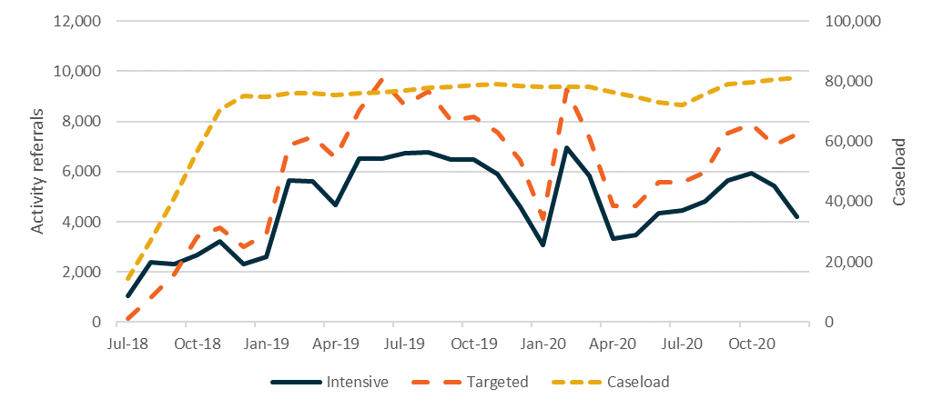
Source: The department’s administrative data
Base: Activity referrals made by 31 December 2020 (n=320,939). These referrals were made for n=127,647 unique participants, as participants could be referred to multiple activities.
Both non-vocational (Figure 3.17) and vocational (Figure 3.18) activity referrals dipped overall between October 2019 and February 2020, likely following the educational year. Between February 2020 and April 2020, these activity referrals again peaked sharply. They dropped away briefly during April 2020 and started rising again in June 2020. While the pattern of peaks and troughs in 2020 was similar to what it was in 2019, the main differences were the sharper peaks in January to April 2020 and a slower/smaller increase in April to October 2020. Notably, these findings confirm the quantitative research results reported in Chapter 6 and the flexibility of the program to respond to the challenge of COVID-19, as well as the innovative practices implemented by providers to support participants over this period.
Figure 3.17: Activity referrals – non-vocational, July 2018 to December 2020
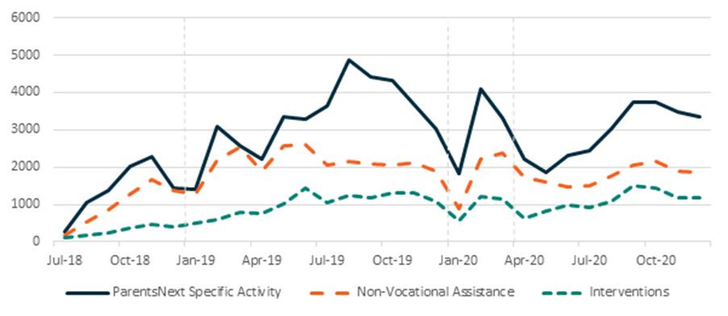
Source: The department’s administrative data
Base: Non-vocational activity referrals made by 31 December 2020 (n=163,024). These referrals were made for n=85,654 unique participants, as participants could be referred to multiple activities.
Consistent with ABS labour market data reported over the COVID-19 pandemic, Figure 3.18 shows
Figure 3.18: Activity referrals – vocational, July 2018 to December 2020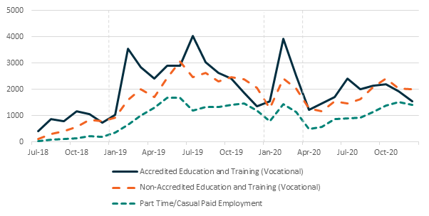
Source: The department’s administrative data
Base: Vocational activity referrals made by 31 December 2020 (n=138,722). These referrals were made for n=78.981 unique participants, as participants could be referred to multiple activities.
that referrals to part-time and casual work dropped away during the COVID-19 shutdown period. Referrals to accredited educational and training varied by cohort (Table 3.13). Just over 50% of referrals were to Certificate III/IV courses.
Table 3.13: Accredited education and training (vocational) activity referrals
Activity subtype | ESL  n=8,743  % | YC5  n=7,454  % | High JSCI  n=43,699  % | Total  n=60,505  %
Accredited skill set/units | 12.8 | 9.3 | 12.0 | 11.8
Certificate I/II | 8.8 | 7.1 | 7.3 | 7.5
Certificate III/IV | 50.5 | 47.8 | 51.2 | 50.7
Secondary school | 10.4 | 0.3 | 0.7 | 2.1
Diploma/advanced diploma | 8.1 | 11.9 | 11.4 | 10.9
Bachelor’s degree | 5.0 | 14.5 | 9.7 | 9.6
Postgraduate certificate/diploma | 0.1 | 0.7 | 0.3 | 0.3
Master’s degree | 0.0 | 1.8 | 0.8 | 0.8
University^{(a)} | 1.6 | 1.5 | 1.4 | 1.5
Language, literacy and numeracy | 2.6 | 5.2 | 5.2 | 4.8
Total | 100.0 | 100.0 | 100.0 | 100.0
Source: The department’s administrative data
Base: Accredited education and training (vocational) referrals made by 31 December 2020 (n=60,505)
Note: (a) Level of study unspecified

3.10 Parenting payment suspensions/compliance
As noted in Section 2.6, compulsory participants were subject to the TCF and payment suspensions and the accrual of demerits occurred when participants failed to comply with their MORs. Participants received an SMS reminder to attend and report their attendance at activities. Suspensions reached an all-time high in May 2019 (Figure 3.19).
A dip in December 2018 and then a rise may have been the result of a seasonal change and departmental shutdowns in December. Possibly the February 2020 rise was just returning to ‘normal’ levels established after new policy changes took effect in November. A seasonal impact is reflected in a drop in January 2020 and a rise in February 2020. Suspensions then dropped away to zero as the compulsory requirements were lifted during the lockdown period, to around 2,000 per month in December 2020.
Figure 3.19: Payment suspensions, July 2018 to December 2020
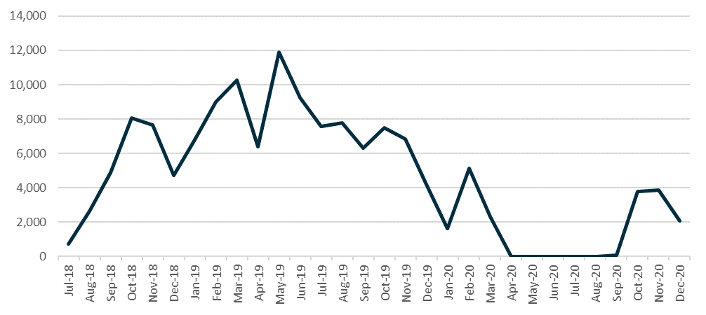
Source: The department’s administrative data
Base: Payment suspensions by 31 December 2020 (n=141,289)

3.10.1 Monitoring participant compliance
Providers had a lot of flexibility when assessing a participant’s reason for non-compliance. Generally a reason was valid provided it was out of the participant’s control, a member of the public would consider it reasonable, or expecting prior notice would be unreasonable.
As the study period drew to a close, from 6 December 2020, participants had 2 business days to resolve any missed requirements before they experienced a hold on their payment. If the participant had a valid reason for missing a requirement, or if they re-engaged within those 2 days, they avoided a payment suspension altogether. In the 6 months following the introduction of this ‘resolution time’, 37% (11,646 of 31,668) of attendance failures that would previously have resulted in a suspension were resolved within 2 business days (that is, payment suspension was avoided). These improvements reduced the potential impact on a participant’s payment and the stress associated with payment delays.
Table 3.14 shows that 50,171 parents received a payment suspension from July 2018 to December 2020. The average suspension period was 3.5 business days, and 1,057 payments were cancelled. Payment cancellation occurred after a payment had been suspended for 28 days without the participant re-engaging with requirements.
Separate to MORs, if a participant did not report their income to Centrelink (Services Australia) for 2 pay cycles, Centrelink cancelled the payment. Aboriginal and/or Torres Strait Islander participants incurred 33%, CALD participants 14% and ESLs 17% of all payment suspensions.
Table 3.14: Parenting Payment suspensions and cancellations, by cohort (2 July 2018 to 31 December 2020)
Cohort | Total number of parents who received a payment suspension | Total number of payment suspension events | % of suspensions lifted in 3 or fewer business days | Average suspension period (business days) | Number of payment cancellation events – failure to re-engage
All | 50,171 | 141,289 | 64% | 3.5 | 1,057
Female | 46,804 | 131,870 | 65% | 3.5 | 938
Male | 3,367 | 9,419 | 57% | 4.0 | 119
Aboriginal and/or Torres Strait Islander | 13,512 | 46,640 | 61% | 3.7 | 210
CALD | 8,476 | 19,873 | 68% | 3.4 | 196
Single (PPS) | 41,830 | 119,624 | 64% | 3.5 | 817
ESL | 7,228 | 24,409 | 60% | 3.7 | 155
Source: Departmental administrative data
Prior to the introduction of the 2-day resolution time, 15% of payment suspensions were reported to have resulted in a delay to participants’ payments. The average delay was 3 calendar days.
Point-in-time analysis undertaken at 31 December 2020 showed ParentsNext participants were highly compliant (Figure 3.20). They were significantly more likely to be in the Green Zone (94%) than those in other employment programs such as jobactive (52%). This difference was likely due to:
- differences in program requirements reflecting the circumstances of parents of younger children
- provider administration of compliance and exemptions based on parents’ circumstances
- the characteristics of the participants in these programs.
Figure 3.20: TCF zones by service type, 31 December 2019
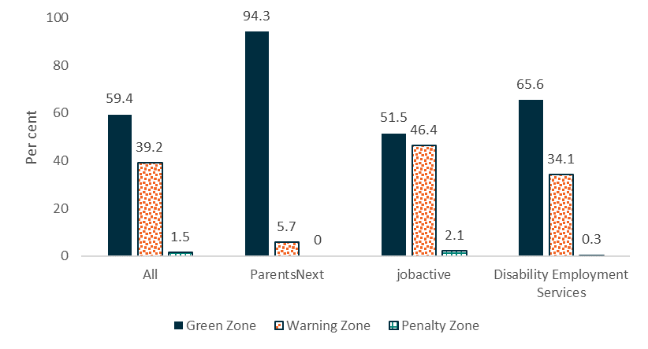
Source: Departmental administrative data
Base: Participants in TCF-applicable programs as at 31 December 2019 (n=583,439); jobactive=382,327; ParentsNext=61,984; DES=139,118
Suspensions varied over time, reflecting the prevailing economic conditions and the program requirements. What did not vary, however, was the differential impact on different equity groups of participants (Figure 3.21). Suspensions of Aboriginal and/or Torres Strait Islander participants remained higher than suspensions of other participant subgroups throughout July 2018 to December 2020.
Figure 3.21: ParentsNext payment suspensions, by equity group, July 2018 to December 2020
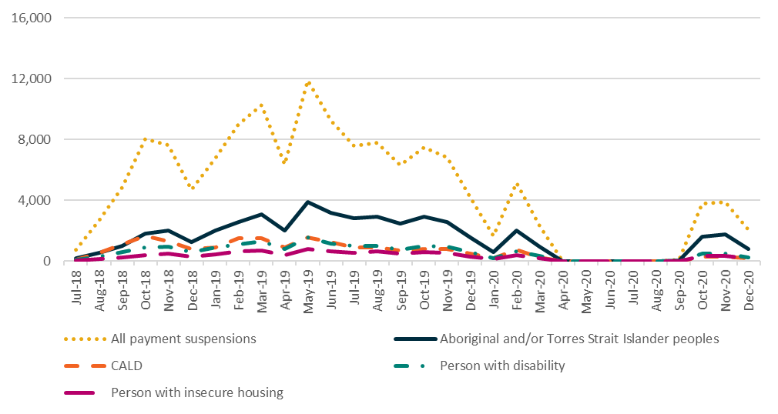
Source: The department’s administrative data
Base: Payment suspensions by 31 December 2020 (n=141,289)
As at 31 December 2020, departmental administrative data shows that participants with characteristics that would indicate vulnerabilities, such as Indigeneity, homelessness, unstable accommodation and ex-offending, were less likely to be in the Green Zone than all participants. Those with significant barriers, such as no transport or no phone, were also less likely to be in the Green Zone. Participants with these characteristics were more likely to be in the Penalty Zone, some subgroups at twice the rate of all participants.
Between July 2018 and December 2020, Aboriginal and Torres Strait Islander participant suspensions were higher than their proportion in the ParentsNext caseload. See Figure 3.22, where zero percentage points indicates no difference from the level expected given the group’s proportion in the caseload. Similarly, the suspension rates of single parents and those flagged at some stage as at risk of homelessness were higher than their caseload numbers. Conversely, the suspension rates for CALD participants and participants with disability were lower than expected given their proportion in the ParentsNext caseload.
Figure 3.22: Difference between the proportion of all participants with payment suspensions and the proportion of all participants on the caseload (percentage points), by subgroup, July 2018 to December 2020
Source: The department’s administrative data
Base: Payment suspensions by 31 December 2020 (n=141,289)
One positive aspect of the TCF mentioned by providers in the qualitative research and provider surveys was its usefulness as an engagement tool for bringing parents into vision (through requiring them to attend the office if appointments were missed) so that providers were able to offer assistance. This was felt to be particularly helpful for parents who were in vulnerable circumstances (such as in a domestic violence situation) and had missed appointments for reasons that were unclear.

3.10.1.1 Participant awareness of requirements
Overall, participants in the Wave 1 qualitative research had a clear understanding of their reporting and compliance obligations, which were clarified during initial meetings with their ParentsNext consultants. Many reported relatively neutral views of their obligation to report their activities – that is, the requirement to report was not seen as unnecessary or unusual; rather, it was conceptualised as part of their day-to-day experiences as Parenting Payment recipients. As reporting was mostly online, many participants considered it to be easy and straightforward.
I find it easy. It’s easy. You just go onto your MyGov, you just click on, and it’ll have reporting and I do the reporting from there. (Interview 19. Parent, metro, intensive, kinship carer)
Some participants disagreed fundamentally with the obligation to report their activities, considering it a potential, and unnecessary, risk to their income and an unfair element of a program that they had not chosen to be part of.
They cut your payments straight up. If you don’t show up to an appointment… Which I think is a bit unfair if something’s happening and you can’t make it. (Interview 17. Parent, metro, intensive)
These views were confirmed in the Wave 2 qualitative research, where some participants reported having had particularly negative experiences when they were already in a vulnerable position, citing the hardships associated with the threat or actuality of having their payments cut off because of matters beyond their control, such as sick children.
My payment got suspended and I didn’t know why. And then I thought I had missed an appointment with them, but I forgot to tick my activity off. (Interview 17. Parent, metro, intensive)
I don’t think cutting me off every second or third week is appropriate… I didn’t get paid till this morning. My kids had no school food Friday and we practically starved over the weekend … because of that. (Interview 34. Parent, regional, targeted, Aboriginal and/or Torres Strait Islander)
Others felt that their personal safety was at risk or that the stresses they were put under retriggered trauma – especially if they were recovering from family violence. Some mentioned developing mental health issues such as anxiety and depression because of the TCF.
Some participants viewed the program as paternalistic. One participant in the Wave 2 qualitative research suggested that the strict compliance measures indicated that the government did not trust women to manage their own lives. She believed there was limited awareness of the barriers that parents face, particularly women.
It’s worsened any confidence I had … this program makes it quite apparent that women cannot be trusted with their own lives … this program is obviously designed by men who have no idea what it’s like. They want women in the workforce, but they don’t want women to step out of the poverty that they’ve been pushed into. (Interview 1. Female, VIC, 1 child, single parent, 35–45 years old)

3.10.1.2 Provider views
While some providers were evidently concerned that the TCF was viewed by participants as potentially punitive, they were keen to highlight their flexibility and discretion in its use. Compelling attendance at the very first ParentsNext appointment was supported by most providers interviewed for the Wave 1 qualitative research; however, their views of the TCF and its usefulness and appropriateness for the cohort were mixed. Some providers, particularly those who had delivered ParentsNext 2016–2018 (where the TCF had not been applied), were concerned about its introduction and how it fitted with the ethos of the ParentsNext program.
Others felt that its introduction had harmed the positive relationships they had built up with their clients. Some noted, however, that while there was concern when the TCF was initially introduced in July 2018, it was less of a problem now that both providers and parents had become familiar with it.
… look I understand in the beginning that this caused a lot of fury … Again, to me it’s just a teething problem of a new program. It’s the fact that staff at that point probably didn’t understand it very well … (Provider 11)
Between the 2019 and 2020 provider surveys, support for the application of the TCF rose by around 10 percentage points. In 2020, most respondents (88%) agreed or strongly agreed that the TCF encouraged compulsory participants to fully engage with ParentsNext (Figure 3.23), in comparison with 76% in 2019. Only 4% of respondents in 2020 disagreed or strongly disagreed that the TCF encouraged compulsory participants, down from 13% in 2019.
Figure 3.23: TCF encourages participant engagement, 2019 and 2020
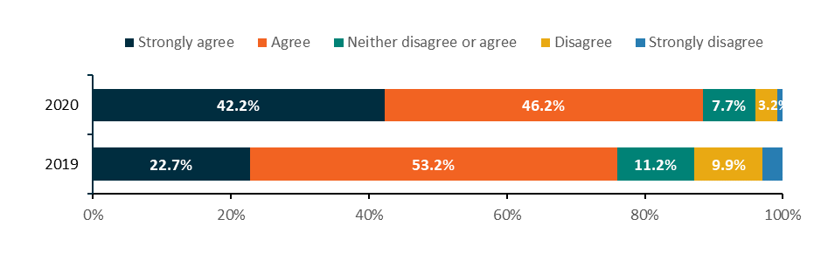
Source: 2019 and 2020 provider surveys
Base: All respondents (2020: n=379; 2019: n=374)
2020: Q12.2; 2019: Q13.2 To what extent do you agree or disagree with the following statements about the TCF? TCF encourages Compulsory Participants to fully engage with ParentsNext.
Most providers reported that they rarely used the demerit system, as most parents provided valid reasons for non-compliance, and that very few capability interviews were conducted. One provider with experience of a capability interview commented that the language in the interview needed to be refocused towards ParentsNext participants as it used employment-heavy terms relevant to jobactive and other employment programs.
… we’re asking questions about employment, job search, it’s completely different. (Provider 4)
In the 2020 Provider Survey, attitudes to the administrative burden created by the TCF were mixed, with over a third of provider respondents (35%) agreeing or strongly agreeing that the time spent administering the ParentsNext program was high due to the compliance framework. This shows a reduction in administration, as almost two-thirds (64%) of provider respondents agreed or strongly agreed with the same statement in 2019. The bedding-down of program arrangements during a major program implementation and the suspension of MORs and their reinstatement during the survey fieldwork may have had an impact on these results.

3.11 Exits
Participants had a variety of reasons for leaving the ParentsNext program (Table 3.15). The largest group were parents who became ineligible for ParentsNext once their youngest child turned 6. If eligible, these parents transitioned to a jobactive provider. A large number of participants had their Parenting Payment cancelled for no longer meeting the eligibility critera of the payment. Few participants exited due to meeting the requirements for a stable employment exit, or as a result of compliance action.
Table 3.15: Exit reasons recorded for periods of assistance, July 2018 to December 2020
Exit reason | Intensive  n=28,970  % | Targeted  n=54,749  % | ESL  n=6,126  % | YC5  n=26,790  % | High JSCI  n=49,675  %
Youngest Parenting Payment child not under 6 | 46.2 | 54.5 | 19.6 | 77.7 | 42.6
Parenting Payment cancelled | 30.0 | 22.0 | 26.8 | 13.1 | 31.2
New child in care | 0.2 | 16.0 | 39.8 | 3.3 | 10.9
Participant achieved stable employment | 5.8 | 5.3 | 6.8 | 3.3 | 6.6
Changed stream location/non-ParentsNext location | 13.6 | 0.4 | 5.3 | 0.7 | 7.3
Other | 4.3 | 1.8 | 1.8 | 2.0 | 1.5
Total exited periods of assistance (n=83,539) | 100.0 | 100.0 | 100.0 | 100.0 | 100.0
Source: The department’s administrative data
Base: Periods of assistance where the participant exited ParentsNext by 31 December 2020 (n=83,539). This is 50.6% of all periods of assistance from 1 July 2018 to 31 December 2020 (n=165,037), including periods of assistance where the participant did not commence. The exited population has n=81,686 unique participants, as some participants had multiple periods of assistance.
Notes: Participant characteristics are as at the period of assistance exit date
Providers interviewed for the qualitative research reported a particular focus on the YC5 group to support their transition to jobactive and explain how a jobactive provider experience would be different from ParentsNext.
So I guess in that last 12 months before their children turn six we need to let them know that it’s different in jobactive, that they – we make sure that they know how to use their MyGov account, that they’ve got some idea of what they want to be doing … we talk to them about that frequently just to remind them that we are a short term provider, so that it’s not a great big shock when their children turn six that they go into this jobactive system. (Provider 2)
Not all YC5 participants anticipated leaving the program to go to a jobactive provider. Those with older children tended to be more active job seekers who saw themselves as ready to begin employment and had started to prepare their résumé and search for work actively.
Like I’ve been applying for so many jobs and just haven’t heard anything back. So, I’m actively looking for work even without the program anyway. (Interview 15. Parent, metro, intensive, YC5)
A few participants indicated that they would prefer the support of a dedicated employment service provider rather than the support offered through ParentsNext, even among those whose youngest child was younger than 5 years. Unsurprisingly, and not necessarily because of the impact of ParentsNext, time to exit was fastest (almost 100% within 12 months of commencement) for the YC5 cohort, followed by ESLs (72% by 12 months). Participants with a high JSCI were slowest to exit (63% by 12 months) (Figure 3.24).
Figure 3.24: Time taken to exit ParentsNext (cumulative per cent)
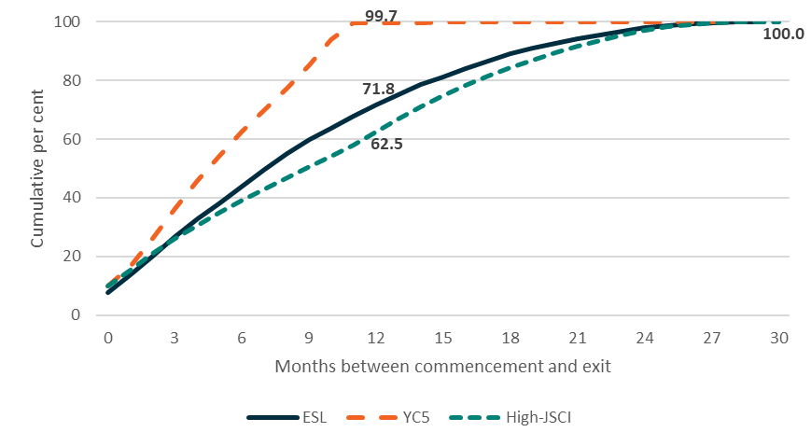
Source: The department’s administrative data
Base: Periods of assistance where the participant commenced and exited ParentsNext by 31 December 2020 (n=75,624). This population has n=73,508 unique participants, as some participants had multiple periods of assistance. It excludes periods of assistance where the eligibility reason was ‘Volunteer’ or ‘Unknown’ (n=1,030) and/or where the time taken to exit was unknown (n=50).
Note: Time taken to exit excludes time where the participant was suspended or exited from service. Participant characteristics are as the first referral in the period of assistance.

3.12 Job placements
For those who found employment, providers recorded their job placements in departmental systems. Tracking them gives an interesting, although incomplete, picture of providers who were successful in assisting their participants to gain employment. Job placements may be recorded for intensive or targeted stream participants. However, as only the intensive stream placements could lead to an outcome payment during the study period, it is likely that these were more commonly recorded by providers.
It may be that some – indeed, evidence would suggest, most – job placements were not captured. At the end of December 2020, provider records showed that 9,160 ParentsNext participants had been placed in employment – some in multiple job placements (Figure 3.25). The dip in placements between March and June 2020 was likely due to the impact of the COVID-19 pandemic. The decrease in December 2020 was likely because some placements were yet to be recorded in the system by the end of the study period, and because of seasonal labour market effects.
Figure 3.25: Job placements, July 2018 to December 2020
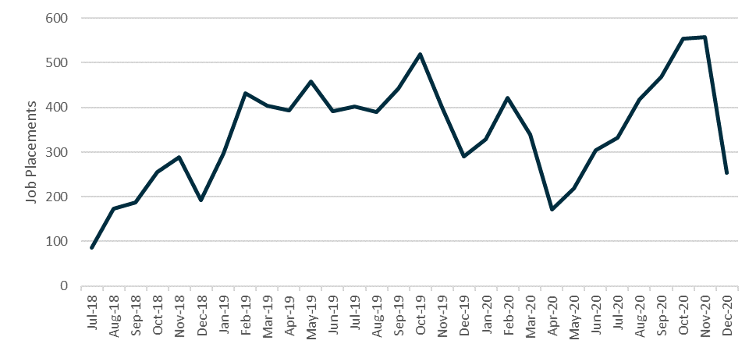
Source: The department’s administrative data
Base: Job placements where the participant was referred to, and confirmed to have started in, the job placement by 31 December 2020 (n=10,371). These job placements were made for n=9,160 unique participants, as participants could have multiple job placements.
As expected, approximately two-thirds of all recorded placements were from the intensive stream and one-third from the targeted stream. Overall, 73% of those placed were from the high-JSCI cohort, 14% were YC5s and 11% were ESLs, in line with their proportions in the study population. There were 10,371 placements overall (Table 3.16).
Table 3.16: ParentsNext job placements, by participant group
Participant group | Number | Per cent
Intensive stream | 6,932 | 66.8
Targeted stream | 3,439 | 33.2
ESL | 1,103 | 10.6
YC5 | 1,462 | 14.1
High JSCI | 7,534 | 72.6
Volunteer | 95 | 0.9
Unknown | 177 | 1.7
Total | 10,371 | 100.0
Source: The department’s administrative data
Base: Job placements where the participant was referred to, and confirmed to have started in, the job placement by 31 December 2020 (n=10,371). These job placements were made for n=9,160 unique participants, as participants could have multiple job placements.

3.13 National Customer Service Line contacts
Complaints about ParentsNext recorded by the National Customer Service Line (NCSL) provided a window into how well the program was meeting its objectives. The NCSL received few contacts in relation to ParentsNext. Complaint numbers throughout the study period totalled 846 from a caseload of around 80,000. The trend fluctuated over time, with few complaints recorded during the COVID-19 lockdown period (Figure 3.26). Most complaints related to policy issues; very few concerned the TCF.
Figure 3.26: NCSL contacts, July 2018 to December 2020
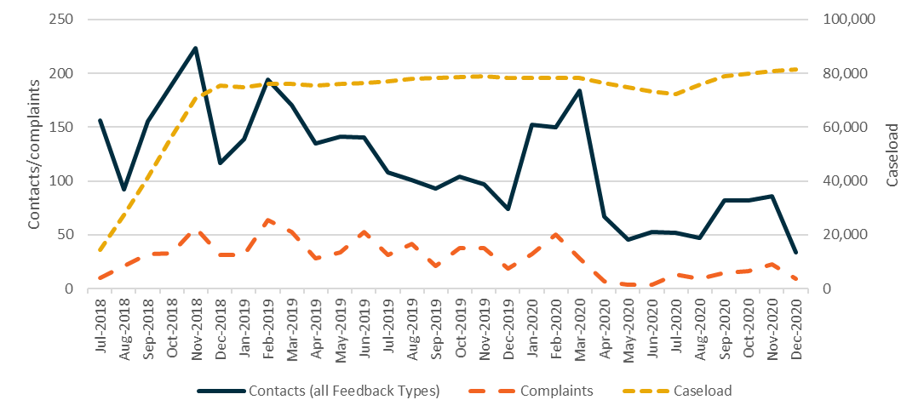
Source: Departmental NCSL data
Base: Contacts made to the NCSL by 31 December 2020 (n=3,463).

3.14 Unit expenditure per participant
The costs associated with ParentsNext should be seen in the context of the costs associated with ongoing Parenting Payment and the desirability of reducing parents’ welfare dependency. The Priority Investment Approach to Welfare identified that in 2014–15 there were 432,000 people receiving Parenting Payment. People currently receiving Parenting Payment had the highest average future lifetime cost of all payment groups, at $441,000 per person.
Young parents were identified as likely to have a higher average future lifetime cost, at $547,000 per person. It was estimated that in 10 years around 48% of those parents would be receiving income support payments, with only 22% having left the welfare system. That is, the government would likely spend an estimated $191 billion on future welfare payments for all people currently receiving Parenting Payment.
In that context, the average expenditure per ParentsNext participant from 2 July 2018 to 31 December 2020, ranging between $1,444 and $1,680 (Table 3.17), seems small. The difference reflects the availability of the Participation Fund to the intensive stream only.
Table 3.17: Average funding per participant, by stream (2 July 2018 to 31 December 2020)
2 July 2018 to 31 December 2020 | 2 July 2018 to 31 December 2020
Intensive stream* | $1,680
Targeted stream# | S1,444
Source: Administrative data
^ GST exclusive. Average funding per participant can only be approximated as service fees are not attributed by stream in the system.
* Includes service fees outcome payments, Participation Fund, Wage Subsidies and relocation Assistance to Take Up a Job
# Includes service fees only
Comparing employment interventions with one another helps in the assessment of whether the program under examination has used funds efficiently. Unfortunately, this was not possible for ParentsNext, as no suitable comparator existed. However, the range of figures for ParentsNext was in line with the average expenditure per participant in ParentsNext 2016–2018 from 1 April 2016 to 30 June 2017: $571 to $1,700 depending on the caseload size. The return on investment for programs such as ParentsNext may take time to become apparent.

3.15 Conclusion
ParentsNext participants experienced a range of barriers to attending appointments and participating in activities. Non-vocational issues such as poor mental health, low confidence and self-esteem, disability, children’s health needs, housing issues and high rates of domestic violence were common. Lack of access to, and affordability of, child care was a persistent problem for those who wished to study or work. Providers reported that they supported parents in a range of ways to address these issues before addressing their limited work history or experience, education needs, and job search skills and goals. When examining the program’s effectiveness and efficiency, the characteristics of the cohorts and their barriers to participation should be borne in mind.
ParentsNext appeared to engage and service participants as it intended, with notable improvements in certain areas as it matured. Around 80% of ParentsNext participants commenced within 30 days of referral, with the YC5 cohort most quickly commenced. The commencement rate was lowest for voluntary participants. Women made up 94%, sole parents 80%, Aboriginal and/or Torres Strait Islander participants 26%, and CALD participants 19% of the commenced population.
Participants’ awareness of the program improved over time. In 2019 more than three-quarters of provider survey respondents (78%) reported that new participants were not well informed by Services Australia about ParentsNext at their initial appointment. By 2020 this had reduced to 59%.
All providers cited examples of parents being referred to the program who either were ineligible or could have been granted an immediate exemption. Both Services Australia and providers exempted participants for a variety of reasons, either at commencement or during the service period. By 31 December 2020, 72,252 exemptions had been granted. Some parents had more than one.
ParentsNext participants were quick to engage with the program. Appointment numbers rose rapidly over the program implementation period and then more gradually over time, with a steep increase at the time of the COVID-19 lockdown when the mode of delivery reverted to telephone appointments, and remained high to the end of December 2020.
As at 31 December 2020, there had been 320,939 referrals to activities. Only 1.6% of activity referrals did not result in the participant commencing in the activity.
Participants were aware of their MORs, were highly compliant and were more likely to be in the Green Zone (94.3%) than those in other employment programs such as jobactive (52%). The vulnerable cohorts were the most likely to experience a Parenting Payment suspension. Although payment suspensions and cancellations were fewer in number, it is possible that some had serious impacts on the affected participants, as the majority were single parents with various vulnerabilities.
Participants had a variety of reasons for leaving ParentsNext. The largest group were parents who became ineligible once their youngest child turned 6. Many participants had their Parenting Payment cancelled due to becoming ineligible for payment or transitioning to another payment type. Very few exited due to entering employment that met the requirements of a stable employment exit, or as a result of compliance action. Even though the numbers of stable employment exits were low, providers recorded 9,160 ParentsNext participants being placed in a job; some had multiple job placements.
The unit expenditure per participant in ParentsNext in 2018–2021 was similar to that of ParentsNext 2016–2018.

Chapter 4 Are the program design and operational processes appropriate to enable the ParentsNext program to achieve its objectives?

4.1 Eligibility criteria
The evaluation of ParentsNext 2016–2018 raised several issues relating to the appropriateness of the eligibility criteria. These included the criteria regarding the number and age of children and the length of time a parent from a CALD background had been in Australia, which may have indicated eligibility for the Adult Migrant English Program (AMEP). During the Wave 1 qualitative research undertaken for this evaluation, the eligibility criteria were described by providers as confusing, complex and inequitable.

4.1.1 Age of the youngest child
Many providers interviewed during the Wave 1 qualitative research suggested raising the age of the youngest child to 12 months. Other feedback included the view that exiting a participant from the program as soon as the youngest child turned 6 years was detrimental if the parent was engaged in an activity or completing a qualification. They suggested that the cut-off age for the youngest child should be raised from 6 to 8 years in the ParentsNext eligibility criteria.
Almost all providers felt that parents with children aged 6 months or younger should not be referred to ParentsNext. Some claimed that the referral process caused considerable anxiety to parents (particularly alongside the commonly held misperception among parents that they were required to look for work).
So, when they’re [Centrelink] delivering [the message to parents with young children] it it’s basically ‘you need to go to the provider and they’re going to help you look for work’. Well no, that’s not it, and obviously [parents] have their back up straightaway. (Provider 10)
This view was reinforced in the 2019 and 2020 ParentsNext provider surveys. In 2019, 52% of respondents surveyed reported that the criterion ‘having a youngest child aged between 6 months and under 6 years’ should be changed, by increasing either the minimum age or the maximum age. In 2020, 29% of respondents suggested a wide variety of changes to the eligibility criteria involving children’s ages and the compulsory nature of the program – an increase from 14% in 2019.

4.1.2 Removing the 2 streams
Providers interviewed during both provider surveys claimed that parents who met the eligibility criteria for ParentsNext should receive the same service regardless of their place of residence. In addition, there was support for removing the 2-streams approach and enabling targeted participants to have access to the Participation Fund.
Not having funding for targeted participants is a huge barrier for these participants. (2020 provider survey)

4.1.3 Participants in full-time study, on an employment break or approaching retirement
The referral of older parents (or grandparent or kinship carers) who were nearing retirement age and did not intend to return to work, and parents in employment, on maternity leave or on a career break, with a clear pathway to return to employment once their child was older, was strongly criticised in the Wave 1 qualitative research. Providers reported during the 2020 provider survey, that it was difficult to know how to support these participants (given that their support needs were relatively low, as in the case of those nearing retirement or those already in work).
… but they’ve got all the necessary skills to return to work when their youngest child turns six. They may even have a job to go back to. They’re referred to ParentsNext ‘well what are you going to do for me?’ They’ve quite often got qualifications, psychologist degrees and teachers and nurses and lawyers and all sorts. (Provider 4, Wave 1 qualitative research)
Some participants don’t want to use the assistance. (2020 provider survey)

4.2 Appropriateness and effectiveness

4.2.1 Participation Plans

4.2.1.1 Participant views
The evaluation of ParentsNext 2016–2018 showed participants to be genuinely engaged with and enthused by their compulsory ParentsNext Participation Plans. This view was confirmed during the Wave 1 qualitative research for this evaluation, in which interviewed participants overall thought they had sufficient input into the development of their Participation Plan.
[My ParentsNext consultant] asked me everything, like what I wanted to do, what [training] I’d completed, what I was completing…That was good, it was alright. I liked that they asked what I was doing and didn’t tell me what I had to do. (Interview 22. Parent, metro, intensive, Aboriginal and/or Torres Strait Islander)
Some participants were more ambivalent about the process of developing a Participation Plan, however, and appeared to lack a sense of agency in relation to identifying a pathway towards employment.
Among the parents interviewed during the Wave 2 research, several were continuing to engage in activities (including casual or ad hoc employment) they had undertaken prior to their involvement in ParentsNext. These parents reported that once they became ParentsNext participants, these activities were included in their Participation Plan.
We didn’t actually reinvent the wheel much in the Participation Plan because I’m already engaged with the community, I’m already doing volunteer work, I’m already considering training options. (Interview 5. Parent, regional, intensive)
Of the participants surveyed for the quantitative research, more than 4 in 5 (85%) recalled having developed and signed a Participation Plan with their provider. Of the participants with a plan, almost 9 in 10 agreed or strongly agreed that the plan included consideration of their preferences and goals (87% compared with 82% in the 2017 qualitative research for the previous evaluation). A similar proportion (88% and 83% in 2017) agreed or strongly agreed that the plan was appropriate for them.
Participants who wanted work expressed a desire for greater support with job search and the job application process than they were able to access in the ParentsNext program. Those who were already studying questioned the program’s relevance to them.
I was already studying and had clear goals, I was told there was nothing to do except come in every couple of months … just coming in and ticking off boxes to say that I was still studying (Interview 1. Female, VIC, 1 child, single parent, 35–45 years old)
[Master’s course] was already in my sights [before ParentsNext]. But [my ParentsNext caseworker] she did suggest to me doing something at TAFE – some kind of counselling course as well [overlapping with her master’s course] and I said, ‘that just doesn’t make sense’. (Interview 8. Female, NSW, 1 child, rural, 35–45 years old)

4.2.1.2 Provider views
Providers who responded to the 2019 and 2020 provider surveys were very supportive of Participation Plans as a tool for reflecting a participant’s pathway to achieving their education and employment goals. In 2020, 89% strongly agreed or agreed, a slight increase from 2019 (83%). Most providers (95%) strongly agreed or agreed that Participation Plans helped staff at their site to work with participants to plan and prepare for work (89% in 2019) and strongly agreed or agreed (93%) that the Participation Plans helped participants to understand their participation requirements (87% in 2019) (Figure 4.1).
Figure 4.1: Attitudes towards Participation Plans, 2020
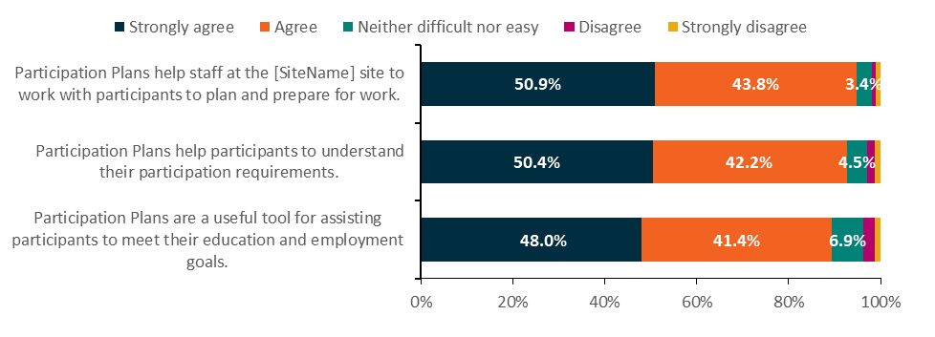
Source: 2020 provider survey
Base: All respondents (n=379)
Q8.4–Q8.6 How strongly do you agree or disagree with the following statements?
That said, providers thought Participation Plans could be made more effective. Over half of respondents (53%) to the 2020 provider survey identified a wide range of issues related to activities, including coding of activities, linking of activity codes and the need for a wider variety of activity codes. This was a notable increase compared with 35% respondents reporting this type of comment in 2019. Almost a third (32%) of respondents identified that increased flexibility was needed to improve plans, including issues with broader choices, more flexible activity selections, improved wording, more structure around goals, and recognising provider assistance. In comparison, 27% of respondents proposed increased flexibility in 2019 (Figure 4.2).
Figure 4.2: Suggested improvements to Participation Plans, 2019 and 2020
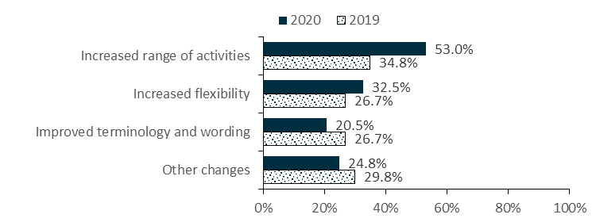
Source: 2019 and 2020 provider surveys
Base: Selected respondents (2020: n=117; 2019: n=161)
Respondents who provided a comment in response to question 8.7 (2020) or 8.8 (2019)
2020: Q8.7; 2019: Q8.8 In what ways, if any, could Participation Plans for ParentsNext be improved?
Note: Responses can be counted in more than one category

4.2.2 Use of the Participation Fund
The Participation Fund provided a source of support for providers to tap into if there were no specialised staff available or their staff were untrained. As noted in Section 2.10, the Participation Fund was only available to intensive stream participants. Intensive stream providers received a one-off credit of $1,252.80 when a participant commenced in the program; however, the average fund expenditure per participant was around $260.64. Providers were generally conservative in their use of the fund. As 2 providers put it during the Wave 1 qualitative research:
So, we’re always mindful on making sure that the dollar we spend is a dollar well spent if it’s scrutinised out in the public, we’ll be happy with spending that dollar. (Provider 2)
That’s challenging when you’ve only got $600 over a six-month period. You can blow $300 in one hit if you’re seeing a psychologist or a counsellor. We have to have funds. (Provider 10)
Overall, providers were unhappy with the selective application of the fund to intensive stream participants. Lack of access to funding in targeted areas was noted as particularly problematic for interpreting services.
People are getting funding based on where they live and not their need. I think that’s an issue. (Provider 11)
Detailed expenditure by category from the fund (Appendix 9) showed that, perhaps unsurprisingly, funding for participant support was the highest expenditure category across all cohorts. It rose steadily during the bushfires and COVID lockdown period and remained elevated for the remainder of 2020. Across all other categories, for male participants work-related expenses was highest. For refugee and CALD participants interpreter servicing was highest, and for Aboriginal and/or Torres Strait Islander participants non-vocational training was highest.
It is interesting to note that expenditure from the Participation Fund for non-vocational training peaked sharply between December 2019 and March 2020 in line with the bushfires and COVID-19 lockdown, then fell rapidly in June 2020 (Figure 4.3) – possibly because these training activities were likely conducted online. Expenditure on accredited training rose in line with participant support but fell away strongly in October 2020 to a level similar to that in June 2019, presumably as the academic semester came to an end.
Figure 4.3: Participation Fund expenditure, July 2018 to December 2020
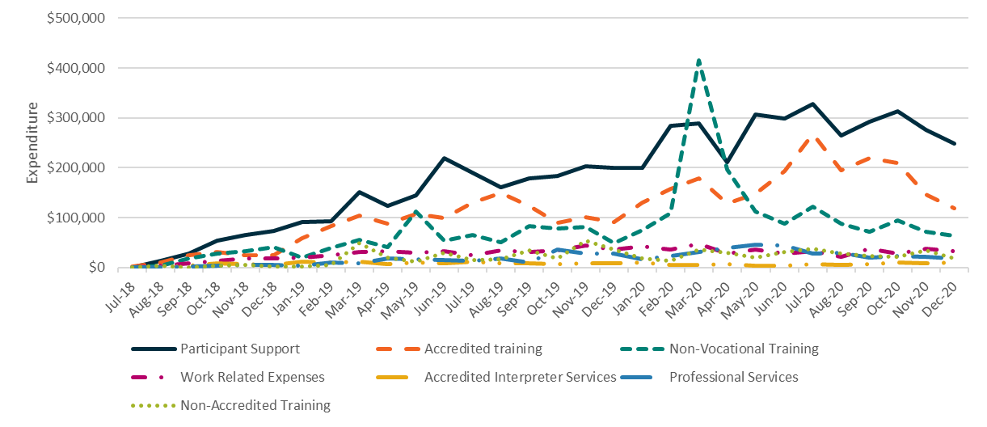
Source: The department’s administrative data
Base: Participation Fund expended transactions made by 31 December 2020 (n=55,948)

4.2.3 Outcome payments
While targeted stream providers did not have access to outcome payments during the study period, almost half of respondents in the 2020 provider survey (44%) who answered that their site serviced intensive or intensive and targeted participants agreed or strongly agreed that outcome payments motivated the inclusion of education and employment-related activities in Participation Plans. However, 23% of respondents disagreed or strongly disagreed, and a further third (32%) had no opinion (Figure 4.4).
Figure 4.4: Attitudes towards outcome payments, 2020
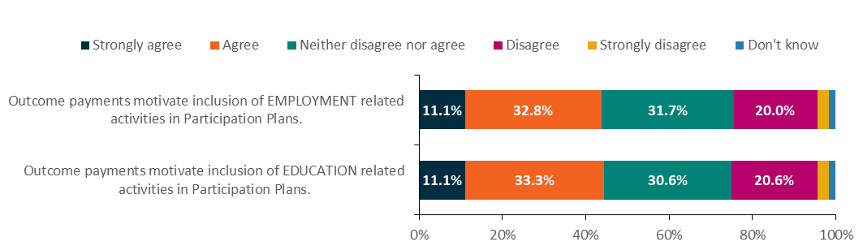
Source: 2020 provider survey
Base: Selected respondents (n=180)
Respondents who answered ‘Intensive’ or ‘Intensive and Targeted’ to Q4.1 Which type of service does the [Site Name] provide?
Q15.1; Q15.2: Thinking about the outcome payments, how strongly do you agree or disagree with the following statements …?

4.3 Concurrent activities and other assistance
Some providers had regarded concurrent servicing of participants in their last 6 months of ParentsNext a useful way to access additional interventions and supports such as the jobactive Employment Fund and ease participants into employment services. In targeted areas, not having access to the Participation Fund was particularly problematic for interpreting services, which were costly and exceeded any service fee.
From 9 December 2019, ParentsNext participants were able to access concurrent referrals to the New Enterprise Incentive Scheme (NEIS) and TtW but not to jobactive face-face services. Instead, participants who wished to look for work as their ParentsNext activity had access to the Volunteer Online Employment Services Trial (VOEST), relocation funding or wage subsidies.
Overall, a very small proportion of participants undertook concurrent activities. On 31 December 2020, there were 81,329 participants on the caseload, 64,213 of whom were in an activity. Of these, approximately 706 were concurrently participating in another employment service:
- approximately 336 in VOEST
- 42 in NEIS
- 328 in TtW.

4.3.1 Wage subsidies
As of 31 December 2020, only 226 participants had accessed wage subsidies since the roll out of the program nationally (Table 4.1).
Table 4.1: Wage subsidy agreements by type
Wage subsidy type | Number | Per cent
Parents Wage Subsidy | 84 | 36.5
Long Term Unemployed Wage Subsidy | 56 | 24.4
Youth Bonus Wage Subsidy | 49 | 21.3
Youth Wage Subsidy | n.p | n.p
Restart Wage Subsidy | <5 | <5.0
Total | 230 | 100.0
Source: The department’s administrative data
Base: Wage subsidy agreements started by 31 December 2020 (n=230). These agreements were made for 226 unique participants.
Note: Wage subsidies were only available to participants in the intensive stream. Consistent with restrictions on the release of social security information to protect individual privacy, aggregation of fewer than 5 is represented as ‘<5’. Related totals and percentages are replaced with ‘n.p’ (not provided).

4.3.2 Relocation funding
Very few ParentsNext participants took up the option of relocation assistance funding. There were only 105 Relocation Assistance to Take Up a Job claims created by 31 December 2020. Given the pre-employment nature of the program, this is unsurprising. Prior to 1 December 2020, Relocation Assistance to Take Up a Job was only available to participants in the intensive stream. From 1 December 2020, it was available to both streams.

4.3.3 VOEST
Some providers considered VOEST a useful option for participating parents because of its convenience and the fact that it was neither time-consuming nor resource intensive. Despite their limited engagement with VOEST, ParentsNext participants and providers saw value in having VOEST as an option for job ready ParentsNext participants.
It is worth noting that in the 2020 provider survey, of the 32 respondents who reported that they would not refer participants to employment programs, 19 reported that they would not refer to VOEST, due to a lack of support for participants and participants refusing referral.

4.4 Provider service strategy and good practice
Provider and participant views in the evaluation of ParentsNext 2016–2018 afforded a valuable insight into the program design, reflecting both their practical experiences of administering and participating in the program and the extent to which the program design was appropriate in meeting the objectives of ParentsNext.
Both providers and participants regarded an individualised approach to achieving parents’ education and employment goals as good practice to address their needs, barriers and preferences. In addition, assigning the best-suited caseworker to work with participants on a one-on-one basis was associated with better participant outcomes.
The majority of participants surveyed for the 2020 participant survey (Figure 4.5) either strongly agreed or agreed that the ParentsNext program was appropriate for their current situation (59.5%) and for parents of young children (66.5%). Some, however, disagreed or strongly disagreed that the program was appropriate for their current situation (25.7%, or 1 in 4) and/or appropriate for parents of young children (17.8%).
Figure 4.5: Appropriateness of the ParentsNext program
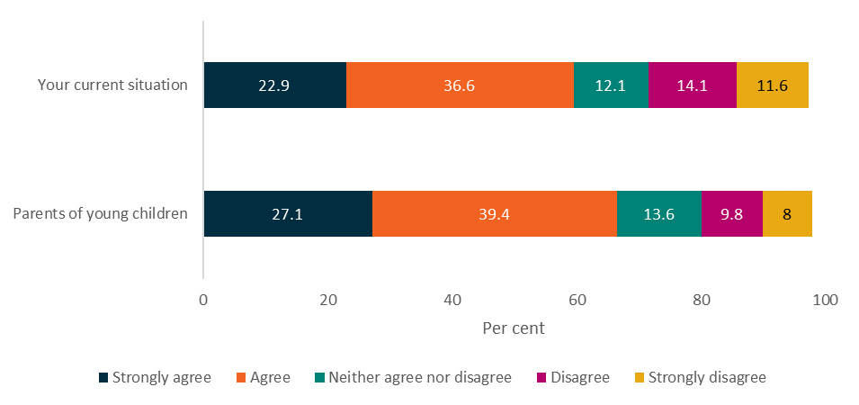
I1a Now some statements about the ParentsNext program. How strongly do you agree or disagree that the program is appropriate for ...?
Base: All (n=2,260)
Source: ParentsNext Participant Survey 2020

4.4.1 Provider assistance to support participants
Respondents to the participant survey reported on the types of assistance delivered by providers (Figure 4.6). The most common form was the creation of a Participation Plan to achieve employment and education goals (76%). Other commonly offered services were ‘help to find and undertake training or study’ (59%), ‘advice about the types of jobs that would suit participants’ skills and abilities’ (56%), ‘advice about child care’ (38%), ‘help with transport difficulties’ (20%) and ‘help finding safe and stable accommodation’ (16%).
Figure 4.6: Assistance from ParentsNext providers
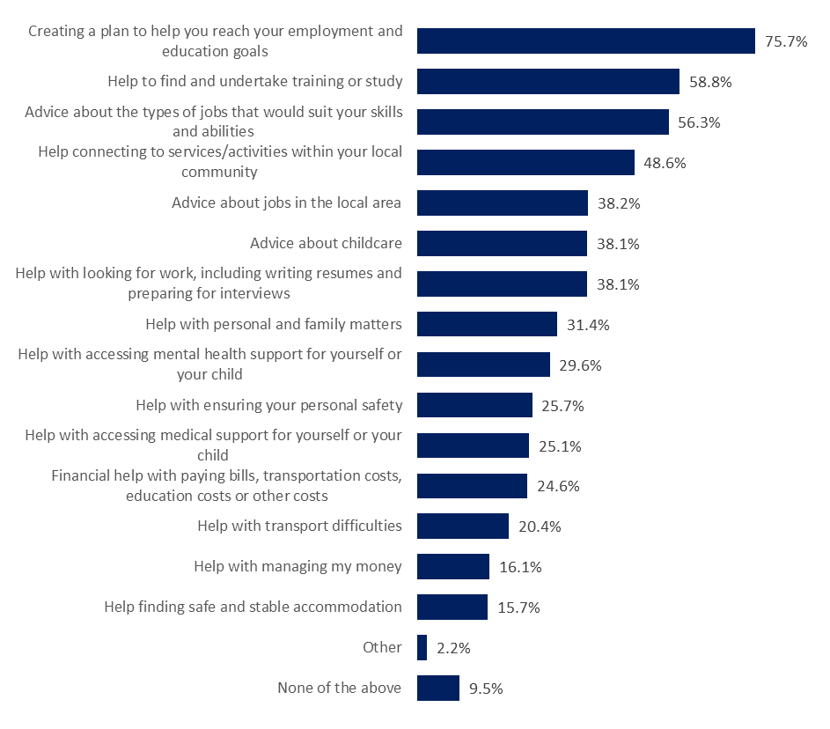
E11. Has your provider helped you with any of the following?
Base: All (n=2,260)
Note: Not shown ‘Unsure’ (0.6%), ‘Prefer not to say’ (0.5%)
Source: ParentsNext Participant Survey 2020
ESL participants were the most likely to report assistance across 12 types of provider services. Participants whose youngest child was aged at least 5 years were less likely to report that their provider helped them across almost all aspects of provider assistance; this is perhaps unsurprising given that these respondents were more likely to have been in the program for a shorter duration, which limited the extent to which they could participate in a broad range of activities. They were also more likely to be working, looking for work, or volunteering, and may not have needed as much support in these areas as participants in the other groups.

4.4.2 Implementing participants’ ideas
As part of the ParentsNext Deed, providers were required to establish frameworks, such as consultation forums and feedback mechanisms, that encouraged participants to be involved in the delivery of the services. In the 2020 provider survey, almost half of respondents (49%) reported having implemented participant ideas gathered through their program governance arrangements (Figure 4.7). This was up from 2019, when 45% of respondents reported implementing participant ideas. It was counterbalanced, however, by the increase in respondents reporting that their site had no program governance arrangements, from 9% in 2019 to 13% in 2020.
Figure 4.7: Implementing participant ideas, 2019 and 2020
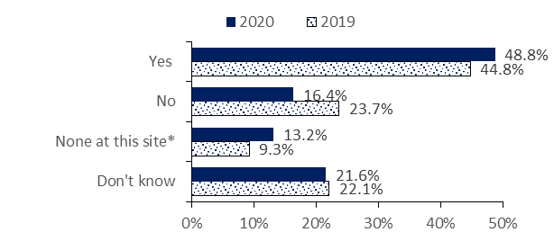
Base: All respondents (2020: n=379; 2019: n=375)
2020: Q8.3; 2019 Q12.5 Have you implemented any participant ideas gathered through your program governance arrangements?
* Response option was ‘No program governance arrangements at this site’
Source: 2019 and 2020 provider surveys
A wide range of implemented ideas were reported (Figure 4.8), including feedback forums, morning teas, information sessions, job clubs and informal discussion opportunities for parents. Parent advisory groups, leadership teams and advisory committees were also arranged.
Figure 4.8: Types of participant ideas implemented at site, 2019 and 2020
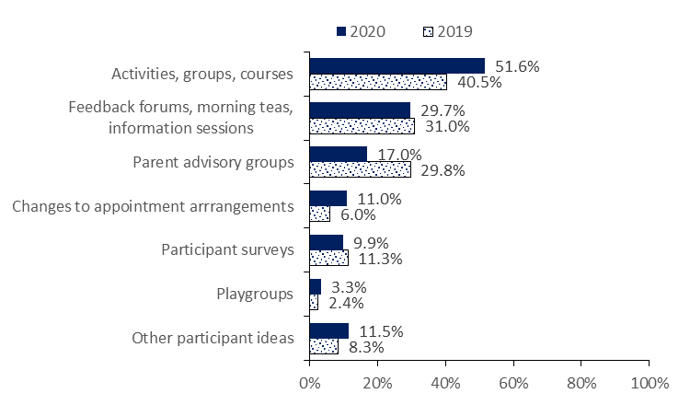
Source: 2019 and 2020 provider surveys
Base: Selected respondents (2020: n=182; 2019: n=168)
2020: Q8.3; 2019 Q12.5 Have you implemented any participant ideas gathered through your program governance arrangements?

4.4.3 Good practice
What constituted good practice was difficult to isolate and measure. However, in the longitudinal case studies and Wave 2 qualitative research, a clearly emerging theme was the importance of the availability, consistency, continuity and skills of the ParentsNext consultants/caseworkers, and their ability to listen actively to, and support, their clients.

4.4.3.1 Caseworker and participant support
Satisfaction with the service provided by ParentsNext providers, as expressed during the Wave 2 qualitative research, hinged largely on the rapport established between the caseworker and the participant. Many participants highlighted emotional support as one of the positive aspects of the program. Those who felt that their caseworkers had a sincere interest in their lives and expressed genuine care towards them tended to have a higher level of satisfaction with the program (and their provider).
We talk about all kinds of things, but that’s just because she’s a lovely, lovely woman … I get the feeling that the worker I have now is interested in helping people and it wasn’t just a job. (Interview 1. Female, VIC, 1 child, single parent, 35–45 years old)
They really make me feel that if I need help, they’re there. Because they did send me stuff when I needed to and asked if I need help with stuff. That was amazing, because when you have three kids by yourself – that was really, amazing. (Interview 13. Female, WA, 3 children, 22–34 years old)
One participant was so satisfied with his provider’s support during times of hardship that he elected to stay on the program voluntarily so that he could continue receiving support from his caseworker.
It’s a good thing [ParentsNext). Before, when I was with Centrelink or social security services, there wasn’t really anyone there to help you mentally … I’ve got self-confidence but … I have my days where I haven’t … so before you would have to go searching [for support], now it’s at your doorstep.
So that’s great that she’s given me the opportunity, for me to do that, instead of just saying, you’re out of the system, we don’t want you no more. (Interview 7. Male, SA, 5 children, 46+ years old)
Those who did not feel a strong rapport with their caseworker tended to report greater dissatisfaction with the program and their provider.
To be honest … she was just ‘hi; how are you? All good?’ That’s the word I remember: ‘all good; thank you; see you next time.’ Not even a minute. There was no chance for talk anyway. (Interview 10. Male, NSW, 2 children, 35–45 years old)
Where relationships appeared less consistent, or participants viewed their consultant as inflexible or less proactive, progress and satisfaction with ParentsNext appeared more limited. A few participants were very dissatisfied and disappointed in their interactions with their caseworkers, whom they felt were rude, discouraging or condescending. In each of these cases, the participant requested to be assigned to another caseworker, with whom they later developed better rapport.
I think that most of my experience … comes down to my provider, who haven’t been the best. I feel like they’re not very supportive and I’m about to change providers … [I] feel like their communication is not good and my queries are not really responded to most of the time, which is disappointing. So, my experience has sort of been that it’s a waste of time for me. (Interview 19. Female, QLD, 3 children, single parent, 22–34 years old)

4.4.3.2 Financial and administrative support
Financial support was described as one of the major benefits of the program. Funding was mostly used to pay for training courses. Some participants received practical help from their caseworkers, with assistance in enrolling in training courses, administrative support for placing their child in child care, access to resources such as a laptop, and assistance with social supports, such as referrals to housing services. These participants indicated that it was beneficial to have a caseworker to help to organise their paperwork, link them to services and discuss their options.
She actually was very helpful when I needed her … to call [Organisation] because I needed some papers from them and because of the COVID lock [down] it was very hard to get in touch with them. She called few times … she helped me with that. For the housing I ask her for few things, and she’s been sending the information to know something about the grants if I needed to start work or something. (Interview 3. Female, NSW, 2 children, single parent, 22–34 years old)
Some participants described not having their request for financial support granted – possibly because their provider was unable to access the Participation Fund or to fund the requested support using their service fees.

4.4.3.3 Specialist staff
Previous internal and external studies commissioned or undertaken by the department have found that in delivering employment services, service specialisation by task, staff, provider or program can enhance service effectiveness and satisfaction (Department of Employment 2014). In ParentsNext, while it was difficult to measure the impact of provider servicing directly, the practice of employing specialists was common. The location of services, targeted and intensive streaming, the availability of specialists, the costs of their services and the extent of services available in the community all likely impacted the type and number of specialists employed.
The 2020 provider survey results showed a rise in sites reporting that they did not employ specialist staff (2020: 54%; 2019: 38%). While the reasons for this were unclear, the environmental shocks during 2020 and the increase in staff training for generalist workers may have contributed.
Both the 2019 and 2020 provider surveys provided a picture of the range of specialist staff employed by providers to deliver an individualised and tailored service. In 2020, 23% of providers reported employing youth workers, 17% disability specialists and 21% training/education specialists
(Figure 4.9). The least reported specialist role was support workers for pre-release prisoners or ex-offenders (3%). There was some change in the types of specialist staff reported in 2020 compared with 2019, with some reductions in the employment of Aboriginal and/or Torres Strait Islander mentors (2020: 13%; 2019: 18%), disability specialists (2020: 17%; 2019: 22%) and interpreters (2020: 7%; 2019: 11%).
Figure 4.9: Employment of specialist staff, 2019 and 2020
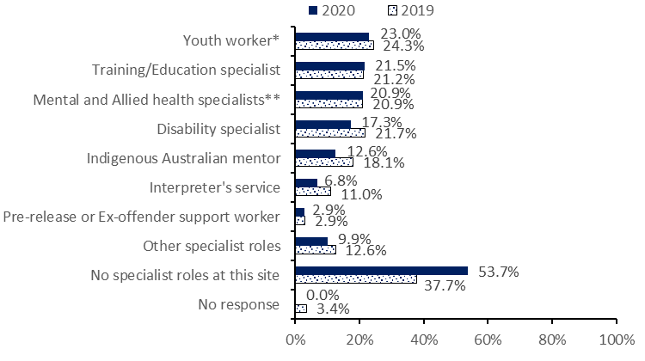
Source: 2019 and 2020 provider surveys
Base: All respondents (2020: n=382; 2019: n=381)
2020: Q5.7; 2019: Q5.7 Thinking about staff roles, are there any of the following specialist roles at the [Site Name] site? Select all that apply.
* Youth worker/staff experienced in working with disengaged young people
** Mental health specialist/Allied health specialist/Psychologist

4.4.3.4 Staff training
Staff training was undertaken by most providers, enabling non-specialist staff to identify and refer participants to appropriate services in the community. Respondents to the 2020 provider survey were asked about the types of training available to staff. Almost all (98%) reported that their site provided training (Figure 4.10), an increase of 7 percentage points compared with 2019. The most common types of training available to staff were COVID-19 related training (87%) and training to support people in family conflict, including domestic violence (87%). The least common was training to support people with disability (52%).
All types of training increased over time. There were increases in training on corporate matters (2020: 81%; 2019: 67%), cultural awareness in relation to CALD/refugee participants (2020: 76%; 2019: 62%), and supporting people with disability (2020: 52%; 2019: 41%).
Figure 4.10: Types of training available to staff, 2019 and 2020
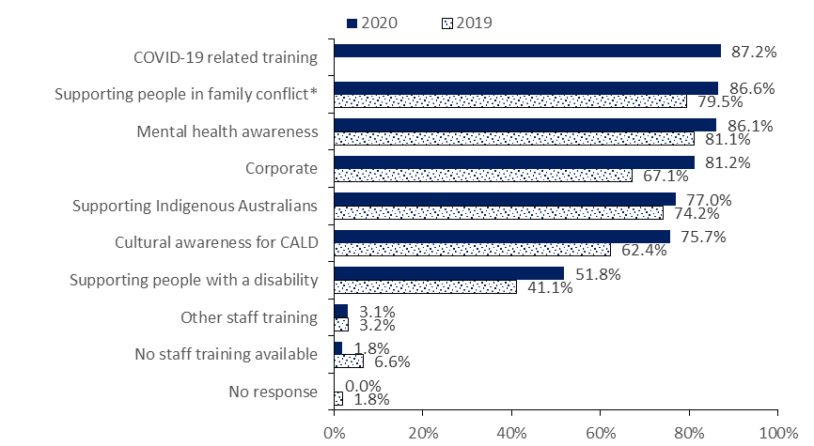
Source: 2019 and 2020 provider surveys
Base: All respondents (2020: n=382; 2019: n=380)
2020: Q5.8; 2019: Q5.8 Which types of training are currently available for staff? Select all that apply.
Note: COVID-19 related training was added into the 2019 response options
* Supporting people in family conflict including domestic violence

4.4.3.5 Innovations
Providers interviewed for the qualitative research found innovative ways to support participants when funding was short. The main avenues for additional support were:
- discretionary funding from within the wider organisation (with concern that this was not sustainable)
- funding from their own site’s budget (again, with concern about the impact on their site’s financial performance)
- free services (although services that had zero fees were reported rarely)
- fundraising and benevolent donations
- offers to meet half of the cost with the participant.
Only one provider, which had been a provider in ParentsNext 2016–2018, found that the lack of access to the Participation Fund was not an issue. Providers had become well versed in finding support or activities at no cost under the earlier program. Access to Smart and Skilled funding was particularly beneficial to providers in areas where it was available for participants who wanted to undertake training.
We did it in the pilot program, we didn’t have any funds … we try and find the funded programs and support in the area or find a community organisation that’s offering some funds … we could grumble about it … we don’t grumble … (Provider 6)
Some respondents to the 2020 provider survey developed innovative ways of keeping in touch with their caseload during the COVID-19 lockdown period. This will be explored further in Chapter 6.
We adapted our servicing to offer flexible support and resources via phone, email, internet, teams, Skype, Facebook etc. (2020 provider survey)

4.5 Servicing different demographic cohorts
The department expects providers to ensure provider staff are trained in areas including disability awareness, cultural sensitivity, and domestic and family violence, to ensure the services they deliver are appropriate, sensitive and suitable to the needs of individuals. The need for additional investment and early intervention to help disadvantaged cohorts become work-ready and connect to employment once their children reach school age was acknowledged and understood by providers.
Aboriginal and Torres Strait Islander and CALD participants generally reported feeling adequately supported in the program during the qualitative research. They explained they were able to work with their consultants to source activities and opportunities that suited their individual needs; however, cultural aspects were not necessarily addressed by providers and most participants did not seek, or in some cases need, such support.
[ParentsNext] treat everybody the same way anyway. They have respect, they’re polite and things like that … [they are] respectful of everyone [and] the culture, we come. But no, they don’t talk about the culture. (Interview 14. Parent, metro, volunteer, CALD)
It’s never been addressed, me being Aboriginal, at all. So, I wouldn’t have a clue. (Interview 22. Metro, Intensive, Aboriginal and/or Torres Strait Islander)
I didn’t speak about my … culture to her [my ParentsNext consultant], so that’s why I wouldn’t be able to explain those questions. (Interview 23. Parent, metro, intensive, CALD)
Engaging with participants with limited English language capability was identified as a challenge for some providers in the 2 provider surveys. Despite this, CALD participants talked about increased confidence and a sense of empowerment from taking part in activities associated with the program, and during meetings with their ParentsNext consultants.
One year before, I was very low, now I’m little bit confident by doing those training … Whenever I go with her, she [my ParentsNext consultant] motivates me a lot. Whenever I go with her I will [be] like ‘I’m not getting [very far]’, she motivate[s] me, ‘don’t worry one day you will get a job.’ Yeah, we [are] all helping you. (Interview 23. Parent, metro, intensive, CALD)
Although fathers were a relatively small cohort in providers’ caseloads, and despite some positive feedback, the qualitative research identified male participants as the most challenging of all the cohorts to support. This was mainly because of the difficulty in finding activities or support that would suit them, as some were reluctant to attend activities that were attended mostly by mothers.
I don’t feel jibbed as such, but I just feel like I was put into something that wasn’t really geared for me and therefore it had very limited success and its sort of hard to gauge. I do think that the program is not designed for me. (Interview 47. Parent, regional, intensive, male, YC5)
Parents living in regional areas indicated that they had limited choice of courses to study. Across regional and metropolitan areas, participants took advantage of courses offered online in order to accommodate study commitments with caring responsibilities.
I’d always wanted to do [study] aged care but I never would have done it unless I had gone through [my ParentsNext provider], I never would have actually worked up to it this soon … (Interview 8. Parent, regional, intensive, CALD)

4.5.1 Aboriginal and/or Torres Strait Islander specific activities
Interestingly, despite the comments in Section 4.5, during the Wave 1 qualitative research, providers with caseloads that included Aboriginal and/or Torres Strait Islander participants highlighted the importance of cultural awareness and sensitivity. They had made efforts to encourage inclusiveness such as raising Aboriginal and Torres Strait Islander peoples’ visibility in the office by displaying Aboriginal and/or Torres Strait Islander artwork, employing an Aboriginal and/or Torres Strait Islander caseworker on staff, having knowledge of, and a presence in, the local Aboriginal and Torres Strait Islander communities (for example, through attendance at community events) and being able to refer participants to suitable local organisations such as a local Aboriginal Centre.
We have an Aboriginal consultant or case manager at the … site and so our next focus is on, I think we’re doing those yarning circles. (Provider 11)
And we have strong relationships with the elders in each region as well. And we sit with them on their meetings and stuff like that and get input into the program as well. And they regularly come along to NAIDOC week and things like that. And they’ve had input into our program as well to ensure that we’re delivering safe practises for culturally and linguistically diverse and Aboriginal and/or Torres Strait Islander people. (Provider 6)
In a few cases, providers spoke of the importance of acknowledging the culture of Aboriginal and/or Torres Strait Islander participants. Examples given included a preference to attend informal activities within their own community; reluctance to engage with services linked to fears and experiences of the forced removal of children; a preference for child care to be provided by family members within their own communities, or a specific Aboriginal and/or Torres Strait Islander run child care centre if available; and difficulties with regular attendance at some activities due to other cultural commitments.
Employment of Aboriginal and/or Torres Strait Islander mentors across provider sites declined in the time between the 2019 (18%) and 2020 (13%) provider surveys. Around 81% of all respondents, however, reported Aboriginal and/or Torres Strait Islander services offering practical help, health services and family counselling services to assist participants being available in their local community. The most commonly reported referrals were to Aboriginal and/or Torres Strait Islander community organisations, which increased substantially from 32% in 2019 to 46% in 2020.
A few providers participating in the qualitative research reported co-locating their service (typically an outreach office) in a community area or hub where other services were located. In one example, a provider opened their office space to a local Aboriginal and/or Torres Strait Islander group.
We just give them that space for free, we let them have the space and we engage with them on any Aboriginal and/or Torres Strait Islander matters; families, things like that, we’ll go to them for guidance. (Provider 8)
For other providers, it was business as usual.
We haven’t had to service them any differently, but I would say that I’m acutely aware of the Aboriginal and/or Torres Strait Islander cohort in [area] and the barriers and things that they face down there. (Provider 2)

4.5.2 Recognition of cultural and linguistic diversity
Some of the providers interviewed during the Wave 1 qualitative research reported that a high proportion of their caseload belonged to a small number of CALD groups (for example, from Arabic-speaking countries or from Vietnamese backgrounds), whereas others had considerable diversity across their caseload. For the former, providers were generally able to secure a consultant with in-language capacity, or to link with the local CALD community to access an in-person interpreter (rather than a telephone interpretation service). All reported the value of having someone within the ParentsNext team of a similar background and/or with language skills.
Providers with a wide variety of CALD groups found that telephone interpreting services could be difficult to access (often due to translator shortages), difficult to coordinate (due to lack of availability at appointment times) and costly to implement (particularly for in-person interpreting) in both targeted and intensive streams.
… which is sometimes proving a little bit of a barrier to get the right translator at the right time at the right appointment to be able to help people be able to communicate. (Provider 2)
So, every week you need to call them after their activity with an interpreter and confirm that they’ve attended their activity and then record the attendance. If you were to do that every single week for six months, you would spend more than $600 which is more than the service fee that a provider receives for engaging that participant. (Provider 4)
Almost all providers observed high rates of domestic violence within their CALD cohort, with many indicating that it was far higher than anticipated. Other notable barriers were poor mental health, low confidence and self-esteem, disability and health needs among children, and housing issues.
Cultural awareness training reported to address the needs of CALD/refugee participants rose 16 percentage points between the 2019 and 2020 provider surveys (2020: 78%; 2019: 62%) while use of interpreter services dropped (2020: 7%; 2019: 11%). Use of interpreter services dropped in this period (2020: 7%; 2019: 11%), likely due to reduced demand during COVID-19 lockdowns.

4.5.3 Parents with disability or a child with disability
Approximately 1 in 4 participants (28%) who responded to the participant survey reported having disability, a health condition or an injury that had lasted or was likely to last more than 6 months (this included psychological conditions). Respondents were more likely to self-report that they had disability if their child had disability (50%). Those aged 46 or older had a similar increased likelihood of reporting disability (49%), whereas those aged 21 or younger were less likely (16%). Over 1 in 5 participants (22.7%) reported that their child had disability, a health condition or an injury that had lasted or was likely to last 6 months or more. In total, 10.4% of participants reported that both they and one of their children had disability.
Two-thirds of respondents (65%) to the 2020 provider survey reported that caring for children with disability/health issues was a barrier to participants achieving their employment and education related goals. It is notable that this had risen by 11 percentage points since 2019, probably because lockdown restrictions during the COVID-19 pandemic impacted the results.
Caring responsibilities are just one of a number of barriers to employment for those who are inactive mainly due to a disability. Therefore, it is important to consider the additional barriers to employment that they face, such as lack of qualifications and skills, lack of confidence, personal problems such as alcohol or drug addiction, lack of motivation, together with labour demand factors including the attitudes and flexibility of employers and the spatial mismatch of employment opportunities. (McQuaid et al. 2013)
The participant survey supported this assumption. Participants with self-reported disability (33.8%) or a child with disability (30.9%) were the most likely of all groups interviewed to indicate that their isolation had been exacerbated by COVID-19 ‘a lot’.
Respondents with a self-reported disability or a child with disability were also the least likely to have a good support network that would help them to work or look for work and the least likely to have the skills and/or experience for the type of job they wanted. The Personal Wellbeing Index (PWI) scores of respondents who had a child with disability (PWI 70) or had disability themselves (PWI 66) were lower than the average for ParentsNext participants (PWI 74) and the national average (PWI 77) in 2020.
In the 2020 provider survey, 17% of respondents reported that they employed disability specialists, a drop of 5 percentage points from 2019 (22%). Sites with small caseloads (21%) were most likely to employ them. Not-for-profit providers were almost 10 percentage points more likely to employ this type of specialist than were for-profit agencies. Almost half of the provider sites offered training to support people with disability (2020: 52%; 2019: 41%); however, it remained the least common form of staff training.
Of all groups canvassed during the participant survey, parents with disability or a child with disability were the least likely to be satisfied with the ParentsNext program overall (64% compared with 70% overall). Many, however, thought the program was appropriate to their needs.
My circumstances are different; my children are intellectually disabled, so they take that into consideration and are really understanding of that and are willing to help. (Parent quantitative research)

4.5.4 Services for fathers
As noted in Section 4.5, men were a very small group of ParentsNext participants overall, so providing services tailored for them proved difficult for some providers, although some were innovative in sourcing options. Some providers had access to men’s groups or had established (or were planning to establish) a social group to enable fathers to meet with other fathers in the caseload. Providers also mentioned that some fathers were mature age (sometimes near to retirement), having taken responsibility for child care within the family and not anticipating they would return to work.
During the qualitative research, a small number of men explained that the program was not suited to their circumstances and consequently did not support their needs. One of these fathers reported being referred to a mother’s group and that this made him feel uncomfortable. Others related a more general lack of support, especially with accessing employment opportunities through the program.
I think for the dads, it’s really some tailored activities. There’s a lot out there for the mums but not so much for the dads. We were actually having this conversation in our meeting this morning. What other services like the men’s sheds and our dad’s programs, can we link in with? It’s a challenge in some of our regional areas where there’s limited services. (Provider 9)

4.5.5 Parents in regional locations
Unsurprisingly, in the 2020 provider survey substantially more respondents in remote or very remote regional areas reported barriers to accessing child care, limited job search skills, limited access to suitable/appropriate training or education, substance abuse issues, financial issues, and cultural issues. Fewer respondents in remote or very remote areas reported language issues or barriers relating to caring for children with disability/health issues.

4.6 Provider satisfaction

4.6.1 Support for the program
Over two-thirds of respondents (70%) to the 2020 provider survey reported that ParentsNext was meeting its objectives very effectively, and a further 28% reported that the ParentsNext objectives were being met somewhat effectively (Figure 4.11). Overall, the proportion of respondents reporting that ParentsNext was effective in 2020 was 2 percentage points higher than in 2019 (2020: 97%; 2019: 95%).
Figure 4.11: Meeting the objectives of ParentsNext, 2019 and 2020
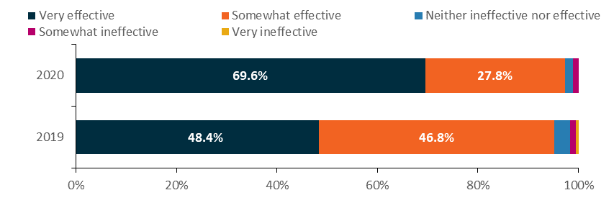
Source: 2019 and 2020 provider surveys
Base: All respondents (2020: n=378; 2019: n=374)
2020: Q19.1; 2019: Q26.1 Overall, how effective is ParentsNext in meeting its objectives?

4.6.2 Flexibility
While most respondents (86%) to the 2020 provider survey agreed or strongly agreed that ParentsNext gave them enough flexibility to meet identified participant needs, it is notable that this increased by 12 percentage points from 2019 to 2020 (2020: 86%; 2019: 75%). Still, 14% of respondents were undecided or disagreed or strongly disagreed, which suggests that there were some provider concerns about flexibility (Figure 4.12).
Figure 4.12: Attitudes towards the ParentsNext program – provider flexibility, 2019 and 2020
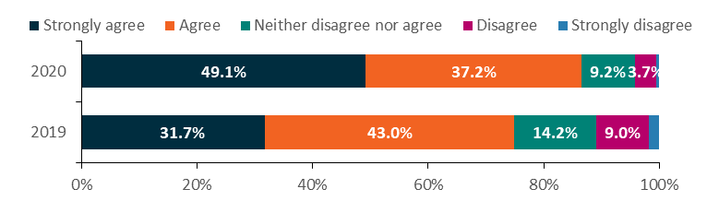
Source: 2019 and 2020 provider surveys
Base: All respondents (2020: n=379; 2019: n=379)
2020: Q9.9; 2019: Q9.9 How strongly do you agree or disagree with the following statements? The ParentsNext program is designed in such a way that it … Gives providers enough flexibility to meet the identified needs of participants.

4.6.3 Departmental support

4.6.3.1 Guidelines and online servicing
Most respondents (96%) to the 2020 provider survey agreed or strongly agreed that the ParentsNext guidelines were comprehensive (Figure 4.13), an improvement from 83% in 2019. Similarly, most respondents (82%) also agreed or strongly agreed that the guidelines were clear, a notable improvement from 66% in 2019. Indeed, the proportion of respondents disagreeing or strongly disagreeing that the guidelines were clear fell from 14% in 2019 to 6% in 2020.
Figure 4.13: Attitudes towards the guidelines, 2019 and 2020
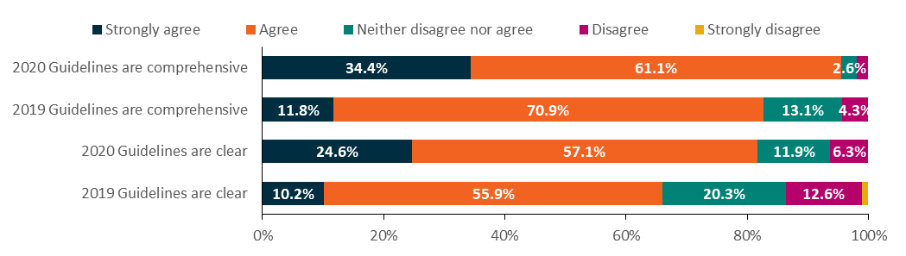
Source: 2019 and 2020 provider surveys
Base: All respondents (2020: n=378; 2019: n=374)
2020: Q17.7-Q17.8; 2019: Q24.7–Q24.8 Thinking about the documentation provided by the department for providers, to what extent do you agree or disagree with the following statements?
Similarly, most respondents agreed or strongly agreed that the department’s online information was comprehensive (89%), accurate (89%), easy to understand (80%), timely (80%) and presented in a useful format (84%) – a 10 percentage point improvement from responses in 2019. In addition, 91% agreed or strongly agreed that the content of the department’s Learning Centre was relevant and helpful.
Although respondents were generally positive in their attitudes towards the department’s Employment Services System interface (ESS Web), there were also many who had concerns. Around a quarter did not agree that sufficient training was available for ESS Web. Even so, all responses had improved since 2019.

4.6.3.2 Quality of services and assistance from departmental staff
In 2020, over three-quarters of respondents (77%) to the provider survey were satisfied or very satisfied with the quality of services provided by the department (Figure 4.14) – an increase of 3 percentage points since 2019 (74%). Of those who reported dissatisfaction, 40% said staff lacked an understanding of ParentsNext or its guidelines.
Figure 4.14: Satisfaction with the quality of services, 2019 and 2020
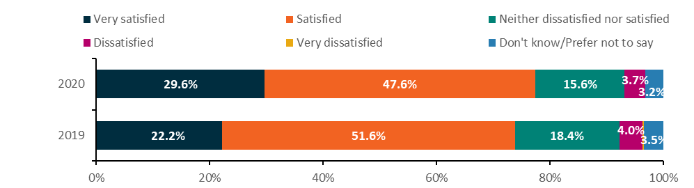
Source: 2019 and 2020 provider surveys
Base: All respondents (2020: n=378; 2019: n=374)
2020: Q18.8; 2019 Q25.8 Overall, to what extent are you satisfied or dissatisfied with the quality of services provided by the department?
In 2020, most respondents were positive about departmental staff in relation to their knowledge, communication, provision of reasonable notice about changes, and treatment of provider staff; 82% agreed or strongly agreed that they were treated with dignity and respect (Figure 4.15). Respondents were less positive about departmental staff knowledge of ParentsNext, with 66% agreeing or strongly agreeing that they were knowledgeable and 13% disagreeing or strongly disagreeing.
Figure 4.15: Attitudes about behaviour of department staff, 2020
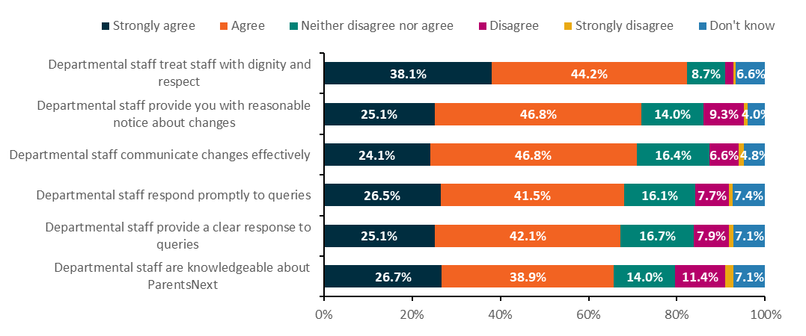
Source: 2020 provider survey
Base: All respondents (n=378)
Q18.2–Q18.7 Thinking about the contact that staff at the [Site name] site have with the department to deliver ParentsNext, how strongly do you agree or disagree with the following statements?

4.6.3.3 Financial reporting and administration
In 2020, as in 2019, around a quarter of provider survey respondents (26%) advised that the department’s financial reporting requirements were easy or very easy to complete. However, given that 55% of all respondents had no view, these results should be treated with caution.
Over a quarter of respondents (27%) reported that the level of administration was too high, while over two-thirds (69%) reported that the level was appropriate. These results represent a substantial shift since 2019, when 48% reported that the level of administration was too high. Over half of all respondents (54%) reported spending between 21% and 60% of their staff time on ParentsNext administrative requirements in 2020.
Analysis undertaken by site and stream shows that more intensive-stream respondents reported that the level of administration was too high (31%), compared with other streams (targeted 27%; intensive and targeted 24%) (Figure 4.16). Given the additional administration in relation to using the Participation Fund, recording job placements and claiming outcome payments, this is not surprising.
Figure 4.16: Level of administration, by site stream
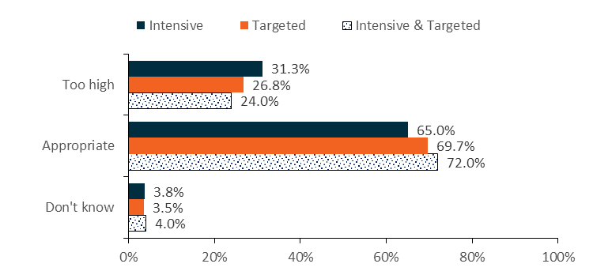
Source: 2020 provider survey
Base: All respondents (n=378; 80 intensive sites; 198 targeted sites and 100 intensive and targeted sites)
Q4.1: Which type of service does the [Site Name] site provide?
Q17.17 Overall, the level of administration required by the department for ParentsNext is …?

4.7 Participant satisfaction
Participants who responded to the 2020 participant survey were generally very satisfied or somewhat satisfied with the ParentsNext program (70%). Of those who previously said that they were very satisfied or somewhat satisfied, more than half (58%) indicated that they found the program to be ‘helpful and beneficial’, to be ‘friendly and supportive’ (29%), to have ‘good and timely communication’ (7%), and to be ‘flexible and accommodating’ (5%). Around 1 in 7 (15%) participants found nothing helpful about the program (Figure 4.17).
Figure 4.17: Reasons for participant satisfaction
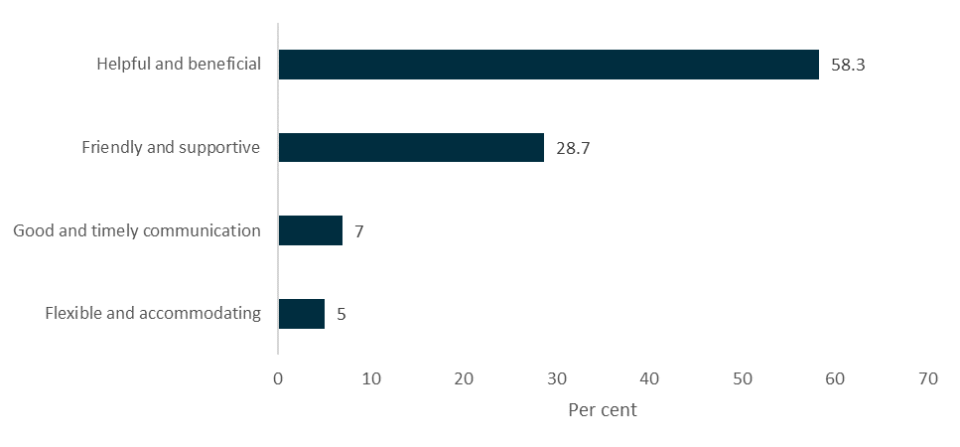
Source: ParentsNext Participant Survey, May 2021
Z3 Why are you (satisfied) with the ParentsNext Program?
Base: Very satisfied or somewhat satisfied with the program at Z2 (n=1,613)
Note: Not shown ‘Unsure’ (6.8%), ‘Prefer not to say’ (5.7%)
Almost all respondents agreed or strongly agreed (Figure 4.18) that their provider had treated them with dignity and respect (94%) and had tried to understand respondents’ needs (86%). Fewer respondents felt that their providers had improved their chances of meeting their education or employment goals (64%) and improved their chances of getting a job in the future (55%). Half of respondents agreed that providers had asked for suggestions to improve ParentsNext (48%).
Figure 4.18: Agreement with statements regarding aspects of provider service

Source: ParentsNext Participant Survey, May 2021
I1. Now some statements about your ParentsNext provider. How strongly do you agree or disagree that they ...
Base: All (n=2,260)
Notes: Not shown ‘Unsure’ (0.5% to 6.5%), ‘Prefer not to say’ (0.2% to 0.6%), Not applicable (0.2% to 3.5%). Labels less than 4% not shown.
Those who were dissatisfied with the program were in a minority. When asked why they were dissatisfied, the most common reasons (Figure 4.19) selected were that they did not receive enough (or appropriate) help (39%), that the program was just another task they had to do (37%) and that the program did not take their circumstances into account (33%).
Figure 4.19: Reasons for dissatisfaction
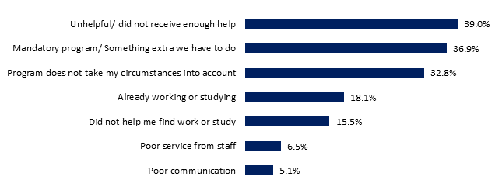
Z3 Why are you (dissatisfied) with the ParentsNext Program?
Source: ParentsNext Participant Survey, May 2021
Base: Dissatisfied with the program at Z2 (n=311)
Note: Not shown ‘Unsure’ (1.0%), ‘Prefer not to say’ (1.3%)
One reason for dissatisfaction with ParentsNext expressed by participants during the qualitative research was the additional burden that the program created, particularly for parents who were already trying to manage multiple competing demands. Some participants indicated that looking for work was not currently a priority for them because of their parenting responsibilities.
Compliance was highlighted as another source of frustration among these participants. Some perceived the program as focusing more on compliance than on trying to find suitable activities. A few participants explained that they had signed up for courses just to appease their provider.
Instead of you looking after your children or finding something that is more useful for you – [it is] time wasting to sign a piece of paper … I feel like I’m bound and have to do it … so that you don’t take the money that’s feeding my family … I don’t think a lot of single parents are asking for money, it’s just that we have very limited time. Either you’re going to help us out or just get rid of the whole program. (Interview 21. Female, NSW, 2 children, CALD, 22–34 years old)
I couldn’t find a suitable activity to participate in and so therefore I felt a bit threatened, I suppose, that my payments were going to be cut [if I didn’t sign up to the course] … [discussion aside] And it’s just pushed on me more so about what the kids are doing or getting me back into studying, which is good and well, but my – I’ve got to be there mentally before – because it’s too overwhelming for me. (Interview 15. Female, VIC, 2 children, 35–45 years old)

4.8 Conclusion
Overall, the majority of participants were satisfied with the quality and appropriateness of the ParentsNext program design. They felt that providers treated them with respect and understood their needs. Around two-thirds thought the program had improved their chances of meeting their education or employment goals and increased their confidence that they would be able to achieve them.
The most important component of the service was the consistency, continuity and skills of the ParentsNext consultants. Participants who had a strong rapport with their caseworker tended to report greatest satisfaction with the program and their provider. Employment of specialist staff and utilisation of staff training were common means of reaching equity groups. Around half of participants interviewed said they were consulted about ways to improve the delivery of the program. Those who found the program unhelpful generally thought it was wrong for them and an added burden in their already busy lives.
Over two-thirds of respondents (70%) to the 2020 provider survey reported that ParentsNext was meeting its objectives very effectively. A further 28% reported that the ParentsNext objectives were being met somewhat effectively and that the program design and operational processes overall were appropriate. Providers praised the flexibility of the program and the support they received from the department. They were unhappy with the lack of access to the Participation Fund for targeted stream participants and made suggestions about how Participation Plans might be improved. Innovative practices and concurrent programs were used as ways to extend limited resources.

Chapter 5 Does participation in ParentsNext improve work readiness and employability of participants?

5.1 Work readiness
As noted in Section 2.13.2, ParentsNext providers are required to measure the progression in some participants’ work readiness by repeated application (every 6 months) of Work StarTM, which is part of a suite of tools from Outcomes StarTM. Work StarTM was deployed in the program from 2018 but it was not fully rolled out until early 2019. While its use was not compulsory for all participants, providers were encouraged to use Work StarTM on all participants to measure change over time. This provided an interesting insight into participants’ assessment of their own progress. PPM surveys were also useful tools in assessing the participants’ views about how successful ParentsNext had been in improving their work readiness over time.

5.1.1 Work StarTM
To measure participants’ work readiness, Work StarTM looks at 7 key areas (or points of the star) that are important in a person’s journey into work. Provider staff go over each point of the star with the participant and use a 1–10 scale to identify where they are at the time of assessment.
Improvements in work readiness are measured once a participant has undertaken at least 2 valid Work StarTM assessments, with assessments generally undertaken 6 months apart. From the start of the program in July 2018 to 31 December 2020, 37,941 ParentsNext participants undertook at least one Work StarTM assessment – that is, 25.3% of all participants who had commenced in ParentsNext. For 20,048 participants, at least one subsequent assessment was recorded (52.8% of those who had undertaken a single assessment) by 31 December 2020. Of these, 14,649 (73.1%) showed an improvement in their work readiness when measured against their initial assessment.
Table 5.1 shows participants who had valid subsequent assessments and their improvement results, measured at 31 December 2020. Improvement rates for Aboriginal and/or Torres Strait Islander participants were slightly lower than those for all participants.
Table 5.1: Work StarTM assessments over time
 | All participants | Aboriginal and/or Torres Strait Islander participants
Participants with a subsequent assessment | 20,048 | 3,611
Improvement recorded | 14,649 | 2,610
No improvement recorded | 5,399 | 1,001
Improvement rate | 73.1% | 72.3%
Source: Work StarTM administrative data
Generally, participants were more likely to show an improvement once they reached their third or fourth assessment, with a more than 20 percentage point increase in improvement for those at their fourth assessment compared to those at their second assessment. Of the 7 points of the star, ‘job skills and experience’ and ‘aspiration and motivation’ were improved for the most participants.
Overall improvement results were noticeably higher than the improvement recorded across each of the points of the star (Table 5.2).
Table 5.2: Percentage improvement overall on the 7 points of Work StarTM
Points of the star | % of participants who improved overall
Job skills and experience | 63%
Aspiration and motivation | 65%
Job search skills | 62%
Stability | 62%
Basic skills (literacy etc) | 62%
Workplace and social skills | 59%
Health and wellbeing | 60%
Overall | 73%
Source: Work StarTM administrative data
* Excludes participants with baseline scores of 10 (which cannot be improved upon)
This was due to the overall measure being an average of the 7 points, giving a much wider scope for improvement; specifically, participants can improve decimally, instead of in whole numbers as with the individual points of the star. As a result, people can achieve an overall improvement result even if they have only improved on one point at a subsequent assessment.
Training is required before staff can administer Work StarTM. The department schedules Work StarTM training and issues licences for those who use it. During both the 2019 and 2020 provider surveys, respondents raised concerns about not having enough licensed staff to administer the Work StarTM tool and undertake assessments, because of the long waiting lists for training. This affected providers’ ability to conduct assessments in the required timeframe and impacted the timeliness of assessments.
A few providers questioned the use of Work StarTM for participants with limited English language skills, as these parents could find the tool difficult to understand and it was almost impossible to translate using the telephone interpreting service.

5.1.1.1 Participant views
Very few participants interviewed for the Wave 1 qualitative research had undertaken a Work StarTM assessment and most did not recall completing Work StarTM or using any similar type of assessment tool. Some participants interviewed during the Wave 2 qualitative research who recalled undertaking a work-readiness assessment indicated that the assessment was of little value for them personally. They had hoped that the assessment would give them greater insight or prompt more targeted support through the program.
I just felt disconnected from it, because for me … I don’t know; I guess I thought they may ask me about what I can do; what other things I could do; what other skills I have [but this was not the case]. (Female, NSW, 1 child, rural, bushfire affected, 35–45 years old)
Around 4 in 5 of those who had completed one or more such assessment agreed that it informed the activities in their Participation Plan (83%), helped them engage with their provider (82%), helped identify personal strengths and abilities (81%), and helped them think about their employment goals (79%).
In the participant survey in December 2020, around 1 in 4 (24%) respondents recalled completing a work-readiness assessment. More than half (55%) indicated that they had not completed a work-readiness assessment and 1 in 5 (20%) were unsure whether they had completed the assessment.

5.1.1.2 Provider views
Unlike some participants, most providers interviewed for the Wave 1 qualitative research found the Work StarTM tool to be valuable as a means of demonstrating progress to their participants.
I wish that we used Work StarTM for all participants, because I think it’s a great tool … Not just for a participant to see where they are, for us to see where they are, but for them to see their improvements. So, we’ve just started the second round of work stars and the improvement that some clients have seen, they’re like, oh, I didn’t think that I had done that much. And I was like, well, look at it. Look how far, how much you’ve achieved. You’ve improved every single section. (Provider 3)
It was a really good reflective tool to show although they thought they hadn’t done much, they actually had progressed and made positive steps forward. (Provider 8)
Work StarTM is designed to measure work readiness, so while it may assist with conversations around participants’ goals and barriers, the tool itself is focused on actual work readiness. A few providers felt that Work StarTM was too ‘work focused’ to be of use to their cohort because it included measurement areas relating to employment that were not relevant for some parents, and it used language that was heavily employment focused. There was also a view within this group of providers that, while it was useful to be able to find a way to measure progress towards goals, Work StarTM was not the best way to achieve this for some.
If the department just said, you need to prove to us that you are moving people towards goals … we could create a method. (Provider 10)
As shown in Figure 5.1, overall provider satisfaction with Work StarTM, measured during the 2019 and 2020 provider surveys, increased over time, growing by 10 percentage points (2020: 67%; 2019: 57%), while dissatisfaction remained stable (2020: 12%; 2019: 13%).
Figure 5.1: Satisfaction with Work StarTM assessment tool, 2019 and 2020
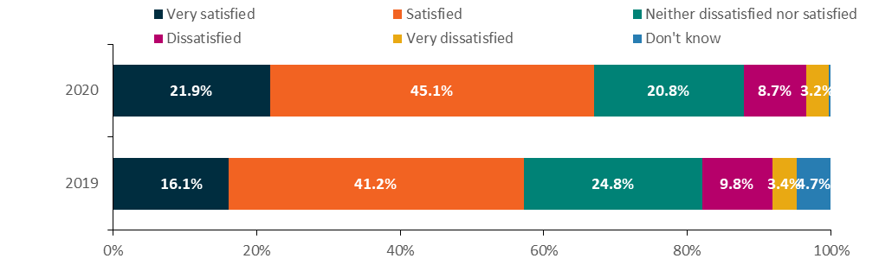 Source: 2019 and 2020 provider surveys
Base: All respondents (2020: n=379; 2019: n=379)
2020: Q8.8; 2019: Q8.9 Overall, to what extent are you satisfied or dissatisfied with Work StarTM as a work readiness assessment tool?
Over three-quarters of respondent providers (76%) in 2020 agreed or strongly agreed that Work StarTM was readily incorporated into their service planning and delivery – an increase since 2019 (70%). Almost two-thirds of respondents (64%) agreed or strongly agreed that the tool helps shape activities and assistance for participants – a sizable increase since 2019 (56%) (Figure 5.2).
Almost half of provider respondents (45%) reported that Work StarTM assisted with participant engagement; however, 22% disagreed or strongly disagreed. These results are very similar to the 2019 results (45% agreed/strongly agreed and 23% disagreed/strongly disagreed).
Figure 5.2: Attitudes towards Work StarTM assessment tool, 2020
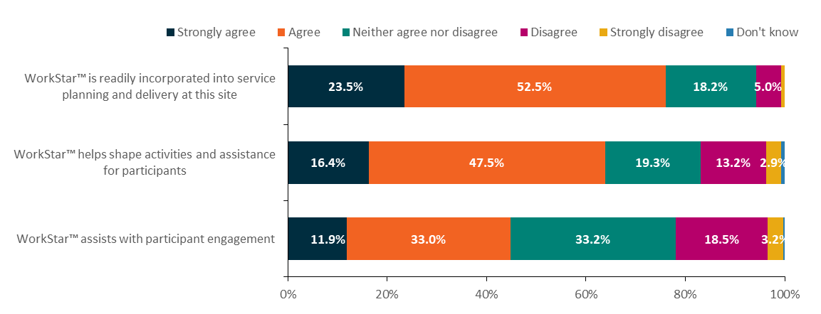
Source: 2020 provider survey
Base: All respondents (n=379)
Q8.9-11 Thinking about Work StarTM, how strongly do you agree or disagree with the following statements?

5.1.2 ParentsNext post-program monitoring
As noted earlier in this report, PPM surveys are used by the department to collect feedback and insights from current and former participants about their education and employment outcomes and experiences in pre-employment and employment services. The 2019 ParentsNext PPM survey showed that, of the participants who claimed improvements in work-readiness skills as a result of the program, ESLs and participants aged under 30 reported higher rates of improvement in their soft skills than in their literacy skills.
In the 2020 ParentsNext PPM survey, participants reported some improvements across all work-readiness categories, with the highest in the human capability indicators (motivation, health and wellbeing). Around three-quarters (74%) of participants reported an improvement in their motivation to achieve work or study goals due to working with their ParentsNext provider. In contrast, only 41% of participants reported an improvement in their computer skills; 56% reported an improvement in how they get on with people; and only 43% of participants reported an improvement in their skills using numbers. Self-reported improvement in participants’ English reading and writing skills was also relatively low, at 43% (Figure 5.3). However, it should be remembered that not all participants start from the same base and some participants may have had these skills already, so there might not have been much room for improvement.
Figure 5.3: Participant-reported improvements in work-readiness skills
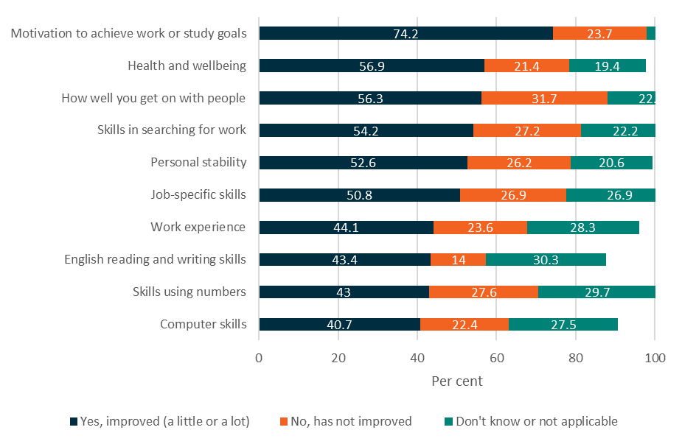
Source: Post-program monitoring survey, 2020
While there were improvements in all work-readiness categories compared to the 2019 results, there were particularly significant increases for literacy, numeracy and digital skills in the 2020 results. While 34% of respondents to the 2019 survey reported that their skills using numbers had improved, this increased to 43% for the 2020 survey. This could be attributed to ParentsNext being a more established national program, as the 2019 results were taken only 6 months after the national rollout.
There were some notable differences in work readiness between the 3 participant groups analysed in Figure 5.4: ESL, YC5 and high JSCI. ESL participants reported a higher rate of improvement than the other 2 groups in work-readiness skills across all 10 work readiness-categories. This was particularly the case for soft skills, including how well participants get on with people (63%), personal stability (62%), and health and wellbeing (65%).
Figure 5.4: Improvement in work-readiness skills (a little and a lot) by participant cohort in 2020
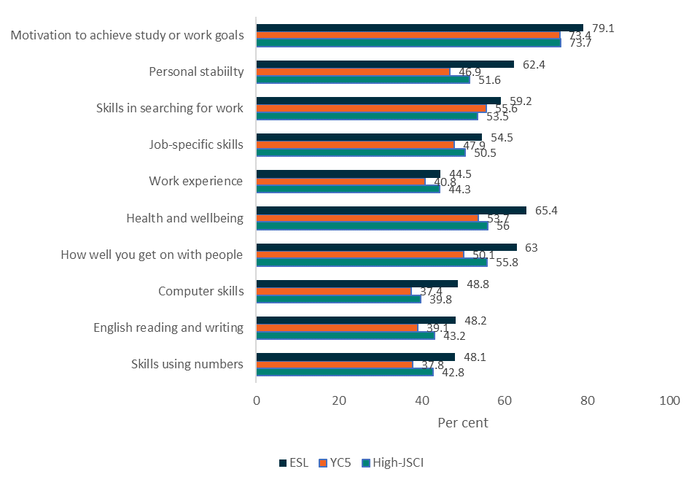
Source: Post-program monitoring survey, 2020
The proportion of participants reporting improved work readiness in the 2020 survey had increased across all 10 work-readiness categories compared to the 2019 survey results. Participants aged 30 and over reported an 11 percentage point increase in health and wellbeing, a 9 percentage point increase in numeracy skills, and a 10 percentage point increase in personal stability. Similar increases were found in participants under 30 years, with a 12 percentage point increase in health and wellbeing, and 10 percentage point increases in numeracy skills and in personal stability.
The third PPM survey of parents who had been on the ParentsNext caseload for at least 3 months at 28 February 2021 showed the reported work skills and wellbeing of participants slipping. In the 4 areas where participants had reported the most improvement in work skills between 2019 and 2020, levels were not as strong in 2021, by 2 to 3 percentage points, although not back to the 2019 levels (Figure 5.5). The impact of the bushfires and the COVID-19 pandemic may have been responsible, in part at least, for this slippage.
Figure 5.5: Improvement in work-readiness skills (a little and a lot) by year of survey, 2019–2021
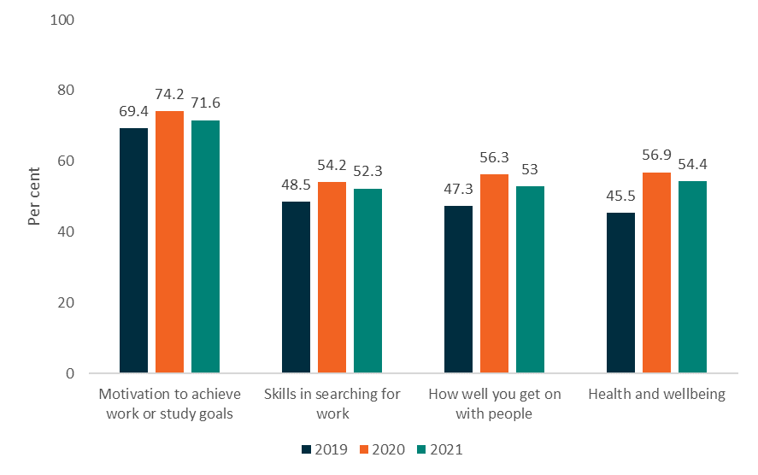
Source: Post-program monitoring survey, 2019, 2020, 2021

5.2 Impact analysis
The impact analysis compared the education and employment outcome rates of parents in each of the treatment (participant) and comparison (non-participant) groups in 2 stages. The first stage examined a population of parents who were eligible for a treatment or comparison group on 2 October 2018, and the second stage examined parents who were eligible one year later, on 2 October 2019. The outcome measures (see Section 1.3.3.6.1 for details) of both populations were tracked for the 8 months following these eligibility dates. For stage 2, this period included the
2019–20 bushfire season and the onset of the COVID-19 pandemic.
The following results compare the proportions of parents in each treatment and comparison group who achieved outcomes. This is followed by regression analyses which statistically controlled for differences in demographic and socio-economic characteristics between these groups, to isolate the impact of ParentsNext on the probability of outcome achievement. The ParentsNext impact was estimated by calculating the probability of the average participant achieving an education or employment related outcome – that is, the ‘average marginal effect’ of the program on each outcome. For detailed descriptions of the impact analysis methodology, see Section 1.3.3.6 and Appendices 4 and 5.

5.2.1 Participation in education and training
Table 5.3 shows the proportions of parents who achieved an education outcome in the 8 months following their eligibility for the stage 1 or stage 2 analysis. Note that these outcome rates likely underestimate parents’ engagement in education as they could only be calculated using indicators that were available for both the treatment and comparison groups. Table 3.10 in Section 3.9 shows the proportion of referrals made to accredited and non-accredited education and training activities for the broader participant population.

In all cases, the treatment groups achieved higher education outcome rates than the comparison groups. These differences were mostly higher for the targeted stream (7.7 percentage points in stage 1) than for the intensive stream (5.7 percentage points in stage 1).
Table 5.3: Education outcome achievement rates
 | Intensive comparison group  % | Intensive treatment group  % | Difference (treatment group – comparison group) | Targeted comparison group  % | Targeted treatment group  % | Difference (treatment group – comparison group)
Stage 1 | - | - | - | - | - | -
All | 4.0 | 9.7 | 5.7 | 3.9 | 11.6 | 7.7
ESL | 1.9 | 13.5 | 11.6 | 3.4 | 9.3 | 5.8
YC5 | 4.2 | 12.9 | 8.7 | 4.4 | 14.0 | 9.6
High JSCI | 4.4 | 9.2 | 4.8 | 4.3 | 11.0 | 6.7
Stage 2 | - | - | - | - | - | -
All | 4.5 | 9.2 | 4.7 | 3.3 | 9.8 | 6.4
ESL | 0.8 | 9.2 | 8.4 | 2.4 | 10.3 | 7.9
YC5 | 5.1 | 7.4 | 2.3 | 4.0 | 10.2 | 6.2
High JSCI | 4.7 | 9.2 | 4.6 | 3.7 | 9.6 | 5.9
Source: The department’s Research and Evaluation Database
Stage 1 group sizes: All intensive (comparison n=3,928, treatment n=12,757), All targeted (comparison n=7,333, treatment n=9,403), ESL intensive (comparison n=526, treatment n=941), ESL targeted (comparison n=3,408, treatment n=1,350). YC5 intensive (comparison n=546, treatment n=760), YC5 targeted (comparison n=1,935, treatment n=2,637), high-JSCI intensive (comparison n=2,856, treatment n=11,056), high-JSCI targeted (comparison n=1,990, treatment n=5,416).
Stage 2 group sizes: All intensive (comparison n=4,129, treatment n=18,558), All targeted (comparison n=6,738, treatment=14,073), ESL intensive (comparison n=240, treatment n=1,366), ESL targeted (comparison n=2,205, treatment n=2,335), YC5 intensive (comparison n=470, treatment n=376), YC5 targeted (comparison n=1,362, treatment n=944), high-JSCI intensive (comparison n=3,419, treatment n=16,816), high-JSCI targeted (comparison n=3,171, treatment n=10,794).
The largest difference in education outcome achievement was among ESL parents in the intensive stream. In stage 1, the outcome rate for ESL intensive treatment parents was 11.6 percentage points higher than for the comparison parents, and this difference was 8.4 percentage points in stage 2. Most of the education outcome rates were higher in stage 1 than in stage 2, as were the differences in these rates between the treatment and comparison parents. In stage 1, the difference in education outcome rates was 5.7 and 7.7 percentage points for intensive and targeted stream parents respectively, compared to 4.7 and 6.4 percentage points in stage 2.These results are consistent with those obtained from the regression analysis, where the differences in demographics between the treatment and comparison parents were statistically controlled (Table 5.4). ParentsNext improved the probability of achieving an education outcome for all participant groups except YC5 intensive, where there was no significant effect.
Table 5.4: Average change in probability of achieving an education outcome, treatment parents compared to comparison parents
 | Intensive  Average change in probability of achieving education outcome  (percentage points) | Targeted  Average change in probability of achieving education outcome  (percentage points)
Stage 1
All | 4.7 | 5.9
ESL | 11.7 | 5.7
YC5 | 6.8 | 7.9
High JSCI | 3.1 | 4.8
Stage 2
All | 3.4 | 5.0
ESL | 8.3 | 7.6
YC5 | Not significant | 5.3
High JSCI | 3.2 | 3.4
Source: The department’s Research and Evaluation Database
The largest program impact was on ESL participants, where the average probability of obtaining an education outcome was higher than for comparison parents by 11.7 (intensive) and 5.7 (targeted) percentage points in stage 1, and 8.3 (intensive) and 7.6 (targeted) percentage points in stage 2. This may be expected given that achieving a Year 12 or a Certificate III (or higher) qualification is a program priority for these ParentsNext participants. Of the significant results, the smallest impact was on high-JSCI parents, where the increase in the average probability of obtaining an education outcome ranged from 3.1 to 4.8 percentage points.
In most cases, the program impact was strongest in stage 1. This may reflect that the stage 2 outcome tracking period included the 2019–20 bushfire season and COVID-19 pandemic, which disrupted education sector operations. As shown in Table 5.4, the education outcome rates mostly decreased during this time for both the treatment and comparison groups.

5.2.2 Employment
The proportions of parents who achieved an employment outcome in the 8-month tracking periods are shown in Table 5.5. The outcome rates ranged from 9.3% for ESL parents in the targeted stream comparison group to 33.5% for YC5 parents in the targeted steam treatment group, indicating that a varied and significant labour market attachment existed among the Parenting Payment recipients regardless of their ParentsNext participant status. The stage 1 employment outcome results were more mixed than were the education outcome results. Treatment parents obtained lower employment outcome rates than comparison parents in the ESL intensive (-4.3 percentage points) and targeted (-0.3 percentage points) streams and in the high-JSCI intensive (-4.6 percentage points) and targeted (-2.9 percentage points) streams. However, in both streams the YC5 treatment parents achieved higher rates than the comparison parents.

Table 5.5: Employment outcome rates
 | Intensive comparison group  % | Intensive treatment group  % | Difference (treatment group – comparison group) | Targeted comparison group  % | Targeted treatment group  % | Difference (treatment group – comparison group)
Stage 1
All | 21.8 | 17.8 | -4.0 | 20.0 | 21.0 | 1.0
ESL | 17.5 | 13.2 | -4.3 | 15.0 | 14.7 | -0.3
YC5 | 24.0 | 26.8 | 2.8 | 26.6 | 27.9 | 1.3
High JSCI | 22.2 | 17.6 | -4.6 | 22.2 | 19.3 | -2.9
Stage 2
All | 16.1 | 16.5 | 0.4 | 13.3 | 17.6 | 4.3
ESL | 11.7 | 12.9 | 1.2 | 9.3 | 13.9 | 4.6
YC5 | 17.7 | 32.2 | 14.5 | 15.8 | 33.5 | 17.7
High JSCI | 16.2 | 16.5 | 0.3 | 15.0 | 17.0 | 1.9
Source: The department’s Research and Evaluation Database
Stage 1 group sizes: All intensive (comparison n=3,928, treatment n=12,757), All targeted (comparison n=7,333, treatment n=9,403), ESL intensive (comparison n=526, treatment n=941), ESL targeted (comparison n=3,408, treatment n=1,350). YC5 intensive (comparison n=546, treatment n=760), YC5 targeted (comparison n=1,935, treatment n=2,637), high-JSCI intensive (comparison n=2,856, treatment n=11,056), high-JSCI targeted (comparison n=1,990, treatment n=5,416).
Stage 2 group sizes: All intensive (comparison n=4,129, treatment n=18,558), All targeted (comparison n=6,738, treatment=14,073), ESL intensive (comparison n=240, treatment n=1,366), ESL targeted (comparison n=2,205, treatment n=2,335), YC5 intensive (comparison n=470, treatment n=376), YC5 targeted (comparison n=1,362, treatment n=944), high-JSCI intensive (comparison n=3,419, treatment n=16,816), high-JSCI targeted (comparison n=3,171, treatment n=10,794).
In almost all cases, the stage 1 employment outcome rates were higher than the stage 2 rates. However, in stage 2 all the treatment groups achieved higher outcome rates than the comparison groups. The largest difference was among YC5 parents, with the treatment groups achieving higher outcome rates, by 14.5 and 17.7 percentage points in the intensive and targeted streams, respectively.
Table 5.6 shows the program impact results after adjusting for demographic differences between the treatment and comparison groups. For ESL participants, the impact of ParentsNext on employment outcomes was either not significant (stage 1 intensive parents and stage 2 intensive and targeted parents) or negative (-3.1 percentage points for stage 1 targeted parents). This may be expected given the program’s prioritisation of educational attainment for this group.
Table 5.6: Average difference in probability of achieving an employment outcome, treatment parents compared to comparison parents
 | Intensive  Average difference in probability of achieving employment outcome  (percentage points) | Targeted  Average difference in probability of achieving employment outcome  (percentage points)
Stage 1
All | Not significant | Not significant
ESL | Not significant | -3.1
YC5 | 5.4 | 3.2
High JSCI | Not significant | 2.1
Stage 2
All | 3.6 | 5.0
ESL | Not significant | Not significant
YC5 | 14.3 | 18.2
High JSCI | 3.0 | 4.3
Source: The department’s Research and Evaluation Database
Consistent with the outcome rate results, the strongest employment outcome impact was on YC5 participants. In stage 2, the average YC5 participant had an increased probability of achieving an employment outcome by 14.3 (intensive) and 18.2 (targeted) percentage points compared to the comparison group parents.
There were several factors which may have predisposed the YC5 parents towards a relatively high level of engagement in employment, compared to the other eligibility groups. These parents may have had more time available to work or look for work, for example, if their youngest child was participating in preschool or was approaching or had reached school age. The YC5 cohort also had the oldest age distribution of parents, which may have meant that they were more likely to focus on work over education.
Additionally, these parents were close to reaching the requirement to move to other employment services and undertake job search. It should also be considered that the construction of the YC5 treatment and comparison groups may have affected these results, apart from any ParentsNext effect, because the treatment parents’ youngest children were at least 8 months older than those of the comparison group (see Section 1.3.3.6 for detail on the impact analysis population construction).
The impact of ParentsNext on employment outcomes for high-JSCI participants was mostly significant, but smaller than that for YC5 participants. This may reflect the high level of labour market disadvantage experienced by these parents (measured by the JSCI).
In stage 2, the ParentsNext effect on employment outcomes was mostly stronger than in stage 1, in some cases becoming significant when it was not previously. This likely reflects that stage 1 included the implementation period of a major program rollout and the gradual referral of participants. This was despite the major economic disruption that occurred during the stage 2 outcome tracking period due to COVID-19. As shown in Table 5.5, the employment outcome rates decreased between stage 1 and stage 2 for both the treatment and comparison groups, as would be expected. However, it appears that the effect of ParentsNext on employment was to provide some protection from socio-economic shock. The stronger program effect in stage 2 may also reflect that the national expansion of ParentsNext had been established for longer by this time, whereas stage 1 was closer to the early implementation period of the program.

5.2.4 Impact on different equity groups

5.2.4.1 Program effect by gender
Male participants form a very small part of the ParentsNext impact analysis study population (Appendix 6.1). As a result, their education results are not robust in the following gender analysis.
As can be seen from Table 5.7, the program had no significant impact on male participants except in relation to employment outcomes in the stage 2 analysis (targeted stream). The program had a significant effect on female participants’ education outcome for both streams and both stages, and for both streams’ employment outcomes in the stage 2 research.

Table 5.7: Estimated impact of ParentsNext (percentage points) – gender
Group | Education outcome | Employment outcome
Stage 1
Intensive
Male | Not significant | Not significant
Female | 5.3 | Not significant
Targeted
Male | Not significant | Not significant
Female | 5.6 | Not significant
Stage 2
Intensive
Male | Not significant | Not significant
Female | 3.7 | 3.7
Targeted
Male | Not significant | 5.0
Female | 5.2 | 4.3
Source: The department’s administrative data

5.2.4.2 Program effect on Aboriginal and/or Torres Strait Islander outcomes
As shown in Table 5.8, participation in ParentsNext significantly increased the average probability of achieving an education outcome among Aboriginal and/or Torres Strait Islander parents in stage 1, by 4.6 percentage points for intensive participants and 5.1 percentage points for targeted participants. This impact was slightly less than that among non-Aboriginal and/or Torres Strait Islander parents in the intensive and targeted streams (4.8 and 5.7 percentage points respectively).
In stage 2, the impact of ParentsNext on education outcomes was similarly positive among Aboriginal and/or Torres Strait Islander parents (5.2 percentage points) and non-Aboriginal and/or Torres Strait Islander parents (5.0 percentage points) in the targeted stream. However, there was no significant impact among Aboriginal and/or Torres Strait Islander parents in the intensive stream.
ParentsNext had no significant impact on employment outcomes among Aboriginal and/or Torres Strait Islander parents in both stages of the analysis. There was similarly no significant impact on employment outcomes among non-Aboriginal and/or Torres Strait Islander parents in stage 1, but there was a positive impact for these parents in stage 2 (3.9 percentage points for the intensive stream and 4.9 percentage points for the targeted stream). The group sizes and odds ratios by Aboriginal and/or Torres Strait Islander status can be found in Appendix 6.2.

Table 5.18: Estimated impact of ParentsNext (percentage points) – Aboriginal and/or Torres Strait Islander status
Group | Education outcome | Employment outcome
Stage 1
Intensive
Aboriginal and/or Torres Strait Islander | 4.6 | Not significant
Non Aboriginal and/or Torres Strait Islander | 4.8 | Not significant
Targeted
Aboriginal and/or Torres Strait Islander | 5.1 | Not significant
Non Aboriginal and/or Torres Strait Islander | 5.7 | Not significant
Stage 2
Intensive
Aboriginal and/or Torres Strait Islander | Not significant | Not significant
Non Aboriginal and/or Torres Strait Islander | 3.6 | 3.9
Targeted
Aboriginal and/or Torres Strait Islander | 5.2 | Not significant
Non Aboriginal and/or Torres Strait Islander | 5.0 | 4.9
Source: The department’s administrative data

5.2.4.3 Program effect on CALD outcomes
In most cases, ParentsNext had a significantly positive impact on education outcomes for CALD parents; however, this impact tended to be smaller than that for non-CALD parents (Table 5.9). In stage 1, there was no significant effect among intensive stream CALD parents, compared to an effect of 5.5 percentage points among non-CALD parents. In the targeted stream in stage 1, ParentsNext increased the average probability of achieving an education outcome by 3.8 percentage points for CALD parents and 5.9 percentage points for non-CALD parents.
In the intensive stream in stage 2, the effect of ParentsNext on education outcomes was 2.5 percentage points for CALD parents compared to 3.8 percentage points for non-CALD parents. In the targeted stream, the effects were similar for the 2 groups (5.0 and 5.1 percentage points, respectively).
In stage 1, the effect of ParentsNext on employment outcomes was non-significant among both CALD and non-CALD participants in the targeted stream, and negative for CALD parents in the intensive stream (-5.5 percentage points). In stage 2, the positive effect of ParentsNext on employment outcomes was similar for targeted stream CALD (4.2 percentage points) and non-CALD parents (4.7 percentage points); however, there was no significant effect among CALD parents in the intensive stream. The group sizes and odds ratios by CALD status can be found in Appendix 6.3.

Table 5.9: Estimated impact of ParentsNext (percentage points) – CALD status
Group | Education outcome | Employment outcome
Stage 1
Intensive
CALD | Not significant | -5.5
Non-CALD | 5.5 | Not significant
Targeted
CALD | 3.8 | Not significant
Non-CALD | 5.9 | Not significant
Stage 2
Intensive
CALD | 2.5 | Not significant
Non-CALD | 3.8 | 4.6
Targeted
CALD | 5.0 | 4.3
Non-CALD | 5.1 | 4.7
Source: The department’s administrative data

5.2.4.4 Program effect by location
ParentsNext had a significantly positive impact on the achievement of education outcomes by parents in both regional/remote and major city locations. In both stages and for both streams, this impact was slightly stronger among parents in regional/remote locations compared to those in major cities. The largest difference was in the intensive stream in stage 2, where the effect was 4.4 percentage points among regional/remote parents, and 2.4 percentage points among parents in major cities.
The results were more mixed for employment outcomes. In stage 1, ParentsNext had a significant effect on employment outcomes only among intensive stream parents in regional/remote locations, and among targeted steam parents in major cities. In stage 2, there was a significant impact among parents in regional/remote locations in both the intensive steam (4.4 percentage points) and the targeted stream (4.7 percentage points), while for parents in major cities the only significant impact was among those in the targeted stream (4.6 percentage points) (Table 5.10). The group sizes and odds ratios by residential location can be found in Appendix 6.4.

Table 5.10: Estimated impact of ParentsNext (percentage points) – residential location
Group | Education outcome | Employment outcome
Stage 1
Intensive
Regional/Remote | 4.8 | 4.8
Major City | 4.4 | Not significant
Targeted
Regional/Remote | 5.2 | Not significant
Major City | 5.3 | 5.3
Stage 2
Intensive
Regional/Remote | 4.4 | 4.4
Major City | 2.4 | Not significant
Targeted
Regional/Remote | 5.9 | 4.7
Major City | 4.6 | 4.6
Source: The department’s administrative data

5.3 Wellbeing
The academic literature cited in Appendix 1 provides consistent evidence that while the impact of welfare-to-work reforms on parents’ and children’s financial wellbeing in many jurisdictions is negative overall, there are significant gaps in the extent to which the magnitude of these impacts is understood. Some impacts were contended to be associated with the poor quality of jobs held by program participants, which made balancing working and caring responsibilities difficult in the context of inadequate resources (Cook and Noblet 2016; Brady and Cook 2015). One study showed that participation in welfare-to-work programs produced a range of largely negative effects on health and wellbeing, due to conflict with child care responsibilities, stress from poorly paid and precarious work, increased depression, and a lack of control over their affairs (Campbell et al. 2016).
ParentsNext is aimed at disadvantaged cohorts. Overall, approximately 1 in 4 (28%) ParentsNext participants surveyed for the 2020 participant survey reported having disability, a health condition or an injury that had lasted or was likely to last more than 6 months (this included psychological conditions). The pre-employment nature of ParentsNext and the support available from the program, however, appears to have a positive effect on participants’ wellbeing. The evaluation of ParentsNext 2016–2018 indicated that ParentsNext participants had a significantly higher aggregate self-reported wellbeing score (71) than did comparison non-participants (67), although both were lower than the national average score of 76.
Parents surveyed for the participant survey in 2020 were found to have a personal wellbeing score overall of 74.0, slightly higher than the score of 71 from the 2017 participant survey but lower than the national averages for personal wellbeing, which were 75.5 in 2017 and 76.5 in 2020 (Table 5.11).
Despite the bushfires and COVID-19, for both the ParentsNext participant survey population and the general population, personal wellbeing scores increased between 2017 and 2020, with the increase for ParentsNext participants (2.8 points) slightly higher than the increase for the general population (1 point). It is speculated that the telephone and online support from providers during these events and/or the increased income support payments provided during the pandemic may have been contributing factors in this result.
Table 5.11: Personal Wellbeing Index (PWI) scores
 | Average PWI score of participants | National average PWI score
2017 | 71.2 | 75.5
2020 | 74.0 | 76.5
Source: ParentsNext Quantitative Research 2021
Perhaps surprisingly, ESL participants showed significantly higher wellbeing scores (78.2) than the YC5 group (73.7) and the high-JSCI respondents (73.1), who were slightly below the overall average of all participants (74.0). ESL participants were also significantly less likely to report disability or a child with disability, which may have been a factor. In addition, there were fewer people in this cohort with formal commitments such as working, volunteering, or caring for someone who was not their child, which may or may not have contributed to their wellbeing.

5.4 Do ParentsNext participants remain on income support?
As noted in Table 3.17, people in different eligibility groups left ParentsNext for different reasons. Participants who commenced in ParentsNext between 1 July 2018 and 31 December 2018 were tracked for 24 months following their first ParentsNext referral date, to observe their movements through the program and the income support system. Characteristics of these 66,826 participants appear in Appendix 10, Table A10.1.
Most of the participants (95%) only had one period of assistance in ParentsNext during the 24-month period. After 24 months, 42% of participants were still in ParentsNext, and around one-quarter (24.2%) were participating in jobactive. Only a small proportion (2%) were in another pre-employment or employment program. Almost one-third (31.7%) of participants were no longer participating in any national pre-employment or employment program (Figure 5.6).
The highest proportion of exits from ParentsNext occurred between 6 and 12 months, likely driven by YC5 participants becoming ineligible when their youngest child reached 6 years of age. The economic impacts of COVID-19 may have contributed to the exit rate slowing between 18 months and 24 months.
Figure 5.6 Program status since first ParentsNext referral
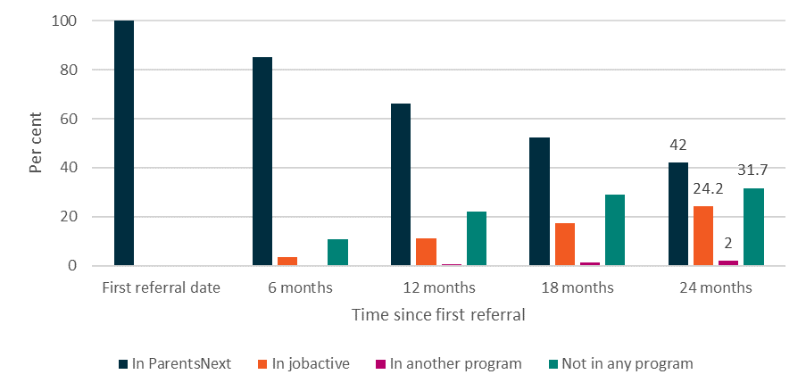
Source: The department’s administrative data
Base: Participants commenced in ParentsNext by 31 December 2018 (n=66,826)
Note: ‘In another program’ includes Disability Employment Services, New Enterprise Incentive Scheme, Transition to Work, Community Development Program and Time to Work Employment Service
Most (95%) participants only had one episode of income support in the 24 months following their referral to ParentsNext (Appendix 10, Table A10.3). After 24 months, 13% of participants had exited income support at least once. YC5 participants were the most likely to have at least one income support exit (19%), followed by high-JSCI participants (11.6%) and ESL participants (10.0%).
At 24 months, the majority of participants were in receipt of Parenting Payment (80%) (Figure 5.7). Some participants were instead receiving JobSeeker Payment (7.3%) or another type of income support payment (5.2%). Eight per cent of participants were no longer receiving any income support. This proportion had reduced slightly from the 18-month point (9.0%), which may indicate that the economic effects of COVID-19 contributed to some parents returning to the income support system.
Figure 5.7: Income support status since first ParentsNext referral
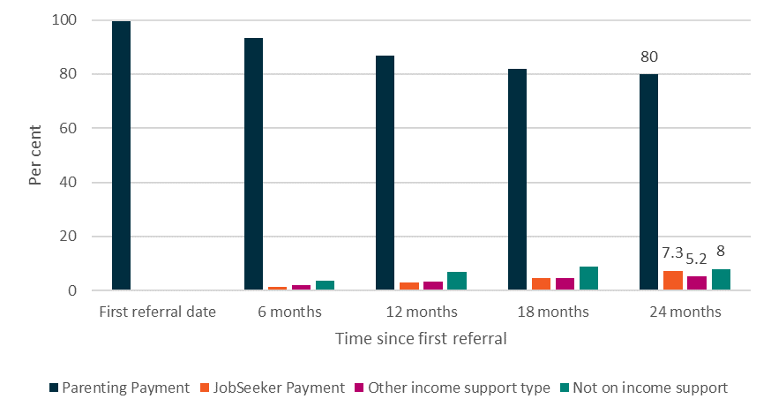
Source: The department’s administrative data
Base: Participants commenced in ParentsNext by 31 December 2018, excluding those who were not in receipt of income support at their first ParentsNext referral date (n=66,253)

5.5 Conclusion
Overall, participation in ParentsNext improved work readiness and potential employability of participants. There was a positive increase in participants’ self-perceived work readiness and wellbeing. ParentsNext participants reported improvements across all work-readiness categories.
In addition, the impact analysis results show that ParentsNext was generally having a positive impact on participants’ education outcomes, while the impact on employment outcomes was mixed. The effect varied across the different cohorts of parents and types of outcomes. For almost all participant groups, ParentsNext improved the average probability of obtaining an education outcome. This effect was especially strong for ESL participants, which aligned with the program intent to prioritise educational attainment for these parents. In most analyses by stream and stage, ParentsNext had a positive impact on education outcomes for CALD and Aboriginal and/or Torres Strait Islander participants, although this effect was smaller than that for non-equity-group participants.
ParentsNext strongly increased the probability of the average YC5 parent achieving an employment outcome, especially in stage 2. These parents had relatively high employment outcome rates, which may reflect their increased focus on preparing for work as their children approach school age. The high-JSCI parents achieved similarly high employment outcome rates but the impact of ParentsNext on this group was smaller, and similar to that on education outcomes. That is, although high-JSCI parents had high employment outcome rates, ParentsNext did not have as much effect on this as it did for YC5 parents.
For both types of outcomes, the achievement rates were generally higher in stage 1 than in stage 2. This was to be expected given that the stage 2 outcome tracking period included the 2019–20 bushfire season and the start of the COVID-19 pandemic. Interestingly, in stage 2 the impact of ParentsNext appeared to reduce for education outcomes and strengthen for employment outcomes. The national program rollout and gradual increase in referrals over the initial months may have impacted employment outcomes during stage 1. After 24 months following their first referral, 80% of participants remained on Parenting Payment and 42% were still in ParentsNext.

Chapter 6 The impact of the COVID-19 pandemic and the 2019–20 bushfires

6.1 The COVID-19 environment
As noted in Section 2.2.1, the 2019–20 bushfires affected the ability of some providers to offer participants activities and work experience. In addition, the COVID-19 pandemic had severe economic and social impacts on Australia in 2020. With contingency arrangements in place and MORs suspended, face-to-face servicing was considerably restricted.
In March 2020, social distancing restrictions were implemented and ParentsNext MORs were lifted. This continued until 28 September 2020, when participants outside of Victoria were once again subject to compliance action if they failed to meet MORs. For Victoria, MORs returned from 23 November 2020.
The impact of COVID-19 depended on participants’ location, personal circumstances, the timing of any child care/school closures and the extent to which participants had social support to assist in child care responsibilities. Participants in Victoria, particularly in Melbourne, experienced the longest period of lockdown in 2020 and the most extensive closures of child care/school and other activities, compared to the rest of Australia. For participants in South Australia, the strictest period of lockdown coincided with school holidays, which meant that for parents there was little change to their children’s school participation.
In interpreting any of the results from the COVID-19 lockdown period, it should be remembered that ParentsNext participants were eligible for a one-off $750 economic support payment and the Coronavirus Supplement (initially $550 per fortnight) from 27 April 2020, which may have improved their wellbeing. Despite sharp increases in unemployment during the COVID-19 pandemic, the Australian National University found, based on scenario modelling, that the Coronavirus Supplement reduced poverty rates for children of single parents on JobSeeker Payment from the pre-COVID-19 level of 39% to 17% in June 2020. It was estimated, however, that removing the Coronavirus Supplement and increasing the JobSeeker Payment by just $50 per fortnight would return poverty rates for the children of single parents to 41% (compared to 13% for children in couple families) by April 2021. This would be more than double the rate during the peak of the crisis and higher than pre-COVID-19 levels (Phillips and Narayanan 2021).

6.2 Impact of social isolation on single parents
Loneliness and the lack of social support have been described as the more serious social consequences of the single-parent family status. Secondary analysis of interviews with a national sample of families across the UK over six years revealed many shifts in the household composition of one parent families over time, a slightly lower level of community participation, and a feeling of powerlessness among single-parent family heads. These findings cast some doubt on the usefulness of natural support systems for single parents and seem reflective of the societal burdens placed upon lone parents. (Smith 1980)
Powerlessness and limited community participation may be viewed as important indicators of the societal conditions with which single parents must cope.
International and Australian research has shown that self-perceived social isolation is linked to physical and mental health outcomes, including higher blood pressure, sleep deprivation and increased mortality risk. Parents’ social isolation has also been linked to self-reported poor health not only for themselves but also for their adolescent children (Thompson et al. 2019). So helping parents address their own social isolation through participation in ParentsNext may have benefited their health and the mental and physical health of others in their household.
Three in 4 participants (77.4%) surveyed for the 2020 ParentsNext participant survey rated their satisfaction with the wellbeing of their children as 9 or 10 out of 10. Fewer than 1 in 10 (6.5%) provided a rating of 0 to 6 out of 10. Aboriginal and Torres Strait Islander participants were more likely to provide ratings of 9 or 10 out of 10 (87.1%). Parents aged 35 to 46 years were more likely (around 1 in 10) than other age groups to provide a low rating: 7 to 8 out of 10 (22.1%) or 0 to 6 out of 10 (11.5%). Those from CALD backgrounds were also more likely to provide ratings of 7 to 8 (22.8%) or 0 to 6 (12.2%). Ratings of 0 to 6 out of 10 were also more likely to be provided by respondents who had a child with disability (10.4%) or had a self-reported disability (10.1%).
Research conducted by the National Health Service in Scotland (Teuton 2018) found that single parents were more likely to have suffered from mental health issues and experienced the same social determinants that caused loneliness. Based on the available data, children and adults who were socio-economically disadvantaged and those who had poor physical and mental health were at particular risk.
Further research conducted in Scotland in 2018 identified loneliness as part of parenthood for the majority of single parents, with 1 in 3 reporting frequent loneliness and 1 in 2 reporting that it was something that they experienced ‘some of the time’. Whether single parents worked was closely associated with how often they considered themselves to be lonely. More work seemed to mean less loneliness. A recurrent theme throughout the interviews was that lack of employment contributed to loneliness through loss of routine (One Parent Families Scotland 2018).
The evaluation of ParentsNext 2016–2018 showed that the problem of isolation of single parents was tackled by providers engaging them with the wider community and arranging suitable referrals to local services and activities that met their identified needs and goals and helped them prepare for employment. Similarly, this evaluation showed that ParentsNext providers continued to support the social inclusion of parents through referral to activities that provided this opportunity.
Unfortunately, restrictions associated with the bushfires and the pandemic impacted some ParentsNext participants’ social isolation and providers’ ability to respond to their needs. Feedback from the qualitative research, however, provided examples of the innovative methods used by providers to contact participants over the lockdown period to provide support, and the value participants gained from the social connection and support of their provider.

6.3 Social isolation during COVID-19
A large number of respondents to the 2020 ParentsNext Participant Survey (61%) indicated that they felt more isolated during COVID-19, with 1 in 4 (25%) reporting that they had felt isolated a lot, and 1 in 3 (36%) felt a little isolated (Figure 6.1).
Figure 6.1: Experience of isolation due to COVID-19 restrictions
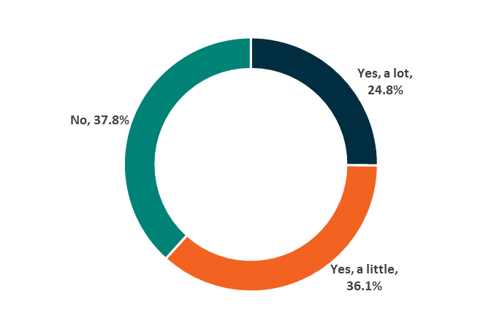
Source: ParentsNext Participant Survey 2020
M7. Have you felt more isolated due to COVID-19 restrictions?
Base: All (n=2,260)
Note: Not shown ‘Unsure’ (0.9%), ‘Prefer not to say’ (0.5%)
For those parents who had a child with disability or had disability themselves who reported social isolation (31% and 34% respectively), the impact of COVID-19 was more intense and they were more likely to feel stressed and isolated.
[The lockdown] was pretty stressful … breaking her [child’s] routine and not being able to do things like go to the park … Being stuck at home, and not being able to go anywhere with her, that was really difficult and that broke her routine a lot.. (Participant, Wave 3 longitudinal case study)
Not all experiences were negative. One participant in the Wave 3 longitudinal case studies (conducted in September to October 2020) reported that, while she felt a greater sense of social isolation than before the start of the pandemic, the pandemic had been the catalyst for her and her son to find new activities they could do together, including taking a daily walk in their local area.
… it’s the time we have spent at home. It’s meant … finding new activities to do together. You know, we got to know this area quite well. We go out every day for a walk. So that was good. Having that time with him at home, and getting to bond with him in that way, which I haven’t really done in the last, you know, year and a half … [has been good]. (Longitudinal case study. Female, 1 child, single parent, 35–45 years old)
This view was confirmed by some of the participants in the Wave 2 qualitative research (conducted in April 2021), for whom the COVID-19 impacts were limited because they were already accustomed to a degree of social isolation (due to living in an isolated rural location, or simply because their circumstances meant they led a quiet social life).
Honestly, it didn’t really change a lot for me ‘cause I don’t go out a lot (laughs). It was the same as other things that kind of made it a little bit more difficult, but not too much. (Interview 9. Female, QLD, 1 child, under 22 years old)
I’m not really social and out there, anyway; I’m always home. So, I didn’t even notice … I’m used to just doing phone calls anyway. People don’t really come out here. Nothing changed in isolation; no, I’m very isolated anyway. (Interview 20. Female, SA, 2 children, single parent, 35–45 years old)

6.4 Impact of COVID-19 and bushfires on referrals and exits
The fact that the COVID-19 pandemic closely followed the devastating bushfires is likely to have exacerbated their impact on communities and individuals in affected areas.
COVID-19 had a significant impact on the average size of the caseload. Reduced referral rates during March to July 2020 significantly reduced the caseload in this period. After an initial peak at the commencement of ParentsNext 2018–2021, referrals to the program remained relatively stable at around 4,000 per month until April 2020, at the height of the lockdown period. Exits were also relatively stable, dropping slightly after March 2020 (Figure 6.2). Around 1 July 2020, referrals increased, peaking between August and September 2020 before returning to the pre-COVID level.
Figure 6.2: Referrals and exits by month
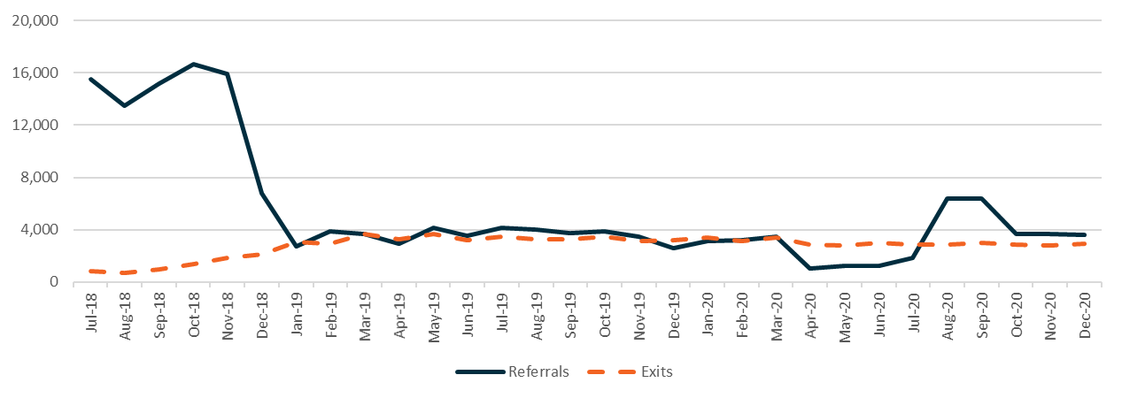
Source: The department’s administrative data
Note: This population has n=158,535 unique participants, as some participants had multiple periods of assistance

6.5 Attending appointments during COVID-19
From 25 March 2020 to 29 September 2020, although ParentsNext participants’ requirements were voluntary, they were still required to report any earnings to Centrelink (Services Australia) fortnightly in accordance with the relevant payment criterion. Participants were encouraged to attend their initial appointment with their provider (but were not compelled to attend). Instead of quarterly appointments with participants, ParentsNext providers were to make monthly contact (by telephone, Skype or video link) with each participant to check on their circumstances and ask if they needed any further assistance.
When interviewed for the 2020 ParentsNext participant survey, 3 in 4 (76%) respondents indicated that they still attended ParentsNext appointments (including by phone or online) during the COVID-19 restrictions. The majority (85%) of respondents in the 2020 participant survey found that these appointments were very easy (45%) or easy (40%) to attend. Fewer than 1 in 10 (7%) reported that it was difficult or very difficult to attend them because of COVID-19 restrictions.
As can be seen in Figure 6.3, the only subgroup differences were higher attendance by ESLs (82%) and lower attendance by those in the high-JSCI group (74%).
Figure 6.3: Attending ParentsNext appointments during COVID-19 restrictions
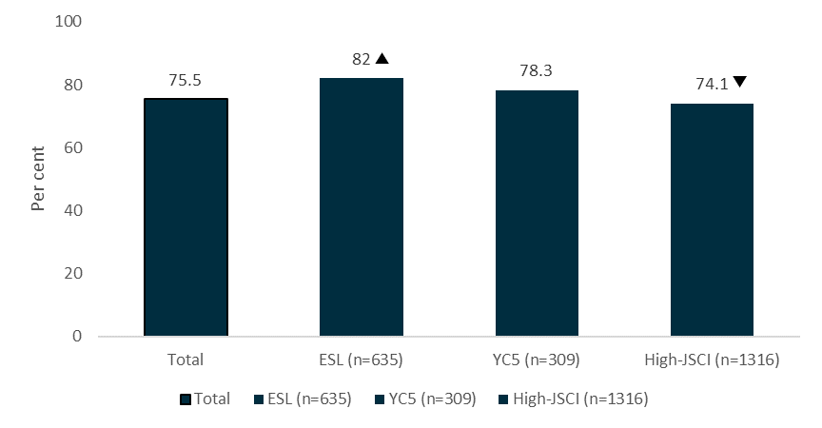
Source: ParentsNext Participant Survey 2020
E11c. Did you attend any ParentsNext appointments during COVID-19 restrictions?
Base: All (n=2,260)
Indicates that the difference in comparison to the total is statistically significant at a 95% confidence level

6.6 Impact on child care
One in 6 respondents (16%) in the 2020 participant survey reported an increase in child care needs due to COVID-19 restrictions, and around 1 in 20 (6%) reported a decrease. However, the majority (72%) reported that their child care needs had stayed the same, although there was a difference between subgroups.
As Table 6.1 shows, respondents with a high JSCI score, those from a CALD background and those who had a child with disability were more likely to indicate that their child care needs had increased as a result of COVID-19 restrictions (17%, 25%, and 22%, respectively). ESL respondents and those aged 21 years or younger were more likely to report that their child care needs remained the same during COVID-19 (80%).

Table 6.1: Impacts of COVID on child care needs – comparison by subgroup
Response | Per cent | Sub-groups who reported this  more often | Sub-groups who reported this  less often
Increased | 16.2% | High JSCI (17.3%)  CALD (24.7%)  Child has disability (22.3%) | ESL (10.0%)  Aged 21 years or less (10.0%)
Stayed the same | 72.3% | ESL (80.0%)  Aged 21 years or less (80.0%) | High JSCI (70.7%)  CALD (59.7%)  Child has disability (66.0%)
Decreased | 5.7% | None | None
Source: ParentsNext Participant Survey 2020
L3. As a result of COVID-19 restrictions have your child care needs increased, decreased or stayed the same?
Base: All (n=2,260)

6.7 Activities during COVID-19
As noted earlier in this report, participation requirements in the ParentsNext program were eased during the COVID-19 pandemic. Participants could participate voluntarily in activities where it was possible and safe to do so. ParentsNext service fees were calculated and paid to providers as normal.
Most respondents in the 2020 participant survey conducted during November 2020 agreed or strongly agreed that the easing of requirements was helpful to them (77%). Three in 5 (61%) agreed or strongly agreed that they participated in fewer activities because it was not required. Respondents in the intensive stream were more likely to indicate agreement that they had lower participation in activities due to a reduced number of activities (64%) and that the easing of restrictions was helpful to them (81%), possibly due to health concerns. Targeted stream participants were less likely to agree with both statements (57% and 74%, respectively) (Table 6.2).
Table 6.2: Impacts of COVID-19 on ParentsNext interactions – comparison by subgroup
Statement | Strongly agree or agree  (per cent) | Sub-groups who reported this more often | Sub-groups who reported this less often
I participated in fewer activities during COVID-19 restrictions because I was not required to | 60.5% | Intensive (64.4%)  Aboriginal or Torres Strait Islander (68.1%) | Targeted (57.4%)
The easing of ParentsNext participant requirements during COVID-19 was helpful for me | 77.2% | Intensive (81.2%) | YC5 (65.8%)  Targeted (73.9%)
Source: ParentsNext Participant Survey 2020
I1a. I’d like you to tell me how strongly you agree or disagree with the following statements about participation requirements.
Base: All (n=2,260)
As national unemployment rates increased between March 2020 and July 2020, the ability of participants to work in the 6 months prior to the participant survey fieldwork period may have been impacted by the COVID-19 restrictions. Among the participants who indicated that they were not currently working, only a small proportion (5%) had worked in the previous 6 months. This did not vary significantly between subgroups. Combining this with the proportion of participants who were currently working provided an overall measure of 1 in 5 (22%) participants having been in paid employment in the past 6 months. This was on par with the 2017 participant survey result of 21% for this measure.
Respondents in the participant survey who indicated that they had employment and/or education and training goals were asked when they thought they would start to work towards those goals. Interestingly, around half reported that they were currently working towards their goals (48%), with 1 in 3 reporting that they were planning to start working towards these goals in the next 12 months (34%). The results in the 2017 survey were quite different, with more respondents currently working towards their goals (57%) and fewer respondents planning to start in the next 12 months (20%). This could be due to the unique circumstances in 2020 of COVID-19 and lockdown measures, which may have limited people from actively working towards their goals at the time of surveying.
As noted in Section 4.5.2, it is notable that calls on the Participation Fund for intensive stream participants show that participant support and accredited training rose steadily between December 2019 and June 2020 and demand for non-vocational training peaked significantly in March 2020. The difficulty of looking for work during the COVID-19 period may have meant that participants turned to the more accessible online non-vocational training. This view was supported by some providers during the 2020 ParentsNext provider survey.
As noted in Section 5.2, while ParentsNext improved the probability of achieving an education outcome for all participant groups in stage 2 except the YC5 intensive stream, where there was no significant effect, most of the education outcome rates were higher in stage 1 than in stage 2. This reflected the fact that the stage 2 outcome tracking period included the 2019–20 bushfire season and the COVID-19 pandemic, which disrupted education sector operations.

6.8 New approaches to servicing
Despite participating in fewer activities, many respondents in the participant survey felt that their ParentsNext provider was helpful during COVID-19 restrictions (61%) (Figure 6.4). One in 4 (24.1%) reported that their provider was extremely helpful, and more than 1 in 3 (36.5%) reported that their provider was very helpful. However, 1 in 8 (12%) felt that their provider was not helpful at all. The high-JSCI group reported the highest rate of provider helpfulness, and the YC5 group the lowest.
Figure 6.4: Helpfulness of ParentsNext provider during COVID-19 restrictions
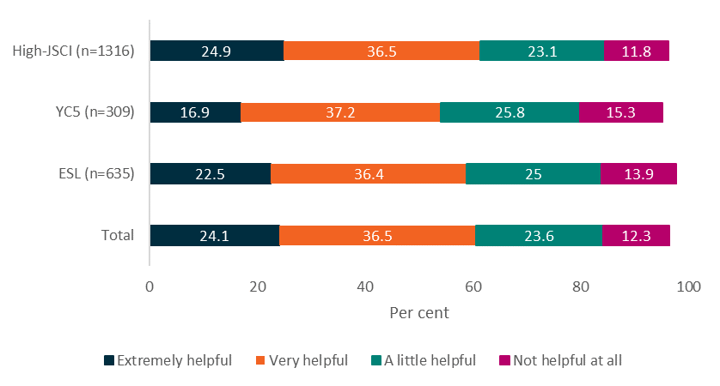
Source: ParentsNext Participant Survey 2020
M8. How helpful was your ParentsNext provider during COVID-19 restrictions?
Base: All (n=2,260)
Note: Not shown ‘Unsure’ (2.7%), ‘Prefer not to say’ (0.8%)
One in 7 respondents (14%) indicated that they had required additional help from their ParentsNext provider, and these respondents were more likely to report that the help they received was extremely helpful (33%) or very helpful (43%).
CALD respondents were more likely than most to report that their ParentsNext provider had been very helpful (45%) during the pandemic, but less likely to report that they had been extremely helpful (15%). As one parent in the participant survey reflected:
Because they are helping, and they understand my situation and with COVID-19 what’s happening, and they understand that I can’t go to the programs I’m supposed to go to. (CALD, participant survey)
It was apparent from the 2020 ParentsNext provider survey that most providers were innovative and persistent in developing servicing options within the limitations they and their participants faced. Many noted participants’ issues involved mental health, relationship and housing challenges. Their approaches to addressing these are captured in Figure 6.5.

Figure 6.5: Supporting participants through bushfires and pandemic, 2020
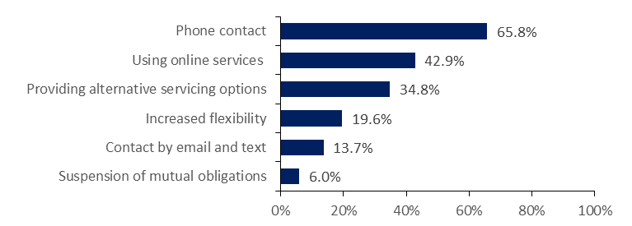
Source: 2020 provider survey
Base: Selected respondents (n=336)
Respondents who answered ‘Comment (please describe)’ to question 7.1
Q7.1 From late 2019 and through 2020, severe bushfires and the COVID-19 pandemic impacted both providers and participants of the ParentsNext program. (For example, closure of local services, activities, and suspension of mutual obligations). What changes, if any, have you made to supporting PARTICIPANTS because of these events?
Phone contact remained the most common form of contact reported by providers (65.8%).
We have changed the way we deliver the program by offering phone appointments on a monthly basis to check in with our participants to ensure they are safe and well. This has also been used to help participants through this difficult time and refer them to services that may be needed.
Servicing participants via phone, this has been the best point of contact for participants moving forward and better suited to their families.
(Source: 2020 provider survey responses)
Almost half (43%) of the provider survey respondents reported using various forms of online technology to maintain contact, including Skype, Zoom and Facebook.
Instead of face to face, study was delivered online as virtual learning and participants continued their study/learning online.
We have introduced most of our in-house training and created some new options like virtual playgroup via zoom so participants can feel more connected.
(Source: 2020 provider survey responses)
In addition to more innovative practices, 20% of providers reported that they had increased their flexibility to accommodate participants during bushfires and the pandemic.
We have provided flexible delivery of services to participants.
Provided flexible and remote servicing of participants, including phone appointments, video conferencing, use of MyGov, and linking agreed activities, such as education and training via online study methods to ensure all participants continued to progress towards their education and work readiness goals.
I have set up an email group to keep participants engaged and motivated in the PN program. I emailed TAFE courses, services and other useful information.
Utilised text messages, video calls and emails to conduct appointments more frequently.
(Source: 2020 provider survey responses)

6.9 Conclusion
Overall, the bushfires and COVID-19 had different impacts on ParentsNext participants depending on where they lived and their particular circumstances. Over 60% of those interviewed for the participant survey indicated that they felt socially isolated, and around a quarter said they felt this a lot. The fact that many participants had built good rapport with their provider and that providers developed innovative ways to keep in touch with participants undoubtedly encouraged continued participation (more than 75% of the participants surveyed continued to attend appointments during the lockdown period, despite the fact that it was no longer compulsory to do so).
Most participants (61%) felt supported by their provider during COVID-19 restrictions. In relation to the lifting of MORs, around 61% of participants interviewed indicated that they participated in fewer activities because it was not required; more of them came from the intensive stream locations.
Unsurprisingly, those most affected by the impact of the pandemic were those from the most disadvantaged equity groups, such as parents with disability or a child with disability, CALD participants, and Aboriginal and/or Torres Strait Islander participants. Parents who had disability or a child with disability also indicated that they had a greater need for child care.

Chapter 7 Did ParentsNext achieve its objectives?

7.1 How well did ParentsNext engage and service/assist participants?

7.1.1 Awareness and engagement
Limited information about the program on referral to ParentsNext was a source of initial anxiety and stress for many new participants. In the 2020 provider survey, over half of the respondents reported that new participants were not well informed, an improvement since 2019 but still a poor result.
Even so, the majority of respondents to the participant survey in 2020 were positive about the service and the information they received from their provider at their first appointment.

7.1.1.2 Commencement, exemptions and participation
Around 80% of ParentsNext participants commenced within 30 days of referral. The targeted stream participants commenced faster than those in the intensive stream, and the cohort whose youngest child was aged 5 (YC5) were the most likely to commence within 30 days.
During any month, exemptions were applied to around 3,000 participants. A total of 72,252 were granted for 47,330 unique participants over the study period (31% for parents caring for large families).
Around a quarter of appointments were rescheduled and over 52% attended during the study period. Around 5% of non-attendances were for a valid reason.

7.1.1.3 Compliance
ParentsNext participants were highly compliant with their mutual obligations. The number of payment suspensions varied over time from a peak of around 12,000 in May 2019 to zero during the COVID-19 lockdown period, when MORs were lifted. Over the study period, Aboriginal and/or Torres Strait Islander participant suspensions were much higher than expected given their proportion in the ParentsNext caseload. Similarly, the suspension rates of single parents and those flagged at some stage as at risk of homelessness were higher than their proportion in the caseload numbers indicated. Conversely, the suspension rates of parents with disability and CALD parents were slightly lower than expected from their proportion of caseload numbers.

7.2 Were the program design and operational processes appropriate to enable the ParentsNext program to achieve its objectives?

7.2.1 Satisfaction
Overall, 70% of participants were satisfied with the program and the majority thought that providers were helpful and their support beneficial. Many participants valued the social and emotional support provided by their consultant. Specific cohorts, such as those from CALD or Aboriginal and/or Torres Strait Islander backgrounds, mature-age parents and men, tended to report experiences similar to those of other participants (see Figure 4.1).
The extent to which participants felt rapport with their caseworkers varied greatly and impacted on participants’ overall satisfaction with the ParentsNext program. Almost two-thirds of participants interviewed for the participant survey agreed that their provider had improved their chances of meeting their goals or getting a job in the future.

7.2.2 Connecting parents to local services that can help them prepare for future education or employment
Providers found that the flexibility of the program enabled them to work with each participant on an individual basis, supporting them to connect with, and gain access to, services and opportunities according to their circumstances and aspirations.

7.2.3 Equity
All providers indicated a broad range of characteristics in their respective caseloads, with a wide spectrum of support needs across both targeted and intensive areas during the provider surveys. Many parents were highly disadvantaged and faced significant personal challenges. Participants from all equity groups in the qualitative research highlighted emotional support as being one of the positive aspects of the ParentsNext program.

7.2.4 Wellbeing
Overall, ParentsNext participants had personal wellbeing scores of 74.0 out of 100, slightly lower than the national average. ESL participants had significantly higher wellbeing scores than YC5 and high-JSCI participants.

7.3 Did participation in ParentsNext improve work readiness and employability of participants?

7.3.1 Targeting early intervention assistance to parents with young children
Around 4 in 5 respondents in the participant survey who had completed at least one Work StarTM assessment agreed that participation had informed the activities in their Participation Plan and helped them engage with their provider, identify personal strengths and abilities, and think about their employment goals.
All respondents in the participant survey, whether working or not, had views about employment. Participants reported significant vocational barriers that prevented them from working, including a lack of appropriate jobs that could fit with their child care responsibilities, financial hardship (preventing some from engaging in study), and a lack of prior work experience.

7.3.2 Helping parents identify and reach their education and employment goals through participation in activities
Almost 2 in 3 respondents in the participant survey felt that their provider had improved their chances of meeting their education or employment goals, and more than half (55%) felt that their provider had improved their chances of getting a job in the future. Overall, around 2 in 3 participants had employment goals (69%) and/or education or training goals (66%) and half of them reported that they were currently working towards these goals.
Almost all participants in the Wave 2 qualitative research were able to articulate their vocational goals. These were influenced greatly by their parenting responsibilities and prioritised employment that was flexible and fitted around school hours.
The impact analysis demonstrated that ParentsNext had a positive effect on education outcomes for CALD and Aboriginal and/or Torres Strait Islander participants, although not as high as for non-equity-group participants. Despite this, Aboriginal and/or Torres Strait Islander parents, CALD parents and parents who had disability or a child with disability were more likely to receive payment suspensions and exemptions.

7.4 Impact of COVID-19
While the impact of the pandemic on ParentsNext participants was variable, many experienced social isolation. For others, the impact was minimal. Providers continued to deliver support through innovative measures and phone contact.

7.5 What could be done better
Providers interviewed in the qualitative research and provider surveys had varying and strong views about what could be done to improve the program. These included changing the eligibility criteria by removing the 2-stream eligibility approach; access to the Participation Fund to support disadvantaged parents in both targeted and intensive areas; and improving the design of Participation Plans.
Some participants sought greater clarity around what services ParentsNext providers could help them access (including what financial assistance could be provided), more interest shown in their personal goals than in compliance requirements, and greater flexibility in paying for items up front and/or reimbursing payments.

7.6 Did the theory of change hold true?
The theory of change underpinning the ParentsNext program maintained that supporting parents of young children to identify their education and employment goals would lead, among other things, to the achievement of greater work readiness, an increase in female workforce participation, and improvements in wellbeing.
The ParentsNext program achieved improved work readiness and wellbeing, and positive education and training outcomes for the majority of participants, especially ESL participants.
There was some limited evidence during the COVID-19 lockdown period that, with the assistance of supportive and flexible caseworkers, some participants continued to attend appointments and undertake activities without a compulsory requirement. The majority of participants, however, participated in fewer activities because they were no longer required to do so.

7.7 Lessons from Australian and international research
While the majority of parents surveyed for this evaluation were highly motivated to achieve study and work goals, a range of structural and/or personal barriers prevented some of them from doing so. For example, international and Australian research suggests that around a quarter of single parents have poor mental health. The clash between unpredictable work and fixed hours of child care limits parents’ choices around working more hours. An increase in earnings may mean losing income support and associated concessions. Confusion about social security family payments and child support rules can create anxiety and undermine economic security.
Lack of access to child care has also been found to have had a significant negative impact internationally on those trying to find a route out of poverty through work. Save the Children Scotland, for example, found that a high proportion of those in severe poverty had given up work, turned down a job, or not taken up education or training because of difficulties accessing child care (McKendrick et al. 2016). For many parents, poverty impacted their mental health and wellbeing.
A number of studies reviewed for this evaluation found widespread fear of making a mistake and risking suspension or cancellation of payments, as well as fear of inadvertently incurring a debt. In some cases, the child support system compounded the parent’s insecurity, especially when the non-custodial parent also failed to pay or failed to declare their income (Bowman and Wickramasinghe 2020). The qualitative research for this evaluation confirmed these findings from the literature for some of the most vulnerable ParentsNext participants.
Despite the differences between operating environments, evaluations of conditional welfare arrangements in the UK and the USA, where sanctions have been particularly strong, provide some warnings of the unintended consequences that emerge – extreme hardship or even destitution for some parents – when the conditions imposed are too severe. The UK research, for example, was undertaken when sanctions were up to 3 years with no payment. The impacts include negative effects on others, especially children (Social Security Advisory Committee 2014; Berry et al. 2012; Watts et al. 2014; Jordan and Fowkes 2016).
Overall, however, Australian research has found that suspensions are very effective at encouraging compliance (Wright et al. 2020) and that warnings of sanction (without a sanction) increase employment and do not decrease post-employment stability (Arni et al. 2013). In addition, an emerging international literature has shown very good effects: increasing employment and decreasing reliance on income support. Nevertheless, some negative effects on those sanctioned have been identified (Arni et al. 2009; Wu 2008; Machin and Marie 2006; Loopstra et al. 2018), although the main effect of compulsory requirements is before application of sanctions (McVicar 2018).

7.8 Options for future research
For the impact of ParentsNext on female and Aboriginal and/or Torres Strait Islander workforce participation to be tested, a longitudinal survey of parents after their exit from the program would be necessary. Determining the impact on intergenerational welfare dependency would require following them and their children, for many years. As the availability, flexibility and affordability of child care is inextricably linked to women’s ability to work, this should be an essential component of the research.
The impact on children of their parents’ non or limited participation in the workforce has been studied extensively overseas. It would be of value to replicate some of this work in Australia. The Growing Up in Australia: The Longitudinal Study of Australian Children (LSAC) survey currently measures a range of cognitive and social development outcomes for children. It may be possible to use data from the LSAC to make an estimate of the impact on children of their parents being on income support or having limited workforce participation.
Studying the motivation and experiences of voluntary participants may provide valuable insights into the benefits of ParentsNext. To date, the figures have been too small to provide meaningful results, as parents in the study period were only able to volunteer if they lived in an intensive stream location or met some other criteria. The numbers in the next iteration of the program are expected to increase and may be sufficient for reliable analysis.
While the program was successful for most eligible participants, further exploration of participants who received a payment suspension would assist in tailoring ParentsNext more effectively to the most vulnerable parents. The relationship between those participants who experienced a payment suspension and those who, for reasons other than a large family, were exempted at some point, is worthy of further exploration. It may be that participants failed to reconnect with their provider at the end of the exemption period because their circumstances were affecting their capacity to comply.
There are several examples in the literature where wraparound services for the most disadvantaged parents have proven successful. For example, the Making it Work (MIW) program in Scotland, which was delivered between 2013 to 2017 in 5 local authority areas with high concentrations of single parent families (Edinburgh, Fife, Glasgow, North Lanarkshire and South Lanarkshire), provides an interesting example of a successful intensive support program for some of the most vulnerable lone parents. This program and others similar to it are worth examining to see if there are elements that have the potential for application in Australia to address the needs of the most vulnerable parents.

7.9 Conclusion
This evaluation of ParentsNext found that the program met the needs and expectations of the majority of participants. The results demonstrated that the key evaluation questions were answered in the affirmative. Overall, the program engaged and serviced participants effectively, and the program design was sufficiently flexible to enable it to achieve its short-term objectives. Taking part in ParentsNext increased participants’ work readiness, participation in education and training, and progress towards their education and employment goals.
Assistance provided to intensive stream participants from the Participation Fund helped them to address non-vocational barriers and access appropriate support services. The wide range of exemptions enabled parents who were temporarily unable to participate due to medical conditions or other reasons to be relieved of MORs without penalty.
Disadvantage experienced by some Aboriginal and/or Torres Strait Islander parents, parents with disability, refugee parents, parents in poverty and parents experiencing homelessness is likely to be the reason why elements of the ParentsNext program presented more difficulties for these participants. Despite the likelihood of this loss being reinstated at some time later, for those on the margins of poverty an absence of income for any period undoubtedly resulted in stress and anxiety.
The results of the evaluation suggest that further research is needed to understand the program’s impact on the most vulnerable participants and whether changes in servicing, activities or obligations may assist them to achieve their education and employment goals.

References
Arni P, Lalive R and van Ours JC (2009). How effective are unemployment benefit sanctions? Looking beyond unemployment exit. Working Paper no. 4509, IZA, Bonn.
Arni P, van Ours JC and Lalive R (2013). How effective are unemployment benefit sanctions? Looking beyond unemployment exit. Journal of Applied Econometrics, 28(7): 1153–1178.
Australian Bureau of Statistics (July 2021). Labour Force, Australia, ABS website, accessed 8 September 2021.
Australian Bureau of Statistics (June 2021). Australian National Accounts, National Income, Expenditure and Product, ABS website, accessed 8 September 2021.
Australian Bureau of Statistics (June 2020). Table 16: Labour force status by labour market region (ASGS) and sex [dataset], Labour Force, Australia, detailed, ABS website, accessed 8 September 2021.
Australian Bureau of Statistics (May 2020). Household Impacts of COVID-19 Survey, 12–15 May 2020, ABS website, accessed 8 September 2021.
Australian Bureau of Statistics (April 2020). Employment and unemployment: An international perspective, ABS website, accessed 8 September 2021.
Australian Bureau of Statistics (July 2018). Census of Population and Housing: Socio-Economic Indexes for Areas (SEIFA), Australia, 2016, ABS website, accessed 8 September 2021.
Australian Bureau of Statistics (July 2016). Australian Statistical Geography Standard (ASGS): Volume 5 – Remoteness Structure, ABS website, accessed 8 September 2021.
Australian Bureau of Statistics (2013). ANZSCO – Australian and New Zealand Standard Classification of Occupations, Version 1.3, ABS website, accessed 8 September 2021.
Australian Institute of Family Studies (AIFS) (n.d.). Sole parenting, AIFS website.
Australian Institute of Family Studies (1999). Social policy on welfare and the family. Family Matters, 54.
Australian Human Rights Commission (2020). Australia’s third Universal Periodic Review, AHRC website.
Australian Government, Employment and Workplace Relations Legislation Amendment (Welfare to Work and Other Measures) Bill 2005, Explanatory Memorandum.
Avram S, Brewer M and Salvatori A (2018). Can’t work or won’t work: Quasi-experimental evidence on work search requirements for single parents. Labour Economics, 51: 63–85.
Bäckman O, Estrada F and Nilsson A (2017). Locked up and locked out? The impact of imprisonment on labour market attachment. The British Journal of Criminology, 58(5), September 2018, 1044–1065.
Berry K, Georghiou N and Kidner C (2012). Welfare Reform (Further Provision) (Scotland) Bill (SPICe Briefing 12/21). Edinburgh: Scottish Parliament.
Bowman D and Wickramasinghe S (2020). Trampolines not traps: Enabling economic security for single mothers and their children. Brotherhood of St Laurence.
Brady M (2019). Conceptualizing activation policies targeted at single mothers: A case study of Australia and the United Kingdom. International Studies in Gender, State & Society.
Brady M (2018). Targeting single mothers? Dynamics of contracting Australian employment services and activation policies at the street level. Journal of Social Policy 47(4): 827–845.
Brady M and Cook K (2015). The impact of welfare-to-work on parents and their children. Evidence Base, 3.
Breitkreuz RS, Williamson DL and Raine KD (2010). Dis-integrated policy: Welfare-to-work participants’ experiences of integrating paid work and unpaid family work. Community, Work and Family, 13(1): 33–69.
Bubonya M and Cobb-Clark DA (2019). Pathways of disadvantage: Unpacking the intergenerational correlation in welfare. Life Course Centre Working Paper Series, 2019-28. Institute for Social Science Research, The University of Queensland.
Butterworth P (2007). The prevalence of mental disorders among income support recipients: An important issue for welfare reform. Australian and New Zealand Journal of Public Health, 27(4): 441–448.
Campbell M, Thomson H, Fenton C and Gibson M (2016). Lone parents, health, wellbeing and welfare-to-work: A systematic review of qualitative studies. BMC Public Health, 16, Article 188.
Card D, Kluve J, Weber A (2018). What works? A meta analysis of recent active labour market program evaluations. Journal of the European Economic Association, 16(3): 894–931.
Casebourne J, Davies M, Foster S, Lane P, Purvis A and Whitehurst D (2010). Lone parent obligations: Destinations of lone parents after income support eligibility ends (Research Report No. 710). London: Department for Work and Pensions.
Cobb-Clark DA, Dahmann SC, Salamanca N and Zhu A (2017). Intergenerational disadvantage: Learning about equal opportunity from social assistance receipt. IZA (Institute of Labor Economics) Discussion Paper No. 11070. Bonn: IZA.
Cobb-Clark D and Zhu A (2017). Childhood homelessness and adult employment: The role of education, incarceration, and welfare receipt. Journal of Popular Economics, 30: 893–924.
Coleman N and Riley T (2012). Lone parent obligations: Following lone parents’ journeys from benefits to work (Research Report No. 818). London: Department for Work and Pensions.
Commonwealth of Australia (2005). Budget Paper no. 2: Budget Measures 2005–06. Canberra: Commonwealth of Australia.
Cook K and Noblet A (2016). Job satisfaction and ‘welfare-to-work’: Is any job a good job for Australian single mothers? Australian Journal of Social Issues, 47(2): 203–219.
Connolly G, Hughes R and Trott D (2015). Policy influences on the female part-time participation rate in Australia. Department of Employment, unpublished.
Crosier T, Butterworth P and Rodgers B (2006). Mental health problems among single and partnered mothers: The role of financial hardship and social support. Social Psychiatry and Psychiatric Epidemiology, 42: 6–13 (2007).
Davies L (2012). Lone parents: Unemployed or otherwise engaged? People, Place & Policy Online, 6(1): 16–28. DOI: 10.3351/ppp.0006.0001.0003.
Deeming C (2015). Foundations of the workfare state: Reflections on the political transformation of the welfare state in Britain. Social Policy and Administration, 49: 862–886.
Department of Education, Employment and Workplace Relations (2012). Building Australia’s future workforce: Overview of place-based initiatives. Canberra: DEEWR.
Department of Employment (2014). Specialist and generalist providers: How do they compare? Canberra: Employment Monitoring and Evaluation Branch, Department of Employment. Unpublished.
Dwyer, P et al. (2020). Work, welfare, and wellbeing: The impacts of welfare conditionality on people with mental health impairments in the UK. Social Policy Administration, 54(2).
Fok YK and McVicar D (2013). Did the 2007 welfare reforms for low income parents in Australia increase welfare exits? IZA Journal of Labor Policy, 2, Article 3.
Gibson M, Thomson H, Banas K, Lutje V, McKee M, Martin S, Fenton C, Bambra C and Bond L (2018). Welfare‐to‐work interventions and their effects on the mental and physical health of lone parents and their children. Cochrane Database of Systematic Reviews, 2018, Issue 2, Article CD009820.
Grabham E and Smith J (2010). From social security to individual responsibility (Part Two): Writing off poor women’s work in the Welfare Reform Act 2009. Journal of Social Welfare and Family Law, 32(1): 81–93.
Graham H and McQuaid R (2014). Exploring the impacts of the UK government’s welfare reforms on lone parents moving into work. Glasgow Centre for Population Health.
Grahame T and Marston G (2012). Welfare-to-work policies and the experience of employed single mothers on income support in Australia: Where are the benefits? Australian Social Work, 65(1): 73–86.
Griffiths R (2011). Helping more parents move into work: An evaluation of the extension of New Deal Plus for Lone Parents and In Work Credit: Final report. Research Report No. 732. London: Department for Work and Pensions.
Herault N, Vu H and Wilkins R (2020). The effect of job search requirements on welfare receipt. IZA Discussion Papers, No. 13684. Institute of Labor Economics.
House of Representatives Select Committee on Intergenerational Welfare Dependence (2019). Living on the edge: Inquiry into Intergenerational Welfare Dependence – final report. Parliament of Australia.
Johnsen S (2015). Lone parents: Does welfare conditionality ease or deepen poverty? [Blog]. Welfare Conditionality.
Johnsen S (2014). Conditionality briefing: Lone parents. Welfare Conditionality.
Johnsen S and Blenkinsopp J (2018). Final findings: Lone parents. Welfare Conditionality.
Jordan, K and Fowkes (2016). Job creation and income support in remote Indigenous Australia: Moving forward with a better system. Australian National University.
Kiely K and Butterworth P (2014). How has welfare-to-work reform affected the mental health of single parents in Australia? Australian and New Zealand Journal of Public Health, 38(6).
Kukutai T, Prickett K, Atatoa-Carr P and Rata A (2020). Poipoia te kākano kia puawai: Family structure, change and the wellbeing of tamariki Māori. Ministry of Social Development.
Labour Market Information Portal (2021a). LGA Data Tables, June quarter 2020, LMIP website.
Labour Market Information Portal (2021b). IVI Data Skill Level – January 2006 onwards, LMIP website.
Loopstra R, Flederjohann J, Reeves A et al. (2018). Impact of welfare benefit sanctioning on food insecurity: A dynamic cross-area study of food bank usage in the UK. Journal of Social Policy, 3: 1–21.
Machin S and Marie O (2006). Crime and benefit sanctions. Portuguese Economic Journal 5(2): 149–165. DOI: 10.1007/s10258-006-0010-9.
McKendrick JM, Mooney G, Scott G, Dickie J and McHardy F (eds) (2016). Poverty in Scotland 2016: Tools for transformation. Child Poverty Action Group.
McQuaid RW (2009). A model of the travel to work limits of parents. Research in Transportation Economics, 25(1): 19–28.
McQuaid RW (2006). Job search success and employability in local labor markets. Annals of Regional Science 40: 407–421.
McQuaid RW, Bond S and Fuertes V (2009). Evaluation of the Working for Families Fund (2004–2008). Edinburgh: Scottish Government Social Research.
McQuaid R, Graham H, Shapira M and Raeside R (2013). DELNI Economic Inactivity Strategy: Literature Review Project. Final report to the Department for Employment and Learning Northern Ireland. Employment Research Institute, Edinburgh Napier University.
McQuaid R and Graham H (2014). Exploring the impacts of the UK government's welfare reforms on lone parents moving into work. Glasgow Centre for Population Health.
McVicar D (2010). Does job search monitoring intensity affect unemployment? Evidence from Northern Ireland. Economica, 77(306): 296–313.
McVicar D (2020). The impact of monitoring and sanctioning on unemployment exit and job-finding rates. IZA World of Labor.
OECD (August 2020). Combatting COVID-19’s effect on children.
OECD (June 2020). Youth and COVID-19: Response, recovery and resilience.
OECD (2018a). A broken social elevator? How to promote social mobility. Paris: OECD Publishing.
OECD (2018b). OECD Economic Surveys: Australia 2018. Paris: OECD Publishing.
One Parent Families Scotland (2018). Social isolation, loneliness and single parents in Scotland.
Ong P, Moga E and Blumenberg E (1998). Getting welfare recipients to work: Transportation and welfare reform – Summary of conference proceedings. University of California.
Phillips B, Gray M and Biddle N (2020). COVID-19 Jobkeeper and JobSeeker impacts on poverty and housing stress under current and alternative economic and policy scenarios. Australian National University.
Phillips B and Narayanan V (2021). Financial stress and social security settings in Australia. Australian National University.
Smith M (1980). The social consequences of single parenthood: A longitudinal perspective. Family Relations, 29(1).
Social Security Advisory Committee (2014). The cumulative impact of welfare reform: A commentary. Occasional Paper No. 12.
Stenberg SA (2004). Inheritance of welfare recipiency: An intergenerational study of social assistance recipiency in postwar Sweden. Journal of Marriage and Family, 62(1).
Stewart M (2018). Psychological tyranny prescribed by the DWP: Preventable harm is government policy. British Journal of General Practice, 68(677): 579.
Tennant T and Bowey K (2019). The impact of social security reforms on single mothers and their children. Australian Social Policy Conference Paper, September 2019.
Teuton J (2018). Social isolation and loneliness in Scotland: A review of prevalence and trends. Edinburgh: NHS Health Scotland.
Thompson T, Rodebaugh TL, Bessaha ML and Sabbath EL (2019). The association between social isolation and health: An analysis of parent–adolescent dyads from the family life, activity, sun, health, and eating study. Clinical Social Work Journal, 48.
Watts B and Fitzpatrick S (2018). Welfare Conditionality. Routledge.
Watts B, Fitzpatrick S, Bramley G and Watkins D (2014). Welfare sanctions and conditionality in the UK. York: Joseph Rowntree Foundation.
Workplace Gender Equality Agency (2020). Gendered impact of COVID-19, WGEA website.
Workplace Gender Equality Agency (2021). The gender pay gap, WGEA website.
Wright A and Dollery B (2020). The impact of varying penalty values on compliance with unemployment payment requirements: An analysis using 2015/16 Australian National Data. Australian Journal of Labour Economics, 23(1).
Wright A, Dollery B, Kortt M and Leu S, (2020). Examining the effects of zero-dollar unemployment payment sanctions. Economic Record, 96(315).
Wright A, Dollery B, Kortt M and Leu S (2022). The impact of more intensive unemployment benefit requirements on jobseekers’ likelihood of complying. Economic Record, 98(320).
Wright A, Dollery B, Kortt M and Leu S (forthcoming). The effect of varying sanction values on future compliance with unemployment benefit requirements: An empirical analysis using Australian administrative data. Public Quarterly.
Wu C (2008). Severity, timing, and duration of welfare sanctions and the economic well-being of TANF families with children. Children and Youth Services Review, 30(1): 26–44.

Appendices

Appendix 1 Australian and international research

Background
The introduction of work search conditionalities, while not directly applicable to ParentsNext given its pre-employment nature, do demonstrate that they may have increased the flow of single parents into work in a number of international jurisdictions. While these reforms appear to have had larger effects than comparable interventions in the past, there have been some unforeseen consequences. In the UK, where sanctions have been particularly stringent, they have been shown to be associated with a significant proportion of single mothers moving into health-related benefits or into non-claimant unemployment in some jurisdictions (Avram et al. 2018).
Conversely, findings from an extensive meta-analysis of Australia and international experiences indicated that conditionality increased the likelihood of finding work and that these effects were strongest for women and disadvantaged groups (Card et al. 2018).

Conditionality
It has been argued, and contested, that welfare conditionality, being based on ‘the assumption of the citizen-worker as autonomous and self-sufficient’, does not give adequate attention to the type of work that women (most lone parents are women), who are frequently low paid and part time, actually do (Breitkreuz et al. 2010). Attempts to balance work and life in these types of employment needs to be recognised as qualitatively different from attempts to do so in the context of ‘middle-class’ working patterns (Grabham and Smith 2010: 85).
An argument posited by Davies (2012) is that categorising lone parents not engaged with the labour market as ‘unemployed’ reopened old debates about who deserves financial support from the state and underpins the notion of conditionality in employment programs.
In the UK, key findings from a longitudinal study that assessed the effectiveness and ethical legitimacy of welfare conditionality on lone parents showed that, as currently implemented, welfare conditionality has had little tangible influence on lone parent interviewees’ motivation to seek or increase their participation in paid employment (Johnsen and Blenkinsopp 2018). Few of the families involved gained and sustained paid work for longer than a short period during the UK study. The majority were no closer to the labour market, and some had shifted further away, given the effects of conditional welfare and/or personal crises.
In Australia in 2006 and 2007, activity requirements for parents receiving payment were introduced for those with a youngest child aged 6 or over. Those with a youngest child aged 6 or 7 experienced no change in payment rates or other settings. Analysis of administrative data by the department showed that this led to an increase in the average proportion of parents reporting earnings in the years following the changes compared to previously:
- from 30% to 38% for parents of youngest children aged 6
- from 32% to 46% for parents of youngest children aged 7.
Additionally, the number of parents receiving payment with a youngest child aged 6 or 7 decreased by 22% and 26% respectively, likely due to these parents finding work.
The first Australian inquiries into the application of sanctions found that there was evidence of increased compliance (Grahame and Marston 2012) and improved wellbeing (Commonwealth of Australia 2005). A 2013 study (Fok and McVicar 2014) found that parent job seekers were more likely to exit income support after the introduction of mutual obligation requirements, with parents of youngest children aged 7 being 48% more likely to exit payment in the year after introduction.
As MORs for parents were introduced progressively, some Australian qualitative research suggested there was an internalisation of welfare-to-work policies by recipients themselves (Grahame and Marston 2012). Other studies, however, highlighted the problems faced by single parents in financial difficulties and by those with disability when compliance measures put additional pressure on their already stressed lives. Some research pointed to these additional pressures as having a negative impact on the mental health and wellbeing of these parents (Cobb-Clark et al. 2017).
Notwithstanding parents’ general support for compulsory activity requirements and the importance of paid work, published research on single parents’ welfare-to-work transition has revealed key concerns across 3 areas: financial wellbeing; subjective wellbeing; and mental and physical health (Brady and Cook 2015). However, few of these evaluations isolated the specific effects of requirements or the results for female parents. One exception concerns the impact of part-time work requirements that were extended to Australian single parents in 2006 (Connolly et al. 2015). Overall, the takeaway message from these results was that in order to raise the female part-time participation rate, it was important to improve the macroeconomic and overall labour market situation as much as feasible, including through appropriate macroeconomic policies.
This was interpreted as being because such policies affect the encouraged/discouraged worker effect, both directly through the female part-time employment population ratio and indirectly through the incidence of long-term unemployment, which is the key driver of the female part-time participation rate. While many microeconomic policies, such as policies to improve the affordability of child care, have a potentially useful role to play in raising the female part-time participation rate, it may be unwise to rely on them alone, given that they have been estimated in the current analysis to have a relatively inelastic effect on the female part-time participation rate.
In 2019 the Brotherhood of Saint Laurence conducted interviews with 27 single mothers from Victoria, of whom 17 received Parenting Payment, examining how the government-administered payments of Child Care Subsidy, income support and child support helped or hindered their financial wellbeing and the intersections between work, care and social security. This research found that, even with careful budgeting, making ends meet was a struggle (Bowman and Wickramasinghe 2020).
Recent studies of Australian compliance arrangements have shown that they encourage compliance effectively and that the TCF, as intended, encouraged compliance with requirements before penalties are incurred (Wright and Dollery 2020a; Wright et al. 2020; Wright et al. forthcoming). Wright et al 2020a also showed, consistent with other Australian (Herault et al. 2020) and international findings, stronger compliance effects for women from Australian compliance arrangements.
Some evidence suggests, however, that interventions aiming at increasing employment among single parents, either by mandating employment, in combination with sanctions and earnings disregards, or by offering additional benefits to those who gain employment voluntarily, are likely to have impacts on health which are generally positive but of a magnitude unlikely to have any tangible effects (Gibson et al. 2018). Effects on employment and income are likely to be small to very small in the medium to long term. There is some evidence to suggest that small negative health impacts are possible in some circumstances. Even where generous financial assistance was provided, effects on income were small (AIFS n.d.).
In addition, some international evidence indicates that, while benefit sanctions (especially severe sanctions) raise exits from benefits and may increase short-term job entry, the longer-term outcomes for earnings, job quality and employment retention appear less favourable (Arni et al. 2013).
Some qualitative evidence (Watts et al. 2014) suggests that, with appropriate support, interventions including elements of conditionality or enforcement may deter some individuals from anti-social behaviour.

Intergenerational welfare dependency
Reducing child poverty and intergenerational welfare dependency have been important policy goals in many countries for the past decade. Unfortunately, empirical studies of intergenerational welfare are scarce (Stenberg 2004), making it challenging to develop practical solutions that might lead to real progress.
This has both direct effects on the transmission of disadvantage across generations and an indirect effect which operates by increasing the likelihood of dropping out of high school. Without adequate parental support, young people’s ability to successfully transition from education to employment may be constrained.
The primary mechanism linking welfare receipt across generations is the failure to complete high school. Adolescents in welfare-reliant families experience more disruptions in their schooling (eg, school changes and residential mobility, expulsions and suspensions) and receive less financial support from their families both of which impact on their chances of completing high school and avoiding the welfare roll. Young people's risk-taking behavior (smoking, illicit drug use, delinquency and pregnancy) is also a key mechanism underpinning intergenerational welfare reliance. Physical and mental health, work-welfare attitudes and academic achievement, in contrast, have a more modest role in transmitting welfare receipt across generations. (Bubonya and Cobb-Clark 2019)
A study utilising administrative data from the Australian social security system (Cobb-Clark et al. 2017) found that young people were 1.8 times more likely to need social assistance if their parents had a history of receiving social assistance themselves. These young people also received more intensive support: an additional $12,000 over an 8-year period. The intergenerational correlation was particularly strong in the case of disability payments, payments for those with caring responsibilities, and parenting payments for single parents. Disadvantage stemming from parents’ poor labour market outcomes seemed to be easier for young people to overcome. This suggests that parental disadvantage may be more harmful to children’s later life outcomes if it is more strongly driven by circumstances rather than personal choice.
Intergenerational welfare dependency can be linked to a failure to complete high school. The progress of children of welfare-dependent mothers, which has been examined extensively, backs up this conclusion. A study undertaken by the University of Queensland examined the administrative welfare records of young Australians (aged 23–26 years) and their parents over a period of nearly 2 decades and linked survey responses from young people aged 18. It found that:
… young Australians in welfare-reliant families experienced more disruptions in their schooling through school changes, residential mobility, school expulsions and school suspensions. They also receive less financial support from their families. These experiences negatively affect these young peoples’ chances of completing high school and avoiding the welfare roll. (Bubonya and Cobb-Clark 2019).
The extent to which a ‘conflict between the demands of paid work and motherhood had an impact on children’s health and wellbeing and the intergenerational transmission of inequity’ was found to vary by socio-economic context and across ethnic and racial groups in New Zealand (Kukutai et al. 2020). Researchers studied data from the New Zealand Longitudinal Census and the Growing Up in New Zealand longitudinal study. They found that, though most Māori children lived in a stable 2-parent family, they were more likely to spend some time in a sole parent household than other children, and diverse family trajectories were linked to poorer cognitive and socio-emotional outcomes. However, these were not the main drivers. The most important predictors were mothers’ education and age, material hardship, and neighbourhood deprivation.
The study also found that cultural connectedness promoted socio-emotional development and, as diverse family trajectories were associated with higher levels of cultural connectedness among Māori children, it served a ‘protective role’.
In Australia, the House of Representatives Select Committee on Intergenerational Welfare Dependence found that while there was a correlation between parents receiving welfare payments for significant periods of time and their children also receiving payments, there was no single explanation, factor or mechanism that linked the outcomes of one generation to those of the next. The committee identified the following factors that increase the risk of entrenched disadvantage: geographic location (accessibility/remoteness); educational attainment; Aboriginal and/or Torres Strait Islander and single parent status; suitability of available employment; health and family welfare; and availability of appropriate support systems (House of Representatives Select Committee on Intergenerational Welfare Dependence 2019).

Wellbeing
Casebourne et al. (2010) studied the effects of UK welfare reforms and found that 16% of those affected moved straight into work. Those who moved into work reported that they were generally better off in work than on benefits, and reported feeling happier and more confident. Lone parents also reported positive effects on their children. Although there were also reports of difficulty managing work and other obligations, such as unexpected caring responsibilities.
Generally, lone parents who had moved into work in this study felt that working had a positive effect on their lives. The main reasons given for feeling happier and more confident were: making friends at work, feeling self-reliant and feeling that they were a valued member of society. While working was in the main a positive experience for interviewees, lone parents could find it stressful combining work and family responsibilities, for example, when a child was sick. Positive effects of working on their children included: having the opportunity to go on school trips and having Christmas presents because of extra family income, observing the good example of a working parent and greater independence. (Casebourne et al. 2010).
Despite claims that a transition from welfare to work would improve wellbeing (Commonwealth of Australia 2005), and notwithstanding parents’ general support for compulsory activity requirements and the importance of paid work, the Social Research Centre (2005) and Grahame and Marston (2012) have published research on single parents’ welfare-to-work transition that reveals key concerns across 3 areas: financial wellbeing; subjective wellbeing; and mental and physical health.
Evaluations of activation reforms in Australia and New Zealand found that increased requirements, job search monitoring, sanctions and mandatory employment programs increased the rate and speed at which unemployed claimants secured employment. The extent to which wellbeing increased was still unclear (Brady and Cook 2015).
A synthesis of the experiences of single parents in mandatory welfare-to-work programs internationally suggests that participation may do little to improve lone parents’ health and wellbeing or economic circumstances and may often only lead to low-paid, precarious employment (Campbell et al. 2016). The demands of single parenting and employment are frequently in direct conflict, and lone parents are at times denied control over major life decisions and everyday routines by their mutual obligations. The results of this synthesis of 16 qualitative studies (following screening of 4,703 identified papers and quality assessments) of welfare to work (WtW) in 5 high-income countries (USA, Canada, UK, Australia and New Zealand) covering a variety of welfare regimes were that:
- WtW requirements often conflicted with child care responsibilities
- WtW can result in increased conflict and reduced control, which may lead to negative impacts on mental health
- availability of social support, however, may mediate the negative health impacts of WtW.
On the contrary, a meta-analysis undertaken by Card et al. (2018) found that conditionality increased the likelihood of participants finding work and that these effects were stronger for disadvantaged groups and women.

Financial competence, mental health and disability
Some research suggests that:
… the welfare-to-work reforms have decreased the financial wellbeing of single parents and their children, resulting in parents making the transition from welfare to work feeling less satisfied with their future security and standard of living, and higher poverty rates amongst the population of single parents with dependent children. However, there remain significant gaps in our understanding of how welfare to work affects parents and their children. (Brady and Cook 2015)
According to several Australian and international researchers, the demographic and socio-economic factors found to have the strongest association with depression and anxiety were lone parenthood and unemployment, especially when long term (Butterworth 2007; Crosier et al. 2006). Much of the association between poor mental health and receipt of parenting payments was explained by financial hardship. In a policy environment where welfare reform was being considered, the importance of the potential health effects needed noting (Kiely and Butterworth 2014).
Utilising data from the 2007 National Survey of Mental Health and Wellbeing and Household Income and Labour Dynamics in Australia (HILDA) data, Australian researchers found that around 45% of unpartnered women who had children and were in receipt of income support payments were identified as having a mental disorder. In contrast, around 10% of people not receiving welfare reported substantial psychological distress and 19% had a diagnosable mental disorder. The prevalence of physical and mental disability was also greater among income support recipients (Butterworth 2003).
The prevalence of moderate to severe mental disability was identified as significantly more pronounced among single mothers (28.7%) compared with partnered mothers (15.7%). Including all explanatory factors, socio-demographic, household income, financial hardship and social support accounted for 94% of the association between single mother status and poor mental health. An underlying feature in both instances was financial hardship, which was indicated by a lack of material resources and the inability to afford essentials rather than by income alone (Crosier et al. 2007).

Appendix 2 Program and policy changes over time
Table A2.1: Program and policy changes 1 July 2018 to 31 December2020
Date | Change | Details
1/07/18 | Commenced TCF | From the beginning of the national rollout, ParentsNext participants were required to meet their requirements under the Targeted Compliance Framework (TCF).  Compulsory participants are required to attend quarterly provider appointments, agree to their Participation Plan attend the compulsory activity in their Participation Plan, report activity attendance (self-report or to their provider) by close of business on day of the requirement or face income support suspension, and report fortnightly to Centrelink regarding any income earned and that they have met their participation requirements.
1/07/2018 | National expansion | Expanded to all jobactive employment regions. Two streams introduced – intensive and targeted – under 2 different new policy proposals.
01/07/2018 | Compulsory participation | ParentsNext became compulsory for those who met the criteria specified in Social Security (Parenting payment participation requirements – classes of persons) Instrument 2018 (No. 1) (legislation.gov.au)
2/07/2018 | Volunteer eligibility change | Can only volunteer if receive Parenting Payment, have a child under 6 and live in an intensive stream location.
12/2018 | Simplified reporting | Simplified and flexible scheduling of some activities came into effect, reducing the impact on parents required to self-report. E.g. if a parent is engaging in full-time study, the provider can schedule a single day of attendance each week or fortnight depending on the study schedule rather than scheduling multiple days to report for the same activity.
01/2019 | External Systems Accreditation Framework (ESA) | Changes to introduce the new ESA Framework, which provides a more streamlined approach to the department gaining assurances over provider IT systems.
01/2019 | Changes to clause 93 of the ParentsNext Deed 2018–2021  Work health and safety | Changes to clause 93 principally to streamline the clauses and reflect the obligations under the guidelines applying to providers in relation to voluntary work, work experience (other) placements, and launch into work placements. Additional changes to clause 93 related to the Regional Employment Trials.
01/2019 | Regional Employment Trials (RET) | Consistent with Notice No 1 regarding the implementation of Regional Employment Trials (RET). RET is a program in which local stakeholders in 10 selected disadvantaged regions can be funded to deliver projects that may include providing activities (among other things). All projects will need to partner with at least one employment services provider.
01/2019 | Education outcomes | Education outcomes: clarifies the drafting of clause 109 and related changes to definitions.
01/2019 | Double outcome payments | Changes to allow outcome payments to be claimed under both the jobactive Deed 2015–2020 and the ParentsNext Deed 2018–2021, or both the Transition to Work Deed 2016–2020 and the ParentsNext Deed 2018–2021, in relation to the same participant in the case of concurrent servicing. Changes to also allow the department to permit double payments in other circumstances through guidelines or written agreements.
01/07/2019 | Changes to minimise payment suspension: SMS reminder message | SMS messages are introduced to remind participants to report their attendance at activities. Reporting activities can be done easily and quickly in the jobactive mobile app or website.
10/2019 to 02/2020 | Bushfire contingency arrangements | ParentsNext bushfire contingency arrangements were put in place for those in affected areas. Attending ParentsNext appointments (online or by phone) and activities were made voluntary for participants so payment suspensions were not applied. Participants were not required to complete their fortnightly ParentsNext ‘activity reporting’ online. SMS messages to participants to inform them of changes to requirements.
9/12/2019 | VOEST | ParentsNext participants can access the Volunteer Online Employment Services Trial (VOEST, later OES) instead of being a volunteer in jobactive as an activity.
25/3/2020 to 29/9/2020 | COVID-19 contingency arrangements | The department applied an ‘Other Special Circumstances Exemption’ to all commenced and newly referred ParentsNext participants on the national caseload for an initial period of 3 months starting from early April 2020.  The TCF did not apply and ParentsNext requirements were voluntary. Participants were still required to report fortnightly to Centrelink any earnings. Participants were encouraged to attend their initial appointment with their provider (but were not compelled).  Instead of quarterly appointments with participants, ParentsNext providers were to make monthly contact (by telephone or Skype) with each participant to check on their circumstances and ask if they needed any further assistance.  Participants could voluntarily participate in activities where possible and safe to do so. ParentsNext service fees were calculated and paid to providers as normal.  Participants who have COVID-19 or are in mandatory self-isolation can access a 14-day exemption from Services Australia.
01/07/2020 | Ongoing contingency arrangements | ParentsNext COVID-19 contingency arrangements were ongoing. Attending ParentsNext appointments (online or by phone) and activities was voluntary for participants, so payment suspensions were not applied. Participants were not required to complete their fortnightly ParentsNext ‘activity reporting’ online. SMS messages were sent to participants regarding requirements.
08/2020 | Appointments continue online and on phone  Participants can return to face-to-face appointments and activities, if safe | COVID-19 contingency arrangements continue but participants can return to face-to-face appointments and activities if they feel safe to do so.  Participants still need to report their income to Centrelink.  Initial provider appointment by phone.
21/09/2020 | Expanding exemptions Services Australia can grant | Services Australia/Centrelink is able to grant the full range of exemptions to ParentsNext participants. Participants can request an exemption from Centrelink or their provider (except for overseas travel).
28/09/2020 | Return of MORs | Participation (mutual obligation) requirements returned nationally – except Victoria.
28/09/2020 | Opt out of face-to-face servicing | Participants can opt out of face-to-face servicing. Providers to assist non-contact participants to meet their requirements in alternative ways. Reporting online.
10/2020 | Budget announcement | Changes to the program from 1 July 2021 announced, including contract extension.
18/11/2020 | Suspension of MORs in SA | South Australian COVID-19 lockdown. Statewide suspension of mutual obligation requirements from 18 November to 29 November 2020.
23/11/2020 | Return of MORs in Vic | Victoria returned to mutual obligation requirements.
30/11/2020 | Return of MORs in SA | SA returned to mutual obligation requirements.
6/12/2020 | 2 business day delay | Participants in Green Zone or Warning Zone on their dashboard have 2 business days grace period for missed requirements.
21/12/2020 | End of year shutdown | Mutual obligation requirements suspended for the Christmas and New Year period 21 December 2020 to 3 January 2021.
Figure A2.1: LGAs eligible for Disaster Recovery Allowance and/or Disaster Recovery Payment
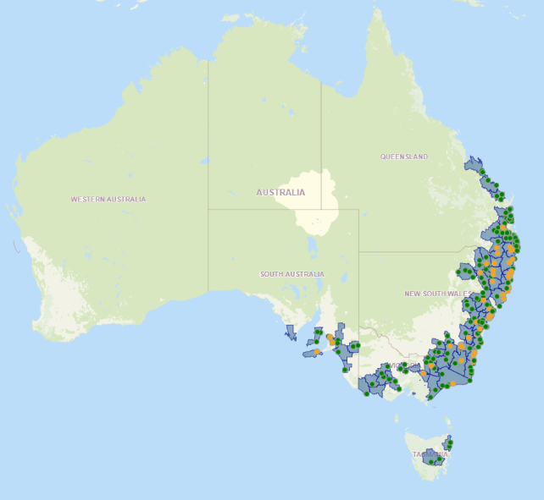
Heavier shading shows eligible areas.

Appendix 3 Program logic
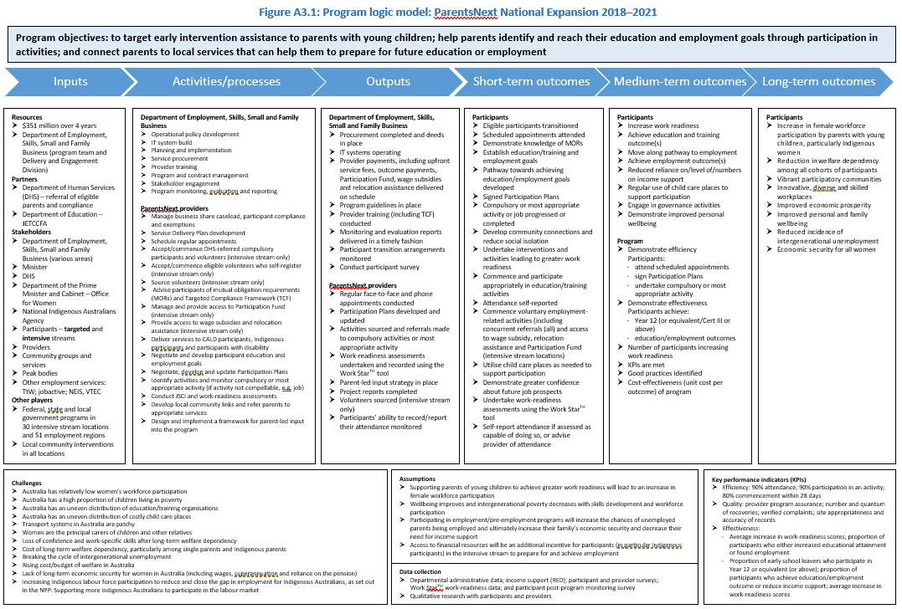

Appendix 4 Impact analysis population construction

A4.1 Additional selection criteria
The selection criteria for the inclusion of parents in this analysis were complex as the impact analysis needed to satisfy multiple requirements to ensure the results were robust. These requirements included:
- ensuring that parents would not be placed into more than one treatment or comparison group
- appropriately dealing with cases where treatment parents became ineligible for ParentsNext during their follow-up period
- ensuring that the parents in each comparison group were sufficiently comparable with those in the corresponding treatment group, including their exposure to the effects of the 2019–20 bushfire season and the COVID-19 pandemic.
The common criteria for each eligibility group were the ParentsNext eligibility criteria, except for the assignment criteria (see Section 1.3.3.6), as well as any additional criteria needed to satisfy the additional requirements for analysis. The rest of this section enumerates these additional criteria.
Parents were excluded from the comparison groups if they commenced as ParentsNext participants from when the rollout of the national expansion began, to the end of the 8-month follow-up period. Parents in the treatment groups were on the ParentsNext caseload on 2 October 2018 (stage 1) or 2 October 2019 (stage 2) and could have initially commenced in the program on any date between the rollout of the national expansion and those dates.
Parents were excluded from the analysis if they were likely to exit the treatment or comparison groups during their 8-month follow-up periods purely because they or their children would exceed the age limits during that period. For example, parents were excluded from the ESL treatment group if they first became eligible for ParentsNext when they were 21 years and 11 months of age, since they were likely to become ineligible only one month later. Imposing this additional age restriction simplified the interpretation of the results. It was most straightforward to compare parents who could have been eligible for ParentsNext for the whole follow-up period (barring unexpected changes in circumstances) with parents who never became eligible. Therefore, the analysis:
- excluded parents whose youngest child was more than 5 years and 4 months of age, as this was 8 months younger than the ParentsNext age limit of 6 years
- excluded parents from the YC5 comparison group if their youngest child was more than 4 years and 4 months of age, as this was 8 months younger than the age limit of 5 years for the YC5 treatment group
- excluded parents from the ESL treatment group if they were more than 21 years and 4 months of age, as this was 8 months younger than the ESL age limit of 22 years.
Parents were excluded from comparison high Job Seeker Classification Instrument (JSCI) score groups if they received a JSCI score above the JSCI threshold before or during their follow-up period. This ensured that parents in these groups were not also included in the high-JSCI treatment group. Parents were also only included in the high-JSCI groups if their youngest child was under 4 years, to ensure that they would not be included in the YC5 group. The impact analysis for the high-JSCI group therefore only directly generalises to parents with relatively young children.

A4.2 Population demographics
The impact analysis population demographics show that the caseload treatment groups (Table A4.1 and Table A4.2) were generally similar demographically to the referral inflow population
(Table A4.3); they had similar proportions of parents who were Aboriginal and/or Torres Strait Islander, culturally and linguistically diverse (CALD), and receiving Parenting Payment partnered. The inflow population had a higher proportion of parents in the intensive stream with a youngest child aged 3 years or below (43%) than the stage 1 (31%) and stage 2 (29%) treatment groups.
The stage 1 population, selected shortly after the ParentsNext national rollout, consisted of a smaller number of parents (33,421) than stage 2 (43,498), which was selected one year later. All the treatment parents in stage 1 had spent less than 6 months in ParentsNext, while in stage 2, half of intensive stream and around 20% of targeted stream participants had 6 months or more in the program. The stage 1 population had a higher proportion of YC5 and a lower proportion of high-JSCI parents than stage 2.
Within the stage 1 and stage 2 populations there were some demographic differences between the treatment and comparison groups. Most of these differences could be controlled in regression analysis to negate their influence on the estimation of program impact. For both stages, the treatment parents were more likely than the comparison parents to be female, Aboriginal and/or Torres Strait Islander, aged 30 years or older, and receiving Parenting Payment single.
Table A4.1: Impact analysis population, stage 1 – demographics
Characteristic | Intensive comparison group  n=3,928  % | Intensive treatment group  n=12,757  % | Targeted comparison group  n=7,333  % | Targeted treatment group  n=9,403  %
Eligibility reason
ESL | 13.4 | 7.4 | 46.5 | 14.4
YC5 | 13.9 | 6.0 | 26.4 | 28.0
High JSCI | 72.7 | 86.7 | 27.1 | 57.6
Youngest child age | - | - | - | -
6 months – 11 months | 13.5 | 12.2
1 year | 32.7 | 30.1 | 25.5 | 8.1
2 years | 23.3 | 26.7 | 15.4 | 4.0
3 years | 16.0 | 24.8 | 31.4 | 59.6
4 years | 14.5 | 0.2 | 27.7 | 0.3
5 years | - | 6.0 | - | 28.0
Parent age
24 years and under | 30.7 | 19.8 | 50.4 | 21.6
25–29 years | 24.5 | 26.6 | 12.4 | 20.4
30–39 years | 33.8 | 43.3 | 25.4 | 40.8
40 years and over | 11.0 | 10.3 | 11.8 | 17.2
Parenting Payment partnered | 53.6 | 21.2 | 39.5 | 17.4
Aboriginal and/or Torres Strait Islander | 12.8 | 24.1 | 12.1 | 14.3
Not born in a main English-speaking country | 19.0 | 19.1 | 17.9 | 18.5
Spoken language not English | 4.9 | 10.2 | 5.2 | 8.7
Male | 9.2 | 3.6 | 8.2 | 5.1
Vulnerability indicator | 15.0 | 26.8 | 21.5 | 21.3
Medical condition | 14.3 | 20.7 | 16.9 | 18.7
JSCI score distance from threshold
≥ 15 points below | 2.2 | 0.1 | 0.6 | 0.1
1–14 points below | 79.4 | 3.3 | 38.5 | 7.5
0–14 points above | 1.6 | 89.5 | 4.0 | 75.3
≥ 15 points above | 0.2 | 3.8 | 0.2 | 1.9
Unknown | 16.6 | 3.3 | 56.6 | 15.2
Months in ParentsNext
0–6 months | - | 100.0 | - | 100.0
7–12 months | - | - | - | -
13+ months | - | - | - | -
State/territory
NSW | 16.3 | 28.5 | 32.9 | 30.0
VIC | 11.8 | 13.2 | 23.7 | 26.5
QLD | 36.5 | 29.8 | 24.4 | 21.6
WA | 23.4 | 12.9 | 9.2 | 7.4
SA | 5.9 | 11.9 | 5.6 | 8.6
TAS/ACT/NT | 6.1 | 3.7 | 4.2 | 5.9
Source: The department’s Research and Evaluation Database
Base: Parents in the stage 1 impact analysis population (n=33,421)
Note: Characteristics were current as at the Research and Evaluation Database release date (2 October 2020) or each parent’s eligibility date. See Table A4.1, Appendix 4 for characteristic definitions.
Table A4.2: Impact analysis population, stage 2 – demographics
Characteristic | Intensive comparison group  n=4,129  % | Intensive treatment group  n=18,558  % | Targeted comparison group  n=6,738  % | Targeted treatment group  n=14,073  %
Eligibility reason
ESL | 5.8 | 7.4 | 32.7 | 16.6
YC5 | 11.4 | 2.0 | 20.2 | 6.7
High JSCI | 82.8 | 90.6 | 47.1 | 76.7
Youngest child age | - | - | - | -
6 months – 11 months | 13.1 | 11.8 | - | -
1 year | 34.0 | 30.9 | 20.1 | 8.5
2 years | 22.8 | 28.3 | 10.4 | 5.4
3 years | 18.6 | 26.9 | 48.8 | 78.9
4 years | 11.5 | 0.1 | 20.7 | 0.5
5 years | - | 2.0 | - | 6.7
Parent age
24 years and under | 23.1 | 19.0 | 37.7 | 22.9
25–29 years | 29.1 | 28.0 | 15.8 | 20.6
30–39 years | 35.7 | 43.0 | 31.0 | 41.8
40 years and over | 12.1 | 9.9 | 15.4 | 14.7
Parenting Payment partnered | 59.4 | 20.4 | 46.6 | 18.5
Aboriginal and/or Torres Strait Islander | 9.9 | 28.3 | 10.1 | 15.1
Not born in a main English-speaking country | 20.9 | 17.6 | 22.7 | 19.9
Spoken language not English | 6.1 | 9.2 | 7.7 | 9.3
Male | 10.1 | 3.3 | 9.9 | 4.9
Vulnerability indicator | 13.3 | 28.4 | 17.7 | 21.7
Medical condition | 12.8 | 20.2 | 13.8 | 17.4
JSCI score distance from threshold
≥ 15 points below | 2.5 | 0.0 | 0.7 | 0.0
1–14 points below | 90.0 | 3.1 | 61.9 | 7.1
0–14 points above | 0.7 | 90.9 | 3.3 | 85.6
≥ 15 points above | 0.0 | 4.5 | 0.1 | 2.3
Unknown | 6.8 | 1.4 | 34.0 | 4.9
Months in ParentsNext
0–6 months | - | 48.7 | - | 79.7
7–12 months | - | 38.8 | - | 19.3
13+ months | - | 12.5 | - | 1.1
State/territory
NSW | 15.3 | 30.2 | 32.4 | 31.7
VIC | 11.3 | 10.4 | 24.8 | 25.6
QLD | 36.4 | 29.1 | 23.7 | 21.7
WA | 25.2 | 16.4 | 9.4 | 7.7
SA | 5.3 | 9.7 | 5.5 | 7.7
TAS/ACT/NT | 6.6 | 4.1 | 4.1 | 5.5
Bushfire-affected area | 21.3 | 28.0 | 25.2 | 26.2
Source: The department’s Research and Evaluation Database
Base: Parents in the stage 2 impact analysis population (n=43,498)
Note: Characteristics were current as at the Research and Evaluation Database release date (2 October 2020) or each parent’s eligibility date. See Table A4.1, Appendix 4 for characteristic definitions.
Table A4.3: Referrals to ParentsNext (commenced) – demographics
Characteristic | Intensive  n=60,170  % | Targeted  n=94,675  % | Total  n=154,845  %
Eligibility reason
ESL | 9.6 | 10.9 | 10.4
YC5 | 13.0 | 22.7 | 18.9
High JSCI | 74.7 | 66.1 | 69.4
Other^{(a)} | 1.6 | 0.0 | 0.6
Unknown | 1.0 | 0.3 | 0.6
Parent age
Under 22 years | 10.6 | 10.9 | 10.8
22 to 29 years | 37.0 | 27.5 | 31.2
30 to 39 years | 40.5 | 43.9 | 42.6
40 years to 49 years | 10.5 | 15.7 | 13.7
50+ years | 1.4 | 2.1 | 1.8
Youngest child age
0 years | 20.5 | 0.0 | 8.0
1 year | 20.4 | 8.1 | 12.9
2 years | 16.4 | 1.6 | 7.3
3 years | 14.9 | 46.1 | 34.0
4 years | 12.6 | 21.0 | 17.7
5 years | 15.1 | 23.2 | 20.0
6+ years | 0.2 | 0.0 | 0.1
Unknown | 0.0 | 0.0 | 0.0
Male | 5.6 | 6.5 | 6.1
Parenting Payment partnered | 23.4 | 20.1 | 21.4
Indigenous | 25.6 | 13.1 | 17.9
CALD | 18.6 | 22.2 | 20.8
Person with a disability | 13.4 | 14.9 | 14.3
Refugee | 6.5 | 5.7 | 6.0
Ex-offender | 8.0 | 6.4 | 7.0
Homeless | 5.4 | 4.5 | 4.9
State/territory
NSW | 29.4 | 29.8 | 29.6
VIC | 10.1 | 27.2 | 20.5
QLD | 30.1 | 22.1 | 25.2
WA | 16.8 | 7.5 | 11.1
SA | 9.4 | 7.7 | 8.4
TAS | 1.6 | 3.7 | 2.9
ACT | 0.0 | 2.0 | 1.2
NT | 2.7 | 0.0 | 1.0
Remoteness area
Major City | 30.5 | 33.4 | 32.2
Inner Regional | 14.7 | 12.1 | 13.1
Outer regional | 12.5 | 4.9 | 7.8
Remote/Very Remote | 0.7 | 0.7 | 0.7
Unknown | 41.6 | 48.9 | 46.0
Base: Periods of assistance where the participant was referred to, and commenced in, ParentsNext by 31 December 2020 (n=154,845). This population has n=150,077 unique participants, as some participants had multiple periods of assistance.
Note: (a) ‘Other’ includes the eligibility reasons ‘Volunteer’, ‘Changed stream location’ and ‘Undetermined’.

Appendix 5 Impact analysis logistic regression models

A5.1 Model variables
Table A5.1 shows the characteristics entered into the logistic regression models used to estimate program impact. A stepwise selection method was used to select the set of significant variables for each model. The variable representing the assignment criterion (Section 1.3.3.6) for each group could not be included in the model for that group, as it would be indistinguishable from the treatment status variable.
Table A5.1: Model variables
Variable | Definition
Treatment status | Whether the parent was in a comparison group or a treatment group
Youngest child age | The age of the youngest child who is in the parent’s care as a principal carer
Parent age | The age of the parent
Gender* | Whether the parent identified as male, female, or not stated
Parenting Payment type | Whether the parent was receiving Parenting Payment single or Parenting Payment partnered
Highest level of education | The highest level of education attained by the parent
Aboriginal and/or Torres Strait Islander status* | Whether the parent identified as Aboriginal, Torres Strait Islander or South Sea Islander
Country of birth status: non main English-speaking country* | Whether the parent was not born in a country defined as a main English-speaking country: Australia, United Kingdom, Ireland, New Zealand, Canada, United States, South Africa
Spoken language not English* | Whether the language spoken by the parent was not English
Refugee status* | Whether the parent had a refugee category visa
Vulnerability indicator | Whether the parent had a recorded vulnerability as at their eligibility date or in the past:  - psychiatric problems or mental illness  - cognitive or neurological impairment  - illness or injury requiring frequent treatment  - drug or alcohol dependency which may impede compliance  - homelessness beyond the control of the job seeker  - recent traumatic relationship breakdown, especially if domestic violence was involved  - significant language and literacy issues  - recent prison release  - significant caring responsibilities
Ex-offender | Whether the parent was an ex-offender, indicated by receipt of a Crisis Payment on release from prison
At least 4 children | Whether the parent had 4 or more children who were in the parent’s care as a principal carer
Medical condition | Whether the parent had a recorded medical condition as at their date of eligibility
Income support duration | The total number of years for which the parent had received income support
State/territory | The parent’s residential state or territory
Remoteness area | ParentsNext is not delivered in remote areas; however, some parents may appear to live in remote areas according to the 5 classes of remoteness based on the Accessibility and Remoteness Index of Australia (ARIA+), which measures relative access to services (ABS 2016).
2016 IRSD decile | The 2016 Index of Socio-economic Disadvantage (IRSD) decile for the parent’s local government area (ABS 2018).
Unemployment rate | The unemployment rate for the parent’s local government area in June 2020 (LMIP 2021a)
Participation rate | The participation rate for the parent’s Statistical Area 4 in June 2020 (ABS June 2020).
Internet Vacancy Index – Skill Level 5 | The Internet Vacancy Index (IVI) for Skill Level 5 occupations (LMIP 2021b), which have a skill level commensurate with one of the following: NZ Register Level 1 qualification, AQF Certificate I, or compulsory secondary education (ABS 2013)
Bushfire-affected area | Whether the parent’s local government area (LGA) was classified as bushfire affected – i.e. LGAs which were eligible for Disaster Recovery Allowance and/or Disaster Recovery Payment due to bushfires occurring in the 2019–20 season
* Indicates variables that were current as at the Research and Evaluation Database release date (2 October 2020). The other variables were current as at each parent’s eligibility date, or as otherwise stated in the definition.

A5.2 Child care use outcome
Receipt of the Additional Child Care Subsidy (ACCS) (Transition to Work) was included in the education and employment composite outcomes as an indicator that a parent had engaged in education or employment related activities. Further detail about the Child Care Subsidy and the ACCS is included in Appendix 7. An individual analysis of the ACCS (Transition to Work) indicator was also conducted as part of the impact analysis. Termed the ‘child care use’ outcome, a parent was counted as having achieved this outcome if they received ACCS (Transition to Work) for any eligible activity (studying, training, looking for a job or working) in the 8 months following their eligibility for a treatment or comparison group.
The results from the analysis of this outcome are included in this appendix but not included in the main report, as it has several limitations. To be eligible to receive ACCS (Transition to Work), parents must meet several eligibility criteria and meet the eligibility criteria for the CCS (see Appendix 7). This indicator may not capture all parents who utilised child care while engaging in education and employment activities, and is not suitable as an indicator for parents using child care generally.It would not, for example, identify parents who used informal child care.
This analysis was only conducted at the stream level as obtainment of the child care use outcome was relatively rare amongst treatment and comparison parents. For both streams, the outcome rates were higher for the treatment group than the comparison group, by 2.0 percentage points (intensive) and 1.4 percentage points (targeted) in stage 1 (Table A5.2). The stage 2 outcome rates were slightly lower than those in stage 1 for all analysis groups.
Table A5.2: Child care outcome rates
 | Intensive comparison group  % | Intensive treatment group  % | Difference (treatment group – comparison group) | Targeted comparison group  % |  | Targeted treatment group  % | Difference (treatment group – comparison group)
Stage 1
All | 1.6 | 3.5 | 2.0 | 1.2 | 2.6 |  | 1.4
Stage 2
All | 0.9 | 2.3 | 1.3 | 0.9 | 1.9 |  | 1.0
Source: The department’s Research and Evaluation Database
Stage 1 group sizes: All intensive (comparison n=3,928, treatment n=12,757), All targeted (comparison n=7,333, treatment n=9,403). Stage 2 group sizes: All intensive (comparison n=4,129, treatment n=18,558), All targeted (comparison n=6,738, treatment=14,073).
Table A5.3 shows the program impact results after controlling for demographic differences between the treatment and comparison parents. These results are consistent with the simple outcome rate comparison in Table A5.2, showing that the average ParentsNext participant in the intensive and targeted streams had a slightly increased probability of obtaining a child care use outcome compared to non-participants. This effect was slightly higher in stage 1 than in stage 2: 2.2 (intensive) and 1.4 (targeted) percentage points and 1.3 (intensive) and 0.9 (targeted) percentage points, respectively. This may have been influenced by the closure of many child care centres during the stage 2 outcome tracking period, the availability of free child care during part of the COVID-19 lockdown and the increase in care being provided at home, especially by women (WGEA 2020).
Table A5.3: Average change in probability of achieving a child care use outcome, treatment parents compared to comparison parents
 | Intensive  Average change in probability of achieving employment outcome  (percentage points) | Targeted  Average change in probability of achieving employment outcome  (percentage points)
Stage 1
All | 2.2 | 1.4
Stage 2
All | 1.3 | 0.9
Source: The department’s Research and Evaluation Database

A5.3 Odds ratios
The ParentsNext program impact was estimated by using the results of logistic regression models to calculate the probability of the average participant achieving an education or employment related outcome. In this section the odds ratio results from these models are included to provide further information on the relationships between the explanatory variables and the outcomes. The outcomes are the education and employment outcomes, and the child care use outcome which was used in the analysis of the whole population (but not in the individual eligibility subgroup analyses).
The explanatory variables are treatment status, which indicates whether each parent was in a comparison or a treatment group, and personal and socio-economic variables that were significantly related to the outcomes. Treatment status was the variable of interest for the estimation of program impact. The other variables were included to isolate this program impact from other factors that contribute to outcome achievement, which were unevenly distributed between the comparison and treatment groups.
The odds ratios represent the odds that an outcome will occur given a particular characteristic, compared to the odds of the outcome occurring in the reference characteristic. In the following tables the reference characteristic (or category) for each variable is indicated to the right of the forward slash (/).
If the variable has an odds ratio greater than 1, then it has a positive relationship with the outcome. Likewise, variables with odds ratios lower than 1 have a negative relationship with the outcome. For example, if the treatment status variable (treatment group / comparison group) has an odds ratio of 1 or more, it is concluded that ParentsNext has a positive impact on the outcome.
This stepwise selection method sequentially added and removed variables to the model to obtain a final set of significant variables. It was only possible to account for variables that were observable. Unobserved characteristics may have led to bias in the impact estimates, and the extent of such bias is unknown. In the individual analyses of the ESL, YC5 and high-JSCI groups it was not possible to control for the differences between the treatment and comparison groups in the assignment criteria (Table 1.3), as these variables would be indistinguishable from the treatment status variable, which was the variable of interest for estimating the program impact. The assignment criteria of parent age, age of the youngest child and JSCI score were likely to affect the probability of outcome achievement, meaning that these impact estimates may have been underestimated or overestimated.
However, it was possible to control for the assignment criteria in the analysis of the whole population. The odds ratio results for the assignment variables in the whole population analysis indicate the extent to which the impact estimates of the ESL, YC5 and high-JSCI analyses may be underestimated or overestimated.
It should also be considered that the ESL and YC5 analysis groups in the intensive stream had small group sizes, which likely reduced the robustness of the impact estimates for these groups. The width of the confidence intervals for the treatment status variable in the logistic regression outputs indicates this.

A5.4 Stage 1: Education outcome
Table A5.4: Logistic regression model – impact of ParentsNext on probability of achieving an education outcome – intensive stream
Variable | Odds ratio | Lower 95% confidence limit | Upper 95% confidence limit
Treatment group / comparison group | 2.166* | 1.799 | 2.608
Parent aged 24 years or under / aged 30 to 39 years | 1.279* | 1.069 | 1.532
Parent aged 25 to 29 years / aged 30 to 39 years | 1.011 | 0.870 | 1.176
Parent aged 40 years or above / aged 30 to 39 years | 0.839 | 0.664 | 1.059
Youngest child age (increased by 1 year) | 1.123* | 1.072 | 1.175
Aboriginal and/or Torres Strait Islander / non Aboriginal and/or Torres Strait Islander | 0.833* | 0.721 | 0.962
Male / female | 0.182* | 0.100 | 0.333
Spoken language not English / English | 0.595* | 0.421 | 0.840
Refugee / non-refugee | 1.389* | 1.026 | 1.879
At least 4 children / fewer than 4 children | 0.833* | 0.695 | 0.998
Parenting Payment partnered / single | 0.259* | 0.210 | 0.320
Income support duration (increased by 1 year) | 0.975* | 0.962 | 0.988
Highest level of education: less than Year 10 / Year 12 or equivalent | 0.727* | 0.582 | 0.909
Highest level of education: Year 10 or Year 11 / Year 12 or equivalent | 0.721* | 0.627 | 0.830
Highest level of education: diploma or tertiary / Year 12 or equivalent | 1.069 | 0.889 | 1.286
Highest level of education: unknown / Year 12 or equivalent | 0.790* | 0.629 | 0.993
Queensland / New South Wales | 0.845* | 0.727 | 0.983
South Australia / New South Wales | 1.085 | 0.851 | 1.383
Victoria / New South Wales | 0.731* | 0.583 | 0.916
Western Australia / New South Wales | 0.866 | 0.699 | 1.073
Tasmania or Australian Capital Territory or Northern Territory / New South Wales | 0.593* | 0.407 | 0.864
IRSD decile (increased by 1) | 1.067* | 1.028 | 1.106
Participation rate (increased by 1.0) | 0.978* | 0.968 | 0.989
Source: The department’s Research and Evaluation Database
Base: n=16,685
* Variable has statistically significant coefficient: p < 0.05
Table A5.5: Logistic regression model – impact of ParentsNext on probability of achieving an education outcome – targeted stream
Variable | Odds ratio | Lower 95% confidence limit | Upper 95% confidence limit
Treatment group / comparison group | 2.519* | 2.174 | 2.920
Parent aged 24 years or under / aged 30 to 39 years | 1.259* | 1.030 | 1.540
Parent aged 25 to 29 years / aged 30 to 39 years | 1.244* | 1.060 | 1.460
Parent aged 40 years or above / aged 30 to 39 years | 0.884 | 0.730 | 1.069
Youngest child age (increased by 1 year) | 1.223* | 1.153 | 1.296
Male / female | 0.550* | 0.397 | 0.761
Aboriginal and/or Torres Strait Islander / non Aboriginal and/or Torres Strait Islander | 0.831* | 0.692 | 0.998
Country of birth: non main English-speaking country / main English-speaking country | 0.797* | 0.658 | 0.965
Ex-offender / non-ex-offender | 0.370* | 0.181 | 0.760
At least 4 children / fewer than 4 children | 0.715* | 0.566 | 0.903
Parenting Payment partnered / single | 0.264* | 0.212 | 0.329
Income support duration (increased by 1 year) | 0.983* | 0.970 | 0.996
Highest level of education: less than Year 10 / Year 12 or equivalent | 0.631* | 0.505 | 0.788
Highest level of education: Year 10 or Year 11 / Year 12 or equivalent | 0.738* | 0.635 | 0.858
Highest level of education: diploma or tertiary / Year 12 or equivalent | 1.185 | 0.980 | 1.434
Highest level of education: unknown / Year 12 or equivalent | 0.614* | 0.502 | 0.751
Remoteness area: Inner Regional / Major City | 1.144 | 0.991 | 1.321
Remoteness area: Outer Regional / Major City | 0.757* | 0.597 | 0.962
Remoteness area: Remote or Very Remote / Major City | 0.390* | 0.180 | 0.841
Queensland / New South Wales | 0.895 | 0.766 | 1.046
South Australia / New South Wales | 0.782* | 0.618 | 0.990
Victoria / New South Wales | 0.734* | 0.626 | 0.860
Western Australia / New South Wales | 1.167 | 0.947 | 1.438
Tasmania or Australian Capital Territory or Northern Territory / New South Wales | 0.440* | 0.311 | 0.622
IRSD decile (increased by 1) | 1.031* | 1.003 | 1.059
Source: The department’s Research and Evaluation Database
Base: n=16,736
* Variable has statistically significant coefficient: p < 0.05
Table A5.6: Logistic regression model – impact of ParentsNext on probability of achieving an education outcome – ESL intensive stream
Variable | Odds ratio | Lower 95% confidence limit | Upper 95% confidence limit
Treatment group / comparison group | 8.305* | 4.318 | 15.974
Aboriginal and/or Torres Strait Islander / non Aboriginal and/or Torres Strait Islander | 0.656* | 0.446 | 0.965
Source: The department’s Research and Evaluation Database
Base: n=1,467
* Variable has statistically significant coefficient: p < 0.05
Table A5.7: Logistic regression model – impact of ParentsNext on probability of achieving an education outcome – ESL targeted stream
Variable | Odds ratio | Lower 95% confidence limit | Upper 95% confidence limit
Treatment group / comparison group | 2.837* | 2.180 | 3.690
Parenting Payment partnered / single | 0.368* | 0.235 | 0.575
Remoteness area: Inner Regional / Major City | 1.120 | 0.840 | 1.494
Remoteness area: Outer Regional / Major City | 0.523* | 0.316 | 0.866
Remoteness area: Remote or Very Remote / Major City | 0.314 | 0.076 | 1.298
Queensland / New South Wales | 0.672* | 0.466 | 0.969
South Australia / New South Wales | 0.781 | 0.427 | 1.428
Victoria / New South Wales | 1.037 | 0.736 | 1.462
Western Australia / New South Wales | 1.169 | 0.744 | 1.837
Tasmania or Australian Capital Territory or Northern Territory / New South Wales | 0.249* | 0.099 | 0.625
Source: The department’s Research and Evaluation Database
Base: n=4,758
* Variable has statistically significant coefficient: p < 0.05
Table A5.8: Logistic regression model – impact of ParentsNext on probability of achieving an education outcome – YC5 intensive stream
Variable | Odds ratio | Lower 95% confidence limit | Upper 95% confidence limit
Treatment group / comparison group | 2.769 | 1.698 | 4.517
Aboriginal and/or Torres Strait Islander / non Aboriginal and/or Torres Strait Islander | 0.384 | 0.198 | 0.745
Male / female | 0.334 | 0.131 | 0.852
Parenting Payment partnered / single | 0.080 | 0.032 | 0.199
Highest level of education: less than Year 10 / Year 12 or equivalent | 1.133 | 0.568 | 2.261
Highest level of education: Year 10 or Year 11 / Year 12 or equivalent | 0.271 | 0.142 | 0.516
Highest level of education: diploma or tertiary / Year 12 or equivalent | 0.935 | 0.477 | 1.831
Highest level of education: unknown / Year 12 or equivalent | 0.666 | 0.400 | 1.110
IRSD decile (increased by 1) | 1.119 | 1.020 | 1.228
Source: The department’s Research and Evaluation Database
Base: n=1,306
* Variable has statistically significant coefficient: p < 0.05
Table A5.9: Logistic regression model – impact of ParentsNext on probability of achieving an education outcome – YC5 targeted stream
Variable | Odds ratio | Lower 95% confidence limit | Upper 95% confidence limit
Treatment group / comparison group | 2.910* | 2.258 | 3.749
Parent aged 24 years or under / aged 30 to 39 years | 1.745* | 1.212 | 2.512
Parent aged 25 to 29 years / aged 30 to 39 years | 1.075 | 0.828 | 1.397
Parent aged 40 years or above / aged 30 to 39 years | 0.832 | 0.638 | 1.085
Male / female | 0.597) | 0.390 | 0.913
Aboriginal and/or Torres Strait Islander / non Aboriginal and/or Torres Strait Islander | 0.588) | 0.396 | 0.872
At least 4 children / fewer than 4 children | 0.520) | 0.337 | 0.803
Parenting Payment partnered / single | 0.211) | 0.138 | 0.320
Highest level of education: less than Year 10 / Year 12 or equivalent | 0.611) | 0.395 | 0.945
Highest level of education: Year 10 or Year 11 / Year 12 or equivalent | 0.887 | 0.679 | 1.158
Highest level of education: diploma or tertiary / Year 12 or equivalent | 1.384) | 0.987 | 1.939
Highest level of education: unknown / Year 12 or equivalent | 0.724* | 0.543 | 0.966
Source: The department’s Research and Evaluation Database
Base: n=4,572
* Variable has statistically significant coefficient: p < 0.05
Table A5.10: Logistic regression model – impact of ParentsNext on probability of achieving an education outcome – high-JSCI intensive stream
Variable | Odds ratio | Lower 95% confidence limit | Upper 95% confidence limit
Treatment group / comparison group | 1.622* | 1.311 | 2.008
Parent aged 24 years or under / aged 30 to 39 years | 1.229* | 1.012 | 1.492
Parent aged 25 to 29 years / aged 30 to 39 years | 1.011 | 0.864 | 1.183
Parent aged 40 years or above / aged 30 to 39 years | 0.726* | 0.556 | 0.948
Youngest child age (increased by 1 year) | 1.126* | 1.057 | 1.200
Male / female | 0.118* | 0.048 | 0.285
Parenting Payment partnered / single | 0.228* | 0.180 | 0.288
At least 4 children / fewer than 4 children | 0.806* | 0.668 | 0.974
Income support duration (increased by 1 year) | 0.984* | 0.969 | 0.998
Highest education level: less than Year 10 / Year 12 or equivalent | 0.661* | 0.508 | 0.860
Highest education level: Year 10 or Year 11 / Year 12 or equivalent | 0.772* | 0.659 | 0.906
Highest education level: diploma or tertiary / Year 12 or equivalent | 1.095 | 0.903 | 1.326
Highest education level: unknown / Year 12 or equivalent | 0.673* | 0.497 | 0.912
Queensland / New South Wales | 0.787* | 0.666 | 0.929
South Australia / New South Wales | 0.969 | 0.745 | 1.260
Victoria / New South Wales | 0.712* | 0.562 | 0.901
Western Australia / New South Wales | 0.865 | 0.680 | 1.101
Tasmania or Australian Capital Territory or Northern Territory / New South Wales | 0.577* | 0.379 | 0.877
IRSD decile (increased by 1) | 1.043* | 1.002 | 1.087
Participation rate (increased by 1.0) | 0.979* | 0.967 | 0.991
Source: The department’s Research and Evaluation Database
Base: n=13,912
* Variable has statistically significant coefficient: p < 0.05
Table A5.11: Logistic regression model – impact of ParentsNext on probability of achieving an education outcome – high-JSCI targeted stream
Variable | Odds ratio | Lower 95% confidence limit | Upper 95% confidence limit
Treatment group / comparison group | 2.029* | 1.561 | 2.636
Parent aged 24 years or under / aged 30 to 39 years | 1.303 | 0.985 | 1.723
Parent aged 25 to 29 years / aged 30 to 39 years | 1.379* | 1.129 | 1.686
Parent aged 40 years or above / aged 30 to 39 years | 0.912 | 0.696 | 1.195
Male / female | 0.443* | 0.264 | 0.743
Parenting Payment partnered / single | 0.223* | 0.163 | 0.304
Income support duration (increased by 1 year) | 0.973* | 0.956 | 0.991
Highest education level: less than Year 10 / Year 12 or equivalent | 0.576* | 0.407 | 0.817
Highest education level: Year 10 or Year 11 / Year 12 or equivalent | 0.719* | 0.579 | 0.893
Highest education level: diploma or tertiary / Year 12 or equivalent | 1.134 | 0.902 | 1.427
Highest education level: unknown / Year 12 or equivalent | 0.575* | 0.381 | 0.868
Remoteness area: Inner Regional / Major City | 1.242* | 1.026 | 1.505
Remoteness area: Outer Regional / Major City | 0.837 | 0.611 | 1.147
Remoteness area: Remote or Very Remote / Major City | 0.438 | 0.157 | 1.225
Queensland / New South Wales | 1.075 | 0.866 | 1.335
South Australia / New South Wales | 0.778 | 0.560 | 1.081
Victoria / New South Wales | 0.651* | 0.518 | 0.819
Western Australia / New South Wales | 1.535* | 1.153 | 2.043
Tasmania or Australian Capital Territory or Northern Territory / New South Wales | 0.451* | 0.277 | 0.734
Source: The department’s Research and Evaluation Database
Base: n=7,406
* Variable has statistically significant coefficient: p < 0.05

A5.5 Stage 1: Employment outcome
Table A5.12: Logistic regression model – impact of ParentsNext on probability of achieving an employment outcome – intensive stream
Variable | Odds ratio | Lower 95% confidence limit | Upper 95% confidence limit
Parent aged 24 years or under / aged 30 to 39 years | 0.622* | 0.546 | 0.710
Parent aged 25 to 29 years / aged 30 to 39 years | 0.891* | 0.803 | 0.989
Parent aged 40 years or above / aged 30 to 39 years | 0.859* | 0.741 | 0.997
Youngest child age (increased by 1 year) | 1.118* | 1.083 | 1.155
Aboriginal and/or Torres Strait Islander / non Aboriginal and/or Torres Strait Islander | 0.747* | 0.667 | 0.837
Country of birth: non main English-speaking country / main English-speaking country | 0.821* | 0.708 | 0.951
Spoken language not English / English | 0.406* | 0.324 | 0.508
Refugee / non-refugee | 1.524* | 1.226 | 1.895
Vulnerability indicator / no vulnerability indicator | 0.727* | 0.655 | 0.807
At least 4 children / fewer than 4 children | 0.776* | 0.686 | 0.879
Parenting Payment partnered / single | 0.798* | 0.724 | 0.881
Income support duration (increased by 1 year) | 0.948* | 0.939 | 0.958
Highest level of education: less than Year 10 / Year 12 or equivalent | 0.662* | 0.560 | 0.782
Highest level of education: Year 10 or Year 11 / Year 12 or equivalent | 0.731* | 0.659 | 0.811
Highest level of education: diploma or tertiary / Year 12 or equivalent | 1.240* | 1.098 | 1.400
Highest level of education: unknown / Year 12 or equivalent | 0.863 | 0.737 | 1.010
Remoteness area: Inner Regional / Major City | 1.125* | 1.011 | 1.253
Remoteness area: Outer Regional / Major City | 1.004 | 0.885 | 1.139
Remoteness area: Remote or Very Remote / Major City | 1.600* | 1.095 | 2.338
Queensland / New South Wales | 0.901 | 0.810 | 1.003
South Australia / New South Wales | 0.803* | 0.686 | 0.939
Victoria / New South Wales | 0.701* | 0.605 | 0.812
Western Australia / New South Wales | 0.711* | 0.619 | 0.816
Tasmania or Australian Capital Territory or Northern Territory / New South Wales | 1.061 | 0.849 | 1.324
Source: The department’s Research and Evaluation Database
Base: n=16,685
* Variable has statistically significant coefficient: p < 0.05
Table A5.13: Logistic regression model – impact of ParentsNext on probability of achieving an employment outcome – targeted stream
Variable | Odds ratio | Lower 95% confidence limit | Upper 95% confidence limit
Parent aged 24 years or under / aged 30 to 39 years | 0.805* | 0.700 | 0.925
Parent aged 25 to 29 years / aged 30 to 39 years | 0.873* | 0.778 | 0.979
Parent aged 40 years or above / aged 30 to 39 years | 0.832* | 0.737 | 0.939
Youngest child age (increased by 1 year) | 1.286* | 1.232 | 1.342
Aboriginal and/or Torres Strait Islander / non Aboriginal and/or Torres Strait Islander | 0.663* | 0.578 | 0.761
Spoken language not English / English | 0.561* | 0.469 | 0.670
Vulnerability indicator / no vulnerability indicator | 0.695* | 0.623 | 0.776
At least 4 children / fewer than 4 children | 0.844* | 0.732 | 0.973
Parenting Payment partnered / single | 0.900* | 0.821 | 0.987
Income support duration (increased by 1 year) | 0.945* | 0.936 | 0.954
Highest level of education: less than Year 10 / Year 12 or equivalent | 0.699* | 0.598 | 0.817
Highest level of education: Year 10 or Year 11 / Year 12 or equivalent | 0.846* | 0.759 | 0.942
Highest level of education: diploma or tertiary / Year 12 or equivalent | 1.090 | 0.959 | 1.240
Highest level of education: unknown / Year 12 or equivalent | 0.869* | 0.764 | 0.988
Remoteness area: Inner Regional / Major City | 1.213* | 1.099 | 1.339
Remoteness area: Outer Regional / Major City | 1.285* | 1.109 | 1.489
Remoteness area: Remote or Very Remote / Major City | 1.292 | 0.913 | 1.829
Queensland / New South Wales | 1.040 | 0.935 | 1.158
South Australia / New South Wales | 0.897 | 0.764 | 1.054
Victoria / New South Wales | 0.894* | 0.803 | 0.994
Western Australia / New South Wales | 0.770* | 0.657 | 0.903
Tasmania or Australian Capital Territory or Northern Territory / New South Wales | 0.996 | 0.825 | 1.202
IRSD decile (increased by 1) | 1.033* | 1.014 | 1.051
Source: The department’s Research and Evaluation Database
Base: n=16,736
* Variable has statistically significant coefficient: p < 0.05
Table A5.14: Logistic regression model – impact of ParentsNext on probability of achieving an employment outcome – ESL intensive stream
Variable | Odds ratio | Lower 95% confidence limit | Upper 95% confidence limit
Youngest child age (increased by 1 year) | 1.189* | 1.035 | 1.365
Aboriginal and/or Torres Strait Islander / non Aboriginal and/or Torres Strait Islander | 0.491* | 0.353 | 0.685
Unemployment rate (increased by 1.0) | 0.919* | 0.863 | 0.979
Source: The department’s Research and Evaluation Database
Base: n=1,467
* Variable has statistically significant coefficient: p < 0.05
Table A5.15: Logistic regression model – impact of ParentsNext on probability of achieving an employment outcome – ESL targeted stream
Variable | Odds ratio | Lower 95% confidence limit | Upper 95% confidence limit
Treatment group / comparison group | 0.769* | 0.611 | 0.968
Youngest child age (increased by 1 year) | 1.245* | 1.127 | 1.374
Male / female | 2.058* | 1.325 | 3.196
Aboriginal and/or Torres Strait Islander / non Aboriginal and/or Torres Strait Islander | 0.604* | 0.482 | 0.758
Vulnerability indicator / no vulnerability indicator | 0.763* | 0.621 | 0.937
Income support duration (increased by 1 year) | 0.903* | 0.863 | 0.945
Highest education level: less than Year 10 / Year 10 or Year 11 | 0.682* | 0.538 | 0.865
Highest education level: unknown / Year 10 or Year 11 | 0.888 | 0.619 | 1.275
Queensland / New South Wales | 0.726* | 0.586 | 0.900
South Australia / New South Wales | 0.469* | 0.309 | 0.710
Victoria / New South Wales | 0.758* | 0.605 | 0.948
Western Australia / New South Wales | 0.656* | 0.480 | 0.897
Tasmania or Australian Capital Territory or Northern Territory / New South Wales | 0.790 | 0.556 | 1.121
Source: The department’s Research and Evaluation Database
Base: n=4,758
* Variable has statistically significant coefficient: p < 0.05
Table A5.16: Logistic regression model – impact of ParentsNext on probability of achieving an employment outcome – YC5 intensive stream
Variable | Odds ratio | Lower 95% confidence limit | Upper 95% confidence limit
Treatment group / comparison group | 1.347* | 1.033 | 1.757
Parent aged 24 years or under / aged 30 to 39 years | 0.547* | 0.302 | 0.990
Parent aged 25 to 29 years / aged 30 to 39 years | 0.892 | 0.643 | 1.238
Parent aged 40 years or above / aged 30 to 39 years | 0.672* | 0.475 | 0.951
Aboriginal and/or Torres Strait Islander / non Aboriginal and/or Torres Strait Islander | 0.660* | 0.442 | 0.984
Spoken language not English / English | 0.390* | 0.200 | 0.762
Vulnerability indicator / no vulnerability indicator | 0.629* | 0.437 | 0.905
Income support duration (increased by 1 year) | 0.950* | 0.926 | 0.976
Source: The department’s Research and Evaluation Database
Base: n=1,306
* Variable has statistically significant coefficient: p < 0.05
Table A5.17: Logistic regression model – impact of ParentsNext on probability of achieving an employment outcome – YC5 targeted stream
Variable | Odds ratio | Lower 95% confidence limit | Upper 95% confidence limit
Treatment group / comparison group | 1.188* | 1.027 | 1.375
Parent aged 24 years or under / aged 30 to 39 years | 0.654* | 0.483 | 0.886
Parent aged 25 to 29 years / aged 30 to 39 years | 0.792 | 0.662 | 0.948
Parent aged 40 years or above / aged 30 to 39 years | 0.851 | 0.720 | 1.007
Aboriginal and/or Torres Strait Islander / non Aboriginal and/or Torres Strait Islander | 0.721* | 0.547 | 0.952
Country of birth: non main English-speaking country / main English-speaking country | 0.771* | 0.630 | 0.945
Spoken language not English / English | 0.703* | 0.516 | 0.957
Parenting Payment partnered / single | 0.777* | 0.651 | 0.928
Vulnerability indicator / no vulnerability indicator | 0.554* | 0.447 | 0.687
At least 4 children / fewer than 4 children | 0.707* | 0.557 | 0.897
Parenting Payment partnered / single | 0.777* | 0.651 | 0.928
Income support duration (increased by 1 year) | 0.930* | 0.917 | 0.943
Queensland / New South Wales | 1.340* | 1.115 | 1.611
South Australia / New South Wales | 0.858 | 0.641 | 1.149
Victoria / New South Wales | 0.961 | 0.802 | 1.151
Western Australia / New South Wales | 0.831 | 0.636 | 1.087
Tasmania or Australian Capital Territory or Northern Territory / New South Wales | 1.216 | 0.849 | 1.742
Source: The department’s Research and Evaluation Database
Base: n=4,572
* Variable has statistically significant coefficient: p < 0.05
Table A5.18: Logistic regression model – impact of ParentsNext on probability of achieving an employment outcome – high-JSCI intensive stream
Variable | Odds ratio | Lower 95% confidence limit | Upper 95% confidence limit
Parent aged 24 years or under / aged 30 to 39 years | 0.630* | 0.543 | 0.731
Parent aged 25 to 29 years / aged 30 to 39 years | 0.881* | 0.789 | 0.984
Parent aged 40 years or above / aged 30 to 39 years | 0.933 | 0.792 | 1.099
Youngest child age (increased by 1 year) | 1.082* | 1.035 | 1.132
Aboriginal and/or Torres Strait Islander / non Aboriginal and/or Torres Strait Islander | 0.819* | 0.725 | 0.925
Country of birth: non main English-speaking country / main English-speaking country | 0.766* | 0.653 | 0.898
Spoken language not English / English | 0.394* | 0.310 | 0.501
Refugee / non-refugee | 1.601* | 1.272 | 2.015
Vulnerability indicator / no vulnerability indicator | 0.721* | 0.644 | 0.809
At least 4 children / fewer than 4 children | 0.794* | 0.696 | 0.905
Parenting Payment partnered / single | 0.743* | 0.665 | 0.829
Income support duration (increased by 1 year) | 0.943* | 0.933 | 0.954
Highest education level: less than Year 10 / Year 12 or equivalent | 0.688* | 0.569 | 0.833
Highest education level: Year 10 or Year 11 / Year 12 or equivalent | 0.697* | 0.618 | 0.787
Highest education level: diploma or tertiary / Year 12 or equivalent | 1.271* | 1.119 | 1.442
Highest education level: unknown / Year 12 or equivalent | 0.873 | 0.719 | 1.059
Queensland / New South Wales | 0.869* | 0.776 | 0.973
South Australia / New South Wales | 0.782* | 0.666 | 0.918
Victoria / New South Wales | 0.708* | 0.608 | 0.826
Western Australia / New South Wales | 0.641* | 0.552 | 0.743
Tasmania or Australian Capital Territory or Northern Territory / New South Wales | 1.124 | 0.891 | 1.417
Source: The department’s Research and Evaluation Database
Base: n=13,912
* Variable has statistically significant coefficient: p < 0.05
Table A5.19: Logistic regression model – impact of ParentsNext on probability of achieving an employment outcome – high-JSCI targeted stream
Variable | Odds ratio | Lower 95% confidence limit | Upper 95% confidence limit
Treatment group / comparison group | 1.149* | 1.002 | 1.317
Spoken language not English / English | 0.476* | 0.374 | 0.605
Vulnerability indicator / no vulnerability indicator | 0.754* | 0.642 | 0.886
Income support duration (increased by 1 year) | 0.951* | 0.940 | 0.963
Highest education level: less than Year 10 / Year 12 or equivalent | 0.714* | 0.559 | 0.912
Highest education level: Year 10 or Year 11 / Year 12 or equivalent | 0.712* | 0.604 | 0.840
Highest education level: diploma or tertiary / Year 12 or equivalent | 1.165* | 1.001 | 1.357
Highest education level: unknown / Year 12 or equivalent | 0.749* | 0.581 | 0.966
Remoteness area: Inner Regional / Major City | 1.258* | 1.093 | 1.447
Remoteness area: Outer Regional / Major City | 1.319* | 1.066 | 1.632
Remoteness area: Remote or Very Remote / Major City | 1.148 | 0.631 | 2.089
Source: The department’s Research and Evaluation Database
Base: n=7,406
* Variable has statistically significant coefficient: p < 0.05

A5.6 Stage 1: Child care use outcome
Table A5.20: Logistic regression model – impact of ParentsNext on probability of achieving a child care use outcome – intensive stream
Variable | Odds ratio | Lower 95% confidence limit | Upper 95% confidence limit
Treatment group / comparison group | 2.553* | 1.904 | 3.422
Youngest child age (increased by 1 year) | 0.828* | 0.767 | 0.894
Male / female | 0.162* | 0.052 | 0.508
Spoken language not English / English | 0.449* | 0.270 | 0.746
At least 4 children / fewer than 4 children | 0.518* | 0.372 | 0.720
Parenting Payment partnered / single | 0.500* | 0.376 | 0.665
Income support duration (increased by 1 year) | 0.957* | 0.939 | 0.975
Highest level of education: less than Year 10 / Year 12 or equivalent | 1.005 | 0.727 | 1.388
Highest level of education: Year 10 or Year 11 / Year 12 or equivalent | 0.667* | 0.532 | 0.836
Highest level of education: diploma or tertiary / Year 12 or equivalent | 1.293 | 0.994 | 1.680
Highest level of education: unknown / Year 12 or equivalent | 0.702 | 0.470 | 1.049
IRSD decile (increased by 1) | 1.044* | 1.002 | 1.088
Source: The department’s Research and Evaluation Database
Base: n=16,685
* Variable has statistically significant coefficient: p < 0.05
TableA5.21: Logistic regression model – impact of ParentsNext on probability of achieving a child care use outcome – targeted stream
Variable | Odds ratio | Lower 95% confidence limit | Upper 95% confidence limit
Treatment group / comparison group | 2.283* | 1.748 | 2.981
Youngest child age (increased by 1 year) | 0.813* | 0.728 | 0.907
Male / female | 0.426* | 0.200 | 0.908
Parenting Payment partnered / single | 0.409* | 0.287 | 0.582
Income support duration (increased by 1 year) | 0.967* | 0.945 | 0.990
Highest level of education: less than Year 10 / Year 12 or equivalent | 0.585* | 0.377 | 0.908
Highest level of education: Year 10 or Year 11 / Year 12 or equivalent | 0.779 | 0.582 | 1.043
Highest level of education: diploma or tertiary / Year 12 or equivalent | 1.134 | 0.791 | 1.627
Highest level of education: unknown / Year 12 or equivalent | 0.714 | 0.483 | 1.056
Remoteness area: Inner Regional / Major City | 1.555 | 0.888 | 1.504
Remoteness area: Outer Regional / Major City | 0.536* | 0.316 | 0.910
Remoteness area: Remote or Very Remote / Major City | 0.434 | 0.106 | 1.775
IRSD decile (increased by 1) | 1.056* | 1.004 | 1.110
Source: The department’s Research and Evaluation Database
Base: n=16,736
* Variable has statistically significant coefficient: p < 0.05

A5.7 Stage 2: Education outcome
Table A5.22: Logistic regression model – impact of ParentsNext on probability of achieving an education outcome – intensive stream
Variable | Odds ratio | Lower 95% confidence limit | Upper 95% confidence limit
Treatment group / comparison group | 1.705* | 1.440 | 2.020
Youngest child age (increased by 1 year) | 1.056* | 1.011 | 1.104
Male / female | 0.294* | 0.191 | 0.452
Spoken language not English / English | 0.678* | 0.519 | 0.885
Parenting Payment partnered / single | 0.257* | 0.215 | 0.308
Income support duration (increased by 1 year) | 0.965* | 0.956 | 0.975
Highest level of education: less than Year 10 / Year 12 or equivalent | 0.675* | 0.555 | 0.820
Highest level of education: Year 10 or Year 11 / Year 12 or equivalent | 0.636* | 0.562 | 0.720
Highest level of education: diploma or tertiary / Year 12 or equivalent | 1.176 | 1.021 | 1.354
Highest level of education: unknown / Year 12 or equivalent | 0.844 | 0.683 | 1.044
Remoteness area: Inner Regional / Major City | 0.910 | 0.796 | 1.041
Remoteness area: Outer Regional / Major City | 1.022 | 0.901 | 1.160
Remoteness area: Remote or Very Remote / Major City | 0.405* | 0.207 | 0.793
Unemployment rate (increased by 1.0) | 0.967* | 0.949 | 0.986
Bushfire-affected area / non-bushfire-affected area | 1.366* | 1.211 | 1.541
Base: n=22,687
* Variable has statistically significant coefficient: p < 0.05
Table A5.23: Logistic regression model – impact of ParentsNext on probability of achieving an education outcome – targeted stream
Variable | Odds ratio | Lower 95% confidence limit | Upper 95% confidence limit
Treatment group / comparison group | 2.421* | 2.078 | 2.820
Parent aged 24 years or under / aged 30 to 39 years | 1.058 | 0.889 | 1.260
Parent aged 25 to 29 years / aged 30 to 39 years | 0.935 | 0.808 | 1.082
Parent aged 40 years or above / aged 30 to 39 years | 0.766* | 0.639 | 0.919
Male / female | 0.298* | 0.200 | 0.443
Spoken language not English / English | 0.747* | 0.570 | 0.980
At least 4 children / fewer than 4 children | 0.807* | 00.661 | 0.985
Parenting Payment partnered / single | 0.188* | 0.150 | 0.235
Income support duration (increased by 1 year) | 0.982* | 0.971 | 0.994
Highest level of education: less than Year 10 / Year 12 or equivalent | 0.603* | 0.488 | 0.747
Highest level of education: Year 10 or Year 11 / Year 12 or equivalent | 0.598* | 0.516 | 0.693
Highest level of education: diploma or tertiary / Year 12 or equivalent | 1.351* | 1.160 | 1.573
Highest level of education: unknown / Year 12 or equivalent | 0.646* | 0.515 | 0.811
Remoteness area: Inner Regional / Major City | 1.070 | 0.933 | 1.227
Remoteness area: Outer Regional / Major City | 0.931 | 0.757 | 1.144
Remoteness area: Remote or Very Remote / Major City | 0.451 | 0.237 | 0.859
Queensland / New South Wales | 0.915 | 0.790 | 1.059
South Australia / New South Wales | 0.926 | 0.743 | 1.155
Victoria / New South Wales | 0.888 | 0.769 | 1.025
Western Australia / New South Wales | 1.150 | 0.945 | 1.399
Tasmania or Australian Capital Territory or Northern Territory / New South Wales | 0.560 | 0.412 | 0.760
IRSD decile (increased by 1) | 1.030* | 1.002 | 1.058
Participation rate (increased by 1.0) | 0.982* | 0.970 | 0.994
Source: The department’s Research and Evaluation Database
Base: n=20,811
* Variable has statistically significant coefficient: p < 0.05
Table A5.24: Logistic regression model – impact of ParentsNext on probability of achieving an education outcome – ESL intensive stream
Variable | Odds ratio | Lower 95% confidence limit | Upper 95% confidence limit
Treatment group / comparison group | 11.699* | 2.858 | 47.892
Aboriginal and/or Torres Strait Islander / non Aboriginal and/or Torres Strait Islander | 0.411* | 0.268 | 0.631
Country of birth: non main English-speaking country / main English-speaking country | 2.525* | 1.231 | 5.179
Parenting Payment partnered / single | 0.474* | 0.273 | 0.824
Internet Vacancy Index – Skill Level 5 (increased by 1.0) | 1.051* | 1.011 | 1.094
Source: The department’s Research and Evaluation Database
Base: n=1,606
* Variable has statistically significant coefficient: p < 0.05
Table A5.25: Logistic regression model – impact of ParentsNext on probability of achieving an education outcome – ESL targeted stream
Variable | Odds ratio | Lower 95% confidence limit | Upper 95% confidence limit
Treatment group / comparison group | 4.440* | 3.280 | 6.012
Aboriginal and/or Torres Strait Islander / non Aboriginal and/or Torres Strait Islander | 0.626* | 0.457 | 0.856
Parenting Payment partnered / single | 0.329* | 0.211 | 0.514
Remoteness area: Inner Regional / Major City | 1.088 | 0.839 | 1.410
Remoteness area: Outer Regional / Major City | 0.508* | 0.317 | 0.813
Remoteness area: Remote or Very Remote / Major City | 0.502 | 0.180 | 1.406
Base: n=4,540
* Variable has statistically significant coefficient: p < 0.05
Table A5.26: Logistic regression model – impact of ParentsNext on probability of achieving an education outcome – YC5 intensive stream
Variable | Odds ratio | Lower 95% confidence limit | Upper 95% confidence limit
Male / female | 0.192* | 0.045 | 0.820
Parenting Payment partnered / single | 0.136* | 0.062 | 0.299
Highest level of education: less than Year 10 / Year 12 or equivalent | 6.090* | 2.083 | 17.811
Highest level of education: Year 10 or Year 11 / Year 12 or equivalent | 0.606 | 0.202 | 1.817
Highest level of education: diploma or tertiary / Year 12 or equivalent | 1.448 | 0.687 | 3.055
Highest level of education: unknown / Year 12 or equivalent | 1.526 | 0.619 | 3.764
Source: The department’s Research and Evaluation Database
Base: n=846
* Variable has statistically significant coefficient: p < 0.05
Table A5.27: Logistic regression model – impact of ParentsNext on probability of achieving an education outcome – YC5 targeted stream
Variable | Odds ratio | Lower 95% confidence limit | Upper 95% confidence limit
Treatment group / comparison group | 2.455* | 1.729 | 3.485
Male / female | 0.461* | 0.238 | 0.895
Vulnerability indicator / no vulnerability indicator | 0.365* | 0.182 | 0.731
At least 4 children / fewer than 4 children | 0.270* | 0.098 | 0.744
Parenting Payment partnered / single | 0.202* | 0.117 | 0.348
Source: The department’s Research and Evaluation Database
Base: n=2,306
* Variable has statistically significant coefficient: p < 0.05
Table A5.28: Logistic regression model – impact of ParentsNext on probability of achieving an education outcome – high-JSCI intensive stream
Variable | Odds ratio | Lower 95% confidence limit | Upper 95% confidence limit
Treatment group / comparison group | 1.647* | 1.369 | 1.981
Youngest child age (increased by 1 year) | 1.057* | 1.004 | 1.112
Male / female | 0.298* | 0.188 | 0.473
Spoken language not English / English | 0.626* | 0.469 | 0.834
Parenting Payment partnered / single | 0.251* | 0.206 | 0.305
Income support duration (increased by 1 year) | 0.965* | 0.955 | 0.975
Highest education level: less than Year 10 / Year 12 or equivalent | 0.677* | 0.544 | 0.842
Highest education level: Year 10 or Year 11 / Year 12 or equivalent | 0.645* | 0.563 | 0.739
Highest education level: diploma or tertiary / Year 12 or equivalent | 1.186* | 1.028 | 1.370
Highest education level: unknown / Year 12 or equivalent | 0.782* | 0.613 | 0.998
Unemployment rate (increased by 1.0) | 0.972* | 0.954 | 0.991
Bushfire-affected area / non-bushfire-affected area | 1.302* | 1.167 | 1.451
Source: The department’s Research and Evaluation Database
Base: n=20,235
* Variable has statistically significant coefficient: p < 0.05
Table A5.29: Logistic regression model – impact of ParentsNext on probability of achieving an education outcome – high-JSCI targeted stream
Variable | Odds ratio | Lower 95% confidence limit | Upper 95% confidence limit
Treatment group / comparison group | 1.720* | 1.389 | 2.129
Parent aged 24 years or under / aged 30 to 39 years | 1.206 | 0.973 | 1.495
Parent aged 25 to 29 years / aged 30 to 39 years | 0.983 | 0.845 | 1.142
Parent aged 40 years or above / aged 30 to 39 years | 0.697* | 0.571 | 0.851
Male / female | 0.257* | 0.155 | 0.426
Medical condition | 1.175* | 1.006 | 1.371
Parenting Payment partnered / single | 0.136* | 0.102 | 0.183
Highest education level: less than Year 10 / Year 12 or equivalent | 0.495* | 0.370 | 0.662
Highest education level: Year 10 or Year 11 / Year 12 or equivalent | 0.588* | 0.492 | 0.702
Highest education level: diploma or tertiary / Year 12 or equivalent | 1.399* | 1.190 | 1.646
Highest education level: unknown / Year 12 or equivalent | 0.443* | 0.317 | 0.620
Queensland / New South Wales | 0.885 | 0.743 | 1.053
South Australia / New South Wales | 0.874 | 0.678 | 1.127
Victoria / New South Wales | 0.804* | 0.679 | 0.9521.195
Western Australia / New South Wales | 1.195 | 0.950 | 1.502
Tasmania or Australian Capital Territory or Northern Territory / New South Wales | 0.471* | 0.320 | 0.693
IRSD decile (increased by 1) | 1.034* | 1.004 | 1.065
Participation rate (increased by 1.0) | 0.978* | 0.965 | 0.992
Source: The department’s Research and Evaluation Database
Base: n=13,965
* Variable has statistically significant coefficient: p < 0.05

A5.8 Stage 2: Employment outcome
Table A5.30: Logistic regression model – impact of ParentsNext on probability of achieving an employment outcome – intensive stream
Variable | Odds ratio | Lower 95% confidence limit | Upper 95% confidence limit
Treatment group / comparison group | 1.340* | 1.203 | 1.494
Parent aged 24 years or under / aged 30 to 39 years | 0.664* | 0.587 | 0.752
Parent aged 25 to 29 years / aged 30 to 39 years | 0.976 | 0.891 | 1.070
Parent aged 40 years or above / aged 30 to 39 years | 0.875 | 0.765 | 1.002
Youngest child age (increased by 1 year) | 1.160* | 1.123 | 1.198
Aboriginal and/or Torres Strait Islander / non Aboriginal and/or Torres Strait Islander | 0.676* | 0.612 | 0.747
Spoken language not English / English | 0.408* | 0.335 | 0.497
Refugee / non-refugee | 1.658* | 1.389 | 1.978
Vulnerability indicator / no vulnerability indicator | 0.781* | 0.713 | 0.856
Ex-offender / non-ex-offender | 0.668* | 0.494 | 0.901
At least 4 children / fewer than 4 children | 0.839* | 0.752 | 0.936
Parenting Payment partnered / single | 0.783* | 0.711 | 0.862
Income support duration (increased by 1 year) | 0.952* | 0.943 | 0.960
Highest level of education: less than Year 10 / Year 12 or equivalent | 0.574* | 0.490 | 0.671
Highest level of education: Year 10 or Year 11 / Year 12 or equivalent | 0.695* | 0.631 | 0.765
Highest level of education: diploma or tertiary / Year 12 or equivalent | 1.207* | 1.087 | 1.341
Highest level of education: unknown / Year 12 or equivalent | 0.820* | 0.698 | 0.962
Remoteness area: Inner Regional / Major City | 1.284* | 1.163 | 1.418
Remoteness area: Outer Regional / Major City | 1.401* | 1.257 | 1.561
Remoteness area: Remote or Very Remote / Major City | 1.555* | 1.078 | 2.242
Queensland / New South Wales | 0.800* | 0.724 | 0.884
South Australia / New South Wales | 0.913 | 0.759 | 1.097
Victoria / New South Wales | 0.717* | 0.621 | 0.828
Western Australia / New South Wales | 0.733* | 0.647 | 0.831
Tasmania or Australian Capital Territory or Northern Territory / New South Wales | 0.674* | 0.546 | 0.834
Unemployment rate (increased by 1.0) | 0.980* | 0.963 | 0.998
Source: The department’s Research and Evaluation Database
Base: n=22,687
* Variable has statistically significant coefficient: p < 0.05
Table A5.31: Logistic regression model – impact of ParentsNext on probability of achieving an employment outcome – targeted stream
Variable | Odds ratio | Lower 95% confidence limit | Upper 95% confidence limit
Treatment group / comparison group | 1.499* | 1.367 | 1.643
Parent aged 24 years or under / aged 30 to 39 years | 0.830* | 0.724 | 0.952
Parent aged 25 to 29 years / aged 30 to 39 years | 0.984 | 0.886 | 1.093
Parent aged 40 years or above / aged 30 to 39 years | 0.829* | 0.736 | 0.935
Youngest child age (increased by 1 year) | 1.306* | 1.237 | 1.379
Aboriginal and/or Torres Strait Islander / non Aboriginal and/or Torres Strait Islander | 0.867* | 0.762 | 0.985
Spoken language not English / English | 0.603* | 0.511 | 0.710
Vulnerability indicator / no vulnerability indicator | 0.774* | 0.696 | 0.861
At least 4 children / fewer than 4 children | 0.777* | 0.676 | 0.893
Parenting Payment partnered / single | 0.876* | 0.795 | 0.965
Income support duration (increased by 1 year) | 0.951* | 0.943 | 0.960
Highest level of education: less than Year 10 / Year 12 or equivalent | 0.616* | 0.524 | 0.725
Highest level of education: Year 10 or Year 11 / Year 12 or equivalent | 0.803* | 0.721 | 0.894
Highest level of education: diploma or tertiary / Year 12 or equivalent | 0.167* | 1.047 | 1.302
Highest level of education: unknown / Year 12 or equivalent | 0.874 | 0.752 | 1.017
Remoteness area: Inner Regional / Major City | 1.236* | 1.127 | 1.356
Remoteness area: Outer Regional / Major City | 1.247* | 1.086 | 1.432
Remoteness area: Remote or Very Remote / Major City | 1.417* | 1.041 | 1.928
Queensland / New South Wales | 1.050 | 0.943 | 1.170
South Australia / New South Wales | 0.994 | 9.845 | 1.169
Victoria / New South Wales | 1.093 | 0.990 | 1.208
Western Australia / New South Wales | 0.818* | 0.700 | 0.955
Tasmania or Australian Capital Territory or Northern Territory / New South Wales | 1.024 | 0.853 | 1.229
Unemployment rate (increased by 1.0) | 0.966* | 0.949 | 0.984
Source: The department’s Research and Evaluation Database
Base: n=20,811
* Variable has statistically significant coefficient: p < 0.05
Table A5.32: Logistic regression model – impact of ParentsNext on probability of achieving an employment outcome – ESL intensive stream
Variable | Odds ratio | Lower 95% confidence limit | Upper 95% confidence limit
Youngest child age (increased by 1 year) | 1.202* | 1.029 | 1.404
Aboriginal and/or Torres Strait Islander / non Aboriginal and/or Torres Strait Islander | 0.419* | 0.299 | 0.587
Highest education level: less than Year 10 / Year 10 or Year 11 | 0.449* | 0.276 | 0.732
Highest education level: unknown / Year 10 or Year 11 | 1.571 | 0.993 | 2.485
Unemployment rate (increased by 1.0) | 0.900* | 0.844 | 0.959
Source: The department’s Research and Evaluation Database
Base: n=1,606
* Variable has statistically significant coefficient: p < 0.05
Table A5.33: Logistic regression model – impact of ParentsNext on probability of achieving an employment outcome – ESL targeted stream
Variable | Odds ratio | Lower 95% confidence limit | Upper 95% confidence limit
Youngest child age (increased by 1 year) | 1.235* | 1.100 | 1.387
Aboriginal and/or Torres Strait Islander / non Aboriginal and/or Torres Strait Islander | 0.740* | 0.589 | 0.930
Income support duration (increased by 1 year) | 0.890* | 0.850 | 0.932
Highest education level: less than Year 10 / Year 10 or Year 11 | 0.734* | 0.565 | 0.953
Highest education level: unknown / Year 10 or Year 11 | 1.252 | 0.916 | 1.712
Bushfire-affected area / non-bushfire-affected area | 1.303* | 1.076 | 1.576
Source: The department’s Research and Evaluation Database
Base: n=4,540
* Variable has statistically significant coefficient: p < 0.05
Table A5.34: Logistic regression model – impact of ParentsNext on probability of achieving an employment outcome – YC5 intensive stream
Variable | Odds ratio | Lower 95% confidence limit | Upper 95% confidence limit
Treatment group / comparison group | 2.240* | 1.616 | 3.106
Spoken language not English / English | 0.177* | 0.062 | 0.502
Income support duration (increased by 1 year) | 0.946* | 0.915 | 0.978
Participation rate (increased by 1.0) | 0.970* | 0.944 | 0.996
Source: The department’s Research and Evaluation Database
Base: n=846
* Variable has statistically significant coefficient: p < 0.05
Table A5.35: Logistic regression model – impact of ParentsNext on probability of achieving an employment outcome – YC5 targeted stream
Variable | Odds ratio | Lower 95% confidence limit | Upper 95% confidence limit
Treatment group / comparison group | 2.838* | 2.318 | 3.475
Country of birth: non main English-speaking country / main English-speaking country | 0.681* | 0.535 | 0.866
Income support duration (increased by 1 year) | 0.938* | 0.918 | 0.957
Unemployment rate (increased by 1.0) | 0.926* | 0.879 | 0.976
Source: The department’s Research and Evaluation Database
Base: n=2,306
* Variable has statistically significant coefficient: p < 0.05
Table A5.36: Logistic regression model – impact of ParentsNext on probability of achieving an employment outcome – high-JSCI intensive stream
Variable | Odds ratio | Lower 95% confidence limit | Upper 95% confidence limit
Treatment group / comparison group | 1.268* | 1.123 | 1.431
Parent aged 24 years or under / aged 30 to 39 years | 0.628* | 0.548 | 0.720
Parent aged 25 to 29 years / aged 30 to 39 years | 0.946 | 0.860 | 1.039
Parent aged 40 years or above / aged 30 to 39 years | 0.859* | 0.743 | 0.993
Youngest child age (increased by 1 year) | 1.153* | 1.108 | 1.200
Highest education level: less than Year 10 / Year 12 or equivalent | 0.628* | 0.531 | 0.743
Highest education level: Year 10 or Year 11 / Year 12 or equivalent | 0.674* | 0.606 | 0.750
Highest education level: diploma or tertiary / Year 12 or equivalent | 1.240* | 1.112 | 1.383
Highest education level: unknown / Year 12 or equivalent | 0.797* | 0.665 | 0.955
Male / female | 0.792* | 0.640 | 0.980
Aboriginal and/or Torres Strait Islander / non Aboriginal and/or Torres Strait Islander | 0.772* | 0.649 | 0.802
Spoken language not English / English | 0.426* | 0.347 | 0.523
Refugee / non-refugee | 1.682* | 1.402 | 2.017
Vulnerability indicator / no vulnerability indicator | 0.772* | 0.701 | 0.850
Ex-offender / non-ex-offender | 0.634* | 0.458 | 0.876
At least 4 children / fewer than 4 children | 0.814* | 0.727 | 0.911
Parenting Payment partnered / single | 0.744* | 0.669 | 0.828
Income support duration (increased by 1 year) | 0.950* | 0.941 | 0.959
Remoteness area: Inner Regional / Major City | 1.335* | 1.203 | 1.481
Remoteness area: Outer Regional / Major City | 1.427* | 1.283 | 1.610
Remoteness area: Remote or Very Remote / Major City | 1.783* | 1.190 | 2.670
Queensland / New South Wales | 0.784* | 0.706 | 0.870
South Australia / New South Wales | 0.840* | 0.719 | 0.982
Victoria / New South Wales | 0.664* | 0.572 | 0.770
Western Australia / New South Wales | 0.730* | 0.640 | 0.833
Tasmania or Australian Capital Territory or Northern Territory / New South Wales | 0.662* | 0.528 | 0.830
Source: The department’s Research and Evaluation Database
Base: n=20,235
* Variable has statistically significant coefficient: p < 0.05
Table A5.37: Logistic regression model – impact of ParentsNext on probability of achieving an employment outcome – high-JSCI targeted stream
Variable | Odds ratio | Lower 95% confidence limit | Upper 95% confidence limit
Treatment group / comparison group | 1.406* | 1.231 | 1.605
Parent aged 24 years or under / aged 30 to 39 years | 0.804* | 0.671 | 0.963
Parent aged 25 to 29 years / aged 30 to 39 years | 0.987 | 0.880 | 1.107
Parent aged 40 years or above / aged 30 to 39 years | 0.852* | 0.742 | 0.978
Highest education level: less than Year 10 / Year 12 or equivalent | 0.639* | 0.520 | 0.785
Highest education level: Year 10 or Year 11 / Year 12 or equivalent | 0.783* | 0.687 | 0.892
Highest education level: diploma or tertiary / Year 12 or equivalent | 1.259* | 1.114 | 1.423
Highest education level: unknown / Year 12 or equivalent | 0.852 | 0.696 | 1.041
Male / female | 0.799* | 0.649 | 0.984
Spoken language not English / English | 0.590* | 0.483 | 0.720
Refugee / non-refugee | 1.315* | 1.055 | 1.638
Vulnerability indicator / no vulnerability indicator | 0.725* | 0.639 | 0.824
At least 4 children / fewer than 4 children | 0.769* | 0.661 | 0.894
Parenting Payment partnered / single | 0.832* | 0.733 | 0.943
Income support duration (increased by 1 year) | 0.953* | 0.943 | 0.963
Remoteness area: Inner Regional / Major City | 1.197* | 1.063 | 1.347
Remoteness area: Outer Regional / Major City | 1.266* | 1.071 | 1.496
Remoteness area: Remote or Very Remote / Major City | 1.464 | 0.974 | 2.202
Unemployment rate (increased by 1.0) | 0.965* | 0.945 | 0.986
Internet Vacancy Index – Skill Level 5 (increased by 1.0) | 0.991* | 0.985 | 0.998
Bushfire-affected area / non-bushfire-affected area | 1.121* | 1.005 | 1.251
Source: The department’s Research and Evaluation Database
Base: n=13,965
* Variable has statistically significant coefficient: p < 0.05

A5.9 Stage 2: Child care use outcome
Table A5.38: Logistic regression model – impact of ParentsNext on probability of achieving a child care use outcome – intensive stream
Variable | Odds ratio | Lower 95% confidence limit | Upper 95% confidence limit
Treatment group / comparison group | 2.424* | 1.708 | 3.439
Youngest child age (increased by 1 year) | 0.834* | 0.764 | 0.910
Aboriginal and/or Torres Strait Islander / non Aboriginal and/or Torres Strait Islander | 0.698* | 0.556 | 0.875
Spoken language not English / English | 0.446* | 0.262 | 0.758
At least 4 children / fewer than 4 children | 0.725* | 0.533 | 0.985
Parenting Payment partnered / single | 0.458* | 0.336 | 0.624
Income support duration (increased by 1 year) | 0.951* | 0.932 | 0.971
Source: The department’s Research and Evaluation Database
Base: n=22,687
* Variable has statistically significant coefficient: p < 0.05
Table A5.39: Logistic regression model – impact of ParentsNext on probability of achieving a child care use outcome – targeted stream
Variable | Odds ratio | Lower 95% confidence limit | Upper 95% confidence limit
Treatment group / comparison group | 2.007* | 1.498 | 2.689
Parent aged 24 years or under / aged 30 to 39 years | 1.703* | 1.198 | 2.421
Parent aged 25 to 29 years / aged 30 to 39 years | 0.840 | 0.594 | 1.186
Parent aged 40 years or above / aged 30 to 39 years | 0.778 | 0.520 | 1.165
Youngest child age (increased by 1 year) | 0.711* | 0.597 | 0.847
Parenting Payment partnered / single | 0.346* | 0.236 | 0.507
Highest level of education: less than Year 10 / Year 12 or equivalent | 0.438* | 0.274 | 0.700
Highest level of education: Year 10 or Year 11 / Year 12 or equivalent | 0.571* | 0.411 | 0.795
Highest level of education: diploma or tertiary / Year 12 or equivalent | 1.248 | 0.884 | 1.761
Highest level of education: unknown / Year 12 or equivalent | 0.749 | 0.480 | 1.169
Source: The department’s Research and Evaluation Database
Base: n=22,694
* Variable has statistically significant coefficient: p < 0.05

Appendix 6 Impact analysis of subgroups

A6.1 Gender
Table A6.1: Analysis group sizes by gender
Stream | Comparison group | Treatment group | Total
Stage 1
Intensive
Male | 360 | 455 | 815
Female | 3,568 | 12,302 | 15,870
Targeted
Male | 601 | 478 | 1,079
Female | 6,732 | 8,925 | 15,657
Stage 2
Intensive
Male | 417 | 619 | 1,036
Female | 3,712 | 17,939 | 21,651
Targeted
Male | 669 | 687 | 1,356
Female | 6,069 | 13,386 | 19,455
Table A6.2: Outcome rates by gender
Outcome | Intensive comparison group  % | Intensive treatment group  % | Difference (treatment group – comparison group) | Targeted comparison group  % |  | Targeted treatment group  % | Difference (treatment group – comparison group)
Stage 1
Education outcome: male | 1.4 | 1.3 | -0.1 | 2.3 | 5.9 |  | 3.5
Education outcome: female | 4.3 | 10.0 | 5.7 | 4.1 | 11.9 |  | 7.8
Employment outcome: male | 19.7 | 19.3 | -0.4 | 25.0 | 25.7 |  | 0.8
Employment outcome: female | 22.1 | 17.8 | -4.3 | 19.5 | 20.8 |  | 1.2
Stage 2
Education outcome: male | 1.7 | 2.4 | 0.7 | 1.2 | 2.6 |  | 1.4
Education outcome: female | 4.8 | 9.4 | 4.6 | 3.6 | 10.1 |  | 6.5
Employment outcome: male | 15.8 | 13.1 | -2.7 | 14.6 | 15.6 |  | 0.9
Employment outcome: female | 16.1 | 16.7 | 0.5 | 13.1 | 17.7 |  | 4.5
Table A6.3: Odds ratios – male/female
Stream | Education outcome | Employment outcome
Stage 1
Intensive | 0.182 (0.100 – 0.333) | Not significant
Targeted | 0.550 (0.397 – 0.761) | Not significant
Stage 2
Intensive | 0.294 (0.191 – 0.452) | Not significant
Targeted | 0.298 (0.200 – 0.443) | Not significant
Table A6.4: Estimated impact of ParentsNext (percentage points) – gender
Group | Education outcome | Employment outcome
Stage 1
Intensive
Male | Not significant | Not significant
Female | 5.3 | Not significant
Targeted
Male | Not significant | Not significant
Female | 5.6 | Not significant
Stage 2
Intensive
Male | Not significant | Not significant
Female | 3.7 | 3.7
Targeted
Male | Not significant | 5.0
Female | 5.2 | 4.3

A6.2 Aboriginal and/or Torres Strait Islander status
Table A6.5: Analysis group sizes by Aboriginal and/or Torres Strait Islander status
Stream | Comparison group | Treatment group | Total
Stage 1
Intensive
Aboriginal and/or Torres Strait Islander | 503 | 3,077 | 3,580
Non Aboriginal and/or Torres Strait Islander | 3,425 | 9,680 | 13,105
Targeted
Aboriginal and/or Torres Strait Islander | 888 | 1,346 | 2,234
Non Aboriginal and/or Torres Strait Islander | 6,445 | 8,057 | 14,502
Stage 2
Intensive
Aboriginal and/or Torres Strait Islander | 407 | 5,246 | 5,653
Non Aboriginal and/or Torres Strait Islander | 3,722 | 13,312 | 17,034
Targeted
Aboriginal and/or Torres Strait Islander | 678 | 2,127 | 2,805
Non Aboriginal and/or Torres Strait Islander | 6,060 | 11,946 | 18,006
Table A6.6: Odds ratios – Aboriginal and/or Torres Strait Islander / non Aboriginal and/or Torres Strait Islander
Stream | Education outcome | Employment outcome
Stage 1
Intensive | 0.833 (0.721 – 0.962) | 0.747 (0.667 – 0.837)
Targeted | 0.831 (0.692 – 0.998) | 0.663 (0.578 – 0.761)
Stage 2
Intensive | Not significant | 0.676 (0.612 – 0.747)
Targeted | Not significant | 0.867 (0.762 – 0.985)
Table A6.7: Estimated impact of ParentsNext (percentage points) – Aboriginal and/or Torres Strait Islander status
Group | Education outcome | Employment outcome
Stage 1
Intensive
Aboriginal and/or Torres Strait Islander | 4.6 | Not significant
Non Aboriginal and/or Torres Strait Islander | 4.8 | Not significant
Targeted
Aboriginal and/or Torres Strait Islander | 5.1 | Not significant
Non Aboriginal and/or Torres Strait Islander | 5.7 | Not significant
Stage 2
Intensive
Aboriginal and/or Torres Strait Islander | Not significant | Not significant
Non Aboriginal and/or Torres Strait Islander | 3.6 | 3.9
Targeted
Aboriginal and/or Torres Strait Islander | 5.2 | Not significant
Non Aboriginal and/or Torres Strait Islander | 5.0 | 4.9

A6.3 CALD status
Table A6.8: Analysis group sizes by CALD status
Stream | Comparison group | Treatment group | Total
Stage 1
Intensive
CALD | 745 | 2,435 | 3,180
Non-CALD | 3,183 | 10,322 | 13,505
Targeted
CALD | 1,312 | 1,739 | 3,051
Non-CALD | 6,021 | 7,664 | 13,685
Stage 2
Intensive
CALD | 862 | 3,271 | 4,133
Non-CALD | 3,267 | 15,287 | 18,554
Targeted
CALD | 1,532 | 2,806 | 4,338
Non-CALD | 5,206 | 11,267 | 16,473
Table A6.9: Analysis group sizes by spoken language
Stream | Comparison group | Treatment group | Total
Stage 1
Intensive
Non-English | 192 | 1,301 | 1,493
English | 3,736 | 11,456 | 15,192
Targeted
Non-English | 382 | 817 | 1,199
English | 6,951 | 8,586 | 15,537
Stage 2
Intensive
Non-English | 251 | 1,700 | 1,951
English | 3,878 | 16,858 | 20,736
Targeted
Non-English | 516 | 1,314 | 1,830
English | 6,222 | 12,759 | 18,981
Table A6.10: Odds ratios – CALD/non-CALD
Stream | Education outcome | Employment outcome
Stage 1
Intensive | Not significant | 0.821 (0.708 – 0.951)
Targeted | 0.797 (0.658 – 0.965) | Not significant
Stage 2
Intensive | Not significant | Not significant
Targeted | Not significant | Not significant
Table A6.11: Odds ratios – non-English/English spoken language
Stream | Education outcome | Employment outcome
Stage 1
Intensive | 0.595 (0.421 – 0.840) | 0.406 (0.324 – 0.508)
Targeted | Not significant | 0.561 (0.469 – 0.670)
Stage 2
Intensive | 0.678 (0.519 – 0.885) | 0.408 (0.355 – 0.497)
Targeted | 0.747 (0.570 – 0.980) | 0.603 (0.511 – 0.710)
Table A6.12: Estimated impact of ParentsNext (percentage points) – CALD status
Group | Education outcome | Employment outcome
Stage 1
Intensive
CALD | Not significant | -5.5
Non-CALD | 5.5 | Not significant
Targeted
CALD | 3.8 | Not significant
Non-CALD | 5.9 | Not significant
Stage 2
Intensive
CALD | 2.5 | Not significant
Non-CALD | 3.8 | 4.6
Targeted
CALD | 5.0 | 4.3
Non-CALD | 5.1 | 4.7

A6.4 Residential location
Table A6.13: Analysis group sizes by residential location
Stream | Comparison group | Treatment group | Total
Stage 1
Intensive
Major City | 2,146 | 7,579 | 9,725
Inner Regional | 966 | 2,868 | 3,834
Outer Regional | 709 | 2,211 | 2,920
Remote/Very Remote | 107 | 99 | 206
Targeted
Major City | 4,796 | 5,992 | 10,788
Inner Regional | 1,766 | 2,340 | 4,106
Outer Regional | 648 | 948 | 1,596
Remote/Very remote | 123 | 123 | 246
Stage 2
Intensive
Major City | 2,251 | 9,571 | 11,822
Inner Regional | 1,025 | 4,719 | 5,744
Outer Regional | 739 | 4,065 | 4,804
Remote/Very Remote | 114 | 203 | 317
Targeted
Major City | 4,692 | 8,948 | 13,640
Inner Regional | 1,396 | 3,534 | 4,930
Outer Regional | 522 | 1,385 | 1,907
Remote/Very Remote | 128 | 206 | 334
Table A6.14: Odds ratios – residential location
Stream | Education outcome | Employment outcome
Stage 1
Intensive
Inner Regional / Major City | Not significant | 1.125* (1.011 – 1.253)
Outer Regional / Major City | Not significant | 1.004 (0.885 – 1.139)
Remote or Very Remote / Major City | Not significant | 1.600 (1.095 – 2.338)
Targeted
Inner Regional / Major City | 1.144 (0.991 – 1.321) | 1.213* (1.099 – 1.339)
Outer Regional / Major City | 0.757* (0.597 – 0.962) | 1.285* (1.109 – 1.489)
Remote or Very Remote / Major City | 0.390* (0.180 – 0.841) | 1.292 (0.913 – 1.829)
Stage 2
Intensive
Inner Regional / Major City | 0.910 (0.796 – 1.041) | 1.284* (1.163 – 1.418)
Outer Regional / Major City | 1.022 (0.901 – 1.160) | 1.401* (1.257 – 1.561)
Remote or Very Remote / Major City | 0.405* (0.207 – 0.793) | 1.555* (1.078 – 2.242)
Targeted
Inner Regional / Major City | 1.284* (1.163 – 1.418) | 1.236* (1.127 – 1.356)
Outer Regional / Major City | 1.401* (1.257 – 1.561) | 1.247* (1.086 – 1.432)
Remote or Very Remote / Major City | 1.555* (1.078 – 2.242) | 1.417* (1.041 – 1.928)
Table A6.15: Estimated impact of ParentsNext (percentage points) – residential location
Group | Education outcome | Employment outcome
Stage 1
Intensive
Regional/Remote | 4.8 | 4.8
Major City | 4.4 | Not significant
Targeted
Regional/Remote | 5.2 | Not significant
Major City | 5.3 | 5.3
Stage 2
Intensive
Regional/Remote | 4.4 | 4.4
Major City | 2.4 | Not significant
Targeted
Regional/Remote | 5.9 | 4.7
Major City | 4.6 | 4.6

Appendix 7 Child Care Subsidy
The Child Care Subsidy (CCS) is provided to applying parents to assist with child care fees. Child care providers must be approved by the department to receive CCS on behalf of families under Family Assistance Law. To be eligible for the subsidy, parents must care for a child aged 13 or younger who is not attending secondary school, or a child in prescribed circumstances; use an approved child care service; be responsible for paying the child care fees; and meet residency and immunisation requirements.
Approved child care providers of centre-based day care – including long day care and occasional outside school hours care, including before school, after school and vacation care – and in-home care can receive the subsidy for parents.
If a parent undertakes more than 48 hours of work per fortnight, 100 hours of subsidy is available per fortnight; for 17 to 48 hours of work per fortnight, up to 72 hours of subsidy is available per fortnight; and for 8 to 16 hours of work per fortnight, up to 36 hours of subsidy is available per fortnight. The level of the subsidy is means tested according to income.
Low-income families on $$69,390 or less a year are able to access 24 hours of subsidised care per fortnight without having to meet the activity test. If a parent does not meet the activity test but has a preschool-aged child attending an early educational program (such as a preschool or kindergarten program) at a centre-based day care service, it is possible for them to access 36 hours of subsidised care per fortnight for that child.
Additional Child Care Subsidy can be provided in the following circumstances:
- ACCS (Child Wellbeing) for families who require practical help to support their child’s safety and wellbeing
- ACCS (Grandparent) for grandparent primary carers on income support
- ACCS (Temporary Financial Hardship) for families experiencing temporary financial hardship
- ACCS (Transition to Work) for parents transitioning to work from income support.
For ACCS (Transition to Work), eligible families will receive a subsidy of 95% of the actual fee charged or up to 95% of the CCS hourly rate cap, whichever is lower. Hours of subsidised care will be determined by the Child Care Subsidy Activity Test.
Table A7.1: Effect of taxable income on CCS (as at 31 December 2020)
Current combined family adjusted taxable income (ATI) | Current CCS
Up to $69,390 | 85%  No annual CCS cap
Above $69,390 to below $174,390 | Decreasing to 50%  Subsidy decreases by 1% for  each $3,000 of family income  No annual CCS cap
$174,390 to $253,680 | 50%  No annual CCS cap
Above $253,680 to below $343,680 | 50%  Annual CCS cap $10,560 per child
$343,680 to below $353,680 | 20%  Annual CCS cap $10,560 per child
$353,680 or more | 0% (no CCS)

Appendix 8 Activities and interventions
Activity category | Subcategory
Accredited Education and Training (Vocational) | Accredited Skill Set
Accredited Education and Training (Vocational) | Accredited Units
Accredited Education and Training (Vocational) | Accredited Units – Language, Literacy and Numeracy (LLN)
Accredited Education and Training (Vocational) | Advanced Diploma
Accredited Education and Training (Vocational) | Associate Degree
Accredited Education and Training (Vocational) | Bachelor’s Degree
Accredited Education and Training (Vocational) | Certificate 1
Accredited Education and Training (Vocational) | Certificate 1 – LLN
Accredited Education and Training (Vocational) | Certificate 2
Accredited Education and Training (Vocational) | Certificate 2 – LLN
Accredited Education and Training (Vocational) | Certificate 3
Accredited Education and Training (Vocational) | Certificate 3 – LLN
Accredited Education and Training (Vocational) | Certificate 4
Accredited Education and Training (Vocational) | Certificate 4 – LLN
Accredited Education and Training (Vocational) | Diploma
Accredited Education and Training (Vocational) | Master’s Degree
Accredited Education and Training (Vocational) | Postgraduate Certificate
Accredited Education and Training (Vocational) | Postgraduate Diploma
Accredited Education and Training (Vocational) | Primary School
Accredited Education and Training (Vocational) | Secondary School – Other
Accredited Education and Training (Vocational) | Secondary School – Year 12
Accredited Education and Training (Vocational) | University
Defence Reserves | n/a
Informal Activity | n/a
Interventions | Addictions Intervention
Interventions | Child Health Services / Clinic Services
Interventions | Counselling / Social Work Services
Interventions | Counselling Services
Interventions | Disability Intervention
Interventions | Drug or Alcohol Detox/Rehabilitation
Interventions | Homelessness Intervention
Interventions | Maternal Health Services
Interventions | Medical/Health Related Services
Interventions | Mental Health Interventions
Interventions | Other
Launch into Work | n/a
Non-Vocational Assistance | Careers Counselling
Non-Vocational Assistance | Cultural Services
Non-Vocational Assistance | Financial Counselling
Non-Vocational Assistance | Interpersonal Skills (Non-Vocational)
Non-Vocational Assistance | Other
Non-Vocational Assistance | Parenting Course
Non-Vocational Assistance | Personal Development
Non-Accredited Education and Training (Vocational) | Driving Course
Non-Accredited Education and Training (Vocational) | Employability Skills
Non-Accredited Education and Training (Vocational) | Job Search Skills
Non-Accredited Education and Training (Vocational) | Other
Non-Accredited Education and Training (Vocational) | Other LLN
Non-Accredited Education and Training (Vocational) | Pre-Employment Training
Other Government Programs | Commonwealth Adult Migrant English Program
Other Government Programs | Other Government Programs
Other Government Programs | Regional Employment Trials
Other Government Programs | Skills for Education and Employment
Other Government Programs | Vocational Training and Employment Centres
ParentsNext Specific Activity | Child Playgroup
 | Aboriginal and/or Torres Strait Islander Peoples Activity
 | Aboriginal and/or Torres Strait Islander Peoples Cultural Activity
 | Parental Support Group
 | ParentsNext NEIS
 | ParentsNext Transition to Work
 | Research/Preparation Activity
Part Time/Casual Paid Employment | n/a
Voluntary Work in Community/Non-Profit Sector | n/a
Work Experience (Other) | n/a

Appendix 9 Participation Fund expenditure
Figure A9.1 Participation Fund expended transactions, July 2018 to December 2020
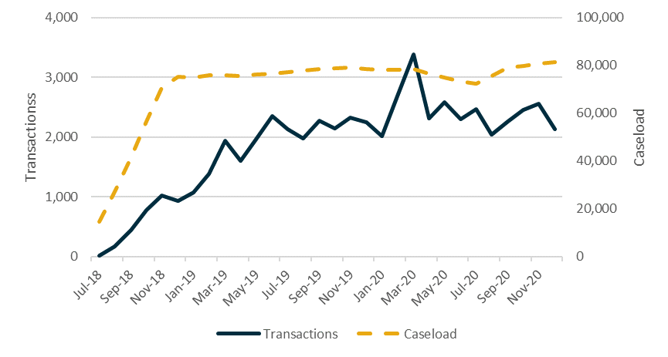
Source: The department’s administrative data
Base: Participation Fund expended transactions made by 31 December 2020 (n=55,948)
Figure A9.2 Participation Fund expenditure, July 2018 to December 2020
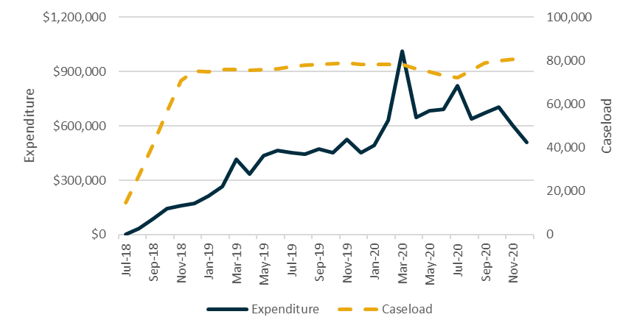
Source: The department’s administrative data
Base: Participation Fund expended commitments made by 31 December 2020 (n=55,948).
Table A9.1: Participation Fund expenditure by category
Category | Transactions  (number) | Transactions  (per cent) | Amount  ($) | Amount  (per cent)
Participant Support | 27,385 | 48.9 | 5,488,800 | 40.3
Accredited Training | 6,888 | 12.3 | 3,437,829 | 25.2
Non-Vocational Training | 6,629 | 11.8 | 2,363,189 | 17.3
Work Related Expenses | 5,251 | 9.4 | 846,264 | 6.2
Accredited Interpreter Services | 3,548 | 6.3 | 220,531 | 1.6
Professional Services | 3,535 | 6.3 | 561,415 | 4.1
Non-Accredited Training | 1,963 | 3.5 | 619,751 | 4.5
Child Care Costs | 550 | 1.0 | 79,262 | 0.6
Work Experience | 122 | 0.2 | 14,218 | 0.1
Job Related Mentoring | 77 | 0.1 | 2,491 | 0.0
Total | 55,948 | 100.0 | 13,633,750 | 100.0
Source: The department’s administrative data
Base: Participation Fund expended transactions made by 31 December 2020 (n=55,948)
Table A9.2: Participation Fund expended transactions by demographic cohort
Category | Male (n=2,465)  per cent | Female (n=53,360)  per cent | Aboriginal and/or Torres Strait Islander (n=15,313)  per cent | CALD (n=9,211)  per cent | Person with disability (n=7,246)  per cent | Refugee  (n=4,526)  per cent
Participant Support | 48.9 | 48.9 | 58.2 | 31.8 | 48.1 | 30.1
Accredited Training | 8.8 | 12.5 | 9.6 | 8.9 | 11.4 | 4.4
Non-Vocational Training | 9.9 | 12.0 | 13.7 | 7.2 | 12.0 | 3.9
Work Related Expenses | 17.0 | 9.1 | 9.4 | 5.4 | 8.3 | 4.7
Accredited Interpreter Services | 3.1 | 6.5 | 0.0 | 38.1 | 5.4 | 50.8
Professional Services | 6.9 | 6.3 | 4.1 | 4.3 | 10.0 | 1.3
Non-Accredited Training | 4.2 | 3.5 | 3.0 | 3.5 | 3.3 | 4.1
Child Care Costs | 0.8 | 1.0 | 1.6 | 0.6 | 1.2 | 0.6
Work Experience | 0.2 | 0.2 | 0.2 | 0.1 | 0.3 | 0.1
Job Related Mentoring | 0.1 | 0.1 | 0.1 | 0.1 | 0.1 | 0.0
Total | 100.0 | 100.0 | 100.0 | 100.0 | 100.0 | 100.0
Source: The department’s administrative data
Base: Participation Fund expended transactions made by 31 December 2020 (n=55,902). Transactions made for bulk purchases which were yet to be associated with individual participants were excluded, as were transactions made for voluntary participants or those with an eligibility reason of ‘Unknown’ (n=1,430).
Table A9.3: Participation Fund expended transactions by eligibility reason
Category | ESL (n=6,190)  per cent | YC5 (n=4,226)  per cent | High JSCI (n=44,102)  per cent
Participant Support | 54.5 | 40.9 | 48.9
Accredited Training | 12.3 | 14.2 | 12.0
Non-Vocational Training | 12.1 | 14.5 | 11.8
Work Related Expenses | 8.1 | 10.3 | 9.4
Accredited Interpreter Services | 2.8 | 7.7 | 6.8
Professional Services | 4.8 | 6.7 | 6.4
Non-Accredited Training | 3.5 | 5.1 | 3.4
Child Care Costs | 1.5 | 0.4 | 1.0
Work Experience | 0.2 | 0.2 | 0.2
Job Related Mentoring | 0.3 | 0.1 | 0.1
Total | 100.0 | 100.0 | 100.0
Source: The department’s administrative data
Base: Participation Fund expended transactions made by 31 December 2020 (n=54,518). Transactions made for bulk purchases which were yet to be associated with individual participants were excluded, as were transactions made for voluntary participants or those with a reason of ‘Other’ or ‘Unknown’ (n=1,430).

Appendix 10 Long-term tracking of ParentsNext participants
Inflow population: Participants who commenced in ParentsNext between 1 July 2018 (start of national expansion) and 31 December 2018.
Follow-up period: 24 months following each participant’s first ParentsNext referral date.
Table A10.1: Participant characteristics at first referral
Characteristic | Participants (number) | Participants (per cent)
Stream
Intensive | 29,770 | 44.6
Targeted | 37,056 | 55.5
Eligibility reason
ESL | 6,893 | 10.3
YC5 | 14,124 | 21.1
High JSCI | 44,868 | 67.1
Volunteer | 3,28 | 0.5
Undetermined | 613 | 0.9
Income support typeª
Parenting Payment single | 52,892 | 79.9
Parenting Payment partnered | 13,048 | 19.7
Other/Unknown | 256 | 0.4
Total | 66,826 | 100.0
Source: The department’s administrative data
Base: Participants commenced in ParentsNext by 31 December 2018 (n=66,826)
Note: (a) Excludes participants who were not receiving income support as at their first ParentsNext referral date (n=573) or who were in an allowable break period between income support episodes (n=57).
Table A10.2: Periods of assistance in ParentsNext as at 24 months post first referral
Periods of assistance | Participants (number) | Participants (per cent)
1 | 63,999 | 95.8
2 | 2,734 | 4.1
3 | 87 | 0.1
4 | 6 | 0.0
Total | 66,826 | 100.0
Source: The department’s administrative data
Base: Participants commenced in ParentsNext by 31 December 2018 (n=66,826). The period of assistance count is as at 24 months following each participant’s first referral date.
Table A10.3: Income support episodes in ParentsNext as at 24 months post first referral
Number of episodes | Participants (number) | Participants (per cent)
1 | 62,641 | 94.6
2 | 3,489 | 5.3
3 | n.p | n.p
4 | <5 | <5.0
5 | <5 | <5.0
Total participants | 66,253 | 100.0
Total episodes | 69,992 | -
Source: The department’s administrative data
Base: Participants commenced in ParentsNext by 31 December 2018 (n=66,826), excluding those who were not receiving income support as at their first ParentsNext referral date (n=573).
Note: Consistent with restrictions on the release of social security information to protect individual privacy, aggregation of fewer than 5 is represented as ‘<5’. Related totals and percentages are replaced with ‘n.p’ (not provided).
Table A10.4: Participant income support exit status
 | Intensive | Targeted | ESL | YC5 | High JSCI | Volunteer | Total
Participants who exited at least one episode of income support (per cent) | 12.5 | 13.5 | 10.0 | 19.1 | 11.6 | 23.1 | 13.1
Total participants | 29,537 | 36,716 | 6,835 | 13,984 | 44,525 | 307 | 66,253
Source: The department’s administrative data
Base: Participants commenced in ParentsNext by 31 December 2018 (n=66,826), excluding those who were not receiving income support as at their first ParentsNext referral date (n=573).

List of short forms
Short form | In full
ABS | Australian Bureau of Statistics
CALD | Culturally and linguistically diverse
department | Department of Employment and Workplace Relations (formerly the Department of Education, Skills and Employment)
DES | Disability Employment Services
ESL | Early school leaver
ESS | Employment Services System
ER | Employment region
JSCI | Job Seeker Classification Instrument
JETCCFA | Jobs, Education and Training Child Care Fee Assistance
KPI | Key performance indicator
KPM | Key performance measure
MORs | Mutual obligation requirements
NPP | NPP: Supporting more Indigenous Australians to participate in the labour market
OECD | Organisation for Economic Co-operation and Development
PPM | Post-program monitoring
PPS | Parenting Payment single
PWI | Personal Wellbeing Index
RED | Research and Evaluation Database
SRC | Social Research Centre
TCF | Targeted Compliance Framework
TtW | Transition to Work
YC5 | Parent with a child aged 5 years

Glossary
Term | Description
Caseload | Caseload refers to the number of participants in services (with a provider) and information about this group captured at a point in time.
Commenced | Having commenced in ParentsNext involves attending appointments, signing a Participation Plan containing activities, and participating in those activities.
Contract | In this report, a contract is an agreement between a provider and the Australian Government to deliver ParentsNext services in a particular employment region. Some providers have more than one contract because they deliver ParentsNext in more than one region.
ESAt | An Employment Services Assessment (ESAt) provides a comprehensive work capacity assessment for people with disability and/or other potentially serious barriers to work. An ESAt is required before a participant can be referred to jobactive Stream C or Disability Employment Services (DES).
ESS Web | ESS Web is the Employment Services System secure interface where providers enter servicing information about participant transactions that stimulate payments consistent with the contractual arrangement with the department.
Exemption | Social Security Law recognises that participants may experience circumstances that make it unreasonable for them to continue participating in ParentsNext for a period. Participants are not required to meet their mutual obligation requirements while they have an exemption. Services Australia or providers can grant exemptions under Social Security Law to compulsory participants. Participants with an exemption may continue to receive support as a voluntary participant and are not subject to compliance.
Exit | In this report, an exit occurs when a participant is exited from the caseload of a ParentsNext provider. Most exits are automatic (effective exit) for reasons such as stopping or changing income support payments, changing to another employment service, death or imprisonment.
Inflow population | The ParentsNext inflow population is the primary study population used in this report. It contains commenced ParentsNext participants.
Inflow period | The inflow period is the time between when ParentsNext participants were referred and when they commenced in ParentsNext.
Intensive stream | The intensive stream operated in 30 locations across Australia – the 10 locations where the ParentsNext 2016–2018 was delivered and an additional 20 locations where a high proportion of Aboriginal and/or Torres Strait Islander people are Parenting Payment recipients.
Job Plan | A Job Plan is an agreement that a jobactive or Transition to Work participant must make with their employment services provider and comply with in return for receiving income support payments and services. It covers things they need to do to meet their mutual obligations – for example, applying for jobs, attending appointments with the provider and participating in approved activities.
jobactive | jobactive is the Australian Government’s mainstream employment service.
Labour market attachment | A participant achieves labour market attachment when the income support and job placement information on the department’s IT system suggests that the participant has secured some form of employment.
Mutual obligation requirements | Mutual obligation requirements are actions that people on activity-tested income support must complete in return for receiving payments. These include requirements for participants to attend ParentsNext provider appointments and interviews, undertake activities to improve their job prospects, and look for and accept suitable paid work.
Outcome payments | Outcome payments equal to $300 are paid to providers in the intensive stream locations for participants who remain in stable employment or who attain the required level of education by completing a qualifying education or training course.
Parenting Payment single (PSS) | PPS is the main income support payment for single parents and other principal carers who have sole or primary responsibility for the care of a young child. These parents may be eligible for PPS until their youngest child turns 8. PPS can only be paid to one person in respect of a particular child.
Parenting Payment partnered (PPP) | PPP is the main income support payment for parents and other principal carers who are members of a couple and who have sole or primary responsibility for the care of a child under the age of 6. PPP is only payable to one member of a couple. An alternative income support payment may be payable to the other member of the couple, depending upon their individual circumstances.
ParentsNext Deed | Providers are contracted under this legal agreement to deliver ParentsNext services.
Participant | In this report, a participant is a person who has commenced with the ParentsNext program.
Participation Fund | The Participation Fund is a flexible pool of funds available to ParentsNext providers delivering a service in the intensive stream. Each provider may claim reimbursement for goods and services that genuinely support and assist participants to gain the support, tools, skills and experience they need to undertake study or obtain and keep a job, up to a one-off credit of $1,200 per participant.
Participation Plan | A Participation Plan is an ‘employment pathway plan’ for the purposes of the Social Security Act 1991. Compulsory participants who do not meet the requirements in their Participation Plan are subject to the Targeted Compliance Framework. Participation Plans set out a participant’s education and employment related goals, the appointments and activities the participant has agreed to undertake to satisfy their requirements, and any voluntary activities the participant has agreed to undertake to reach their goals.
Periods of assistance | Periods of assistance relate to assistance received by participants who have been referred to and commenced with ParentsNext. Some participants experience more than one.
Program guidelines | Program guidelines provide information on administering employment service programs.
Provider | In this report, a provider is an organisation that has a contract (or contracts) to deliver ParentsNext services.
Provider Portal | The Provider Portal is a secure website for providers of Australian Government employment services and departmental staff to access policy and program information and advice.
Referrals | In this report, referrals sometimes means parents who have been referred to the ParentsNext service. Services Australia refers participants to providers by booking an initial interview for a participant in the provider’s electronic calendar. Providers must accept all referrals made by Services Australia. Participants can select which provider they are referred to at their interview with Services Australia.
Stable employment | Stable employment is paid employment averaging 15 hours per week or 30 hours per fortnight, maintained over at least 12 weeks, and is expected to be ongoing. Providers must exit a compulsory participant in stable employment using the department’s IT systems.
Study period | Period in which participants in the main study populations were observed.
Study outcome | The study outcome measure used in this report is defined as a ParentsNext participant recording an education activity that could qualify for an education outcome payment in the department’s IT system.
Suspension | When a participant has an exemption, their status changes from commenced to suspended. Providers are not required to deliver services to suspended participants unless a participant chooses to participate voluntarily. A suspended participant is not subject to the Targeted Compliance Framework.
Targeted stream | The targeted stream assists disadvantaged parents who are at risk of long-term welfare dependency in all areas of the 51 employment regions but are not part of the intensive stream.
Targeted Compliance Framework (TCF) | The TCF creates a system of demerit points designed to ensure that only those jobseekers who are persistently and wilfully non-compliant with their obligations incur financial penalties. The TCF comprises 3 zones: the Green Zone, the Warning Zone and the Penalty Zone. All job seekers, including ParentsNext participants, will start in the Green Zone. So long as they meet all their mutual obligation requirements, they will remain in this zone. Where a job seeker incurs a mutual obligation failure, they will move to the Warning Zone. As they continue to be non-compliant, they will be in either the Warning Zone or the Penalty Zone.
Transfers | If a participant can demonstrate that they will receive better assistance from another provider, the participant may request a transfer by contacting the department’s National Customer Service Line. The department will action a transfer if it agrees that the participant will receive better assistance from another provider. The department will inform the participant if it does not agree to the request.
Work readiness | Work readiness in the ParentsNext Deed is defined as possessing the core skills and behaviours required by employers, including teamwork skills; communication skills; and a positive attitude and work ethic, including motivation, reliability and a willingness to work. It is sometimes assessed according to 7 key attributes: job skills and experience; aspiration and motivation; job search skills; stability; basic skills; workplace and social skills; and health and wellbeing.
Work StarTM | Work StarTM is a work-readiness assessment tool that measures improvements in work readiness over time. Providers are required to conduct work-readiness assessments of their participants using Work StarTM. In each employment region, providers are required to assess work readiness for either 100 participants or 50% of the provider’s actual caseload, whichever is lower.

https://learningforsustainability.net/theory-of-change/
In line with the Public Governance, Performance and Accountability Act 2013 (PGPA Act), evaluations, described as systematic and objective assessments of ongoing or completed projects, activities or policies, are undertaken to (a) improve the performance of existing interventions or policies, (b) assess their effects and impacts, and (c) inform decisions about future programming. Evaluations are formal analytical endeavours involving systematic collection and analysis of qualitative and quantitative information. Evidence derived from them contributes to performance reporting in annual performance statements.
The Job Seeker Classification Instrument (JSCI) is a questionnaire that seeks to identify an individual’s risk of becoming long-term unemployed.
See Australian Unity, The Australian Unity Wellbeing Index
The impact analysis compared the outcome rates of parents in each of the treatment (participant) and comparison (non-participant) groups in 2 stages. The first stage examined a population of parents who were eligible for a treatment or comparison group on 2 October 2018, and the second stage examined parents who were eligible one year later, on 2 October 2019. The education and employment outcomes of both populations were tracked for the 8 months following these eligibility dates. For stage 2, this period included the 2019–20 bushfire season and the onset of the COVID-19 pandemic. Composite outcomes were constructed to capture multiple indicators as to whether parents had engaged in education or employment activities. Program-defined outcome measures were not used as they were not available for all the groups being compared. For example, the education outcomes in the impact analysis are based on someone commencing education during their follow-up period, not completion of the activity.
Services Australia did not grant the full range of exemptions until September 2020.
Expectant mothers can only be granted a pregnancy exemption if they are within 6 weeks of their due date.
From 1 July 2021 changes to the program increased the age of the youngest child to 9 months and introduced one stream with access to all additional supports.
The Targeted Compliance Framework (TCF) creates a system of demerits designed to ensure that only those job seekers who are persistently and wilfully non-compliant with their obligations incur financial penalties. The TCF comprises 3 zones: the Green Zone, the Warning Zone and the Penalty Zone. All job seekers will start in the Green Zone and they will remain in this zone so long as they meet all their mutual obligation requirements. Where a job seeker incurs a mutual obligation failure without a valid reason they will move to the Warning Zone. If they continue to be non-compliant, they either remain in the Warning Zone or enter the Penalty Zone. Safeguards are in place to review job seekers’ requirements and ensure they are appropriate.
Senate Community Affairs References Committee, ParentsNext, including its trial and subsequent broader rollout – Parliament of Australia (aph.gov.au).
Parliamentary Joint Committee on Human Rights, ParentsNext: examination of Social Security (Parenting payment participation requirements – class of persons) Instrument 2021 – Parliament of Australia (aph.gov.au).
The ParentsNext Evaluation 2016–2018 followed the progress of participants who commenced in the program from April 2016 to 30 June 2017 in 10 local government areas across Australia. The evaluation report can be found at: https://docs.employment.gov.au/documents/parentsnext-evaluation-report
As several labour market programs that interact with ParentsNext have been evaluated independently, the evaluation did not assess their impact on participants, although reference has been made to the results of these evaluations where appropriate.
This was due to differences in the reporting requirements of the underlying outcome indicators. For example, Parenting Payment recipients are generally required to report their income to Centrelink, but may not necessarily report their engagement in education activities.
With the advent of major bushfires at the end of December 2019 and COVID-19 this landscape changed rapidly and dramatically.
A condition of receiving payments with mutual obligation requirements is that recipients must do all that they can to increase their likelihood of being able to support themselves in the future. Under Social Security Law, requirements must be tailored to individual circumstances, including consideration of caring responsibilities.
A number of these caveats were addressed in the expanded program (see Appendix 2).
Social Security (Parenting payment participation requirements – classes of persons) Instrument 2018 (No. 1) (legislation.gov.au).
A jobless family is defined as a family where the parent (for Parenting Payment single recipients) or the parent and their partner (for Parenting Payment partnered recipients) has no reported employment earnings in the previous 6 months.
The 2019–20 bushfires primarily affected the east coast of Australia (Queensland, New South Wales and Victoria), southern parts of Victoria and South Australia, and central east Tasmania (see Appendix 2.1).
Conventionally, the JSCI is completed through a phone or face-to-face interview with Services Australia or an employment services provider. Each JSCI factor is given a numerical weight or points that indicate the average contribution that factor makes to the participant’s difficulty in finding and maintaining employment. The points are added together to calculate a JSCI score, which reflects a participant’s relative level of disadvantage in the labour market. A higher score indicates a higher likelihood of the participant remaining unemployed for at least another year.
In some circumstances, a participant’s most appropriate activity can only be recorded as voluntary work.
Payment suspensions and penalties under the TCF only affect a participant’s Parenting Payment. Payments relating to children (such as Family Tax Benefit), concession card eligibility and Rent Assistance (where paid through the family payments system) are not affected.
The range of assistance includes pre-employment training, accredited training, work-related items, transport, medical and health related expenses (if health issues are inhibiting a participant’s capacity to attend activities or training, participate in programs, or find and keep a job), short-term rent and crisis accommodation, driver training costs, interpreter services and mentoring. Bulk purchases are permitted for the following categories: accredited interpreter services, child care costs, participant support, work experience and work-related expenses.
Stable employment is paid employment averaging 15 hours per week or 30 hours per fortnight, maintained over at least 12 weeks, and is expected to be ongoing.
The Services Guarantee reflects the Australian Government’s expectations of ParentsNext providers when delivering ParentsNext services to participants. It sets out the minimum level of service a participant can expect to receive, as well as the requirements a participant needs to meet while preparing for employment.
Under changes to jobactive arrangements for volunteers, from December 2019, ParentsNext participants who volunteered for jobactive received digital services under either the New Employment Services Trial (NEST) or the Volunteer Online Employment Services Trial (VOEST), depending on where they lived.
In 2018–19 the department included the proportion of ParentsNext participants who were in a current activity as a key performance measure (KPM) for the program. This KPM had a target of 80% of the caseload. Participants with a current activity recorded in their Participation Plan were used to determine performance against this measure. This was in recognition of the issue of providers not consistently and/or adequately referring participants to activities in the department’s IT system.
Lockdown restrictions during the pandemic were announced by the Australian Government Department of Health (see Coronavirus (COVID-19) news and media (health.gov.au), accessed 3 May 2021) and by each state/territory department of health.
Source: Coronavirus response – Free child care – Parliament of Australia (aph.gov.au).
See Australian Institute of Health and Welfare, Family, domestic and sexual violence in Australia, 2018, Summary (aihw.gov.au) and QUT, Pandemic stress increased frequency and severity of domestic abuse (qut.edu.au).
Note that in the 2017 participant survey these types of questions were asked about a parent’s first meeting with their provider, while the 2020 survey asked about meetings with the provider without specifying the first meeting.
While not directly comparable, the evaluation of Transition to Work (TtW) found that almost all of the matched TtW participants (92%) commenced within 30 days, compared with only 81% of the matched jobactive participants, suggesting that different program settings may have resulted in different provider or participant behaviours.
According to the Wave 1 qualitative research conducted 10 months after the program commenced, some providers were confused about the role of Services Australia in relation to its granting of only limited exemptions in this early stage of the program.
The capability interview is a key component of the TCF and provides additional protection for vulnerable job seekers. The purpose of the capability interview is to ensure that job seekers are capable of meeting their current MORs as set out in their Job Plan. Capability interviews, designed around jobactive and job search, are conducted by providers and are triggered when a ParentsNext participant incurs 3 demerits (3 mutual obligation failures without valid reason) in a 6-month period. The purpose of the interview is to provide the participant with the opportunity to disclose any new information or circumstances that may be impacting on their capacity to meet their mutual obligation requirements, as well as to discuss the recent non-compliance and the requirements outlined in their Participation Plan.
See Australian Bureau of Statistics, COVID-19 (abs.gov.au), Weekly Payroll Jobs and Wages (abs.gov.au), and the associated media release Casuals hardest hit by job losses in 2020 (abs.gov.au)
From September 2020, participants were no longer required to meet a re-engagement requirement if they had a valid reason for missing a requirement, and an additional SMS reminder was introduced. In October 2019, changes were made by the department to the reporting requirements for participants. Parents were not required to report activity attendance more than once a fortnight and did not have to report at all if engaged in full-time education or a flexible activity.
MORs were lifted nationwide from 21 December 2020 to 3 January 2021 in accordance with the Christmas shutdown period, and suspensions fell to a level similar to that during the December 2019 to January 2020 Christmas period.
This figure is based on 2018 year-end data supplied by Services Australia. More recent data was unavailable.
It should be noted that participants are not required to attend appointments or participate in activities during the fortnight in which the Christmas Day public holiday falls. Providers must not schedule any compulsory appointments or activities during this time. While participants should generally continue undertaking activities during school holidays, providers must not schedule a compulsory activity if a participant is unable to obtain suitable child care. Further, providers should not compel a participant to undertake a new activity if their agreed activity has a periodic break during the departmental shutdown period.
It should be noted that a homelessness vulnerability indicator does not mean homeless, and that it could have been put on a person’s record several years previously.
It should be noted that participants may be in employment but not with sufficient hours to reduce income support to zero, or to meet the requirements for an exit due to stable employment, and would therefore remain in the program.
Participants’ Parenting Payment may be cancelled when they are no longer eligible to receive the payment due to reasons including: the parent is no longer a principal carer for a child aged under 8 years (single) or under 6 years (partnered), the parent no longer meets the Australian residence rules or no longer meets the income limits and assets test.
Department of Social Services, Australian Priority Investment Approach to Welfare (dss.gov.au).
Program policy changes came into force from 1 July 2021 in response to these stakeholder concerns. These included streamlining the program into one service offering (consolidating the intensive and targeted streams), simplifying eligibility criteria to one set of rules for all participants, and the exclusion of parents from referral to ParentsNext if their study meets specified requirements and if they are over 55 years old.
This was $1,200 from 1 July 2018 and increased to $1,252.8 from 1 July 2020.
Department of Education, Skills and Employment, Volunteer online employment services trial – Information for Providers (dese.gov.au).
NSW Government, Smart and Skilled (nsw.gov.au) – available in NSW only.
As part of the ParentsNext 2018 procurement process, all providers were required to identify diverse strategies to ensure culturally competent servicing of Aboriginal and/or Torres Strait Islander and CALD particpants.
Lockdown restrictions during the pandemic were announced by the Australian Government Department of Health (see Coronavirus (COVID-19) news and media (health.gov.au), accessed 3 May 2021) and by each state/territory department of health.
In theory ParentsNext was not provided in remote or very remote locations. However, 14 ParentsNext sites in NSW, QLD and WA were identified in the departmental administrative data as remote/very remote regions.
Some providers chose to utilise other additional tools to measure changes in work readiness.
Job skills and experience; aspiration and motivation; job search skills; stability; basic skills (literacy etc.); workplace and social skills; health and wellbeing.
424 parents (2.1%) with at least one subsequent assessment had recorded a score of 10 (the highest possible score) for all points of the star at their initial assessment. When these participants are removed from the denominator, 74.6% show an improvement in their work readiness when measured against their initial assessment.
Baseline 10s are participants who scored 10 on their first valid assessment. We provided figures including baseline 10s as they are included in calculations of KPIs/KPMs. Program KPIs/KPMs only look at overall improvement percentages. Figures exclude baseline 10s as they have no possibility of improving. Only 2% of participants have an overall baseline score of 10, so the impact on overall improvement percentages is small. However, if individual points of the star are examined, the number of baseline 10 scores is significant enough (up to 28% of all baseline scores) that they should be excluded when considering improvement.
Low frequencies were undoubtedly influenced by the small sample size for male participants and the lack of education data and, as a result, should be treated with caution.
Deakin University, Subjective Wellbeing During COVID-19 (2020).
Deakin University, Australian Unity Wellbeing Index Survey 34: Summary Report August 2017 (2017).
Deakin University, Subjective Wellbeing During COVID-19 (2020).
An income support episode begins when a person starts receiving income support payments and ends when they have ceased receiving income support payments for longer than 6 weeks (if they have been on income support for fewer than 12 months) or for longer than 13 weeks (if they have been on income support for at least 12 months).
New coronavirus supplement – Parliament of Australia (aph.gov.au). Note that the supplement tapered off to $250 from 25 September 2020 to 21 December 2020.
This was as a result of a decision by Services Australia to put on hold or undertake fewer ParentsNext referrals during this time.
Australian Bureau of Statistics, Understanding unemployment and the loss of work during the COVID-19 period: An Australian and International perspective (2020).
As noted earlier, given the difference between the program iterations, comparisons should be approached with caution.
Many of these recommendations were taken into account on 1 July 2021 when ParentsNext 2021-2024 came into effect.
MIW, a voluntary program, provided lone parents with intensive key worker support and involved tailored help with child care, health and social care, housing, and financial inclusion, alongside posting to existing services. As well as supporting individuals, MIW had positive impacts on communities through building social capital and influencing policy. The successes of and lessons learned from MIW in Edinburgh provide good evidence about how education and employment goals can be achieved for the most vulnerable parents. Making it Work: Learning and Evaluation Contract – final report
Note the CCS cap was removed from 10 December 2021.
Department of Education, Skills and Employment, Work Readiness Assessment Guideline, January 2019.

