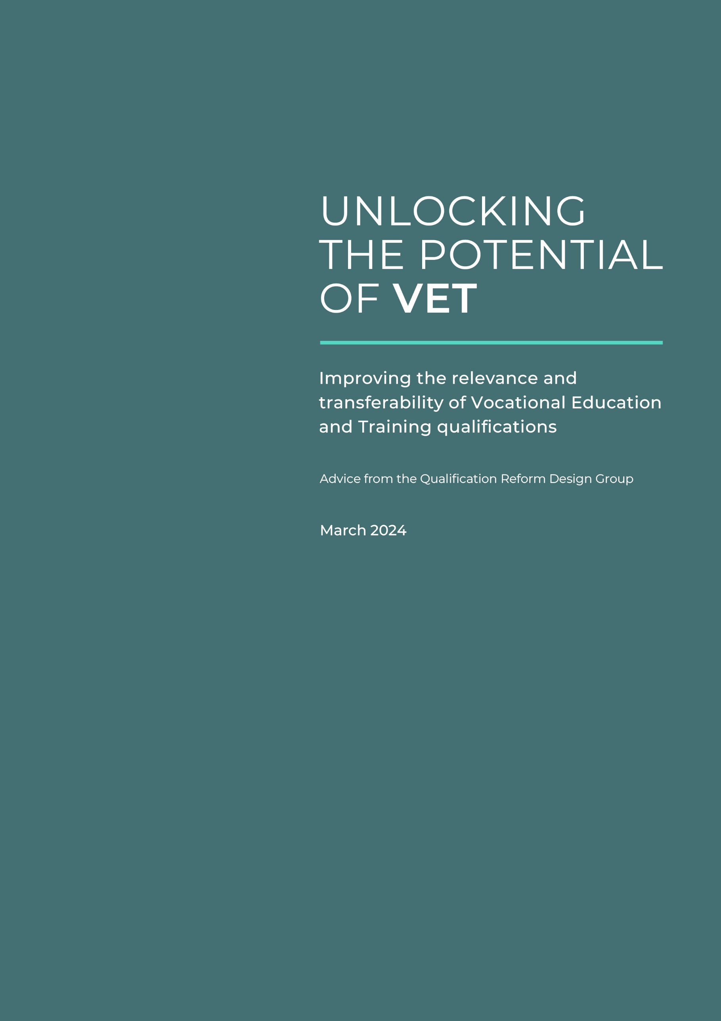
Unlocking the potential of VET

Improving the relevance and transferability of VET qualifications
Advice from the Qualification Reform Design Group
March 2024

Contents

Executive summary 3
Recommendations to Skills and Workforce Ministerial Council (SWMC) 5
Introduction: Qualification reform for a stronger VET system 7
Towards a differentiated qualifications system 12
Attachment A – Evidence of the case for change 16
Attachment B – Details of the proposed new qualifications system 22
Attachment C – Next steps 27
Attachment D – Typology of Qualifications 31
Attachment E – How we got here and what it means for today’s VET qualifications 32
Glossary 34

Executive summary
The Qualification Reform Design Group is pleased to provide its initial advice to Skills Ministers on reforming Australia’s Vocational Education and Training (VET) qualifications system.
All members are clear that there is a need for qualification reform, are motivated by the priorities of those they represent, and share a desire for a high-performing VET system that meets the economic needs of Australia and supports Australians of all backgrounds to benefit from the changes occurring across the economy.
The proposals presented in this report reflect a significant step in redesigning qualifications to better support the diverse users of the VET system and their needs, and to meet the new expectations placed on the VET system such as through the National Skills Agreement (NSA).

Case for change: Towards qualification reform for a stronger VET system
Australia needs a new system of VET qualifications. The ambition is that the new qualifications system must:
- meet industry needs by strengthening the path from qualification design to delivery, and producing graduates with industry-relevant and transferable skills for changing workplaces and industries;
- bring more students into the VET sector by delivering the knowledge, skills and core capabilities they need for life and work, and building confidence in the future that a VET qualification offers;
- improve the status and responsiveness of the VET system by retaining what is working while generating new models for use across sectors, with appropriate oversight to maintain trust; and
- enable quality delivery by reducing the overspecification that contributes to compliance overload in VET delivery and assessment, leading to better learning experiences and outcomes.
The Design Group’s tripartite membership has enabled it to draw on insights from industry, unions, training providers, and governments, and work collaboratively to design the new system outlined below.

Proposal: A differentiated qualifications system
The Design Group proposes a new differentiated qualifications system to preserve qualifications that are working well while enabling new qualification models to serve different purposes. The new system moves from a ‘one size fits all’ approach to designing qualifications based on their purposes:
- Purpose 1 – qualifications leading to a specific occupation (for example a licensed trade)
- Purpose 2 – qualifications to prepare learners for multiple occupations within an industry
- Purpose 3 – qualifications that develop cross-sectoral or foundation skills and knowledge which may be applied across industries, or lead to tertiary education and training pathways.
The level of ambition is high and the scale of change significant. For this reason, the design group is committed to an action learning approach through the next stages of work involving testing the purposes and trialling new qualification models.

Jobs and Skills Councils (JSCs) are key partners to take this work forward. They will be asked to review existing training products against the purposes as a way of validating the purposes approach, and where suitable, develop new qualification models as exemplars. The Design Group will support JSCs by advising on system issues and related reforms.
By end 2024, the Design Group, assisted by JSCs, will report to Skills Ministers on demonstration projects and any changes to operating arrangements for VET qualifications (such as the Training Package Organising Framework) necessary to implement the new system.
Part of the advice will include an implementation plan for the new qualifications system from 2025 based on joint work with JSCs, state and territory governments and sector stakeholders.
While qualification reform presents an exciting opportunity for change that will deliver significant benefits, the challenges of succeeding in this endeavour can only be solved by drawing on the depth of expertise across the sector.
The Design Group looks forward to working in partnership with JSCs and other stakeholders to test the purpose-led design of qualifications using the action-learning methodology, and learn from this process to inform new policy settings for the qualifications system as a whole.

Recommendations to Skills and Workforce Ministerial Council (SWMC)
- Agree an approach to improving VET Qualification Design that:
  - tests and refines the proposed purpose driven, principles-based system of qualification design (as outlined in Recommendation 2),
  - works through the detailed implications for the different sectors that utilise VET, in a way that builds stakeholder ownership of reform and that draws on evidence of the connection between qualifications and employment;
  - considers alignment of the new qualifications system with other current sector reforms such as reforms to the Standards for Registered Training Organisations, and the Blueprint for the VET workforce;
  - validates new approaches to qualification design to ensure they support achievement of the new expectations on VET arising from the National Skills Agreement, the Employment White Paper and the need for a coherent tertiary sector; and
  - results in updates to the Training Package Organising Framework.
- Note that the proposed purpose-driven, principles-based qualification system involves:
  - Developing and applying differentiated qualification models to meet the different purposes of training, including for new labour market entrants, individuals looking to upskill, and individuals looking to reskill, and to support the application of the Qualification Development Quality Principles:
      - Purpose 1 maintains a level of specificity necessary for safety or licencing requirements, particularly the integrity of the trades, and is unlikely to change substantially from the current approach;
      - Purpose 2 focuses on the development of qualifications that prepare learners for multiple, related occupations while retaining industry relevance;
      - Purpose 3 provides additional opportunities for innovation in areas such as cross-sectoral skills, foundation skills and tertiary pathways.
  - Applying the following Qualification Development Quality Principles to the design of qualifications (new and existing qualifications, for all stages of an individual’s career):
- ensure learners’ needs and aspirations inform qualification design, including occupations, transferability, transitioning occupations and industries, and mobility across industries;
- place equal importance on skill, knowledge, and application;
- allow flexible training and assessment in high-quality training environments;
- avoid duplication with other training products where industry context does not require it;
- reduce specificity except where a higher level of detail is required for licencing, high-risk, safety, regulatory or graduate quality reasons;
- consider and integrate foundation skills, general capabilities, and knowledge progression.

- Note the benefits of the proposed system in maximising outcomes for learners, preserving industrial benefits for workers, facilitating transferability of skills and knowledge across industries, and improving flexibility and supporting improved quality of learning and assessment.
- Agree that Jobs and Skills Councils (JSCs) be asked to lead VET qualification reform in 2024 through an action learning approach with the Design Group that involves:
  - undertaking a stocktake of training products in their industry by applying the proposed Qualification Development Quality Principles and mapping their existing qualifications against all three Purposes, with a view to simplifying and rationalising qualifications where possible;
  - giving particular attention to assessing the value of zero and low-use qualifications against the Quality Principles to assist in identifying where qualifications can be consolidated, deleted or new solutions developed;
  - selected JSCs developing an initial suite of qualification models across all three Purposes as demonstration projects, which reflect priorities identified in JSC workplans and particularly those which align with the National Skills Agreement;
  - identifying barriers within the current Training Package Organising Framework limiting the implementation of the proposed system.
- Note that the work of JSCs outlined at Recommendation 4 will be informed by:
  - JSC strategic workforce planning and industry intelligence about the skills and knowledge required for job roles, within and between industry sectors;
  - data about where graduates are going in the labour market with their qualifications;
  - collaboration with other JSCs where skills and knowledge are common with other qualifications;
  - the pace of change in the industry or skill area; and
  - whether a qualification predominantly leads to one job, multiple jobs, or further education and training.
- Agree the next steps in qualification reform to be delivered by the end of 2024:
  - The Design Group and JSCs will report back to SWMC on learnings from the demonstration projects and the feasibility of the system outlined in Recommendation 2;
  - Under guidance from the Design Group, the Commonwealth to work with states and territories to establish a process for ongoing engagement between JSCs and state and territory governments to consider implementation issues and plans for the new qualifications system and models, that support state and territory investment priorities for vocational education outcomes;
  - The Design Group will refine the qualification models and operating arrangements such as the Training Package Organising Framework to present to SWMC in 2024 along with advice on other VET policies which may need refining to support a new approach to qualifications;
  - JSCs and Jobs and Skills Australia will accelerate development of an evidence base that will support qualification reforms, including better data on the flows of individuals into and through the workforce and the core and similar skills which underpin success in work.

Introduction: Qualification reform for a stronger VET system
This report sets out the directions and progress of the Vocational Education and Training (VET) Qualification Reform Design Group (Design Group). The focus of work to date has been developing a differentiated VET qualifications system to counter the current one-size-fits-all approach.
VET is at a turning point, with heightened expectations for it to respond to the higher order skills characteristic of an increasing proportion of employment opportunities, and to lift the capabilities of Australians as they navigate from school to work and existing workers seeking to apply their skills in a quickly changing work environment. VET also has a critical role to play in building the capability of Australians at risk of being left behind because their literacy, numeracy and digital skills are inadequate to engage fully in contemporary work and society.
A segment of current VET qualifications appears fit for purpose, leading to well-defined and accepted occupations in the economy with good outcomes for graduates and employers. Improved outcomes for students and employers could be achieved through redesign applied to the remainder. Some qualifications and units of competency are narrowly constructed around granular job tasks, and many are under-utilised or not used at all. Redesign can increase the development of transferable skills and help prospective students see VET as a valuable point for starting their career or transitioning to other occupations. This new design is expected to bring more students through VET and increase the supply and utilisation of skills for the benefit of employers and communities.
In response to these issues, the objectives of qualification reform are to:
- design a coherent system of qualifications that work together to meet individual, industry and community needs;
- identify opportunities to streamline qualifications and make learning more relevant and transferable so graduates succeed in the labour market and in their life; and
- improve the supply and utilisation of skills within the Australian labour market to support continued economic opportunity and workforce productivity; and
- enable VET providers to focus on effective learning content and processes to meet the needs of students.
These broader outcomes will add value to qualifications for learners and employers and ensure VET delivers on its potential as the sector characterised as one of opportunity regardless of a participant’s prior education experience.
This report begins by summarising the case for change in qualification reform, supported by evidence in Attachment A. It then proposes new qualification design options that has the capacity to generate new learning and qualifications delivery models which deliver greater benefits to the diverse users of the VET system.
The next stage of the program is for Jobs and Skills Councils to design and test new qualification models for their industries with states and territories, for the Design Group to continue to oversight the economy wide implications, and work through specific issues relating to the detail of qualification design.
This would be in preparation for development of a new way of working in qualification design. It is envisaged that there will be purpose-driven policies, procedures and templates developed during 2024, in anticipation of implementation from 2025.

The changing economy is placing new demands on VET
The opportunity exists through a new qualifications system to bring new knowledge and skills to workplaces, while also empowering students to shape their careers in a dynamic economy.
VET has a long history of delivering the skills that place students into occupations, industries and pathways to employment, and providing the skills on which society depends. However, employers’ expectations of skills are increasingly changing, more students – especially women – are choosing higher education, and employers who do use the VET system are expressing decreased satisfaction.
Ultimately, VET needs to evolve to enable more opportunities for lifelong learning - for those individuals commencing their working life, and for those upskilling or reskilling to take up new opportunities presented by the changing economy. The clean energy transformation, ongoing infrastructure development, the care and digital economies, investment in sovereign capabilities, plus the significance of services-related employment across the economy all heighten demand for a vocationally prepared workforce.
These broad transformations have important implications on what VET qualifications must deliver:
- Higher order knowledge and skills are the benchmark for success across a far larger proportion of the labour market and society than when the VET qualifications system was first designed in the 1980s. There is an increasing need for technical skills to be supported by knowledge in order to prepare students for the jobs of the future.
- Both knowledge and skills are core prerequisites for secure work and provide the foundation for lifelong learning as individual and employer needs change. Use of digital tools and automation of routine tasks is driving the re-organisation of work, and all workers need knowledge and skills to navigate blurring boundaries between occupations and tasks.
- Australian workers are increasingly mobile, within and across occupations. Dynamic economic conditions, transitioning industries and the evolving expectations of work impact almost all workers and at different stages of their career.
- A growing number of Australians are at risk of being left behind because their literacy, numeracy and digital skills are inadequate to engage fully in contemporary work and society. Proficiency in the use of digital tools is now a universal need for successful participation in work and society.
- Society also has new expectations on the nature of work and the operation of the workplace, including gender equality, equal opportunity for people of all abilities and acceptance of gender diversity. Closing the gap and facilitating equal access to economic and social opportunity for First Nations peoples also remains a national priority.
VET is a critical contributor to bringing these transformations to the workplace and society more broadly. The sector must respond more meaningfully to these cues, especially through the intent and content of qualifications, which ultimately are a vehicle for achieving economic and social outcomes.

There are opportunities for improving the qualifications system
Benefits for students and employers in the current qualifications system are not distributed equally. While the system works well for some, it falls far short of its potential for others.
The current qualifications system reflects a ‘one qualification, one job’ logic that arises from historical factors outlined later in this document. Competency based training aligned to individual occupations worked well in the 1990s and early 2000s to bring standards of skilling to wider segments of industry. It helped recognise the competency of workers who did not have access to institutional forms of learning and underscored the transition of workers from declining industries into new work opportunities.
This logic continues to work well for a segment of the current system. Many current high-use qualifications are designed around the competencies required for well-defined occupations and provide secure work outcomes for graduates and a strong base for further skilling and advancement in a career. This includes traditional trade qualifications and many reflected within modern awards.
Driven by national policy efforts to align VET qualifications with occupations and jobs (including efforts to reach more occupations and industries), over time the ‘one qualification, one job’ applied to all qualifications has generated significant systemic issues that are limiting the utility of VET to students and employers.

There is a large number of training products, many of which have low or no take-up
In the current system, development of industry-specific units and qualifications has generally been the go-to response to meeting skills needs, even when a new training product is not necessarily the best solution. Only some qualifications import existing units from other Training Packages.
The number of training products in the system – including around 1,200 qualifications and 15,000 units of competency – can confuse prospective students and other users of the system. A significant proportion are under-utilised or unused, with poor rates of delivery or enrolment.
Multiple systemic factors affect the flow from design of a new or revised qualification to delivery and take-up:
- Funding agencies subsidise participation in VET to support industry growth and employment, and need to make trade-offs to limit the number of courses within capped budgets.
- Registered Training Organisations (RTOs) are reluctant to take on new qualifications, as they face uncertain prospects of student enrolment, trainer shortages, change management costs for qualification changes and costs to the Australian Skills Quality Authority (ASQA) for scope changes as a full cost recovery agency. This is compounded in regional areas where providers cannot afford to deliver narrow qualifications with the prospect of small enrolment numbers.
- VET activity data does not support the assumption that a high number of qualifications supports a corresponding expansion of privately funded training, apart from individual units or skills sets that meet a regulatory requirement.
These legitimate constraints call for examination of the VET product suite, to improve the flow from qualification design to delivery in a way that creates value for the student and the sector overall.

Redesign could increase transferability of skills and knowledge and enhance recognition of prior learning
The current design of VET qualifications has the unintended effect of constraining job and role transferability. Narrow prescription aimed too tightly at specific occupations can limit the broader recognition of competency, especially by employers, disadvantaging students’ transitions into and through the labour market.
While this level of technical detail can be valuable in supporting graduate outcomes for some well-defined and established occupations, the negative effects of this can be seen in learning and employment pathways:
- Prospective students see many qualifications as limiting their options to that sub-sector with limited long-term value to support their aspirations for movement into and through the labour market;
- Employers find it difficult to recognise the skills a transferring worker from another sector brings, as the narrow focus on occupation or role in industry sectors with qualifications limits recognition of competencies to that sector;
- Recognition of prior learning (RPL) is often limited to recognising competency in the role or occupation the worker is transitioning from rather than their skills and knowledge; and
- Students transitioning to Higher Education struggle to gain credit for VET qualifications due to uncertainty about how performance-based competency can be translated or trusted as a proxy of learning and knowledge which underpins higher education. Transition and credit recognition between VET and Higher Education are now critical issues for many industries, as they build knowledge and skills across their workforce and redistribute work roles.

Overspecification within qualifications constrains quality delivery and assessment
The complexity in the qualifications system translates to growing complexity within qualifications themselves. Over recent decades they have moved away from a standards approach, resulting in:
- Competency often giving way to definitions of specific tasks, further narrowing the learning outcomes and work options for some graduates;
- Over-prescription of assessment and delivery requirements within units, resulting in a compliance approach to learning and compromising engagement of students;
- Reduced focus on employability skills such as critical thinking and problem-solving, due to the prescriptive nature of assessment against granular competency requirements; and
- Rapid turnover of qualifications to maintain currency adding repeated transition costs on providers.
While it is difficult to pinpoint the genesis of this trend towards prescription and specification, developers cite the desire to shore-up quality in delivery for their industry as the main reason.

Qualification reform must build confidence in VET as the sector for lifelong learning
VET needs to be seen as the vehicle for learning that enables participants to remain actively engaged throughout their life, with relevance to changing workplace needs; utility for those upskilling, reskilling or commencing their career; and transferability across occupations.
The issues with the qualifications system outlined in this report impact the effectiveness of VET overall in the eyes of students and employers as its primary beneficiaries.
The VET sector should be known for offering qualifications that maximise employment outcomes for students – whether pathways to specific highly skilled occupations, or opportunities for a wider range of jobs within an industry, VET’s key value proposition should be developing students’ skills to support their more mobile career.
These issues are broad trends across the system, and there are always exceptions. One task of the Design Group is to identify the features of these successes for broader application in the sector.
The proposed new qualifications system outlined below preserves the best of VET’s current product offering, while recognising that different models are needed to improve system performance overall.

Towards a differentiated qualifications system
The first stage of the Design Group’s work has been designing a system for VET qualifications which moves away from a one-size-fits-all approach to differentiated models.
The relationship between knowledge, skills and application will vary across occupations and industries. Some industries and occupations would greatly benefit from a broader application of skills and knowledge across a number of roles or contexts, while others require these attributes to be more highly specified. Reform to VET qualifications needs to reflect this diversity, and allow for qualifications and skills development to be broad-based, or specific to a narrower range of tasks.
The proposed system (detailed at Attachment B) involves Qualification Design Quality Principles and new qualification models built around the diverse purposes that VET serves in the labour market.
The proposed system ensures that qualifications already performing well can be preserved.
It also enables new models to be designed, to improve students’ work outcomes and career options or develop knowledge and skills as preparation for further education or training. It will improve how qualifications work together to support lifelong learning and efficiently meet industry skills needs.
The purposes of each qualification model are:
- Purpose 1 – qualifications leading to a specific occupation (for example a licensed trade)
- Purpose 2 – qualifications that prepare learners for multiple occupations within an industry
- Purpose 3 – qualifications that develop cross-sectoral or foundation skills and knowledge which may be applied across industries, or lead to tertiary education and training pathways.
A qualification design system that acknowledges these varying purposes and offers a range of options for qualification and study would deliver greater value to students in terms of clarity about employment and learning outcomes.
There are also areas for change relevant to all qualifications, regardless of their purpose, which warrant further analysis. This includes, but is not limited to:
- Improving coherence between qualifications and how they are organised and connected to meet the changing needs of industry and support learners;
- Reducing, to the extent that it supports achievement of the qualification’s primary purpose, the high levels of specification inherent within the current Unit of Competency, arising from assessment specification and, at times, misplaced input controls;
- Bringing a stronger focus on the knowledge systems and progression that underpin effective practice and skills through the equal consideration of skills and knowledge; and
- A stronger focus on the personal capabilities (foundation skills, general capabilities and knowledge progression) which build skills for effective engagement in work and life.
In setting the terms of reference for qualifications reform, Ministers have directed that Units of Competency remain the building block for VET in Australia. The current Unit of Competency design focuses on performing discrete tasks rather than developing broader conceptual and knowledge understanding. New models could explore ways to foreground knowledge at all qualification levels, alongside skills and application, to produce more adaptable graduates ready for non-routine tasks. New models could also help develop foundation skills, either within or as distinct qualifications.
As new qualification approaches are developed, this in turn may inform any changes to the Unit of Competency or qualification templates necessary to fully realise the benefits of reform.
All qualifications would retain the ability for modular delivery, in line with current approaches. However, as the intent of the new model qualifications is to leverage wider outcomes for students, the intention of the design would be to encourage completion of the full qualification.

JSCs have been commissioned to drive strategic workforce development and support new approaches to qualifications
JSCs, as key agents in national VET arrangements, are central partners in bringing industry insights into new qualification models, and promoting the improved outcomes expected from new qualifications to current and prospective users of VET.
JSCs represent new national industry engagement arrangements, built on tripartite principles, and have been established to drive strategic workforce development, including working collaboratively to bring new insights to the qualifications system and qualifications design.
JSCs will identify skills and workforce needs for their sectors; map educational and career pathways across education sectors; develop contemporary VET training products; support collaboration between industry and training providers to improve training and assessment practice; and act as a source of intelligence and provide advice on issues impacting their sectors to the VET sector, learners, business and governments.
JSCs’ role in supporting training product development and effective VET outcomes (as well as noting Higher Education and migration settings), includes:
- Analysis of industry workforce design and trends and the flow-on impact on knowledge and skill requirements;
- Leveraging evidence of the effectiveness of VET qualifications in supporting graduate success in the labour market and/or success in life and engagement in society; and
- Collaboration with other JSCs to identify common and transferable skills across industries.

Next steps
The changes proposed to the system of VET qualifications and to qualifications themselves represent what could be the most significant change in the sector for several decades.
The potential significance and scale of the change has the Design Group proceeding with careful yet outcome-driven design steps. These are outlined below and in Attachment C:
- Partnering with JSCs – JSCs are key players in fielding the skill needs of the industries they support, forming standards for competencies and informing assessment expectations. As next steps the Design Group will partner with JSCs to trial and refine the Quality Principles and purpose-driven models and develop test case qualifications. This includes facilitating collaboration across JSCs to explore opportunities for new cross-sectoral models.
- Examining policy interdependencies – to support the work of JSCs, the Design Group will engage relevant stakeholders to examine areas of existing qualification policies and reform from across VET impacting on the utility and value of qualifications to inform design and models of qualifications.
- Test models and map out implementation with States and Territories – the Design Group will test with states and territories, as key enablers of vocational education, the utility of the proposed models for meeting local economic and social development priorities and map out implementation steps and issues for funding, reporting and accountability.
- Design for improved educational intent – a key feature of each qualification should be improved educational intent and delivery. The principles of good applied-education practice will be considered in final design decisions.
JSCs are key partners to take this work forward. They will be asked to review existing training products against the purposes as a way of validating the purposes approach and where suitable develop new qualification models as exemplars. The Design Group will support JSCs by advising on system issues and related reforms.
By end 2024, the Design Group, assisted by JSCs, will report to Skills Ministers on demonstration projects and any changes to operating arrangements for VET qualifications (such as the Training Package Organising Framework) necessary to implement the new system.
Part of the advice will include an implementation plan for the new qualifications system from 2025 based on joint work with JSCs, state and territory governments and sector stakeholders.

Engagement and communication
The proposal is informed by previous consultation, experience from sector stakeholders and research. It is built upon a deep understanding that the VET system is used by different stakeholders, for different reasons, and across different parts of the labour market.
For some training products the proposed new system may result in very different structures compared to what currently exists. This means it will be important to ensure that the model is developed, tested and implemented in a way that informs stakeholders and builds confidence along the way.
JSCs will be a co-designer and co-owner of reform as well as the main driver of implementation, and accordingly, their support for the proposal is critical. JSCs have expressed interest in progressing qualification reform, recognising the potential of their broader remit, and have noted opportunities for:
- reduced detail in units of competency to address over-specification
- improved guidance for training providers, including potential for improved learning and assessment resources or framework curriculum
- opportunities for VET practitioners to return to a focus on learning and teaching as opposed to a focus on assessing narrow tasks
- support for broader career pathways for learners.
The change needed is not merely technical but requires a cultural shift in the way diverse stakeholders work together on the co-design and co-ownership of qualification reform. As reform progresses, the tripartite approach of the Design Group and JSCs will support strategic engagement with diverse VET stakeholders and ongoing communication about the vision for reform.
The Design Group has also drawn on previous consultation processes undertaken by DEWR on qualification reform, which demonstrated broad support for the need to reform VET qualifications to reflect the changing economy and a desire from stakeholders to be engaged in change to maximise the benefits of reform. Continued engagement will be essential as the reform journey progresses.

Attachment A – Evidence of the case for change
This attachment summarises key evidence to support the case for change in qualification reform.

Demand for skills at all levels remains strong in Australia’s knowledge economy
Australia’s economy is rapidly changing in response to global pressures and opportunities. An ageing population, rising demand for quality care and support services, expanded use of digital and advanced technologies, climate change and the net zero transformation, and geopolitical risk and fragmentation are key underlying drivers of this change.
Figure 1 shows the impact of these forces in the labour market, driving a strong increase in demand for higher skill requirements between 2000 and 2021, which is forecast to continue. The increasing skills demands of the economy, in particular the declining share of Skill level 3, the backbone of VET qualifications, demonstrates a need for enhanced skills and knowledge progression to support the changing economy.
Figure 1: Changes in occupational skill requirements over time (2000 – 2026)
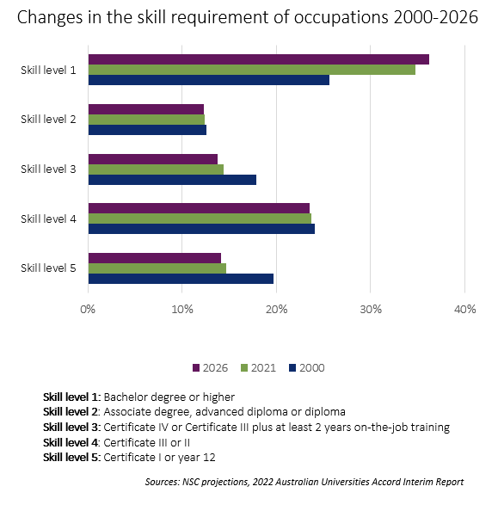
VET also maintains a critical role in addressing some of our most pressing skills shortages. In 2022, skill level 3 occupations (those requiring a Certificate III or IV) recorded the highest share of occupations in shortage, with 46 per cent of occupations in shortage.
In the care industry, 85 per cent of jobs are in shortage, and 96 per cent of jobs in the construction industry and 90 per cent of clean energy jobs are in shortage. While these shortages arise from intersecting challenges including gender-skewed roles, they clearly show the ongoing importance of VET in delivering essential skills.

Young people, particularly females, are choosing Higher Education over VET
Australians are increasingly choosing bachelor degrees over certificate or diploma level qualifications, reflecting student preferences over time. As demonstrated by Figure 2, the proportion of 25–34-year-olds with higher education qualifications has increased by 10 per cent since 2011, while the proportion of young people with VET qualifications has remained static over this time.
Figure 2: Percent of 25-34 year old Australians by their highest level of qualification

Source: Education and Work, 2022; Australian Bureau of Statistics
Notes:
1. Analysis includes estimates that have a relative standard error of 25% to 50% and should be used with caution.
2. Analysis excludes estimates that have a relative standard error greater than 50% and is considered too unreliable for general use.
*This trend line shows qualifications delivered by the VET and HE sectors. In 2012 and 2013, Associate degrees (provided by the HE sector) were grouped with Advanced diplomas and included in this trend line.
This is particularly true for females aged 25–34. Half of all women in this cohort hold a bachelor degree or higher compared to 30 per cent who hold a VET qualification.
Recent analysis showed 78 per cent of students aged 15–24 were pursuing or intending to pursue higher education compared to 20 per cent of students for a VET pathway. This divide was even greater for females.

Automation means more workers at all levels require higher order knowledge and skills
Labour force data supports the need to build knowledge and enhance the adaptability of VET graduates in the workplace. Over the last 40 years jobs that have a higher share of non-routine tasks have grown as a share of employment, a trend that is likely to accelerate as employers increasingly automate routine tasks in order to focus on more complex value adding processes. (Figure 3).
Figure 3 – Change in routine and non-routine tasks as share of employment
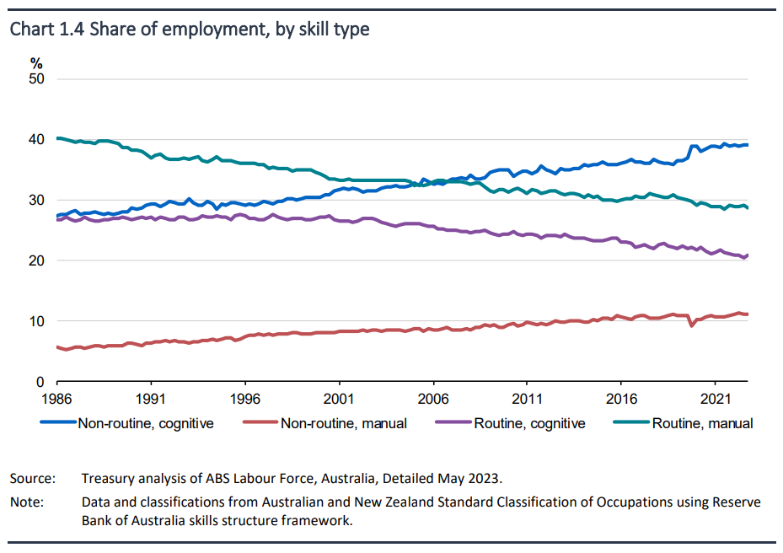
Source: Working Future: The Australian Government’s White Paper on Jobs and Opportunities 2023, p8)

Workers are increasingly mobile – particularly in lower skill level occupations
In the year ending February 2023, 1.3 million people changed jobs, with job mobility remaining at 9.5 per cent for the second year in a row – the highest rate in a decade. This means almost one in ten workers changed jobs over the past year. Those in lower skill level jobs are moving to jobs within the same occupation group but also to other occupation groups (see Figure 4).
Individuals build, maintain, and enhance their portfolio of skills and knowledge in a range of different ways, and the application of skills and knowledge to new jobs is critical to supporting mobility.
Figure 4: Proportion of people who changed jobs to a different or within the same occupation group.
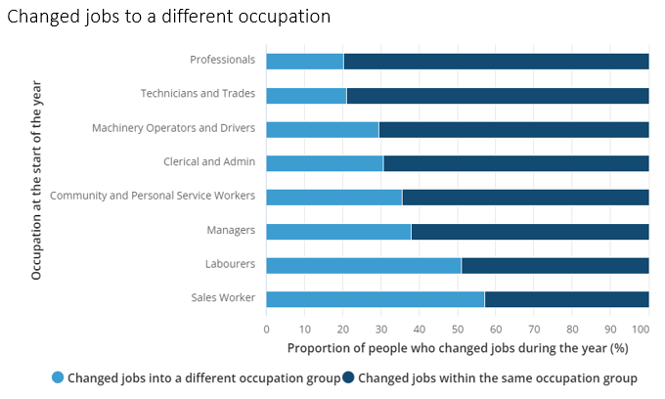
Source: ABS, Job Mobility to Feb 2023

Learners face complex and duplicative journeys through the system
Proliferation and overspecification have resulted in learners being subjected to potentially duplicative training and unnecessary periods of study (see Figure 5).
Figure 5: An example learner journey in the current VET qualifications system.
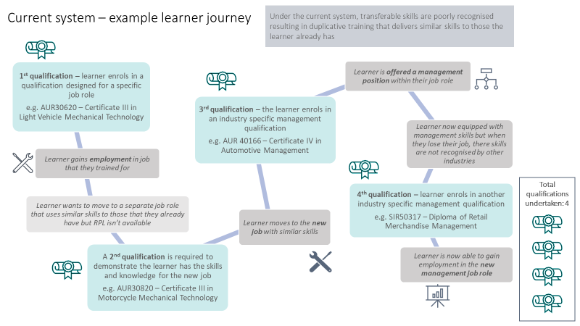
Pathways for learners are further inhibited by the underutilisation of Recognition of Prior Learning (RPL). In 2018, less than 5 per cent of all successful subject results were granted through RPL and less than 3 per cent of all students successfully completed any subjects through RPL.
Analysis shows that some industries are more conducive to the use of RPL. The qualifications with the highest rates of RPL granted are from a diverse mix of fields and range from higher-level public service training to traditional trade areas (examples include hospitality, government, construction, and engineering). Further, the incidence of both RPL and credit transfer increases with increasing AQF level.

A large proportion of current VET qualifications have low use or no use
The VET system has expanded to include around 1,200 qualifications and 15,000 units of competency. Between 2018 and 2022, 21.1 per cent of qualifications had no enrolments and 32.9 per cent had fewer than 10 enrolments per annum (Figure 6).
Figure 6: Distribution of average annual program enrolments between 2018 and 2022
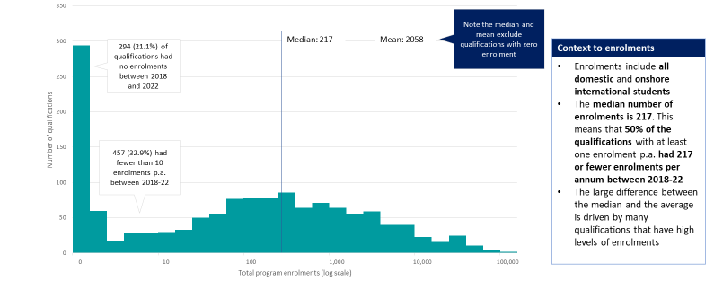
Source: DEWR analysis of NCVER 2023, Total students and courses 2022, NCVER, Adelaide.

Employers are increasingly dissatisfied with VET qualifications
Of employers who were engaged with VET in 2021, 67.7 per cent were satisfied with all forms of VET engagement, which is down from 73.1 per cent in 2013 (Figure 7). Of those employers that were dissatisfied, the top reasons for dissatisfaction were that the training is of a poor quality or low standard (50.6 per cent), relevant skills are not taught (46.5 per cent), and not enough of a focus on practical skills (31.5 per cent). This contrasts with relatively stable levels of student satisfaction.
Figure 7: Satisfaction with VET by employers and students, 2009-2019.
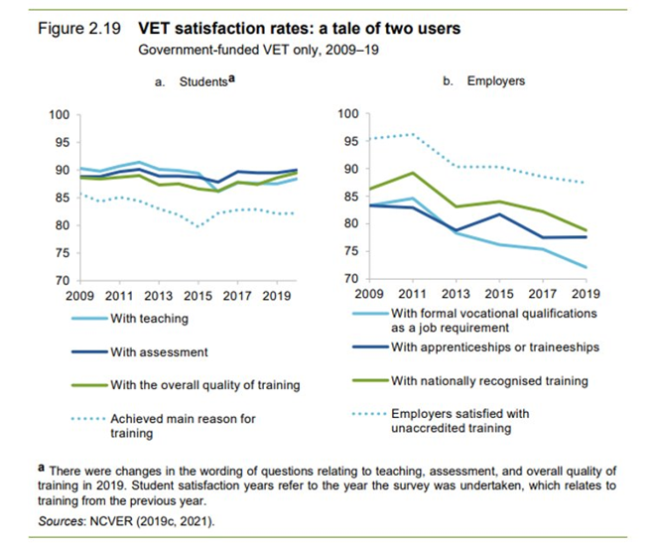

Attachment B – Details of the proposed new qualifications system
This attachment details the proposed principles-based, qualifications system that recognises the different purposes of training.

Principles
The Design Group has developed 6 Qualification Development Quality Principles to guide the cultural shift that needs to occur in qualifications design:
- ensure learners’ needs and aspirations inform qualification design, including transferability, transitioning occupations and industries, and mobility across industries;
- place equal importance on skill, knowledge, and application;
- allow flexible training and assessment in high-quality training environments;
- avoid duplication with other training products where industry context does not require it;
- reduce specificity except where a higher level of detail is required for licencing, high-risk, safety, regulatory or graduate quality reasons; and
- consider and integrate foundation skills, general capabilities, and knowledge progression.
These principles may be applied to development of new qualifications, or the rationalisation or revision of existing qualifications. The extent to which Quality Principles drive change will depend on each qualification model and the needs of industry in developing that qualification; for example, more change may occur in qualifications identified as meeting Purpose 2 or 3 than Purpose 1.
The intent of these principles is to shift away from a one-size-fits-all approach where every qualification is aligned to a specific occupation. Instead, JSCs will use evidence to better understand the relationship between qualifications and occupational outcomes and be empowered to build products that better suit industry and learner needs.

Purposes
Applying the principles will involve qualification developers first determining the purpose of the qualification they intend to develop. Three possible purposes have been identified. Each purpose can be applied to qualifications at any level of the Australian Qualifications Framework:
- Purpose 1 – qualifications leading to a specific occupation (for example a licensed trade)
- Purpose 2 – qualifications that prepare learners for multiple occupations within an industry
- Purpose 3 – qualifications that develop cross-sectoral or foundation skills and knowledge which may be applied across industries, or lead to tertiary education and training pathways.
Application of the 3 purposes will depend on their perceived usefulness in achieving the goals of reform. Potential for the 3 purposes to achieve Ministers’ goals for the VET system is outlined below.

- The 3 models will improve workforce adaptability while maintaining safety and quality
The purpose-driven approach enables industries to retain qualifications that are working well and linked to specific occupations (Purpose 1). This is especially important for licensed occupations, or where a clear need exists for specific qualifications to meet safety or regulatory requirements.
At the same time, the 3 models will challenge industry to think about new ways of designing and organising qualifications that are not directly linked to specific occupations or licensing requirements, that deliver broader capabilities for individuals and employers, and which better leverage the educational capability of TAFEs and other high quality providers.
- Purpose 1 qualifications maintain the status quo in industries that rely on specific qualifications to deliver specific skills and knowledge for an occupation, especially to meet regulatory or licensing requirements.
- Purpose 2 qualifications encourage tripartite collaboration within industries to identify more efficient, adaptable ways to deliver the skills required industry-wide. Application of this purpose will vary across industries, informed by mapping of industry-wide skills pathways and needs.
- Purpose 3 qualifications encourage innovative thinking about economy-wide skills or knowledge needs, moving beyond specific competencies or occupations, that supports labour market participation and pathways to further study.
- The 3 models will deliver a higher-performing, easier-to-navigate VET qualifications system
The purpose-driven approach is designed to ensure qualifications are designed to reflect the needs of industry and learners, rather than being forced into a single approach. This will support improved performance of qualifications, and reduce overspecification within qualifications that contributes to their proliferation.
Designing qualifications that better reflect the needs of industry and learners, particularly those designed to deliver a broader capability to industry, will benefit employers by improving the likelihood that qualifications will be delivered (by reducing pressure on providers to stretch resources across multiple qualifications); and by increasing the number of students enrolled in each course. Broader capabilities will enable more employers and industries to gain direct benefit from VET delivery by increasing the number of people with relevant transferrable skills. It will also benefit learners by making the system easier to navigate by offering fewer, better choices.
- Purpose 1 qualifications will remain highly specified, and will not be subject to rationalisation where there is a clear need to retain them. As industries make more use of Purpose 2 and 3 qualifications, Purpose 1 qualifications will become a smaller proportion of VET offerings overall.
- Purpose 2 qualifications create scope for rationalising qualifications within an industry in a way that improves intra-industry workforce mobility. This may involve consolidating entry-level qualifications with significant overlap, or higher-level qualifications with industry-wide relevance.
- Purpose 3 qualifications address cross-cutting skills and knowledge relevant across many industries, providing versatile products for use by many different learners and employers.

- The 3 models will support innovation and excellence in training delivery and assessment
The purpose-driven approach invites new ways of thinking about how the design of qualifications shapes delivery by VET providers and the learning experience for students. It encourages a shift away from a narrow model of competency-based training based on specification of discrete tasks, towards broader possibilities for combining skills and knowledge and applying them in different contexts.
This approach will enable a broader, more holistic, approach to competency-based assessment and an opportunity for training providers and schools to have a higher level focus on concepts, principles and underpinning skills training.
- Purpose 1 qualifications can be delivered using the existing competency-based training model, as they are likely to remain focused on discrete tasks associated with a specific occupation.
- Purpose 2 qualifications encourage a focus on the standard of skills and knowledge required across an industry rather than the performance of specific, discrete tasks. They may require new approaches to assessment that enable skills and knowledge to be applied in different contexts.
- Purpose 3 qualifications encourage a focus on the skills and knowledge that a qualification develops, with flexibility in the context of application. They may require evolution of qualification design beyond the current competency-based model towards a focus on learning outcomes.

Table 1: The 3 purpose-driven models of VET qualifications – attributes, benefits and issues
 | Purpose 1 models | Purpose 2 models | Purpose 3 models
Attributes | Qualifications leading to a specific occupation (for example licensed trade).  Built around specific tasks, with a high level of prescription to support safety or technical requirements. | Qualifications that prepare learners for multiple occupations within an industry.  Built around a common core of skills and knowledge for the industry, with optional specialisations. | Qualifications that develop cross-sectoral or foundation skills and knowledge which may be applied across industries, or lead to tertiary education and training pathways.  Built around general skills and knowledge, or specific skills and knowledge with cross-sectoral applicability.
Benefits | - Preserves qualifications with clear labour market outcomes  - Ensures safety and regulatory requirements are upheld | - Improves transferability and mobility within an industry  - Supports setting of ‘industry standard’ knowledge and skills  - Drives strategic reduction in total number of qualifications  - Increases the likelihood that qualifications are delivered  - Encourages innovation in delivery and assessment | - Delivers skills and knowledge for an agile future workforce  - Drives more learner-centred delivery and assessment  - Develops foundation skills to build equity and productivity  - Supports pathways into and equity with higher education
Issues | - High level of specificity limits transferability and mobility  - Task-based design risks ‘tick box’ approach to delivery | - Requires collaboration across industries (and possibly JSCs)  - Needs careful consideration of industrial relations issues  - Creates pressure to redefine outcomes-based assessment  - Requires discipline to avoid lengthy lists of electives | - Requires collaboration across JSCs and require additional educator and technical expertise [may not be JSC led]  - Challenges current unit of competency approach  - Requires appropriate quality assurance to ensure value
Example | Qualifications tied to specific job roles:  - Motor mechanic - Cert III in Light Vehicle Mechanical Technology  - Visual Merchandising – Diploma or Advanced Diploma of Visual Merchandising | Qualifications for an industry:  - Retail industry – Cert III in Retail  - Certificate III in Individual Support | Qualifications with cross-sector and pathways applications:  - Cert II in Retail  - Cert II in Applied Digital Technologies  - Diploma of Leadership and Management

Stakeholder views on the feasibility of the approach
The proposed new qualifications system, purposes and Quality Principles have been discussed with representatives from JSCs to gauge how they may support a more differentiated approach to training development and help address some of the challenges facing VET qualifications.
Initial feedback acknowledged the flexibility it may provide for VET qualifications to better reflect the different needs of diverse stakeholders across the sector. It allows for targeted change to qualifications which are working well, while providing new models of qualifications for entry and progress within an industry across many occupations and to develop qualifications and units that have a more universal application across VET.

Attachment C – Next steps

Towards a roadmap for qualification reform
The proposed reform model for VET qualifications represents a fundamental change in the way the VET sector approaches qualification development. It has flow-on effects through all levels of the VET system, from the guiding vision for the VET sector to the details of implementation and delivery.
Not all elements of a complex ecosystem can be considered at once. A staged roadmap for implementation of the new qualifications system and models is therefore required. This involves building momentum through 2024 towards embedding new models in 2025 and beyond.
Systemic change in VET requires a collaborative approach. The establishment of JSCs, underpinned by strong tripartite governance and engagement, and the capability these organisations have already developed, provide new opportunities to drive this reform and ensure it delivers for VET students, industry and educators. Stakeholder contributions and a commitment to iteration and learning will also build confidence in the reform and identify specific implications for different industry sectors.
By end 2024, a proposed timeline for longer-term qualification reform will be delivered to Ministers to embed a new organising logic for VET qualifications and any necessary updates to the TPOF.
Advice to Ministers will be informed by the following processes to occur in 2024 (detailed below):
- Trialling and application of the proposed new qualifications system by JSCs
- Analysis and consultation on related issues by the Design Group to support JSCs’ work
- Leveraging relationships with concurrent VET reform, including any AQF revisions.
DEWR with advice from SSON and Jobs and Skills Australia will provide advice to support JSCs in delivering on reform objectives, alongside the ongoing support provided by the Design Group.

Trialling and application of the proposed new qualification system by JSCs
The Design Group has identified action learning as a co-design methodology that JSCs can use to ensure that qualification purposes and principles are developed iteratively and collaboratively. Action learning involves applying new knowledge to a collaborative task, reflecting on successes and issues, then refining the approach. It will enable JSCs to identify any changes required to meet the training needs of their sectors and inform feasibility of implementation of reform.
JSCs will be asked to apply the purposes and principles to their work in the following ways, supported by guiding documents developed by the Design Group:
- Initially, JSCs will be asked to map, at a high level, their training products (qualifications, skill sets and units) to one of the 3 defined purposes. This will require data and evidence, combined with industry intelligence and judgement to consider the relationship between qualifications and employment, and any potential to improve learning pathways for students. It will also require consideration of what constitutes a high-performing qualification, with measures of success to be developed by the Design Group mapped to the Quality Principles.
- A suite of demonstration projects will also commence as first movers on qualification reform, involving JSCs producing a small number of training product updates that address issues identified through JSC Strategic Workforce Planning, particularly NSA priorities. These projects will draw on industry and educator expertise in qualification design, and state and territory government advice on their respective priorities for funding and resourcing.
This process may elicit opportunities for JSCs to reduce unnecessary prescription and duplication, leverage learning design expertise from educators, identify skills relevant across occupations or industries, or develop approaches that provide for more flexible training and assessment.
Consistent with Skills Ministers’ directive to retain Units of Competency, these projects would utilise current Unit of Competency templates to the extent possible – however may suggest potential changes to templates or other areas of the TPOF where these are creating barriers to reform.
As these training products are developed JSCs will also be asked to identify any other factors which may impact their successful implementation. This may include intersections with RTO standards and regulatory approaches, barriers to credit transfer and recognition of prior learning, funding barriers or inhibitors, or intersections with other training products such as accredited courses.

Analysis and consultation on related issues by the Design Group
The work of JSCs in trialling and refining the purpose-driven approach will be complemented by ongoing Design Group work to explore the complex issues associated with qualifications reform and support JSCs to navigate them. Accessing specialist advice and engaging with those organisations which leverage the qualifications system for important economic outcomes is critical in this next stage of work.
Specific issues that will require further exploration in 2024 include:
- Assessment
Competency, as an outcomes-based education model, affords system administrators flexibility on specifying education inputs and modes with the assurance that assessment ultimately tests the quality of the input. Equally, assessment is the key promise of VET to industry of the skills of the graduate.
However, qualification developers concerned with quality delivery have inserted input controls and heavy assessment requirements which compromise the intent of the outcomes-based education model and stymie learning and engagement. A move to address the flaw in qualifications by reverting to a standards approach and placing more trust in providers to frame good learning presents implementation risks.
The proposed new purpose-driven qualification model calls for different assessment approaches that better reflect the knowledge attributes of qualifications and are more attuned to assessing learning, not just performance which is the key attribute of competency-based training. Detailed analysis of assessment options and implications for the sector will both inform and be informed by the JSC action learning process.
- Industrial Relations
The Industrial Relations (IR) system and VET interact where nationally recognised qualifications are referenced in awards or agreements to provide for minimum qualification requirements for entry, or particular pay rates for employees that are subject to a certain level of qualification attainment.
Drawing on expertise and understanding of how any changes to the design of qualifications will flow to or impact on awards is a key design consideration, which will in-turn inform the model and implementation of reforms.

- Funding
In VET, each jurisdiction is responsible for its own funding policies, where to prioritise its subsidies, and how much to ultimately spend based on jurisdictional priorities. This creates the risk of disconnect between training product development and state and territory funding decisions, leaving relevant qualifications unutilised. The Design Group, in conjunction with JSCs, will work with state and territory governments to explore implementation issues for states and territories.
- Foundation skills
Foundation skills are vital for meaningful participation in the economic, social and cultural domains of contemporary Australian life. However, the system supporting foundation skills in Australia is fragmented and there are variations in approaches and practices, and limited outcomes measurement, research, and evaluation.
While supports for foundation skills exist within the current process for qualification design, these are not operating effectively across the VET system:
- The Training Package Products Policy requires that Training Packages must explicitly include and describe the foundation skills within the Training Package. However, the application of the policy by training product developers differs, and in practice, foundation skills are inconsistently described in units of competency.
- The Foundation Skills (FSK) Training Package was designed to be primarily delivered by importing FSK units of competency into other Training Packages to support learner achievement of vocational pathways. This is because they do not have a specific vocational outcome and industry context is provided through packaging these units with industry specific units. However, the uptake of FSK units are mostly in FSK qualifications themselves rather than in industry specific qualifications.
Further work will be required during 2024 to work through the different alternatives for improving foundation skills in VET qualifications and any consequential impacts on the development of different types of qualifications. This will require drawing on specialist expertise to inform necessary changes to VET qualifications design.

Leveraging relationships with concurrent VET reform
Opportunities exist to leverage and enhance related VET reforms, particularly:
- the commencement of the NSA from January 2024 and collaborative stewardship model.
- the establishment of TAFE Centres of Excellence
- the introduction of the revised Standards for RTOs from mid-2024 which will help underpin quality throughout the VET system, alongside the VET Workforce Blueprint.
Alignment with these reforms will likely provide opportunities for demonstration projects from 2024 and would support innovation in the design and delivery of qualifications reform. For example:
- VET quality reforms – the new Standards for RTOs and self-assurance model from ASQA offer enhanced VET quality assurance levers beyond specifying additional requirements within training package products. The differentiated models in the proposed new qualifications system could complement differentiated, risk-based approaches to provider and course regulation.
- VET workforce reforms – the differentiated qualification models could also support greater diversity in our training workforce to boost the supply of trainers and assessors.
- Australian Qualifications Framework - while there are diverse views from across the sector in relation to the review of the AQF, the interim report from the University Accord Review Panel recommended progressing reform in this space. Maintaining awareness of developments and subsequent implications and opportunities will be essential during the next phase of VET qualification reform.
The Design Group will pursue relationships with relevant reform as qualification reform progresses, contributing to a more strategic discussion on the nature of Australia’s VET training market.
A strong evidence base that can assist JSCs in this work will also be critical. There has been positive engagement between Jobs and Skills Australia and JSCs during 2023 as these organisations have been developing their capability and approaches. This engagement should continue, alongside the Design Group’s ongoing work, with a clear goal during 2024 being the development of agreed data sets and methodologies to identify the flows of individuals between qualifications and occupations, the shared skills and knowledge between occupations, and to explore further opportunities for collaboration and reform. This will require continued work to refine and validate the Australian Skills Taxonomy, as an additional tool to assist in identifying potential career pathways.

Attachment D – Typology of Qualifications
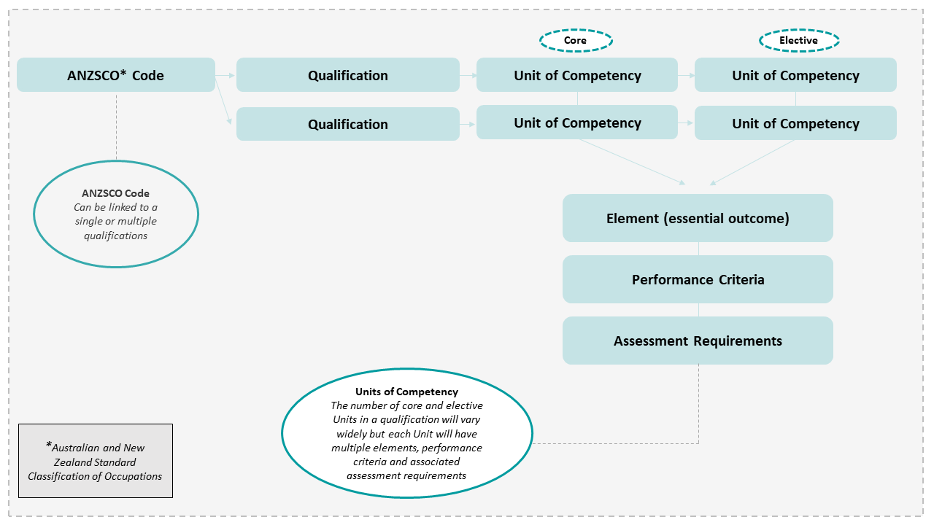

Attachment E – How we got here and what it means for today’s VET qualifications

A 40-year history
The Design Group discussed the importance of understanding the history of how Australia has arrived at our current system of VET qualifications.
The Design Group noted that during the 1980s, Australia’s VET system was characterised by a TAFE-led model, with national core curricula and a system of classifications of TAFE courses. However, the global industrial, technological, and economic landscape was changing, and numerous reviews highlighted the need for structural adjustment.
The seminal document, Australia reconstructed, defined an approach to integrate employment, education and training programs, and led to the 1988 national wage case that related wage gains and career progression to skills acquisition through training or recognition of prior learning. A subsequent document, A changing workforce, described how the newly established relationships between education and award restructuring could reshape participation in education, the workforce and the community. Many of the features of our current VET system including competency-based training, industry-based provision, and a single qualification to a single occupation, originated during this period.
In 1990, work began on the development and approval of industry-specific ‘competency standards’, mainly for the traditional trades. Eventually the approach was extended to all VET occupations and a new system of entry-level training arrangements to all industries was achieved. Born out of this was the concept that every VET occupation in every industry required codification into the competency-based model.
Training packages, which consist of units of competency that specify the standard of performance required in the workplace packaged into qualifications aligned to the Australian Qualifications Framework (AQF), were first introduced as a concept in 1996. The concept of competency adopted in Australia focused on the consistent application of knowledge and skill to the standard of performance required in the workplace. The first Training Packages were endorsed the following year in 1997.
The Design Group agreed that tripartism was the bedrock of these arrangements, acknowledging the need for employer and union involvement in responding to Australia’s workforce needs and developing more relevant training. While competency standards were initially developed by state training advisory boards, in the 1990s national industry councils began to determine the content of training and the form it would take, while RTOs and teachers/trainers provided the pedagogical expertise to deliver and assess the skill development industry required. This approach has remained a defining and respected characteristic of Australia’s VET system.
While the system of VET qualifications is broadly similar to the 1990s, the VET market has distinctly changed. There has been a shift away from the TAFE-centred focus of the 1980s and a growing diversification of training providers with over 4,000 RTOs delivering training today. VET qualifications are delivered on the job, in classrooms, or online by public, private, community and enterprise RTOs in a dynamic VET marketplace.

What this means for Australia’s current VET qualifications system
The Australian approach to competency-based training can be task-focused, compared to many countries which are broader in their focus, including more personal or non-technical competencies. While today’s system of VET qualifications has moved beyond occupational standards of the 1990s, key foundational concepts remain:
- the notion that skills are not seen as of equal value as knowledge (for example through the AQF),
- the binary assessment of an individual as competent or not yet competent ,
- the need to codify every skill in every VET occupation, regardless of whether training is required,
- the industry develops the standards while RTOs train and assess,
- the focus on describing tasks rather than describing understanding.
The Design Group observed that the application of this approach has led to unintended outcomes, and does not adequately meet the increasingly complex needs and use cases for today’s VET system. The Design Group also recognises that the history of VET qualifications is nuanced across different industries, and that reforms must learn from successes as well as addressing emerging concerns.

Glossary
Qualification reform elements | Description
Accredited course | An accredited VET course is:  - a structured sequence of training developed to meet training needs that are not addressed by existing training packages or developed for regulatory reasons;  - a course accredited by the national VET regulator or by a delegated body of the national VET regulator, and  - a course that has been assessed by ASQA as compliant with the Standards for VET Accredited Courses 2021 and the AQF.
Competency | The consistent application of knowledge and skill to the standard of performance required in the workplace. It embodies the ability to transfer and apply skills and knowledge to new situations and environments.
Foundation Skills | English language, literacy, numeracy and digital literacy skills and employability skills.  Foundation skills must be explicit and recognisable within the training package, and must reflect, and not exceed, the foundation skills required in the workplace. Foundation skill requirements, where not explicit in the performance criteria, must be stated in the ‘Foundation Skills’ field of the unit of competency template. Foundation skills are an integral part of a unit of competency and need to be assessed by the RTO.
Mobility | Mobility is used in this report in the context of the labour market. It refers to an individual changing employer or business, industry sector or occupation.
Purpose of qualifications | The process of Jobs and Skills Council’s determining the reason for which a qualification is required, to inform qualification design.  The Design Group is proposing a purpose-led model for qualification design, with the following three purposes:  - Purpose 1 preserves a level of specificity necessary for safety or licencing requirements, particularly the integrity of the trades, and is unlikely to change substantially from the current approach.  - Purpose 2 focuses on the development of qualifications that prepare students for multiple, related occupations while retaining industry relevance.  - Purpose 3 provides additional opportunities for innovation in areas such as cross-sectoral skills, foundation skills and tertiary pathways.
Pathway | A path or sequence of learning or experience that can be followed to attain competency and qualifications.
Qualifications | Formal certification that is awarded by an accredited authority in recognition of the successful completion of an educational program. In the vocational education and training (VET) sector, qualifications are awarded when a person has satisfied all requirements of the units of competency or modules that comprise an AQF qualification, as specified by a nationally endorsed training package or an accredited course that provides training for that qualification.
Qualification Development Quality Principles | Once a Jobs and Skills Council has determined the Qualification Purpose, these proposed principles should guide the development of training products.  The Design Group proposes the following Quality Principles:  - ensure learners’ needs and aspirations inform qualification design, including transferability, recognition of prior learning and credit transfer, and mobility across industries where possible,  - place equal importance on skill, knowledge, and application,  - allow flexible training and assessment in high-quality training environments,  - avoid duplication with other training products where industry context does not require it,  - reduce specificity except where a higher level of detail is required for licencing, high-risk, safety, regulatory or graduate quality reasons,  - consider and integrate foundation skills, general capabilities, and knowledge progression.
Skills | Skills refer to what a graduate can do. They can be described in terms of kinds and complexity and include cognitive skills, technical skills, communication skills, creative skills, interpersonal skills and generic skills
Skill sets | Are not qualifications and are defined as single units of competency, or combinations of units of competency from endorsed training packages, which link to a licensing or regulatory requirement, or a defined industry need.  These are identified in the National Training Register (www.training.gov.au) by the inclusion of ‘SS’ in the unique code (ie TLISS00102 – Access and Move a Track Vehicle within a Defined Worksite Skill Set).
Specialisations | Elective units of competency that relate to a specific focus area can be combined into ‘Groups’, which can be used to provide a qualification with a Specialisation/s that is included on the appropriate AQF certification documentation. For a Group to be a Specialisation, the training package developer must: provide the name of the Specialisation/s; and indicate how many units of those listed in the Group are required to be completed to meet the Specialisation.
Standards for RTOs 2015 | The purpose of the Standards is to:  - describe the requirements that an organisation must meet in order to be an RTO in Australia  - ensure that training delivered by RTOs meets industry requirements (as set out in training packages and accredited courses) and has integrity for employment and further study  - ensure RTOs operate ethically and consider the needs of both students and industry.  Note: The Standards are currently being revised with the aim of providing greater clarity for RTOs and regulators, strengthening the focus on quality outcomes for learners and employers, and allowing for more flexibility and innovation in training delivery (see Quality Reforms - Department of Employment and Workplace Relations, Australian Government (dewr.gov.au)).
Training packages | Specify the knowledge and skills required by individuals to perform effectively in the workplace, which are expressed in units of competency. Training packages detail how units of competency are packaged into nationally recognised and portable qualifications that comply with the AQF.
Training Package Organising Framework (TPOF) | Owned by Skills Ministers, TPOF comprises the:  - Standards for Training Packages ('the Standards’) – set the overarching design and development requirements of training products for endorsement by Skills Ministers.  - Training Package Products Policy (TPPP) – outlines the design rules that must be adhered to when developing or modifying a training product.  - Training Package Products Development and Endorsement Process Policy (TPPDEPP) – outlines the process for developing and seeking the endorsement of training products.
Transferability | Skills that can be applied to different jobs, occupations and industry settings.  Transferable skills enable labour market flow between industries, sectors and occupations and could minimise duplication of units in the training system.  Note: Transferability may also be considered in the context of an individual’s ability to transfer to other jobs, occupations and industry settings.
Units of competency | The specification of the standards of performance required in the workplace as defined in a VET accredited course or Training Package.

Attachment A, Figure 1
Attachment A, Figure 2
Attachment A, Figure 7
Attachment A, Figure 3
Attachment A, Figure 4
Jobs and Skills Councils Program Guidelines
Working Future: The Australian Government’s White Paper on Jobs and Opportunities, p2
National Skills Commission, Skills Priority List Key Findings 2022
Australian Bureau of Statistics, Education and Work, Australia May 2022
Walker, I, (2023) After the ATAR 4, Year13, Australia.
Based on ANZSCO skill level definitions of the occupations
Osborne, K & Serich, C 2020, Exploring the recognition of prior learning in Australian VET, NCVER, Adelaide.
www.training.gov.au
Vocational education and training - Report on Government Services 2023, Productivity Commission
Australian Council of Trade Unions & Trade Development Council, Australia reconstructed, ACTU/TDC mission to Western Europe report, 1987
Dawkins, JS, Skills for Australia, Australian Government Publishing Service, 1986.
Bowman, K & McKenna, S, The development of Australia’s national training system: a dynamic tension between consistency and flexibility, NCVER, 2016
A basic typology of VET qualifications is at Attachment A
Misko, J and Circelli, M, Adding value to competency-based training, NCVER, 2022
Training.gov.au data indicates 4,088 current providers as of 1 December 2023.
Misko J, Circelli M 2022, Adding value to competency-based training. NCVER, Adelaide
Zoellner, D.L., If Vocational Education and Training is the answer, what was the question? Theorising an Australian machinery of population control, 2013.

