

We acknowledge the Traditional Owners and Custodians of
Country throughout Australia and acknowledge their continuing
connection to land, water, and community. We pay our respects
to the people, the cultures and the elders past and present.
We acknowledge First Nations custodianship of 65,000 years
of knowledge, skills and learning systems.



© Commonwealth of Australia 2025
The material in this document is licensed under a Creative Commons Attribution—4.0 International license, with the exception of:
- this department’s logo
- any third party material
- any material protected by a trade mark, and
- any images and/or photographs.
More information on this CC BY license is set out at the creative commons website: www.creativecommons.org.
Enquiries about this license and any use of this document can be sent to: copyright@dewr.gov.au.
Use of all or part of this document must include the following attribution: © Commonwealth of Australia 2025

Contents
Section 1 6
Skills and Workforce Ministerial Council Foreword 6
Section 2 8
What’s in the 2025–26 edition of the National Skills Plan 8
Section 3 11
Context: Australia’s skills and training landscape 11
Section 4 15
Delivering on Australia’s Skills Needs: The National Skills Agreement 15
Section 5 25
National Priorities 25
Gender Equity 27
Closing the Gap 30
Supporting the Net Zero Transformation 34
Sustaining Essential Care Services 38
Developing Australia’s Sovereign Capability and Food Security 42
Ensuring Australia’s Digital and Technology Capability 46
Delivering Housing Supply 50
Delivering reforms to improve the regulation of VET qualifications and quality 56
References 61

4 Skills and Workforce Ministerial Council




Building a skilled
Australia through
Vocational Education
and Training

Endorsed by:

The Hon Andrew Giles MP
Minister for Skills and Training

Michael Pettersson MLA
Australian Capital Territory
Minister for Skills, Training and Industrial Relations

The Hon Steve Whan MP
New South Wales
Minister for Skills, TAFE and Tertiary Education

The Hon Jo Hersey MLA
Northern Territory
Minister for Education and Training

The Hon Rosslyn Bates MP
Queensland
Minister for Finance, Trade, Employment and Training

The Hon Blair Boyer MP
South Australia
Minister for Education, Training and Skills

The Hon Felix Ellis MP
Tasmania
Minister for Skills and Jobs

The Hon Gayle Tierney MLC
Victoria
Minister for Skills and TAFE

The Hon Amber-Jade Sanderson MLA
Western Australia
Minister for Skills and TAFE

Section 1

Skills and Workforce Ministerial Council Foreword

Vocational education and training (VET) plays a critical role in driving Australia’s productivity, enabling inclusion, opportunity and economic equality, and ensuring Australia has the skilled workforce it needs to help navigate major workforce transitions within a changing economy.

Skills and Workforce Ministers are pleased to provide Australia’s second National Skills Plan, developed under the 2024–2028 National Skills Agreement. This 2025–26 Plan advances our shared stewardship of the national VET system and commitment to meaningful and lasting reform to deliver accessible, high-quality and responsive education and training.

Since the publication of the inaugural National Skills Plan in 2024, key elements of the National Skills Agreement have been implemented and are delivering early benefits. With our VET system partners, governments have finalised implementation plans for reforms to strengthen the system, including to establish:
- 14 TAFE Centres of Excellence to support innovation and excellence in areas of national priority;
- the National Foundation Skills Strategy 2025–35, which is helping Australians access foundational literacy, numeracy and digital skills; and
- a National TAFE Network to enhance the quality of teaching and learning in TAFEs and public providers at the heart of the VET system.
The Outcomes Framework, published in December 2024, will allow national progress to be measured and inform future action to address gaps and emerging needs.

The National Skills Agreement reflects our commitment to Closing the Gap through genuine partnership with Aboriginal and Torres Strait Islander people. Working with the Coalition of the Peaks through an Interim Partnership Committee, we are on track to establish a nationally-networked First Nations VET Policy Partnership and an Indigenous Centre for Vocational Excellence in the coming 12 months. Local partnership arrangements are also being embedded in each state and territory to ensure VET reforms align with local First Nations communities’ priorities and needs.

Progress under the National Skills Agreement has been complemented by a range of action to support and strengthen the VET system. Through initiatives such as the updated Training Package Organising Framework, the new 2025 Standards for Registered Training Organisations (RTOs) and Free TAFE, now a permanent feature of the VET system through the Free TAFE Act 2025, we are expanding access to relevant, high-quality education and training and strengthening RTOs to deliver that training. The Strategic Review of the Australian Apprenticeship Incentive System, delivered in January 2025, provides evidence and direction to strengthen collaboration between governments in delivering support for high-quality apprenticeships and traineeships that meet Australia’s skills needs.

The first National Skills Plan set out the vision for delivering on shared national priorities and identified early national actions. This 2025–26 Plan provides an update on the progress made and includes new actions to address gaps and ensure early progress is sustained.

VET plays an important role in driving productivity and economic reform. Through efforts to better match skills supply and demand and maximise inclusive and meaningful labour force participation, we can improve the resilience, growth, and capability of Australia’s economy. For the coming year, Skills Ministers have identified three areas of focus within the national priorities to ensure VET delivers on the outcomes of the recent Economic Reform Roundtable.
These are:
- supporting the upskilling of the workforce to maximise the productivity benefits of Artificial Intelligence (AI), drawing on Jobs and Skills Australia’s Gen AI Transition study and the work being done by Jobs and Skills Councils
- working with the newly formed Australian Tertiary Education Commission (ATEC) and Tertiary System Advisory Council to deliver a more joined up tertiary education system, to make it easier for students to move between VET and higher education and set up the system to support students to gain qualifications matched to Australia’s future skills needs, and
- ensuring training system capacity in national priority sectors is timely and aligned to demand, particularly for apprentices, including to support growth in the skilled workforce required to enable the net zero transformation and address housing and construction needs.
Skills and Workforce Ministerial Council,
December 2025

Section 2

What’s in the 2025–26 edition of the National Skills Plan

The National Skills Plan provides the strategic direction for achievement of the objectives of the National Skills Agreement and delivery of national priorities for the VET system.

The first National Skills Plan: Building a skilled Australia through Vocational Education and Training was published in September 2024. While the longer-term strategic direction and context set out in the first National Skills Plan remains the same, annual updates to the Plan will include progress in implementing the National Skills Agreement and delivering on early national actions for the national priorities, as well as new initiatives and priorities. This edition features updates on:
- Jobs and Skills Councils in section 3, including insights on the work conducted over the past year with a focus on achieving national productivity goals and cross-cutting workforce priorities
- Implementation of key elements of the National Skills Agreement including the shared stewardship model, publication of jurisdictional action plans, publication of the outcomes framework and progress in developing the balanced scorecard, in section 4
- Progress in design and delivery of policy initiatives under the National Skills Agreement, including TAFE Centres of Excellence, VET Workforce and the National TAFE Network in sections 4 and 5
- Progress on a range of complementary actions such as Mobile TAFE, Free TAFE and the Australian Skills Guarantee, in section 4
- Progress on the National Agreement on Closing the Gap priority reforms through co-designed initiatives and work towards the establishment of the National First Nations VET Policy Partnership and the Indigenous Centre for Vocational Excellence in 2026, outlined in sections 4 and 5
- The eight National Priorities and the new focus areas for the coming 12 months, in section 5. This section identifies new areas of focus relating to capacity building in VET to maximise the productivity benefits of AI adoption, increasing alignment of VET with higher education through a more joined up tertiary sector, and ensuring that training system capacity is timely and meets demand in national priority sectors.
A new feature in this year’s National Skills Plan is a set of state and territory case studies in section 5 to highlight local initiatives to address each of the national priorities.



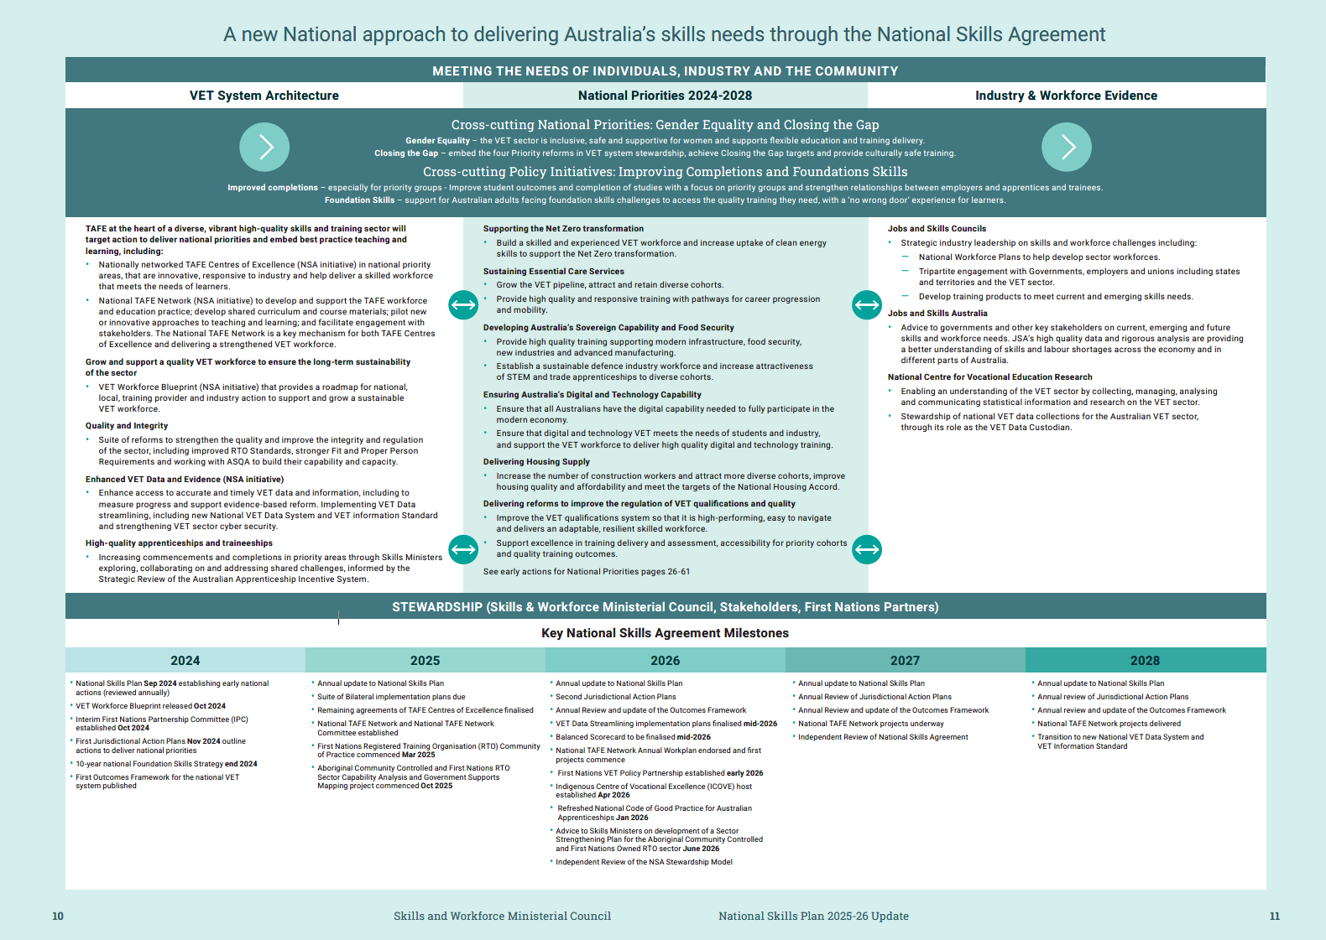

Section 3

Context: Australia’s skills and training landscape

A strong VET system is an essential national asset for our economy and communities.

Australia’s VET system has an important role to play in meeting the needs of industry, individuals and the community. The National Skills Agreement is a commitment to high-quality, responsive and accessible VET to boost productivity and support Australians to achieve the skills they need.

As the economy transitions to new industries and ways of working, the skills and capabilities of all Australians are a linchpin for productivity and for Australia’s ability to keep pace with the rest of the world.

To achieve these overarching ambitions, governments are delivering reforms that will:
- meet the demand for skills in critical industries
- increase the number of students completing VET qualifications, including by lifting access and support for students experiencing disadvantage
- incentivise young people and employers to engage in high-quality apprenticeships and traineeships within in demand sectors
- allow Australians to build new skills - upskilling and reskilling - over their working lives
- support adults with low foundation skills to access the training they need to participate in employment, further education and training and the community
- improve the capacity and capability of the VET workforce to deliver this education and training
- invest in infrastructure and technology to teach the skills needed in today’s and future workplaces
- be future focused with a robust evidence base to understand Australia’s skills and workforce needs
- embed genuine tripartite engagement between employers, unions and governments
- support genuine partnership with First Nations peoples on national policy and programs in VET to strengthen VET outcomes for First Nations learners, workers, communities, and employers.

TAFE at the centre of a diverse, vibrant high-quality skills and training sector that meets industry, student and community needs.

All Australian governments have agreed to support a high-performing and world-class VET sector with TAFE at the heart, in which TAFE:
- provides access to education and training to Australians from all walks of life
- is governments’ trusted training partner
- drives quality improvements across the VET sector
- innovates in teaching and learning practice
- is a centre of innovation that is responsive to industries and delivers a skilled workforce
- supports students to succeed
- supports Australians to train, upskill and retrain
- is an esteemed community asset.
Complementing TAFE is a vibrant and diverse sector of independent private and community providers. This includes those that operate in regional and remote communities, including Aboriginal Community Controlled and First Nations Owned RTOs that deliver culturally embedded and contextualised training with wraparound supports to meet the needs and aspirations of Aboriginal and Torres Strait Islander communities and students.

Delivery partnerships between the First Nations sector and TAFE and private providers also ensure learners are supported and can thrive in diverse educational settings.

The VET system is uniquely able to provide students with a combination of ‘on the job’ knowledge and training from teachers and trainers with industry experience. It offers students flexible learning arrangements and is being strengthened to better respond to and support students’ individual and changing needs.
Tripartite institutions to guide skills and workforce development.

The establishment of the tripartite Jobs and Skills Australia (JSA) and 10 Jobs and Skills Councils (JSCs) ensures integrated sector-specific and national strategic planning, evidence and analysis of Australia’s skills and workforce needs.

JSA has a crucial role advising governments and other key stakeholders on current, emerging and future skills and workforce needs. JSA’s high quality data and rigorous analysis are providing a better understanding of skills and labour shortages across the economy and in different parts of Australia, including regional Australia.

JSA’s annual work plan is also directed towards addressing Australia’s skills and labour market priorities. State and territory governments have the opportunity to contribute to these projects and draw on their findings.
JSCs are bringing together industry, government and training organisations to tackle and advise on workforce solutions for their sectors and as a national network. JSCs’ core functions include strategic workforce analysis and planning, training product development, implementation, promotion and monitoring of training strategies and industry stewardship.

In 2025, JSCs have each delivered their third workforce plan and collectively are working on more than 200 approved activities. This work is shaping practical workforce solutions and aligning training with real-world needs across broad industry groupings.

With over two years of operation under their belts, individual JSCs and the collective system have matured and are delivering tangible outcomes that align with the priorities of the National Skills Plan. Their work is underpinned by strong partnerships with government and JSA

As a collective, the JSCs have provided advice to government on key themes for strengthening the skills and training sector to achieve national productivity goals and are collaborating across the network to address cross-cutting workforce priorities such as sustainability and inclusion, including stronger participation and representation of First Nations peoples and advancing gender diversity across the workforce

JSCs are continuing to contribute to the strengthening of the VET workforce by identifying industry-specific barriers to attracting and retaining trainers and assessors and by continuing to lead the implementation of the qualification reform principles through ongoing training product development activities. Many of their initiatives are also bridging the gap between Hiher Education and VET systems through the development of hybrid training products.

There is a range of activity underway to tackle Australia’s productivity and growth challenges.

The VET sector is one of many contributors to meeting Australia’s economic and labour market needs. In addition to reform of the VET sector, Australian governments are working with stakeholders across the economy and community on complementary reforms to boost productivity and economic growth.

The importance of building a skilled and adaptable workforce was an area of consensus identified by the Australian Government’s Economic Reform Roundtable in August 2025, which brought together leaders from business, unions, civil society and government.

Other key national initiatives directed to these challenges include the Future Made in Australia agenda, the White Paper on Jobs and Opportunities, Working for Women: A National Strategy for Gender Equality, the Australian Universities Accord Final Report, the Better and Fairer Schools Agreement, the National Agreement on Closing the Gap, Australia’s Net Zero Plan, and the Migration Strategy.

Following the recommendations of the Universities Accord, the Australian Government has set an overall tertiary attainment target of 80% of the working age population by 2050. Achievement of this target would see the proportion of working age Australians with a Certificate III or higher qualification increase to 80% by 2050, up from 60% in 2023. Efforts to address Australia’s tertiary education needs will be led by the ATEC, which in August 2025 was tasked with developing a Tertiary Roadmap to deliver a joined up tertiary education system.


These national strategies complement local workforce, skills and training strategies and reforms underway across individual states and territories and described in their jurisdictional action plans

Section 4

Delivering on Australia’s Skills Needs: The National Skills Agreement

The landmark National Skills Agreement provides the foundations for reform.

In response to the challenges and opportunities facing Australia’s VET sector, National Cabinet agreed in 2023 to a new National Skills Agreement, replacing the previous intergovernmental funding arrangements with a renewed focus on co-investment, collaboration, planning and evidence-led reform.

The landmark National Skills Agreement commenced on 1 January 2024, with the objective of ensuring the national VET sector provides high-quality, responsive and accessible education and training to boost productivity, deliver national priorities and support Australians to obtain the skills and capabilities they need to prosper.

The National Skills Agreement provides states and territories with access to additional Commonwealth funds of up to $3.7 billion over 5 years, taking total Commonwealth funding to $12.6 billion over 5 years. The total combined investment by Commonwealth, state and territory governments will be more than $34 billion over this period.

Stewardship offers a new model for shared responsibility and collective vision for change.

The National Skills Agreement represents a fundamental shift in the way governments work together to address shared challenges and capitalise on shared opportunities through the VET sector.

A stewardship model of governance and planning is guiding action under the National Skills Agreement. Stewardship describes the intentional collaboration and engagement between governments – and with and between stakeholders – through a circular learning process for all parties guided by a shared vision for the sector and an agreed set of priorities. It is evidence-informed and founded on principles of transparency and continuous evaluation, shared learning and adjustment.

The framework for collaborative progress envisaged by the National Skills Agreement is illustrated in Figure 2 on page 61.


The National Skills Plan guides efforts across the VET system.

The National Skills Plan guides the work of all governments to deliver on the outcomes and shared national priorities set out in the National Skills Agreement.

The National Skills Plan is also a clear guide for employers, industry and the VET sector. It provides clarity on what Australian governments see as the key national priorities for the skills and training ecosystem and helps stakeholders plan and prioritise their own efforts to ensure the system is driving in the same direction. It also recognises that governments need to be informed, in turn, by the expertise and experience of stakeholders and that the cross-cutting nature of many challenges and priorities requires collaboration between stakeholders and across industries. Facilitating tripartite partnership between unions, employers and governments is a critical step to building investment in skills by all stakeholders.

Jurisdictional action plans outline local initiatives.
All governments have published inaugural jurisdictional action plans to detail their actions and ambitions to deliver on national priorities and outcomes, tailored to meet their local needs Jurisdictional Action Plans - Department of Employment and Workplace Relations, Australian Government. Together, the jurisdictional plans provide a clear picture of the individual and shared action being taken by all Australian governments to deliver on the objectives of the National Skills Agreement.

Population and system-level outcomes will guide effort and form the basis for measuring progress.
To drive progress in meeting the objectives of the National Skills Agreement, all governments have agreed to a suite of population and system-level outcomes. The outcomes are set out in Figure 2 on page 61.
Population outcomes, with a focus on growing productivity, are aimed at whole of economy considerations that are influenced by the VET sector, among a range of other factors and systems. System-level outcomes are aimed at areas where the VET sector has more direct control. Achieving system outcomes will help drive improvement in population-level outcomes.
A comprehensive Outcomes Framework to assess progress.
An Outcomes Framework National Skills Agreement Outcomes Framework - Department of Employment and Workplace Relations, Australian Government, the first of its kind for the VET sector, was published in December 2024 and will provide an assessment of progress against the nine outcomes identified in the National Skills Agreement. The Outcomes Framework will allow progress to be measured and action to be taken when gaps and shortfalls are identified.
Governments are working with JSA to develop a ‘balanced scorecard’ of national targets and indicators. A ‘balanced scorecard’ approach recognises the VET sector’s complexity, and will present progress against a range of indicators, targets and cohorts for each outcome at the national level to provide a view of the entire VET system.
There will be a continuous cycle of monitoring, evaluation and learning.
This National Skills Plan, Jurisdictional Action Plans and the national priorities are subject to an annual review cycle and feedback loop. This review process is informed by analysis and evidence from JSA, the NCVER and JSCs as well as monitoring through the Outcomes Framework. All governments will continue to seek input, advice and analysis from key stakeholders including the VET sector, industry, unions, and First Nations partners to ensure their actions address local needs and challenges whilst also contributing to national objectives.
The new approach will support delivery of the National Agreement on Closing the Gap priority reforms.
The national priorities and policy initiatives contained in the National Skills Agreement will support delivery of the priority reforms in the National Agreement on Closing the Gap, including through the establishment of a First Nations VET Policy Partnership and the Indigenous Centre for Vocational Excellence. In line with Priority Reform 1 of the National Agreement on Closing the Gap, the First Nations VET policy partnership will provide a formal partnership arrangement to ensure the full involvement of Aboriginal and Torres Strait Islander people in shared decision-making at a national level.
All governments recognise the importance of jurisdictional level First Nations partnership arrangements in delivering reforms that align with local First Nations communities’ priorities and needs. State and territory level partnerships with First Nations organisations and communities, including Aboriginal Community Controlled and First Nations Owned RTOs, have been embedded and will be enhanced through implementation plans for the Closing the Gap policy initiative.
The national priorities and policy initiatives also contribute to other Closing the Gap outcomes and targets such as economic participation, secure, appropriate and affordable housing and access to information and services to inform decision-making.



Policy initiatives provide an immediate springboard for addressing gaps and harnessing key learnings.

The National Skills Agreement provides $1.3 billion in funding for the policy initiatives shown in Table 1 on page 19.

Bilateral implementation plans for these initiatives have been developed between the Commonwealth, state and territory governments, their partners and stakeholders during the first 2 years of the National Skills Agreement. Finalised implementation plans are published National Skills Agreement | Federal Financial Relations.

The bilateral plans demonstrate a shared commitment to strengthen the VET system and to deliver on
national priorities, including:

- A focus on priority cohorts such as women, First Nations peoples, people with disability, culturally and linguistically diverse learners, and regional and remote communities through inclusive design and targeted programs

- Genuine, shared-decision making with First Nations peoples, through formal partnerships with a diverse range of community-led organisations. These vital relationships ensure accountability, transparency, and meaningful investment towards Closing the Gap priorities.

- Strengthening sectors such as clean energy, essential care services, housing, and national security through TAFE Centres of Excellence. These Centres are driven by innovation, applied research, and national collaboration so that training aligns with industry needs and workforce priorities

- Helping Australians access foundation skills in literacy, language, numeracy and digital skills domains, with a strong emphasis on a ‘no-wrong door’ experience for those seeking support and no-or low-fee access to training, and strengthening the Adult and Community Education (ACE) sector through targeted investments, including the delivery of blended and contextualised learning

- Attracting, upskilling, and retaining the VET workforce by directing funding towards workforce scholarships, professional development, mentoring and proficiency uplift for VET teachers and trainers
- Enhancing student support tools and services and enabling early identification of at-risk students for targeted intervention to support better student outcomes. This includes a focus on better course and career information, wraparound support, employer engagement, and ongoing evaluation of what works

- Ensuring sustainable implementation, continuous improvement, and effective knowledge sharing through the integration of evaluation frameworks, performance indicators, and regular reporting cycles.

Table 1 - Delivering on Australia’s Skills Needs: Policy Initiatives
Policy Initiative | What are we trying to achieve? | What will be delivered?
Closing the Gap | Improve outcomes  for First Nations  VET students  Deliver Closing the Gap commitments  for skills in full and genuine partnership with First Nations organisations | Partnership arrangements established between First Nations peoples and governments in each jurisdiction for engagement on and delivery of place based initiatives.  New funding to deliver Closing the Gap initiatives including:  - expanding investment in the capability, sustainability, and growth of the Aboriginal Community‑Controlled and First Nations owned training sector  - growing the First Nations VET workforce  - boosting cultural competency of mainstream RTOs  - boosting data and evaluation capability in the First Nations VET sector.  Partnership with First Nations organisations to scope the development of a Sector Strengthening Plan for the Aboriginal Community‑Controlled and First  Nations Owned RTO sector.  Ensuring overall National Skills Agreement funding maximises the experiences and outcomes of First Nations learners and communities.
Ensuring Access to Foundation Skills Training | Support for Australian adults facing foundation skills challenges to access the quality training they need to participate in further education and training, employment, and the broader community | A ‘no wrong door’ experience for learners in relation to foundation skills assessment and referral.  No or low‑fee access to training through VET and ACE, with additional funding for the ACE sector to support disadvantaged Australians learn in a more informal local community environment.  A 10‑year national foundation skills strategy to strengthen the quality and sustainability of the sector and funding for agreed actions arising from the strategy.

Policy Initiative | What are we trying to achieve? | What will be delivered?
Improved Completions – especially for priority groups | Improve student outcomes, including completion of studies, with a focus on priority groups ‑ First Nations students and women - and strengthen relationships between employers and apprentices and trainees | Trial, evaluate and scale initiatives to support students, enhance the ‘student voice’ and build shared knowledge nationally, providing a robust evidence base on effective, efficient, and scalable solutions to improve completions.  Refresh the National Code of Good Practice for Australian Apprenticeships, to promote best practice, and the resources for employers and their apprentices or trainees.
Measures to Strengthen the VET Workforce | Grow and support a quality VET workforce to ensure the long-term sustainability of the sector | Implement a VET Workforce Blueprint that provides  a roadmap for national, local, training provider and  industry action to support and grow a sustainable  VET workforce.
Enhanced VET Data and Evidence | Enhance access to accurate and timely VET data and information, including to measure progress and support evidence-based reform | Implement the VET Data Streamlining Program, including development of a new National VET Data System; transition to a new VET Information Standard; develop strategies and guidance to strengthen VET sector cyber security capability; and develop a medium to long‑term VET Data Reform Blueprint and Investment Roadmap.
TAFE Centres of Excellence | Through partnerships between TAFEs, industry, universities and governments, Centres of Excellence will be established to help deliver the skills needed for high‑potential and strategically important industries | Establish nationally networked TAFE Centres of Excellence, aligned with national priorities, that provide national leadership, innovative education and research, and address high priority skill needs.
Establishing a National TAFE Network | Foster collaboration between TAFE teachers and administrators to improve teaching and learning practice, and enhance the status of TAFE | Establish a National TAFE Network to develop and support the TAFE workforce and education practice, including developing shared curriculum and course materials; piloting new or innovative approaches to teaching and learning, and facilitating engagement with stakeholders.


National TAFE Network is an essential piece of architecture that complements and maximises the benefits of other National Skills Agreement initiatives, including TAFE Centres of Excellence and the VET Workforce Blueprint.

The National TAFE Network will deliver high-quality, nationally significant outcomes for learners and industry, and embed TAFE workforce leadership as a key activity to support TAFE at the heart of the VET sector. The National TAFE Network will create strong communities of practice focused on key topics and share curriculum, assessment, and learning resources to support TAFEs across the country. This collaboration will help TAFEs address national skills priorities and build the capacity to successfully scale innovative practices across jurisdictions.

Through its Coordination Hub, the National TAFE Network will provide a platform for engagement with TAFE Centres of Excellence, Jobs and Skills Councils, universities, employers, unions and other key stakeholders. This strengthened collaboration will ensure that TAFEs and public training providers are well-positioned to deliver training that aligns with industry needs and supports the objectives of the National Skills Agreement, including a more responsive, accessible, and high-quality VET system.

The foundations for the National TAFE Network are now in place, with the National TAFE Network Committee and Coordination Hub both established in 2025. The Network will continue to scale up its activities in 2026.

Governments will work together on broad objectives and through complementary action.

The National Skills Agreement outlines roles and responsibilities for governments to deliver on shared objectives and outcomes. In addition to delivering on this National Skills Plan, governments will work to:
- maintain a system of national regulation of VET that prioritises quality and best practice
- build connections and alignment across VET, the education sector including universities and schools, and other relevant systems
- share an agreed set of data on the training system and the labour market, with the NCVER as the custodian of national VET data collections and JSA holding a range of high-quality data and analysis on labour market and skills needs across the economy.
Governments are working together on a range of complementary actions to ensure the VET sector continues to provide the strong foundations necessary to support and unlock opportunities for learners and employers, including:
- Free TAFE: The Australian Government in partnership with states and territories is delivering over $1.5 billion in joint funding for over 500,000 Free TAFE VET places across Australia from 2023 to 2026. Between 1 January 2023 and 30 September 2025, Free TAFE delivered over 725,000 enrolments nationally. The Australian Government has made Free TAFE a permanent feature of the national VET system, investing over $1.6 billion through to 2034–35 to support at least 100,000 places per year from 2027, underpinned by the Free TAFE Act 2025. Places will continue to be prioritised to cohorts who typically face barriers to education and training and offered in fields of study in high demand and of national and state priority.
- Mobile TAFE: The Australian Government has committed to providing $31 million over five years from 2025–26 through to 2029–30 to deliver up to 12 Mobile TAFE projects nationally as part of the TAFE Technology Fund. Mobile training units will enable VET providers to take skills on the road and train the next generation of workers in remote communities. The Australian Government will work with states and territories to identify projects in partnership with First Nations organisations to meet local skills needs for remote First Nations communities.
- Qualification reform: In December 2024, Skills Ministers agreed to a new, purpose-led approach to VET qualification design, guided by principles to improve quality, simplify training package product design and reduce complexity. From 1 July 2025, the updated Training Package Organising Framework came into effect, embedding the new approach, including new and revised templates, with Jobs and Skills Councils leading phased implementation through training product development activities to ensure products are fit-for-purpose, relevant to labour market needs, and responsive to Australia’s labour market and economic needs.
- Quality reforms: a suite of reforms have been made to strengthen the quality and improve the integrity and regulation of the sector, including:
- commencement of the 2025 Standards for RTOs in July 2025 to support high-quality training delivery
- amendments to the National Vocational Education and Training Regulator Act 2011 to support the national VET regulator, the Australian Skills Quality Authority (ASQA), to take swift action to address integrity risks
- stronger Fit and Proper Person Requirements to support ASQA to respond to and remove non-genuine operators.
- Australian Skills Guarantee: the Australian Skills Guarantee Procurement Connected Policy sets national targets for apprentices and other ‘learning workers’ employed on Australian Government-funded major construction and ICT projects. It leverages the Australian Government’s purchasing power to help address skill shortages and gender segregation in the construction and IT sectors.
- In the 2025–26 financial year, targets for women working on major construction projects have increased by one percentage point to drive long-term sustainable change to increase gender equality and participation of women in the apprenticeship system.
- On 1 October 2025, the Skills Guarantee introduced set targets for apprentices, Learning Workers and women working on major ICT projects that will increase each financial year.
- High-value ICT projects with an estimated individual value of $50 million or more are also required to set and meet a more ambitious target for women and prepare a Gender Equality Action Plan outlining how targets will be achieved and sustained.
- Skills for Education and Employment (SEE) program: the SEE program helps participants build their reading, writing, maths and basic computer skills across metropolitan, regional and remote areas. Since 1 July 2024, all Australians aged 15 years and over who have left school, including those already in the workforce, are eligible for support. Additional investment has supported a range of initiatives, including:
- provision of accredited and non-accredited training to better support learner needs
- more support for learners to remain in training and achieve outcomes
- project funding to deliver more workplace-based training to support workers to maintain their employment or obtain career advancement
- The SEE program includes a specific stream of delivery for First Nations learners, communities and people that will fund place-based, whole of community projects to meet the community’s English language, literacy, numeracy and digital skills training needs.
- Investment in trusted VET data and digital infrastructure, including updating the National Training Register and VET data collection pathways, funded via the National Skills Agreement, will allow for more precise and timely data on vocational education registrations, training outcomes and transitions. This will create a stronger foundation of evidence to guide future policy development and government investment in the VET sector.


Strengthening the Apprenticeships system.

Apprenticeships represent VET in action, providing an opportunity to earn an income while gaining a nationally-recognised VET qualification through a combination of workplace and classroom training. Apprenticeships are also critical to meeting Australia’s skills needs, as a mandatory or preferred training pathway for key occupations in the net zero, housing construction and care sectors.

The Strategic Review of the Australian Apprenticeship Incentive System, released on 24 January 2025, made 34 recommendations to strengthen the apprenticeship system and ensure it meets the needs of the labour market, apprentices, and government. In response, the Australian Government announced targeted investments, including:
- Maintaining the 2025 Australian Apprenticeship Priority List while undertaking consultation on the longer-term methodology that underpins it.
- Extending the Australian Apprentice Training Support and Priority Hiring Incentive payments (both $5,000) by a further six months to 31 December 2025 for apprentices and employers in priority occupations.
- Revising the Australian Apprenticeship Incentive System to boost uptake in critical sectors by expanding the New Energy Apprenticeship Program into the Key Apprenticeship Program (KAP). The KAP now includes an additional Housing Construction Apprenticeship stream, offering up to $10,000 in financial support to eligible apprentices (in both streams) over the course of their apprenticeship.
- Increasing the Living Away From Home Allowance and Disability Australian Apprentice Wage Support (DAAWS) payment from 1 July 2025 and enhancing the DAAWS payment to include annual indexation and removal of annual review checks for apprentices with permanent disability.

These initial investments address the most urgent recommendations while longer-term reforms are considered.

Additionally, a new Australian Apprenticeship Support Services delivery model commenced on 1 July 2024. Delivered nationally by Apprentice Connect Australia Providers, the model offers improved wraparound support from commencement to completion, with strengthened assistance for First Nations apprentices, women in male-dominated trades, apprentices with disability, and those in remote areas

Section 5

National Priorities

Eight National Priorities are guiding the efforts of all governments and focusing the attention of all parts of the skills system.

The National Skills Agreement stewardship model supports governments to work collaboratively and purposefully towards a suite of agreed national priorities, while preserving flexibility for states and territories to meet local skills needs and support local communities.

Skills Ministers have agreed to eight priorities. This is the first time all governments have jointly agreed and will work to address challenges and entrenched barriers to the delivery of quality, responsive qualifications and skills in specific industries. Under the National Skills Agreement, all governments are required to show how they are addressing each priority through national collaboration and flexible local policies and program design.

This National Skills Plan sets out a snapshot of what is known about these priority sectors and cohorts; the enabling features of a strong VET sector; a stated future vision; some of the known drivers for change; and the actions that governments and others are taking to bring about change. This will evolve and be shaped by conversations with stakeholders including industry groups, education and training providers, employers, First Nations partners and informed by the expertise of JSA and JSCs.

The national priorities are reviewed annually, informed by national evidence and advice from individual governments on their skills needs and priorities.

For 2025–26, Skills Ministers have identified new areas for focused effort within the existing priorities. The adoption of AI, reforms to ensure a joined-up tertiary education system, and ensuring training capacity for apprenticeships and traineeships in key sectors will be areas of focus to support economic and community outcomes and help grow Australia’s productivity.

The eight National Priorities are set out at Figure 1 and expanded on in detail in the next section.

National priorities are areas that the Commonwealth, state and territory governments have agreed require focused collective effort to address critical skills and workforce shortages. They may relate to workforces, skills/capabilities, priority groups or national system reforms.


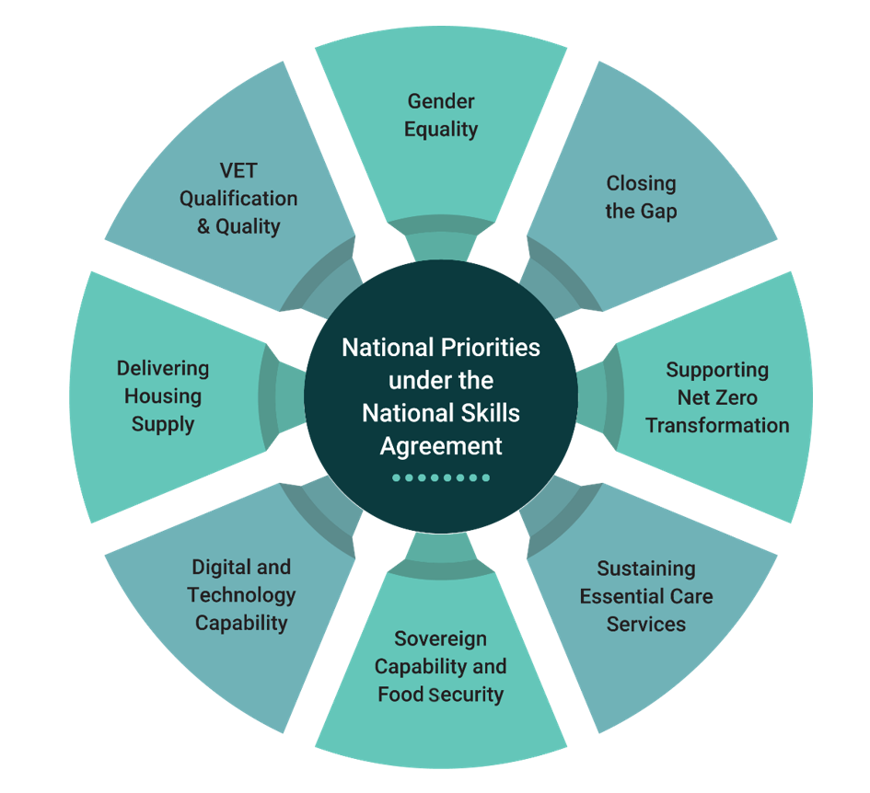
Figure 1 - National priorities for skills reform


National Priorities Under the National Skills Agreement

Gender Equity

What we know
While Australia ranks 13th in the world for gender equality in 2025, a significant improvement since 2023, gender segregation remains a critical issue for the VET system¹. In the VET system, the majority of students in training that leads to high paying occupations continue to be men, while women are the majority in training that leads to lower paying occupations.²

Key findings from the JSA Gender Economic Equality Study³ show that Skill Level 3 jobs, many of which offer an apprenticeship or traineeship pathway to a Certificate III/IV qualification, are the most gender segregated. Increasing the share of women in male dominated trades at this skill level will be important in addressing shortages, highlighting the importance of shifting gender segregation.

In addition, First Nations workers are more likely to work in highly gender segregated jobs.⁴

The gender segregation in training reflects similar imbalances in the workforce, driving skills shortages in both male and female-dominated occupations and industries.⁵ Fifty-four per cent of male-dominated occupations – that is, those where men make up at least 80% of the workforce (electricians, carpenters and construction trades workers), and 40% of female-dominated occupations (early childhood education and care and other healthcare and social assistance occupations) – were in shortage in 2023.⁶

Addressing gender inequality in the VET system is critical for women’s economic equality, security
and safety.

Ambitions for the VET sector
- The VET sector is inclusive, safe and supportive for women, free from gender-based discrimination, harassment and violence, including for women who face additional barriers due to disability, cultural background, socioeconomic status, and geographical location.
- Gender segregation in VET is reduced, particularly for education and training in gendered occupations.
- The VET sector supports flexible education and training delivery that allows students to balance personal responsibilities with their learning goals.

Drivers of change
- The student experience differs for men and women. Female students are more likely to cease training for personal reasons, whereas males are more likely to cease for a change in job circumstances.⁷ Student satisfaction with support services varies, at 60% for males and at 55% for females.⁸
- Women spend roughly 8 more hours per week on unpaid care and housework compared to men.⁹
- Elimination of gender-based violence and ensuring women’s safety in all environments – including work, study and home.

Key focus areas
- Providing innovative training opportunities to improve the flexibility of VET delivery.
- Offering additional support for women undertaking VET and employers of women apprentices and trainees, particularly in male-dominated sectors.
- Leveraging supports and targets to promote gender-sensitive, safe and inclusive placement and work environments.
- Delivering wraparound support for women undertaking VET (including apprentices) from enrolment through to completion and employment.

Progress on 2024 national actions
- In March 2025, a total of 20 partnership projects - 10 industry-led and 10 community-led - were announced under the Building Women’s Careers (BWC) Program. These projects aim to drive structural and cultural change to improve women’s access to flexible, safe and inclusive training and work opportunities in the key male-dominated industries and sectors of construction, clean energy, advanced manufacturing and digital and technology. A Community of Practice is supporting capability development and lessons learned across all partnership projects.
- The Australian Skills Guarantee Procurement Connected Policy leverages the Australian Government’s purchasing power to help address skill shortages and gender segregation in the construction and ICT sectors (see page 22, Australian Skills Guarantee).

New national actions
- Apprentice Connect Australia Providers deliver strengthened support for apprentices who are at the highest risk of non-completion. In the new model, commenced 1 July 2024, women in male dominated trades are a key client group offered specialised wraparound support.
- As of June 2025, 62% of Free TAFE enrolments are by women, which is helping to address financial barriers to participation in VET in fields of study of high workforce demand, emerging skills needs and of national or state priority.
- JSA’s Gender Economic Equality Study explores the gendered nature of work, education and skills and training in Australia, identifying evidence gaps and proposing policy solutions to address occupational gender segregation and gendered patterns in VET. The final paper was released in October 2025.
- Initiatives delivered by TAFE Centres of Excellence are supporting inclusion. For example, the TAFE NSW Manufacturing Centres of Excellence have launched free digital short courses to help employers support apprentices from diverse backgrounds, including a strong focus on supporting more women into traditionally male-dominated manufacturing roles, and are conducting an applied research program focused on supporting increased representation by equity groups, including women, in the manufacturing sector.

Gender segregation in VET is reduced, particularly for education and training in gendered occupations.

New South Wales: Driving women’s participation in construction
The NSW Department of Education, in partnership with Infrastructure NSW, has delivered two key initiatives under the NSW Women in Construction (WiC) Program to strengthen women’s participation and leadership across the state’s construction workforce.

Between 2023 and June 2025, two major initiatives — the Industry Innovation Program and the Women in Construction focused Infrastructure Skills Legacy Program (WiC ISLP) — supported industry to embed sustainable, gender-inclusive practices and demonstrate new ways of working.
National Skills Plan 2025-26 Update 30

The Industry Innovation Program allocated $5.9 million to 34 projects trialling innovative approaches to attract, retain and advance women in construction, including inclusive recruitment, flexible work design and leadership development. The WiC ISLP embedded 19 Project Officers across 23 major NSW Government infrastructure projects to trial new workforce participation targets — 4% of trade roles and 7% of non-traditional roles to be held by women. As of May 2025, participating projects were tracking at 4% against the 4% target and 6.3% against the 7% target.

Together, these initiatives have delivered enduring outcomes that support the national goal of increasing women’s representation in traditionally male-dominated industries.



National Priorities Under the National Skills Agreement


Closing the Gap

What we know
While First Nations peoples’ participation in VET is relatively high, their completion and employment outcomes remain lower than other Australians. The Closing the Gap targets related to the VET sector (Targets 5-7 below) are not on track to be met by 2031.¹⁰ VET is a contributor to educational attainment and economic participation and will help to close the skills and employment gaps for First Nations peoples. A significant proportion of First Nations people also have unpaid caring responsibilities, including kinship and cultural care, impacting on their ability to participate in education and training.

The Closing the Gap targets related to the VET sector (Targets 5-7 below) are not on track to be met.
- Target 5: By 2031, increase the proportion of Aboriginal and Torres Strait Islander people (age 20-24) attaining year 12 or equivalent qualification to 96%.
- Target 6: By 2031, increase the proportion of Aboriginal and Torres Strait Islander people aged 25-34 years who have completed a tertiary qualification (Certificate III and above) to 70%.
- Target 7: By 2031, increase the proportion of Aboriginal and Torres Strait Islander youth (15-24 years) who are in employment, education or training to 67%.

Ambitions for the VET sector
- Governments to focus efforts to embed the four Priority Reforms within, and achieve Closing the Gap targets relating to, the VET sector and VET system stewardship.
- First Nations people inform how the VET system works for them, including through genuine partnership arrangements.
- Training is culturally safe and appropriate for First Nations students.
- Cultural expertise of First Nations people, communities and organisations is recognised, valued, and informs VET delivery to First Nations students.

Drivers of change
- Since 2016, rates of completion of qualifications at Certificate III level or above among First Nations people have increased. However, completion rates are comparatively higher in major cities, and lower in regional areas. Completion rates decline as remoteness and location disadvantage increase.¹¹
- As the education level of First Nations people increases the employment gap between First Nations peoples and other Australians closes, with First Nations peoples being 23 percentage points less likely to be employed compared to non-Indigenous Australians with year 10-11 attainment, narrowing this employment gap to 12.7 percentage points with a Certificate III or IV.¹²

Key focus areas
- Establishing partnerships with First Nations organisations, including place-based partnerships between TAFEs and Aboriginal Community-Controlled and First Nations Owned training organisations.
- Supporting capability development of the First Nations VET workforce and enabling communities of practice for First Nations educators and trainers.
- Strengthening culturally responsive training environments by enabling educators, trainers and support staff to access and complete regular, fit-for-purpose cultural awareness and safety training.
- Delivering wraparound support for First Nations students from enrolment through to completion and employment.

Progress on 2024 national actions
- An interim First Nations Partnership Committee (IPC) was established in October 2024 to design a nationally networked VET Policy Partnership to support active engagement with First Nations people, organisations and communities in national skills matters which directly impact First Nations people.
- The Australian Government is working with First Nations partners to scope the development of a Sector Strengthening Plan for the Aboriginal Community Controlled (ACC) and First Nations Owned (FNO) RTO sector. The initial scoping will inform a clearer understanding of the sector’s operational needs and clarify cross-government roles in supporting First Nations-led VET delivery. The Coalition of Peaks has commenced a Sector Capability Analysis project to inform this work.
- The National Aboriginal Community Controlled Health Organisation (NACCHO) delivered the Trainer and Assessor Demonstration Project from May 2024 to July 2025 in collaboration with participating Aboriginal Community Controlled Health Organisations. This pilot project was established to deliver culturally safe and accessible pathways for First Nations peoples to become qualified trainers and assessors. The outcomes from the project evaluation will be considered, with the goal to extend and expand the pilot approach to build a skilled and capable First Nations trainer and assessor workforce in other community-controlled sectors.

New national actions
- The Australian Government is working with the Coalition of Peaks to better reflect First Nations peoples’ perspectives in the National Skills Agreement Outcomes Framework, to inform future assessment of progress.
- In 2026, the Australian Government will establish the Indigenous Centre for Vocational Excellence (ICOVE) to operate as a First Nations Skills Peak alternative and a national, evidence-informed best practice VET hub.
- Governments are co-investing in National Skills Agreement place-based Closing the Gap activities developed by states and territories with their First Nations partners.
- The redesigned SEE program commenced on 1 July 2024 and includes a First Nations Stream with approximately $46.8 million set aside to support up to 2,200 people per year, delivered through First Nations organisations in partnership with TAFEs, other RTOs and ACE sector providers.
- Remote Training Hubs locations have been confirmed in 7 locations, including a Central Australia Mobile Training Unit, and will be established by 30 June 2028.
- The Australian Government is supporting up to 12 Mobile TAFE projects over 5 years (see page 22, Mobile TAFE)
- The Apprentice Connect Australia Provider model includes additional support for key client groups, including First Nations apprentices.

First Nations VET Partnerships
The Australian Government, represented by the Department of Employment and Workplace Relations (DEWR), is committed to working in partnership with the Coalition of Peaks and states to establish a nationally-networked First Nations VET Policy Partnership.
DEWR and the Coalition of Peaks co-chair the First Nations VET Interim Partnership Committee (IPC). This group, made up of equal representatives from the First Nations RTO sector and governments, has met four times and is progressing the design of the First Nations VET Policy Partnership for the consideration of Skills Ministers.
The intended outcome of the First Nations VET policy partnership is to strengthen high-quality skills offerings for First Nations learners, leading to improved employment opportunities.
The VET Policy Partnership will be established in early 2026.

South Australia: The Anangu Pitjantjatjara Yankunytjatjara (APY) Lands Methodology and Translation Initiative
The Anangu Pitjantjatjara Yankunytjatjara (APY) Lands Methodology and Translation Initiative aims to adapt selected content from the CHC30121 Certificate III in Early Childhood Education and Care (ECEC) into Pitjantjatjara to increase access to vocational education and strengthen workforce participation for Anangu communities. The project addresses long-standing challenges in equity, participation, and completion within early childhood training by embedding Anangu language, knowledge, and cultural perspectives into the nationally recognised qualification framework.
This initiative ensures that learning materials and assessment practices reflect the lived experiences, languages, and knowledge systems of Anangu learners, making vocational education more relevant and meaningful. By translating key ECEC concepts and developing a supporting glossary of terms, the project enhances cultural and linguistic inclusivity while supporting educators to deliver training that resonates with Anangu students.
Diana Hurford, TAFE SA Coordinator and Lecturer in the Children’s Education and Care program said, “I tested the translated PowerPoint with a student—her face said it all. She took her time reading the Pitjantjatjara text, but when she heard it spoken—wow! That’s when it truly hit me how much this translation will help.”
Translation and contextualisation work will focus on three core units of competency:
- CHCECE033 Develop positive and respectful relationships with children
- CHCECE034 Use an approved learning framework to guide practice, and
- CHCECE056 Work effectively in children’s education and care.
Through culturally grounded translation and educator support, the initiative represents a significant step toward embedding cultural relevance in vocational education and creating sustainable learning pathways for Anangu learners.

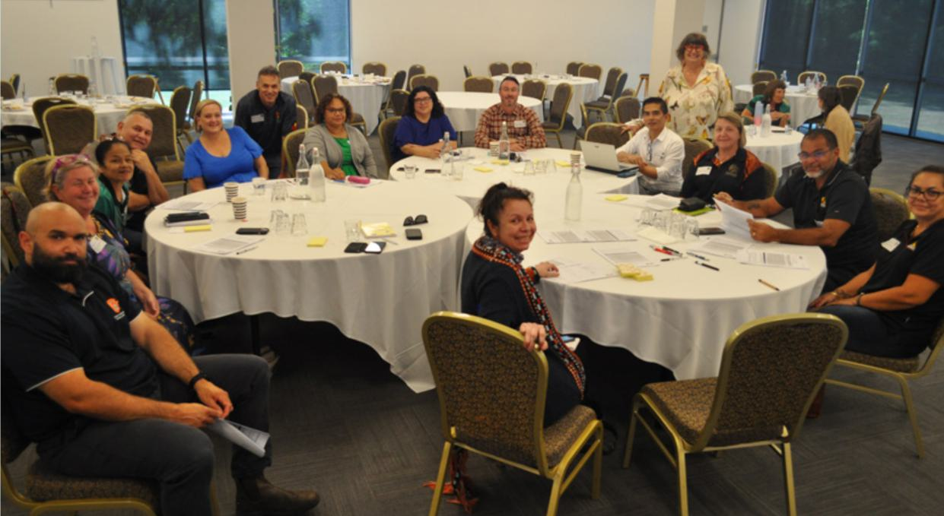

Northern Territory: NT First Nations RTO Advisory Group
The Northern Territory (NT) First Nations RTO Advisory Group is a strategic platform to drive transformative change for First Nations students and communities through vocational education and training (VET).

Established under the National Skills Agreement-Closing the Gap initiative, the inaugural Advisory Group comprises nine dedicated First Nations training organisations and Aboriginal Community Controlled Organisation representatives. Together, they form a strong, inclusive, and coordinated network of First Nations VET leaders united in their purpose to shape policies and programs that improve outcomes for First Nations communities.

The Advisory Group will guide strategic actions and targeted initiatives under the National Skills Agreement and NT Government programs to build a strong, culturally capable, and sustainable First Nations VET workforce. Through this collective partnership, the Group will advance efforts to grow a skilled First Nations workforce and develop future leaders through leadership pathways, scholarships, mentoring, and sector-strengthening initiatives, ensuring training translates into meaningful employment and long-term community benefit.

The Group’s call to action is to build capability and capacity of the First Nations training sector, empower First Nations participation in VET, and to deliver practical training that will help First Nations people in regional and remote areas to achieve sustainable employment outcomes.

The Advisory Group has met and participated in events across Darwin, Alice Springs and remote communities, contributing in strategic discussions that are progressing the implementation of the National Skills Agreement.

First Nations people inform how the VET system works for them, including through genuine partnership arrangements.

National Priorities Under the National Skills Agreement


Supporting the Net Zero Transformation

What we know
To meet the target of net zero by 2050, the critical clean energy workforce must grow by around 240,000 workers by 2030, according to JSA.¹³ In VET, this increase largely relates to trade and technician occupations such as electrical, construction and engineering required to transition to renewable energy sources, and support for affected communities, regions, and displaced workers.¹⁴

At current rates, Australia will have a critical shortage of 42,000 energy trades workers by 2030, with an annual increase of 40% needed in energy apprenticeship completions to meet employment targets.¹⁵ The number of women commencing an electrical apprenticeship has continued to increase annually and First Nations participation in energy apprenticeship training has grown by more than 50% since 2020, but women and First Nations people currently make up only 5% and 2% of the energy trades workforce respectively, below the average across all occupations. ¹⁶

Ambitions for the VET sector
- Reduce gender segregation in clean energy VET subjects and programs.
- Increase uptake of training in clean energy skills and qualifications to support the Net Zero transformation, particularly in regional and remote areas to allow those areas to maximise the benefits harnessed from the transition.
- Build a skilled and experienced VET workforce to ensure the VET sector has the capacity and capability to address emerging skills needs

Drivers of change
- Many Australians working in the transitioning carbon-based energy sector have skills transferrable to the clean energy sector but may require some additional training, particularly mature-age workers with relevant, but outdated qualifications.
- Skills required for the Net Zero transformation are multidisciplinary, encompassing digital skills as well as areas such as chemistry (for clean hydrogen) and environmental sciences (for biodiversity mitigation).
- Many of the roles required for the Net Zero transformation will be in regional and remote Australia and will require dedicated support to ensure an appropriately skilled workforce is available in those areas.
- The value of energy skills and the pathways to acquiring energy skills have the potential to be promoted to all Australians, particularly women and First Nations people, who are underrepresented.
- First Nations peoples’ participation in the carbon lifecycle workforce, which manages carbon capture, the circular economy, forestry and living biomass, is critical, including through Caring for Country programs.¹⁷
- Key themes for the VET system identified by JSA to support the growth of a clean energy workforce include designing clearer training pathways, providing employer incentives, growing and supporting the VET workforce, greater integration between VET and higher education, and increasing participation by students (particularly among priority cohorts).¹⁸

Focus areas
- Supporting timely apprenticeship commencements for clean energy occupations, including improving training capacity of the clean energy VET workforce and offering financial supports for apprentices and their employers.
- Decreasing delays in apprentices commencing off-the-job training and thereby reduce safety risks in the workplace. Improving responsiveness of VET delivery through collaboration with industry to identify key skills required for emerging clean energy technology.
- Supporting the re-skilling of displaced workers and workers at risk of displacement, such as workers currently employed in high-emissions industries.
- Increasing diversity, particularly women and First Nations students undertaking Net Zero programs, especially electrical apprenticeships, accompanied by appropriate foundation skills and wraparound supports.
- Attracting more industry-experienced, culturally and gender responsive teachers and trainers.
- Ensuring the availability and accessibility of training for clean energy occupations in regional areas.

Progress on 2024 national actions
- Five TAFE Centres of Excellence to support the national transition to clean energy have been established across ACT, QLD, WA, NSW and TAS. Roadshows and workshops are underway in several jurisdictions, the first round of student enrolments has opened in NSW, and QLD has opened applied research grants rounds.
- The JSC Powering Skills Organisation has updated training packages, published research briefs relating to diversification of the energy workforce and developed strategic partnerships to facilitate collaboration within the energy, gas and renewables sectors. to apprentices commencing or recommencing an Australian Apprenticeship in the clean energy sector. At 30 September 2025, 15,045 new energy apprenticeships have been engaged since the start of the program in 2023.
- The New Energy Apprenticeship Program, which commenced on 1 January 2023, was reframed
as the Key Apprenticeship Program - New Energy Apprenticeship stream on 1 July 2025. This
incentive offers up to $10,000 in financial support to apprentices commencing or recommencing an Australian Apprenticeship in the clean energy sector. At 30 September 2025, 15,045 new energy apprenticeships have been engaged since the start of the program in 2023.
- The Australian Government is investing:
- $35 million in a Clean Energy Capital Investment Fund to assist TAFEs and industry-based RTOs to equip themselves to deliver training in the clean energy sector.
- $1.8 million for a Group Training Organisation (GTO) Reimbursement Pilot Program that provides small and medium businesses with access to subsidised GTO fees for up to 400 apprentice places in Australian Apprenticeships Priority List occupations.
- $30 million to support Turbocharging the VET teacher workforce that will increase the number and capacity of VET teachers, trainers and assessors in delivering education and training which meets the growing demand for skilled workers in clean energy, manufacturing and construction.
- $3.1 million to promote clean energy careers to increase uptake of training.
- $20 million for a national training centre in new energy skills, to upskill over 2,000 tradespeople and apprentices each year in partnership with Victoria and the Plumbing Industry Climate Action Centre.

New national actions
- An Aboriginal-owned not-for profit organisation, Ninti One Limited, was engaged to deliver the First Nations Engagement in the Transition to Net Zero project. Through extensive research and targeted consultation, Ninti One developed a suite of resources to build awareness and strengthen visibility of opportunities in clean energy for First Nations people. Practical resources were also developed for employers and training organisations to make sure workplaces and training environments are culturally safe for First Nations students and workers.
- The Australian Government is delivering a number of measures to support the transition away from fossil fuels, including the Energy Industry Jobs Plan, Regional Workforce Transition Officers to identify and develop opportunities for future employment pathways, and Regional Workforce Transition Plans in regions that are impacted by the closure of coal and gas fired power stations.
- The Building Women’s Careers program is funding partnership projects to advance structural and cultural change to improve women’s access to flexible, safe and inclusive training and work opportunities in the key male-dominated industries of clean energy, construction, advanced manufacturing and digital and technology.
- Skills Ministers have agreed to Australian Government-led targeted actions, including initiatives to attract and retain VET teachers, trainers and assessors for electrical and construction industries aligned with current actions identified in the VET Workforce Blueprint.
- The Australian Government is working with states, territories, businesses and unions to design a national licensing scheme for electrical occupations to improve labour mobility of electricians across jurisdictions.



Tasmania: Supporting the Net Zero transformation through Tasmania’s Clean Energy Centre of Excellence
The Tasmanian Government and Australian Government are jointly investing $26.4 million over five years through the National Skills Agreement to establish the new Tasmanian Clean Energy Centre of Excellence in Burnie. An additional $800,000 will be allocated through the Australian Government’s Turbocharging TAFE Centres of Excellence initiative.
The Centre will support growth in the clean energy sector by attracting and training more Tasmanians for a career in clean energy and related trades. Tasmania’s clean energy sector is rapidly expanding, with major projects across the north-west, north, and central regions expected to create demand for thousands of skilled workers over the next decade.
These initiatives will require expertise in areas such as offshore wind maintenance, hydrogen handling, and energy storage, alongside hybrid skill sets shaped by global advances in automation, robotics, and cyber-physical system.
The Centre will identify training needs across the sector, facilitate pathways and strengthen employment pipelines. It will play a crucial role in ensuring Australia meets its goal of achieving net zero emissions by 2050.
Establishing the Tasmanian Clean Energy Centre of Excellence will build on on the Tasmanian Government’s commitment to provide a state-of-the-art industry training facility in partnership with industry, dedicated to clean energy skills.
Build a skilled and experienced VET workforce to ensure the VET sector has the capacity and capability to address emerging skills needs.

National Priorities Under the National Skills Agreement


Sustaining Essential Care Services

What we know
Care and support services (health and aged care, disability support, veterans’ care, early childhood education and care) make a significant contribution to workforce participation, gender equality, socioeconomic equality, and inclusive economic growth in Australia.
Employment in the Health Care and Social Assistance Industry is projected to grow strongly, from 2.36 million in May 2025 to 2.85 million by May 2034 – an increase of 490,000 workers over nine years.¹⁹ This growth underscores the critical role of the VET system in building a sufficiently large and skilled workforce to meet Australia’s current and future care and support needs.
The care and support workforce is becoming more diverse, helping to deliver more inclusive and responsive services. There is growing representation of culturally and linguistically diverse (CALD) people and those with lived experience, particularly in disability support roles.²⁰ However, the workforce remains highly gender imbalanced, with women comprising 75% of workers – a figure largely unchanged over the past decade.²¹
JSA’s ECEC Workforce Capacity Study, completed in partnership with HumanAbility, the care and support JSC, found persistent workforce shortages, low pay, and limited career progression opportunities across this critical sector. It estimates a current shortfall of around 21,000 qualified ECEC professionals to meet existing demand and improve working conditions, an additional 18,000 staff to address unmet demand in services not yet established, and over 18,000 more staff to fully implement Child Care Subsidy changes and expanded preschool policies.²²

Ambitions for the VET sector
- Grow the VET pipeline of skilled workers to keep pace with rising demand for care and support services.
- Attract and retain more diverse cohorts in care and support programs, including First Nations people, men, people of diverse ages, people with disability, those from CALD backgrounds and remote communities.
- Ensure education and training is high quality, responsive to current and emerging skill needs, widely available (including in thin markets), supports entry into the sector, and provides pathways for career progression as well as opportunities for upskilling, re-skilling, and mobility.
- Align with broader reforms to improve the safety and quality of care and support services across multiple sectors.

Drivers of change
- The care and support economy continues to face persistent labour shortages, particularly in aged care and disability support. While VET enrolments have increased, the Productivity Commission reports that workforce supply is still not keeping pace with demand.²³ Key challenges include attraction and retention, skills gaps, career pathways, work placements, and workforce supply in regional and remote areas.
- Diversity outcomes are mixed. Women continue to dominate training enrolments, and while First Nations participation is relatively high, completion rates remain lower.²⁴ There is an ongoing need to increase participation by men, people with disability, and learners from CALD backgrounds.
- Workforce skill needs are evolving due to factors such as an ageing population, increasing complexity of health conditions, a stronger focus on professionalisation, reforms to improve safety and quality in care services, changing models of service delivery, and technological advancements.
- Care and support for First Nations peoples is most effective when it is culturally safe, skilled, and local. There is a need for the VET system to equip all students with the skills to deliver appropriate care to First Nations people, and to provide a culturally safe and responsive education for First Nations students to help grow the First Nations care and support workforce.
- Training delivery varies across the care and support sector. In early childhood education and care, apprenticeships and traineeships are widely used, particularly for entry-level qualifications such as the Certificate III in Early Childhood Education and Care. In contrast, aged care and disability support training is typically delivered through institutional VET programs, with minimal use of apprenticeships or traineeships.²⁵

Key focus areas
- Developing the First Nations care and support workforce and ensuring the provision of culturally safe and responsive training to First Nations learners.
- Skilling all workers to deliver culturally safe and trauma-informed care to First Nations peoples.
- Developing and delivering training that supports entry into the sector and facilitates career progression and mobility pathways.
- Strengthening, diversifying, and promoting training pathways from school through to VET and between VET and higher education, including working with industry to enable more on-the-job training.
- Increasing training access and availability in rural, regional and remote areas, and in thin markets.
- Trialling new delivery and assessment approaches to lift training outcomes and ensure graduates are job-ready with a foundation for further learning.

Progress on 2024 national actions
- HumanAbility delivered its Workforce Plan 2025 in August 2025. The Plan outlines the key workforce issues impacting the care and support sector and highlights the need for reform in qualifications, clearer career pathways, and regulatory settings to support workforce sustainability.
- In partnership with HumanAbility, JSA undertook the ECEC Capacity Study in September 2024 to support current and future workforce planning. The study made recommendations relating to improvements to wages and conditions, career pathways and professional development, training quality and accessibility, promoting the value of the profession, and diversity and inclusion.
- The Commonwealth Prac Payment commenced on 1 July 2025 to help eligible students manage the costs associated with undertaking mandatory placements, including the Diploma of Nursing.
- Three TAFE Centres of Excellence focused on the essential care and early childhood education sectors are being established in Queensland, South Australia, and the Northern Territory. These Centres will strengthen the VET system’s capacity to deliver high-quality and responsive training and a skilled workforce in care and support through increased collaboration between TAFEs and employers, universities, unions and other stakeholders.
- The care and support economy is a national area of priority for Free TAFE and over 35% (over 255,000 enrolments) of all Free TAFE enrolments between 1 January 2023 and 30 September 2025 were in courses relating to Care and ECEC sectors.

New national actions
- HumanAbility is progressing a range of projects to update training and improve skills and training outcomes for the care and support workforce more broadly. This includes:
- projects to review training in the areas of aged care and disability support, early childhood education and care, mental health and alcohol and other drugs, health services assistance, health administration and medical practice, dental services, sterilisation services, optical dispensing, audiometry, and pathology
- research projects on Earn-While-You-Learn models and training enrolments and completions.

Ensure education and training provided is high quality, responsive to current and emerging skills needs, widely available (including in thin markets), supports entry into the sector, and provides pathways for career progression as well as opportunities for upskilling, re-skilling, and mobility.

New South Wales: Aged Care Diploma-level existing worker traineeships and skillsets
The care and support economy is a Critical Skills Area in the NSW Skills Plan. NSW is piloting new qualifications to support VET completions and the future pipeline of skilled workers in the care and aged care sectors. This initiative will target Diploma level existing worker traineeships and skills sets in aged care and aim to support an additional 50 diploma trained workers over 2 years and 500 workers upskilled through skillsets over 3 years.



National Priorities Under the National Skills Agreement

Developing Australia’s Sovereign Capability and Food Security

What we know
Australia’s sovereign capability includes the industrial, economic, agricultural, logistical, research and educational capabilities required to deliver against key areas of national interest. This covers sectors such as manufacturing, defence industries, critical minerals extraction and processing, energy, transport and logistics, and food production.²⁶ Australia currently has the lowest level of manufacturing self-sufficiency of OECD nations²⁷ and experiences food supply chain labour challenges which affect sovereign resilience and food security.²⁸
Many emerging workforce needs are in transitioning or new industries such as advanced manufacturing, onshore critical minerals processing, clean energy, and the sustainable defence industry. There are also critical workforce shortages in transport and logistics that affect all sovereign capability sectors, including the food supply chain workforce.²⁹

Future Made Australia
The VET sector has an important part to play in meeting the Australian Government’s ambitions for a Future Made in Australia. Supporting the development of a dynamic workforce with advanced and evolving skills is central to delivering an expanded industrial base, increased manufacturing capability, meeting net zero goals and achieving economic security for Australia in the years ahead.

Ambitions for the VET sector
- Unlock workforce supply by increasing the attractiveness of STEM-related training to women and First Nations people, including trade apprenticeships.
- Equip the VET sector to provide high quality training on the cutting edge of industrial transformation and innovation, supporting modern infrastructure, new industries, and advanced manufacturing.
- Establish a long-term sustainable defence industry workforce with sustainment capabilities, including transferrable qualifications.

Drivers of change
- Australia’s high input costs, in particular high fixed and labour costs, mean attracting private investment in sovereign capability and food security often requires additional government investment.
- Australia’s deteriorating strategic circumstances and global geopolitical instability are driving the need to grow sovereign industrial capacity including in the defence industry.
- There is a growing reliance on STEM roles, from trade apprenticeships to warehousing and logistics.
- Many occupations are male dominated, with low levels of participation by women and First Nations people, with additional challenges relating to ageing workforces.
- Australia has limited onshore capability in critical minerals processing and refining, which limits the value derived from their extraction.

Key focus areas
- Increasing availability and accessibility of training in regional and rural areas for critical minerals processing, agriculture, clean energy and logistics.
- Expanding RTO integration with government, industry and unions to attract, skill and employ workers and to strengthen career-long pipelines.
- Collaborating with industry on the development of new and updated courses to support industrial transformation, new industries and advanced manufacturing.
- Providing industry placements to offer hands-on training in real workplace settings, utilising existing infrastructure.
- Increasing the number of women and First Nations trainers to foster a safe, inclusive and culturally appropriate training environment in male-dominated fields important to sovereign capability including STEM and trades.

Progress on 2024 national actions
- JSCs responsible for industry sectors relating to sovereign capability have released their respective 2025 workforce plans.
- Skills Insights’ 2025–26 Workforce Plan, released September 2025, outlines strategic priorities to support primary production industry leadership to champion VET solutions.
- Manufacturing Industry Skills Alliance’s (MISA) 2025 Workforce Plan, released August 2025, focuses on 5 key pillars to transform the manufacturing environment: clean manufacturing, circular economy, advanced technology, sovereign capability, and a responsive skills system.
- The Mining and Automotive Skills Alliance’s (AUSMASA) 2025 Workforce Plan, released July 2025, outlines strategic actions to strengthen workforce capability in the mining sector, including research into alternative career pathways (such as into critical minerals) for displaced workers in the Net Zero transition, and a proposed reclassification of ‘critical minerals’ in national industry data to improve workforce planning and policy responsiveness.
- Industry Skills Australia’s (ISA) 2025 Workforce Plans for the Aviation, Maritime, Rail, Transport and Logistics industries set out challenges and drivers of change for these industries and strategies to support a responsive and agile supply chain workforce.
- JSA’s Food Supply Chain Capacity Study identified VET enrolment levels in key food supply chain disciplines as remaining lower than average enrolments across all training packages and includes recommendations to improve the relevance and delivery of tertiary education and training.
- Free TAFE is helping fund priority training pathways in manufacturing, agriculture, sovereign capability, technology and digital, and defence - with almost 113,000 enrolments between January 2023 and September 2025.

New national actions
- MISA is delivering projects addressing workforce issues in the manufacturing sector, including working with defence stakeholders to build a Defence Manufacturing workforce, implementing a multimedia attraction campaign to change perceptions about careers in the future of the manufacturing sector and building an information hub of government and industry initiatives supporting women to participate in the manufacturing sector.
- ISA is progressing projects to address supply chain workforce challenges, including a program of work to build a sustainable maritime skills pipeline, developing a National Heavy Vehicle Driver Action Plan in consultation with industry, piloting a training program for the transport and logistics industry in secondary schools and work to support mutual recognition of nationally recognised entry level rail skills training.
- Skills Insight has been progressing multiple projects to amplify industry’s voice and identify solutions for workforce challenges, including investigating the establishment of an agricultural apprenticeship pathway and development of a Meat Safety Pilot project, due for release in late 2025.
- Five Centres of Excellence to support Australia’s sovereign capability and food security have been announced across 4 states.
- TAFE NSW has developed a series of microskills and microcredentials, with the first round of enrolments in 2025. The courses emphasise manufacturing’s role in innovation, sustainability, and economic growth, while also building practical skills in mathematics and computer-aided design software for application in the sector.



Western Australia: Defence Industry Skills Centre of Excellence
The WA and Australian governments are jointly investing $14.6 million in the Defence Industry Skills Centre of Excellence (DISCE) to develop Australia’s sovereign capability.
The DISCE, which commenced operations in January 2025, is led by WA’s award-winning defence industry trainer South Metropolitan TAFE, with training delivered across its defence industry-focused campuses along the Western Trade Coast.
As a priority, DISCE is developing AUKUS-specific skills and trades training to equip WA’s workforce to undertake nuclear-powered submarine maintenance and sustainment work and defence shipbuilding, sustainment and maintenance activities.
An important focus is also driving workforce diversity and inclusion in the defence industry, through targeted programs and support for women, young people, Aboriginal peoples, people with disability and Defence veterans.
To increase participation of women in the defence industry workforce, the DISCE has expanded delivery of the successful Women in Defence Industry scholarship program to include a cyber security training stream. 52 women have completed the program so far.
The DISCE also launched a pilot version of the Defence Industry Pathway Program School-based Traineeship, which enables Year 11 students to learn about the diverse career options available in the defence industry while completing their WA Certificate of Education.
Equip the VET sector to provide high quality training on the cutting edge of industrial transformation and innovation, supporting modern infrastructure, new industries, and advanced manufacturing.


National Priorities Under the National Skills Agreement

Ensuring Australia’s Digital and Technology Capability

What we know
The importance of digital skills to economic, social and civic life in Australia is continually increasing. Basic digital skills are now critical for obtaining meaningful work and actively participating in the community, with around 87% of jobs in Australia requiring digital skills.³⁰ However, many Australians remain digitally excluded, with First Nations people, those living in regional and remote Australia and those with lower incomes more likely to be digitally excluded, which exacerbates participation challenges.
Digital and technology capability is also important to boost productivity, with digital and technology sector occupations growing at double the rate of all other jobs. Specific digital and technology jobs are expected to grow by 21% over the ten years to 2033.³¹ Australia has committed to a target of 1.2 million tech-related jobs by 2030, comprising tech and non-tech jobs within the tech sector and tech jobs outside of the tech sector.³² However, sector skills shortages are exacerbated by gender segregation, with only 17% of cyber security workers being women.³³
Although the technology industry has experienced strong growth, the JSC for the finance, technology and business sectors, Future Skills Organisation’s (FSO) 2025 Workforce Plan indicates a workforce shortage of 61,000 people for the technology industry, and 131,000 people for technology occupations.

Ambitions for the VET sector
- Ensure that all Australians have the digital capability needed to fully participate in the modern economy and society.
- Increase the number of women and First Nations digital and tech students.
- Ensure that digital and tech VET meets the needs of students and industry, keeping pace with technological change, to increase the standing of VET pathways in the industry.
- Support the VET workforce to deliver strong, high-quality digital and technology training.

Drivers of change
- Gender segregation at the occupational level is mirrored in VET. In 2024, only 24.7% of government- funded enrolments in IT programs were women.³⁴
- First Nations students are underrepresented. In 2024, only 3.7% of government-funded enrolments in IT programs were by First Nations students, lower than the proportion of government-funded First Nations students across all education fields at 7.8%.³⁵
- Rapid development and emergence of technologies, such as Generative AI, and changing work practices have led to a perceived mismatch between VET qualifications and the skills in high demand in many tech occupations.³⁶
- There is a lack of awareness about pathways into the digital and tech workforce and changing expectations by industry in relation to skills and experience for entry-level roles^{.37}

Key focus areas
- Increasing the availability of accessible VET to First Nations communities, including culturally safe, inclusive, and appropriate supports for First Nations students.
- Promoting digital and tech VET pathways for women, including through ensuring the safety and inclusivity of training environments.
- Closer collaboration with industry to ensure VET meets the needs of employers and students, ensuring the right mix of technical and transferrable skills.
- Supporting the development of earn-while-you-learn programs to create job-ready VET tech graduates.
- Developing new and innovative programs of study in collaboration with higher education.

Focused attention on AI by all governments is essential to help maximise adoption and adaption economy wide. Work is also required to address labour force impacts of AI, such as the automation of certain roles or effects on entry level jobs.

Progress on 2024 national actions
- FSO is supporting digital skills uplift, including work to update training packages to incorporate generalist digital, AI and cybersecurity skills at all qualification levels, test new approaches to teaching digital skills, and explore new ‘earn while you learn’ pathways into entry-level digital roles. FSO is also supporting AI adoption by small and medium enterprises and diverse cohorts of workers.
- The National Foundation Skills Strategy 2025–2035 was finalised in December 2024. Initial actions to operationalise the strategy include updating components of the national foundation skills sector architecture, which includes core skills frameworks.
- The SEE program assisted over 25,400 participants in the 2024—25 financial year, with approximately 8% identifying as First Nations participants and 65% as female.
- The SEE Program includes Workplace-Based Training Projects where employers, industry associations and unions partner with a SEE Provider to deliver workplace-based training to employed people. The majority of Workplace-Based Training Projects approved to date include digital literacy skills development or have digital literacy as a primary focus to support industries increasing their digitisation.
- The ongoing JSA National Study of Adult Literacy, Numeracy and Digital Skills is gathering insights into skill levels, especially of priority groups, and will establish a national definition of digital literacy.
- The Australian Skills Guarantee sets national targets for apprentices, other ‘learning workers’ and women working on Australian Government-funded major ICT projects. (see page 22, Australian Skills Guarantee)

New national actions
- Maximising the benefits of AI adoption by lifting the capacity of VET to support upskilling of the workforce is a national priority focus area of all governments for 2025–26. Progress under this focus area will draw on the insights provided in JSA’s Our Gen AI Transition capacity study and the activities of FSO and other JSCs.
- The FSO Skills Accelerator - AI is a strategic partnership between employers, industry and training providers to help close Australia’s AI skills gap. This initiative will enable teachers, trainers, administrators and learners across Australia to rapidly access and develop the skills needed for an AI-enabled future.
- FSO’s Digital Knowledge Exchange is a national collaboration platform that facilitates the sharing of knowledge and best practice on digital skills initiatives across states and territories. This initiative aims to promote diversity and inclusion, support capability development for the VET workforce and foster industry collaboration, and is working with states and territories to support:
- 20% Alternative Pathway Pledge – gaining commitment from employers to hiring 20% of digital entry-level roles from non-university pathways by 2030. This project scales an initiative developed by FSO with the NSW Digital Skills and Workforce Compact 2023—2030.
- Uplift Digital Capability for Educators – equipping teachers and trainers with resources to build students’ digital competencies, with delivery tailored to each state and territory.
- JSA published its Gen AI Capacity Study in August 2025 with recommendations for embedding data, digital and AI skills in VET qualifications and uplifting the digital and AI capability of the tertiary education workforce.
- The TAFE NSW Heavy Manufacturing Centre of Excellence will deliver digital skills through a Higher Apprenticeship in Manufacturing and Applied Digital Technologies. The Tertiary Education Quality and Standards Agency (TEQSA)-accredited Associate Degree, approved in April 2025, will begin enrolments in August 2026, equipping industry with advanced digital capabilities to drive innovation and productivity in manufacturing.



Australian Capital Territory: Ensuring Australia’s Digital and Technology Capability

Canberra is recognised as Australia’s cyber security hub – where advanced high-tech companies and national security organisations converge to protect our nation’s critical sovereign capability and infrastructure.

Jointly funded by the ACT and Australian Governments through the National Skills Agreement, the Cyber Security TAFE Centre of Excellence, will be situated at the new, state-of-the-art Canberra Institute of Technology (CIT) Woden campus. It will focus on developing and enhancing cyber skills essential to national security, collaborating with businesses, research organisations and tertiary education providers to address critical skills gaps and build a national workforce fit to protect Australia’s digital future.

In 2025–26, the ACT will establish its project governance and planning frameworks, and commence extensive stakeholder engagement for the project. The Centre of Excellence will build on existing relationships and strengthen strategic partnerships, including with the Canberra Cyber Hub and Future Skills Organisation, creating new training opportunities that align with industry needs now and into the future. This will also include a partnership between CIT and the University of New South Wales (Canberra), to explore the development of a higher degree apprenticeship which will combine advanced cyber knowledge with practical work experience.

Ensure that digital and tech VET meets the needs of students and industry,
keeping pace with technological change, to increase the standing of VET pathways
in the industry.
National Priorities Under the National Skills Agreement


Delivering Housing Supply

What we know
Australia’s increasing population and tight supply of labour and materials have led to significant housing shortages.³⁸ Although construction job vacancies continue to decline from their peak in 2022, they remain higher than the average over the prior decade.³⁹ Construction trades are currently in shortage, with these shortages projected to grow.⁴⁰ The shortfall in skilled labour will impact Australia’s ability to ensure adequate housing for all residents and meet National Housing Accord targets, particularly in regional and remote areas.⁴¹ Attraction and retention of apprentices and trainees, high levels of gender segregation and stagnant productivity are also issues for the sector.

Meeting this challenge requires a strong VET sector response; more than half of the construction workforce, and 80% of those with a post-school qualification, hold a VET qualification as the highest level of education.⁴²

Assuming labour is the only constraint to housing supply, BuildSkills Australia’s Housing Workforce Capacity Study modelling indicates that an extra 116,700 workers (trade and non-trade) will be needed to meet the National Housing Accord target of 1.2 million new homes by mid-2029.⁴³

Ambitions for the VET sector
- Increase the number of construction workers to build capacity in the residential construction sector, improve quality housing supply and affordability and meet the targets of the National Housing Accord.
- Drive productivity and innovation in the construction industry through a future-focussed VET sector.
- Unlock workforce supply by increasing the attractiveness and adaptability of trades and other construction-related qualifications in VET for a broader pool of workers, particularly women, people from diverse backgrounds, and regional and remote resident.

Drivers of change
- Several factors affect housing supply, including supply chain issues, planning constraints, shortages of skilled construction workers (particularly local workers), and competition from other sectors such as clean energy, mining, and infrastructure.
- Productivity in the construction sector has been largely stagnant for the last two decades, providing an opportunity to drive increased productivity through advanced and emerging technologies.
- All governments have committed to improving housing supply and affordability, including through the National Housing Accord, which sets a target of 1.2 million new, well-located homes over 5 years from mid-2024.
- Apprenticeships are a key pathway to construction trade roles, though employers commonly report difficulty attracting apprentices, and construction trade apprenticeship individual completion rates are approximately 53.9%.44
- Women are particularly underrepresented in trade apprenticeships, which exacerbates apprenticeship supply issues.

Key focus
- Offering financial support for apprentices and employers to support an increase in timely apprenticeship commencements and completions for construction occupations.
- Increasing the availability and accessibility of training in regional and remote areas.
- Embedding advanced and emerging technologies and clean energy skills into construction-related trade qualifications, to support a skilled and adaptable workforce to help drive the expansion of modern methods of construction and boost productivity.
- Attracting industry experienced trainers, including women and First Nations trainers to foster a safe, inclusive and culturally responsive training environment in construction and related trades.
- Building a sufficient supply of qualified teachers, trainers and assessors to ensure training availability meets demand.

Progress on 2024 national actions
- Following the release of its initial Workforce Plan, BuildSkills Australia is leading action to address the current and emerging workforce challenges facing the residential construction sector, including:
- Investigating how workers currently move between residential construction and non-residential construction sectors, identifying barriers to mobility and proposing strategies that can facilitate greater labour mobility across the sectors, and
- Collaborating with other Jobs and Skills Councils to support modern methods of construction and supporting the response to the VET Workforce Blueprint.
- Funding 20,000 additional Free TAFE Construction places over 2025–2026, including around 5,000 pre-apprenticeship places: From 1 January 2023 to 30 September 2025, there were over 59,000 Free TAFE enrolments in the construction sector.
- Revisions to the Australian Apprenticeship Incentive System from 1 July 2024 promote uptake of apprenticeships in priority occupations.
- The expansion of the New Energy Apprenticeships Program into the Key Apprenticeship Program which includes a Housing Construction Apprenticeship stream, offers up to $10,000 in financial incentives to eligible apprentices over the course of their apprenticeship.
- The Living Away From Home Allowance and the Disability Australian Apprentice Wage Support (DAAWS) payment was increased from 1 July 2025 (see page 24, Apprenticeships).
- The Australian Skills Guarantee Procurement Connected Policy sets national targets for apprentices, other ‘learning workers’ and women employed on Australian Government-funded major construction projects (see page 22, Australian Skills Guarantee).

New national action
- All governments have identified training capacity for apprenticeships and traineeships in national priority sectors, particularly housing supply, as a national priority focus area for 2025–26.
- The Australian Apprentice Training Support Payment (AATSP) and Priority Hiring Incentive will be extended by a further 6 months to 31 December 2025 for apprentices and employers in priority occupations, including construction (see page 24, Apprenticeships).
- A national licensing scheme will be designed with governments, business and unions to improve mobility of electricians between jurisdictions.
- An Advanced Entry Trades Training program will fast track the qualifications of 6,000 experienced but unqualified tradespeople in the residential housing and civil construction industry through recognition of prior learning and gap training. This builds on the success of the NSW Government’s recent Trade Pathways for Experienced Workers initiative.
- Streamlined skills assessments are accelerating the entry of skilled workers into the sector. From 1 July 2024 to June 2025, just under 13,000 applicants benefited from streamlined skills assessment, prioritising applications for construction skilled migrants.
- The Building Women’s Careers Program is supporting 13 construction-focused partnership projects.
- The Group Training Organisation Reimbursement Pilot Program, which commenced 1 January 2025, provides small and medium businesses with access to subsidised Group Training Organisation (GTO) fees for up to 400 apprentice places, including a 20% target for women apprentices.
- BuildSkills Australia is exploring the use of existing digital platforms and leading-edge immersive technologies that incorporates real-world content to support secondary school students to make informed career choices about construction occupations.



Victoria: Melbourne Polytechnic Future of Housing Construction Centre of Excellence
The Victorian and Australian governments are jointly funding a $50 million Future of Housing Construction Centre of Excellence at Melbourne Polytechnic’s Heidelberg campus which will seek to address critical challenges faced by Australia’s housing construction industry by creating innovative training and skills development in Modern Methods of Construction (MMC).
Melbourne Polytechnic is partnering with construction and manufacturing leaders, peak bodies and TAFEs to co-design the Centre’s operating model to ensure training keeps pace with new technologies and the realities of delivering projects on the ground.
Training will focus on building the skills and capabilities related to prefabrication, modular construction and volumetric construction.
Funding includes construction of a new building that will showcase and demonstrate MMC in action. The design of the new building is expected to be finalised in late 2026, and operational by 2029. It will feature purpose-built facilities, cutting-edge equipment, and digital technologies, such as a holographic training suite.
Training has already commenced from the Heidelberg campus, with a pilot program being delivered to carpentry apprentices introducing MMC concepts.
The Centre will also model inclusive and sustainable building practices, promoting gender equality and environmentally responsible construction.
The Centre welcomes the participation of apprentices and employers in shaping the development and training offerings.

Queensland: Career change – from sales to carpentry
The Queensland Government is committed to boosting housing supply to deliver more homes for Queenslanders. Key to this is supporting the skills needed to sustain the construction sector and ensure the delivery of new private, social and community homes.
The Queensland Government has invested more than $98 million in construction specific training industries over 2024–25, supporting over 29,000 students. Queensland is also providing Free Construction Apprenticeships for Over 25s to cover the cost of training in eligible construction-related apprenticeships.
One Queenslander who has taken the opportunity to secure a career in the construction industry is Christopher Reppel.
At 40, Christopher swapped his career in sales for timber and toolbelts. He took a bold step and started a carpentry apprenticeship with Cairns’ based MB Constructions and Ballinger Training and Consultancy, and the move has changed his life.
“Ever since I left school, I wanted to be a carpenter,” Christopher said.
“It wasn’t until I was doing some reno work at our townhouse that I realised this is what I need to do. It made me feel focused and fulfilled.”
With a young family, a mortgage, and plenty of uncertainty, the decision to start an apprenticeship was hard but Christopher knew it was the right one.
“I got fitter, sorted out my mental health, and I look forward to Mondays again,” he said.
The Australian and Queensland Government’s investment in the VET system through the National Skills Agreement is supporting successful careers in construction like Christopher’.




National Priorities Under the National Skills Agreement

Delivering reforms to improve the regulation of VET qualifications and quality

What we know
In 2023, while 74% of employers for jobs that require vocational qualifications were satisfied with VET as a way of meeting their skills needs, there is room for improved flexibility and responsiveness and a stronger focus on quality. For employers who were dissatisfied, the top reasons were that the training was of a poor quality or low standard and that relevant skills were not taught.⁴⁵ With all governments working together, there are opportunities to improve regulation of VET qualifications and quality and improve industry and student satisfaction.

Ambitions for the VET sector
- Improve the VET qualifications system so that it is high-performing, easy to navigate, and meets the needs of employers and learners, especially priority cohorts.
- Have the VET sector support excellence in training delivery and assessment, accessibility for priority cohorts, and quality in training outcomes, with TAFE at the heart of VET.
- Ensure the VET sector supports more employers to use nationally recognised training and delivers an adaptable skilled workforce resilient to structural change.
- Improve student outcomes, experience, and mobility through the tertiary education system through improved credit transfer and recognition of prior learning

Drivers of change
- The focus on quality of training delivery in the VET sector has generally been on minimum standards rather than excellence. Key elements of excellence are a student-centred culture, a focus on continuous improvement, and an adaptable, flexible, responsive system with strong industry links.46
- VET qualifications need to meet the needs of students and employers, and reform is required to enhance the relevance and transferability of VET credentials and to ensure the training system better delivers an adaptable skilled workforce resilient to structural changes while supporting more employers to use nationally recognised training.
- Meeting industry and student needs requires innovative and flexible approaches rather than a one-size-fits-all approach.

Improve the VET qualifications system so that it is high-performing, easy to navigate, and meets the needs of employers and learners, especially priority cohorts.

Key focus areas
- Promoting best-practice teaching and assessment approaches to drive excellence in the VET workforce.
- Facilitating responsive, flexible training to make the VET sector resilient to structural change to increase the standing of VET qualified jobseekers with employers.
- Ensuring the availability of key training, including existing broad-based qualifications, top-ups and electives, and new qualifications targeted to emerging sectors.
- Ensuring consistency of training packages through the requirements of the Training Package Assurance Body.
- Successfully implementing regulatory reforms, such as supporting RTOs through the transition to revised Standards for RTOs and ensuring TAFEs remain leaders in their breadth of VET delivery.
- Delivering a joined up tertiary education system that enables students to move between the VET and higher education sectors seamlessly and gain qualifications that meet labour market needs.

Progress on 2024 national actions
- The 2025 Standards for RTOs came into effect on 1 July 2025, providing a clearer and more direct link between the requirements RTOs are expected to meet and outcomes they are expected to deliver. The Standards shift the focus beyond baseline administrative requirements toward outcome-focussed standards across key quality areas – training and assessment, student support, workforce, and governance.
- The VET Workforce Blueprint, released in October 2024, identifies flexible opportunities and actions to allow all stakeholders, including governments, RTOs, industry, peak organisations, unions and employers to develop responses to meet local and regional contexts and priorities. A suite of foundational national actions will help build understanding of the VET workforce and provide an evidence base for policy and funding decisions to support and grow a sustainable VET workforce.
- ASQA is uplifting and building its digital and data capability through the new ASQA Regulatory Management System, enhancing public reporting tools (tip-off and complaints functions), intelligence and contact centre capabilities, website accessibility, and data analytics.
- The National TAFE Network, which held its first Committee meeting in August 2025, will enhance the quality of teaching and learning practice in TAFEs and public training providers. To date, six jurisdictions have signed onto the National TAFE Network.
- The Training Package Assurance Body, established in March 2023 through the Training Package Organising Framework (TPOF), supports the JSC Program by assessing training package products against the TPOF and making recommendations to Skills Ministers about whether proposed training package products should be endorsed.
- In December 2024, Skills Ministers agreed to update the Training Package Organising Framework with a new purpose-driven, principles-based approach to qualification design. Commencing from 1 July 2025, phased implementation provides for JSCs to adopt the new approach at a pace aligned to industry needs and priorities, with the differentiated model supporting qualifications to be developed at all Australian Qualifications Framework (AQF) Levels to strengthen career pathways and learner progression. The National Training Register has also been enhanced to implement the updated TPOF and strengthen data quality on training package products.
- The Australian Government is progressing reforms recommended by the Australian Universities Accord (see new national actions).
- ASQA will deliver strengthened risk-based regulation of the VET sector through additional funding to respond to fraudulent issuance of VET qualifications and to deliver additional integrity activities for Australia’s international VET sector. This builds on earlier investment in ASQA’s integrity unit and tip-off line, and legislative amendments enacted in March 2024 to expand ASQA’s powers and increase penalties for a range of offences.
- Continuing reform and innovation, including the establishment in 2025 of a new AQF7 vocational degree (equivalent to a traditional Bachelor degree), will provide additional flexibility to meet the needs of a diverse range of VET users.

New national actions
Achieving the benefits of a joined up tertiary education system in productivity and student outcomes is a critical area of focus for all governments in 2025-26.

The interim ATEC was established on 1 July 2025 and will work across governments to promote a more joined up tertiary system. ATEC, through engagement with the Tertiary System Advisory Council, will lead the development of a Tertiary Roadmap to inform the next steps and actions for the Commonwealth, states and territories and the VET and Higher Education sector to drive tertiary reform.

Continuing work will improve regulatory approaches to dual-sector providers and TAFEs and pilot delegating ASQA’s course accreditation function to select TAFEs.

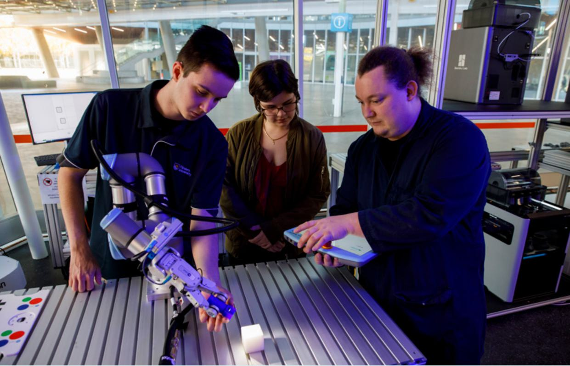

  - South Australia: Degree apprenticeships to support sovereign capability
The South Australian Skills Commission has worked with employers, unions and universities to establish a degree apprenticeship framework to support, in the first instance, the AUKUS submarine build.
Modelling traditional apprenticeships, degree apprentices learning the trades of Software Engineer and Mechanical Engineer, are engaged under a training contract through which their employers commit to provide on-job training by a suitably qualified supervisor.
Throughout the five-year training contract, apprentices are paid to attend university and undertake relevant work for the employer, providing them with the opportunity to apply their theoretical knowledge in the workplace.
Upon completion of their honours degree and being deemed competent in the work-related components of the apprenticeship, graduates will be ready from day one to apply their skills, knowledge and employability skills.
The first cohort of thirteen Software Engineer apprentices commenced in February 2024 with second intake of eight starting in 2025. Nine Mechanical Engineer apprentices started in February 2025.
The outcomes of the degree apprenticeship have surpassed the expectations of the participating employers. The apprentices have contributed productively to the workplace within the first six months of commencement, a result that wasn’t anticipated. The apprentices have immersed themselves within the workplace culture and now have experience in systems and knowledge that goes beyond the technical training. Employers can already see that this will put the students and the organisations in a more advantageous position at the end of the degree compared to employing new graduates without workplace experience.
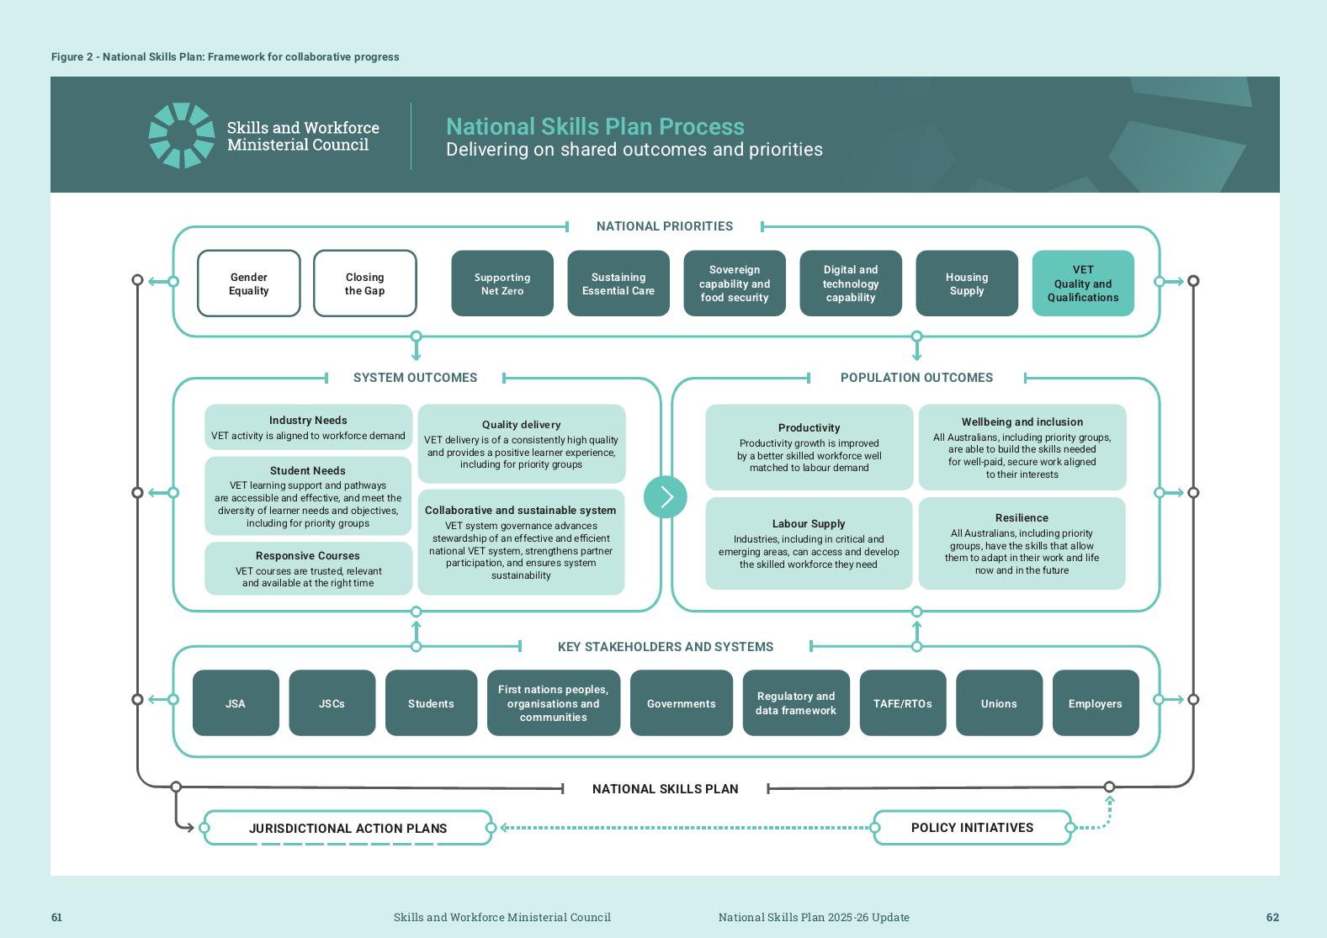

References

1 World Economic Forum (WEF), Global Gender Gap Report 2025, WEF, Geneva, 2025.
2 Australian Bureau of Statistics (ABS), How Australians Use Their Time, ABS, Australian Government, 2022
3 Jobs and Skills Australia (JSA), New Perspectives on Old Problems: Gendered Jobs Work and Pay, JSA, Australian Government, 7 August 2025.
4 Jobs and Skills Australia (JSA), New Perspectives on Old Problems: Gendered Jobs Work and Pay, JSA, Australian Government, 7 August 2025.
5 Jobs and Skills Australia (JSA), Towards a National Jobs and Skills Roadmap: Annual Jobs and Skills Report 2023, JSA, Australian Government, 2023.
6 Jobs and Skills Australia (JSA), Towards a National Jobs and Skills Roadmap: Annual Jobs and Skills Report 2023, JSA, Australian Government, 2023.
7 National Centre for Vocational Education Research, VOCSTATS, accessed March 2024
8 National Centre for Vocational Education Research, VOCSTATS, accessed March 2024
9 Australian Bureau of Statistics (ABS), How Australians Use Their Time, ABS, Australian Government, 2022
10 Productivity Commission, Closing the Gap Annual Data Compilation Report July 2025, Productivity Commission, Australian Government, 2025
11 Productivity Commission, Closing the Gap Annual Data Compilation Report July 2023, Productivity Commission, Australian Government, 2023, p54
12 Australian Institute of Health and Welfare (AIHW), Employment of First Nations people, 2025.
13 Jobs and Skills Australia (JSA), The Clean Energy Generation, JSA, Australian Government, 2023.
14 Jobs and Skills Australia (JSA), The Clean Energy Generation, JSA, Australian Government, 2023.
15 High Load, Short Supply: Bridging the gap to 2030, 2025 Workforce Plan, Powering Skills Organisation, 28 August 2025, p9
16 High Load, Short Supply: Bridging the gap to 2030, 2025 Workforce Plan, Powering Skills Organisation, 28 August 2025
17 Jobs and Skills Australia (JSA), The Clean Energy Generation, JSA, Australian Government, 2023, p230.
18 Jobs and Skills Australia (JSA), The Clean Energy Generation, JSA, Australian Government, 2023.
19 Australian Bureau of Statistics 2006, Australian and New Zealand Standard Industrial Classification (ANZSIC) 2006 (Revision 2.0): The detailed classification, ABS, accessed June 2024.
20 HumanAbility, Workforce Plan 2025, HumanAbility, 2025, p17.
21 ABS, Labour Force Survey, Detailed, May 2025, EQ06 four-quarter average data, Customised Report, 2025.
22 Jobs and Skills Australia, Early Childhood Education and Care Workforce Capacity Study: Summary Report, JSA, Australian Government, 2025.
23 Productivity Commission, Delivering quality care more efficiently: Interim report, Productivity Commission, 2025.
24 HumanAbility, Workforce Plan 2025, HumanAbility, 2025.

25 National Centre for Vocational Education and Research 2024, Apprentices and trainees 2024: December quarter, NCVER, 2024, accessed September 2025,.
26 The Australian Sovereign Capability Alliance (ASCA), Submission to the Senate Economic References Committee Inquiry ‘The Australian Manufacturing Industry’, ASCA, September 2021.
27 J Stanford, A Fair Share for Australian Manufacturing: Manufacturing Renewal for the Post-COVID Economy, The Australia Institute’s Centre for Future Work, Canberra, July 2020
28 National Farmer’s Federation (NFF), Unprecedented labour crisis across Australia’s food supply chain, NFF, 22 August 2022, accessed 20 November 2023
29 National Farmer’s Federation (NFF), Unprecedented labour crisis across Australia’s food supply chain, NFF, 22 August 2022, accessed 20 November 2023
30 RMIT Online, Deloitte Access Economics, Ready, set, upskill: effective training for the jobs of tomorrow, RMIT, Melbourne, 2021.
31 Treasury, Working Future: The Australian Government’s White Paper on Jobs and Opportunities, Treasury, Australian Government, 2023, p 98.
32 Future Skills Organisation (FSO), Workforce Plan 2025: Pathways to Impact, FSO, 2025.
33 L Risse, M Beaumond, J Hall, Y Wang, MJ Warren, B Barua and V Kondylas, Gender Dimensions of
the Australian Cyber Security Sector Report, RMIT University Centre for Cyber Security Research and
Innovation, Melbourne 2023
34 NCVER, Government-funded students and courses 2024, NCVER, Australian Government, 2025
35 NCVER, Government-funded students and courses 2024, NCVER, Australian Government, 2025
36 Future Skills Organisation (FSO), Workforce Plan 2025: Pathways to Impact, FSO, August 2025.
37 Future Skills Organisation (FSO), Workforce Plan 2025: Pathways to Impact, FSO, August 2025.
38 National Housing Finance and Investment Corporation (NHFIC), State of the Nation’s Housing Report 2022-23, NHFIC, Australian Government, April 2023.
39 BuildSkills Australia, Housing Workforce Capacity Study, BuildSkills Australia, September 2025.
40 Infrastructure Australia, Infrastructure Market Capacity Report, Infrastructure Australia, Australian Government, December 2024.
41 Master Builders Australia (MBA), The Future of the Workforce: The Building and Construction Industry, MBA, September 2024.
42 MBA, Submission to the House of Representatives Inquiry into the perceptions and status of VET, MBA, 16 March 2023.
43 BuildSkills Australia, Housing Workforce Capacity Study, BuildSkills Australia, September 2025.
44 NCVER, Completion and attrition rates for apprentices and trainees 2023, NCVER, Adelaide, 2024.
45 NCVER, Employers’ use and views of the VET system 2023, NCVER, Australian Government, 2023
46 Consultation took place between DEWR and RTOs between December 2020 and March 2021. Consultation was informed by two issues papers - RTO Quality and Supporting the VET Workforce.



