

Commonwealth Contract – Services

Disclaimer: This document is a sample copy of the Norfolk Island Employment Support Program Contract, for external publication. This copy is provided only for your information and as a guide. If you have entered into the contract with the Department, you must rely on the original signed contract and any contract variations you have entered into. You should seek your own legal advice, if required. While the Department has exercised reasonable care in publishing this document, the Department makes no representation, express or implied, as to the accuracy or currency of this document or its applicability to you or your circumstances. You should note that you may or may not have executed the contract, or any subsequent variations to it, in the particular form expressed in this document. The Department accepts no liability for any use of this document or any reliance on it.

Customer
Customer Name: | Department of Employment and Workplace Relations
Customer ABN: | 96 584 957 427
Address: | GPO BOX 9828  Canberra, ACT 2601
Supplier
Full Name of the Legal Entity: | <Supplier Legal Name>
Supplier ABN: | <Supplier ABN>
Address: | <Supplier Address>

Statement of Work
C.A.1 Key Events and Dates
This Contract commences on the Contract Start Date or the date this Contract is executed, whichever is the later, and continues for the Contract Term unless:
a) it is terminated earlier or
b) the Customer exercises the Contract Extension Option, in which case this Contract will continue until the end of the extended time (unless it is terminated earlier).
Event | Details
Contract Start Date: | Tuesday, 1 July 2025
Contract Term: | This Contract will terminate on Monday, 31 July 2028.
Contract Extension Option: | This Contract includes the following extension option(s): periods of up to a total of 12 months.

C.A.2 The Requirement
The Supplier must provide a holistic service to all Norfolk Island residents with employment and higher education needs, such as those with a disability, parents, mature-aged, youth, those who are unemployed, or underemployed, self-employed and the long-term unemployed, including by:
- customising its services to support Participants to prepare for, find and maintain sustainable employment, noting that the needs of each individual will differ, and some will require more support than others;
- supporting eligible students through subsidised courses and payment of related costs;
- proactively supporting local employers, through a range of supports, to understand and address their specific workforce needs;
- implementing inclusive employment practices and identifying employment opportunities, including creating or tailoring roles where needed, such as for individuals with a disability;
- assisting newly arrived workforce to understand the unique culture of Norfolk Island; and
- undertaking stakeholder engagement activities to support the community and improve coordination across the service system.
The Customer is committed to ensuring that Norfolk Island residents have access to high-quality employment support, delivered by a high-quality Supplier that places Participants and employers at the centre of their service design and builds meaningful relationships with Participants and employers. The Supplier must specialise in delivering employment support like services and have staff and leadership with a variety of relevant skills and experience and be representative of the Norfolk Island community.
The Customer does not guarantee and makes no representation that a particular number of Participants will be Referred to or Directly Register with the Supplier. The Supplier does not need to rely on Referrals from Services Australia. The Supplier may engage and Directly Register eligible individuals, including those not in receipt of income support, in order to have sustainable caseloads.
The Supplier must maintain records of services delivered to Participants, employers and the community, as well as engagement undertaken with stakeholders as described in Contract Annex A and in accordance with any Guidelines and/or any other direction from the Customer.
Contract Annex A describes in more detail the Services that the Supplier must deliver and contains a glossary of defined terms used in this Contract in addition to the Commonwealth Contracting Suite Glossary and Interpretation.
C.A.2(a) Commonwealth Supplier Code of Conduct
The Commonwealth expects its suppliers to conduct themselves with high standards of ethics such that they consistently act with integrity and accountability. The Commonwealth Supplier Code of Conduct (Code) outlines the Commonwealth’s minimum expectations of suppliers and their subcontractors while under contract with the Commonwealth.
The Supplier must comply with Commonwealth Contract Terms [Clause C.C.23], which creates a number of obligations in connection with the Code. Further information on the Code can be found at: https://www.finance.gov.au/government/procurement/commonwealth-supplier-code-conduct.
C.A.2(b) Standards
The Supplier must ensure that the Services comply with:
- the Norfolk Island Quality Standards of Servicing (NIQSS),
- Disability Services and Inclusion (Code of Conduct) Rules 2023 (Cth),
- ISO/IEC 27001:2022 Information security, cybersecurity and privacy protection — Information security management systems,
- ISO 9001:2015 Quality Management Systems,
and all applicable Australian and international standards.
The Supplier must ensure that it obtains copies of all relevant certifications and maintains records evidencing its compliance with those standards. If requested by the Customer, the Supplier must enable the Customer, or an independent assessor, to conduct periodic audits to confirm compliance with those standards.
Web Content Accessibility
As applicable, the Supplier must ensure that any website, associated material and/or online publications (where applicable) complies with the Web Content Accessibility Guidelines available at: https://www.w3.org/WAI/intro/wcag.
Performance Measures
To demonstrate progress towards achievement of the Requirement, the Supplier is required to participate proactively in:
- scheduled quarterly reporting;
- regular contract management activities;
- assurance review(s) in relation to achievement and maintenance of the NIQSS; and
- other monitoring activities undertaken by the Customer,
to determine the level and quality of service received by Participants, employers and the community to meet their needs.
C.A.2(c) Security Requirements
The Supplier must ensure that sufficient cybersecurity controls and policy is adhered to, including but not limited to the Right Fit for Risk (RFFR) framework, Australian Government’s Protective Security Policy Framework (PSPF) and the External Systems Assurance Framework (ESAF). See Contract Annex A for further detail.
C.A.2(d) Work Health and Safety
Prior to commencement of this Contract, the Customer’s Contract Manager and the Supplier’s Contract Manager will identify any potential work health and safety (WHS) issues anticipated to arise during the term of this Contract and assign management of each issue identified to the party best able to manage it. For all issues assigned to the Supplier, the Supplier will provide the Customer with a WHS plan for approval and no work will commence until the plan is approved unless agreed in writing by the Customer.
The Supplier must at all times ensure that the Services are carried out in a safe manner and with adherence to relevant WHS laws and industry awards. In the event of a notifiable incident, breach or alleged breach of relevant WHS laws, the Supplier must:
- notify the Customer within 24 hours of becoming aware of an incident and provide full details as and when such details become known to the Supplier;
- at the same time, or as soon as is possible in the circumstances, notify the relevant regulator of the notifiable incident if required by the relevant WHS law to report to the regulator; and
- cooperate with any investigation undertaken by the Customer concerning the notifiable incident, breach or alleged breach of the WHS laws, or any audit of the Supplier’s WHS performance arising out of, or in respect of, delivering Services for the Norfolk Island Employment Support Program (NIESP).
For avoidance of doubt, notifiable incidents may include, but are not limited to:
- any accident, injury or death occurring during, or as a result of, an Activity, including in relation to a Participant or a member of the public; and/or
- any incident which relates to a WHS issue that may negatively impact upon the Customer, or bring the Customer, NIESP or the Supplier into disrepute.
Throughout the Contract Term, the Customer and the Supplier will proactively identify and cooperate to manage any WHS issues that arise.
C.A.2(e) Delivery and Acceptance
Where the Customer rejects any deliverables under Clause C.C.11 [Delivery and Acceptance] the Customer will specify a timeframe in which the Supplier is required to rectify deficiencies, at the Supplier’s cost, so that the deliverables meet the requirements of this Contract. The Supplier must comply with any such requirement. Rectified deliverables are subject to acceptance under Clause C.C.11 [Delivery and Acceptance].
The Supplier will refund all payments related to the rejected deliverables unless the relevant deliverables are rectified and accepted by the Customer.
If the Supplier is unable to meet the Customer’s timeframe, the Customer may terminate this Contract in accordance with Clause C.C.16 [Termination for Cause].
Milestone Description | Delivery | Due Date
Transition-in begins | Online, on site on Norfolk Island, and by correspondence with the Customer as needed | Contract Start Date
Commencement of Services in full | Online, on site on Norfolk Island, and by correspondence with the Customer as needed | 1/07/2025
Report for Year 1 Quarter 1 | <Customer Email> | 10/10/2025
Report for Year 1 Quarter 2 | <Customer Email> | 10/01/2026
Report for Year 1 Quarter 3 | <Customer Email> | 10/04/2026
Report for Year 1 Quarter 4 | <Customer Email> | 10/07/2026
Report for Year 2 Quarter 1 | <Customer Email> | 10/10/2026
Report for Year 2 Quarter 2 | <Customer Email> | 10/01/2027
Report for Year 2 Quarter 3 | <Customer Email> | 10/04/2027
Report for Year 2 Quarter 4 | <Customer Email> | 10/07/2027
Report for Year 3 Quarter 1 | <Customer Email> | 10/10/2027
Report for Year 3 Quarter 2 | <Customer Email> | 10/01/2028
Report for Year 3 Quarter 3 | <Customer Email> | 10/04/2028
Report for Year 3 Quarter 4 | <Customer Email> | 10/07/2028
C.A.2(f) Meetings
The Supplier is required to attend meetings as follows:
Meeting Type | Frequency | Mode
Contract management meetings | quarterly | Video Conference, or face to face
Program management meetings | ad hoc | Video Conference, or face to face
C.A.2(g) Facilities and Assistance Offered by the Customer
The Customer, through the Department of Employment and Workplace Relations (DEWR), will provide access to the IT System subject to the Supplier complying with Clause C.A.2(c) [Security Requirements].
C.A.2(h) Customer Material
The Customer will issue the Supplier with transition advice and Guidelines to assist the Supplier in implementing the NIESP.
C.A.2(i) Conflicts of Interest
<Conflicts of Interest details, if any>
C.A.2(j) Public Interest Disclosure
For information about how to make a Public Interest Disclosure, please refer to the information provided on the Customer’s website: https://www.dewr.gov.au/about-department/corporate-reporting/freedom-information-foi/foi-disclosure-log/public-interest-disclosure-act-2013.
All Public Interest Disclosure matters (relating to this procurement) should be referred to:
Name/Position: | Authorised Officer
Email Address: | PID@dewr.gov.au
C.A.2(k) Complaints Handling
For information about how to make a procurement complaint, please refer to the information provided on the Customer’s website: https://www.dewr.gov.au/about-department/corporate-reporting/procurement-complaints
Any complaints relating to this procurement should be referred to:
Email Address: | procurementcomplaints@dewr.gov.au
If your issue is not resolved refer https://www.finance.gov.au/business/procurement/complaints-handling-charter-complaints for more information relating to complaints.
C.A.3 Contract Price
Subject to the Supplier delivering the services specified in this Contract to the complete satisfaction of the Customer, the Customer will pay the Contract Price. The maximum Contract Price inclusive of GST and all taxes and charges will not exceed <amount> as set out below.
C.A.3(a) Payments
Payments include taxes, duties and other government charges which may be imposed or levied in Australia and overseas, and all other costs associated with providing the Services, including travel and delivery fees and expenses where applicable.
Services to Participants, employers and the community payment
The Services to Participants, employers and the community payment is as specified at Table 1 at clause C.A.3(b) below. Subject to the Supplier delivering the services specified in this Contract to the complete satisfaction of the Customer, this payment will be paid to the Supplier for supporting Participants to overcome difficulties in finding or keeping employment, including through purchasing work-related goods and services for the benefit of Participants and providing wage subsidies to employers in accordance with any Guidelines or as otherwise directed by the Customer, on the payment dates specified in Table 1 at clause C.A.3(b).
VET Assistance Funding administration fee
The VET Assistance Funding administration fee is as specified at Table 2 at clause C.A.3(b). It is a one-off fixed fee for each new individual Participant that will be paid in accordance with Table 2 at clause C.A.3(b) for the Supplier’s administration of VET Assistance Funding in accordance with any Guidelines. The Supplier must not charge any additional administration fees. The VET Assistance Funding administration fee is paid separately to VETFAI funding (see below).
Vocational Education and Training Financial Assistance Initiative (VETFAI) funding
The Supplier will have access to VETFAI funding to provide financial assistance to Participants for VET and TAFE courses and related costs and must use VETFAI funding in accordance with Contract, Annex A and the Guidelines.
VETFAI funding is demand driven. Following the advance payment set out in paragraph (a) below, the Customer may adjust the amount of funding available by quarterly top up payments, based on the Supplier’s use of the funding over the previous quarterly service period, historic expenditure data, and estimated future demand, in accordance with paragraph (b) below.
Unless otherwise notified in writing by the Customer, top up payments of VETFAI funding will not exceed <amount> (GST inclusive) less any VET Assistance Funding administration fees payable for the previous quarterly service period (which fees will be paid separately to the Supplier).
- Advance payment
The Customer will make an advance payment of <amount> in VETFAI funding on 1 July 2025.
- Top up payments
Subject to compliance by the Supplier with the Contract to the Customer’s complete satisfaction and acceptance of the relevant quarterly report, the Customer may notify the Supplier of a top up of VETFAI funding for each subsequent quarterly service period, calculated in accordance with the following formulae (as applicable):
Formulae | VETFAI funding top up amount (GST inclusive)
If Remaining Funding is greater than Estimated Future Demand | 0
If Remaining Funding is less than Estimated Future Demand | The difference between Remaining Funding and Estimated Future Demand
where:
‘Remaining Funding’ is the remaining amount of VETFAI funding held by the Supplier at the end of the previous quarterly service period as specified in the relevant quarterly report.
‘Estimated Future Demand’ is the Customer’s estimation of the expected demand for VETFAI funding support in the upcoming quarterly service period taking into consideration the relevant factors specified in the Guidelines.
Note: Unless otherwise notified in writing by the Customer, top up payments of VETFAI funding will not exceed <amount> (GST inclusive) less any VET Assistance Funding administration fees payable for the previous quarterly service period.
The Customer may, at any time and at its absolute discretion, notify the Supplier of an additional amount of VETFAI funding.
Following notification by the Customer of any top up of VETFAI funding, the Supplier must invoice the Customer in accordance with the Guidelines to claim the relevant VETFAI funding top up amount.
- VETFAI funding management
The following VETFAI funding management requirements apply to VETFAI funding and do not apply to VET Assistance Funding administration fees.
Holding VETFAI funding
The Supplier must:
  - ensure that any VETFAI funding that it receives from the Customer is held in an account:
    - in the Supplier’s name;
    - with a deposit-taking institution authorised under the Banking Act 1959 (Cth) to carry on banking business in Australia; and
    - which the Supplier solely controls;
  - ensure that the account referred to in clause C.A.3(a)(c)(i)B. is:
    - established solely for the purposes of accounting for, and administering VETFAI funding; and
    - separate from the Supplier’s other operational and/or personal accounts;
  - identify the receipt and expenditure of VETFAI funding separately within the Supplier’s accounts and records;
  - if requested by the Customer, provide the authorised deposit-taking institution with an authority for the Customer to obtain all details relating to any use of the account; and
  - if the account changes, notify the Department in writing within 10 Business Days of the new account details and comply with clauses C.A.3(a)(c)(i) to (iii) above in respect of the new account.
Expenditure of VETFAI funding
Subject to this Contract, the Supplier may only use VETFAI funding in accordance with any Guidelines.
Use of interest
For the avoidance of doubt, any interest earned by the Supplier in relation to VETFAI funding must be used and dealt with by the Supplier as if the interest earned was part of the VETFAI funding.
Reporting
In this clause C.A.3(a), ‘Unexpended Monies’ means any VETFAI funding not actually expended or legally committed for expenditure in accordance with the Contract.
The Supplier must ensure that each quarterly report submitted in accordance with section 2.9 of the Statement of Work includes a financial acquittal report showing:
  - the actual expenditure of VETFAI funding by the Supplier;
  - interest earned by the Supplier in relation to VETFAI funding; and
  - any Unexpended Monies,
for the relevant financial quarter.
Evidence of expenditure
The Supplier must store and retain, for at least two years after the end of the Contract Term, all documents (such as tax invoices and receipts) that verify the disbursement of VETFAI funding to Registered Training Organisations and Participants.
The Supplier must provide evidence of the disbursement of VETFAI funding within 10 Business Days of any request by the Customer to do so.
Unexpended Monies and interest
The Supplier must notify the Customer of any Unexpended Monies and interest earned in relation to VETFAI funding within 10 Business Days of the end of the Contract Term.
The Customer may, at its absolute discretion, and by written notice to the Supplier, require the Supplier to return Unexpended Monies and any unexpended interest earned in relation to VETFAI funding to the Customer as required by the Customer (including as to the amount, timing and method of repayment).
Mismanagement of VETFAI funding
If at any time, the Customer determines that:
  - VETFAI funding has not been spent, or legally committed for expenditure, in accordance with the Contract including any Guidelines;
  - VETFAI funding has not been acquitted to the Customer’s complete satisfaction; or
  - the Supplier has otherwise breached clause C.A.3(a),
the Customer may at its absolute discretion:
  - determine not to provide any further top up of VETFAI funding; and
  - recover some or all of the VETFAI funding from the Supplier as a debt without prejudice to any other rights that the Customer may have under the Contract or the law.
C.A.3(b) Payment Schedule
Subject to this Contract, Payments (inclusive of any GST and all taxes and charges) will be made as follows:
Table 1 – Services to Participants, employers and the community payments
Payment date | Payment Description | Payment (GST inclusive)
1/07/2025 | Year 1 Quarter 1 | <amount>
30/10/2025 | Year 1 Quarter 2 | <amount>
30/01/2026 | Year 1 Quarter 3 | <amount>
30/04/2026 | Year 1 Quarter 4 | <amount>
30/07/2026 | Year 2 Quarter 1 | <amount>
30/10/2026 | Year 2 Quarter 2 | <amount>
30/01/2027 | Year 2 Quarter 3 | <amount>
30/04/2027 | Year 2 Quarter 4 | <amount>
30/07/2027 | Year 3 Quarter 1 | <amount>
30/10/2027 | Year 3 Quarter 2 | <amount>
30/01/2028 | Year 3 Quarter 3 | <amount>
30/04/2028 | Year 3 Quarter 4 | <amount>
Total price for three years |  | <amount>
Table 2 – VETFAI funding administration fee
Payment type | Payment description | Payment date | Fee (GST inclusive)
VET Assistance Funding administration fee | For each new individual Participant payable once on commencement | Paid quarterly | <amount>

C.A.4 Contract Managers and Addresses for Notices
Contract Managers are responsible for issuing or accepting any written Notices under this Contract and are the contact points for general liaison.
C.A.4(a) Customer’s Contract Manager:
Name: | <Customer Contract Manager Name>
Email Address: | <Customer Contract Manager Email> mailto:
Postal Address: | <Customer Contract Manager Address>
C.A.4(b) Customer’s Address for Invoices:
Name: | <Customer Name>
Email Address: | <Customer Email>
The Customer’s preferred method of invoicing is by email.
C.A.4(c) Supplier’s Contract Manager:
Name: | <Supplier Contract Manager>
Position Title: | <Supplier Contract Manager Title>
Telephone: | <Supplier Contract Manager Telephone>
Mobile: | <Supplier Contract Manager Mobile>
Email Address: | <Supplier Contract Manager Email>
Postal Address: | <Supplier Contract Manager Address>
C.A.4(d) Supplier’s Address for Notices
Name: | <Supplier Contact Name>
Position Title: | <Supplier Contact Title>
Email Address: | <Supplier Contact Email>
Postal Address: | <Supplier Contact Address>
C.A.5 Specified Personnel
Position/Role | Name | Weekly hours delivering Services
Senior Mentor | <Senior Mentor Name> | <Hours delivering services>
Mentor | <Mentor Name> | <Hours delivering services>
C.A.6 Subcontractors
<Subcontractor/s Name/s, if any>
Additional Contract Terms
An executed contract will incorporate the Commonwealth Contract Terms and also the following Additional Contact Terms:
C.B.1 Intellectual Property
1.1. The Customer owns the Intellectual Property Rights in the Material created under the Contract.
1.2. To the extent the Supplier or a third party holds any Intellectual Property Rights in any existing Material, the Supplier hereby agrees to licence the Customer to enable the Customer to exercise full rights and interests in the Intellectual Property Rights in any Material provided under the Contract. The Supplier agrees to create, execute or sign any documents and perform all acts which may be necessary to allow the use of those rights by the Customer for any purpose.
1.3. The Customer grants to the Supplier a non-exclusive, non-transferable, irrevocable, royalty-free licence for the Contract Term to exercise the Intellectual Property Rights in the Material for the sole purpose of fulfilling its obligations under the Contract. The licence in this clause is subject to any conditions or limitations of third parties that the Customer notifies to the Supplier.
1.4. Intellectual Property Rights in Goods provided under the Contract or pre-existing Intellectual Property of the Supplier, set out below (if any), will not change as a result of the Contract.
Pre-Existing Intellectual Property of the Supplier
1.5. Pre-Existing Material:
- employability training materials
- Supplier’s Service Delivery Model, including process flows and internal staff training materials related the Service Delivery Model
- Participant facing materials
- reporting dashboard designs
- Supplier’s list of stakeholders used to support community engagement activity.
1.6. The Supplier grants to, or in the case of Third-Party Material, must obtain for, the Customer a non-exclusive, irrevocable, royalty-free, perpetual, world-wide licence (including the right to sub-licence) to exercise the Intellectual Property Rights in all Pre-existing Material and Third-Party Material incorporated into the Material to enable the Customer to receive the full benefit of the Goods and/or Services and the Material and to exercise its rights in relation to the Material.
C.B.2 Confidential Information of the Supplier
The Customer agrees that the following information meets the Commonwealth’s confidentiality guidelines and agrees to treat the information as confidential unless required by law to disclose the information. The Customer retains the right to disclose any other information contained in this Contract.
Information to be kept Confidential | Period of confidentiality
<Confidential Information details, if any> | <Confidential Information period, if any>
C.B.3 Payment Terms
The Customer must pay the amount of a Correctly Rendered Invoice to the Supplier within twenty (20) calendar days after receiving it, or if this day is not a Business Day, on the next Business Day.
C.B.4 Workplace Gender Equality Act 2012 (Cth)
Where the Supplier is a relevant employer under the Workplace Gender Equality Act 2012 (Cth) (the WGE Act) the Supplier must provide evidence that it complies with its obligations under the WGE Act before commencement of any Contract and, if the term is more than 18 months, within 18 months of commencement and annually thereafter for the duration of the Contract. If the Supplier becomes non-compliant with the WGE Act during the course of the Contract, the Supplier must notify the Customer’s Contact Manager in writing within 10 Business Days. Compliance with the WGE Act does not relieve the Supplier from its responsibilities to comply with its other obligations under the Contract.
C.B.5 Child Safety
5.1. In this clause:
Child means an individual(s) under the age of 18 years and Children has a similar meaning;
Child-Related Personnel means officers, employees, contractors, agents and volunteers of the Supplier involved with the Services who as part of that involvement may interact with Children;
Legislation means a provision of a statute or subordinate legislation of the Commonwealth, or of a State, Territory or local authority;
National Principles for Child Safe Organisations means the National Principles for Child Safe Organisations, endorsed by the Council of Australian Governments as published by the Commonwealth Government (available at https://childsafe.humanrights.gov.au/national-principles);
Relevant Legislation means Legislation in force in any jurisdiction where any part of the Services may be carried out;
Working With Children Check or WWCC means the process in place pursuant to Relevant Legislation to screen an individual for fitness to work with Children.
5.2. The Supplier must:
- comply with all Relevant Legislation relating to the employment or engagement of Child-Related Personnel in relation to the Services, including all necessary Working With Children Checks however described; and
- ensure that Working With Children Checks obtained in accordance with this clause C.B.5.2 remain current and that all Child-Related Personnel continue to comply with all Relevant Legislation for the duration of their involvement in the Services.
5.3. The Supplier agrees in relation to the Services to:
- implement the National Principles for Child Safe Organisations;
- ensure that all Child-Related Personnel implement the National Principles for Child Safe Organisations;
- complete and update, at least annually, a risk assessment to identify the level of responsibility for Children and the level of risk of harm or abuse to Children;
- put into place and update, at least annually, an appropriate risk management strategy to manage risks identified through the risk assessment required by this clause C.B.5.3;
- provide training and establish a compliance regime to ensure that all Child-Related Personnel are aware of, and comply with:
  - the National Principles for Child Safe Organisations;
  - the Supplier’s risk management strategy required by this clause C.B.5.3;
  - Relevant Legislation relating to requirements for working with Children, including Working With Children Checks; and
  - Relevant Legislation relating to mandatory reporting of suspected child abuse or neglect, however described.
- provide the Customer with an annual statement of compliance with clauses C.B.5.2 and C.B.5.3, in such form as may be specified by Customer.
5.4. With reasonable notice to the Supplier, the Customer may conduct a review of the Supplier’s compliance with this clause C.B.5.
5.5. The Supplier agrees to:
- notify the Customer of any failure to comply with this clause C.B.5;
- co-operate with the Customer in any review conducted by the Customer of the Supplier’s implementation of the National Principles for Child Safe Organisations or compliance with this clause C.B.5; and
- promptly, and at the Supplier’s cost, take such action as is necessary to rectify, to the Customer’s satisfaction, any failure to implement the National Principles for Child Safe Organisations or any other failure to comply with this clause C.B.5.
5.6. When obligations under this clause C.B.5 may be relevant to a subcontract, the Supplier must ensure that the relevant subcontract imposes on the Subcontractor the same obligations regarding child safety that the Supplier has under the Contract. Each subcontract must also require the same obligations (where relevant) to be included by the Subcontractor in any secondary subcontracts.
C.B.6 Working with Vulnerable Persons
6.1. In this clause:
Criminal or Court Record means any record of any Other Offence;
Other Offence means, in relation to a person, a conviction, finding of guilt, on-the-spot fine for, or court order relating to:
(a) an apprehended violence or protection order made against the person;
(b) the consumption, dealing in, possession or handling of alcohol, a prohibited drug, narcotic or other prohibited substance;
(c) violence against another person or the injury, but excluding the death, of another person; or
(d) an attempt to commit a crime or offence, or to engage in any conduct or activity, described in paragraphs (a) to (c);
Police Check means a formal inquiry made to the relevant police authority in each State or Territory and designed to obtain details of an individual’s criminal conviction or a finding of guilt in all places (within and outside Australia) that the Supplier knows the person has resided in;
Serious Offence means:
(a) a crime or offence involving the death of a person;
(b) a sex-related offence or a crime, including sexual assault (whether against an adult or child); child pornography, or an indecent act involving a child;
(c) fraud, money laundering, insider dealing or any other financial offence or crime, including those under legislation relating to companies, banking, insurance or other financial services; or
(d) an attempt to commit a crime or offence described in (a) to (c);
Serious Record means a conviction or any finding of guilt regarding a Serious Offence; and
Vulnerable Person means:
- an individual under the age of 18 years; and/or
(b) an individual aged 18 years and above who is or may be unable to take care of themselves, or is unable to protect themselves against harm or exploitation for any reason, including age, physical or mental illness, trauma or disability, pregnancy, the influence, or past or existing use, of alcohol, drugs or substances or any other reason.
6.2. Before any person commences performing work on any part of the Services that involves working or contact with a Vulnerable Person, the Supplier must:
(a) obtain a Police Check for that person;
(b) confirm that the person is not prohibited by any law from being engaged in a capacity where they may have contact with a Vulnerable Person;
(c) comply with all State, Territory or Commonwealth laws relating the employment or engagement of persons in any capacity where they may have contact with a Vulnerable Person; and
(d) ensure that the person holds all licences or permits for the capacity in which they are to be engaged, including any specified in the Contract.
6.3. The Supplier must ensure that Police Checks and any licences or permits obtained in accordance with this clause remain current for the duration of their involvement in the Services.
6.4. The Supplier must ensure that a person is not involved in the delivery of any Services that involves working or contact with a Vulnerable Person if a Police Check indicates that the person at any time has:
(a) a Serious Record; or
(b) a Criminal or Court Record,
unless and until the Supplier has:
(c) conducted a detailed risk assessment in writing and determined that any risk is acceptable; and
(d) obtained the Customer’s explicit prior written consent.
6.5. In undertaking this risk assessment, the Supplier must have regard to:
(a) the nature and circumstances of the offence(s) on the person’s Criminal or Court Record and whether the charge or conviction involved Vulnerable Persons;
(b) whether the person’s Criminal or Court Record is directly relevant to, or reasonably likely to impair the person’s ability to perform, the role that the person will, or is likely to, perform in relation to the Services;
(c) the length of time that has passed since the person’s charge or conviction and their record since that time;
(d) the circumstances in which the person will, or is likely to, have contact with a Vulnerable Person as part of the Services; and
(e) any other relevant matter.
6.6. If during the term of the Contract a person involved in performing work on any part of the Services that involves working or contact with a Vulnerable Person is:
(a) charged with a Serious Offence or Other Offence, the Supplier must immediately notify the Customer; or
(b) convicted of a Serious Offence, the Supplier must immediately notify the Customer and ensure that that person does not, from the date of the conviction, perform any work or role relating to the Services.
C.B.7 Step-in Rights
7.1. If at any time:
(a) a default occurs (whether or not the Supplier has notified the Customer); and
(b) the Customer considers that it is necessary to exercise its step-in rights to ensure the provision of the Services; or
(c) the Supplier requests the Customer to exercise step-in-rights under this clause for a reasonable cause stated by the Supplier,
the Customer may by written Notice to the Supplier suspend the obligation on the Supplier to provide some or all of the Services as specified in the Notice (Step‑in Notice).
7.2. From the date specified in the Step‑in Notice:
(a) other than as directed by the Customer, the Supplier will cease being responsible for the provision of the Services as specified in the Step-in Notice;
(b) the Customer may, acting on its own behalf or through a third party, take any step to perform the Services as specified in the Step-in Notice;
(c) the Customer’s obligation to pay the Supplier is suspended in relation to the Services to which the Supplier has ceased being responsible; and
(d) the Supplier will provide all reasonable assistance and comply with any direction of the Customer to enable the Customer to exercise its rights under this clause and to manage the Contract.
7.3. The Customer will be entitled to recover reasonable costs from the Supplier in exercising its rights under this clause to the extent those costs are in excess of the amount by which the Contract Price has been reduced under clause C.B.7.2(c).
7.4. The Customer may by written notice (Withdrawal Notice), withdraw the Step‑in Notice where, in the Customer’s reasonable opinion:
(a) the circumstances giving rise to the Step‑in Notice have ceased or are able to be appropriately managed by the Supplier; and
(b) the Supplier will otherwise be able to comply with its obligations under this Contract.
7.5. The Supplier will as soon as reasonably practicable and in any event by the date specified in the Withdrawal Notice, recommence performance of any obligations ceased under the relevant Step-in Notice.
7.6. Nothing in this clause obliges the Customer to exercise its step-in rights and the exercise of its rights under this clause C.B.7 will not affect any other right of the Customer under this Contract, including but not limited to any right to terminate the Contract.
C.B.8 Supplier not to use AI without prior consent
8.1. In this clause:
AI System means the machine-based system that, for explicit or implicit objectives, infers, from the input it receives, how to generate outputs such as predictions, content, recommendations, or decisions that can influence physical or virtual environments. Different AI Systems vary in their levels of autonomy and adaptiveness after deployment.
Use means to utilise an AI System in a manner that the Customer or any Participant consumes, interacts, or is impacted by, an AI System or products or services delivered or generated by the AI System.
8.2. The Supplier must not, and must ensure that each of its Subcontractors do not, Use any AI System, without the explicit and specific prior written approval of the Customer, which approval may include terms and conditions regarding the Use of the relevant AI System.
Contract Annex A
This document, separately attached, contains further details to the Requirement.

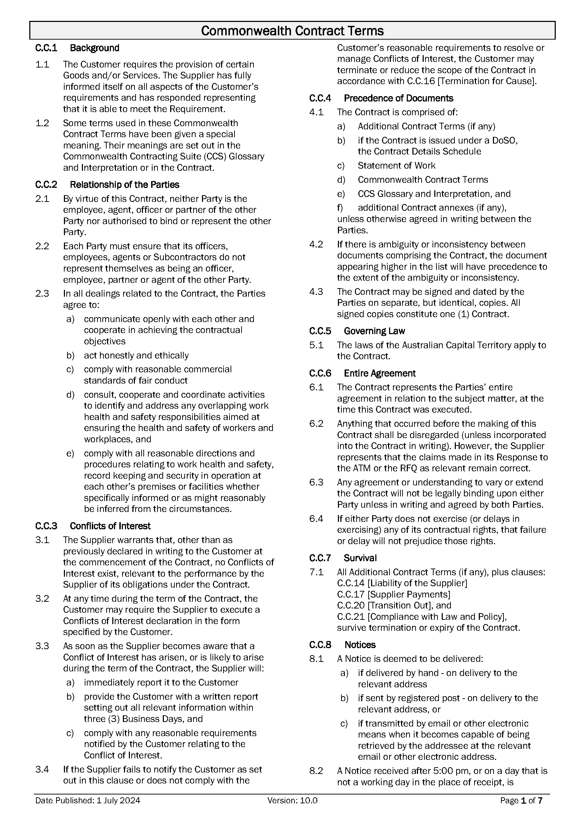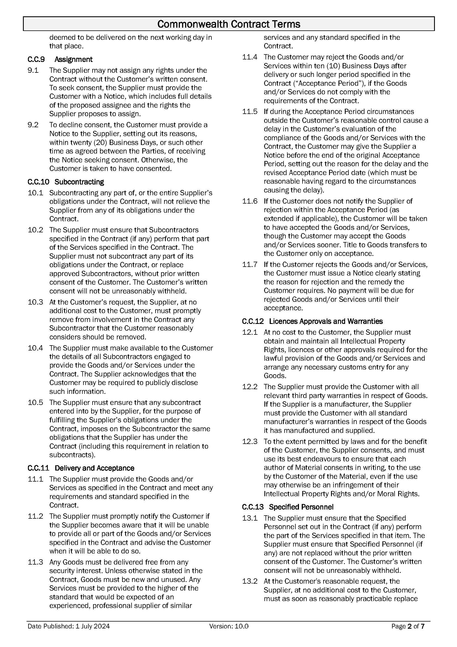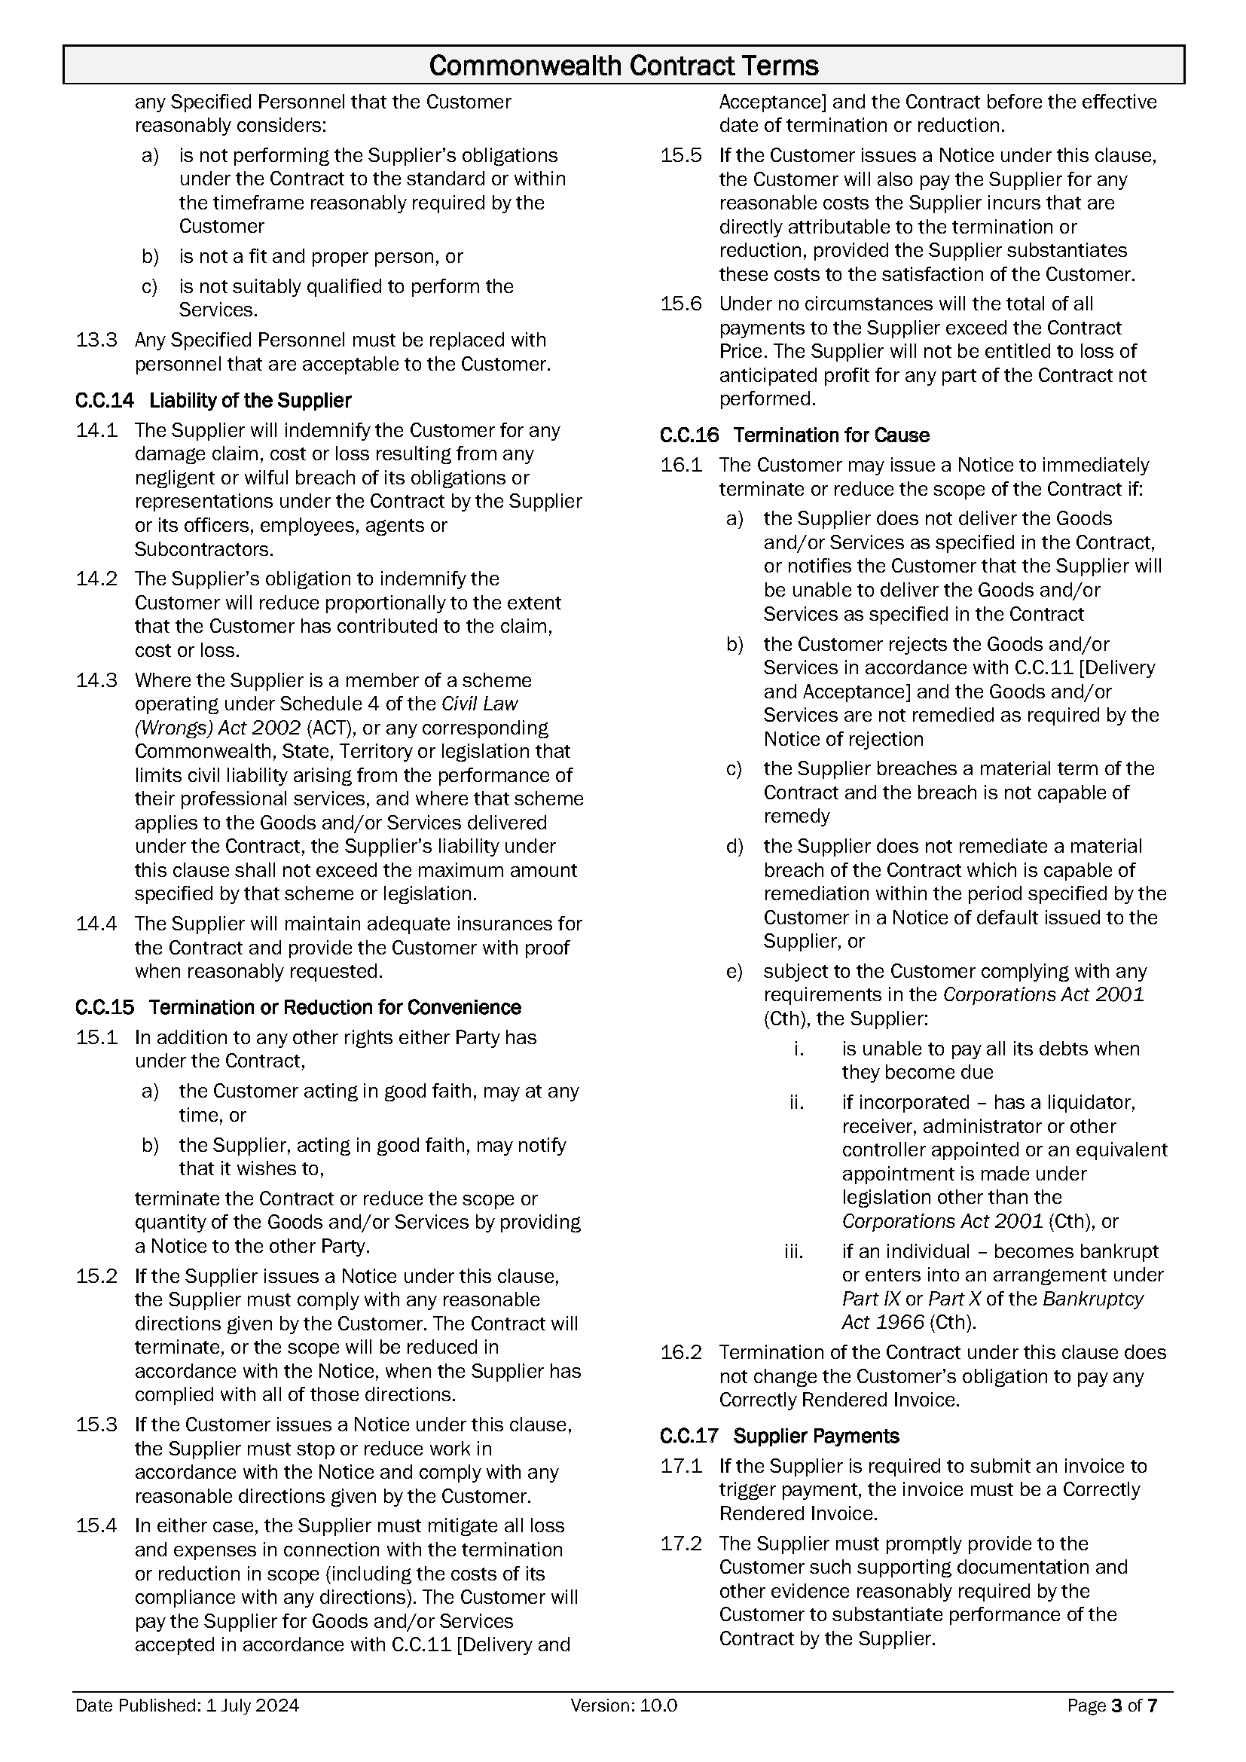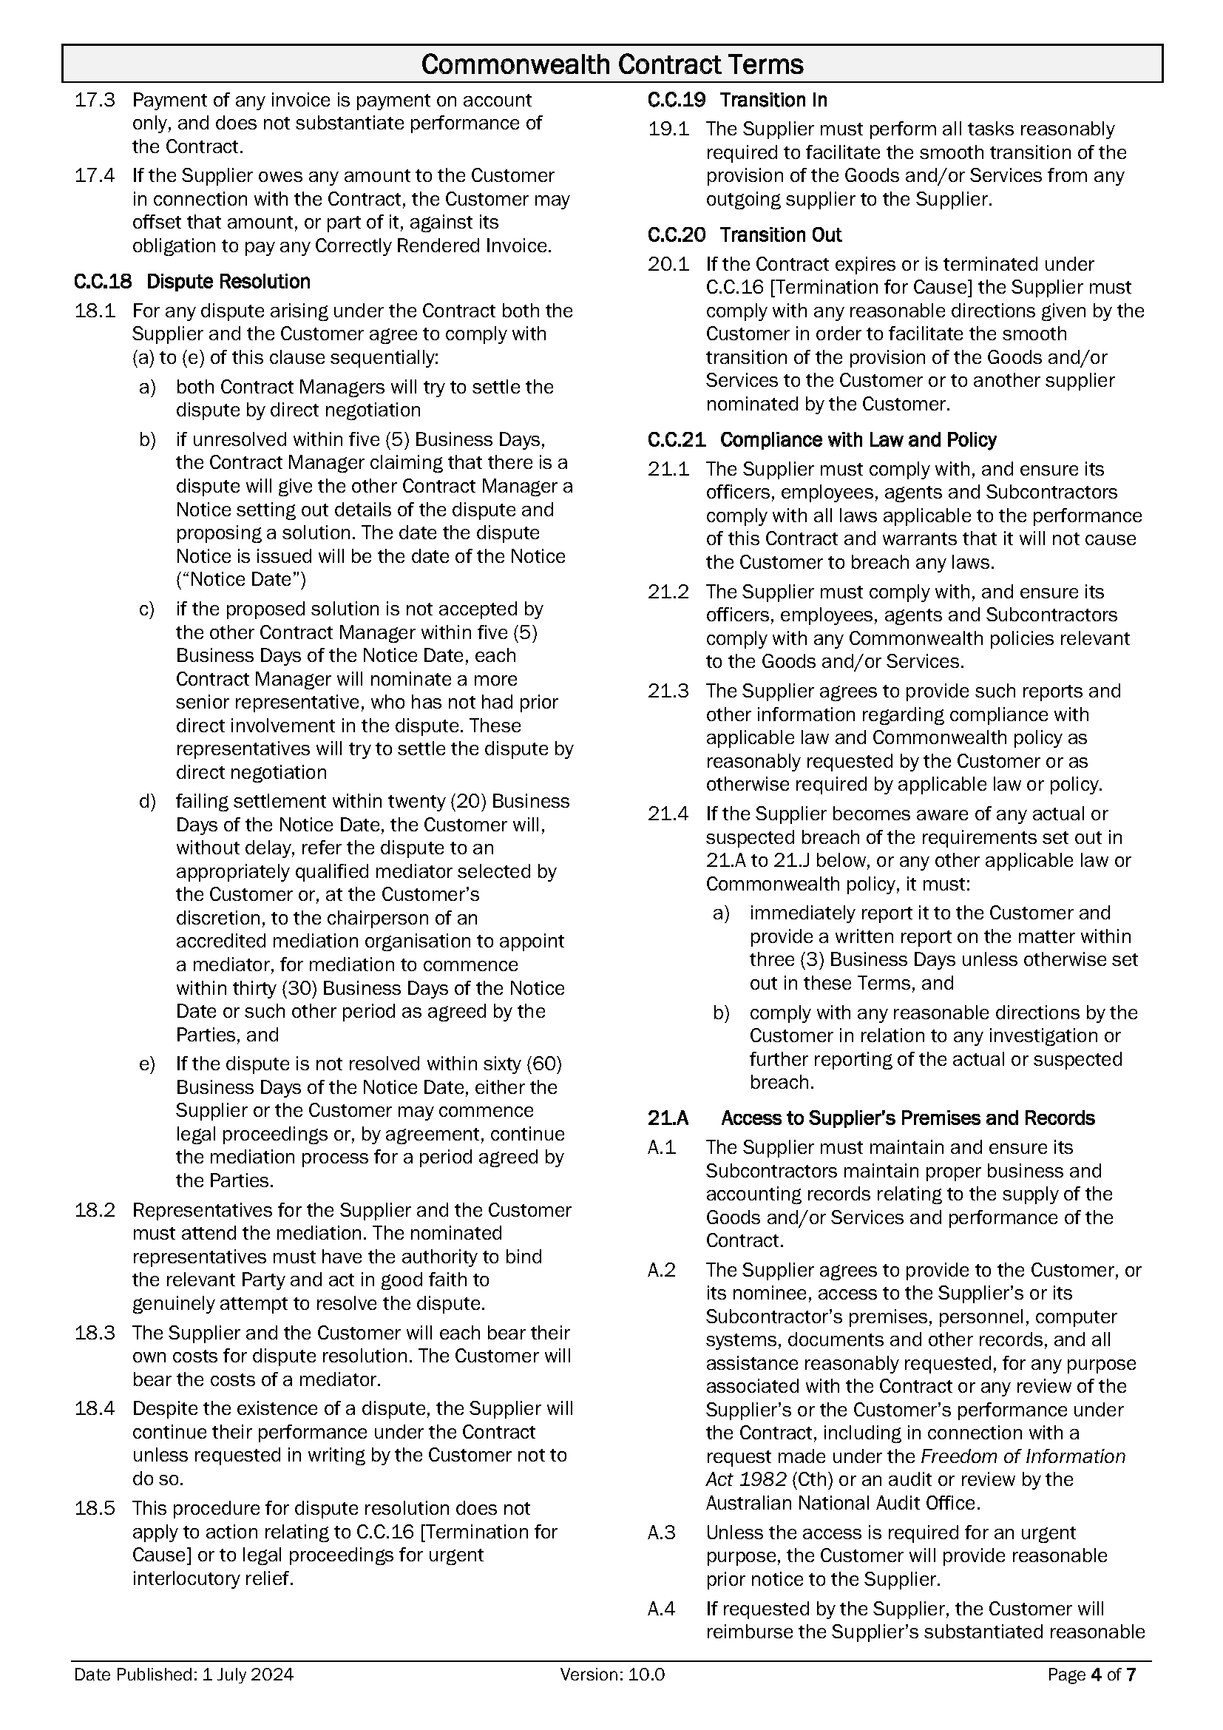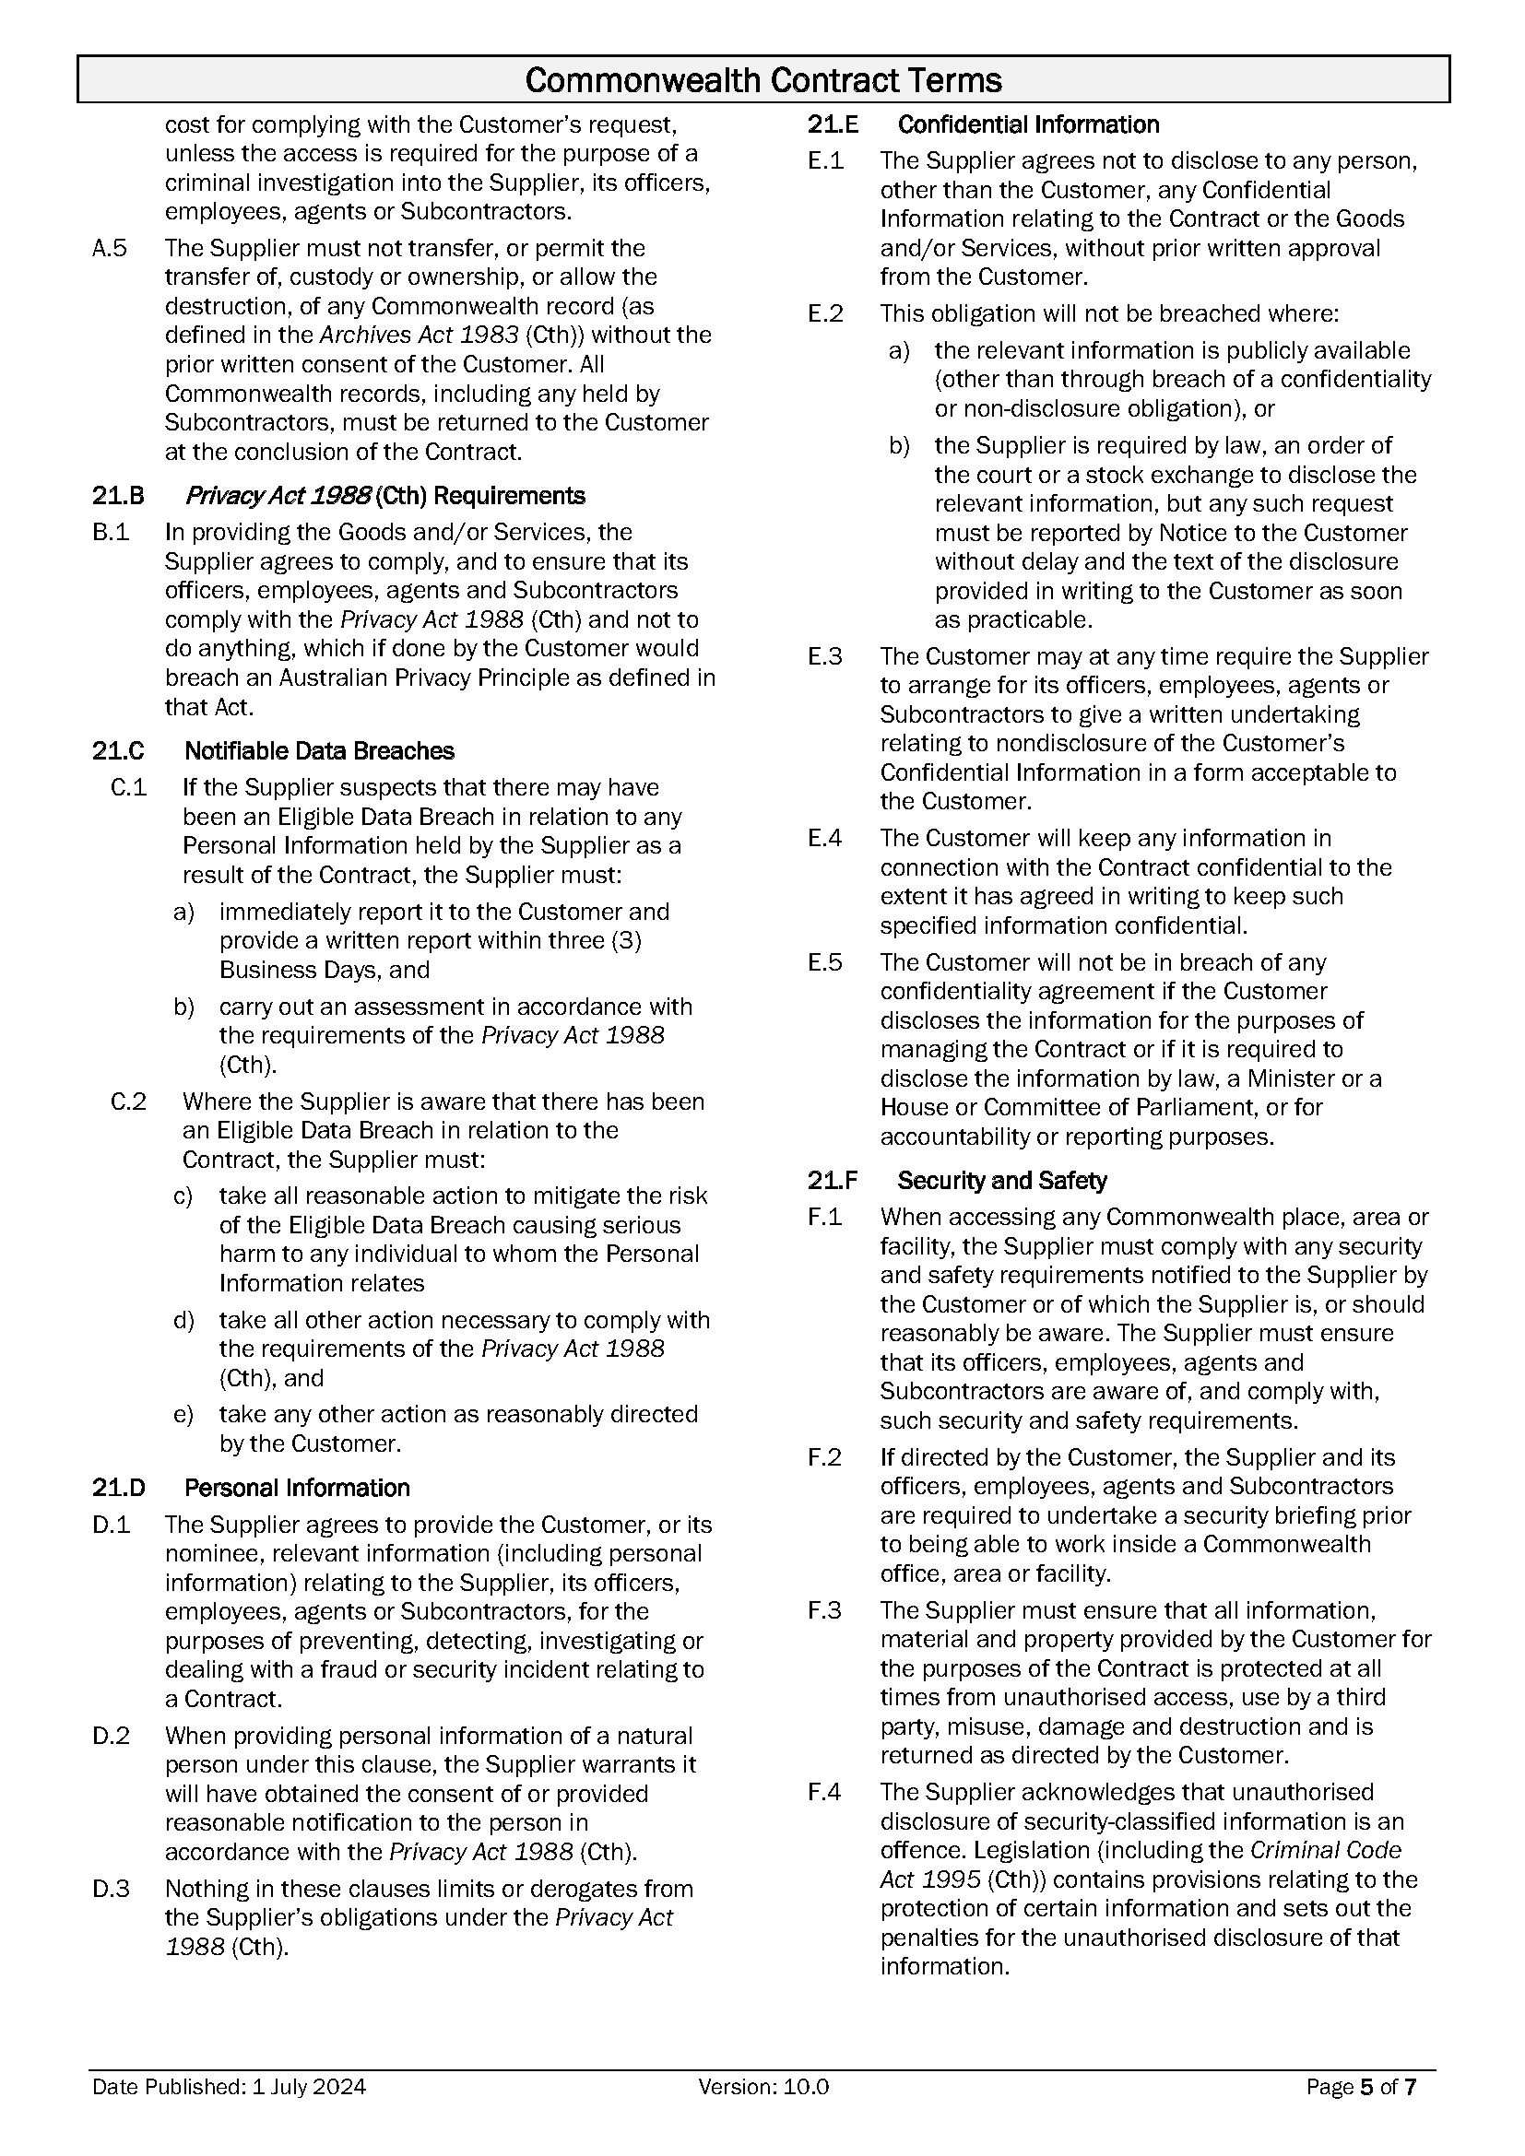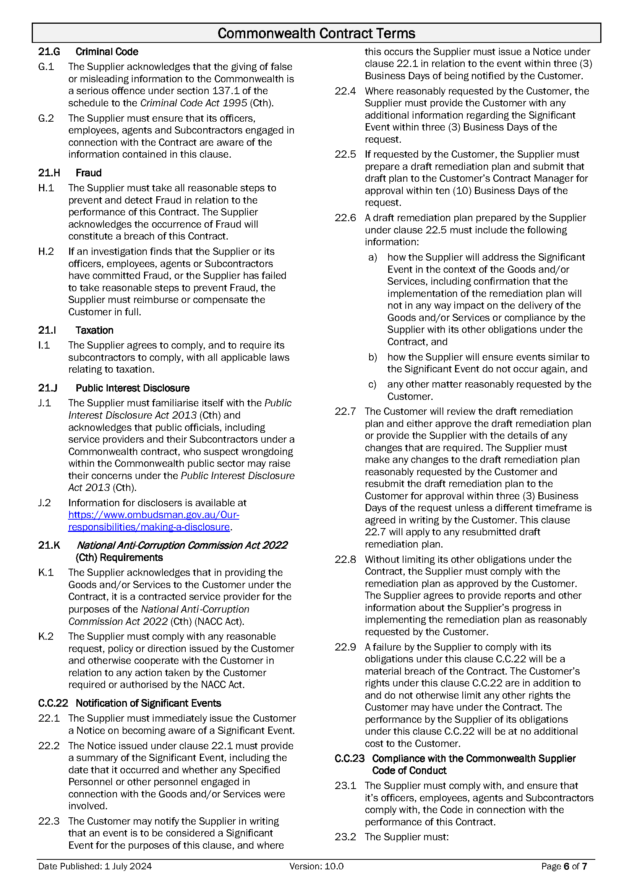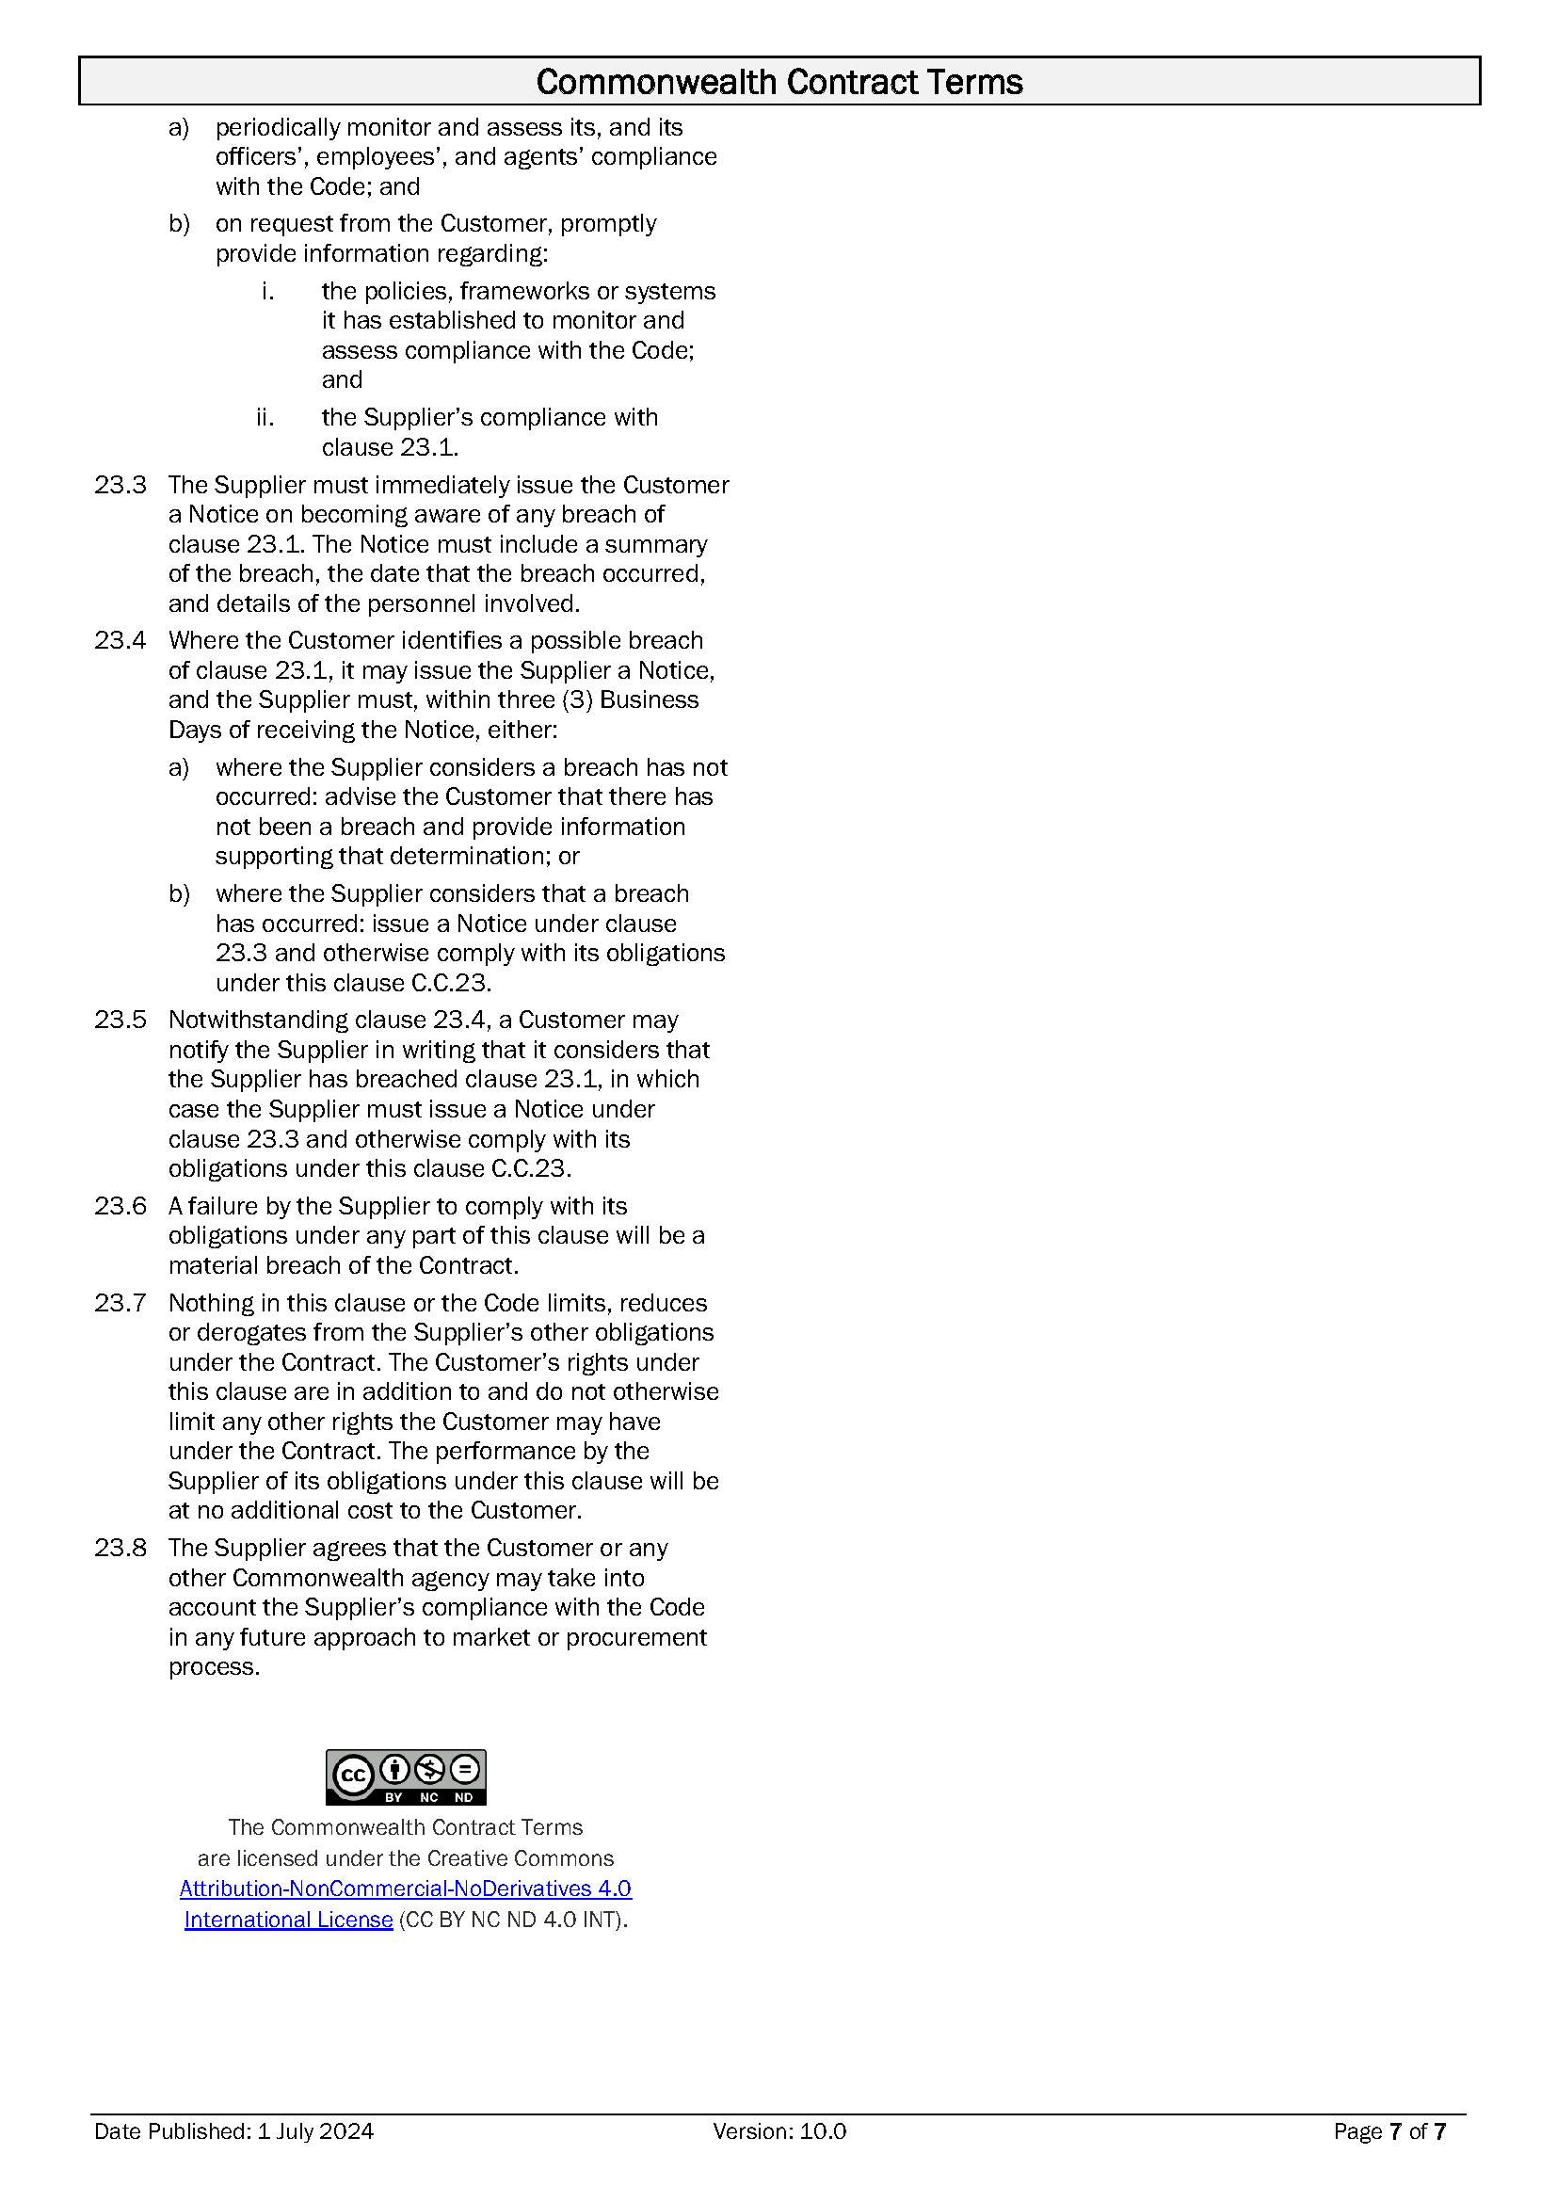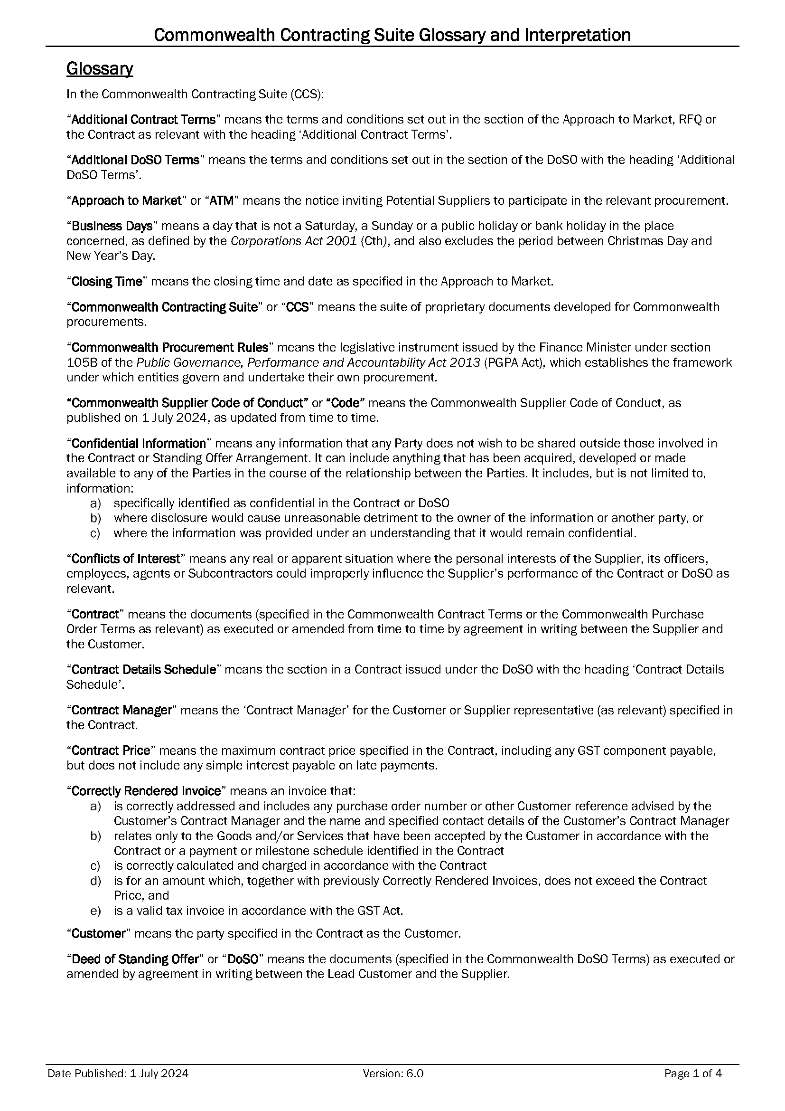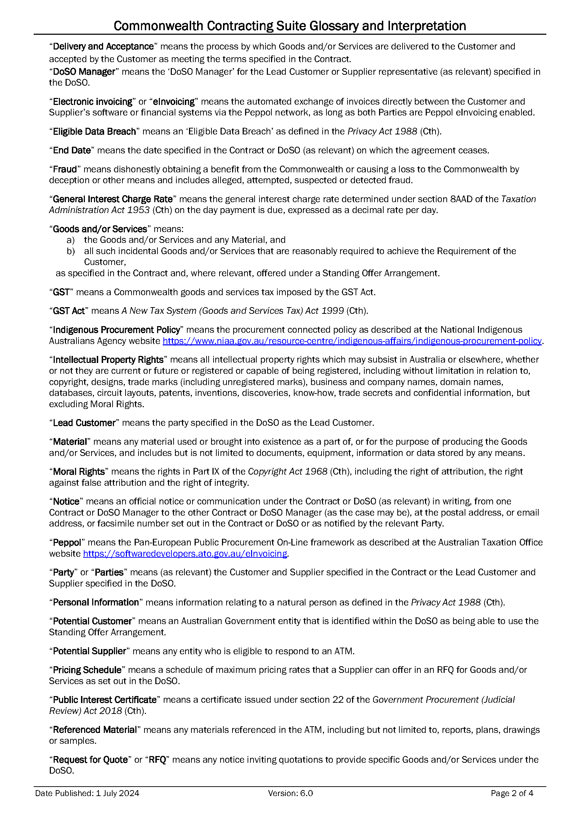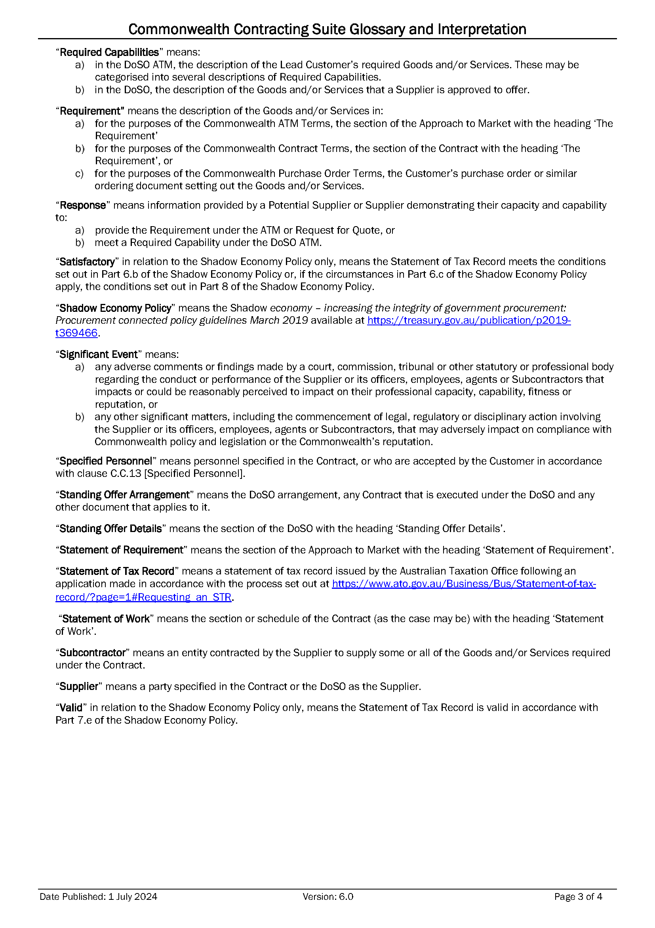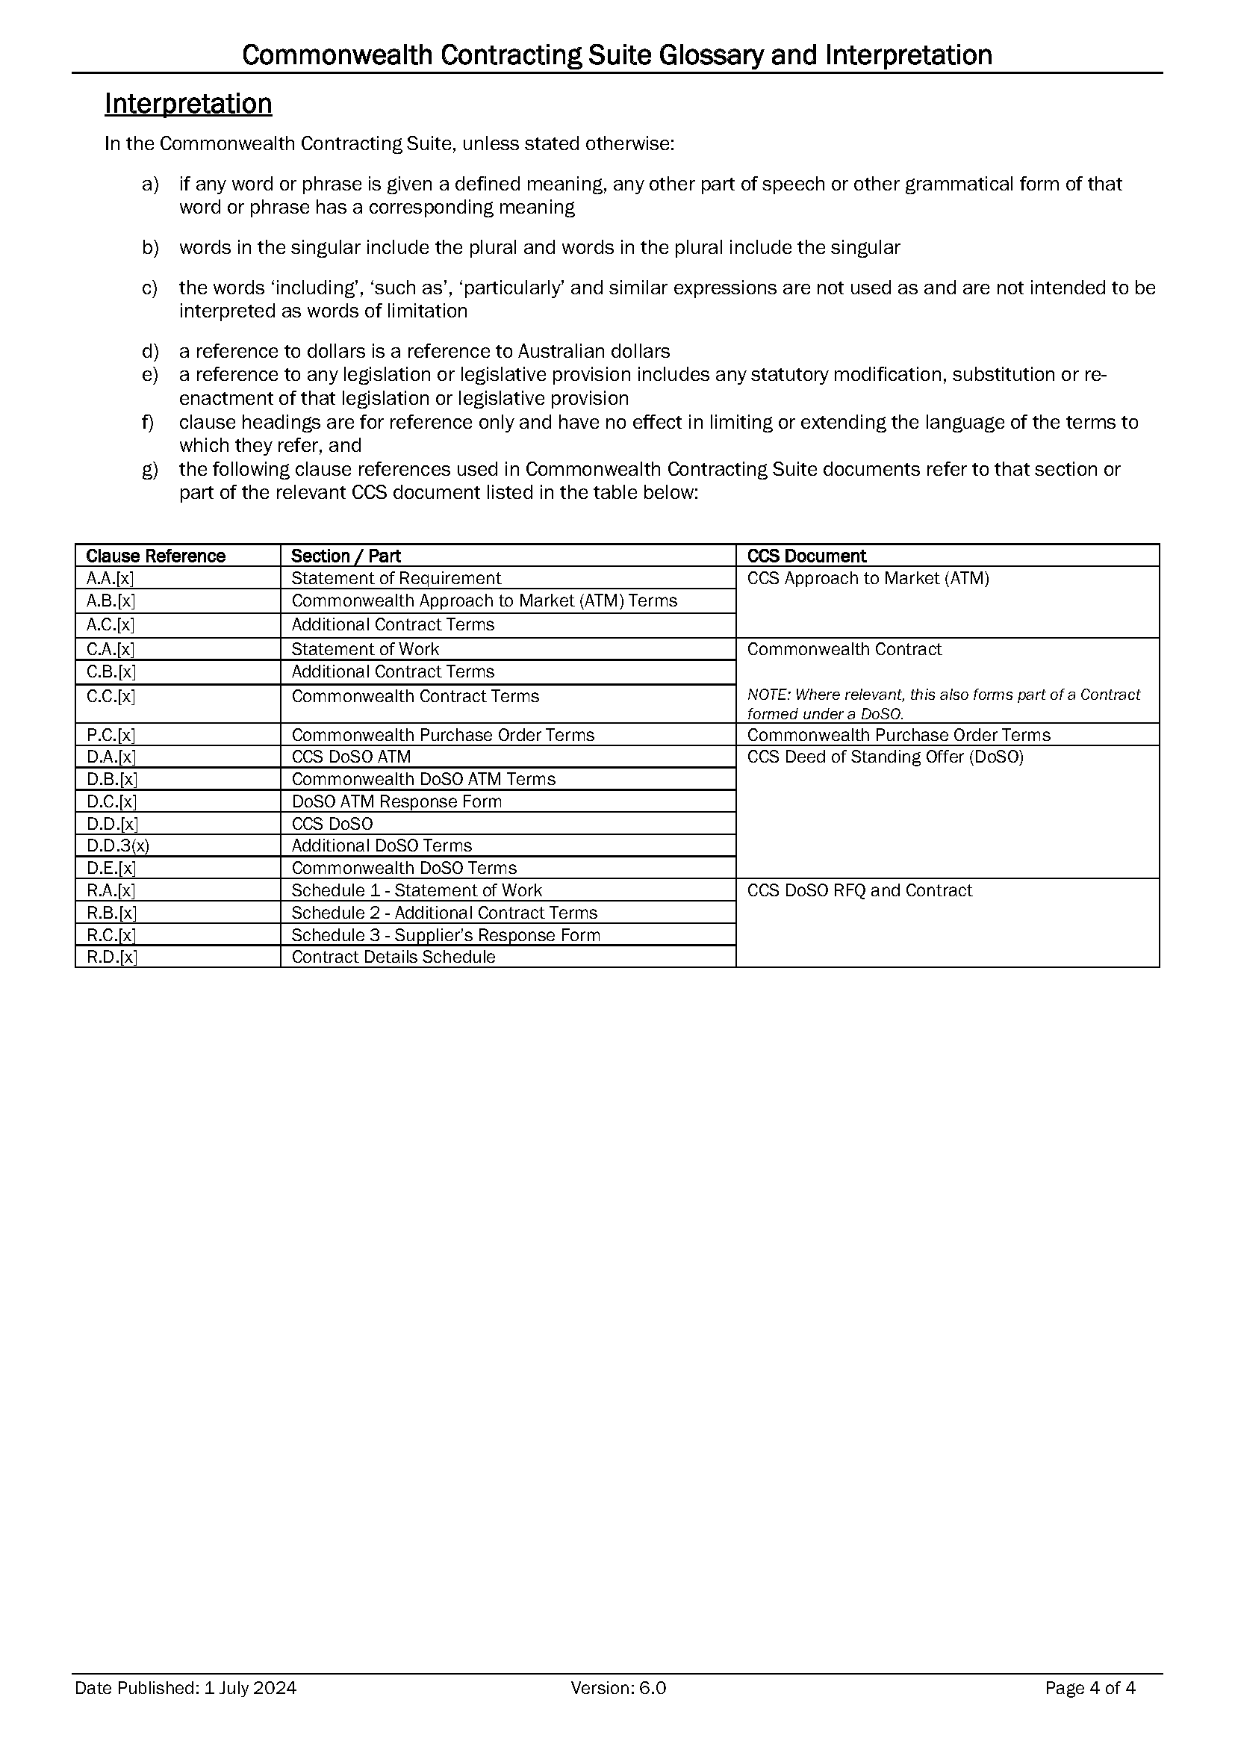
Contract Signing Page
The Parties agree that by signing this Commonwealth Contract – Services, they enter into a Contract comprising:
- Additional Contract Terms
- Statement of Work (including Contract Annex A)
- Commonwealth Contract Terms
- Commonwealth Contracting Suite Glossary and Interpretation



ANNEX A – Statement of Work

Contract for
Norfolk Island Employment Support Program (2025-2028)

Table of Contents
1 Background 3
2 Scope of Work 3
2.1 General 3
2.2 Overview of the Supplier role 4
2.3 Program objectives 4
2.4 Code of Conduct and Service Guarantee 5
2.4.1 Code of Conduct 5
2.4.2 Service Guarantee 5
2.5 Guidelines 6
2.6 Promotion and style guides 6
2.7 Service coverage 6
2.8 Premises and accessibility of Services 6
2.8.1 Sites 6
2.8.2 Facilities 7
2.9 Quarterly reporting 7
2.10 Mandatory Training Modules 8
2.11 Participant feedback process 8
2.12 Linkages with the Centre for Inclusive Employment 9
2.13 Transition-in arrangements 9
2.14 Business continuity 10
3 Services to Participants 10
3.1 Service overview 10
3.2 Participant-led Services 11
3.3 Eligibility 12
3.3.1 Category 1 Participants 12
3.3.2 Category 2 Participants 13
3.4 Period of Registration and Period of Service 13
3.4.1 Transfers during a Period of Service 14
3.5 Services to Category 1 Participants 14
3.5.1 Referral of Participants 14
3.5.2 Initial Interview of Category 1 Participants 15
3.5.3 Initial engagement period 16
3.5.4 Appointments and Contacts with Category 1 Participants 16
3.5.5 Job Plan 17
3.5.6 Mutual Obligation Requirements 18
3.5.7 Compulsory Participation Requirements 20
3.5.8 Personal responsibility and reporting 21
3.5.9 Suspensions and Exits as a Category 1 Participant 21
3.6 Services to Category 2 Participants 22
3.6.1 Direct Registration of Participants 22
3.6.2 Initial Interview of Category 2 Participants 22
3.6.3 Appointments and Contacts with Category 2 Participants 23
3.7 Common Requirements for Categories 1 and 2 24
3.7.1 Record of employment outcomes 24
3.7.2 Support Plan 24
3.7.3 Voluntary job plan for mobility allowance 25
3.7.4 Activities 25
3.7.5 Sustaining Employment Support 28
4 Services to employers on Norfolk Island 29
4.1 Overview 29
4.2 Support to fill vacancies 29
4.3 Support to source suitable employees 30
4.4 Sustaining Employment Support 30
4.5 Financial Assistance 30
4.5.1 Wage Subsidies 30
4.5.2 Employment Assistance Fund 31
5 Services to the community, including stakeholder engagement 33
5.1 Overview 33
5.2 Stakeholder engagement 33
5.3 Key Information to support the newly arrived workforce 34
6 Financial assistance to support access to TAFE and VET courses: Vocational Education and Training (VET) Assistance 35
6.1 Overview 35
6.2 Eligibility for VET Assistance 35
6.2.1 Application for VET Assistance 35
6.2.2 Individual eligibility 35
6.2.3 VET course eligibility 36
6.2.4 Initial Interview for VET Assistance 36
6.3 Negotiation and documentation 37
6.3.1 Letter of offer 37
6.3.2 Authority to Release Information Form 37
6.4 Delivery of VET Assistance 37
6.4.1 Course fee assistance 37
6.4.2 Air travel and accommodation assistance for apprentices and trainees 38
6.5 Communication and monitoring 38
6.5.1 Contact with Participants for VET Assistance 38
6.5.2 Community engagement 39
6.6 Repayment of VET Assistance 39
7 Payment Model 40
7.1 Payments to Supplier 40
7.2 Purchase of goods and services to support Participants 40
8 Norfolk Island Quality Standards of Servicing 41
8.1 Overview 41
8.2 Quality Principles 41
8.3 Practice requirements 42
9 Security Requirements 43
9.1 External IT Systems Accreditation 43
9.1.1 External IT systems 43
9.1.2 External Systems Assurance Framework 44
9.1.3 Maintaining accreditation under the External Systems Assurance Framework 45
Appendix A – Participant Characteristics and Requirements by Income Support Payment Type 46
Appendix B – Service Guarantee 47
Appendix C – Interactions with Services Australia 48
Appendix D – Definitions 49

Background
The Norfolk Island Employment Support Program (NIESP) brings together the fundamental aspects of three national employment related programs currently delivered separately on Norfolk Island:
- Employment Services (Norfolk Island), also known as Workforce Australia
- Disability Employment Services (DES), which is to be replaced by Inclusive Employment Australia from 1 November 2025
- VET Financial Assistance Initiative (VETFAI).
The labour market on Norfolk Island is unique and complex, with more available jobs than there are people to fill them. While there is high participation in the labour market (63.7 per cent, compared with 58.2 per cent in other Territories and 61.1 per cent on mainland Australia), many people work multiple part-time jobs.
The overall population on Norfolk Island is small (2,188), and the available workforce is limited, with the population aging and young people often moving away for other pursuits. This, together with the regional nature of the Island, results in skills shortages in some key fields. Norfolk Island residents, including those who are underemployed, in low skilled positions, or have barriers to employment, need support to upskill to fill these positions.
The Norfolk Island Employment Support Program aims to provide a coordinated response to support the sustainment of the labour market on Norfolk Island by upskilling locals to move towards secure employment, creating more employment pathways to help address skills shortages and provide greater assurance of access to key services for the community.
The Supplier must deliver relevant Services to all Participants, regardless of their personal characteristics, circumstances or needs. Participants who access the Norfolk Island Employment Support Program may have varying degrees of disadvantage and barriers that need to be addressed to enable them to reach their employment and education goals and fulfil their future aspirations. For this reason, the Supplier must take a tailored and trauma-informed approach to service delivery that addresses the needs of each Participant.

Scope of Work

General
Services delivered under the Norfolk Island Employment Support Program must focus on maximising social and economic participation for individuals, including those with a disability. The NIESP also supports employers and bring benefits to the broader Norfolk Island community.
The Norfolk Island Employment Support Program will provide a holistic service to all Norfolk Island residents with employment and higher education needs, including:
- people with a disability, injury or heath condition
- parents
- mature-aged individuals
- youths
- individuals who are unemployed, underemployed or self-employed.
The Supplier must:
- customise its services to support Participants to prepare for, find and maintain sustainable employment, noting that the needs of each Participant will differ, and some will require more support than others
- support relevant Participants through subsidised Vocational Education and Training and TAFE courses and related costs
- proactively assist local employers, through a range of supports, to understand and address their specific workforce needs, implement inclusive employment practices and identify employment opportunities, including creating or tailoring roles where needed, such as for Participants with a disability.
- assist the newly arrived workforce to understand the unique culture of Norfolk Island
- undertake stakeholder engagement activities to support the community and improve coordination across the service system.
Refer to Appendix A for Program Characteristics and Requirements by Payment Type.

Overview of the Supplier role
The Supplier must act in good faith (honestly, fairly, with respect and empathy) towards Participants, employers, the community and the Department and in a manner that maintains a positive reputation for the Norfolk Island Employment Support Program. Services must be delivered as described herein and in accordance with Guidelines and/or any other direction from the Department.
The Supplier must take a person-centred, case management and trauma informed approach to service delivery which is flexible and responsive to the needs of Participants, employers and the community. Intensive ‘in-person’ tailored service delivery is fundamental to the effective delivery of the Norfolk Island Employment Support Program.

Program objectives
The objectives of the Norfolk Island Employment Support Program are to:
- assist all Participants to identify their future aspirations and education and employment goals, and access appropriate support available to progress these
- assist all Participants to build skills to prepare for, secure, and maintain employment
- address barriers to employment, through tailored support
- support employers to understand and address their workforce needs
- establish and maintain collaborative working relationships with key stakeholders to support sustainable social and economic participation of Norfolk Island residents
- support the newly arrived workforce to understand and engage in the Norfolk Island community and economy
- support Participants to access Vocational education through financial assistance with courses and related costs.

Code of Conduct and Service Guarantee
The Code of Conduct and Service Guarantee aim to ensure each Participant receives a high-quality service.

Code of Conduct
The Code of Conduct sets out acceptable, appropriate and ethical conduct that must be adhered to by the Supplier in delivering the Norfolk Island Employment Support Program as outlined below:
- act with respect for the individual rights of people to freedom of expression, self-determination and decision making, in accordance with applicable laws and conventions
- respect the privacy of people
- provide services in a safe and competent manner, with care and skill
- act with integrity, honesty and transparency
- promptly take steps to raise and act on concerns about matters that may impact the quality and safety of the provision of the service to people, including those with a disability
- take all reasonable steps to prevent and respond to all forms of violence against, and exploitation, neglect and abuse of, people, including people with a disability, and
- take all reasonable steps to prevent and respond to sexual misconduct.
Non-compliance with the Code of Conduct may constitute a breach of the Contract which may result in the Department taking remedial action against the Supplier, which could include suspension of payments or termination of the Contract.

Service Guarantee
The Supplier must adhere to the Service Guarantee which sets out the minimum level of service expected across the full range of Services. Under the Service Guarantee, Participants can expect to be treated fairly, respectfully and in a culturally sensitive way, and to receive high quality services tailored to their individual needs that support them to build readiness for employment.
Refer to Appendix B for the Service Guarantee.
A copy of the Service Guarantee must be provided to each Participant at the Initial Interview and must be prominently displayed in the site/s and on the Supplier’s website. The Supplier must also make the Service Guarantee available to potential Participants and employers.

Guidelines
The Supplier must observe and implement the provisions of any Guidelines issued by the Department.

Promotion and style guides
The Supplier must adhere to promotion and style guides issued by the Department to govern promotional activity, including any obligation to ensure that all advertisements, publicity and promotional materials carry the relevant badging, signage and acknowledgements approved by the department.

Service coverage
The Supplier must deliver the Norfolk Island Employment Support Program on Norfolk Island.

Premises and accessibility of Services

Sites
The Supplier must operate from at least one site physically located on Norfolk Island. At least one such site must be opened from the Contract Start Date.
At a minimum, the site/s must:
- be open for in-person service delivery from 9am to 5pm every Business Day with the exception of the Christmas shut down period as notified by the Department each year
- be close to frequently visited services and amenities
- be accessible to all individuals, including those with a disability and/or mobility restrictions
- ensure the security of personal information and privacy for Participants
- consider the needs and experience of all Participants, for example, the site must be disability and youth friendly and accommodate parents with children
- be culturally, physically, and emotionally safe for all Participants on the caseload, visitors (including children) and staff.

Facilities
The Supplier must provide a dedicated space and facilities for Participants where they have access to a self-help facility, at no cost to Participants, such as: computers, Wi-Fi, telephone and printing facilities.
The Supplier must also support Participants to use these self-help facilities, as needed.
The Supplier must assist Participants to access available online services and information, as needed, which support Participants to improve their employment prospects, including but not limited to:
- Workforce Australia Online
(www.workforceaustralia.gov.au/individuals), including self-reporting, undertaking job searches, and tools and information about the best ways to look for and find employment
- Australian labour market information, such as information available on Jobs and Skills Australia Website (https://www.jobsandskills.gov.au/)
- career information, in particular through the National Careers Institute website (https://www.dewr.gov.au/nci)
- information on training pathways, in particular through the Your Career website (https://www.yourcareer.gov.au/)
- JobAccess (https://www.jobaccess.gov.au/), the national hub for workplace and employment information for people with disability, employers and service providers.
The Supplier must ensure that sufficient cybersecurity controls and policy is adhered to as outlined in section 9 of this Statement of Work.

Quarterly reporting
The Supplier must submit a comprehensive quarterly report in a form stipulated by, or otherwise agreed with, the Department.
At a minimum, the quarterly report must include:
- the Supplier’s service delivery approaches and strategies to ensure high quality and tailored service provision, including but not limited to:
- specific areas of focus for service delivery, such as new initiatives or continuous improvement activities
- activities undertaken to demonstrate achievement of program objectives, including case study examples from the relevant quarter
- a summary of stakeholder engagements with Participants, employers and the community, including commentary on:
- outcomes, for example, streamlined referral pathways and employment pathways for Participants
- identified gaps in key services, such as those resulting from skills shortages
- barriers for participation by particular groups, such as people with a disability, women, youth
- other local intelligence, such as current and future labour market pressures and opportunities, emerging trends
- a summary of once-off service delivery from the relevant quarter
- any feedback received, including complaints
- updates on recruitment, training and staff development
- any identified risks and mitigations
- the number and dates of completed Initial Interviews for VET Assistance, including details of the Participant, the VET course including whether it is a school based or non-school based course, Participant eligibility and forecasted costs;
- the number and dates of letter of offers issued and considered legally binding, including details of the Participant, the VET course, forecasted costs and expiry date of the course;
- total administered fee assistance including the breakdown of the course fee, any further RTO fees, air travel and accommodation assistance for apprentices and trainees, by Participant and the VET course;
- the number of students successfully engaged with by the Supplier and deemed actively participating in training, including details of participation and Activities by each Participant;
- the number of students who have successfully completed a course, including details of the Participant, the VET course, including the total broken down and total costs of administered assistance; and
- the number of students who have withdrawn from or failed to complete courses, including details of the Participant, the VET course, costs to date and activities undertaken or proposed to recover eligible funds.

Mandatory Training Modules
The Supplier must ensure that its staff involved in the delivery of the Services undertake mandatory training modules notified by the Department from time to time, covering such topics as fraud and corruption and privacy and confidentiality, and to refresh relevant training every 12 months.
Training materials will also cover information that supports the Supplier and its staff to understand the IT System.

Participant feedback process
The Supplier must implement and maintain an appropriate Participant feedback process. As part of this, the Supplier must assess whether feedback relates to the Supplier’s failure to comply with the Code of Conduct and/or Service Guarantee. Feedback relating to the Supplier’s failure to comply with the Code of Conduct and/or Service Guarantee must be reported to the Department.
Participants who believe they are not receiving service of the standard identified in the Code of Conduct and/or Service Guarantee are entitled to raise this with the Supplier in the first instance and, if not satisfied, may then raise their complaint with the National Customer Service Line (NCSL).

Linkages with the Centre for Inclusive Employment
The Centre for Inclusive Employment will develop best practice, evidence-based information to help employment service providers, including the Supplier, to deliver high-quality effective employment services and supports. The Supplier must make use of the resources, tools, and training available through the Centre for Inclusive Employment.
For more information, see Centre for Inclusive Employment | Department of Social Services.

Transition-in arrangements
Transition-in arrangements will be put in place to move from the three national employment related programs currently delivered separately on Norfolk Island to the Norfolk Island Employment Support Program.
The objective of transition-in is to achieve a smooth and timely transfer to the Norfolk Island Employment Support Program with minimal disruption for Participants, employers, the community and the Supplier. Transition-in arrangements must ensure that Participants are informed about the services they will continue to receive under the Norfolk Island Employment Support Program as well as any service changes, if any, taking into account their individual circumstances.
The Department will work with the Supplier to provide transition advice and manage the transition-in process using the following principles:
- Transition-in activities will support continuity of services from existing programs to the Norfolk Island Employment Support Program.
- Transition-in processes must be automated where possible, to alleviate administrative burden for the Participant and the Supplier.
- There will be communication with Participants, stakeholders, employers and the community throughout the transition-in process using multiple channels.
Current Employment Services (Norfolk Island), DES and VETFAI Participants with a residential address on Norfolk Island will transition to the Norfolk Island Employment Support Program on 1 July 2025.
The Department will issue the Supplier with transition advice. Guidelines and online modules will be available to assist the Supplier in implementing the Norfolk Island Employment Support Program and to understand the IT System.
The Supplier will communicate with transitioning Participants about the new arrangements. The Supplier will also provide information for employers and the community on the new Norfolk Island Employment Support Program.

Business continuity
The Supplier must have appropriate business continuity arrangements in place to ensure that emergencies, incidents, and changes in Specified Personnel that may disrupt operations and/or impact its delivery of Services are adequately managed. Within 3 months from the Contract Start Date, the Supplier must submit its business continuity plan to the Customer for review and approval. The plan should address, at a minimum:
- management of site safety and security (including lockdowns or evacuations) and securing records and filing systems
- management of data safety and IT security (including containment and notification to the Department of cyber incidents) and securing access to the IT System
- timing and protocols for the submission of urgent or critical notifications and incident reports (including temporary site closure reports) to the Department and other relevant entities (e.g. police, health/welfare agencies, emergency responders)
- process for identifying critical Services, as well as Participants, employers, and other stakeholders who may be affected
- communication and coordination protocol with the Department, Participants, employers and other stakeholders
- where relevant, handover of tasks and responsibilities and alternative options to deliver critical Services, and
- process for ensuring that the Targeted Compliance Framework is not applied where Mutual Obligation Requirements have been suspended.

Services to Participants

Service overview
The Norfolk Island Employment Support Program is focussed on the Supplier delivering high quality Participant-led case management services that achieve greater social and economic inclusion for all Norfolk Island residents. Services delivered to Participants must focus on providing a pathway to employment or higher education that considers their individual needs, circumstances, strengths, goals and aspirations and that they are well-placed to meet the needs of employers.
The Supplier must:
- focus on achieving sustainable employment outcomes for Participants and providing ongoing support as needed for the duration of their Period of Registration;
- support, motivate and encourage Participants to prepare for, find and maintain employment or engage in higher education through regular meaningful engagement;
- work to achieve high levels of engagement with all cohorts (e.g. parents, youth, women, people with a disability etc) using case management strategies, including goal setting and planning tools;
- consider the needs and circumstances of each Participant when determining the frequency and appropriate mode of engagement, noting that there are minimum requirements for Category 1 Participants;
- record all engagements, such as Appointments and Activities, in the IT System.
- promote meaningful engagement and facilitate career development by providing support that recognises that Participants have choice in the Activities they undertake to improve their employability or find employment; and
- recognise that a person’s employment journey may involve multiple steps before they are able to find a job.

Participant-led Services
Based on the needs of each Participant, the Supplier must:
- develop and maintain a supportive relationship, through regular, meaningful, professional, in-person contact (preferred) or via the phone, email or other virtual platforms when necessary;
- deliver tailored and flexible support to Participants which considers:
- the results of any assessment strengths, skills, experience and aspirations
- nature of disability, injury or health condition (where applicable)
- language or hearing barriers, including the use of interpreters (where applicable)
- cultural background and linguistic diversity
- vocational and non-vocational barriers to employment;
- advocate for the best interests of Participants in all respects, for example, negotiating access to services, streamlining referral processes, promoting the needs and interests of Participants with other stakeholders;
- provide career advice and job search assistance, including advice on how to prepare and maintain an appropriate resume, undertake suitable job searches and develop job applications, and advice on interview techniques, including exploring post-interview outcomes;
- provide career advice and job search assistance, including advice on how to prepare and maintain an appropriate resume, undertake suitable job searches and develop job applications, and advice on interview techniques, including exploring post-interview outcomes;
- provide support for small business growth and entrepreneurial activities;
- improve foundation and employability skills such as the ability to work in a team, communication skills, digital skills, motivation and reliability;
- provide support to access online resources and undertake online training;
- promote pathways to employment to maximise employment prospects, including a focus on addressing skills shortages on Norfolk Island;
- develop and deliver training and/or short courses;
- source and refer Participants to suitable vacancies;
- where appropriate, provide wage subsidies to generate employment opportunities for Participants with a disability;
- refer to Activities to address vocational and non-vocational needs, including facilitating introductions;
- where appropriate, purchase goods and/or services to proactively support Participants to overcome difficulties in finding or keeping employment (e.g. equipment, licences, work clothing etc);
- provide ongoing support following commencement of a job or in education that may result in employment or to support job retention;
- support Participants to engage with education opportunities through financial assistance for VET and TAFE courses; and
- support employers to hire more people with a disability into the right roles, including provision of help to create and tailor job opportunities and connecting employers to relevant government services such as the Employment Assistance Fund.

Eligibility
All Norfolk Island residents of working age (15-66 years), who require support to address barriers to employment, or vocational education are eligible for support through the Norfolk Island Employment Support Program. Participants who volunteer into the NIESP must have work rights in Australia.
For the purposes of describing servicing requirements for Participants in relation to Services described in section 2.14 of this Statement of Work, there are two categories of Participants: Category 1 Participants and Category 2 Participants. For avoidance of doubt, references to obligations on Participants described in section 2.14 of this Statement of Work apply only to Category 1 Participants and Category 2 Participants and are not obligations on Participants in relation to VET Assistance. Participant rights and obligations in relation to VET Assistance are detailed in section 6 of this Statement of Work. Eligibility requirements in relation to Participants for VET Assistance are specified in (a) of this Statement of Work.

Category 1 Participants
Category 1 Participants are required to participate in the Norfolk Island Employment Support Program. This is because Category 1 Participants are individuals on specific income support payments who must undertake tasks and activities in return for income support (known as Mutual Obligation Requirements for unemployment payments or Compulsory Participation Requirements for Disability Support Pension).
Participants receiving the following Income Support Payments have Mutual Obligation Requirements:
- JobSeeker Payment
- Parenting Payment single with youngest child aged 6 years and over
- Youth Allowance for job seekers
- Special Benefit (nominated visa holders).
Participants receiving the Disability Support Pension will have Compulsory Participation Requirements if they:
- are aged under 35 years
- have an assessed work capacity of 8 or more hours work per week, and
- do not have a dependent child aged under 6 years.

Category 2 Participants
Category 2 Participants are not required to participate in the Norfolk Island Employment Support Program, but can volunteer to do so and include:
- individuals on specific Income Support Payments without Mutual Obligation Requirements, including:
- Carer Payment;
- Parenting Payment single with youngest child aged under 6 years; or
- Disability Support Pension, without Compulsory Participation Requirements; and
- individuals with employment needs who are not on an income support payment, not Centrelink-managed, or who otherwise wish to volunteer to receive services, which may include individuals who are underemployed or in low skilled positions and who wish to upskill and improve their employment prospects, or people whose jobs are at risk and need support to retain their jobs.

Period of Registration and Period of Service
The Supplier must provide services to a Participant for the duration of their Period of Registration.
A Participant’s Period of Registration is the period of time of that name, as specified in the IT System. The Period of Registration:
- begins on Commencement with the Supplier
- pauses if a Participant is Suspended (where applicable), and
- ends when the Participant is:
  - transferred to another program, such as on mainland Australia (i.e. if the Participant moves location), or
  - Exited.
A Participant’s Period of Service is the period of time of that name, specified in the IT System in relation to a particular Participant.
For the avoidance of doubt, the Period of Registration and Period of Service includes Sustaining Employment Support.

Transfers during a Period of Service
During the Period of Service, if a Participant moves from Norfolk Island to mainland Australia, for example, they will be transferred to a relevant program, for example, Workforce Australia, Inclusive Employment Australia, Remote Australia Employment Service, Transition to Work or Parent Pathways.
Participants who have been referred to a Workforce Australia, Inclusive Employment Australia or Remote Australia Employment Service provider, and who change their residential address to Norfolk Island, will be transferred to the Norfolk Island Employment Support Program.

Services to Category 1 Participants

Referral of Participants
Participants claiming Income Support Payments may be referred to the Norfolk Island Employment Support Program through Services Australia. As part of applying for Income Support Payments or employment services assistance (via Services Australia), Participants will generally be asked to complete the Job Seeker Snapshot that includes questions to assess their relative disadvantage in the labour market and risk of long-term unemployment, known as the Job Seeker Classification Instrument score. Participants will then partake in a participation interview with Services Australia. If the Job Seeker Snapshot is not completed prior to this interview, Services Australia will conduct this during the participation interview.
The results of the Job Seeker Snapshot and participation interview will determine whether a Referral will be made to the Norfolk Island Employment Support Program. It may also indicate the need for an Employment Services Assessment, which will assess the impact of barriers to work.
The Supplier must, at all times, have Appointments available in the Electronic Calendar to support acceptance of a Referral from Services Australia within two Business Days of receipt.
Refer to Appendix C for detail on the interactions with Service Australia.

Initial Interview of Category 1 Participants
The purpose of the Initial Interview is to explain employment services, discuss the needs of the Participant and tailor Mutual Obligation Requirements (where they apply) appropriately and to support the Participant to find and maintain suitable employment. The Initial Interview also informs tailored servicing.
The Supplier must conduct an Initial Interview with each new Participant and record completion of the Initial Interview in the IT System within 10 days of receiving a Referral. Where reasonable to do so, the Initial Interview must be conducted in person.
The Supplier may need to conduct a Job Seeker Snapshot if it has not been completed by Services Australia or the Participant as part of the Income Support Payment claim process.
At the Initial Interview the Supplier must:
- confirm the Participant’s identity
- assess the needs of a Participant as required. This could include use of:
  - the Job Seeker Snapshot
  - any other assessment it has which is reliable
- explain the Norfolk Island Employment Support Program and the range of support available
- identify whether the Participant is already engaged in any Activities
- develop an initial Job Plan
- explain the Participant’s Mutual Obligation Requirements, including the requirement to attend Appointments and complete job search (where it applies)
- explain the Points Based Activation System and the Targeted Compliance Framework (where it applies)
- prepare an initial Support Plan, documenting a Participant’s short, medium and long-term employment and skills goals and the pathway to progress towards them
- explain when an exemption from Mutual Obligation Requirements might be appropriate and how to apply (directing the Participant to Services Australia)
- explain how a Participant can Fully Meet their requirements (if applicable) by undertaking certain Activities to become Centrelink-managed.
- explain to Participants their rights and obligations under the NIESP and consequences of not participating in accordance with their Job Plan
- provide:
  - the Service Guarantee
  - details of the current National Minimum Wage
  - the Fair Work Ombudsman website and contact details.

Initial engagement period
The initial engagement period is the first 4 weeks of a Participant’s Period of Registration, commencing from the successful completion of the Initial Interview.
This time allows for a Participant-centred case management approach for each Participant and to:
- build a positive relationship with the Participant
- consider the approach to servicing to ensure it is tailored to their individual needs, circumstances, skills, strengths and goals
- jointly finalise the Participant’s Job Plan and Support Plan.

Appointments and Contacts with Category 1 Participants
The frequency and mode of delivery of Appointments and Contact with Category 1 Participants will be determined based on the needs and circumstances of each Participant and focussed on ensuring they remain meaningfully engaged.
Each Contact or Appointment must be conducted in accordance with Guidelines and:
- on the date and at the time agreed to with the Participant and recorded in the IT System,
- in a professional manner,
- in a communication mode agreed by the Participant at an accessible, appropriate and safe location, if in-person (noting that this must not be at a Participant’s home),
- with use of an interpreter if needed, and
- without causing a conflict with employment or training.

Appointments for Category 1 Participants
The Supplier must have Appointments available in the Electronic Calendar within the next 2 to 5 Business Days, at all times, for:
- Initial Interviews
- re-engagement appointments — an Appointment during which the Supplier re-engages a Participant following a period of Suspension, an incident of non-compliance, or the completion of an approved Activity
- conducting a Contact with the Participant following a Change of Circumstances Reassessment, and
- Capability Interviews — an Appointment between the Supplier and a Participant to ensure requirements specified in the Participant’s Job Plan are appropriate to their circumstances and the Participant is capable of meeting them.
The Supplier must provide Participants with details of Appointments and other Contacts record attendance on the IT system and/or in accordance with Guidelines or direction from the Department. Where the Supplier or a Participant needs to reschedule an Appointment or other Contact, this must be at the next available opportunity taking into consideration the Participant’s circumstances.

Contact for Category 1 Participants
At a minimum, the Supplier must conduct at least 6 Contacts over each 3-month period for each Category 1 Participant.
Contact with Participants may be:
- one-on-one,
- group-based Activities such as employment-related information sessions or training sessions delivered by the Supplier, or
- with third parties such as the Participant’s family, carer(s) or listed nominee, NDIS local area coordinator or NDIS support workers, or an employer, with agreement from the Participant.
At each Contact, the Supplier must confirm the Participant’s identity and ensure that their current postal address, mobile phone number and email address are recorded accurately in the IT System and/or in accordance with Guidelines and/or any other direction from the Department.
Additionally, the Supplier must ensure the Job Seeker Snapshot is up-to- date and may review the Job Seeker Snapshot, at any time, as a mechanism to inform or modify the employment services to ensure they are appropriate for each Participant. Changes in personal circumstances and/or new information must be recorded in the IT System in the Capability Management Tool (CMT).
Where the Job Seeker Snapshot indicates in the IT System that an Employment Services Assessment (ESAt) may be required, the Supplier must refer the Participant to Services Australia to have that assessment conducted.

Job Plan
Category 1 Participants must have a current, up-to-date Job Plan and the Job Plan must be developed in partnership with the Participant and recorded on the IT System. The Job Plan is to be reviewed and kept up to date throughout the Participant’s time in the Norfolk Island Employment Support Program.
The purpose of a Job Plan is to document what the Participant must do to meet their Mutual Obligation or Compulsory Participation Requirements, which will include:
- meeting a Points Requirement - Points Target and Job Search Requirements, tailored to the Participant’s needs (only applicable to Participants with Mutual Obligation Requirements)
- attending and acting appropriately during any compulsory Appointments (i.e. Appointments with the Supplier or appointments with third parties, of which the Participant is notified about)
- following up on job referrals and Activities the Participant is referred to by the Supplier
- attending and acting appropriately during a job interview/s
- accepting an offer of a suitable job and not voluntarily leaving a suitable job
- taking responsibility to accurately record or report attendance at their requirements, if appropriate to the Participant’s capabilities
- participating in Activities on the dates and times notified, where required.
The Supplier must:
- create a Job Plan with each Participant and review it regularly, ensuring it is updated as required;
- provide 2 Business Days’ ‘think time’ for the Participant to consider the Job Plan before agreeing to it;
- enter into and approve or update a Job Plan with the Participant;
- provide each Participant with assistance to meet the requirements in their Job Plan;
- assess a Participant’s circumstances and capability to take personal responsibility for self-reporting, and provide support to report if needed;
- refer Participants to suitable Activities;
- allow Participants to arrange and report on self-initiated Activities and tasks to earn points for the PBAS, such as:
  - job interviews
  - employment
  - education and training
  - service to community
  - Participant sourced voluntary work
  - online learning;
- ensure Participants are aware of their Mutual Obligation or Compulsory Participation Requirements and that they must record details of their completed tasks appropriately; and
- conduct a quality review of job search efforts within 5 Business Days of the end of each Points Reporting Period to assess the quality of Participants’ job search efforts (note that this is optional for Participants with Compulsory Participation Requirements).

Mutual Obligation Requirements
Participants on specific Income Support Payments are subject to Mutual Obligation Requirements.
A key component of Mutual Obligation Requirements under the Norfolk Island Employment Support Program will be for Participants to regularly and meaningfully engage with the Supplier. The Supplier must consider every Participant’s needs and circumstances in determining the frequency of engagement.
The Supplier must support each Participant to understand their Mutual Obligation Requirements, how to meet them, and the consequences for not meeting them.
Participants with Mutual Obligation Requirements must meet a monthly Points Requirement under the Points Based Activation System.
The Supplier must ensure Points Targets and Job Search Requirements are tailored and reflects a Participant’s personal circumstances and the unique settings of the location. A Participant’s personal circumstances must be considered and reviewed at each Points Reporting Period to ensure they are able to meet their requirements, and where necessary the points must be adjusted. Additionally, the Supplier must assess a Participant’s circumstances and capability to take personal responsibility for self-reporting.
Where a Participant is unable to self-manage their participation and/or reporting, the Supplier must update the Participant’s Job Plan to remove the PA03 personal responsibility code in the IT system and the Supplier must report on the Participant’s behalf for each Points Reporting Period while they are on an Income Support Payment.

Centrelink-managed Participants
Participants in certain cohorts, who participate through 30 hours per fortnight in eligible Activities, can be recorded on the IT System as Fully Meeting their Mutual Obligation Requirements. They will then become Centrelink-managed and will be Suspended on the Supplier’s caseload. This applies to the following cohorts:
- Participants with a partial capacity to work
- principal carers
- Participants aged 55 years or older
- unemployment payment recipients who receive carer allowance.
Both Services Australia and the Supplier have the ability to record these Participants as Fully Meeting their Mutual Obligation Requirements through sufficient participation in an approved Activity. Where appropriate, the Supplier must record the Participant as Fully Meeting through an approved Activity in accordance with Guidelines.

Six-month Activity Requirement
Category 1 Participants with Mutual Obligation Requirements must be supported to stay actively engaged and making progress to employment.
The Supplier must review each Participant’s engagement with work, study, Activities and Norfolk Island Employment Support Program at least every 6 months. In discussion with the Participant, the Supplier will tailor the level of engagement with services and Activities to suit the Participant’s individual needs, circumstances and capacity.
Successful engagement includes a Participant’s genuine efforts towards improving their employment prospects through a diverse mix of work, engagement with Norfolk Island services, and vocational or non-vocational Activities. Participants who have actively engaged will be defined as having met their Activity requirement.
The Supplier must have strategies in place to respond to instances where a Participant is not adequately engaged in services or making progress to employment.

Targeted Compliance Framework
The Targeted Compliance Framework applies only to Category 1 Participants with Mutual Obligation Requirements.
The Targeted Compliance Framework is a compliance system which applies to Participants who do not meet their obligations, including any Points Target or Job Search Requirements, without a good reason. This includes compliance zones and penalties. Refer to Compliance, demerits and zones for more information.

Training Requirements
The Supplier must ensure that its staff successfully complete Targeted Compliance Framework training at least once every 12 months. If staff don’t successfully complete the course, they will be prevented from using the IT System to record attendance results, utilise the Targeted Compliance Framework including re-engagement processes and conducting Capability Interviews.

Compulsory Participation Requirements
Disability Support Pension recipients under age 35 who have an assessed work capacity of at least 8 hours per week and do not have a child under 6 years are subject to Compulsory Participation Requirements. These Participants are not subject to the Targeted Compliance Framework.
A key component of Compulsory Participation Requirements under the Norfolk Island Employment Support Program will be for Participants to regularly and meaningfully engage with the Supplier.
The Supplier is responsible for monitoring the attendance and engagement of these Participants at Appointments and in compulsory Activities.
Where the Supplier becomes aware that any Category 1 Participant on a Disability Support Pension has failed to comply with one or more of their requirements in the Job Plan, the Supplier must attempt to contact the Participant on the same Business Day of becoming aware of the failure to comply, and:
- if there is contact, discuss the circumstances of the apparent non-compliance and assess if the Participant has a valid reason or if the non-compliance must be reported to Services Australia, or
- if the contact was unsuccessful, determine if any further action must be taken.
If the Supplier determines that the non-compliance must be reported to Services Australia, the Supplier must advise Services Australia of the non-compliance within 10 Business Days of the failure/apparent failure and record details and outcomes required in the IT System. Services Australia will determine what impact, if any, there will be as a result of the non-compliance.
Where the Supplier chooses not to report the non-compliance, they must use another engagement strategy to ensure the Participant meets their Compulsory Requirements at the next available opportunity.

Personal responsibility and reporting
The Supplier must assess each Participant’s capability to take personal responsibility for self-reporting their Mutual Obligation or Compulsory Participation Requirements and record the result of this assessment in the IT System.
In determining whether a Participant can self-report online, consideration must be given to whether a Participant is capable of planning, managing, and reporting their Mutual Obligation or Compulsory Participation Requirements, are digitally literate and able to use online services without assistance, or with minimal, appropriate support from the Supplier.
If the Participant is not able or capable, the Supplier must do this on their behalf.

Suspensions and Exits as a Category 1 Participant
At any time, a Category 1 Participant may be subject to a Suspension or Exit from the Norfolk Island Employment Support Program. The IT System will identify Suspensions or Exits and will show the Participant’s Period of Registration, Period of Service and Period of Unemployment.
Where a Category 1 Participant’s Suspension from servicing ends, the Supplier must resume providing services to the Participant as a Category 1 Participant. For avoidance of doubt, Suspension of a Category 1 Participant does not prevent that individual from receiving either VET Assistance or services as a Category 2 Participant.
Where a Category 1 Participant is Exited, the Supplier will cease providing relevant services to that Participant.

Management during and after a Suspension
Where a Participant is Suspended and does not volunteer to participate in Activities, the Supplier must cease providing relevant services to the Participant until the Suspension is lifted.
If a Participant who is Suspended has decided to voluntarily participate in Activities while Suspended, the Supplier must record this voluntary period on the IT Systems.
Category 1 Participants who are Suspended when they are Fully Meeting through an approved Activity will be Exited where the Activity must continue for 13 weeks or more unless they continue as a volunteer Participant. Participants who are Fully Meeting will become Centrelink-managed and have a Job Plan with Services Australia.
If the Supplier becomes aware that a Participant who was Suspended is no longer Suspended or not participating in their Fully Meeting Activity, the Supplier must re-engage with the Participant to Commence them in Activities, update the Job Plan as appropriate and record this on the IT System.
Following a period of Suspension, the Supplier must hold a re-engagement Appointment to reconnect with the Participant and update their Job Plan accordingly.

Services to Category 2 Participants

Direct Registration of Participants
Participants on an Income Support Payment without Mutual Obligation Requirements or Compulsory Participation Requirements, or Participants with employment needs who are not on an Income Support Payment, can volunteer to receive services through the Norfolk Island Employment Support Program. For example, those who are underemployed or in low skilled positions and wish to upskill and improve their employment prospects, or those people whose jobs are at risk and need support to retain their job.
The Supplier must confirm the Participant’s eligibility to become a Category 2 Participant, and where service delivery will extend beyond a once-only service (i.e. a single engagement to provide general advice), Directly Register each Participant on the IT System.
The Supplier must develop a Support Plan for all Category 2 Participants, other than those requiring a once-only service. Separate records for a once-only service must be maintained by the Supplier and reported to the Department as part of quarterly reporting (outside of the IT System).

Initial Interview of Category 2 Participants
The Supplier must conduct an in in-person Initial Interview with each new Participant at the time of registration and record the completion of the Initial Interview on the IT System.
The purpose of the Initial Interview is to:
- confirm the Participant’s identity
- explain the Norfolk Island Employment Support Program and the range of support available
- identify whether the Participant is already engaged in any Activities
- prepare a Support Plan documenting a Participant’s short, medium and long-term employment and skills goals and the pathway to progress towards them, including any Activities
- provide:
  - the Service Guarantee
  - details of the current National Minimum Wage
  - the Fair Work Ombudsman website and contact details
At the Initial Interview, the Supplier must undertake an assessment for each Participant, to ensure that servicing is tailored to their individual needs and circumstances, skills, strengths and any support they need to improve their work readiness and progress towards their employment goals.

Appointments and Contacts with Category 2 Participants
The frequency and mode of Appointments and Contact with Category 2 Participants will be determined based on the needs and circumstances of each Participant and focussed on ensuring they remain meaningfully engaged.
Each Contact or Appointment must be conducted in accordance with Guidelines and:
- on the date and at the time agreed to with the Participant and recorded in the IT System (other than for a once-only service),
- in a professional manner,
- in a communication mode agreed by the Participant (noting that in person is preferred where possible),
- at an accessible, appropriate and safe location, if in-person (noting that this must not be at a Participant’s home), and
- without causing a conflict with employment or training.

Appointments for Category 2 Participants
The Supplier must provide Participants with details of Appointments and record attendance in accordance with Guidelines or direction from the Department. Where the Supplier or a Participant needs to reschedule an Appointment, the Supplier must make an Appointment with the Participant at the next available opportunity taking into consideration the Participant’s circumstances.

Contact for Category 2 Participants
At a minimum, the Supplier must use best endeavours to conduct at least 3 Contacts over each 3 month period for each Category 2 Participant, unless the Participant is Centrelink-managed or not on a payment, in which case contact would be driven by Participant need. For Category 2 Participants there is no impact if they do not engage.
Contact with Participants may be:
- one-on-one with the Participant
- group-based Activities such as pre-employment or employment-related information sessions or training delivered by the Supplier, or
- with third parties such as the Participant’s family or carer(s), NDIS local area coordinator or NDIS support workers, or an employer, with agreement from the Participant.
At each Contact, the Supplier must confirm the Participant’s identity and ensure that their current postal address, mobile phone number and email address are recorded accurately in the IT System and/or in accordance with Guidelines and/or any other direction from the Department.

Common Requirements for Categories 1 and 2

Record of employment outcomes
Where applicable, the Supplier must monitor and record in the IT System, the achievement of employment outcomes for each Category 1 Participant and Category 2 Participant. Employment outcomes are when a Participant achieves employment, unsubsidised self-employment, an apprenticeship or traineeship.
For the avoidance of doubt, achievement of employment outcomes will not result in a payment to the Supplier.

Support Plan
The purpose of the Support Plan is to document a Participant’s employment and skills goals and the steps to be taken to progress towards them, including:
- a Participant’s individual circumstances
- short, medium and long-term employment and skills goals and aspirations
- an assessment of a Participant’s strengths and their development needs
- action to be undertaken towards a Participant’s employment and skills goals and aspirations, including what, when and who will take the action
- progress towards employment and skills goals.
The Supplier must:
- develop a Support Plan for each Category 1 Participant and Category 2 Participant (except for Category 2 Participants requiring a once-only service), taking into account the results of any assessments
- provide a copy of the Support Plan to the Participant
- take action attributed to the Norfolk Island Employment Support Program as outlined in the Support Plan and follow up on other actions to ensure they are being progressed
- update the Support Plan at regular intervals so that it continues to provide a pathway to employment, including:
  - documenting when actions were undertaken
  - any issues with progress and what is being done to overcome them
  - changes in actions and/or goals
  - each Contact with the Participant and/or other stakeholders relevant to the Support Plan
  - information on any goods and/or services purchased for the Participant by the Supplier
  - other information that relates to the Participant’s progress towards their employment and skills goals and aspirations.

Voluntary job plan for mobility allowance
Where a Participant advises the Supplier that they are claiming or receiving (the higher or standard rate of) mobility allowance, the Supplier must negotiate and approve with the Participant a voluntary job plan containing a suitable voluntary Activity.
This plan is a voluntary agreement and is not a Job Plan.
The voluntary job plan must include Activities relevant to the Participant’s circumstances, in accordance with the Guidelines.
The Supplier must manage and record in the Electronic Calendar the voluntary Activity participation of Participants claiming or receiving mobility allowance.

Activities

Overview
All Participants must be encouraged to participate in Activities, both vocational and non-vocational, to assist them to address individual barriers to improve their employment prospects and progress towards employment. The Supplier must help Participants understand the value of participating in Activities and how participation helps them to progress towards their education and employment goals.
The Supplier must promote the benefits of all types of Activities, respond to any enquires from Participants in relation to Activities, and support them to fully engage in (for example, supporting a Participant with low digital literacy skills to undertake training in digital skills) and maintain a balance across any Activities they choose to undertake or are referred to by the Supplier.
In determining if a Participant will benefit from an Activity, the Supplier must consider their:
- eligibility for the Activity
- age
- disability (if relevant)
- education level
- skills, experience and aspirations
- vocational and non-vocational barriers
- cultural background
- caring responsibilities
- assessed work capacity, and
- access to transport.
The Supplier must work with Participants to help them understand their strengths and the types of work for which they have an aptitude and that they can realistically secure, including as a pathway to job opportunities they aspire to. In partnership with the Participant, the Supplier will identify Activities that will best support the Participant’s pathway to employment and vocational education and when referring them to local services, provide personalised assistance to help them connect to the service.

Training
On an as needs basis, the Supplier must develop and deliver face to face training on the following, noting that content will need to be tailored to the starting knowledge base and needs of each Participant:
- digital literacy skills
- practical support to build job search skills and workplace skills.
- self-employment skills, including starting, planning for and managing a new business.

Delivery
Activities can be delivered in several ways, for example:
- through in-house service provision (as per the training outlined above)
- purchased from an external Supplier
- by referral to programs and services within the local community or online, including government funded and/or private and community-based organisations, and/or
- Participant self-directed and/or sourced.

Scope of Activities
Activities that could be undertaken include, but are not limited to:
- résumé writing sessions
- sessions on how to apply for jobs using a variety of methods such as online and in person
- interview preparation sessions
- employer meet and greet sessions and job expos
- vocational education or training
- higher education short courses
- non-accredited study
- work preparation
- sessions on self-employment
- Skills for Education and Employment (SEE) (available online)
- voluntary work (organised by the Participant or sourced by the Supplier)
- paid work trials
- part-time work
- Observational Work Experience
- work with a social enterprise or supported employment Supplier, and
- non-vocational supports and interventions, such as receiving, participating in or undertaking:
  - social support services, such as housing, domestic violence or crisis/trauma
  - legal services
  - financial support services and financial counselling
  - programs which address disability, injury or health concerns
  - appointments with general practitioners and specialists (doctors)
  - appointments with allied health professionals, such as physiotherapists, occupational therapists and pain management services
  - self/help groups and peer support services
  - cultural services and social groups
  - other health services, such as drug and alcohol treatment, and/or
  - mental health services, for example Headspace or psychological counselling.

Risk Assessments
Prior to the start of each Activity, including those undertaken by the Supplier, the Supplier must ensure the Activity is safe and appropriate for each Participant in accordance with the work, health and safety requirements.
In addition, the Supplier must have a Competent Person undertake the following risk assessments for Specified Activities:
- an Activity Risk Assessment of every Activity that the Supplier arranged; and
- a Participant Risk Assessment for each Participant, with regard to the Participant’s potential participation in any Specified Activity and before the commencement of each Specified Activity.
The Supplier must confirm with any Host Organisation that required actions identified in the risk assessment/s have been addressed. The Supplier must engage with Host Organisations throughout placements and update the risk assessment as needed.
Records of each risk assessment must be retained and provided to the Department upon request.

Sustaining Employment Support
Where needed, the Supplier must provide support to each Participant to sustain their employment following commencement in a job, unsubsidised self-employment or in education that may result in a job. The intensity and duration of this support will be commensurate with the needs of each Participant and may involve ongoing support to enable them to remain in employment.
Sustaining Employment Support may include, but is not limited to:
- ongoing Contact with the Participant to support the placement;
- advocating for Participant interests with employer, including Participants with a disability; and/or
- for Participants with a disability, support to access to funding for workplace modifications and equipment, available through the Employment Assistance Fund.

Services to employers on Norfolk Island

Overview
The Norfolk Island Employment Support Program includes delivery of tailored support to employers as outlined below. The Supplier must record support delivered to employers in a format agreed by the Department.
The Supplier must:
- actively engage with employers to establish and maintain effective relationships
- deliver high quality, responsive and tailored support to employers based on their recruitment needs
- support employers to implement safe and inclusive employment practices
- work closely with employers to build their confidence and capability to employ people with a disability
- identify employment opportunities and match suitable Participants to vacancies (including apprenticeships and traineeships), including Participants with a disability, ensuring Participants have the skills employers need, or supports in place to develop them
- support employers to improve disability employment practices and attract employees with a disability
- support employers to introduce workplace adjustments and/or design and customise jobs for Participants with a disability and provide additional training where needed to ensure safe and productive workplaces
- support employers to maximise employee retention, including but not limited to those with a disability, through measures such as on-site training, raising disability awareness within the organisation and/or organising workplace assessments and modifications or wage subsidies (available for Participants with a disability)
- advise employers of the other government resources and supports available to support employers and employees with a disability in the workplace, such as:
  - Job Access
  - Employment Assistance Fund (EAF)
Additionally, the Supplier must engage with potential or actual Host Organisations when arranging or supporting voluntary work and/ or work experience.
Supplier’s engagements with employers must consider the circumstances and needs of each employer.

Support to fill vacancies
The Supplier must support employers to fill their vacancies by understanding the workforce and recruitment needs of employers and sourcing suitable candidates. The primary focus must be on connecting employers to Participants on the caseload and/or other locals, noting that some Participants may need support to upskill or other job or workplace modifications.
The Supplier must record on the IT System every vacancy they source and place a Participant into.

Support to source suitable employees
Norfolk Island’s limited available workforce and skill shortages means that the Supplier must support employers source employees through other means such as skilled migration or other schemes.
The level of support to employers may include identifying suitable schemes, understanding the requirements, including associated costs, completing necessary paperwork and so on.
The Supplier must also develop and provide information for the newly arrived workforce to support their settlement and sustainment of the labour market.
For absolute clarity, the Supplier is not required under the NIESP to engage migration agents or perform the function of a migration agent.

Sustaining Employment Support
Where needed, following commencement of a Participant with an employer, the Supplier must provide support to the employer to maximise job retention.
The intensity and duration of Sustaining Employment Support will vary depending on each placement and may involve ongoing support, although it is expected that the level of support will decrease as the placement continues.
Support may include, but is not limited to:
- advice and/or training, such as disability and cultural awareness training
- job modifications
- support to access funding for workplace modifications and equipment, available through the Employment Assistance Fund
- mentoring and advice to Participants or employers.

Financial Assistance

Wage Subsidies
The Supplier can offer financial assistance to a prospective employer in the form of a Wage Subsidy for positions that are likely to result in ongoing sustainable employment for Participants on a Disability Support Pension who have been assessed by Services Australia as having a partial capacity to work.
Wage Subsidies can be an appropriate tool to help build Participant confidence and offset initial hiring costs, which reduces the risk to the employer in offering a job opportunity.
The Supplier must decide if they will or will not offer the Wage Subsidy to an employer.
The Supplier must commence negotiating a Wage Subsidy Agreement with an eligible employer prior to the start of the job placement using the template agreement generated by the IT System. Where a Wage Subsidy is offered, all parties must enter into a Wage Subsidy Agreement that outlines the terms and conditions of the Wage Subsidy. For avoidance of doubt, the Department is not party to any Wage Subsidy Agreement.
The value of the Wage Subsidy is the lesser amount of the wages actually paid to the Participant, and the maximum Wage Subsidy value agreed with the employer. For the avoidance of doubt, the maximum value of the Wage Subsidy must not exceed the gross wages actually paid to the Participant and may reduce if the Wage Subsidy placement does not meet the full duration.

Employment Assistance Fund
The Employment Assistance Fund provides financial assistance for work-related modifications and services for eligible people with disability or health conditions who are looking for work, about to start a job, are self-employed, or who are currently working, as well as to employers of eligible employees with disability.
The Supplier may assist or act on behalf of a Participant or employer. The Employment Assistance Fund can be accessed through JobAccess (https://www.jobaccess.gov.au/), the national hub for workplace and employment information for people with disability, employers and service providers.
The Employment Assistance Fund may reimburse the cost of work-related modifications and services, including:
- the cost of modifications to the physical work environment and work vehicles
- adaptive equipment for the workplace
- information and communication devices
- Auslan interpreting services
- assistance for co-workers to learn sign language
- specialist services for employees with specific learning disorders and mental health conditions
- disability and deafness awareness training, and
- mental health awareness training.
Where required, a Workplace Modification Assessment may be undertaken to assess the application for the Employment Assistance Fund. These assessments:
- identify the work requirements, work environment, nature of the Participant’s disability and barriers to performing work tasks as a result of the Participant’s disability
- conduct research into available modifications that will be suitable to respond to the identified barriers, and
- discuss and recommend with the employer and Participant the potential modifications which are available to improve access to work and work productivity.
Workplace Modification Assessments are undertaken free of charge by National Panel of Assessors’ providers.

Services to the community, including stakeholder engagement

Overview
The Supplier must deliver high quality and responsive support to the Norfolk Island community, including playing a leading role in stakeholder engagement activities with a view to streamlining the service system and sustaining the labour market.
The Supplier must:
- develop a resource with key information to support the positive settlement experience of the newly arrived workforce, aimed to sustain the labour market and support community cohesion, in consultation with the community
- provide resource material to the newly arrived workforce, noting that in some instances, employers may, but not always, serve as the conduit
- actively engage with a variety of stakeholders to promote the Norfolk Island Employment Support Program and the range of supports available
- attend community events, job fairs and so on, to represent and promote the Norfolk Island Employment Support Program
- engage with established on-island stakeholder groups
- work with the community to understand and improve referral pathways to key services, and work to address any gaps in services, and
- develop and introduce place-based service delivery approaches or innovations to support the unique needs and circumstances of the local community.

Stakeholder engagement
The Supplier must establish and maintain close and collaborative links with a broad range of stakeholders to support the delivery of the NIESP and facilitate streamlined referrals and employment pathways for Participants, including links with:
- employers, including Host Organisations
- NDIS providers/local area coordinators
- private and community-based providers of other services in the community
- education and training institutions
- healthcare organisations
- employer stakeholders, such as local business councils
- peak bodies and industry representatives
- other service providers.
Stakeholder engagement activities expected of the Supplier may include, but are not limited to:
- workshops or meetings to support employment pathways
- community events
- events to connect employers with Participants, local networks and forums.
Insights gained through engagements must be shared with the Department as part of quarterly reporting.

Key Information to support the newly arrived workforce
In consultation with the community, the Supplier must develop resource material with key information to support the newly arrived workforce to settle on Norfolk Island, covering topics such as:
- unique aspects of living remotely, such as limited supplies and retail operations
- local customs and history
- key local advice/support points, and
- opportunities for social connections.
The Supplier must make this information publicly available, including but not limited to their website, so that the newly arrived workforce can access this information at any time. Additionally, other channels of communicating this information will be required, such as via local employers.

Financial assistance to support access to TAFE and VET courses: Vocational Education and Training (VET) Assistance

Overview
The Supplier must deliver VET Assistance, which, in broad terms, involves the following elements:
- assess VET Assistance applications and conduct an Initial Interview to determine an individual’s eligibility for VET Assistance;
- negotiate payment and other details with the Participant and issue relevant documentation;
- take appropriate steps to deliver and administer VET Assistance, including making payments to relevant Registered Training Organisations and processing air travel and accommodation assistance;
- communicate with Participants, monitor progress, and offer tailored support as needed; and
- arrange repayment of VET Assistance from the Participant back to the Department in certain circumstances.

Eligibility for VET Assistance

Application for VET Assistance
The Supplier must:
- develop an application form for VET Assistance, share and update the form if requested by the Department;
- make application forms available physically on site and provide a digital copy to Participants where requested; and
- assess application forms submitted based on current eligibility requirements for VET Assistance.

Individual eligibility
To receive VET Assistance, an individual must:
- submit an application for VET Assistance;
- be at least 15 years old, or in Year 10 (or above) – if the individual is under 15 years old, they must provide a letter of approval from their school principal;
- be enrolled in an eligible VET course (see 6.2.3on course eligibility);
- meet the eligibility requirements for the equivalent Queensland funded program (available from https://desbt.qld.gov.au/training/providers/funded), excluding the Queensland residency requirement;
- be an Australian or New Zealand citizen or Australian permanent resident (including humanitarian entrants), or a temporary resident with the necessary visa and work permits on the pathway to permanent residency;
- not receive any other government funding for the same course;
- not receive VET Assistance for more than two separate courses every four years, except in exceptional circumstances approved by the Department; and
- be living on Norfolk Island throughout the completion of the course, which means the Participant is required to reside on Norfolk Island from the commencement of the course to the completion of the course.
For avoidance of doubt, an individual may still be eligible to receive VET Assistance while on Suspension. An individual who was Exited as a Category 1 Participant or Category 2 Participant may still be eligible to received VET Assistance.

VET course eligibility
To receive VET Assistance, the VET course chosen by the Participant must meet the following conditions. The VET course must:
- be delivered by a Registered Training Organisation (RTO) based in Queensland
- be eligible for subsidy under a Queensland funded program
- be delivered online (excluding any off-the-job training component)
- lead to a qualification under the Australian Qualifications Framework at one of the following levels:
  - Certificate I
  - Certificate II
  - Certificate III
  - Certificate IV
  - Diploma
  - Advanced Diploma or Associate Degree
Changes or adjustments to eligibility of VET courses will be notified by the Department to the Supplier based on advice from the Queensland Department of Trade, Employment and Training.

Initial Interview for VET Assistance
The Supplier must undertake an Initial Interview for each individual seeking VET Assistance to determine if they and their chosen course are eligible. The Supplier must record the completion of each Initial Interview for VET Assistance and submit details of each interview in quarterly reporting in accordance with section 2.9 of this Statement of Work.

Negotiation and documentation

Letter of offer
If an individual seeking VET Assistance is found to be eligible, the individual becomes a Participant under the NIESP. The Supplier must prepare a letter of offer addressed to the Participant that follows the template letter of offer approved by the Department. The letter of offer must include, at a minimum:
- details of the Participant and VET course;
- any relevant payment schedule for VET Assistance;
- circumstances under which VET Assistance may cease; and
- circumstances under which repayment from the Participant may be required.
The letter of offer becomes a legally binding agreement once it is signed by both the Supplier and the Participant.
The Supplier must use best endeavours to ensure that each letter of offer is signed by both parties within 4 weeks of the completion of the Initial Interview. VET Assistance can only be provided after the letter of offer is signed by both the Supplier and the Participant.

Authority to Release Information Form
The Supplier must ensure that both the Participant and the RTO providing the VET course that is subject to the VET Assistance sign the relevant Authority to Release Information Form before the Supplier signs the letter of offer. This allows the Supplier to monitor the Participant’s course progress and offer targeted support when needed.

Delivery of VET Assistance
The Supplier must deliver VET Assistance in accordance with the Guidelines or any other direction from the Department and as outlined below.
VET Assistance is provided in two ways:
- course fee assistance and
- air travel and accommodation assistance for apprentices and trainees.

Course fee assistance
Course fee assistance reduces the cost of VET courses for Participants, making it similar to the funding programs available to Queensland residents. This assistance is paid directly to the RTO by the Supplier to pay for a Participant’s course on their behalf.
Further detailed course fee assistance information will be provided to the Supplier by the Department in the form of a course price list from time to time based on advice from the Queensland Department of Trade, Employment and Training and is subject to change.

Air travel and accommodation assistance for apprentices and trainees
Air travel and accommodation assistance for apprentices and trainees helps cover the cost of air travel and accommodation for Participants if they are an apprentice or trainee and they need to complete “off-the-job training” in Queensland as part of their course. “Off-the-job-training” must be completed in Queensland to be eligible for VET Assistance in relation to air travel and accommodation assistance.
This assistance is paid as a reimbursement to Participants once they have provided proof that they have passed the “off-the-job-training” component of their VET course.
The following assistance may be available:
- air travel assistance is available once per ”off-the-job-training” block period: 1 x return economy ticket from Norfolk Island to Brisbane Airport per course. If the Participant misses their flight, they will not be eligible to request additional air travel or accommodation assistance.
- accommodation assistance is available in one block period once per course:
  - $109 per training day (Non-School based Apprentices and Trainees)
  - $55 per training day (School-based Apprentice and Trainees)
If the Participant is under the age of 18 years old, they can make a request to the Supplier for one parent or guardian to accompany them. Subject to approval by the Department, they may be eligible for air travel assistance under VET Assistance, but no additional accommodation assistance.
Further detailed information about the amount of air travel and accommodation assistance applicable will be provided to the Supplier by the Department from time to time based on advice from the Queensland Department of Trade, Employment and Training and the Queensland Department of Education and are subject to change.

Communication and monitoring

Contact with Participants for VET Assistance
The frequency and mode of Contact with Participants accessing VET Assistance will be determined based on the needs and circumstances of each Participant and focussed on ensuring they remain on-track, are meaningfully engaged in the NIESP and are actively working towards their qualification. This is facilitated through the signed Authority to Release Information Form allowing transparent communication between the Supplier, the Participant and the RTO. The Supplier must record all Contact in accordance with Guidelines or direction from the Department.
Each Contact in relation to VET Assistance must be conducted in accordance with Guidelines and:
- on the date and at the time agreed to with the Participant,
- in a professional manner,
- in a communication mode agreed by the Participant (noting that in-person is preferred where possible),
- at an accessible, appropriate and safe location, if in-person (noting that this must not be at a Participant’s home),
- without causing a conflict with employment or training, and.
- be recorded on the Supplier’s records management system and made available to the Department on request.

Community engagement
The Supplier must support and encourage participation in the NIESP by promoting opportunities for VET Assistance through schools and other community organisations.

Repayment of VET Assistance
The Participant may be required to repay some or all of the VET Assistance accessed in the following circumstances, as determined by the Department:
- if the VET course costs more than the course fee assistance the Participant is eligible for via VET Assistance, the Supplier must ensure that the letter of offer details a payment schedule for the Participant to repay the difference out-of-pocket to the Supplier; and
- if the Participant does not complete the relevant VET course and withdraws, postpones, or stops participating in the NIESP, the Supplier must terminate the agreement formed by the signed letter of offer in writing subject to further detailed directions from the Department, and repayments may be required.
As and when the above circumstances arise, the Supplier must notify the Department as required and provide full details in order for the Department to instruct the Supplier as to next steps. Further detailed guidance in relation to these circumstances and the repayment of VET Assistance more generally may be provided by the Department in the Guidelines.

Payment Model
The Norfolk Island Employment Support Program payment structure recognises that the Supplier will be servicing disadvantaged Participants and will need to invest in them if they are to secure long-term employment.

Payments to Supplier
Please refer to clause C.A.3 of the Contract (Contract Price) for further detail.

Purchase of goods and services to support Participants
The Supplier must proactively support Participants to overcome difficulties in finding or keeping employment through purchasing work-related goods and services for the benefit of Participants in line with the Guidelines or as otherwise directed by the Department.
Information on what items are considered appropriate and prohibited will be available in the Guidelines.

Norfolk Island Quality Standards of Servicing

Overview
To support quality service delivery and continuous improvement, the Supplier must achieve and maintain the Norfolk Island Quality Standards of Servicing in the delivery of employment services. An assurance review may be undertaken within the first year of the Contract, with subsequent annual assurance reviews at times agreed with the Department.
The Norfolk Island Quality Standards of Servicing include certification against the Quality Principles listed below.

Quality Principles
The Quality Principles are the principles by which the Supplier demonstrates adherence to the Norfolk Island Quality Standards of Servicing. There are 7 Quality Principles:

Principle | Description
Principle 1 – Governance | The Supplier must have appropriate policies and processes in place that manage operational and strategic risks for the delivery of services, including management of risk, fraud and IT systems, including information security.
Principle 2 – Leadership | Operational elements of the Supplier’s delivery model and how this relates to the purpose of the Norfolk Island Employment Support Program, are understood by all of the Supplier’s staff.
Principle 3 – Personnel | The Supplier has a structured approach to the employment, development and performance management of its staff.
Principle 4 – Participants | The Supplier has strategies in place that result in regular meaningful engagement with Participants and delivery of services to Participants which is tailored to their vocational and non-vocational needs and circumstances to progress towards employment.
Principle 5 – Labour market, employers and community | The Supplier identifies and incorporates local labour market knowledge into service delivery and has a systematic approach to engaging with employers and other key stakeholders which result in outcomes for Participants and benefits for the community.
Principle 6 – Operational effectiveness | The Supplier’s policies and processes support the delivery of services that comply with the Contract and Guidelines, comply with work health and safety requirements and ensure the privacy and confidentiality of Participants’ information.
Principle 7 – Continual improvement | The Supplier has systems and documented practices in place to identify and implement continual improvements to all aspects of its operations in relation to the delivery of Services under the Contract, including strategies to measure the satisfaction of Participants, employers, the community and its staff.

Practice requirements
Each of the Quality Principles is underpinned by a set of practice requirements that must be met to demonstrate conformance. The corresponding practice requirements for each Quality Principle will be outlined in the Guidelines.

Security Requirements
The Department’s IT System will be used by the Supplier in the delivery of the Norfolk Island Employment Support Program.

External IT Systems Accreditation
Under the Australian Government’s Protective Security Policy Framework (PSPF), the Department is responsible for the protection of data entrusted in its systems and is accountable for ensuring the Supplier and its systems used in the delivery of the Norfolk Island Employment Support Program comply with relevant PSPF requirements. PSPF Annual Release | Protective Security Policy Framework (protectivesecurity.gov.au/publications-library/pspf-annual-release) sets out the requirement for the Department to ensure organisations accessing its systems, including the Supplier, comply with the PSPF, in addition to providing guidance on applicability to non-government organisations and third party service providers. The Department gives effect to these obligations, in part, through the External Systems Assurance Framework (ESAF). The ESAF sets out the Department’s accreditation of external IT systems using the Right Fit For Risk (RFFR) approach.
The Department’s will remain engaged with the Supplier throughout the RFFR approach through the Department’s allocated provider lead.
The Supplier must provide information related to current security accreditation, where applicable, and/or existing security processes, controls and governance to the Department’s. This is to assist in understanding the Supplier’s security posture and preparedness to securely manage its Information Communication Technology (ICT) environment to protect the information related to services delivered under the Norfolk Island Employment Support Program.
The Supplier must achieve RFFR accreditation and maintain compliance with the ESAF in conjunction with the related clauses of their Contract.
Further information on the ESAF and RFFR process is available on dewr.gov.au/right-fit-risk-cyber-security-accreditation.

External IT systems
An external IT system is any system outside the Australia Government’s direct control that is involved in storing, processing, or transferring data relating to services contracted to be delivered on behalf of the Australian Government.
An external IT system typically includes a combination of:
- a contracted organisation’s own IT system – required for the interaction between its systems and the IT System. This could include the Supplier’s own network, software applications, data stores and endpoint devices such as laptops, tablets, or smartphones; and
- third party IT.
Third party IT can include:
- Third Party Employment and Skills (TPES) systems, which are software products/services tailored specifically to the needs of the employment and skills industry. The Department has accredited several of these third-party systems. Details are available on dewr.gov.au/right-fit-risk-cyber-security-accreditation.
- Third Party Supplementary IT services (TPSITs) are managed by a third party under explicit direction by a contracted organisation, for example, a third party engaged by the Supplier to administer its IT systems or destroy media on the Supplier’s behalf.
- Cloud Services – A contracted organisation typically uses a range of cloud services to supplement its own IT system.
The Supplier will be responsible for ensuring its use and operations of any external IT system (including any third party IT) meets requirements outlined in the ESAF. It is a requirement that appropriate security requirements and periodic performance monitoring arrangements are reflected in any agreements with third party IT suppliers.
Some third parties may be independently certified through ISO/IEC 27001 or the Information Security Registered Assessors Program (IRAP), for example. However, the obligation remains with the Supplier to understand the scope of any certification for the components of its external IT system, to confirm the certified configuration matches its own usage, and to ensure it meets any customer-specific obligations.

External Systems Assurance Framework
Right Fit For Risk (RFFR) is a key component of the External Systems Assurance Framework (ESAF) and the approach through which the Department gains assurance of the Supplier’s IT systems. RFFR uses the international standard ISO/IEC 27001, which is contextualised for government-sponsored services by embedding controls sourced from the Australian Government Information Security Manual along with specific obligations relevant to all providers.
The ESAF is a risk-based framework that reflects the policy intent of the Australian Government’s principal security policies and the Department’s security and assurance policy and guidelines. The ESAF in effect sets the operating principles under which the RFFR accreditation program operates. In turn, RFFR is the mechanism for delivering assurance that contracted organisations operate an appropriate standard of security.

Maintaining accreditation under the External Systems Assurance Framework
The Supplier is currently accredited under the Department’s ESAF (RFFR accredited), and must continue its agreed review and re-accreditation schedule. Accreditation under the ESAF must be maintained for the duration of the contracted period. The Supplier must submit evidence annually to the Department describing maintenance to their ISMS, including the outcomes of the annual ISO/IEC 27001 surveillance audits if the Supplier is a category 1 provider.
To ensure currency with technology and evolving cyber security threats, supporting continuous improvement, the Supplier must be re-accredited every 3 years. Failure to maintain accreditation may give rise to a right for the Department to terminate or reduce the scope of the Contract in accordance with clause C.C.16.1 of the Contract.
Details on maintaining RFFR accreditation are available on dewr.gov.au/right-fit-risk-cyber-security-accreditation/accreditation-maintenance.

Appendix A – Participant Characteristics and Requirements by Income Support Payment Type

Participant Categories and requirements | Income Support Payment Type | Job Seeker Snapshot | Employment Services Assessment | Job Plan type | Mutual Obligation Requirements | Compulsory Participation Requirements
Category 1 Participants  - Entry point: Referred by Services Australia  - Must have an Initial Interview within 10 days of Referral  Participant contact is expected to occur at least 6 times within each 3-month period. | Job seeker payment | Yes | No | Job Plan | Yes | No
 | Parenting Payment single with youngest child aged 6 years and over | Yes | No | Job Plan | Yes | No
 | Youth Allowance for Job Seekers | Yes | No | Job Plan | Yes | No
 | Special Benefit (Nominated Visa Holders) | Yes | No | Job Plan | Yes | No
 | Disability Support Pension with Compulsory Participation Requirements | Yes | Yes | Job Plan | No | Yes
Category 2 Participants  - Entry point: Voluntary Direct Registration  - Initial Interview is at time of registration  Participant contact is expected to occur at least 3 times within each 3-month period, except where the Participant is Centrelink-managed or not on payment, where the Participant contact is dictated by Participant need | Carer Payment | Yes | No | voluntary job plan | No | No
 | Parenting Payment single with youngest child aged under 6 years | No | No | voluntary job plan | No | No
 | Disability Support Pension without Compulsory Participation Requirements | Yes | Yes | voluntary job plan | No | No
 | Individuals not on an income support payment | No | No | voluntary job plan | No | No
 | Centrelink-managed clients | Yes | No | Centrelink-managed | No | No
 | Clients claiming mobility allowance | No | No | voluntary job plan | No | No
Individuals wishing to access VET Financial Assistance  - Individuals assessed for eligibility  - Level of assistance assessed based on criteria  Can subsidise courses and travel | Not applicable  *Participants seeking financial assistance to access VET do not receive income support, they can access VET course and travel subsidies. | No | No | No | No | No
Common requirements all Payment types and client types
- Participants to be registered on IT System, except for clients accessing VET Assistance who will be captured in quarterly reporting.
- Employment outcomes are recorded in the IT System.
- Development and updating of client Support Plans.
- Participants are referred to Activities to address individual barriers to improve their employment prospects and progress towards employment.
- Risk assessments conducted for Activities Participants are referred to.
- Option to support Participants to address barriers via purchase of work-related tools, skills and experience as per guidelines.
- Support for Participants to sustain their employment following commencement in a job.

Appendix B – Service Guarantee
Norfolk Island Employment Support Program Service Guarantee
What you can expect from the Australian Government
We will:
- provide information in a simple and clear manner
- treat you fairly and with respect
- provide culturally appropriate support
- deliver person-centred and flexible support tailored to your needs and circumstances.
What you can expect from <the Supplier>
<The Supplier> will:
- talk with you respectfully and regularly to help you stay on track in pursuit of your goals
- work with you to agree on a plan to help you achieve your employment or education goals
- look at your strengths, skills, experience to help you find suitable opportunities
- work with you to identify and address any barriers to employment considering both your needs, aspirations and local job market challenges
- provide career advice, such as preparing resumes and interview techniques to help you build your skills and find a job
- provide a clean, accessible and safe space with free access to IT facilities
- connect you to activities which may include training, education or work experience to help you prepare for work
- connect you with other support services you may need
- help you after you find a job to make sure you succeed in your new role
- help you (and your employer) to access a range of support services. This may include modifying your work area or purchasing special technology
- support you to understand, meet and report your participation or mutual obligation requirements, if needed
- help you access financial assistance, if available
- ensure information and resources are accessible.
What is expected of you
You will:
- talk respectfully and regularly and with <the Supplier> to achieve your employment or education goals
- tell <the Supplier> as soon as possible if you can’t attend an appointment or do an activity that has been arranged. This is important as it may impact your income support payment
- tell <the Supplier> if your circumstances change. This includes changes to:
- your physical or mental health, or parenting responsibilities
- your voluntary or paid work
- your studies or courses
- do everything you need to do to meet and report your participation and mutual obligation requirements, if needed
- do everything you need to do to check any financial assistance you have received is correct

Appendix C – Interactions with Services Australia
 |  | Payments |  | Engagement with NIESP |  | Change in Circumstances
Services Australia |  | Conducts a participation interview with the Participant |  | Refers Participant to the Supplier via the IT System, including booking an Appointment for the Participant with the Supplier |  | Participant moves from Norfolk Island to mainland Australia  Refers Participant to appropriate program on mainland Australia via the IT System (i.e. Workforce Australia, Remote Australia Employment Service, Inclusive Employment Australia, Transition to Work, Parent Pathways)
Services Australia |  | Conducts an ESAt* Assessment (where participation interview indicates significant barriers) |  |  |  | Participant changes their Payment type  Reflects new payments and any associated requirements such as mutual obligations
Services Australia |  | Grants income support payment |  |  |  | Participant reports sufficient income indicating they no longer need income support  Ceases the Participant’s payment and exits them from program on the IT System
The Supplier |  | Can view a Participant’s payment type via the IT System. Tailors its services to meet the mutual obligation requirements (where applicable) for that payment type |  | Creates a Job Plan in the IT System and explains Mutual Obligation or Compulsory Requirements** |  | Updates Participant’s Job Seeker Snapshot in the IT System****
The Supplier |  |  |  | Discusses employment and education goals with Participant  and creates a Support Plan***
The Supplier |  |  |  | Schedules regular Appointments with the Participant  in the IT system
The Supplier |  | Meets with participant at Initial Interview and Commences them in the departmental IT platform. |  | Provides tailored support to Participant to support their employment and education goals
The Supplier |  |  |  | Refers and links participant to appropriate external supports and activities based on their circumstances
Participant |  | Completes a claim for Income Support with Services Australia |  | Participates at Initial Interview and attends subsequent regular appointments and reports against Job Plan |  | Advises the Supplier and/or Services Australia of changes in their circumstances
Participant |  | Completes a Job Seeker Snapshot questionnaire**** |  | Engages with the NIESP either as a compulsory participant or as a volunteer based on payment type criteria
Participant |  | Completes a Job Seeker Snapshot questionnaire**** |  | Develops a Support Plan and works on Support Plan actions
*An Employment Services Assessment (ESAt) is a test done by Services Australia. This test helps Services Australia decide what kind of employment service a Participant needs to help find and keep a job. A Participant might need an ESAt if they have an injury or a medical condition, or if there are other factors stopping them from working full-time.
**A Participant on an income support payment will have a Job Plan, depending on the payment they receive.
***A Support Plan is a living document which records a Participant’s employment and skills goals, and the steps needed to progress them. It is created off-system, updated at each appointment and attached to a Participant’s record on the IT System.
****The Job Seeker Snapshot is the first assessment a Participant undertakes after they claim income support. It is a questionnaire that collects information to understand their circumstances, job search confidence, strengths and ability to use online services. It includes questions that determines their Job Seeker Classification Instrument (JSCI) score which determines their risk of long-term unemployment and servicing eligibility. Once referred into an employment service, the Job Seeker Snapshot must be updated when a Participant’s circumstances change. These updates can be made by the Supplier, Services Australia, or the Participant via their online account.
NOTE: The Department will receive relevant reporting information from Services Australia.

Appendix D – Definitions
Activity | An activity as outlined in this Statement of Work and any Guidelines. Explanation of the nature of some Activities are detailed at 3.7.4 of this Statement of Work.
Activity Risk Assessment | A risk assessment in relation to a potential or actual Specified Activity, which is undertaken and/or updated in accordance with any Guidelines.
Appointments | A date and time for a Contact recorded in the Electronic Calendar.
Authority to Release Information Form | A document that allows the Supplier to access relevant information from the relevant RTO in order to monitor a Participant’s progress in relation to each VET course that is subject to VET Assistance.
Australian Government | The national government of Australia as opposed to state, territory or local governments.
Australian Qualifications Framework | The Australian Qualifications Framework (AQF) is the national policy for regulated qualifications in Australian education and training.
Capability Assessment | An assessment by Services Australia to ensure that the Mutual Obligation Requirements specified in a Participant's Job Plan are appropriate to their circumstances and that the Participant is capable of meeting them.
Capability Interview | A contact between the Supplier and a Participant to ensure that the Mutual Obligation Requirements specified in the Participant’s Job Plan are appropriate to their circumstances and that the Participant is capable of meeting them.
Capability Management Tool or CMT | The tool that the Supplier will use to record, review and manage vocational and non-vocational barriers that may be affecting a Participant’s capacity to secure and maintain employment.
Carer Payment | has, or where relevant, had, the meaning given to the term in the Social Security Act 1991 (Cth) or the Social Security (Administration) Act 1999 (Cth), as relevant.
Category 1 Participant | Category 1 Participants are those referred to in section 4.1 of this Statement of Work.
Category 2 Participant | Category 2 Participants are those referred to in section 4.2 of this Statement of Work.
Centre for Inclusive Employment | As specified in 2.12 of this Statement of Work.
Centrelink | A program within Services Australia which delivers social security payments and services.
Code of Conduct | As specified at 2.4.1 of this Statement of Work.
Commence or Commencement | 'Commence' or 'Commencement' means for Participants, the time at which the Participant becomes covered by the NIESP, whether as a result of being found eligible via an Initial Interview or as otherwise recorded in the IT System.
Competent Person | An individual who has acquired training, qualification or experience the knowledge and skills to carry out specific work health and safety tasks, and as otherwise specified in any Guidelines.
Contact | A contact between the Supplier and a Participant in accordance this Statement of Work.
Contract | The written agreement between the Department and the Supplier setting out requirements for the Supplier to deliver the Norfolk Island Employment Support Program.
Compulsory Participation Requirements | As specified in 3.5.7 of this Statement of Work.
Department | The Customer under the Contract, being the Commonwealth of Australia as represented by the Department of Employment and Workplace Relations.
Department of Social Services or DSS | The Australian Government department of that name, or such other agency or department as notified by the Department from time to time, and includes its officers, delegates, employees, contractors and agents.
Direct Registration or Directly Register | Registration by the Supplier of an individual who does not have a Referral, in accordance with this Statement of Work and Guidelines.
Disability Employment Services or DES | The services provided under the Disability Employment Services Grant Agreement 2018-2023 administered by the Department of Social Services.
Disability Support Pension or DSP | An income support payment for people who are unable to work for at least 15 hours per week at or above the relevant minimum wage, for at least the next 2 years, due to a physical, intellectual or psychiatric impairment.
Electronic Calendar | The electronic calendar in the IT System for managing, and/or setting dates and times for:  (a) Referrals;  (b) engagements; and  (c) referrals by the Supplier to other employment services.
Employment Assistance Fund | As specified in 4.5.2 of this Statement of Work.
Employment Services Assessment or ESAt | An assessment of a Participant's barriers to employment and work capacity conducted by Services Australia.
Exit | An exit of a Participant from the Norfolk Island Employment Support Program.
External Systems Assurance Framework or ESAF | The framework that the Department uses to gain assurance that external IT systems and data are safeguarded. The ESAF has been created to provide assurance for the Department that the risk to its systems and confidential data stored outside of its ICT environment is being managed responsibly. Refer to section 11.1 of this Statement of Work.
Fair Work Ombudsman | The Fair Work Ombudsman established under the Fair Work Act 2009 (Cth) and includes any other entity that may, from time to time, perform the functions of the Fair Work Ombudsman.
Fully Meeting | Refers to a Participant who is meeting their Mutual Obligation Requirements through sufficient participation in tasks and activities and does not have any other requirements, such as attending appointments with the Supplier or minimum job search requirements
Guidelines | Supporting materials issued by the Department under the Contract from time to time to provide further guidance to the Supplier in relation to the delivery of the Services.
Host Organisation | An organisation that hosts an Activity.  Note: For the avoidance of doubt, where applicable, a Host Organisation could include the Supplier.
Inclusive Employment Australia | The services provided under the Inclusive Employment Australia Deed 2025-2023 administered by the Department of Social Services.
Inclusive Employment Australia Deed 2025-2030 | The agreement for the provision of Inclusive Employment Australia services with the Department of Social Services.
Income Support Payment | An income support payment is a regular payment made by Centrelink that helps people with the cost of living. Services Australia deliver all Centrelink payments, for example: JobSeeker Payment, Disability Support Pension and Parenting Payment.
Information Security Manual | The Australian Government’s cyber security framework of that name, as amended from time to time, available at  https://www.cyber.gov.au/resources-business-and-government/essential-cyber-security/ism
Initial Interview | An initial Contact between the Supplier and a Participant as detailed in this Statement of Work
IT System | Refers to the Department’s IT system through which information is exchanged between the Supplier, Subcontractors, Services Australia and the Department in relation to the Norfolk Island Employment Support Program.
Job Plan | The plan described in this Statement of Work and which includes an employment pathway plan under the Social Security Act 1991 (Cth) and a participation plan for Disability Support Pension Recipients (Compulsory Participation Requirements) under the Social Security Act 1991 (Cth), or, if the Social Security Act 1991 (Cth) is amended, any other such plans.
Job Seeker Classification Instrument or JSCI | The statistical tool that determines a Participant’s risk of becoming long-term unemployed and is the core assessment mechanism in the Job Seeker Snapshot.
JobSeeker Payment | has, or where relevant, had, the meaning given to the term in the Social Security Act 1991 (Cth) or the Social Security (Administration) Act 1999 (Cth), as relevant.
Job Seeker Snapshot | A questionnaire completed by the Participant, Services Australia or the Supplier, the results of which informs the Participant of the employment services that they are eligible for and supports them in making relevant choices. It includes questions that determine the Participant’s JSCI score.
Mutual Obligation Failure | The same meaning given to it in its decapitalised form in the Social Security Act 1991 (Cth).
Mutual Obligation Requirements | A requirement that a Category 1 Participant must meet in order to receive an Income Support Payment.
National Customer Service Line or NCSL | A point of contact managed by the Department, for Participants in employment services who require assistance, wish to provide feedback or make a complaint.
National Disability Insurance Scheme or NDIS | An Australian Government scheme that provides funding to eligible people with disability to gain more time with family and friends, greater independence, access to new skills, jobs, or volunteering in their community, and an improved quality of life.  The NDIS also connects anyone with disability to services in their community available at https://www.ndis.gov.au/.
National Minimum Wage | The national minimum wage as set in a national minimum wage order made under Part 2-6 of the Fair Work Act 2009 (Cth).
National Panel of Assessors or NPA | A standing panel of independent assessment service providers who support the needs of people with disability in the workplace.
Non-School based Apprentices and Trainees | A non-school based student undertaking training, practical work experience and on the job training leading to a vocational qualification.
Norfolk Island Employment Support Program or NIESP | The Australian Government’s employment support program on Norfolk Island as specified in this Statement of Work.
Norfolk Island Quality Standards of Servicing or NIQSS | The standards required for the Supplier to meet in the delivery of the Norfolk Island Employment Services Program, as specified in section 8 of this Statement of Work.
Observational Work Experience | A short-term, observational, unpaid work experience placement.
Parenting Payment | has, or where relevant, had, the meaning given to the term in the Social Security Act 1991 (Cth) or the Social Security (Administration) Act 1999 (Cth), as relevant.
Parent Pathways | The Australian Government program of that name (or such other name as advised by the Department), administered by the Department.
Participant | A Category 1 Participant, Category 2 Participant, or an individual who is found to be eligible to receive VET Assistance as detailed in 6.2 of this Statement of Work.
Participant Risk Assessment | A risk assessment in relation to a Participant's involvement in a Specified Activity undertaken and updated in accordance with any Guidelines.
Period of Registration | As specified in 3.4 of this Statement of Work.
Period of Service | As specified in 3.4 of this Statement of Work.
Period of Unemployment | The period of time of that name and which is effectively the period that:  - begins on the date on which the Participant registers with Services Australia or directly registers with the Supplier, as relevant, and  - ends as specified in the IT System.
Points Based Activation System or PBAS | The system which allows Category 1 Participants to meet their Mutual Obligation Requirements by undertaking sufficient tasks and activities to meet a monthly Points Target.
Points Reporting Period | Unless otherwise specified in any Guidelines, the first month and each successive month thereafter, of a Category 1 Participant's (Mutual Obligation) Period of Unemployment.
Points Requirement | The requirement that a Category 1 Participant (Mutual Obligation) meet their Points Target in each Points Reporting Period.
Points Target | In relation to a Category 1 Participant (Mutual Obligation), the number of points specified on the Participant's dashboard on the Department’s website or the JobSeeker application.
Quality Principles | As set out in 8.2 of this Statement of Work.
Queensland Department of Education | The government department of that name within the State of Queensland, or such other agency or department as notified by the Department from time to time, and includes its officers, delegates, employees, contractors and agents.
Queensland Department of Trade, Employment and Training | The government department of that name within the State of Queensland, or such other agency or department as notified by the Department from time to time, and includes its officers, delegates, employees, contractors and agents.
Referral or Referred | A referral of a Category 1 Participant to the Supplier through the IT System, including by Services Australia.
Registered Training Organisation or RTO | Registered training organisations (RTOs) are Suppliers and assessors of nationally recognised training that have been registered by the Australian Skills Quality Authority.
Remote Australia Employment Service | The Commonwealth program of that name, or such other name as advised by the National Indigenous Australians Agency from time to time.
Right Fit For Risk or RFFR | The Department’s risk-based approach to cyber security for contracted organisations accessing the IT System. It includes requirements in relation to the Supplier’s IT system accreditation, associated timelines, standards and guidelines and is available on IT Systems or at such other location as advised by the Department from time to time. The RFFR approach forms part of the ESAF.
School-based Apprentice and Trainees | A student in Years 10, 11 and 12 undertaking employment-based training while continuing full-time enrolment in a school program leading to both a senior school certificate and a vocational qualification.
Service Guarantee | As set out at 2.4.2 of this Statement of Work.
Services | All services, including Activities, that the Supplier is required to deliver or undertake under the Contract.
Services Australia | The Australian Government agency of that name, or such other agency or department as notified by the Department from time to time, and includes it officers, delegates, employees, contractors and agents.
Skills for Education and Employment or SEE | The Australian Government program of that name that provides language, literacy, numeracy and digital literacy training to eligible Participants, with the expectation that such improvements will enable them to participate more effectively in training or in the labour force.
Special Benefit | An income support payment to help a person in financial hardship where the person is not eligible for any other income support payment from Services Australia.
Specified Activity | A work experience Activity or Supplier Sourced Voluntary Work and any other Activity specified in any Guidelines.
Supplier Sourced Voluntary Work | Voluntary Work that the Supplier has identified and secured for a Participant, including Voluntary Work that the Supplier itself arranges with a Host Organisation.
Support Plan | As specified in 3.7.2 of this Statement of Work.
Suspend or Suspended | The act of imposing a Suspension.
Suspension | A period of time of that name as specified in the IT System, during which a Category 1 Participant is not obliged to participate in the Norfolk Island Employment Support Program.
Sustaining Employment Support | Support provided by the Supplier to Participants and/or employers as specified in 3.7.5 and 4.4 of this Statement of Work.
TAFE | Technical and Further Education, a government-run system in Australia that provides education after high school in vocational areas.
Targeted Compliance Framework or TCF | A compliance system which may apply to Category 1 Participants who do not meet their Mutual Obligation Requirements.
Transition to Work or TTW | The Australian Government service of that name (or such other name as advised by the Department), administered by the Department.
VET Assistance | Part of the NIESP that provides financial assistance to support eligible individuals living on Norfolk Island to manage the costs of studying full-time or part-time at TAFE or a VET institution, as detailed in section 6 of this Statement of Work.
VET Financial Assistance Initiative or VETFAI | The services provided under the VET Financial Assistance Initiative 2019 – 2025 administered by the Department.
Vocational Education and Training or VET | Post-compulsory education and training (excluding degree and higher-level programs delivered by further education institutions but including courses delivered by TAFE institutions) which provides people with occupational or work-related knowledge and skills.
Wage Subsidy | Financial assistance provided by the Supplier to an employer for positions that are likely to result in ongoing sustainable employment for Participants:  - on a Disability Support Pension, and  - assessed by Services Australia as having a partial capacity to work.
Wage Subsidy Agreement | An agreement that outlines the terms and conditions of the Wage Subsidy.
Workforce Australia Online | Workforce Australia Online means services provided by the Department through a digital employment services platform and its Digital Services Contact Centre.
Workforce Australia | The Australian Government’s single consolidated masterbrand for employment services, providing employment support for individuals in receipt of income support on mainland Australia.
Workplace Modification Assessment | An assessment undertaken by National Panel of Assessors’ providers to assess an application for the Employment Assistance Fund.
Youth Allowance | has, or where relevant, had, the meaning given to the term in the Social Security Act 1991 (Cth) or the Social Security (Administration) Act 1999 (Cth), as relevant.

2021 Norfolk Island, Census All persons QuickStats | Australian Bureau of Statistics

