Slide 1
Albury-Wodonga Region
8 April 2014

Presenter: Ivan Neville
Branch Manager
Labour Market Research and Analysis Branch

Slide 2

Albury-Wodonga Region
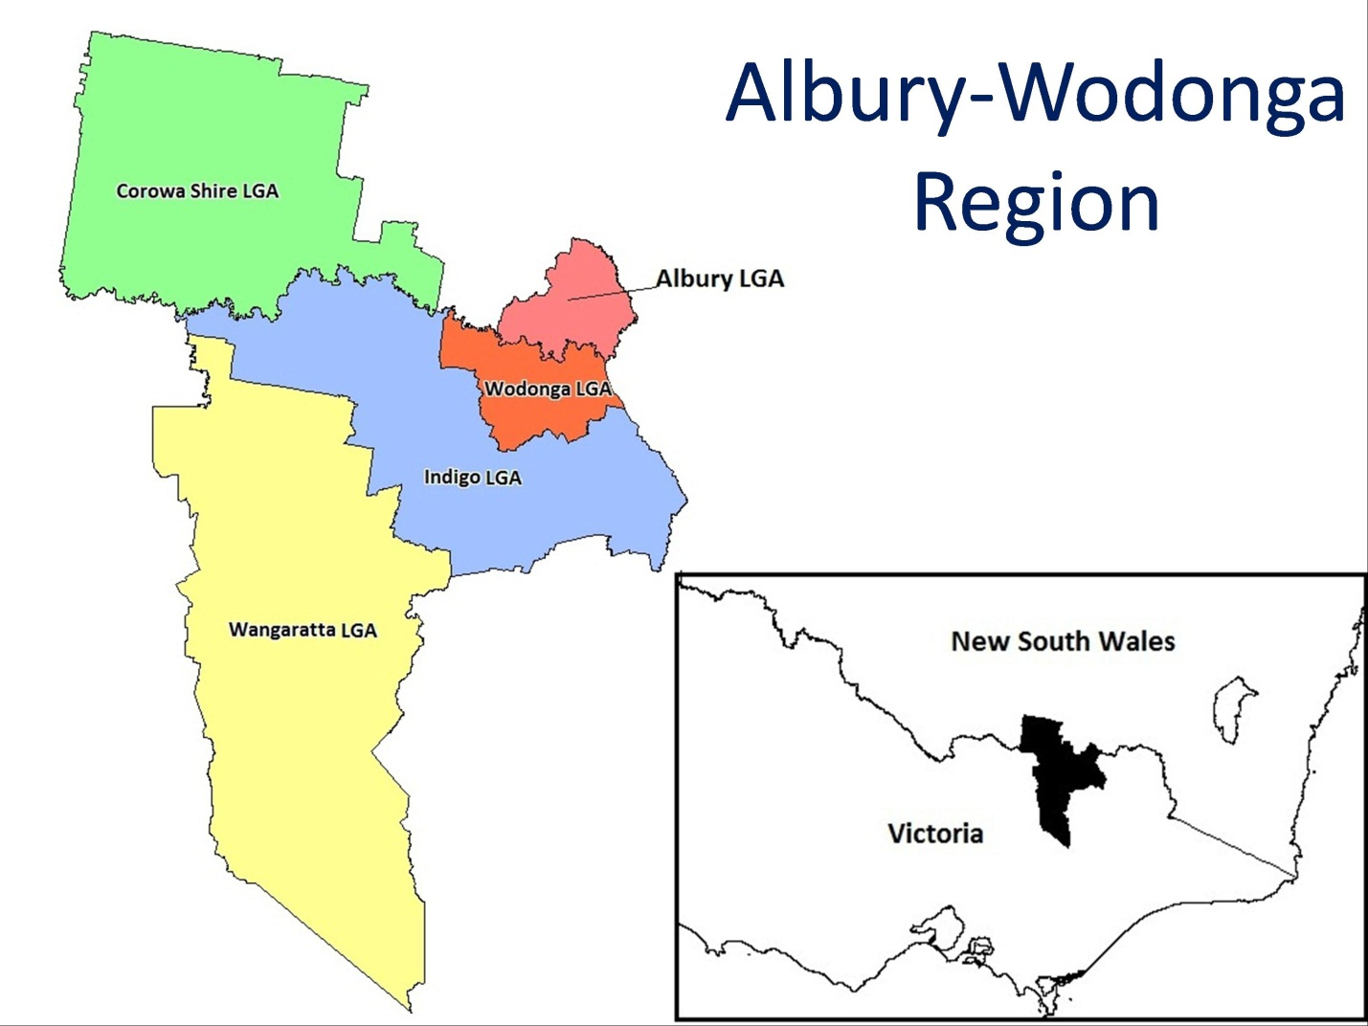

Albury-Wodonga Region

The Albury-Wodonga Region sits within the North Eastern Victoria Priority Employment Area and comprises five Local Government Areas (LGAs):
Albury
Corowa Shire
Indigo
Wangaratta
Wodonga

The Albury-Wodonga Region makes up 49 per cent of the Hume SA4 (Victoria) and 53 percent of the Murray SA4 (NSW).

Slide 3

Population profile
Region | Adult Population  (15+) | Adult Population Growth  (2007-2012) | Median Age
Albury LGA | 40,300 | 5% | 37
Wodonga LGA | 28,800 | 9% | 35
Corowa Shire LGA | 9,300 | 3% | 47
Indigo LGA | 12,500 | 4% | 44
Wangaratta LGA | 22,200 | 3% | 43
Albury-Wodonga Region | 113,100 | 5% | 39
Victoria | 4,599,100 | 10% | 37
Australia | 18,419,600 | 10% | 37

Population Profile
Sources: ABS Estimated Resident Population 2012; ABS, Census of Population and Housing, Usual Residence, 2011

In the five years to 2011 the Albury-Wodonga Region experienced slower growth in the adult population (15 years and over) than Victorian and Australia (both 10 per cent). Within the region growth has been strongest in the major centres, Wodonga and, to a lesser extent, Albury.

The median age in the Albury-Wodonga Region is only slightly higher than the state average, although Corowa Shire LGA and Indigo LGA have significantly higher median ages.

Slide 4

Age Distribution
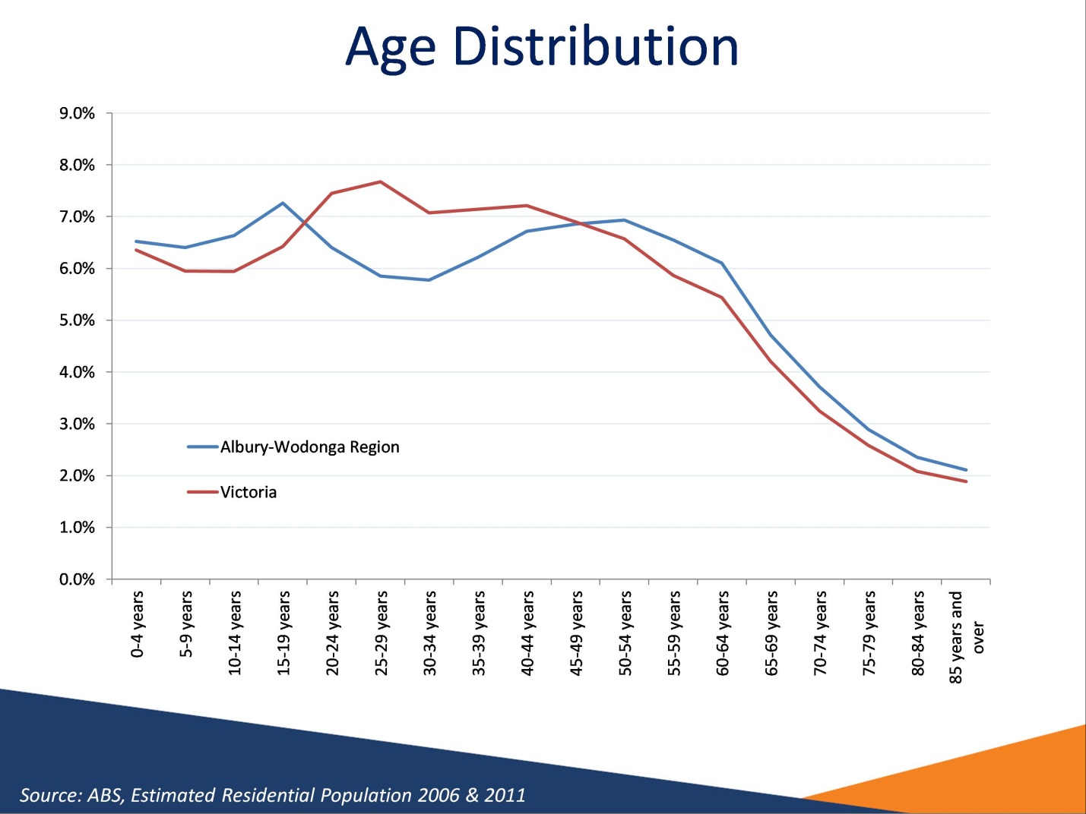

Age distribution
Sources: ABS, Estimated Residential Population 2006 & 2011

This graph shows the age distribution of Albury-Wodonga Region compared with the age distribution of Victoria. The age distribution of the region shows that a markedly smaller proportion of the population is made up of people aged between 20 and 44 years, when compared with the Victorian age distribution. Similar demographic patterns exist for other regional areas and are due in part to young adults moving to major urban centres.

Slide 5

Ageing labour force

Albury-Wodonga Region
Age | 2007 | 2012 | Growth
15-49 years | 63,170 | 62,520 | -1%
50 years and over | 44,340 | 50,610 | 14%
Total | 107,520 | 113,140 | 5%

Albury-Wodonga Region
Source: ABS, Estimated Residential Population 2007 and 2012

Between 2006 and 2011 the population above 50 years of age increased considerably in the Albury-Wodonga Region. On the other hand, the population 15-49 year declined slightly.

Slide 6

Full-time employment decreasing

Working age population (15-64), 2009-2014
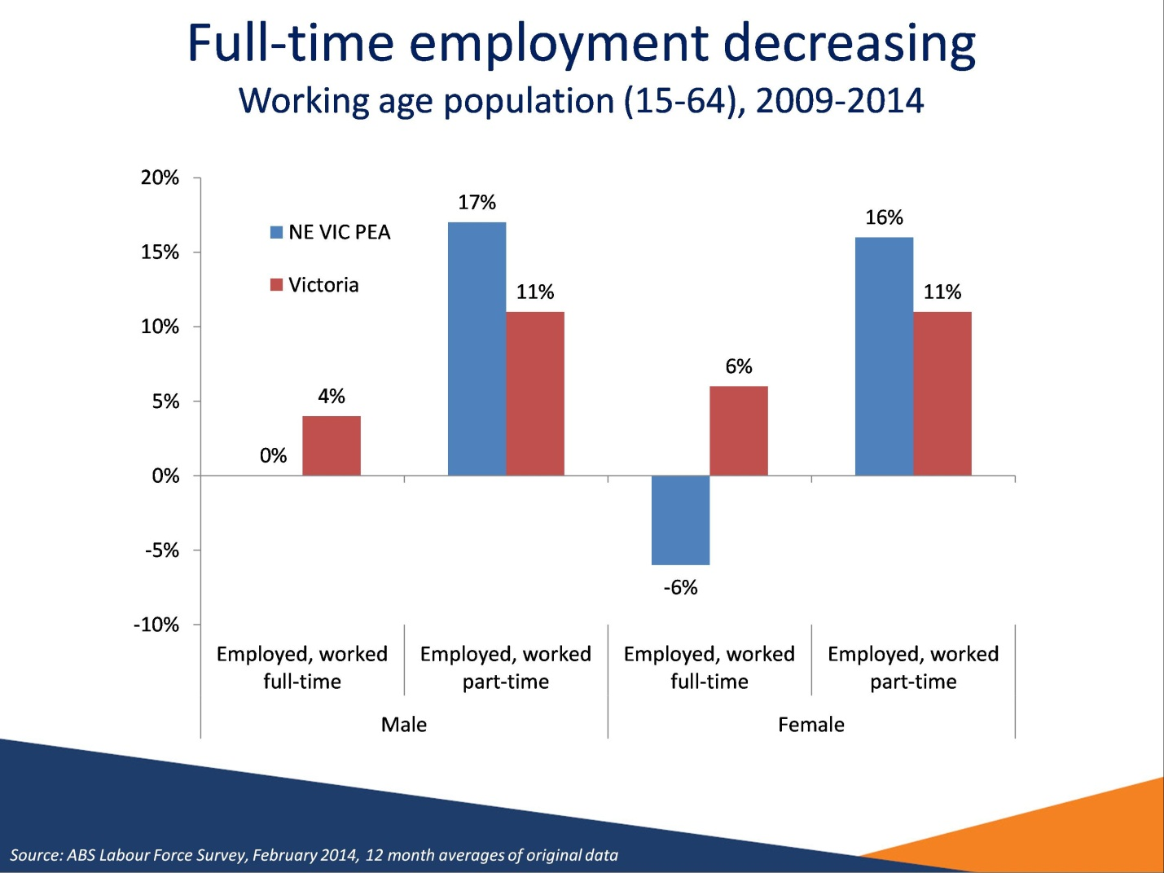

Full-time employment decreasing
Source: ABS Labour Force Survey, February 2014, 12 month averages of original data

The NE Victoria PEA figures are an aggregation of the Murray, Hume and Shepparton SA4s. The NE Victoria PEA makes up 73 per cent of the combined Murray, Hume and Shepparton SA4s.

Full-time jobs growth in the NE Victoria PEA was negative between February 2009 and February 2014, with no change in male full-time employment, and a 6 per cent decrease in female full-time employment.

Slide 7

Unemployment on the rise
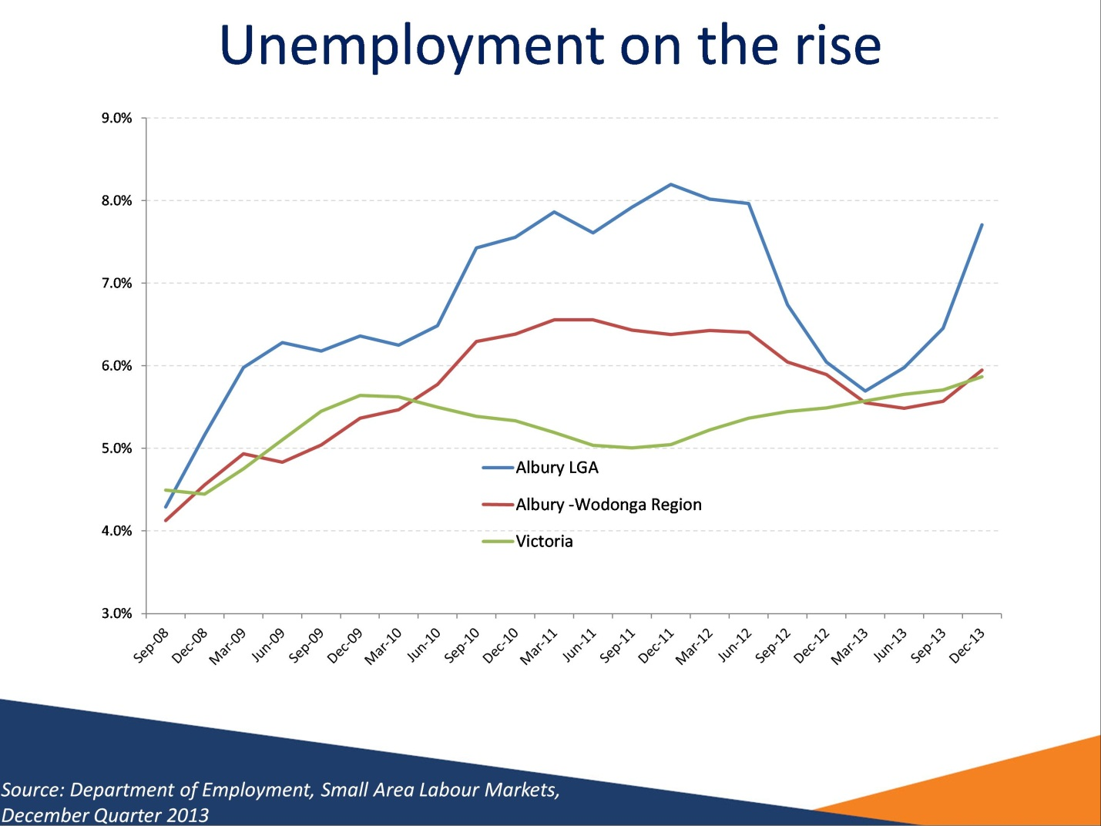

Unemployment on the rise
Source: Department of Employment, Small Area Labour Markets, December Quarter 2013

The unemployment rate for the Albury-Wodonga Region (5.9 per cent) is slightly higher than the national unemployment rate (5.8 per cent) but lower than the state unemployment rate (6.2 per cent).

Slide 8

Unemployment rate varies by region
Region | Dec-12 | Dec-13 | Annual Change | Participation Rate  (Working Age Population, 2011)
Albury LGA | 6.0% | 7.7% | 1.7% pts | 77.3%
Wodonga LGA | 7.0% | 5.8% | -1.2% pts | 77.1%
Corowa Shire LGA | 4.3% | 5.5% | 1.2% pts | 75.6%
Indigo LGA | 4.1% | 3.5% | -0.6% pts | 76.9%
Wangaratta LGA | 5.8% | 4.6% | -1.2% pts | 77.9%
Albury-Wodonga Region | 5.9% | 5.9% | 0.0% pts | 76.3%
Victoria (Seasonally adj.) | 5.5%  (Feb 2013) | 6.4%  (Feb 2014) | 0.9% pts | 75.6%

Unemployment rate varies by region
Source: Department of Employment, Small Area Labour Markets, December Quarter 2013, ABS Labour Force Survey February 2014, ABS Census of Population and Housing 2011

In December 2013, the unemployment rate in the Albury-Wodonga Region was 5.9 per cent, a figure below the state and national unemployment rates (6.4 per cent and 6.0 per cent respectively).

The Albury and Wodonga LGAs recorded the highest unemployment rates within the Albury-Wodonga Region in December 2013 (7.7 and 5.8 per cent respectively). While the Indigo LGA reported the lowest unemployment rate (3.5 per cent).

From December 2012 to December 2013 the region’s unemployment rate did not change while the unemployment rate rose by 0.7 percentage points for Victoria. The largest decrease within the region was in the Wodonga LGA (-1.2 percentage points).

Slide 9

Who is unemployed?
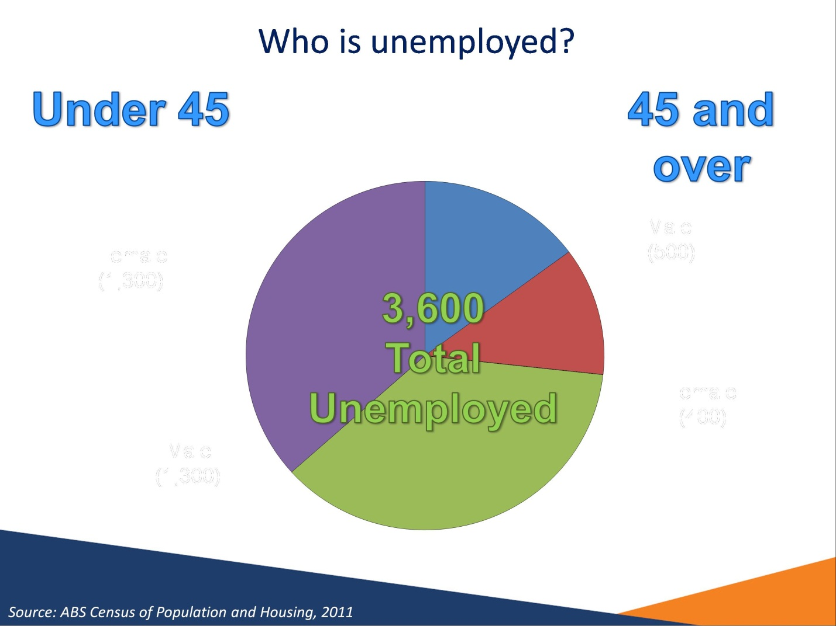

Who is unemployed?
Source: ABS Census of Population and Housing, 2011

74 per cent of unemployed people in the Albury-Wodonga Region were aged 45 years and under.
1,300 (37 per cent) were male and 1,300 (37 per cent) were female.

26 per cent of unemployed people in the Albury-Wodonga Region were aged 45 years and over.

500 (15 per cent) were male and 400 (12 per cent) were female.

Slide 10

Long-term unemployment an issue in some areas
Region | Long-term unemployed (52 weeks or more) Persons | Long-term unemployed (52 weeks or more) Percent of all unemployed | Average duration of unemployment
Murray SA4 | 1,200 | 37% | 65 weeks
Hume SA4 | 1,000 | 24% | 35 weeks
Victoria | 32,200 | 18% | 34 weeks
Australia | 137,600 | 20% | 37 weeks

Long-term unemployment an issue in some areas
Source: ABS, Labour Force Data, February 2014, 12 month averages of original data

Long-term unemployed are those who have been unemployed and looking for work for at least 52 weeks.

The proportion of unemployed people who were long-term unemployed in the Murray SA4 (37 per cent) was higher compared with the Victorian (18 per cent) and national averages (20 per cent).

The average duration of unemployment in the Murray SA4 (65 weeks) was higher than the Victorian (34 weeks) and national averages (37 weeks).

Slide 11

Jobless Families
Region | Number of children in jobless families* | Number of jobless families | Proportion  of all families that are jobless
Albury LGA | 1,600 | 750 | 16%
Wodonga LGA | 1,410 | 660 | 17%
Wangaratta LGA | 770 | 340 | 14%
Albury-Wodonga Region | 4,340 | 2,030 | 15%
Victoria | 145,050 | 66,720 | 13%
*Dependent children under 15 years of age; number is a minimum

Jobless Families
Source: ABS, Census of Population and Housing, Usual Residence, 2011

Note: as Census 2011 includes families with six children or more under the one classification, the numbers of children in the above slide are a minimum as an exact number is not available.

Jobless families are families where the parents are unemployed or not in the labour force, with children under 15 years of age.

Some 15 per cent of all families (with children under 15 years) in the Albury-Wodonga Region were jobless, a figure slightly larger than that for Victoria (13 per cent). However, family joblessness varied greatly between LGAs.

At least 4,340 dependent children under the age of 15 were in a family with no working parent.

Slide 12

What are the youth doing?
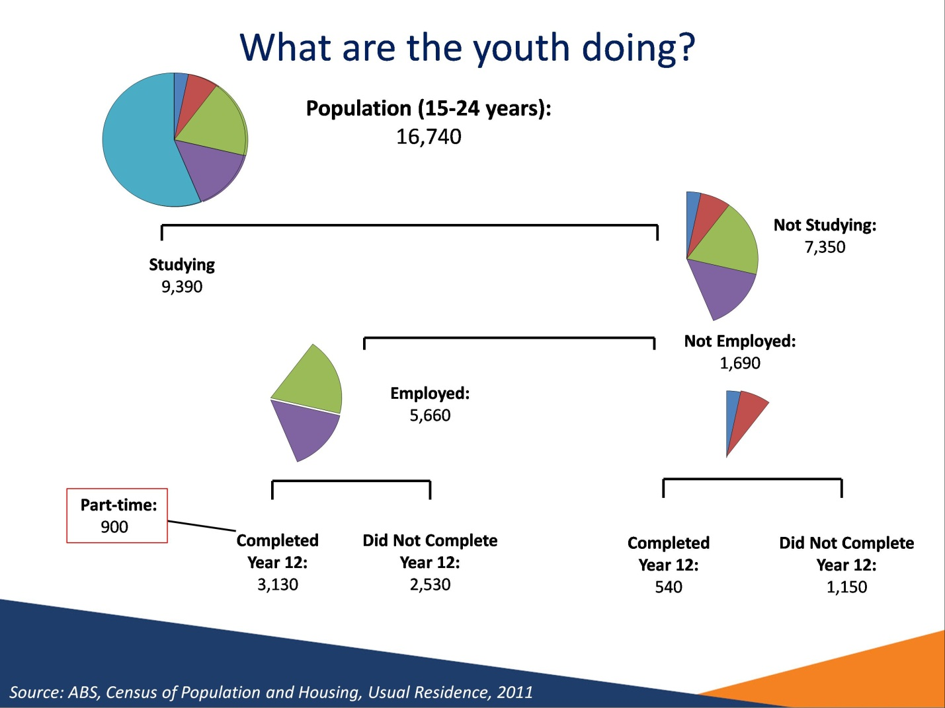

What are the youth doing?
Source: ABS, Census of Population and Housing, 2011

At the time of the census, there were 16,740 15-24 years old in the Albury-Wodonga Region, of whom 7,350 (44 per cent) were not studying.
Of the 7,350 who were not studying, those who did not complete year 12, whether they are employed are not employed, are vulnerable and may have difficulty entering the labour market.

Note: Not stated records for FT/PT Student Status, Labour Force Status and Highest Year of School Completed have not been included.

Slide 13

High levels of disengagement among young adults

(20-24 year olds)
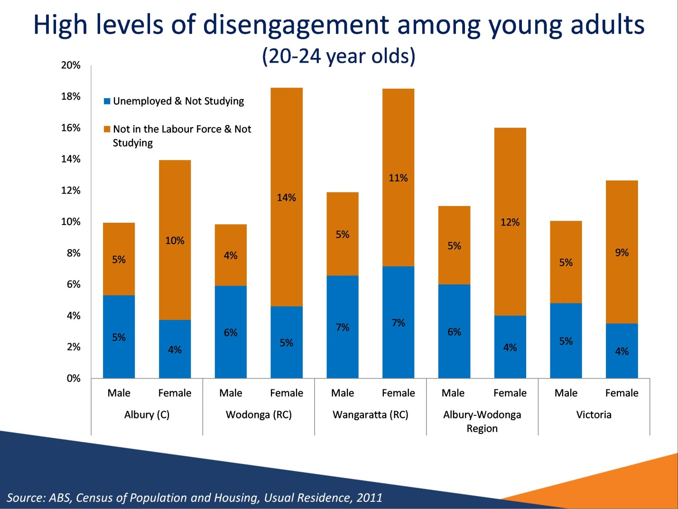

High levels of disengagement amongst young adults
Source: ABS, Census of Population and Housing, Usual Residence, 2011

At the time of the 2011 Census, 14 per cent of young adults (persons aged 20 to 24 years) in the Albury-Wodonga Region were neither working nor studying. This figure was higher when compared with Victoria (11 per cent).

For young adult males in the Albury-Wodonga Region, 5 per cent were not in the labour force and not studying and a further 6 per cent were unemployed and not studying.

For young adult females in the region, 12 per cent were not in the labour force and not studying and a further 4 per cent were unemployed and not studying.

Slide 14

Lower Educational Attainment – persons aged 25-34 years
Region | Completed Yr 12 | Attained Advanced Diploma, Diploma or Certificate III & IV Level | Attained Bachelor Degree or Higher
Albury LGA | 65% | 37% | 26%
Wodonga LGA | 60% | 41% | 19%
Corowa Shire LGA | 53% | 44% | 15%
Indigo LGA | 61% | 39% | 24%
Wangaratta LGA | 63% | 40% | 22%
Albury-Wodonga Region | 62% | 39% | 23%
Victoria | 79% | 29% | 40%
Australia | 75% | 30% | 35%

Lower Educational Attainment – persons aged 25-34 years
Source: ABS, Census of Population and Housing, Usual Residence, 2011

Job seekers who have not completed Year 12 and have limited experience in the workforce are likely to lack many basic employability skills that employers value and look for in applicants, particularly for lower skilled vacancies and entry level positions such as apprenticeships and traineeships.

At the time of the 2011 Census, the proportion of 25 to 34 year olds in the Albury-Wodonga Region who had completed Year 12 or equivalent was 62 per cent, smaller than for Victoria (79 per cent) and Australia (75 per cent).

At the time of the 2011 Census, the proportion of 25 to 34 year olds who had attained an Advanced Diploma, Diploma or Certificate level III or IV in the Albury-Wodonga Region (39 per cent) was larger than state and national averages (29 per cent and 30 per cent respectively), while the proportion who had attained a Bachelor Degree or higher (23 per cent) was far lower than the state and national averages (40 per cent and 35 per cent respectively).

Slide 15

Educational Attainment & Labour Market Outcomes

Persons aged 25-34 years
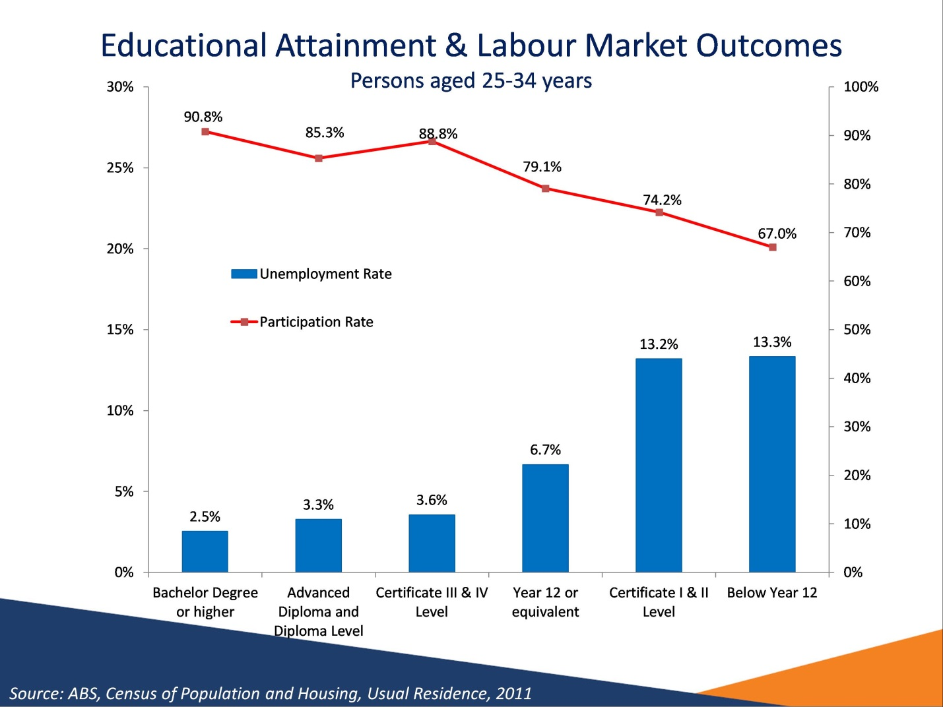

Educational Attainment and Labour Market Outcomes
Source: ABS, Census of Population and Housing, Usual Residence, 2011

There is a strong relationship between educational attainment and employment outcomes. For those aged 25 to 34 years in the Albury-Wodonga Region, there were high unemployment rates for those who had completed Certificate I & II, but had not completed Year 12 (13.2%) and those who did not complete Year 12 without any further post school qualification (13.3%).

Unemployment rates were considerably lower for those who have completed a tertiary education at the Bachelor degree, Advanced Diploma and Diploma Level. It should also be noted that employment outcomes are better for those who have attained Certificate Levels III or IV. This emphasises the importance of post school education in ensuring success in gaining employment.

Slide 16

Weaker Labour Market Outcomes for Indigenous Working Age Population
 | % WAP Indigenous | Unemployment rate (%) |  | Participation rate (%)
 | % WAP Indigenous | Indigenous | Non-Indigenous | Indigenous | Non-Indigenous
Albury LGA | 2.1% | 20.7% | 5.7% | 52.7% | 77.9%
Wodonga LGA | 1.6% | 27.6% | 5.4% | 56.1% | 77.5%
Corowa Shire LGA | 1.3% | 23.7% | 4.6% | 71.1% | 75.9%
Indigo LGA | 1.0% | 9.1% | 4.1% | 62.5% | 77.1%
Wangaratta LGA | 1.0% | 12.2% | 4.9% | 54.3% | 78.1%
Albury-Wodonga Region | 1.6% | 21.0% | 5.2% | 55.7% | 77.6%
Victoria | 0.7% | 14.2% | 5.5% | 59.0% | 75.8%

Weaker Labour Market Outcomes for Indigenous Working Age Population
Source: ABS, Census of Population and Housing, Usual Residence, 2011

This slide shows labour market outcomes of the Indigenous working age population in Albury-Wodonga Region, Victoria and Australia.

Some 1.6 per cent of the working age population in Albury-Wodonga Region identify themselves as Indigenous, a figure larger than that for the state (0.7 per cent).

For Albury-Wodonga Region, the unemployment rate for Indigenous people was 21.0 per cent, four times the unemployment rate for non-Indigenous people (5.2 per cent). This disparity is greater compared with the state Indigenous and non-Indigenous unemployment rates.

Slide 17

Employment by Industry
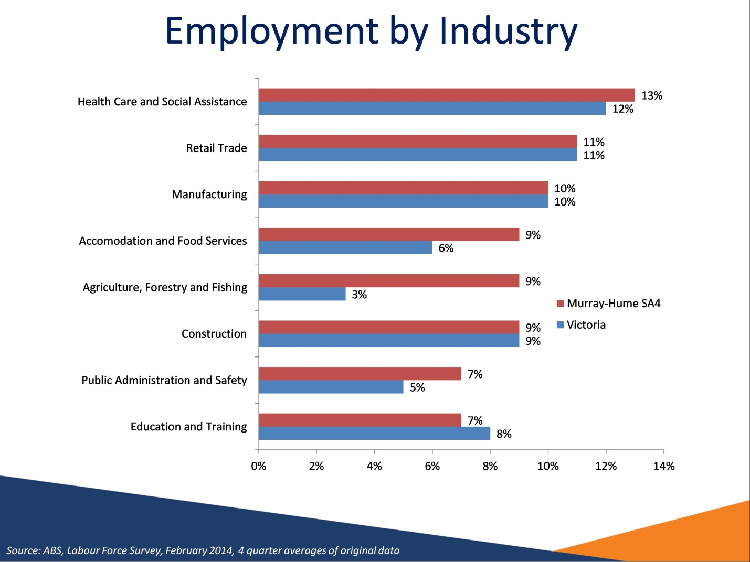

Employment by Industry
Source: ABS, Labour Force Survey, February 2014, 4 quarter averages of original data

The largest employing industries in the region are the Health Care and Social Assistance, Retail Trade and Manufacturing industries.

Slide 18

Employment Growth for Largest Industries

Albury-Wodonga Region 2009-2014
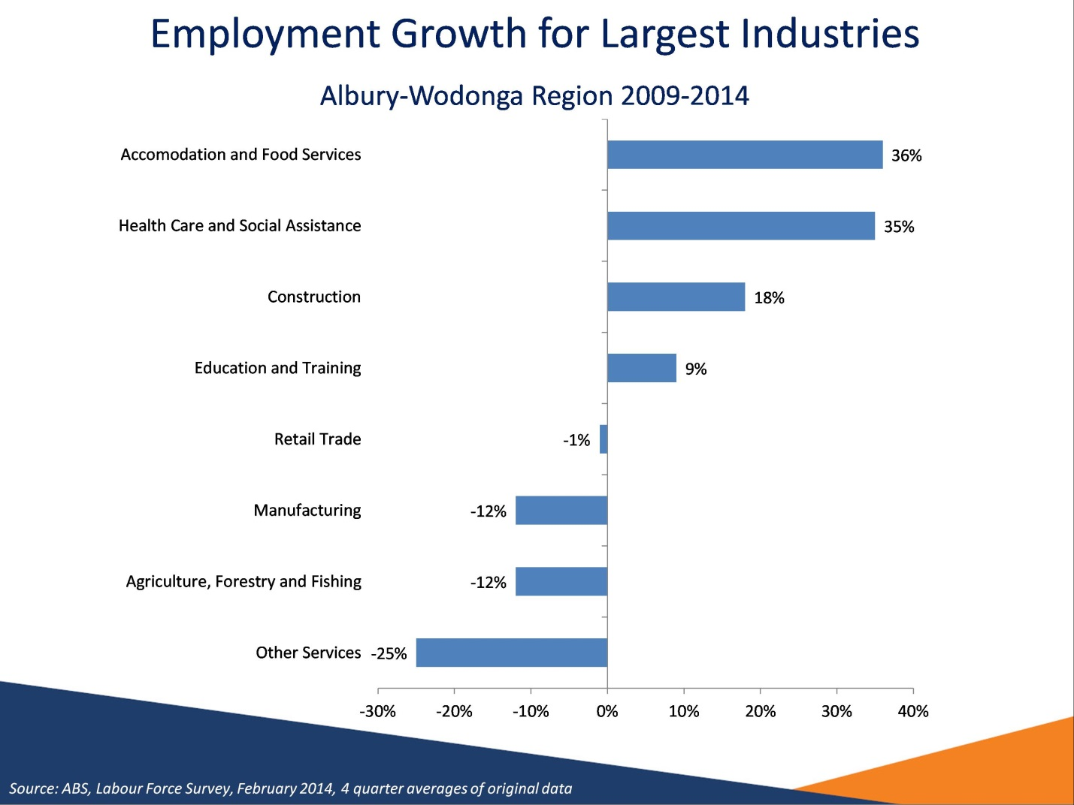

Employment Growth for Largest Industries
Source: ABS, Labour Force Survey, February 2014, 4 quarter averages of original data

Industries that have grown significantly over the last five years include Accommodation and Food Services and Health Care and Social Assistance.

Two of the largest employing industries, Manufacturing and Agriculture, Forestry and Fishing, experienced significant decreases in employment.

Slide 19

Recruitment activity mixed
Recruitment activity mixed

- The proportion of employers who had recruited (62 per cent) had increased since the region was last surveyed
(50 per cent)
- Around 1 in 5 employers increased staff numbers
- Unfilled vacancies (3.6 per cent) and recruitment difficulty
(31 per cent) in employers’ most recent recruitment round were low
- Competition for vacancies was low, so there are still opportunities available

Recruitment activity mixed
Source: Department of Employment, Survey of Employers’ Recruitment Experiences, October 2013 and September 2012, North Eastern Victoria Priority Employment Area and all regions surveyed in the 9 months to November 2013

210 employers were surveyed in Albury-Wodonga Region, as part of the North Eastern Victoria PEA survey in October 2013.

The proportion of employers who had recruited (62 per cent) had increased since the region was last surveyed, when the figure was 50 per cent, and was smaller than the results for all previous surveys in the region back to December 2009.

The rate of unfilled vacancies (3.6 per cent) was higher than in September 2012 (1.8 per cent) but slightly lower compared to all regions surveyed (3.8 per cent).

The proportion of employers who reported recruitment difficulty (44 per cent) was also lower compared with all regions (49 per cent).

Slide 20

Small increase in Demand for Labour
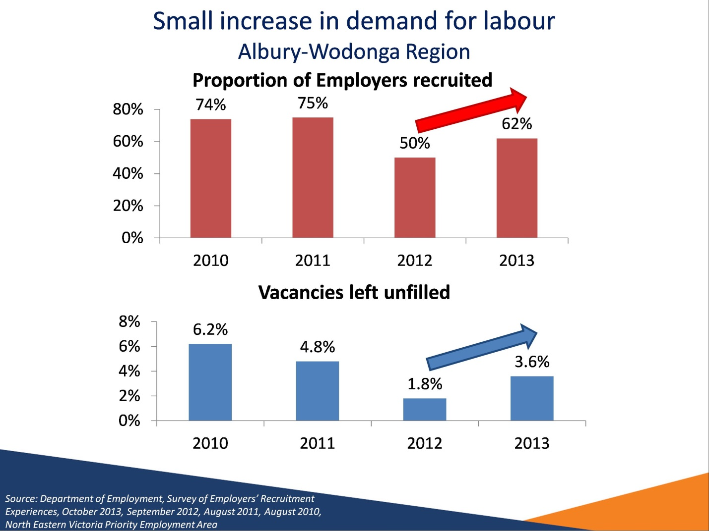

Small increase in Demand for Labour
Source: Department of Employment, Survey of Employers’ Recruitment Experiences, 12 months before the survey, October 2013, September 2012, August 2011, August 2010, North Eastern Victoria Priority Employment Area (Albury-Wodonga region)

The graphs compares indicators of recruitment activity from the October 2013 survey (proportion of employers who had recruited and vacancies left unfilled in the past twelve months) with those of three previous surveys going back to August 2010.

The results indicate a recent increase in recruitment activity and the proportion of unfilled vacancies in the Albury-Wodonga Region.

Slide 21

Few suitable applicants
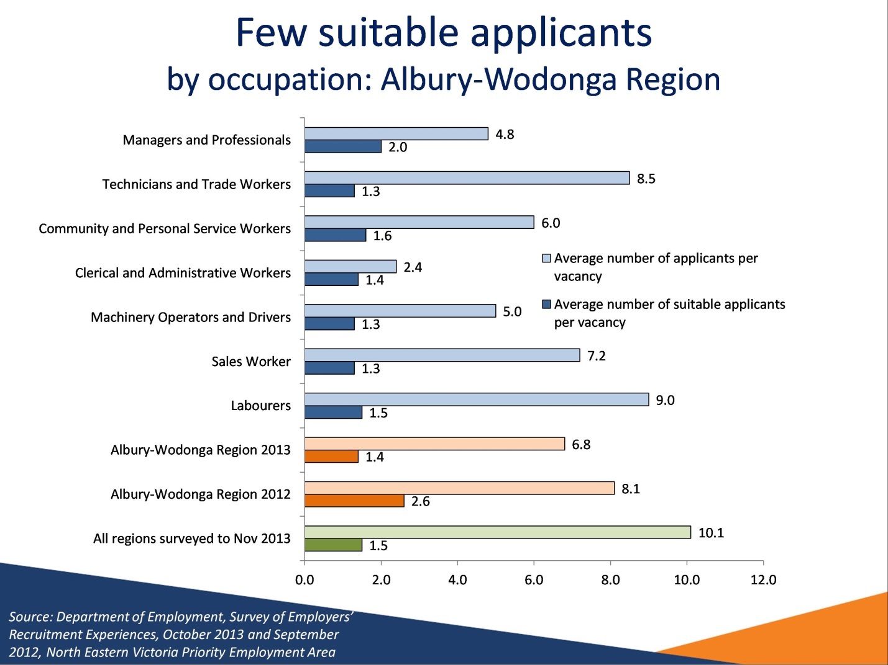

Few suitable applicants
Source: Department of Employment, Survey of Employers’ Recruitment Experiences, October 2013 and September 2012, North Eastern Victoria Priority Employment Area and all regions surveyed in the 9 months to November 2013.

There was, on average, less competition for vacancies in the Albury-Wodonga Region (6.8 applicants per vacancy) compared with the last time the region was surveyed (8.1 applicants per vacancy). The average number of suitable applicants per vacancy (1.4) was also lower compared to the previous survey (2.6).

There was a high level of competition for Technicians and Trade Workers and Labourers vacancies, with an average of 8.5 and 9.0 applicants per vacancy respectively.

Employers recruiting for Clerical and Administrative Workers had little choice of applicants with an average of 2.4 applicants.

Slide 22

Reasons applicants did not receive an interview

Albury-Wodonga Region
Reasons applicants did not receive an interview
Albury-Wodonga Region
- 68% of applicants did not receive an interview
- Reasons applicants did not get an interview include:
  - Insufficient experience to perform job duties (45%)
  - Insufficient qualifications or training (28%)
  - Application poorly written/presented or not good enough (19%)

Reasons applicants did not receive an interview
Source: Department of Employment, Survey of Employers’ Recruitment Experiences, October 2013, North Eastern Victoria Priority Employment Area

Over two-thirds (68 per cent) did not receive an interview.

Reasons applicants did not get an interview include:
- Insufficient experience to perform job duties (45%)
- Insufficient qualifications or training (28%)
- Application poorly written/presented or not good enough (19%)

Slide 23

The recruitment process

In the Albury-Wodonga Region
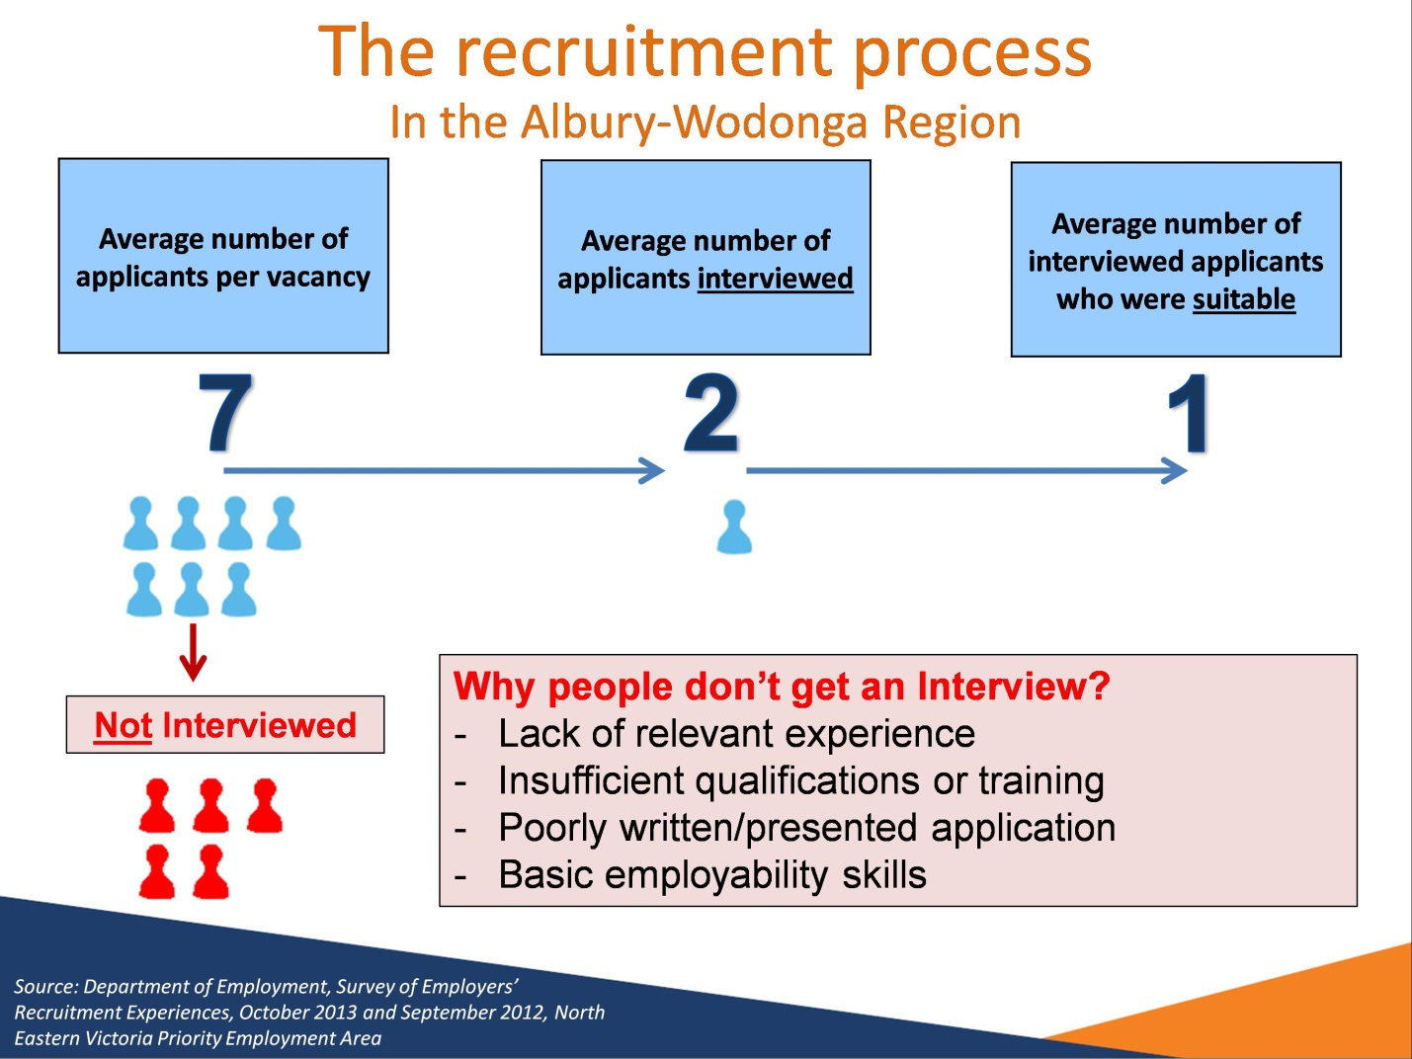

The recruitment process – in the Albury-Wodonga Region
Source: Department of Employment, Survey of Employers’ Recruitment Experiences, October 2013 and September 2012, North Eastern Victoria Priority Employment Area

This slide shows the recruitment process employers go through in the Albury-Wodonga Region
On average employers in Albury-Wodonga Region receive 7 (6.8) applicants per vacancy.
Of these applicants on average only 2 (2.2) are interviewed.
Of these interviewed applicants only 1 (1.4) are suitable for the vacancy.

The reason applicants do not get an interview were:
- Lack of relevant experience
- Insufficient qualifications or training
- Poorly written/presented application
- Basic employability skills

Slide 24

Basic Employability Skills
Basic Employability Skills

Most importance placed on:
- 30 per cent personal traits and qualities only
- 28 per cent technical skills only
- 41 per cent both equally important

Personal traits and qualities applicants lacked:
- Enthusiasm
- Motivation
- Communication
- Confidence
- Teamwork

Basic Employability Skills
Source: All regions surveyed in the 12 months to December 2010

Most importance placed on:
- 30 per cent personal traits and qualities only
- 28 per cent technical skills only
- 41 per cent both equally important

Personal traits and qualities applicants lacked:
- Enthusiasm
- Motivation
- Communication
- Confidence
- Teamwork

Slide 25

Recruitment Methods

Albury-Wodonga Region
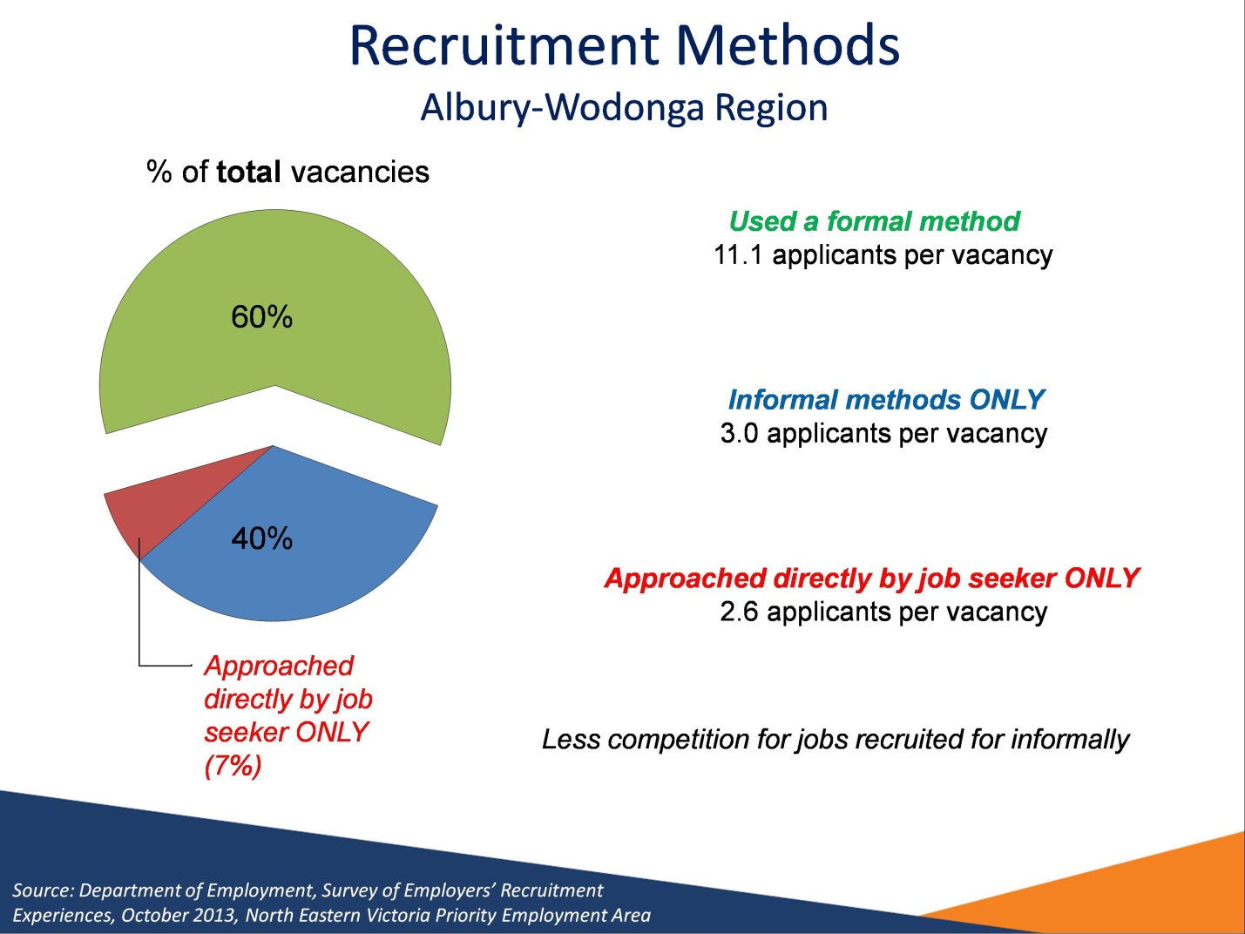

Recruitment Methods
Source: Department of Employment, Survey of Employers’ Recruitment Experiences, October 2013, North Eastern Victoria Priority Employment Area

60 per cent of vacancies in the Albury-Wodonga Region were recruited for through formal methods of recruitment (such as the Internet or Newspapers), receiving an average of 11.1 applicants per vacancy.

By contrast, 40 per cent of vacancies were recruited for through informal methods only (such as word of mouth or approached by job seeker), receiving an average of just 3.0 applicants per vacancy.

Employers for some 7 per cent of vacancies relied solely on being approached directly by job seekers. For those vacancies there was an average of 2.6 applicants per vacancy.

Slide 26

Occupations that were Difficult to Fill
Higher Skill Level – Bachelor Degree or Higher
Medium Skill Level – Certificate IV to Associate Degree
Early Childhood Teachers
Cabinetmakers | Chef *
Architectural, Building and Survey Technicians | Motor Mechanics *
Structural Steel and Welding Trades Workers * | Cooks

Lower Skill Level – Compulsory Secondary Education to Certificate III
Housekeepers * | Child Carers
Truck Drivers

Occupations that were Difficult to Fill
Source: Department of Employment, Survey of Employers’ Recruitment Experiences, September 2012, North Eastern Victoria Priority Employment Area

This slide shows the vacancies that employers considered difficult to fill throughout the North Eastern Victoria PEA (*Occupations also difficult to fill in the September 2012 Survey)

Higher Skill Level (1) - Bachelor Degree or Higher
Early Childhood Teachers

Medium Skill Level (2&3) – Certificate IV to Associate Degree
Cabinetmakers
Motor Mechanics *
Chefs *
Architectural, Building and Survey Technicians
Cooks
Structural Steel and Welding Trades Workers *

Lower Skill Level (4&5) – Compulsory Secondary Education to Certificate III
Housekeepers *
Child Carers
Truck Drivers

Slide 27

Recruitment Outlook
Recruitment Outlook

- Employers’ outlook somewhat cautious
- 38 per cent of employers expected to recruit in the next 12 months with 17 per cent of employers expecting to increase staff numbers
- Strong recruitment expected in the Accommodation and Food Services and Education and Training industries
- Economy was the greatest concern for almost half of surveyed employers

Recruitment Outlook
Source: Department of Employment, Survey of Employers’ Recruitment Experiences, October 2013, North Eastern Victoria Priority Employment Area

38 per cent of employers expected to recruit in the next 12 months.

Only 17 per cent of employers expected to increase staff numbers in the next 12 months.

Slide 28

Occupations employers expect to recruit for in the 12 months following the survey
Higher Skill Level – Bachelor Degree of Higher
Medium Skill Level – Certificate IV to Associate Degree
Early Childhood Teachers
Cabinetmakers | Chefs

Lower Skill Level – Compulsory Secondary Education to Certificate III
Sales Assistants (General) | Packers
General Clerks | Truck Drivers
Crop Farm Workers | Waiters
Child Carers | Bar Attendants and Baristas

Occupations employers expect to recruit for in the 12 months following the survey
Source: Department of Employment, Survey of Employers’ Recruitment Experiences, October 2013, North Eastern Victoria Priority Employment Area

This slide shows the vacancies that employers most commonly expected to recruit for throughout the North Eastern Victoria PEA in the 12 months following the survey.

Higher Skill Level (1) - Bachelor Degree or Higher
Early Childhood Teachers

Medium Skill Level (2 & 3) – Certificate IV to Associate Degree
Cabinetmakers
Chefs

Lower Skill Level (4 & 5) – Compulsory Secondary Education to Certificate III
Sales Assistants (General)
General Clerks
Crop Farm Workers
Child Carers
Packers
Truck Drivers
Waiters
Bar Attendants and Baristas

Slide 29

Conclusion
Conclusion
- Labour market conditions subdued
- Unemployment rate is rising, and is very high in the Albury LGA
- Decline of full-time employing industries (Agriculture and Manufacturing)
- Challenges
- Youth unemployment/disengagement and low education levels
- Weaker labour market outcomes among Indigenous
- Jobless families
- Slow population growth, particular among younger age groups
- Transition from Agriculture and Manufacturing to Services sector
- Opportunities
- Recruitment activity picking up
- Strong employment growth expected in Health Care and Social Assistance
- Opportunities for less experienced job seekers in industries with high turnover (Retail Trade and Accommodation and Food Services)
- Job seekers need to have…
- Employability skills
- Education and Training
- Collaboration with key stakeholders

Conclusion
- Labour market conditions subdued
- Unemployment rate is rising, and is very high in the Albury LGA
- Decline of full-time employing industries (Agriculture and Manufacturing)
- Challenges
- Youth unemployment/disengagement and low education levels
- Weaker labour market outcomes among Indigenous
- Jobless families
- Slow population growth, particular among younger age groups
- Transition from Agriculture and Manufacturing to Services sector
- Opportunities
- Recruitment activity picking up
- Strong employment growth expected in Health Care and Social Assistance
- Opportunities for less experienced job seekers in industries with high turnover (Retail Trade and Accommodation and Food Services)
- Job seekers need to have…
- Employability skills
- Education and Training
- Collaboration with key stakeholders

Slide 30

Further Information
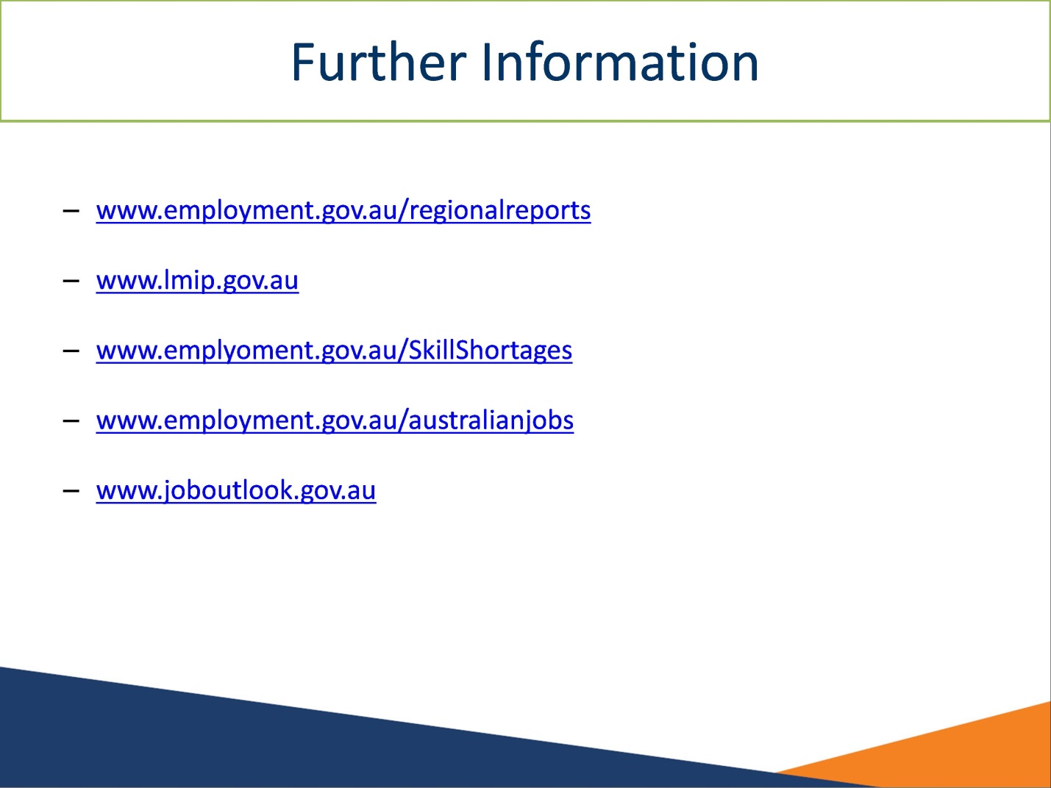

Further Information

More information on labour market conditions and other research on small areas can be found on these websites:
- www.employment.gov.au/regionalreports
- www.lmip.gov.au
- www.emplyoment.gov.au/SkillShortages
- www.employment.gov.au/australianjobs
- www.joboutlook.gov.au

Slide 31

If you have any questions about the presentation please contact the Recruitment Analysis and Employer Surveys sections on 1800 059 439 or email recruitmentsurveys@employment.gov.au

If you have any questions about the presentation please contact the Recruitment Analysis and Employer Surveys sections on 1800 059 439 or email recruitmentsurveys@employment.gov.au

Slide 32

