Portfolio Supplementary
Additional Estimates Statements

2017–18
Appropriation Bill (No. 5) 2017–18
and
Appropriation Bill (No. 6) 2017–18
Jobs and Innovation Portfolio
(Jobs and Small Business)
Explanations of Supplementary Additional Estimates 2017–18
© Commonwealth of Australia 2018
ISSN 2209-007X (print)
ISSN 2209-0088 (online)
This publication is available for your use under a Creative Commons BY Attribution 3.0 Australia licence, with the exception of the Commonwealth Coat of Arms, the Department of Jobs and Small Business logo, photographs, images, signatures and where otherwise stated. The full licence terms are available from http://creativecommons.org/licenses/by/3.0/au/legalcode.
Use of the Department of Jobs and Small Business material under a Creative Commons BY Attribution 3.0 Australia licence requires you to attribute the work (but not in any way that suggests that the department endorses you or your use of the work).
Department of jobs and Small Business material used ‘as supplied’
Provided you have not modified or transformed the Department of Jobs and Small Business material in any way including, for example, by changing the text; calculating percentage changes; graphing or charting data; or deriving new statistics from published statistics—then the department prefers the following attribution:
Source: The Australian Government Department of Jobs and Small Business
Derivative material
If you have modified or transformed Department of Jobs and Small Business material, or derived new material from those of the department in any way, then the Department of Jobs and Small Business prefers the following attribution:
Based on The Australian Government Department of Jobs and Small Business data
Use of the Coat of Arms
The terms under which the Coat of Arms can be used are set out on the It’s an Honour website (see www.itsanhonour.gov.au).
Other uses
Enquiries regarding this licence and any other use of this document are welcome at:
Department of Jobs and Small Business on 1300 488 064

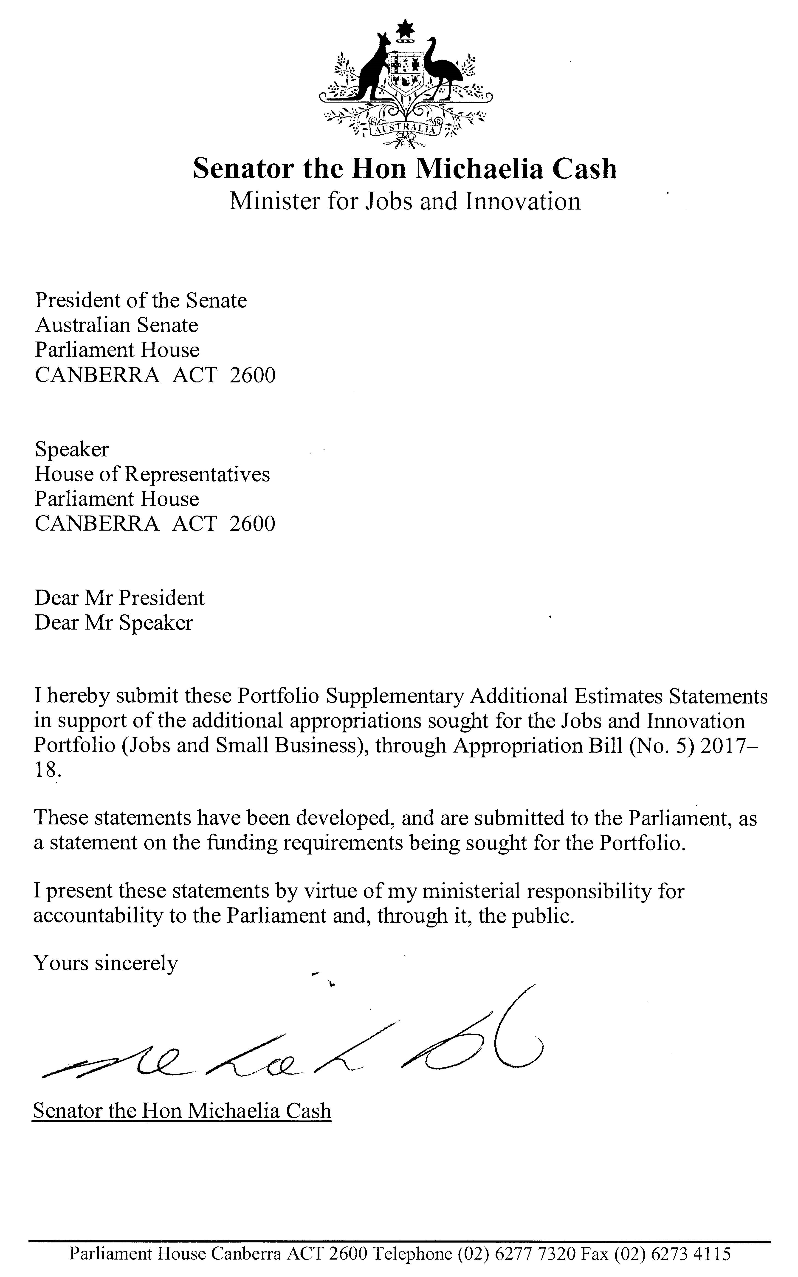

Abbreviations and conventions
The following notations may be used:
NEC/nec not elsewhere classified
- nil
.. not zero, but rounded to zero
na not applicable (unless otherwise specified)
nfp not for publication
$m $ million
Figures in tables and in the text may be rounded. Figures in text are generally rounded to one decimal place, whereas figures in tables are generally rounded to the nearest thousand. Discrepancies in tables between totals and sums of components are due to rounding.

Enquiries
Should you have any enquiries regarding this publication please contact the Chief Financial Officer at the Department of Jobs and Small Business on 1300 488 064.
A copy of this document can be located on the Australian Government Budget website at: www.budget.gov.au.

User Guide
The purpose of the 2017–18 Portfolio Supplementary Additional Estimates Statements (PSAES) is to inform Senators, Members of Parliament and the public of the proposed allocation of additional resources to government outcomes by entities within the portfolio.
The PSAES facilitate understanding of the proposed appropriations in Appropriation Bill (No. 5) 2017–18 and Appropriation Bill (No. 6) 2017–18. In this sense the PSAES is declared by the Appropriation Acts to be a ‘relevant document’ to the interpretation of the Acts according to section 15AB of the Acts Interpretation Act 1901.
Appropriation Bill (No. 5) 2017–18, which follows on from Appropriation Act (No. 1) tabled at Budget and Appropriation Bill (No. 3) tabled at Additional Estimates, will provide additional expenditure authority for the ordinary annual services of government in respect of the 2017–18 financial year.
Appropriation Bill (No. 6) 2017–18, which follows on from Appropriation Act (No. 2) tabled at Budget and Appropriation Bill (No. 4) tabled at Additional Estimates, will provide additional expenditure authority in respect of the 2017–18 financial year for capital works and services, payments to or for the states, territories and local government authorities, and new administered outcomes not authorised in specific legislation.

Department of Jobs and Small Business
Overview of additional appropriations 1
Entity measures table 2
Additional estimates and variations 3
Breakdown of additional estimates by appropriation bill 4

Department of Jobs and Small Business

Overview of additional appropriations
The PSAES is a supplement to the 2017–18 Portfolio Additional Estimates Statements (PAES) explaining the subsequent changes to estimates as they appear in the Supplementary Additional Estimates Appropriation Bills. As a result of estimates variations as well as measures taken by the Australian Government since PAES, the Department of Jobs and Small Business is seeking additional appropriation through Appropriation Bill No. 5. The majority of the additional appropriation sought relates to program-specific parameter adjustments for the jobactive program. A full list of additional estimates and variations to funding can be found at Table 1.2.
The Department’s name was changed from the Department of Employment to the Department of Jobs and Small Business as a result of Administrative Arrangements introduced on 20 December 2017. A full outline of the Department’s strategic direction can be found in the Jobs and Innovation Portfolio (Jobs and Small Business) 2018–19 Portfolio Budget Statements, Budget Related Paper No. 1.13B.

Entity measures table
Table 1.1 summarises new Government measures taken since the 2017–18 Additional Estimates. The table is split into revenue, expense and capital measures, with the affected program identified.
Table 1.1 Entity 2017–18 supplementary additional estimates measures
 | Program | 2017–18  $’000 | 2018–19  $’000 | 2019–20  $’000 | 2020–21  $’000
Expense measures
More Choices for a Longer Life — jobs and skills for mature age Australians (a) | 1.1, 2.3
Administered expenses |  | (9,262) | - | - | -
Departmental expenses |  | - | - | - | -
Total |  | (9,262) | - | - | -
Total expense measures
Administered |  | (9,262) | - | - | -
Departmental |  | - | - | - | -
Total |  | (9,262) | - | - | -
Prepared on a Government Finance Statistics (fiscal) basis. Figures displayed as a negative (-) represent a decrease in funds and a positive (+) represent an increase in funds.
- Refer to the Jobs and Innovation Portfolio (Jobs and Small Business) 2018–19 Portfolio Budget Statements, Budget Related Paper No. 1.13B for the 2018–19 and forward years impacts, and to the 2018–19 Budget Paper No. 2 for the full measure impact.

Additional estimates and variations
The following table details the changes to the resourcing for the Department of Jobs and Small Business at Supplementary Additional Estimates, by outcome. The following table details the supplementary estimates and variations resulting from new measures and any other variations (if applicable) since the 2017–18 Additional Estimates in Appropriation Bills (No. 5 and No. 6).
Table 1.2 Supplementary estimates and variations to outcomes from measures and other variations
 | Program impacted | 2017–18  $’000 | 2018–19  $’000 | 2019–20  $’000 | 2020–21  $’000
Outcome 1
Administered
Annual appropriations
More Choices for a Longer Life — jobs and skills for mature age Australians (a) | 1.1 | (7,746) | - | - | -
Changes in number of unemployment beneficiaries
(net decrease) | 1.1 | (757) | - | - | -
Changes in Parameters
(net increase) | 1.1 | 240 | 904 | 851 | 760
Program Specific Parameters
(net increase) | 1.1 | 45,675 | - | - | -
Legislation Delays
(net increase) | 1.1 | (484) | (797) | 1,515 | 3,577
Net impact on appropriations for Outcome 1 (administered) |  | 36,928 | 107 | 2,366 | 4,337
Total net impact on appropriations for Outcome 1 |  | 36,928 | 107 | 2,366 | 4,337
Outcome 2
Administered
Annual appropriations
More Choices for a Longer Life — jobs and skills for mature age Australians (a) | 2.3 | (1,516) | - | - | -
Other Variations
(net decrease) | 2.3 | (3,000) | - | - | -
Net impact on appropriations for Outcome 2 (administered) |  | (4,516) | - | - | -
Total net impact on appropriations for Outcome 2 |  | (4,516) | - | - | -
- Refer to the Jobs and Innovation Portfolio (Jobs and Small Business) 2018–19 Portfolio Budget Statements, Budget Related Paper No. 1.13B for the 2018–19 and forward years impacts, and to the 2018–19 Budget Paper No. 2 for the full measure impact.

Breakdown of additional estimates by appropriation bill
The following tables detail the Additional Estimates sought for the Department of Jobs and Small Business through Appropriation Bills (No. 5 and No. 6).
Table 1.3: Appropriation Bill (No. 5) 2017–18
 | 2016–17  Available  $’000 | 2017–18  Budget and Additional Estimates  $’000 | 2017–18  Revised  $’000 | Supplementary Additional Estimates  $’000 | Supplementary Reduced Estimates  $’000
Administered items
Outcome 1—  Foster a productive and competitive labour market through employment policies and programs that assist job seekers into work, meet employer needs and increase Australia’s workplace participation. | 1,644,056 | 1,648,437 | 1,685,365 | 36,928 | -
Outcome 2 (a)—  Facilitate jobs growth through policies that promote fair, productive and safe workplaces. | 25,947 | 42,733 | 38,217 | - | 4,516
Total administered | 1,670,003 | 1,691,170 | 1,723,582 | 36,928 | 4,516
Departmental programs
Outcome 1—  Foster a productive and competitive labour market through employment policies and programs that assist job seekers into work, meet employer needs and increase Australia’s workplace participation. | 248,177 | 256,230 | 256,230 | - | -
Outcome 2 (a)—  Facilitate jobs growth through policies that promote fair, productive and safe workplaces. | 77,848 | 85,906 | 85,906 | - | -
Total departmental | 326,025 | 342,136 | 342,136 | - | -
Total administered and departmental | 1,996,028 | 2,033,306 | 2,065,718 | 36,928 | 4,516
Note: 2016–17 available appropriation is included to allow a comparison of this year’s appropriation with what was made available for use in the previous year.
- Excludes estimates for Machinery of Government adjustments as these are not included in Appropriation Bill No. 5.

Table 1.4: Appropriation Bill (No. 6) 2017–18
The Department has no additional funding through Appropriation Bill No. 6. For this reason, Table 1.4 is not presented.

