


The next generation of employment services
Discussion paper

ISBN
978-1-76051-505-8 [PRINT]
978-1-76051-506-5 [PDF]
978-1-76051-507-2 [DOCX]

With the exception of the Commonwealth Coat of Arms, the department’s logo, any material protected by a trade mark and where otherwise noted, all material presented in this document is provided under a Creative Commons Attribution 3.0 Australia (http://creativecommons.org/licenses/by/3.0/au/) licence.
The details of the relevant licence conditions are available on the Creative Commons website (accessible using the links provided) as is the full legal code for the CC BY 3.0 AU licence (http://creativecommons.org/licenses/by/3.0/au/legalcode).
The document must be attributed as: The next generation of employment services: discussion paper

Contents
Executive summary 4
Chapter overview 10
Overview of the employment market 13
Meet the people who would use our future system... 15
Chapter 1: Government employment services today 18
Chapter 2: The goals for future employment services 19
Chapter 3: Helping disadvantaged Australians into work 23
Chapter 4: Empowering job seekers and employers through improved online services 29
Chapter 5: Better meeting the needs of employers 35
Chapter 6: Assessing job seekers to tailor support to their needs 40
Chapter 7: Incentives for job seekers to find work 47
Chapter 8: Targeted regional and local approaches 54
Chapter 9: A service culture built on competition and quality 58
Chapter 10: Transitioning to a future employment services model 65
Next steps 67
Summary of questions 68
Glossary of terms 70

Executive summary
The Australian Government is focused on getting Australians into jobs
The Government is providing the tools for job seekers to connect with jobs and help employers find the right people for their business.
A particular focus is helping job seekers who need extra support, including mature age Australians changing careers, Indigenous Australians, women and young people getting their first job.
Publicly funded employment services play an important role in the Australian labour market
Over 94 per cent of Australians who want work have it. Most Australians want to work and most who want work are able to find it without Government assistance. Others use private recruitment companies or other networks to help them.
The Australian Government funds employment services so those dependent on income support and job seekers in weak labour markets who may not be serviced by the private sector have access to employment services.
Employment services help increase the competitiveness of job seekers so they can take advantage of the work opportunities that a growing economy presents. The current generalist employment services system, jobactive, does this by providing employers with a free service to find the labour they need through one of 42 service providers operating at over 1700 sites around Australia.
jobactive has achieved significant results
The Australian Government introduced the current generalist employment service, jobactive, in 2015. In April 2018 it reached a milestone of more than one million job placements. The labour market is strong, with over 12.5 million Australians in work, the highest on record. The proportion of the working age population receiving a welfare payment is now 15 per cent, the lowest proportion it has been for at least 25 years.
jobactive will continue to provide quality services to job seekers and employers until existing contracting arrangements cease in 2020. This includes through a number of new employment initiatives announced in the 2018–19 Budget.
But there is always room for improvement
Almost half of the people in jobactive have remained in the service for two years or more. Among the most disadvantaged job seekers (Stream C), the average length of time on the caseload is five years. More must be done to assist these people to find work and move off income support.
Employment services need to adapt and change with the labour market
The way that business and government delivers services to users in advanced economies is changing. The most effective modes of service delivery are increasingly those that put the user at the centre. This means recognising that people want services delivered when it suits them, where it suits them, in a way that understands and addresses their specific needs. It also means providing people with greater control over the services they use.
Need to deliver better targeted and more tailored services that benefit users
The challenge that both business and government face in facilitating this transformation is delivering more tailored service to large numbers of users efficiently, effectively and affordably.
Continuing to deliver employment services within existing parameters is unlikely to deliver the tailored services that users expect and need in a changing labour market. A one size fits all model gives users limited control and choice, and is less likely to adapt to a changing, contemporary economy.
Developing services that are more responsive to stakeholders’ needs can encourage innovation and enable more disadvantaged job seekers to get the help they need. It can also create the efficiencies necessary to finance these services, and help transition employment services to a platform that people want to use, and offers value to both employers and job seekers.
How user experiences with the current system inform consideration of a future system
User-centred research commissioned by the Department of Jobs and Small Business in 2017 found that:
- many complex life issues can impact on job seekers’ motivations and their ability to participate in work
- the systems that job seekers need to address their life issues are complex and can impose administrative and emotional burdens
- employers’ recruitment methods were strongly influenced by personal networks and their personal labour market experiences
- some employers are averse to employing jobactive candidates due to perceived lack of reliability
- employment services consultants felt it was difficult to provide quality service to more vulnerable job seekers within the time constraints they work
- employment services consultants felt they spent more time on administration (and compliance) than on securing job seeker outcomes.
A future model must be fit-for-purpose
A future employment service will build on the success of previous models, but faces a unique design challenge: it needs to adapt and be flexible to keep pace and be fit-for-purpose in a world of rapidly changing technology, jobs and industries.
Australians are embracing digital technology; 88 per cent own a smartphone and 86 per cent are on a 4G internet network. Recruitment is increasingly being done online, with more and more job seekers and employers using a range of online platforms such as SEEK and Indeed to fill jobs.
Technology is changing and employment services need to change with it
Technological advancement is changing existing skills and industries and creating new ones. More Australians are likely to change jobs and careers more often. In this context, successful labour market transitions require access to platforms that will encourage lifelong learning, facilitating retraining and upskilling before individuals access income support.
Technology is already helping employers to more readily identify and connect with job seekers matched to their business. It also helps employment services consultants to understand the needs of people looking for work and employers seeking workers, to offer more targeted services, and to help achieve successful job placements faster. However, better use can be made of technology to provide a service that is more effective at meeting the needs of job seekers and employers.
Smarter use of technology
A future model could use technology to more efficiently engage and encourage job-ready job seekers to look for work and more effectively help employers meet their recruitment needs. The model could offer a spectrum of services, including a universally available online service that could deliver better services to job seekers and employers.
The development of an online employment service could allow for more intensive face-to-face services to be delivered to those requiring extra help and targeted to those most in need.
Developing an appropriate market structure is critical to delivering a more user-centred employment services system to more effectively meet users’ needs.
More targeted services to those who need them
With more job seekers using online services, resources could be redirected to more intensive services for those most in need of support. This may make the role of providers more challenging, requiring different strategies to help these job seekers into employment. More targeted services may require closer partnerships and a range of incentives and benefits for job seekers, employers and providers. This includes providing employers with the right incentives and support to hire disadvantaged job seekers and manage perceived risks.
Impact of a possible future employment services system on employers
Australian employers are the cornerstone of the economy and the future system will reach out and help them grow their businesses. To do this, employers could have access to an online service that helps them find the right people through improved job matching, a simplified recruitment process and access to a larger pool of potential employees. Employers who require a more specialised service could combine these online services with tailored face-to-face support from employment service providers.
Impact of a possible future employment services system on job seekers
To keep the economy strong and build better businesses, job seekers need to gain skills and practical work experience that can be used now and into the future. A future employment services system could give job seekers access to the resources and level of support they need to find work. This includes access to a tailored online service and more responsibility over the activities they engage in. The Government could also continue to invest in those who need extra support to find work through enhanced services.
Impact of a possible future employment services system on employment services providers
Employment services providers are at the front line of helping people into work. Rolling out a comprehensive online employment service could reduce administration and simplify compliance reporting. In this scenario, providers would no longer need to place as much emphasis on servicing all job seekers, with some job-ready job seekers able to find work through an online self-service system. This scenario gives employment services consultants more time to spend meeting the needs of employers and job seekers.
Stakeholder engagement
The Government is committed to consulting on the design of the future model to deliver better outcomes for job seekers, employers and taxpayers.
This discussion paper sets out key issues to be considered in the design of a future employment services model. The Employment Services Expert Advisory Panel, national and international research, and co-design with users, including job seekers, employers and employment services providers, have also informed this document.
At the end of this paper you will find details on how to provide comments about the issues raised. The Government encourages responses to this discussion paper and welcomes ideas on how to create a more effective employment services system.
The Employment Services Expert Advisory Panel
This panel was established on 22 January 2018 by the Minister for Jobs and Innovation, Senator the Hon Michaelia Cash. It includes representatives from employer, provider, Indigenous Australian and welfare groups as well as a labour market economist. For further information on the panel and its terms of reference see: www.jobs.gov.au/future-employment-services
The panel believes that a contemporary employment services system will provide an integrated service that combines online and face-to-face components for job seekers and employers. The role of employment services could continue to evolve from activating all job seekers regardless of their need, to providing tailored services to users who need it most.
In response to the Minister’s vision, the panel developed an initial framework to guide a future model for better services for all users
As part of this framework, the panel envisages:
- A more sophisticated assessment system to better identify the needs and strengths of job seekers and the services they need.
- More intensive and better-targeted face-to-face services delivered by increasingly professional and well-trained consultants to help job seekers address their vocational (work-readiness and capability) and non-vocational (homelessness, addiction, mental health, etc.) barriers.
- Devolved decision making to better connect regional and place-based services across portfolios to job seekers.
- Greater use of an online employment service to better connect job seekers and employers. This could:
  - give job seekers a choice of activities to increase their work readiness and record how they meet their mutual obligations
  - provide businesses with a larger pool of job seekers, and identify the job seekers who will receive financial or other support when they are hired
  - enable providers to focus on service provision and target their compliance activities more to those who need them.

The Employment Services Expert Advisory Panel Membership
Name | Position | Organisation
Sandra McPhee AM (Chair) | Non-Executive Director | Saint Vincent’s Health Australia
Caryn Katsikogianis | Chief People Officer | Woolworths Group
Peter Davidson | Senior Adviser | Australian Council of Social Service
Chris Blake | Executive General Manager, Group Services | Australia Post
Prof. Jeff Borland | Truby Williams Professor of Economics | University of Melbourne
Nick Debere | Interim CEO | Jobs Australia
Sally Sinclair | CEO | National Employment Services Association
Allan McCallum | Chairman | Tassal
Wally Tallis | Acting Deputy Chief Executive Officer | Indigenous Business Australia
Matt O’Sullivan | Employment and Workforce Development Specialist | Generation One
Dr Susan Neuhaus CSC | President | Minda Inc
Robert Pennicott | Managing Director | Pennicott Wilderness Journeys
Karen Sheldon AM | Managing Director | Karen Sheldon Catering
Jenny Lambert | Director, Employment Education and Training | Australian Chamber of Commerce and Industry
Kate Carnell AO | Ombudsman | Small Business and Family Enterprise Ombudsman
Martin Hehir | Deputy Secretary | Department of Jobs and Small Business

Chapter overview
Chapter 1: Government employment services today
The Government is reviewing the design of the generalist employment service (jobactive).
Disability Employment Services, the Community Development Programme, Vocational Training and Employment Centres and programs run by state and territory governments are out of scope for this review.

Chapter 2: The goals for future employment services
The Australian labour market is large, growing and dynamic.
Digital and other technologies are enabling productivity improvements for businesses and workers and changing how businesses recruit.
Employment services will continue to be important in encouraging a productive, efficient and inclusive labour market.
The goals for future services are to:
- maximise job seeker outcomes
- be responsive to a changing labour market
- strengthen engagement of employers and job seekers
- deliver efficiency and value for money
- enable effective activation
- promote fairness and equity
- encourage self-sufficiency and personal responsibility.

Chapter 3: Helping disadvantaged Australians into work
We must do more to support job seekers who face complex barriers to finding work.
A future model could redirect more resources to assist job seekers who need help to overcome their barriers and prepare for, and find, jobs that last.
This could include more intensive face-to-face services.
These services could be supplied through a national network of providers, who would deliver quality services tailored to job seekers’ and employers’ goals and needs.
These enhanced services providers could encourage and support employers to hire highly disadvantaged job seekers.

Chapter 4: Empowering job seekers and employers through improved online services
Greater use of online technologies can provide an enhanced service for both job seekers and employers.
An online service could provide business with a single point of contact to access a larger pool of labour and more sophisticated tools to filter and shortlist candidates to make sure they meet their needs.
Advances in data analytics, including machine learning and artificial intelligence, can better match job seekers to vacancies, deliver more tailored solutions to help job seekers upskill and help employers find the right candidate faster.
Improved online services that leverage existing platforms could be made available to all job seekers or just to those on income support. This has potential to enable those at risk of losing their job to access help early so they are better prepared to make a successful transition and less likely to need income support.

Chapter 5: Better meeting the needs of employers
A future model could add value to businesses by making it easier to find, recruit and retain skilled people through a range of tailored services.
It would provide business with a single point of contact to access a larger pool of labour and more sophisticated tools to filter and shortlist candidates to make sure they meet their needs.
A network of enhanced services providers could deliver employers personalised, end-to-end recruitment services, supporting them to find and retain the right people for their business.
A range of financial incentives, training, work experience and other supports could be available to encourage employers to hire disadvantaged job seekers.

Chapter 6: Assessing job seekers to tailor support to their needs
Accurately assessing job seekers to determine their individual needs and strengths for finding work could support the future employment services model to work efficiently and effectively. This allows for targeted and tailored services, the investment of resources in those job seekers who need it most, as well as improved matching of job seekers to employer needs.
This could be done by:
- Building a comprehensive understanding of the job seeker, including their personal circumstances, strengths, capabilities and challenges in finding a job.
- Using assessments to target enhanced services to those who need it most, while getting out of the way of those who do not need help to find work.
- Using assessments to inform the activation process, helping job seekers and their providers understand their needs and plan personalised pathways to work.
Chapter 7: Incentives for job seekers to find work
Activation will continue to be at the heart of the working-age income support system.
The majority of job seekers want to work and the activation process should reflect this, encouraging job seeker choice and individualised services that support sustainable jobs.
A key challenge for the future model will be to activate all job seekers, while targeting resources towards those who most need support or motivation.

Chapter 8: Targeted regional and local approaches
Australia is comprised of many labour markets across metropolitan and country regions.
Labour market conditions vary from region to region. Some regions perform strongly, while others present unique challenges, including a lack of available job opportunities.
In these cases, place-based and regional approaches can be used to implement locally designed solutions that help job seekers prepare for and find work.
The Regional Employment Trials program will test some of these approaches through a place-based solution. It will bring together local community stakeholders and employment services providers to develop solutions that suit their needs and tackle local employment challenges.

Chapter 9: A service culture built on competition and quality
To make sure enhanced services meet job seekers’ needs and are delivered efficiently, the Government may engage a diverse network of expert providers across Australia.
A greater degree of competition could also be encouraged to drive the best possible services for job seekers.
It may be desirable to reduce barriers to entering the employment services market. This could involve transitioning to a licensing-based procurement model.
The performance management system and the payment structure can incentivise the delivery of quality services and help job seekers find and stay in work. Options to achieve these goals include transitioning to a benchmarking framework that could be linked to the payments providers receive.

Overview of the employment market
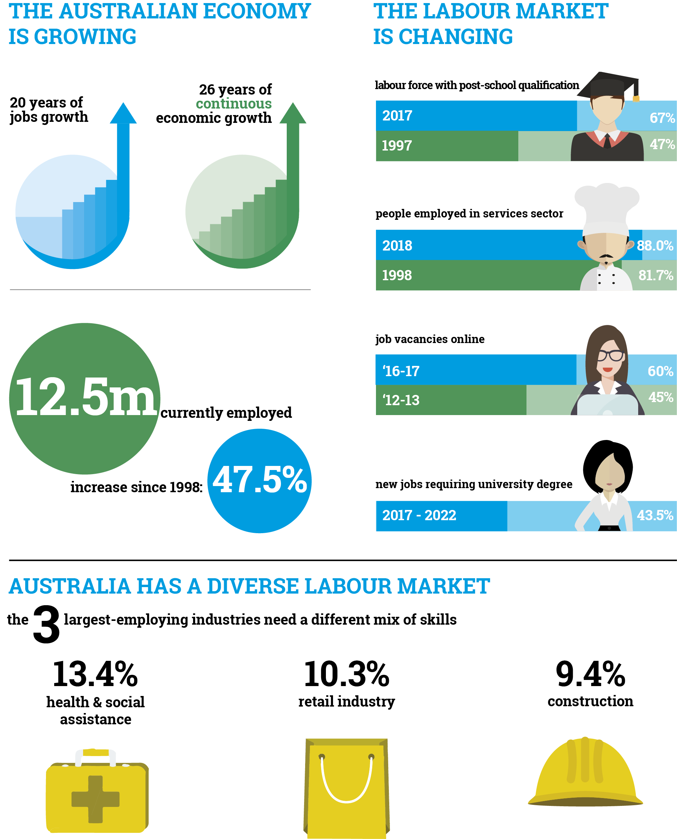
.
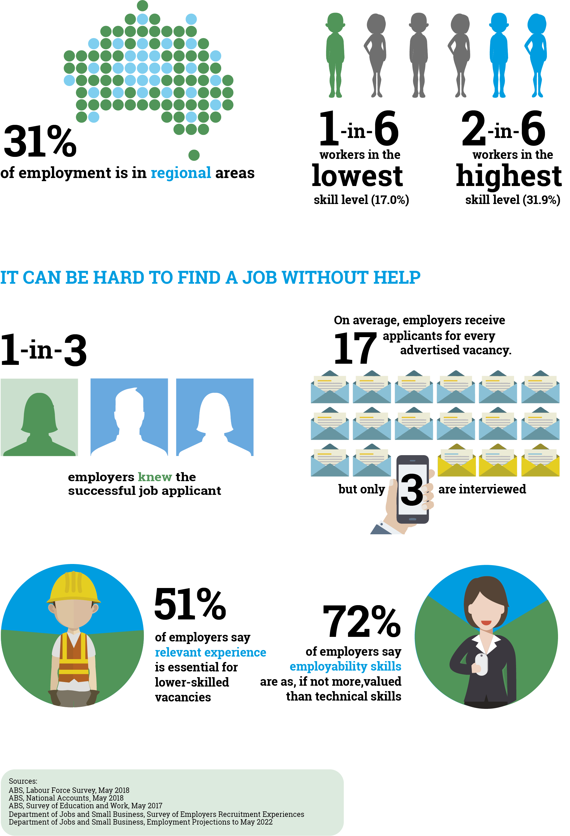

Meet the people who would use our future system...
The Government wants an employment services model that meets the needs of users. That is why the Department of Jobs and Small Business is committed to keeping the needs of users at the centre of policy development. It has continued to undertake a range of user-centred work to understand what it is like for those people and organisations that are supported by this system.

Building on a strong base of existing quantitative and qualitative data and insights, the department has undertaken a range of additional qualitative interviews. This gave users a chance to share their story, and an opportunity for the department to validate existing knowledge bases. The fieldwork involved hearing from a range of users in their communities and places of business, to listen to peoples stories, learn who they are, and gain a deeper understanding about the challenges they face. Through this work, the department has created a number of personas to help highlight the different types of users in the system. Each persona represents a group of users with similar behaviours and motivations rather than a single user’s experience.

While these are fictional characters, they are based on real insights from real people. Through these personas, the Government can consider what a future employment services model might look like and how it might work for those who will use it. Quotes represent real experiences of people using employment services. Their stories have been included throughout a range of chapters, to give a voice of the user, and help all stakeholders better hear their story, in their words.

To help maintain this focus, we have included five personas throughout the different chapters. Consider each of the personas as you consider each of the issues core to the next generation of employment services.

Meet Dave
Dave wants to change his circumstances but does not know where to start or how to take the first step.
Dave’s story
Dave is in his early 40s and has been on and off income support for his entire life. Growing up, his father was in and out of prison, and neither of his parents worked. This upbringing normalised income support as a way of life, and means that Dave does not know many people in stable jobs. All his siblings also live on income support. Dave also has low self-esteem and confidence. He left school at the end of year 10, and has no formal qualifications. He also gets frustrated when his provider tells him to search for jobs online, because he has not had the opportunity to learn computer skills and cannot access a computer at home. He does not know what help he needs, or how he could improve his situation. This is worrying Dave because he and his partner have a baby on the way.
Dave needs:
- to find work so he can better support his growing family
- to figure out what his biggest needs are and find ways to start working towards addressing them (such as improving his self-esteem, confidence, and computer skills), and
- to build the experience and skills needed so he can stay in a job long-term.
Meet Stephanie
Stephanie is very motivated and wants to rebuild her professional career, but needs some flexibility.
Stephanie’s story
Stephanie is a single parent in her 30s who is starting to look for work again after spending the past decade out of the workforce raising her three kids. Her youngest child is about to turn six, and Stephanie feels ready to return to her career. She has been looking for work for the past three months, but has not been able to land a job yet. Stephanie has high aspirations for her career having previously held professional positions, and is looking for something that will use her skills and previous experience.
Stephanie needs:
• an employer that can be flexible around her caring responsibilities
• a job that makes use of her professional skills and work experience, and
- help updating her résumé.

Meet Brenda
Brenda is a young Indigenous job seeker who wants to work, but is not sure what to do.
Brenda’s story
Brenda is 19 years old and finished year 12 last year. She is an Indigenous job seeker who lives at home with her parents and two sisters in a small regional town. While Brenda is unsure what she wants to do for a career, she would be happy to work in any job at the moment. Brenda has some work experience and volunteers as coach of a local soccer team, but often lacks confidence due to being bullied at school. She gets very nervous at interviews and so far has not succeeded in finding work. Her parents are both employed but have very limited time to help with applying for jobs or preparing for interviews. Brenda is comfortable using computers and smartphones and searches online for jobs. Brenda is not sure what else she can do to explore her future options and find a path into a career.
Brenda needs:
- someone to help her explore her options and find a path into work
- more work experience and opportunities to develop her soft skills, and
- someone to help her learn from her experiences and stay motivated when she is unsuccessful in applying for jobs.
Meet The Shop
A regional business that is keen to find employees with the right attitude.
The Shop’s story
The Shop is a small business operating in a regional city that is reliant on unskilled workers. There aren’t many people in the local area willing to do this sort of work, and those it does hire often leave within the first few months. This is beginning to worry The Shop, because a number of its key people/workers are starting to retire, and The Shop doesn’t have anyone to replace them. It is happy to provide some training to new starters, but given so many end up leaving, it prefers to wait until the person is committed to the business before it provides more training opportunities. The shop is engaged with the local employment service provider and happy to give people a chance, but it has been hard to find people with the right attitude to work.
The Shop needs:
- to reduce the turnover of new starters
- to retain its employees in the long-term so it can replace older workers that
- are retiring, and
- to find new workers who have the right attitude to work.
Meet Kingstons
A large company that wants employees that will align with its corporate goals.
Kingstons’ story
Kingstons is a large national company that operates in most capital cities around Australia and has a diverse range of employees working across varying roles. Given its size, Kingstons recruits regularly, and often receives a large number of high-calibre applicants. However, Kingstons also has a strong sense of corporate social responsibility, and has inclusion and diversity strategies as well as targets under government contracts, which require it to recruit a diverse range of job seekers. While it is linked with employment services providers and other government initiatives, it wants a more targeted approach that helps to meet its corporate goals, including by supporting the recruitment of a diverse range of workers.
Kingston needs:
- an employment services provider it can build a relationship with, that understands its business, requirements and corporate values
- employment services providers that are willing to work together to help Kingtons meet its recruitment targets
- access to employees all over Australia with diverse range of skills, and
- employees that are flexible, reliable and align to its corporate values.
At the end of each chapter, you will find a summary of the users’ journey and the guiding questions for the chapter. Consider the users’ journey as you consider each question.

Chapter 1: Government employment services today
The Government is reviewing the design of the generalist employment service (jobactive).
Disability Employment Services, the Community Development Programme, Vocational Training and Employment Centres and programs run by state and territory governments are out of scope for this review.
The Australian Government’s publicly funded employment service landscape includes jobactive, Disability Employment Services (DES) and the Community Development Programme (CDP). These are supported by a range of complementary programs that serve specific groups or particular objectives.
jobactive is the largest program through which employment services are delivered. It has achieved over 1 million job placements and has over 650,000 people engaged at any point in time.
42 jobactive providers operate over 1700 sites in 51 employment regions in metropolitan and regional Australia.
The Department of Jobs and Small Business currently delivers the following complementary programs to help job seekers on their pathway to employment. This list does not include programs administered by other government agencies or community organisations:

- Career Transition Assistance (CTA)*
- Empowering YOUth Initiatives (EYI)
- Harvest Labour Service (HLS) and the National Harvest Labour Information Service*
- Launch into Work*
- National Work Experience Programme (NWEP)*
- New Enterprise Incentive Scheme (NEIS)*
- ParentsNext
- Relocation Assistance to Take Up a Job*
- Structural Adjustment Programs (SAPs) and Stronger Transitions
- Time to Work (TWES)
- Transition to Work (TtW)
- Work for the Dole (WfD)*
- Youth Jobs PaTH*

Chapter 2: The goals for future employment services
The Australian labour market is large, growing and dynamic.
Digital and other technologies are enabling productivity improvements for businesses and workers and changing how businesses recruit.
Employment services will continue to be important in encouraging a productive, efficient and inclusive labour market.
The goals for future services are to:
- maximise job seeker outcomes
- be responsive to a changing labour market
- strengthen engagement of employers and job seekers
- deliver efficiency and value for money
- enable effective activation
- promote fairness and equity
- encourage self-sufficiency and personal responsibility.

The case for change

The Australian labour market – current state of play
The Australian labour market is large, growing and dynamic. More Australians are in paid work than ever before (with more than 12 million in May 2018), over 4 million jobs are filled each year and more than 94 per cent of those in the labour market are working. The Australian labour market provides economic opportunities for most Australians who participate in it and most Australians want to work.
Today’s labour force participants are more qualified and better educated. Young people are working less and studying more while mature age Australians and women are working more.
However, the Government understands that there is more to do. Young people, Indigenous Australians and people with a disability have less success in finding work. Mature age job seekers remain unemployed significantly longer than all other job seekers.
Women, who account for half of all job seekers, also face unique barriers to employment. In 2014, Australia led the G20 to set a goal to reduce the labour force participation gap between men and women by 25 per cent by 2025. In July 2017, the Government released the Towards 2025: Strategy for Boosting Women’s Workforce Participation which outlines the Government’s approach to increase women’s workforce participation.

The Australian labour market is changing
Technological change, digitisation and globalisation are changing industries and skillsets. Many jobs are increasingly integrating technology to allow people to be more productive and efficient. There is now a need for new skillsets to provide services to consumers and for employment platforms to focus more on preparing Australians to seize opportunities that technological change may bring.
Technology is also altering how most employers advertise jobs and how job seekers find them. Employers can now easily and cheaply approach the market directly. People can access help to prepare for jobs and other career and employment advice that will help them find work online and at no cost.
Jobs will change across a wide range of industries and more people are likely to need to update their training to meet the needs of a changing economy. Job seekers, and especially those who face barriers to entering employment or moving to a new job, will need help to identify transferable skills, upskill and find work.

Responsive to regional variation
In designing a future employment services model, consideration could be given to tailoring services to be responsive and targeted to the particular needs of regions. Analysis conducted by the Organisation for Economic Co-operation and Development (OECD) has highlighted that the most successful government programs are flexible and adaptable to local conditions, allowing communities to create local solutions to their distinct needs, maximising employment opportunities and building their capability to identify and drive strategic change.

Stronger support needed for the most disadvantaged job seekers
The Government spends around $1.3 billion a year on jobactive and pays employment services providers to activate all job seekers. More than half of all job seekers exit the system within 12 months. However there is evidence that the focus on activating all job seekers equally, regardless of their need, may be contributing to sub-optimal outcomes for disadvantaged job seekers.
Almost two thirds of jobactive’s caseload is long-term unemployed (more than 12 months on the caseload) and almost half have been on the caseload for over two years. The average length of time on the caseload for the most disadvantaged job seekers (Stream C) is five years. While the long-term unemployed are achieving consistent outcomes, the future model will aim to provide more intensive support for this group. This approach aligns with the international evidence of supporting intensive servicing of the long-term unemployed to encourage their return to work.
Research suggests the average employment services consultant manages a caseload of around 148 job seekers. Research also shows that jobactive provider consultant turnover is almost three times the national average. This makes it difficult to provide high-quality, tailored services to disadvantaged job seekers. Similarly, employers may not always have access to the right incentives or support to hire these job seekers.
Indigenous Australians comprise more than 10 per cent of jobactive participants, despite only making up three per cent of Australia’s total population. More Indigenous job seekers are serviced by jobactive than the Community Development Programme and Disability Employment Services combined.

Digital technology creates opportunity
Digital technology offers the opportunity for more efficient and targeted employment services for job seekers, employers and providers.
Competition is driving innovation in the online recruitment industry. Online job boards are investing to improve matching between employers and job seekers, using artificial intelligence and other technology to offer more tailored employment information, advice and training. Many other countries have sought to enhance their servicing of job seekers online. For example, the Netherlands’ employment service recently implemented a multi-channel approach to servicing job seekers, comprising computer, phone, face-to-face and social media.
Individuals increasingly expect services to be available online and for digital applications to deliver more tailored and individualised services.
Tailored online experiences could be more efficient and effective in helping most job seekers to find work than traditional face-to-face servicing. Moreover, these tools could enhance face-to-face services and provide information that can be used to tailor services, while automating compliance reporting. This streamlined approach would free up more time for providers to spend servicing clients with higher needs and meeting the needs of employers.

Goals of future employment services

It is important to consider the overarching objectives in designing a future employment services model. Transformational change aims to achieve the following goals:

Maximise job seeker outcomes
Help as many job seekers as possible to find and stay in work.

Responsive to a changing labour market
Job seekers are assisted to improve their job readiness, particularly for industries and occupations with strong growth prospects. Businesses of all shapes and sizes receive appropriate help to find people that are a good fit.

Strengthen engagement of employers and job seekers
Users are provided with a tailored service that drives greater employer participation and buy-in from businesses and job seekers, delivered by high quality, and appropriately skilled employment service consultants.

Deliver efficiency and value for money
Users are provided timely and relevant information to assist their decision-making. The future model allocates additional resources to those who need them.

Enabling effective activation
Job seekers are looking for work or undertaking activities that improve their job prospects. The assistance a job seeker receives and the activities they undertake are tailored to their individual circumstances.

Promote fairness and equity
All job seekers and employers are treated fairly and provided with an appropriate level of assistance. Service users can exercise choice and all job seekers are supported on their pathway to employment. This will help to reduce the gap in employment outcomes between men and women, and Indigenous and non-Indigenous Australians.

Encourage self-sufficiency and personal responsibility
Users are supported to help themselves where appropriate. Job seekers meet community expectations around what is required in return for them to continue to receive income support.
The planned reforms to employment services are aimed at creating the right conditions to enable all Australians to work and support themselves. A transformed employment service will empower job seekers to find work, providers to prosper and businesses to grow.
Guiding questions for Chapter 2
- What other economic, social or labour market trends are likely to affect employment services in the future?
- Are there other goals that should be included?

Chapter 3: Helping disadvantaged Australians into work
We must do more to support job seekers who face complex barriers to finding work.
A future model could redirect more resources to assist job seekers who need help to overcome their barriers and prepare for, and find, jobs that last.
This could include more intensive face-to-face services.
These services could be supplied through a national network of providers, who would deliver quality services tailored to job seekers’ and employers’ goals and needs.
These enhanced services providers could encourage and support employers to hire highly disadvantaged job seekers.

The benefits of directing resources towards the most disadvantaged job seekers

Employment services should meet different job seeker needs
The assistance job seekers need to find work can vary considerably. While many job seekers who are assisted through the Australian Government’s employment services are able to find work quickly, others face significant barriers to entering and sustaining employment. For many job seekers, these barriers are highly complex and can involve multiple issues.
To help people move from income support to work, a future employment services model could direct additional resources to the most disadvantaged job seekers to help them find employment faster. This would reflect international best practice: the OECD recommends that government employment services “concentrate … scarce resources on job seekers who have become long-term unemployed, or ideally those most at risk of becoming long-term unemployed”.
Streamlining services for refugees
To better support the settlement of newly arrived refugees, the Government is simplifying the approach to accessing support services.
Under current arrangements, newly arrived refugees are eligible for the Humanitarian Settlement Program (HSP), Adult Migrant English Program (AMEP) and jobactive.
From 1 January 2019, newly arrived refugees, receiving activity tested income support, will focus on HSP and AMEP for six months. These services allow newly arrived refugees to develop their literacy skills (including through an online e-learning package) and settle in Australia. They will then become eligible for full jobactive services after six months of receiving income support.
Under a future employment services model, employment services consultants could coordinate their services with other forms of support to assist refugees find employment.
It is proposed that all job seekers have access to the online employment services described in Chapter 4. These services will include support to assist job seekers find employment, including through integrating online forms of assistance with other services. Those job seekers who face complex barriers could receive additional, specialised, forms of support. This additional assistance could be delivered by enhanced services providers, with the goal of helping job seekers to find work as quickly as possible and stay in work.

Options for assisting job seekers through the enhanced services

What assistance should be available to job seekers who face disadvantage?
OECD analysis has found that job seekers who face substantial barriers to employment typically benefit from relatively high levels of assistance coordinated by a skilled employment services consultant. This approach to helping disadvantaged job seekers has also been found to be effective in Australia’s employment services. The Australian and international evidence indicates that employment services consultants should focus on the individual needs of the job seeker and connect them with the help they need to find work. To achieve this, consultants must have good contacts with local employers and support services.
Employment services consultants could work one-on-one with eligible job seekers to develop and implement short and longer-term strategies that help them to prepare for and gain employment. Where necessary, consultants should connect job seekers with other relevant assistance in their local area, such as housing or mental health services. The services job seekers receive could be tailored to their goals and needs and be delivered in culturally sensitive ways.
“I feel like [the] job service provider could do a bit more for its clients in helping them find work or find what they want to do, instead of … just like being a thing that you have to do”, job seeker.
The more intensive face-to-face services could provide job seekers with four main types of assistance:
- pre-employment interventions such as job readiness training
- vocational training, including training to provide skills needed for specific jobs
- employment and work experience placements, including by offering wage subsidies to employers and other forms of assistance
- post-placement support to help job seekers keep a job.
The exact type and mix of services individual job seekers get should be tailored to their needs and local employment opportunities. These services should also assist employers to hire and retain people with minimal administrative impact to their business.
As noted earlier, these services could complement the online services. This would allow the enhanced services employment services consultants, who delivering enhanced services to focus on helping job seekers overcome more complex barriers to employment.
Transition to Work
Transition to Work (TtW) helps young people from 15 to 21 who are early school leavers or who have had difficulty entering employment after school. The service supports eligible young people to get work by helping them develop practical skills, connect with education or training, undertake work experience and find local job opportunities. It also connects them with other relevant local community services.
There are significant differences between TtW and jobactive. TtW providers do not directly compete against one another. The providers are also allocated annual funded places and receive upfront payments for each place, reflecting the number of participants they are expected to assist. Providers must meet strong performance targets in return for these payments and receive bonus payments for exceeding their targets.

How should services be delivered?
Disadvantaged job seekers are currently helped through a ‘hub and spoke’ model. This comprises generalist employment services supported by a range of complementary programs and support tools. While these services effectively target assistance, there is a risk that disadvantaged job seekers could fall between the cracks if they are not part of the cohorts targeted by the complementary programs. Incorporating complementary programs into a single service could give providers greater flexibility to match services to the needs of job seekers.
Options for delivering services to disadvantaged job seekers could include:
- a single unified enhanced service that assists all highly disadvantaged job seekers, with providers being responsible for meeting individual job seeker needs
- continuing the ‘hub and spoke’ model, which includes a generalist, enhanced service as well as complementary programs targeting particular job seekers, in some cases being delivered by separate providers.

Options to further improve service quality
The goal of enhanced services is to achieve positive outcomes for as many job seekers as possible, with a focus on finding and staying in work. To achieve this, it is desirable for the employment services consultants who work with job seekers to have the skills and resources needed to deliver quality services that build on the assistance job seekers access online. This could be achieved through further industry-led improvements to service quality, including by specifying minimum capabilities and recognising relevant experience.
Research shows that jobactive employment services consultants have an average caseload of 148 job seekers. Consideration could be given to measures that enable more personalised and user-centred services by reducing caseload size. These efforts could be supported by digital tools that draw on data to suggest the types of assistance that are likely to be successful based on job seekers’ needs, strengths and employment goals.
Transitioning to the online approach for monitoring job seekers’ compliance with their mutual obligations (proposed in Chapter 7) could also reduce the demands on employment services consultants’ time and enable them to focus even more on working with their caseload.
“By seeing the same person more often I think it makes you probably more confident that they’re going to help you because if they’re doing their job right and they’re believing the person and the qualities that you have, then after time they should gain you employment”, job seeker.
The incentives and performance measures applying to enhanced services providers could also drive further improvements to services and job seeker outcomes. These are discussed in Chapter 9, where it is proposed that they would include core quality standards as well as incentives for providers to assist all of their clients.
As long as the quality standards are met, enhanced services providers could have discretion in designing and implementing strategies to assist job seekers. This would continue current arrangements under jobactive and encourage diverse approaches that are tailored to job seekers’ needs and local challenges and opportunities.
It is proposed that enhanced service providers have access to a flexible pool of funding similar to the current Employment Fund. This allows providers to purchase items and services needed to assist job seekers into work and is supported by international evidence.

Further expanding job seeker choice
User-choice can play an important role in making sure that government-funded services are effective. As the Australian Government Competition Policy Review noted “in many instances, users (rather than governments or providers) are best placed to make appropriate choices about the human services they need”. Enabling users to exercise choice can encourage providers to offer more diverse, individualised and better quality services to attract and retain job seekers.
While most job seekers are satisfied with the quality of assistance available under the current services, there may be scope to strengthen the role of user-choice. As well as improving job seekers’ input into their Job Plan (discussed in Chapter 7), they could have more responsibility for the types of assistance they receive. One option to achieve this is to require enhanced service providers to develop a short-list of services that would meet the job seeker’s needs, with the job seeker being able to choose between them.
To further expand user-choice and strengthen incentives for all providers to deliver quality services, the current rules concerning transfers between providers could also be relaxed. This would make it easier for job seekers to move to a new provider if they believed that doing so would improve their prospects of gaining employment, ending the current process where the department assesses such transfer requests by making them automatic. The number of times job seekers could make such transfers during each period of service could be capped, with restrictions around the timing of transfers.

Eligibility for the enhanced services
Enhanced services would be targeted at job seekers who are highly disadvantaged. This could include those who have been:
- assessed as requiring considerable assistance to enable them to enter employment
- largely self-servicing through the online employment services for a set period (for example, 12 months), but who have reached a point where they need more help to find work.
In line with international best practice, job seekers within the enhanced services would receive the level of assistance that reflects their needs. Options for directing sufficient resources and incentives to providers to achieve this include:
- allocating job seekers into ‘tiers’ with different levels of resources and incentives based on their level of relative disadvantage (for example, a tier for job seekers with very high levels of disadvantage and a tier for other job seekers eligible for enhanced services
- basing this on the number of ‘points’ measuring disadvantage in the labour force the job seeker is assigned through the assessment process, with each point increment attracting higher levels of resources and incentives. While this option could enable precise allocations of resources, it may be too complex for providers to apply.

User journey Chapter 3

Meet Dave
Dave wants to change his circumstances but faces some major barriers to getting a job
His journey
- Dave and his case manager agree that he should focus on preparing for employment first.
- Dave’s employment service consultant helps him to access other support services that can improve his literacy and computer skills.
- Dave completes a course to gain the skills needed for local jobs.
- Dave undertakes a work experience placement with a local employer while continuing to look for jobs.
- Dave’s work experience placement goes well, and turns into an ongoing job.
- Dave’s employment service consultant helps his new employer to provide Dave with ongoing training and support.
Dave accessed support service to build his skills and prepare for work.
Meet Brenda
Brenda is very motivated but needs support to find a path into work.
Her journey
- Brenda and her employment services consultant research some career options and decide to focus on building the skills needed for a job in a growing local industry.
- Brenda is supported to complete specialist training related to the industry she is interested in.
- Brenda uses the online services to look for work.
- Brenda’s employment services consultant helps her to apply for jobs in her new field.
- Brenda is hired by an employer in her new field.
- Brenda’s employment service consultant checks up with her to make sure she is settling into the new job.

Brenda used online services and received additional support from a providers to find a job

Guiding questions for Chapter 3
- What services should be available to job seekers who are disadvantaged in the labour market and how can they be delivered in a culturally competent way?
- What incentives might be useful to assist job seekers who are disadvantaged in the labour market to find work?
- Are enhanced services best delivered through a single unified service, or a model that includes specialist service provision directed at particular cohorts of job seekers, as well as a core service?
- How could the quality of services job seekers receive from their employment services consultant be improved?

Chapter 4: Empowering job seekers and employers through improved online services
Greater use of online technologies can provide an enhanced service for both job seekers and employers.
An online service could provide business with a single point of contact to access a larger pool of labour and more sophisticated tools to filter and shortlist candidates to make sure they meet their needs.
Advances in data analytics, including machine learning and artificial intelligence, can better match job seekers to vacancies, deliver more tailored solutions to help job seekers upskill and help employers find the right candidate faster.
Improved online services that leverage existing platforms could be made available to all job seekers or just to those on income support. This has potential to enable those at risk of losing their job to access help early so they are better prepared to make a successful transition and less likely to need income support.

Rationale for strengthening the online component of employment services
Customer service delivery using online channels is common and enables job seekers and private enterprises to capitalise on online job search, job matching and training techniques.
Research from the Australian Competition and Consumer Commission highlights growing use of, and familiarity with, platforms that connect buyers and sellers and reduce transactions costs.
jobactive currently offers several services online. However, there remains potential to capitalise on smarter features that aid job filtering and personalisation of services. Harnessing these opportunities could improve the online experiences for job seekers and employers.
An online service could give job-ready job seekers greater responsibility for their job search efforts. These job seekers could be supported through improved online features and better integration with other services. Time saved from the online service could be spent providing face-to-face services for job seekers with complex needs and meeting the needs of employers.
Australians are changing careers more often than ever before. The online service could help job seekers manage their career journey by providing access to the training, information and support that they need as they move between jobs. It could also provide the platform for individuals to engage in lifelong learning throughout their working life.
The online service could also support employers through enhanced matching capability that simplifies the recruitment process and shortlists candidates with the skills they are looking for.
The service should also recognise that not all job placements are sourced online, so should provide job seekers with the tools to conduct job search activities face-to-face or by other means.
Internationally, public employment services face the challenge of adapting business modes to new users and new technologies. The examples below summarise some of these models.
International online experiences
Online service channels are commonly used to help job seekers in OECD countries. Data-driven services (for example registration, vacancy search, job matching) are being delivered online and more complex, trust-driven services (such as counselling, dealing with complicated employment cases) are delivered in person.
Satisfaction of online employment services appears similar to face-to-face services. In the late 2000s, the Netherlands used online services to cope with the increasing number of job seekers and decreasing budget from the global economic crisis. While an initial reduction in customer satisfaction resulted from perceptions about a reduced level of servicing, satisfaction has improved as the system has evolved to meet user needs.
In Spain, services available in unemployment benefits offices are offered electronically. In 2013, Spanish citizens recorded their satisfaction with electronic services at 78 per cent, better than face-to-face services at 72 per cent.
Flanders public employment agency (VDAB)
The VDAB in Belgium has adopted a digital first (digital-by-default) approach for servicing job seekers. The agency has developed an online services platform where tools and apps are freely available to job seekers and external service providers to embed them into their systems. VDAB has partnered with private recruitment firms, such as Adecco and Randstad, to assist job seekers by sharing information on vacancies.
The VDAB system is designed to reflect customers’ needs and satisfaction in terms of speed, comfort and personalisation of services. VDAB has continued to diversify its services to meet job seekers’ needs, including enhancing its online job matching via ‘Flex-iTraining’.
This is a mixed method approach to training using a suite of online courses, workshops and coaching. VDAB has also formed partnerships with organisations such as Coursera and T4S to develop and offer courses, including certified courses, which employers often value. Course completion is tracked and there is an 80 per cent completion rate (courses are voluntary).

Possible overall structure of online employment services
The overall structure of online service hinges on two considerations:
  - What features should an online service offer job seekers and employers?
  - Who owns and operates an online employment services platform?
Existing online platforms currently service a large number of job seekers and employers. The future online service should not compete with these platforms, but integrate services as much as possible.
The additional online services could include:
- An online platform that could link with private organisations, such as training organisations or existing online job aggregators to provide an enhanced user experience. The service could be a one-stop-shop for the job seeker and the employer and could seamlessly connect all stakeholders involved in supporting Australians into work.
- Services that are primarily focussed on job seekers who are required to use employment services. The platform would link to existing job aggregators for vacancies but not link job seekers and employers directly. The platform would focus on getting job seekers ready for work.
- Services for workers who may be likely to move onto income support, for example where additional training may be necessary in order to transition to a new role, or unemployment in the industry is high, and where the Government has programs or industry assistance available.
Online Employment Services Trial
The Online Employment Services Trial will begin on 2 July 2018 and will run for two years. During the trial, 10,000 randomly selected job-ready job seekers who are not in need of specialised services will be referred directly to an online servicing platform where they will approve their own Job Plan, self-manage mutual obligation requirements and report job search contacts.
The aim of the trial is to test the delivery of employment services online as well as the ability of job seekers to effectively look for work in an online environment. Job seeker functionality and online experience will continue to develop over the life of the trial in response to user experience.
The trial will help inform the development of an online platform to service job-ready job seekers.

The role of data analytics and disclosure
The OECD recommends that employment services providers have access to job seeker information to support and train their job seekers. Online services will allow for targeted assistance to be provided to job seekers and potential employers, including:
  - providing recommendations for work, training or other activities to a job seeker based on their existing skills and experience
  - providing recommendations for suitable job seekers to potential employers, including the skills, enthusiasm and experience of the job seeker
  - reviewing or creating résumés for job seekers
  - using emails or SMS to remind job seekers of tasks, or to suggest new job vacancies
  - assisting job seekers to understand opportunities such as relevant training available to build their skills and career
  - tailoring activation requirements for the job seeker in relation to their circumstances
  - creating channels to provide and receive feedback on the job seeking process.
Data could be used to tailor services, and to understand job seeker motivations and opportunities, vulnerabilities and indications of non-compliance. As with other online services, user privacy will always be protected. Linking de-identified datasets from across Government could also benefit both business and job seekers by informing employment and training trends and opportunities, nationally and regionally.

Online user considerations
It is proposed that the service is governed by three principles:
- meet the needs of the user, so that it is relevant and simple
- responsive to changes in the labour market and emerging technologies
- a learning-oriented system.
This means the online services would need to evolve over time, enabling any future system to learn from and respond to user need and behaviour.
Online servicing has the potential to make employment services more accessible to more Australians. For example, workers who are not on income support but who are struggling to find work (e.g. parents looking to return to the workforce and who have been looking for work for some time) could receive career advice and recommendations to apply for jobs. Workers could use online features while still in work, getting guidance on options for career changes and training opportunities. There are sections of the community that may prefer to operate in an online environment, as it allows them greater say on the time and place they access the service.
Online skills transferability tool
Transferable skills are increasingly important in assisting employees to move between jobs. The recent automotive and manufacturing industry closures demonstrate workers often do not understand their transferable skills, particularly if they have been in the same job for many years.
The Job Change initiative includes a new online skills transferability tool to help retrenched workers and others find jobs and careers that match their existing skillsets and experience. The tool could highlight careers that may not have been considered but that have shared skillsets, as well as advise on required training. It will also provide information on wages, local job opportunities and growth sectors.
For job seekers who are required to use employment services, online servicing could place a greater emphasis on the quality of activities undertaken to find a job, rather than the quantity of job applications. It could also enable more efficient and effective monitoring of job search activity and reporting of compliance activities. This could provide taxpayers with greater assurance that job seekers are meeting their mutual obligations and protect the integrity of the income support system. It could also enable resources currently devoted to manual reporting of mutual obligations by providers to be redirected to activities better focused on employment outcomes.
Although the proportion of households with access to the internet has increased considerably since 2004–05, it has remained constant since 2014–15 at 86 per cent. There is also a gap between the digital inclusion levels of Indigenous and non-Indigenous Australians, with Indigenous Australians less likely to have an internet connection. Mobile devices may provide access for some job seekers and facilities to access online services exist at Centrelink offices or public libraries, as well as potentially the offices of employment services providers. Job seekers would also retain the option of using face-to-face services where they do not have access to online services.
Depending on the design, the service could offer employers easier sourcing, filling and managing of vacancies. This could be facilitated by user-friendly access to labour market information, such as emerging industries, job seekers looking for work in regions and data on jobs, better-targeted searches for jobs listed, shortlisting features and other refinements based on employer needs.
Employment services providers could benefit from more efficient online processes. Smarter use of information could lower the amount of time spent on administration, allowing consultants to focus more on job seekers.
Job aggregators (or other private recruitment firms) could provide a platform with the Government contributing tools to improve accessibility and use of the services for job seekers who are receiving, or are likely to receive, support from government-provided employment services. Any online services would not aim to compete with job aggregators but to complement their service offering by providing an input they can utilise to deliver a better service offering to users. For example, the government could work with job aggregators to target job recommendations and record compliance for these job seekers, or could concentrate a large number of job seekers at one web location, which is something that could be appealing for employers.
User journey Chapter 4
Meet Stephanie
She is very motivated and wants to rebuild her career with flexibility.
Her journey
- Stephanie creates a MyGov profile to start looking for work.
- Stephanie develops a job plan.
- She records her search effort easily online.
- Stephanie attends unsuccessful interviews.
- She is encouraged by relevant job matching suggestions to help her search.
- The platform matches her profile to alternative jobs, providing suggestion by SMS and email.
- Stephanie completes a web-based survey that tests for employer requirements.
- Her children fall ill and so her job search requirements are reduced.
- The platform tracks her progress and detects that she has found a job. Centrelink notifies her that income support payments will cease.
Stephanie is offered a job that accommodates her situation.
Meet Kingstons
A large company that wants employees that will align with its corporate goals.
Their journey
- Kingstons becomes aware of a free online recruitment platform.
- A vacancy opens up at Kingstons.
- Kingstons posts a job ad online.
- The platform matches Stephanie’s capabilities to Kingstons’ position.
- Kingstons interviews Stephanie and rate her as a strong candidate.
- Kingstons offers Stephanie a job.
Kingstons hires Stephanie after posting a job ad.

Guiding questions for Chapter 4
- What online tools and assistance should be included to better meet the needs of particular user groups? Which are the most important features that are required?
- Is there a group of users that the online service should target?
- How can data be used to provide more personalised, effective services?
- How should the online service interact with existing online job aggregators and recruitment firms?

Chapter 5: Better meeting the needs of employers
A future model could add value to businesses by making it easier to find, recruit and retain skilled people through a range of tailored services.
It would provide business with a single point of contact to access a larger pool of labour and more sophisticated tools to filter and shortlist candidates to make sure they meet their needs.
A network of enhanced services providers could deliver employers personalised, end-to-end recruitment services, supporting them to find and retain the right people for their business.
A range of financial incentives, training, work experience and other supports could be available to encourage employers to hire disadvantaged job seekers.

Government employment services are meeting a specific need
The overwhelming majority of recruitment activity in Australia occurs without government intervention. Many employers do not look to jobactive for their recruitment needs.
The Government provides support to assist income support recipients to move into work. It also assists to achieve social outcomes such as promoting employment amongst disadvantaged groups, such as people with disability, mature age people, Indigenous Australians or refugees.
Government-funded employment services are designed to enhance the normal operation of the labour market, not to interfere in it. No employment service model can work without successful employer engagement. A future model must offer employers an attractive, value-adding service in order to generate repeat business. With more employers using the service, it is easier to achieve the other goals of future employment services (see Chapter 2).
A future employment services model could reach out to businesses and offer them a tailored recruitment service at no cost to them. The service could enable employers to find and hire people when they want and how they want. Services could be delivered through two main channels: the online employment services and via enhanced services providers.

Services for employers

Online services providing high-quality matching
Around 60 per cent of job vacancies are advertised online. To harness this growing trend, the online employment services could provide employers with the tools needed to find the right people for their business, 24 hours a day, seven days a week.
The online service could enable employers to post job vacancies, search for potential employees from a large database, shortlist and contact candidates, and manage the recruitment process when and where it suits. It would provide employers with access to a larger pool of labour than jobactive currently provides because it would provide access to all job seekers using the system and not just those managed by an individual provider.
To encourage high quality matching of job candidates to vacancies, the online service could use artificial intelligence and machine learning. The service could harness a rich data set of job seekers’ skills, strengths and experiences, enabling a better match for employers.
Online services could also deliver up-to-date labour market information and advice to job seekers, employers and employment services consultants. This could include future growth projections for different industries and occupations, or advice about training and financial support for new employees.
“We haven’t really searched for it, but even if there was a webpage that outlines all of the type of assistance you could get, that would be good”, employer

Enhanced services providing personalised services
It is proposed that a network of enhanced services providers perform a key role in delivering end-to-end recruitment services to employers, helping them find the right people for their business.
Feedback from employers is that some prefer a more personalised service where they can call or speak face-to-face with someone about their recruitment needs. While businesses will be able to approach the service, the service will also approach them, offering a tailored service at no cost.
Enhanced services providers would advise employers on the range of services available, including pre-employment training, work-related equipment and mentoring support for new employees. It is proposed that enhanced services providers also refer screened and job-ready candidates to specific job vacancies.
Combining the online service with personal service from the enhanced service providers could yield additional benefits. For example, employers could initially identify some potential candidates from a wide selection and then work with providers to finalise the process. This delivers an element of autonomy for the employer, but also helps the employer engage the new employee.
“If you [a job seeker] could, I guess, enter your strengths. So, ‘I’m strong on phones’ or ‘I’m strong on writing’. Then you [an employer] could have criteria for the job role you’re putting out there and they could match candidates to the strengths you’re looking for versus the strengths they think they’re good at”, employer

Other potential benefits for business
Employers consistently raised concerns that a high volume of job applications are received from job seekers, sent merely to meet mutual obligation requirements. The flexible activation framework proposed in Chapter 7 would respond to this issue, promoting a more targeted approach to job applications.
Employers would also benefit from an overall increase in the quality of job applications brought about by the proposed online services. Job seekers in future employment services could receive recommendations for jobs based on their interests, experience and skills, as well as assistance in résumé development and job applications. This approach could better match candidates to job vacancies and generate higher quality applications.
As discussed in Chapter 9, the performance framework for enhanced services providers could include elements that incentivise providers to build strong connections with local communities and employers. This could include measures of employers’ satisfaction with an enhanced services provider, helping to drive an even higher quality of employer servicing.

Incentives for employers to hire disadvantaged job seekers
A future model could feature a suite of incentives and supports to help encourage businesses to overcome any perceived risks and hire disadvantaged job seekers. These supports may help lead to even greater sustainability in jobs.

Wage subsidies to help cover costs
Wage subsidies function as a financial incentive to help overcome employers’ reluctance to hire certain groups by compensating employers for real or perceived lower levels of productivity.
Over 100,000 wage subsidy job placements have occurred under jobactive, which offers employers that hire an eligible job seeker up to $10,000 over six months. Wage subsidies have experienced significant growth in uptake since changes were introduced in January 2017 to make them easier for businesses to access and manage.
Australian and overseas research illustrates that wage subsidies are more effective if they are tightly targeted to minimise deadweight costs (paying a wage subsidy for a person who would have been hired anyway). A targeted approach is proposed for the future model, with possible options including limiting eligibility to employers who hire job seekers:
- registered in enhanced services
- who have been unemployed for a certain period of time (e.g. six months or more), or
- who are in a particular pre-identified cohort (e.g. Indigenous, mature age, young people).

Work experience is beneficial for all
Work experience is an effective way for a business to see if a potential employee is the right fit before choosing to hire them. Work experience can give a job seeker valuable experience in a workplace and inform them about what working in an occupation or industry entails.
Where possible, work experience in the future employment services would be in a realistic, work-like situation. Placements would also offer the participant a greater prospect of securing a subsequent job.
Feedback from business is that the cost of hosting a work experience placement is one reason many are reluctant to offer such placements. A financial payment to the host business may encourage more to offer work experience and help cover the cost of supervision, training or any other associated expenses.
Host businesses could have access to an online interface enabling them to easily manage work experience placements.
To prevent exploitation of vulnerable job seekers, risk assessments, insurance and regular monitoring of placements would be implemented.
The Government’s PaTH Internship program currently provides host businesses with a $1000 upfront payment to host an eligible young person for up to 12 weeks. Similarly, the National Work Experience Programme now provides host businesses with a $300 upfront payment for hosting an eligible job seeker for up to four weeks.

Mentoring and other support to strengthen employee retention
Some employees require additional support to remain in a job long-term. This could include mentoring for the employee, but also training, uniforms or work equipment.
The future model could provide the employer with a central point of contact to raise any concerns. This could be an enhanced services provider consultant or an Australian Government hotline to enable employers to access advice and support and to work through any issues.

User journey Chapter 5
Meet The Shop
A small business looking to hire a couple of entry-level workers.
Its journey
- The Shop uses the online services to list job vacancies and shortlist job-ready candidates.
- A local provider contacts The Shop on behalf of an Indigenous job seeker, explaining that a wage subsidy is available. The Shop signs a wage subsidy agreement and hires the person full-time.
The Shop uses the online services to hire another local person.
Meet Kingstons
A large business operating in several capital cities, looking to build a more diverse workforce.
Its journey
- Kingstons find out about the enhanced services through a community networking event, and contacts a local enhanced services provider.
- Kingstons chooses to trial a candidate for a month to test if they are the right fit for the job. Kingstons receives financial help to cover costs associated with the work experience placement.

Kingstons uses the enhanced services to hire several people after a work trial.

Guiding questions for Chapter 5
- How can the Government raise awareness of employment services available to employers?
- How can future employment services add value to an employer’s recruitment process?
- What functionality would employers expect or desire in an online employment service?
- How should employment services providers work with employers to meet their needs?
- What incentives (financial or otherwise) would help employers overcome any perceived risks associated with hiring disadvantaged job seekers? How should these operate?

Chapter 6: Assessing job seekers to tailor support to their needs
Accurately assessing job seekers to determine their individual needs and strengths for finding work could support the future employment services model to work efficiently and effectively. This allows for targeted and tailored services, the investment of resources in those job seekers who need it most, as well as improved matching of job seekers to employer needs.
This could be done by:
- Building a comprehensive understanding of the job seeker, including their personal circumstances, strengths, capabilities and challenges in finding a job.
- Using assessments to target enhanced services to those who need it most, while getting out of the way of those who do not need help to find work.
- Using assessments to inform the activation process, helping job seekers and their providers understand their needs and plan personalised pathways to work.

Assessment
Assessment is the process of gathering information to understand what help a person may need. This includes understanding the job seeker’s personal factors, capabilities, strengths and challenges that affect their ability to find work.
The Job Seeker Classification Instrument is the main tool to understand job seeker characteristics
The use of assessment tools to understand job seekers is common practice for public employment services around the world. In Australia, the main tool is the Job Seeker Classification Instrument (JSCI), a statistical tool that asks job seekers a range of questions to measure their capacity and needs. The tool then allocates points depending on the answers and using a regression model, determines a job seeker’s relative level of disadvantage and their likelihood of remaining unemployed.
Where the JSCI identifies that a job seeker may have multiple or complex barriers to employment, they may need to complete an Employment Services Assessment (ESAt). The ESAt further explores these barriers and is currently used to refer job seekers to jobactive Stream C or Disability Employment Services (DES).
There is an opportunity to improve the comprehensiveness of the assessment process
While the JSCI assesses relative disadvantage in the labour market, it does not provide information on the specific assistance a job seeker might need to get a job (noting that this is not the tool’s purpose).
Currently, the JSCI and ESAts are conducted by the Government, with further in-depth assessments of job seekers undertaken by employment services providers. There is an opportunity to adopt a more holistic approach that builds on the JSCI process and captures factors such as strengths, skills, attitudes, capabilities and resilience more consistently. Assessing job seekers’ ability to use the online services will also be important as technology becomes more significant to service delivery.
Improved engagement by understanding a job seekers strengths
Strength-based assessments include soft factors such as attitudes and behaviours, as well as hard factors like technical skills and previous work experience. Job seekers are more likely to respond positively to strength-based assessments, compared with questions that focus on their barriers to employment. A key challenge is finding the appropriate tools to perform these assessments.
This information could be provided to job seekers, helping them to understand how they can use their existing attributes to make them more competitive when finding work. This process could also identify additional skills they could gain through training (for example, digital literacy training), broadening their job options.
Better understanding of individuals will enhance job matching in the online service
Another benefit of incorporating skills assessments and career aspirations into the online platform is that vacancies can be matched to job seekers. This would help job seekers identify the positions for which they are most suitable. The IT system could also push these vacancies to the job seeker to encourage them to apply for job opportunities.
Motivation is important in job search
The OECD has identified motivation as a key element for job seekers actively pursuing employment. Other international jurisdictions have incorporated behavioural questions into their assessment tools, including Germany and the Netherlands. For example:
- The German public employment service assessment process uses an in-depth interview that focuses on the strengths and potential of the individual. It takes into account qualitative and quantitative variables such as education, previous work experience, hard and soft skills, and professional capabilities.
- The Dutch WorkProfiler is a tool that indicates a job seeker’s probability of returning to work. It includes behavioural questions that provide insight into the job seeker’s obstacles, including factors like motivation.
Job seekers could be offered counselling and other supports to assist in increasing their motivation.
Digital literacy will be an important factor in future employment services
Digital technology will provide better and more efficient employment services. The ability to interact with digital technology is known as ‘digital literacy’. Most job seekers are likely to require a basic level of digital literacy, measured as the ability to use technology to find information, solve problems or complete tasks.
It will be critical to assess the digital literacy of job seekers, so that no one is disadvantaged as more aspects of employment services are delivered online. As some people may require additional support or training to use online services, alternative arrangements may be necessary for job seekers who lack basic digital and other literacy to make sure their needs are properly assessed and (if necessary) they receive training. Noting this, research by Innovation and Business Skills Australia suggests that the groups most affected by low digital literacy are also those that generally face other challenges in finding work (e.g. mature age, Indigenous Australians and culturally and linguistically diverse) and are therefore likely to be eligible for additional support.
Improved data sharing will enhance job seekers interactions with employment services
A number of government agencies hold information that would be relevant to understanding a job seeker’s circumstances. To improve the efficiency of employment services, there is an opportunity to link administrative data across Australian Government agencies, streamlining a job seeker’s journey through employment services and minimising the need to provide the same information repeatedly.

The value of reassessment
Currently job seekers are assessed during their initial contact with the Department of Human Services as part of their application for income support. Job seekers can be reassessed when their circumstances change to make sure they continue to receive appropriate services. Ongoing reassessment could be used to measure progress, support engagement and determine how interventions need to change through the job seeker’s journey to work.
For example, job seeker feedback suggests that even the most highly motivated job seeker can become disheartened as their time in employment services increases. If this fall in motivation was identified, greater support could be provided.
“I’m so miserable… I don’t know how I’m going to go finding a job here. There just isn’t that much and my motivation levels are sort of have [hand gesture in a downward motion]”, job seeker

Disclosure of information is key
The JSCI (like broader assessment processes) are dependent on a person’s willingness to share information. Anecdotal evidence suggests that people are less willing to disclose personal information during the initial intake process, affecting the ability to deliver the right services.
To help minimise this, it is vital that job seekers understand the importance of being open and honest by explaining the intent of the assessment process to make sure they receive the support they need.
“We hadn’t had him long and he was too embarrassed to say to his EC [employment consultant], ‘I can’t read and write’”, provider

Data matching and reassessment will support accurate understanding of job seeker needs. Reassessment also provides the opportunity for job seekers to update their information based on their change in circumstances.

Assessment will determine eligibility for enhanced services
A key aspect of the new model is targeting intensive assistance to the job seekers who would benefit most from this help. Information from the assessment process can help identify the most disadvantaged job seekers and the reasons why they are disadvantaged. This allows their servicing strategy to be tailored to overcome these challenges. It also minimises the risk of resources being directed to job seekers who do not need them to find work.

How should job seekers be assessed?

Option 1: User-profile assessment
All job seekers entering employment services could be required to undertake the assessment process. A JSCI-like tool could assess a job seeker’s characteristics that may indicate relative disadvantage. Leveraging the online service, assessments would be conducted online or, for those with accessibility issues, face-to-face or by phone. Based on this assessment, job seekers who are identified as potentially having barriers to employment could be evaluated for access to enhanced services by being referred to an ESAt.
Job seekers assessed as ineligible for enhanced services would be required to complete an additional assessment process that covers digital literacy, attitudes, skills and needs. This would underpin the development of the job seeker’s Job Plan and facilitate better job matching in the online service. This would enable skill gaps to be identified for the job seeker to address, broadening their opportunity for work. These tools would also be available for job seekers in enhanced services, with the provider to facilitate assessment and interpret the results.
Job seekers would be required to undergo regular reassessments (online with support from a provider for applicable job seekers), either triggered by a change in circumstance or at fixed intervals.

User-profile assessment option
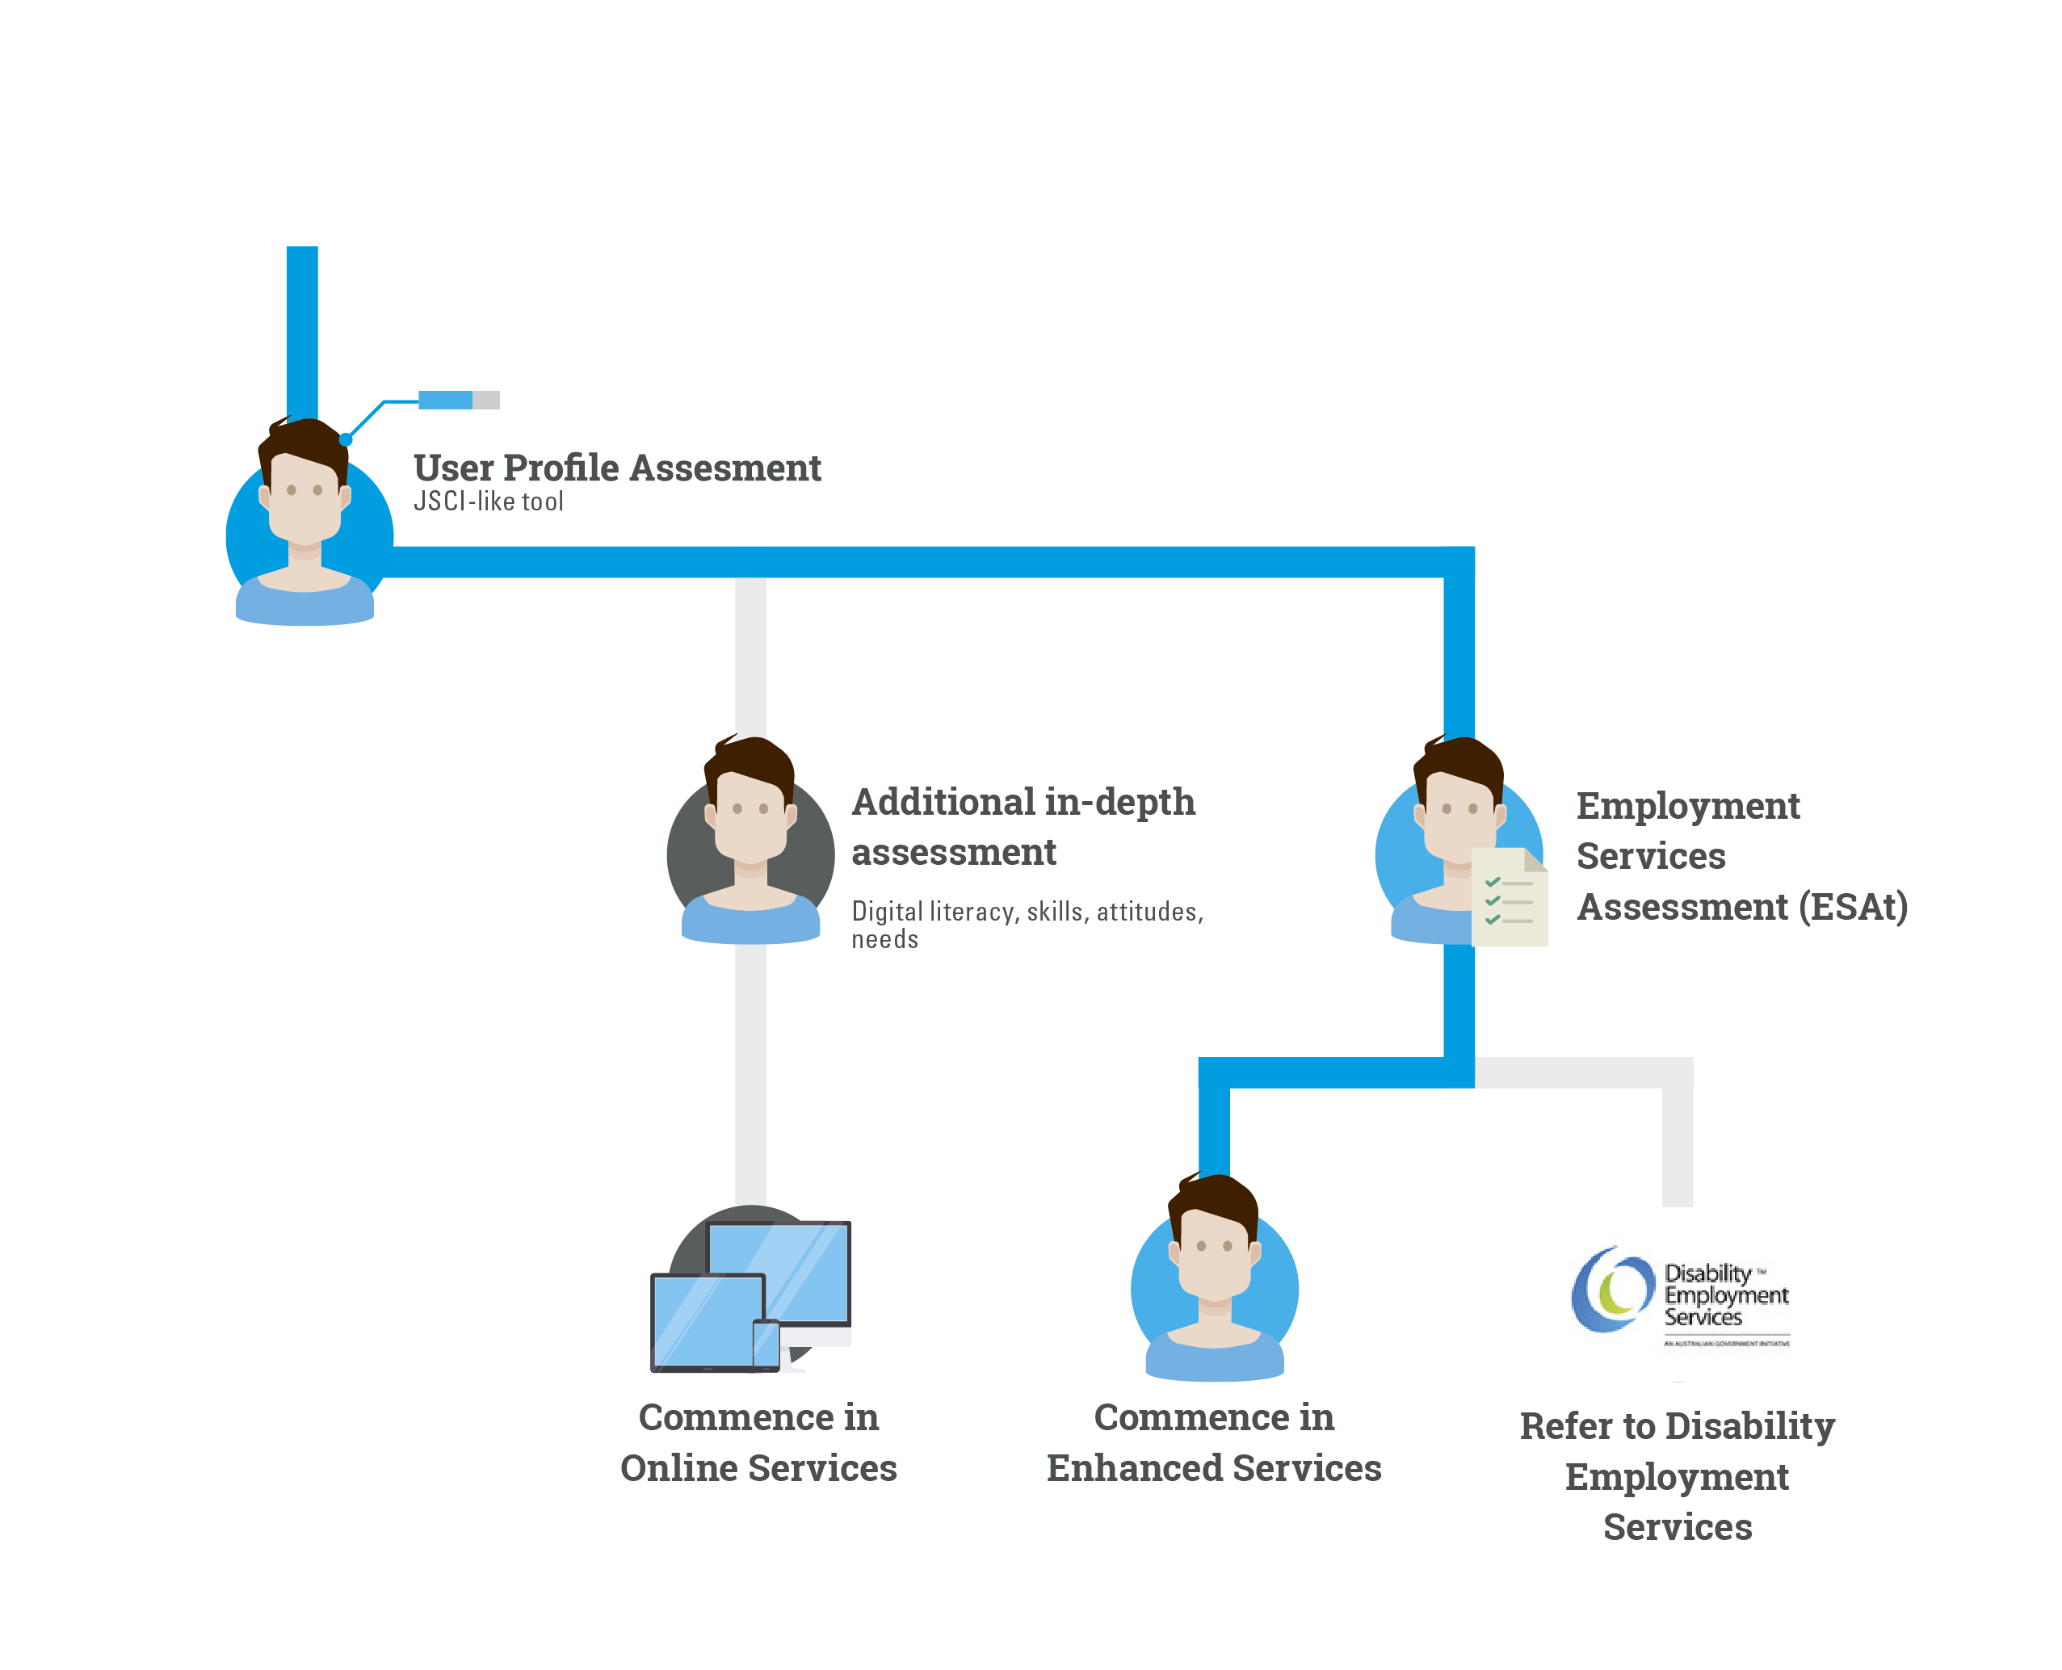

Option 2: Staggered assessments, pre-screening and data matching
Job seekers undergo an initial screening process that can identify those who have recently left work and who have an established connection with the labour market. Those that meet these criteria can choose to ‘opt out’ of the full user profile assessment process. This is supported by the user-centred design research, which shows that some job seekers did not receive the support they needed to find work and that their provider relationship was transactional and compliance focused.
“I think a lot of people have the same expectations… they were going to help me find a job, but they’re not doing that”, job seeker

Those who have not recently left work would undertake the user profile assessment process that includes a JSCI-like tool, high-level work readiness questions and a digital literacy and resilience assessment. Eligibility for enhanced services would be determined on the results from this assessment process, and may require the job seeker to undertake an ESAt.
Further in-depth assessments of strengths, capabilities (including skills), aptitudes and needs would be conducted later, either by providers (for job seekers who are eligible for enhanced services), or through the online employment services (noting that enhanced services job seekers can also use the online assessment tools, avoiding duplication). This would form the basis of the job seeker’s Job Plan and be used to inform interventions, improve job matching or identify training that could cover a skill gap.
Further reassessments would be conducted online, either triggered by a change in circumstance by the job seekers after the completion of an intervention, or at fixed time intervals.

Pre-screening option
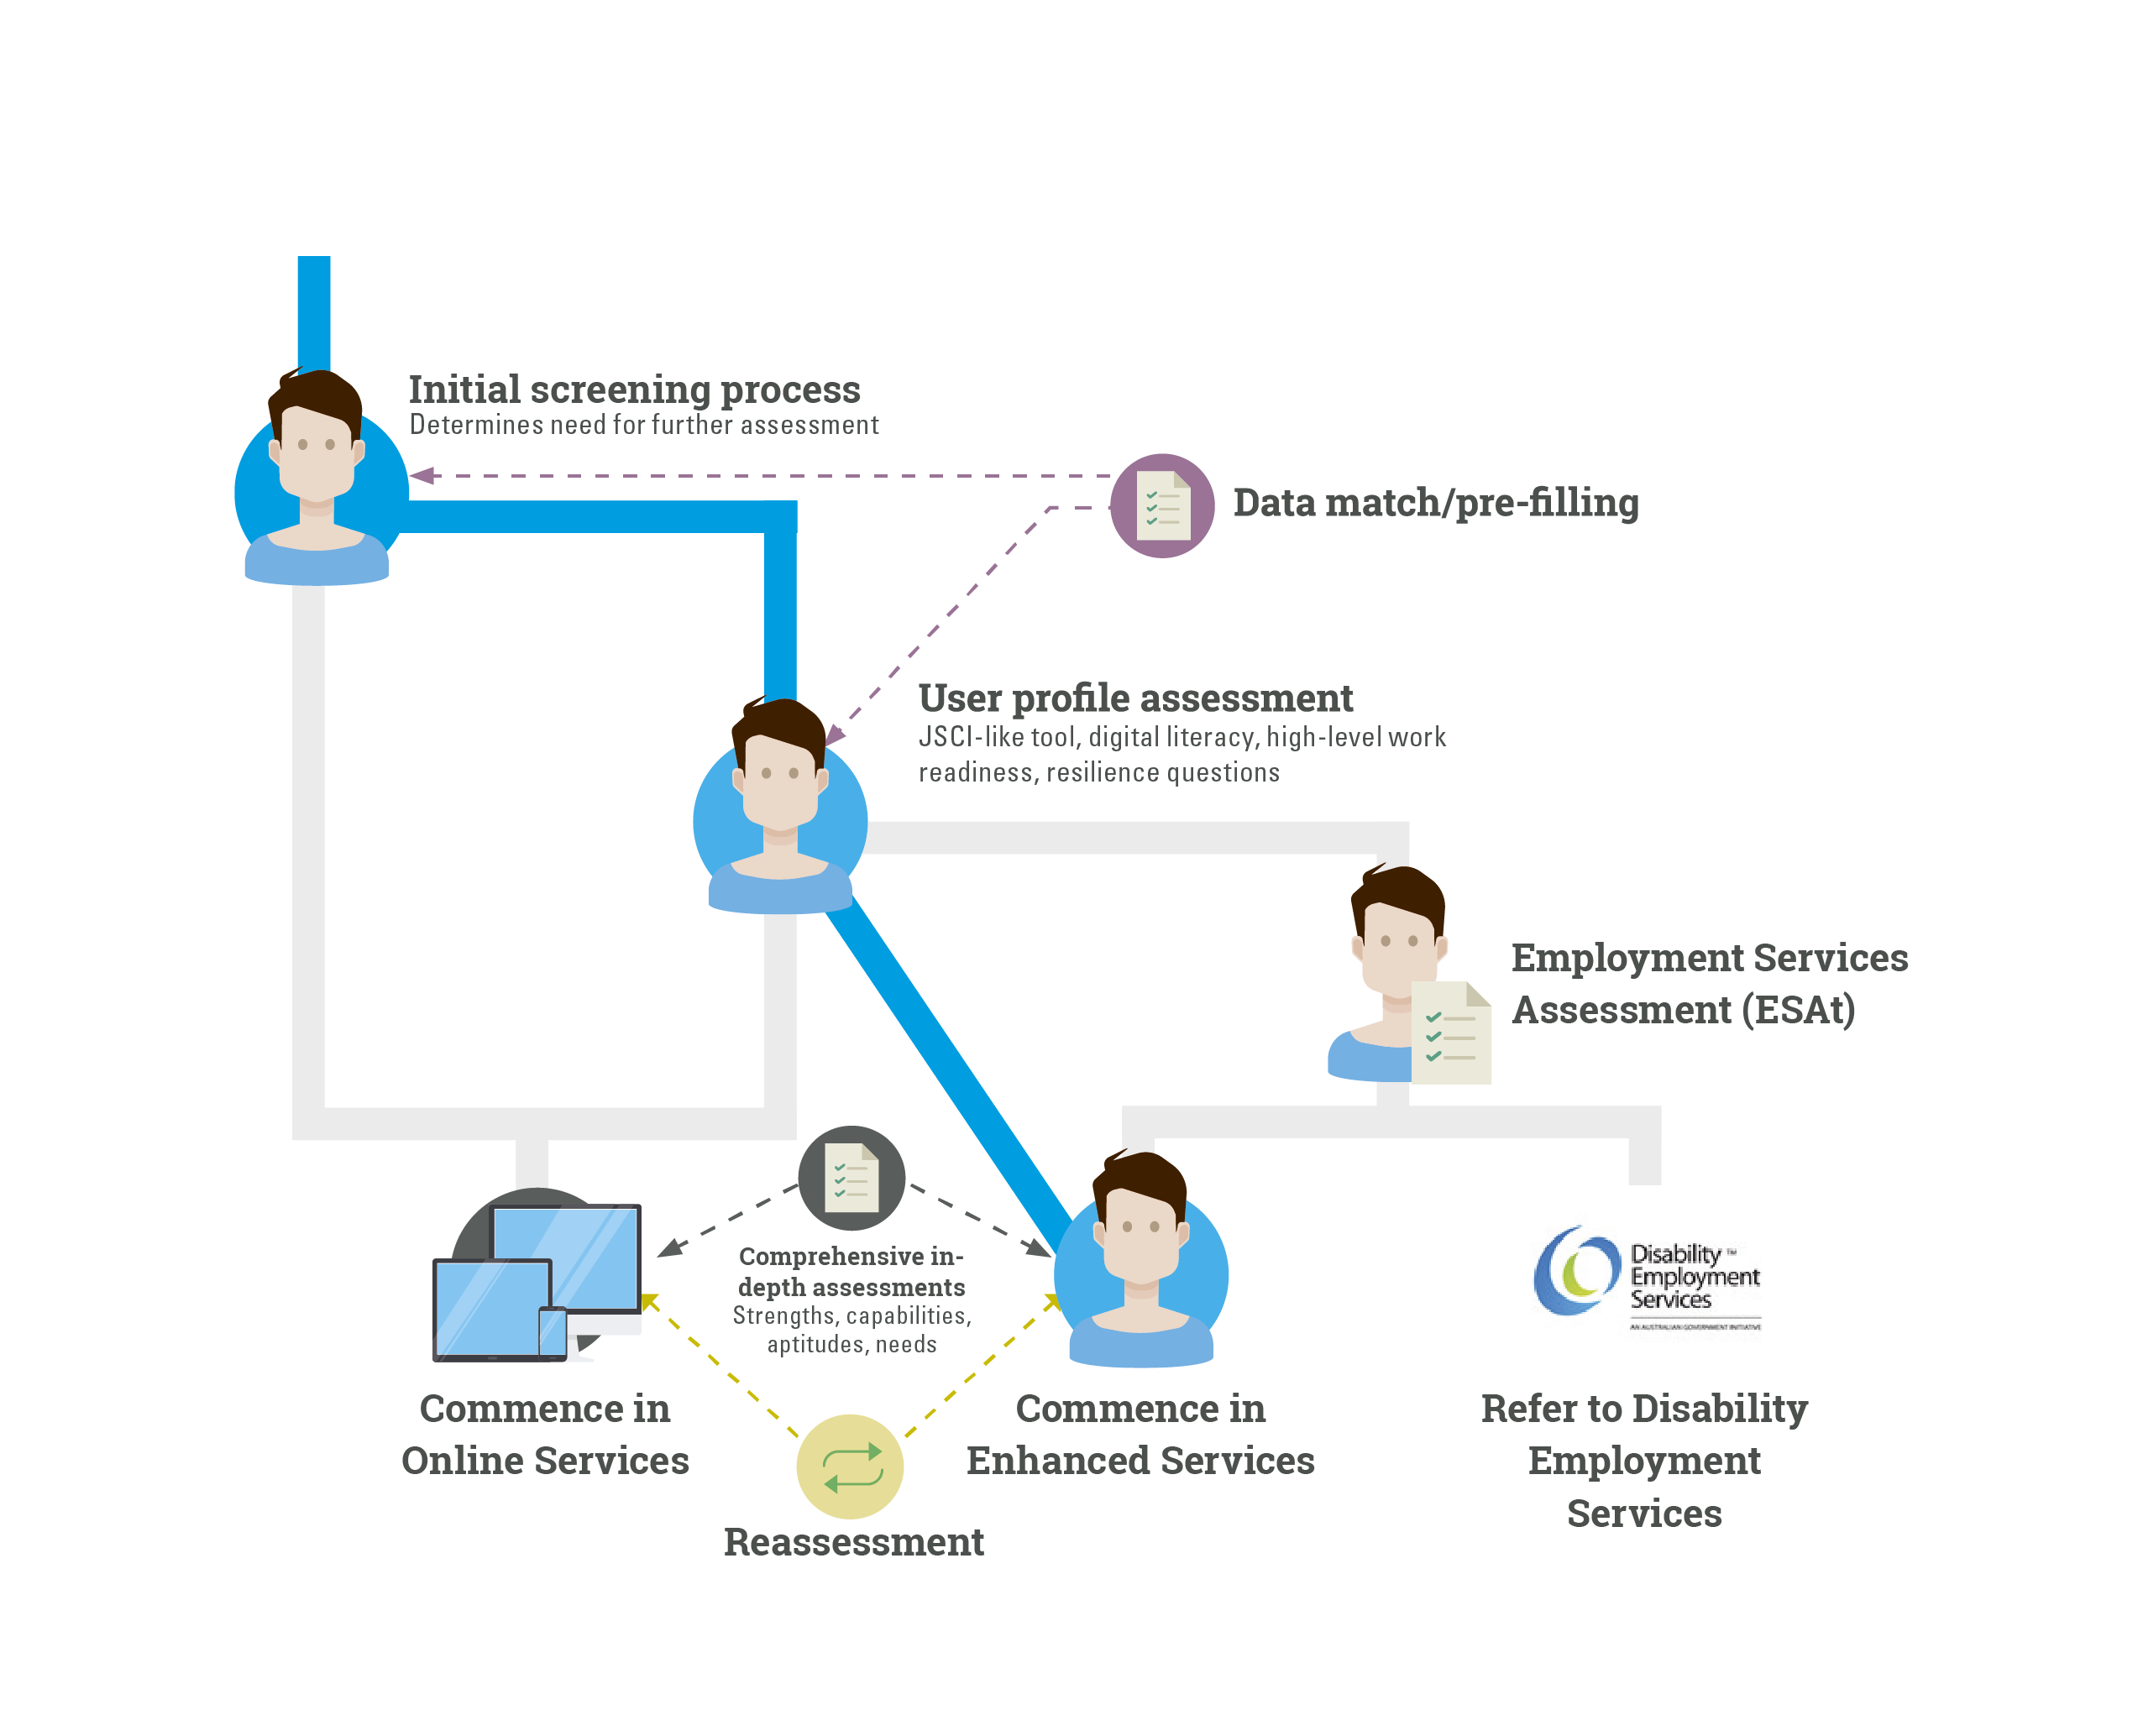

User journey Chapter 6
Meet Dave
Dave wants to change his circumstance but struggles with initiative.
His journey
- Dave answers a range of questions that explore his circumstances.
- Dave is eligible for training to improve his digital literacy.
- Dave’s assessment picks up that he is struggling with initiative. Dave receives additional support and reminders to keep him moving forward.
- Dave’s assessment indicates he needs more support and is eligible for enhanced services.
- Dave didn’t mention something during his first assessment because he was embarrassed. The reassessment point gives him a chance to update his circumstances.
Dave completed his assessment and was eligible for enhanced services. He updated his personal circumstances during the reassessment process.
Meet The Shop
A regional business that is keen to find employees with the right attitude.
Its journey
- Employers value employability skills and want to know what skills job seekers have.
- The Shop receives applications for job seekers matched to its needs. It shortlists candidates for interview.
The Shop appreciated the screening of job seekers who matched what it was looking for and found someone with the right attitude.

Guiding questions for Chapter 6
- Which of the proposed options to assess job seekers (user profile or staggered assessment) would be most effective in directing them to assistance that meets their needs?
- Are there other options for accurately assessing job seekers needs that should be considered?
- What is the best approach to assessing a job seeker’s digital literacy?
- How can information be collected in a way that minimises burden on job seekers, providers and employers?

Chapter 7: Incentives for job seekers to find work
Activation will continue to be at the heart of the working-age income support system.
The majority of job seekers want to work and the activation process should reflect this, encouraging job seeker choice and individualised services that support sustainable jobs.
A key challenge for the future model will be to activate all job seekers, while targeting resources towards those who most need support or motivation.

Well-designed activation policies can help job seekers find work
The OECD has found “effective activation policies can foster the productive potential of each country’s population in the long run, thereby contributing to economic growth and the sustainability of its social protection system”. While approaches differ, countries across the OECD have implemented successful activation regimes against a range of different social settings. International literature and Australian employment services evaluations have found that early and intensive activation is particularly important.
Flexible and individualised approaches support people into jobs that last
Tailoring activation strategies to individual circumstances and local labour market conditions can encourage a more career-oriented approach. While jobactive providers have some freedom around how to activate job seekers, including by reducing job searches, this discretion is not always exercised. A 2016 survey of jobactive consultants observed a trend towards standardisation of services, with standard program rules and regulations influencing service decisions.
Some specialist employment programs, such as ParentsNext and Transition to Work (TtW), have encouraged more personalised servicing through a flexible approach to activation. While ParentsNext and TtW target different job seekers and have different requirements, both services encourage job seekers and providers to work together to identify activities that best help the participant to meet their goals.
The majority of job seekers want to work and the system should reflect this
Departmental administrative data shows the majority of job seekers want to work and only rarely fail to meet a requirement (often with a reasonable excuse). However a small group persistently fail to meet requirements and may respond better to different incentives. Building on this data, it is proposed that the new model would incorporate the Targeted Compliance Framework announced in the 2017–18 Budget. This strengthens penalties for persistent and deliberate non-compliance while providing extra help for genuine job seekers to meet their requirements. Figure 7.1 shows how the Targeted Compliance Framework operates.
Figure 7.1: How the Targeted Compliance Framework currently operates
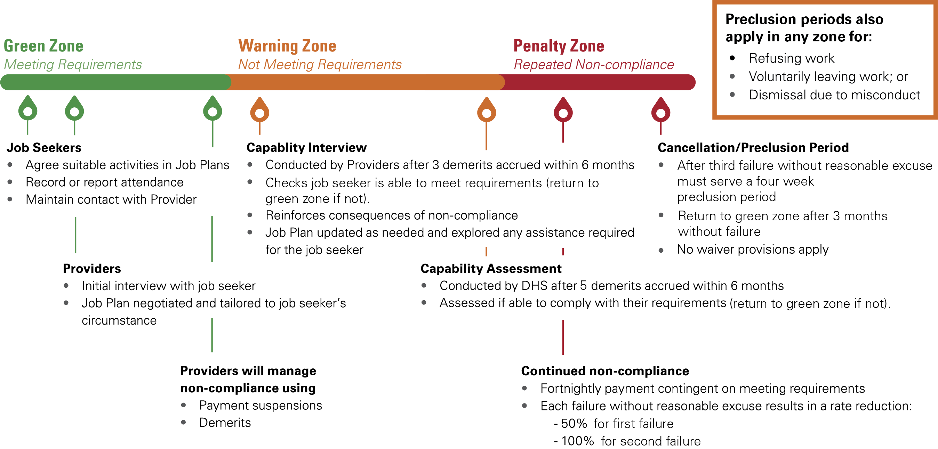
Monitor compliance online
The department is testing the practicality of delivering some employment services online. This includes how effective it is to monitor job seeker reporting online. This would be important going forward, with the OECD finding that job search monitoring and verification can have a considerable impact on re-employment rates.
There are some fundamental requirements that should apply to all job seekers
All job seekers in the new model would need to meet the basic requirements outlined in the Social Security Act 1991. This includes actively looking for work, or undertaking activities to improve employment prospects and accepting offers of suitable employment. Participants would also need to undertake job search to the extent of their capacity. The concept of mutual obligation will remain in the future employment services model. Other options for activating all job seekers, both those who participate in enhanced services and those who largely self-service, are outlined below.
Increase job seeker choice in planning an employment pathway
Agreeing on a Job Plan, a road map that outlines what a job seeker will do to progress towards employment, is a core aspect of activation. All job seekers could be given more responsibility and control over their Job Plan, including the ability to add activities and a stronger focus on setting goals (separate to or as part of the Job Plan).
Apply a points-based system for activation
Job search lies at the heart of Australia’s current approach to activation, with job seekers generally required to look for 20 jobs each month. While literature suggests that job search requirements generally make a difference, the incentive or ‘compliance’ effects can weaken with the duration of unemployment. Further, when applied almost universally, volume based job search requirements can be burdensome, with large numbers of untargeted approaches to businesses.
To promote a broader mix of activities, a points-based activation system could be introduced. Under this approach, job seekers would be required to reach a set number of points a month. Job seekers would gain points for various activities (such as job searches, attending interviews or participating in online services). A comparable example is the ‘100 point system’ used in financial services, where points are allocated to the different types of documents people can use to prove their identity.
This approach to activation would allow job seekers to choose from a range of approved activities that are relevant to their needs. To encourage accountability, there would be minimum job search requirements along with a cap on how many points job seekers can earn through certain activities.
Apply a time-based system for activation
As an alternative to the points-based system, another option is to retain the time-based nature of participation requirements. This could be achieved by counting the time spent on job search activities, not the number of applications. Currently, Government counts all job searches equally, even though some can take longer than others. Recognising time taken may better encourage and reward quality job search activities, while reducing low-value applications. To promote user-choice, job seekers could also be given flexibility to decide what activities will comprise their hourly requirements.
The number of hours could be based on current TtW activation settings, with job seekers required to meet up to 25 hours a week, depending on their age and capacity to work. To retain a minimum amount of job search activity, there could also be a requirement for at least five hours a week (for example) to be spent on applying for a job. This could involve preparing their résumé and applications, cold-calling employers, or attending interviews.
Introduce a time limit on how long job seekers can largely self-service
The online service could provide an opportunity for many job seekers to largely self-service. Job seekers who become long-term unemployed and need more support could be automatically transitioned into enhanced services after a set period. Exceptions could be introduced around job seekers in ongoing part-time work, keeping enhanced services focused on those most in need of support.
Allow additional interventions for job seekers who largely self-service online
While job seekers who largely self-service would have access to tailored online assistance, many would benefit from additional interventions that may not be readily available on an online service. Options include allowing these job seekers to:
- choose from a menu of short and intensive compulsory events (e.g. intensive job search training, employability skills training or job clubs)
- volunteer for lengthier activities (e.g. work experience placements, approved training and education courses and non-vocational interventions)
- engage in a limited number of provider appointments (e.g. one initial appointment to interpret assessment results and inform Job Plan/goal setting, followed by additional appointments as needed, such as to access funding for a White Card or driving lessons).
As well as providing further assistance, some of these events could achieve a ‘referral effect’, where referral to a compulsory program motivates people to find employment or disclose undeclared jobs. However the triggers for these events need careful consideration to limit expenditure on employment outcomes that would happen without Government involvement.
Given the importance of targeting resources to those who would most benefit, eligibility for additional interventions may also need some restrictions. Options to manage this consideration include:
- making additional interventions available equally and to all job seekers, with interventions provided when needed (e.g. where a job seeker needs the intervention to access an employment opportunity)
- targeting access to additional interventions based on relative disadvantage (e.g. job seekers with the most barriers get the most access, while those who are more job-ready receive less)
- linking additional interventions to the goals and career options included in a Job Plan, including any allocation of funding (e.g. provide access to a white card where a job seeker’s long-term goal involves construction work)
- introducing additional interventions at different points in time (e.g. access to a flexible pool of funds from three months, choice of intensive compulsory events from between six months and 12 months).
Promote ongoing appointments and opportunities for review in the enhanced services offer
Ongoing appointments between providers and job seekers would be a key feature of activation in enhanced services, providing a mechanism to identify suitable activities, update Job Plans and discuss options for change when progression stalls. The timing and intensity of appointments would vary depending on individual job seeker needs. However there may need to be a baseline number of appointments, to make sure all job seekers receive a default level of service. To help achieve this, there could be a minimum number of six appointments over set periods (e.g. at least six appointments every six months). Under this option, providers and job seekers could maintain discretion around timing so long as they reach the minimum number of appointments (e.g. frontload or spread them out).
Introduce an intensive phase to encourage labour market engagement
After a job seeker has been in employment services for a lengthy period (e.g. 12 months), it is proposed they enter a compulsory intensive phase lasting several months. This phase would both increase the intensity of a job seeker’s activity requirements, as well as change the types of activities they are undertaking. To promote a personalised service, job seekers could work with their provider to choose activities. For example, the phase could include intensive support in social skills and work readiness combined with workplace visits that interest the job seeker.
The purpose of the intensive phase is to make sure job seekers maintain strong engagement with the labour market, while testing whether different types of activities are more effective. While providers and job seekers would be expected to try different approaches throughout their period of service, a mandatory period of change guarantees that all job seekers remain active and engaged and are given the chance to gain new skills and experience while looking for work. Introducing an intensive phase would also provide a possible referral effect, with some job seekers potentially motivated to find employment or disclose undeclared jobs rather than commence the intensive phase.
Introducing the intensive phase around 12 months after commencing in employment services gives sufficient time for providers and job seekers in enhanced services to build a trusting relationship. For job seekers who start out self-servicing and transfer to enhanced services, their total time in service could be taken into account.
Three possible options for the intensive phase include:
- A set period for all job seekers. For example, from 12 to 15 months after commencing in employment services.
- A requirement that the phase commence from between 12 and 24 months after commencement, with job seekers and providers able to negotiate on the exact timing. For example, from 12 to 15 months, or 16 to 19 months after commencement.
- Break up the phase into smaller blocks occurring between 12 and 24 months after commencement. For example, three six week blocks of training set three months apart.
Any of these options could utilise the points-based or hours-based activation approach.
Options for integrating the New Enterprise Incentive Scheme (NEIS) into the model
The role of entrepreneurship, self-employment and the gig economy is an important consideration in the future of employment services. The Commonwealth Scientific and Industrial Research Organisation (CSIRO) has identified the ‘era of the entrepreneur’ as one of six megatrends that are likely to impact on the future of work, with the reduction of barriers to market entry – and decreasing costs from experimenting with new business models – favouring entrepreneurial attitudes and skillsets.
Recognising the importance of entrepreneurship, NEIS could be continued with both self-servicing and enhanced services participants being eligible. It is also proposed that the online platform be used to promote and increase visibility of federal and state government programs and initiatives that support self-employment and entrepreneurship, including NEIS. To avoid untargeted applications and oversubscription, this promotion would be targeted using job seeker qualifications, skills and interests.

User journey Chapter 7
Meet Dave
Dave wants to change his situation but struggles with initiative.
His journey
- Dave wants to work to better support his family.
- Dave works with his provider to identify his goals, ranging from building up his confidence to improving core skills like literacy. Together, they build a Job Plan that can help him to get there.
- Dave uses the online resume builder and develops an online career profile, listing his interest, experience and skills that he identified with his provider.
- Dave reaches his points per month by applying for jobs matched to his profile and participating in services linked to his goals, like mentoring and literacy training.
- Dave has some difficulty meeting his requirements. He talks to his provider about why he is having trouble and how they can adjust his requirements to better meet his needs.
- Dave is closer to his goals but after 12 months, he is still on income support. He talks with his providers about options for change. They agree on a new way forward, including an intensive period of case management and volunteering.
Dave continues towards his goals with a new way forward.
Meet Stephanie
Stephanie is very motivated and wants to rebuild her career with flexibility.
Her journey
- Stephanie wants an employer that understands her caring responsibilities.
- Stephanie tailors her Job Plan to match her responsibilities as a parent. She sets the goal of getting a flexible job that makes use of her past work experience.
- Stephanie uses online tools to get ready for work, outlining her skills and experience to potential employers. She also accesses targeted career advice, responsive to her interests.
- Stephanie reaches her points per month through a mix of targeted job searches, attending an interview and participating in job search training.
- Stephanie secures a job that was matched to her online and is flexible to allow her to meet her family responsibilities.
Stephanie has found a job that is flexible and suits her caring responsibilities.

Guiding questions for Chapter 7
- Which of the activation options (points-based or time-based) would best support job seekers who largely self-service?
- Which of the activation options (points-based or time-based) would best support enhanced services participants?
- In addition to compliance actions for job seekers who do not meet requirements, could the activation framework also recognise job seekers who regularly exceed requirements? If so, how could this operate in practice?
- What appropriate additional initiatives might be useful to support self-employment?
- What appropriate additional initiatives might be useful to support job seekers participating in social enterprises and other non-traditional forms of work?

Chapter 8: Targeted regional and local approaches
Australia is comprised of many labour markets across metropolitan and country regions.
Labour market conditions vary from region to region. Some regions perform strongly, while others present unique challenges, including a lack of available job opportunities.
In these cases, place-based and regional approaches can be used to implement locally designed solutions that help job seekers prepare for and find work.
The Regional Employment Trials program will test some of these approaches through a place-based solution. It will bring together local community stakeholders and employment services providers to develop solutions that suit their needs and tackle local employment challenges.
Labour market differences across regions
Economic and labour market conditions vary significantly across Australia. While some locations are performing well, others continue to experience disadvantage. A region’s economic and labour market conditions can be a result of a number of factors, including:
  - a region’s industry base
  - its population’s access to and participation in higher education
  - transport networks and infrastructure
  - its degree of natural amenity
  - population size and growth
  - accessibility to broader dynamic labour markets
  - the skill level of its labour force.
Place-based solutions – local solutions to local problems
Developing tailored solutions can help local people address barriers specific to their community. The Productivity Commission’s Transitioning Regional Economies report supports adapting policies to local conditions. It highlights that contemporary regional policies favour place-based approaches.
Place-based approaches can help deliver localised solutions to address problems specific to a region. They are designed and delivered to target specific geographical locations and particular population groups in response to complex social problems. Individual place-based approaches can be highly effective and support for these has been growing.
While communities are considered best placed to drive the employment priorities of their region, they may not always have the funding or resources to do so. This requires collaboration between employment services providers, local governments, employers and other social and community services.

How place-based approaches work
Place-based approaches recognise the value of local knowledge and connections. Through these, communities can develop ways to address issues in their region. These need to be underpinned by governance arrangements that support local decision-making, allowing communities to drive initiatives that best meet their needs.
To develop placed-based solutions, intermediaries or brokers can be used to:
- build relationships with the local communities and businesses
- raise funds and program awareness
- drive effective program implementation
- discuss how resources can be allocated
- support the harmonisation of local services
- communicate information between all parties.

Place-based approaches for structural adjustment
The department manages a number of employment facilitators who undertake place-based, brokering roles. Some examples of the successes achieved by these facilitators include:
- linking retrenched workers to 200 new entry-level food manufacturing positions in the Gippsland region
- sourcing 20 students for a Certificate III in non-emergency patient transport via the Royal Flying Doctors Service of Australia, with a guaranteed job upon completion.
Through its employment facilitators, the department also runs a series of place-based events such as jobs fairs and career information sessions. These events connect job seekers and employers in the local community, building awareness of job opportunities, future projects needing workers or chances to upskill.
Regional approaches
A future employment service could incorporate a strategic regional approach that helps job seekers in locations where job opportunities are limited. OECD analysis highlights the importance of strong connections between regional stakeholders to enable communities to prepare for change and take advantage of local opportunities. There is also international support for governments to deliver programs at the local level, using regional and local stakeholders in driving effective workforce planning.
Devolving decision making to a local level and facilitating this with local governance structures
A future model could establish local governance structures (e.g. boards or committees) in selected disadvantaged regions to facilitate better linkages between regional stakeholders, encouraging them to work together to identify solutions for local employment issues. This could be supported through a pool of funds for local community projects.

Regional Employment Trials program
The Regional Employment Trials program will commence on 1 October 2018 to test some of these concepts. The program aligns with the Government’s priority to secure jobs and promote growth by helping communities respond to employment challenges faced by job seekers in their locations. In selected regions, employment facilitators will work with Regional Development Australia committees to develop local employment projects. A grant program will provide
$1 million to each of the ten regions to develop local employment projects. For eligible job seekers, the trial will also examine how earlier access to relocation assistance to take up a job can assist with securing employment.
Provider funding could reflect regional differences
In recognition of the challenges experienced by different regions, a future funding model could consider how to incentivise continued, strong performance. This could include:
- grouping locations by disadvantage using labour market data and providing additional funds in these locations
- incorporating education or social outcome fees for regions with limited jobs
- payments that acknowledge short-term work placements, or bonus payments for providers that place a certain number of job seekers into pre-identified industries.
These options could incentivise providers to work in regional locations.
Promoting labour market mobility
Labour mobility (the ability of workers to move from region to region) is an important element of effective labour markets. Encouraging labour mobility means workers could travel outside their local community to find and engage in work. For some job seekers, this may mean a permanent move to a region with greater job prospects. A future model could consider how labour market mobility is best supported, allowing job seekers to find work that suits their needs and circumstances (e.g. moving with family members).
Incentives for seasonal employment
Particular industries, such as agriculture and tourism, often have difficulty filling seasonal employment opportunities.
There are a number of ways to encourage job seekers to take up positions in industries with high demand for workers. These include financial incentives for job seekers, promoting areas where opportunities exist and encouraging employers to oversee the wellbeing of job seekers. The department is testing incentives to take up seasonal horticulture work through the Seasonal Worker Incentives Trial, which commenced on 1 July 2017 and will end on 30 June 2019.
User journey Chapter 8
Meet The Shop
A regional business this is keen to find employees with the right attitude.
Its journey
- The Shop is engaged by a local provider who works with it to understand the business’s needs.
- The Shop participates in a local skills matching project to help fill its vacancies.
- The Shop provides feedback on its experiences working with a provider.
The Shop developed a strong relationship with local provider and continued to participate in local skills matching to fill its vacancies.
Meet Brenda
Brenda is keen to work but needs help to find a path into employment.
Her journey
- Brenda lives in a small regional town with limited job opportunities.
- Brenda participates in the local skills matching project which has been identified by her provider.
- Brenda’s provider works with her and considers if relocation assistance could help her find a job in another region that suits her interests and skills.
Brenda continued to work with her provider to understand her options and find a path into employment.

Guiding questions for Chapter 8
- What strategies would help job seekers adapt to regional economic and labour market variations?
- How could local stakeholders be encouraged to identify priorities, engage with providers and implement local employment solutions?
- What strategies would improve labour market mobility from regions that have poor employment prospects?

Chapter 9: A service culture built on competition and quality
To make sure enhanced services meet job seekers’ needs and are delivered efficiently, the Government may engage a diverse network of expert providers across Australia.
A greater degree of competition could also be encouraged to drive the best possible services for job seekers.
It may be desirable to reduce barriers to entering the employment services market. This could involve transitioning to a licensing-based procurement model.
The performance management system and the payment structure can incentivise the delivery of quality services and help job seekers find and stay in work. Options to achieve these goals include transitioning to a benchmarking framework that could be linked to the payments providers receive.

Competition in context
As outlined in Chapter 3, the proposed enhanced services would be vital for highly disadvantaged job seekers who may struggle to find employment without intensive support. This chapter focuses on options for procuring and improving the quality of those services.
Since the 1990s the Australian Government has selected employment services providers through periodic open tender rounds. These arrangements have performed well and are considered by the OECD to be best practice. However there may be scope for reforms to further improve the diversity and quality of services.

General model: how employment services are delivered
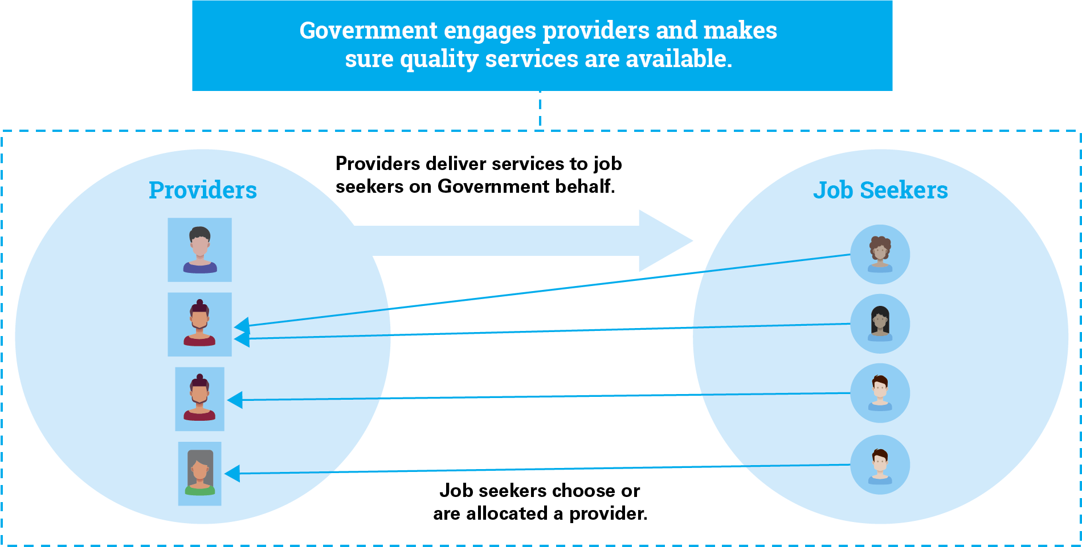

Leveraging competition in the market for employment services
Australian and international evidence shows that competitive arrangements for engaging employment and other human services providers can deliver higher quality services at a lower cost than direct provision. Competition can encourage a diversity of approaches and provide service providers with a strong incentive to achieve outcomes in an efficient way. As the Australian Government’s Competition Policy Review notes, governments should take on a stewardship role when commissioning services. That means governments make certain citizens have access to high quality assistance.
The transition to a future employment services model provides an opportunity to consider options to further improve the structure of the market to maximise job seekers’ outcomes and value for money. A number of issues will influence the dynamics of the proposed market for enhanced services. These include:
- the extent of contestability across the market and within employment regions
- how services are purchased
- how provider performance is monitored and incentivised.

Balancing contestability with quality control
Contestability is a key feature of markets for commissioned social services, and complements the role of user-choice in driving competition and outcomes. The Productivity Commission has defined contestable markets as “those where there are no substantial barriers preventing a provider that is not currently supplying services to users from doing so now or in the future”. The Competition Policy Review recommendations include “that commissioned services are contestable and service providers face credible threats of replacement for poor performance”.
While it is generally desirable to foster contestability when commissioning services, governments are responsible for monitoring the level of contestability that is in the interest of service users. There is a risk that excessive contestability in the market for enhanced services (for instance, if too many providers were active in an employment region) could lead to a high turnover of providers. High turnover could disrupt the services disadvantaged job seekers receive and discourage employers and other stakeholders from engaging with the system.
The level of contestability can shape the marketplace
Potential options for the enhanced services provider market include:
- A moderately flexible market that would include continuing to cap the number of providers in each employment region (with the cap set at a level that encourages competition, varying between employment regions based on local labour market conditions). The department could intervene in the market, when doing so is in the interests of job seekers.
- A highly flexible market that would include removing all limits on the number of providers in each employment region and reducing the department’s interventions in the market, noting a strong performance framework would continue to be in place.
- A collaboration focused market in which there would be a single provider in each employment region (with the number of employment regions being increased). Providers would be encouraged to collaborate across regions. This would also provide employers with a single point of contact in each region.

Purchasing arrangements for enhanced services
Revising the way employment services are purchased could improve competition and lead to better outcomes for job seekers and employers. This may include reducing entry barriers to the market and more strongly encouraging different types of organisations to deliver employment services. The Productivity Commission’s Independent Review of Job Network recommended that competitive tendering for employment services be replaced by a licensing system, through which the department would grant a licence to applicants to enter the market at any time if they meet a common set of criteria. A simpler process would provide more certainty for organisations considering applying to join the market. The Commission argued that licensing “would be less costly [to providers and Government] than the current tender process, need not compromise service quality or geographic coverage and could, if necessary, be phased in”. More recently, the Competition Policy Review endorsed both licensing and tender-based mechanisms for procuring human services.
Options for purchasing enhanced services in the new employment services model include:
- Transitioning to a licensing model. Organisations could at any time apply for a licence to deliver services (at the employment region level) and immediately enter the market provided they meet set criteria and any cap on the number of licences has not been reached. This reform would reduce barriers to market entry, with providers being regularly audited to make sure they continue to meet the entry criteria.
- A revised tendering model. Barriers to entry could be reduced by simplifying the tender process and allowing new providers to periodically enter the market after it commences. This could be achieved by establishing a ‘panel’ of enhanced services providers comprising organisations that demonstrate they meet a set of relevant minimum criteria. Panel participants could apply to enter the market at the start of the future employment services model and if opportunities arise during subsequent business allocation periods (e.g. if another provider leaves the market).
To further encourage competition, it is proposed that enhanced services providers would not be allocated a predetermined market share. Instead, providers would compete to attract and retain job seekers. Such an approach could strengthen the role of user-choice in future services.
Other options to expand the diversity and quality of providers include:
- Permitting enhanced services providers to specialise in particular cohorts of job seekers (e.g. Indigenous Australians or young people). Such providers would be required to service all job seekers from their specialist cohort who select them, but might not be required to service other job seekers.
- More strongly encouraging tenders or licence applications from providers who wish to specialise inside a specific geographic area within an employment region (e.g a town).
Any caps on the number of providers in each employment region would take into account the role and number of specialist providers in that area.

Performance monitoring
Monitoring service quality is a key responsibility for Government, as steward of the system. Stewardship, as defined by the Productivity Commission, “includes developing regulatory and institutional arrangements to underpin service provision that is responsive to users, accountable to those who fund the services, equitable, efficient and high quality”. These responsibilities are important in regard to employment services, given many job seekers are vulnerable people.
A performance framework should balance the benefits of flexible service provision with the need to make sure job seekers receive quality services. Therefore, it needs to include:
- core quality standards and service guarantees that must be met
- incentives to encourage further high performance.
The performance framework could be designed to complement market entry processes. If market entry involves significant scrutiny, then monitoring may need to be less intensive; if thresholds for market entry are lower, more intensive monitoring may be necessary.
It is important that employment services are responsive to cultural and historic factors affecting Indigenous job seekers. Quality standards would include a requirement that services are culturally appropriate and culturally competent. It is also proposed that enhanced services providers continue to have specific targets for Indigenous employment outcomes, in line with the Government’s commitment to closing the gap in employment outcomes.

Evaluating performance
Performance frameworks can take either a relative or a benchmarked approach.
- Under a relative approach, such as the current Star Rating methodology, the evaluation compares providers’ performance. Relative measures of performance can increase competitive drive.
- Under a benchmark framework, providers would be required to meet or exceed set criteria. Absolute performance evaluations may give providers greater clarity about what they are expected to achieve than relative measures of performance.
Either performance framework could produce a single composite ‘score’ (combining multiple weighted measures) or a ‘report card’ with grades for specific domains or requirements.
Future performance frameworks would continue to take into account local labour market conditions and providers’ caseload characteristics. Performance targets could be adjusted over time. For instance, adjustments could be made in response to changing labour market conditions or to encourage further improvements in performance (including for specific groups of job seekers). As discussed in Chapter 8, the performance frameworks for enhanced services providers could also include elements that incentivise providers to build strong connections with local communities and employers.
Information on enhanced services provider performance is also useful for job seekers when choosing or considering changing a provider. Where information on the type and quality of services is readily accessible to future users, competitive forces can help drive improvements in service quality. The proposed online services would offer ways to publicise provider performance ratings, and could be used to collect and publish user evaluations.

How the benchmarking option could operate for a provider

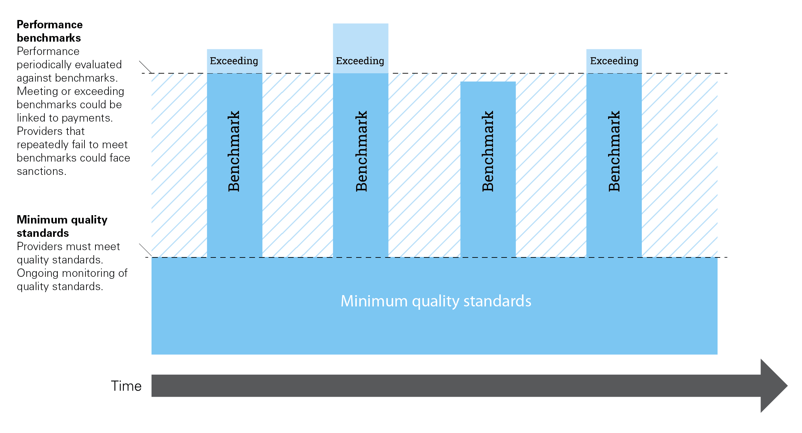

What factors could be included in the framework?
A performance framework for enhanced services providers could include the following criteria:
- Measures of the provider’s success in achieving outcomes for job seekers, with a focus on comparing providers’ performance to the outcomes that would otherwise be expected, given local labour market conditions, for the job seekers they are supporting.
- A measure of the degree of improvement in work readiness for all job seekers being serviced by the provider. Recognising that the most disadvantaged job seekers may require support over an extended period, such a measure would reward providers that make sure all job seekers receive appropriate support.
- Performance in achieving outcomes and improving work readiness for priority demographic groups of job seekers, including Indigenous Australians.
- Measures of job seekers’ satisfaction with the provider and possibly the satisfaction of local employers and other community stakeholders (subject to reliable and meaningful measures being developed). This could include feedback from Indigenous communities.

Managing and rewarding performance
Data produced through performance monitoring can be used to determine provider payments and inform future procurement decisions, incentivising and rewarding good performance.
Data monitoring can also be used to review poorer performance and encourage providers to improve practice. If poor performers are unable to meet the necessary service standards they may be exited from the market. The performance monitoring framework could include measures to make sure that providers can realistically achieve their goals and that the level of provider turnover is not excessive.
Payments to providers could be linked to meeting benchmarks or exceeding performance targets. This would be similar to the approach used under Transition to Work, where providers are required to meet targets and are granted bonus payments where they are exceeded.
Providers that fail to meet either minimum service standards or performance targets could also face sanctions, including having their licence or contract cancelled. To give providers a stronger incentive to achieve outcomes, Government could shorten the period before performance evaluations commence. If, after a set period following an unsatisfactory assessment, performance does not meet the required standards, sanctions could automatically apply.

Guiding questions for Chapter 9
- What level of contestability, competition and Government intervention in the market is desirable?
- Should provider performance be evaluated against set benchmarks, or compared with that of other providers? What factors should inform performance evaluation?
- Should the Government allocate market share among service providers? If so, how?
- Should the Government transition to commissioning enhanced services providers through a licensing arrangement? If so, how?

Chapter 10: Transitioning to a future employment services model
Transformational change to employment services would affect job seekers, employers, employment services providers, complementary service providers and the income support sector. To allow for a smooth transition to this large-scale reform, the Government is proposing an ongoing process of consultation, a trial of new arrangements and an iterative roll out of some services.

The role of system users in the transition process
Under a fundamentally new service, system users would need to adapt to new roles. For job seekers, employers and employment services providers, this could mean interacting with new incentives, accessing new support services, working under new market design arrangements and meeting a new set of responsibilities. It will be important that all employment services users play their part in the implementation and have appropriate time to adjust. To encourage this, the design process would involve ongoing consultations, continued user-centred design and open communication around timeframes and expectations.

Trialling new services before rolling them out nationally
Changes to business processes, particularly those that are heavily reliant on digital technology, can involve high up-front risks and cost pressures. Testing new approaches with users before expanding nationally is a proven way to reduce risk, support transition and more closely align with user needs.

Online employment services trial
The department is testing delivery of some employment services online and whether job seekers can find work using digital-based support. The trial will start in July this year and will involve 5000 job-ready people per year for two years. This will assess how job seekers interact with online services, determine if solutions work seamlessly for users, inform implementation and mitigate risks to service levels. Early results from the trial will inform the development of future employment services. For further information visit jobs.gov.au/future-employment-services

Regional employment trials program
As detailed in Chapter 8, the department will also trial initiatives to help people in disadvantaged regions participate in the labour market. For further information, visit jobs.gov.au/regional-employment-trials-program

Options for iterative implementation
There is potential to implement some arrangements iteratively, prototyping and building on them over time. The online platform can be expanded, including through user-centred design. Core arrangements should be in place for the commencement of the future model, but continuous improvement could play a critical role in evaluating and improving services. Some elements could be tested and updated in short periods but other elements would rely on longer tests to evaluate effectiveness.
Guiding questions for Chapter 10
- How would an iterative approach to implementation help transition to a future employment services model?
- If we undertake an iterative approach, which aspects should be prioritised and sequenced first?

Next steps
Interested parties are invited to respond to this paper on a future employment services model. Electronic lodgement of submissions to the Consultation Hub is preferred and can be accessed via the Department of Jobs and Small Business Future of Employment Service website at jobs.gov.au/future-employment-services
If you cannot submit your response online, send a written submission to:
Future Employment Services Consultation
Active Labour Market Assistance Branch
C10MT4
Department of Jobs and Small Business
GPO Box 9880
CANBERRA ACT 2601

We value diverse perspectives on how to best shape the future employment services model. All views and comments are welcome. While your submission does not need to respond to the questions raised in this paper, these are designed to cover key aspects of the future model.

The closing date for submissions is 5:00pm EST on Friday 3 August 2018.
All submissions will be published on the Department of Jobs and Small Business and the Department of Industry, Innovation and Science’s websites. Please indicate when lodging your submission if you do not agree to its publication. If lodging your submission by post, please advise in the covering letter.
We value your privacy. If you do not want your personal details to be published, please include these in your covering letter only, not in your submission, and clearly advise that you do not want these details published.
If you have questions about how to complete a submission, please email Future-Employment-Services@jobs.gov.au or phone 1800 805 260. Please note, submissions will not be accepted via email. They must be submitted either online through the Consultation Hub or by post.
If you currently use jobactive, your response will not affect the service you receive.
The department will continue to engage stakeholders with an interest in employment services. We will hold forums in capital cities and in selected regional areas to discuss how the future model can better help job seekers into work.
While it may not be possible for everyone with an interest to attend these sessions, your views are important. Your response to this paper, along with those of others, will help to inform the panel’s report to Government in October 2018 outlining a proposal for reform.

Summary of questions
Guiding questions for Chapter 2
- What other economic, social or labour market trends are likely to affect employment services in the future?
- Are there other goals that should be included?

Guiding questions for Chapter 3
- What services should be available to job seekers who are disadvantaged in the labour market and how can they be delivered in a culturally competent way?
- What incentives might be useful to assist job seekers who are disadvantaged in the labour market to find work?
- Are enhanced services best delivered through a single unified service, or a model that includes specialist service provision directed at particular cohorts of job seekers, as well as a core service?
- How could the quality of services job seekers receive from their employment services consultant be improved?

Guiding questions for Chapter 4
- What online tools and assistance should be included to better meet the needs of particular user groups? Which are the most important features that are required?
- Is there a group of users that the online service should target?
- How can data be used to provide more personalised, effective services?
- How should the online service interact with existing online job aggregators and recruitment firms?

Guiding questions for Chapter 5
- How can the Government raise awareness of employment services available to employers?
- How can future employment services add value to an employer’s recruitment process?
- What functionality would employers expect or desire in an online employment service?
- How should employment services providers work with employers to meet their needs?
- What incentives (financial or otherwise) would help employers overcome any perceived risks associated with hiring disadvantaged job seekers? How should these operate?

Guiding questions for Chapter 6
- Which of the proposed options to assess job seekers (user profile or staggered assessment) would be most effective in directing them to assistance that meets their needs?
- Are there other options for accurately assessing job seekers needs that should be considered?
- What is the best approach to assessing a job seeker’s digital literacy?
- How can information be collected in a way that minimises burden on job seekers, providers and employers?

Guiding questions for Chapter 7
- Which of the activation options (points-based or time-based) would best support job seekers who largely self-service?
- Which of the activation options (points-based or time-based) would best support enhanced services participants?
- In addition to compliance actions for job seekers who do not meet requirements, could the activation framework also recognise job seekers who regularly exceed requirements? If so, how could this operate in practice?
- What appropriate additional initiatives might be useful to support self-employment?
- What appropriate additional initiatives might be useful to support job seekers participating in social enterprises and other non-traditional forms of work?

Guiding questions for Chapter 8
- What strategies would help job seekers adapt to regional economic and labour market variations?
- How could local stakeholders be encouraged to identify priorities, engage with providers and implement local employment solutions?
- What strategies would improve labour market mobility from regions that have poor employment prospects?

Guiding questions for Chapter 9
- What level of contestability, competition and Government intervention in the market is desirable?
- Should provider performance be evaluated against set benchmarks, or compared with that of other providers? What factors should inform performance evaluation?
- Should the Government allocate market share among service providers? If so, how?
- Should the Government transition to commissioning enhanced services providers through a licensing arrangement? If so, how?
Guiding questions for Chapter 10
- How would an iterative approach to implementation help transition to a future employment services model?
- If we undertake an iterative approach, which aspects should be prioritised and sequenced first?

Glossary of terms
Term | Definition in the Employment Services Context
Activation | The requirement of job seekers who receive income support payments to look for work or undertake activities that prepare them for work.
Artificial intelligence | A computer system with the ability to perform tasks normally requiring human interaction.
Assessment | The process of determining a job seeker’s required level of support to find and maintain work.
Case manager | A service provider consultant who assists job seekers to strengthen their employability, meet mutual obligations and enter employment.
Caseload | Job seekers who are being assisted through employment services.
Data analytics | Using facts, figures and information to support decision-making.
Disadvantaged job seeker | A person who may require additional assistance to find and maintain employment. This can include overcoming barriers or increasing motivation.
Employment Facilitators | Employment Facilitators work in specific regions to support local stakeholders and help connect people in the community with training and job opportunities.
Employment Fund | Funding available to jobactive providers to assist job seekers to find and keep a job.
Employment initiatives | Government programs that help job seekers find and keep work.
Employment region | There are 51 different Employment Regions in Australian where jobactive and other mainstream employment services operate.
Employment Services Assessment (ESAt) | A tool used to assess the most appropriate assistance to help job seekers find and keep work, taking into account barriers and work capacity.
Employment services platform | A digital system that provides information and employment services to job seekers. It also supports service providers, employers and mutual obligation performance and monitoring.
Employment services system | The government system that supports people to move from welfare into work. This can include removing barriers to finding and maintaining employment.
Enhanced services | Employment services that provide additional assistance to get job seekers ready for work.
Extremely Long Term Unemployed (ELTU) | A job seeker who has been unemployed for more than five years.
Job placement | Occurs when a job seeker finds a job, either on their own or with assistance from their provider. This job is referred to as a ‘job placement’.
Job Plan | The contract between a job seeker and service provider that sets out the minimum requirements and activities for a job seeker. It ensures the job seeker is making the best efforts to gain employment and increases the likelihood of them finding and keeping work.
Job seeker | A participant in the employment services system looking for employment or looking to increase their employability. A job seeker is not always unemployed.
Job Seeker Classification Instrument (JSCI) | The tool used by Department of Human Services to measure a job seeker’s likelihood of finding and keeping work, based on personal circumstances and labour market skills. This assists to stream job seekers and provide appropriate support.
jobactive | The Government’s generalist employment services, which has been in place since July 2015.
Job-ready | A job seeker is considered job-ready if they have a range of personal attributes that make them attractive to potential employers like work experience, qualifications and experience.
Licensing-based procurement model | A method of purchasing services where organisations are issued with a license to deliver services if they meet specified entry criteria.
Long Term Unemployed (LTU) | A job seeker who has been unemployed for more than one year.
Machine learning | A subset of artificial intelligence that gives a computer the ability to improve its own performance.
Mutual obligation | The participation requirements that a job seeker must meet to receive an income support payment. These are agreed in a job plan and increase a job seeker’s employability.
Online services | A digital system that provides information and employment services to job seekers and contracted service providers and employers. It also enables mutual obligation performance and monitoring.
Employment outcome | When a job seeker is successfully placed in employment.
Paid outcome | When a provider receives a payment from the Department of Jobs and Small Business for helping a job seeker find a job, where the job seeker stays in the job for a set period of time and reduces their reliance on income support payments.
Place-based approaches | Local solutions to issues in a specific location or region.
Post placement support | Assistance provided to job seekers to ensure they are able to maintain employment and meet their employer’s needs.
Regional Employment Trials Program | A trial program running from 1 October 2018 to 30 June 2020. The trial will support local stakeholders in selected disadvantaged regions to develop and implement tailored projects that address local employment issues and gaps, working in partnership with existing employment services providers.
Seasonal employment | Work that does not continue year-round, but usually repeats.
Service provider | An organisation contracted through the Department of Jobs and Small Business to provide employment services to employers and job seekers, including helping job seekers to find and keep a job and employers to meet their recruitment needs.
Star Ratings | The system used to assess the relative performance of jobactive providers.
Stream | The classification of job seekers to determine the level of support and assistance they require. This includes three Streams ‘A’, ‘B’ and ‘C’.
Structural adjustment | Economic transition that may have significant impacts on some workers and their families, industries, firms and regions.
User-centred design (UCD) | An approach where the end-user's needs, wants and limitations are a core consideration throughout all stages of the design and development process.
Very Long Term Unemployed (VLTU) | A job seeker who has been unemployed for more than two years.

Australian Bureau of Statistics (ABS), cat. no. 6202.0 – Labour Force, Australia, May 2018. abs.gov.au/ausstats/abs%40.nsf/mf/6202.0
Australian Government, Budget 2018-19: Ensuring the Government lives within its means, 2018. budget.gov.au/2018-19/content/lwom.html
For further information on the 2018–19 Budget relating to the Department of Jobs and Small Business see jobs.gov.au/2018-19-budget-jobs-and-small-business-overview
Deloitte, Mobile Consumer Survey 2017: The Australian Cut, 2017. deloitte.com/au/mobile-consumer-survey
Department of Jobs and Small Business administrative data, 2018.
Senator the Hon Michaelia Cash, Reforming future employment services [media release], 22 January 2018. ministers.jobs.gov.au/cash/reforming-future-employment-services
Since being appointed to the Panel, Mr O’Sullivan’s engagement with GenerationOne has ceased.
Department of Jobs and Small Business administrative data, 2018.
jobactive does not operate in remote Australia. Employment services in remote Australia are delivered through the Community Development Programme.
The Empowering YOUth initiatives are pilot programs designed to test service methods.
ParentsNext is a pre-employment program.
Structural Adjustment Programs (SAPs) are provided on a case-by-case basis in exceptional circumstances to help retrenched workers find new employment as quickly as possible. SAPs connect job seekers to jobactive.
Time to Work and Transition to Work are complementary services operating outside the jobactive framework.
Programs with an asterisk (*) operate within the jobactive framework.
Australian Bureau of Statistics (ABS), cat. no. 6202.0 – Labour Force, Australia, May 2018. abs.gov.au/ausstats/abs%40.nsf/mf/6202.0
Department of Jobs and Small Business, Australian Jobs 2018. jobs.gov.au/australian-jobs-publication
Australian Bureau of Statistics (ABS), cat. no. 6202.0 – Labour Force, Australia, May 2018. abs.gov.au/ausstats/abs%40.nsf/mf/6202.0 Australian Bureau of Statistics (ABS), cat. no. 6291.0.55.001 - Labour Force, Australia, Detailed – Electronic Delivery, May 2018. abs.gov.au/ausstats/abs@.nsf/mf/6291.0.55.001
Australian Bureau of Statistics (ABS), cat. no. 6291.0.55.001 – Labour Force, Australia, Detailed – Electronic Delivery, May 2018. abs.gov.au/ausstats/abs@.nsf/mf/6291.0.55.001
Department of Prime Minister and Cabinet, Towards 2025: An Australian Government Strategy to Boost Women’s Workforce Participation, Commonwealth of Australia, 2017. womensworkforceparticipation.pmc.gov.au
The implications of the future of work for employment services are discussed further in Appendix G.
Presented during ‘Increasing Productivity, Job Creation and Inclusion from the Bottom Up’, 13th Annual Meeting of the Organisation for Economic Cooperation and Development (OECD) Local Economic and Employment Development Forum on Partnerships and Local Development, Prague, 10–11 April 2017.
Department of Jobs and Small Business administrative data, 2018.
Department of Jobs and Small Business administrative data, 2018.
Council of the European Union, Council Recommendation of 15 February 2016 on the integration of the long-term unemployed into the labour market, 2016/C 67/01. eur-lex.europa.eu/legal-content/EN/TXT/PDF/?uri=CELEX:32016H0220(01)
J. Lewis, M. Considine, S. O’Sullivan, P. Nguyen and M. McGann, From Entitlement to Experiment: The New Governance of Welfare to Work – Australian Report back to Industry Partners, University of Melbourne, 2016. arts.unimelb.edu.au/ssps/research/further-research-projects/employment-services/from-entitlement-to-experiment
National Employment Services Association (NESA), Employment Services Workforce Survey of Remuneration and Human Resource Management Performance, 2016. nesa.com.au/employment-services-workforce-survey/
Department of Jobs and Small Business administrative data, 2018.
C. Peeters, The ‘Work Profiler’ and the ‘Personal Work Folder’: A Digitalised Master Plan for Integration into the Labour Market, European Commission, 2017. ec.europa.eu/social/BlobServlet?docId=17555&langId=en
Factors that can contribute to job seekers being highly disadvantaged in the labour market are discussed in Appendix G.
Organisation for Economic Cooperation and Development (OECD), Employment Outlook 2015, OECD Publishing, 2015, p. 123. doi.org/10.1787/empl_outlook-2015-en
Organisation for Economic Cooperation and Development (OECD), Strengthening Public Employment Services: Paper Prepared for the G20 Employment Working Group, Istanbul, 2015. g20.org.tr/wp-content/uploads/2015/11/Strengthening-Public-Employment-Services.pdf
Department of Education, Employment and Workplace Relations, Better Practice Guide 4: Case Management, 2013. docs.jobs.gov.au/documents/better-practice-guide-4-case-management
See Appendix C for further information on Transition to Work.
J. Lewis, M. Considine, S. O’Sullivan, P. Nguyen and M. McGann, From Entitlement to Experiment: The New Governance of Welfare to Work – Australian Report back to Industry Partners, University of Melbourne, 2016. arts.unimelb.edu.au/ssps/research/further-research-projects/employment-services/from-entitlement-to-experiment
For further information on the Employment Fund see docs.jobs.gov.au/documents/employment-fund-general-account-guideline
Organisation for Economic Cooperation and Development (OECD), Activating Jobseekers: How Australia Does It, OECD Publishing, 2012. dx.doi.org/10.1787/9789264185920-en
I. Harper, P. Anderson, S. McCluskey and M. O’Bryan, Competition Policy Review: Final Report, The Treasury, 2015, p.230. competitionpolicyreview.gov.au/final-report/
Under the new Disability Employment Services model job seekers can transfer between providers on similar grounds up to five times during each period of assistance.
Approaches to assess the help job seekers need are discussed in Chapter 6.
The assessment process, including the current allocation of ‘points’ through the Job Seeker Classification Instrument, is described in Chapter 6.
Deloitte Access Economics (2015) The sharing economy and the Competition and Consumer Act, commissioned by Australian Competition and Consumer Commission.
Available at: https://jobactive.gov.au/.
The world of public employment services, Inter-American Development Bank; World Association of Public Employment Services; Organisation for Economic Co-operation and Development (OECD).
European Commission (2014) Peer Review ‘Blended service delivery for jobseekers’ – Spain, http://ec.europa.eu/social/BlobServlet?docId=11859&langId=en.
European Commission (2018) The VDAB's Innovation Lab. Available at: http://ow.ly/eAqs30dvjZj.
Visit to the VDAB by staff of the Department of Jobs and Small Business (personal communication, March 2018)
www.jobs.gov.au/future-employment-services.
OECD (2016) Getting Skills Right: Assessing and Anticipating Changing Skills Needs.
The Job Change initiative will provide job seekers with practical assistance to reskill, stay in the workforce or find a new job, and enjoy the economic and social benefits that employment brings. More information available at: www.jobs.gov.au/2018-19-budget-jobs-and-small-business-overview
Australian Bureau of Statistics (ABS) (2018) 8146.0 – Household Use of Information Technology, Australia, 2016–17
Department of Jobs and Small Business, Survey of Employers’ Recruitment Experiences 2016–17.
Department of Jobs and Small Business, Survey of Employers’ Recruitment Experiences 2016–17.
Regression analysis is a set of statistical processes for estimating relationships among variables.
Organisation for Economic Cooperation and Development (OECD), Employment Outlook 2015, OECD Publishing, 2015. doi.org/10.1787/empl_outlook-2015-en
Á. Scharle and M. Csillag, Practitioner’s Toolkit: To Assist the Implementation of the LTU Recommendation, European Commission, 2016. ec.europa.eu/social/BlobServlet?docId=17024&langId=en
M. A. Wijnhoven and H. Havinga, ‘The Work Profiler: a digital instrument for selection and diagnosis of the unemployed’, Local Economy, vol. 29 iss. 6–7, 2014. journals.sagepub.com/doi/abs/10.1177/0269094214545045
See literacyandnumeracy.gov.au/digital-literacy-activities
M. Bowles, Digital Literacy and E-skills: Participation in the Digital Economy, Innovation and Business Skills Australia, 2013. researchgate.net/publication/275522942_Digital_Literacy_and_E-skills_Participation_in_the_Digital_Economy
Organisation for Economic Cooperation and Development (OECD), Employment Outlook 2015, OECD Publishing, Paris, 2015. doi.org/10.1787/empl_outlook-2015-en
J. Martin, Activation and Active Labour Market Policies in OECD Countries: Stylized Facts and Evidence on their Effectiveness, IZA Policy Paper 84, 2014.
Organisation for Economic Cooperation and Development (OECD), Back to Work: Australia: Improving the Re-employment Prospects of Displaced Workers, OECD Publishing, 2016. doi.org/10.1787/9789264253476-en
J. Lewis, M. Considine, S. O’Sullivan, P. Nguyen and M. McGann, From Entitlement to Experiment: The New Governance of Welfare to Work – Australian Report back to Industry Partners, University of Melbourne, 2016. arts.unimelb.edu.au/ssps/research/further-research-projects/employment-services/from-entitlement-to-experiment
At 30 June 2017, 70 per cent of job seekers on payment had not been reported for non-compliance or had been reported only once in the previous 12 months. At the same time, 14 per cent of job seekers on payment had been reported for non-compliance five or more times in the previous 12 months and were responsible for 71 per cent of non-compliance reports (latest publicly available figures).
Organisation for Economic Cooperation and Development (OECD), Employment Outlook 2015, OECD Publishing, 2015. doi.org/10.1787/empl_outlook-2015-en
Providers can revise the required number of searches. As at 31 March 2018, the Stream A average was 17.8, the Stream B average was 14.9 and the Stream C average was 13.2.
Department of Employment, Survey of Employers 2014–15.
M. Rosholm and M. Svarer, ‘The threat effect of active labour market programmes’, The Scandinavian Journal of Economics, vol. 110 iss. 2, 2008. onlinelibrary.wiley.com/doi/abs/10.1111/j.1467-9442.2008.00544.x
S. Hajkowicz, A. Reeson, L. Rudd, A. Bratanova, L. Hodgers, C. Mason and N. Boughen, Tomorrow’s Digitally Enabled Workforce: Megatrends and Scenarios for Jobs and Employment in Australia over the Coming Twenty Years, CSIRO, 2016. publications.csiro.au/rpr/pub?pid=csiro:EP161054
Productivity Commission, Transitioning Regional Economies, Study Report, 2017. pc.gov.au/inquiries/completed/transitioning-regions/report
Organisation for Economic Cooperation and Development Local Economic and Employment Development (OECD LEED) Forum on Local Development and Partnerships, Prague Action Statement, 2017. oecd.org/leed-forum/activities/2017-Prague-Action-Statement.pdf
See jobs.gov.au/regional-employment-trials-program
See jobs.gov.au/seasonal-work-incentives-trial
Organisation for Economic Cooperation and Development (OECD), Employment Outlook 2015, OECD Publishing, 2015. doi.org/10.1787/empl_outlook-2015-en.
Improvements to service quality and outcomes that resulted from the transition to Job Network are discussed in Department of Employment and Workplace Relations, Job Network Evaluation. Stage Three: Effectiveness Report, Commonwealth of Australia, 2002. docs.jobs.gov.au/documents/job-network-evaluation-stage-three-effectiveness-report
Productivity Commission, Introducing Competition and Informed User Choice into Human Services: Identifying Sectors for Reform, Study Report, 2016. pc.gov.au/inquiries/completed/human-services/identifying-reform/report
Market stewardship means that governments retain responsibility for overseeing the impact of policies on users.
I. Harper, P. Anderson, S. McCluskey and M. O’Bryan, Competition Policy Review: Final Report, The Treasury, 2015. competitionpolicyreview.gov.au/final-report/
Productivity Commission, Introducing Competition and Informed User Choice in Human Services: Reforms to Human Services, Report No. 85, 2017, p. 65. pc.gov.au/inquiries/completed/human-services/reforms/report
I. Harper, P. Anderson, S. McCluskey and M. O’Bryan, Competition Policy Review: Final Report, The Treasury, 2015, p. 37. competitionpolicyreview.gov.au/final-report/
Productivity Commission, Independent Review of Job Network, Report No. 21, 2002. pc.gov.au/inquiries/completed/job-network/report
I. Harper, P. Anderson, S. McCluskey and M. O’Bryan, Competition Policy Review: Final Report, The Treasury, 2015. competitionpolicyreview.gov.au/final-report/
Productivity Commission, Introducing Competition and Informed User Choice in Human Services: Reforms to Human Services, Report No. 85, 2017. pc.gov.au/inquiries/completed/human-services/reforms/report
jobactive providers currently have specific targets in relation to Indigenous job seekers. These targets make explicit the expectation that providers achieve parity benchmarks in employment placements and outcomes for Indigenous job seekers.
For example, the Transition to Work program uses a benchmarking performance framework.
These are similar to the components of the jobactive quality principles and Star Ratings methodology.

