

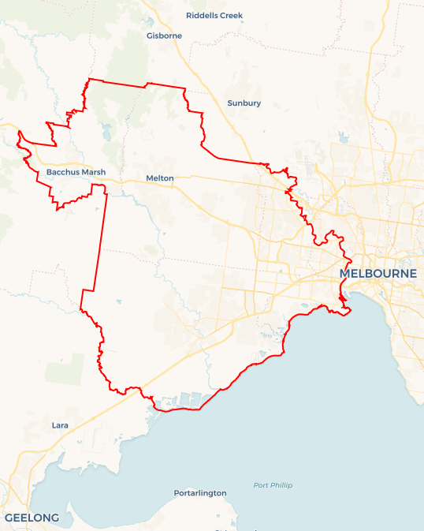Local Jobs Plan

Western Melbourne Employment Region | Victoria | ****March 2025****

Workforce Australia Local Jobs (Local Jobs) is a program that supports tailored approaches to accelerate   
reskilling, upskilling and employment pathways in response to current and emerging local workforce needs.

## Local Jobs elements

### Local Jobs Plan

The Local Jobs Plan sets out the skills and employment challenges and priorities of the region, and associated strategies that will drive the design and implementation of activities to be implemented to address these challenges.

### Job Coordinators

Job Coordinators and Support Officers support the delivery of the program by bringing together key stakeholders including businesses, employment services providers, higher education and training organisations.

### Local Jobs and Skills Taskforce

Each Employment Region has its own Taskforce. Representatives include local stakeholders who have demonstrated experience in upskilling, reskilling, and an ability to represent, connect and collaborate with others in the region to meet labour market needs.

### Program Funds

The Employment Region’s Local Initiatives Fund enables targeted local investments that support local labour market functioning. Further, from 2025/26, a central grants-based fund will respond to local needs and help progress broader employment service reform objectives.

Explore labour market insights for the  
[Western Melbourne](https://www.jobsandskills.gov.au/work/employment-region-dashboards-and-profiles/monthly-labour-market-dashboards) Employment Region

## Local labour market challenges in the region

* Western Melbourne has a diverse labour market profile presenting strong job opportunities in growth industries and skills-in-demand sectors, the region has a history of **labour market and social challenges.**
* The proportion of the **working age population on income support**in Western Melbourne is higher than the Victorian average.
* **Young people** represent a large percentage of the Workforce Australia caseload in the Western Melbourne region.
* Foundation skills, such as literacy, numeracy and digital proficiency, are lacking in some participant groups such as young people, culturally and linguistically diverse people and First Nations, impacting labour market participation.
* Access to**public transport and lack of public transport options that align with the start and end times for roles involving shift work.**

## Local jobs and skills priorities and strategies in the region

### Priority 1 – Priority Industries: transport and logistics, health care and social assistance

#### What are our challenges and opportunities?

Western Melbourne is experiencing strong employment demand in both the transport and logistics and health care and social assistance sectors. Workforce shortages are a key challenge to growth. The transport sector faces ongoing shortages. In health and social assistance, demand for nurses, aged care, disability and childcare workers is outpacing supply, particularly in growth areas like Melton and Tarneit. By analysing these sectors and leveraging existing government programs, we can create pathways for the local workforce into in-demand fields such as transportation, logistics and healthcare.

#### How are we responding?

* Collaborating with businesses in the transport and logistics, health care and social assistance sectors in Western Melbourne to raise awareness of employment opportunities in these fields. Ongoing partnerships with stakeholders such as the Wyndham Community and Education Centre will support people entering these industries, offering essential assistance through various industry-specific programs.
* Working with organisations such as Western Health and industry partners to assist individuals and implement joint projects through facilitation, knowledge exchange, meetings and creative regional programs.
* Actively engaging with employers and industry to support skill development and understand workforce needs. We are also working with social enterprises in priority industries to create programs that assist people facing challenges in Western Melbourne.
* Working closely with organisations like Fruit2Work to identify and overcome employment challenges faced by formerly incarcerated people by educating industry partners to the benefits of employing people who have been impacted by the justice system.

### Priority 2 – Employment pathways into major projects

#### What are our challenges and opportunities?

To commit to a significant upskilling initiative for the region's workforce to ensure they are fully prepared and highly competent to meet the demands of major infrastructure and large-scale construction projects in Western Melbourne. Major construction projects in Western Melbourne are creating strong demand for skilled workers, yet the industry faces ongoing labour shortages. Limited access to trades, apprentices and transport to key growth areas like Melton and Wyndham is impacting project delivery. Targeted investment in local training, apprenticeships and improved access to job sites is essential to support the construction pipeline and ensure timely completion of critical infrastructure.

#### How are we responding?

* Collaborating with various partners, including Workforce Australia Employment Service Providers (providers), training organisations, community partners, Skills and Jobs Centres, industry networks, place-based programs and regional specific committees.
* Aligning pathways with local labour demands by offering upskilling and reskilling opportunities. We will organise industry-specific events and activities in partnership with all levels of government to create local job opportunities for the community.
* Partnering with major project contractors like Lendlease and John Holland to boost social inclusion hiring for significant infrastructure projects. These include the Melton and Footscray hospitals, the Cobble Bank level crossing removal, the Melton train station upgrade and other upcoming regional projects. We are working directly with their recruitment teams to publicise job opportunities through the Local Jobs and Skills Taskforce and provider monthly briefings.

### Priority 3 – Young people (youth)

#### What are our challenges and opportunities?

To effectively connect youth with skill development and employment opportunities across all sectors, we must build strong relationships with businesses, industry groups and educational institutions to facilitate apprenticeships, traineeships and other work-based learning. By understanding sector-specific needs, we can match young people with suitable training and career pathways, ensuring they gain relevant skills, with an aim of reducing **youth disengagement** and increasing participation in study or work.

#### How are we responding?

* Working alongside local and state government agencies to organise youth career and employment events that prioritise inclusion and engagement with young people. This commitment ensures that we provide continuous support for youth.
* Working with local community networks to design and deliver industry-specific programs to support young people engaging with industries. We are developing localised industry resources for young people in collaboration with the Western Melbourne Local Learning and Employment Network providers, with an aim of having these resources complete by the end of 2025.
* Collaborating with Local Learning and Employment Networks to expand career support programs in schools for students and professionals. Additionally with businesses such as Youth Projects and Lendlease/The Exchange we are supporting initiatives that help businesses hire and keep young people at risk of disengaging from employment or education. We are also supporting organisations that connect young people with suitable employment opportunities.

### Priority 4 – ****Challenges to employment for multicultural communities****

#### What are our challenges and opportunities?

To develop and implement targeted, supported employment pathways that lead to real job opportunities in priority sectors, ensuring equitable access and integration into the workforce for people from multicultural communities, with an emphasis on reducing existing challenges faced by many culturally and linguistically diverse people.

#### How are we responding?

* Partnering with businesses to overcome transportation challenges faced by multicultural communities. Our focus is on collaborating with businesses in priority industries to adjust work schedules to better match public transport options, ensuring all stakeholders feel engaged and contribute to positive change.
* To better understand the needs of multicultural communities, the Local Jobs and Skills Taskforce consulted with community Elders. Identified needs include but are not limited to language, literacy, numeracy skills, transportation issues and unfamiliarity with Australian workplace culture.

### Priority 5 – Supporting women into employment

#### What are our challenges and opportunities?

To focus on empowering and guiding women to secure employment in fields that match local labour demands, with an emphasis on supporting their entry into industries where men have historically held the majority of roles.

#### How are we responding?

* Local Jobs has partnered with a provider and local Parent Pathways providers to create the ‘Women's Care to Careers’ group. This initiative aims to provide a supportive and inclusive environment for multicultural women, assisting them in entering or re-entering the workforce.
* Collaborating with local governments to enact specific programs, careers and employment events. This ensures ongoing support for increased female participation, providing our stakeholders with a sense of security and reassurance such as working with ReadySet to create opportunities for women to be provided with work specific clothing. We have also created a ‘Canvas to Careers’ workshop where women can attend to gain professional insights into the creative industry and get assistance with professional photographs to ensure they have an up-to-date portfolio for their work.
* Western Melbourne Local Jobs has partnered with SheForce and various employers to support women seeking employment and training in male-dominated industries. Our goal is to enhance job opportunities for women in the local community.

### Priority 6 – Supporting First Nations peoples

#### What are our challenges and opportunities?

To develop and implement effective strategies to create equitable employment opportunities and support sustainable career pathways, with an emphasis on reducing existing labour market challenges faced by many First Nations peoples.

#### How are we responding?

* Aiming to develop customised work experience and employment programs in partnership with regional stakeholders, addressing the challenges First Nations peoples face in obtaining meaningful and culturally safe employment.
* Identifying opportunities and create skills development pathways aligned with growth economies in all industries in Western Melbourne especially the transport and logistics, healthcare and social assistance areas to support First Nations people and provide additional support through First Nations-led initiatives, including business awareness training that has been identified by employers seeking to create and understand culturally safe workplaces.
* To better understand and support the needs of First Nations people, Local Jobs is collaborating with Social Outcomes Solutions and local First Nation providers.

## Want to know more?

* Contact: Kylie Olsen, Western Melbourne Job Coordinator: kylie.olsen@mylocaljobsprogram.com.au
* Visit: [Local Jobs](https://www.dewr.gov.au/local-jobs) or [Workforce Australia](https://www.workforceaustralia.gov.au/)