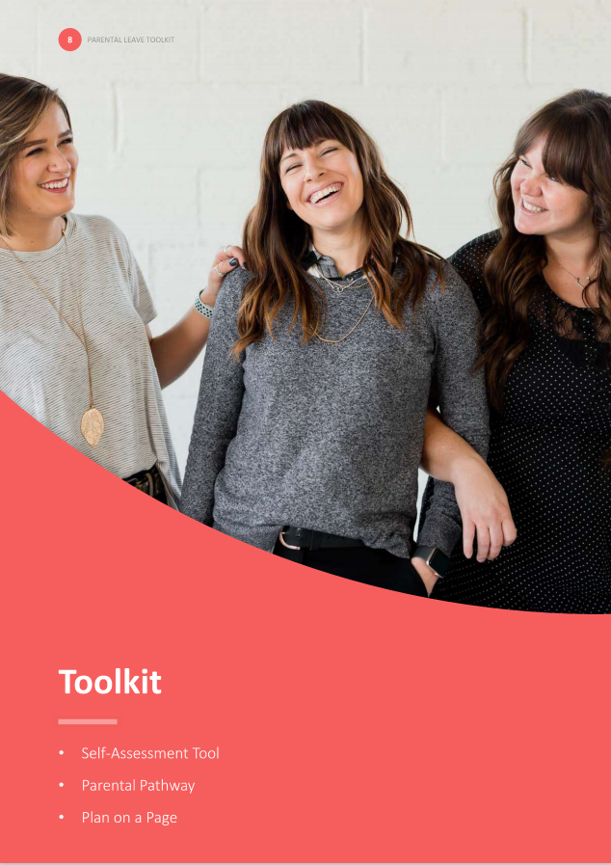

* Plan on a Page example

**Plan on a Page example**

**To support employees and managers to have regular, honest and open dialogue about transitions and aspirations pre and post parental leave, consider developing a Parental Leave Plan on a Page. The template helps managers to see employees through a different lens and could be used as a dynamic document, updated before, during and following return.**

| **Employee: Claire Marshall** |
| --- |
| **CONTACT DETAILS**  PHONE: 0314 356 879  EMAIL: [Claire.Marshall@Hotmail.com](mailto:Claire.Marshall@Hotmail.com)  **GETTING READY**  **CONVERSATION FREQUENCY:**  Monthly discussion with manager  **KEY DATES**  HANDOVER PERIOD: May – June 2020  LEAVE PERIOD: 1 June 2020 – March 2021  DUE DATE: 15 June 2020  **ON MY MIND**  MEDICAL: Wondering about taking time for antenatal care, and whether I need to take leave or manage within my given hours.  PROFESSIONAL: Ensuring I am considered during performance evaluation and appraisal.  OTHER: Seeking confirmation of contractual maternity pay.  **IMMEDIATE:**  Promotion to Senior Designer  **LONG TERM:**  Team leader  **WHILE I’M AWAY**  **STAYING IN TOUCH:**  PREFERRED CHANNELS: SMS or email  FREQUENCY: Fortnightly  TOPICS: Organisation restructures, promotion opportunities and team social events.  **RE-INTEGRATION**  **TRAINING AND DEVELOPMENT**   * Mandatory risk training on return * Human centred design   **CHANGES TO WORK PATTERNS AND SCHEDULES**  KEEPING IN TOUCH DAYS: To be utilised for training and planning days.  FLEXIBLE WORK REQUEST: Request to work part time (Monday – Wednesday)  **SUPPORT NETWORKS**  Member of the parents at work network  Regular catch ups with manager (fortnightly) |