

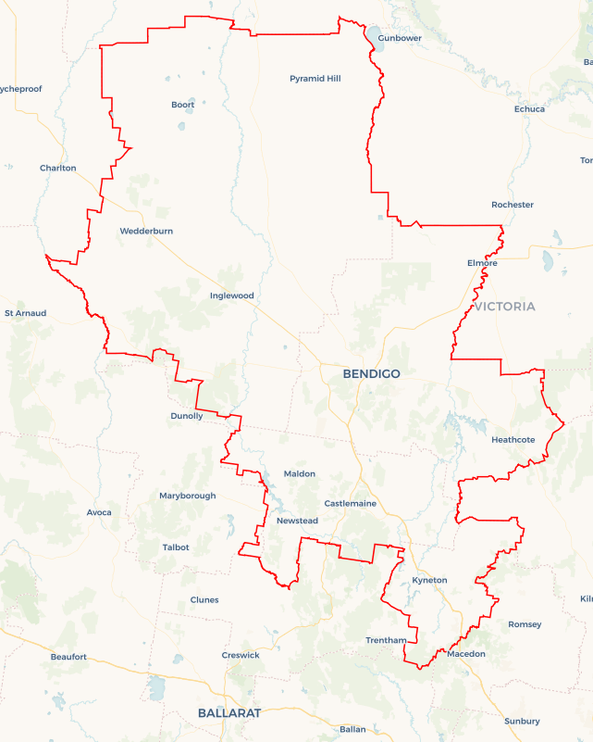Local Jobs Plan

Bendigo ****Employment Region**** | VIC | ****April 2025****

Workforce Australia Local Jobs (Local Jobs) is a program that supports tailored approaches to accelerate   
reskilling, upskilling and employment pathways in response to current and emerging local workforce needs.

## Local Jobs elements

### Local Jobs Plan

The Local Jobs Plan sets out the skills and employment challenges and priorities of the region, and associated strategies that will drive the design and implementation of activities to be implemented to address these challenges.

### Job Coordinators

Job Coordinators and Support Officers support the delivery of the program by bringing together key stakeholders including businesses, employment services providers, higher education and training organisations.

### Local Jobs and Skills Taskforce

Each Employment Region has its own Taskforce. Representatives include local stakeholders who have demonstrated experience in upskilling, reskilling, and an ability to represent, connect and collaborate with others in the region to meet labour market needs.

### Program Funds

The Employment Region’s Local Initiatives Fund enables targeted local investments that support local labour market functioning. Further, from 2025/26, a central grants-based fund will respond to local needs and help progress broader employment service reform objectives.

Explore labour market insights for the  
[Bendigo](https://www.jobsandskills.gov.au/work/employment-region-dashboards-and-profiles/monthly-labour-market-dashboards) Employment Region

## Local labour market challenges in the region

* A high proportion of participants in employment services have been receiving assistance for more than 12 months and face complex challenges to employment.
* Youth unemployment in the region remains high.
* Labour and skills shortages are impacting ability for businesses to find suitable workers to operate and grow their business.
* Transitioning to a net zero economy will require new skills and jobs in traditional and emerging sectors.

## Local jobs and skills priorities and strategies in the region

### Priority 1 – Long term participants in employment services

#### What are our challenges and opportunities?

The proportion of participants receiving assistance from Workforce Australia Employment Services Providers (providers) for more than 12 months is significant. Individuals may face complex challenges to employment, including transport, health conditions, homelessness, education, financial literacy and self-esteem.   
Place-based, tailored approaches are needed to prepare participants to enter or re-enter the workforce and retain employment.

#### How are we responding?

* Engaging with providers regularly to understand the needs of participants and co-design place-based resources, activities and events that assist individuals to progress towards employment.
* Building the capacity of individuals to enter or re-enter the workforce through activities that address challenges to employment, build confidence, create aspiration, provide relevant skill-sets and introduce individuals to local businesses with current employment opportunities.
* Collaborating with businesses, training organisations, local councils and other stakeholders to support employment expos, site tours, open days and other events that are easily accessible to providers and individuals.
* Assisting local businesses to make employment opportunities more accessible to individuals by increasing their capacity to recruit, onboard and retain employees from priority cohorts. We will do this by providing resources and events that promote inclusion and diversity in the workplace and educating businesses on the provision of peer support and mentoring to individuals that face challenges to employment.

### Priority 2 – Youth unemployment

#### What are our challenges and opportunities?

Youth unemployment (people aged 15 - 24 years) rates remain significantly higher than the total unemployment rate in the Bendigo Employment Region. Occupations with higher skill levels have strong forecasted growth to 2034 in the Bendigo Employment Region – many of which require apprenticeship or traineeship qualifications. There are opportunities to broker employment for young people to be engaged or re-engaged in the care and support, visitor economy, manufacturing, and construction sectors as the demand for entry level and skilled workers grows.

#### How are we responding?

* Connecting businesses that have entry-level apprenticeship and traineeship employment opportunities with providers and other stakeholders who support young people to enter or re-enter the labour force. This is done by collaborating with business and other stakeholders to support open days, information sessions and employment expos that are easily accessible and appealing to young people and providers.
* Raising awareness of the supports available to providers and other stakeholders so that information can be shared with young people to increase engagement in the local labour market and relevant training or pathway to employment programs.
* Assisting local businesses to make employment opportunities more accessible to people aged 15-24 by increasing their capacity to recruit, onboard and retain younger employees. We will do this by providing resources and events that educate businesses to conduct relevant recruiting strategies, provide peer support and mentoring to younger employees and provide opportunities for younger employees to upskill on the job.
* Engaging with local businesses to address challenges to employment faced by young people. Providing additional transport solutions, mental health services and more flexible working conditions will increase participation of young people in the labour force.
* Raising awareness of the benefits of apprenticeships and traineeships to businesses, providers and younger participants to build a skilled workforce for the future with more secure employment opportunities for young people. The campaign will target those involved in the care and support, visitor economy and construction sectors to increase participation and completion of apprenticeships and traineeships in the Bendigo Employment Region.

### Priority 3 – Occupations in demand

#### What are our challenges and opportunities?

Local businesses have ongoing unmet labour market demand for entry level and skilled roles. Many are unable to grow their business due to the lack of suitable applicants.

#### How are we responding?

* Connecting businesses that have current and upcoming recruitment needs with providers, training organisations, and other initiatives that support individuals to engage in the labour force. This is done by promoting training and employment opportunities through videoconferencing events, email networks and social media.
* Collaborating with businesses, training organisations, local councils and other stakeholders to support employment expos, site tours and open days that are easily accessible to providers and individuals.
* Promoting funded initiatives that create pathways into employment in occupations with skills shortages and forecasted high growth to providers and individuals and supporting those initiatives to better connect with local business.
* Engaging with businesses who have difficulty recruiting due to their remote location to provide transport solutions and other initiatives that increase the accessibility of employment opportunities to individuals.
* Assisting local businesses to make employment opportunities more accessible to individuals by increasing their capacity to recruit, onboard and retain employees. We will do this by providing resources and events that promote inclusion and diversity in the workplace and educating businesses on the provision of peer support and mentoring to participants with challenges to employment.

### Priority 4 – Skills for the future

#### What are our challenges and opportunities?

#### Skill shortages are most common in occupations requiring an apprenticeship or traineeship. Jobs growth is expected to be highest across service industries and in jobs requiring higher level qualifications. The green economy and technologies provide cutting-edge opportunities requiring additional skills, new credentials and new occupations. Apprenticeships and traineeships provide an opportunity to equip individuals with the skills needed for many net zero carbon and green economy occupations.

#### How are we responding?

* Engaging with industry to identify the employment opportunities available and the skills needed, then sharing this information with providers and other stakeholders.
* Collaborating with industry, education and training providers and other stakeholders to leverage existing training, upskilling and pathway to employment programs and to promote these opportunities to providers in support of increased referrals and completion rates.
* Strengthening connections between businesses, providers, training organisations and other industry stakeholders by collaborating on employment expos. Building these relationships will streamline pathways into employment opportunities and increase participation in upskilling initiatives.
* Raising awareness of the benefits of apprenticeships and traineeships to businesses and individuals as these employment opportunities provide training and skill development for occupations with strong forecasted demand.

## Want to know more?

* Contact: Christopher Booth, Bendigo Job Coordinator: Chris.Booth@localjobs.org.au
* Visit: [Local Jobs](https://www.dewr.gov.au/local-jobs) or [Workforce Australia](https://www.workforceaustralia.gov.au/)