


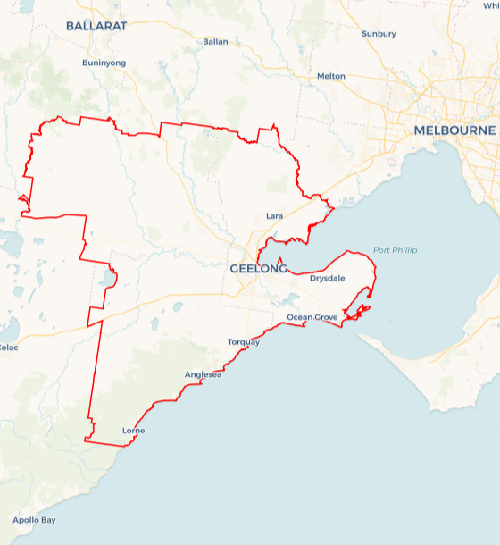
Local Jobs Plan
  - Barwon Employment Region | Victoria | June 2026
Workforce Australia Local Jobs (Local Jobs) is a program that creates partnerships between business
and communities to meet local workforce needs, thereby improving employment outcomes.
Local Jobs operates in all 51 Employment Regions in Australia.

Local Jobs Overview

Local Jobs Plan
Each Employment Region has a Local Jobs Plan which outlines the labour market challenges in the region and the strategies to address these challenges.

Job Coordinators
Each Employment Region has a dedicated Job Coordinator who leverages existing resources, supports local labour markets through structural adjustments and retrenchments, and creates opportunities for collaboration between business and communities.

Local Jobs and Skills Taskforce
Each Employment Region has its own taskforce that meets regularly with the Job Coordinator to develop an understanding of challenges in the region and implement solutions. The taskforce is comprised of representatives from the region.

Local Jobs, Local People Grant
The Local Jobs, Local People grant funds activities that help people into ongoing employment or training. Activities must support local labour market needs.
Explore labour market insights for the
Barwon Employment Region

Local labour market challenges

- Some suburbs experience significantly higher unemployment and fewer local opportunities.
- Employers in key sectors continue to report workforce shortages, such as health care and social assistance, construction, accommodation and food services (including hospitality and tourism), education and training (particularly in early childhood education and care), transport, postal and warehousing, manufacturing and arts and recreation services (including creative industries and digital technologies).
- A growing skills gap is appearing between individuals’ current skills and the skills needed for available roles.
- Limited understanding and uptake of apprenticeships and traineeships, including for women in non-traditional pathways.
- Transport, housing and digital access can impact participation in work and training.
- Inclusion challenges affecting Aboriginal and Torres Strait Islander people, people with disability, people from multicultural communities and people affected by the justice system.

Local priorities

Priority 1 – Support for local employers with Aboriginal and Torres Strait Islander employment and retention

What are our challenges?
Some Aboriginal and Torres Strait Islander community members need extra support to gain and keep work, and local employers want practical guidance to create culturally safe and supportive workplaces. Retention in Aboriginal and Torres Strait Islander -specific roles can be difficult, and more support is needed to help workers build long-term careers in these roles.

How are we responding?
- We will partner with local Aboriginal and Torres Strait Islander organisations to understand the needs of local community members. We will support the co-design of culturally safe, strengths-based pre-employment and job-ready support tailored to community needs.
- We delivered an Inclusive Employment workshop focused on Aboriginal and Torres Strait Islander inclusion. We will continue to support employers who attended, helping them carry out their planned actions and providing links to available resources.
- We will support the development of a peer network for Aboriginal and Torres Strait Islander workers to share experiences and strengthen retention.
- We will create regular connection points between Workforce Australia Employment Services Providers and Aboriginal and Torres Strait Islander agencies to coordinate culturally specific support.
- We will continue to support Aboriginal and Torres Strait Islander career events and the Geelong First Nations Employment Collective.

Priority 2 – Strengthening industries facing shortages and change

What are our challenges?
Employers in priority sectors such as health care and social assistance (particularly aged care), manufacturing, accommodation and food services (including hospitality and tourism along the Great Ocean Road), and education and training (particularly early childhood education and care) continue to experience workforce shortages, and difficulty finding suitable candidates. Changing labour market conditions, including some movement of manufacturing work offshore, are affecting local opportunities, while industry restructuring is creating uncertainty for workers and businesses. Some employers also report challenges attracting candidates due to factors such as limited transport options, variable job quality and hours, and the need for more experience or work-ready skills. Small businesses require clarity around support programs available, as they are key drivers of local jobs.

How are we responding?
- We are participating in the Transition Support Network to coordinate support for employers and workers during retrenchments or structural change.
- We are delivering targeted jobs and careers expos for priority sectors, including aged care, hospitality and tourism, advanced manufacturing and apprenticeships and traineeships.
- We will partner with local councils to run education sessions to inform small businesses of the support programs available.
- We are supporting the Surf Coast Industry to Internship Program, creating pathways into hospitality and tourism businesses in Lorne on the Great Ocean Road.
- We are collaborating regionally to strengthen workforce supply and sustainability in early childhood education and care.
- We are supporting regional careers expos in partnership with local stakeholders, including the Geelong and Golden Plains Careers Expo.

Priority 3 – Address the skills mismatch and support upskilling/reskilling

What are our challenges?
Many jobs in the region now require post-school qualifications and digital capability, and individuals need clear pathways to upskill or reskill. Entry-level roles can be harder to access. The gap between the skills people currently have and the skills needed for available roles is widening as higher-skilled jobs emerge. This makes it harder for people to find suitable opportunities unless they can build new skills. Demand for technical skills, including computer and basic Artificial Intelligence (AI) literacy is increasing across industries. Some individuals also need more support to strengthen their work readiness and gain experience that aligns with employer expectations.

How are we responding?
- We will partner with local training organisations and employers to pilot short, entry-level digital and AI literacy workshops aligned to current industry requirements.
- We are mapping pre-employment/job-ready programs across Barwon and filling gaps through co-designed offerings.
- We will target foundation skills and short accredited skill sets for high-demand roles.
- We will host customised informal recruitment events to encourage networking between industry and individuals.
- We will build job-creation partnerships with council, major projects and community organisations to create more entry-level roles.

Priority 4 – Grow apprenticeships and traineeships, with a focus on supporting women

What are our challenges?
Many employers and individuals need clearer information and support to start and complete apprenticeships and traineeships, especially women entering non-traditional trades. There is limited understanding of the projects, workforce needs and support needed to meet state and federal government priorities. This includes growing apprenticeship and traineeship participation, increasing women’s engagement in non-traditional pathways, and supporting the transition to net zero. Women are also more likely to be underemployed than men, with flexible options needed to allow women access to full time hours if they choose.

How are we responding?
- We are hosting two Apprenticeship and Traineeship Forums, one for potential apprentices in partnership with Skilling the Bay, and another for employers as part of the Geelong Small Business Festival.
- We will develop a program to support women returning to work with practical help, including confidence building, work readiness, financial literacy and connections to local employers. We will promote flexible work options that support women to increase their workforce participation.
- We are working with Apprenticeships Victoria and GROW at the Give Where You Live Foundation to strengthen social procurement outcomes on major builds.
- We are promoting suitable Certificate II and pre-apprenticeship options with local training providers, including a new Certificate II in Renewables.
- We are collaborating with The Gordon on a Build-Her workshop that introduces skills, and the use of common tools in the building and construction industry.

Priority 5 – Build inclusive workplaces and employer capability

What are our challenges?
Some jobseekers, including people with disability, people from multicultural communities and people affected by the justice system, need extra support in getting and keeping work. Many people would benefit from tailored support to build confidence, strengthen work readiness and connect with inclusive employers. People with disability are a significant part of the local caseload and may need workplace adjustments or clearer pathways to sustainable employment. Some individuals have been connected to services long-term and need coordinated support to move into suitable roles.

How are we responding?
- We delivered a series of three Inclusive Employment Workshops with GROW, supporting businesses to develop tailored action plans.
- We will develop a small online resource library that combines tools, case studies and local referral points.
- We are supporting The Gordon Centre of Excellence in Disability Inclusion and will share practical roles with employers.
- We are exploring a workshop for businesses on supporting people affected by the justice system.
- We are supporting multicultural community members by developing a Multicultural Employment Strategy for the region.

Priority 6 – Reduce access barriers and support place-based responses

What are our challenges?
Transport, housing and digital access can limit participation, especially in suburbs with fewer local opportunities. Some areas in the region experience higher unemployment, and residents may need more targeted support to connect with jobs. Several suburbs, including Corio, Moolap, Newcomb, Norlane, North Geelong, Portarlington and Whittington continue to face social and economic barriers that affect access to education and sustainable employment.

How are we responding?
- Advocating for improved public transport links and promote roles at the Avalon Employment Precinct now that transport services have expanded.
- Chairing the Geelong Pre-Employment Professionals Network to improve referrals and promote existing programs, including relevant sub-groups.
- Exploring driver-licence readiness support (e.g. simulators) with local partners.
- Launching and promoting the Settlement Processes and Services Guide to help navigation of local services.
- Trialling place-based employment initiatives in suburbs with higher unemployment, in partnership with community organisations, local councils and employers.

Want to know more?
- Contact Tracey Jeffery, Barwon Region Job Coordinator at tjeffery@barwonregionlocaljobs.org.au
- Visit Barwon Region Local Jobs, Local Jobs or Workforce Australia

