SUMMARY report
Evaluation of the National Careers Institute Partnership Grants Program: Summary Report

Department of Employment and Workplace Relations
23 October 2023

Contact
PO Box 4177
Kingston ACT 2604
Level 4, 42 Macquarie Street
Barton ACT 2600 Australia
T +61 2 6234 7777

Disclaimer
The opinions and views expressed in this report are based on the inputs received from grant recipients of the National Careers Institute’s Partnership Grants Program. They do not represent the opinions and views of Noetic Solutions Pty Limited or the Australian Government.

Contents
Introduction 5
Background 5
Purpose 5
Method 6
Report structure 6
Program Overview 7
Outcomes 7
Objectives 7
Rounds 1-2 7
Rounds 3-4 8
Summary of analysis 9
Project characteristics 10
Project type 10
Target cohort 10
Priority areas 12
Geographical distribution 13
Industry 13
Learnings 15
Success factors 15
Awareness 15
Confidence and agency 15
Communication and engagement 15
Partnerships 16
Challenges and learnings 17
Career influencers 17
Project design 17
Project management 17
Key findings 17
Career influencers 17
Employers 17
Engagement 18
Non-technical skills 18
Suggested Design Principles 19

Success Stories 20
Round 1 20
TAFE Queensland (Defence to Civilian Transition Training Project) 20
ACT Community Services Directorate (Understanding the Australian Building and Construction Industry) 22
Round 2 24
AMES Australia (Opening Minds, Building Futures – A Career Development Project) 24
workRestart Social Enterprises Ltd (Project Restart) 25
Round 3 26
Deakin University (Careers Guidance and Support for Women from Migrant Backgrounds) 26
University of South Australia (South Australian Academy for Gender Equity in STEM) 28
Highlands Local Learning and Employment Network Inc (Ballarat Try a Trade) 30
Round 4 32
Settlement Services International Limited (Youth Employment Planning Passport) 32
SYC Ltd (Career Grit – Volition and Career Adaptability: Disengaged Young People) 33
Breakaway Aboriginal Corporation (Career Dimensions through self-exploration and collaboration) 34
Conclusion 35
Annex A: Project Summaries 36
Round 1 36
Round 2 42
Round 3 51
Round 4 71
Version History 76

Introduction

Background
About the Program
The National Careers Institute’s Partnership Grants Program (the Program) was a competitive, merit-based grants program. It provided funding for organisations, such as employers, training providers, schools, and community organisations, to work collaboratively to create education and training pathways to improve career outcomes.
The Program aimed to support people at all stages of their careers, career advisors, career influencers and employers.
About the Projects
The Program funded projects with collaborative arrangements to deliver innovative ways to help Australians develop dynamic careers that can adapt to the workforce of today and the future. The projects aimed to improve careers information and advice, and address service gaps by enhancing partnerships between industry, employers, schools, and tertiary providers.
The Program funded 79 projects for a total of $22.5 million across four rounds over the period between December 2020 and June 2023. Each of the four rounds focussed on a different cohort and their career development needs.

Figure 1: Number of projects funded in each round.
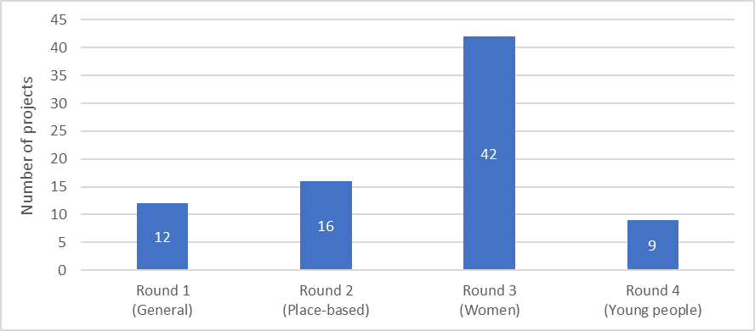

Purpose
Noetic Solutions Pty Limited (Noetic) was contracted by the National Careers Institute (NCI) within the Department of Employment and Workplace Relations (DEWR) to evaluate the Program.
The purpose of this Summary Report is to share a high-level overview of the evaluation, showcase success stories of the Program and share learnings to inform best practice related to future career development initiatives.

Method
A structured approach was used to evaluate the Program. Information was collected from grant recipients to inform the evaluation through three mechanisms:
- desktop research
- survey of grant recipients (62 out of 79 surveys were received)
- interviews with grant recipients (45 out of 79 grant recipients were interviewed).

Report structure
The report is structured as follows:
- Program overview: provides program level insights on the target cohort, geographical coverage, industry, and priority areas covered by the Program.
- Lessons: shares lessons and insights to inform best practice in delivery of career development projects.
- Success stories: shows examples of projects funded by the Program and includes case studies that demonstrate impact.
- Conclusion: summarises key points.
- Annex A: provides a list of all projects funded by the Program with a short overview for each project.

Program Overview

Outcomes
The desired outcomes for the Program were:
- Outcome 1: Enhance career pathways that helped the target audience to reach their full career potential.
- Outcome 2: Increase understanding of skills sought by employers.
- Outcome 3: Stronger collaboration in the delivery of careers information and advice
- Outcome 4: Improved quality of careers information and advice.
The desired outcomes for Rounds 1-4 were the same, though they each had a different focus or target audience:
- Round 1: focused on an Australia-wide, general audience.
- Round 2: focused on local, place-based projects.
- Round 3: targeted women, especially women returning to work from a career break, in non-traditional industries or in industries where they are under-represented.
- Round 4: targeted young people, especially young people disengaged from education, employment, or training.

Objectives
The objectives of the Program were different for each round. However, there is sufficient overlap in the objectives for Rounds 1-2 and Rounds 3-4 to group their objectives together.

Rounds 1-2
The objectives for Rounds 1-2 are shown in the table below. The Round 1 objectives are broader level while Round 2 objectives focus on local, place-based projects that provide face-to-face services to individuals (as opposed to macro and research projects).

Table 1: Program objectives for Rounds 1-2
Objective number | Round 1 | Round 2
Objective 1 | Improve the quality of, and access to, careers information and advice | Improve the quality of, and access to, locally based, personalised career guidance
Objective 2 | Develop and showcase innovative approaches to delivering career development services | Develop and deliver innovative locally based approaches to delivering career guidance services
Objective 3 | Demonstrate the value of career development | Demonstrate the value of career guidance to those seeking to re-enter the workforce, change or further develop their careers, primary school students and students in years 7 to 10
Objective 4 | Increase knowledge and create greater awareness of career paths and career information | Increase knowledge and create greater awareness of career paths and career guidance for those seeking to re-enter the workforce, change or further develop their careers, primary school students and students in years 7 to 10
Objective 5 | Build an evidence-base for best practice career development | N/A

Rounds 3-4
The objectives for Rounds 3 and 4 are similar, but they have different target audiences:
- Round 3 objectives: women
- Round 4 objectives: young people.

Table 2: Program objectives for Rounds 3-4
Objective number | Round 3 | Round 4
Objective 1 | Create greater awareness of career pathways and career information for women with a focus on women returning to work from a career break, women in non-traditional industries and occupations, or industries where women are under-represented (including at senior levels) | Create greater awareness of career pathways and career information for young people not in education, employment, or training
Objective 2 | Contribute to an evidence base for addressing the needs of women undertaking training and apprenticeships | Contribute to an evidence base for addressing the needs of young people who are disengaged from education, employment, or training

Summary of analysis
This section summarises the qualitative analysis of the Program based on the inputs received from grant recipients via surveys and interviews.
Overall, the Program was successful in delivering the desired outcomes and objectives, especially for cohorts that face barriers to accessing career advice, career opportunities, and/or government services.
The grant recipients that were interviewed were extremely passionate about their project and the impact it had on the lives of participants. All the projects were delivered during and post the COVID-19 pandemic and most projects took significant steps to adapt to the external disruption caused by the pandemic. The passion and drive of grant recipients was an essential requirement to deliver the successful outcomes and benefits that were achieved through all the projects. This passion often translated into in-kind contributions that outstripped initial expectations.
The partnership element of the Program was particularly powerful. It achieved the outcome of stronger collaboration in the delivery of careers information and advice. More importantly, the partnership element of the Program was a key enabler of success, which allowed projects to meet the other objectives. The partnerships allowed projects to draw on the strengths and existing relationships of their various partners to better meet the career development needs of their target audience.
Almost all the projects reported that the Program established new partnerships or strengthened existing partnerships. Most of the partnerships resulting from the Program will continue after funding has ended and will continue to deliver ongoing benefits in future projects or in day-to-day operations.
Another key feature of the Program that was critical in delivering the outcomes was the flexibility allowed by the Program. The Program was open to industry partners, which some grant recipients noted as a key differentiator from other grant programs. Industry partners were able to utilise their expertise and relationships to pursue initiatives that delivered meaningful social benefits aligned with the outcomes of the Program.
In addition, the flexibility of the Program allowed projects to adjust their approach along the way. This allowed projects to test approaches and make adjustments to better meet the career development needs of their target audience. Importantly, this flexibility allowed grant recipients to adapt their approach during the pandemic, which had major impacts to project delivery, especially in relation to engaging participants.
The Program provided flexible funding that stimulated in-kind contributions and strengthened partnerships, which resulted in projects delivering outcomes that exceeded what would be possible by the grant funding alone.

Project characteristics
The projects funded by the Program were characterised by project type, target cohort, priority area, geography, and industry to demonstrate the overall impact of the Program.

Project type
The projects funded by the Program were classified into two types:
- Research – 10 projects (13%)
- Career development delivery – 77 projects (97%).
Eight out of the 79 projects funded by the Program were classified as both research and career development delivery projects, which is why the sum of the percentages shown above exceed 100%.

Figure 2: The number of projects by type, by round

Target cohort
The Program was aimed at supporting the following cohorts:
people at all stages of their careers, including students, job seekers, people developing their career, and people looking to change careers—people are twice as likely to be engaged in work if they have the opportunity to engage in high quality career development, and are also more productive in the workplace.
- career advisors— 68% would like greater contact with employers/industry to enhance their role.
- career influencers, parents, and peers—because 48% of young people get their most trusted career advice from parents/carers.
- employers—because research shows that a lack of career development is one of the top reasons why an employee leaves a job, and it costs employers an average of $27,000 to replace an employee.
All projects targeted 'people at all stages of their careers', who would directly benefit from the delivery of career development. The age groups targeted within this cohort are shown in the figure below.

Figure 3: The number of projects by target age group
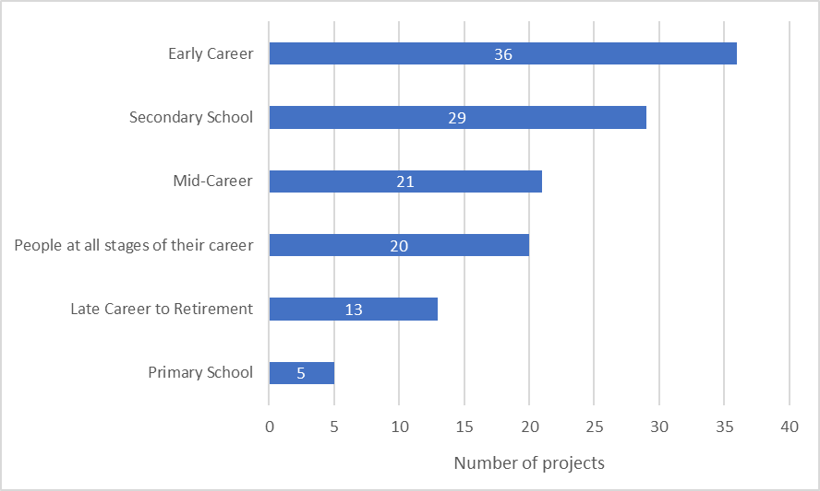
While all projects aimed to serve the people who would directly benefit from career development, many projects also targeted career influencers – usually to support the main target cohort. Career advisers were the main career influencer cohort targeted, followed by teachers/educators.

Figure 4: The number of projects by career influencer cohort
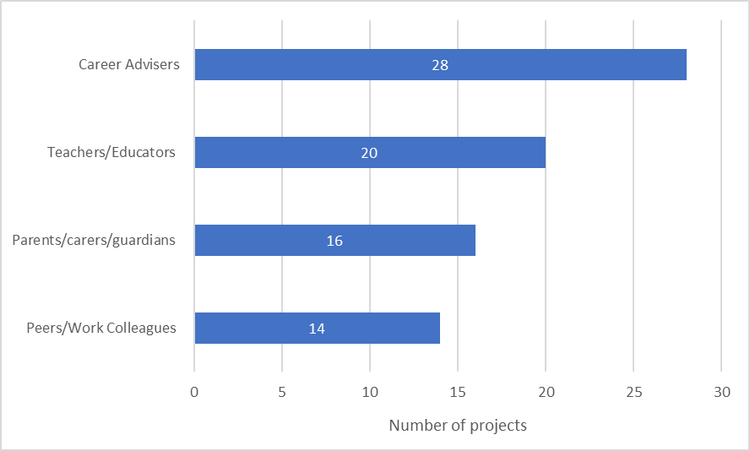

Priority areas
The projects in the Program supported cohorts shown in the figure below. Many projects covered more than one cohort.

Figure 5: The number of projects by cohort
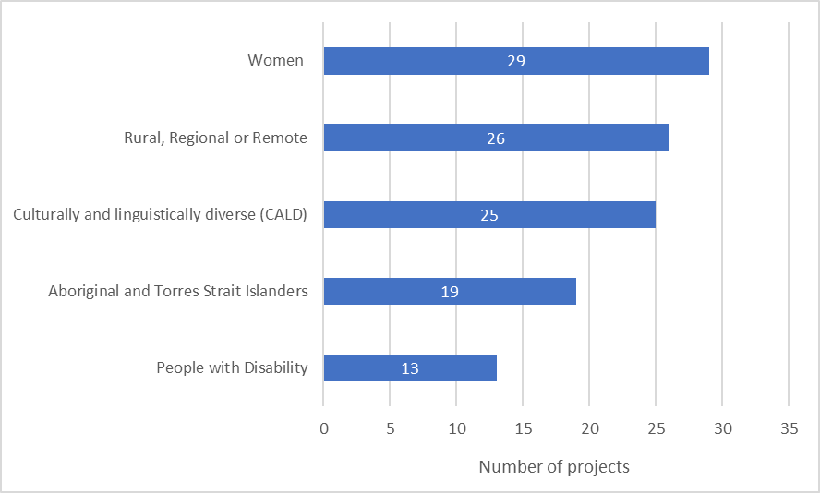
The women cohort was the most targeted cohort by the projects funded by the Program. This is because all of the 42 projects in Round 3 focused on women.

Geographical distribution
Eleven projects in the Program had a national focus. The figure below compares the number of place-based projects against the population in those locations. The figure excludes the projects that had a national focus. Overall, NSW and WA had the least number of projects per capita. For higher population States and Territories (VIC, NSW, QLD, and WA), the number of projects was proportionate to the population in these locations. For lower population States and Territories (SA, TAS, ACT and NT), there were more projects relative to the population in these locations. South Australia stands out in particular as benefiting from the additional career development delivery projects because of the significant increase in people required to work in the fast-growing Defence industry sector in South Australia.

Figure 6: The number of projects compared to population by geography (excludes National)
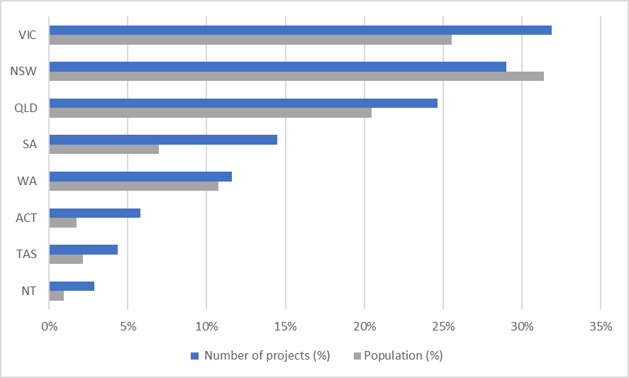

Industry
The figure below shows the industry sectors, which are based on the Australian and New Zealand Standard Industrial Classification (ANZSIC), that were targeted by the projects in this Program. Most projects targeted specific industries which were often based on:
existing partnerships with employers
industries where there is expected to be an increased workforce demand
industries that are most accessible to place-based participants (for example, Agriculture in rural, regional, or remote areas).
The industries that were engaged most by projects were Construction and Agriculture, Forestry and Fishing. Other industries that received relatively high engagement are: Education and Training; Professional, Scientific and Technical Services; Health Care and Social Assistance; Information Media and Telecommunications and Other (STEM).
One third of projects were participant-led in their approach to engaging with industry. These projects were industry-agnostic and engaged a broad range of industries, based on the interests of participants.

Figure 7: The number of projects by industry covered
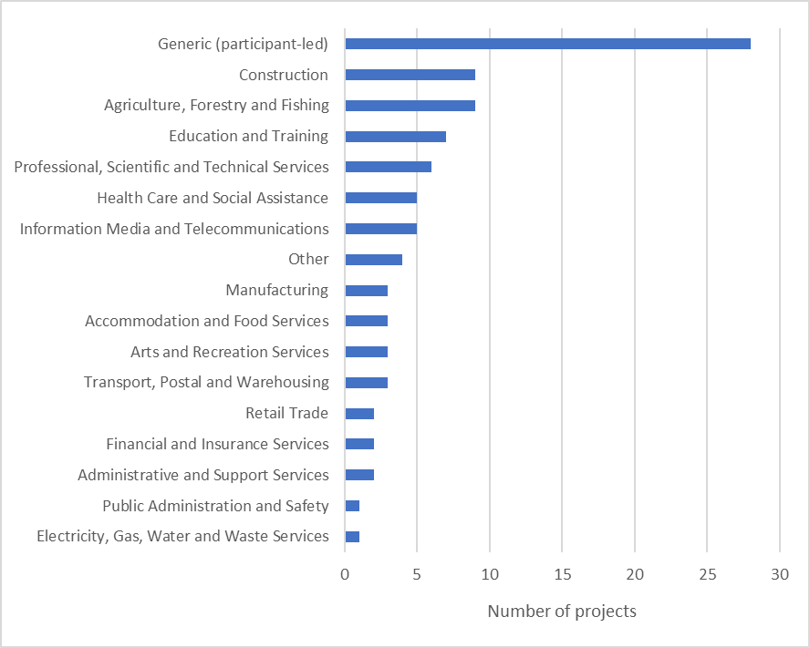

Learnings
The feedback received from grant recipients via surveys and interviews were used to identify learnings. The challenges faced, successes achieved, and findings uncovered by projects were many and varied. Through this evaluation, 119 unique observations were recorded, noting that many of the recorded observations were observed for several projects. These observations were grouped and themed to develop the insights that are summarised below. These insights are all based on the experience and interpretation of the grant recipients.

Success factors

Awareness
- The 'be what you can see' model was widely used by projects and was effective at demonstrating career pathways to participants, especially participants with limited information or role models.
- It was important to use relatable role models as speakers and career champions. For example, projects used local speakers at rural, regional, or remote events or speakers with a similar background as the target audience.

Confidence and agency
- Confidence building was identified as an important enabler for career development, especially for women. Effective strategies to build confidence were 'be what you can see' speakers, mentoring, creating peer networks and on-the-job work experience in a safe environment.
- Projects focusing on cohorts with complex barriers, such as people with culturally and linguistically diverse (CALD) backgrounds or disengaged young people, gave participants agency, and did not force outcomes on participants. An example was when projects did not focus on employment outcomes, participants sought out opportunities that led to employment outcomes because they felt empowered to do so.

Communication and engagement

Complex needs
- Personalised, high-trust communication and engagement strategies were the most effective way to engage participants, especially for cohorts that needed higher levels of support. These personalised, high-trust communication and engagement strategies include word-of-mouth, drawing on the credibility of existing partnerships, building relationships, and communicating by phone or in-person (not email).
- It was important to create psychological safety for participants through small groups and one-on-one sessions. This was especially important when participants had a high degree of intersectionality.
- Participants with complex needs require personalised, tailored support to overcome their unique barriers. Many participants did not find this type of support through generic services – for example, many participants said, "this is the first time someone asked me what I wanted".

Young people
- Students found immersive experiences most impactful. For example, projects used work experience, virtual reality, and hands-on activities to create immersive experiences.
- Young people were more engaged when they committed to projects. For example, some projects asked young people upfront to treat their participation in the project like a job. Some projects also found that young people were more committed when there were rules and structure, particularly projects that observed participating disengaged young people often lacked structure in other parts of their life.
- Projects successfully engaged young people who were disengaged from education or employment by using rolling intakes, simple messaging, and tailoring information sessions to the needs of the audience such as using short sessions that allowed interaction and discussion rather than ‘book work’.

Women
- Projects aimed at women, especially women returning to work, provided flexibility that enabled participation while caring for children: several projects offered free on-site childcare, scheduled sessions in the evenings, or were delivered online, to keep women engaged with the project.

Partnerships
- Projects that had lasting, self-sustaining impacts set up relationships that were not dependent on a central party. For example, these projects used peer-mentoring and peer support groups that could continue after the project ended.
- The Program created new partnerships and strengthened existing partnerships which will continue after the project ends with ongoing impacts through future projects or business-as-usual activities.
- For most projects, the Program resulted in new partnerships being created and existing partnerships being strengthened, which will continue after the project ends with ongoing impacts through future projects or business-as-usual activities.
- Most effective partnerships occurred when partners had existing relationships with cohorts, employers, education, or support organisations. This allowed projects to draw on the existing trust these partners had to attract and serve the target audience.
- Effective partnerships required shared values/mission, clear roles, capacity to contribute, flexibility, and transparent and effective communication.
- The projects that most effectively met the needs of participants were ones that co-designed the project with partners and created feedback loops that allowed adjustments to be made to meet the needs of participants. For example, these projects created mechanisms to listen to what the participants need or delivered the project in rounds through rolling intakes.
- Converting registrants to participants was more successful when a nominal fee was charged because this demonstrated that the project provided value.

Challenges and learnings

Career influencers
- Teachers and career advisors were often severely under-resourced and had very limited time to support the Program. Although the Program supported these roles, this impacted their capacity to participate in projects that were targeted at students. This was especially true during the COVID-19 pandemic.
- Projects highlighted the importance of building trust with teachers so that the teachers could advocate for projects to get into schools.
- Parents were important to engage due to the influence they have on their children, especially in multicultural communities, however parents were often difficult to engage directly.

Project design
- Building trust and credibility with participants and their communities was often cited by projects as a key to success but required a long time to build. Many projects reported that a longer project duration would allow projects to reap the full benefits of the time invested throughout the project, including building trust and credibility with participants.

Project management
- Most projects underestimated the effort required to perform project management activities such as hiring staff, engaging with schools, coordinating people, and arranging transport and venues. It was noted that the COVID-19 pandemic created many unexpected complexities that required more effort to manage.

Key findings
The following findings were shared by the projects funded by the Program. These findings stemmed from the research conducted by these projects and by the experience of projects that delivered career development services.

Career influencers
- Projects found that schools and universities that focussed more on academic results than career outcomes limited their students' awareness and access to career pathways. For example, some projects found that educators did not provide career advice, students were not aware of VET-based career options, school career advisors provided advice biased to their own experience and school processes deterred employers from engaging with students.

Employers

Young people
- Employers were often unaware of the barriers they could remove to attract and retain young people for their talent pipeline. For example, some employers were unaware of the importance of providing re-assurance and feedback, and they were unaware that salary was particularly important to disengaged young people who may be supporting their families financially.

Women
- Employers were often unaware of the barriers they could remove to attract and retain women who they strongly aspired to have on staff. Some employers had limited female representation on their websites. Often employers were unaware that some women might value flexibility, such as part-time/job sharing arrangements more than pay. Some employers were unaware that they had inadequate facilities for women, such as not having facilities for breastfeeding.
- Some projects identified mentoring and leadership as key aspects to support women's career development.
- Some projects identified non-financial motivators, such as workplace flexibility and leave, as beneficial to increase the involvement of women in senior roles.
- One project found that organisations that publicly shared the results of their evaluation of programs to support women's career development were seen as more supportive and credible by women.

Engagement
- Some projects found that participants needed discussions with professionals to interpret information provided by online career information tools.

Non-technical skills
- Non-technical skills, such as time management, networking, and communication skills, were identified as a key enabler for career development. Projects needed to address these skills first before they were able to provide more targeted technical training or advice. Some cohorts were identified to lack these non-technical skills, in particular: young people, especially disengaged young people, and people who have experience in correctional facilities.

Suggested Design Principles
The insights and lessons identified from the projects funded by the Program were used to develop design principles for future programs, policies, and services. It should be noted that these design principles should be tailored to the objectives and desired outcomes of the program, policy, or service. Many of the principles are based on lessons and best practice for projects to meet the Program outcomes and objectives for their target cohort. If the goal is for projects to be more scalable, then many of these principles may not apply.
Principle 1 - Draw on existing credibility and relationships: using partners with existing relationships and credibility with the target audience ensures that the need is well understood and maximises the breadth of participation and depth of engagement within a set timeframe.
Principle 2 – Lasting benefits: design initiatives to have lasting benefits after the funding ends by creating outputs with ongoing utility or by creating relationships that do not rely on central facilitators.
Principle 3 – Flexible: be clear on the outcomes and objectives but be flexible in the approach to allow projects to innovate and adapt to challenges.
Principle 4 – Focus on empowerment, not employment outcomes: focusing on individual empowerment allowed for individuals to feel that they would be able to be prepared and confident.
Principle 5 – Open: keep the opportunities to contribute open to public, private, and non-profit sectors to draw on the expertise and relationships in each sector.
Principle 6 – Coordinated: align initiatives to the operational cadence of the targeted delivery partners and/or the target audience, such as using calendar years when targeting schools.
Principle 7 – Capitalise on investments: allow sufficient time for initiatives to provide a return on the upfront investment of establishing relationships and creating supporting materials.
Principle 8 – Close the gaps: pursue initiatives that address the needs of cohorts that fall between the gaps of current services.

Success Stories

Round 1

TAFE Queensland (Defence to Civilian Transition Training Project)
Need
This project offered a new way to provide training and career solutions for Australian Defence Force (ADF) members transitioning to civilian life across Australia. Transitioning ADF members can be faced with significant challenges adapting into civilian life. The primary concern stems from a widespread misunderstanding of the distinctive language, skills, experience, ranks, and roles that transitioning military members possess. Unfortunately, they are frequently treated in the same manner as regular student participants, disregarding their specific needs, skills, and experience. The idea behind this project was to provide an informed, consistent, and national approach to address this challenge.
Approach
The project provided ex-ADF members with a single point of contact, a Defence Solutions Officer (DSO), for veteran and transition enquiries to TAFE in Australia. The DSO provided personalised support and advice to each veteran. In addition, the project team worked with partners in the TAFE network across Australia to help them better support veterans to upskill. This included recognising veterans' prior training in Defence and offering short courses targeted as closing training gaps, instead of doing an entire course or an apprenticeship. The project also established connections between TAFEs and ex-service organisations (ESOs) across Australia. Transition Seminars were hosted at TAFEs, and even at military bases, around Australia. The transition seminars allowed broader engagement with ex-members and TAFEs and included time at the end to provide personalised advice to attendees.
Impact
This project was the first ‘large scale’ project where TAFE’s institutes nationally worked together to support a specific cohort. This work has resulted in consistent career support to transitioning veterans, ensuring a smooth transition into civilian life and a better understanding of the challenges faced by veterans across the transition process.
Case Study
Case Study 1
During a previous visit to Gallipoli Barracks, a seasoned TAFE Defence Solutions Officer (DSO), engaged in a career discussion with a transitioning member who had amassed 15 years of invaluable experience as a highly skilled sniper in the ADF. The member approached the team for guidance in pursuing a complete career-change enrolling in the 'Diploma of Graphic Design', a program which heavily relies on Adobe software. However, during the enrolment application, it was revealed that the member did not meet the eligibility criteria as he had not completed Grade 10 maths. The program’s criteria seemed contradictory considering the member's extensive skillset acquired through years of military service.
Snipers demonstrate extraordinary skills in marksmanship, enabling them to shoot targets with remarkable precision over long distances. Their proficiency extends to advanced mathematical aptitude, as they calculate ballistics and make the necessary adjustments accounting for various factors like the Coriolis effect, the earth's rotation, distance, and elevation. They consistently hit watermelon size targets from distances ranging from 1 to 3 kilometres. These demanding activities are executed instinctively, requiring cognitive abilities performed in real-time, typically within emotionally challenging circumstances. Following that, the DSO explained the level of mathematical agility within the member's role and that it surpassed the mathematical skills needed to operate Adobe Photoshop and Illustrator. The graphics teacher gained a deeper understanding of the expertise acquired in such a military career. Consequently, the member was granted permission to join the class and has since flourished in his new profession, showcasing remarkable aptitude.
After this member had such a positive experience, his wife, who was employed as a clerk on the same base, approached the team with the intention of applying for an apprenticeship, specifically in the field of electrical work. The DSO gladly assisted the member's wife by introducing her to the RSL Queensland pathway into the Ergon|Energex 'Bright-sparks' apprenticeship program, which is specifically designed for veterans and their partners. Through rigorous hard work and displaying a positive aptitude, the partner successfully secured a place in the ‘hotly contested’ program. As of now, she is nearing the completion of her electrical apprenticeship.
Case Study 2
During a recent visit to Cerberus Barracks, the primary training facility for naval personnel in Victoria, the TAFE Queensland Defence Team had the opportunity to speak with a newly transitioned member. This individual, who had extensive experience as a maritime technical propulsion engineer, often referred to as a Stoker, shared their excitement about receiving a recent letter of acceptance from a globally recognized manufacturer of construction and mining equipment. The letter offered them a position as a diesel mechanic tradesman, a role they were proud to have secured.
During the discussion, the team inquired about how the member, who had been working as a stoker on naval vessels for the past 25 years, gained knowledge in technical areas such as suspension, steering and braking. It exposed the fact that the individual did not possess a complete Certificate III qualification as a Diesel Mechanic and lacked a fully recognised civilian accreditation. This realisation caused concern as the member's eligibility for financial assistance of up to $5,320 under the Defence Force Transition Program (DFTP) was nullified due to already having a job offer. Furthermore, the manufacturer had not yet conducted the necessary verification of his formal qualifications, potentially resulting in the withdrawal of his role.
The TAFE Queensland Defence Team, leveraging their local TAFE Network were able to successfully reinstate the DFTP funding for the member. This funding enabled the veteran to undergo Recognition of Prior Learning for their existing diesel skills. Additionally, they received training to address the technical gaps such as suspension, steering and braking. As a result, the individual obtained a formal Certificate III qualification as a Diesel Mechanic, which was duly recognised by their new employer.
The training approach of the Australia Defence Force (ADF) focuses on equipping its personnel with the specific skills they require and actively utilise. In the case of ADF Electricians, they typically undergo training that leads to an Electrical Fitter outcome. However, there is a small gap of approximately three units that they need to fulfil in order to obtain their full Electrical Mechanic license. It's important to note that this ‘capability only’ approach may be subject to change in the future.
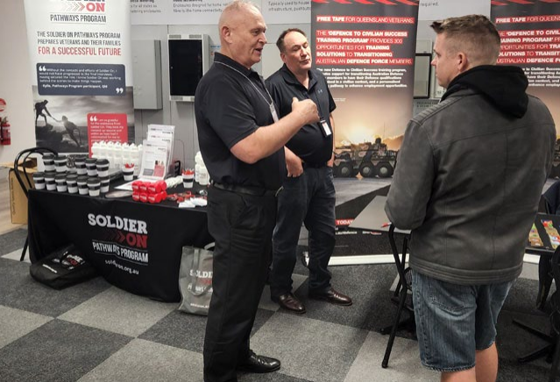

ACT Community Services Directorate (Understanding the Australian Building and Construction Industry)
Need
This project piloted a learning program that aligns with the Australian Curriculum and integrated industry perspectives to improve understanding of the building and construction industry for Years 7-8 (General Capabilities) and Years 9-10 (Work Studies). The aim was to address the low uptake of women in occupations within the industry and to enable ACT public school students to increase their understanding about what the building and construction industry involves, and how to access opportunities.
Approach
During this project, the Community Services Directorate developed and implemented an innovative, structured model for career education in the building and construction industry; this matched with the Australian Curriculum and embedded contemporary industry perspectives in student activities.
Impact
Students were able to increase their knowledge of the building and construction industry and better understand how they might explore careers both in construction, but also more broadly. In addition to the benefits experienced by students, the teachers and career advisors in schools were exposed to relevant and up-to-date information on the industry, both locally and nationally. The students involved are now better prepared for employment pathways in the industry and have gained an understanding of the broad range of pathways, including Australian Apprenticeships, training, and further education they can pursue.
Case Study
The perceptions of students that participated in the program were challenged. Those students that completed the work studies elective for Years 9 and 10 were able to finish the program armed with information that would support them to make informed choices about the subjects they chose for their ACT Senior Secondary Certificate, including options to undertake an Australian School-based Apprenticeship. The success of the program was recognised through the 2022 ACT Public Education Awards, taking out both the Outstanding Partnership of the Year Award and the Director-General’s Excellence Award. Mount Stromlo High School was one of four pilot schools that participated in this innovative pilot program and the school posted on its social media channels at the end of the school term.
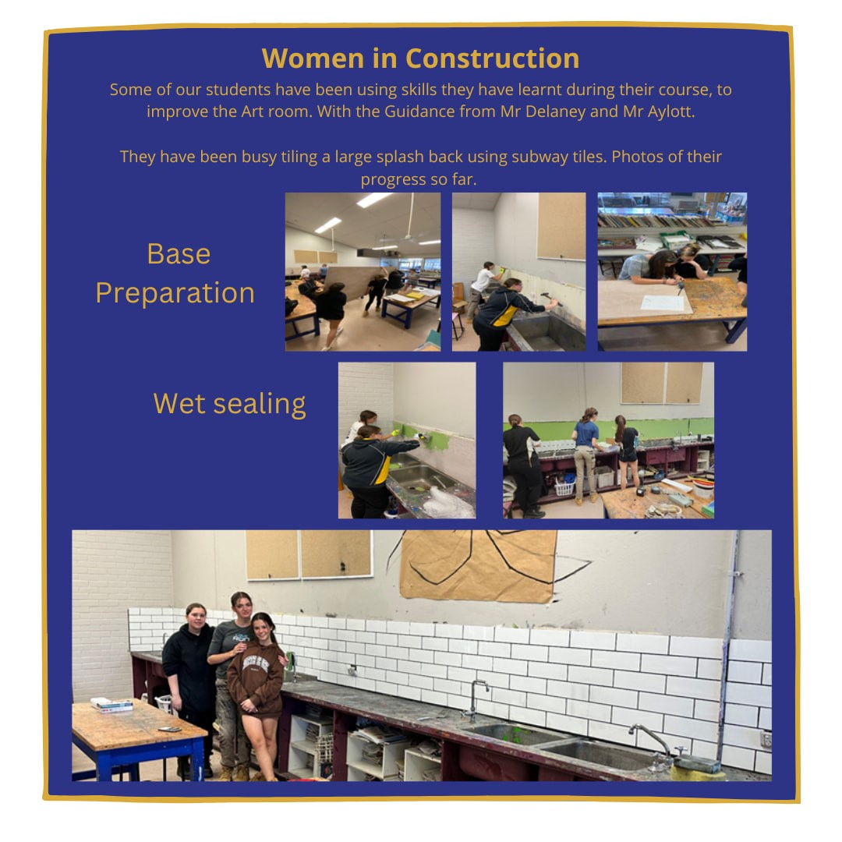

Round 2

AMES Australia (Opening Minds, Building Futures – A Career Development Project)
Need
While there are many young migrant and refugee people aged 16-29 who are highly motivated to embrace education and employment opportunities in Victoria, they are overrepresented in unemployment data compared to other young people in the Victorian region. In particular, 17% of Pasifika young people leave school early compared to 9.8% of the general population. Moreover, in 2016 the unemployment rate for the South Sudan-born population in Victoria was 31.8% compared to the Victorian population at 6.6%.
Approach
The aim of this project was to engage, inform and empower young people and support them in identifying career goals and pathways; and to also build the confidence in parents and school influencers who advise them. To achieve this, Ames Australia, and the Centre for Multicultural Youth (CMY) provided information sessions, workshops, and one-on-one career counselling to Years 7-10 students from Pasifika and South Sudanese communities in metropolitan Melbourne. Over 18 months, the project supported 240 young people through a strengths-based, co-designed and culturally sensitive approach.
Impact
To date, a total of 267 young people were provided information about career planning, employment opportunities of the future and associated education, training and experience associated with those pathways. 120 young people had individual contact with Community Youth Workers and career conversations. 85 young people attended individual one-on-one career development session, and a further 78 career plans were developed.
Case Study
Maverick, a Year 12 student dropped out of school in the middle of the year because he was finding it difficult to learn remotely and needed extra help with his studies. He started working in a biscuit factory but started having issues with his leg after six months. Since the job required standing for long periods of time, it began to negatively impact his health.
This program supported Maverick by finding a career counsellor to match his needs and introducing him to the CMY’s Le Mana Pasifika project. The career counsellor introduced him to myfuture, explained the key features and encouraged him to complete the activities and find a career that could be a good match for him. Through the project Maverick ended up securing a casual role with the Le Mana team and wanted to build on his skills and experience by completing a course as a youth worker. He explored a variety of courses with his counsellor and is now enrolled in a Diploma of Community Services.

workRestart Social Enterprises Ltd (Project Restart)
Need
People with an experience of incarceration face overwhelming barriers to employment and building a career. Most people leaving prison face unemployment when they return to the community. Long-term stable employment is a key protective factor against reoffending. This was the first-time work experience was taken into a prison.
Approach
The team created seven 2-hour learning modules for delivery inside the correctional centre and the participants received workbooks and facilitator guides. A career development program induction was put together, and one-to-one sessions were conducted to discuss each prisoners’ transition to an employment plan. For those expecting to be discharged from prison within a few months, their plans focussed on options for work experience and training, developing their resume, and discussing the best approach to their job search. For those who requested it, individual career counselling sessions were provided by Career Ipsum.
Impact
There is value to prisoners in having access to a structured career development program within their prison industry workplaces. By embedding Project reStart in the work areas, prisoners were able to participate as a normal part of their workday. They attended group learning sessions, had one-to-one discussions with project team members, and could talk with their supervisors who reinforced career mindedness.
Employers of prison leavers could benefit from access to structured career guidance themselves. Supervisors in small to medium businesses are often unaware of the value of this and are somewhat reluctant to allocate time and resources to providing this to their workers.
Case Study
A core element of Project reStart was implemented inside a correctional centre in Queensland during 2022. The project was embedded within the prison industries area where serving prisoners were engaged by workRestart in steel framing fabrication, light manufacturing, and industrial sewing. This unique project combined work experience and career development, all designed to prepare prison leavers to overcome employment and career barriers upon release.

Round 3

Deakin University (Careers Guidance and Support for Women from Migrant Backgrounds)
Need
This program addressed the lack of career programs targeted at highly skilled migrant women looking to re-establish their careers. In addition, it identified that a number of existing programs were usually run during the day and not accessible online at a time that suits migrant women who have caring responsibilities. Existing programs also rarely provide individualised support in the form of mentors. The program considered the career breaks and other issues faced by migrant women.
Approach
As part of this program, six careers’ clinics for women from refugee and migrant backgrounds were rolled out. A total of 128 women registered for the clinics, most of which participated from capital cities across the Australian mainland. The clinics were designed to provide career guidance to unemployed migrant women and help them obtain meaningful employment in line with their skills and experience. The clinics were run in an online format in the evenings This provided women with a Wi-Fi and a laptop, who also had caring responsibilities and lack of transport to access the clinics and their mentor. Mentees were also partnered with mentors and would meet up outside of career clinics, either virtually or face-to-face and they would receive tailored advice, specific to their context.
Impact
There were several impacts obtained from the program. Through the development of a program and associated materials, such as a workbook, the program has led to improvements in the quality of support for migrant women in Australia. Learnings from the project and program materials will be shared with Workforce Australia providers and migrant support agencies at the end of the project. This will support agencies in assisting women clients from migrant backgrounds post the completion of the project.
Case Study
Natasha, a Ukrainian refugee on a temporary 786 visa, moved to Sydney with her seven-year-old, school-aged child just over a year ago. Upon arriving she was faced with several challenges which included, her partner staying behind in Ukraine as part of the armed forces, having limited ability to keep up with Ukrainian news and contact her family due to having no Australian credit rating to establish a Wi-Fi-plan. Moreover, she was accommodated in hotel accommodation in Western Sydney which was an hour away from her child’s school in Sydney's Inner South.
After talking to Natasha, Deakin University contacted the refugee resettlement agency, Settlement Services International (SSI), to let them know about the Wi-Fi issue. SSI arranged for all career clinic participants referred by SSI to have 8 weeks of free Wi-Fi for the duration of the clinic.
Natasha was also one of the clinic participants who did not have access to a laptop, so two mentors of the clinic leveraged their professional networks to source a laptop for her. Natasha’s mentor in the career clinic was a Deakin University alumni with strong business connections. Working together over the eight weeks of the clinic, her mentor assisted Natasha with her CV, practising networking conversations, and planning to find long-term meaningful work in Australia. Through her professional connections, Janice arranged for Natasha to attend a networking event, where she met her future employer. Deakin staff, and Janice were Natasha’s Australian support network.
Natasha now has a position as an administration officer in a major Australian firm. While she has further career aspirations, she has good pay, good working conditions and an empathetic employer who treats her with dignity. She is now saving for a bond so she can move out of the hotel accommodation. Since attending the Women’s Career Clinic, she has an ongoing friendship with a mentor, a job, and a network of people who she can call on to be her rental referees. Her job also means she can access more economical Wi-Fi deals and phone plans.
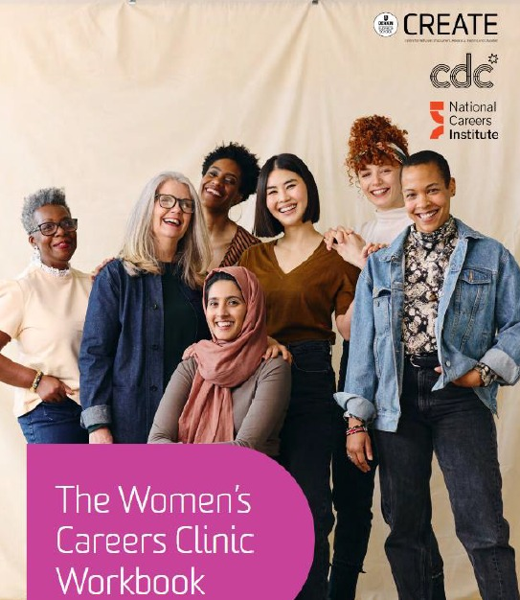

University of South Australia (South Australian Academy for Gender Equity in STEM)
Need
Despite a push towards getting women into STEM careers, there is a severe drop off in women’s participation in STEM early in their careers. The reasons for this are complex and nuanced but highlight a critical need for support in women’s high school and the early career years.
Approach
Our methodology diverged from traditional approaches due to the limited impact recognised by previous programs targeting gender equity in STEM. This realisation necessitated a different kind of intervention, prompting the establishment of the South Australian Academy for Gender Equity in STEM (SAAGES). This program developed creative confidence in girls by allowing them to generate innovative solutions to real world STEM problems, while building their personal STEM networks.
Impact
Approximately 200 girls and women directly benefited from the Think Tanks course and creative challenge. The report likely impacted a larger number of women beyond the project's scope. The press release attracted 35 stories, including print items and radio interviews, benefiting women across Australia. Coverage analysis found that these news stories reached a cumulative potential reach of over 1.2 million people. 'Inclusive Leadership Through Mentoring' is a self-sustainable online course with biannual intakes for the next three years. Interest and waitlist of mentees have increased the number of women impacted by the course, equating to around 120 women over three years. The creative challenge attracted 160 girls from 18 schools in 2023.
Case Study
The online mentoring and leadership development course – Inclusive Leadership Through Mentoring – is currently in progress. One participant said she was motivated to join the course because: “I'm looking to develop the skills and mindset needed to create more diverse, equitable and inclusive teams where everyone can thrive by learning from mentors who prioritise inclusivity and equity". Another student explained that her motivation was, “exploring the prospect of leadership early in my career will allow me to determine if leadership roles are what I am interested in doing long-term".
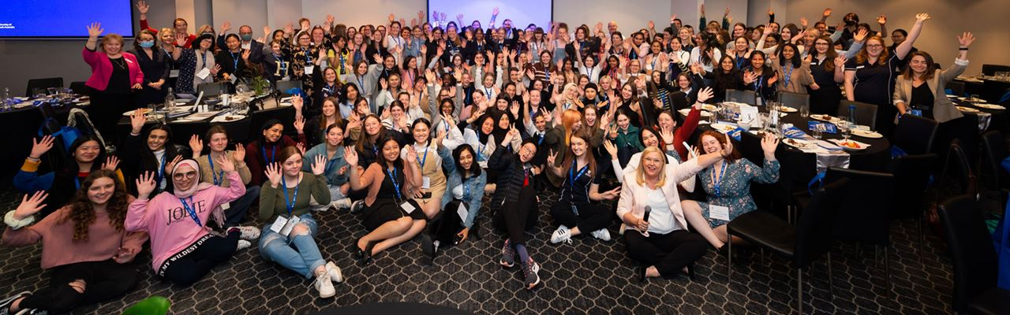
A research report was developed as an output for this project. Key findings are summarised in the graphic below.
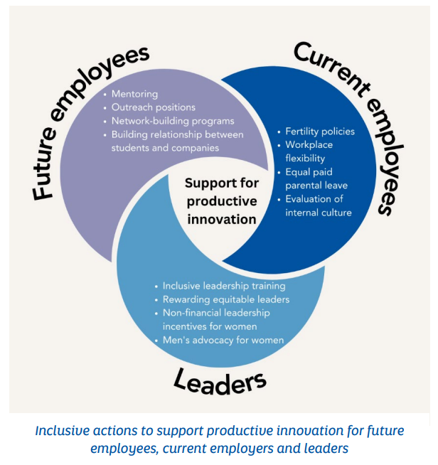

Highlands Local Learning and Employment Network Inc (Ballarat Try a Trade)
Need
The NextGen Tradies ‘Try a Trade’ program was a pilot program developed after Highlands Local Learning and Employment Network Inc. (HLLENI) identified a clear need to increase the participation of women in trades across Victoria. The need for this project came from identifying that 2% of females are represented in Traditional Trades in the Victoria region.
Approach
For this program, HLLENI travelled to schools and engaged female students in activities that allowed them to experience a ‘day-in-the-life’ of tradies. This included travelling to schools, facilitating presentations from people in trades, providing participants with work uniforms and ‘tradie style’ lunches, and the building and painting of a mini house on a single day. The original aim was to undertake this program with six schools, however HLLENI ended up delivering the program to over 13 schools and 154 female students.
Impact
Through this program, HLLENI were able to achieve a 15% increase in students entering the construction industry or changing career pathways. This was determined by surveying students after the activity to gauge their willingness to give a trade a try after participating in the full-day experience.
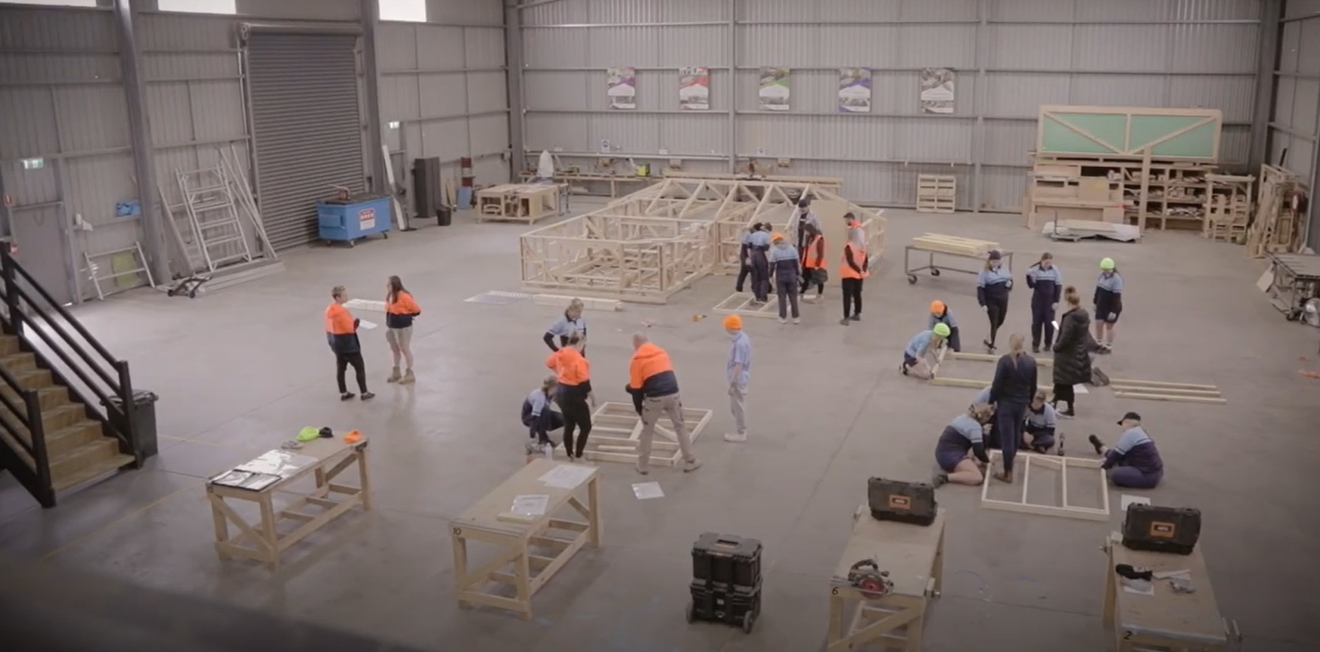
Case Study
The NextGen Tradies ‘Try a Trade’ program gave students the opportunity to learn key aspects of a work environment focusing on diversity and equality but also encompassing the hands-on component of building a walk-in mini house with facilitators. During the project, students received the opportunity to try different tools needed to build a house and experience hands-on skills, as if on a real construction site. Upon completion of the mini house, another workshop in painting was undertaken by students on a separate day to learn how to paint their mini house effectively.
During this program, students received the opportunity to understand their capabilities and the job outcomes available to them, regardless of gender. Upon completion of the program, students were provided with a Certificate of Completion along with a voucher for further one-on-one career consultations through face-to-face or phone discussions. With a limited number of work experience opportunities available to students in trades, the NextGen Tradies Try a Trade program enabled students the opportunity to get on the tools and learn skills while potentially finding a new love for carpentry or painting.

From the 15 programs run during this program, HLLENI identified that 15% of students who completed the program had successfully chosen a pathway or new direction in VET courses relating to their chosen trade field and included an apprenticeship or traineeship upon leaving school. Their evaluation of the program determined that, of the students attending the program per day, 99% of students thoroughly enjoy the day and would do it again if offered. Feedback from the schools and teachers has directly established the extent of the program by re-engaging disengaged and disinterested students back into school while helping the students to realise their future potential and driving them to complete a project that achieves self-worth. 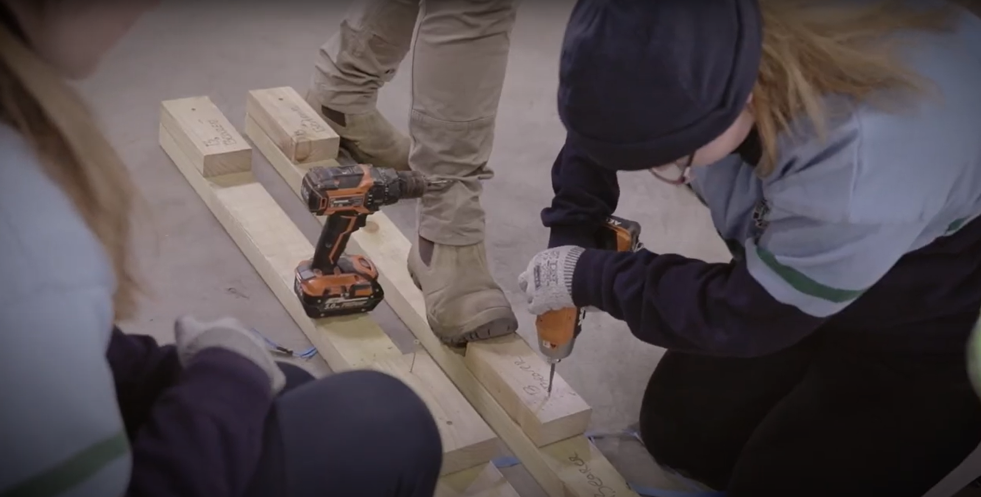

Round 4

Settlement Services International Limited (Youth Employment Planning Passport)
Need
The Youth Employment Planning Passport (YEPP) project provided high quality, locally informed career counselling advice and support to young people in three locations across Australia (NSW, VIC, and QLD). Young people in diverse circumstances need a high level of support above what is not offered in current services. The project was specifically tailored to meet individual needs that helped identify the young person's career goals and the planning required to meet the goal. Behavioural economic and capability approach concepts were used when consulting with young people and an increased engagement was evident. The project focused on supporting Year 11 and 12 students, but also included some disengaged Year 10 students.
Approach
Young people were supported through a five-phase program as they completed their personal Career Passport. Students interacted in both group sessions and one-on-one sessions and received a tailored, local career passport which assisted them in making informed career choices relevant to their skills, interests, and capabilities. The flexibility of the program meant students' specific needs were able to be targeted, and students were able to contact the facilitator for targeted assistance when needed.
Impact
The overall impact of the project has been significant, both to date and projected into the future. The YEPP program has provided guidance, mentorship, and resources to students who have faced academic setbacks, enabling them to explore alternative pathways and find success in their chosen fields. The projected impact includes increased student engagement, improved career outcomes, and a shift in the perception of success beyond traditional academic achievements. This project was innovative because it intervened before young people got in a downward spiral.
Case Study
Ray faced challenges in the school system and struggled to make progress academically. As a result, he enrolled in non-ATAR subjects at the Study Work school and joined the YEPP program to receive guidance and advice on career planning. Throughout the program's five stages, Ray actively engaged and learned valuable lessons. One key takeaway was that success comes in various forms and can be achieved through proper planning and mentoring.
Ray secured a carpentry apprenticeship after leaving school and through the program was encouraged to recognise the value of work experience. He developed the confidence to approach local employers, showcasing his skills and expressing his interest in a carpentry apprenticeship. Ray is currently supported by his YEPP advisor to understand his work rights, work culture, superannuation, and taxation to gain the knowledge needed to sign his contract with confidence. He will be starting as a full-time apprentice shortly and has been supported financially from the YEPP program to buy the necessary tools needed for his carpentry apprenticeship role.

SYC Ltd (Career Grit – Volition and Career Adaptability: Disengaged Young People)
Need
Career Grit was developed to fill an identified gap in youth services in Adelaide for young people aged 15-24 from disadvantaged backgrounds to access consistent, appropriate education and employment opportunities and advice. This included young people who experienced or were at risk of homelessness or the justice system, mental health issues, low levels of education completion, Indigenous, disability, and/or long-term unemployment.
Approach
SYC developed posters to advertise the new program to young people. The team also visited several schools, youth services, housing programs and communities to deliver promotional material and provide information about the project. Several student visits to ‘The Foundry by SYC’ were also scheduled as an opportunity for professionals to present background on their work and to discuss career pathways with participants. In addition to these visits, there were also excursions to local business and individual coaching sessions that were delivered to students to reflect on their strengths and interests and how these could be applied in a work setting.
Impact
The Career Grit project received a total of 63 referrals, out of which 48 young people actively engaged in the service delivery. 24 young people achieved an employment outcome, such as paid work, work trial or traineeship, and 4 young people re-engaged in education. Partners to this project were able to engage with young people from disadvantaged backgrounds and learn about their individual strengths and abilities.
Case Study
19-yearold Harlow joined the Career Grit program at The Foundry by SYC in October 2022. Their initial thoughts were that it would be “just something to do… but they’re not going to make me get a job.” Fast forward to mid-February 2023 and it seems they were right. Harlow was not made to get a job, they simply wanted to get a job, and that’s exactly what they have done!
Throughout their time here at The Foundry, Harlow has engaged with enthusiasm and a positive attitude. They attended the group workshops, one-on-one appointments, and presentations by visiting employers, always showing an interest, and asking valid questions of our guests, even if they weren’t particularly interested in that particular type of work.
Harlow is now two shifts into their new role and is absolutely loving life. They have a brand-new uniform including pants, polo shirt and boots, and even a fresh new haircut free of charge thanks to the partnership with Archie & Co. Life is good with Harlow saying after their first week on the job “It’s really changing me into a better person. I’m a lot more productive with my time. I’m excited for the future” and added “I couldn’t have done it without The Foundry, I love it there!”
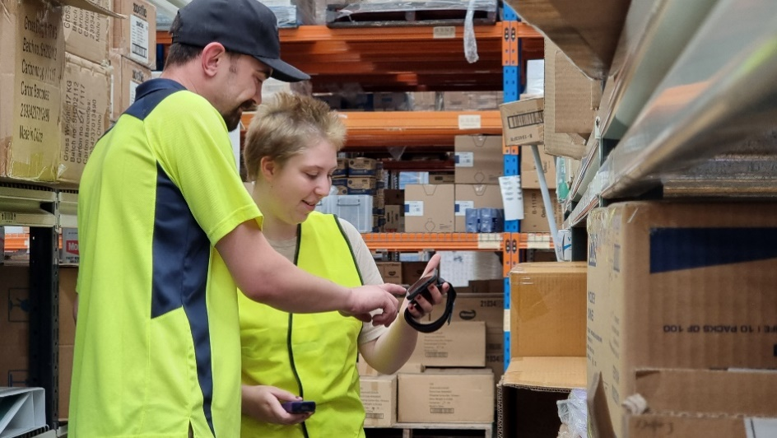

Breakaway Aboriginal Corporation (Career Dimensions through self-exploration and collaboration)
Need
Key barriers identified in career development for disengaged youth aged 12-17 included a lack of understanding about different personality types, including their own, and issues communicating with employers. The focus of this program was to provide young people with a safe space and the support to understand themselves, careers of interest, and how to communicate effectively with potential employers, including any issues that may arise in the workplace.
Approach
Disengaged students were invited to the program through word of mouth and an expression of interest interview process. During the program, students, some of which had been disengaged from school for three years, participated in short group sessions that were split across several days. They were also introduced to a Career/Personality Dimensions® tool which better helped them to understand their personality and explore careers to match. A career taster event was also organised for participants through TAFE.
Impact
All participants received an improved awareness of themselves, their careers of interest and also developed skills that will give them more career opportunities. Additionally, students have a better understanding of different personalities they may experience in the workplace and a better understanding of interacting with people with opposite personalities.
Case Study
Personality Dimensions Breakaway held a stakeholders’ event which resulted in the establishment of partnerships between Breakaway Aboriginal Corporation, Southwest Regional College of TAFE, and Jobs and Skills Southwest. These partnerships provided a platform for students to be involved in conversations on the process and enabled them to enrol into their desired career course at the South West Regional College of TAFE.

Conclusion
As can be seen in the above case studies, the Program was successful in meeting the desired outcomes of:
- Outcome 1: Enhance career pathways that helped the target audience to reach their full career potential.
- Outcome 2: Increase understanding of skills sought by employers.
- Outcome 3: Stronger collaboration in the delivery of careers information and advice
- Outcome 4: Improved quality of careers information and advice.
The projects delivered meaningful social benefits, especially to cohorts with complex needs who often struggle to access broader services.
The projects funded by this grant had a consistent theme of personalised support. This approach usually targeted small cohorts but had a profound impact on the individuals in those cohorts.
The partnerships created through this Program will continue to have an ongoing legacy, improving access to career development and career pathways for people in various stages of their careers. The projects funded through the Program added to the body of knowledge regarding career development delivery and allowed several approaches to be piloted to allow for insights and learnings to be developed.

- Project Summaries

Round 1
Recipient | Project Title | Description | State | Target Audience | Target career influencers | Target Cohort
Community Services Directorate | Understanding the Australian Building and Construction Industry | This project piloted a learning program that aligns with the Australian Curriculum and integrates industry perspectives to improve understanding of the General Capabilities for the Building and construction industry for Years 7-8 and further Work Studies for Years 9-10. Resources were made available to Australian schools as a product to adapt into existing and future subject delivery. Increased knowledge and understanding of the role of this industry in Australia’s economy, and the opportunities available, did support more students to consider a career in building and construction, in particular young women. This innovation has strengthened ties with industry to improve understanding and access to industry opportunities. | ACT | Secondary School | Career Advisers  Career Influencers  Parents/Carers/ Guardians  Teachers/Educators | Women
Co-operative For Aborigines Limited | Burawa- The National Indigenous Careers Centre based at Tranby | Burawa: Moving our Mob Upwards, National Indigenous Careers Centre based at Tranby provided a culturally relevant assessment of aptitude, and based on the assessment of appropriate career options, provided information and advice through career pathway mapping, leadership training, professional upskilling courses and culturally safe mentoring support to enhance the educational and career trajectories of Indigenous adults. | National | People at all stages of their career | None | Aboriginal and Torres Strait Islanders
Curtin University | National Career Development Learning Hub for Students with Disability | This project established the first dedicated national Career Development Learning (CDL) Hub for students with a disability. The CDL Hub created an accessible range of freely available resources and practical examples of programs that address CDL for students with a disability across the student lifecycle. To achieve this goal, the project team; 1) conducted a national audit of existing CDL programs across the educational life cycle; 2) leveraged the results of this audit, and outreach evaluation expertise, to identify best practice; and 3) trialled a series of pilot studies that built upon this empirical evidence to create case studies foregrounding best practice in the field. | NSW  TAS  VIC  WA | Primary School  Secondary School  Early Career | All | People with Disability
Federation University Australia | Careers in Everyday Industries: Potential Benefits of Increased Visibility | This research project examined career paths in retail and hospitality, and the attitudes towards them. These industries employ 20% of the workforce operating throughout Australia, yet the industries suffer from low prestige, affecting their choice as careers and the future prospects of workers in the industries. The project examined and made visible the careers that are available, the reasons for the low image of these industries, and researched awareness about careers in the industries among young people, adults, and those who advise them. It has improved the visibility of available careers and thereby helped those looking for work, assist career influencers, and brought associated societal and economic benefits. | National | People at all stages of their career | All | None
Graduate Careers Australia Limited | Careers Registration - Supporting Tertiary Education Career Development | The project strengthened career development in Australian tertiary institutions by promoting, supporting, and evaluating the sector-wide uptake of Careers Registration. Careers Registration is a proven innovative approach to career development now widely used in UK institutions and involves the inclusion of just three graduate employability focused questions into the student enrolment (registration) process for all new and re-enrolling students. Each year, longitudinal data is captured on individual students’ perceived state of career readiness progress and is used to engage students, especially students deemed at risk, with career management support. | National | Early Career | Teachers/Educators  Career Advisers | All
Institute of Public Works Engineering Australasia Queensland | Adventures in Engineering Take Science Innovation Stories into Schools | The Adventures in Engineering books project increased student interest in science developing real world stories of problems solved by engineers as engaging narratives for primary school aged children (Years 4 to 6). Based on solutions for real problems (‘What to do when the dam runs dry?’), our books were accessibly written narratives that engaged young people with examples of science in action, that’s allowed for an understanding of science in the context of potential adult futures, elevate engineering’s public profile and note the way it contributes to society and human wellbeing - to attract young people to engineering futures. | QLD | Primary School | Not Provided | Not Provided
National Association of Australian Apprenticeships Centres Inc. | PRIME – A Linked Ecosystem of Support for Vocational Pathways | PRIME has five elements which improved apprenticeship completions:  1. An assessment of suitability for different vocations based on job clusters and vocational pathways that interest an individual.  2. An intrinsic attitudinal assessment that predicts the individual’s ability to complete their chosen apprenticeship or traineeship.  3. Informed by recent local apprenticeship and traineeship commencement data plus the vacancies currently available.  4. Matched and supported by the local Gateway service of the individuals Apprenticeship Network Provider.  5. Engaging advisers and influencers. | National | Secondary School  Early Career | Parents/Carers/ Guardians  Teachers/Educators  Career Advisers | Women  Rural, Regional or Remote
Skillset Limited | Skillset CareerLink Central West | Skillset CareerLink Central West is a community based, regional career development service, partnering with RDA Central West that provided face-to-face guidance, information, and support to working aged people across the 11 LGAs of Central West NSW. The service featured 3 delivery streams:  1. CareerLink Hub - a careers centre in Bathurst, now providing a central point of coordination and a contemporary setting for hosting careers events, activities, and ongoing support.  2. CareerLink Mobile - solved a major service gap through our in-person, locally delivered, regional career development service.  3. CareerLink Community - demonstrating the value of career development through organisation of and participation in high-profile regional career events. | NSW | People at all stages of their career | Not Provided | Not Provided
TAFE Queensland | Defence to Civilian Transition Training (DCTT) Project | This project has offered a new way to provide training and career solutions for Australian Defence Force (ADF) members transitioning to civilian life across Australia. Transitioning ADF members can be faced with significant challenges adapting to civilian life. The DCTT Project has provided an informed, consistent, and national approach to address this challenge. This was achieved by providing one point of contact, a Defence Solutions Officer (DSO), for veteran and transition enquiries to TAFE in Australia. To make the process even more effective, the DSO has a significant background grounded in Defence, a personal ADF transition experience and has VET trade teacher experience. | National | Early Career  Mid-Career  Late Career to Retirement | Parents/Carers/ Guardians  Teachers/Educators  Career Advisers | All
The University of Adelaide | CareerSpark | The CareerSpark project created a web-based, interactive virtual experience, enabling users to interact with the simulated work environments and workers and get careers advice and information on education pathways into key industry sectors:  - Aerospace & Space.  - Shipbuilding & Defence Industries.  - Cyber & Big Data  - Allied Industries.  The project targeted the ‘pre-careers’ audience - 1.5 million students in Year 10 through to 2nd year undergraduate at University and VET. The project aimed to engage users in immersive virtual experiences and kick-start their career journey. This aimed to contribute to industry benefitting from a pipeline of talent for future business growth and education institutions seeing an increased take-up of STEM related courses. | SA | Secondary School  Early Career | Not Provided | Not Provided
University of Melbourne | Developing Students’ Life and Career Skills for Successful Workplace Entry | Employers have noted that young people need better employability skills to gain entry-level positions following school or initial VET training. This project developed a portfolio assessment tool for school and VET educators to help them assess young people’s employability skills and develop support materials for teachers to use to build these skills in school and VET classes. It also worked with employers to identify the employability skill requirements for entry-level positions in four industries and map these against the tool. The products from the project have helped educators enable young people to build the essential employability capabilities required for successful transition to employment in major industries. | NSW  VIC | Secondary School | Teachers/Educators  Career Advisers | None
Work Window Australia Pty Ltd | Work Window Virtual Reality Scaleup | Work Window’s innovative virtual reality (VR) career experiences aimed to help students understand and succeed at work. Work Window partnered with industry-leading employers to create virtual job shadowing using VR. The validated prototype has proven product-market fit, and with grant support aimed to deliver a feature-rich product to massively enhance the breadth and ease of early-stage career exploration for hundreds of thousands of students and job seekers across Australia. This project allowed Work Window to grow from a bootstrapped startup to a growth company working with hundreds of schools and universities to help them access better careers information that gives students real insight into different jobs so that they can make the right choices for their future. | QLD | Secondary School | Not Provided | Not Provided

Round 2
Recipient | Project Title | Description | State | Target Audience | Target career influencers | Target Cohort
AgCommunicators Pty Ltd | The SA Ag Careers Hub: Promoting Future Ag Opportunities | The SA Ag Careers Ambassadors program supported South Australian schools to showcase and raise awareness of agricultural (ag) careers and opportunities. The initiative was designed in response to skills shortages faced in the agricultural sector where there are currently five jobs for every graduate.  AgCommunicators partnered with colleagues at Urrbrae Agricultural High School, the Agricultural Science Teachers Association of South Australia (ATASA) and the University of Adelaide. The program focused on providing a support network and access to current resources around Agricultural work within SA. This included: linking students with TAFE and University opportunities; showcasing real-world agricultural careers through in-school visits and industry site visits; developing innovative ways of incorporating agriculture into a range of subjects (cross curriculum). The project also developed resources to support schools and developed a network of people who can talk in schools and share their stories. | SA | Secondary School | Teachers/Educators  Career Advisers | Rural, Regional or Remote
Ames Australia | Opening Minds, Building Futures - a Career Development Project | This project engaged, informed, and empowered young people to identify career goals and pathways, and built confidence in the advice given by parents and school influencers. AMES Australia and the Centre for Multicultural Youth (CMY) provided information sessions, workshops, and one-on-one career counselling to Years 7-10 students from Pasifika and South Sudanese communities in metropolitan Melbourne. The project supported 267 young people over 18 months through a strengths-based, co-designed and culturally sensitive approach - delivered by multicultural youth workers and career counsellors. The project has helped young people increase their confidence and knowledge of their opportunities, which led to structural changes in highly socio-economic disadvantaged areas. | VIC | Secondary School  Early Career | Parents/carers/ guardians  Teachers/Educators  Peers/Work Colleagues | Culturally and linguistically diverse (CALD)
Australian Capital Territory Council of Social Service Inc | ACT Health and Community Services Careers Hub: Know you made a difference | The ACT Health and Community Services Careers Hub has:  - increased knowledge and created greater awareness of career paths in the sector  - promoted a rewarding career change for mid-career professionals or people re-entering the workforce  - changed perceptions in the broader community such as parents, career advisers and educators about careers in our sector  - supported the sector workforce to develop and reach their full career potential  - highlighted the sector as a career aspiration for younger school children.  Impacts included an increased understanding of skills sought by the social services sector, increased number of people choosing to stay in or join the sector, and improved local collaboration between employers, training providers and the government. | ACT | People at all stages of their career | Career Advisers  Career Influencers | All
Central Queensland University | Excited 4 Careers in Agriculture | The Excited 4 Careers in Agriculture program improved the quality of, and access to, locally based, personalised career guidance for K-10 students in regional and rural communities. The agricultural industry offers many career pathways, however young people often do not know about the opportunities available to them in their local region. Partners in this project collaborated to develop and deliver innovative activities which provided quality career guidance about the range of skills needed for agricultural jobs in a local context to primary and secondary students. As a result, young people in regional and rural areas now know how to develop the skills required by local employers, enabling them to reach their career potential. | NSW  NT  QLD  SA  VIC | Primary School  Secondary School | All | Rural, Regional or Remote
Community Disability Alliance Hunter Incorporated | Peer2Peer | Peer2Peer provided innovative, locally based career guidance for people with disability, by people with a disability. The University of Newcastle adapted existing best practice in career guidance and peer mentoring to develop the Peer2Peer Model. Peer mentors delivered the model with peer mentees who were seeking employment, career change or development. The key activities included: model design and delivery, and engagement with industry and business. The key outcomes were: enhanced career pathways for people with a disability, increased employer understanding of the benefits of employing people with disability, and improved quality of career guidance. | NSW | People at all stages of their career | Peers/Work Colleagues  Teachers/Educators  Career Influencers | People with Disability
Community Migrant Resource Centre Incorporated | Career Pathways to Future Success | The project was a joint initiative of Community Migrant Resource Centre, HOST International and Glow Up Careers, and had five key areas of focus:  - supported parents from diverse backgrounds to access career information  - supported their children with pathway planning and access to information on future careers and education opportunities  - built capacity of young people as peer leaders in the areas of career coaching and mentoring  - brought interactive digital education and connection to both parents and their children to ensure they are future jobs ready  - connected parents and children from diverse backgrounds to industries in demand including STEM and VET pathways. | NSW | People at all stages of their career | All | Culturally and linguistically diverse (CALD)
Eurobodalla Shire Council | Creating Career Pathways | Through partners and the broader community, the Creating Career Pathways project delivered on a shared vision to strengthen community and individuals through the delivery of a co-designed progressive career guidance activities that supported a vibrant and diverse economy. The project improved access to higher education, lifelong learning and career development opportunities through programs that respond to our changing environment, building community resilience by focusing on continuous improvement and innovation to prepare for future challenges and growth. | NSW | Secondary School | All | Rural, Regional or Remote  Women  People with Disability
Glenelg & Southern Grampians Local Learning and Employment Network | Enhance Work Placement Experience for Everyone | The project has enhanced career education and work experience opportunities by increasing access for rural students to ‘industries of choice’ in larger communities. The project coordinator brought together a collaborative partnership between schools, Rotary, SWTAFE and the LLEN to identify and recruit Rotary host families to billet rural students in safe accommodation so they can have access to broader industry placements. The program provided specialist PPE and travel for work experience related requirements for students and a series of workshops for students, parents, and employers to build a greater understanding of the importance of work experience, employer expectations and VET pathways. Practical tools for host employers were also developed. | VIC | Secondary School | Parents/carers/ guardians | Rural, Regional or Remote
Holmesglen Institute | Uncovering Careers in Tunnelling and Underground Operations | The project raised the awareness of careers and career pathways in the tunnel construction and tunnel operation industries. The project developed interactive career tours, career pathway documentation and a mentoring platform to assist people preparing to enter the sector or those who have just commenced their career. There was an identified shortage of skilled workers and very little information available on careers and career pathways in the sector. The successful deployment of this project has assisted in meeting the employment demands of major tunnel construction projects planned for Victoria over the next 10 years. | VIC | People at all stages of their career | Career Advisers  Parents/Carers/ Guardians  Teachers/Educators | Women  Aboriginal and Torres Strait Islanders  Culturally and linguistically diverse (CALD)
Hume Employment Service Limited | SPI a Career - Students, Parents & Industry Promoting Careers to Years 7-10 | Kestrel, Wodonga Senior Secondary, Wodonga Middle Years, Mt Beauty and Beechworth Colleges partnered to deliver SPI A Career – a program that built career advice capability of parents through the Engaging Parents in Career Conversations (EPiCC) Model. It supported students to develop career portfolios using the Career Tools digital platform and encouraged careers in local skill shortage areas or roles that are less widely publicised through traditional careers channels. SPI introduced Year 7-10 students from low socio-economic areas to new industries at a point in their lives where they start making decisions that may impact their career options and integrated this into existing careers programs to ensure long term sustainability. | VIC | Secondary School | Career Advisers  Parents/Carers/ Guardians | Rural, Regional or Remote
Jobs South West Inc | Jobs South West Careers of the Future Program | The Jobs South West (JSW) Careers of the Future Program (COFP) developed a Career Related Learning (CRL) aspirational curriculum based on international best practice and research for primary school aged children and young adults. The program delivered extensive career services equalising the opportunities for learners, their peers, and families to understand the careers of the future in a very local context. | WA | Primary School  Secondary School  Early Career | Parents/carers/ Guardians  Peers/Work Colleagues | All
Moonee Valley City Council | Mamma’s Kitchen Co-designed Career Guidance for Migrant & Refugee Women | Effective career guidance for women from migrant and refugee backgrounds was tailored to be culturally relevant and to address the intersecting barriers to employment and job-seeking faced by this cohort. Building on the success of Moonee Valley City Council’s hospitality-focused work experience program, Mamma’s Kitchen Pilot Program, the Mamma’s Kitchen 2020, sought funding to create a co-designed career guidance program for migrant and refugee women. With combined interactive workshops with peer-mentoring and tailored support, the program empowered local women to improve their industry knowledge and networks and achieve their career goals in sectors of their choice. | VIC | People at all stages of their career | All | Culturally and linguistically diverse (CALD)
University of South Australia | University of South Australia Careers Compass | This project aimed to design and deliver a scalable and sustainable program to assist young people in Years 6 to 9 to develop the competencies of the Australian Blueprint for Career Development. The project aimed to co-design, develop, and roll out facilitated workshops for Years 6 and 8, and ‘units of work’ embedded in the Australian Curriculum for Years 7 and 9, with associated teacher professional development. All educational resources to be delivered in the project included a set of ‘personas’ highlighting the diversity of career paths and structures available. The project was locally focused, face-to-face, and supported young people in South Australia in their career development through the critical middle years of school. | SA | Early Career | Not Provided | Not Provided
University of The Sunshine Coast | Crystallising STEM Careers | The Crystallising STEM Careers project aimed to bring about systemic change in STEM career uptake by preparing Years 4-10 students to make informed decisions about engaging in STEM subjects at school, and future transitions into tertiary studies and STEM careers. The project aimed to achieve this via innovative STEM-focused career and technical education (CTE) delivered face-to-face in a series of lessons with students in schools and via interactive workshops for parents/carers. This project aimed to provide a unique and valuable opportunity for students and parents/carers in the South East QLD North, Wide Bay Burnett, and Central QLD regions, where previously these programs have only been available to students in low socio-economic government schools. | QLD | Primary School  Secondary School | Not Provided | Women
Wodonga Institute of TAFE | ABC - A Boost to Careers program | The project resourced and delivered an engaging careers program for junior students in isolated rural secondary schools within the Albury Wodonga Career Advisors Association (AWCAA) footprint of North East Victoria and NSW Southern Riverina. The program provided an immersive learning format; understanding of jobs, local industry, apprenticeships and traineeships, the VET sector, educational pathways and increase awareness of a range of occupations. Students identified their own strengths, found assistance in future selection of subjects, were linked to state career projects, and gained guidance towards relevant career choices. It formed a part of a suite of career guidance initiatives offered by Wodonga TAFE. | NSW  VIC | Secondary School | Career Advisers  Parents/Carers/ Guardians  Teachers/Educators | Rural, Regional or Remote
Workrestart Social Enterprises Ltd | Project reStart | Project reStart developed and implemented a suite of innovative career development interventions for offenders and their employers that lead to a higher proportion of ex-offenders successfully building careers and making a positive contribution to the communities in which they live and work. The project brought together people with an experience of incarceration, career development practitioners and employers to design and deliver career advice and educational activities that build competence, and enable self-determination needed for successful reintegration into meaningful employment. | QLD | Early Career  Mid-Career | None | Aboriginal and Torres Strait Islanders

Round 3
Recipient | Project Title | Description | State | Target Audience | Target career influencers | Target Cohort
Adelaide Crows Foundation Limited | Kuwa Circles: Safe spaces for Indigenous women in Career Education | Kuwa Circles, named for the Kaurna word for Crow, represents the Country and origin of the program. It explicitly addressed the challenges faced by Indigenous females in career education. The heart of the program was Circles discussion to create safe spaces to learn, yarn and work together on this career journey. The program improved career pathway education and engagement. Partners identified three weaves that underpin the core of the Kuwa Circles program: Connection, Curriculum and Careers. Each individual weave was drawn together through project activities to strengthen the Kuwa Circles and achieve improvements towards Indigenous women’s experience of careers pathways education and prospects. | SA | Secondary School  Early Career | None | Aboriginal and Torres Strait Islanders  Women
Aged & Community Services Australia | Discovering Aged Care Careers | This project aimed to deliver a sustainable framework to connect women to employment pathways, gain information and consider the diverse roles and career options available within the Aged Care Sector through the Industry Awareness Program, Career Discovery Days, Practical Experience Days, Women Leading Aged Care Series and Aged Care Workforce Innovation Network. This industry-led approach aimed to improve awareness of the diversity of job roles and career pathways available within the sector; a practical understanding of the skills and aptitudes sought by employers – right fit and skills for the right job; and aimed to enable employers and stakeholders in the employment supply chain to support and encourage women into jobs within the sector. | TAS | Early Career  Mid-Career  Late Career to Retirement | Not Provided | Women
Agrifood Industry Training Advisory Body Ltd | Manufacturing, Agrifood & Electrotechnology (MAE) Careers Pathfinders Project | The MAE project aimed to develop a current, relatable career data for the manufacturing, agrifood and electrotechnology industries. The project aimed to develop 20 job guides, 10 career/job specialisation flow charts and six podcasts. The project aimed to develop nine industry specific showcase days, of which two were by MAE industries combined with demonstrations from female industry leaders and practitioners. The project intended to organise a post showcase day career development services and to develop a showcase day toolkit for replication. The aim was also to develop 10 PD sessions interviewing female industry champions. The project benefited the MAE industries by increasing relevant, industry endorsed career data, strengthening partnerships & attracting new female candidates. | NSW | Not Provided | Not Provided | Women
Alstonville High School | Alstonville Female Leaders of Tomorrow | The locally focused program aimed to offer up to 50 female high school students the opportunity to connect with 40 female role models (from industry, community leaders, school alumni) across mentoring panels, one-on-one engagements, training workshops and an End of Program graduation ceremony. Topics were tailored to the needs spanning across pathways, stories/opportunities to strengthen local collaboration, overcoming barriers, and future skills. With industry, co-designed an innovative solution that will see us move from a paper-based approach of capturing information and engaging students, to one that enables greater visibility, usability, and the consolidation of knowledge and career resources for working aged women. | NSW | Secondary School | Not Provided | Rural, Regional or Remote  Women
Australasian College of Road Safety Incorporated | Road Safety – A Career Pathway for Women | The Australasian College of Road Safety (ACRS) partnered with the Australian Local Government Association (ALGA) and the Monash University Accident Research Centre (MUARC) to review career pathways for women into the field of road safety, and their professional development requirements. The project researched the skills and expertise required by employees, the professional development needed by road safety professionals, and the gaps in available education. The main outcome of the project was to create a partnership between industry, employers, tertiary providers, and local government to identify and establish a clear career pathway, with training requirements, for women to enhance their careers within road safety. | National | People at all stages of their career | Career Influencers  Teachers/Educators | Women
Australian Cricket Players Ltd | Smashing the Glass Boundary | Smashing the Glass Boundary improved the quality of, and access to, locally based, personalised career guidance for semi-professional female cricketers in Australia. Whilst the increased professionalisation of the women’s game is a launch pad for female cricketers to pursue multiple career pathways, many do not have access to quality career guidance that assists them to transition into the workforce. Partners in this project collaborated to build career guidance capacity within the Australian Cricketer’s Association (ACA) for female cricketers and to support women to access career pathways into non-traditional roles in the sport. As a result, female cricketers can now access quality career guidance that facilitates enhanced career pathways to reach their full career potential. | National | People at all stages of their career | Career Advisers | Women
Automotive Food Metals Engineering Printing & Kindred Industries Union | Careers for Women in Trades | This project provided targeted career development services which encouraged women and female students into trades through an innovative partnership between the Australian Manufacturing Workers’ Union (AMWU) and Bendigo Kangan Institute (BKI). The AMWU and BKI hosted Women's Networking Forums and worked with secondary schools in Broadmeadows, Bendigo and Geelong to encourage young women to consider trades and non-traditional careers. BKI provided Try a Trade Day workshops and the AMWU facilitated employer visits with local manufacturing companies in the Geelong region. Furthermore, women were encouraged to upskill, reskill, and develop their careers through career education and one-on-one coaching sessions. | VIC | People at all stages of their career | Career Advisers  Parents/Carers/ Guardians  Teachers/Educators | Women
Baringa Child Care Centre Incorporated | Early Learning Connection | Early Learning Connection provided an innovative and holistic career pathway into the early childhood education profession. The purpose was to create an individual-focused culture across the ACT Early Childhood Education and Care (ECEC) sector between the University of Canberra, Baringa Early Learning Centre, reputable training providers and employers. Women returning to work from a career break and working women seeking to fulfill their full career potential participated in career guidance and practical industry experience to explore flexible pathways into further qualifications. The collaboration of key stakeholders at the local level demonstrates a commitment to empower women in their careers and take action to address the skills shortage in a critical sector of the Australian economy. | ACT | Early Career  Mid-Career  Late Career to Retirement | Teachers/Educators | Women  Aboriginal and Torres Strait Islanders  Culturally and linguistically diverse (CALD)
Business in Schools Incorporated | Making Her Mark | ‘Making Her Mark’ targeted girls, women, non-binary, teachers, and parents, to strengthen their knowledge and understanding of career opportunities and pathways available in under-represented industries and non-traditional industries. The project inspired, educated, and encouraged girls and women to explore careers in non-traditional industries. The project included the development of an online ‘Making Her Mark’ kit, with resources and informative content from women in under-represented industries or roles, acting as ambassadors/role models to showcase careers, including video and written profiles. The project delivered three events: an official launch event and two regional showcase events with an audience of female secondary students, their parents, and teachers to foster direct engagement and awareness of career opportunities. The project led by Business in Schools Inc developed a number of partnerships with apprenticeships, universities, industry, education, and government organisations. | SA | Early Career  Mid-Career  Secondary School | Career Advisers  Parents/Carers/ Guardians  Teachers/Educators | Women  Rural, Regional or Remote
Business Services Network Pty Ltd | LEAP 2030 WRQ Leading Effective Action Program for Women in Regional QLD | LEAP 2030 WRQ mapped non-traditional tech and emerging career opportunities and skills in demand for women in three regional QLD locales, enhancing connections to industry & employers. LEAP delivered targeted support for school leavers, mid-career returners, as well as those transitioning into the workforce and seeking career uplift. LEAP’s Career Accelerator Connect Events presented local opportunities and industry information. 20 women in each locality undertook individual tailored coaching sessions, with personal support to build personal career maps. Participant data, case studies and The Career Personal Development Toolkit with tailored Local Opportunity Portfolios strengthened connections to local networks, a legacy and model for adaptation in other locations. | QLD | People at all stages of their career | Career Advisers | Women  Rural, Regional or Remote  Culturally and linguistically diverse (CALD)
Carers NSW Limited | Carer Career Guidance Project | The Carer Career Guidance Project supported women of working age whose careers are impacted by caring for a partner, parent, child or other relative who lives with a disability, mental illness, or health condition. It focused on young women aged 16-18 years as they transition into the workforce and women in their mid-to-late career who are seeking to transition back into, or increase their engagement with, the workforce following a change in their caring role. Drawing on the extensive evidence, expertise and reach of Carers NSW and TAFE NSW, the project provided individual, group based and audio-visual career guidance to women carers and support the career guidance sector to provide women carers with more tailored assistance. | NSW | Early Career  Mid-Career | Teachers/Educators | Women
Central Queensland University | Reframing Our Future | CQUniversity and Tomorrow Architects aimed to co-design an innovative program to help women realise their career potential. Through a six-week career development program, the intent was for participants to align their personal interests and skills to identify career clusters relevant to the future of work. The intent was for participants to increase their knowledge of skills required in emerging industries, participate in self-reflection and visioning workshops to identify ideal career pathways, and action next steps with professional career advisers.  The aim was to lead to greater gender equality as participants from the program leave ready to start work in their chosen field or upskill through micro-credentials, VET or Higher Education courses that propel them into employment. | VIC | Not Provided | Not Provided | Women
Chisholm Institute | Women in Business, Finance and Technology | The Women in Business, Finance and Technology program supported career pathways for women in non-traditional occupations within Melbourne’s southeast. The project’s components included a targeted marketing and communications campaign to build awareness of career options and pathways; mentoring and work experience opportunities through Chisholm’s partnership with EQUANS (an audio-visual technology company based in southeast Victoria); tailored career development, wrap around support; and transition support into further study or work. The outcomes of the project were to increase the number of women participating in business, finance, and technology courses, and to enhance non-traditional employment pathways for women. | VIC | People at all stages of their career | Not Provided | Women
City of Salisbury | Career Connections | This collaborative project saw us partner with the Northern Adelaide State Secondary Schools Alliance, Veterans SA, local industry, and community organisations to raise awareness of career pathways and opportunities for women in both traditional and non-traditional roles in STEM and local employment growth areas. The project delivered two forums: the first focussed on local Year 9 and 10 students and the second focussed on women whose careers may have been impacted by COVID-19 or who may be feeling vulnerable due to their personal situation. This project created strong links between industry, employers, schools, and tertiary providers leading to long term sustainable partnerships that support career pathways for women. | SA | People at all stages of their career | Teachers/Educators | Rural, Regional or Remote  Women
Cowboys Charity Limited | Education for Purpose and Empowerment of Women | NRL Cowboys House Girls Campus students aged 16-19 years participated in a series of supportive, and culturally safe conversations, workshops and experiences that built their knowledge, skills, and confidence in preparing for and securing work experience, employment, and financial independence post-secondary school education. These young women, who come from some of Australia's most geographically disadvantaged communities, call NRL Cowboys House home while they attend one of our 10 partner secondary schools in Townsville during the school year. NRL Cowboys House is the Cowboys Community Foundation’s flagship initiative. | QLD | Secondary School  Early Career | Teachers/Educators | Aboriginal and Torres Strait Islanders  Women  Culturally and linguistically diverse (CALD)  Rural, Regional or Remote
Curtin University | Facilitating Career Sustainability and Economic Empowerment of RRR Women | This project aimed to equip Regional, Rural and Remote (RRR) women with the required capabilities and knowledge to take ownership of their careers as a pathway to short and long-term career sustainability and economic independence. A team of experts from academia, industry and local community groups aimed to facilitate a series of targeted workshops to maximise participant learning outcomes and impact. The series of workshops aimed to equip participants with a 'career-ready' toolkit as a platform for career sustainability and economic empowerment. Industry and peer-mentoring and facilitation of a community of practice would ensure the project’s longer-term sustainability for locally informed career guidance, collaboration, and support for RRR women in WA. | WA | People at all stages of their career | Not Provided | Rural, Regional or Remote  Women
Deakin University | Careers Guidance and Support for Women from Migrant Backgrounds | This project involved the development, delivery, and evaluation of online career clinics for women from migrant backgrounds who have experienced career interruptions caused by the COVID-19 pandemic, relocation from overseas, family career breaks, relationship breakdowns, or family violence. Specifically, the clinics provided career guidance to unemployed migrant women and help them obtain meaningful employment commensurate with their skills and experience, with the support of a mentor. The clinics targeted participants across multiple states and will be developed based on the experiences, capacities, and latest research insights of the team at Deakin University and its partner, the Career Development Centre. | ACT  NSW  NT  QLD | Early Career  Mid-Career  Late Career to Retirement | None | Women  Culturally and linguistically diverse (CALD)
Future Women Pty. Ltd. | Project Return | Project Return was an innovative, digital program that supported women returning to work. Project Return gave women the confidence, knowledge, and connections they need for a rewarding and secure career. Project Return was delivered in partnership with Future Fit to 150 women who have been outside of paid employment because of caring responsibilities. Participants had access to activities, workshops and career advice delivered flexibly and tailored to meet their specific needs. | National | Early Career  Mid-Career  Late Career to Retirement | Parents/Carers/ Guardians  Peers/Work Colleagues | Aboriginal and Torres Strait Islanders  People with Disability  Women  Culturally and linguistically diverse (CALD)
Gippsland Group Training Limited | AGA present career-focused symposiums - Gippsland Women in New Careers | AGA delivered Women in New Careers (WiNC), with 12 career-focused symposiums for women aged 16-64 in four Gippsland locations. It focussed on alternative career pathways and transferable skills identification in three key industries – health/community services, construction, and agriculture/forestry. Participation was open to women at various stages of their career - with a focus on career starters, women returning to work and women looking to change careers. Our Program Coordinator connected with employers, industry, schools, and other partners. Our Career Development Consultants (CDCs) arranged one-on-one sessions after each symposium and developed a clear plan, allowing the participants to map their career journey within these industries. | VIC | Mid-Career  Secondary School  Early Career  Late Career to Retirement | Parents/Carers/ Guardians  Peers/Work Colleagues | Women  Rural, Regional or Remote
Gordon Institute of TAFE | Women’s Career Pathways Program (WCPP) | Funding was used to deliver five rounds of a five-week Women’s Career Pathways Program (WCPP), reaching a target of between 50-75 women in total. The program provided careers guidance, embedded skills tasters, and wrap-around mentoring support to women from diverse backgrounds at different self-identified levels of employment readiness, using the CEAV Employment Readiness Scale and informational interviews with a dedicated WCPP Program Coordinator. This program addressed key barriers to women obtaining high-quality and up-to-date careers information and guidance, including lack of access to appropriate and affordable child-minding facilities, digital technology, and issues related to individual’s self-efficacy and confidence levels. | VIC | Early Career  Mid-Career  Late Career to Retirement | None | Women  Culturally and linguistically diverse (CALD)
Green Fox Training Studio Limited | JumpStart for Women - Victoria | Green Fox Studio is an award-winning, full-service creative agency that has been operating Australia’s first not-for-profit graphic design training studio inside a high-security men’s prison in Queensland. We have trained nearly 200 detainees in graphic design, 3D modelling and animation and professional skills, and achieved a recidivism rate of just 3% (compared with the national average of over 40%). In reducing crime and recidivism in 2022, we aimed to open a studio inside a women’s prison in Victoria, where our proven training model will provide women in prison with the technical training, education, and social support resources they need to secure meaningful employment and build positive lifestyles away from the criminal justice system. | SA  VIC | Early Career  Late Career to Retirement | None | Women
Heaton Communications Pty. Ltd. | C2 - Create & Collaborate - Careers for Women | Career visualisation and Career Hack program involved co-designed events with corporates, leading to a better understanding of the scope of opportunities within businesses as well as enhancing access to career pathways. | NSW  VIC | Early Career | None | Women
Highlands Local Learning & Employment Network Inc | Ballarat Try a Trade - Careers Hub and Industry Experience Program | The NextGen Tradies Try a Trade program established a Careers Hub that nurtured young women aged 16-24 years old and encouraged, informed, and equipped them to consider non-traditional careers. Backed with an Industry Experience Program, the program targeted a minimum of 154 interested students from 13 schools to participate in a hands-on experience in the construction, automotive, electrical, and plumbing industries. | VIC | Early Career | None | Women  Rural, Regional or Remote
La Trobe University | Futureproof Career Development for Female Migrants | This collaborative project aimed to develop a career development program to support working-age migrant women who have experienced career breaks, work in non-traditional occupations, or need to reskill due to a career change. This project leveraged the educational and mentorship resources offered by the partners to develop a tailored program addressing the specific needs of female migrants. Synergising the partners' strengths, the project reached female migrants in different sectors and enhance their work readiness and employability through activities responsive to the industry needs of today and tomorrow. Those activities included; career advancement program, career hub, networking, and online career Expo. | VIC | Not Provided | Not Provided | Not Provided
Macquarie Community College | Skills4You | Empower2Work program is an innovative approach to integrate skills training with wraparound support for 90 vulnerable migrant women across the LGAs of Blacktown and Parramatta. The objective of the program was to empower women to acquire accredited qualifications and contribute to their community, through skilled employment in caring careers such as, aged care and childcare and disability care where significant skills shortages exist. The program integrated employment assessment, skills training, work experience with personal support (mentoring and case management) from social workers to address individual challenges; providing them with the skills, confidence, training, and career guidance, for sustained employment and improved quality of life. | NSW | Mid-Career  Late Career to Retirement | Teachers/Educators | Culturally and linguistically diverse (CALD)  Women
MAS National Limited | Supporting Migrant Women Into Employment (SMWE) | Migrant and refugee women in Greater Western Sydney regularly struggle to find and sustain employment. Quality career advice and targeted support has consistently been identified as a powerful and cost-effective tool. MAS National collaborated with four Migrant Resource Centres (MRCs): MetroAssist, Canterbury City Community Centre, SydWest Multicultural Services, and Community Migrant Resource Centre across the Greater Western Sydney Employment Region (ER) to provide their clients with one-on-one career guidance, peer support workshops and mentoring. In the process, MAS career counsellors worked with MRC case workers to build their capacity to provide effective career guidance and fully utilise existing quality resources, creating sustainable employment guidance. | NSW | People at all stages of their career | Parents/Carers/ Guardians  Teachers/Educators | Culturally and linguistically diverse (CALD)  Women
Motor Trades Association of QLD Industrial Organisation of Employers | Driving Auto Women’s Careers (DAWC) | Driving Auto Women’s Careers (DAWC) was designed to deliver an innovative approach to develop, guide and support careers for women in the automotive industry. Women at school, undertaking an apprenticeship or working in the trade have been and will continue to be educated on current and future career options through face-to-face and virtual meetings, presentations, and events. Led by an experienced industry Women’s Career Guidance Officer and mentor team, the project sought to entice women into an industry that is filled with opportunity and ensure those who were already working in the Automotive industry were supported to complete their qualification, change career direction, or undertake professional development to pursue promotion. | QLD | People at all stages of their career | Parents/Carers/ Guardians  Peers/Work Colleagues  Teachers/Educators  Career Advisers | Women
NEP Australia Pty Ltd | You Can't Be What You Can't See - Women in Sport Broadcast Technology | Women are under-represented in technical and technology roles in sports broadcasting. Statistics from NEP crew database total 2,217 crew of which 16.4% are women. You Can’t Be What You Can’t See aimed to illuminate career options and provide career guidance for women through a Work-integrated Learning (WIL) internship and mentoring program. This project aimed to set the foundation for a strong women workforce in Technology Broadcast roles leading up to and during the 2032 Brisbane Olympic and Paralympic Games. The project aimed to combine experience and diversity to develop career pathways for women by delivering authentic digital content and collateral to National Careers Institute, events, and tangible work experiences for women. | QLD | Early Career  Mid-Career | None | Women
PSK Environmental Pty Ltd | Career Pathways to Contaminated Land | As one of the only female led and dominated environmental consultancies in Australia, PSK was uniquely positioned to deliver a project that provided an opportunity for the upskilling and career development for Griffith University Science and Engineering Students who identify as women. The project delivered industry-relevant training opportunities through a number of practical workshops and built on university academic experience to best prepare students who identify as women for work in the contaminated land industry. Further, opportunities for work placement within PSK were offered in conjunction with workshop training. | QLD | Mid-Career | Teachers/Educators | Culturally and linguistically diverse (CALD)  Women
Royal Melbourne Institute of Technology | Encore: A co-designed career guidance program for women restarting in music | The Encore program aimed to produce innovative career guidance materials for women returning to music work after a career break. The music industry has ongoing issues of gender inequality, with little known about the current obstacles women face when returning to work in this area or how to overcome them. This project brought together expertise from key stakeholders (including employers, industry bodies, and women who have successfully restarted careers) to co-design training uniquely tailored to this industry. This local pilot program for Victoria has been readily adaptable for implementation in other states. Ultimately, women will acquire specialist knowledge, skills, advice, and education needed for re-entry and career longevity. | VIC | Mid-Career  Late Career to Retirement | None | Women
Royal Melbourne Institute of Technology | WOMENG - Women in Infrastructure Engineering and Construction | Australia is investing heavily in transport infrastructure as a way to boost economic growth, create jobs and ensure a sustainable development of the country. The Government is spending a record $110 billion in transport infrastructure projects over the next decade through its infrastructure plan. This project was able to promote the role of women in road and airport engineering through a partnership between RMIT University, AfPA as the peak industry body that represents contractors and suppliers responsible for building new roads and airports, and Austroads who represent the departments of transport of various states. The program offered two streams for creating awareness around career pathways and enhance partnership with industry. | VIC | People at all stages of their career | All | Rural, Regional or Remote  Women
Skills Strategies International Pty Ltd | Mandurah Multicultural Mentoring | The Mandurah Multicultural Mentoring program assisted migrant women in enhancing their career. The businesswomen from Businesswomen Australia completed mentoring training which may articulate to Certificate IV in Career Development. The mentoring explored the opportunities and barriers to career development and advancement for the mentor. Each mentor was supported with activities and debriefings by the highly qualified and experienced Skills Strategies International Coordinator and Career Development Staff. Mentors were trained in leadership, emotional intelligence, and support to operate effectively within the structured mentoring program. Mentoring skills would also transfer to business roles. | WA | Early Career  Mid-Career  Late Career to Retirement | Career Advisers | Women  Culturally and linguistically diverse (CALD)
Strategic Career Management Pty Ltd | Flourishing Careers for Women Leaders | Flourishing Careers for Women Leaders honoured the uniqueness of each individual while harnessing the power of the collective knowledge, skills, and networks of program partners. It assists mid-late career women in, or aspiring to, non-traditional roles to succeed by building their authentic career brand, clarity on career direction, professional presence, and voice. Further, it built ally/advocacy skills within organisations to support women to reach their full career potential. Participants had access to trained mentors and a peer cohort. Through workshops and masterclasses, career practitioners, a professional voice/presence coach and industry specialists took each participant through a process of learning to mastery. | WA | Early Career  Mid-Career  Late Career to Retirement | Peers/Work Colleagues | Women  People with Disability  Culturally and linguistically diverse (CALD)  Aboriginal and Torres Strait Islanders
Strategic Career Management Pty Ltd | Flourish Careers - Return to Work Program | Flourishing Careers Return to Work Program is a work re-engagement program for women aimed at parents of school-aged children. It is focused on empowering women to identify their skills, motivations, values and careers of interest; learn about the future of work; understand the non-traditional industry opportunities for women in the local area; identified career and education pathways; connected with local industry; increase understanding of and skills in career development to build capacity as ‘career influencers’ to assist their children and others to explore career pathways; and strengthen links between industry, community and local business. | WA | Early Career  Mid-Career  Late Career to Retirement | Peers/Work Colleagues | Women  Culturally and linguistically diverse (CALD)  People with Disability  Rural, Regional or Remote  Aboriginal and Torres Strait Islanders
The Intime Collective Pty Ltd | The World of Work – A Practical Program to Empower Women | This program was a multidisciplinary education and coaching program comprised of careers advice and on-demand, customised support designed to assist women in developing the skills employers are looking for now and, in the future, take control of their careers and design their work and life. It empowered women to harness their career potential, develop critical skills in communication, and provided information to make informed career choices and design careers that work. Through our partnerships with training providers and employer groups, this program spanned life design and identified career paths to pursue further education and placement in the workforce - supporting women and improving female workforce participation. | National | People at all stages of their career | Peers/Work Colleagues  Career Advisers  Teachers/Educators | Women  Culturally and linguistically diverse (CALD)  Rural, Regional or Remote
The Rural Woman Co-Operative Limited | Reactivating Women: Digital Mavens in Transforming Agriculture’s Future | Women comprise 32% of workers in agriculture (ABARES, 2021). Women are 51% of the Australian population and bring valuable skills to a workforce, such as building empathetic innovation driven systems and early adoption of technology. This gender gap in agricultural workforce participation is a missed opportunity. Through individually tailored career re-entry support, this project was able to increase agricultural workforce participation for women exiting childbearing years. Working with Dairy Australia, Australian Wool Innovation and University of New England, The Rural Woman provided coaching, role models, professional networking, and formal recognition of achievement with micro-credentials for 224+ women to secure a career in agriculture. | National | Mid-Career | Peers/Work Colleagues  Career Advisers | Rural, Regional or Remote  Women
University of Newcastle | Career Pathways for Women in Building Surveying & Quantity Surveying | This partnership project demonstrated viable career pathways for women in the building surveying and quantity surveying professions. The project developed and disseminated career information toolkits tailored to women, to showcase the diverse career pathways and opportunities in the construction industry where women are under-represented. In addition, scholarships, mentoring and memberships to professional bodies were awarded to female students at the University of Newcastle to support women to develop their careers. Increased participation of women in the construction industry that contributes to nearly a tenth of Australia's GDP and employs over 1.1 million people which has created a sustained career and leadership opportunities. | NSW | Not provided | Not provided | Women
University of South Australia | South Australian Academy for Gender Equity in STEM | A partnership between the University of South Australia (UniSA), HerTechPath, Trinity College and some of the state’s leading companies including, the South Australian Academy for Gender Equity in STEM (SAAGES) has enhanced career pathways for women and help them to reach their full career potential, particularly in STEM industries where women are under-represented. The Academy now provides intensive career support for women on a STEM education and career pathway. It used a student mentoring program as an authentic context for engaging women of working age in their own career development while also mentoring the student members of the Academy. | SA | Early Career  Mid-Career | None | Women
University of Southern Queensland | You’ve Got Mail: e-career-counselling for incarcerated women | You’ve Got Mail delivered evidence-based career counselling to incarcerated women in an innovative and engaging format. The project was delivered in partnership with Queensland Corrective Services. Before the project, female offenders had limited access to locally based career guidance but from this project, they have been provided access to career counselling by email. The key outcome was a digitally published e-counselling protocol, that guided five career counselling sessions. The e-counselling protocol guidelines and facilitation notes now support the career service being expanded to other Centres throughout Australia, thus ensuring greater access to quality career counselling for female offenders. | QLD | Early Career  Mid-Career | Not provided | Women
University of Technology Sydney | Addressing Digital Marketing Labour Shortages via Women Returning to Work | The joint project by the University of Technology Sydney, IAB Australia, Right Management Australia, and multiple digital marketing agencies aimed to address a major talent deficit in the increasingly important Australian digital marketing industry by assisting women, who are under-represented in digital marketing positions, re-enter the job market after a career break. The unique collaboration between higher education, industry associations, and individual firms provided digital marketing management workshops, technical training sessions, mentorship and coaching, and continual networking. Its outcomes focussed on assisting 25 women re-entering the job market, get jobs and address the talent and gender gap in a rapidly growing Australian industry. | NSW | Mid-Career | Parents/Carers/ Guardians | Women
Women in Technology WA (Inc.) | WiTWA+ presents ‘Techtrails Future STEM Jobs + Skills Initiative’ | This project improved the quality of, and access to, locally based career guidance for Years 10, 11 and 12 students in WA metro, regional and rural communities. The collective STEM industries offer many career pathways, however young adults often do not know about the opportunities available to them in their local region. Our project partners collaborated in workshops to develop innovative activities and solutions in providing quality career guidance targeting STEM skills and their importance. As a result, WiTWA delivered eight Techtrails Incursions with a goal of nurturing a generation of students who are not only well educated on the wide range of career options within the STEM environment but are highly motivated for change, who are not only well educated on the wide range of career options within the STEM environment but are highly motivated for change. | WA | Secondary School | Not Provided | Women  Rural, Regional or Remote
Work & Training Limited | Community Career Directions Tasmania – Disability home care careers in N/NW | Community Career Directions Tasmania (CCDT) delivered 47 career workshops in Tasmania. The project was managed by Work & Training (W&T), with further expert career support provided by MAS National (MAS) and consultation from Interact Australia (IA) and industry partner, National Disability Service (NDS). Further support was provided by employers, stakeholders, and schools in the regions. Participants were invited to experience working in their chosen roles via two ‘workplace experience’ sessions with one-on-one career guidance support to help with the next steps. | TAS | People at all stages of their career | People at all Stages of their careers | People with Disability

Round 4
Recipient | Project Title | Description | State | Target Audience | Target career influencers | Target Cohort
Action for Agriculture Incorporated | Action4Youth -Explore Connect Support to Thrive in Careers in Agriculture | The Australian agriculture and fisheries sectors produce 93% of the food we consume and has a strong outlook (with an 11% predicted growth by 2030). The sector plays a critical role in national well-being and global sustainable development. People are key to this success and as such, jobs and career opportunities are plentiful. This project brought together community groups, education, and industry to support disengaged, indigenous, and migrant youth to EXPLORE agriculture as a career, CONNECT with businesses for job opportunities, and receive individually tailored SUPPORT including entry-level and life skills to transition to the workforce. The project delivered a holistic approach that any school, community, or local employer can reference. | NSW  QLD | Secondary School  Early Career | Career Advisers  Teachers/Educators | Aboriginal and Torres Strait Islanders  Culturally and linguistically diverse (CALD)  Rural, Regional or Remote
Breakaway Aboriginal Corporation | Career Dimensions through self-exploration and collaboration | This program provided young people with a safe space and the appropriate support to understand themselves, careers of interest and how to communicate effectively with potential employers, including any issues that may arise in the workplace. Further key activities included relevant support agencies and stakeholders, family members, and potential employers. The project delivered workshops, which outlined and highlighted the program’s benefits, including an insight into the Career/Personality Dimensions® tool, where participants could explore their personality traits and characteristics further. | WA | Secondary School  Early Career | None | Aboriginal and Torres Strait Islanders
Compact Incorporated | Next Level Careers: Early Childhood Education and Care regional partnership | Next Level Careers: Early Childhood Education and Care (NLC-ECEC) pilot program is a regionally focussed career development industry partnership with NSW Riverina Murray early childhood services. The project addressed rampant workforce shortages by inspiring local youth aged 15-24 years not engaged in employment, education, and training (NEETs) and/or at significant risk of disengagement at school due to impacts of COVID-19, to commence entry-level careers in ECEC. Participants gained essential industry-endorsed work ready skills to support Traineeship applications and built a skilled workforce to enable regional economic participation. Employers benefit by influencing the development of their potential future workforce. | NSW | Early Career | Not Provided | Rural, Regional or Remote
JT Academy Pty Ltd | JTSucceed | JT Academy employment pathway program aimed to instil confidence, courage, and self-belief within the career pathway journey in our Nation’s youth aged 15-24. In collaboration with industry, employers, and education, the project aimed to empower young people to be their own champions and be motivated to drive and own their career journey. Utilising Johnathan Thurston’s role modelling brand for youth engagement and impact, particularly First Nation communities, the JTSucceed program aimed to enhance the employment eligibility of young people by collaborating with employment partners, providing powerful workshops, and delivering firsthand knowledge on current employability trends to benefit our youth for their futures. | QLD | Secondary School  Early Career | Not Provided | Aboriginal and Torres Strait Islanders
Lives Lived Well Ltd | Nurture Youth Training and Employment Project | The Nurture Project offered access to targeted, high quality career guidance and Life Skills development for young people (ages 15-24 years) who are disadvantaged and/or disengaged from education, training, or employment. Nurture is an established working farm which operates as a social venture. It offers access to a practical learning and work experience environment, coupled with intensive Individual and group supported career pathway guidance. The overall outcomes of the project were reduced welfare dependency, built resilience, and promoted lifelong health and wellbeing. | QLD | Secondary School  Early Career | Not Provided | Not Provided
Settlement Services International Limited | Youth Employment Planning Passport | The Youth Employment Planning Passport (YEPP) project provided high quality, locally informed career counselling advice and support to young people in three locations across Australia. In partnership with the PCYC the project worked with young people in-school and in the community to complete a personalised Career Passport, build skills and bring together a range of localised experiences relevant to their careers. Training experts AWT supplemented this with practical skilling advice. Young people have also benefited from support that identified their goals and aspirations, educated them on work and study options in the community, built local connections, provided work experience as appropriate and skills them to identify and manage career pathways. | NSW  QLD  VIC | Secondary School  Early Career | Peers/Work Colleagues  Teachers/Educators  Parents/Carers/ Guardians | Aboriginal and Torres Strait Islanders  People with Disability  Women  Culturally and linguistically diverse (CALD)
SYC Ltd | Career Grit - Volition and Career Adaptability: Disengaged Young people | SYCs Career Grit project has enhanced the ability of disengaged young people to explore and make career decisions. Collaboration with partner employers has source role-models and opportunities to learn about different careers/industries. Workshops were built by each young person’s agency and strengths-based thinking. One-on-one coaching supported personal development and career exploration activities. Consistent with the framework of the Australian Blueprint for Career Development (ABCD), there was an intentional focus upon work volition and career adaptability, supporting young people to move from an ‘I can’t’ to an ‘I can’ and ‘I will’ mindset to create career pathways and achieve their full potential. | SA | Secondary School  Early Career | None | Aboriginal and Torres Strait Islanders  People with Disability  Women
Tablelands Regional Council | Tablelands Tomorrow | Tablelands Regional Council (TRC) in conjunction with its Project Partners and Community Supporters offered individualised career support, advice, and guidance to the local community, with a particular focus on local industry needs in primary industry, health, and social assistance. Targeted cohorts included school age students in Years 9-12 at risk of not finishing their education and unemployed young persons (aged 15 to 24), including those whose careers have been impacted by COVID-19 or because of being women, disengaged youth, Indigenous persons, or migrants. | QLD | Secondary School  Early Career | Parents/Carers/ Guardians | Aboriginal and Torres Strait Islanders  Women  Culturally and linguistically diverse (CALD)
Whittlesea Community Connections Inc | Supported Work & Learning Opportunities for Young People in Whittlesea | This project supported young people disengaged from education, unemployed, impacted by COVID-19, migrant and Aboriginal and Torres Strait Islander young people to access careers information and supported and developed the skills they need to obtain work in the local job market. Careers information was provided to at-risk students through local secondary schools, supported by Melbourne Polytechnic. Young people also had the opportunity to learn more about different career pathways through workshops and industry-based placements in partnership with Shared Cup, Belgravia Leisure, 2 Bros Construction and Whittlesea Community Farm. Mentoring support was provided to young people addressing needs in a holistic and coordinated way. | VIC | Secondary School | Teachers/Educators  Career Advisers | Aboriginal and Torres Strait Islanders  Culturally and linguistically diverse (CALD)

Version History
Version | Description of change | Author | Effective date
V1.0 | Initial draft | Noetic | 30 June 2023
V2.0 | Amended document to incorporate feedback from grant recipients on case studies featured in this report.  Updated figures related to Project Type, Priority Areas, and Target Cohort. | Noetic | 14 July 2023
V3.0 | Amended document to incorporate feedback from the NCI. | Noetic | 4 August 2023
V4.0 | Corrected the tense for some of the project descriptions in Annex A. | Noetic | 29 August 2023
V5.0 | Edits to update information | Noetic | 29 September 2023
V5.1 | Edits to improve readability | DEWR | 23 October 2023
V5.2 | Formatting edits, update to contents table and removal of DRAFT watermark | DEWR | 23 October 2023
V5.3 | Minor edits to improve readability | DEWR | 2 November 2023

'Cohort' in this report means a group of people who the Program intended to provide benefits to.
Best efforts were made to follow up with grant recipients to complete the survey.
All projects were given an opportunity to participate in an interview.
Whiston, S. C., Li, Y., Goodrich Mitts, N., & Wright, L, (2017), Effectiveness of career choice interventions: A meta-analytic replication and extension, Journal of Vocational Behaviour, 100, 175–184.
Career Industry Council of Australia & McCrindle, The Role of Career Practitioners in Our Schools, https://mccrindle.com.au/insights/blogarchive/the-role-of-career-practitioners-in-our-schools/
Year 13, After the ATAR, https://cica.org.au/wp-content/uploads/Y13_YS_ResearchPaper.compressed.pdf
Work Institute, 2017 Retention Report, https://cdn2.hubspot.net/hubfs/478187/2017%20Retention%20Report%20Campaign/Work%20Institute%202017%20-Retention%20Report.pdf
‘Other’ refers to the representation of STEM with the two projects being “South Australian Academy for Gender Equity in STEM” and “WiTWA+ presents ‘Techtrails Future STEM Jobs + Skills Initiative’.”
[Most of these findings under the women heading?] were from the research conducted through the South Australian Academy for Gender Equity in STEM project delivered by the University of South Australia. A case study on this project can be seen on page 29.

