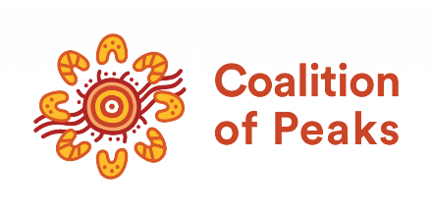

First Nations VET Leadership Roundtable 2

***Co-Chairs***

The Coalition of Peaks

The Commonwealth Department of Employment and Workplace Relations

*with*

State based First Nations Partner organisations

State and Territory Skills Officials

First Peoples Disability Network

Lowitja Institute

First Nations Media

Alliance of First Peoples Independent Education and Training Providers (AFNIETP)

Secretariat for National Aboriginal and Islander Child Care (SNAICC)

National Aboriginal and Torres Strait Islander Health Workers and Health Practitioners (NAATSIHWP)

National Indigenous Employment and Training Alliance (NIETA)

Indigenous Allied Health Australian Government (IAHA)

National Aboriginal and Torres Strait Islander Education Council (NATSIEC)

National Aboriginal Community Controlled Health Organisation (NACCHO)

National Native Title Council

National Family Violence Prevention and Legal Services

First Nations Languages Australia

Commonwealth Department of Health and Aged Care

Commonwealth Department of Education

National Indigenous Australians Agency

The roundtable was facilitated by Clinton Scott-Knight, a Wiradjuri/Ngunnawal man from NITES Consulting.

# CO-CHAIRS' MESSAGE

**First Nations Partner Organisations and Federal, State and Territory Government Skills Officials partner for the second First Nations VET Leadership Roundtable.**

On 7 June 2024, Federal, State and Territory Government Skills Officials and First Nations Partner organisations met for the second time this year, for a roundtable on First Nations Vocational Education and Training (VET). This was a virtual event co‑chaired by Ms Catherine Liddle, Acting Lead Convenor of the Coalition of Peaks (Peaks), and Ms Anna Faithfull, Deputy Secretary of the Commonwealth Department of Employment and Workplace Relations (DEWR) Skills and Training Group, from the DEWR office on the lands of the Kulin Nations, on Wurundjeri Country.

The co-chairs opened the roundtable by reaffirming that this work together is an obligation of the National Agreement on Closing the Gap and Peaks need to be included in every step of the journey. These arrangements are necessary so that the National Skills Agreement fully realises all Priority Reforms of Closing the Gap, and improves outcomes for First Nations learners, families and communities.

**‘*We’re here to design a VET system together that delivers on both the National Agreements for Closing the Gap and Skills, and which honours the vision of our mob’*.**

*Co-Chair, Ms Catherine Liddle (Peaks)*

***‘Thanks to everyone for attending…. it’s a real signal of your commitment… our true intent is to have a collective approach and be as enabling as possible’.***

*Co-Chair, Ms Anna Faithfull (DEWR)*

Themes from the discussion at the roundtable are outlined below:

## Partnership, shared decision making and stewardship

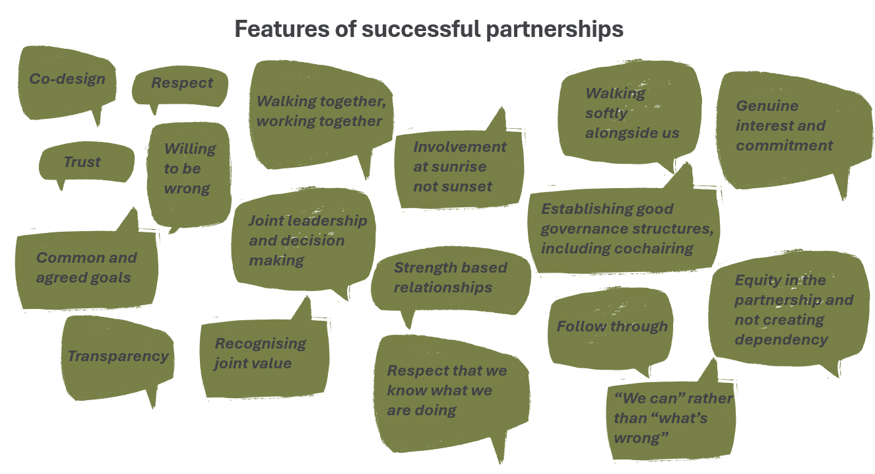

Participants expressed a desire for greater transparency and clarity of how Partnership in the VET and Skills space operates. Such stewardship requires urgent, concerted effort at both the national and jurisdictional levels, so governments and Peaks can participate in shared decision-making on systemic reform in VET and Skills.

## Establishing a First Nations VET Interim Partnership Committee

Participants agreed a next step to enable progress is to quickly establish the First Nations VET Interim Partnership Committee as a mechanism to:

* design and establish a national VET and Skills Policy Partnership, building on the strengths of existing governance structures, networks and relationships.
* provide a forum to address critical priorities raised at both roundtables, including support to sustain and build the ACC RTO sector.

## Stabilising and supporting ACC RTOs

Many voices collectively echoed that a high order issue the First Nations VET Interim Partnership Committee must address is the urgent need to support the ACC RTO sector, with a long-term goal to secure support for these organisations. It is also vital that mainstream organisations, including TAFEs, continue to improve their capacity to deliver culturally responsive services for First Nations students, communities and employers.

## Keeping First Nations VET students at the heart of our work

The virtual roundtable allowed for an opportunity to share views on what success looks like in the VET and Skills space for First Nations students. For example, there were differences in opinion on whether the continued empowerment of First Nations learners, First Nations training providers or employers and industry should be the focal point of this work. Ideally, the right governance would include all three as attention areas, and can discern the best ways of making the right policy and program connections and system improvements.

***‘We need to be mindful not to just fall back into default relationships and make this a box ticking exercise – we are being challenged to work differently together.’***

*Co-Chair, Ms Anna Faithfull (DEWR)*

***‘We vote with our feet, if we’re still in the room, there’s a reason we are here.’***

*Co-Chair, Ms Catherine Liddle (Peaks)*

The next step will be formalising the Interim Partnership Committee to progress key priorities in August 2024. This interim committee will then develop a nationally networked Policy Partnership. The Roundtable, with its broader membership, will be re-convened later to keep conversations and connections growing across the skills and training sector.

**7 June 2024**

**More information on the National Skills Agreement can be found here** [www.dewr.gov.au/skills-reform/national-skills-agreement](http://www.dewr.gov.au/skills-reform/national-skills-agreement) **and the National Agreement on Closing the Gap can be found here** [www.closingthegap.gov.au/national-agreement](http://www.closingthegap.gov.au/national-agreement)