

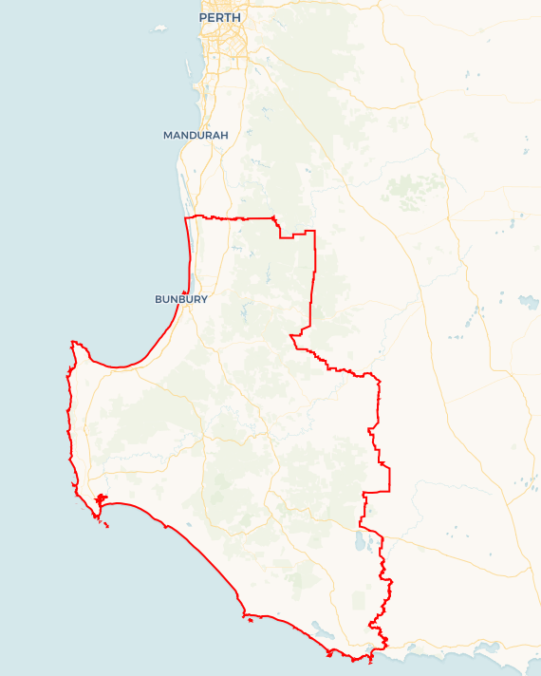Local Jobs Plan

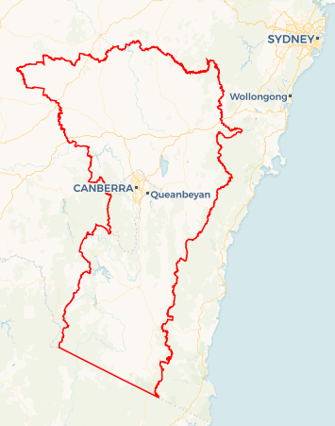

**SAMPLE MAP ONLY**

A map of your Employment Region and hyperlink will be added before publishing.

South West ****Employment Region**** | Western Australia | ****August 2024****

Workforce Australia Local Jobs (Local Jobs) is a program that supports tailored approaches to accelerate   
reskilling, upskilling and employment pathways in response to current and emerging local workforce needs.

## Local Jobs elements

### Local Jobs Plan

The Local Jobs Plan sets out the skills and employment challenges and priorities of the region, and associated strategies that will drive the design and implementation of activities to be implemented to address these challenges.

### Employment Facilitators

Employment Facilitators and Support Officers support the delivery of the program by bringing together key stakeholders including businesses, employment services providers, higher education and training organisations.

### Local Jobs and Skills Taskforce

Each Employment Region has its own Taskforce. Representatives include local stakeholders who have demonstrated experience in upskilling, reskilling, and an ability to represent, connect and collaborate with others in the region to meet labour market needs.

### Local Recovery and National Priority Funds

The Local Recovery Fund supports projects that meet the priorities identified in the Local Jobs Plan. The National Priority Fund provides funding for innovative local solutions to address structural barriers to employment.

Explore labour market insights for   
[South](https://labourmarketinsights.gov.au/regions/employment-regions/) West WA Employment Region

## Local labour market challenges in the region

* The current available workforce is mismatched to the skills requirements for the available jobs, especially with Net Zero Transforming Economy job roles becoming available now and into the future.
* High amounts of short-term, seasonal and casualised roles in industries such as horticulture, agriculture, hospitality and the care sector, meaning long term job security is not always able to be provided.
* Job exposure activities are limited and constrained due to administrative and/or legal considerations inherent within the provider/client relationship. This limits young people, long term unemployed individuals or people wanting a career change to be exposed to other industries.
* There is disparity between individuals expectations of employment and training and a business or training organisation’s expectation of an employee/student.
* Disproportionate employment difficulties for people with limited capacity to commit to full time employment such as but not limited to people with a disability, people with caring responsibilities, young people, people undertaking study.
* Loss of trained workforce to other locations such as the Pilbara and Goldfields mining communities (fly in fly out workers) to larger centres such as Perth.
* A small caseload consisting of individuals with challenges to employment such as lack of housing security, cost of living pressures, lack of a driver’s licence or other means of transport, mental health, fines and access to reliable technology or internet.
* High amounts of staff burnout and turnover in businesses means a reduced capacity to support new employees and turnover remains high.

## Local jobs and skills priorities and strategies in the region

### Priority 1 – Address complex challenges with a person-centred approach

#### What are our challenges and opportunities?

Individuals experiencing challenges such as lack of housing security, cost of living pressures, lack of a driver’s licence or other means of transport, mental health, fines and access to reliable technology or internet, which prevents entry into viable employment pathways.

#### How are we responding?

* We are optimising conversations through the South West Employment Skills and Participation (SWESP) roundtable, strategy, training, attraction and retention group and the Aboriginal Engagement Working Group around available Commonwealth and state funded programs that address challenges to employment.
* We effectively communicate with businesses around diverse and underrepresented cohorts to maximise integration into employment opportunities.
* We are communicating through auxiliary services including our South West Local Jobs newsletter and ‘Did you Know’ emails to provide resources for programs to support and direct individuals seeking training and employment.
* We understand available support services, community organisations and programs to assist personal challenges and communicate to relevant stakeholders.
* We support program development to include an aspect of person-centred tailoring with all organisations we work alongside.

### Priority 2 – Use existing programming and incentives

#### What are our challenges and opportunities?

Many organisations and individuals don’t know where to look to get help as they don’t know about the large numbers of Australian Government and Western Australian Government programs available.

#### How are we responding?

* We coordinate and facilitate a monthly SWESP roundtable which is used as a platform to share ongoing incentives, programs and training opportunities to enter industry.
* We are targeting events to promote industries and the specific career paths and build aspirations to work in these industries.
* We are supporting existing programs to identify transferable skills into employing industries.
* We are utilising social media channels, the South West newsletter and ‘Did You Know’ series to communicate relevant resource and programs from all levels of government.
* We work closely with stakeholders such as (but not limited to) organisations delivering under the banner of Workforce Australia, Regional Development Australia, Chambers of Commerce and Industry, South West Development Commission, Jobs and Skills Centre and Community Resource Centres.

### Priority 3 – Industry and job exposure, apprenticeship, traineeship and training uptake

#### What are our challenges and opportunities?

There is disparity between individuals expectations of employment and training, and a business or training organisation’s expectation of an employee/student, as well as a lack of exposure opportunities to current and future jobs. There is a mismatch of skills between the current available workforce and the skill requirements for available jobs and jobs into the future.

#### How are we responding?

* We are working closely with Jobs and Skills Centres and Registered Training Organisations to understand current offerings, and communicate this to Workforce Australia Employment Services Providers and other stakeholders to ensure individuals have a broad understanding of available opportunities for skilling, including in the Net Zero space.
* We host a Strategies for Training Attraction and Retention meeting with training providers and Employment Services Providers to enhance understanding of localised training solutions.
* We use data and industry insights to support a regional approach to the skills gaps and inform the development of skill sets and programs to meet this demand, and work alongside the Regional Workforce Transition Officer who has a focus on Net Zero Transforming Economies to understand future demand of this industry.
* We are hosting ‘Embrace Employment, Skills and Participation’ events throughout the region to connect individuals with appropriate opportunities in training, upskilling, and for person centred assistance.
* We are promoting and connecting Australian Apprenticeship Support Services and the Year 9 Career Taster Program to organisations, along with options about current incentives and relevant resources.
* We are supporting job and training ‘taster’ experiences which increase awareness and understanding of both individuals and businesses.

### Priority 4 – Employer support for staff attraction and retention

#### What are our challenges and opportunities?

#### Many businesses are understaffed, meaning there is high amounts of staff burnout for existing staff and employees have a higher turnover rate due to lack of ability to train and support them. Understaffing also means these businesses do not have the resources to put into recruiting new staff. Likewise, businesses have minimal understanding of the available workforce and may not be prepared to support new employees to develop and grow within the business. How are we responding?

* We are working closely with industry peak bodies to understand the needs and assisting to develop programming to support businesses and community.
* We use data and industry insights to support a regional approach to business attraction and retention.
* We provide presentations to key stakeholder groups including (but not limited to) local government, Community Resource Centres, Chambers of Commerce and Industry and various industry groups and training councils.
* We are emailing various stakeholder groups with relevant resources and programs and share data to stakeholders to inform on current labour market trends through the SWESP roundtable meetings and presentations.
* We ensure content in our newsletter, ’Did you know’ emails and social media is relevant and contains information on current labour market trends, caseload characteristics and business support opportunities.
* We are engaging with businesses about business attraction strategies for recruitment and retention of workforce and availability of cohorts they may not have considered previously.

## Want to know more?

* Contact: Kate Monaghan, South West WA Employment Facilitator: [facilitator@swlocaljobs.com.au](mailto:facilitator@swlocaljobs.com.au) and Tanya Scudamore, Regional Workforce Transition Officer: [SouthWestWA.RWTO@dewr.gov.au](mailto:SouthWestWA.RWTO@dewr.gov.au)
* Visit: [Local Jobs](https://www.dewr.gov.au/local-jobs) or [Workforce Australia](https://www.workforceaustralia.gov.au/)
* The Regional Workforce Transition Officer is working collaboratively with the Employment Facilitator in your region to support the positive and orderly transition to a net zero economy. For further information please refer to the [South West WA – supporting workforce transition to a net zero economy](https://www.dewr.gov.au/local-jobs/resources/south-west-wa-supporting-workforce-transition-net-zero-economy).