


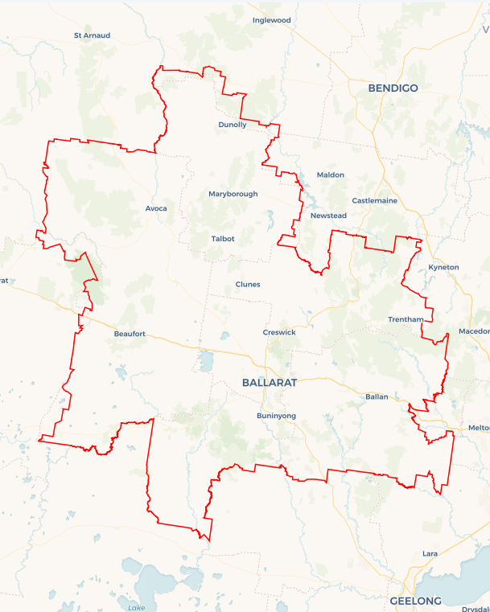
Local Jobs Plan
  - Ballarat Employment Region | VIC | March 2026
Workforce Australia Local Jobs (Local Jobs) is a program that creates partnerships between business
and communities to meet local workforce needs, thereby improving employment outcomes.
Local Jobs operates in all 51 Employment Regions in Australia.

Local Jobs Overview

Local Jobs Plan
Each Employment Region has a Local Jobs Plan which outlines the labour market challenges in the region and the strategies to address these challenges.

Job Coordinators
Each Employment Region has a dedicated Job Coordinator who leverages existing resources, supports local labour markets through structural adjustments and retrenchments, and creates opportunities for collaboration between business and communities.

Local Jobs and Skills Taskforce
Each Employment Region has its own taskforce that meets regularly with the Job Coordinator to develop an understanding of challenges in the region and implement solutions. The taskforce is comprised of representatives from the region.

Local Jobs, Local People Grant
The Local Jobs, Local People grant funds activities that help people into ongoing employment or training. Activities must support local labour market needs.
Explore labour market insights for
Ballarat Employment Region

Local labour market challenges

- Youth unemployment in the region remains high.
- Regional women continue to face disproportionate employment barriers, including family violence, unstable housing, caring responsibilities, limited childcare, and low-paid, inflexible work in female-dominated sectors such as health, social services and education.
- Key groups across the region, including youth, mature age workers, people living with a disability, culturally and linguistically diverse (CALD) communities and First Nations peoples continue to face significant labour market challenges.
- Labour and skills shortages are impacting the ability of businesses to find suitable workers to operate and grow their business.

Local priorities

Priority 1 – Youth unemployment in the region remains high

What are our challenges?
Young people in Ballarat continue to experience higher levels of unemployment and often face complex barriers to securing work, including poor mental health, housing instability, limited work experience and low awareness of career pathways. Neurodivergent young people and those disengaged from education require tailored capacity building support to access entry-level roles, apprenticeships and traineeships. Concurrently, Ballarat faces persistent labour and skills shortages across the care, construction, hospitality and education sectors, exacerbated by a lack of available training, transport, childcare, inclusive hiring practices and poor workforce retention. These conditions present an opportunity to enhance the capabilities of regional youth to align with employer preferences.

How are we responding?
- Identifying training pathways that align with local industry requirements.
- Collaborating with stakeholders including secondary schools, Highlands Local Learning and Employment Network, Workforce Australia Employment Services Providers, businesses, Transition to Work and Apprentice Connect Australia Providers, registered training organisations and TAFE.
- Strengthening opportunities for entry-level employment, apprenticeships and traineeships.

Priority 2 – Women in the region remain disproportionately affected by employment barriers

What are our challenges?
Women in the Ballarat Employment Region face intersecting barriers to economic participation. These can include housing insecurity, limited access to affordable childcare, unpaid caring responsibilities, family violence, and underrepresentation in leadership roles are evident across the region. Many women are employed in female-dominated industries with low remuneration and a lack of flexible work options. Gender inequity also extends to financial literacy and career progression, limiting the ability of women to build economic security. Inclusive career pathways and access to community-led support is often limited.

How are we responding?
- Engaging with women’s groups, government and local stakeholders to connect women to services that help with housing, childcare and financial skills.
- Partnering with local industry and business groups to create flexible pathways for women, particularly within male-dominated industries.
- Collaborating with Workforce Australia Employment Services Providers, registered training organisations, and business groups to identify emerging vocational opportunities for women.
- Promoting inclusive hiring practices, flexible work arrangements, and equitable career progression strategies.
- Showcasing success stories.

Priority 3 – Labour market challenges experienced by key cohorts

What are our challenges?
Ballarat’s workforce encompasses various cohorts including First Nations, youth, mature age, CALD, people living with a disability and members of the LGBTQIA+ community. Many continue to face systemic barriers to employment, including a lack of inclusive employment opportunities, a limited understanding of workplace supports that may be available to them and how to access reasonable adjustments if required. Businesses need targeted support to build and retain inclusive workforces that reflect the diversity of the region. A focus on promoting inclusion will help to address labour shortages and increase regional workforce participation.

How are we responding?
- Strengthening collaboration between industry and specialist employment services (inclusive employment services, multicultural networks, youth services and First Nations organisations) to promote inclusive recruitment and employment opportunities.
- Supporting businesses to meet social procurement requirements and implement inclusive workplace practices.
- Connecting employers to “Inclusive Employment” sessions and workshops.

Priority 4 – Skills for the future

What are our challenges?
The Ballarat Employment Region is experiencing a growing skills mismatch, with persistent shortages across health care and social assistance, construction, hospitality, education and training, manufacturing and professional and technical services. These shortages stem from rapid industry growth, an ageing population, limited access to training, transport and childcare, underutilisation of key workforce groups and challenges retaining talent in the region. Without targeted action, these gaps risk constraining economic growth, reducing service delivery options and impacting community wellbeing.

How are we responding?
- Co-designing employment pathways with local industry to ensure training and recruitment options align with labour market demand, such as Launch into Work.
- Partnering with registered training organisations and businesses to deliver flexible, regionally accessible training and work-based learning models that support individuals to meet industry needs.
- Leveraging data and labour market insights to inform strategic workforce planning.

Want to know more?
- Contact Bec Ware, Ballarat Employment Region Job Coordinator at bec.ware@ballaratlocaljobs.com.au
- Visit Local Jobs or Workforce Australia

