


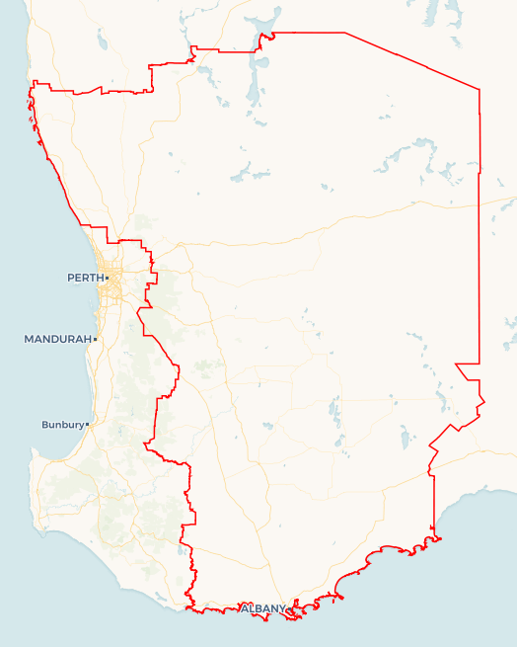
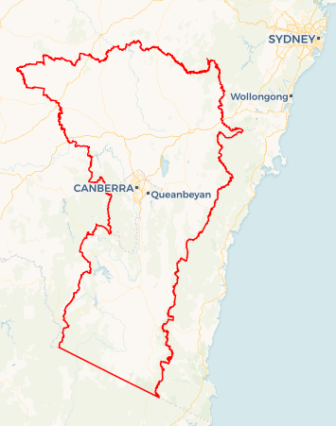
Local Jobs Plan
SAMPLE MAP ONLY
A map of your Employment Region and hyperlink will be added before publishing.
  - Great Southern Wheatbelt Employment Region | WA | February 2026
Workforce Australia Local Jobs (Local Jobs) is a program that creates partnerships between business
and communities to meet local workforce needs, thereby improving employment outcomes.
Local Jobs operates in all 51 Employment Regions in Australia.

Local Jobs Overview

Local Jobs Plan
Each Employment Region has a Local Jobs Plan which outlines the labour market challenges in the region and the strategies to address these challenges.

Job Coordinators
Each Employment Region has a dedicated Job Coordinator who leverages existing resources, supports local labour markets through structural adjustments and retrenchments, and creates opportunities for collaboration between business and communities.

Local Jobs and Skills Taskforce
Each Employment Region has its own taskforce that meets regularly with the Job Coordinator to develop an understanding of challenges in the region and implement solutions. The taskforce is comprised of representatives from the region.

Local Jobs, Local People Grant
The Local Jobs, Local People grant funds activities that help people into ongoing employment or training. Activities must support local labour market needs.
Explore labour market insights for
Great Southern Wheatbelt Employment Region

Local labour market challenges

- A significant portion of Workforce Australia Participants are experiencing periods of intermittent work due to seasonal and casual work, long-term unemployment, and/or inter-generational unemployment.
- The region has an ageing population and difficulties attracting and retaining young people in employment (youth out-migration). This impacts apprenticeship uptake, primary industry and small businesses.
- There are actual and predicted skills shortages in various industries, including agriculture, allied health, trades, transport, logistics, retail and administration.
- There are difficulties attracting people to employment in the agricultural sector and a decrease in intergenerational farming. This is further compounded by the live sheep export ban and the resultant shearing industry adjustment.
- Language, literacy, numeracy and digital competency remain key challenges for employment outcomes across the region.
- First Nations peoples and people with disabilities, significant cohorts within Workforce Australia, continue to face multiple challenges when entering the workforce, including limited access to reliable and accessible transport and driver licensing, digital exclusion, connectivity barriers and the need for culturally safe, tailored employment and disability support services.
- Employers in the region lack the time and resources to develop tailored recruitment and onboarding programs for individuals with support needs and/or those experiencing long-term unemployment. As a result, they are not well-connected to government-funded employment support services and may overlook individuals who require additional onboarding assistance. Small and mid-range businesses remain conservative with their hiring plans.
- The large geographical area and dispersed population make connecting training and programs problematic.
- Housing shortages, affordable rental and accommodation shortages, cost of living, telecommunication issues, travel, transport and attaining a driver’s licence remain barriers for employment and recruiting staff.
- Limited childcare is resulting in parent travel, reduced hours of work and is a direct barrier to women’s participation in the workforce.

Local priorities

Priority 1 – Improve support to individuals experiencing long-term and/or inter-generational unemployment

What are our challenges?

The Great Southern Wheatbelt experiences diverse workforce challenges across its sub-regions, reflecting geographic scale and diversity of industries, including agriculture, forestry, manufacturing, tourism and allied health. Many Workforce Australia participants face persistent unemployment due to intersecting barriers such as limited housing availability, rising living costs, transport constraints, access to childcare, and mental health and disability-related challenges. In addition, required training is often not available locally, with delivery concentrated in larger population centres or scheduled infrequently, further limiting participation and employment outcomes.

How are we responding?
- We are collaborating with community, government, non-government stakeholders and Workforce Australia Employment Service Providers that assist people with complex barriers, to leverage existing programs and develop further initiatives.
- We are collaborating with local provider networks, including the Department of Education, Department of Training and Workforce Development, TAFE, Jobs and Skills Australia and Registered Training Organisations (RTO’s), to identify capacity building opportunities, improve access to mentoring, and to support career tasters, skill sets, short courses and long-term programs that support job readiness and employment pathways.
- We are encouraging training providers to design programs to align with participant needs, incorporating flexible or part-time delivery, digital skills coaching and exploration of customised job pathways.
- We are encouraging program providers to consider the opportunity to involve and/or communicate with the participant’s family through the program.
- We are supporting opportunities to build connections and awareness of mental health, mature age and disability experiences within communities and employer networks.
- We are liaising with the transport industry and local communities to identify transport barriers and explore potential licencing and logistics solutions.

Priority 2 – Provide tailored support to First Nations peoples

What are our challenges?
First Nations participants often face multiple challenges when entering the workforce, including language, literacy, numeracy, digital competency, and transport barriers and require culturally appropriate support and mentoring.

How are we responding?
- We are identifying and exploring opportunities to collaborate with the Department of Education, TAFE, Apprenticeship Support Networks, Group Training Organisations (GTO’s) and RTO’s to improve education and training pathways for First Nations students.
- We are connecting with Indigenous-owned organisations and culturally safe employers to inform initiatives and to provide warm introductions between employment service providers and employers.
- We advocate for the employment of First Nations staff within the region’s employment services programs to support culturally safe engagement and stronger outcomes for participants.
- We are supporting opportunities to build connections and cultural awareness within communities and employer networks.

Priority 3 – Support transitioning and emerging job pathways

What are our challenges?
Job pathways into emerging sectors are unclear, and there is a risk of jobs being centralised to Perth, fly-in fly-out or drive-in drive-out, rather than retained in the region. The limited availability of ongoing positions in the clean energy sector poses issues engaging trainees and apprentices in the construction phase. The live sheep export ban is anticipated to have far-reaching employment and industry impact across the region.

How are we responding?
- We are proactively identifying and developing emerging regional employment pathways and transitioning occupations across agriculture, clean energy, advanced manufacturing, mining, defence and tourism. This work supports workforce planning by forecasting future skills demand, creating targeted training and transition opportunities, and strengthening local capability to address projected labour shortages.
- We are identifying education, training and supply chain pathway opportunities related to emerging sectors and communicating these opportunities to key stakeholders, industry and the business sector.
- We are establishing an agricultural committee to work with industry and training providers to develop career tasters and skill sets to attract people to the industry and to promote support available, given the end of the live sheep export and subsequent shearing industry transition.
- We are advocating for training providers and employers to consider appropriate support to increase participation from female and First Nations participants in these emerging pathways.

Priority 4 – Improve connection and hiring success between local employers and candidates

What are our challenges?

Employers in the region lack the time and resources to develop tailored recruitment and onboarding programs for individuals with support needs and/or those experiencing long-term unemployment. As a result, they are often not well-connected to government-funded employment support services and may overlook individuals who require additional onboarding assistance.
How are we responding?
- We are connecting and educating local employers to widen their candidate pool and adjust their recruitment and onboarding process to meet the available labour market.
- We are advocating for more pre-apprenticeship training opportunities in the region, particularly in trades-based environments such as mechanical and construction services and in areas of emerging industries such as renewable energy, manufacturing, automation and cyber security.
- We are exploring ways to enhance awareness and promote the benefits of employing people with disabilities. We are raising awareness of available supports to encourage businesses to build inclusive and productive workplaces.

Priority 5 – Support delivery of local programs through collaboration between services

What are our challenges?

The large geographical area and dispersed population can make connecting training and government programs challenging. Local training and pre-employment initiatives traditionally have the most success when local service providers are consulted and included in program planning and promotions.

How are we responding?
- We are maintaining and building strong networks within key regional centres, connecting service providers across multiple state and federal government-funded services, RTO’s and GTO’s, education providers, community support agencies and employer networks.
- We are partnering with local organisations in the delivery of Local Initiative Fund activities to boost community ties and activity effectiveness. We will encourage local job activity hosts and other program providers to do the same.

Want to know more?
- Contact Chloe Jones, Great Southern Wheatbelt Job Coordinator at jc@gswlocaljobs.com.au.
- Visit Local Jobs or Workforce Australia

