PATH BUSINESS PLACEMENT PARTNERSHIPS EVALUATION STRATEGY
Prepared for Department of Education, Skills and Employment
21 October 2021

Disclaimer
This document has been produced with information supplied to Clear Horizon by the Department of Education, Skills and Employment, including proceedings from the inception meeting (held on 20 May 2021) and evaluation planning workshop (held on 30 May 2021), a review of key documentation, and consultations with key stakeholders. While we make every effort to ensure the accuracy of the information contained in this report, any judgements as to suitability of the information for the client’s purposes are the client’s responsibility. Clear Horizon extends no warranties and assumes no responsibility as to the suitability of this information or for the consequences of its use.

ISBN
978-1-76114-133-1 [PDF]
978-1-76114-134-8 [DOCX]

Contents
Overview 4
Theory of change 7
Scope and limitations 11
Key evaluation questions 12
Methodology 14
Governance and roles 26
Stakeholders 27
Reporting 30
Risks 32

Acronyms
Acronym | Meaning
DESE | Department of Education, Skills and Employment
IWS | Industry Workforce Solution
KEQ | key evaluation question
NESM | New Employment Services Model
TOC | theory of change
VET | vocational education and training

Overview

About this document
This document presents the evaluation strategy for PaTH Business Placement Partnerships (‘Business Partnerships’). Clear Horizon has been contracted by the Department of Education, Skills and Employment (‘the department’) to deliver this work in partnership with the department.
This document is intended to undergo continuous review throughout the course of the evaluation in order to ensure the evaluation adapts dynamically to changing circumstances and maintains relevance during a time of rapidly changing labour market circumstances. This version reflects the state of the document as at its date of publication and may differ from the final version.

About Business Partnerships
The Australian Government is seeking to address high rates of youth unemployment following the impact of COVID-19 on the labour market. Business Partnerships was announced in the 2020–21 Federal Budget and is intended to support industries to employ young job seekers through supported pathways that prepare them to meet employers’ needs. Business Partnerships is taking an innovative approach, aiming to develop and deliver new employment pathways to help skill and support more young people into jobs. A key feature of this work is that it is working on strengthening the demand side of the interaction between employment services and the labour market. To this end, the Government is partnering with industry associations to co-design and deliver Industry Workforce Solutions (IWSs) that address unmet demand in industry settings. These innovative solutions will support those industries that access young job seekers and will help to prepare young people through supported pathways. A second key feature of this work is the co-design aspect. These IWSs will be co-designed between industry associations, government, employment services providers (‘providers’), and other key stakeholders to respond to emerging employment opportunities in industries with workforce needs.
The IWS will make use of and leverage existing government-funded programs, such as Youth Jobs PaTH (‘PaTH’) and the National Work Experience Program, combined with other supports, to place eligible young job seekers into apprenticeships, traineeships and ongoing employment.
Business Partnerships works through a specific identification and co-design process, as outlined in Figure 1, involving a panel of 12 industry partners.
The idea is that the co-designed IWS will provide access to ongoing employment opportunities through pathways that leverage on apprenticeships and/or traineeships as well as work experience for eligible young people with suitable employers. These opportunities should be realised within the term of the Work Order, as described in Figure 1, and/or the duration of the panel. It is important to note that the focus of IWSs is on tailoring pre-employment pathways to the needs of industry and employers, and using existing programs, services and supports to help job seekers take up opportunities and sustain employment. Effective collaboration with providers will need to underpin any workforce solution delivered under Business Partnerships.
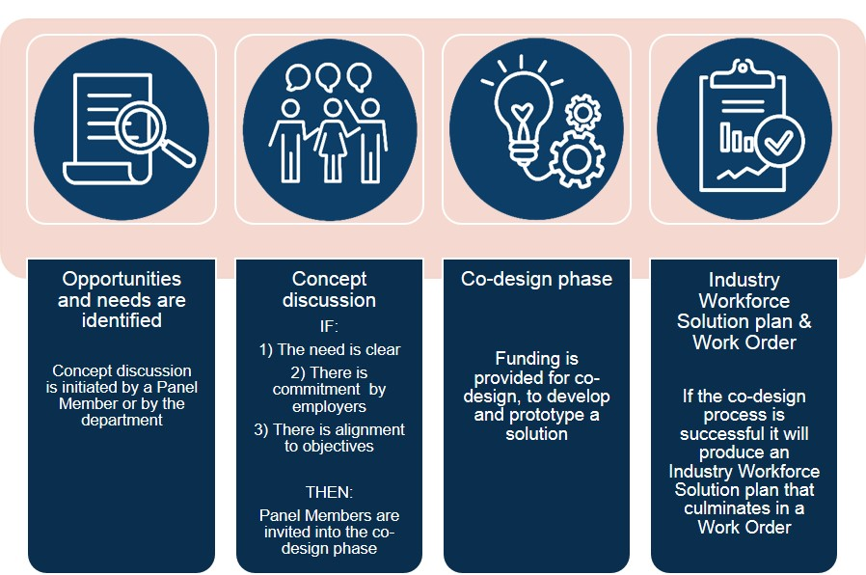
Figure 1. IWS identification and co-design process

About the Business Partnerships evaluation
The primary purpose of the evaluation is to draw out evidence-based insights that can be used to refine and improve the current Business Partnerships model as well as influencing new policy and systems including the New Employment Services Model (NESM). Insights from the evaluation will feed into workforce and employment policy development in as timely a fashion as possible via informal distribution of evaluation observations within the department as they arise.
The evaluation also needs to provide a summative report on the effectiveness and value of the Business Partnerships model with a central focus on the effectiveness of the co-design element of the Business Partnerships model (as this is its distinguishing feature).
Table 1 outlines the primary and secondary audiences for the Business Partnerships evaluation. The evaluation audience refers to stakeholders of the evaluation. The primary audiences are stakeholders who will use information about Business Partnerships for decision-making. The secondary audiences are stakeholders who may have an interest in the evaluative outputs, but for whom the evaluation is not specifically tailored.
Table 1. Evaluation audiences and their information needs
Audience | Information needs
Primary audience (groups for which findings are directly relevant) | –
Employment Research and Evaluation Branch, DESE | Learnings and insights about co-design and substantive issues associated with overcoming labour market barriers to the employment of job seekers
Policy team, DESE | As above
Internal elements of DESE with an interest in the design, implementation and evaluation of workforce strategies | As above
Panel members and their partners | As above and also to feel that their key issues have been heard
Secondary audience (groups with a broader interest in the findings) | –
General public | Value for money  That the department is doing things for the public interest and achieving success through them  That Business Partnerships delivers quality outcomes
Ministers | Case studies, stories and data from Business Partnerships  That Business Partnerships delivers quality outcomes
Employment services provider market | Learnings about substantive issues that inform their service delivery
Other areas in DESE focused on skills, VET | Learnings and insights about co-design and substantive issues about overcoming labour market barriers to the employment of job seekers
Other departments | As above

Theory of change
The theory of change (TOC) refers to the rationale behind a program outlining what changes it is expected to achieve and how. TOCs help to map the cause-and-effect relationships between program activities, outputs, intermediate outcomes, and ultimate outcomes (see Table 2 for a detailed breakdown of the levels of hierarchy in a TOC). They are generally depicted as a diagram or narrative and have a central focus on cause and effect – and are essentially thinking tools. A logic model can be developed later to help scope out the specific outputs and timeframes as a second step (this logic model is often presented in a table and is more of a project management tool).
A TOC (see Figure 2) was developed for the Business Partnerships model based on a review of existing program documentation, the project request for quotation, and consultations with key stakeholders, as well as input gathered at an evaluation planning workshop. Table 2 explains each of the levels of the TOC that are used in this model. A crucial part of the TOC, the co-design process adopted as part of the Business Partnerships activities, has been detailed in a separate diagram (see Figure 3). The diagram presents the steps in the process, as identified by the department, and identifies two ‘gates’ – points at which the process cannot proceed unless approval from the appropriate delegate is granted.
Table 2. Levels of hierarchy in a TOC
Outcome hierarchy | Definition of level
Broader goals | Broader goals that end of program outcomes are expected to contribute towards (usually refer to social, economic or environmental consequences).
Longer-term outcomes | Longer-term outcomes that may be some years after Business Partnerships has finished. These include practice and policy changes.
End of trial outcomes | The desired final result of Business Partnerships at the end of the trial phase (June 2022).
Intermediate outcomes | This relates to medium-term outcomes that occur as a result of the immediate outcomes and contribute to the achievement of end of trial and longer-term outcomes.
Immediate outcomes | Things that are a direct result of activities.
Activities | Activities undertaken to bring about change in behaviour, practice, etc.

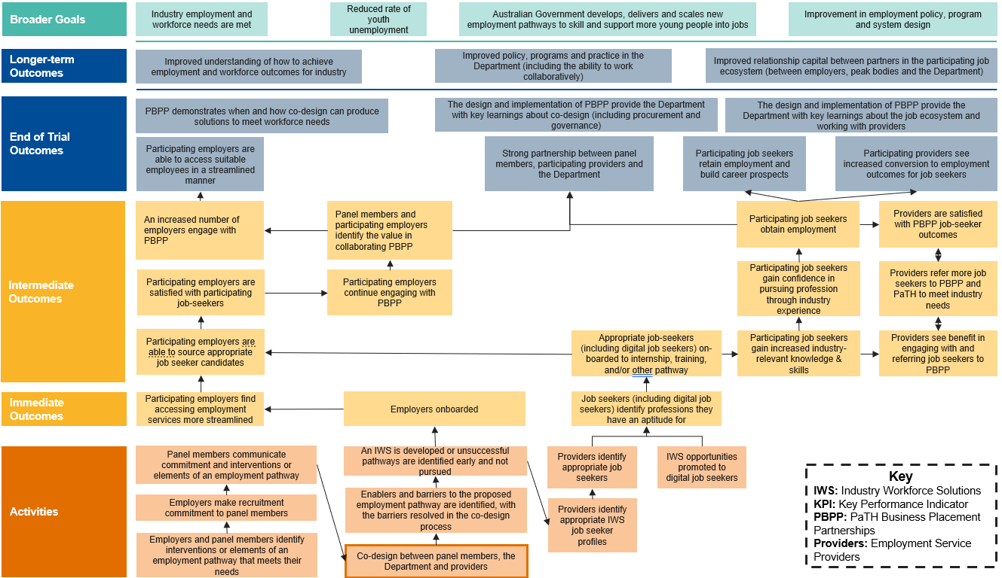
Figure 2 Business Partnerships TOC
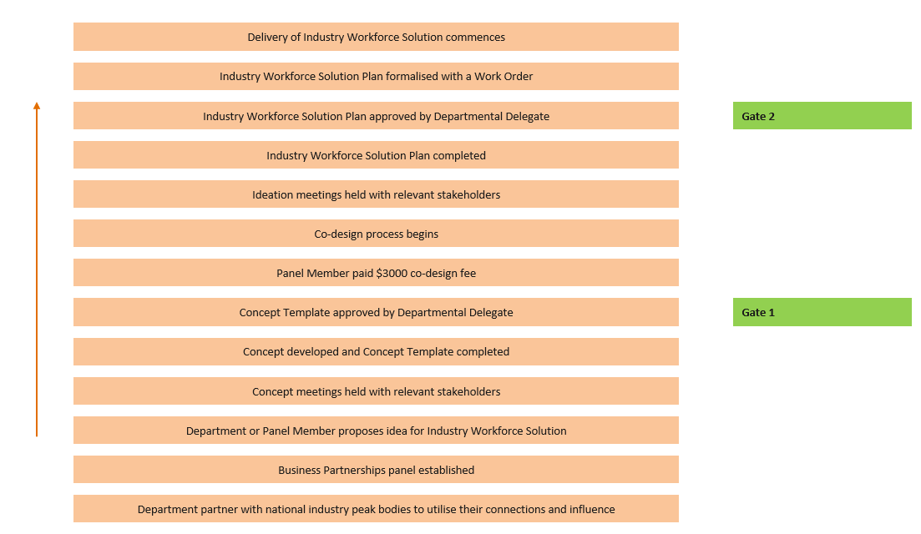
Figure 3. Business Partnerships co-design process

Assumptions
The assumptions underpinning the TOC are listed below:
- Employers see the value in engaging in the PaTH initiatives.
- The timeframe is sufficient to allow for project set-up, kick-off and collection of learnings.
- The co-design approach will reinforce buy-in from key stakeholders.
- Understanding industry demand will overcome issues pertaining to supply.
- The right training providers exist, in the right geographic locations.
- The supply of labour exists in locations where pathways are introduced.
- The demand for labour exists in locations where pathways are introduced.
- Providers will be open and willing to adopt a different approach to facilitating job outcomes for job seekers.
- Young people will value what is offered and be able to engage with the opportunity fully.
- The fact that current employment service contracts expire in June 2022 won’t deter engagement of providers.
- It is feasible to accommodate the disparate goals of all parties.
- The Business Partnerships model is appropriate for job seekers in Online Employment Services or Digital Employment Services.

Principles
The principles that will guide the delivery of Business Partnerships activities, specifically the co-design process, are as follows:
- Flexibility
- Collaboration
- Trust and relationship building
- Scalable solutions.

Scope and limitations

Scope
The evaluation will commence in May 2021 and run until June 2022 when a final evaluation report and presentation will be delivered. It will cover the period from May 2021 to June 2022.
The evaluation of Business Partnerships will have a focus on the co-design process between Business Partnerships panel members and the department, and how it supports the recruitment needs of employers and outcomes for job seekers.
The Business Partnerships evaluation will cover three components:
- Process and model evaluation: to identify the extent to which the co-design process and model was appropriate in taking into account the needs of job seekers and employers and the suitability of using pre-existing government programs. ​The process and model evaluation will be conducted twice: as a standalone interim process evaluation and as part of the final evaluation.
- Solution evaluations: to assess the effectiveness of each of the individual solutions developed by Business Partnerships in relation to key metrics and comparison with other programs. Metrics include provider referrals, job seeker attendance, number of internships and job placements and employment outcomes. Up to four IWSs will be evaluated and reported on in mini evaluations. These findings will be fed into an assessment of the effectiveness of the model as a whole.
- Learnings: to identify and document learnings about 1) the co-design process and 2) the interaction between employment services and the labour market that might inform future policy and practice undertaken by the department. These learnings will be captured across the project’s delivery and reported through the interim process evaluation, after retrospective and adaptation sessions, as well as in the final evaluation report.
The longer-term outcomes detailed in the TOC will be out of scope for this evaluation.

Key evaluation questions
This evaluation will focus on five higher-level evaluation questions (referred to as ‘key evaluation questions’ or KEQs). These KEQs are broken down further into sub-questions that help guide data collection and analysis. The full set of KEQs and sub-questions is listed in Table 3.
The final evaluation report will be structured against the key evaluation questions. Due to the emergent nature of the Business Partnerships co-design process and model, it is expected that the KEQs and sub-KEQs may be revised slightly as the project progresses. Any revisions will be undertaken in collaboration with the department following an adaptation and retrospective session.
Table 3. The key evaluation questions
KEQ | Sub-KEQ
1. Appropriateness of the co-design model: How appropriate was the co-design model for meeting the objectives of Business Partnerships? | 1a. What were the intended key elements and principles of the co-design approach? (e.g. adaptive, collaborative, fit for purpose)?
– | 1b. To what extent did the co-design process work as planned and what were the adaptations?
– | 1c. How well were the different parties able to meaningfully engage?
– | 1d. To what extent were the right people at the table?
– | 1e. How does this model of co-design process compare with other similar things that have been tried in similar contexts, and what further elements could be incorporated?
2. Effectiveness of Industry Workforce Solutions: To what extent did each of the solutions achieve the intended outcomes for the key parties? | 2a. To what extent were providers able to accommodate the solution?
– | 2b. How well did each solution meet the needs of employers?
– | 2c. How well did each solution meet the needs of job seekers?
– | 2d. How well did each solution equip job seekers for the job?
– | 2e. How many employment outcomes (and other key metrics) did each IWS achieve?
– | 2f. In general how well does the solution ‘compare’ to other programs?
3. Effectiveness of the co-design model: How effective was the co-design model? | 3a. To what extent, and how, did it foster collaboration and trust in the initial stages?
– | 3b. To what extent, and how, did it uncover and work through differences, tensions and process constraints?
– | 3c. To what extent did it produce viable ideas that met diverse stakeholder needs?
– | 3d. Did the co-design process produce any unintended consequences?
4. Effectiveness (of partnerships): How effective was the Business Partnerships model in creating effective partnerships that will support future work? | 4a. To what extent was relationship capital built between the department and panel members?
– | 4b. What was the department’s value add in terms of coordinating employers and providers across the network?
– | 4c. How did the co-design process help or hinder partnerships?
– | 4d. To what extent were relationships built between panel members, employers and providers that can be leveraged in future work?
5. Learnings: What were the key insights for policy and programs? | 5a. What was learned through the co-design process about how to meet demand and supply in the labour market?
– | 5b. What aspects of co-design could be built into future programs/policies?

Methodology

Approach
The methodology is guided by four key principles:
- A theory-driven approach. As well as developing a theory of change for the overall Business Partnerships trial, a mini theory of change will be developed for each solution, outlining how change is expected to occur and what intermediate changes are expected within the timeframes.
- A mixed-methods approach. We will take a sequential approach that applies qualitative and quantitative methods in sequence to serve different purposes and different stages of the design cycle. In the early co-design process evaluation, data collection will be mostly qualitative and observational. To evaluate the effectiveness of IWSs we will use qualitative and quantitative methods (including standardised questionnaires), supplemented by departmental data on key metrics (such as provider referrals, job seeker attendance, number of internships, job placements and employment outcomes).
- A collaborative approach to the development of the evaluation strategy and reporting. A facilitated workshop and key informant interviews have shaped the development of this evaluation strategy with ongoing in-depth involvement of stakeholders in the delivery of the overall project.
- An adaptive project management approach to ensure that the evaluation methodology can be adapted as IWSs are developed. Clear Horizon will conduct adaptation meetings with the department to reflect on the evaluation work carried out in the three months prior, and to refine the plan around evaluation activities for the forthcoming work. This iterative approach is particularly important as we do not know what and how many IWSs will emerge.
In the following sections, we first provide an overview of what methods will be used to address the three components of the evaluation: 1) process and model evaluation (Table 4); 2) solutions evaluation (Table 5); and 3) learnings (Table 6). We then provide a consolidated table showing the full set of questions (including sub-questions) and methods (Table 7).

Process and model evaluation
The process and model evaluation will consider all Business Partnerships co-design activities to identify the extent to which the Business Partnerships co-design process and model is appropriate. This includes whether it was able to take into account the needs of job seekers and employers and the suitability of using pre-existing government programs. The process evaluation will respond to KEQs 1 and 3.
Table 4 steps out the methods that will be employed in the delivery of the process evaluation.
Table 4. Process evaluation methods
Method | Number | Description
Semi-structured interviews with key stakeholders in the co-design process | Interim reporting: 5  Final reporting: 20 (5 per IWS) | Purpose:  To understand how well key stakeholders were engaged in the co-design process  To understand how well the co-design process upheld its principles  To identify any pain points, levers and tensions in the co-design process  To learn more about similar co-design processes undertaken by the department (this will be a subset of the interviews)  To learn how the co-design process helped or hindered partnerships  The interviews will be conducted via Microsoft Teams and are expected to be 45 to 60 minutes in length. Interview data will be analysed using the qualitative thematic coding of responses.
Semi-structured interviews with key stakeholders from similar programs | 2 | Purpose:  To learn more about similar co-design processes undertaken by the department  The interviews will be conducted via Microsoft Teams and are expected to be 45 to 60 minutes in length. Interview data will be analysed using the qualitative thematic coding of responses.
Non-participant observation of the process | Interim reporting: 1 workshop  Final reporting: 4 (1 per IWS) | Purpose:  To understand how well key stakeholders were engaged  To identify any pain points, levers and tensions in the co-design process  To understand how well the co-design process adhered to its principles  Non-participant observation includes reading plans and observing concept or ideation meetings. This data will be analysed through qualitative thematic coding.
Document review of Business Partnerships co-design materials | 16 | Purpose:  To understand the intended key elements and principles of the co-design approach  A light review of key documents pertaining to the Business Partnerships co-design.
Document review of similar processes | 3 | Purpose:  To learn more about similar co-design processes undertaken by the department  A light review of any evaluations or other reporting about other co-design efforts in the department. Where possible, illustrative examples of process will be identified for incorporation in the evaluation report.

Solutions evaluation
The solutions evaluation will assess up to four IWSs trialled between July 2021 and June 2022. The purpose of the solutions evaluation is to assess the effectiveness of each IWS in relation to key metrics and in comparison with each other, and other programs where feasible. The solutions evaluation will respond to KEQs 2 and 4.
Table 5 steps out the methods that will be employed in the delivery of the solutions evaluation.
Table 5. Solutions evaluation methods
Method | Number | Description
Semi-structured interviews with key stakeholders in the IWS | 40  (10 per IWS) | Purpose:  To better understand emergent questionnaire themes  To identify how relationships have been coordinated and built  Interviews will be conducted via Microsoft Teams and/or in person (depending on location and timing) and are expected to be 45 to 60 minutes in length. Interview data will be analysed using the qualitative thematic coding of responses.
Employer survey | 1 | Purpose:  To learn about the experience of employers engaging with IWSs  A standardised questionnaire for employers, to be adapted to each IWS as needed. The adapted questionnaire will be administered to employers at the end of the IWS trial period.  Questionnaire data will be analysed through descriptive statistics to identify the mean, median, standard deviation, and any other useful pieces of information. Statistical significance of the results will be verified using applicable statistical tests, with further tests potentially including paired t-tests, to compare across groups regardless of sample discrepancy (such as differences between gender, age, and industry), and/or regression analysis. These will likely be executed using R Studio and will be decided based on data appropriateness and availability.
IWS participant survey | 1 | Purpose:  To learn about the experience of participants engaging with IWSs  A standardised questionnaire for participants, to be adapted to each IWS as needed. The adapted questionnaire will be administered to employers at the end of the IWS trial period.  Questionnaire data will be analysed through descriptive statistics to identify the mean, median, standard deviation, and any other useful pieces of information. Statistical significance of the results will be verified using applicable statistical tests, with further tests potentially including paired t-tests, to compare across groups regardless of sample discrepancy (such as differences between gender, age, and industry), and/or regression analysis. These will likely be executed using R Studio and will be decided based on data appropriateness and availability.
Review of administrative data | – | Purpose:  To understand the demographic make-up of IWS key stakeholders  Administrative data will be used to plan fieldwork, recruit respondents and facilitate analysis using descriptive statistics to understand outcomes for specific cohort groups (such as by gender, age or industry).  Key metrics will also be used to understand employment outcomes. The provisional metrics we will use include provider referrals, job seeker attendance, number of internships and job placements and employment outcomes.  Analysis will likely be executed using R Studio, based on data appropriateness and availability.

Learnings
The learnings component of the Business Partnerships evaluation will identify and document learnings about 1) the co-design process and 2) the labour market that might inform future policy and practice undertaken by the department. It will respond to KEQ 5.
Table 6 steps out the methods that will be employed in the delivery of the learnings.
Table 6. Learnings methods
Method | Number | Description
Quarterly retrospective and adaptation sessions | 4 | Purpose:  To collect reflections and learnings about the co-design process, including areas of improvement  To collect learnings about barriers and solutions to matching demand and supply in the labour market  Following each session, Clear Horizon will produce a short learnings report (see ‘Reporting’ for further information).
Debrief sessions following co-design work | For up to 3 half day meetings | Purpose:  To collect reflections and learnings about the co-design process, including areas of improvement

Data collection tools
In order to deliver the methods detailed above, a series of data collection tools and associated collateral will be produced. These tools are still in development and will be incorporated into iterations of the rolling project plan as they are finalised. Data collection tools include:
- A standardised participant survey
- A standardised employer survey
- A semi-structured interview guide for co-design participants (to inform the process evaluation)
- A semi-structured interview guide for participating job seekers (to inform the solutions evaluation)
- A semi-structured interview guide for employers (to inform the solutions evaluation)
- A semi-structured interview guide for providers (to inform the solutions evaluation)
- A semi-structured interview guide for panel members (to inform the solutions evaluation).

Table 7. Full evaluation plan
KEQ | Sub-KEQ | Evaluation focus | Methods | Frequency
1. Appropriateness of the co-design model: How appropriate was the co-design model for meeting the objectives of Business Partnerships? | 1a. What were the intended key elements and principles of the co-design approach? (e.g. adaptive, collaborative, fit for purpose) | Identification and documentation of the Business Partnerships co-design process and principles | Semi-structured interviews (process)  Document review | May 2021 and November 2021 to February 2022  One-off, May 2021
– | 1b. To what extent did the process work as planned and what were the adaptations? | Whether the co-design process was delivered as intended | Semi-structured interviews (process)  Non-participant observation  Retrospective and adaptation sessions | May 2021 and November 2021 to February 2022  May 2021 and November 2021 to February 2022  Quarterly
– | 1c. How well were the different parties able to meaningfully engage? | Extent to which key stakeholder groups felt involved in/ownership of the Business Partnerships co-design process | Semi-structured interviews (process)  Non-participant observation  Retrospective and adaptation sessions | May 2021 and November 2021 to February 2022  May 2021 and November 2021 to February 2022  Quarterly
– | 1d. To what extent were the right people at the table? | Whether additional stakeholders and the assessment of their needs are required to improve the appropriateness of the co-design process | Semi-structured interviews (process)  Non-participant observation  Retrospective and adaptation sessions | May 2021 and November 2021 to February 2022  May 2021 and November 2021 to February 2022  Quarterly
– | 1e. How does this model of co-design process compare with other similar things that have been tried in similar contexts, and what further elements could be incorporated? | Identification of promising elements of the Business Partnerships co-design process  Identification of opportunities for improving the Business Partnerships co-design process | Semi-structured interviews (process)  Document review | May 2021 and November 2021 to February 2022  One-off, May 2021
2. Effectiveness of Industry Workforce Solutions: To what extent did each of the solutions achieve the intended outcomes for the key parties? | 2a. To what extent were providers able to accommodate the solution? | Whether the IWS was designed and delivered cohesively | Semi-structured interviews (solutions) | 10 per IWS mini evaluation, March–April 2022
– | 2b. How well did each solution meet the needs of employers? | Performance of the IWS against the TOC  Emergence of positive or negative outcomes not captured in the Business Partnerships TOC | Employer survey  Semi-structured interviews (solutions) | For each IWS mini evaluation, March–April 2022  10 per IWS mini evaluation, March – April 22
– | 2c. How well did each solution meet the needs of job seekers? | Performance of the IWS against the TOC  Emergence of positive or negative outcomes not captured in the Business Partnerships TOC | Participant survey  Semi-structured interviews (solutions) | For each IWS mini evaluation, December 2021 ongoing  10 per IWS mini evaluation, March–April 2022
– | 2d. How well did each solution equip job seekers for the job? | Performance of the IWS against the TOC  Emergence of positive or negative outcomes not captured in the Business Partnerships TOC | Participant survey  Employer survey  Semi-structured interviews (solutions) | For each IWS mini evaluation, December 2021 ongoing  For each IWS mini evaluation, March–April 2022  10 per IWS mini evaluation, March–April 2022
– | 2e. How many employment outcomes (and other key metrics) did each IWS achieve? | Performance of the IWS against the TOC | Participant survey  Employer survey  Semi-structured interviews (solutions)  Review of administrative data | For each IWS mini evaluation, December 2021 ongoing  For each IWS mini evaluation, March–April 2022  10 per IWS mini evaluation, March–April 2022  For each IWS mini evaluation, March–April 2022
– | 2f. In general, how well does the solution ‘compare’ to other programs in terms of overall value? | Perception of the value of the Business Partnerships model in comparison to similar programs | Matching administrative data from other similar programs | One-off, May 2022
3. Effectiveness of the co-design model: How effective was the co-design model? | 3a. To what extent did it foster collaboration and trust in the initial stages? | Whether the Business Partnerships co-design process adhered to its principles | Semi-structured interviews (process)  Non-participant observation  Retrospective and adaptation sessions | May 2021 and November 2021 to February 2022  May 2021 and November 2021 to February 2022  Quarterly
– | 3b. To what extent did it surface and work through differences, tensions and process constraints? | Whether the Business Partnerships co-design process identified barriers and solutions to matching demand and supply in the labour market | Semi-structured interviews (process)  Non-participant observation  Retrospective and adaptation sessions | May 2021 and November 2021 to February 2022  May 2021 and November 2021 to February 2022  Quarterly
– | 3c. To what extent did it produce viable ideas that met diverse stakeholder needs? | Whether stakeholder expectations were successfully managed and addressed | Semi-structured interviews (process)  Non-participant observation | May 2021 and November 2021 to February 2022  May 2021 and November 2021 to February 2022
– | 3d. Did the co-design process produce any unintended consequences? | Emergence of negative outcomes not captured in the Business Partnerships objectives or TOC | Semi-structured interviews (process)  Non-participant observation  Retrospective and adaptation sessions | May 2021 and November 2021 to February 2022  May 2021 and November 2021 to February 2022  Quarterly
4. Effectiveness (of partnerships): How effective was the Business Partnerships model in creating effective partnerships that will support future work? | 4a. To what extent was relationship capital built between the department and panel members? | Whether Business Partnerships led to relationships being strengthened in a manner that will support future collaborative work | Victorian Partnership Assessment tool  Semi-structured interviews (solutions) | For each IWS mini evaluation, March–April 2022  10 per IWS mini evaluation, March–April 2022
– | 4b. What was the department’s value add in terms of coordinating employers and providers across the network? | To better understand the role of the department in this collaborative model | Employer survey  Semi-structured interviews (solutions) | For each IWS mini evaluation, March–April 2022  10 per IWS mini evaluation, March–April 2022
– | 4c. How did the co-design process help or hinder partnerships? | Identification of promising elements of the Business Partnerships co-design process  Identification of opportunities for improving the Business Partnerships co-design process | Employer survey  Semi-structured interviews (solutions) | For each IWS mini evaluation, March–April 2022  10 per IWS mini evaluation, March–April 2022
– | 4d. To what extent were relationships built between panel members, employers and providers that can be leveraged in future work? | Whether Business Partnerships led to relationships being strengthened in a manner that will support future collaborative work | Employer survey  Semi-structured interviews (solutions) | For each IWS mini evaluation, March–April 2022  10 per IWS mini evaluation, March–April 2022
5. Learnings: What were the key insights for policy and programs? | 5a. What was learned through the co-design process about how to meet demand and supply in the labour market? | Learnings to inform the development of future programs/policies | Retrospective and adaptation sessions | Quarterly
– | 5b. What aspects of co-design could be built into future programs/policies? | Identification of promising elements of the Business Partnerships model  Learnings to inform the development of future programs/policies | Retrospective and adaptation sessions | Quarterly

Governance and roles
Key milestones will be approved by the Senior Evaluation and Research Officer, Employment Research and Evaluation Branch. The major deliverables are indicated in Table 8. The delegate will require a turnaround time of 10 days to review the key deliverables. The department’s project manager will collate all feedback into one consolidated set of feedback and provide it to the evaluators. The evaluators will provide a second draft of the report along with a ‘feedback tracker’ that notes how the feedback was incorporated (and if it was not incorporated the evaluators will provide a rationale). The department may choose to undertake a second round of feedback to resolve any changes that have not been incorporated, as listed in the feedback tracker.
Minor deliverables such as the inception plan and iterations of the theory of change document can be approved by the department’s project manager. The turnaround time for minor deliverables will be determined by Clear Horizon and the department on a case-by-case basis.
Table 8. Milestones
# | Description | Nature of deliverable | Date
1 | Draft evaluation report | Major | 30 May 2022
2 | Reports for mini evaluations  Presentation  Final evaluation report | Major | 30 June 2022

Stakeholders
The following section describes the stakeholders relevant to this evaluation strategy and how they will be engaged. This stakeholder analysis and engagement plan draws on the IAP2 Spectrum of Public Participation (see Table 9).
Table 9. IAP2 Spectrum of Public Participation – levels of engagement
INFORM | CONSULT | INVOLVE | COLLABORATE | EMPOWER
We will keep you informed. | We will keep you informed, listen to and acknowledge concerns and provide feedback on how your input influenced the decision. | We will work with you to ensure that your concerns and aspirations are directly reflected in the alternatives developed and provide feedback on how your input influenced the decision. | We will look to you for direct advice and innovation in formulating solutions and incorporate your advice and recommendations into the decisions to the maximum extent possible. | We will implement what you decide.

Stakeholders
Stakeholder engagement activities can be grouped according to the nature of the stakeholder involved. The primary stakeholder categories are:
- Department stakeholders
- Business Partnerships panel members
- Providers
- Employers
- Job seekers
- Training organisations.
Planned evaluation activities across the aforementioned groups are detailed in Table 10.

Table 10. Planned stakeholder engagement
Stakeholder groups | Type of engagement in the evaluation | Activities
Department stakeholders | COLLABORATE | Quarterly retrospective and adaptation sessions  Consultations  Interviews
Business Placement Partnerships panel members | CONSULT | Interviews
Providers | CONSULT | Interviews
Employers | CONSULT | Interviews  Survey
Job seekers | CONSULT | Interviews  Focus groups  Survey

Ethical considerations
While undertaking consultation and fieldwork, special consideration will be paid to ethical protocols and risks to ensure conduct does not cause harm or undermine the experiences of job seekers and other respondents.
When undertaking consultations, facilitators will need to ensure ethical conduct (including permission to collect data), confidentiality and privacy. Adequate protocols for ensuring informed consent by consultation and fieldwork participants will be necessary, and Clear Horizon will prepare templates for this as needed. The consultations will be conducted in accordance with requirements specified in the department’s Deed of Standing Offer for the supply of Research and Evaluation Services, the Privacy Act 1988, the Public Service Act 1999, the Public Service Code of Conduct and the Australian Evaluation Society Code of Ethics, which includes strict guidelines about participant confidentiality. In accordance with the requirements of the department, interviews or focus groups will be recorded only with participant consent, and confidentiality of participant information will be explained. Interviewees are able to decline being recorded but de-identified interview transcripts/notes will be retained by the evaluation unit of the department and interviewees will be informed of this.
As the consultations will engage with job seekers, consideration must also be paid to the nature of their participation and the information they are asked to divulge. Job seekers should not be requested to share personal experiences or any information that is considered sensitive to their person. To ensure these consultations are appropriate and embody ethical research practice, the department undertook an internal ethics review in line with its Protocol for the Ethical Conduct of Human Research. This review found that the research poses negligible risk and can proceed with the incorporation of the following recommendations. Further recommendations regarding risk mitigation strategies can be found in ‘Risks’.
- As job seekers participating in the Business Partnerships trial are considered to be in an ‘unequal or dependent relationship’ with the department, stakeholder engagement should incorporate appropriate mitigation strategies such as informing research participants that neither participating nor declining to participate will impact servicing or assistance received and that participation is voluntary.
- Consider the National Statement guidelines on incentives for participants and recruitment when designing the research. Participants should receive incentives of the same amount and in the same form.
- If a research participant wishes to express their concerns about the conduct of the research, they should be able to contact a person independent of the evaluation team and contracted supplier. Suggest providing details for the National Customer Service Line and the Digital Services Contact Centre in the preamble included with the survey.

Reporting

Quarterly learning reports
Quarterly learning reports will be produced following the quarterly retrospective and adaptation sessions with the department. Each report will be a maximum of three pages in length and will capture the proceedings from a quarterly retrospective and adaptation session. The reports will detail any pain points and levers identified in the Business Partnerships co-design process. Each report will be submitted a week after the respective retrospective and adaptation session.

IWS mini evaluation reports
Four mini IWS evaluation reports will be developed. Each report will evaluate one IWS and will be no more than five pages in length. It is expected that all reports will be produced between July 2021 and May 2022, although the exact date of each report will depend on the progress of the IWSs. Each mini evaluation report will first be submitted as a draft and will then be finalised. The reports will be structured as follows:
- Overview of the objectives of the IWS and partners involved
- Findings about the effectiveness of the workforce solutions with regard to employment outcomes and key metrics
- How well the solution met different employer needs
- Extent to which participating providers were able to accommodate the solution
- How well the solution helped equip job seekers for employment
- Overall assessment of the effectiveness of the solution
- Key learnings about the barriers and solutions in this trial
- Conclusion.

Final evaluation report
A draft report encompassing the synthesis of all data collection and analysis activities encompassed in this strategy will be submitted to the department in mid-June 2022. This report will consist of draft findings. Based on one set of collated feedback from the department, Clear Horizon will develop the final evaluation report for submission by the end of June 2022.
The report will be structured as follows:
- Executive summary
- Introduction
- Methodology
- Key findings against the key evaluation questions
- What was the nature of the ‘co-design’ model and how did it adhere to the principles of good design?
- To what extent did each of the solutions achieve the intended outcomes for the key parties?
- How effective was the co-design model?
- How effective was the Business Partnerships model in creating effective partnerships that will support future work?
- Learnings and conclusions
- What was learned through the co-design process about how to meet demand and supply in the labour market?
- What aspects of co-design were crucial and should be built into future programs/policies?
- Recommendations.

Risks
The following risk register (Table 11) was developed based on discussions at the inception meeting. It has since been updated based on recommendations from the internal ethics review undertaken by the department.
Table 11. Risk register
Original proposed activity | Agreed change | Rationale
Two half day evaluation planning workshops to be held online | One full day evaluation planning workshop held in person | Due to eased travel restrictions, the 2 half day workshops were replaced with a single full day, in-person workshop. This allowed stakeholders to meet in person and minimised the challenge associated with scheduling 2 workshops in quick succession.
Two background papers to be developed prior to the evaluation planning workshops | One background paper developed prior to the evaluation planning workshop. The second background paper adapted to a summary of workshop outputs and circulated to attendees following the workshop. | A full day evaluation planning workshop was held instead of 2 half day workshops. As such, a single background paper could cover the content to be discussed on the day, while the second paper could be used to consolidate and disseminate the outputs for feedback.
Eight consultations to inform preparation for the evaluation planning workshop | Four consultations held to inform the workshop. One consultation used to inform the development of the standardised questionnaire. The outstanding 4 consultations to be incorporated into the interim process evaluation. | The availability of participants and the timeframe for holding consultations meant that not all 8 consultations could be held prior to the development of the draft evaluation strategy. Therefore, the remaining consultations were repurposed to meet other needs in the delivery of the Business Partnerships evaluation.
The Business Partnerships evaluation to consist of 3 components: a process evaluation, a solutions evaluation and a replicability assessment | Replicability assessment replaced with a learnings component to identify and document learnings about 1) the co-design process and 2) the job ecosystem that might inform future policy and practice undertaken by the department. | At the evaluation planning workshop, the evaluation components were interrogated against the department’s information needs, resulting in a shift in evaluation focus from replicability to learnings. It was determined that the department is not looking to replicate Business Partnerships but to apply learnings about the co-design model elsewhere, if appropriate.
Non-participant observation to be adopted as a data collection method for the interim process evaluation | Based on the progress of each IWS development process (both concept development and co-design), non-participant observation may be replaced with retrospective consultations. | During the course of the month, it became clear that the process for developing IWS is highly emergent and might not lend to non-participant observation. As such, the time available for this data collection method may be repurposed to ensure adequate data is collected regarding the Business Partnerships process.
Conduct a survey pilot to test for overt problems as well as a more involved process of cognitive interviews to test surveys with a small, purposive sample. These tests were to be focused on comprehension, judgement, retrieval, and response to ensure final questions were understood and data could be compared between key groups. | Cognitive testing undertaken with 2 departmental representatives in the first instance. Once an IWS has successfully moved to implementation and has been selected for evaluation, the standardised questionnaires will be tested with a sample cohort of participating job seekers and employers. | The approach to cognitive testing was changed in response to the progress of the IWSs. Without job seekers or employers identified for participation in an IWS, Clear Horizon was unable to undertake cognitive testing with a sample cohort. It was decided to incorporate this testing once possible.
Provision of collateral for field work associated with component 4 (including participant information forms and approach letters) as part of component 3. | Production and submission of collateral for fieldwork as IWSs are approved for implementation and their respective evaluation process begins. | As IWSs are yet to be approved, no IWSs have been selected for evaluation, hindering the ability to produce relevant collateral. Since fieldwork collateral is not considered a milestone deliverable, the decision was made by the department that fieldwork collateral will be provided on an ongoing basis (similar to the approach taken with the interim evaluation).
Data collection activities for each evaluation of an IWS will consist of 10 semi-structured interviews, 2 focus groups or group interviews and the administration of 2 questionnaires. | The 2 focus groups or group interviews per IWS have been replaced with one non-participant observation of a co-design meeting and 5 interviews with co-design stakeholders. | It was identified that process evaluation activities needed to be better embedded into the evaluation of each IWS. It was also noted that focus groups or group interviews will likely be less effective than the one-on-one interviews, which are already included.
Fortnightly stand-up meetings will be held between the Clear Horizon project manager and the key contact in the department’s internal evaluation team. | Fortnightly stand-up meetings will now be attended by one or more representatives from the core Business Partnerships project team. | To increase the number of touchpoints between the Business Partnerships team and Clear Horizon, improving the ability to keep the team abreast of project delivery and needs.
Quarterly retrospectives and adaptation sessions will be attended by the core Business Partnerships project team and representatives from the department’s internal evaluation team. | Adapt quarterly retrospectives and adaptation sessions to include the relationship managers of panel members that are progressing with IWSs. | By including relationship managers, there is more opportunity to harvest insights pertaining to the Business Partnerships co-design model.
The final Business Partnerships evaluation will encompass outcomes and process findings. | Bring forward the process evaluation component of the final Business Partnerships evaluation. | To allow the Business Partnerships team to draw on the findings to inform their practice prior to the completion of the trial.

Note: due to the short timeframes we will not be conducting an analysis of costs per output. In using the term ‘in general’ we imply that we will be making a value determination in a generalised manner, by looking at the magnitude of job outcomes achieved through this model compared with other models, and factoring in the overall effort and expenditure associated with this at a programmatic level.
For further information see the International Association for Public Participation (IAP2) website.

