


Quick Reference Guide: How to accept an authorisation in RAM
The Australian Government’s Relationship Authorisation Manager (RAM) allows you to link your Digital Identity to your business and manage who can act on behalf of your business online. This guide shows you how you can accept an authorisation in RAM.
Before you start, you must have a Digital Identity, such as myGovID set up to log in to RAM.
To start using government online services on behalf of a business, a principal authority or authorisation administrator needs to authorise you to act on behalf of a business.

- Ask your organisation’s Principal Authority or Authorisation Administrator to authorise you in RAM. Provide them with your full legal name as used to set up your myGovID.
Note: the email address used in RAM can be different from the email address used to set up your myGovID.
For more information on Principal Authorities, visit https://info.authorisationmanager.gov.au/get-started
- Check your email for your RAM authorisation request and code.
Go to authorisationmanager.gov.au and click on the ‘Login with myGovID’ button.
- Follow the myGovID login directions displayed on screen.
RESULT: You will be logged into RAM.
- Locate the authorisation request for your business in RAM.
- Use your authorisation code from your email to accept the authorisation request.
RESULT: You are now authorised in RAM to act on behalf of your business.
NOTE: You have seven days to accept an authorisation in RAM.
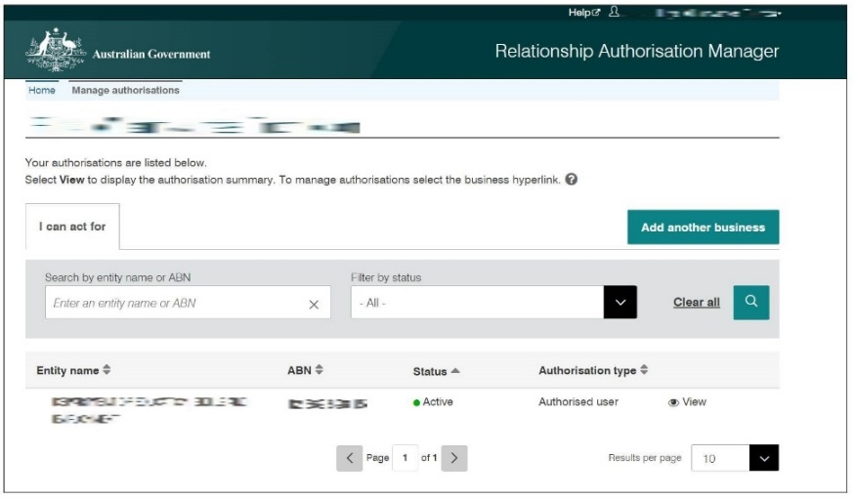

Support
See the myGovID and RAM help pages for additional support and troubleshooting.
For assistance with ADMS, contact the National Customer Service Line (NCSL) on 1800 020 108.
For feedback on this quick reference guide, contact ADMSEngagement@dese.gov.au

