


Quick Reference Guide: How to set up Authorisation Administrators and Authorised Users in RAM
This guide shows how Principal Authorities and Authorisation Administrators can use the Australian Government’s Relationship Authorisation Manager (RAM) to authorise others to act online on behalf of a business. This guide should be used along with the RAM website: info.authorisationmanager.gov.au.

- Go to https://authorisationmanager.gov.au
- Click the ‘Login with myGovID’ button.
RESULT: You will be redirected to the myGovID login.
- Enter the email address you used to set up myGovID.
- Click Login.
RESULT: A myGovID authorisation code will be displayed.
- Open myGovID on your smart device and enter the code.
- Click Accept.
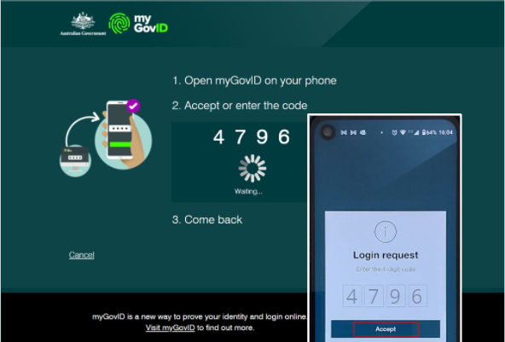
RESULT: The RAM home page will be displayed.
- Click ‘View or manage authorisations, machine credentials and cloud software notifications’.
- Select the business you would like to create and authorised.
- Click ‘Add new user’.
- Select the ‘Standard user’ representative type.
- Click ‘Continue’.
- Enter the user’s details into the ‘Representative details’ section.
NOTE: The user’s given and family names must exactly match their myGovID details. It is recommended to use a business email address – it does not need to match the user’s myGovID email address.
- In the ‘Authorisation details’ section select if you would like the user to be an Authorised Administrator. Selecting ‘No’ will mean the user is created as an Authorised User.
NOTE: Please visit info.authorisationmanager.gov.au/authorised-users-and-administrators to learn more about the different user types.
- Select if you would like the user to be a machine credential administrator. This is not necessary for access to ADMS.
- Enter a start date for when you would like the authorisation to begin.
- If required, enter an end date for the authorisation.
- In the ‘Agency access’ section, locate the Department of Education, Skills and Employment and select Custom access.
- Click Continue.
- Review details in the Summary section.
- Read the declaration and if you understand it, check the ‘I understand and accept this declaration’.
- Click Submit.
RESULT: A notification will display, confirming the authorisation request has been successfully created and sent to the user.
NOTE: The user will have seven days to accept the authorisation.

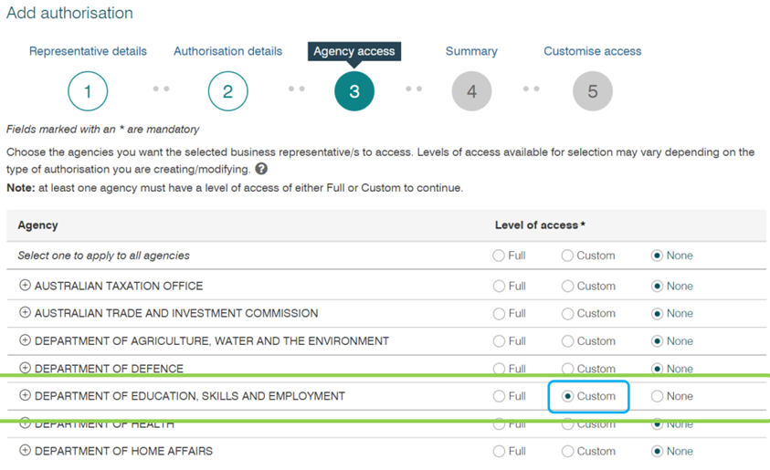

Support
For assistance with ADMS, contact the National Customer Service Line (NCSL) on 1800 020 108.
For feedback on this quick reference guide, contact ADMSEngagement@dese.gov.au.

