

How to use FEG Online Services
FEG Online Services is a secure online portal you can use to make, submit and track your Fair Entitlements Guarantee (FEG) claim. The easiest way to apply FEG assistance is through FEG Online Services as it means we will receive your claim as soon as it is submitted.

What you can do in FEG Online Services
In FEG Online Service you can:
- lodge your FEG claim online and check the status of your claim at any time – even if you first submitted a paper form
- complete your tax file number (TFN) declaration, provide your bank details, update your TFN and bank details, upload documents, and update contact, agent or entitlement details
- access letters the Department of Employment and Workplace Relations (the department) sends you
- lodge a request for a review if you disagree with the decision on your FEG claim.

Even if you have lodged an offline (paper-based) claim, you can still register for FEG Online Service to track your claim and view letters sent by the department.

How to register for FEG Online Services
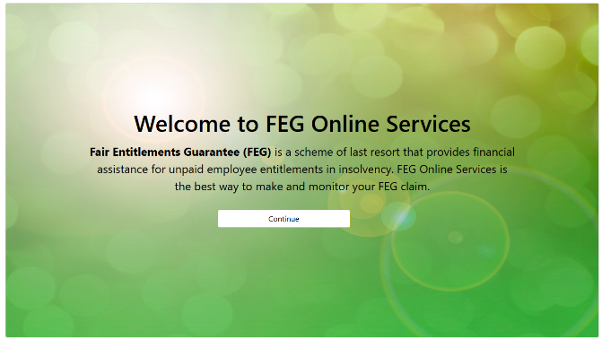
Step 1
Go to FEG Online Services: https://fegonlineservices.dewr.gov.au/ and click Continue.

Step 2
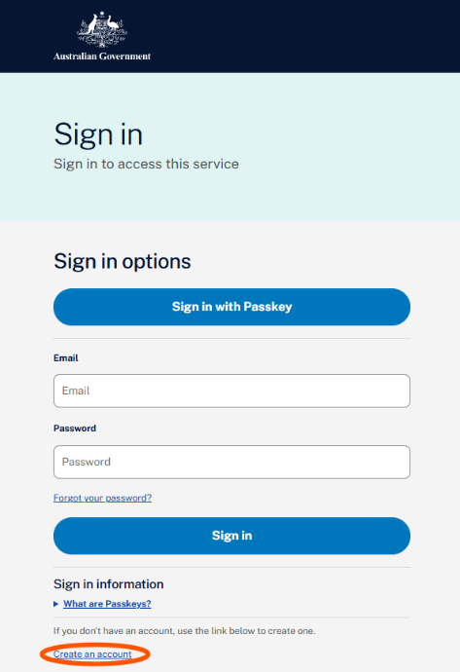
Click Create an account to begin the registration process.

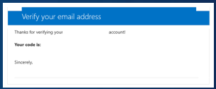
Step 3
Enter the required personal details (legal first and surname only) and email address. These details will flow to your claim form when you start your claim for FEG assistancet.
Click Send verification code. A verification code will be sent to the email address you entered.

Note: Your registration email address is a unique identifier for FEG Online Services. Once an online services account has been created using an email address, it cannot be used by anyone else to register for FEG Online Services

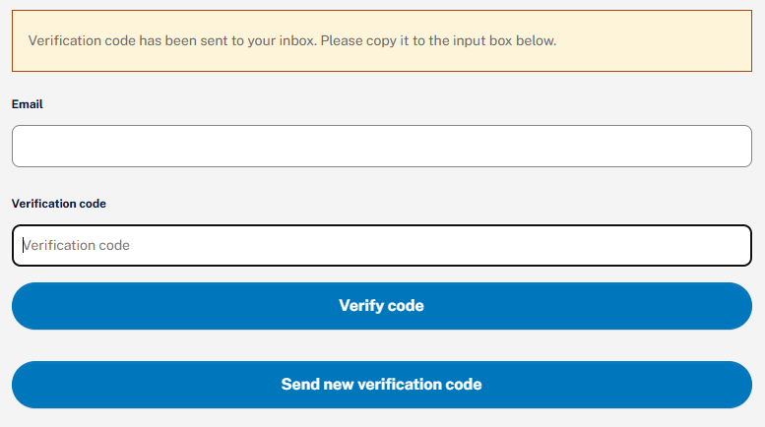
Step 4
Return to FEG Online Services and enter the verification code you were emailed and click Verify code.

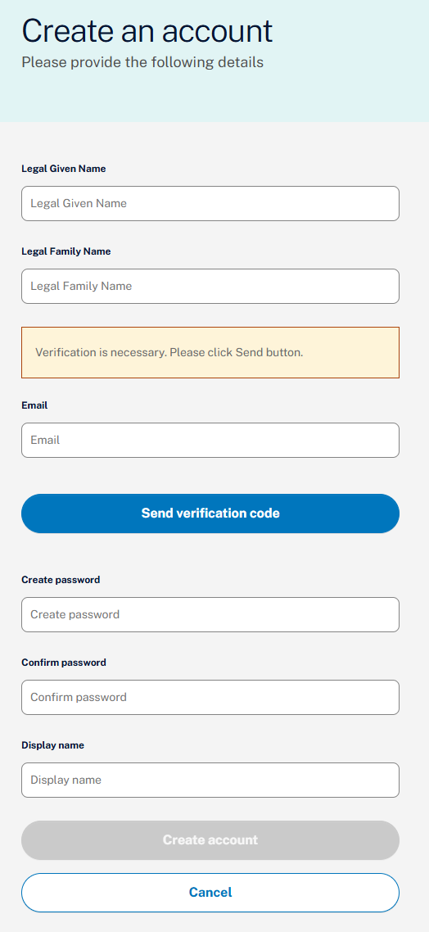
Step 5
Complete all the user details information and click Create.

Your password must contain:
- 8-16 characters,
- contain 3 out of 4 of the following
  - Lowercase characters,
  - uppercase characters,
  - digits (0-9), one or more of the following symbols: @ # $ % ^ & * - _ + = [ ] { } | \ : ' , ? / ` ~ " ( ) ; .
Your display name cannot include any special characters

Note: This is not your FEG claim. You will be able to complete and submit your FEG claim after you finish registering for FEG Online Services.

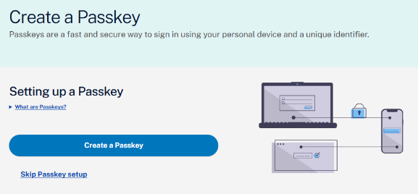
Step 6: Set up a passkey
To set up a passkey, select Create a Passkey.
If you prefer you can select Skip Passkey setup and go to Step 7 to choose Multi-Factor Authentication (MFA)

What is a passkey?
A passkey is a simple and secure way to sign into websites and apps without using a password.
Instead of a password, you use your device’s built-in security such as:
- your fingerprint,
- face recognition, or
- device PIN or screen lock.

When you create a passkey, it is saved on your phone, tablet, or computer. The next time you sign in, you confirm your identity using that device.

Why use a passkey?
Passkeys are:
- easy to use – you don’t need to remember or type passwords
- more secure - they help protect you from phishing and data breaches
- convenient - they can sync across your devices (for example, with iCloud or Google Password Manager).
With a supported device, you can sign in quickly and safely.

Before you start
Make sure your device supports passkeys.
Minumum requirements:
- Windows: Windows 10 (2015) or later
- Mac: or macOS Ventura (2022) or later
- Android: Android 9 (2018) or later
- iPhone/iPad: iOS 16 (2022) or later

Go to:
- Step 6a to set up for Windows Hello
- Step 6b if you are using an iOS device or for an Android device

Step 6a: Setting up Windows Hello
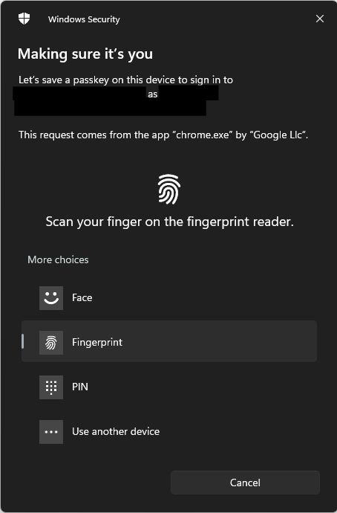
Before you can create a passkey on your PC, you need to set up Windows Hello. You can do this in Windows Settings.
When you create your passkey, a Windows Security pop‑up will appear. You will be asked to confirm your identity using your usual Windows Hello method, such as:
- a PIN,
- your fingerprint, or
- facial recognition.

If you prefer to create your passkey on a mobile device instead, select Use another device.

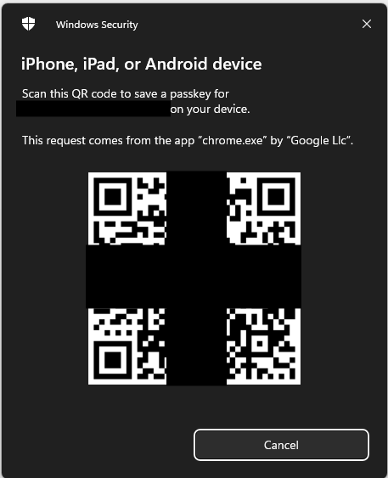
Step 6b: Setting up other device
Scan the QR code that is displayed using your mobile device.

iOS (iPhone or iPad)
Open the Passwords application when prompted to save your passkey.

Android
Select Google Password Manager to save your passkey.

Once you have set up your passkey, go to Step 8.

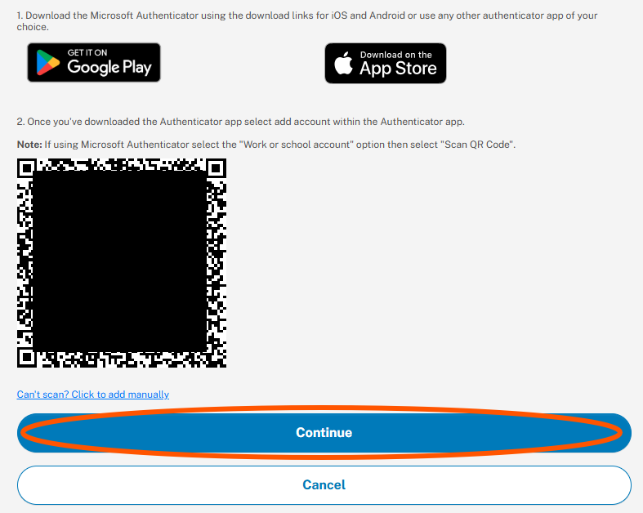
Step 7: Set up an MFA application
Example
If you choose not to use a a passkey, you will need to install an MFA application on your smart device (if you haven’t already).

Download your preferred MFA application from your device’s app store.

Once installed, select ““Click Once you have downloaded….”to display a QRcode.

Open your MFA application and scan the QR code using on your smart device.

Select Continue, then enter the one time verification code shwon in your MFA application.

Examples of a MFA applications include:
- Microsoft Authenticator
- Google Authenticator
- Duo Mobile
- Authenticator App
- Okta Verify

Step 8: Complete set up
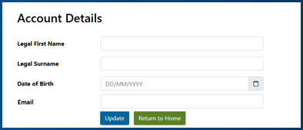
Once your device is successfully linked, you will be redirected to the FEG Online Services sign in page.

Your name and email address will auto fill here based on your registration details. You will need to complete your date of birth and click Update.

Completing the claim form in FEG Online Services
After registering and logging in, the FEG Online Services homepage will provide an option to Start a FEG Claim.
- You will need to complete all mandatory questions including providing details about your employment. You can also provide information about the entitlements you believe you are owed, your bank account details. You can also complete a tax file number declaration.
- You will need to upload all mandatory documents. Alternatively, you can use the Identity and Residency Document Verification Service (DVS) to authenticate your citizenship/residency documents.

Using the DVS
The DVS contained within FEG Online Services is a quick, easy and secure way to verify your account and prove your identity and Australian citizenship or residency.
DVS can verify documents, including:
- Full Australian Birth Certificate
- Change of Name Certificate
- Citizenship
- Marriage Certificate
- Passport
- Registration By Descent
- Visa.
The DVS checks that the personal details you enter match the original records held by an issuing agency. Once both an Identity document and a residency document are successfully matched, your account status will change to verified.
The DVS record and attachments will be sent to the department when you submit your claim, or added to any submitted claims that have not yet been processed.
Note: It is optional to verify your account or use the Identity and Residency Document process. Alternatively, mandatory documents to support Australian citizenship or residency status can be attached to your claim by selecting ‘Actions and Manage Attachments’ in the FEG Online System.

Verifying your FEG Online Services account (preferred)
- After signing into FEG Online Services, if the status of your account is ‘unverified’ you will be asked to verify your account.

- Select Identity and Residency Document Verification on the navigation bar and you will be taken to the ‘Manage Identity and Residency Documents screen’. Select Add New Verification.
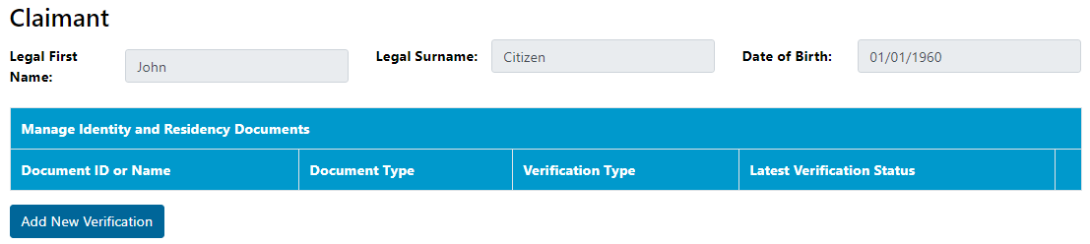
- Review the Verify Identity or Residency Document Consent information and confirm you are authorised to provide the details and consent to the information being checked. If you are, you can tick the ‘Agree’ box and select Continue.
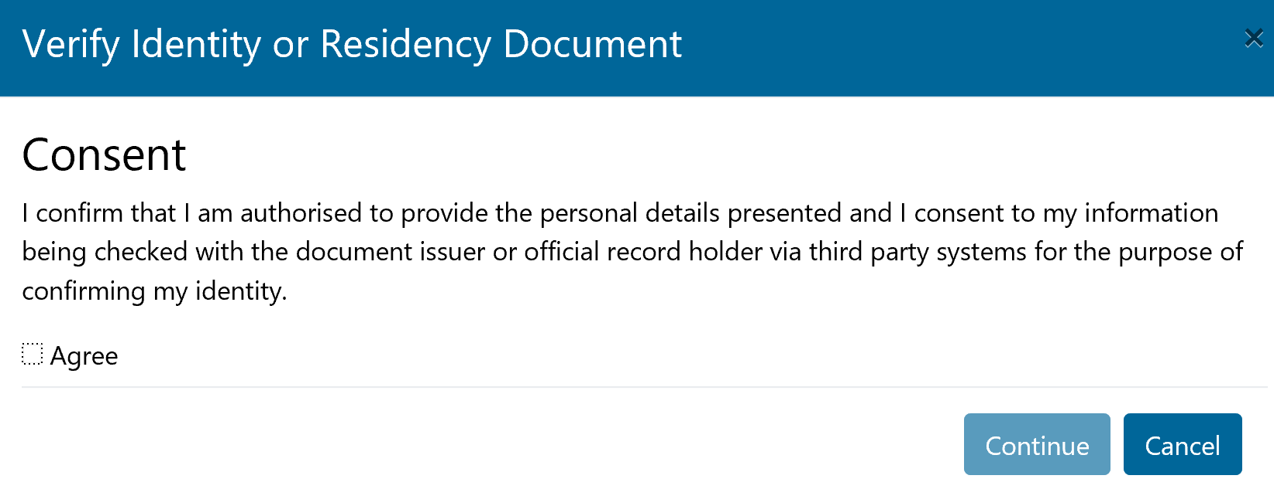
- Select from the list the documents you want to verify and click Continue. Enter the document details, then click Save. To upload a copy of the document click the Add button. This is required to make sure your claim meets effective and eligible requirements.

- In the popup window that appears, drag and drop the file, or click the grey panel to choose a file from your device.
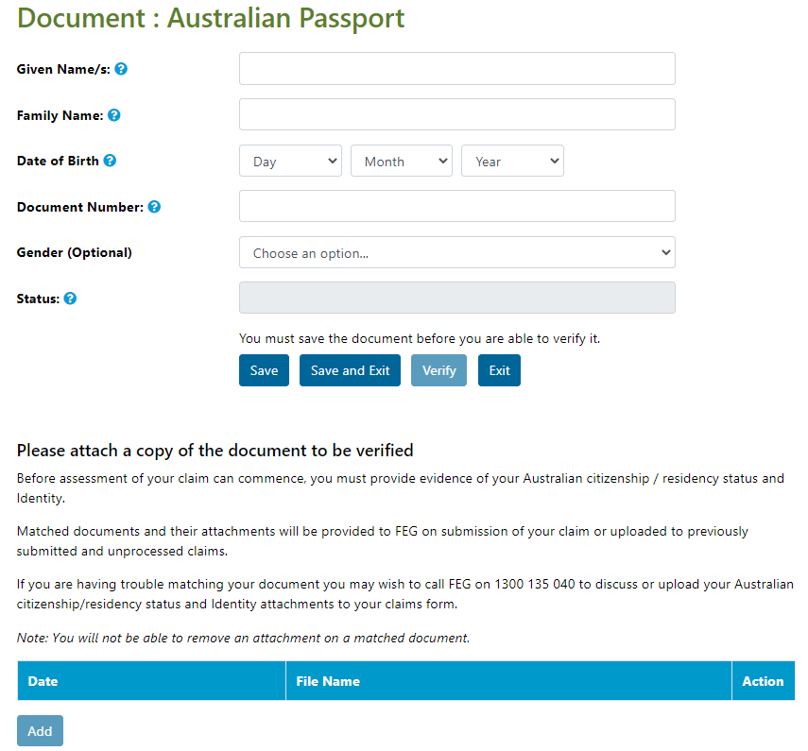
- Check that all the details you have entered are correct, then select Verify. The DVS will confirm all required fields are complete and send your request to the issuer agency.

- The status of your document will update to one of four responses from the issuer agency:
- Matched—No further action is needed. Once matched you cannot change the document details or remove attachments, but you can add extra attachments. These will be included when you submit your claim or added to any submitted and unprocessed claims.
- Not Matched—some details do not match the issuer record. Check your entries against the original, correct any errors, and select Verify.
- Document is invalid or not electronically captured—the document cannot be verified electronically. You can verify a different document, or upload proof of your Australian citizenship or residency with your claim for manual checking.
- System Error—There may be an issue sending the information to the verification service. Select Verify to resend the request.
- To add another document, select Exit to return to the Identity and Residency Documents screen.
- To view all draft, submitted and processed claims, select Home on the navigation bar.
DVS trouble shooting tips
- Your FEG Online Services account will only change to Verified once you have successfully verified both your identity and residency. Some documents, like your passport, can verify both identity and residency. Others such as a drivers’ licence can only verify your identity. Until both identity and residency are verified, your account will remain Unverified.
- You can reuse the same document if it returns an Unmatched result. Review and correct the details so they match the original document, then save it before selecting Verify.
- You can still add attachments after the document has been matched. Any identity or residency documents you upload before submitting your claim — or before your claim is finalised — will be available to department staff.

Linking an existing claim form in FEG Online Services
Claimants and agents can use this function to link to an existing FEG claim. To successfully link a claim the agent details recorded in the claimant’s claim form must match the agent’s registration details.
- To link an existing claim, you will need to provide your details and the details of the claim, including the claim number.
- You can find your claim number on correspondence sent to you by the department. You can also contact the FEG Hotline on 1300 135 040 (Monday - Friday, 9am – 5pm, Canberra time) or via email: feg@dewr.gov.au
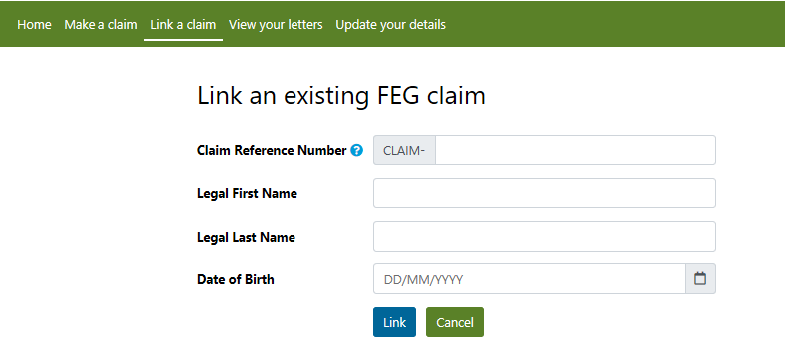

Accessibility and support
- Interpreting: call Translating and Interpreting Service (TIS National) on 131 450 and ask them to contact the FEG Hotline on 1300 135 040.
- Interpreter services for First Nations people: visit the National Indigenous Australians Agency website to find a service that is right for you.
- Hearing or speech: contact us through the National Relay Service (NRS) and provide our contact phone number 1300 135 040 when asked by the relay officer.
- Support person: you may nominate someone as an alternative contact or agent to assist you. More information can be found on the department’s website.

Need more information or help?
If you are having problems using FEG Online Services, contact the FEG Hotline:
- Phone: 1300 135 040 (Monday - Friday, 9am – 5pm, Canberra time)
- Email: FEG@dewr.gov.au
The information contained in this fact sheet is of a general nature and is not legal advice. You should seek your own independent legal advice for your circumstances. The Commonwealth makes no representation or warranty as to the accuracy, reliability, currency or completeness of this information and is not liable for any loss resulting from any action taken or reliance on it.

