

Using FEG IP Online
FEG IP Online is the secure portal used by insolvency practitioners (IPs) and the Department of Employment and Workplace Relations (the department) to exchange information about Fair Entitlements Guarantee (FEG) claims.

What is FEG IP Online?
FEG IP online helps IPs to:
- exchange information and documents related to FEG claims
- receive, action and submit tasks requested by the department
- track the progress of claims and cases
- communicate easily with the department
- upload verification spreadsheets and other required documents.

Accessing FEG IP Online
Create an account
From 21 May 2025, all users must register a new account using the email issued by your firm’s System administrator.
To register
Step 1
Open FEG IP Online and click Continue. 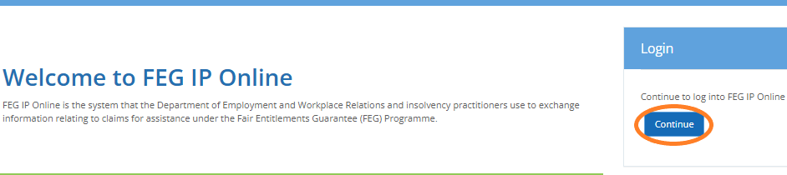

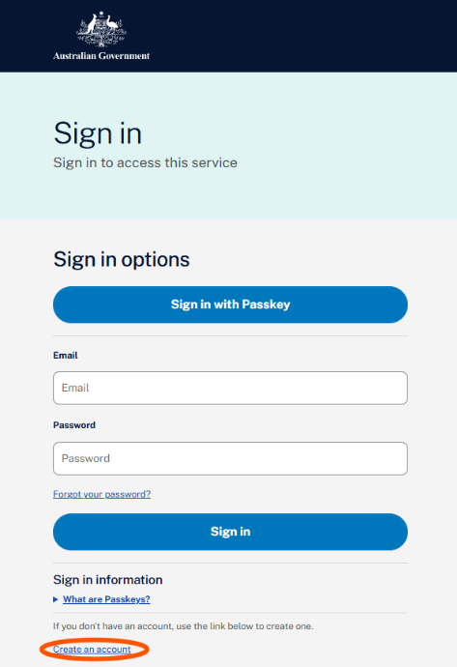
Step 2
Click Create an account to begin the registration process.

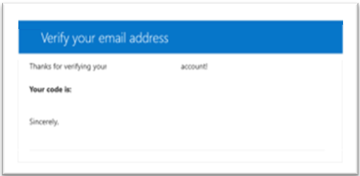
Step 3
Complete the required fields, including the email address agreed with your firm’s System Administrator.
Click Send verification code. The verification code will be sent to the email address you entered.
Note: Your registration email address is your unique identifier for FEG IP Online. Once an online services account has been created using a specific email address, that same email address cannot be used by aonone else to register for FEG IP Online.

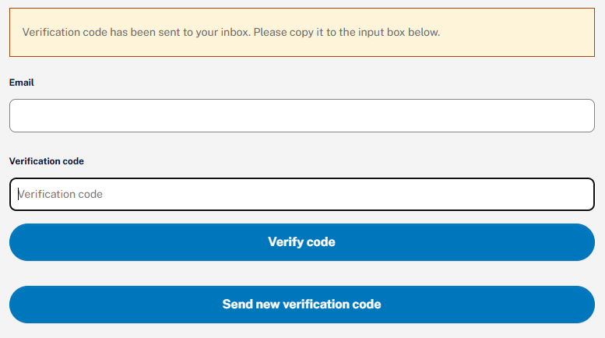
Step 4
Return to FEG IP Online and enter the verification code you recevied via your email and click Verify code.

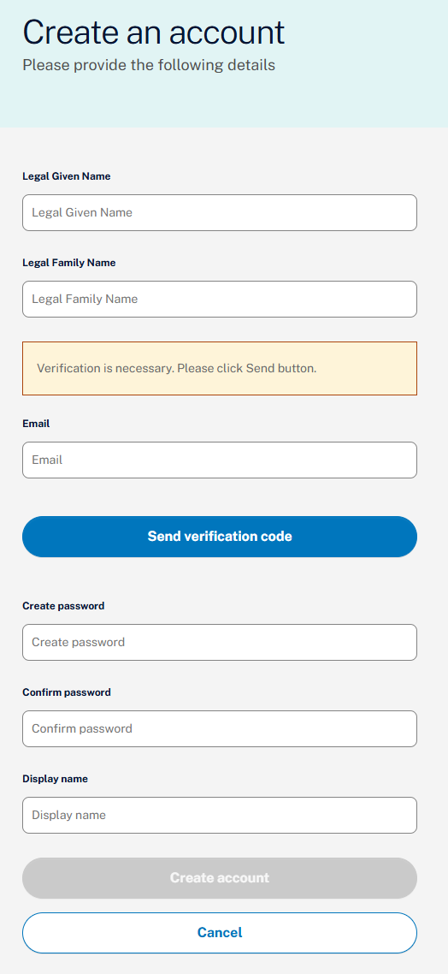
Step 5
Complete all the user details information and click Create.
Your password must contain:
- 8-16 characters,
- 3 out of the 4 following:
  - lowercase characters
  - uppercase characters
  - digits (0-9)
  - one or more of the following symbols:
@ # $ % ^ & * - _ + = [ ] { } | \ : ' , ? / ` ~ " ( ) ;

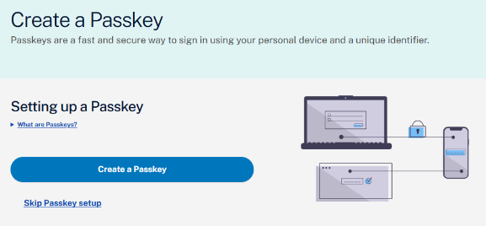
Step 6: Set up a passkey
To set up a passkey, select Create a Passkey.
If you prefer you can select Skip Passkey setup and go to Step 7 to choose another Multi-Factor Authentication (MFA)
What is a passkey?
A passkey is a simple and secure way to sign into websites and apps without using a password.
Instead of a password, you use your device’s built-in security, such as:
- your fingerprint,
- face recognition, or
- device PIN or screen lock

When you create a passkey, it is saved on your phone, tablet, or computer. The next time you sign in, you just confirm your identity using that device.

Why use a passkey?
Passkeys are:
- easy to use – you don’t need to remember or type passwords
- more secure – they help protect you from phishing and data breaches
- convenient - they can sync across your devices (for example, with iCloud or Google Password Manager)
With a supported device, you can sign-in quickly and safely.

Before you start
Make sure your device supports passkeys.
Minimum requirements:
- Windows: Windows 10 (2015) or later
- Mac: macOS Ventura (2022) or later
- Android: Android 9 (2018) or later
- iPhone/iPad: iOS 16 (2022) or later
If your devide does not meet these requirements, chose the MFA option in step 7.
Go to:
- Step 6a to set up for Windows Hello
- Step 6b if you are using an iOS device or for an Android device

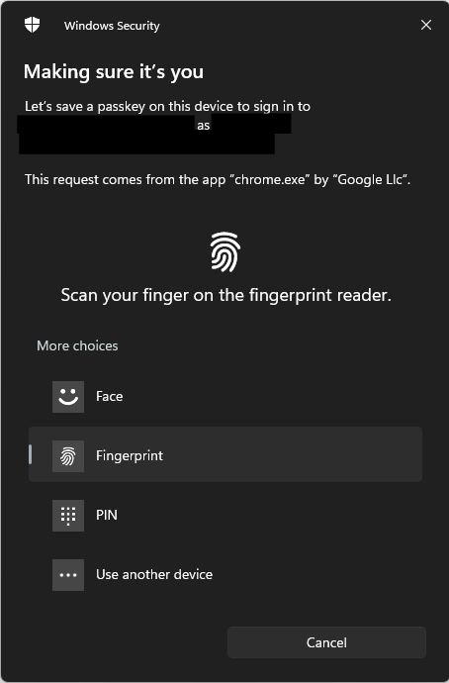
Step 6a: Setting up Windows Hello
Before you can create a passkey on your PC, you need to set up Windows Hello. You can do this in Windows Settings.

When you create your passkey, a Windows Security pop‑up will appear. You will be asked to confirm your identity using your Windows Hello method, such as:
- a PIN,
- your fingerprint, or
- facial recognition.

If you prefer to create your passkey on a mobile device instead, select Use another device.

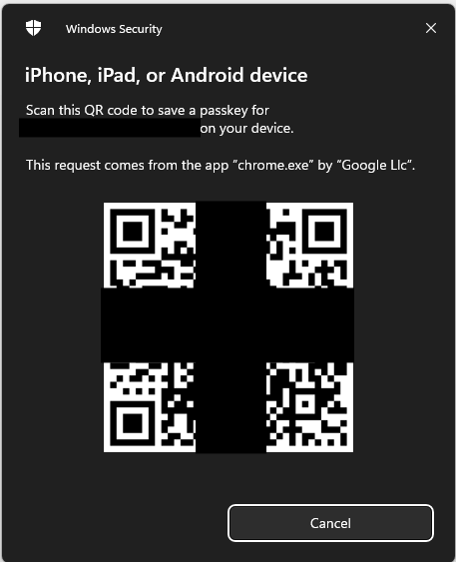
Step 6b: Setting up other device
Scan the QRcode that is displayed using your mobile device.
iOS (iPhone or iPad)
Open the Passwords application when prompted to save your passkey.
Android
Select Google Password Manager to save your passkey.

Once you have set up your passkey, go to Step 8.

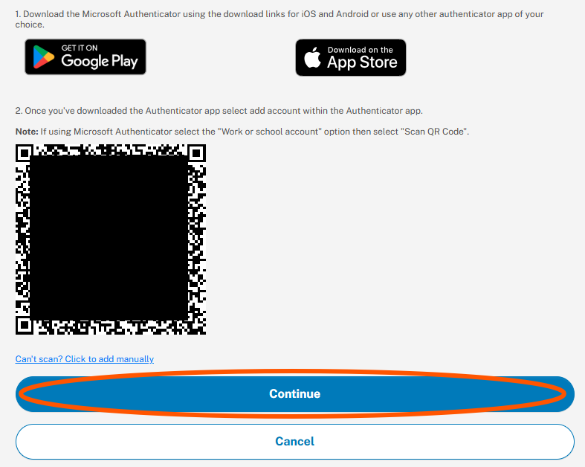
Step 7: Set up an MFA application
Example
If you choose not to use a passkey, you will need to install an MFA application on your smart device (if you haven’t already).

Download your preferred MFA application from your device’s app store.

Once installed, select “Click Once you have downloaded…” to display a QR code.

Open your MFA application and scan the QR code using your your smart device.

Select Continue, then enter the one time verification code shown in your MFA application.

Examples of MFA applications include:
- Microsoft Authenticator
- Google Authenticator
- Duo Mobile
- Authenticator App
- Okta Verify

Step 8
Once your smart device is successfully linked, you will be redirected to the FEG IP Online firm Dashboard.
You will be asked to select your profile if you have access to more than one.
Note: If you see a message saying no account was found, contact your firm’s System Adminsistrator to create or update your account.

Using FEG IP Online
Note: For a detailed help guide, please navigate to FEG IP Online

Logging in to FEG IP Online
Once you have registered, click Continue on the login page.

Enter the portal via your prefered authentication method and then select your profile (if attached to multiple offices)

Your Azure B2C login is shared across all offices you work in.

Using the Dashboard
After logging in, you arrive at My Dashboard, which displays:
- tasks assigned to you or your team
- tasks you created
- messages you created or received
- active cases
- tasks awaiting your approval
- notice Board updates
You can also switch to Firm Dashboard to see all tasks and messages at the firm level.

Navigation Menu Overview
The left navigation menu provides direct access to:
- Manage Cases
- Manage Claims
- Manage Tasks
- Messages
- Correspondence
- Reports
- Settings (System Administrators only)
- Resource Centre (guides, practice notes, contacts)

Managing cases
Searching for Cases
- You can search by business name, trading name, ABN, and other fields.
- If a search returns nothing, try clearing the Status field (leaving it blank).

Case Status Types
- Active – case created; claims processing underway
- Recovery – all claims processed
- Closed – no further claims or actions required

Case Page Includes:
- Case details (employees, claims, insolvency date)
- Claims graph
- Tasks graph
- Total payments made
- Case attachments
- Questionnaires
- Case assignment (team or liaison user)
System Administrators (or users with permissions) can assign or reassign liaisons. They cannot remove the last remaining liaison until a replacement is added.

Managing Claims
From Manage Claims, you can:
- search by claimant name or other criteria
- view claim progress, claimant details, decisions, and correspondence
- create tasks related to that specific claim

Managing Tasks
Tasks are the main way the department and IPs communicate and exchange information.
Task Statuses
- IP Created – drafted but not submitted
- New – newly assigned to you
- In Progress – you’ve started working on it
- Submitted – sent to the department
- Overdue – past due date
- Pending Approval – awaiting internal approval
- Approved – cleared for submission
- Completed – no further action required
Receiving Tasks
You receive automated email alerts when tasks are created, overdue or escalated due to no response
Working on Tasks
For each task, you can:
- read instructions
- upload files
- view or complete questionnaires
- add comments
- assign to another team/user
- request approval
Attachments cannot be removed once a task has been submitted.

Questionnaires (Initial Contact and Recovery)
Completing a Questionnaire:
- Access via dashboard, case page, or task
- Use Work on Task → then Edit
- Use navigation bar or Next/Prev buttons
- Complete all mandatory fields
- Submit to the department
The Initial Contact questionnaire is mandatory; the Recovery questionnaire is optional.
Mandatory fields include the “Agree” checkbox and specific required questions.

Verification Spreadsheet Tasks
This is a key function for IPs providing verification services.
Important Rules:
- Upload the spreadsheet using Upload Data, not Attachments.
- Only one spreadsheet may be uploaded at a time.
- Errors must be corrected before submitting.
- Warnings do not prevent submission.
You may use either the FEG-supplied spreadsheet, or your firm’s customised template (mapped in Settings → Manage Templates)

Opting Out or Requesting an Extension
If you are unable to provide data, click Opt Out, select a reason and provide additional information if required

Messaging (Non-Case Communication)
Use Messages to contact the department about matters not yet visible in FEG IP Online, such as potential liquidations or early enquiries.

Message statuses include: New, In Progress, Submitted, Sent by Department, Completed.
Attachments can be uploaded, but cannot be removed after submitting.

Managing Correspondence
The Correspondence section allows you to view:
- letters and notices issued to claimants
- correspondence relating to cases or claims assigned to your firm
You can filter by case, claimant, date range, or status.

Reports
You can generate reports including:
- dividends received
- case-specific reporting
Reports are generated one at a time.

User and Team Management (System Administrators Only)
System Administrators can:
- create and update users
- assign role permissions (e.g. Submit Task, Approve Task, Maintain Users and Maintain Teams)
- create and manage teams
- assign primary contacts
- manage task workflow (that is, permissions for approving specific types of tasks)

Note: System Administrators do not automatically have approval permissions—they must be assigned Approve Tasks for each task type.

Accessibility and support
- Interpreting: call Translating and Interpreting Service (TIS National) on 131 450 and ask them to contact the FEG Hotline on 1300 135 040.
- Interpreter services for First Nations people: visit the National Indigenous Australians Agency website to find a service that is right for you.
- Hearing or speech: contact us through the National Relay Service (NRS) and provide our contact phone number 1300135 040 when asked by the relay officer.

Need help?
If you need help using FEG IP Online, contact the FEG IP Helpline (for IPs only):
- Phone: (02) 6240 0440 (Monday to Friday, 9am — 5pm, Canberra time)
- Email: FEGIPOnline@dewr.gov.au

The information contained in this fact sheet is of a general nature and is not legal advice. You should seek independent legal advice for your circumstances. The Commonwealth makes no representation or warranty as to the accuracy, reliability, currency or completeness of this information and is not liable for any loss resulting from actions taken or reliance made on it.

