Debiasing systems

Managing bias across the talent lifecycle
Research shows that bias exists in every corner of an organisation, including hiring, performance, evaluations, meetings, sponsorship, promotion and pay.
Left unchecked, bias can also shape a company or industry culture and norms.
Naming the bias and developing mitigation strategies is critical to creating more inclusive, diverse, and equitable organisations.
The map below, shows common types of bias and how they manifest across the talent lifecycle. While the explicit focus of this interactive map is gender bias, biases are not gendered by nature. Unconscious racism, ageism, ableism and sexism impacts all people within your organisation.
Follow the path in the map below to see how common forms of bias materialise across the talent lifecycle. The map may be used to spark a conversation about organisational bias and steps to disrupt and mitigate.
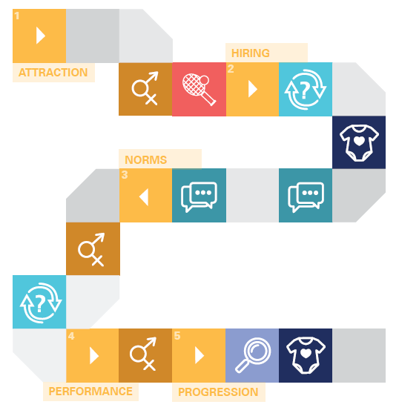
1. Attraction
  Subtle word choices impact on the application pool. Masculine language, including adjectives like ‘competitive’, ‘decisive’ and ‘determined’ can result in women perceiving they do not belong in the workplace.  Women are less likely than men to apply for roles if they do not meet 100% of the stated criteria. |   Software programs that highlight stereotypical gendered words may help counteract this effect. Use programs like gender decoder to remove words or replace them with more neutral descriptions.  Reduce job requirements and focus only on essential skills and qualifications.

 | Gender bias – A preference for one gender over the other. Usually, a result of ingrained beliefs about gender roles and stereotypes.
 | Affinity bias – A tendency to gravitate toward people who share our interests, beliefs, and backgrounds.

2. Hiring
Studies show that women, LGBTIQA+ candidates, individuals with disabilities and older people are less likely to be hired than their peers. A bias for likability and natural chemistry is one of the most difficult to bust.  In hiring processes, mothers are less likely to receive a call back from potential employers, even when their resumes are identical to those of male applicants or childless women. | A blind, systematic process for reviewing applications and resumes will help you remain focused on the candidate’s qualifications and talents, as opposed to demographic characteristics.  Asking candidates to solve a work-related problem or skills test that mimic the kinds of tasks candidates will be doing can help you focus on the quality of a candidate’s work as opposed to unconsciously judging them on appearance, gender, age or personality.  Use an interview scorecard that grades candidate responses to questions on a predetermined scale. Ideally, the interview score card will be an independent data point linked to an anonymous CV review and work sample.

 | Prove it Again bias – Groups stereotyped as less competent – including women, individuals with disability, older Australians and LGBTIQA+ have to prove themselves over and over.
 | Maternal wall bias – Women with children see their commitment and competence questioned or face disapproval for being too career focused.
 | Conformity bias – We take behavioural cues from the actions of others rather than exercising independent judgement.

3. Norms
Women are 20% more likely than their male colleagues to volunteer for or be assigned ‘office housework’ such as organising, cleaning up after a meeting, scheduling meetings or taking notes. Meanwhile, ‘glamour work’ that leads to networking and promotion opportunities goes disproportionately towards men.  Women and people of Asian descent are more likely to have been raised believing that they should be communal, modest and helpful. The so called ‘modest mandate’ can lead individuals to hold back their thoughts or to speak in a tentative or deferential way.  Research shows that men are more likely than women to dominate conversation, with women typically participating about 25% less often than their male colleagues. | Systemise office ‘housework’ tasks by creating a spreadsheet or roster to ensure that the load falls equally on all staff.  Create mechanisms to track and reward lower profile contributions, including recognising staff mentoring in performance reviews.  If you are unsure if this is occurring in your meetings, start to track who is at the table and who is doing the talking. Apps such as All.ai can also be used to track the proportion of the meeting that your voice was heard.  Introduce office rules or principles around meeting etiquette, including not interrupting or speaking over others.  Train managers and leaders to create space for all staff to contribute to the conversation, for example explicitly asking quieter staff members to provide their thoughts and opinions.  When a female staff member is interrupted or discredited, call out the bias that may be at play. If it is not appropriate to call out bias during the meeting, politely raise the pattern of interruption you have noticed following the meeting.

4. Performance
An analysis of men and women’s written performance reviews found that women were more likely than men to receive vague feedback that did not offer specific details of what they had done well and what they could do to advance.  Men were more likely to receive longer reviews focused on technical competency compared with shorter reviews for women  While men are judged on potential, mistakes made by ‘prove it again groups’, including women, are noticed more and remembered longer.  A narrower range of workplace behaviour is accepted for women. While white men need to be authoritative and ambitious to succeed, women often risk being labelled aggressive or difficult if they behave in a similar fashion. | Adopt mechanisms that enhance the specificity of manager reviews. Develop a rubric for evaluation that clearly defines the criteria against which an employee’s performance will be assessed. Research shows that you are less likely to be influenced by instinct when you first agree to the criteria used in assessment.  To guide managers performance reviews, consider the prompts to better reflect decisions and intentions. For example, prompt with statements like:  - I would always want this person on my team  - I would award this person the highest possible compensation increases and bonuses  - I would hire this person again  - This person is ready for promotion today  Disrupt the ‘modesty mandate’ by giving staff tools to manage their own performance. Be clear that it is acceptable and expected to advocate for oneself.  Invite an independent and trained arbiter in to help call out bias as it manifests in real time.

5. Progression
Managers are more likely to underestimate the career aspirations of women with children, unfairly assuming they are less committed to progressing at work.  Women may face a “likeability” penalty if they attempt to negotiate for higher pay.  Women are less likely than their male peers to receive sponsorship and stretch opportunities than their male colleagues, a fact which is often attributed to affinity bias.  Women are less likely than men to reapply for roles and promotions after narrowly missing out. | Create conversation prompts for managers that requires them to discuss and clarify performance goals and ambitions with team members.  Frequently review salaries for parity between genders and commit to make changes if this is not occurring.  Monitor assignment opportunities to identify and disrupt biased sponsorship patterns.  Invest in a sponsorship (or reciprocal mentorship) program which connects senior male leaders with diverse talent. Encourage them to use their power and influence to help women to advance.  Make a habit of following up with unsuccessful candidates with an email or phone call. Provide feedback and encourage them to re-apply for roles in future.

 | Tightrope bias – A narrower range of workplace behaviours is accepted from some groups than from others.

