An apprentice and a tradesman in a Cabinet Making factory, looking at plans in a workshop.
Employability Skills Training (EST) enhances the work readiness of participants, providing intensive and targeted pre-employment training.

# Workforce Ready Participants

Designer Life is committed to working with local employers to provide customised services to help you find the right candidate for your business in **Mackay and the surrounding regional areas**.

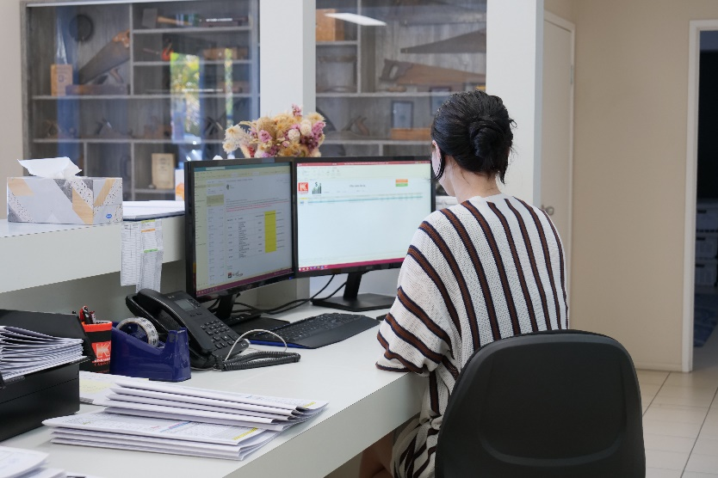We work closely with business, labour-hire, and industry associations to help fill vacancies. We develop specific pre-employment skills training to equip job seekers with the right skills that you need for your business. We work with you to co-design and inform our programs about what employability and micro-credential skills you need to hire local and minimise skills and labour shortages.

Designer Life is a Registered Training Organisation delivering accredited courses across a range of industries.

# Services we guarantee

* Free advertising of your vacancy and access to our job seeker database to help find you the right fit.
* Pre-screening of participants
* Employer / participant engagement events
* A dedicated team to work with you to:
* Learn about your recruitment and workforce needs
* Help tailor a recruitment strategy that works best for your business or industry
* Provide advice on training products and government employment programs to meet your needs including:
* Seasonal strategies
* Workforce diversity targets
* Workplace inclusive practices, including supervisor training
* Employment subsidy programs including wage subsidies, workplace modifications and employment programs for Indigenous Australians.
* Industry awareness activities
* Design EST training with you that incorporates:
* Micro-credential skills and training brokerage to meet your entry-level requirements
* Tailored skills development training addressing skills deficit/s
* Job placement support, including traineeships and apprenticeships

A hospitality Barista using a coffee machine making a coffee. Dressed in a red blazer.


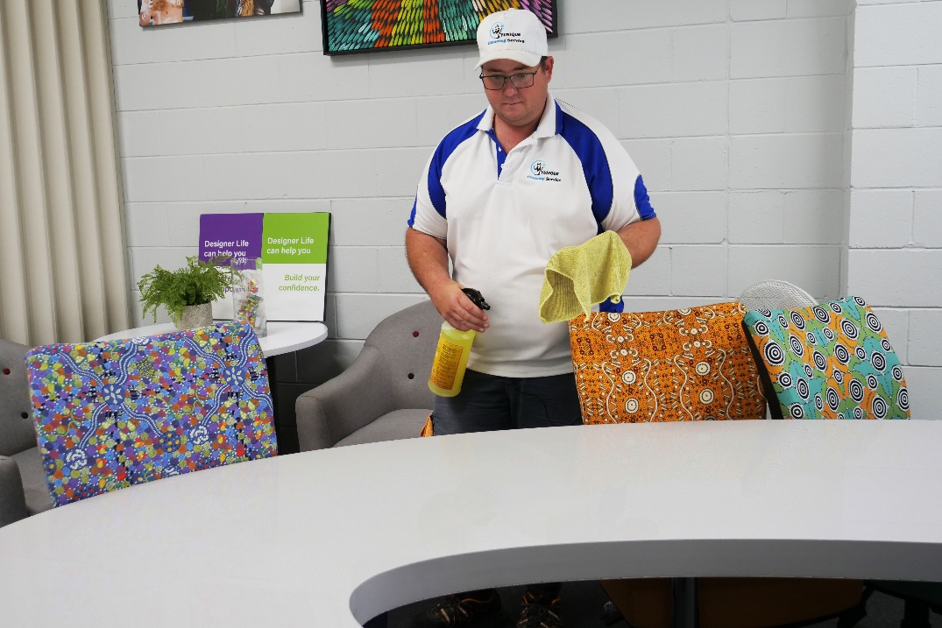

## We form industry partnerships with:

* Large companies and large employer chains in retail, healthcare, hospitality
* National and local industry associations
* Labour Hire companies
* Local small and medium business owners
* Government agencies

## We want to work with you in sectors including:

* Building and construction
* Mining and the resources
* Commercial cleaning
* Hospitality
* Community services
* Disability Support Services
* Retail and Business administration
* Transport
* Local employers with workplaces accessible to regional areas or employers   
  willing to negotiate worker transport solutions with us

## A man wearing a headset and working in a call centre answering calls.What do you need to do?

So we can tailor a recruitment plan to meet your needs, connect with us online or through the Designer Life Contact Centre.

We will then contact you to discuss your vacancy so we can learn about your business and design an EST training solution to prepare suitable job seekers to become a good fit for your business.

We need your support to do this, and we welcome your attendance at our program to be part of our EST courses and provide practical advice to job seekers looking for work.

We also need your commitment to offer industry awareness experiences to build job seekers confidence and skills.

We can provide advice on available subsidy payments to support you for your willingness to work with us to help local people to get into and stay in work.

**FOR MORE INFORMATION Call: 07 3333 2055 or Email:** [**est@designerlife.com.au**](mailto:est@designerlife.com.au)