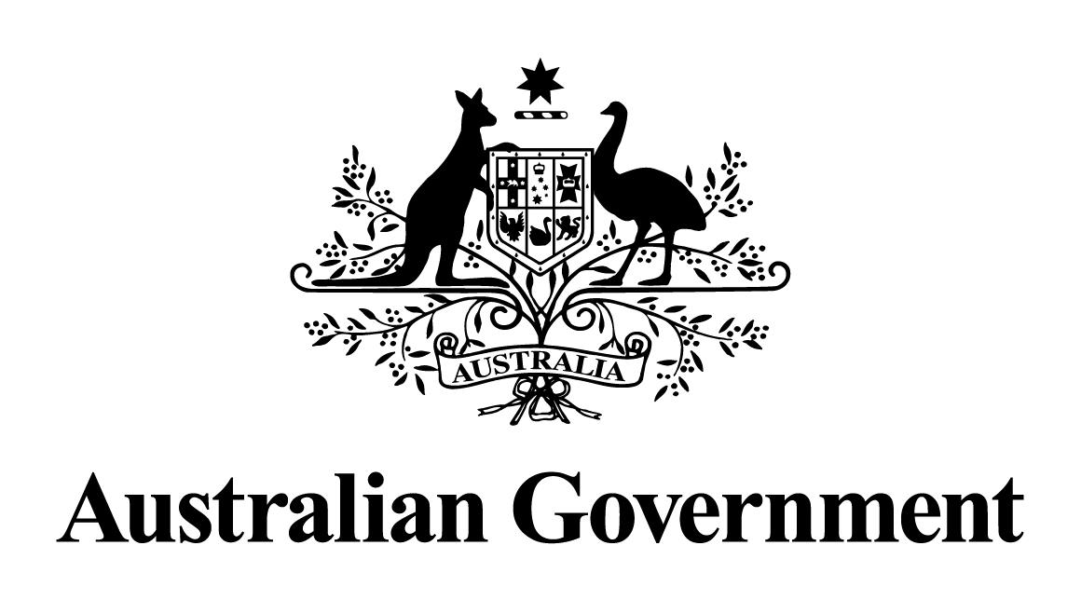
Australian Government response to the
Select Committee on the Future of Work and Workers report:
Hope is not a strategy – our shared responsibility for the future of work and workers
MArch 2023

Overview
The Government welcomes the recommendations outlined in the Hope is not a strategy – our shared responsibility for the future of work and workers report (the Report) and thanks the Committee for its work. The Government particularly acknowledges the valuable submissions to the enquiry made by over 160 individuals and organisations. The feedback provided at public hearings was used by the Committee and Government in framing the inquiry report and this response.
The nature of work is constantly changing. How we currently work and will work in the future is being shaped by factors such as economic, technological and demographic change, as well as shifts in business practices as industries and communities adapt to climate change. The way we work also continues to evolve. For example, COVID -19 has accelerated digital transformation and adoption of new technologies and new work styles.
To keep pace, workers and employers are adopting new ways of operating. These changes provide an opportunity for Australia. The priorities of ensuring access to better skills and training, secure jobs and growing wages create new opportunities for more Australians and are key objectives for the Government.
The Government has a clear plan for a better future for all Australian workers and is making jobs more secure by implementing reforms to strengthen protections available to workers. Jobs and Skills Australia has been established to strengthen workforce planning, the training system is being improved and there is increased investment in TAFE and university places to train workers for the new jobs of the future.
On 1-2 September 2022, the Government convened the Jobs and Skills Summit which brought Australians together to work constructively on the challenges and opportunities facing the Australian labour market and economy. In collaboration with industry, unions and other community stakeholders, the Government agreed to a range of immediate initiatives.
- An additional $1 billion in joint Federal-State funding for fee-free TAFE in 2023 and accelerated delivery of 480,000 fee-free TAFE places.
- Modernising Australia’s workplace relations laws, including to make bargaining accessible for all workers and businesses.
- Amending the Fair Work Act to strengthen access to flexible working arrangements, make unpaid parental leave more flexible and strengthen protection for workers against discrimination and harassment.
- Improving access to jobs and training pathways for women, First Nations people, regional Australians and culturally and linguistically diverse people, including equity targets for training places, 1,000 digital apprenticeships in the Australian Public Service, and other measures to reduce barriers to employment.
- Increasing the permanent Migration Program ceiling to 195,000 in 2022-23 to help ease widespread workforce shortages.
The Government is focused on medium and long-term reforms to prepare Australia’s future labour market and has undertaken to develop an Employment White Paper which will build on the outcomes of the Jobs and Skills Summit and will focus on the objectives of full employment and productivity growth for the benefit of all Australians, along with women’s economic participation and equality.
The Government will continue proactively working with business and unions to address the workforce challenges presented by the changing labour market and is focused on building a bigger, better trained and more productive workforce, boosting incomes and living standards to ensure jobs are secure and businesses are thriving.
Changing employment trends and working patterns
Technology has always changed the way workers do their jobs.
COVID-19 led to rapid changes in the way people worked and transformed almost every aspect of people’s lives. Workers and employers were forced to adopt new ways of working. Many activities moved online, and many aspects of these changes may remain permanent.
The Government recognises the importance of ensuring everyone can take advantage of the opportunities presented by new technologies and a modern workforce. The Government is improving access to the internet, including providing reliable services in more regional areas and investing in skills development to ensure digital literacy training is available to people who need it.
Rapid technological advancement, disrupted global supply chain settings, and an ageing Australian population are expected to result in further structural change in the labour market continuing over the medium and long term. It is projected that four service industries – health care and social assistance, professional, scientific and technical services, education and training, and accommodation and food services – will provide more than three-fifths of total employment growth over the next five years.
Our recovery from COVID-19 highlighted vulnerabilities in the global supply chain. The $15 billion National Reconstruction Fund is the first step in the Government’s plan to rebuild Australia’s industrial base. The National Reconstruction Fund will provide financing to drive investment in projects that will build prosperity across the country, broadening our industrial base and boosting regional economic development and employment opportunities.
The Powering Australia Plan will also prioritise regional growth and investment. Increasing investment in renewable energy will create jobs, cut power bills, and reduce emissions. These initiatives will support Australian businesses to grow and ensure more opportunities are available for employees.
The Government is focused on leveraging the opportunities these changes present and shaping the future so that everyone prospers. Skilling Australians for change is crucial to building a better future. To take advantage of these opportunities, the Government will also work in partnership with businesses and unions to achieve better outcomes for the Australian economy. This includes updating workplace laws, boosting job security and wages, and advancing gender equality for women.
Building a better skilled, better trained workforce
Training workers for the future is key to taking advantage of the opportunities these changes bring. How we skill people up and prepare Australians for change is crucial. Investing in education and equipping people with the right knowledge and skills is the best long-term generator of economic growth and productivity. A strong education, from early learning and schools right through to universities and TAFEs helps set people up to make the most of upcoming opportunities. As workplaces evolve, workers will need support to continue to deepen, develop and adapt their skills throughout their working lives.
Jobs and Skills Australia has been established as a priority. The new agency will provide independent, evidence-based advice on current and emerging skills and labour needs and workforce challenges, and will engage widely with business, unions, governments and the education and training sectors. The agency’s analysis will support government and industry to address short-term challenges and emerging opportunities.
Having good quality and responsive higher education and vocational education and training (VET) systems is critical to ensuring people are prepared to take up future jobs. To support this goal, the Government will work in collaboration with states, territories and key VET stakeholders to create a National Skills Agreement that offers Australians the skills they need to gain secure employment in the future, and to develop a comprehensive VET Workforce Blueprint to support and grow a quality VET workforce, ensuring the long-term sustainability of the VET sector. This partnership will drive improved outcomes in the VET sectors and strengthen workforce planning, particularly in growing sectors of our economy.
The Government is supporting more technology-related jobs by making available 480,000 fee-free TAFE places and up to 20,000 additional Commonwealth-supported university places for under-represented groups in areas of skills shortages. The Australian Skills Guarantee (the Guarantee) will ensure one in ten workers on major government projects is an apprentice, trainee or cadet. The Guarantee complements the Australian Apprenticeships Incentive System which provides financial assistance to all employers hiring an apprentice or trainee. Additional support through a wage subsidy is available for employers of apprentices in priority occupations identified as being skills in demand. Apprentices and trainees in priority occupations are also eligible for direct payments to assist with their costs of living and completing their apprenticeship.
A New Energy Skills program is funding 10,000 New Energy Apprentices. The New Energy Apprenticeships initiative will help secure a pipeline of talent to build a skilled workforce so that Australia can become a renewable energy superpower.
Increasing the participation of women in the workforce
Despite considerable gains in the workforce participation of Australian women over the past 50 years, employment and economic outcomes for women remain unequal. The Government is working towards reducing barriers to employment so that all Australians have an equal opportunity to reach their full potential. This will include:
- Reducing the cost of childcare for over 95 per cent of eligible families, boosting women’s workforce participation and helping to close the gap in retirement incomes so women don’t retire in poverty.
- Requiring employers with 500 or more employees to commit to measurable targets to improve gender equality in their workplaces.
- Requiring employers with 100 or more employees to publicly report their gender pay gap to Workplace Gender Equality Agency.
- Requiring the Australian Public Service to report to the Workplace Gender Equality Agency and to set targets to improve gender equity in the public service.
- Continuing to provide additional support for women undertaking apprenticeships in trades, including career advice, personalised assistance and access to peer networks and mentors.
- Setting targets for women on major Australian Government funded projects to provide women with opportunities to work and train on major projects through the Australian Skills Guarantee.
Making it easier for people to get jobs
The Government is committed to ensuring Commonwealth employment services support people to find good secure jobs.
The Government has established a House Select Committee inquiry into Workforce Australia Employment Services so that employment services are best designed to meet current and future challenges facing Australians.
The Committee will examine the first 12 months of the new Workforce Australia system and has committed to review all aspects of the program including the implementation, performance and appropriateness. The Committee has also resolved to include pre-employment and complementary programs within the scope of its inquiry.
The Committee undertook to make any recommendations on ParentsNext in an interim report before the end of February 2023 while a final report will be provided back to Parliament by 29 September 2023. The Committee will conduct a number of public hearings and will seek submissions from stakeholders as part of this process.
Creating secure jobs
Employment has a profound impact on an individual’s and families’ quality of life. Insecure work, low wages and low productivity have material consequences for individuals, businesses, the economy and the community as a whole. The Government wants a strong economy where every Australian has the opportunity to find a secure job, with fair pay and proper protections. An effective workplace relations system will allow Australians to build a safe, prosperous and secure future while providing workers and businesses a pathway to seek better outcomes and thrive.
The Government’s Secure Jobs, Better Pay legislation will bring changes to the workplace relations system that deliver better productivity and flexibility for employers and better pay and conditions for workers. The new laws:
- boost bargaining and workplace relationships
- improve job security and gender equality
- improve workplace conditions and protections
- restore balance to workplace relations institutions.
The Fair Work Legislation Amendment (Secure Jobs, Better Pay) Act 2022 does this by:
- reforming the Better Off Overall Test so it’s simple, flexible and fair
- including gender equity and job security as objects of the Fair Work Act
- introducing a statutory equal remuneration principle
- prohibiting pay secrecy clauses
- providing stronger access to flexible rostering arrangements
- limiting the use of fixed term contracts
- prohibiting job ads that advertise below minimum rates of pay
- giving the Fair Work Commission more powers to arbitrate industrial disputes
- abolishing politicised anti-worker organisations.
The Secure Australian Jobs Code will be established under the Buy Australian Plan to prioritise secure work in government contracts and ensure that government purchasing power is being used to support businesses that engage in fair, equivalent, ethical and sustainable practices.
The Senate Committee’s final Report recommended that the Fair Work Act be updated to respond to emerging issues in Australia’s employment and workplace relations’ system, including the rapid emergence of the gig economy. Changes to the workplace relations framework are necessary to ensure all workers have adequate protections for themselves and their families.
The Government has also committed to:
- Establishing a right to superannuation in the National Employment Standards to provide workers a clear pathway to recover unpaid superannuation entitlements.
- Establishing a national labour hire regulation, which will help to protect labour hire workers by promoting greater compliance with workplace and other relevant laws and encourage a consistent approach to labour hire across Australia.
- Empowering the Fair Work Commission to set minimum standards for employee-like forms of work, including gig work, to ensure that all workers in Australia are protected and fairly paid.
- Introducing Same Job, Same Pay, which will ensure that workers who are doing the same job are being paid fairly and consistently, regardless of how they are engaged to work.
Conclusion
The Government thanks everyone who participated in the Select Committee on the Future of Work and Workers for their insights. The possibilities emerging from new technologies and work practices create many valuable opportunities for Australian businesses and their workers. As workforces continue to undergo change, we will continue to take forward initiatives that help build a better trained and more productive workforce, create secure jobs, boost real wages and living standards, and create more opportunities for more Australians.

Employment Outlook (five years to November 2026), National Skills Commission.

