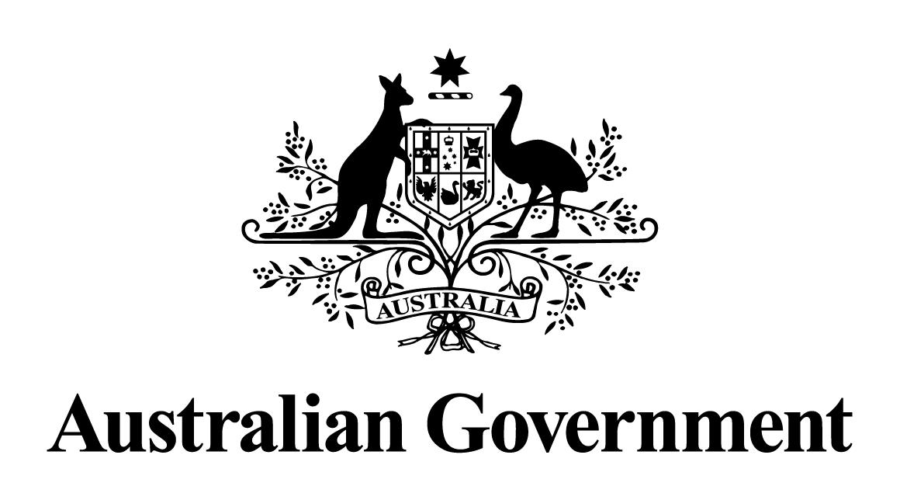
Australian Government response to the Education and Employment Legislation Committee report:
Fair Work Legislation Amendment (Secure Jobs, Better Pay) Bill 2022 [Provisions]
MARCH 2023

Recommendation 1
The committee recommends that the bill be passed, subject to the amendments that follow.

The Government notes this recommendation.
Recommendation 2
The committee recommends that an amendment be made to the bill to clarify that conciliation should take place before arbitration of disputes over flexible working arrangements unless there are exceptional circumstances.

The Government supports this recommendation. In response to this recommendation, the Government moved an amendment to require the Fair Work Commission to first attempt to resolve a dispute by means other than arbitration, such as conciliation. Paragraph 65B(4)(a) notes the Fair Work Commission must first deal with a dispute over flexible working arrangements by means other than arbitration, unless there are exceptional circumstances.
Recommendation 3
The committee recommends that an amendment be made to the bill to clarify that the protections and entitlements under the Fair Work Act 2009 apply regardless of immigration status.

The Government supports this recommendation in principle. The Government has made an election commitment to implement the recommendations of the Migrant Workers’ Taskforce, which covers this recommendation. Implementation of this recommendation is expected to occur in the first half of 2023.

Recommendation 4
The committee recommends that the provisions of the bill prohibiting sexual harassment be reviewed for consistency with the Sex Discrimination and Fair Work (Respect at Work) Amendment Act 2021 and the Anti-Discrimination and Human Rights Legislation Amendment (Respect at Work) Bill 2022.

The Government supports this recommendation. The Department of Employment and Workplace Relations has reviewed the provisions in the bill for consistency with other recent Respect@Work reforms to the Sex Discrimination Act 1984 and concluded that any differences are necessary given the different context of the two pieces of legislation.
Recommendation 5
The committee recommends that the definition of 'small business employer', for the purpose of Part 21 of the bill be increased from fewer than 15 employees, to fewer than 20 employees, including regular and systematic casuals, based on headcount. The definition of 'small business employer' in section 23 of the Fair Work Act 2009 should remain unchanged.

The Government notes this recommendation. In response to Recommendation 5 of the Senate Committee Inquiry, the Government moved an amendment which increases the small business exemption for single interest employer authorisation where an employee organisation applies to add an employer to a single interest agreement or authorisation. Employers must have at least 20 employees at the time the application an made. Such employers will still be able to be added to an authorisation or agreement by consent.

Recommendation 6
The committee recommends the amendment of the 'minimum bargaining period' in s235(5)(i) for the purpose of an intractable bargaining declaration, to provide for a nine month minimum bargaining period commencing after either the nominal expiry date of the agreement or nine months from the commencement of bargaining, whichever is later.
The Government notes this recommendation. In response to Recommendation 6 of the Senate Committee Inquiry, the Government supported the amendment moved by Senator David Pocock which extends the ‘minimum bargaining period’ to the latter of nine months from the nominal expiry date of the agreement, or nine months after bargaining starts. This longer timeframe ensure that parties will have a reasonable period of time in which to bargain for an agreement before the Fair Work Commission is able to settle a bargaining dispute using an intractable bargaining declaration.
Recommendation 7
The committee recommends that a statutory review of the bill be undertaken but occurs no earlier than three years after the bill receives Royal Assent.
The Government supports this recommendation in principle. The Government moved an amendment which requires the Minister to cause a review to be conducted into the operation of the amendments made by the Fair Work Legislation Amendment (Secure Jobs, Better Pay) Act 2022. It must start no later than two years after the Act receives Royal Assent, with a written report provided to the Minister within 6 months of its commencement. The report must subsequently be tabled in each House of the Parliament.

Recommendation 8
The committee recommends section 180A of the bill be amended so that no party can unreasonably withhold agreement for a proposed enterprise agreement being put to a vote, and the Fair Work Commission should have the power to resolve disputes pertaining to this.

The Government notes this recommendation. In response to Recommendation 8 of the Senate inquiry, the Government moved an amendment to ensure that employers are not unreasonably prevented from putting multi-enterprise agreements to a vote.

Coalition Senator’s Dissenting Report and Additional Comments

The Government does not support the recommendations set out in the Dissenting Report and Additional Comments.

