


Evaluation Strategy for Workforce Australia Employment Services 2022–2028
  - March 2023

Title
ISBN
xxx-x-xxx-xxxxx-x [PRINT]
xxx-x-xxx-xxxxx-x [PDF]
xxx-x-xxx-xxxxx-x [DOCX]
With the exception of the Commonwealth Coat of Arms, the department’s logo, any material protected by a trade mark and where otherwise noted all material presented in this document is provided under a Creative Commons Attribution 3.0 Australia licence.
The details of the relevant licence conditions are available on the Creative Commons website (accessible using the links provided) as is the full legal code for the CC BY 3.0 AU licence.
The document must be attributed as the Evaluation Strategy for Workforce Australia Employment Services.

Contents
1. Introduction 6
1.1 Background to Workforce Australia Employment Services 8
1.1.1 The history of outsourced government employment services 8
1.1.2 The development of Workforce Australia Employment Services 10
2. Workforce Australia 11
1.1 Workforce Australia 11
2.1 Overview of Workforce Australia Employment Services 12
2.2 Workforce Australia Online 13
2.2.1 Workforce Australia Online core functions 13
2.2.2 Enhancements 14
2.2.3 Safeguards 14
2.2.4 Digital Services Contact Centre 15
2.3 Workforce Australia Services 15
2.3.1 Licensing system 15
2.3.2 Provider performance framework 15
2.3.3 Departmental support 16
2.3.4 Payment model 17
2.3.5 Wage subsidies 19
2.4 Workforce Australia Employment Services for individuals 19
2.4.1 Referral to Workforce Australia Online 19
2.4.2 Referral to a provider who case manages 19
2.5 Mutual obligations 20
2.5.1 Points Based Activation System 20
2.5.2 Targeted Compliance Framework 20
2.6 Employment Fund 21
2.7 Workforce Australia Employment Services for businesses 23
2.7.1 Workforce Australia Online for businesses 23
2.7.2 Businesses using Workforce Australia Services 23
2.7.3 Workforce Specialists 24
3. The evaluation 25
3.1 Evaluation theories 25
3.1.1 Standards of evidence 25
3.2 Principles of the evaluation 26
3.3 Purpose of the evaluation 26
3.4 Evaluation scope 27
3.4.1 In scope 27
3.4.2 Out of scope 27
3.5 Risks and limitations 28
4. Program logic and key evaluation questions 29
4.1 Program logic 29
4.2 Key evaluation questions 29
4.2.1 Workforce Australia Employment Services KEQs 29
5. Methodology and data sources 31
5.1 Method 31
5.1.1 Estimating net impact 31
5.1.2 Outcome measures 31
5.1.3 Mixed-method analysis 32
5.2 Data sources 32
5.2.1 Administrative data 32
5.2.2 Other data (survey and/or qualitative data) 33
5.2.3 Other surveys 35
5.2.4 Further qualitative research 35
6. Evaluation management 36
6.1 Stakeholders 36
6.2 Governance 36
6.2.1 Workforce Australia Employment Services Evaluation Advisory Group 36
6.2.2 Workforce Australia Employment Services Evaluation Reference Group 36
7. Reporting, dissemination and feedback 37
7.1 Reporting and dissemination 37
7.2 Key deliverables 37
7.2.1 Interim report 37
7.2.2 Final report 37
8. Other reviews and inquiries 38
8.1 Review of Workforce Australia 38
8.2 House Select Committee on Workforce Australia Employment Services 38
9. Appendices 39
9.1 Standards of evidence 39
9.2 Program logic and data framework 40
9.3 Points Based Activation System activities and points values 43

1. Introduction
The Department of Employment and Workplace Relations (the department) is required to progressively monitor and evaluate Australian Government employment services and programs under the terms of the Public Governance, Performance and Accountability Act 2013 (PGPA Act) and specific directives from Cabinet.
As distinct from program monitoring, which monitors the performance of a program against key performance indicators, program evaluation assesses the effectiveness, efficiency and appropriateness of a program in achieving its aims and compares it to similar programs where appropriate. Evaluation also aims to drive continuous improvement by providing evidence to inform policy development and program design.
Under Workforce Australia, there are 2 mainstream employment services – these are online services (Workforce Australia Online) and provider-led services (Workforce Australia Services). Given the strong interaction between these services, both in terms of tools and in terms of assistance available, and the ability for participants to move seamlessly between them, the department is evaluating both online and provider-led services in a single evaluation – the Evaluation of Workforce Australia Employment Services. In this document Workforce Australia Employment Services is the term used to describe the combination of Workforce Australia Online and Workforce Australia Services.
This strategy outlines how the department will evaluate Workforce Australia Employment Services over the first 6 years of the model (2022–2028).
This section briefly summarises the history of government employment services leading up to the implementation of Workforce Australia in July 2022.
Section 2 outlines the Workforce Australia Employment Services policy settings.
Section 3 defines the structure of the evaluation, including the evaluation theories, principles and purpose.
Section 4 outlines the evaluation scope, including what is in and out of scope, and the risks and limitations of the evaluation.
Section 5 details the program logic and key evaluation questions.
Section 6 describes the methodological approach and outlines the data sources that will be used in this evaluation.
Section 7 focuses on the evaluation governance, including key stakeholders and governance groups.
Section 8 outlines the reporting and dissemination strategy, including key deliverables.
Section 9 presents the appendices, including the program logic for Workforce Australia Employment Services (Figure 9.1) and a data framework (Figure 9.2) that maps key evaluation questions to relevant data sources and data collection activities.

1.1 Background to Workforce Australia Employment Services
Workforce Australia Employment Services is the most recent iteration of mainstream government-funded employment services. It operates in all non-remote regions of Australia.

1.1.1 The history of outsourced government employment services
The Australian Government has outsourced employment services to largely non-government-owned providers since 1998. There have been several iterations of mainstream government-funded employment services: Job Network (1998–2009), Job Services Australia (2009–2015), jobactive (2015–2022) and Workforce Australia Employment Services (since July 2022) (Figure 1.1).
Figure 1.1 Timeline of outsourced employment services in Australia
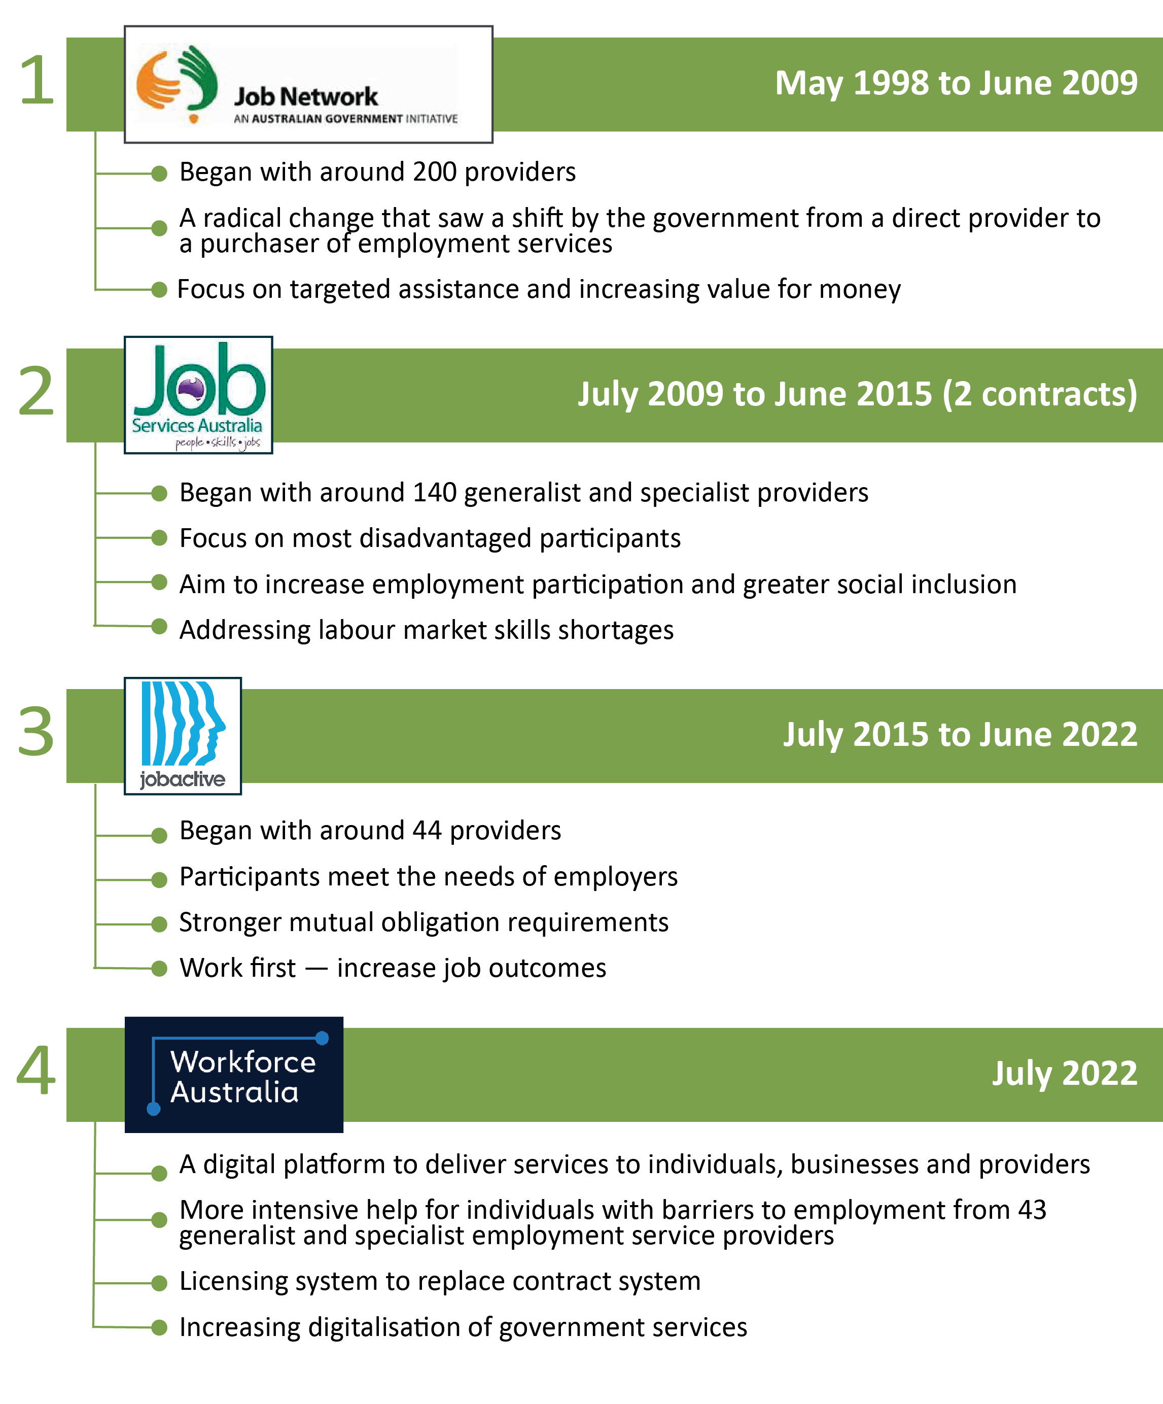

1.1.2 The development of Workforce Australia Employment Services
The government convened an independent expert advisory panel in January 2018 to help shape the future design of employment services in Australia. Members of the panel included business, provider and welfare group representatives, as well as a labour market economist and an expert in business transformation. The panel subsequently produced the I want to work report in December 2018. The report set out 11 recommendations on the future of employment services. The panel recommended that service delivery be grounded in digital methods and supported with face-to-face services for those who need them. It recommended a more user-friendly and personalised system designed around and empowering to users.
In March 2019 the Australian Government announced that Workforce Australia Employment Services would replace jobactive in July 2022. In the lead-up to this, several trials were undertaken to inform the development of Workforce Australia Employment Services:
- Online Employment Services Trial (OEST) (July 2018 – April 2020). This was a randomised trial to test the feasibility and outcomes of providing employment services online. The evaluation of the trial was published in March 2021.
- Online Job Seeker Classification Instrument (JSCI) Trial (July 2018 – April 2020). This trial tested the feasibility, accuracy and outcomes of assessment of job seeker needs online. The evaluation of the trial was published in March 2021.
- New Employment Services Trial (NEST) (July 2019 – July 2022). This trial operated in 2 employment regions – Adelaide South, South Australia; and Mid North Coast, New South Wales – and offered 2 service levels: Digital Services (online) and Enhanced Services (provider).
The NEST adopted the principles of user-centred design, with an iterative approach to testing policy, program and platform design with participants, employment services providers and other stakeholders, and making real-time adjustments where possible in response to feedback. All of the trials have been evaluated by the Employment Evaluation Branch in the Department of Employment and Workplace Relations (DEWR).

2. Workforce Australia

Workforce Australia
Workforce Australia is a significant transformation of government funded employment and skills programs and initiatives. The principles underpinning Workforce Australia are services that are:
- simple – with everything in one place
- supported – providing the tools needed to progress
- connected – linking individuals to jobs and businesses to staff
- respectful – giving individuals choice and control.
The mainstream employment services, Workforce Australia Employment Services, is designed to be a personal and effective employment service that:
- supports eligible individuals to find work, including sustainable and secure jobs
- assists individuals who are job ready and capable of self-managing online via a digital employment service with the support of the Digital Services Contact Centre
- focuses providers on supporting individuals who have higher needs, reducing the risk of these individuals becoming or remaining long-term unemployed
- assists businesses to source suitable employees
- is cost-effective for government.
Workforce Australia was developed and agreed in March 2022, prior to the change of government that occurred in May 2022. It was designed as a client-centric operating model (Figure 2.1) with individuals and businesses at the core. The online service (Workforce Australia Online) is focused on enabling individuals to self-manage and connect with businesses through online and digital platforms. Tailored services are offered through a network of providers within Workforce Australia Services who are engaged to deliver personalised support for those with more complex needs.
Figure 2.1 Workforce Australia Employment Services client-centric operating model
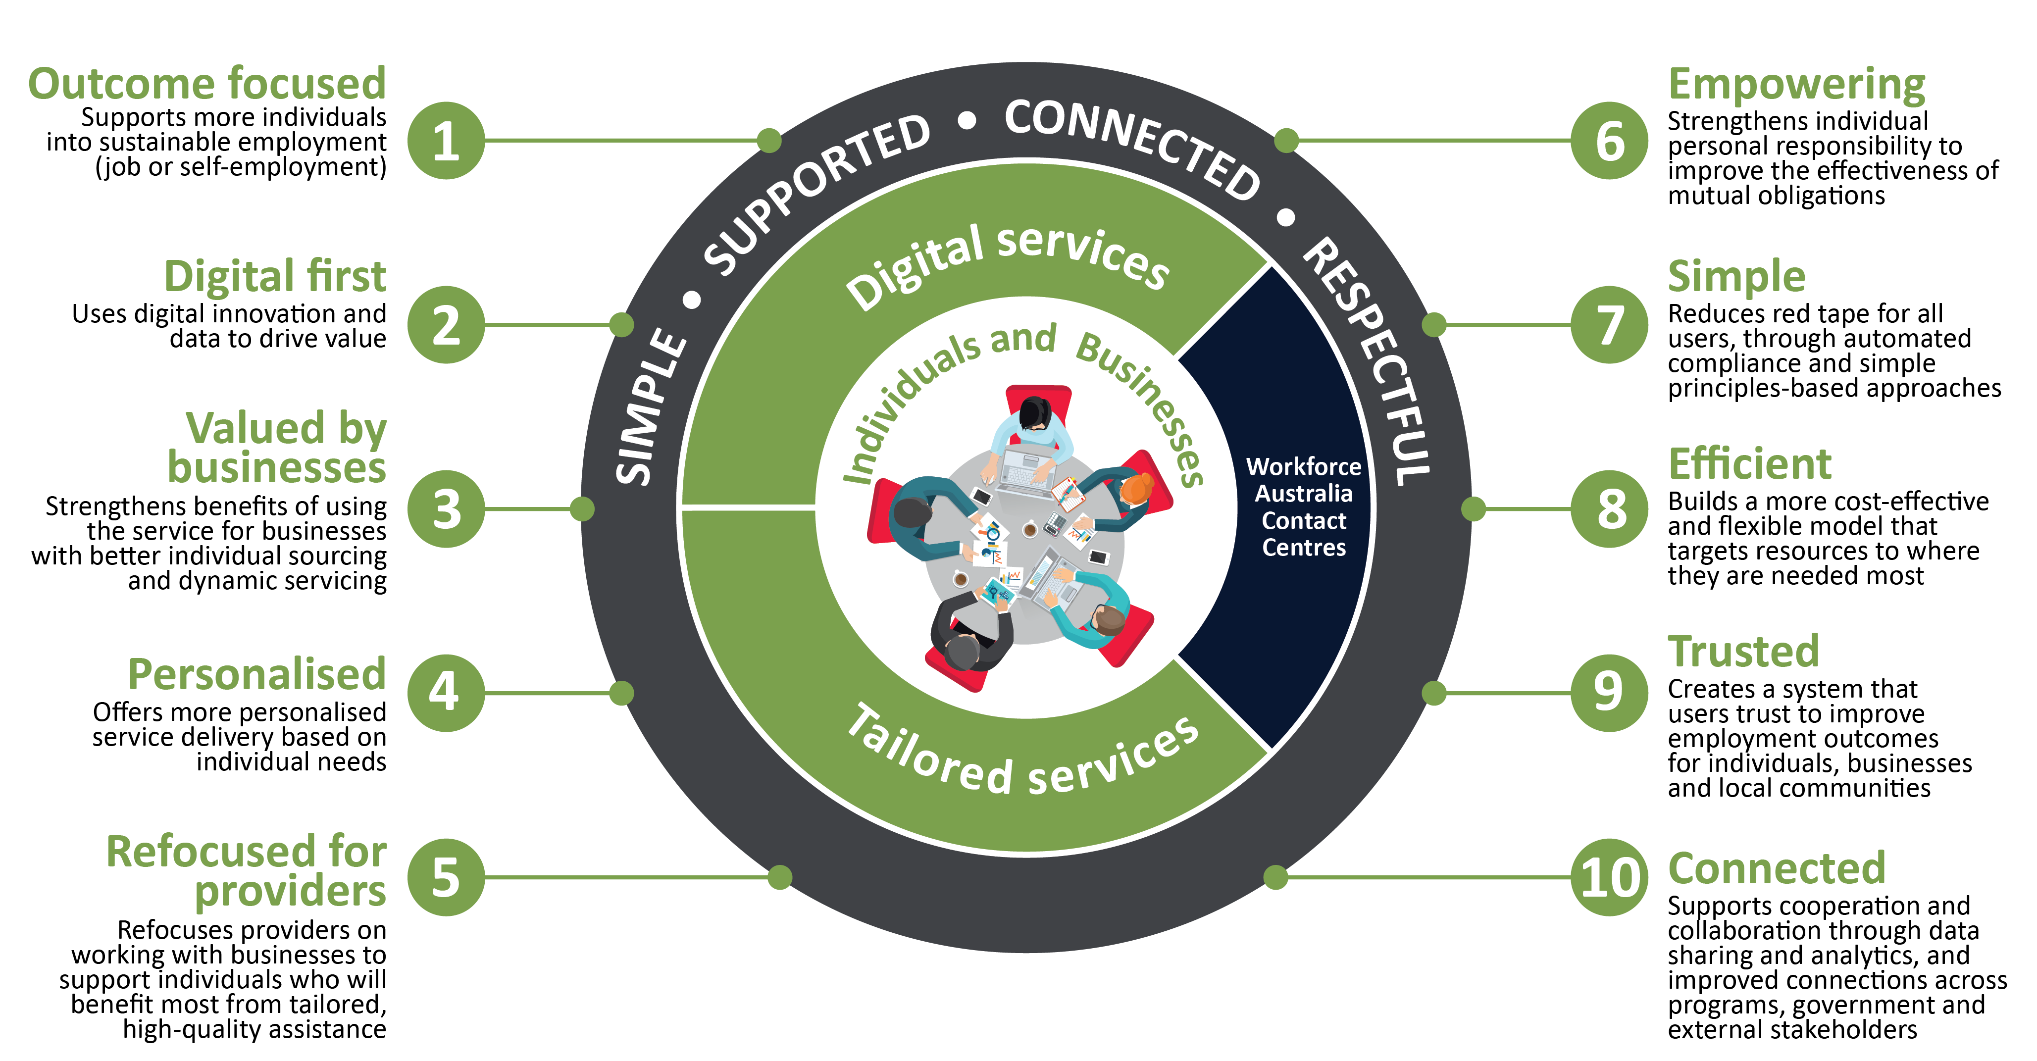

2.1 Overview of Workforce Australia Employment Services
An individual’s journey in Workforce Australia generally begins when they lodge a claim for income support with Services Australia. From that point, the process involves:
- Individuals complete questionnaires that are used to determine the most appropriate service.
- Those who are assessed as being able to self-manage their mutual obligations and job search online are referred to Workforce Australia Online.
  - Once referred to Workforce Australia Online, they receive and review a Job Plan. The Job Plan states that the participant agrees to meet their MORs (Section 2.5). Changes to MORs can be negotiated using the Digital Services Contact Centre. Once the Job Plan is accepted, they commence in Workforce Australia Online.
  - They undertake activities and report them online in order to accrue points.
  - They can opt out of Workforce Australia Online to Workforce Australia Services at any time by contacting the Digital Services Contact Centre.
  - They are transferred to Workforce Australia Services after 12 months if they have not reported any work or study in the previous 6 months.
- Those who are assessed as needing more support are referred to Workforce Australia Services.
  - Once referred to a provider, they attend an initial meeting where they negotiate a Job Plan with their provider and accept it. The Job Plan identifies the participant’s MORs (Section 2.5)
  - They undertake activities and receive tailored assistance.
- Individuals in Workforce Australia Services and Workforce Australia Online receive assistance from their providers and the Digital Services Contact Centre respectively to undertake relevant activities and training.

2.2 Workforce Australia Online
Technology is enabling change in how employment services are being delivered as increasingly more individuals can, and do, look for and find work using digital services. Workforce Australia Online is designed for the most job-ready individuals with the digital capability to self-manage their mutual obligation requirements (MORs) online.
If an individual is assessed, using the Job Seeker Snapshot (JSS) and a Digital Assessment (DA), as being able to self-manage employment services online, they will be referred to Workforce Australia Online for Individuals Full Service or ‘Online Full Service’ and asked to review and accept a Job Plan detailing their MORs. The Online Full Service enables them to self-manage their participation in employment services with a range of supports available such as access to the Digital Employment Fund (Section 2.6), pre-employment pathways for eligible participants and support provided by the Digital Services Contact Centre.
Individuals without a referral from Services Australia and who are not considered a fully eligible participants can access the Workforce Australia Online for Individuals Base Service via myGov. The Online Base Service is available to any Australian wishing to participate in employment services and enables them to look for jobs, develop their résumé and access complementary employment programs, based on the eligibility of each program. The Online Base Service is not within the scope of this evaluation.

2.2.1 Workforce Australia Online core functions
Workforce Australia Online enables individuals to:
- search and apply for jobs
- access a personalised homepage to assist in their job search
- review and accept a Job Plan
- manage their reporting requirements to fulfil their mutual obligations
- create a profile listing their skills, education and training, work history and work availability
- set their profile to public, if they choose, allowing businesses to contact them about positions they may be suited to
- set up job alerts
- upload job search details (to manage mutual obligations)
- access support tools and resources
- access support from the Digital Services Contact Centre
- receive notifications via their inbox on the Workforce Australia website and app, SMS or email
- upskill or reskill, using links to subsidised training offered through JobTrainer and higher education short courses
- access skills-matching tools including JobSwitch to explore jobs they might not have considered
- access activities and employment-related programs that will help improve their skills such as Career Transition Assistance, Employability Skills Training and Self-Employment Assistance via the Workforce Australia website and app
- connect with businesses through job search filtering and detailed job advertisements from businesses
- transfer to a provider at any point they choose.

2.2.2 Enhancements
Workforce Australia Online is based on Online Employment Services but with enhancements such as:
- improved filtering and searching functionality for businesses to find candidates to better meet their recruitment needs
- improved matching, shortlisting and dynamic servicing based on the business’s workforce needs
- reduced administration and red tape to simplify and accelerate the recruitment process – for example:
  - individuals receive support to complete paperwork they need to start a job, such as police checks and working with vulnerable people registration
  - relocation assistance is immediately available for eligible individuals to support their move to another location for employment, particularly in regional areas.
Further enhancements and refinements will be made in response to ongoing user feedback and based on emerging needs.

2.2.3 Safeguards
The following safeguards are in place to assess whether individuals continue to be in the most appropriate Workforce Australia service:
- Individuals can opt out of Workforce Australia Online at any point and be referred to a provider.
- Individuals can update their JSS if their circumstances change and can contact the Digital Services Contact Centre for support.
- Individuals are asked to complete a Digital Assessment (DA) as part of their onboarding, to assess their level of online access and ability to self-manage online.
- Individuals are prompted to complete a Digital Service Review (DSR) at the fourth and eighth month in Workforce Australia Online to assess whether online servicing is still suitable for them. Those in employment, study or training are not subject to these reviews.
- Individuals whose responses to the DA and/or DSR suggest they may be unsuitable for digital servicing are encouraged to opt out to a provider.
- Individuals are automatically transferred to a provider after 12 months if they have not been in work or undertaking study in the past 6 months.
- Young people (15–24) participating in Workforce Australia Online can access up to 3 one-hour Youth Advisory Sessions with a Transition to Work (TtW) provider by contacting the Digital Services Contact Centre.

2.2.4 Digital Services Contact Centre
The Digital Services Contact Centre is available to provide individualised support to people in Workforce Australia Online if needed, to help them deal with issues and barriers they may face in relation to complying with their MORs. It also facilitates access to the Employment Fund for eligible expenses. (See Section 2.6 for information about the Employment Fund.)

2.3 Workforce Australia Services
Workforce Australia Services is designed to provide greater focus on tailored and personalised servicing to participants that is flexible and innovative, which also includes specialist services for some defined groups of participants. Key changes from previous provider service models include a licensing system, the new provider performance framework, increased departmental support, the new payment structure, and changes to wage subsidies.

2.3.1 Licensing system
Previous models of employment services have relied on a tender process to engage employment services providers for a fixed contract. Workforce Australia Services implements a licensing system, whereby providers are selected through a tender process to be part of a panel, from which licences are issued. This model also includes specialist licences, which are designed to provide greater support for participants who are part of a specialist cohort, such as Indigenous, refugee, culturally and linguistically diverse, or ex-offender participants. However, generalist licence holders are still expected to provide servicing that is tailored to each participant’s needs and circumstances.
All licences are subject to an Annual Licence Review (ALR). The ALR will determine whether the provider’s performance warrants a licence extension, based on the overall performance ratings determined by the Provider Performance Framework, as outlined in Figure 2.2.
The first ALR will occur 15 months after the introduction of Workforce Australia, in October 2023. From 2024 the ALR will be based on performance to June each year.

2.3.2 Provider performance framework
The provider performance framework assesses provider performance at the licence level. It is used to determine performance ratings which feed into the ALR, and is intended to:
- encourage innovation and drive continuous performance improvement
- ensure that providers are fulfilling their obligations under the Workforce Australia Deed and meeting the standards required
- inform individuals and businesses of each provider’s performance in their local employment region.
The provider performance framework consists of 5 modules (Figure 2.2), with each module having its own measures of assessment. Measure-level ratings are determined based on provider activity. Module-level ratings are determined by the combination of measure-level ratings. Overall performance ratings are determined by the combination of module-level ratings.
Figure 2.2 Provider performance framework
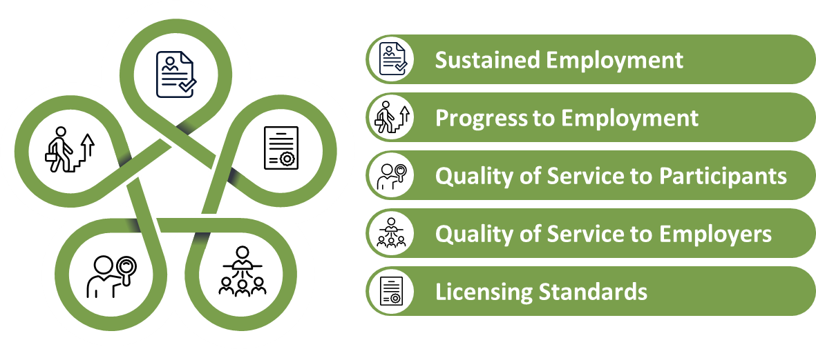

Performance ratings
Every quarter, each licence holder’s performance will be rated as High, Moderate or Low for each measure, for each module and overall. Overall performance ratings inform ALR decisions.
The department will release performance ratings quarterly, beginning with the quarter ending 30 June 2023. The overall and module ratings for all licences will be publicly released on departmental websites and distributed to Services Australia, m making them available to individuals and businesses who are seeking performance information about the Workforce Australia Services providers in their area. Measure ratings will not be released, except for the User Views – Quality measure. This measure indicates the overall level of satisfaction with the quality of service individuals have received from their provider.

2.3.3 Departmental support

Provider Lead
The Provider Lead is the key point of contact between the department and providers. The Provider Lead has overarching responsibility for a provider and all matters related to administration of their contract. Provider Leads:
- manage the senior-level relationship with the provider
- liaise with other teams in the department about provider concerns or queries.

Employment Region Lead
The Employment Region (ER) Lead is the senior local and primary point of contact for all Workforce Australia providers in each employment region. ER Leads have responsibility for the performance of Workforce Australia providers at the ER level. ER Leads:
- manage the relationship and drive provider performance at the ER and licence level
- have autonomy and are accountable for these actions
- regularly communicate and collaborate with Provider Leads
- take responsibility for joining up local intelligence and initiatives across the ER.

Other departmental support
The department continues to support providers through its local, place-based State and Territory Network, technology and digital system support, and coordinated communication. Under Workforce Australia these supports have been reviewed and refined in a way that is designed to support providers more efficiently.
The State and Territory Network is the primary point of contact for communication with providers. The network develops and maintains a productive and collaborative relationship with each provider and their offices across every employment region. Together with the Provider Engagement and Advice Branch, the network supports a holistic view of a provider’s operations for the department.

2.3.4 Payment model
Many aspects of the new payment model were tested in the NEST. The model is designed to strike a balance between incentives for employment outcomes and incentives to support the longer-term and sustained investment required for individuals with high levels of labour market disadvantage. Indexation of 6.8% will be applied to payment rates every 3 years (with the first indexation occurring on 1 July 2025).

Upfront payments
Upfront payments to providers are designed to support early investment in assisting individuals to achieve sustainable employment outcomes. They comprise:
- a $1,200 engagement payment for new referrals and those transitioning from online services
- a $600 engagement payment for individuals transitioning from jobactive or NEST (until 30 June 2023)
- a $600 transfer payment for individuals who have previously commenced in Workforce Australia Services.

Progress payment
A $750 progress payment is payable to providers for each individual once in every 24 months in service. This payment is in recognition of the investment made to get individuals job ready. Activities and interventions which can be counted for eligibility for this payment include:
- education, such as completing a Certificate III, Adult Migrant English Program or Skills for Education and Employment course
- successful completion of 2 or more activities or interventions that build work readiness or address vocational or non-vocational barriers, including:
  - work placements such as voluntary work
  - vocational interventions such as Career Transition Assistance or Employability Skills Training (only one vocational intervention can be claimed)
  - non-vocational interventions such as drug and alcohol treatment or counselling
- successful completion of a pathway to employment intervention such as:
  - Launch into Work
  - Workforce Specialist Projects
- assurance (through a progress payment review) that the individual has completed a number of non-vocational interventions, the provider considers the individual has made progress towards employment, and the individual agrees and verifies this.

Employment outcome payments
Employment outcome payments are a core feature of the new model, as they were in previous models. These payments are a financial incentive for moving individuals into employment. They are payable for 4-, 12- and 26-week full or partial outcomes and are based on the individual’s relative level of labour market disadvantage.
- Payments for partial outcomes range from $240 for an individual with a moderate level of labour market disadvantage who achieves a 4-week outcome, up to $1,650 for an individual with a high level of labour market disadvantage who achieves a 26-week outcome.
- Payments for full outcomes range from $500 to $5,000.
A key change from the jobactive payment model is the introduction of a partial 26-week outcome payment, which recognises the more disadvantaged caseload in the new model and supports job placements in industries, such as the aged care sector, which have a high prevalence of part-time work.

Very long-term participant bonus
The very long-term participant bonus is payable when an individual who has been in employment services for more than 24 months at the time of job placement achieves a 12- or 26-week employment outcome. This is automatically paid on top of the employment outcome payment and ranges from $1,000 for a 12-week partial outcome to $4,000 for a 26-week full outcome.
Indexation of 6.8% will be applied to payment rates every 3 years (with the first indexation occurring on 1 July 2025).

2.3.5 Wage subsidies
Wage subsidies are a financial incentive providers can offer to eligible businesses to encourage them to hire eligible individuals in ongoing jobs by contributing to the initial costs of hiring. Individuals participating in provider-led employment services are eligible to attract a wage subsidy when they meet time in service requirements. These requirements are:
- a minimum of 6 months in provider-led services, or
- a minimum of 12 months in online services (prior to commencing with a provider), or
- from day 1 in provider-led services for Indigenous participants.
There are 2 types of wage subsidies available in Workforce Australia Services, as shown in Table 2.1.
Table 2.1 Wage subsidy types available in Workforce Australia Services
 | Youth Bonus Wage Subsidy | Workforce Australia Services Wage Subsidy
Cohort | Individuals aged under 25 years | Individuals aged 25 years and over
Wage subsidy agreement terms | - Fixed  - Must offer maximum of $10,000  - Agreement term 26 weeks  - Minimum of 20 hours of work per week | - Negotiable  - Maximum cannot exceed $10,000  - Agreement term between 6 and 26 weeks  - Minimum of 15 hours of work per week
Funding | Demand-driven pool | Employment Fund

2.4 Workforce Australia Employment Services for individuals

2.4.1 Referral to Workforce Australia Online
Job-ready individuals are able to self-manage digitally, with access to:
- a high-quality, personalised digital platform
- a range of tools, online learning and job matching
- the Digital Services Contact Centre via phone or email.
Eligible Workforce Australia Online participants will have access to additional support including individual career coaching, the Employment Fund, Employability Skills Training and personalised support from the Digital Services Contact Centre.

2.4.2 Referral to a provider who case manages
Individuals who are referred to provider services are those who are more disadvantaged and need more individualised services to find and maintain secure employment. These individuals will receive case management through an employment services provider to prepare them for and support them along the pathway to employment and into work. This includes:
- individualised service
- a focus on early support
- access to the online and additional resources to help address an individual’s needs through tailored services including:
  - career guidance
  - mentoring
  - vocational training
  - the Employment Fund
  - work experience, job placements and post-placement support
- a revised Work for the Dole program that results in recognised skills and micro-credentials alongside gaining work-like experience
- in some regions, access to specialist providers catering to particular groups, such as Indigenous specialists.

2.5 Mutual obligations

2.5.1 Points Based Activation System
The Points Based Activation System (PBAS), which was trialled in the NEST, is designed to give individuals in both Workforce Australia Online and Workforce Australia Services more choice and flexibility in managing their mutual obligations. PBAS was developed in response to the I want to work report.
Individuals’ point targets are tailored based on local labour market conditions and personal circumstances. Individuals can bank points (up to half their target), for use in the following month, providing additional flexibility and reward for doing more tasks.

Points value
The PBAS is a new and more flexible way for individuals to meet their MORs, by meeting a specified points target each month. After the model was tested in the NEST, the points allocations were revised for Workforce Australia. Table 9.2 outlines the points allocations in Workforce Australia as at September 2022.

2.5.2 Targeted Compliance Framework
The Targeted Compliance Framework (TCF) applies to most individuals on activity-tested income support. The TCF consists of 3 ‘zones’: the Green Zone, the Warning Zone and the Penalty Zone.
Green Zone: All individuals start in the Green Zone. So long as they meet all their MORs, they will remain in this zone.
Warning Zone: Individuals enter the Warning Zone if they accrue a demerit. Each demerit has a life span of 6 active months. If an individual accrues 3 demerits or incurs a ‘fast-track’ mutual obligation failure their provider, or the Digital Services Contact Centre in the case of individuals in Workforce Australia Online, will conduct a Capability Interview with them to determine whether their requirements are appropriate to their individual circumstances. If the individual is deemed capable, they continue in the Warning Zone; otherwise their demerits will be reset to zero and they will return to the Green Zone. Providers or the Digital Services Contact Centre will be required to address the issue identified by the Capability Interview.
Penalty Zone: If an individual accrues 5 demerits in 6 months or incurs a fast-track mutual obligation failure while on 3 or more demerits, Services Australia will conduct a Capability Assessment with them to determine whether their requirements are appropriate to their individual circumstances. If the individual is deemed capable, they enter the Penalty Zone; otherwise they are returned to the Green Zone.
Once in the Penalty Zone, if the individual continues to fail to meet their requirements, they will incur financial penalties unless they have a reasonable excuse for non-compliance. The financial penalties are:
- loss of 50% of fortnightly payment after the first failure in the Penalty Zone
- loss of 100% of fortnightly payment after the second failure in the Penalty Zone
- payment cancellation and a 4-week post-cancellation non-payment period after the third failure.

2.6 Employment Fund
The Employment Fund is a flexible pool of funds available to providers and the Digital Services Contact Centre to fund support tailored to the needs of individuals, employers and the local labour market. It works slightly differently for individuals in Workforce Australia Online and Workforce Australia Services, as shown in Table 2.2.
Table 2.2 Operation of the Employment Fund in Workforce Australia Online and Workforce Australia Services
Activity | Workforce Australia Online full Service | Workforce Australia Services
Eligibility | Participants in Online Full Services are eligible to request assistance. The participant must be:  - commenced in Online Full Service, or  - suspended after commencement in full online services, or  - pending after previous commencement in full online services, or  - within 183 calendar days after being exited from full online services. | All individuals in Workforce Australia Services are eligible for assistance. A provider may claim reimbursement if the individual received the goods or services when they were:  - commenced with the provider, or  - suspended after commencement with the provider, or  - pending after previous commencement with the provider, or  - pending with the provider and required certified interpreter services, or  - within 183 calendar days after being exited from the provider, or  - within 183 calendar days after being transferred from the provider to another provider.
Notional amount | $300 credit when an individual has been in Full Online Service for 2 months  $75 credit allocated on commencement in Full Online Service for participants who transitioned from Workforce Australia Services. | $1,600 credit when an individual is commenced in Workforce Australia Services  $400, $800 or $1,200 credit allocated on commencement in Workforce Australia Services for participants who transitioned from Workforce Australia Online depending on their period of service
Frequency | Once per period of service | Once per period of service
Process | Digital Services Contact Centre discretion  Digital Services Contact Centre pays suppliers | Provider discretion  Provider pays the supplier and then claims reimbursement from the department
Employment Fund categories | - Accredited training  - Clothing and personal protective equipment  - Driver’s licence  - Petrol  - Phone credit and internet data  - Police check  - Public transport  - Relocation assistance  - Workplace checks  - Work-related licensing  - Work-related training | - Accredited training  - Activity costs  - Certified interpreters  - Cohort-specific training  - Communications and technology  - Non-vocational support  - Professional services  - Provider indigenous mentoring capability  - relocation assistance  - Transport  - Wage subsidies  - Work-related items  - Work-related training and licensing
Each provider receives credits to a fund they can claim reimbursement against for the purchase of goods and services that support and assist individuals to gain the tools and build the skills and experience they need to get and keep a job. These credits are not tied to particular individuals and they can be spent according to the guidelines on any eligible individual.

2.7 Workforce Australia Employment Services for businesses
Workforce Australia Employment Services is designed to offer improved support to businesses with intensive recruitment and workforce planning solutions.

2.7.1 Workforce Australia Online for businesses
Businesses can self-manage their recruitment needs through Workforce Australia Online, with applicant matching. The online platform is designed to enable businesses to search for and find suitable individuals to fill their vacancies at no cost. They have access to a pool of individuals, with filtering and search functionality to find suitable candidates.

2.7.2 Businesses using Workforce Australia Services
Providers are required to have a comprehensive strategy for engaging with and supporting businesses in the locations where they are licensed to deliver services. As part of this strategy, providers should tailor services in a way that reflects an understanding of the local labour market, including key employers and priority industries.
Providers are expected to:
- develop and maintain relationships with local businesses to understand their recruitment needs, as well as strong links with local community services to facilitate suitable pathways to employment for participants who need additional support
- organise pre-employment opportunities for businesses to prepare and trial participants, including work experience and work trials
- provide post-placement support, for employers and participants where needed
- improve the alignment of skills and training gained by participants with the needs of businesses
- collaborate with other providers and services to identify and refer suitable participants for major businesses and significant projects
- work closely with businesses to organise licences and other support individuals may need to start the new job.

2.7.3 Workforce Specialists
For business and industry groups needing support with larger scale recruitment, tailored projects may be delivered by Workforce Specialists. This approach is designed to enable the department to strategically and rapidly respond to labour demand opportunities.

3. The evaluation
Program evaluation informs future policy development, drives continuous improvement and innovation and contributes to the Australian Government’s transparency and accountability agenda. With the implementation of the enhanced Commonwealth performance framework in July 2015 under the requirements of the PGPA Act, evidence generated from the evaluation can also be used to support good performance reporting in annual performance statements.
Evaluations often need to adopt a flexible approach, recognising that as the evaluation progresses, new questions may emerge, and some of the questions identified as important at the outset may become more, or less, so over time. This is particularly the case given that the Workforce Australia Employment Services Evaluation will operate over a 6-year period. As the evaluation progresses, its focus and scope may be adapted to changes in policy, the relative importance of issues and the availability of resources and data.

3.1 Evaluation theories
The Workforce Australia Employment Services Evaluation will use elements of developmental and summative evaluation theory to inform the evaluation design.
Developmental evaluation incorporates the collection of real-time, or near-real-time, information from relevant stakeholders to allow a process of ongoing feedback, facilitating continuous development.
Summative evaluation focuses on mid- and long-term outcomes of the program.
Combined, this evaluation will assess the core operations and impact of Workforce Australia Employment Services, including the appropriateness of the program design and operational processes as well as the program’s efficiency and effectiveness, as outlined in the evaluation questions in Section 4.2. A program logic model outlining the program inputs, activities and outputs, and expected short-, medium- and long-term outcomes is at Figure 9.1

3.1.1 Standards of evidence
This evaluation will use the Nesta Standards of Evidence, a 1 to 5 scale on which Level 2 is the minimum evidence requirement that would be expected of the evaluation (see Figure 3.1). As the levels go up, so will the certainty of the findings (See Table 9.1).
Figure 3.1 Nesta Standards of Evidence hierarchy
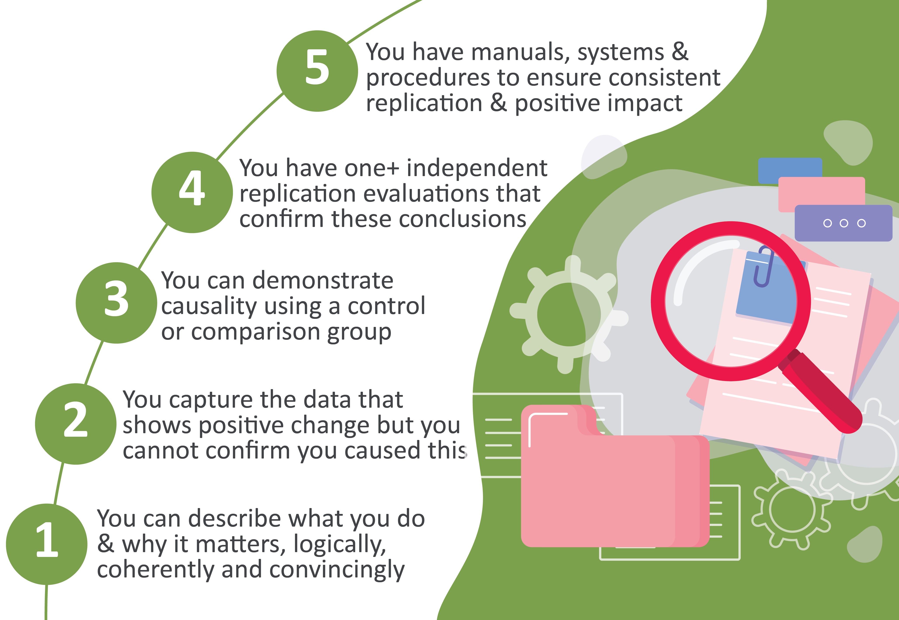
Source: Puttick, R and Ludlow, J (2012) ‘Standards of Evidence for Impact Investing’, London: Nesta.

3.2 Principles of the evaluation
The Workforce Australia Employment Services Evaluation will follow defined evaluation principles. These are:
- a clearly defined evaluation purpose and scope that is fit for purpose and includes key evaluation questions and a data framework
- impartiality and independence from the policymaking, implementation and program management at all stages of the evaluation process
- credibility through the expertise and independence of the evaluation team and the transparency of the evaluation process, including publication of the evaluation strategy and evaluation reports
- relevant and useful evaluation findings presented clearly and concisely in a timely manner to inform decision-making.

3.3 Purpose of the evaluation
The evaluation aims to:
- assess the appropriateness, effectiveness and efficiency of Workforce Australia Employment Services
- contribute to the evidence base for the development and improvement of digital and provider-led employment servicing throughout the Workforce Australia period and into the future.

3.4 Evaluation scope

3.4.1 In scope

Workforce Australia Employment Services for individuals
This comprises services for activity-tested income support recipients (including those on JobSeeker Payment, Parenting Payment, Youth Allowance (Other), and Special Benefits and the Disability Support Pension) who have a mutual obligation requirement and:
- are referred to Workforce Australia Online and/or
- are referred to Workforce Australia Services and/or
- engage with Workforce Specialist Projects.

Workforce Australia Employment Services programs
This comprises:
- Workforce Australia Online
- Workforce Australia Services (including specialist providers).

Other Workforce Australia services
- Workforce Specialists.

Other services and settings
Services to business through Workforce Australia Online and Workforce Australia Services providers will be included in the evaluation, as will the licensing system to engage and manage providers. Other program design elements, including program assurance and provider performance frameworks and payment models, are also in scope.

3.4.2 Out of scope

Individuals
Services for individuals who use Workforce Australia Online as volunteers (Base Service) are not in scope. This includes those who:
- are incidental users of the platform
- use the platform through another program as volunteers.

Programs
Participants may interact with complementary programs, such as Employability Skills Training and Career Transition Assistance, as part of their engagement with Workforce Australia Employment Services. The evaluation will examine the extent to which participation in these programs facilitates the goals of Workforce Australia Employment Services. The following programs are out of the scope of the evaluation:

Youth programs
- Transition to Work (TtW)

Self-employment programs
- Entrepreneurship Facilitators
- Self-Employment Assistance

Place-based programs
- Local Jobs Program

Other complementary or related programs
- Disability Employment Services
- Harvest Trail Services
- Community Development Program
- ParentsNext

3.5 Risks and limitations
There are several risks and limitations to the evaluation:
- Data quality and availability: Administrative data, including Employment Services System (ESS) data and income support data, is the primary data source for some measures. If the scope and nature of the administrative data is not sufficient, this may limit the evaluation.
- Access to income support data: The evaluation assumes that the department will continue to have timely access to income support data from Services Australia and that this data will remain similar to what is currently shared. Any unforeseen changes may impact the scope of the analysis.
- Changing policy and program elements: Changes to policy and program settings make it more difficult to attribute effects and outcomes to the given program settings.
- Resource management: The evaluation depends on the availability of adequate funding for external research and recruiting and retaining internal staff with appropriate skills.

4. Program logic and key evaluation questions

4.1 Program logic
The Workforce Australia Employment Services program logic (Figure 9.1) is a visual representation of how core functionalities, enhancements and safeguards lead to desired outcomes for individuals. It identifies immediate and intermediate outcomes and their contribution to long-term impact when certain assumptions are met. The program logic is used to structure data collection and analysis activities to assess whether the hypothesised relationships between activities and expected outcomes are achieved and to identify unexpected factors or other emerging outcomes.

4.2 Key evaluation questions
There are 3 sets of key evaluation questions (KEQs): KEQs for the program as a whole, separate KEQs for the self-managed and provider-serviced parts of the program.

4.2.1 Workforce Australia Employment Services KEQs
KEQ.1 Appropriateness: Does Workforce Australia Employment Services meet the needs of key stakeholders including individuals, businesses and providers?
KEQ.2 Effectiveness: How effective is Workforce Australia Employment Services in helping individuals find sustained employment that promotes job security?
KEQ.3 Efficiency: How cost-effective is Workforce Australia Employment Services in achieving its objectives?

Workforce Australia Online KEQs
KEQ.O1 How effectively does Workforce Australia Online support individuals to self-manage their mutual obligations and to find secure work?
KEQ.O2 To what extent is Workforce Australia Online user-friendly and useful?
KEQ.O3 How well does Workforce Australia Online assist businesses to meet their recruitment needs?
KEQ.O4 How well does Workforce Australia Online connect individuals to businesses?

Workforce Australia Services KEQs
KEQ.E1 How effective are the Workforce Australia Services payment system and provider performance framework at driving outcomes?
KEQ.E2 To what extent has the licensing system achieved its aim of stronger competition and easier entry to and exit from the market?
KEQ.E3 Has the move to Workforce Australia Services produced more flexible and better tailored provider servicing, particularly for individuals with more complex disadvantage in the labour market?
KEQ.E4 How successful are specialist providers at securing outcomes for their cohorts, compared to generalist providers?
KEQ.E5 To what degree are Workforce Specialists achieving their aims?
In assessing the appropriateness of the program and its effectiveness in assisting individuals to find and maintain secure employment, the evaluation will examine specific cohorts separately, such as women, young people, Indigenous people, people with disability, and people from culturally and linguistically diverse backgrounds.

5. Methodology and data sources
This section describes the evaluation methodology. The methodology drives data collection and analysis methods and is mapped in more detail in a data framework, which identifies for each evaluation question:
- the indicators to be examined
- data sources – existing and new
- data gaps
- methods of data collection and analysis
- research participants and stakeholders.
The data framework is presented in Figure 9.2.

5.1 Method

5.1.1 Estimating net impact
A net impact study, which determines the difference between outcomes in the presence and absence of an intervention, is widely regarded as best practice in evaluation. However, the universal nature of Workforce Australia Employment Services and its predecessor programs precludes a net impact analysis at a whole-of-program level. This is because no credible counterfactual exists; nor can one be constructed via proxy measures. Consequently the evaluation will compare Workforce Australia Employment Services with its predecessors to assess whether and to what extent Workforce Australia achieves better outcomes for individuals. Workforce Australia Online will be compared with OES (2020–2022), and Workforce Australia Services will be compared with jobactive (2015–2020). An overall Workforce Australia Employment Services comparison will also be made with pre-COVID jobactive data. This will enable an analysis which compares the whole program against its predecessor and will be the only way to make a direct comparison across the whole Workforce Australia Employment Services cohort.
Statistical modelling which controls for the effect of changes in the macro-economic environment and changes in the composition of the participant population will be used as appropriate. In addition, where there is an opportunity, other quasi-experimental approaches will be used.

5.1.2 Outcome measures

Exits from service and income support
Key measures of the program’s effectiveness include individuals exiting employment services, going off income support, and reducing their reliance on income support. Exits from employment services and from income support payments are used as complementary proxy measures for employment, as administrative data does not provide comprehensive information on individuals’ employment status after they exit employment services. Of the 2 measures, exit from income support is generally the stronger proxy for employment, as many participants exit employment services to join other programs or due to eligibility changes rather than exiting to employment. While it is true that not all exits from income support are to employment, most are, making this a preferred – though still a proxy – measure. For some participants, leaving income support is unlikely, due to parenting or other caring responsibilities. In these circumstances a measure of the degree of reliance on income support is relevant. To assess the sustainability of outcomes, the evaluation will also examine how long individuals are off income support after exit.
Exits from income support and from employment services can be defined as outcomes for all individuals who commence in the Workforce Australia program. These measures will be complemented by data collected through surveys, as outlined below. Individuals who participate in the surveys will be asked their actual employment status.

Provider paid outcomes
Provider outcome payments will be used as another direct measure of employment for the Workforce Australia Services component of the evaluation only, as there is no equivalent in Workforce Australia Online.

5.1.3 Mixed-method analysis
The analysis will use a mixed-method approach, using both quantitative and qualitative data. Qualitative research will be used to address the questions about policy and process appropriateness. The qualitative research will also contribute contextual information around individual engagement, compliance issues, the long-term impact of the program, and service quality. Administrative and survey data will be used for descriptive and inferential statistical analysis.

5.2 Data sources

5.2.1 Administrative data
The department’s administrative data contains information on individuals in Workforce Australia Employment Services (e.g., individual demographics, referrals, commencements, and JSS and Employment Services Assessment (ESAt) outcomes); payment transactions (e.g., claims for service and outcome fees, wage subsidies and reimbursements, and Employment Fund expenditure); some types of assistance received; job placements; and paid outcomes. The following is a summary of existing departmental datasets.

Research and Evaluation Database data
The Research and Evaluation Database (RED) contains information related to income support payments and recipients based on Services Australia administrative data. For example, it includes data on individual demographic characteristics, family circumstances, hours worked, earnings, educational activities, and receipt of income support payments. The data will mainly be used to examine changes in reliance on income support, including exits from income support as a proxy for employment.

Employment Services System data
Individual administrative data is held on ESS. Information in ESS includes JSCI/JSS and ESAt results, Job Plans, job search activity, and compliance outcomes. The data will be used to examine, among other things, how quickly individuals commence services after a referral, how long they remain in service, whether and when they exit from online or provider services or transfer to a different service (e.g., from Workforce Australia Online to Workforce Australia Services), and their accumulation of demerit points resulting from non-compliance.

Customer relationship management data
Information on the reasons for calls made to the National Customer Service Line and the Digital Services Contact Centre are recorded and can be analysed to determine the types of queries that individuals make in relation to their employment services. Detailed qualitative call notes are also recorded. For contacts made prior to 7 December 2021 this data is stored in the Employment Services Feedback System database. Following the launch of a new customer relationship management (CRM) system on 7 December 2021, Digital Services Contact Centre data is not currently available for linking with other administrative data sources. A solution is being developed and the timing of this will impact the way in which this data can be used.

5.2.2 Other data (survey and/or qualitative data)

Participant Pathways Research
This research is designed to regularly (biannually) engage with Workforce Australia Employment Services participants to better understand their experience of employment services and how it relates to their employment and employment prospects. It will follow 8,000 Workforce Australia Employment Services participants over 4 years across 8 waves while they are engaged in employment services and will continue to connect with them once they leave employment services.
Each wave of the research will include a survey with core questions and topic-specific questions, as well as focus groups and/or interviews, which will be used to explore the experiences of Workforce Australia Employment Services participants and will include discussions of emerging issues and specific topics.
The research will provide information about how the employment and employment prospects, skill levels, attitudes, and barriers to employment of individuals change as a result of being part of Workforce Australia Employment Services. It is designed to gather information on individuals that is not typically available in administrative data (Table 5.1).
Table 5.1 Indicative Participant Pathways Research structure
Waves | Dates | Methodology
1 | August to December 2022 | - Longitudinal survey – initial (n=8,000)  - Cognitive testing interviews (n=10)  - Focus groups (n=10)
2 | February to April 2023 | - Longitudinal survey (n=8,000)  - Focus groups (n=10)
3 | August to October 2023 | - Longitudinal survey (n=8,000)  - Focus groups (n=5)
4 | February to April 2024 | - Longitudinal survey (n=6,000 or 8,000)  - Focus groups (n=5)
5 | August to October 2024 | - Longitudinal survey – initial (n=8,000)  - Cognitive testing interviews (n=10)  - Focus groups (n=10)
6 | February to April 2025 | - Longitudinal survey (n=8,000)  - Focus groups (n=10)
7 | August to October 2025 | - Longitudinal survey (n=6,000 or 8,000)  - Focus groups (n=5)
8 | February to April 2026 | - Longitudinal survey (n=6,000 or 8,000)  - Focus groups (n=5)

Provider census
The department has conducted regular surveys of employment services providers since 1999. These surveys will gather data about provider experiences of and perspectives on the Workforce Australia Services model, policy settings and operating conditions. All Workforce Australia Services providers will be in scope. The surveys will be conducted at site level, with full-time site managers or other site staff as identified by the provider organisation invited to participate. The evaluation team will look to conduct surveys on a rolling 12- to 18-month cycle.

Post Program Monitoring surveys
Post Program Monitoring (PPM) surveys are used to measure employment and education outcomes of individuals who have received employment services assistance. Each month a pool of Workforce Australia Employment Services participants who are currently on the caseload and a pool of individuals who have left these services in the past 3 months are selected for surveying. Over the following 3 months, these people are invited to participate in surveys about their current labour force and educational situation.
The PPM Quality and Progress Survey will be delivered to participants in Workforce Australia Services, including those in Transition to Work. This survey is critical to the ongoing monitoring of provider and program performance against 2 key elements:
- supporting people to progress into work
- participants receiving quality services.
The survey questionnaire also gathers participants’ views on:
- how satisfied they are with specific elements of the service, such as being connected to support services
- whether the services are appropriate and will help them in the short or long term
- whether the services are helping them address their individual needs.

Business study
The business study will use survey and qualitative research methods to collect data from businesses that have engaged with Workforce Australia Online and/or Workforce Australia Services to:
- categorise and quantify segments of businesses and identify their different service and recruitment requirements
- identify drivers of satisfaction and dissatisfaction with government employment services and programs
- identify barriers and enablers of usage
- identify areas where services to businesses can be improved
- identify types of businesses (by business size, industry, etc.) that are employing individuals who may be in key groups of interest (Indigenous, mature age, people with disability, young people, etc.)
- assess businesses’ attitudes and intentions regarding hiring people in key groups of interest
- assess the operation of, and outcomes from, Workforce Specialists
- inform the continuous improvement of Workforce Australia Employment Services.

5.2.3 Other surveys
Other ad hoc surveys may be conducted as required to augment existing data and fill emerging data gaps.

5.2.4 Further qualitative research
As well as the qualitative research undertaken as part of the individual and business studies, further qualitative research, typically through focus group discussions and/or in-depth interviews, will be undertaken to broaden the scope of feedback – for example, with other stakeholders such as the Digital Services Contact Centre, other government agencies, host organisations and training organisations – in order to fill emerging data gaps and/or respond to new/emerging questions.

6. Evaluation management
The Employment Evaluation Branch (EEB) in the department is responsible for planning, designing and conducting the evaluation of Workforce Australia Employment Services. The Workforce Australia Employment Services evaluation will be conducted in accordance with relevant legislation and departmental policies.

6.1 Stakeholders
A range of key stakeholders will be consulted, where appropriate, during the course of this evaluation.
It is anticipated that the policy and program areas in the department, as well as Services Australia, the National Indigenous Australians Agency, the Department of Finance and the Department of the Prime Minister and Cabinet, will also be consulted, where relevant, during the course of the evaluation. In addition, Provider Leads, employment services providers, peak bodies (from the community sector and the employment service industry), employers and program participants will be consulted to inform evaluation findings.
To the extent possible, EEB will aim to incorporate the views of all stakeholders in the evaluation design and implementation.

6.2 Governance
Employment and workforce governance committees in the department will be responsible for endorsing the evaluation strategy for publication, endorsing changes in evaluation priorities, monitoring progress and endorsing evaluation reports for publication.
Key findings from the evaluation will be shared through these committees as soon as they become available.

6.2.1 Workforce Australia Employment Services Evaluation Advisory Group
The Evaluation Advisory Group will serve as an advisory body, testing methodological concepts and operational options and providing expert and strategic advice to the evaluation team on how evidence can most effectively be gathered, analysed and used.

6.2.2 Workforce Australia Employment Services Evaluation Reference Group
Comprising key internal stakeholders, the Evaluation Reference Group will facilitate access to data and policy expertise, as well as the dissemination of evaluation findings. The Evaluation Reference Group will meet regularly to discuss the progress of, and provide guidance to, the evaluation.

7. Reporting, dissemination and feedback

7.1 Reporting and dissemination
The evaluation team will provide:
- regular and timely fieldwork reports to policy and program areas through the Evaluation Reference Group to facilitate evidence-based continuous improvement
- contributions to any reviews or inquiries as evidence becomes available
- regular presentations of findings to the Employment and Workforce Assistant Secretaries Committee and the Workforce and Employment Steering Committee
- key deliverables, including an interim evaluation report and a final evaluation report.

7.2 Key deliverables

7.2.1 Interim report
The interim report will assess the short- and medium-term impacts of Workforce Australia Employment Services, including:
- changes to its operation, including a licensing review
- policies implemented after commencement
- medium-term outcomes, including experiences of individuals and providers transitioning into Workforce Australia Employment Services, and Participant Pathways Research findings
- lessons learned from medium-term outcomes to inform policy and program improvements.
The interim report is expected to be completed by 30 June 2026.

7.2.2 Final report
This will assess the overall effectiveness, efficiency and appropriateness of the program, focus on the key evaluation questions and cover long-term outcomes where appropriate. The final report is expected to be completed by 30 December 2028.
The expectation is that both the interim and final evaluation reports will be published.

8. Other reviews and inquiries

8.1 Review of Workforce Australia
The Australian Parliament requires a review of Workforce Australia Employment Services to be undertaken within the first 2 years of its operation. Publication of the review is legislated.
The review is not part of the Workforce Australia Employment Services Evaluation. It will focus on the effects of:
- activity requirements
- compliance and penalties on recipients of participation payments
- digital services and enhanced services on recipients of participation payments, on employers and on employment outcomes.

8.2 House Select Committee on Workforce Australia Employment Services
The House Select Committee on Workforce Australia Employment Services was established by a resolution of appointment passed by the House of Representatives on 2 August 2022. The committee will present its final report by 23 September 2023. It was appointed to inquire into and report on:
        - the implementation, performance and appropriateness of Workforce Australia Employment Services;
        - the extent to which Workforce Australia Employment Services delivers services in a way that is fair, leaves no one behind, respects individuals’ diverse needs, and supports job seekers into secure work, in particular, its support for long term unemployed and young people;
        - other matters in relation to Workforce Australia Employment Services.

9. Appendices

9.1 Standards of evidence
Table 9.1 Standards of evidence
Standards of evidence¹ | Expectation | How the evidence can be generated
Level 1 | Be able to give an account of impact. This means providing a logical reason, or set of reasons, why the initiative could have an impact and why that could be an improvement on the current situation. | This is done by drawing upon relevant information and research from existing sources and consulting with relevant stakeholders.  Literature review and the theory-based approach are commonly used for this level of evidence.
Level 2 | Be able to show some change among those participating in the initiative.  At this stage, data can begin to show effect but it will not evidence direct causality. | This is done by gathering baseline and outcome data for individuals and conducting pre- and post-evaluation or cohort/panel study.  This is commonly done by conducting descriptive analysis.
Level 3 | Be able to demonstrate that the initiative is causing the impact, by showing less impact among the similar group who do not participate in the initiative. | This is done by applying robust methods using a control/comparison group (experimental or quasi-experimental designs) that begin to isolate the impact of the initiative. Random selection of individuals (with sufficient sample) strengthens the evidence at this level.
Level 4 | Be able to explain why and how the initiative is observed to have the impact. The evaluation quantifies the impact.  In addition, the initiative can deliver impact at a reasonable cost, suggesting that it could be replicated and purchased in multiple locations. | Built on the evidence of Level 3, the evaluation at this level also investigates and validates the nature of the impact. This is done via a mixed-method approach (including quantitative and qualitative study). It is also expected to collect and report on the cost information for the initiative.
Level 5 | Be able to show that the initiative could be operated by someone else, somewhere else and scaled up, whilst continuing to have positive and direct impact on the outcome, and while remaining financially viable. | The evidence at this level will be further supported by such approaches as replication evaluations, future and scenario analysis, and fidelity evaluation.
1 ‘Standards of evidence’ refers to how confident we can be that findings from the evaluation are accurate. The framework is an approach that helps structure how evidence is gathered, interpreted and assessed.

9.2 Program logic and data framework
Figures 9.1 and 9.2 outline the program logic and data framework for the evaluation.

Figure 9.1 Program logic
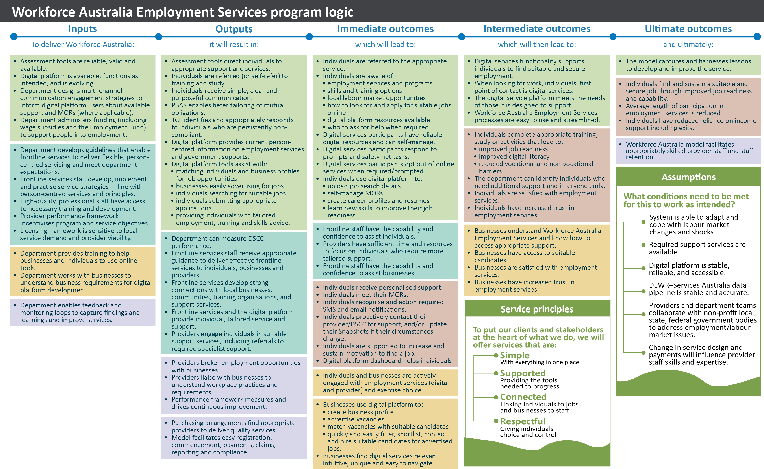
Figure 9.2 Data framework
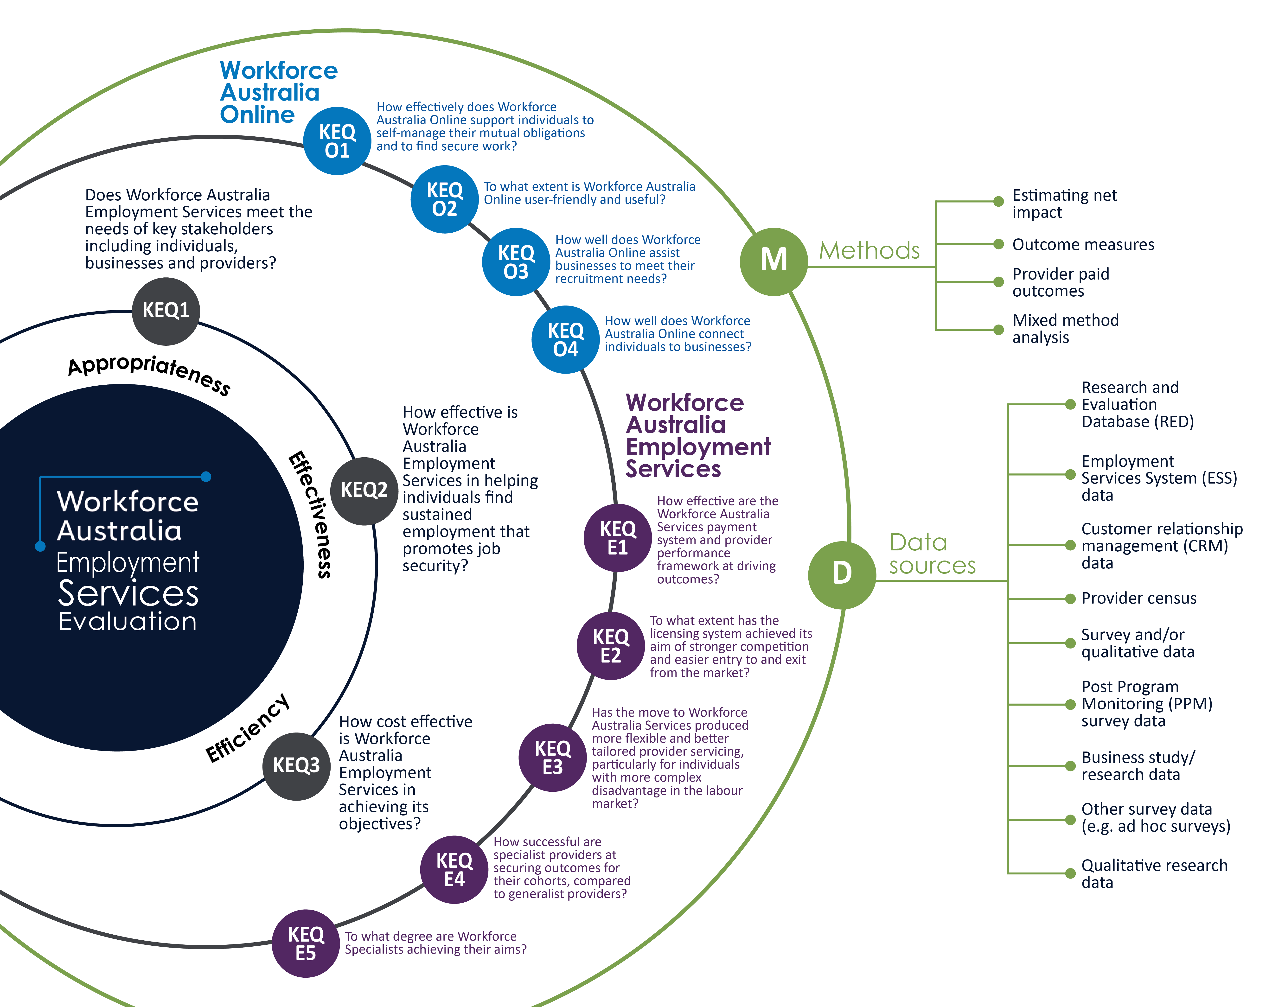

9.3 Points Based Activation System activities and points values
Table 9.2 PBAS activities and points value
Tasks and activities | Points value
Completing a job application (job search) | 5 points
Creating and updating the profile | 5 points (maximum of 5 points per month)
Online learning modules² (short online modules to support résumé writing, tailoring job applications, getting work experience) | 5 points (maximum of 5 points per month)
Paid work | 5 points for 5 hours (rounded up)
Individual-sourced voluntary work (e.g., fire reserves, school canteen) | 5 points for 5 hours (maximum of 10 points per month)
Driver’s licence hours | 10 points for 5 hours (rounded up)
Counselling¹ | 15 points (with flexibility to increase)
Drug and alcohol rehabilitation and/or interventions¹ | 15 points (with flexibility to increase)
Non-vocational assistance¹ (e.g., cultural services, personal development courses) | 15 points (with flexibility to increase)
Provider workshops/informal activities¹ (e.g., work preparation activities, job clubs) | 15 points (with flexibility to increase)
Self-help and support groups¹ | 15 points (with flexibility to increase)
Defence Force Reserves | 15 points (with flexibility to increase)
Career Transition Assistance | 15 points per week
Work-related licences and qualifications (e.g., forklift licence, white card) | 20 points (with flexibility to increase)
Attending a job fair | 20 points (limited to 3 sessions per year)
Other government programs¹ (e.g., local, state or federal government programs with an employment focus, such as the Indigenous Skills and Employment Program) | 20 points per week (contact hours over 15 hours per week)  15 points per week (contact hours up to 15 hours per week)
Non-government programs¹ (e.g., approved not-for-profit organisations, work-focused programs or vocational interventions approved by the department, such as the Job Ready Program) | 20 points per week (contact hours over 15 hours per week)  15 points per week (contact hours up to 15 hours per week)
Self-Employment Assistance Exploring Self Employment Workshops | 20 points per week
Education and training³ | 20 points per week (contact hours over 15 hours per week)  15 points per week (contact hours up to 15 hours per week)
Employability Skills Training | 20 points per week (contact hours over 15 hours per week)  15 points per week (contact hours up to 15 hours per week)
Observational work experience¹  Provider-sourced voluntary work¹ | 20 points per week (contact hours over 15 hours per week)  15 points per week (contact hours up to 15 hours per week)
Work for the Dole¹ | 20 points per week (contact hours over 15 hours per week)  15 points per week (contact hours up to 15 hours per week)
Adult Migrant English Program⁴ | 20 points per week (contact hours over 15 hours per week)  15 points per week (contact hours up to 15 hours per week)
Skills for Education and Employment⁴ | 25 points per week
Attending a job interview | 25 points
Driver’s licence attainment¹ | 25 points
Launch into Work^{1,4} | 25 points per week
Self-Employment Assistance Small Business Training⁴ | 25 points per week
Local Jobs Program  Workforce Specialist Projects | 25 points
Starting a job | 50 points
Relocation for a job | 100 points
Note: Providers and the Digital Services Contact Centre may increase the values of certain tasks or activities through an activity bonus to reflect the circumstances of the individual and the task or activity they are doing.
- These tasks and activities are available to Workforce Australia Services participants only. The 15-points value is generally based on a one-hour session. Providers can adjust the value for longer engagements.
- These tasks and activities are available to Workforce Australia Online participants only.
- The points target and minimum job search requirement can be tailored for individuals undertaking education and training for over 15 hours per week or full time as defined by the institution.
- Individuals undertaking these activities are not required to complete a minimum job search requirement.

While the OEST was expected to run until July 2022, the evaluation was suspended with the onset of the COVID-19 pandemic. This was due to the rapid demand for income support, and the subsequent pressures placed on employment services. Consequently, Online Employment Services (OES) commenced in April 2020 as the mainstream service for job-ready participants. A separate evaluation of the OES (April 2020 – June 2022) is being conducted.
https://www.dese.gov.au/employment-research-and-statistics/resources/online-employment-services-trial-evaluation-report.
https://www.dese.gov.au/job-seeker-assessment-framework/resources/online-job-seeker-classification-instrument-trial-evaluation-report.
DEWR came into existence following machinery-of-government changes on 1 July 2022. Prior to this the Employment Evaluation Branch (and its predecessors) was in the Department of Education, Skills and Employment.
Both Workforce Australia Online and Workforce Australia Services participants have 2 days of ‘think time’ to accept a Job Plan but must sign it to commence in service.
The online employment service in place prior to July 2022.
As measured by the Job Seeker Classification Instrument.
Targeted Compliance Framework: Mutual Obligation Failures Guideline v1.1 effective from 10 September 2018.
Participants incur a fast-track mutual obligation failure by either intentionally acting in a manner at a job interview that could result in an offer of employment not being made, failing to attend a job interview, or failing to act on a job referral or job opportunity when requested to do so by their provider.
Targeted Compliance Framework: Mutual Obligation Failures Guideline v1.1 effective from 10 September 2018, p. 17.
A panel of Workforce Specialists has been established to meet the workforce needs of identified industries and occupations, connecting them to eligible individuals in Workforce Australia Services, Workforce Australia Online and Workforce Australia – Transition to Work. The projects delivered by Workforce Specialists will be designed to actively target industries and occupations identified in the Workforce Specialist Project Framework (https://www.dewr.gov.au/workforce-australia/resources/workforce-connections-workforce-specialist-project-framework)
Previous evaluations of this type have typically lasted 3 to 5 years.
Specialist service providers for youth for the Transition to Work (TtW) program are included in the evaluation of the TtW program.
While TtW is outside the scope of this evaluation since it has its own evaluation, this evaluation will consider the interactions of the 2 programs. The 2 evaluation teams will collaborate in data collection, analysis, and reporting where appropriate.
It is highly likely that there will be attrition in subsequent waves of the longitudinal survey. We will top up the sample when attrition occurs, to maintain 8,000 individuals in each wave of the survey. But this does mean that fewer than 8,000 individuals will complete all 8 waves. This is an issue faced by all longitudinal surveys.

