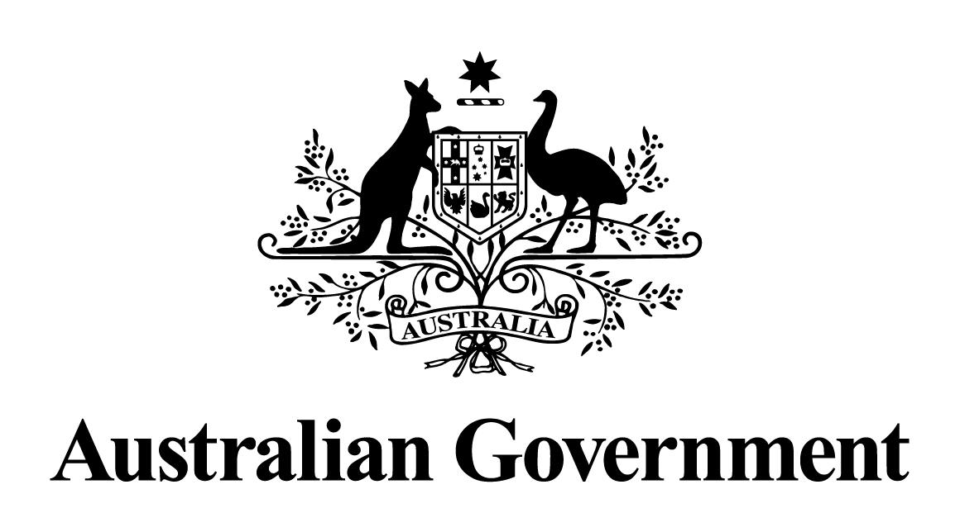

Australian Government response to the
Education and Employment Legislation Committee report:

Free TAFE Bill 2024 [Provisions]
OCTOBER 2025

Overview
The Australian Government is committed to ensuring Australia’s vocational education and training (VET) sector delivers high-quality, responsive and accessible education and training to boost productivity, address skills shortages, and support Australians to obtain secure and well-paid jobs, including those who typically face barriers to participating in education and employment.
The government has made Free TAFE a permanent feature of the national VET system, supporting at least 100,000 Free TAFE and VET places per year from 2027, indexed to population growth.
It is underpinned by the Free TAFE Act 2025 which commenced on 28 March 2025. The Act establishes an ongoing commitment to a grant of Commonwealth financial assistance to states to deliver Free TAFE places and provides certainty to students, teachers and trainers, VET providers, industry, and states and territories that Free TAFE will remain an ongoing national program.
Free TAFE places will be prioritised to vulnerable cohorts and will be offered in fields of study in high demand and of national and state priority. It will provide cost-of-living relief to those who benefit most through the removal of tuition fees and by reducing the debt burden a student may carry over their lifetime. It will support national prosperity through building the skilled workforce Australia needs both now and into the future, and deliver on the Government’s commitment to put TAFE at the centre of the VET system.
Free TAFE builds on the success of the 2023-2026 Fee-Free TAFE Skills Agreement between the Commonwealth and states and territories, which is delivering over 500,000 Fee-Free TAFE and VET places across Australia.
From 1 January 2023 to 30 September 2024, there have been over 568,400 enrolments nationally in Fee-Free TAFE. More than 60% of enrolments have been by women, around 25% by jobseekers and more than 30% by students in regional areas. It has supported over 150,000 care sector course enrolments, over 54,000 technology and digital sector course enrolments and over 39,000 construction sector course enrolments.

Recommendation 1
The committee recommends that the Senate pass the bill.

The government supports this recommendation.

The Bill passed both houses of Parliament on 26 March 2025, and the Free TAFE Act 2025 commenced on 28 March 2025.

Coalition Senators’ dissenting report

Recommendation 1
That the Free TAFE Bill 2024 not be passed by the Senate.

The government does not support this recommendation.

Free TAFE will help to address local and national skills shortages to boost productivity, support Australians to obtain meaningful and well-paid jobs, and deliver cost of living relief to those who need it most.

Australian Greens’ additional comments

Recommendation 1
That the Australian Government legislate the Free TAFE Bill 2024 in this term of government.

The government supports this recommendation.

Recommendation 2
That the Australian Government wipe all student debt and make university and TAFE free for everyone.
The government does not support this recommendation.

Recommendation 3
That the Australian Government increase investment in TAFEs to update infrastructure and equipment, and ensure secure jobs, fair pay and conditions for staff, and adequate resources and support for both staff and students.
The government notes this recommendation.
Funding for the VET system is a joint responsibility of the Commonwealth and the state and territory governments. The Commonwealth contributes to the VET system by both directly funding parts of the national training system and providing funding to states and territories to operate their training systems.
Under the National Skills Agreement, the Commonwealth is investing up to $12.6 billion over 2024 to 2028 to expand and transform access to the VET sector, support training providers to deliver quality education and training, and implement reforms to address critical skills needs. This represents an additional $3.7 billion on previous funding levels. It includes up to $11.3 billion in flexible funding for state and territory skills systems. States and territories can use this funding for a range of purposes, including investing in TAFE infrastructure and equipment, supports for students and staffing costs. Through the Agreement, all governments have also acknowledged the importance of TAFEs as enduring institutions with a public interest mandate.
The government is also investing $50 million in TAFE infrastructure through the TAFE Technology Fund to support TAFEs across the country to upgrade and expand facilities including laboratories, workshops, and IT services.

Recommendation 4
That the Australian Government move administration of the Adult Migrant English Program from the Department of Home Affairs to the Department of Education.
The government does not support the recommendation.
As the Commonwealth’s largest settlement program, the Adult Migrant English Program (AMEP) is well placed within the Department of Home Affairs, which also has responsibility for migrant, humanitarian settlement and multicultural affairs policy and programs. The synergies between these related services within the Department of Home Affairs better achieves Australia’s overall settlement policy objectives and the successful integration, social and economic participation of migrants and humanitarian entrants.
Given the profile of its clients and the strong focus on settlement in the AMEP curriculum, the AMEP should not been viewed solely through the lens of an education service, but as a critical component of Australia’s overarching Settlement framework, which falls within DHA’s remit.
From 1 January 2026, a new AMEP Business Model will commence, developed through extensive consultation. The model will provide greater flexibility and enhanced client, and teacher supports to further improve English language and settlement outcomes for AMEP clients.

