


Complaints service
  - Factsheet for employers
This factsheet will help you understand how to make a complaint about our employment or pre-employment services, what the complaints process is, and how we manage your complaint.

Reasons you may make a complaint
You can make a complaint to us at any time about our employment or pre-employment services, including Workforce Australia and Parent Pathways. You could make a complaint about:
- accessing wage subsidies
- using the Workforce Australia website
- the actions of an employment services provider or other individual
- recruiting candidates.
If your complaint is not about the employment services and pre-employment services we deliver, you can find the appropriate contact area on the department’s complaint webpage: Making a complaint to the department

How to make a complaint
You can make a complaint:
- online using our online complaint form
- over the phone by calling the Employer Hotline on 13 17 15, from Monday to Friday between 9am and 7pm AEST/AEDT.
- by post at: The National Customer Service Line Manager Department of Employment and Workplace Relations GPO Box 9828 Canberra ACT 2601
If you need an interpreter in your preferred language call Translation and Interpreting Service on 131 450 and ask to be connected to the Employer Hotline.
If you’re deaf or find it hard to hear or speak on the phone, Text Telephone (TTY) on 1800 555 677 or call the National Relay Service on 1800 555 727 and ask to be connected to the Employer Hotline 13 17 15.
Note: If your complaint is about another agency, government department or non-government organisation, please send your feedback directly to them.

The complaints process
When we receive your complaint, we will work to understand what happened and if something different should have happened. The diagram below outlines key stages in the complaints process and when we might contact you for more information.
Figure 1: Our complaints process
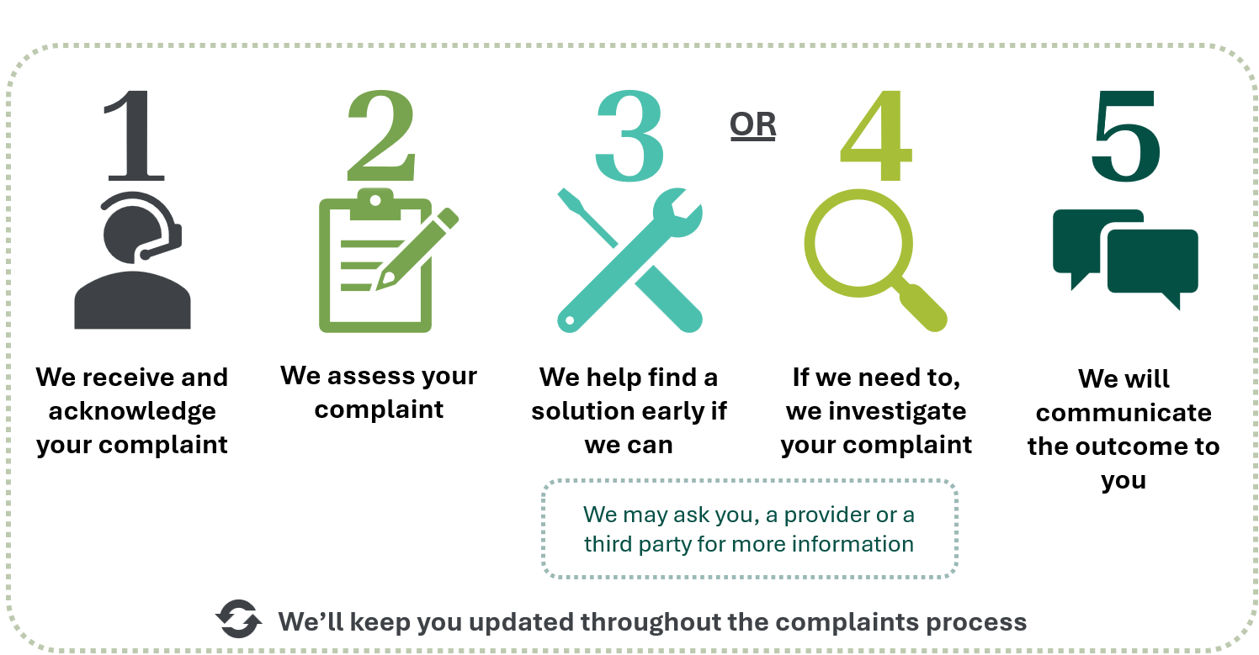

What you can expect from us
We are committed to deliver a complaints service that is:
- Fair – focused on achieving fair outcomes for each complaint. We’ll handle each complaint fairly, confidentially, and with respect for all parties involved.
- Accessible – easy for you to make a complaint. You can make a complaint online, by email, over the phone or by letter.
- Efficient – prompt in addressing your complaint and communicating proactively with you. We’ll let you know if we need more time or if there is a delay.
- Transparent – open and honest with you about your complaint. We’ll keep you informed at each stage of the complaints process and explain the outcome of your complaint, including any findings that we make.

What we expect from you
To help us resolve your complaint, we ask that you engage respectfully with the complaints officer handling your complaint and provide additional information promptly if we request it.

Request a complaint review
If you disagree with a decision we have made about your complaint, you can ask us to review your complaint outcome.
Send your complaint review request to us by email or post. Your complaint review request must explain why you believe the original complaint outcome was wrong and provide any relevant supporting information or evidence. We will assess your complaint review request and let you know if we will change the outcome.
If we have undertaken a complaint review and you still disagree with our decision, you can contact the Commonwealth Ombudsman to seek further consideration of the complaint by:
- calling 1300 362 072
- visiting the Commonwealth Ombudsman website (http://www.ombudsman.gov.au)

Further information
To learn more about our complaints service, visit Making a complaint about Employment and Pre-employment Services.

Privacy statement
Information about how we manage your privacy is available on the Making a complaint about Employment and Pre-Employment Services page.

