Department of Education Strategic Plan 2014–2017

Secretary’s foreword
I am delighted to present the Department of Education’s 2014–2017 Strategic Plan.
The plan sets out our vision: Opportunity through learning. These three words encapsulate so much. Our department provides opportunity to build a stronger economy, opportunity to build stronger communities and opportunity for a more equitable society. We enable learning that is lifelong; through early learning, formal education and through the richness of discovery and research.
Our plan helps our stakeholders know what they can expect from us. It identifies the skills and capabilities of our people that are critical to our success. It explains our values and culture and how we behave when doing our work. It shows our commitment to improving the opportunities in education for Aboriginal and Torres Strait Islander peoples. For us, Indigenous business is everyone’s business.
I would like to thank everyone who has contributed to developing the plan. The plan will build a shared understanding of our goals, pathways, values and culture so we can work together to achieve our vision of Opportunity through learning.
Lisa Paul AO PSM

Our vision
Opportunity through learning.

Our mission
Opportunity through learning can transform lives. We aim to provide learning opportunities for everyone – from children starting childcare or pre-school to school and university students achieving their potential; from international students using our quality universities to the global impact of research. We want to be recognised for delivering quality, value for money education services to the Australian community.
The department’s work reflects the Australian Government’s priorities. We provide evidence-based, well informed and highly regarded advice to support our ministers and stakeholders. We work together and in partnership with our stakeholders in achieving our vision.

Our goals
Our goals describe the areas of work we will focus on to achieve our vision. We know we will only achieve success in our goals by collaborating with one another, success in early learning, for example, will result in better outcomes in schooling and higher education. Across all of our goals we work to reduce red tape while striving for excellence.
Enrich early learning
Support affordable, accessible, flexible and quality child care and early childhood learning.
- Children’s early learning and development and their transition to schooling is supported.
- The child care system supports workforce participation especially for women and meets the needs of modern families and the economy.
- Services are inclusive and responsive for children, parents and communities, including regional and disadvantaged Australians.

Support quality schooling
Support a world class school education system through high quality teaching; parents’ engagement in their children’s learning; school autonomy; and a strong national curriculum.
- National policy priorities for schooling are achieved through engagement with state and territory governments, non-government schooling authorities, schools, students, parents and communities.
- Educational outcomes are measured and a national evidence base identifies quality practices to drive improvement in schools and classrooms.
- Equitable, needs-based, stable and sustainable funding supports high quality student outcomes.

Excel through knowledge
Enable the delivery of quality higher education, international education and research that contributes to Australia’s society and the global economy.
- Policies, funding and systems support high quality higher education and research.
- Higher education and research outcomes demonstrate the relationship between education, research and prosperity.
- Policy settings and growth in the sector inspires confidence from international providers and students and engages Australia with the region.

Enable business areas
Our internal corporate services and Shared Services Centre work collaboratively to support business areas in achieving their goals and maintaining productivity and excellence within a constrained fiscal environment.
- Corporate areas offer strategic services and expertise to business areas.
- Corporate services are delivered seamlessly without compromising accountability, compliance or quality.
- Reliable technologies and systems are accessible and support our ministers, the department and stakeholders to strive for better ways of working.

Our pathways
Our pathways describe how we will get the job done. They articulate our behaviours and ways of working that reflect what is most important to us as we work towards achieving our goals. Our pathways describe the expectations of ourselves and guide how we work with each other and our stakeholders. Our pathways help us strive to be the best we can be.

Respond and deliver
We listen actively and understand the aspirations and values of communities, families and individuals. We deliver valued services to our stakeholders by using our network of staff across the states, territories and regions.
- We provide quality and timely advice to our ministers and support the Government to meet its priorities.
- We collaborate to find better ways of working and managing within our budget.
- We are confident and informed professionals who provide solutions and advice based on our expertise.
- We build and promote a culture of genuine engagement and partnerships with our stakeholders. We continue to look for new and diverse ways of engaging and building a shared understanding with our stakeholders.

Excellence through evidence
We maximise Australia’s potential to achieve excellence in education through ongoing research, evaluation and information management. We develop evidence-based policy and programmes to deliver change and achieve globally competitive results.
- We value evidence to inform and shape policy discussion, development and evaluation.
- We invest in data and information collection and analysis and innovative research to support change.
- We make it easy for internal and external stakeholders to access data and evidence.

Empower our people
We provide a flexible and inclusive work environment and support the wellbeing of our people. We value formal and informal learning that develops our people’s capabilities.
- We delegate responsibility to build high performance, leadership and innovation in our people.
- We aim to be an employer of choice, designing jobs that allow flexible working arrangements and opportunities for our people to learn and grow.
- We recognise and reward talent and leadership at all levels.

Capability through diversity
We are proud to employ people with a range of experiences and capabilities and we value their diversity. We cultivate an environment of inclusion, trust and respect of all people and deliver our services with empathy.
- We provide systemic support for leaders at all levels to promote and embrace diversity.
- We embed principles of diversity, accessibility and reconciliation into everyday business practices.
- We strengthen our commitment towards working with Aboriginal and Torres Strait Islander peoples to improve their life opportunities through our daily work, employment practices and our Reconciliation Action Plan.

Our values and culture
We proudly uphold the Australian Public Service ICARE values. We are impartial, committed to service, accountable, respectful and ethical. We support these values by creating a culture where:
- We are consultative and responsive.
- We value learning, research, discovery and opportunity.
- We innovate to achieve our business outcomes more efficiently.
- We collaborate internally and externally to reach our goals.
- We lead by example at all levels and pride ourselves on being professional, high performing and innovative.
- We care for and support each other and value the skills, difference and diversity of our people.
- We celebrate our successes and learn from our experiences.

Indigenous business is everyone’s business
The Department of Education supports the Government’s priority to work with Aboriginal and Torres Strait Islander peoples and communities to build a better future and improve opportunities. The department develops and delivers education policies and programmes by working with Aboriginal and Torres Strait Islander peoples, respecting their cultures and building our own cultural capability.
Each of us works to strengthen our understanding and appreciation of Aboriginal and Torres Strait Islander peoples’ cultures, history and diversity. Our Aboriginal and Torres Strait Islander staff are supported to reach their potential and we recognise their unique skills and experiences are vital in supporting the department’s priorities.
Our people are encouraged to embrace and value the important contribution Aboriginal and Torres Strait Islander peoples make to our department and wider Australian society. The department’s Reconciliation Action Plan (RAP) is a formal commitment and call to action for all our people to ensure Indigenous business is part of their day to day business.

Our operating environment

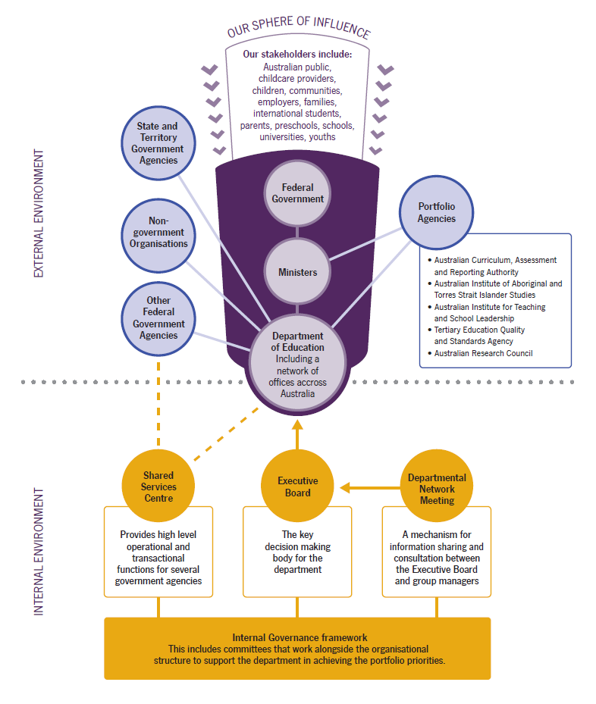

Contacts:
StrategicPlan@education.gov.au
www.education.gov.au

