Portfolio Supplementary
Additional Estimates Statements
2017–18
Appropriation Bill (No. 5) 2017–2018
and
Appropriation Bill (No. 6) 2017–2018
Education and Training Portfolio

Explanations of Supplementary Additional Estimates 2017–18

© Commonwealth of Australia 2018
ISBN 978-1-76051-459-4 [PRINT]
978-1-76051-457-0 [PDF]
978-1-76051-458-7 [DOCX]

With the exception of the Commonwealth Coat of Arms, the department’s logo, any material protected by a trade mark and where otherwise noted all material presented in this document is provided under a Creative Commons Attribution 4.0 International (https://creativecommons.org/licenses/by/4.0/) licence.
The details of the relevant licence conditions are available on the Creative Commons website (accessible using the links provided) as is the full legal code for the CC BY 4.0 International (https://creativecommons.org/licenses/by/4.0/legalcode).
The document must be attributed as the Portfolio Supplementary Additional Estimates Statements 2017–18 Education and Training Portfolio.
Derivative material
If you have modified or transformed Department of Education and Training material, or derived new material from those of the Department of Education and Training in any way, then Department of Education and Training prefers the following attribution: Based on the Australian Government Department of Education and Training data.
Use of the Coat of Arms
The terms under which the Coat of Arms can be used are set out on the It’s an Honour website (see www.dpmc.gov.au/government/its-honour).
Other Uses
Inquiries regarding this licence and any other use of this document should be directed to the Department of Education and Training on 1300 566 046.

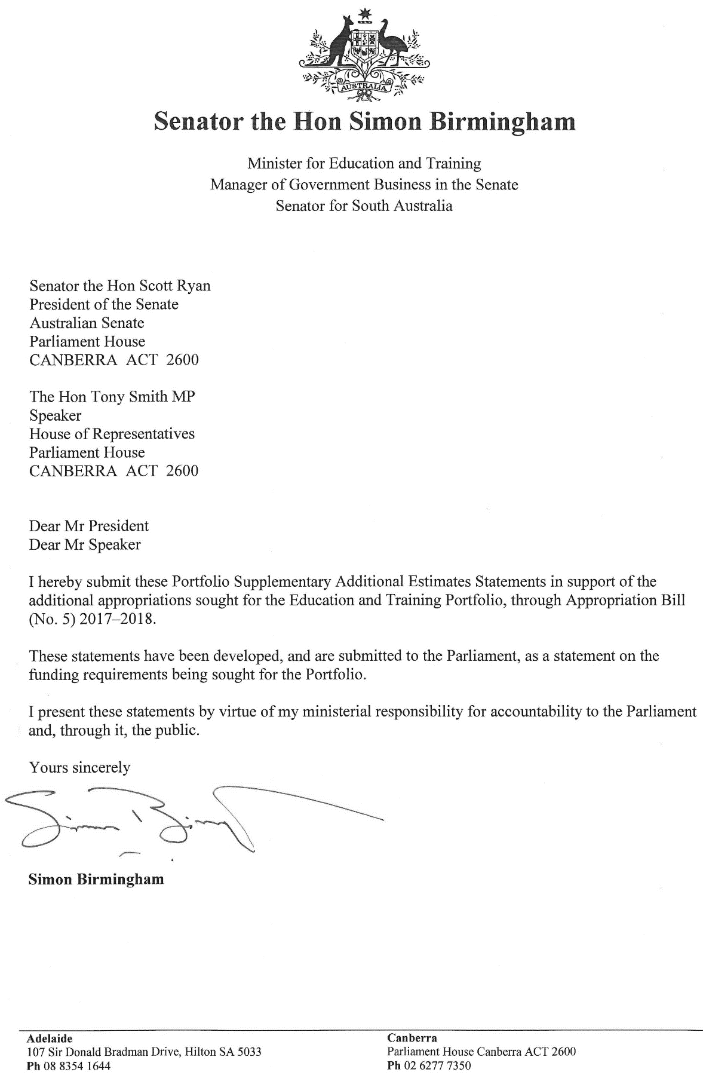

Abbreviations and conventions
The following notation may be used:
NEC/nec not elsewhere classified
- nil
.. not zero, but rounded to zero
n/a not applicable (unless otherwise specified)
nfp not for publication
$m $ million
$b $ billion
tbc to be confirmed
Figures in tables and in the text may be rounded. Figures in text are generally rounded to one decimal place, whereas figures in tables are generally rounded to the nearest thousand. Discrepancies in tables between totals and sums of components are due to rounding.
Enquiries
Should you have any enquiries regarding this publication please contact the Chief Financial Officer, Department of Education and Training on 1300 566 046.
Links to this document can be located on the Australian Government Budget website at: www.budget.gov.au.

User Guide
to the
Portfolio Supplementary Additional Estimates
Statements

User guide
The purpose of the 2017–18 Portfolio Supplementary Additional Estimates Statements (PSAES) is to inform Senators, Members of Parliament and the public of the proposed allocation of additional resources to government outcomes by entities within the portfolio.
The PSAES facilitate understanding of the proposed appropriations in Appropriation Bill (No. 5) 2017–2018 and Appropriation Bill (No. 6) 2017–2018. In this sense the PSAES is declared by the Appropriation Acts to be a ‘relevant document’ to the interpretation of the Acts according to section 15AB of the Acts Interpretation Act 1901.
Appropriation Bill (No. 5) 2017–2018, which follows on from Appropriation Act (No. 1) tabled at Budget and Appropriation Bill (No. 3) tabled at Additional Estimates, will provide additional expenditure authority for the ordinary annual services of government in respect of the 2017–18 financial year.
Appropriation Bill (No. 6) 2017–2018, which follows on from Appropriation Act (No. 2) tabled at Budget and Appropriation Bill (No. 4) tabled at Additional Estimates, will provide additional expenditure authority in respect of the 2017–18 financial year for capital works and services, payments to or for the states, territories and local government authorities, and new administered outcomes not authorised in specific legislation.

Contents
User guide vi
Entity Supplementary Additional Estimates Statements 3
Department of Education and Training 3

Department of Education and Training
Overview of additional appropriations 3
Entity measures table 3
Additional estimates and variations 4
Breakdown of additional estimates by Appropriation Bill 5

Department of Education And Training

Overview of additional appropriations
Overall, the Department of Education and Training is receiving a net increase in funding in 2017–18. This increase is the effect of additional funding to support measures in Table 1.1 Entity 2017–18 supplementary additional estimates measures and other variations as demonstrated in Table 1.2 Supplementary estimates and variations to outcomes from measures and other variations.

Entity measures table
Table 1.1 summarises new Government measures taken since the 2017–18 Additional Estimates. The table is split into revenue, expense and capital measures, with the affected program identified.
Table 1.1 Entity 2017–18 supplementary additional estimates measures
Prepared on a Government Financial Statistics (fiscal) basis. Figures displayed in brackets are negative and represent a decrease in funds. Non-bracketed figures are positive and represent an increase in funds.
(a) Refer to the Education and Training 2018–19 Portfolio Budget Statements: Table 1.2 Department of Education and Training 2018–19 Budget Measures for the 2018–19 and forward years financial impacts and to the 2018–19 Budget Paper No. 2 for the full measure impact.

Additional estimates and variations
The following table details the changes to the resourcing for the Department of Education and Training at Supplementary Additional Estimates, by outcome. The table details the supplementary estimates and variations resulting from new measures and any other variations since the 2017–18 Additional Estimates in Appropriation Bills (No. 5 and No. 6).
Table 1.2 Supplementary estimates and variations to outcomes from measures and other variations

Breakdown of additional estimates by appropriation bill
The following tables detail the Additional Estimates sought for the Department of Education and Training through Appropriation Bills (No. 5 and No. 6).
Table 1.3: Appropriation Bill (No. 5) 2017–2018
Table 1.4: Appropriation Bill (No. 6) 2017–2018
The Department of Education and Training has no measures in Appropriation Bill (No. 6) 2017–2018 and so Table 1.4 is not presented.

