Slide 1 Australian Government Department of Employment Central Victoria Priority Employment Area labour market overview – Ballarat presentation 13 June 2014.

Presentation given by Ivan Neville Branch Manager Labour Market Research and Analysis Branch based on survey of Central Victoria Priority Employment Area conducted November 2013

Slide 2 Map of Central Victoria – Ballarat region

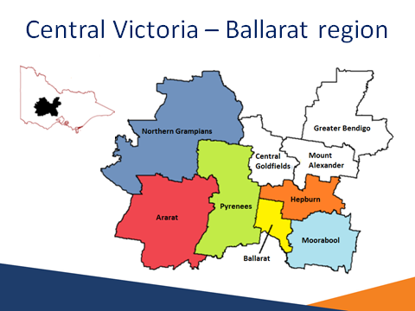
Source: ABS (ASGC), 2006 LGA boundaries

The Ballarat region includes the Local Government Areas (LGAs) of:
- Northern Grampians
- Ararat
- Pyrenees
- Ballarat
- Moorabool
- Hepburn

The Central Victoria region includes the Ballarat region plus the following Local Government Areas (LGAs) of:
- Central Goldfields
- Greater Bendigo
- Mount Alexander

76% of the Ballarat SA4 population lives in the Ballarat region.

Slide 3 What has changed in the Ballarat region? (Since last survey, March 2012)

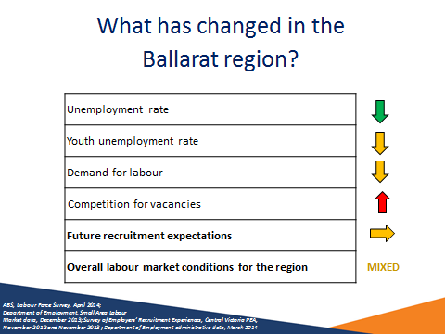
Source: ABS, Labour Force Survey, April 2014; Department of Employment, Small Area Labour Market data, December 2013; Survey of Employers’ Recruitment Experiences, Central Victoria PEA, November 2012 and November 2013; Department of Employment administrative data, March 2014

- Labour market conditions in the Ballarat region have strengthened slightly since 2012.
- The unemployment rate in the Ballarat region decreased to 5.8 per cent in December 2013 from 6.7 per cent in December 2012 (SALM, December 2013).
- The youth unemployment rate for the Ballarat region dropped from
17.7 per cent in April 2013 to 7.9 per cent in April 2014 (ABS LFS, April 2014).
- Competition for vacancies increased substantially.
- The survey showed an increase in recruitment activity and expectations of future recruitment were encouraging.

Slide 4 Population profile for the Ballarat region

 | Adult  Population  (15 +) | Growth  2007 to 2012 | Working Age  (15-64) Participation Rate (2011) | Median Age  (2011)
Ballarat LGA | 78,300 | 11% | 74.6% | 36
Ararat LGA | 9,400 | 1% | 69.9% | 43
Hepburn LGA | 12,200 | 6% | 71.6% | 44
Moorabool LGA | 23,200 | 13% | 75.6% | 37
N. Grampians LGA | 9,900 | 1% | 73.0% | 42
Pyrenees LGA | 5,700 | 4% | 65.2% | 45
Central Victoria region | 247,900 | 8% | 73.5% | 40
Victoria | 4,599,100 | 10% | 75.6% | 37
Australia | 18,419,600 | 10% | 75.8% | 37
Source: ABS, Estimated Resident Population, 2007 and 2012; ABS, Census of Population and Housing, 2011

The adult population (15 years+) in the Central Victoria region (247,900) has increased by 8 per cent in the five years to June 2012. The adult population for Victoria and Australia have both increased in the same period by 10 per cent. The Moorabool LGA has the strongest population growth (13 per cent) while the Ararat and N. Grampians LGAs had the weakest (both 1 per cent).

At the time of the 2011 Census, the Working Age Population (15-64 years) participation rate for the region was 73.5 per cent, slightly weaker that Victoria
(75.6 per cent) and Australia (75.8 per cent).

The median age in the region was 40 years at the time of the 2011 Census, a slightly higher age compared with Victoria and Australia (both 37 years). The Pyrenees LGA had the highest median age (45 years).

Slide 5 Age distribution — Ballarat region

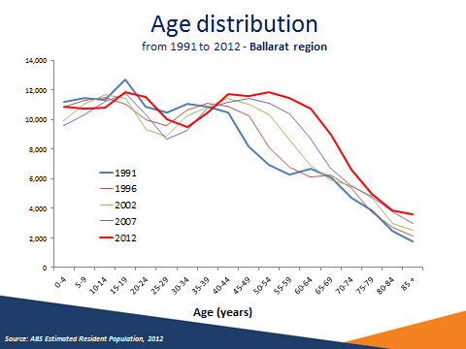
Source: ABS Estimated Resident Population, 2012

Over the 21 years between 1991 and 2012 the population has shown signs of aging.

Slide 6 More people moving into the region over the past 5 years - Working Age Population (15-64 years)

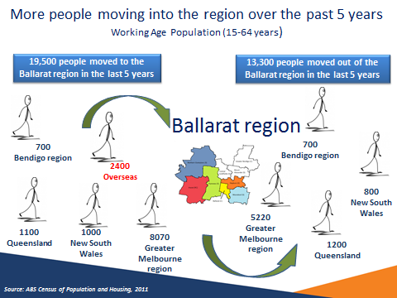
Source: ABS Census of Population and Housing, 2011

In the five years to the 2011 Census, 19,500 people aged 15 to 64 have moved to the Ballarat region. The majority of people came from the following localities:

Region | People | % of people who moved to the region
Melbourne | 8,070 | (41%)
Overseas | 2,400 | (12%)
Queensland | 1,100 | (6%)
New South Wales | 1,000 | (5%)
Bendigo region | 700 | (4%)

In the five years to the 2011 Census, 13,300 people aged 15 to 64 moved out of the Ballarat region.

Region | People | % of people who moved to the region
Melbourne | 5,220 | (39%)
Queensland | 1,200 | (9%)
New South Wales | 800 | (6%)
Bendigo region | 700 | (5%)

Slide 7 Residents on the move

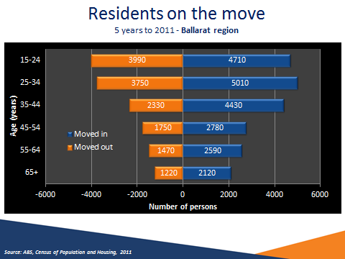
Source: ABS, Census of Population and Housing, 2011

The age group responsible for the largest migration out of the Ballarat region is the 15 to 24 years age group (3,990 moving out, with a net figure of 720 persons moving into the region).

The largest migration into the region occurred in the 25 to 34 years age group (5,010 moving in, with a net figure of 1,400 persons moving into the region).

The age group with the largest net migration into the region are 35 to 44 year olds (a net figure of 2,100 persons moving in).

Slide 8 Migrating with a job into the Ballarat region?

Group (age at 2011) | Number of People | Employed | Unemployed | Not in the labour force
WAP | 19,430* | 65% (70%)* | 7% (4%)* | 29% (26%)*
15-24 | 4690 | 51% (57%) | 10% (8%) | 39% (35%)
25-44 | 9400 | 75% | 5% | 20%
45-54 | 2790 | 69% (79%) | 7% (3%) | 24% (18%)
55-64 | 2560 | 48% (59%) | 5% (2%) | 47% (39%)
Source: ABS, Census of Population and Housing, 2011

People of working age (age at 2011) who had migrated into Ballarat LGA between 2006 and 2011 (19,430 persons) were more likely to be unemployed (7 per cent compared with 4 per cent overall) and not in the labour force (29 per cent, compared with 26 per cent overall).

Slide 9 Where else do Ballarat residents work?

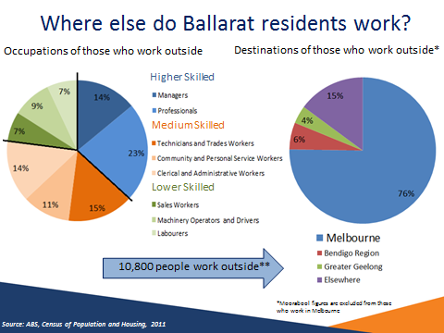
Source: ABS, Census of Population and Housing, 2011

Of those who defined their place of work in 2011, 83 per cent (54,100) work locally and 17 per cent (10,800) work outside the Ballarat region. Those who work outside were more likely to be employed as Professionals (23 per cent compared with
19 per cent for those who live and work locally).

Melbourne is by far the most common destination for Ballarat residents who work outside the region (8,200 persons or 76 per cent of those who work elsewhere), followed by the Bendigo region (620 persons or 6 per cent of those who work elsewhere). Greater Geelong is also an important working destination (4 per cent).

**9,000 employed people living in the Ballarat region inadequately defined their place of work and so are excluded from these figures

Slide 10 Unemployment Rate relatively flat…

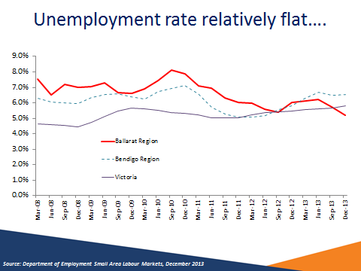
Source: Department of Employment Small Area Labour Markets, December 2013

In December 2013, the unemployment rate in the Ballarat region was 5.2 per cent, lower than the Bendigo region (6.5 per cent) and Victoria (5.8 per cent).

While the unemployment rate in the Ballarat region has decreased over the last few years, the region has consistently had higher unemployment rate than Victoria.

Slide 11 …but recent decline
Region | December 2012 | December 2013 | Annual Change
Ballarat LGA | 6.7% | 5.8% | -0.9% pts
Ararat LGA | 5.4% | 4.9% | -0.5% pts
Hepburn LGA | 6.1% | 5.2% | -0.9% pts
Moorabool LGA | 4.5% | 3.9% | -0.6% pts
N. Grampians LGA | 5.3% | 4.4% | -0.9% pts
Pyrenees LGA | 5.8% | 4.9% | -0.9% pts
Ballarat region | 6.0% | 5.2% | -0.8% pts
Central Victoria region | 5.9% | 5.8% | -0.1% pts
Victoria * | 5.8%  April 2013 | 6.4%  April 2014 | 0.6% pts

* Seasonally adjusted April figure
Source: DEEWR, Small Area Labour Markets, December 2013

In December 2013, the unemployment rate in the Central Victoria region was
5.8 per cent, lower compared with the state (6.4 per cent).

The LGAs of Ballarat and Hepburn reported the highest unemployment rates in the Ballarat region (5.8 and 5.2 per cent, respectively). In contrast, the Moorabool LGA reported an unemployment rate of only 3.9 per cent.

In the 12 months to December 2013, the unemployment in the Central Victoria region has decreased (by 0.1 percentage point) while Victoria it increased (by
0.6 percentage points) to 6.4 per cent.

Slide 12 Below average participation in most age groups

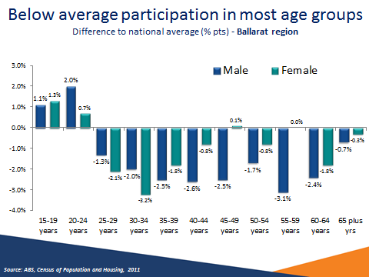
Source: ABS, Census of Population and Housing, 2011

The participation rate for males aged 15 to 19 years (49.4 per cent) had a relatively high participation rate compared with the national rate (48.3 per cent). The participation rate for females in the same cohort (53.6 per cent) was also high compared with the national rate (52.3 per cent). The participation rate for males aged 55 to 59 had the lowest comparative rate with the Australia (76.7 per cent compared with 79.8 per cent), while females aged 30 to 34 had the lowest comparative rate with Australia (70.2 per cent compared with 73.4 per cent).

Slide 13 Male employment growth both full-time and part-time

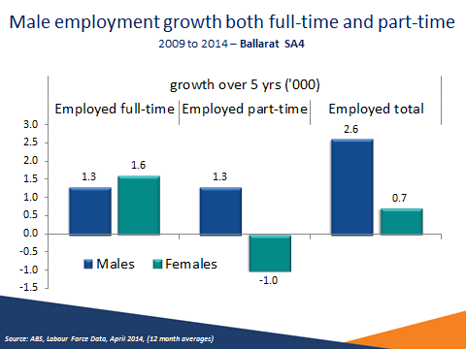
Source: ABS, Labour Force Data, April 2014, (12 month averages)

Over the five years to 2014, employment has grown by 3300 jobs across Ballarat SA4s. This growth was driven by male employment (up 2600 jobs). The growth was split evenly between full-time and part-time employment, both growing by 1300 jobs. Female full-time jobs grew by 1600 jobs, however, this was offset by a decline of 1000 part-time jobs over the same period.

Industries in which growth occurred
Male full-time employment growth
- Construction; Healthcare and Social Assistance and Information Media and Telecommunications
Male part-time employment growth
- Retail; Accommodation and Food Services; Construction and Manufacturing
Female full-time employment growth
- Education; Public Administration and Safety; Financial and Insurance Services and Health Care and Social Assistance
Female part-time employment growth
- Increase - Healthcare and Social Assistance
- Decrease - Retail; and Administrative and Support Services

Slide 14 Health and Retail largest employing industries

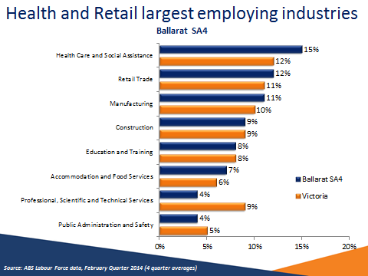
Source: ABS Labour Force data, February Quarter 2014 (4 quarter averages)

Employment in the Ballarat region was highest in the Health Care and Social Assistance (15 per cent of all employed), Retail Trade (12 per cent) and Manufacturing Industries (11 per cent).

Slide 15 Structural change in industry employment Ballarat SA4

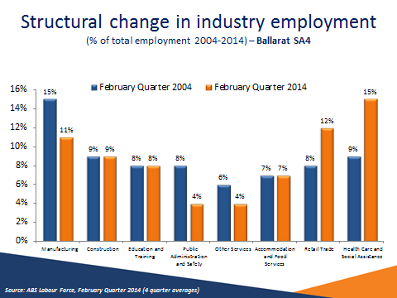
Source: ABS Labour Force, February Quarter 2014 (4 quarter averages)

In the 10 years from 2004, industry employment has changed quite substantially in the Ballarat region. The reliance on the Manufacturing Industry has lessened, reducing from 15 per cent to 11 per cent of all employment. Whereas, the importance of the Health Care and Social Assistance industry is very evident having grown from 9 per cent to 15 per cent of all employment in the region.

Slide 16 One in four receive income support

Region | Proportion of working age population  in receipt of a benefit
Region | Income Support benefits | Unemployment benefits | Disability Support Benefits
Ballarat LGA | 24% | 7% | 8%
Ararat LGA | 23% | 7% | 9%
Hepburn LGA | 23% | 7% | 9%
Moorabool LGA | 17% | 5% | 5%
N. Grampians LGA | 23% | 7% | 11%
Pyrenees LGA | 26% | 7% | 11%
Ballarat region | 23% | 7% | 8%
Central Victoria region | 24% | 7% | 8%
Victoria | 17% | 5% | 5%
Australia | 17% | 6% | 5%
Source: Department of Employment administrative data, March 2014; ABS Estimated Residential Population, 2012

In March 2013, almost one in four (23 per cent) of the working age population were in receipt of an Income Support benefit in the Ballarat region, higher compared with Victoria and Australia (both 17 per cent). The proportion of working age persons on Disability Support Pension was particularly high (8 per cent) compared with the state and Australia (both 5 per cent of WAP).

There is significant variation across the LGAs for example, 26 per cent of working age persons in the Pyrenees LGA were on Income Support benefits compared with only 17 per cent in the Moorabool LGA. Pyrenees also had 11 per cent of the working age population receiving Disability Support Benefits compared to 5 per cent in both Victoria and nationally.

Slide 17 What’s happening with 45 to 64 year olds? – Ballarat region

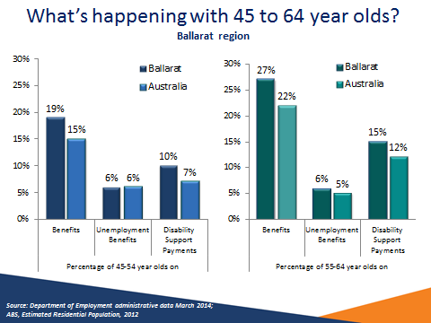
Source: Department of Employment administrative data, March 2014; ABS, Estimated Residential Population, 2012

Reliance on income support payments is particularly high for those aged 45 to 64 years in the Ballarat region when compared with Australia overall. This is especially so for those aged 55 to 64 years. Disability Support Payments are the most common payment and a far higher proportion of the age group receive this payment when compared to Australia overall.

Slide 18 Jobless Families in the Ballarat region with children under 15

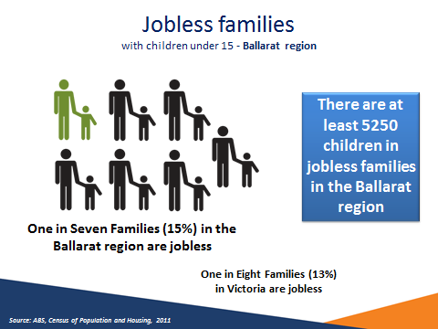
Source: ABS, Census of Population and Housing, 2011

The proportion of families with children under 15 years in the Ballarat region who are jobless (15 per cent) is above both Victoria (13 per cent) and Australia
(14 per cent).

One in seven families with children under 15 in the Ballarat region is jobless.
- 1 in 20 couple families are jobless
- Almost 1 in 2 lone parent families are jobless

There are at least 5,250 children in jobless families in the Ballarat region

Slide 19 Is youth unemployment really only 7.9%?

Region | Youth unemployment rate (15-24 years) | Youth Participation Rate (April 2014) | Youth Unemployment to population ratio
Ballarat SA4 | 7.9% | 75.6% | 6.0%
Victoria | 12.8% | 65.3% | 8.4%
Australia | 12.5% | 66.6% | 8.3%
Source: ABS, Labour Force, April 2014 (12 month averages)

Due to their lack of skills and experience, youth participating in the labour market can be particularly vulnerable during a labour market downturn.

In April 2014, the unemployment rate for the Ballarat SA4 was 7.9 per cent, a decrease of 9.8 per cent since the previous year. The unemployment rate was significantly lower than both Victoria (12.8 per cent) and Australia (12.5 per cent).

Similarly, the youth unemployment to population ratio in the Ballarat SA4 (6.0 per cent) was lower than Victoria (8.4 per cent) and Australia (8.3 per cent).

Slide 20 More young people in Central Victoria not studying

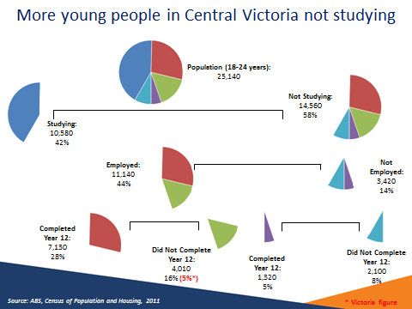
Source: ABS, Census of Population and Housing, 2011

At the time of the 2011 Census, there were 25,140 18-24 year olds in the Central Victoria region, of which 14,560 (58 per cent) were not studying. Overall in Victoria the percentage of 18 to 24 year olds that were studying was higher at 51 per cent.

Of the 14,560 who were not studying, those who did not complete year 12, are vulnerable and may have difficulty entering the labour market, whether they’re employed or not employed. One in four people (24 per cent) in the Central Victoria region aged 18 to 24 were not studying and had not completed Year 12, this was high compared to the state where 16 per cent were not studying and had not completed Year 12.

Of those not studying, 77 per cent were employed comparable with Victoria where 78 per cent of those not studying were employed.

Slide 21 Lower educational attainment in Ballarat

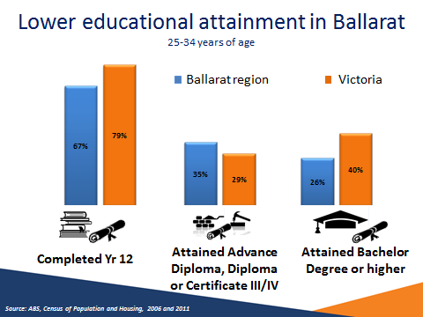
Source: ABS, Census of Population and Housing, 2006 and 2011

The Ballarat region has had an improvement of 6 percentage points in the proportion of 25 to 34 year olds that have completed Yr 12 or equivalent studies between 2006 and 2011. This is in line with the 6 percentage point improvement seen in Victoria overall.

The improvement was not even across all LGAs. Ararat LGA had an improvement of
8 percentage points (to 63 per cent) while North Grampians LGA only had a
1 percentage point improvement (to 57 per cent)

The number of 25 to 34 year olds having completed an Advance Diploma, Diploma or Certificate III/IV was quite high for all Ballarat LGAs. In the Moorabool LGA some
41 per cent of the cohort had completed these courses compared to 29 per cent for Victoria.

The story was very different for Bachelor Degrees or higher. Ballarat LGA had the highest level at 29 per cent of the cohort while the Pyrenees LGA had a level of only 16 per cent. The level for Victoria was 40 per cent.

Slide 22 Importance of education to labour market outcome

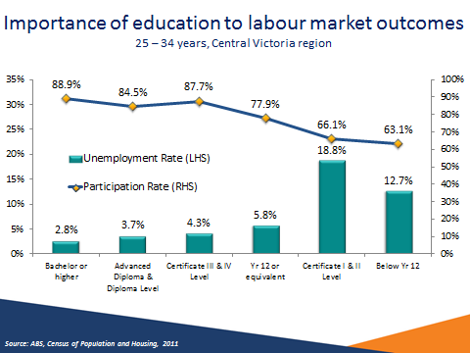
Source: ABS, Census of Population and Housing, 2011

This slide illustrates the correlation between education and labour market outcomes in the Central Victoria region, with higher labour force participation rates and lower unemployment rates for those with higher levels of educational attainment. This reflects the pattern seen across Australia and demonstrates the importance of continuing education to help job seekers obtain employment and participate in the labour market.

Slide 23 Improving Youth labour market outcomes

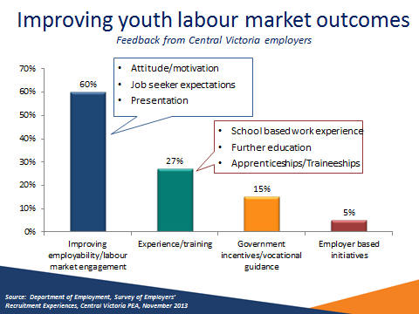
Source: Department of Employment, Survey of Employers’ Recruitment Experiences, Central Victoria PEA, November 2013

Employers in Central Victoria were asked for feedback on strategies to improve labour market outcomes for youth.

The majority of employers (60 per cent) believed that improving employability and labour market engagement were the most important factors in improving youth labour market outcomes, most particularly:

- Attitude/motivation
- Job seeker expectations
- Presentation

A substantial proportion of employers (27 per cent) believed that experience or training was most important for youth, in particular:

- School based work experience
- Further education
- Traineeships

Slide 24 Signs of weakening recruitment conditions

 | Ballarat region |  | Central Victoria region |  | All regions surveyed  (12 months to March 2014)
 | November 2013 | November 2012 | November 2013 | November 2012 | All regions surveyed  (12 months to March 2014)
Annual vacancies  per 100 staff | 15 | 15 | 14 | 16 | 16
Increased staff | 20% | 22% | 19% | 20% | 16%
Decreased staff | 21% | 14% | 21% | 17% | 22%
Source: Department of Employment, Survey of Employers’ Recruitment Experiences, Central Victoria Coast Priority Employment Area, November 2012 and November 2013; All regions surveyed in the 12 months to March 2014

The survey results indicate a weakening in recruitment conditions across the Central Victoria region and Ballarat region over the last year. Recruitment activity has decreased over the year (from 16 vacancies to 14 vacancies per 100 staff). Additionally, a slightly smaller proportion of employers had increased staff and a larger proportion had decreased staff when compared to the results from a year earlier.

Slide 25 Competition for vacancies increased since 2012

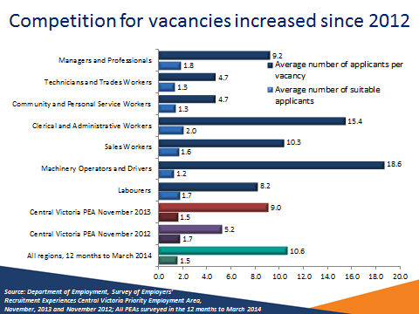
Source: Department of Employment, Survey of Employers’ Recruitment Experiences, Central Victoria PEA, November 2013 and November 2012; All PEAs surveyed in the 12 months to March 2014

There was a higher average number of applicants per vacancy (9.0) compared with previous surveys (5.2 in November 2012). The average number of suitable applicants interviewed per vacancy (1.5) was similar to November 2012 (1.7) and all regions surveyed to March 2014 (1.5).

Slide 26 Informal recruitment growing in popularity

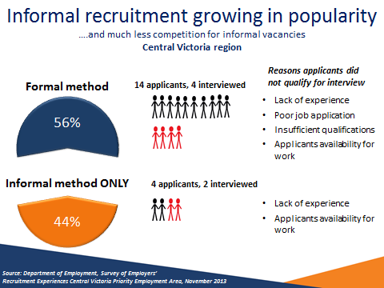
Source: Department of Employment, Survey of Employers’ Recruitment Experiences Central Victoria Priority Employment Area, November 2013

Employers in the Central Victoria region relied on informal recruitment methods only, such as word of mouth and being approached by job seekers, slightly less often than formal methods, such as newspapers, the internet and recruitment agencies. Nevertheless, vacancies for which employers used informal recruitment methods attracted less than one third the number of applicants than when the employers used formal methods. This highlights the value of job seekers actively approaching employers when looking for work.

Slide 27 Personality Traits and Employability Skills employers in Central Victoria viewed as essential

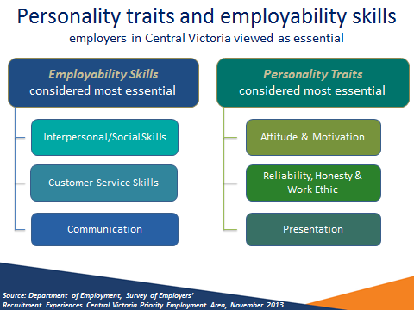
Source: Department of Employment, Survey of Employers’, Recruitment Experiences Central Victoria Priority Employment Area, November 2013

There were a range of general employability skills and personality traits that employers in the Central Victoria region commonly viewed as essential for the position they recently recruited for.

Employability skills commonly considered essential included:
- Interpersonal/Social Skills
- Customer Skills
- Communication

Personality traits commonly considered essential included:
- Attitude and Motivation
- Reliability, Honesty and Work Ethic
- Presentation

Slide 28 Overall recruitment expectations

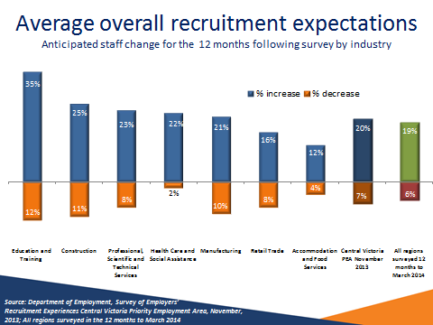
Source: Department of Employment, Survey of Employers’ Recruitment Experiences, Central Victoria PEA, November 2013; All regions surveyed in the 12 months to March 2014

One in five (20%) of employers in the Central Victoria region anticipated increasing staff numbers in the 12 months following the survey, while 7% anticipated decreasing staff numbers, comparable with the average for all regions surveyed (19% increase, 6% decrease).

The Education and Training and Construction industries were most likely to increase staff in the 12 months following the survey (35% and 25% respectively).

While 10% of employers in the Manufacturing industry expected decreasing staff numbers in the 12 months following the survey, there are still jobs in the industry with just over one in five employers expecting to increase staff numbers.

Slide 29 Many opportunities exist across occupations- * Occupations Difficult to Fill

47 per cent of employers in Central Victoria anticipate recruiting in the 12 months following the survey most commonly for:

Future recruitment
Sales Assistants (General)
Motor Mechanics *
Structural Steel and Welding Trade Workers *
Truck Drivers *
Kitchenhands
Real Estate Sales Agents
Pharmacists *
Waiters
Checkout Operators and Office Cashiers
Child Carers *
Bar Attendants and Baristas
Nursing Support and Personal Care Workers
Pharmacy Sales Assistants
Registered Nurses *
* Occupations that employers reported were difficult to fill in their last
recruitment round

Source: Department of Employment, Survey of Employers’ Recruitment Experiences, Central Victoria PEA, November 2013

Other occupations difficult to fill
- Chefs
- Motor Vehicle and Vehicle Parts Salespersons
- Bakers and Pastrycooks

Slide 30 Employers’ concerns for the future

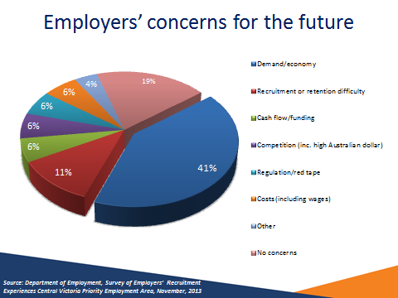
Source: Department of Employment, Survey of Employers’ Recruitment Experiences Central Victoria Priority Employment Area, November, 2013

Two in five (41 per cent) employers surveyed considered demand and the economy to be their greatest concern. While some 11 per cent felt recruitment and staff retention difficulties to be of concern. One in five (19 per cent) employers felt they had no concerns at all.

Slide 31 Conclusion

- The labour market is mixed in the Ballarat region …
- Recent decline in unemployment, yet regional disparity
- Recruitment activity falling
- Overall decline in the Manufacturing industry
- Demographic change: ageing population, young people leaving the region
- Residents travelling to other regions for work - Melbourne and Geelong
- Future labour supply
- Disadvantaged groups:
- Vulnerable and disengaged youth, persons with lower levels of education, mature age population, high number of income support recipients
- Opportunities exist
- Major growth industries (Health)
- Almost half of employers expect to recruit
- A broad range of occupations will be in demand
- Improved opportunities for job seekers who actively approach employers
- Job seekers need to be engaged in the labour market
- Employability skills are a must
- Continued stakeholder and employer engagement

Slide 32 Contacts

If you have any questions about the presentation please contact the Employer Surveys Section or Recruitment Analysis Section on:

Tel: 1800 059 439 or
Email: recruitmentsurveys@employment.gov.au

More information on labour market conditions and other research on small areas can be found on these web sites

LMIP www.employment.gov.au/LMIP
Skill Shortages www.employment.gov.au/SkillShortages
Regional Reports www.employment.gov.au/RegionalReports
Australian Jobs www.employment.gov.au/australianjobs
Job Outlook www.joboutlook.gov.au

Thank you.



