Slide 1 Australian Government Department of Employment Central Victoria Priority Employment Area labour market overview – Bendigo presentation 13 June 2014.

Presentation given by Ivan Neville Branch Manager Labour Market Research and Analysis Branch based on survey of Central Victoria Priority Employment Area conducted November 2013

Slide 2 Central Victoria – Bendigo region

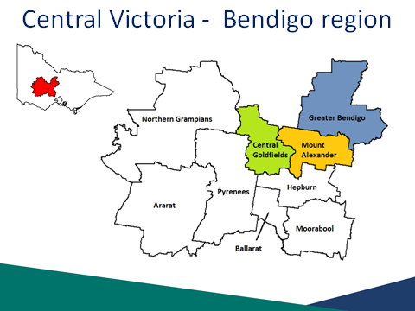
Source: ABS (ASGC), 2006 LGA boundaries

The Bendigo region includes the Local Government Areas (LGAs) of:
- Central Goldfields
- Mount Alexander
- Greater Bendigo

The Central Victoria region includes the Bendigo region plus the following Local Government Areas (LGAs) of:
- Ararat
- Ballarat
- Hepburn
- Moorabool
- Northern Grampians
- Pyrenees

87% of the Bendigo SA4 population lives in the Bendigo region.

Slide 3 Labour market conditions have softened since 2012

Unemployment rate
Youth unemployment rate
Income support recipients
Recruitment activity
Competition for vacancies
Future recruitment expectations
Overall labour market conditions for the region
ABS, Labour Force Survey, April 2014; Department of Employment, Small Area Labour Markets, December 2013; Survey of Employers’ Recruitment Experiences, Central Victoria PEA, November 2012 and November 2013; Department of Employment, administrative data, March 2014

- Labour market conditions in the Bendigo region have softened since 2012.
- The unemployment rate in the Bendigo region increased to 6.5 per cent in December 2013 from 5.8 per cent in December 2012 (SALM, December 2013).
- The youth unemployment rate for the Bendigo region dropped from 13.9 per cent in April 2013 to 12.9 per cent in April 2014 (ABS LFS, April 2014).
- The proportion of people in receipt of income support increased slightly from 24 per cent to 25 per cent in the 12 months to March 2014 (Dept of Employment, March 2014)
- Competition for vacancies increased substantially.
- The survey showed a decrease in recruitment activity but expectations of future recruitment were encouraging.

Slide 4 Population profile for the Bendigo region:

Region | Adult  Population  (15 +) | Growth  2007 to 2012 | Working Age  (15-64) Participation Rate (2011) | Median Age  (2011)
Greater Bendigo LGA | 83,660 | 9% | 74.9% | 37
Central Goldfields LGA | 10,500 | 3% | 64.5% | 46
Mount Alexander LGA | 15,020 | 5% | 69.7% | 44
Bendigo region | 109,180 | 8% | 73.3% | 40
Central Victoria region | 247,940 | 8% | 73.5% | 40
Victoria | 4,599,100 | 10% | 75.6% | 37
Australia | 18,419,630 | 10% | 75.8% | 37
Source: ABS Estimated Resident Population, 2007 and 2012; ABS Census of Population and Housing, 2011

The adult population (15 years+) in the Central Victoria region (247,940) has increased by 8 per cent in the five years to 2012. Similarly, the adult population for Victoria and Australia have both increased in the same period by 10 per cent. The Bendigo region has an adult population of 109,180.

At the time of the 2011 Census, the Working Age Population (15-64 years) participation rate for the region was 73.5 per cent, lower to that of Victoria
(75.6 per cent) and Australia (75.8 per cent).

The median age in the region was 40 years at the time of the 2011 Census, a slightly higher age compared with Victoria and Australia (both 37 years).

Slide 5 Age distribution — Bendigo region

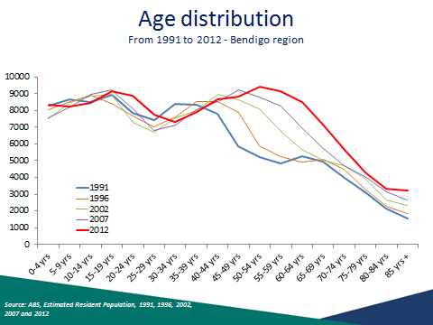
Source: ABS, Estimated Resident Population, 1991, 1996, 2002, 2007 and 2012

Between 1991 and 2011 the largest growth in population in the Bendigo region has been to the 50 years plus age group. This has coincided with a slight decline in adults aged between 25 to 40 years.

Slide 6 More people moving in to the region over the past 5 years

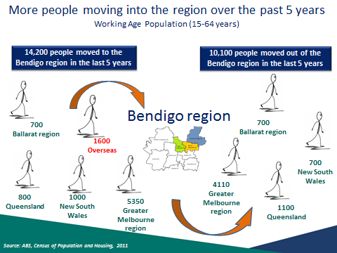
Source: ABS, Census of Population and Housing, 2011

In the five years to the 2011 Census, 14,200 people aged from 15 to 64 have moved to the Bendigo region and 10,100 have moved out of the region. This gives a net migration of 4,100 working age persons moving into the region

The majority of people came from the following localities:

Region | People | % of people who moved to the region
Greater Melbourne region | 5,350 | (38%)
Overseas | 1,600 | (11%)
New South Wales | 1,000 | (7%)
Queensland | 800 | (6%)
Ballarat region | 700 | (5%)

Slide 7 Residents on the move

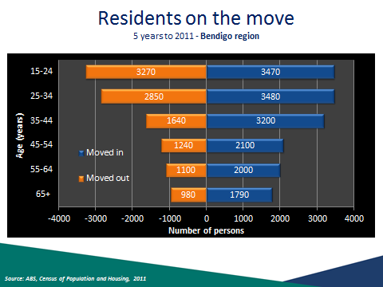
Source: ABS, Census of Population and Housing, 2011

There was a net migration of 200 15 to 24 year olds moving into the Bendigo region in the five years to 2011. This number is a lot smaller compared to 35 to 44 year olds where there is a net migration of 1,560 moving into the region.

Slide 8 Migrating with a job into the Bendigo region?

Group  (age at 2011) | Number of People | Employed | Unemployed | Not in the labour force
WAP | 14,180* | 65% (69%)* | 6% (4%)* | 29% (27%)*
15-24 years | 3,460 | 55% | 8% | 37%
25-44 years | 6,660 | 74% | 5% | 21%
45-54 years | 2,090 | 71% (79%) | 6% (3%) | 23% (18%)
55-64 years | 1,970 | 45% (56%) | 5% (2%) | 49% (41%)
Migrating from Overseas | 1,570 | 64% | 6% | 30%
Source: ABS, Census of Population and Housing, 2011

People of working age (age at 2011) who had migrated into Bendigo region between 2006 and 2011 (14,180 persons) were more likely to be unemployed (6 per cent compared with 4 per cent overall) and not in the labour force (29 per cent, compared with 27 per cent overall).

Slide 9 Where else do Bendigo residents work?

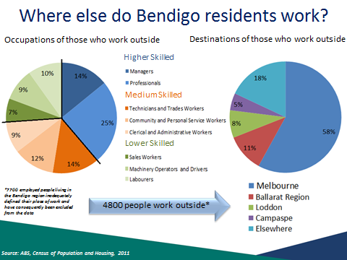
Source: ABS, Census of Population and Housing, 2011

Of those who defined their place of work, 83 per cent (44,500) work locally and 17 per cent (4,800) work outside the Bendigo region. Those who work outside were more likely to be employed as Professionals (25 per cent compared with 21 per cent for those who live and work locally).

Melbourne is by far the most common destination for Bendigo residents who work outside the region (2,800 persons or 58 per cent of those who work elsewhere), followed by the Ballarat region (540 persons or 11 per cent of those who work elsewhere). Loddon and Campaspe are also important working destinations.

Slide 10 Unemployment rate rising…

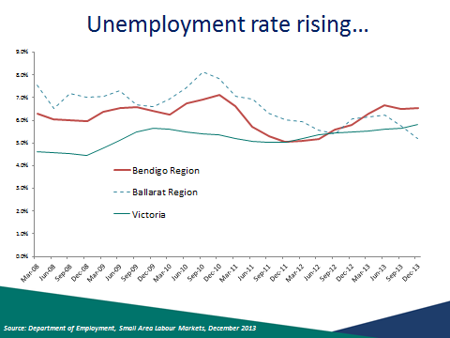
Source: Department of Employment, Small Area Labour Markets, December 2013

In December 2013, the unemployment rate for the Bendigo region was 6.5 per cent, higher compared with Victoria (5.8 per cent).

Slide 11 …across all Local Government Areas

Region | December 2012 | December 2013 | Annual Change
Greater Bendigo LGA | 5.5% | 6.3% | 0.8% pts
Central Goldfields LGA | 9.5% | 10.0% | 0.5% pts
Mount Alexander LGA | 5.3% | 5.8% | 0.5% pts
Bendigo region | 5.8% | 6.5% | 0.7% pts
Central Victoria region | 5.9% | 5.8% | -0.1% pts
Victoria * | 5.8%  April 2013 | 6.4%  April 2014 | 0.6% pts
Source: Department of Employment, Small Area Labour Markets, December 2013

In the 12 months to December 2013, the unemployment rate in the Bendigo region rose by 0.7 percentage points to 6.5 per cent, slightly higher compared with the state (6.4 per cent).

The Central Goldfields LGA reported the highest unemployment rate in the Bendigo region (10.0 per cent), significantly more than the LGAs of Greater Bendigo and Mount Alexander (6.3 per cent and 5.8 per cent respectively).

In the 12 months to December 2013, the unemployment rate in Central Victoria has decreased (by 0.1 percentage point) while Victoria has increased by 0.6 percentage points.

Slide 12 Below average participation in most age groups

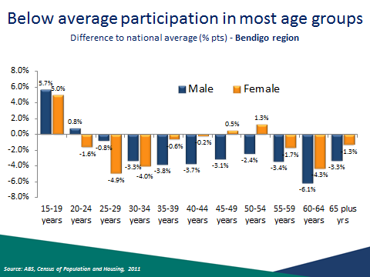
Source: ABS, Census of Population and Housing, 2011

The participation rate for males aged 15 to 19 years (53.9 per cent) was relatively high compared with the national rate (48.3 per cent). The participation rate for females in the same cohort (57.4 per cent) was also high compared with the national rate (52.4 per cent). The participation rate for males aged 61 to 64 years had the lowest comparative rate with the Australia (55.6 per cent compared with 61.7 per cent), while females aged 25 to 29 years had the lowest comparative rate with Australia (72.1 per cent compared with 77.0 per cent).

Slide 13 Part-time employment increasing

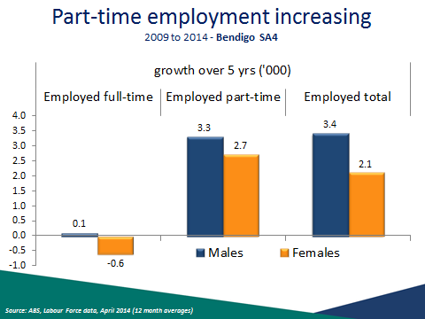
Source: ABS Labour Force data, April 2014 (12 month averages)

Over the five years to 2014, employment has grown by 5,500 jobs across Bendigo SA4s. This growth was driven by part-time employment (up 6,000 jobs) and was slightly offset by a fall in full-time employment (down 500 jobs). The jobs growth for males (3400 jobs) was slightly stronger than that for females (2,100 jobs). However, there was a fall in full-time jobs for females (down 600 jobs) and a very small growth for male full-time employment (up 100 jobs).

Industries in which growth occurred

Male full-time employment growth
Manufacturing, Accommodation and Food Services, Mining and Construction
Male part-time employment growth
Retail, Manufacturing, Accommodation and Food Services and Health Care and Social Assistance

Female full-time employment growth
Increase- Retail, Manufacturing, Accommodation and Food Services and Education
Decrease- Health Care and Social Assistance
Female part-time employment growth
Retail, Manufacturing and Education

Slide 14 Retail and Health largest employment industries

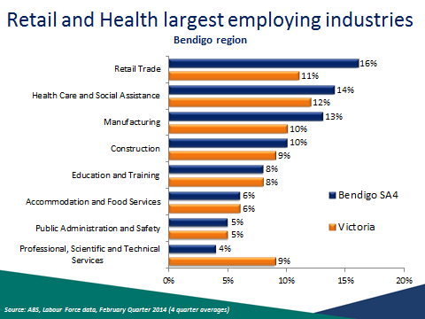
Source: ABS, Labour Force data, February Quarter 2014 (4 quarter averages)

Employment in the Bendigo region was highest in the Retail Trade (16 per cent of all employed), Health Care and Social Assistance (14 per cent) and Manufacturing
(13 per cent) industries.

Slide 15 Structural change in industry employment

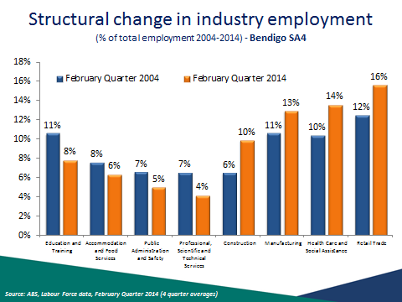
Source: ABS, Labour Force data, February Quarter 2014 (4 quarter averages)

In the 10 years from 2004, industries have changed quite substantially in the Bendigo region. The reliance on the Education and Training industry has lessened, reducing from 11 per cent to 8 per cent of all employment. Whereas, the importance of the Retail Trade is very evident, having grown from 12 per cent to 16 per cent of all employment in the region. Reliance on the Construction, Manufacturing, Health Care and Social Assistance industries has also increased.

Slide 16 Long-term unemployment

Region | Long-term unemployed  (52 weeks or more) |  | Average number of weeks unemployed
Region | Persons  (‘000) | Per cent of all unemployed | Average number of weeks unemployed
Bendigo SA4 | 1.2 | 23.6% | 34.4
Victoria | 34.6 | 18.6% | 35.9
Australia | 144.9 | 20.5% | 38.3
Source: ABS, Labour Force data, April 2014 (12 month averages)

Long-term unemployed are those who have been unemployed and looking for work for 52 weeks or more.

The proportion of unemployed persons who are long-term unemployed in the Bendigo SA4 (23.6%) was higher than both Victoria (18.6%) and Australia (20.5%). However, the average number of weeks unemployed was less than the state and national average.

Slide 17 One in four receive income support

Region | Proportion of working age population  in receipt of a benefit
Region | Income Support benefits | Unemployment benefits | Disability Support Payments
Greater Bendigo LGA | 24% | 7% | 8%
Central Goldfields LGA | 37% | 11% | 15%
Mount Alexander LGA | 22% | 7% | 9%
Bendigo region | 25% | 7% | 9%
Central Victoria region | 24% | 7% | 8%
Victoria | 17% | 5% | 5%
Australia | 17% | 6% | 5%
Source: Department of Employment, administrative data, March 2014; ABS, Estimated Resident Population, 2012

In March 2014, one in four (25 per cent) of the working age population were in receipt of an Income Support benefit in the Bendigo region, higher compared with Victoria and Australia (both 17 per cent). The proportion of working aged population receiving Disability Support Pension was particularly high (9 per cent) compared with the State and Australia (both 5 per cent of WAP).

There is significant variation across LGAs for example, 37 per cent of working age persons in the Central Goldfields LGA were on Income Support payments compared with only 22 per cent in the Mount Alexander LGA. Central Goldfields had a high level of working aged population on Disability Support Payment (15 per cent).

Slide 18 What’s happening with 45 to 64 year olds?

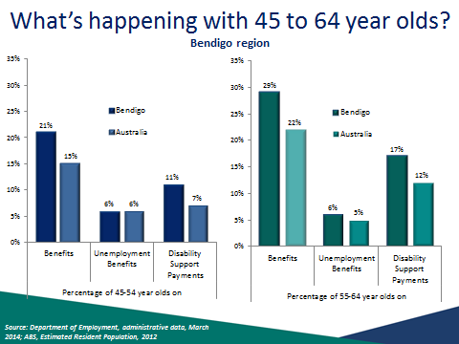
Source: Department of Employment, administrative data, March 2014; ABS, Estimated Resident Population, 2012

Reliance on Income Support Payments is particularly high for those aged 45 to 64 years in the Bendigo region when compared with Australia overall. This is especially so for those aged 55 to 64 years. Disability Support Payments are the most common payment and a far higher proportion of the age group receive this payment when compared to Australia overall.

Slide 19 Jobless Families in the Bendigo region with children under 15

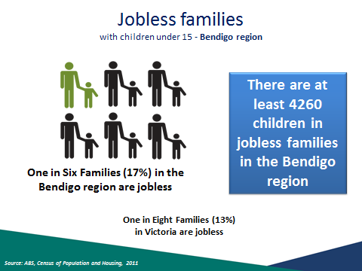
Source: ABS, Census of Population and Housing, 2011

The proportion of families with children under 15 years in the Bendigo region who are jobless (17 per cent) is above both Victoria (13 per cent) and Australia (14 per cent). 1 in 4 families (25 per cent) with children under 15 years in the Central Goldfields LGA are jobless, the highest in the Central Victoria region.

One in six families with children under 15 in the Bendigo region is jobless.
1 in 20 couple families are jobless
Almost 1 in 2 lone parent families are jobless

There are at least 4260 children in jobless families in the Bendigo region.

Slide 20 Is the youth unemployment rate really only 12.9%?

Region | Youth unemployment rate (15-24 years) |  | Youth Participation Rate  (April 2014) | Youth Unemployment to population ratio
Region | April 2013 | April 2014 | Youth Participation Rate  (April 2014) | Youth Unemployment to population ratio
Bendigo SA4 | 13.9% | 12.9% | 71.3% | 9.2%
Victoria | 12.9% | 12.8% | 65.3% | 8.4%
Australia | 11.9% | 12.5% | 66.6% | 8.3%
Source: ABS, Labour Force data, April 2014 (12 month averages)

Due to their lack of skills and experience, youth participating in the labour market can be particularly vulnerable during a labour market downturn.

In April 2014, the youth unemployment rate for the Bendigo SA4 was 12.9 per cent, a decrease of one percentage point since the previous year. The unemployment rate was on par with Victoria (12.8 per cent) and slightly higher than Australia
(12.5 per cent) but still higher than at the time of Global Financial Crisis.

The youth unemployment to population ratio in the Bendigo SA4 (9.2 per cent) was higher than Victoria and Australia (8.4 per cent and 8.3 per cent respectively).

Youth participation was higher in the Bendigo SA4 (71.3 per cent) compared to Victoria (65.3 per cent) or Australia (66.6 per cent)

Slide 21 More young people in Central Victoria not studying

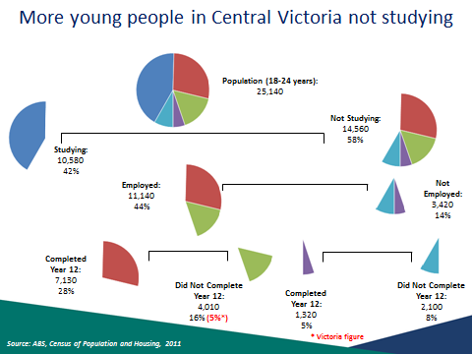
Source: ABS, Census of Population and Housing, 2011

At the time of the 2011 Census, there were 25,140 18-24 year olds in the Central Victoria region, of which 14,560 (58 per cent) were not studying. Overall in Victoria the percentage of 18 to 24 year olds that were studying was higher at 51 per cent.

- Of the 14,560 who were not studying, those who did not complete year 12, are vulnerable and may have difficulty entering the labour market, whether they’re employed or not employed. One in four people (24 per cent) in the Central Victoria region aged 18 to 24 were not studying and had not completed Year 12, this was high compared to the state where 16 per cent were not studying and had not completed Year 12.
- Of those not studying, 77 per cent were employed comparable with Victoria where 78 per cent of those not studying were employed.

Slide 22 More young people disengaged

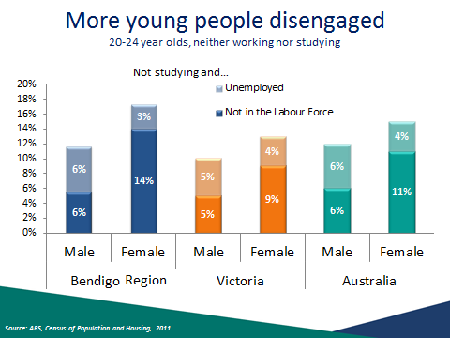
Source: ABS 2011 Census of Population and Housing.

This chart shows persons aged 20-24 years who are neither working nor studying. Non studying females aged 20 to 24 years are particularly disengaged with
17 per cent unemployed or not in the labour force. This is high compared with the state (13 per cent).

Slide 23 Lower educational attainment in Bendigo

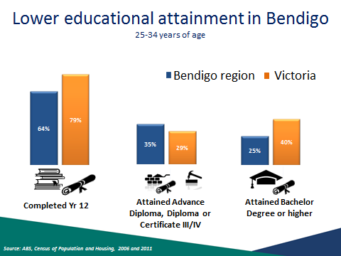
Source: ABS, Census of Population and Housing, 2006 and 2011

The Bendigo region has had an improvement of 6 percentage points in the proportion of 25 to 34 year olds that have completed Yr 12 or equivalent studies between 2006 and 2011. This is in line with the 6 percentage point improvement seen in Victoria overall.

The improvement was not even across all LGAs. Mount Alexander LGA had an improvement of 11 percentage points (to 65 per cent) while Central Goldfields LGA only had a 3 percentage point improvement (to 52 per cent)

The number of 25 to 34 year olds having completed an Advance Diploma, Diploma or Certificate III/IV was relatively high for all Bendigo LGAs. In the Central Goldfields LGA some 36 per cent of the cohort had completed these courses compared to
29 per cent for Victoria.

The story was very different for Bachelor Degrees or higher. Greater Bendigo LGA had the highest level at 26 per cent of the cohort while the Central Goldfields LGA had a level of only 11 per cent. The level for Victoria was 40 per cent.

Slide 24 Importance of education to labour market outcomes

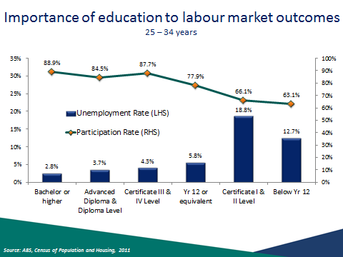
Source: ABS, Census of Population and Housing, 2011

This slide illustrates the correlation between education and labour market outcomes in the Central Victoria region, with higher labour force participation rates and lower unemployment rates for those with higher levels of educational attainment. This reflects the pattern seen across Australia and demonstrates the importance of continuing education to help job seekers obtain employment and participate in the labour market.

Slide 25 Improving youth labour market outcomes

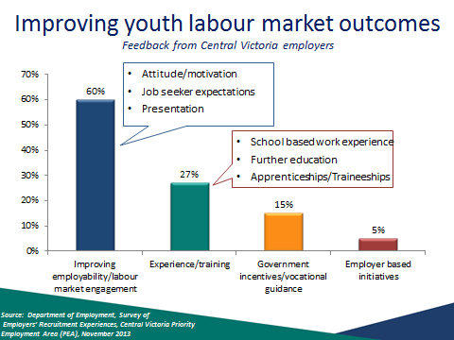
Source: Department of Employment, Survey of Employers’ Recruitment Experiences, Central Victoria Priority Employment Area (PEA), November 2013

Employers in Central Victoria were asked for feedback on strategies to improve labour market outcomes for youth.

The majority of employers (60 per cent) believed that improving employability and labour market engagement were the most important factors in improving youth labour market outcomes, most particularly:

- Attitude/motivation
- Job seeker expectations (too high for youth)
- Presentation

A substantial proportion of employers (27 per cent) believed that experience or training was most important for youth, in particular:

- School based work experience
- Further education
- Apprenticeships/traineeships

Slide 26 Signs of weakening recruitment activity

 | Bendigo region |  | Central Victoria region |  | All regions surveyed  (12 months to March 2014)
 | November  2013 | November  2012 | November  2013 | November  2012 | All regions surveyed  (12 months to March 2014)
Annual vacancies  per 100 staff | 13 | 17 | 14 | 16 | 16
Increased staff | 18% | 18% | 19% | 20% | 16%
Decreased staff | 21% | 20% | 21% | 17% | 22%
Source: Department of Employment, Survey of Employers’ Recruitment Experiences, Central Victoria PEA, November 2013; November 2012 and All regions surveyed in the 12 months to March 2014

The survey results indicate a weakening in labour markets conditions across the Central Victoria region over the last year. Recruitment activity has decreased over the year (from 17 vacancies to 13 vacancies per 100 staff). Additionally, a slightly smaller proportion of employers had increased staff and a larger proportion had decreased staff when compared to the results from a year earlier.

Slide 27 Competition for vacancies increased since 2012

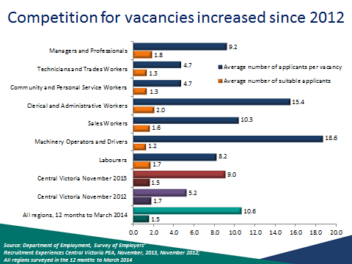
Source: Department of Employment, Survey of Employers’ Recruitment Experiences, Central Victoria PEA, November 2013; November 2012 and All regions surveyed in the 12 months to March 2014

There was a higher average number of applicants per vacancy (9.0) compared with previous surveys (5.2 in November 2012). The average number of suitable applicants interviewed per vacancy (1.5) was similar to November 2012 (1.7) and all regions surveyed to March 2014 (1.5).

Slide 28 Many employers do not advertise vacancies

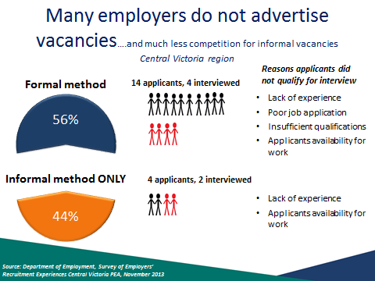
Source: Department of Employment, Survey of Employers’ Recruitment Experiences Central Victoria PEA, November 2013

Employers in the Central Victoria region relied on informal recruitment methods only, such as word of mouth and being approached by job seekers, slightly less often than formal methods, such as newspapers, the internet and recruitment agencies. Nevertheless vacancies for which employers used informal recruitment methods attracted less than one third the number of applicants than when the employers used formal methods. This highlights the value of job seekers actively approaching employers when looking for work.

Slide 29 Personality Traits and Employability Skills employers in Central Victoria viewed as essential

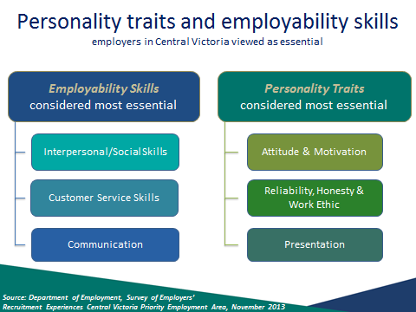
Source: Department of Employment, Survey of Employers’ Recruitment Experiences Central Victoria Priority Employment Area, November 2013

There were was range of general employability skills and personality traits that employers in the Central Victoria region commonly viewed as essential for the position they recently recruited for.

- Employability skills commonly considered essential included:
- Interpersonal/Social Skills
- Customer Skills
- Communication

Personality traits commonly considered essential included:
- Attitude and Motivation
- Reliability, Honesty and Work Ethic
- Presentation

Slide 30 Many opportunities exist across occupations- * Occupations Difficult to Fill

Sales Assistants (General)
Motor Mechanics *
Structural Steel and Welding Trade Workers *
Truck Drivers *
Kitchenhands
Real Estate Sales Agents
Pharmacists *
Waiters
Checkout Operators and Office Cashiers
Child Carers *
Bar Attendants and Baristas
Nursing Support and Personal Care Workers
Pharmacy Sales Assistants
Registered Nurse *
* Occupations that employers reported were difficult to fill in their last recruitment round

Source: Department of Employment, Survey of Employers’ Recruitment Experiences, Central Victoria PEA, November 2013

Other occupations difficult to fill

Chefs
Motor Vehicle and Vehicle Parts Salespersons
Bakers and Pastrycooks

Slide 31 Average overall recruitment expectations

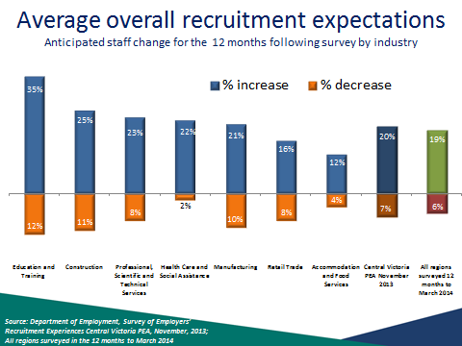
Source: Department of Employment, Survey of Employers’ Recruitment Experiences Central Victoria PEA, November, 2013; All regions surveyed in the 12 months to March 2014

One in five (20 per cent) of employers in the Central Victoria region anticipated increasing staff numbers in the 12 months following the survey, while 7 per cent anticipated decreasing staff numbers, comparable with the average for all regions surveyed (19 per cent increase, 6 per cent decrease).

The Education and Training and Construction industries were most likely to increase staff in the 12 months following the survey (35 per cent and 25 per cent respectively).

While 10 per cent of employers in the Manufacturing industry expected to decrease staff numbers in the 12 months following the survey, there are still likely to be growth in employment in the industry with just over one in five employers expecting to increase staff numbers.

Slide 32 Employers’ concerns for the future

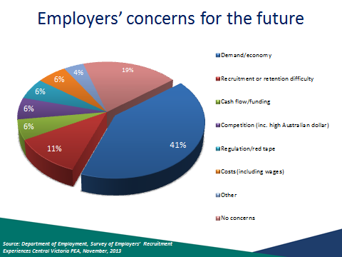
Source: Department of Employment, Survey of Employers’ Recruitment Experiences Central Victoria PEA, November, 2013

Two in five (41 per cent) employers surveyed considered demand and the economy to be their greatest concern. While some 11 per cent felt recruitment and staff retention difficulties to be of concern. One in five (19 per cent) employers felt they had no concerns at all.

Slide 33 Conclusion

The labour market in the Bendigo region has softened in the past year…
- Labour market challenges
- Rising unemployment rate
- Demographic change: ageing population, young people leaving the region
- Recruitment activity falling
- Underemployment – part-time employment growth high
- High number of income support recipients
- Residents travelling to other regions for work – Melbourne and Ballarat
- Future labour supply
- Disadvantaged groups:
- Vulnerable and disengaged youth, persons with lower levels of education, long-term unemployed, mature age population
- Opportunities exist
- Major growth industries (Health)
- Almost half of employers expect to recruit.
- A broad range of occupations will be in demand
- Improved opportunities for job seekers who actively approach employers
- Job seekers need to be engaged in the labour market
- Employability skills a must
- Continued stakeholder and employer engagement

Slide 34 Any Questions?

If you have any questions about the presentation please contact the Employer Surveys Section or Recruitment Analysis Section on:

Tel: 1800 059 439 or
Email: recruitmentsurveys@employment.gov.au

More information on labour market conditions and other research on small areas can be found on these web sites

LMIP www.employment.gov.au/LMIP
Skill Shortages www.employment.gov.au/SkillShortages
Regional Reports www.employment.gov.au/RegionalReports
Australian Jobs www.employment.gov.au/australianjobs
Job Outlook www.joboutlook.gov.au

Thank you.



